Mental Health YS*5.01*217

Deployment, Installation, Back-out, and Rollback Guide
January 2023
Version 1.0

Department of Veterans Affairs
Office of Information and Technology (OIT)

Revision History

Date | Version | Description | Author
12/1/2022 | 1.0 | Initial Version | Liberty IT Solutions

Table of Contents
1 Introduction 1
1.1 Purpose 1
1.2 Dependencies 1
1.3 Constraints 1
2 Roles and Responsibilities 1
3 Deployment 2
3.1 Timeline 2
3.2 Site Readiness Assessment 2
3.2.1 Deployment Topology (Targeted Architecture) 2
3.2.2 Site Information (Locations, Deployment Recipients) 2
3.2.3 Site Preparation 2
3.3 Resources 3
3.3.1 Facility Specifics (optional) 3
3.3.2 Hardware 3
3.3.3 Software 3
3.3.4 Communications 3
4 Installation 3
4.1 Pre-installation and System Requirements 3
4.2 Platform Installation and Preparation 3
4.3 Access Requirements and Skills Needed for the Installation 4
4.4 Installation Procedure 4
4.5 Post-installation 4
4.6 Installation Verification Procedure 5
4.7 Database Tuning 5
5 Back-out Procedure 5
5.1 Back-out Strategy 5
5.2 Back-out Considerations 5
5.3 Back-out Criteria 5
5.4 Back-out Risks 5
5.5 Authority for Back-out 5
5.6 Back-out Procedure 5
5.7 Back-out Verification Procedure 6
6 Rollback Procedure 6
6.1 Rollback Considerations 6
6.2 Rollback Criteria 6
6.3 Rollback Risks 6
6.4 Authority for Rollback 6
6.5 Rollback Procedure 6
6.6 Rollback Verification Procedure 8
7 Appendix A – Acronyms 9

List of Tables
Table 1: Deployment, Installation, Back-out, and Rollback Roles and Responsibilities 1
Table 2: Acronyms 9

Introduction
This document describes how to deploy and install the patch YS*5.01*217 of the Mental Health package, as well as how to back-out the product and rollback to a previous version or data set. This document is a companion to the project charter and management plan for this effort.

Purpose
The purpose of this plan is to provide a single, common document that describes how, when, where, and to whom Mental Health patch YS*5.01*217 will be deployed and installed, as well as how it is to be backed out and rolled back, if necessary. The plan also identifies resources, communications plan, and rollout schedule. Specific instructions for installation, back-out, and rollback are included in this document.

Dependencies
It is assumed that this patch is being installed into a fully patched Veterans Health Information System and Technology Architecture (VistA) system. Patches YS*5.01*141 and YS*5.01*202 must be installed prior to this patch.

Constraints
For all other VistA sites, there are no constraints beyond the installation into an up-to-date VistA system.

Roles and Responsibilities
The following describes the roles and responsibilities associated with the testing and release of YS*5.01*217. This application requires both a VistA installation and an update to the web application. The Azure application manager will install the web application part of the patch. The VistA patch will be deployed via the normal PackMan route.
Table 1: Deployment, Installation, Back-out, and Rollback Roles and Responsibilities
Team | Phase / Role | Tasks | Project Phase (See Schedule)
Project Manager | Deployment | Determine and document the roles and responsibilities of those involved in the deployment | Design
Software Quality Assurance (SQA), Test Sites | Deployment | Test for operational readiness | Test
Project Manager, Release Manager | Deployment | Execute deployment | Release
Individual VistA Sites | Installation | Plan and schedule installation | Release
Azure Manager | Installation | Plan and schedule installation | Release
Release Manager | Back-out | Confirm availability of back-out instructions and back-out strategy (what are the criteria that trigger a back-out) | Release
Sustainment Team | Post Deployment | Hardware, Software and System Support | Sustain

Deployment
The deployment is planned as a simultaneous (National Release) rollout. Once approval has been given to nationally release, YS*5.01*217 will be available for installation and deployment at all sites.
Scheduling of test installs, testing, and production deployment will be at the site’s discretion. It is anticipated there will be a 30-day compliance period.

Timeline
The deployment and installation are scheduled to run during January and February 2023.

Site Readiness Assessment
This section discusses the locations that will receive the YS*5.01*217 deployment.

Deployment Topology (Targeted Architecture)
Local sites, as well as regional data centers, will need to execute the VistA installation steps during the required installation period to stay synchronized with the updates to the web application.

Site Information (Locations, Deployment Recipients)
The initial deployment will be to Initial Operating Capability (IOC) sites for verification of functionality. Once testing is completed and approval is given for national release, YS*5.01*217 will be deployed to all VistA systems.
The Production IOC testing sites are:
Clement J. Zablocki VAMC (Milwaukee, WI)
Orlando VAMC (Orlando, FL)

Site Preparation
YS*5.01*217 requires a fully patched VistA system. Patches YS*5.01*141 and YS*5.01*202 must be installed prior to the installation of YS*5.01*217.

Resources

Facility Specifics (optional)
No specific facility instructions needed.

Hardware
No hardware instructions needed.

Software
No software instructions needed.

Communications
When YS*5.01*217 is released, the released-patch notification will be sent from the National Patch Module to all personnel who have subscribed to notifications for the Mental Health package patch.

Installation

Pre-installation and System Requirements
There are no pre-installation requirements.

Platform Installation and Preparation
This patch can be loaded with users in the system. Installation time will be less than 5 minutes.
To ensure the integrity of the transport global, use the “Verify Checksums in Transport Global” to compare the checksums with the list that follows:
The checksums below are new checksums, and can be checked with CHECK1^XTSUMBLD.

Select BUILD NAME: YS*5.01*217 MENTAL HEALTH
YS217PST value = 9701774
YTQAPI1 value = 33692139
YTQAPI17 value = 5761273
YTQAPI2 value = 33799161
YTQROPT value = 9607623
YTSCAT value = 57710486
YTSCIA value = 5411954
YTSCORE value = 58177918
YTSEDEQ value = 11852660
YTSMCMI4 value = 251755612
YTSMCMIA value = 86005550
done

Access Requirements and Skills Needed for the Installation
Installation of YS*5.01*217 requires access to Kernel Installation and Distribution System (KIDS) options to be able to load and install the KIDS build.

Installation Procedure
This patch may be installed with users on the system although it is recommended that it be installed during non-peak hours to minimize potential disruption to users. This patch should take less than 5 minutes to install.
- Choose the PackMan message containing this build. Then select the INSTALL/CHECK MESSAGE PackMan option to load the build.
- From the Kernel Installation and Distribution System Menu, select the Installation Menu. From this menu:
  - Select the Verify Checksums in Transport Global option to confirm the integrity of the routines that are in the transport global. When prompted for the INSTALL NAME enter the patch or build name (YS*5.01*217).
  - Select the Backup a Transport Global option to create a backup message. You must use this option for each patch contained in the Host File. For each patch you can specify what to backup, the entire Build or just Routines. The backup message can be used to restore just the routines or everything that will restore your system to pre-patch condition.
  - You may also elect to use the following options:
    - Print Transport Global - This option will allow you to view the components of the KIDS build.
    - Compare Transport Global to Current System - This option will allow you to view all changes that will be made when this patch is installed. It compares all of the components of this patch, such as routines, DDs, templates, etc.
  - Select the Install Package(s) option and choose the patch to install (YS*5.01*217).
    - If prompted 'Want KIDS to Rebuild Menu Trees Upon Completion of Install? NO//', answer NO.
    - When prompted 'Want KIDS to INHIBIT LOGONs during the install? NO//', answer NO.
    - When prompted 'Want to DISABLE Scheduled Options, Menu Options, and Protocols? NO//', answer NO.

Post-installation
A post-install routine will run to change the name of the ASRS instrument to ASRS-6 and update the CESD instrument with a Total scale. A new instrument category, Eating/Nutrition, will be added. The routine will also set the instrument categories for the EDE-Q, CIA, AD8, NUDESC, SIP-AD-30, SIP-AD-START, and SWEMWBS instruments.

Installation Verification Procedure
Open CPRS and launch the MHA Web application. Create a new assignment on a test patient and verify instruments such as the CIA and EDD-Q are selectable. Also verify that the ASRS instrument is now named ASRS-6. Press the CANCEL button to cancel the assignment.

Database Tuning
No database tuning required.

Back-out Procedure

Back-out Strategy
This patch updates the Mental Health Assistant – Web (MHA Web) application. If MHA Web does not perform as desired, it is possible to back out to the previous implementation.

Back-out Considerations
If the YS*5.01*217 patch is backed out, there will be minimal impact to users. Special consideration will have to be given to deactivating the instruments that were added (CIA and EDE-Q).

Back-out Criteria
A back-out should only be considered if there is a patient safety issue, if MHA Web no longer functions, or if there is some other catastrophic failure.

Back-out Risks
The risks vary depending on what is causing the failure of the system. The main risk is that the MHA Web will be unavailable.

Authority for Back-out
The VistA system manager determines if a back-out of YS*5.01*217 should be considered.

Back-out Procedure
The following routines need to be restored to their previous versions:
- YTQAPI1
- YTQAPI17
- YTQAPI2
- YTQROPT
- YTSCAT
- YTSCIA
- YTSEDEQ
- YTSCORE
- YTSMCMI4
- YTSMCMIA
Use the KIDS utility restore the routines backed up in section 4.4, 2B.
*** NOTE ***
Follow the instrument Deactivation procedure in section 6.5 Rollback Procedure to Drop the CIA and EDE-Q instruments.

Back-out Verification Procedure
Open CPRS and launch MHA Web. Click on the + sign to create a new Assignment. Verify that the CIA and EDE-Q instruments are no longer visible.

Rollback Procedure

Rollback Considerations
To rollback this patch, three entries in the MH TESTS AND SURVEYS file need to be updated. The two instruments that were added in this patch need to be set to DROPPED.

Rollback Criteria
If the patch is backed out, the MH TESTS AND SURVEYS file must be rolled back.

Rollback Risks
By only changing the OPERATIONAL flag, LAST EDIT DATE, and LAST EDITED BY fields in the MH TESTS AND SURVEYS file, the risks are minimal as any existing MH ADMINISTRATION that used these instruments will still be available.

Authority for Rollback
If the backout of the patch is authorized, then that same authorization is required for rollback.

Rollback Procedure
Deactivate:
- CIA
- EDE-Q

The following example is for the CIA but will be the same for each instrument.

Log in to VistA.
Go to the VA FileMan menu
Go to Enter or Edit File Entries

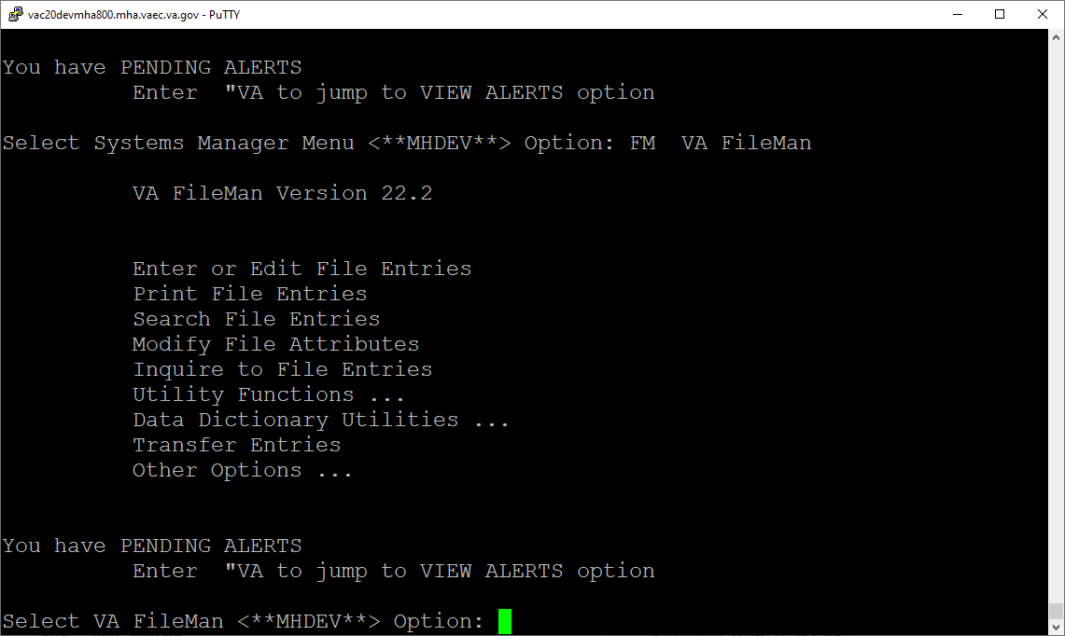

At the Input to what File: prompt enter MH TESTS AND SURVEYS
At the EDIT WHICH FIELD prompt enter:
OPERATIONAL
LAST EDIT DATE
LAST EDITED BY

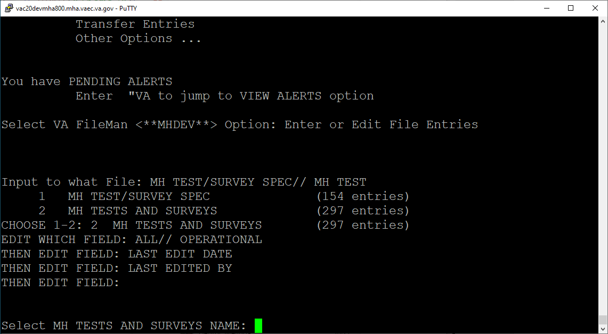

At the Select MH TESTS AND SURVEYS NAME: prompt enter CIA
At the OPERATIONAL prompt enter DROPPED
At the LAST EDIT DATE prompt enter N for NOW
At the LAST EDITED BY prompt enter your name.
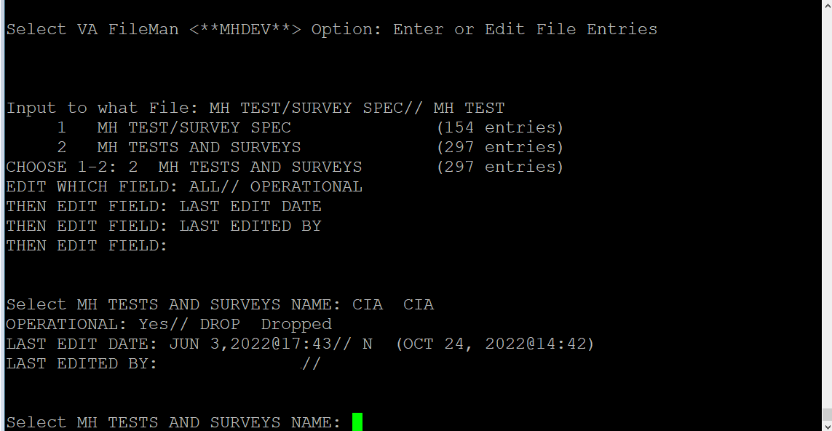

Repeat this process for the EDE-Q.

Rollback Verification Procedure
Go to CPRS and log in. Go to the Tools Menu and launch MHA Web. Click on the plus sign to create a new Assignment. Click on View All Instruments to see the full instrument list. Verify that the CIA and EDE-Q do not appear.

Appendix A – Acronyms
Table 2: Acronyms
Acronym | Definition
ASRS | Adult ADHD Self-Report Scale
CAG | Citrix Access Gateway
CES-D | Center for Epidemiologic Studies Depression Scale
CIA | Clinical Impairment Assessment
CPRS | Computerized Patient Record System
DIBRG | Deployment, Installation, Back-out, and Rollback Guide
EDE-Q | Eating Disorder Examination Questionnaire
IOC | Initial Operating Capability
KIDS | Kernel Installation and Distribution System
MHA | Mental Health Assistant
OIT | Office of Information and Technology
PIN | Personal Identification Number
PIV | Personal Identity Verification
SQA | Software Quality Assurance
SSOi | Single Sign-On Integration
VA | Department of Veterans Affairs
VAMC | Veterans Affairs Medical Center
VIP | Veteran-focused Integration Process
VistA | Veterans Health Information System and Technology Architecture

