VETERAN APPOINTMENT REQUEST (v 3.0)

USER GUIDE

Table of Contents

APPLICATION OVERVIEW 4
PREREQUISITES 4
ACCESS METHOD 4
USER CREDENTIALS 4
ACCESSING THE APPLICATION 5
USING THE APPLICATION 8
LOGGING IN 8
User Enrolled in Veteran Health Administration 9
User Not Enrolled in Veteran Health Administration 10
USER MENU 12
USER MENU > ABOUT 14
USER MENU > FEEDBACK 15
USER MENU > LAUNCHPAD 16
USER MENU > LOGOUT 17
SCHEDULING AN APPOINTMENT 17
NEW APPOINTMENT/REQUEST 18
SCHEDULE A PRIMARY CARE APPOINTMENT MYSELF (DIRECT SCHEDULING) 20
FACILITY 20
CLINIC 23
REASON FOR APPOINTMENT 25
PREFERRED DATE 26
SELECT DATE AND TIME 27
EMAIL PREFERENCES 28
SCHEDULE APPOINTMENT / CANCEL APPOINTMENT 30
Schedule Appointment button 30
Cancel Appointment 31
REQUEST HELP SCHEDULING PRIMARY CARE APPOINTMENT/ SCHEDULING A MENTAL HEALTH APPOINTMENT 34
FACILITY 35
TYPE OF VISIT 37
PURPOSE OF VISIT 38
OTHER PURPOSE 39
DESIRED APPOINTMENT DATES/TIMES 40
PHONE/VERIFY PHONE 42
BEST TIMES FOR VA TO CALL 44
WOULD YOU LIKE THE VA TO CALL YOU REGARDING THIS REQUEST? 45
EMAIL PREFERENCES 45
SUBMIT REQUEST/CANCEL BUTTONS 46
Cancel button 46
Submit Request Button 47
VIEW APPOINTMENTS/REQUESTS 48
REFRESH TO VIEW APPOINTMENTS/REQUESTS 48
VIEW APPOINTMENT/REQUEST DETAILS 49
APPOINTMENT DETAILS 49
REQUEST DETAILS 51
CANCELLING APPOINTMENT/REQUEST 53
CANCEL APPOINTMENT 53
CANCEL REQUEST 55
MESSAGE A SCHEDULING CLERK 58
MESSAGING RULES 59
Maximum 2 messages can be sent 59
Cancelled request cannot send messages 60
Not Booked request cannot send messages 61
No Messages Exchanged 62
ERROR MESSAGES 63
INTERNET CONNECTION 64
SERVER UNAVAILABLE 65
SESSION TIMEOUT WARNING 66
LOGIN SESSION ENDED 67

Application Overview
Veteran Appointment Requests (VAR) version 3.0 provides the Veteran with an interface to allow them to directly schedule an appointment in VistA from the web (desktop or mobile device) or create a request for the clerk to book an appointment. The patient can view their upcoming booked VA appointments at the VA facility they selected.

While scheduling an appointment directly, the patient will see available appointment slots in Primary Care Clinics with their Patient Aligned Care Team (PACT) provider, in which they can book based upon appointment availability in VistA provided the site has elected to designate for direct patient booking using this app. The application shall support notifying the Veteran about the success of appointment cancellation and booking.

Prerequisites

Access method

VAR3.0 is a web-based application. The user can access the application from any desktop or mobile devices using any of the following supported browsers: IE10 +, Chrome 47+, Firefox 24+. Additionally, being a web based application, VAR requires internet connectivity.

User credentials

Veterans with a valid DS LOGON can use this application.

Accessing the application
There are two ways to access this application:

- From Launchpad:

From a supported web browser, navigate to the Launchpad URL: http://10.2.2.5/launchpad/
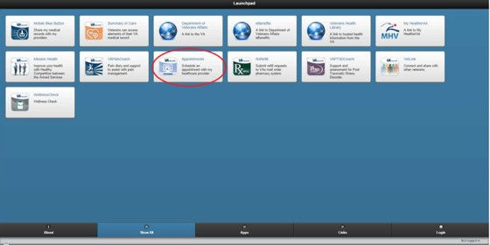

Select the Appointments icon.

- From the application URL: <https://10.2.2.5/veteran-appointment-requests>

The application can be accessed from a supported web browser by navigating to the following URL:<https://10.2.2.5/veteran-appointment-requests>

The following landing page is displayed.

Users can either click the phone number links or the icons to call.
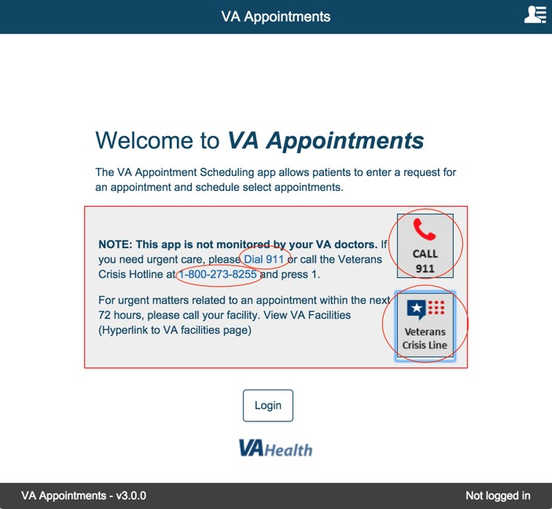

Select the phone number link or the phone icons for 911 or Veterans Crisis Line.

The following confirmation modal is displayed. Selecting Return will close the confirmation modal and the user is returned back to the landing page.

Selecting Continue will initiate the call based on the phone application that is available in the device.

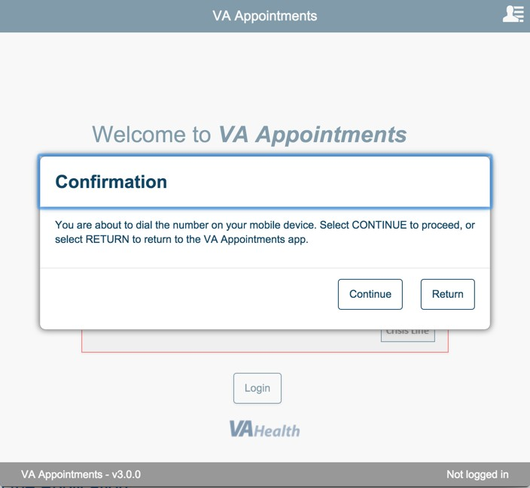

Using the Application

Logging in

Select Login from the Landing Page.

Enter valid user name and password and select 'Sign in'.
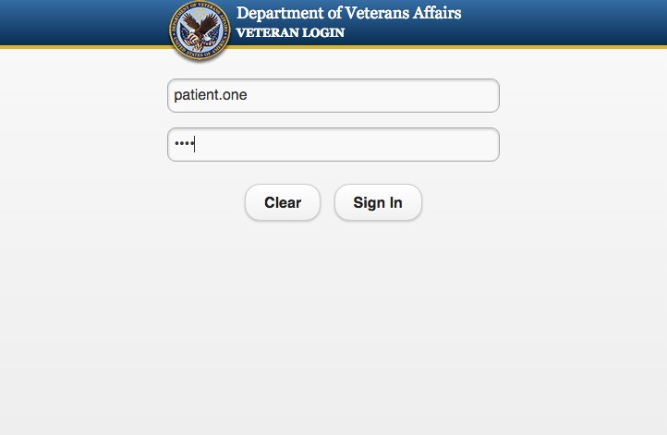

User Enrolled in Veteran Health Administration
If valid credentials are entered and the patient is already enrolled in Veteran Health Administration the following landing page is displayed.
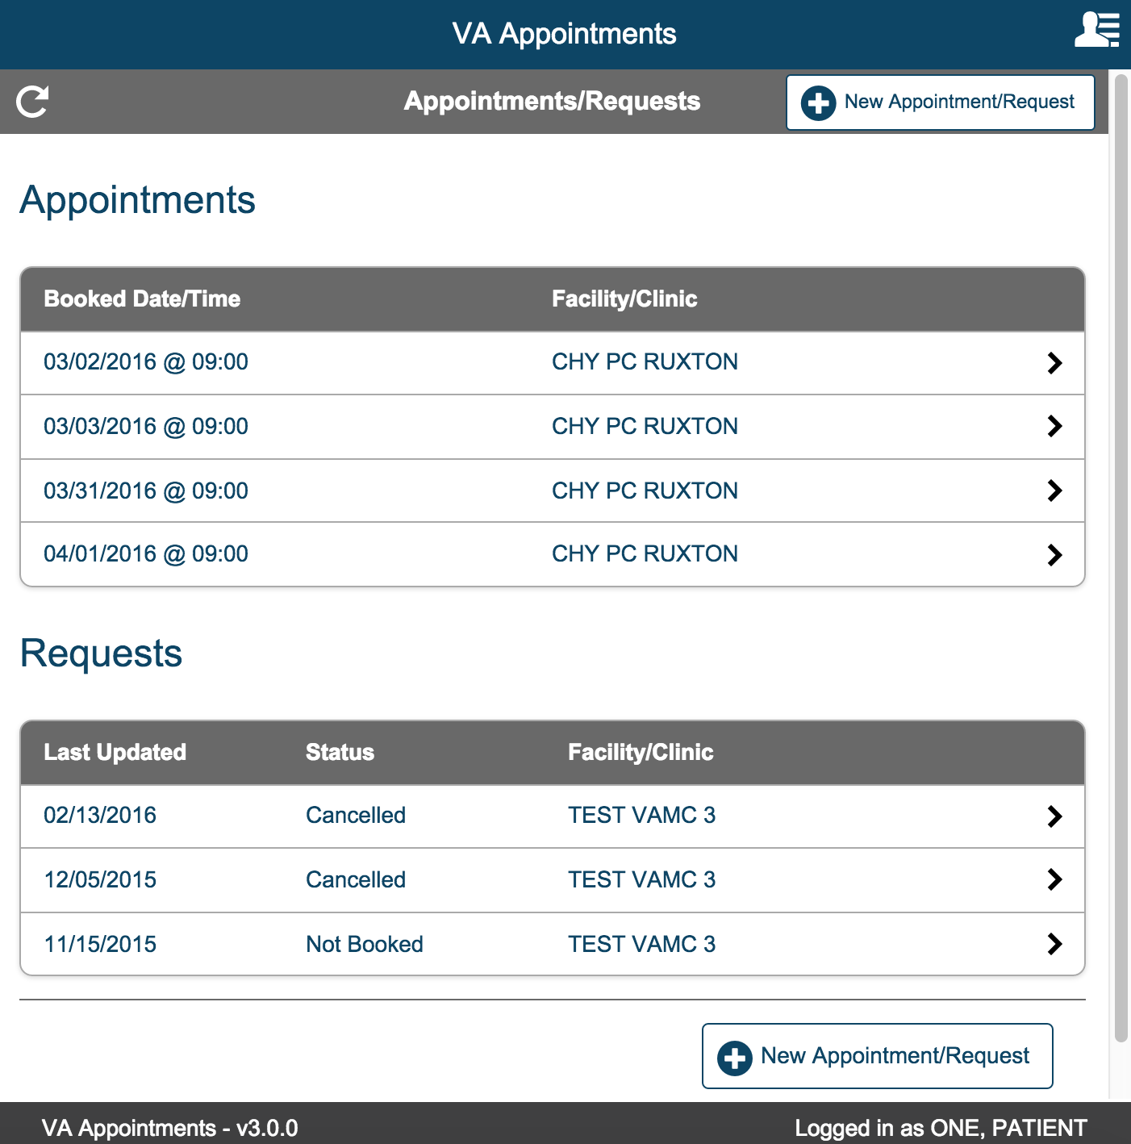

User Not Enrolled in Veteran Health Administration
If a user who is not enrolled in the Veteran Health Administration logs in, the following page is displayed.
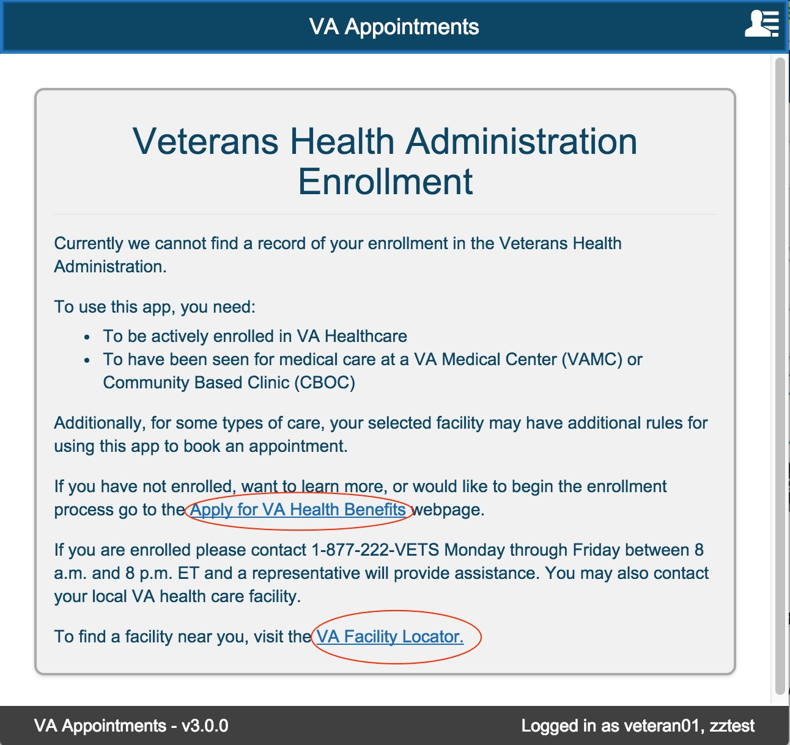

Selecting the links 'Apply for VA Health Benefits Link' or 'VA Facility Locator' will display a confirmation modal.

Select Continue. This will direct user to the corresponding external website. If you do not want to be redirected now, select Return.

Selecting Return, will close the Confirmation modal and user will remain on the landing page.
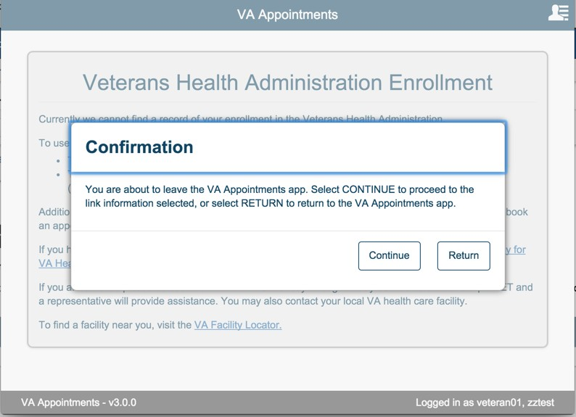

User Menu
The User Menu can be accessed by selecting or tapping on the icon at the top right corner of the menu as shown below:

User can access only the launchpad from the user menu when they have not logged in to the application.
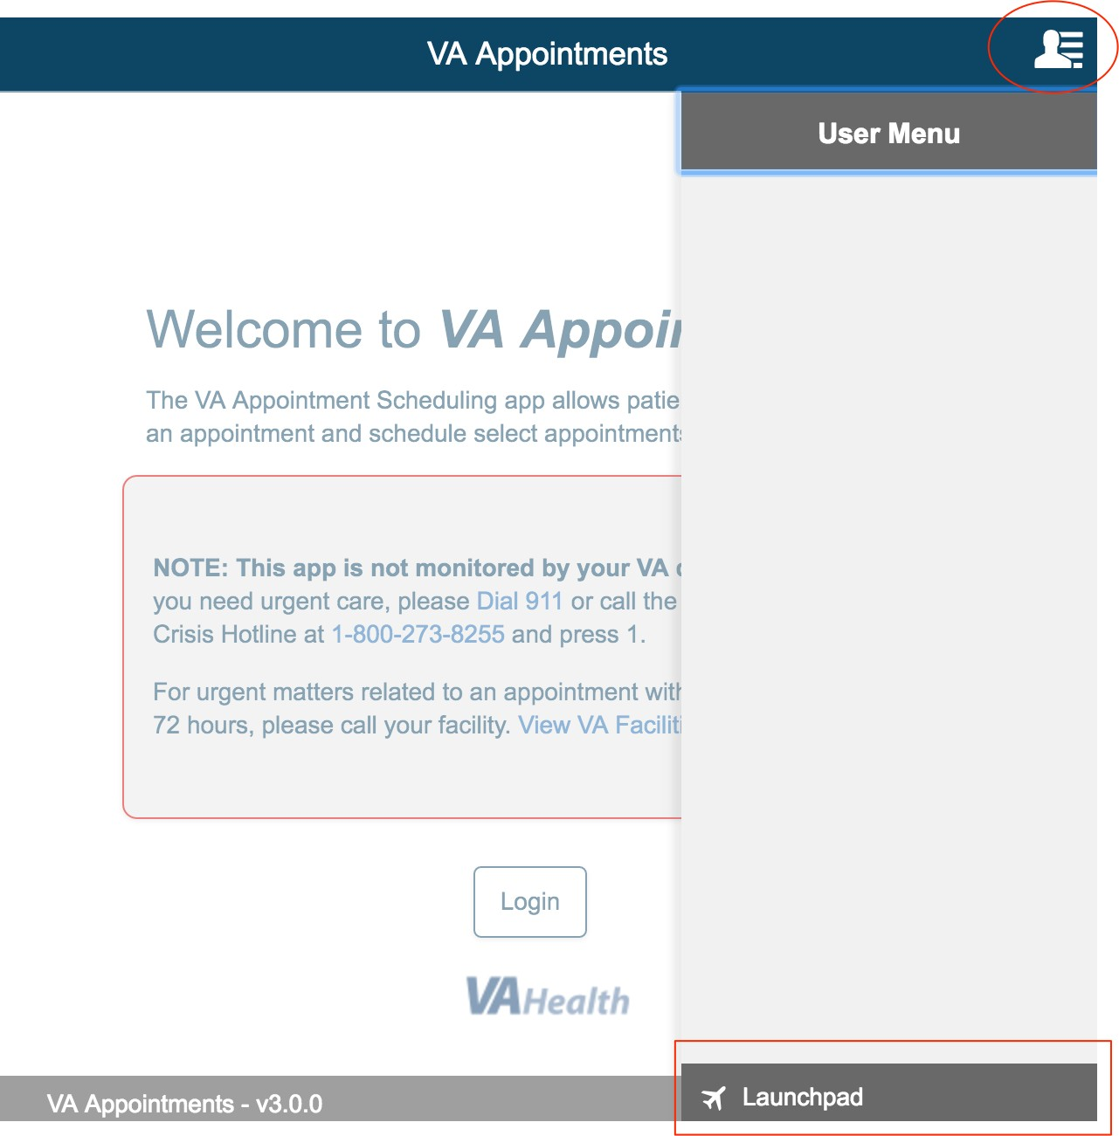

Select the User Menu icon again to close the user menu.
Login to the application. Once the user successfully logs into the application select the User Menu displayed on the top right corner of the page.
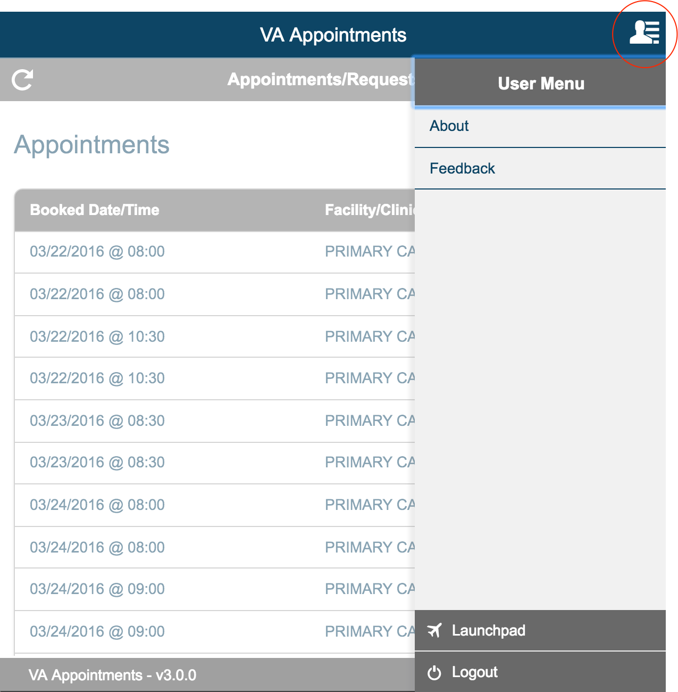

User Menu > About

Select the About link from User Menu.

This displays the version information of the application and the purpose of the application. This section has the link to the user guide. Selecting OK will close the modal and return user back to the page that they were on.
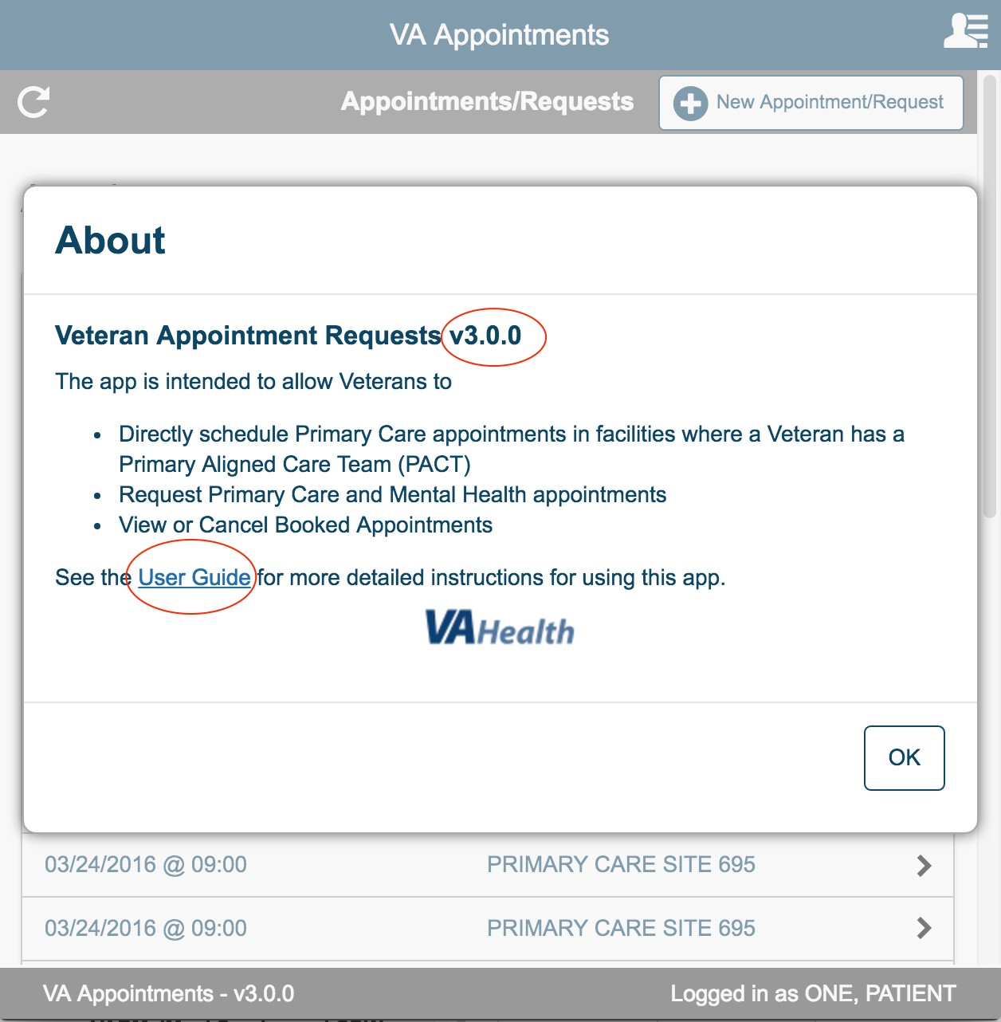

User Menu > Feedback

Select Feedback link from user menu.

User can fill in and submit the feedback form to better improve the service provided to the user by using this app.
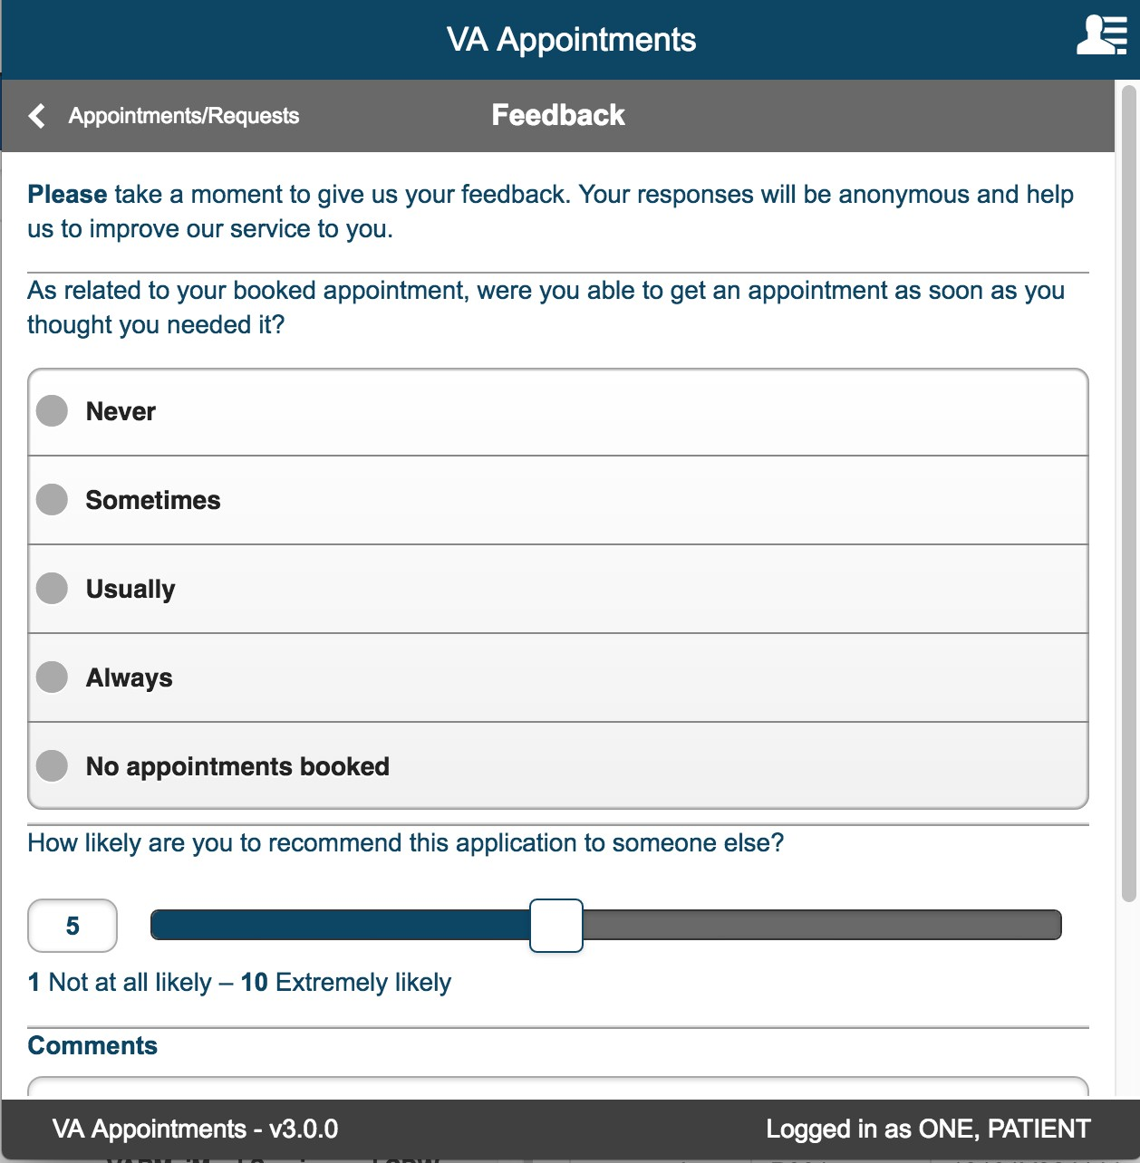

User Menu > Launchpad

Selecting launchpad link from user menu takes user to Launchpad. Launchpad displays all the different apps that are currently available for the user.

User can access the apps from launchpad.
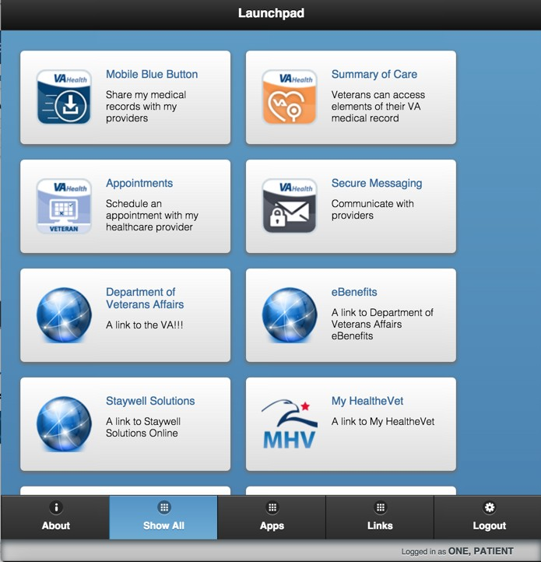

User Menu > Logout

Selecting logout from User Menu logs out the user and takes the user to Launchpad.

Scheduling an appointment

There are three ways a veteran can make an appointment.

- They can make an appointment directly in a Primary Care Clinic with their assigned PACT provider, if they are eligible.
- They can submit a request for an appointment and a VA Scheduling Clerk can fulfill the request by scheduling the appointment using the Scheduling Manager Web Application.
- They can submit a request for a phone call. A VA Scheduling Clerk will be able to see the request in the Scheduling Manager Web Application and will call the veteran back to schedule the appointment.

The key distinction to keep in mind is that a “Request” does NOT make an appointment in VistA. A “Request” will HAVE to be processed by a Scheduling Clerk to schedule an actual appointment.

The following sections explain how these three functionalities are implemented.

New Appointment/Request

Once the user has logged into the application, select the ' + New Appointment/Requests' button that is displayed on the Appointments/Requests Landing page.
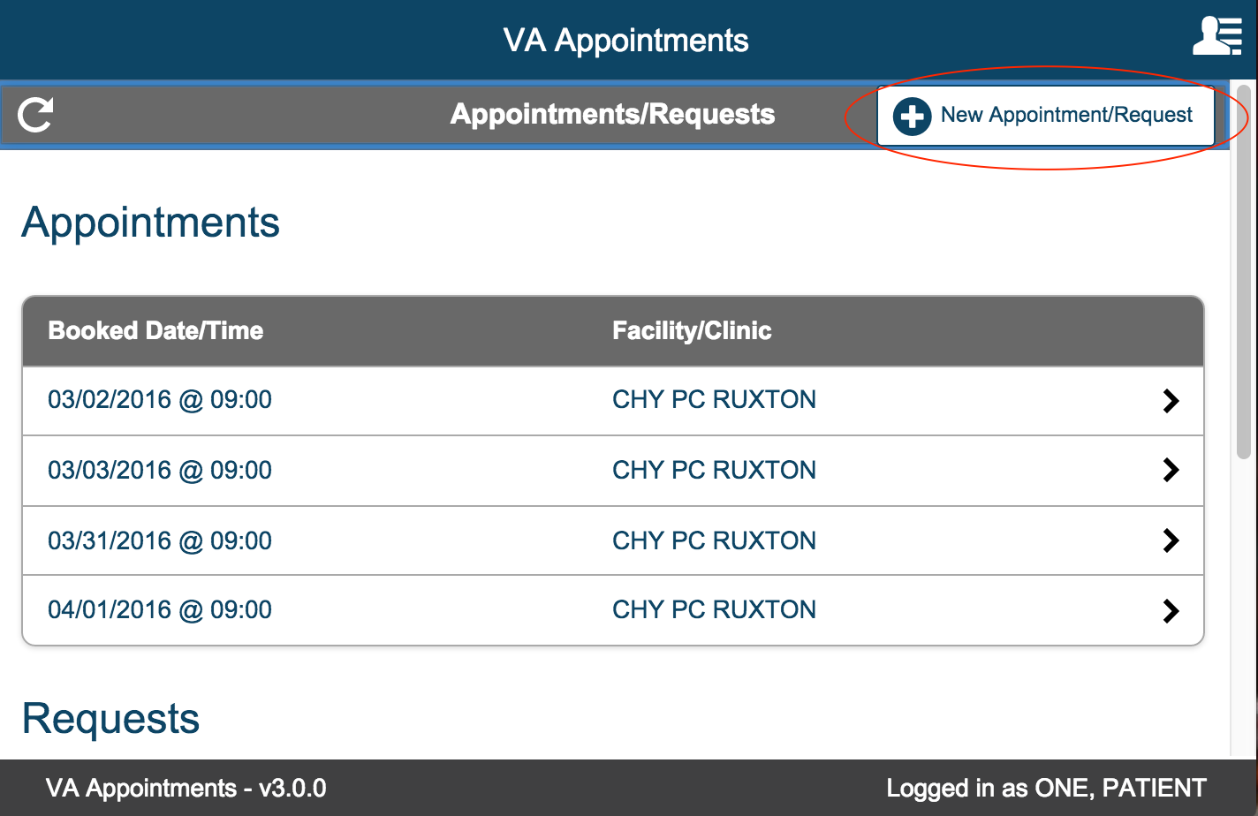

New Appointment/Request page is displayed.

In this page the user has to first select one of the three radio button options. This is required and is denoted by ‘*’.

The first radio button 'Schedule a Primary Care appointment myself' is selected, if the user wants to directly schedule a Primary Care appointment.

The second radio button ' Request help scheduling a Primary Care appointment' is selected, if the user wants to request a clerk to schedule a Primary Care appointment.

The third radio button 'Request help scheduling a Mental Health appointment' is selected, if the user wants to request a clerk to schedule a Mental Health appointment.

User can always select the Cancel button or select the Appointment/Request back button to exit the New Appointment/Requests page and return to the Appointments/Requests page.
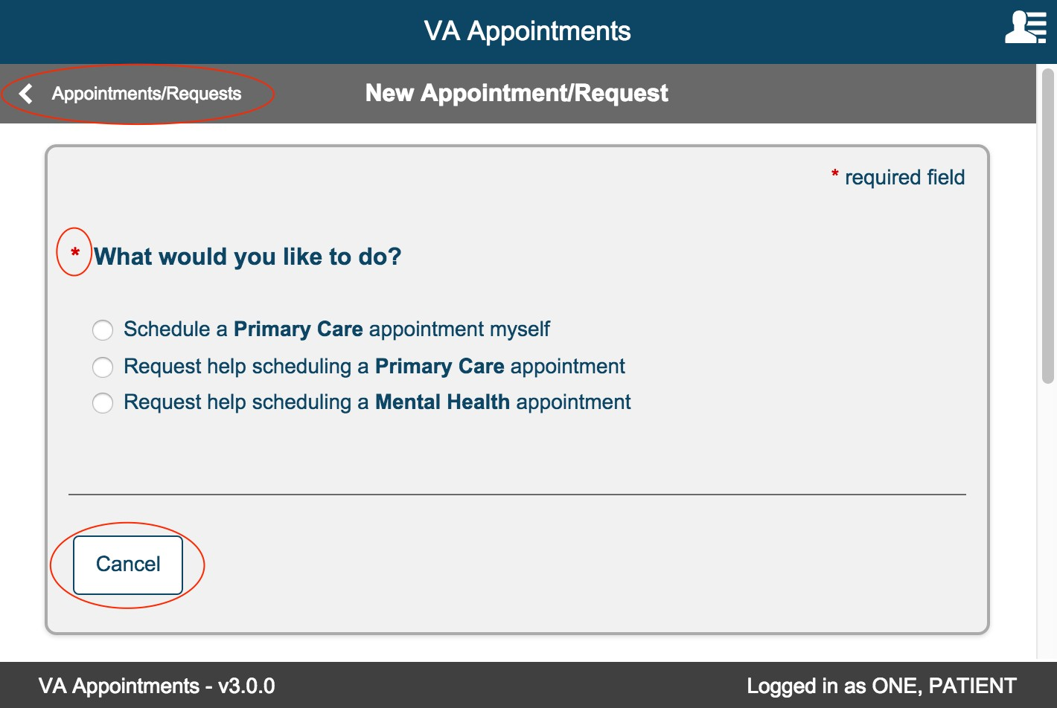

Schedule a Primary Care appointment myself (Direct Scheduling)
Select ‘Schedule a Primary Care appointment myself’ radio button. Appointment Details section is displayed.

Facility

This section displays the list of facilities that the user has been registered to.
This is a required field. User must select one facility if multiple facilities are available. ‘View Your Care Team (PACT)’ link is displayed for each facility.
Select the radio button to select a facility.
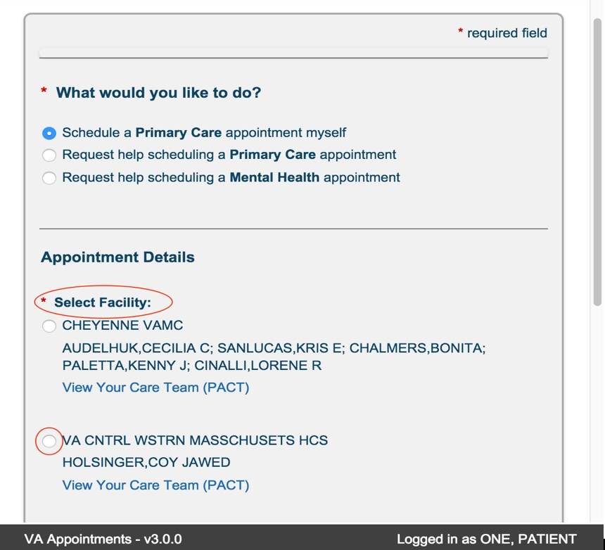

Click the ‘View Your Care Team (PACT)’ link. A modal is displayed that lists the Primary Care Providers and Team List.
Click the close button to return to the New Appointment

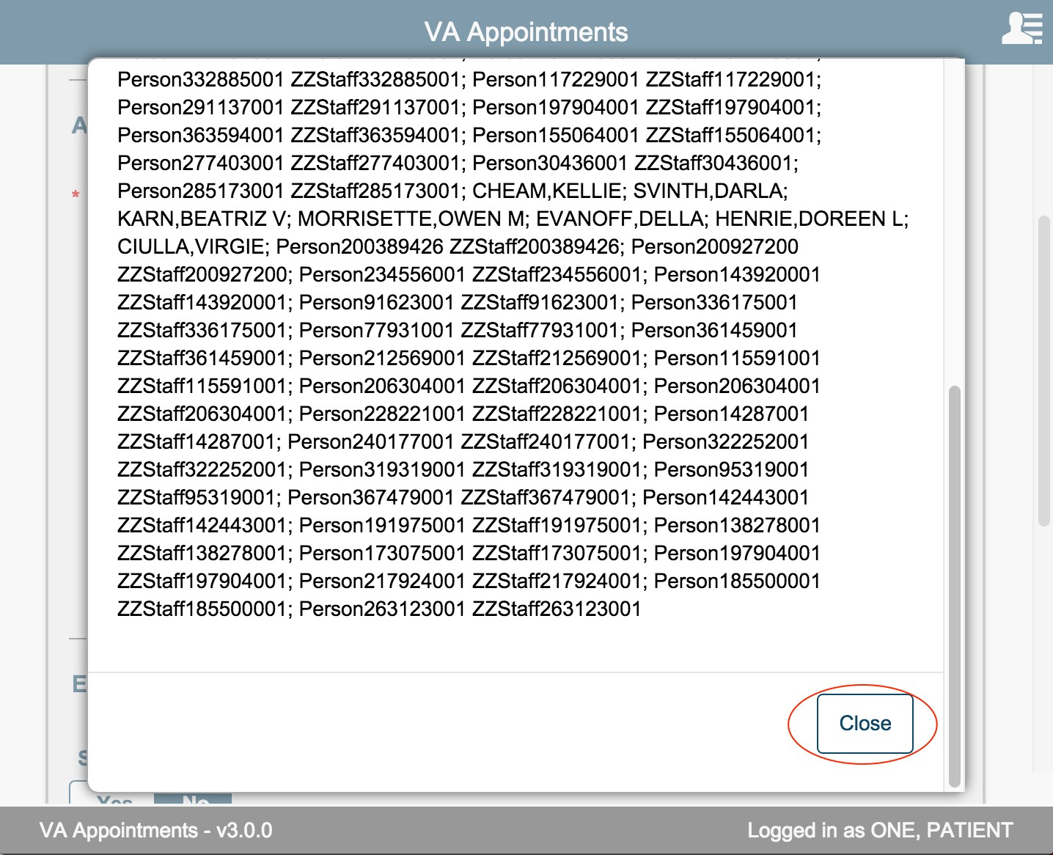

If only one facility is available, the facility is displayed as read only and user cannot change the facility.
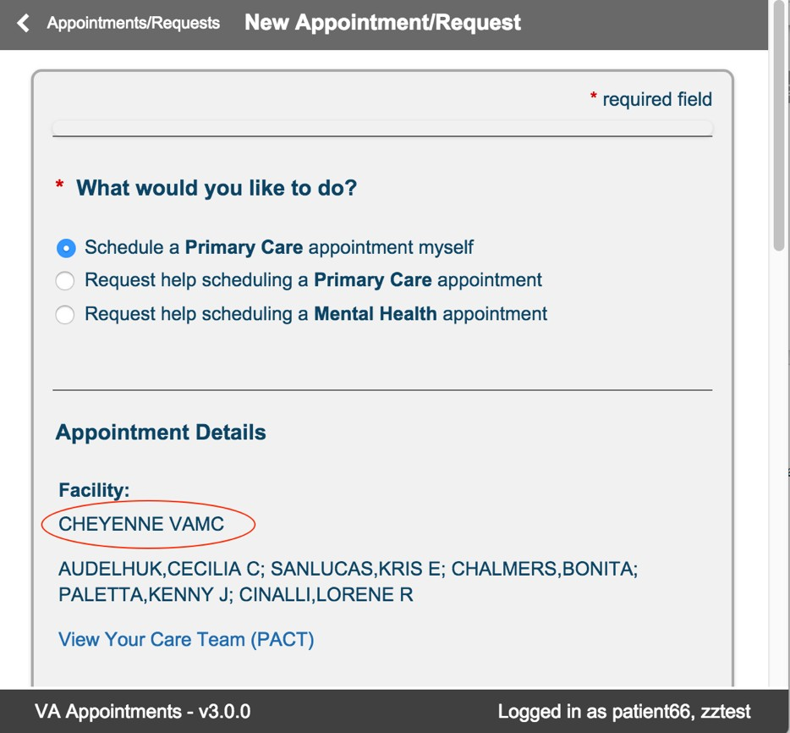

Clinic

Clinics are displayed based on the facility selected. This section displays clinic name, location, and the number of appointments available for that clinic within the +1 to + 90 day range where the user has a PACT team under the selected facility.
If only one facility is available, then clinics associate with that facility are automatically displayed.
This is a required fields and user must select one clinic if multiple clinics are available

If only one clinic is available for the selected facility, the clinic displays as read only text and user cannot change the clinic value.
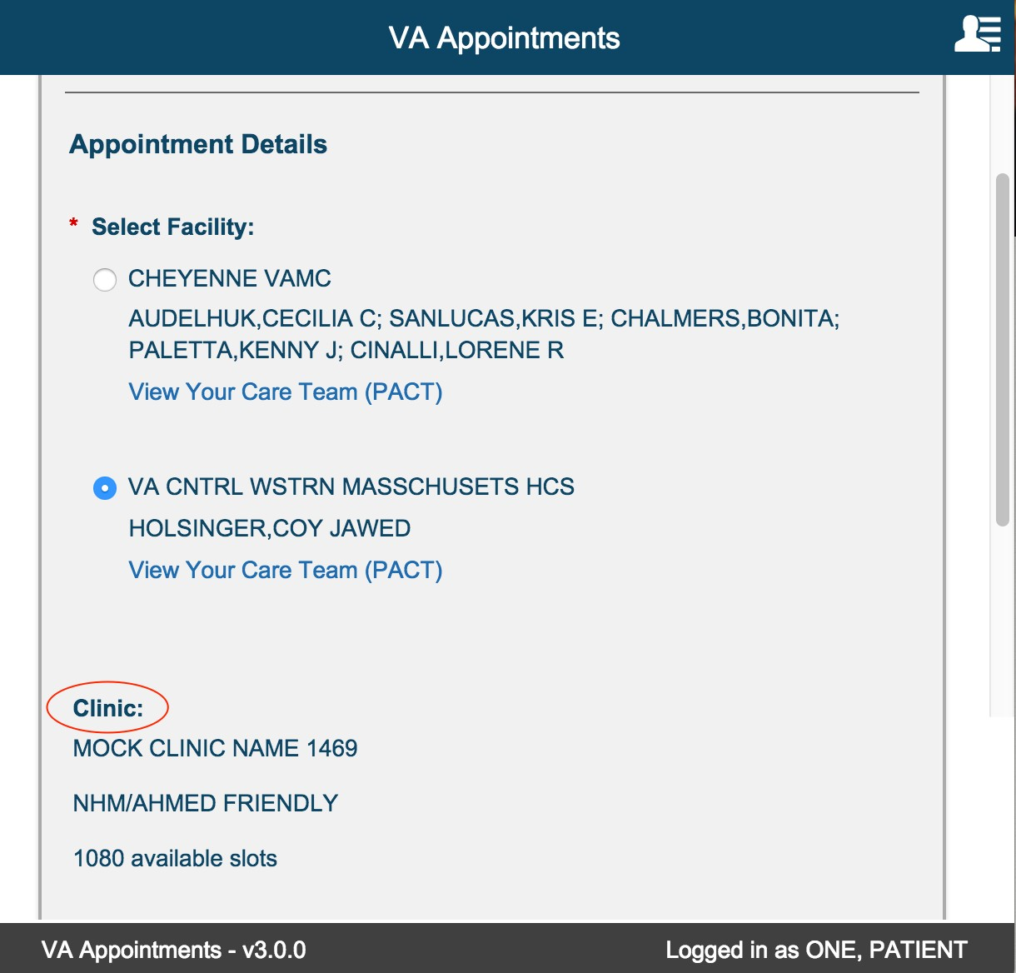

If a clinic does not have available appointment slots, then the radio button to select this clinic is disabled and the following information text is displayed. "There are no appointments available at this clinic for self-scheduling. To schedule at this clinic through this app, please change your choice to "Request help scheduling a Primary Care appointment" or contact your facility for assistance."
For those clinics where there are open slots available to book an appointment, the radio button is enabled.
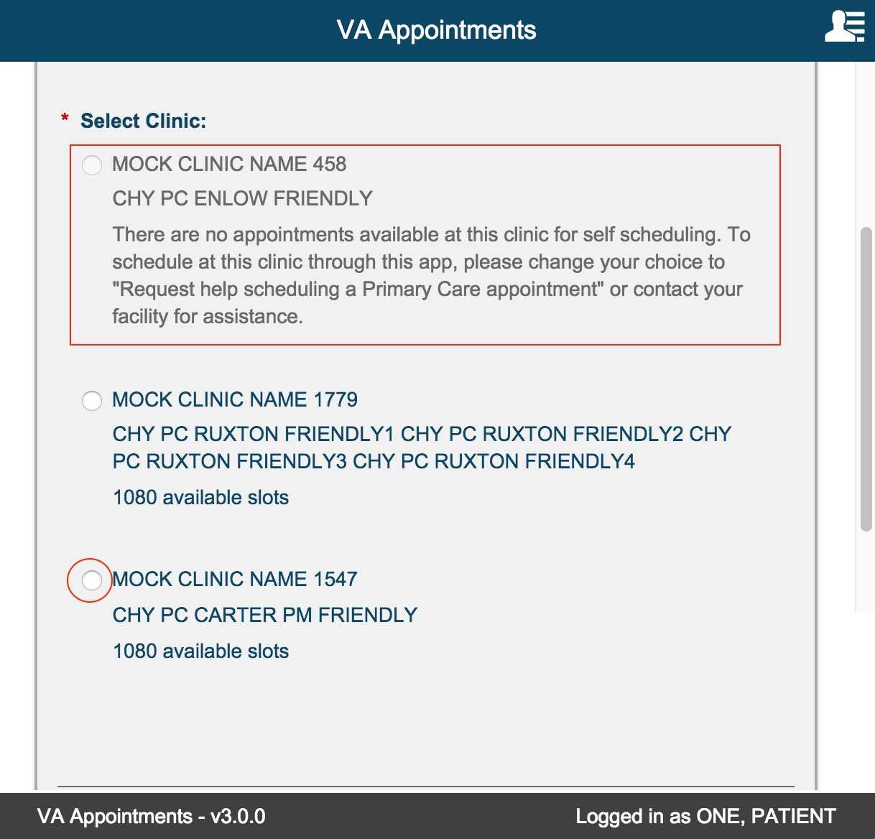

Reason for Appointment

This field is displayed as soon as a clinic is selected.
This is a required multi line text box. 150 alphanumeric characters are allowed.
The character count down will indicate the remaining number of characters allowed.
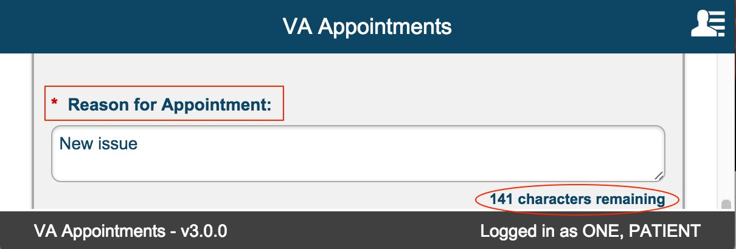

Preferred Date

This is a required field. This field is displayed after a clinic is selected. The date entered must be in the range between today + 1 and today + 90. The user can either directly type a preferred date or use the calendar picker to select a date.
The calendar picker will allow user to select only those dates within the range.
Selecting a valid date will display the ‘Select Date and Time’ section. If invalid dates or dates out of range are entered, the ‘Select Date and Time’ section is not displayed and validation error message is displayed above the ‘What would you like to do?’ section.
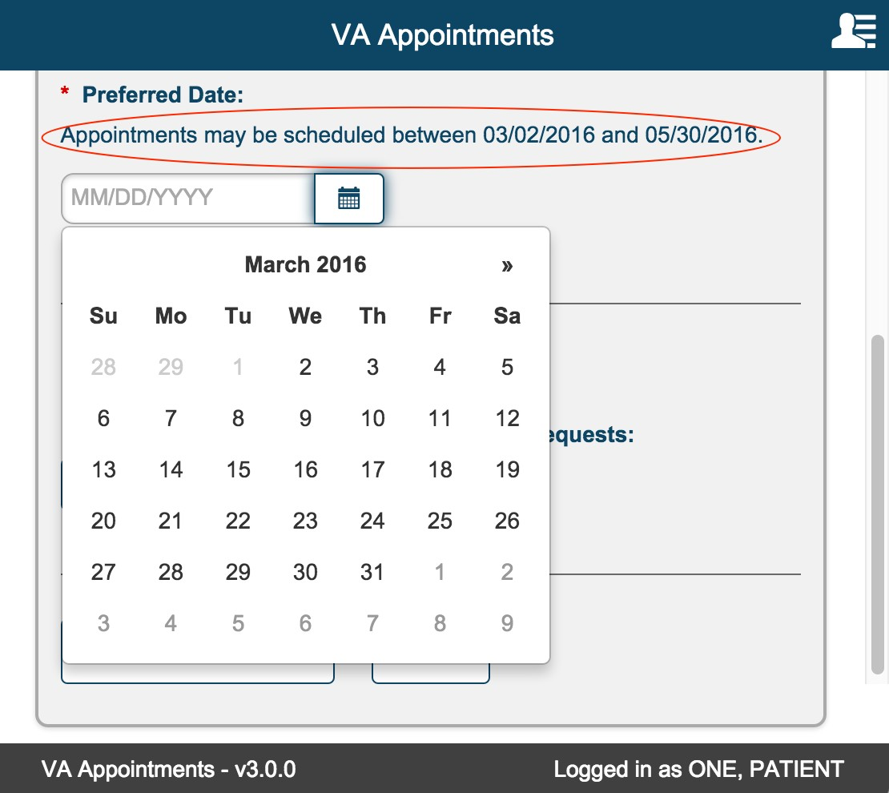

Select Date and Time

This section is displayed only if a valid preferred date is keyed in or selected. Only those dates with available appointment slots are displayed under each month.
The available dates are grouped by month.
Each month is expanded by default. User can expand and collapse as needed. Under each month, dates with available appointment slots are displayed.
The dates are collapsed by default. User can expand and collapse as needed. Expanding each date displays timeslots that are available.
If the preferred date is available and there are time slots available, the date is automatically expanded and focus is moved to that date.
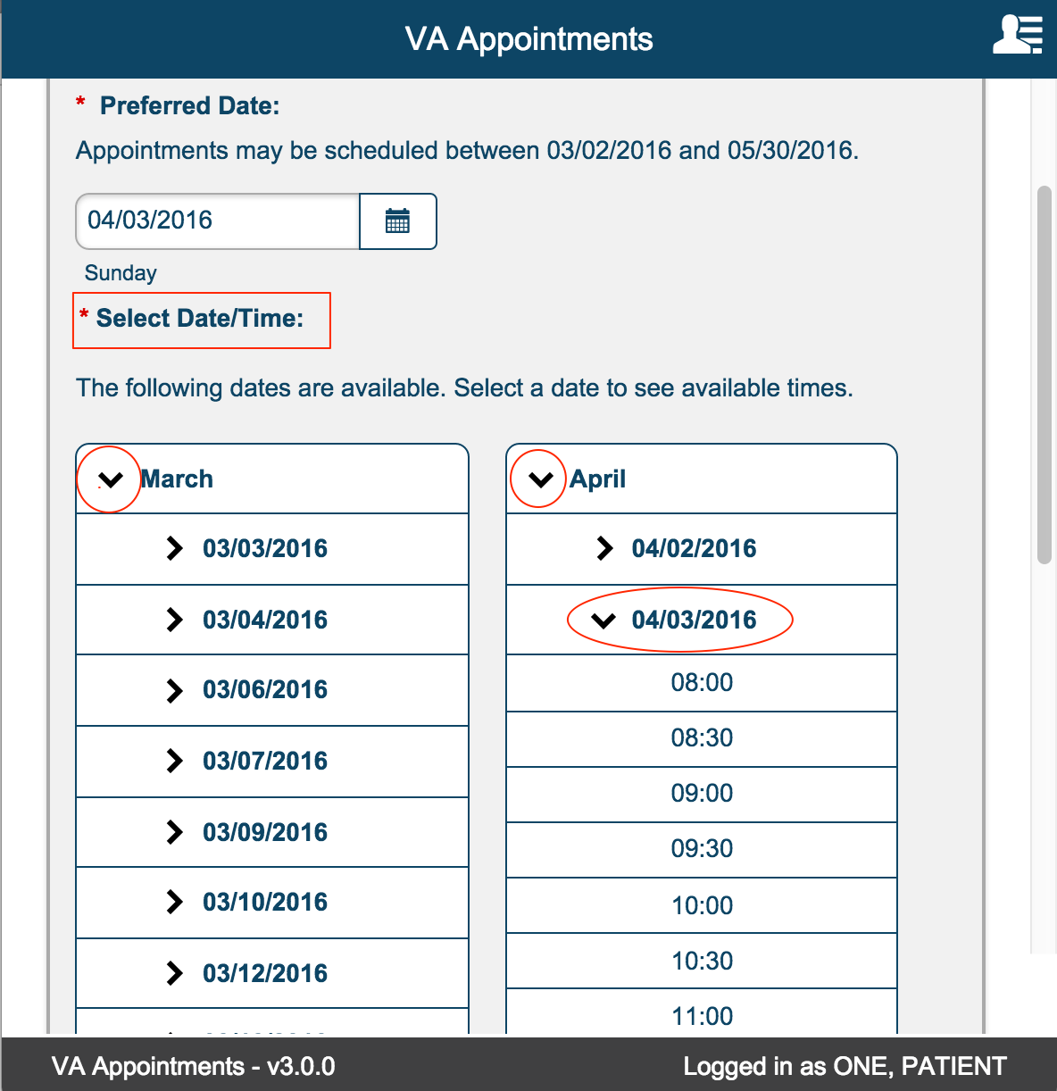

Selecting a time slot displays, ‘You are scheduling an appointment for: <day>, <Date Time>’.
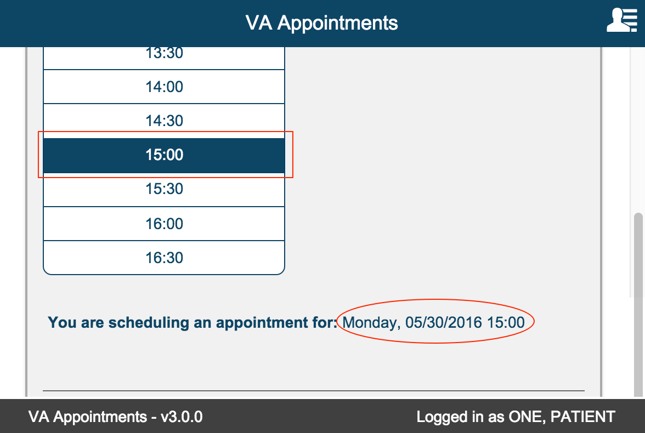

Email Preferences

Default value is set to No. User can change this value any time a new appointment or request is initiated. Email Preference is a global preference that is persisted for the patient.
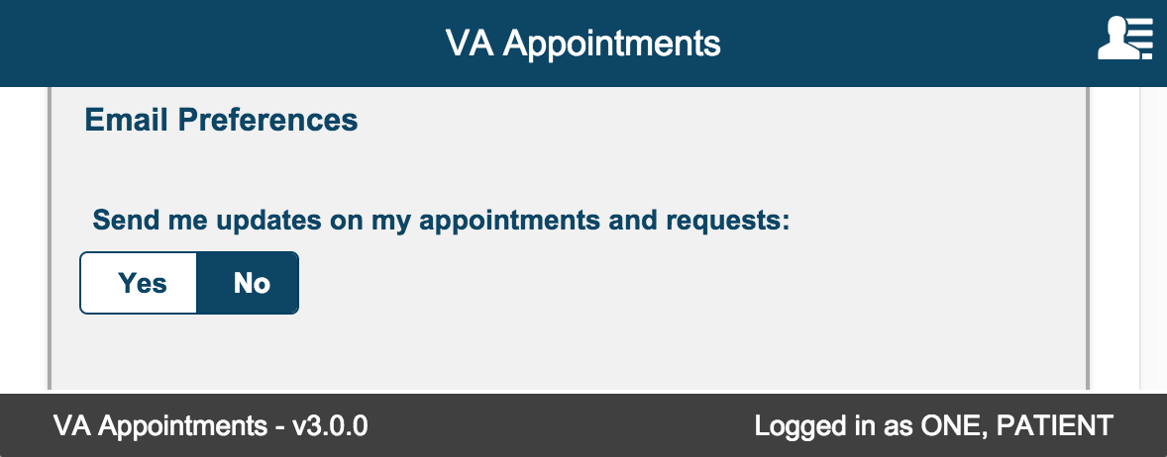

Select 'Yes' toggle button. This displays the Email field. This is a required field. The email address can be 100 characters long.

A valid email address must be entered to be saved successfully.
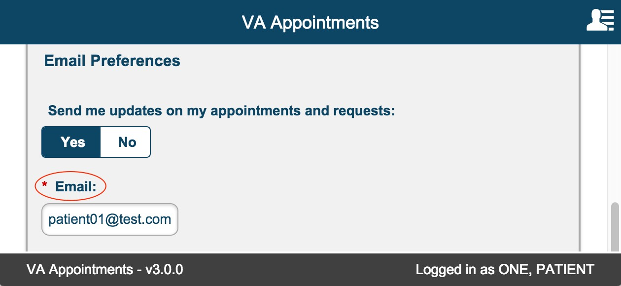

Schedule Appointment / Cancel Appointment

Schedule Appointment button
Clicking on ‘Schedule Appointment’ button validates the form for any errors. If no errors, the appointment is scheduled and the following Appointment Scheduled page is displayed.
User can navigate back to the Appointments/Requests page by selecting ‘Appointments/Requests button.
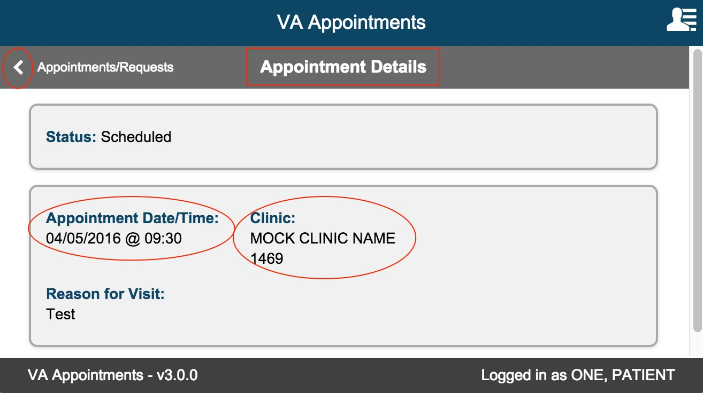

Cancel Appointment
On the Appointments/Request landing page select the appointment to be cancelled from the Appointments list table.
Appointment Details page is displayed. Select the Radio button ‘Yes’ under ‘I need to cancel this appointment’. Reason for Cancellation drop down list box is displayed. This is a required field and is denoted by ‘*’. The list of reasons is specific to the facility.
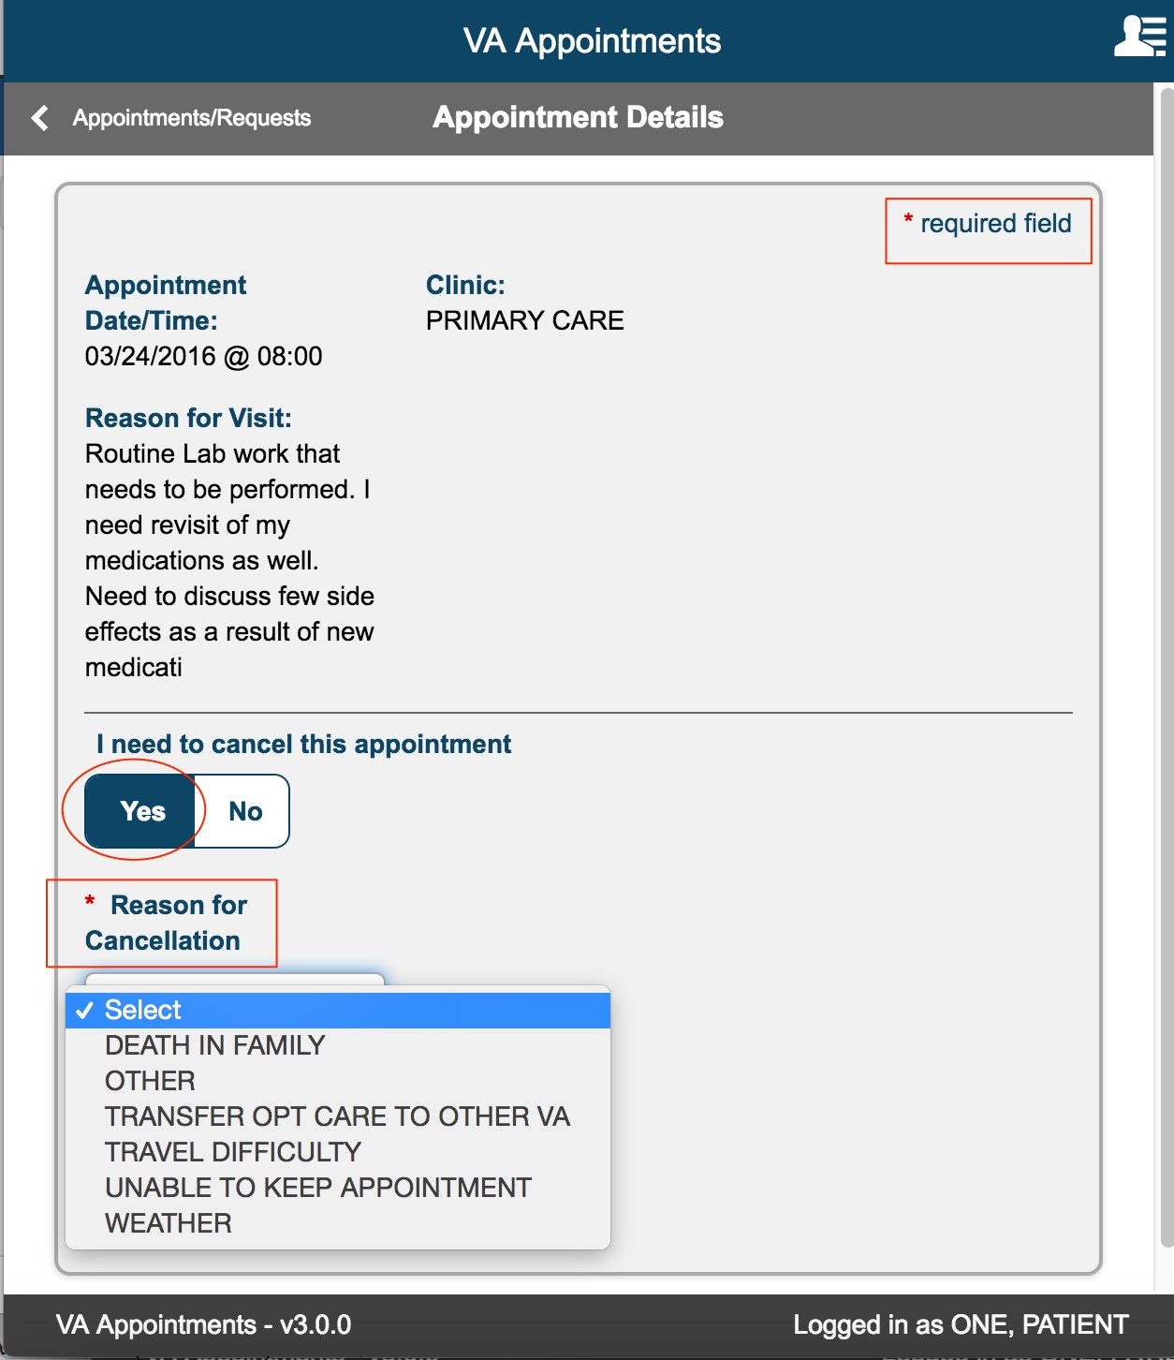

Select a Reason for Cancellation from the drop down and select ‘Cancel Appointment button’
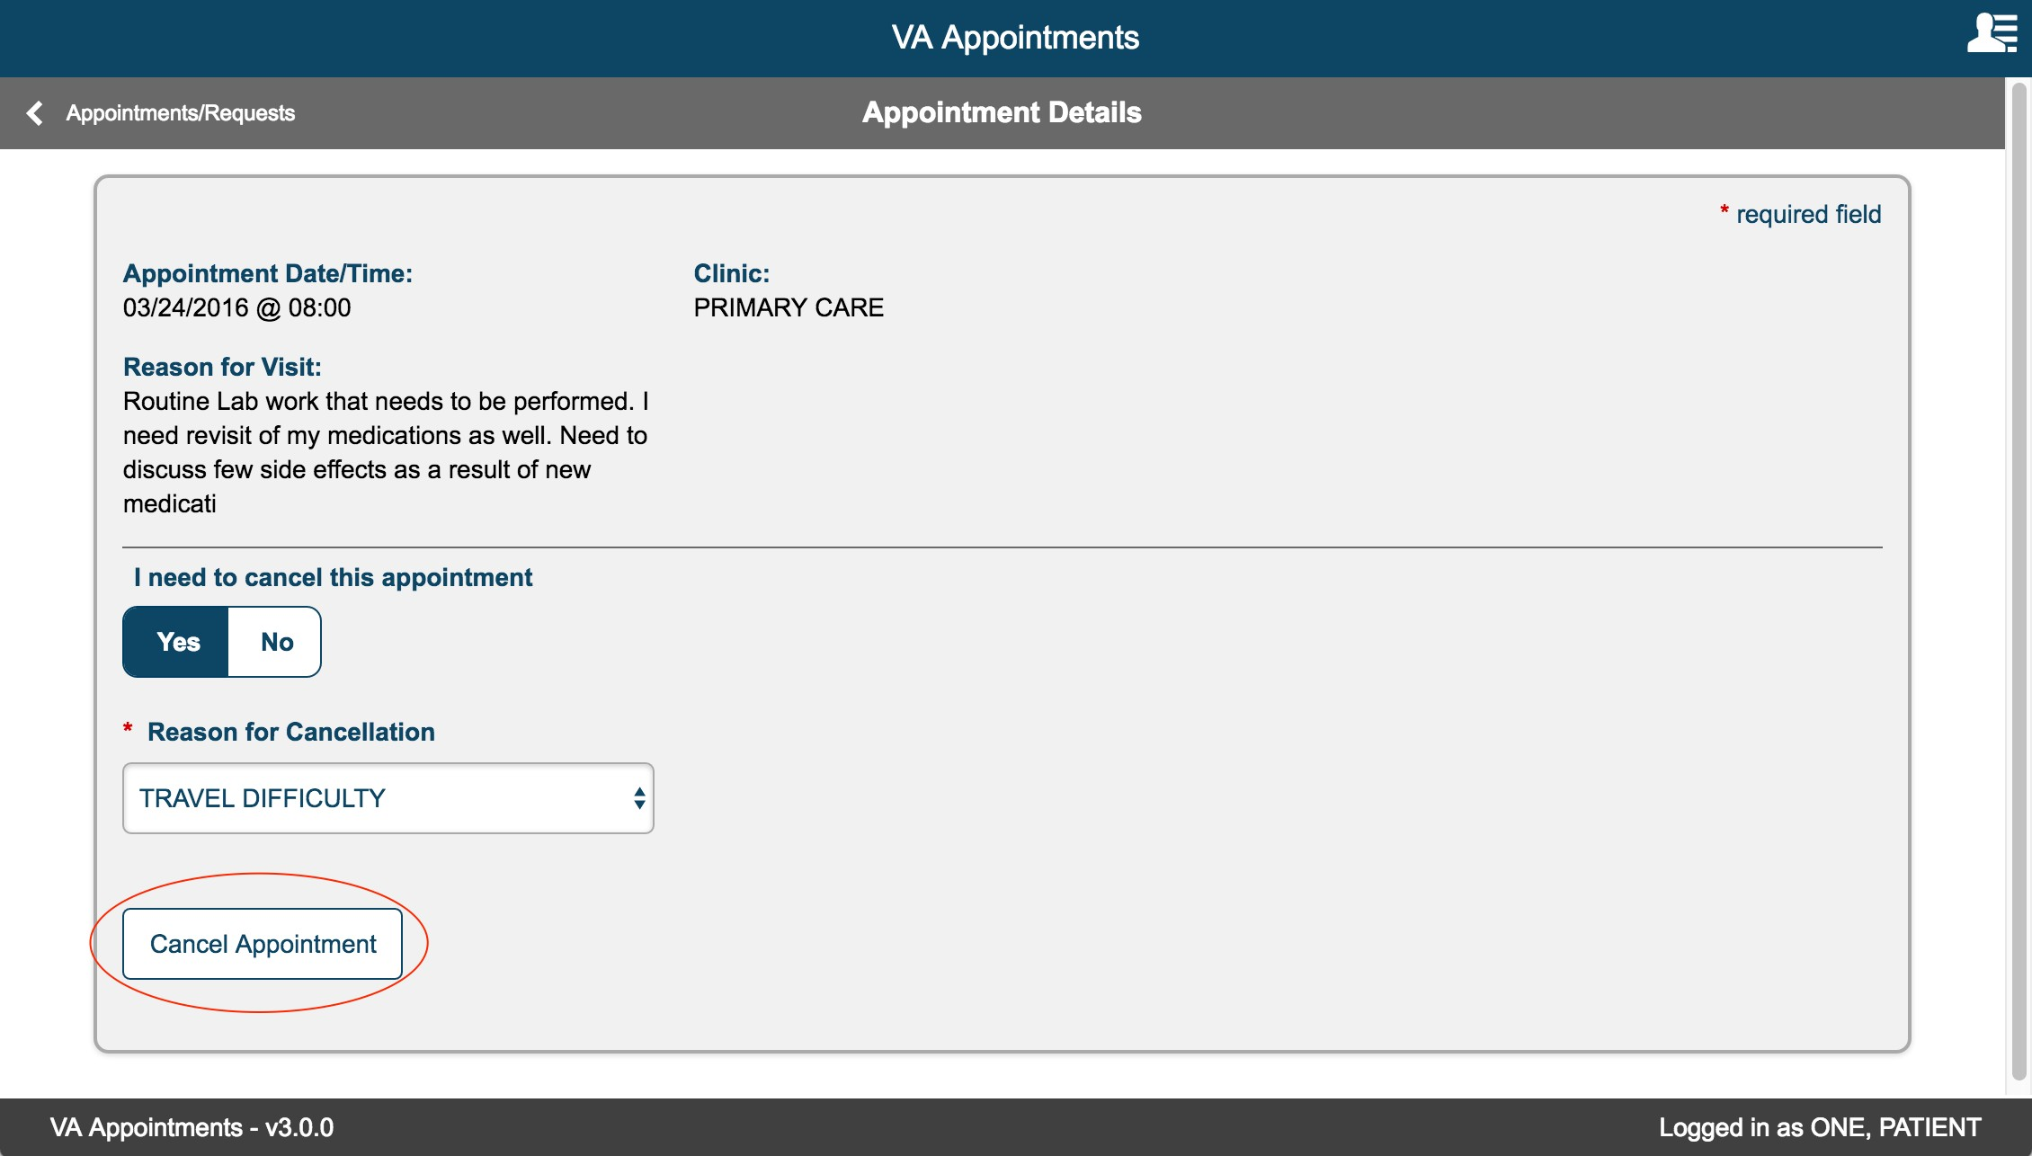
Confirmation modal is displayed. Selecting ‘No’ closes the modal and returns user to the Appointment Details page.
Selecting ‘Yes’, closes the modal and displays the Appointment Cancelled Page.
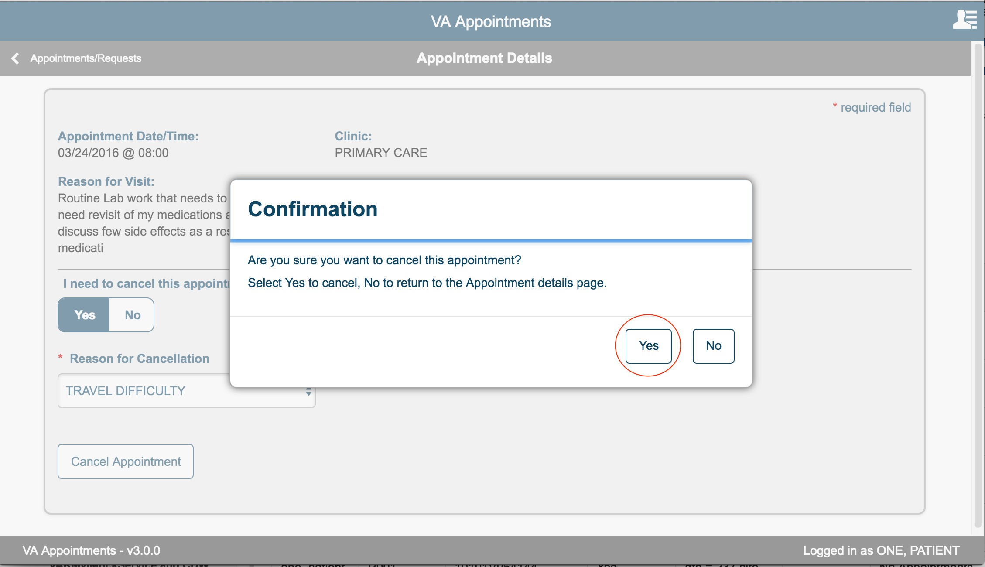

The Appointment Cancelled page displayed a confirmation message that the appointment is cancelled. User can select the ‘< Appointments/Requests’ back button to go to the landing page.
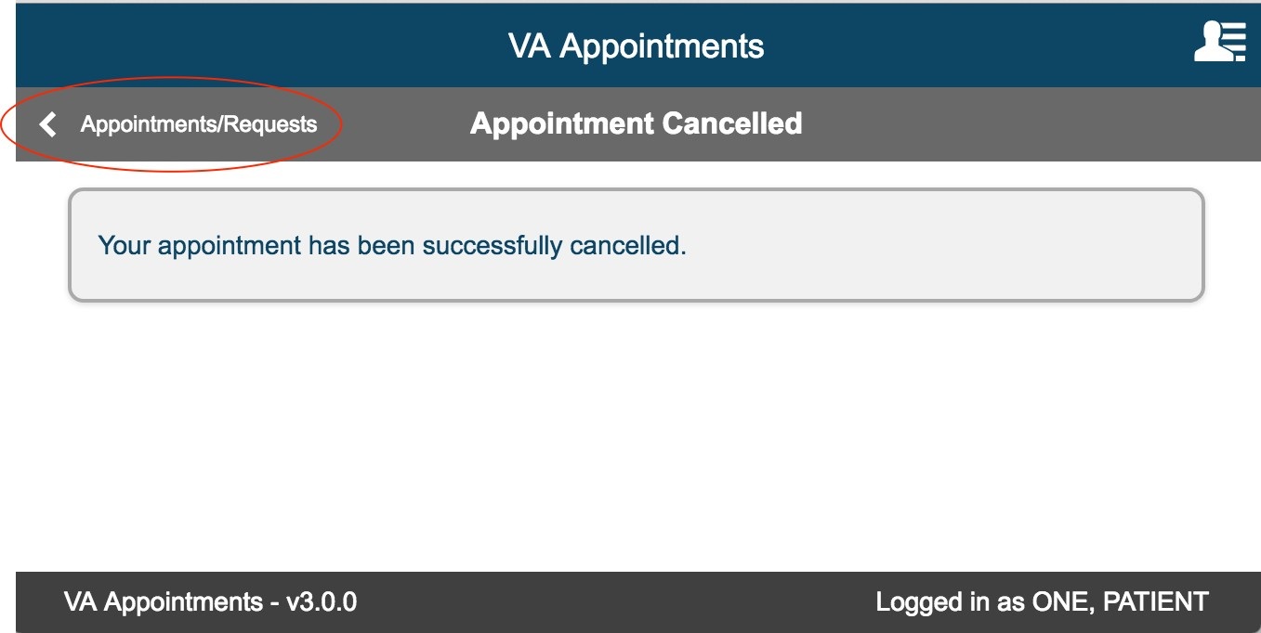

Request help Scheduling Primary Care appointment/ Scheduling a Mental Health appointment
On New Appointment/Request page select the radio button 'Request help scheduling a Primary Care appointment'.
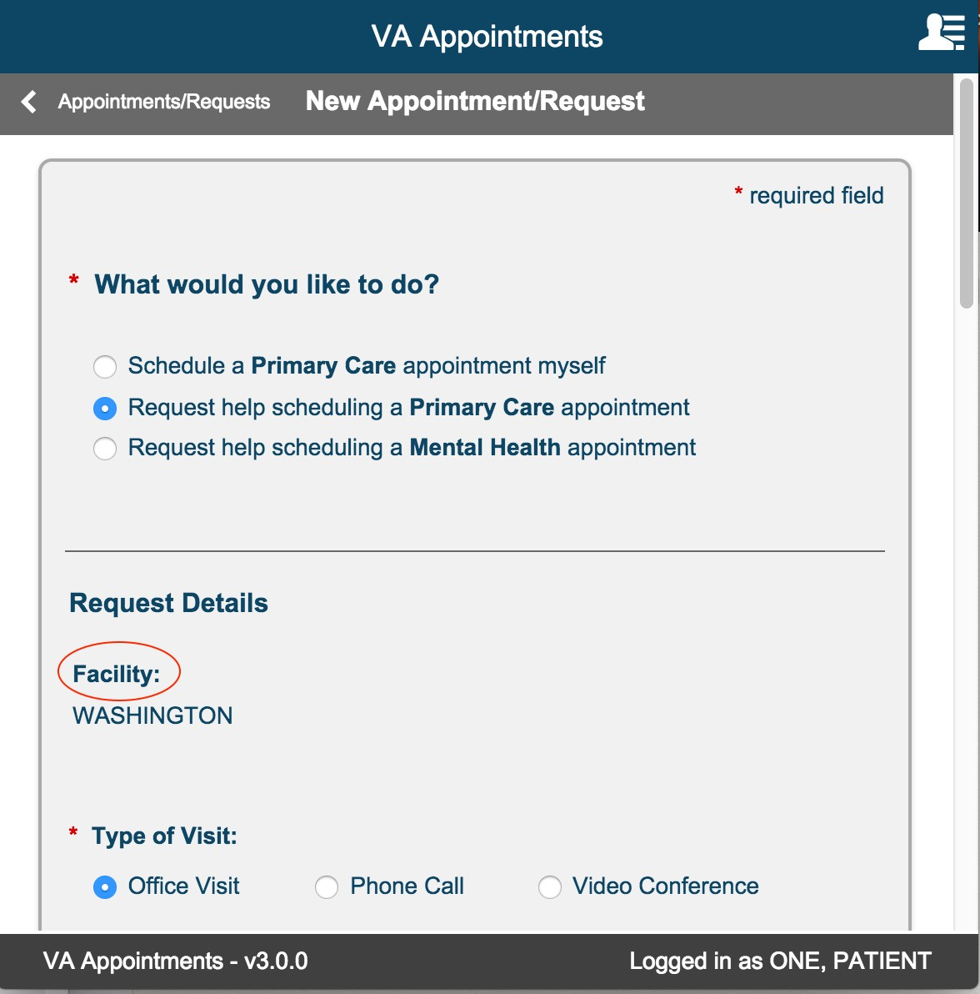

Once a radio button is selected the 'Request Details' section is displayed.

Facility:

If the user is registered only in one facility, the Facility section displays the facility by default.

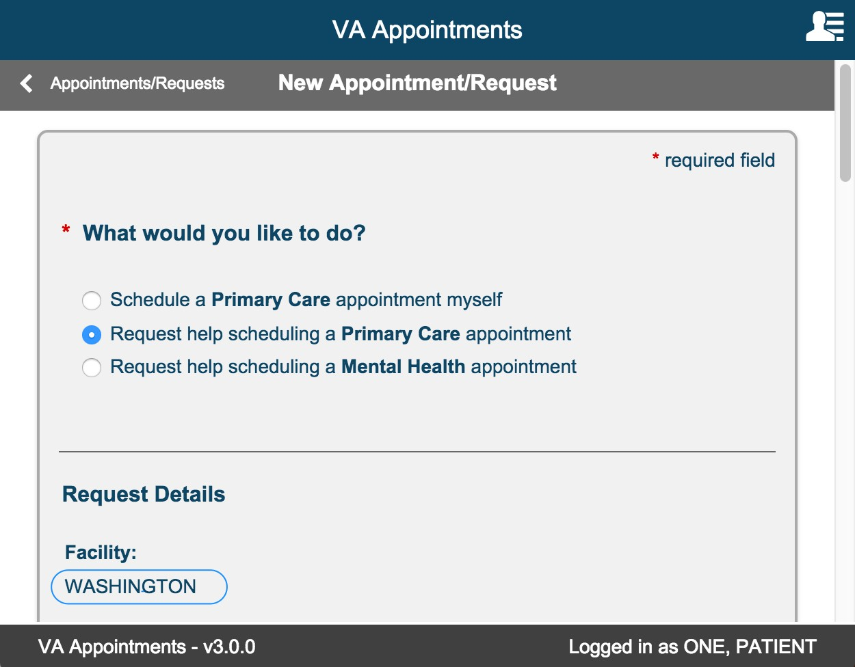

If the user is registered in more than one facility, the list of all registered facilities are displayed. Select one facility by selecting the radio button.
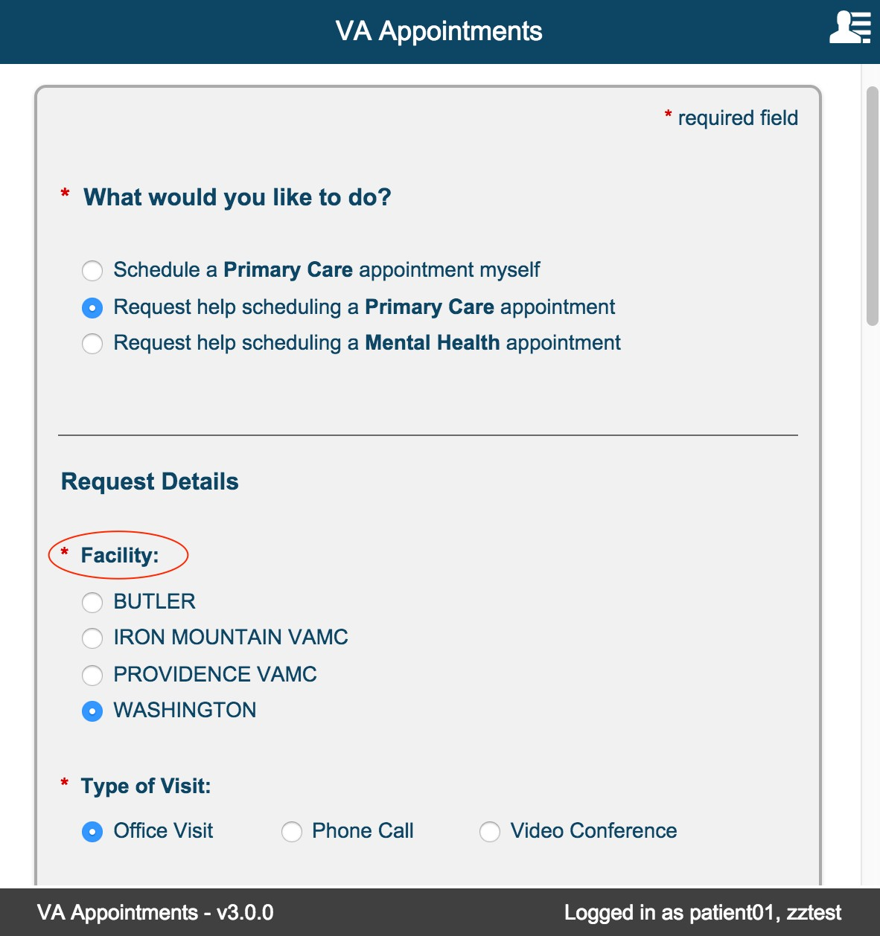

Type of Visit:

This is a required field. The default value selected is 'Office Visit'. The user can change the selection based on their requirement.

NOTE: Video Conference option is currently not available.

If the 'Video Conference' radio button is selected, the following informational message is displayed.
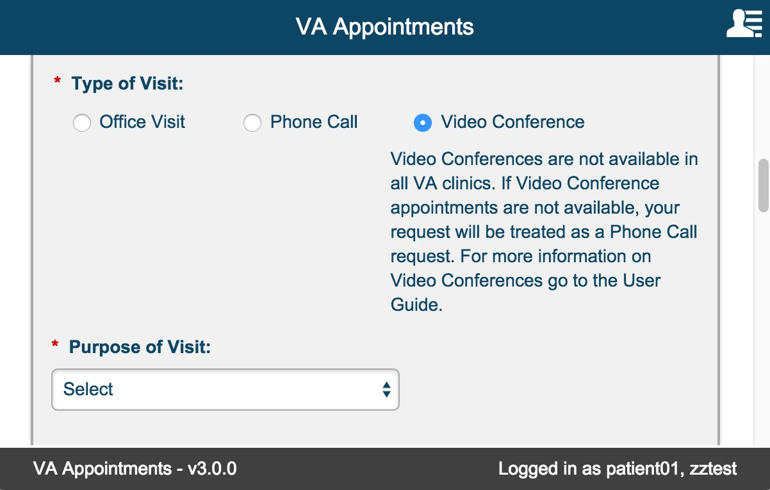

Purpose of Visit:

This is a required field. The default value is 'Select'. User must select a different value from the drop down list.

The screen shot below shows the different options available in the drop down.
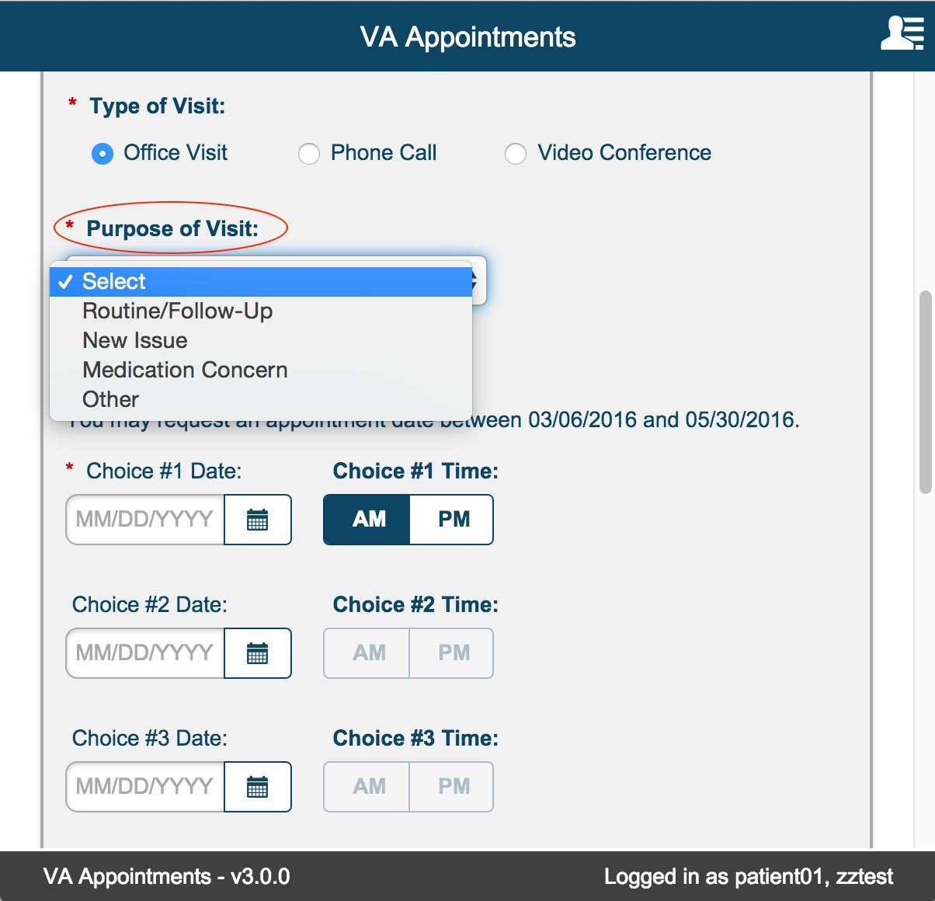

Other Purpose:

This is a required field. This field is displayed only if the user selects Purpose of Visit = 'Other' User can enter Alphanumeric text of 50 characters long.
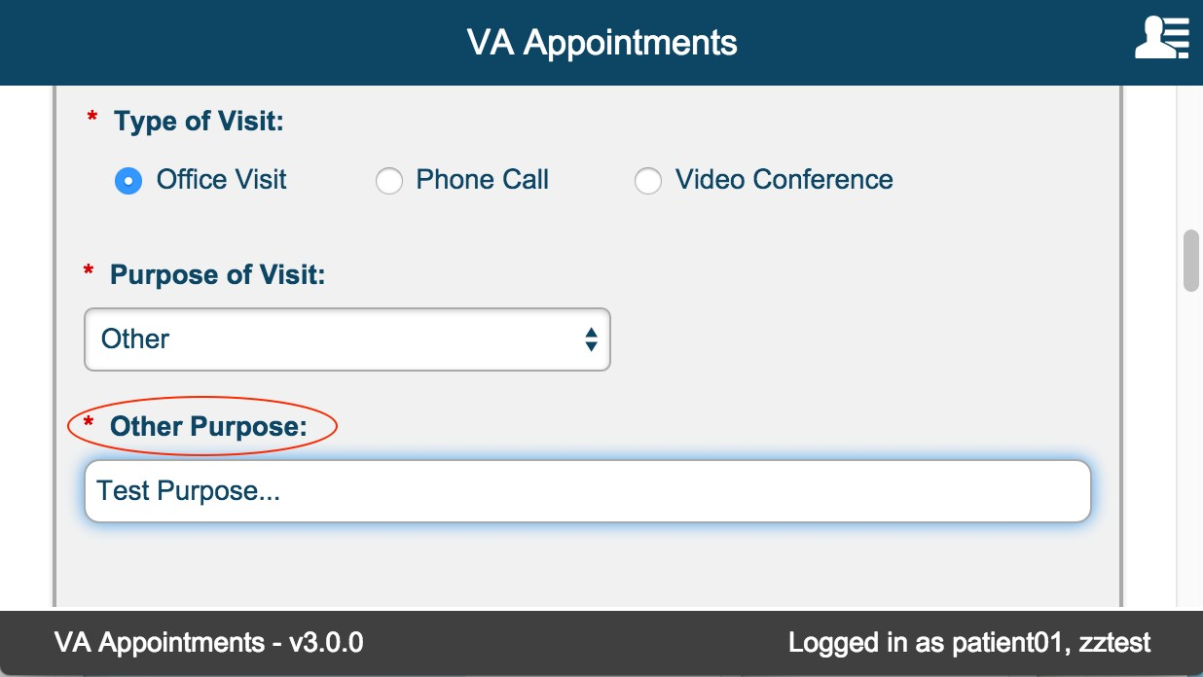

Desired Appointment Dates/Times

This is a required field. User must select 'Choice #1 Date'.

Date can either be typed in or can be selected by selecting the calendar icon. User can only select a value between today +5 and today +90.

Choice #1 Time is defaulted to AM. User can always change this default value. But a value must be selected.
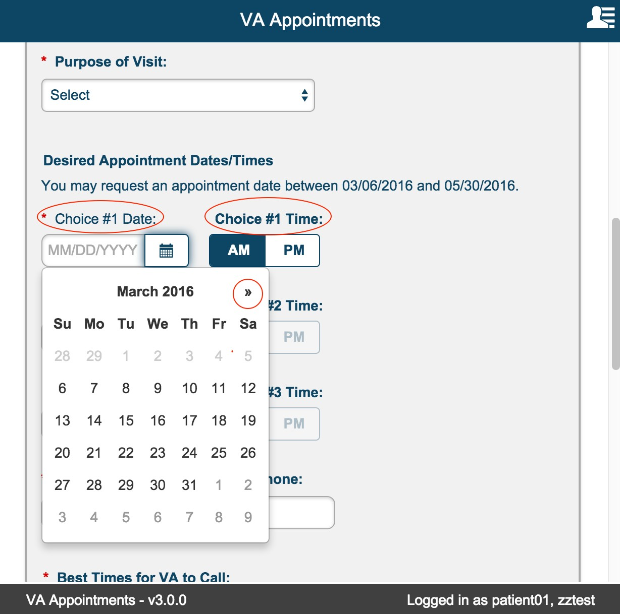

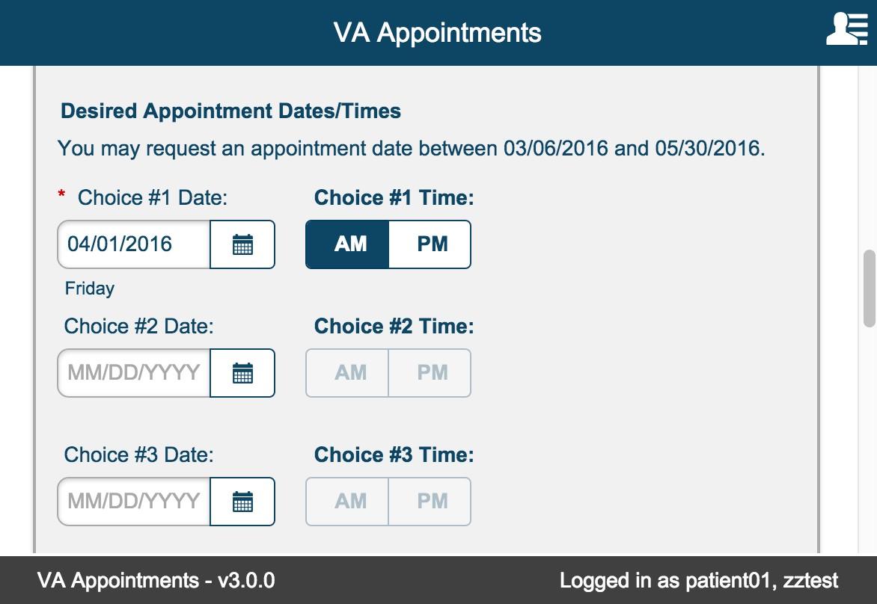
Validations occur for invalid or out of range date selections.
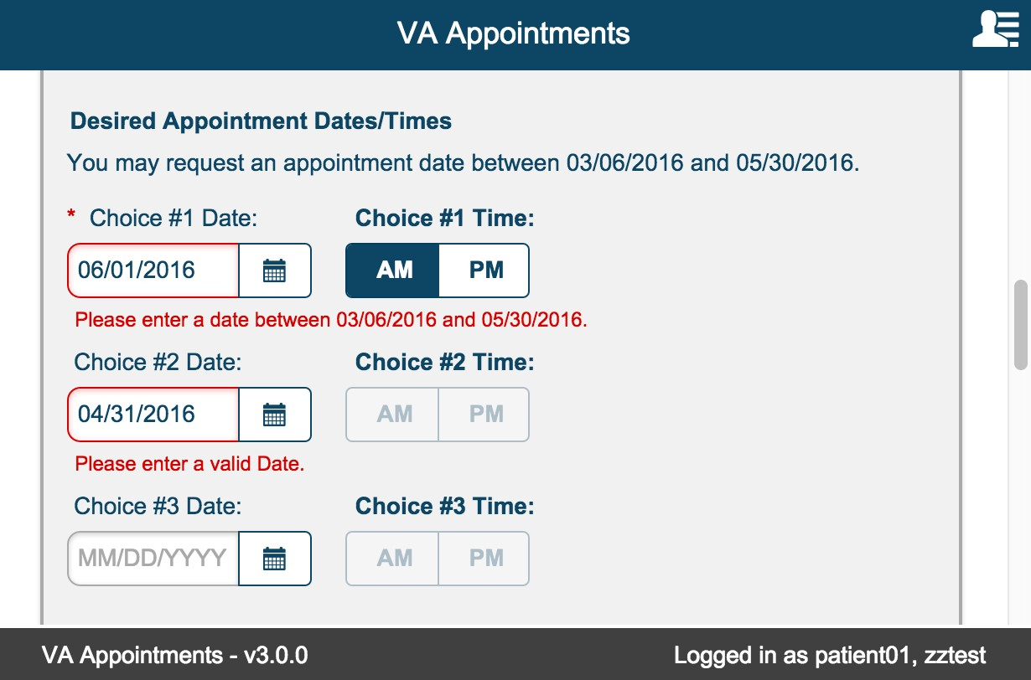
User must select valid dates and time for Choice #1. Choice #2 and Choice #3 date and time fields are optional.

Phone/Verify Phone

This is a required field. The data entered is automatically formatted to display as (xxx) xxx-xxxx. Phone and Verify Phone must be the same.
If the numbers do not match, an error message is displayed to the user.
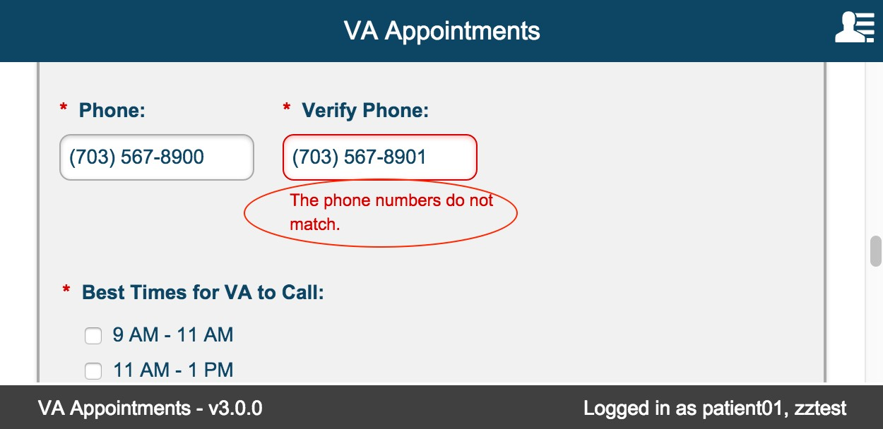

Phone number must be valid. The following error message is displayed for invalid entry.
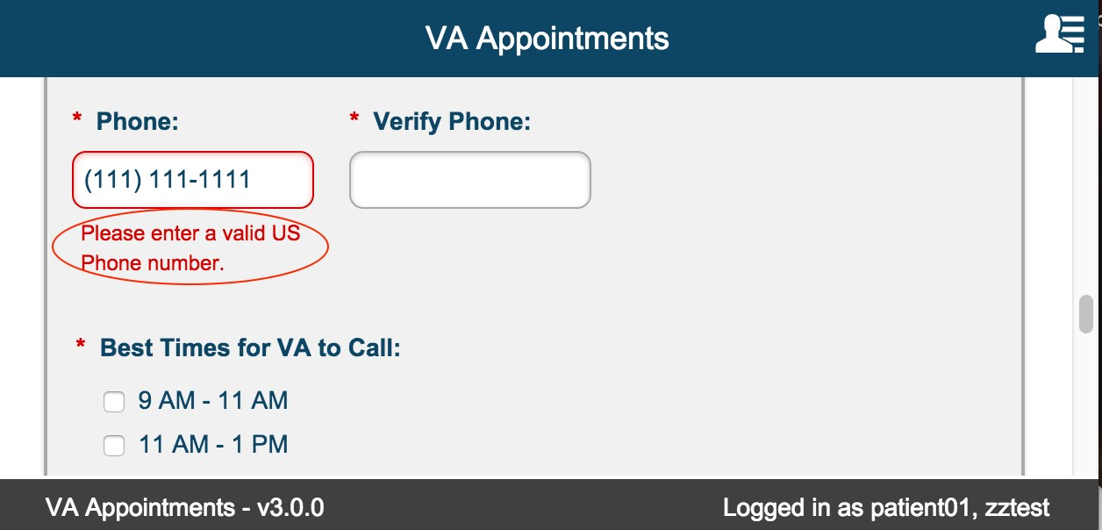

Best Times for VA to Call:

This is a required field.

User can select more than one option.
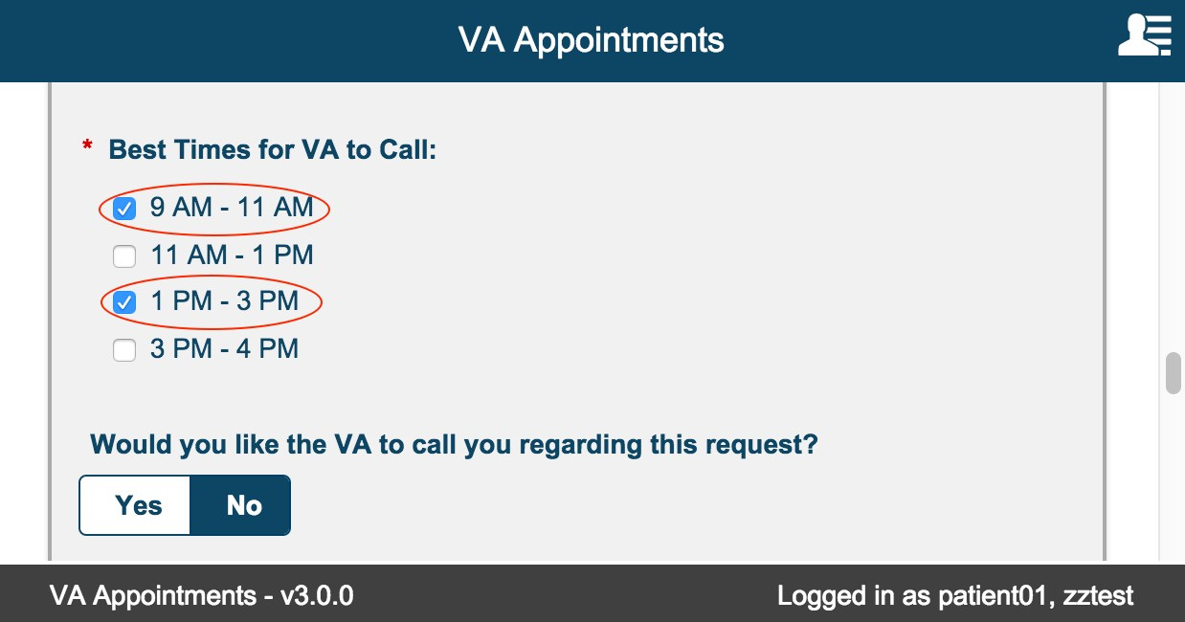

Would you like the VA to call you regarding this request?

Default value is No. User can leave it as is or toggle to 'Yes' if they would like the VA to call regarding the request.

The value set in this field applies to only this request.
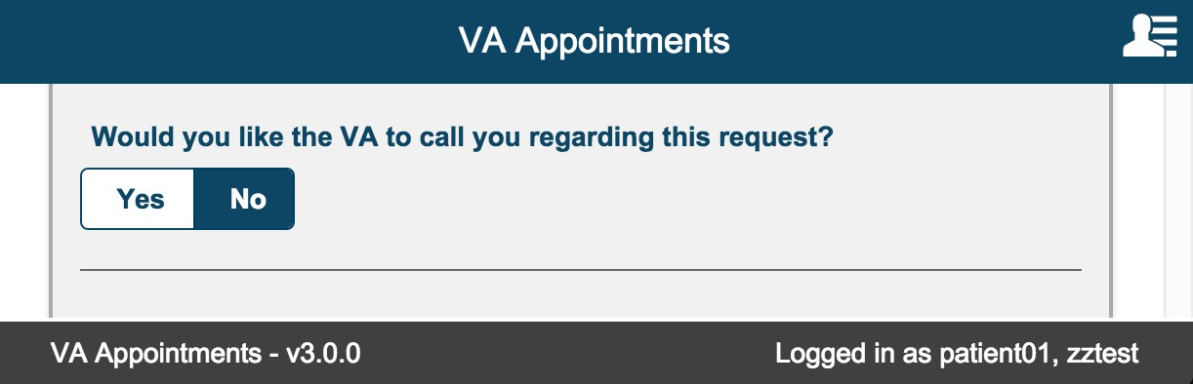

Email Preferences

Default value is set to No. User can change this value any time a new appointment or request is initiated. Email Preference is a global preference that is persisted for the patient.
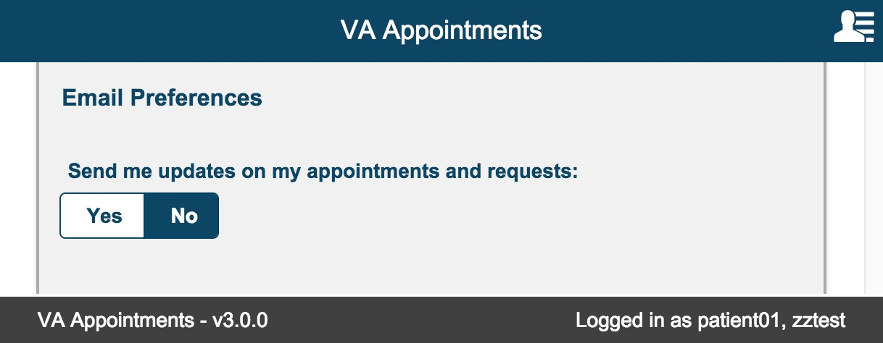

Select 'Yes' toggle button. This displays the Email field. This is a required field. The email address can be 100 characters long.

A valid email address must be entered to be saved successfully.

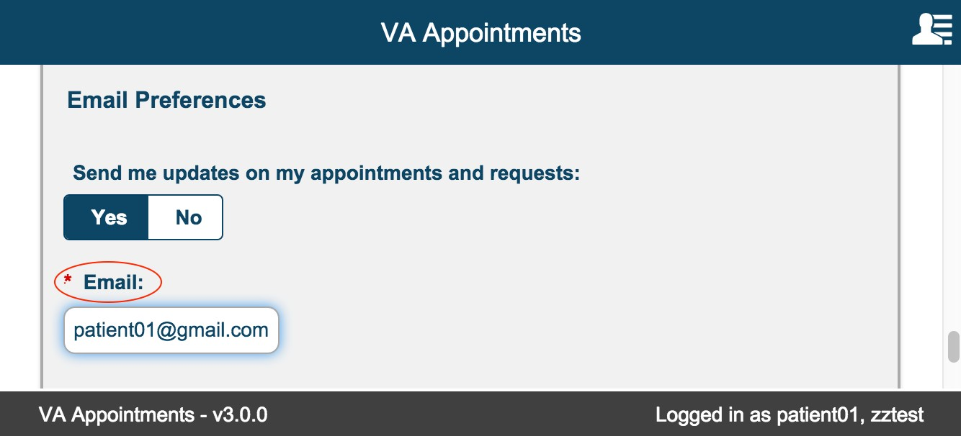

Submit Request/Cancel Buttons

Cancel button
Selecting Cancel displays the confirmation modal. Selecting ‘No’ closes the modal and returns user to the New Appointment/Request form.
Selecting ‘Yes’ in the confirmation modal, closes the modal and returns user to Appointments/Requests landing page. The New Appointment/Request form is not saved.
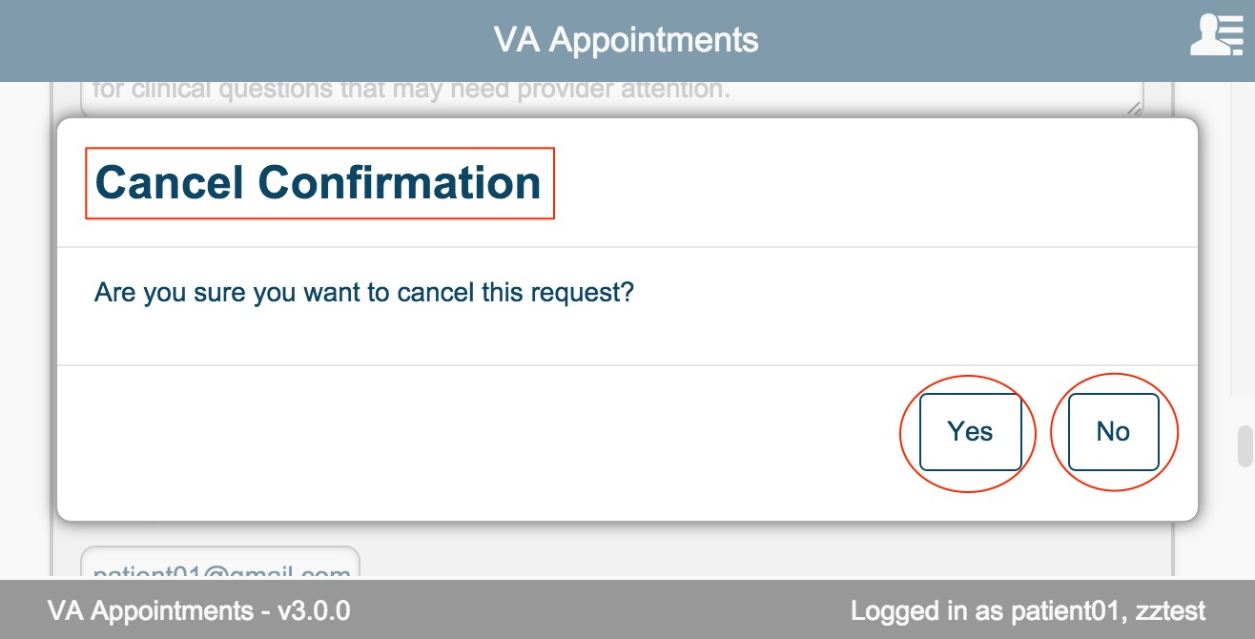

Submit Request Button
Select 'Submit Request' on the form.

If the request form passes validation (no errors are triggered), the system displays the Request Details page for the submitted request.
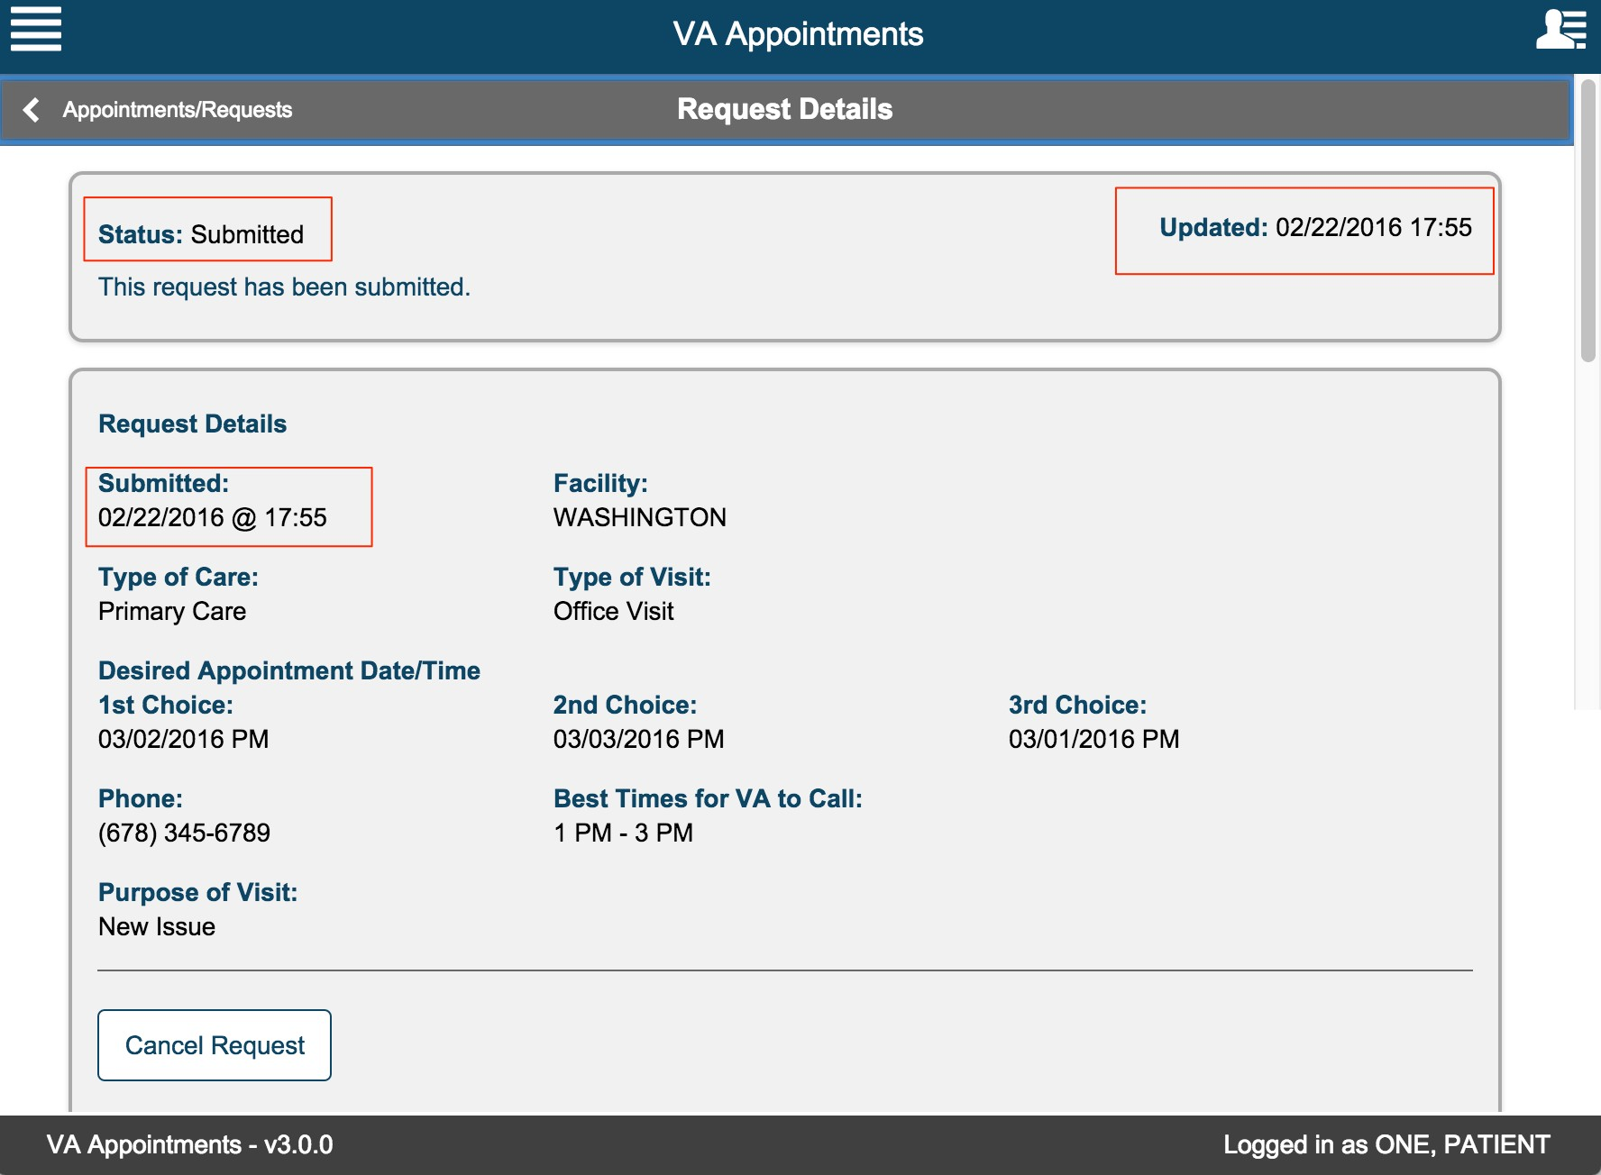

View Appointments/Requests
Login to the app as a user that is already enrolled in Veteran Health Administration and already has appointments scheduled and requests created. The appointments/requests page is displayed.

Refresh to view Appointments/Requests

Select the refresh button on the header for the page to refresh and display any updates to the Appointments and Requests.
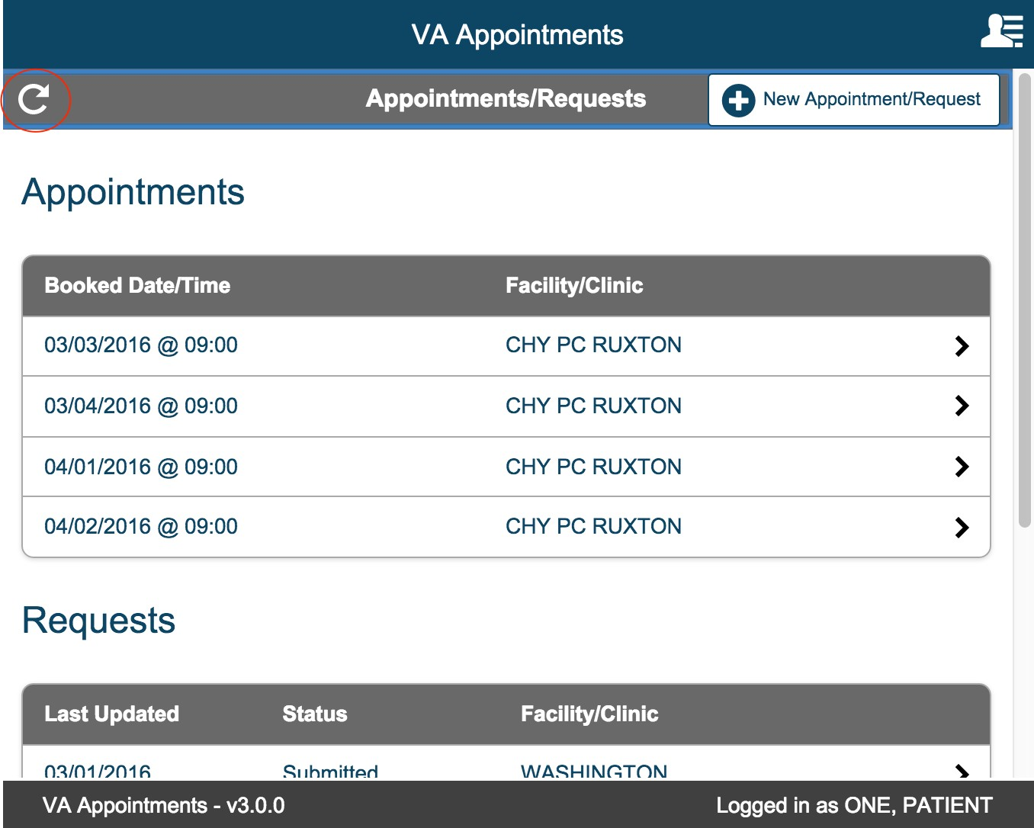

View Appointment/Request Details

Appointment Details

From the Appointments table select an appointment to view details.
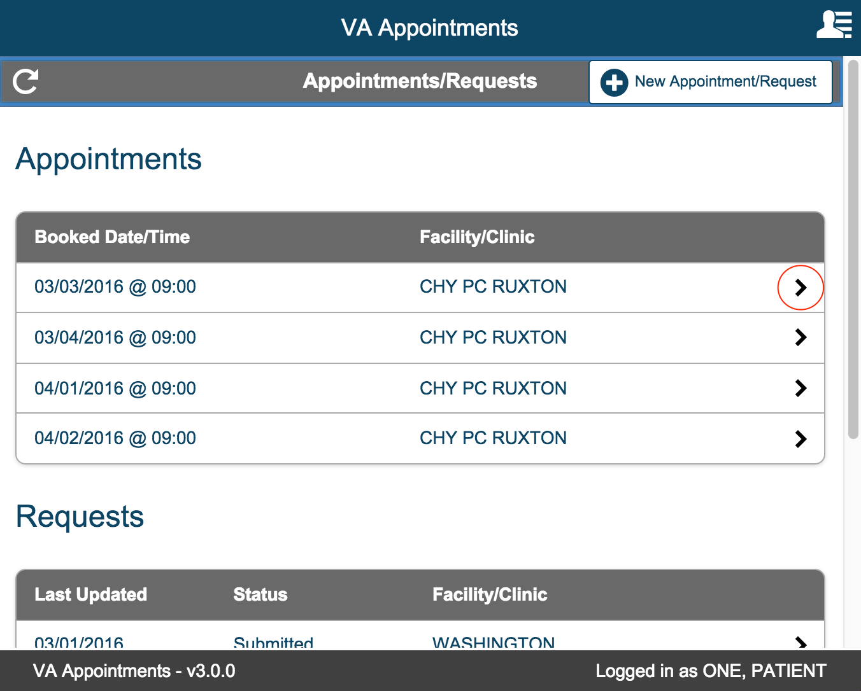

Appointment Details Page is displayed.
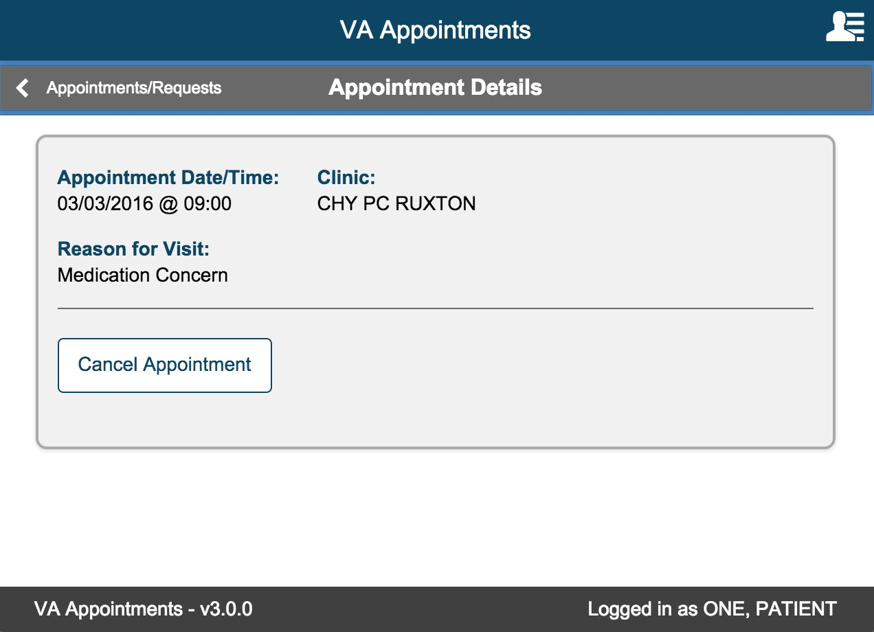

Select the Appointments/Requests button to return to the page to view the Appointments and Requests.

Request Details

Now from Request Table select a Request to view details
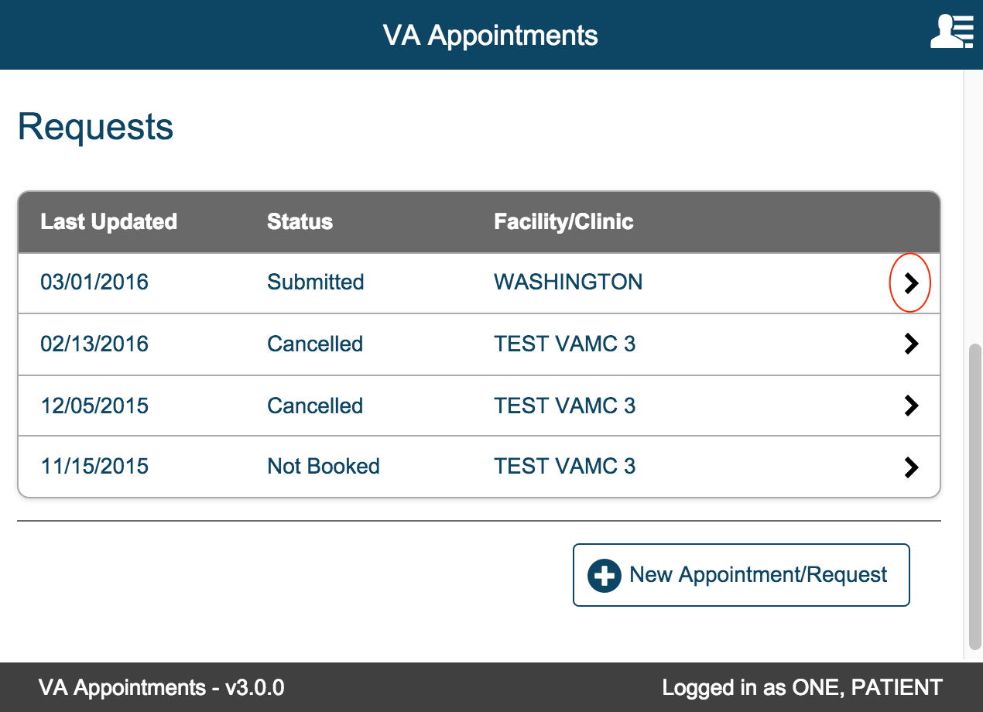

Request Details page is displayed
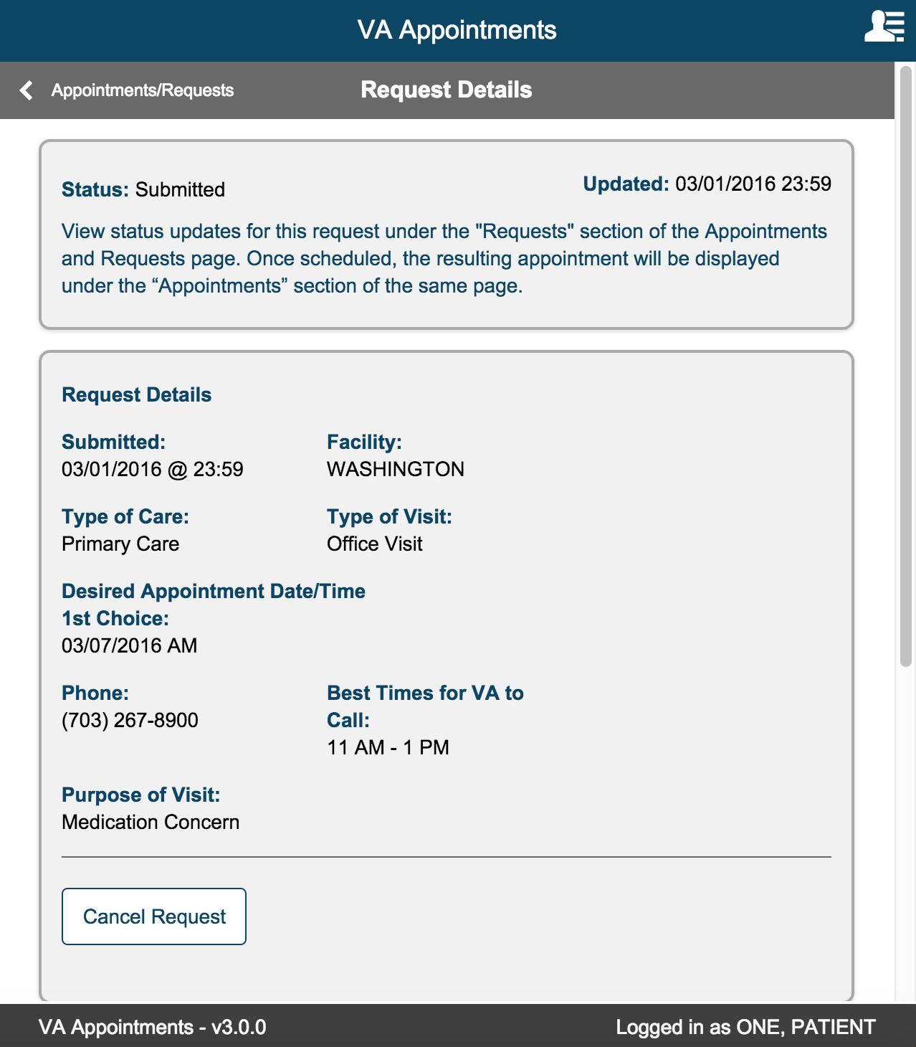
Select the Appointments/Requests button to return to the page to view the Appointments and Requests.

Cancelling Appointment/Request
Cancel Appointment

From the Appointments/Requests page, select the appointment that you want to cancel from the Appointments table.

On the Appointment Details page select the Cancel Appointment button.
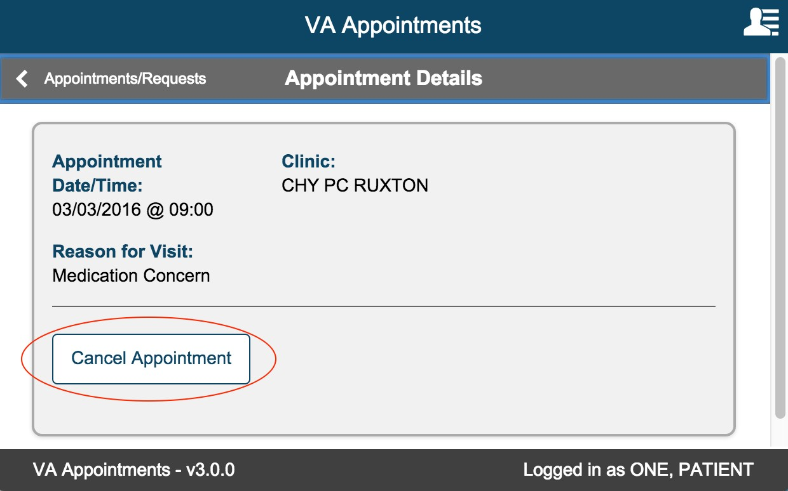

Confirmation modal is displayed.

Select No button to return back to appointment details page. Select Yes to confirm canceling the appointment.
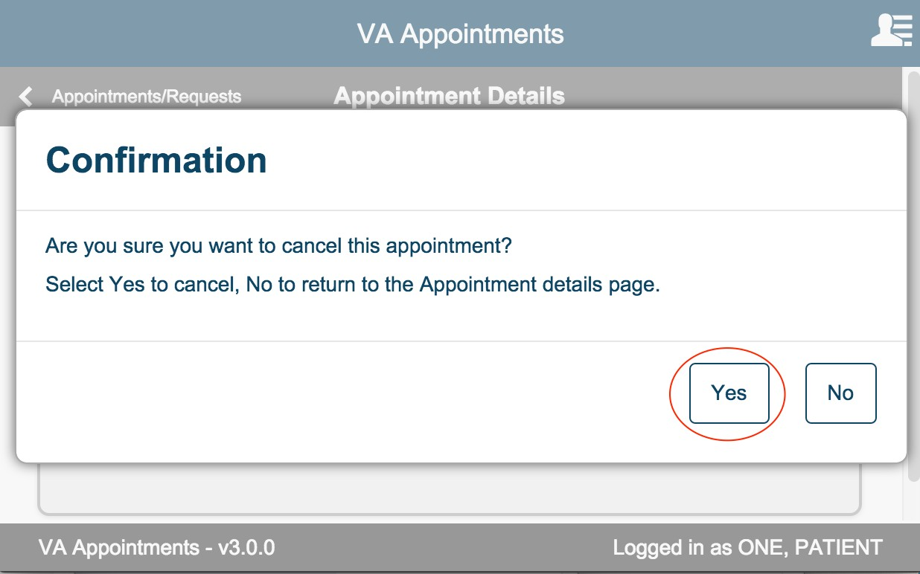

On selecting yes, the appointment status is updated and the Appointment Cancelled page is displayed.
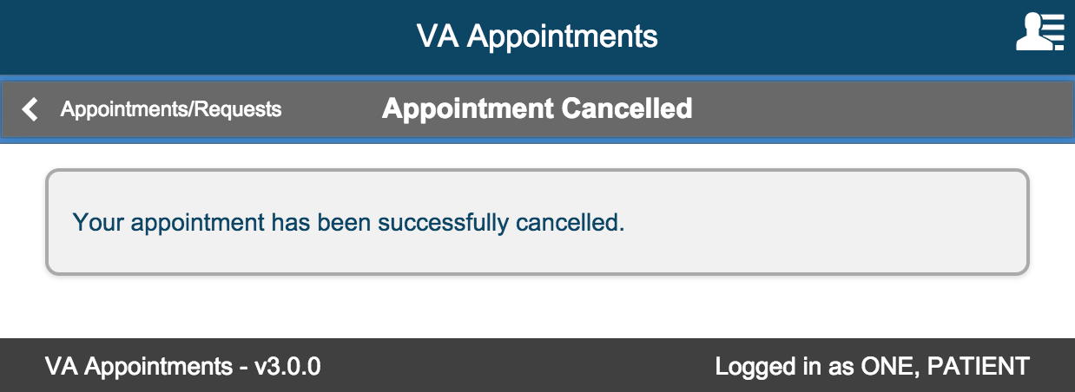

Select the Appointments/Requests button to return to the page to view the Appointments and Requests.

Cancel Request

Select the request that you want to cancel. On the Request Details Page select the Cancel Request button

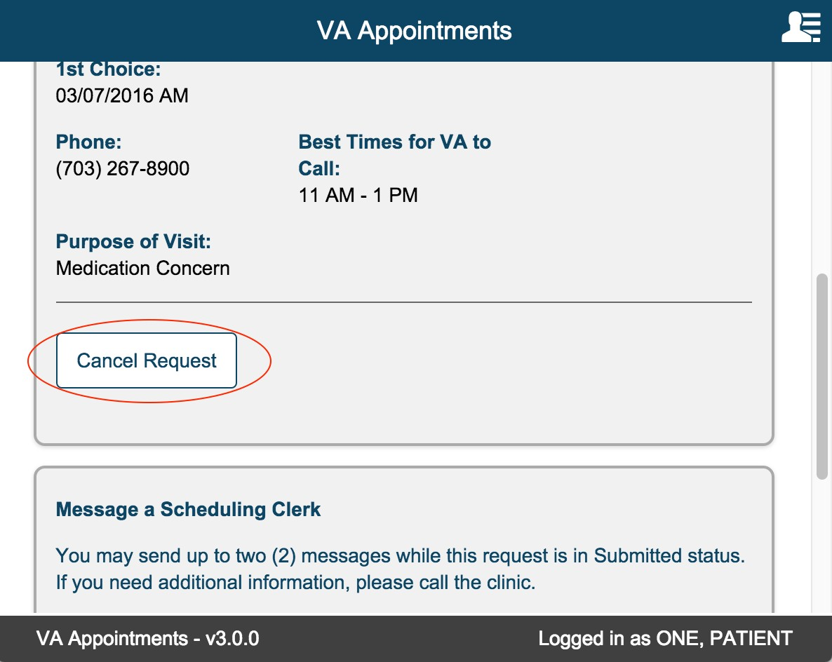

Confirmation modal is displayed.

Select No button to return back to request details page. Select Yes to confirm canceling the request.
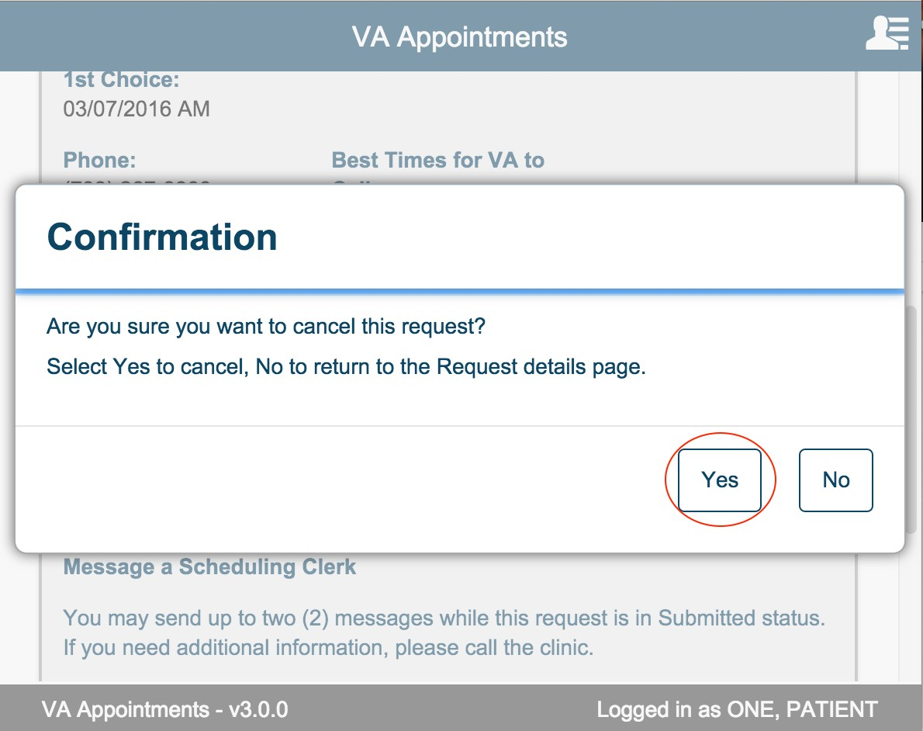

On selecting yes button, the request is cancelled and the status for the request is updated.
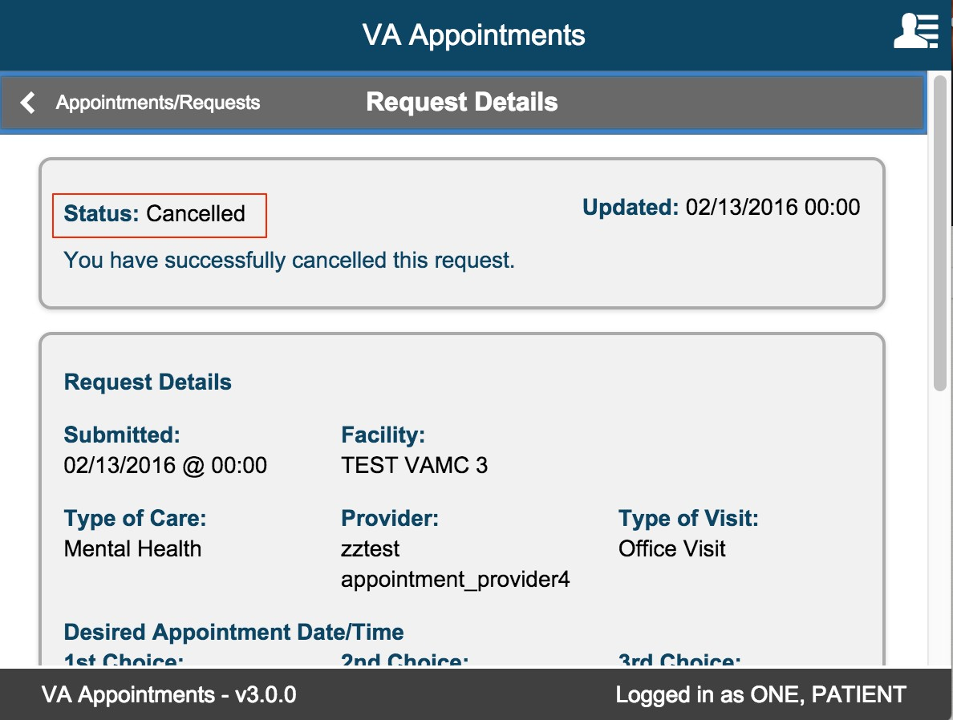
Select the Appointments/Requests button to return to the page to view the Appointments and Requests.

Message a Scheduling Clerk
This is an optional text field that allows user to communicate with the clerk. This feature is available only on New Request and Submitted requests. The user can send only up to two messages. User can view messages exchanged on the request details page.
This messaging should not be used for cancelling an appointment or for clinical questions that requires provider attention. The message text box is multiline that allows a max of 100 characters. The character count down will indicate the remaining number of characters.
User can send messages when creating new request or on request details page of a Submitted Request.
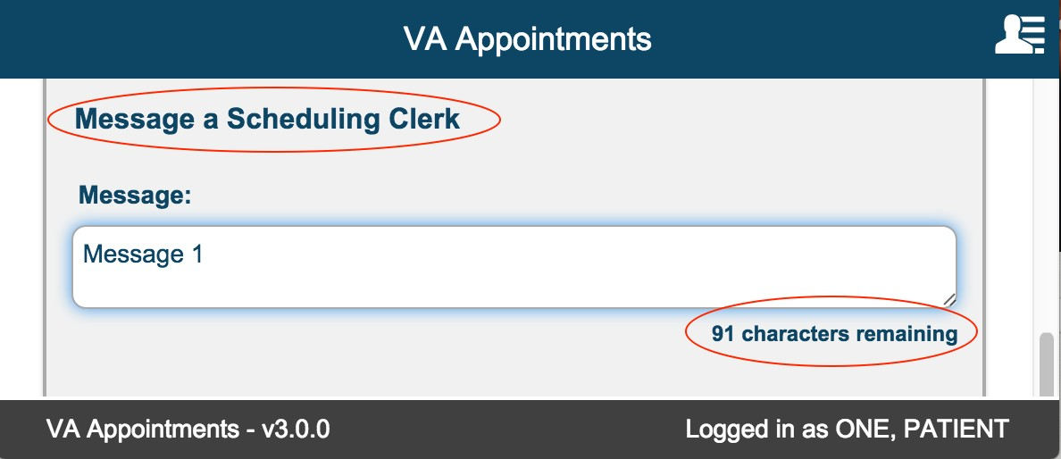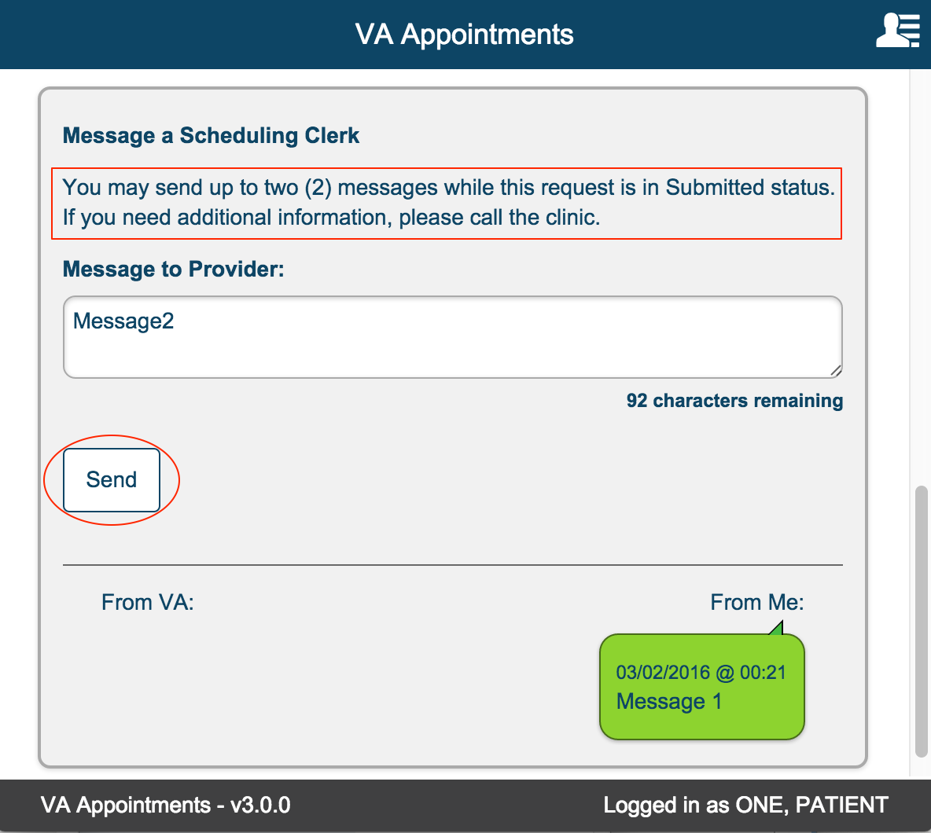

Messaging Rules

Maximum 2 messages can be sent
A user can send only maximum of 2 messages per request.
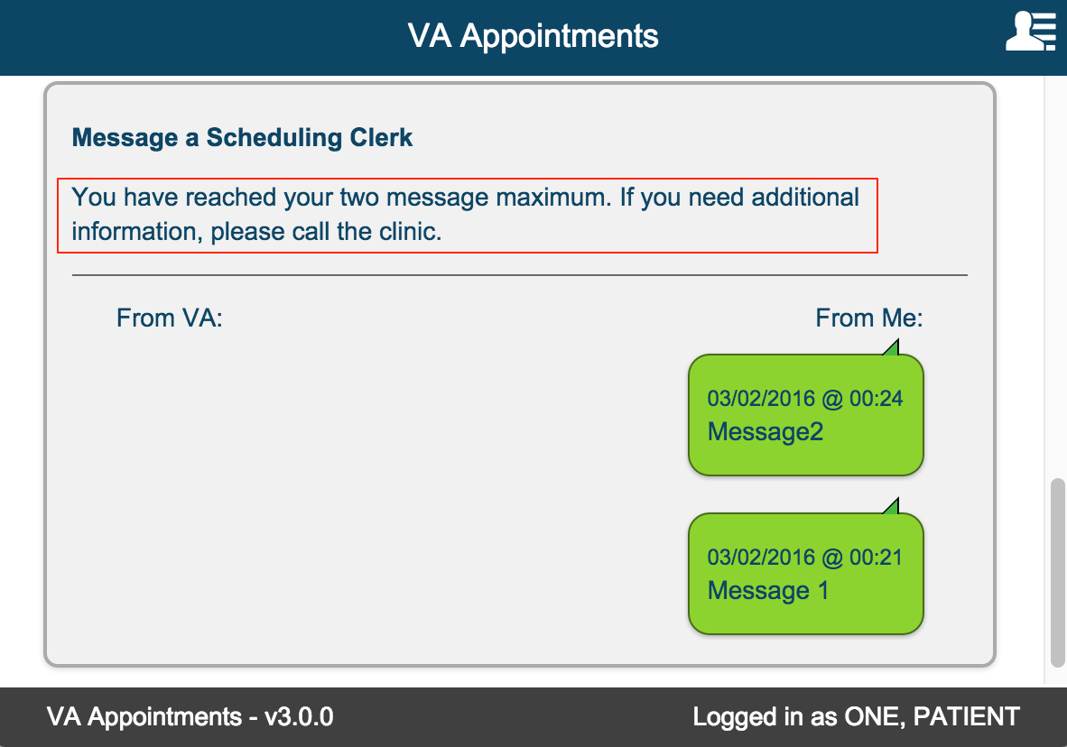

Cancelled request cannot send messages

Messages cannot be sent on a Cancelled request.
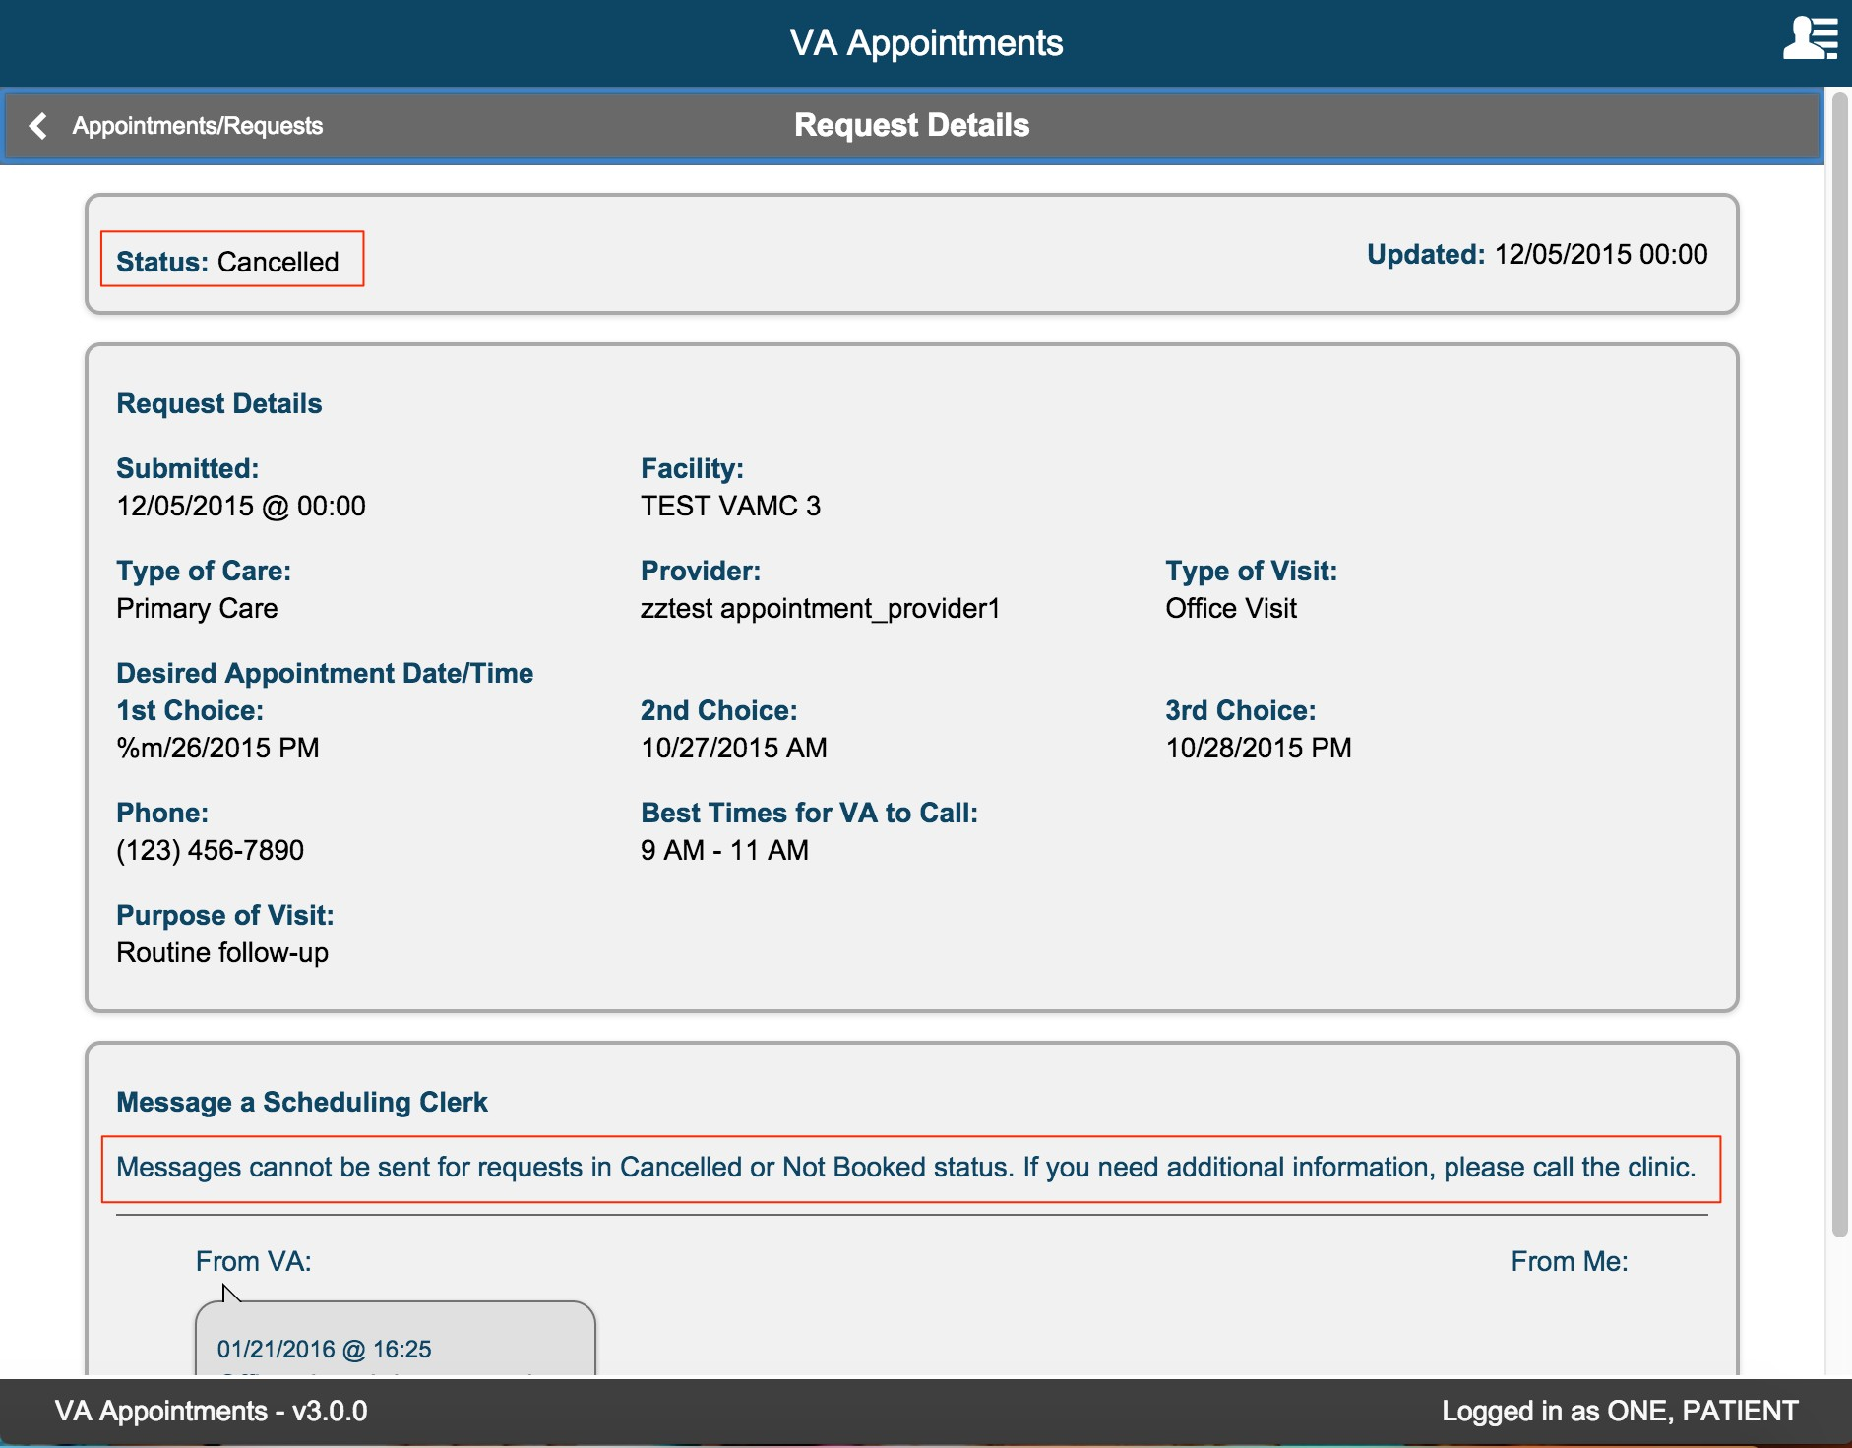

Not Booked request cannot send messages

Messages cannot be sent on a Not Booked request.
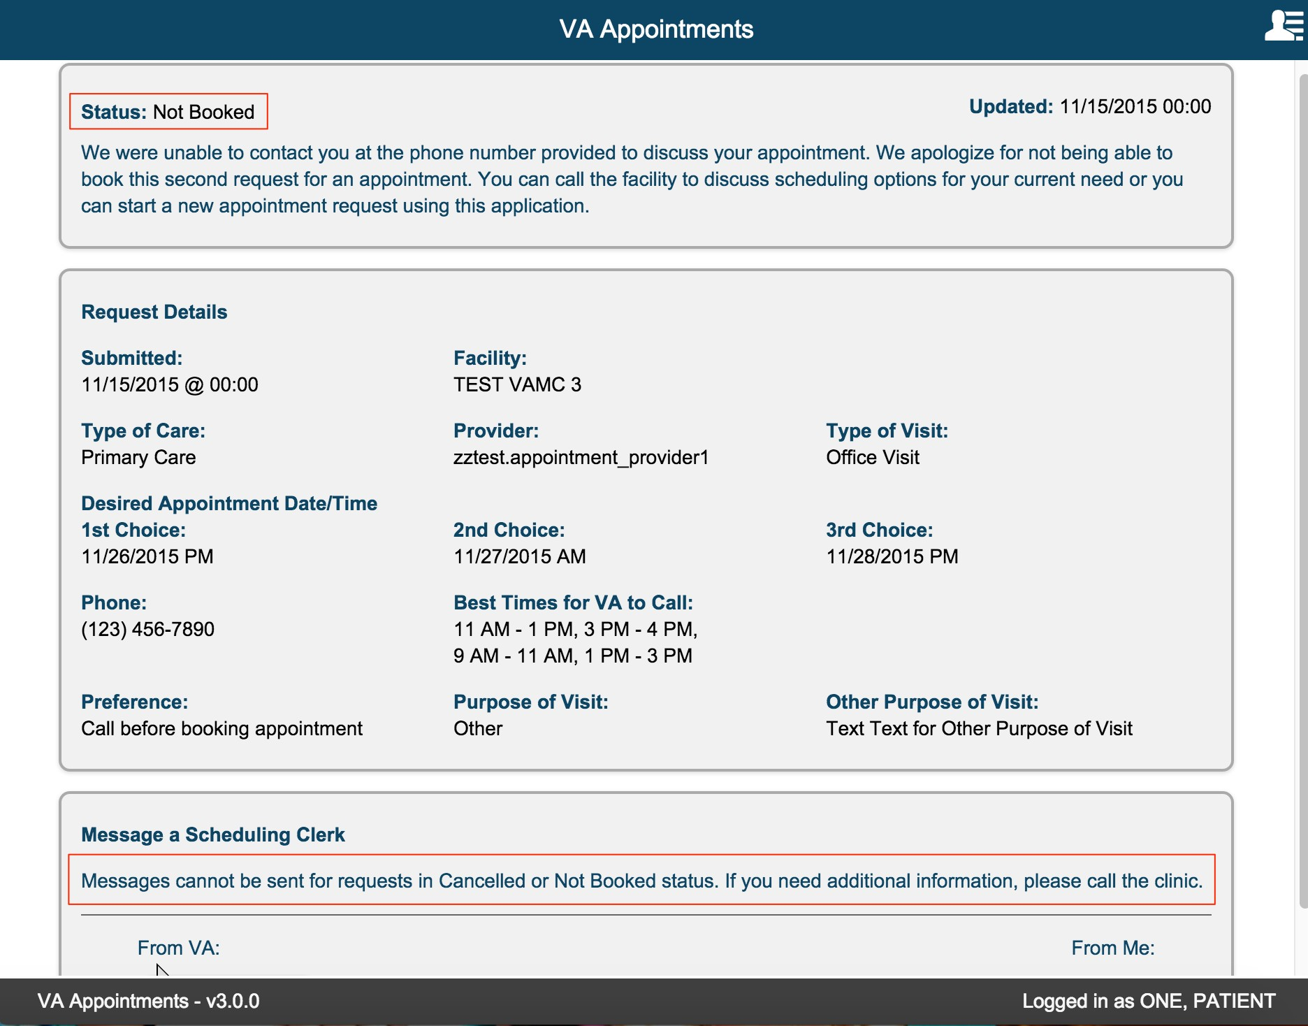

No Messages Exchanged

If no historical messages are found and the request is in Not Booked or Cancelled status, informational text ‘No messages were exchanged on this request.’
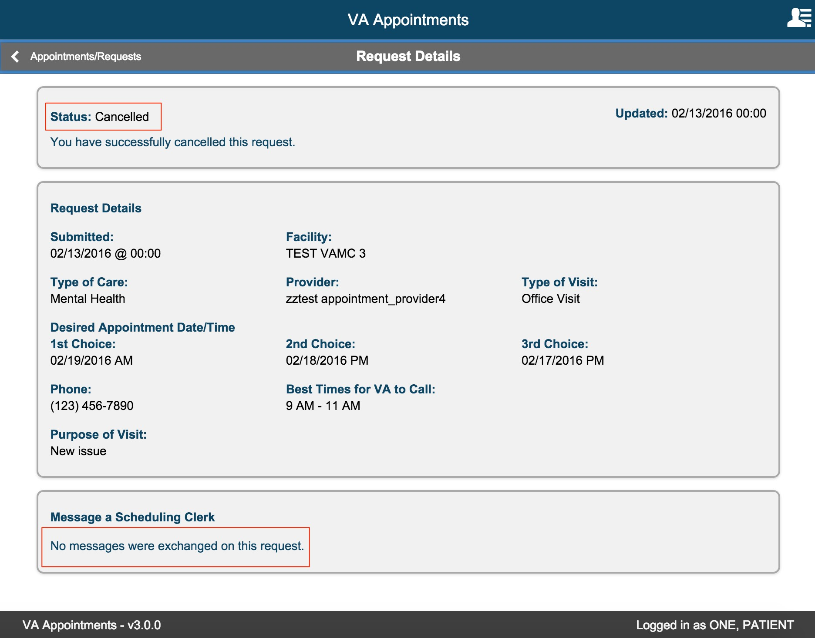

Error Messages
Error messages are displayed in the app due to environment issues. Changes may not be saved when a system error is encountered.

User might have to perform the action again after the error is resolved. Below are some of the errors the user may encounter when accessing the app.

Internet Connection

If internet connection is disrupted when accessing the application, the following error message is displayed to the user
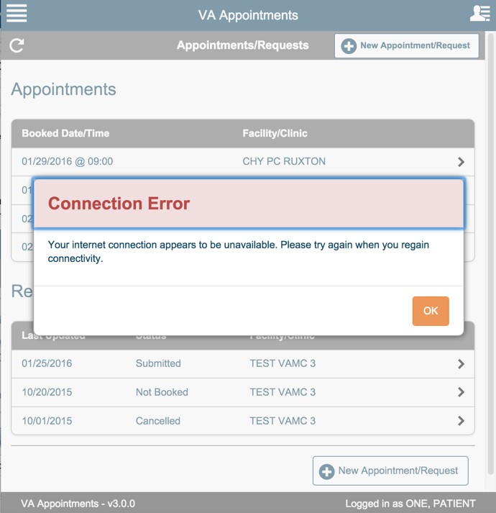

The user can select OK in the error modal and the modal closes. User can retry to access the app when internet connection is restored.

Server Unavailable

There are certain instances the backend server might be disrupted or not reachable. In such cases, when a user tries to perform an action that needs to make a call to the backend services, for example the database, the following error message is displayed to the user.
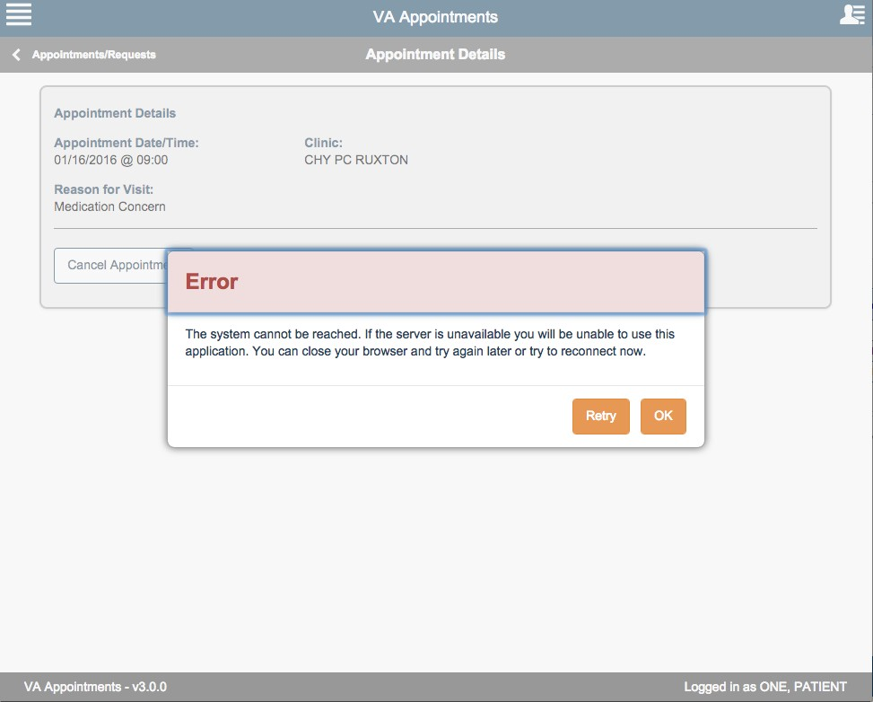

Selecting Retry will try to access the backend services. If the services is back up, the error message is not displayed anymore and the user can continue to use the app.

If the backend service is still down, the error message is displayed again. To close the error message modal, select OK.

User can retry to access the app after some time.

Session Timeout Warning

Session timeout message is displayed when the application has been idle. The current setting for session timeout is 15 mins. User is displayed a warning message after 12 mins of inactivity to let them know that they will be logged out of the application after 3 minutes. The 3-minute warning will reduce to 2 mins and then to 1 min if the user does not take an action.

Selecting Continue will reset the session and the user can continue to use the application. Selecting Logout will log the user out of the application.
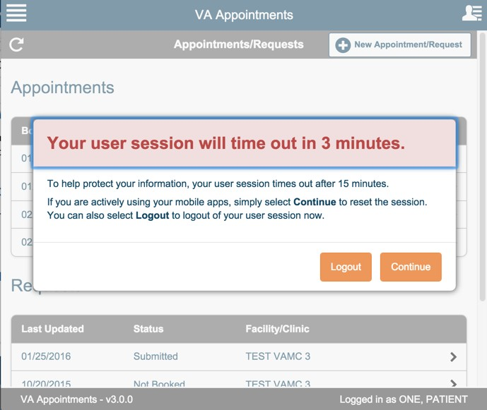

Login Session Ended

If the user does not take an action within 3 minutes after the session timeout warning message is displayed. The user is automatically logged out of the application.

This action is performed by the application due to security reasons.
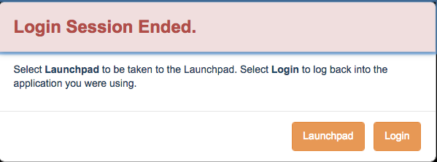

Select Login to login back to the application.

Select Launchpad to navigate to the launchpad to access other apps that are available on Launchpad.

