Scheduling Manager (v 1.2.0)

User Guide

March 17, 2016

Content
Content 2
Table of Figures 3
General Information 4
Application Overview 4
Organization of User Guide 4
Application Summary 4
Configuration 4
User Access Levels 4
Getting Started 5
Accessing the Launchpad and Scheduling Manager 5
Components of the Launchpad 5
Starting Scheduling Manager 5
Using Scheduling Manager 6
Scheduling Manager Warning Dialog 7
Scheduling Manager Home Page 8
Booking an Appointment 9
Searching for a Patient 9
Searching for a clinic 12
Choosing a Desired Date 12
Viewing appointment availability 13
Book Appointment Dialog 16
Patient-Centric View 18
Future Appointments 19
Cancel Appointment 19
Patient Wait List 21
Patient Consult Orders 22
Wait List Page 23
Consults Page 25
Veteran Requests Page 26
Processing an Appointment Request 26
Cancel Request 28
Unavailable 28
Booking an Appointment Request 29

Table of Figures
Figure 1 Launchpad 5
Figure 2 Login Screen 6
Figure 3 Warning Dialog 7
Figure 4 Home Page 8
Figure 5 Booking Page 9
Figure 6 Patient Search Dialog 10
Figure 7 Patient Search Demographic Popup 11
Figure 8 Header with Patient in Context 11
Figure 9 Patient Contact Details Popup 11
Figure 10 Searching for a Clinic 12
Figure 11 Desired Date of Appointment field and button 12
Figure 12 Desired Date Popup 12
Figure 13 Calendar Month View 13
Figure 14 Calendar Week View 14
Figure 15 Calendar Day View 15
Figure 16 Book Appointment Dialog 16
Figure 17 Successful Booking Dialog 17
Figure 18 Patient-Centric View 19
Figure 19 Cancel Appointment Dialog 20
Figure 20 Cancel Appointment Success Dialog 21
Figure 21 Patient Wait List 21
Figure 22 Patient Consult Orders 22
Figure 23 Wait List Page 23
Figure 24 Wait List Details on the Booking Page 23
Figure 25 Book Appointment for Wait List Dialog 24
Figure 26 Consults Page 25
Figure 27 Veteran Requests Page 26
Figure 28 Veteran Request Details on the Booking Page 27
Figure 29 More of the Veteran Request Details Collapsible 27
Figure 30 Cancel Request Popup 28
Figure 31 Cancel Veteran Request Success Message 28
Figure 32 Unavailable Appointment Popup 29
Figure 33 Unavailable Appointment Success Message 29
Figure 34 Book Appointment Dialog with Veteran Request 30

General Information
This document is the user guide for the Scheduling Manager application which provides VA scheduling clerks and staff the ability to manage Veterans’ appointment requests and the Electronic Wait List.

Application Overview
Scheduling Manager provides a clerk with the ability to schedule and cancel patient appointments. Patients on the Electronic waitlist, Recall and NEAR lists can be viewed and managed. The Scheduling Manager works in conjunction with The Veteran Appointment Request (VAR) application so that a scheduling clerk and a Veteran can have a secure message dialog to request an appointment. The Clerk can book an appointment based on the request

Organization of User Guide
The User Guide describes the key features and functionality of the Scheduling Manager Application. The User Guide consists of four sections:
General Information - Section explains in general terms the application and the purpose for which it is intended.

Application Summary - Section provides a general overview of the application. The summary outlines the hardware and software requirements, the configuration, user access levels and workflow.

Getting Started - Section explains how to launch Scheduling Manager from
the Launchpad and log on.

Using the Application - Section provides a detailed description of functionality.

Application Summary
This section provides a general overview of platform requirements for using Scheduling Manager.

Configuration
Scheduling Manager is a web based application. The target platform for Scheduling Manager to run on is a VA provided desktop device running MS Windows with Internet Explorer. Scheduling Manager can be run on VA provided tablets. It is not recommended that Scheduling Manager be run on a mobile device with a small screen such as a phone.

User Access Levels
Only users with a valid VA DS Logon can use this application. The user’s Vista credentials will determine which facilities and clinics the individual will be able to access and manage. The ability to overbook or book into restricted clinics will be governed through the use of security keys assigned to the credential.

Getting Started
This Section describes the Launchpad and logging into Scheduling Manager.

Accessing the Launchpad and Scheduling Manager
Scheduling Manager is a web based application so there must be connectivity to the internet to access it. Scheduling Manager is one component in a suite of applications provided to the VA. This suite of applications is presented on the Launchpad.

Components of the Launchpad
Each application has an icon. The arrangement of the icons varies depending on the size of the browser window and the physical screen size. The individual user’s VA credentials will determine which apps can be accessed and the functionality available in each app.
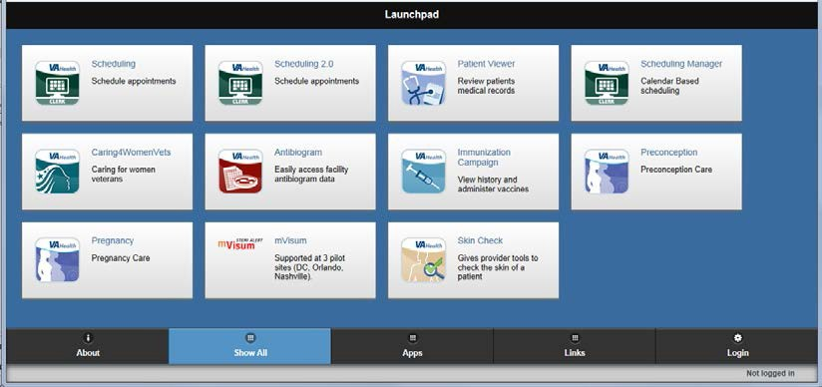
Figure 1 Launchpad

There are a several buttons at the bottom of the Launchpad. The About button displays brief information about the Launchpad. Show All refreshes the display of icons. Apps and Links provides access to other VA applications. Login requests the user’s ID, password and facility the user will access.

The bottom bar of the Launch pad displays the version of the Launchpad. The status of the user is also shown. If a user is logged in their user name and the facility they are accessing will be displayed.

Starting Scheduling Manager
Select the icon labeled “Scheduling Manager – Calendar Based Scheduling”. If the user is not logged in the login screen will be displayed.

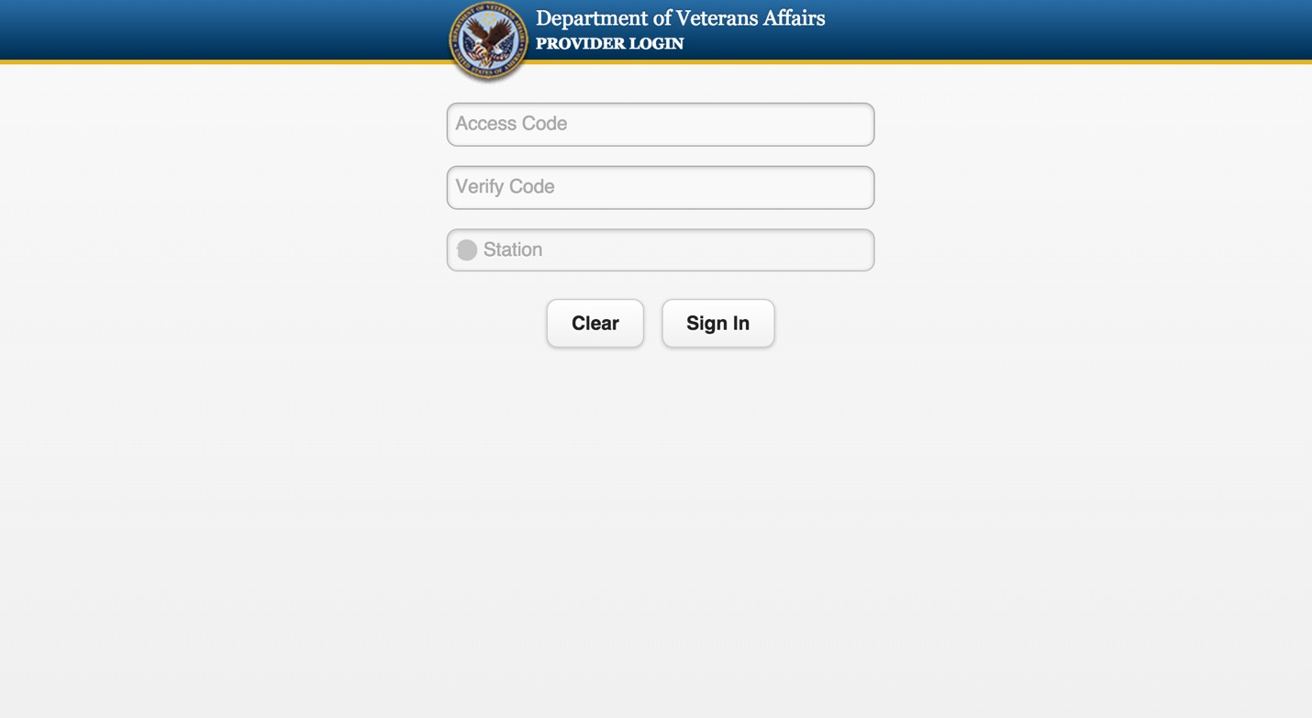
Figure 2 Login Screen

Logging in requires the user to enter their VistA access and verify codes, and the VA medical facility they are authorized to access.

Using Scheduling Manager
In general the Scheduling Manager screen is divided into two parts. The left pane is used to select what the Clerk will work on. This can be a clinic in the facility, the waitlist, an appointment request or a specific Veteran. The right side of the screen will display details about what was chosen and present actions the Clerk can take.

Scheduling Manager Warning Dialog !
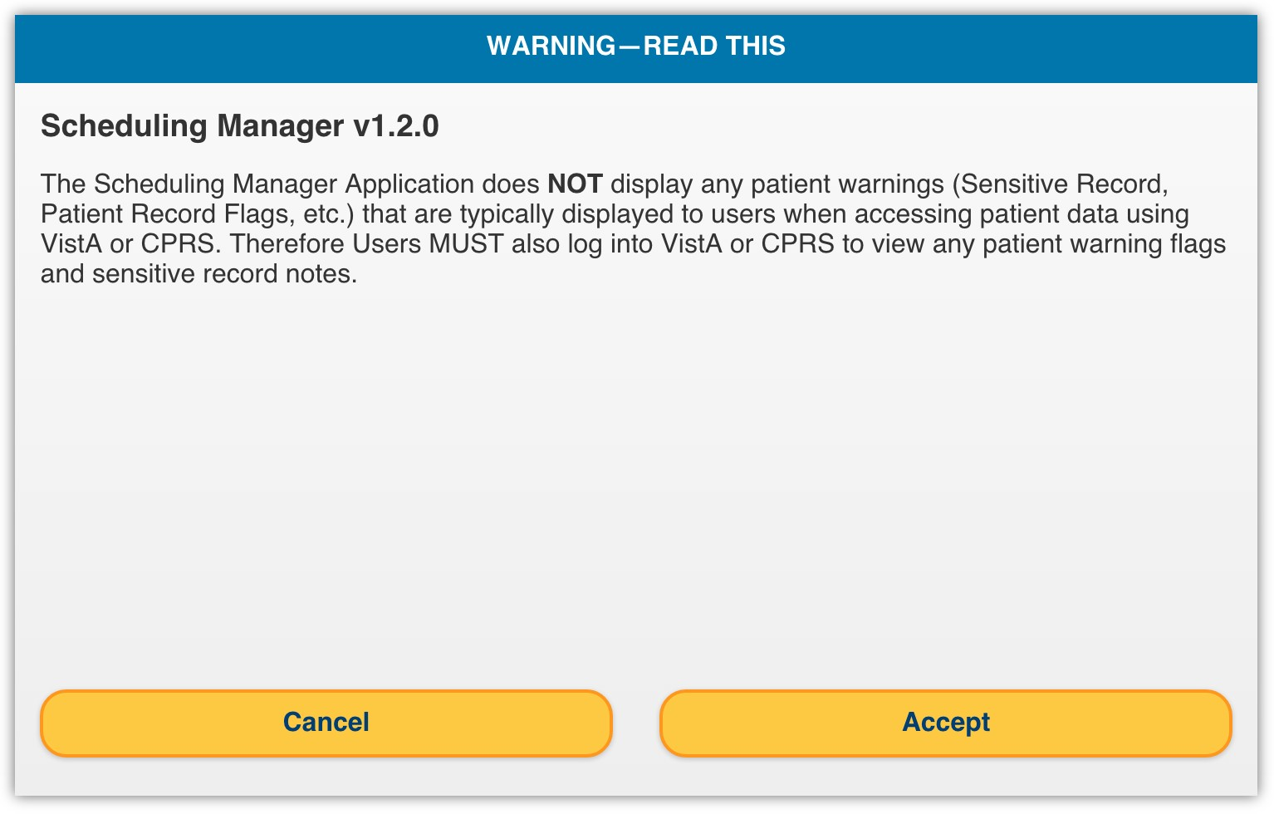
Figure 3 Warning Dialog

After a user logs in, a dialog appears notifying the user that Scheduling Manager does not display any patient warnings usually available to CPRS users. In order to proceed and use the application, the user must select the Accept button. If the user selects the Cancel button, the user is sent back to the Launchpad, still logged in.

Scheduling Manager Home Page !
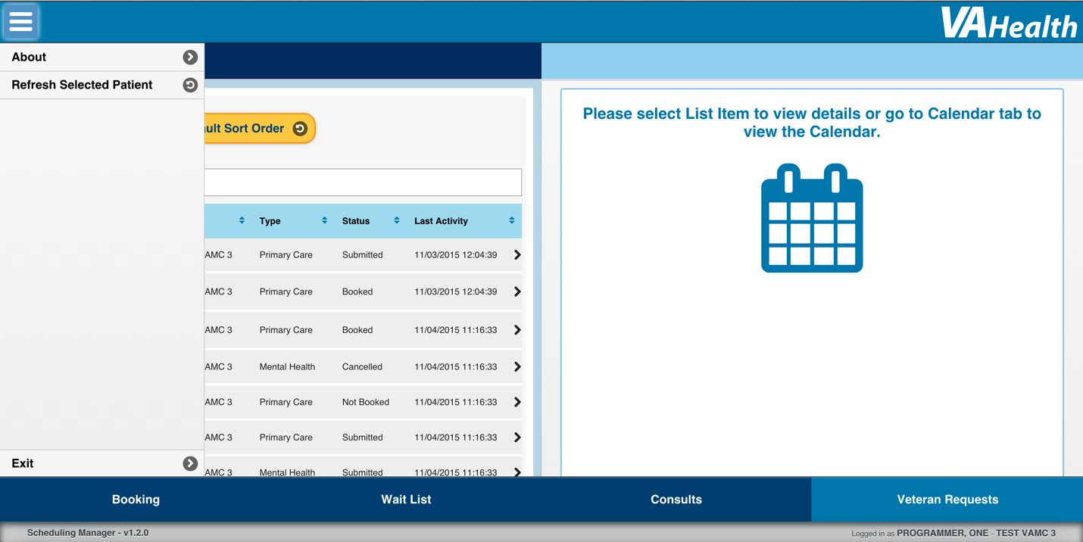
Figure 4 Home Page

At the top-left of the screen is the Menu button. When a user selects this, a menu is opened with the following items:

- About – Opens a dialog which gives a brief summary of the application and its functionality.
- Refresh Selected Patient – Refreshes the information in the application for the currently selected patient, if any.
- Exit – Opens a popup with options to logout or return to the Launchpad while maintaining the current user session.

The buttons at the bottom of the screen navigate to the features of Scheduling Manager:

- Booking – The user can view clinic availability and book or cancel appointments
- Wait List – Manages the Electronic Wait List (EWL) of the current facility
- Consults – View consults by specialty
- Veteran Requests – A list of appointment requests for the current facility made by veterans using the Veteran Appointment Requests (VAR) application

By default, the Veteran Requests screen is displayed.

Booking an Appointment !
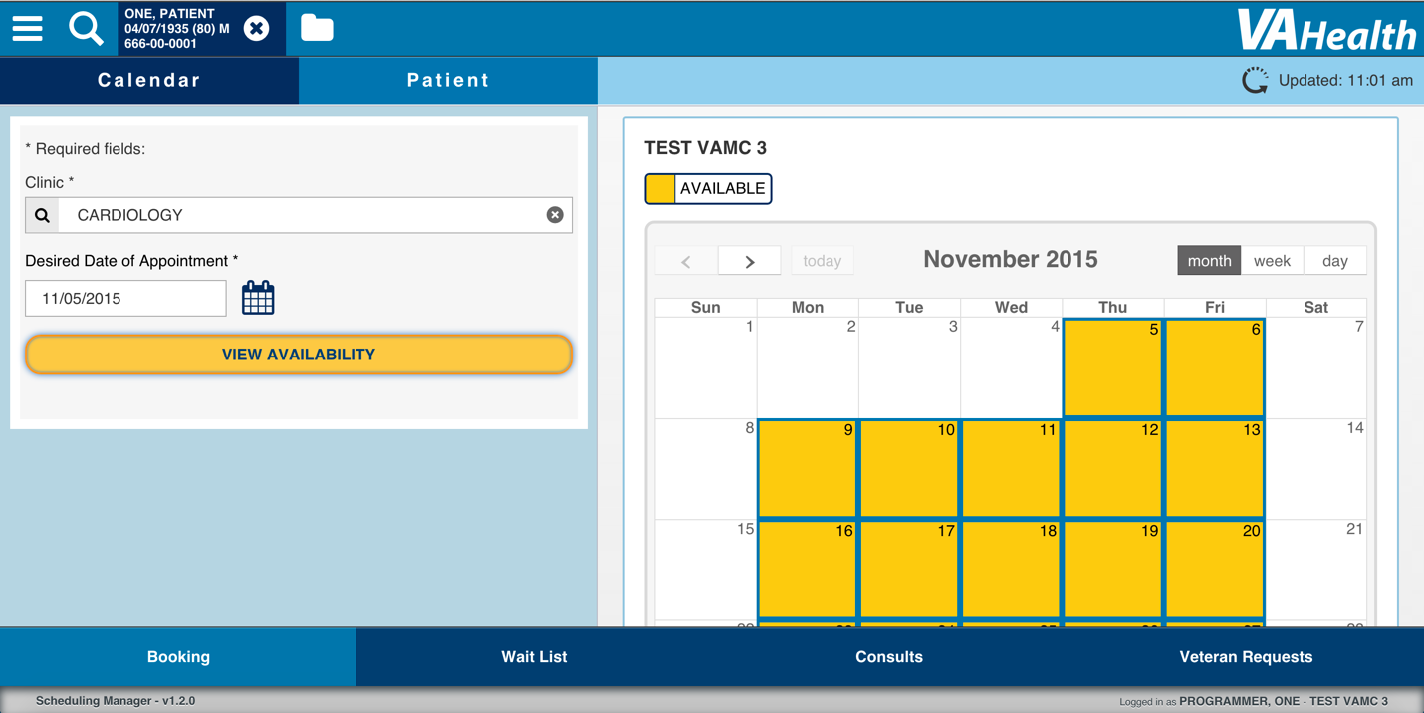
Figure 5 Booking Page

From the booking page, the user can search for a patient, and book and appointment for that patient in a specific clinic.

Searching for a Patient
When the user selects the Patient Search button at the top of the screen, indicated by a magnifying class icon, the Patient Search dialog appears.

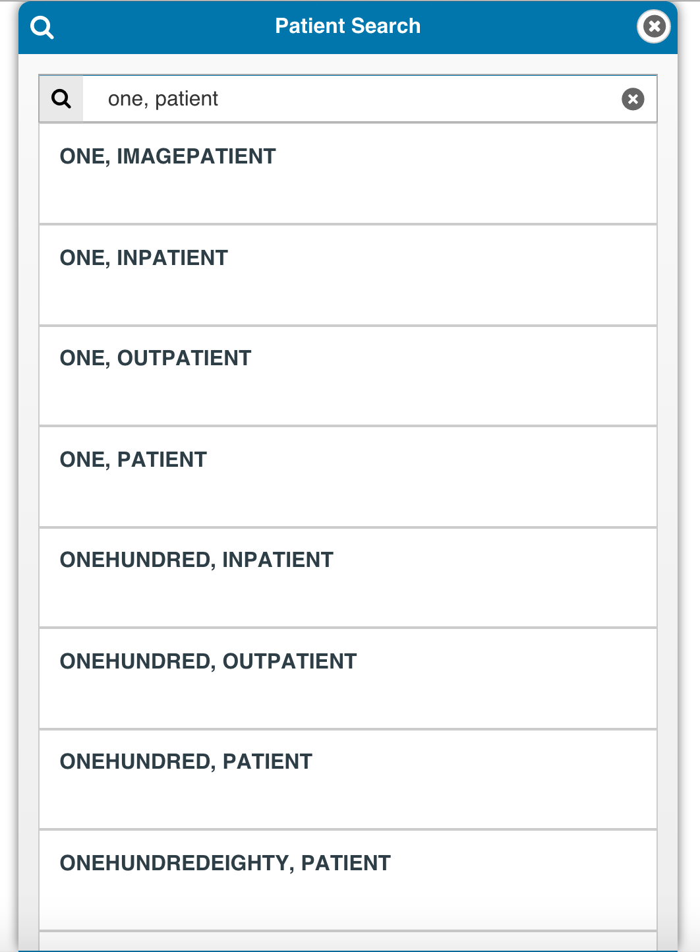
Figure 6 Patient Search Dialog

In the Patient Search Dialog, the user can search for a patient by the following criteria:

- Last Name
- Last Name, First Name
- SSN
- First Initial of Last Name + Last 4 of SSN

When the user enters valid criteria, a list of results will appear below the search field. After selecting a patient from the list, a popup appears displaying the patient’s demographic information.

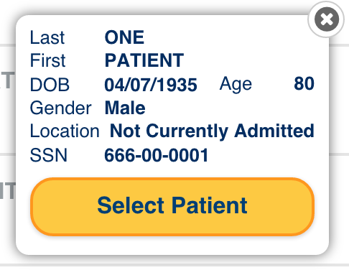
Figure 7 Patient Search Demographic Popup

The user can select the Select Patient button to confirm the selection and place the patient in context. The Patient Search Dialog will then close and the patient’s information will be displayed in the header.
Figure 8 Header with Patient in Context

With a patient in context, the user can select the Clear Patient Context button, denoted by an “X” in a circle next to the patient demographics, to clear the current patient from context. The current patient is also cleared from context when the user logs out of the application.

When the user selects the Patient Contact Details button, denoted by a folder icon next to the Clear Patient Context button, a popup will appear with the current patient’s Contact Details from VistA. The user can select the Done button to close the popup.
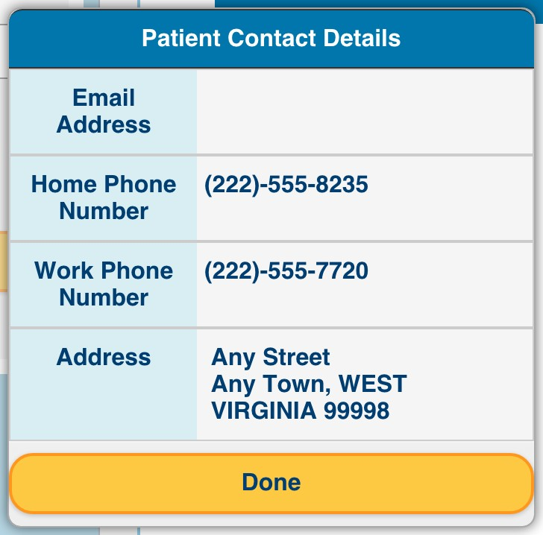
Figure 9 Patient Contact Details Popup

Searching for a clinic
In order to book an appointment, the user must first select a clinic. The user can search for a clinic using the Clinic search field. As the user types in the search field, a list of results will appear, and the user can select a clinic from the list.
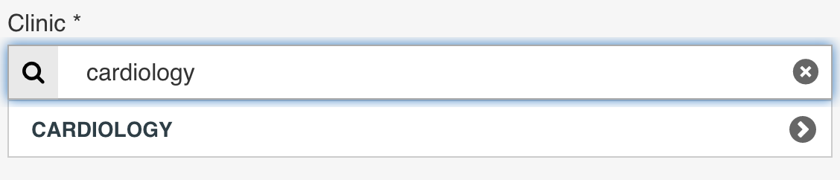
Figure 10 Searching for a Clinic

Choosing a Desired Date
After selecting a clinic, the user must specify a desired date for the appointment. The user can either enter a date in the Desired Date input field, or select the Select Date button, denoted by a calendar icon next to the input field.
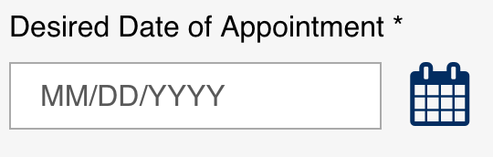
Figure 11 Desired Date of Appointment field and button

When the user selects the Select Date button, a popup will appear allowing the user to choose a desired date.
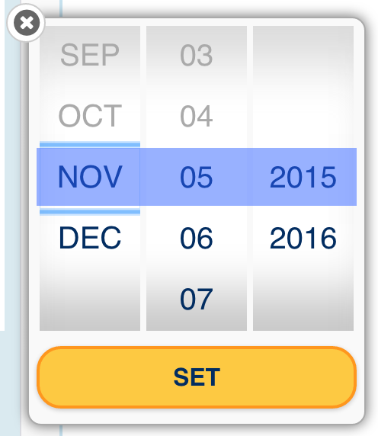
Figure 12 Desired Date Popup

Viewing appointment availability
After selecting a clinic and specifying a desired date, the user can select View Availability to display a calendar showing the availability for the currently selected clinic. The calendar has three views: Month, Week, and Day. The user can switch between views using the Month, Week, and Day buttons above the calendar. Available appointment slots are denoted by shaded boxes with thick borders. A head-and-shoulders icon indicates when a patient has an appointment already scheduled. Appointments can only be booked from Day view.

Above the calendar, the user can see the last time the availability in the calendar was updated in the application. The user can select the Refresh button to manually refresh the availability shown on the calendar.
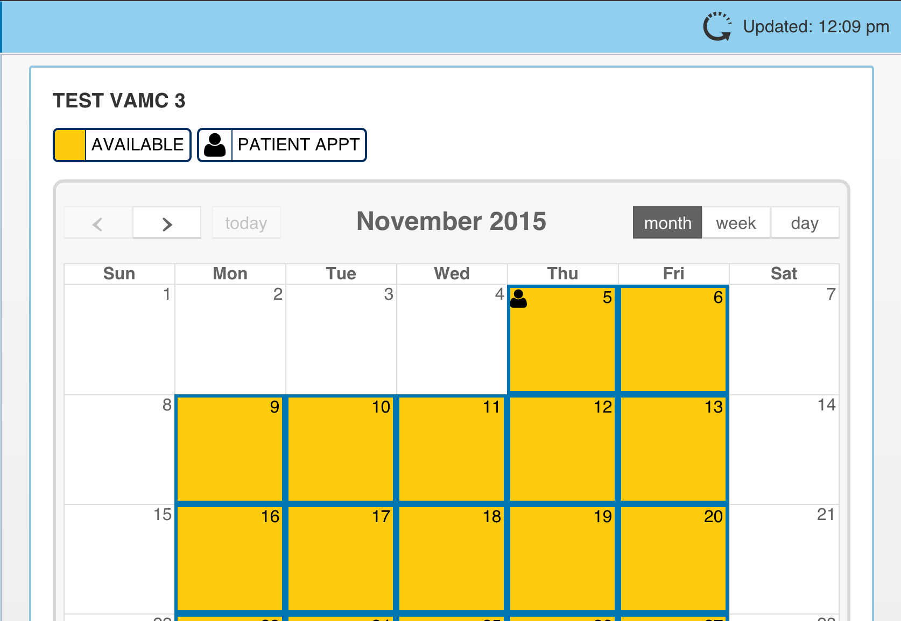
Figure 13 Calendar Month View

By default, the calendar shows the Month view. On the month view, the calendar only displays which days are available and / or the patient already has an appointment. The user can select a day to open the day view.

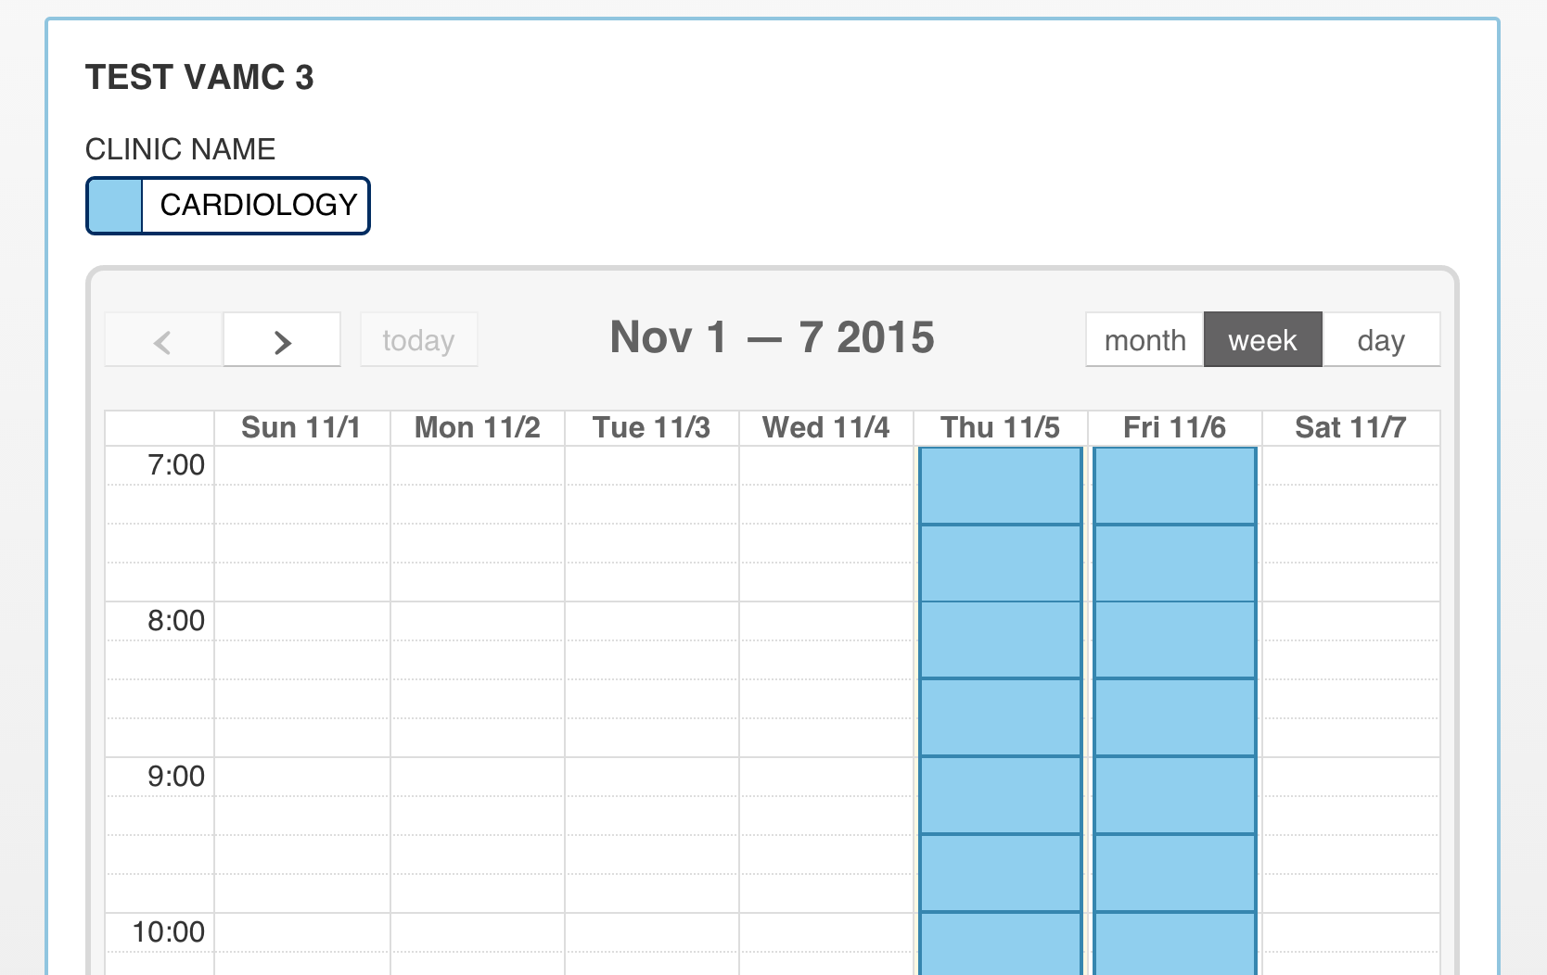
Figure 14 Calendar Week View

On the Week view, the calendar displays which times are available for the entire week. The user can select a time slot on the Week view to open the Day view.

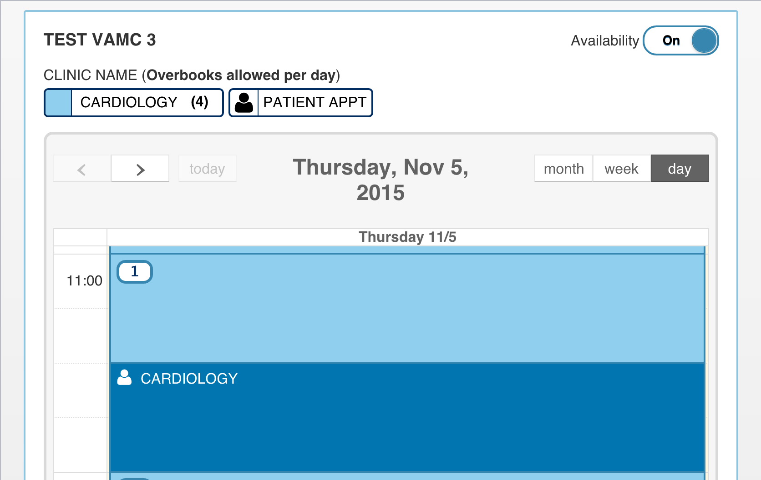
Figure 15 Calendar Day View

On the Day view, the user can see the VistA availability codes for each slot. The user can optionally turn these off using the availability switch above the calendar. Previously booked appointments for the current patient display the clinic where the patient has an appointment.

Book Appointment Dialog !
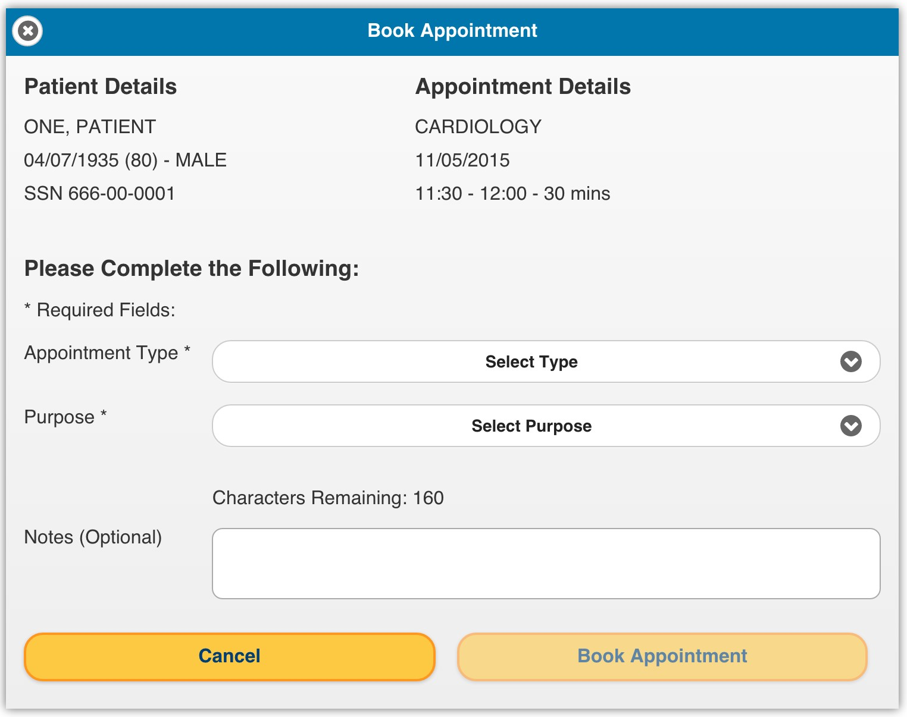
Figure 16 Book Appointment Dialog

When the user selects an appointment slot from the calendar, the Book Appointment Dialog appears. At the top, the demographics for the current patient and the appointment details are shown. If the user selects the Cancel button, they are returned to the calendar on the booking page. To proceed, the user must select an Appointment Type and Purpose from the dropdowns provided. The user can optionally provide comments on the appointment.

Once the fields in the Book Appointment Dialog are filled in correctly, the user can select Book Appointment to book the appointment for the selected patient in VistA.

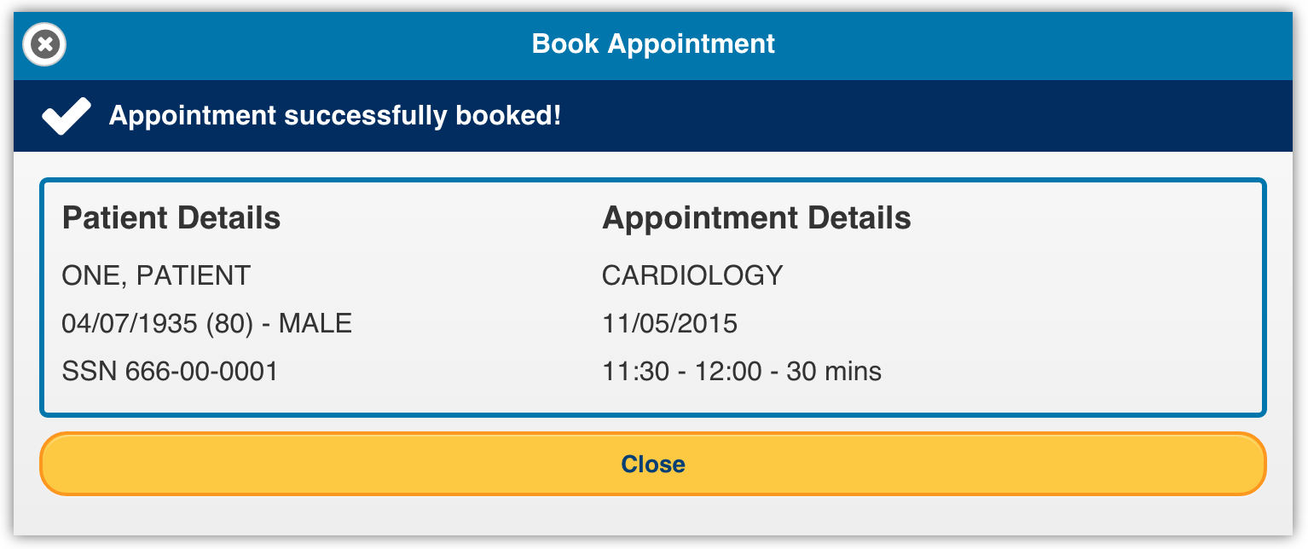
Figure 17 Successful Booking Dialog

After the appointment is booked in VistA, a dialog appears showing a success message to the user, along with the patient demographics and the appointment details. If the appointment failed to book in VistA, the dialog appears with an error message stating why the booking failed. The user can select the Close button to dismiss the dialog and return to the booking page.

Related Wait List Entries / Consults
When the user selects Close from the Successful Booking Dialog, another dialog appears displaying any Wait List Entries or Consults for the current patient related to the scheduled appointment. If the current patient does not have Wait List Entries or Consults, the user is returned to the Booking Page.

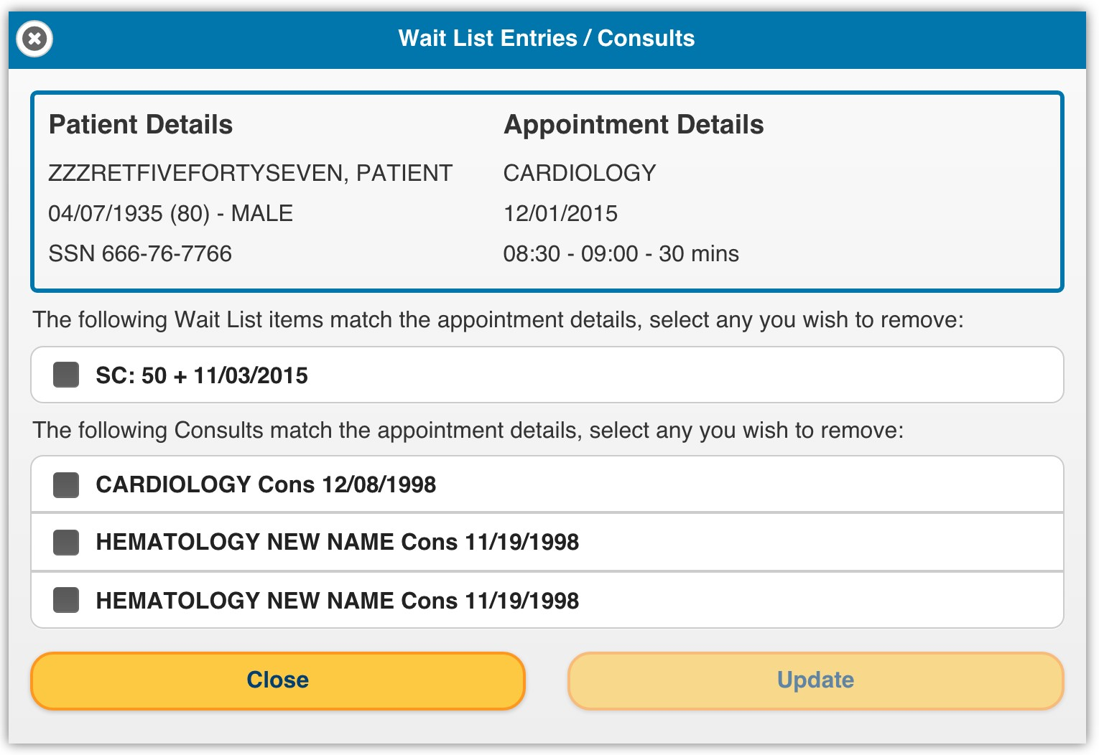

The user can select any Wait List Entries or Consults and select Update to process them in VistA so they will no longer be shown in Scheduling Manager. Or the user can select Close to dismiss the dialog and return to the Booking Page without updating and Wait List Entries or Consults.

Patient-Centric View
If a patient is in context, the user can select the Patient button on the Booking page to view future appointments, wait list items, and pending consults for the selected patient.

Future Appointments !
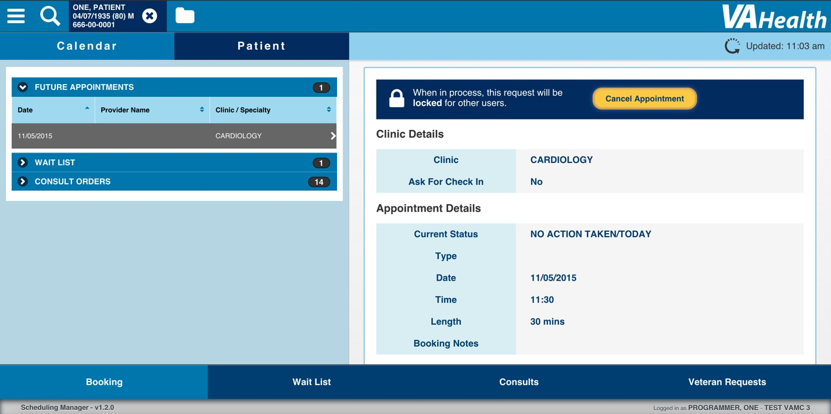
Figure 18 Patient-Centric View

By default, the Future Appointments collapsible is open on the patient-centric view. This list shows all of the upcoming appointments for the current patient. When a user selects an item from the list, the appointment details appear on the right-hand side.

Cancel Appointment
When the user selects Cancel Appointment while viewing details on an appointment for a patient, the Cancel Appointment dialog appears.

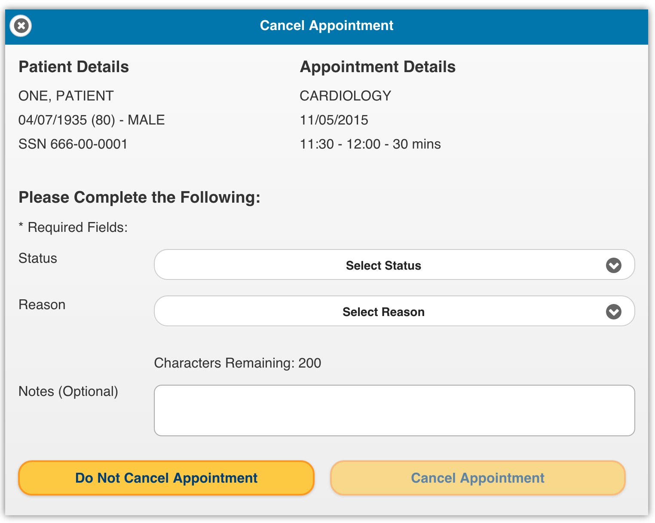

Figure 19 Cancel Appointment Dialog

The Cancel Appointment dialog is similar to the Booking Dialog, except the user must select a status and reason to proceed with cancelling the appointment. The user can also select Do Not Cancel Appointment to dismiss the dialog without cancelling the appointment.

Once the fields are filled in correctly, the user can select Cancel Appointment to cancel the current appointment in VistA.

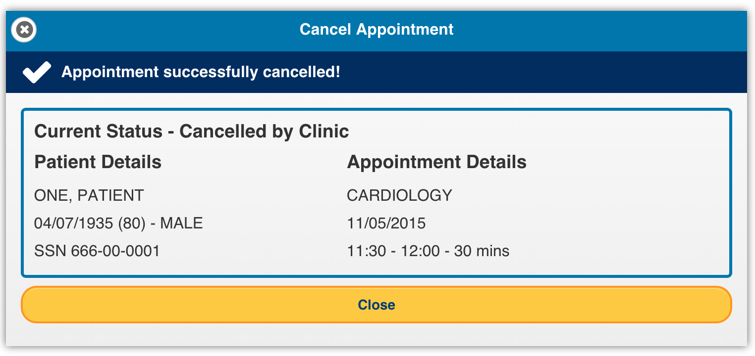
Figure 20 Cancel Appointment Success Dialog

Once the appointment is cancelled in VistA, a dialog appears showing a success message to the user, along with the patient’s demographics and the details of the cancelled appointment. If cancelling the appointment failed, the dialog will appear with an error message explaining why the appointment was not cancelled. The user can select the Close button to return to the Future Appointments list, where the cancelled appointment will no longer appear.

Patient Wait List
From the Patient Centric View, the user can open the Wait List collapsible to view a list of all the items on the Electronic Wait List (EWL) for the current patient.
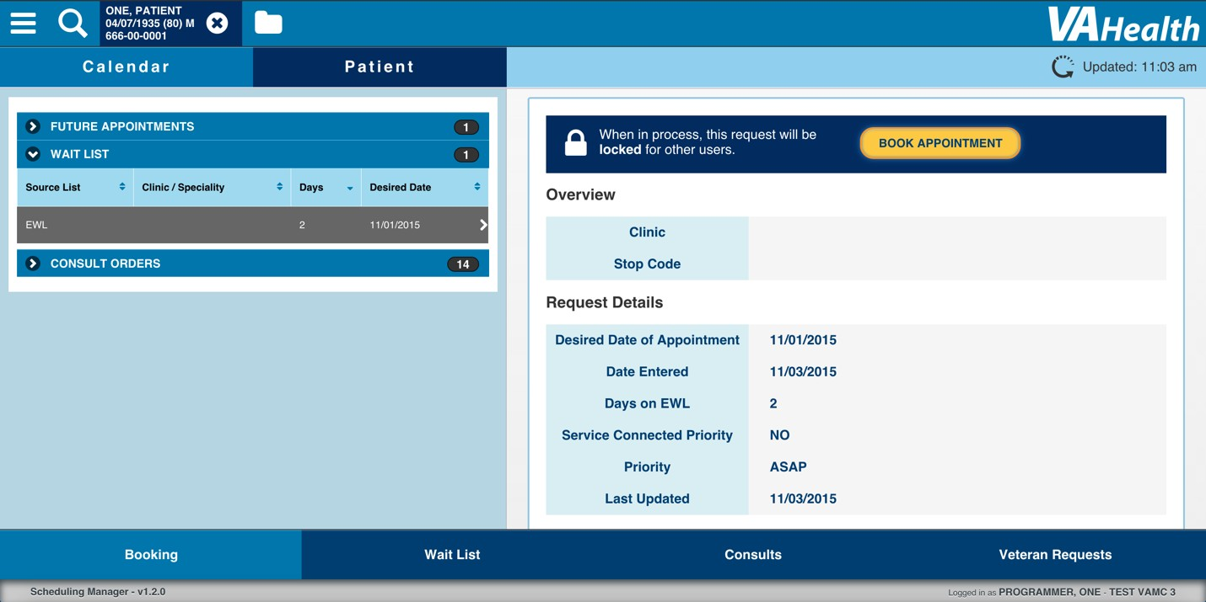
Figure 21 Patient Wait List

When the user selects an item from the list, the details for the Wait List item appear on the right. The user can select the Book Appointment button above the details to process the Wait List Item.

Patient Consult Orders
From the Patient Centric View, the user can open the Consult Orders collapsible to view a list of all the pending Consult Orders for the current patient.
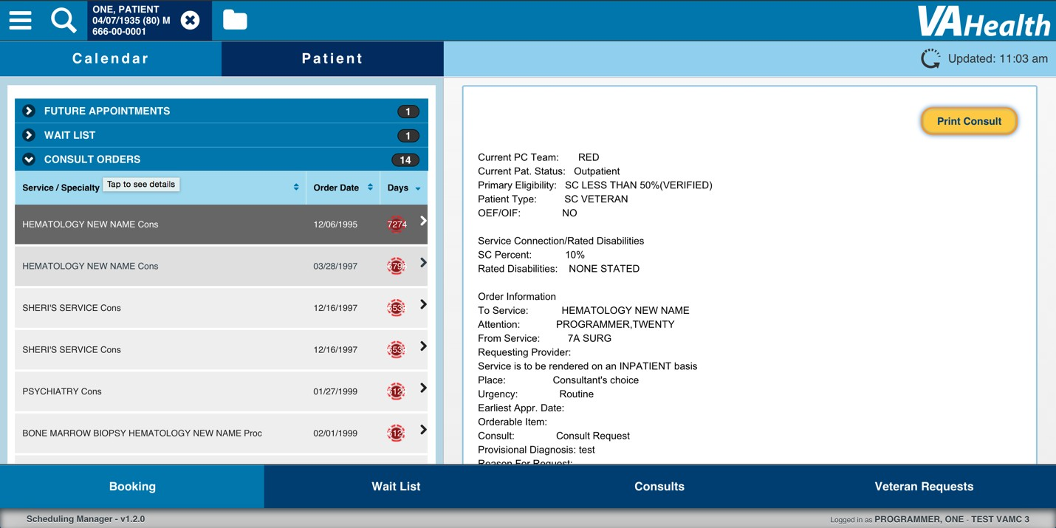
Figure 22 Patient Consult Orders

When the user selects a Consult Order from the list, the details for that Consult Order appear on the right. The user can select Print Consult to generate a pdf of the details for the Consult Order.

Wait List Page !
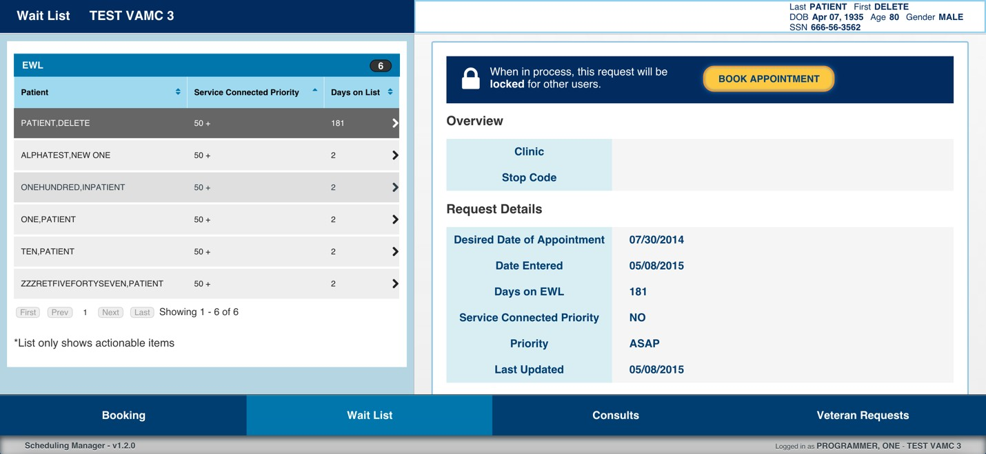
Figure 23 Wait List Page

From the Wait List page, the user can view the Electronic Wait List (EWL) for the current facility. When the user selects an item from the list, the details for that item and the demographic information for the patient associated with the item are shown on the right.

When the user selects Book Appointment from a Wait List item, the patient associated with the Wait List Item is placed in context and the user is redirected to the Booking page, where the details for the Wait List item are displayed below the View Availability button.
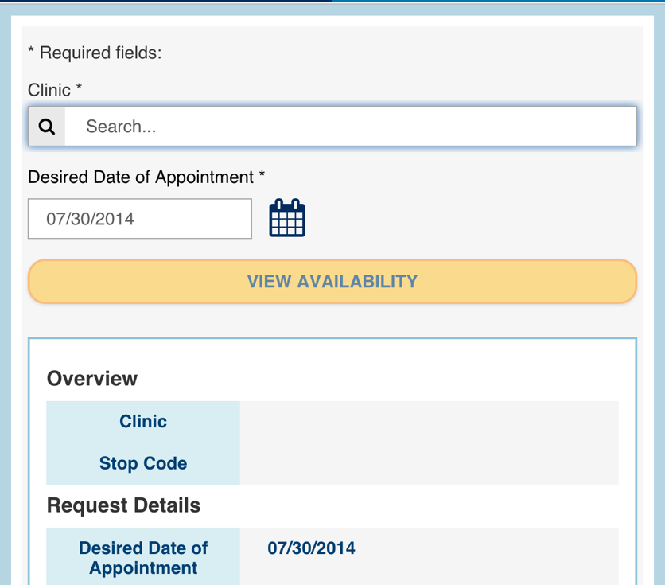
Figure 24 Wait List Details on the Booking Page

The user can follow the booking process as usual to book an appointment based on the Wait List Item. When the Book Appointment dialog appears, the details of the Wait List Item appear below the patient demographics and appointment details.
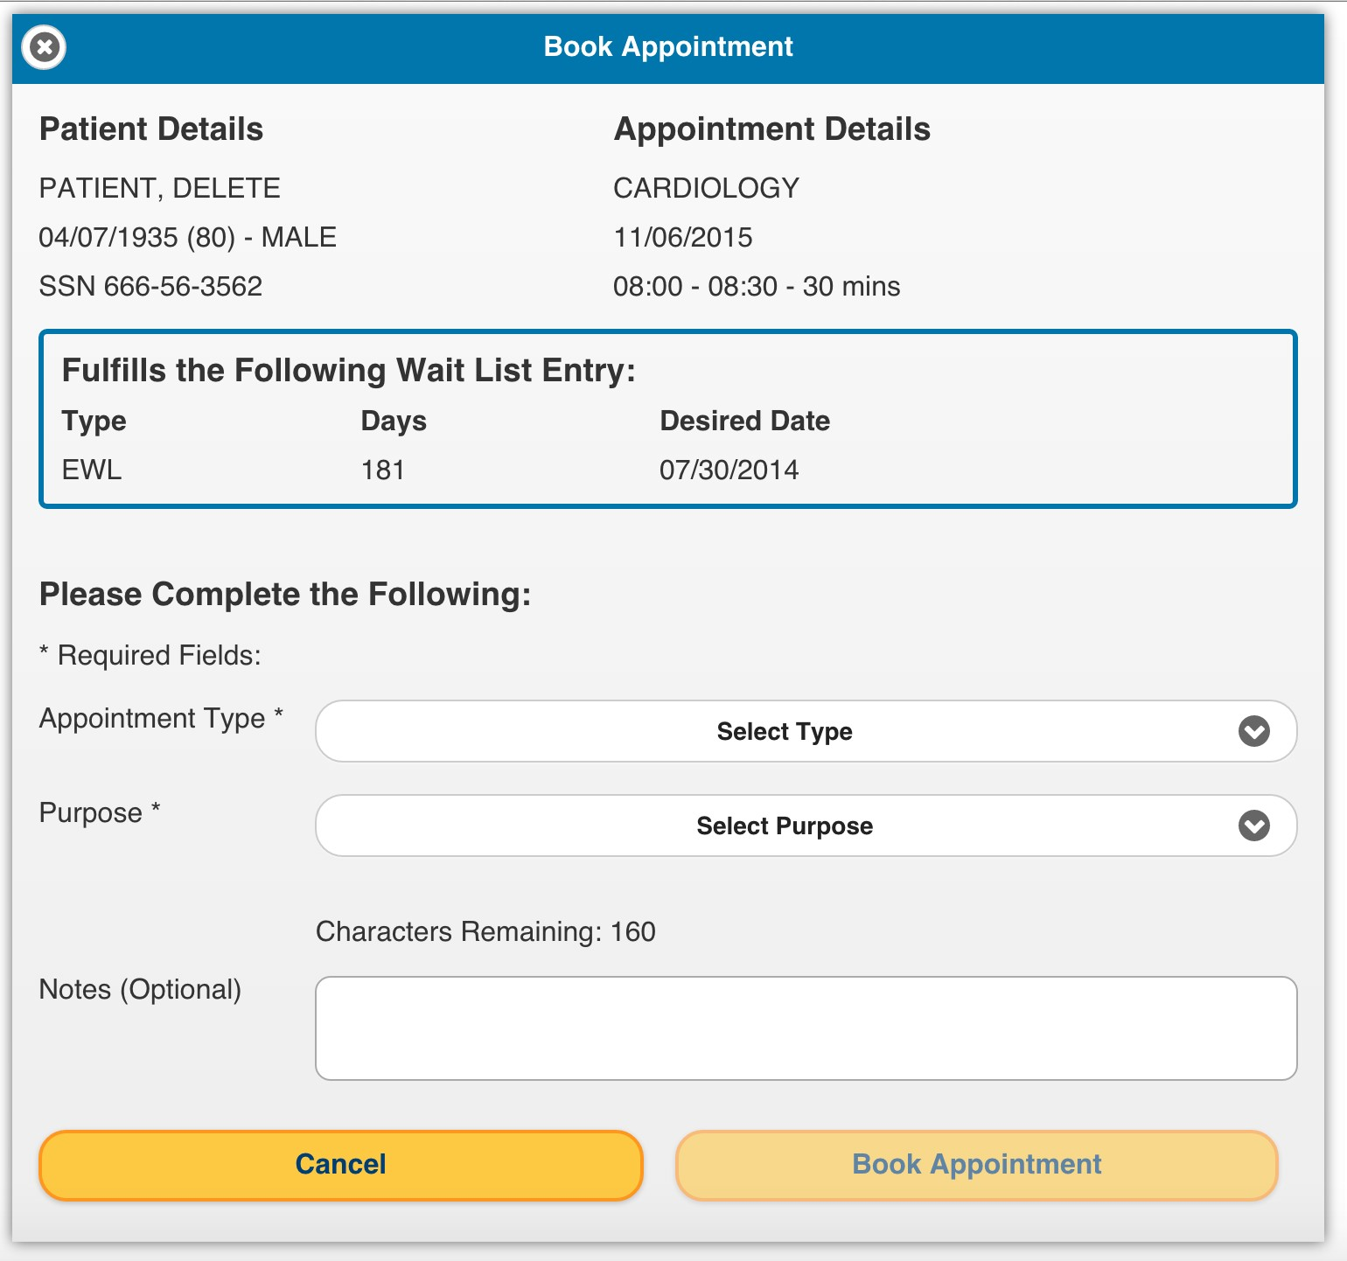
Figure 25 Book Appointment for Wait List Dialog

When the user selects Book Appointment, the application attempts to remove the Wait List Entry in addition to booking the appointment. After the appointment is booked, the successful booking dialog shows a separate status to indicate whether the Wait List Entry was successfully removed from the Wait List.

Consults Page !
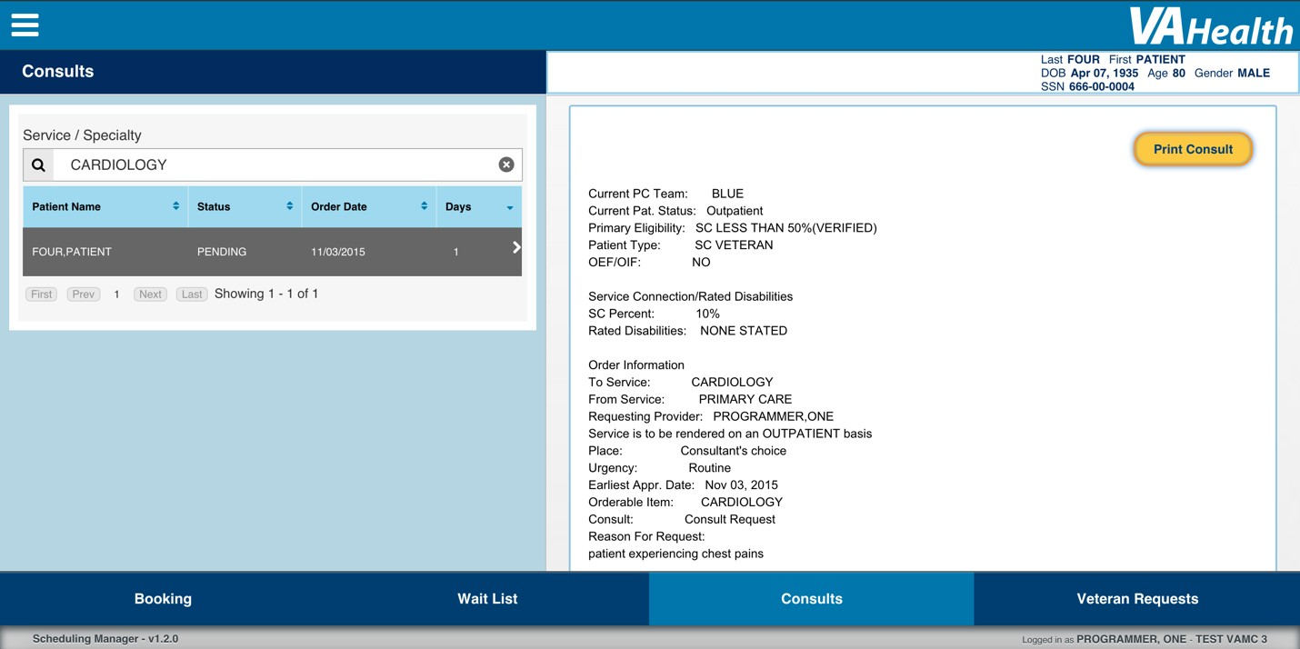
Figure 26 Consults Page

On the Consults Page, the user can search for a service / specialty to view a list of consult orders in the current facility for that service / specialty. Consults have a number of days in which they need to be processed. Alerts will appear for the consult items when they are close to the maximum number of days, when they have been on the list for the maximum number of days, or if they have been on the list longer than the maximum number of days.

The user can select a consult from the list to view the details and the patient information related to that consult on the right. The user can select Print Consult when viewing consult details to generate a pdf of the consult details.

Veteran Requests Page !
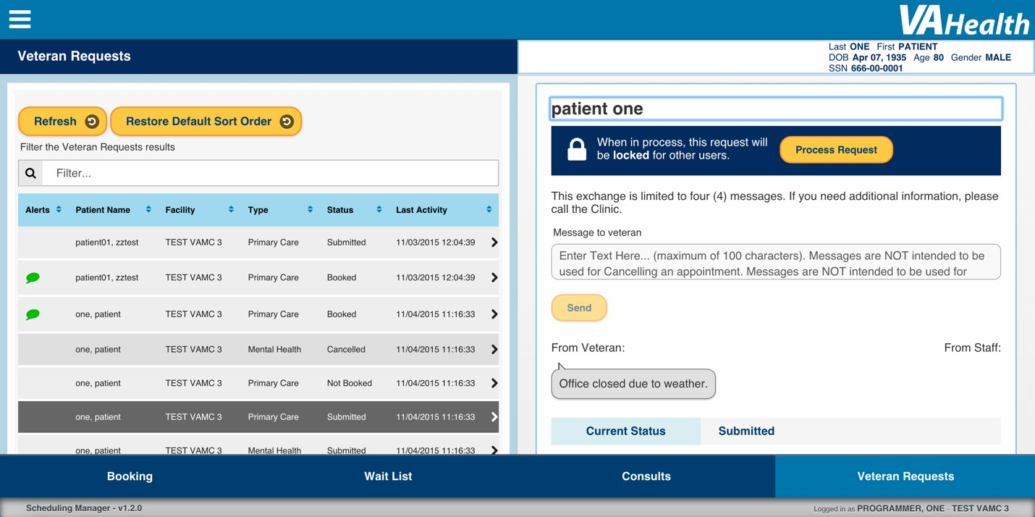
Figure 27 Veteran Requests Page

On the Veteran Requests Page, the user can see a list of the appointment requests made by veterans using the Veteran Appointment Requests (VAR) application. The user can click Refresh to refresh the data in the list. As the user types in the Filter field, the list shows only those items containing the text the user entered. If there is an active filter on the list and/or the user has changed the sorting on the list, the user can select the Restore Default Sort Order button to return the list to its original state.

When the user selects an appointment request from the list, the details for that request are shown on the right, along with the demographic information of the patient who made the request. From the details the user can send a message to a veteran and read messages sent from the veteran. However, this exchange is limited to four messages total, regardless of who sent the messages.

Processing an Appointment Request
When the user selects Process Request from appointment request details, the patient who made the request is put into context, and the user is directed to the Booking page, where the appointment request details appear in a collapsible beneath the View Availability button.

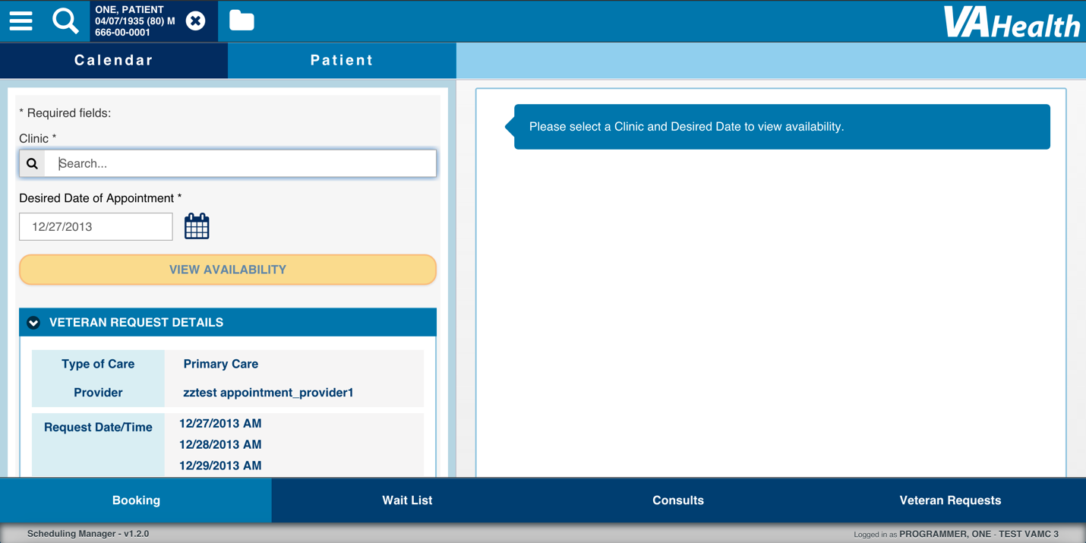
Figure 28 Veteran Request Details on the Booking Page
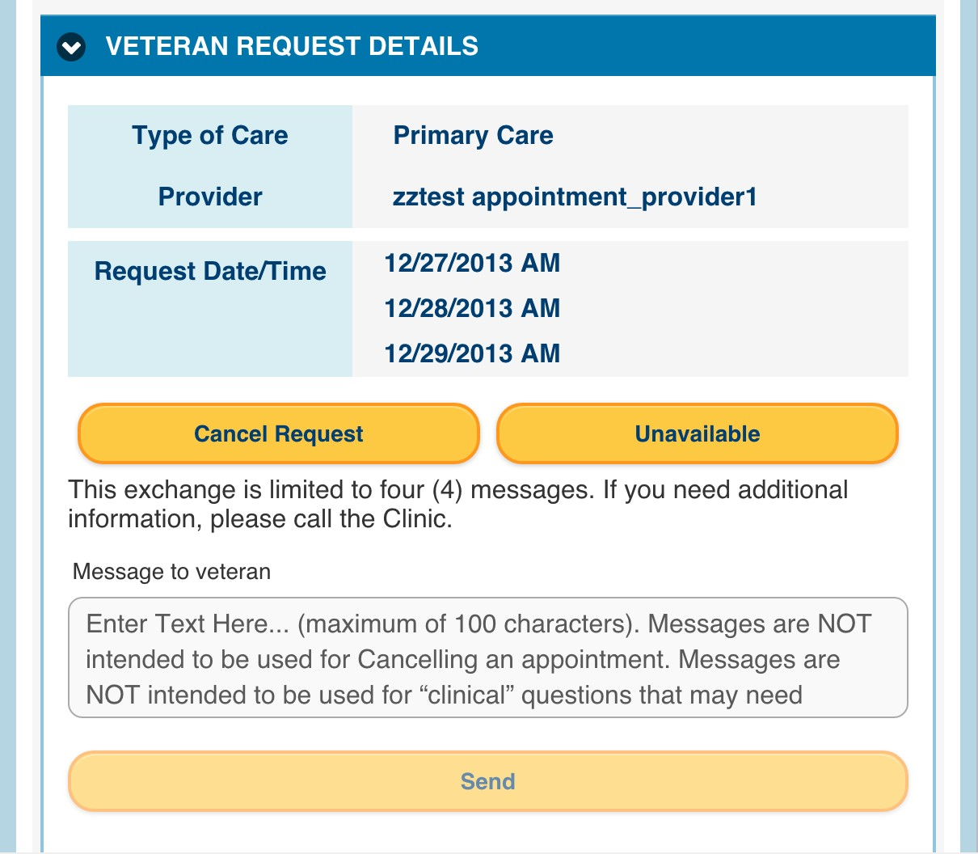
Figure 29 More of the Veteran Request Details Collapsible

The user can message the current patient from the Veteran Request Details collapsible on the Booking Page just like the item details on the Veteran Requests page.

Cancel Request
If the user selects Cancel Request from the Veteran Request Details collapsible, a Cancel Request popup appears, with a list of radio buttons to indicate who cancelled the appointment request. To proceed, the user must select an option from the list. The user can select Return to dismiss the popup.
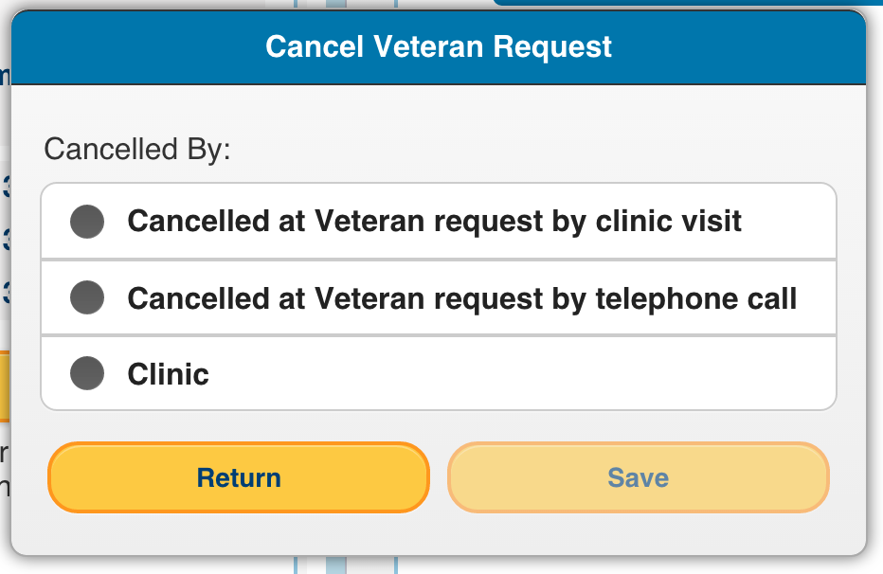
Figure 30 Cancel Request Popup

After the user selects an option from the list and selects the Save button, the patient is removed from context, the Veteran Request Details collapsible disappears, and a success popup appears. After the user dismisses the success popup, the user is returned to the Veteran Requests page.
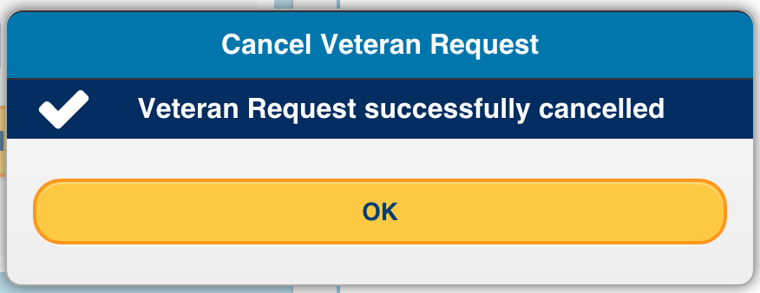
Figure 31 Cancel Veteran Request Success Message

Unavailable
If the user selects Unavailable from the Veteran Request Details Collapsible, a popup appears asking the user to confirm their decision. The user can either select “Return” to dismiss the popup or “Save” to mark the appointment request as Unavailable.

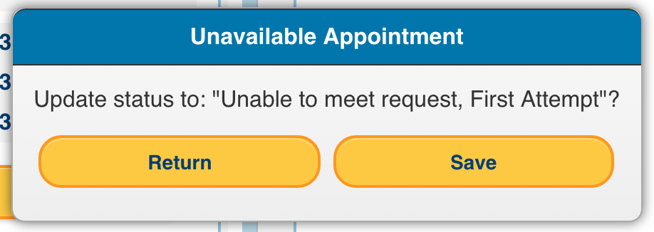
Figure 32 Unavailable Appointment Popup

When the user selects “Save”, the patient is removed from context, the Veteran Request Details Collapsible disappears, and a success popup appears. After the user dismisses the success popup, the user is returned to the Veteran Requests page.
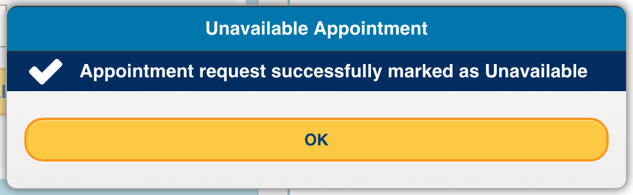
Figure 33 Unavailable Appointment Success Message

Booking an Appointment Request
After selecting Process Request on an appointment request, the user can follow the normal booking process to book an appointment based on that request. When the Book Appointment dialog opens, a new section is displayed entitled Fulfills the Following Veteran Request. The user must select an option under Request date/time in order to proceed.

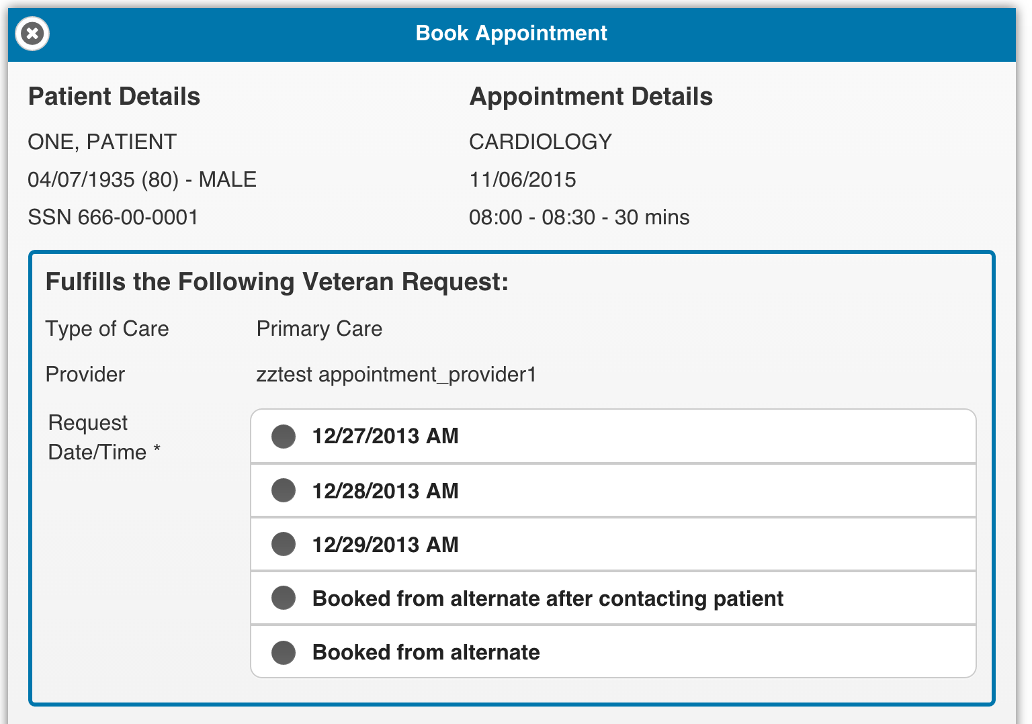
Figure 34 Book Appointment Dialog with Veteran Request

When the fields are filled out and the user selects Book Appointment, the application will book the selected appointment in VistA and update the appointment request. A success message will be displayed to the user showing a separate status for the appointment booked in VistA and the appointment request.

