Patient Appointment Information Transmission (PAIT)

Release Notes and Installation Guide

Patch SD*5.3*333

March 2004
Revised January 2009

Department of Veterans Affairs
VistA Health Systems Design and Development

This page left blank intentionally

Revision History

Date | Revision | Description | Author
1.28.2004 | 1.0 | Version 1 | REDACTED
1.28.2004 | 1.1 | Revisions | REDACTED
1.29.2004 | 1.2 | Revisions | REDACTED
2.2.2004 | 1.3 | Revisions | REDACTED
2.3.2004 | 1.4 | Revisions | REDACTED
3.1.2004 | 1.5 | Revisions | REDACTED
3.2.2004 | 1.6 | EVS trouble shooting | REDACTED
3.3.2004 | 1.7 | Revisions | REDACTED
3.4.2004 | 1.8 | Revisions | REDACTED
7.10.2006 | 1.9 | Corrections | REDACTED
7.12.2006 | 1.91 | Document Review | REDACTED
12.4.2008 | 1.92 | Changes for patch SD*5.3*528 | REDACTED
1.5.2009 | 1.93 | Changes for patch SD*5.3*534 | REDACTED

This page left blank intentionally
Table of Contents

Introduction 7
Description of Functionality 7
Changes introduced with SD*5.3*333 patch 8
Table VA087 - Scheduling Event Reason 10
Table 0276 - Appointment Reason Codes 11
2.3.9 SCH Schedule Activity Information 11
Table VA0021 – Enrollment Priority 11
Table 0277 - Appointment Type Codes 12
Table AAC001 - Error Code Set 13
Installation 14
Post Installation Instructions 18
User Options 23
MailMan Messages 24
Technical Information 25
Initial Seeding Run Times: 27
Appendix A – HL7 Specifications 28
Introduction 28
General 28
1.2 Message Content 28
1.2.0 Data Capture and Transmission 31
1.2.1 Batch Messages 32
1.2.2 Batch Acknowledgements 32
1.2.3 Lower Level Protocol 32
2 HL7 Control Segments 33
2.1 Message Definitions 33
2.2 Segment Table Definitions 33
2.3 Message Control Segments 33
2.3.1 MSH - Message Header Segment 34
2.3.2 BHS – Batch Header Segment 35
2.3.3 BTS - Batch Trailer Segment 36
2.3.4 PID - Patient Identification Segment 36
2.3.4 PID - Patient Identification Segment (continued) 37
2.3.5 PV1 - Patient Visit Segment 37
2.3.7 AIP - Appointment Information - Personnel Resource Segment 40
2.3.8 AIL Appointment Information 41
2.3.9 SCH Schedule Activity Information 42
2.3.10 ZCL - VA-Specific Outpatient Classification Segment 43
2.3.11 ZEN - VA-Specific Enrollment Segment 43
2.3.12 ZSP - VA-Specific Service Period Segment 43
3.0 SUPPORTED AND USER-DEFINED HL7 TABLES 44
Table 0003 - Event type 44
Table 0004 – Patient Class 44
Table 0008 - Acknowledgment Code 44
Table 0076 - Message Type 44
Table 0216 - Patient Status Codes 45
Table 0276 - Appointment Reason Codes 45
Table 0277 - Appointment Type Codes 45
Table 0278 Filler Status Codes 46
Table VA01 - Yes/No 46
Table SD008 - Outpatient Classification Type 46
Table SD009 - Purpose of Visit & Appointment Type 46
Table VA0021 – Enrollment Priority 47
Table VA087 - Scheduling Event Reason 48
Table AAC001 - Error Code Set 48
Table VA088 – DSS ID and DSS Credit Stop 49
4.0 Appointment Selection Logic 59
4.1 Acknowledgement Processing Logic 61
4.2 Whole Batch Accept 62
4.3 Whole Batch Reject 62
4.4 Whole Batch Accept with Rejections 62
4.5 Rejected Appointments Processing 62
5.0 Messages Examples 64
Appendix B - VistA Interface Engine Site I.P. Addresses 65
Appendix C – Trouble Shooting 66
Mail Notifications 66
HL7 System Monitor 67
VistA Interface Engine 68
XTMP Global 68
VistA Reporting 68
National Help Desk Reporting 78
VistA Communication Problems 82

Introduction

This patch contains several enhancements, modifications and a fix to the Patient Appointment Information Transmission, originally released in patch SD*5.3*290. A post install routine will delete all previous seeding and update data from file 409.6 and a new seeding run will be activated.

Data from all pending appointments within the range 9.01.2002 to present and data for final appointments, that meet specified criteria, beginning 9.01.2003 will be wrapped in HL7 batch messages and transmitted to the Austin Automation Center (AAC).

This additional data supplements the existing Clinic Appointment Wait Time extracts 1 & 2. At this time those extracts should continue to be transmitted on the 5th and 31st of each month as originally designated in SD*5.3*193. Further instructions will be provided when those transmissions will no longer be necessary.

The One –Time Option Queue from the Taskman Management menu will be used to start SD-PAIT TASKED TRANSMISSION on a scheduled date. Subsequent updating transmissions will be scheduled on 1st and 15th day of each month. The frequency of transmission may change based on reporting needs.

Description of Functionality

A bi-monthly Taskman job will collect and format data for HL7 batch transmission.

A set number of appointments, maximum of 5000, is collected in a temporary file. This file is used to create a HL7 batch transmission. After the batch data has been moved to the HL7 processing queue the temporary file is deleted and the process of generating data for transmission continues until all required data is generated and transmitted. The design allows for an immediate transmission after generation of partial data, and prevents the temporary file from becoming too large. The process is repeated until all required data is generated and transmitted.

Follow up transmissions begin scanning appointment data created from the day following the last scanned date saved at the end of each transmission in the last Scanned Date field (# 1.2) of the PATIENT APPOINTMENT INFO LOG file. Appointment statuses of previously transmitted data is also checked for final status values, (see SCH.25 Filler Status in the Interface Appendix). Entries in file 409.6 sent with the final status will be deleted after an HL7 acknowledgement of the successful transmission is received.

Changes introduced with SD*5.3*333 patch

This patch contains significant enhancements, modifications and a fix to the Patient Appointment Information Transmission - PAIT. The majority of enhancements are related to message transmission and tracking.

The transmission process involves several steps and makes use of new technology – the VistA Interface Engine .

- Transmission to a local VistA Interface Engine
- Transmission to the clustered Interface Engine at the AAC
- Transmission and conversion of data to the AAC to create SAS files

A thorough review of all steps and the quality of data pointed us to the
following enhancements, modifications and a fix:

1. Utilization of the server functionality of VA Mailman and creation of
a server option on Forum that will receive PAIT and AAC messages related to transmission and acknowledgements. Selected data elements from transmission and acknowledgement messages are parsed and filed in the PAIT TRANSMISSION LOG file (# 409.8) hosted on Forum. Report options provide transmission verification and history for all VA sites.

Field Description

DATE/TIME the date/time a transmission mail message
is received by the FORUM server option
SD-PAIT-SERVER

MESSAGE TYPE this field records the type of message received:
A - Site Batch acknowledgement
B - Site Background job transmission completion
M - Missing sites report FROM AAC
T –Transmitted sites report from AAC

SITE NUMBER a unique three digits facility site number

LOG NUMBER the log entry number of the transmission;
this is the run entry number of the
PATIENT multiple field in file 409.6

RUN COMPLETION DATE the date/time of the completed
transmission; this is the TRANSMISSION
FINISHED field (#1.5) of 409.6 file

# OF BATCHES the number of batch messages transmitted
from the site.

# OF APPOINTMENTS the number of appointments included in
all created batches.

IP ADDRESS the IP address of the Vitria Interface
Engine set up at the PAIT transmission
site.

BATCHES GENERATED the number of HL7 messages generated by
the PAIT transmissions and recorded in
SD-PAIT Logical Link; this number may include
batches from the previous transmissions.

BATCHES SENT the number of HL7 messages sent to the
local Interface Engine and recorded in the
SD-PAIT Logical Link.

STATUS the status indicated by a received
Message A or B:
A – status of the acknowledgement completion
B – status of the SD-PAIT Logical Link at the end of transmission

HL7 MESSAGE ID This field records the HL7 Message ID of
received acknowledgement.

BATCH CONTROL ID This field records the HL7 Batch ID of
received acknowledgement.

RUN ACK STATUS the ACK Status - the number ACK's received
by HL7 vs the number of messages (batches) sent .

ACKS COMPLETE this field is marked YES if all ACK's for
a PAIT transmission are received.

2. Detailed information related to each transmission will be permanently stored in file 409.6

Field Description

1.3 # OF APPOINTMENTS
1.4 # OF BATCHES
1.5 TRANSMISSION FINISHED
2 PATIENT <-Mult [409.69P
9 CLINIC - pointer to the HOSPITAL LOCATION file
3 BATCH TRACKING <-Mult [409.7A]
01 BATCH CONTROL ID
02 BATCH CREATE DATE/TIME
03 MESSAGE CONTROL ID
04 APPLICATION ACK DATE/TIME
05 APPLICATION ACK TYPE

- New report options for the site to print both the Transmission Summary and Acknowledgement Summary.

4.. New option SD-PAIT MANUAL BATCH REJECT to be used if a batch was
not accepted by the AAC, was sent from VistA and the whole batch rejection
has not been received.

Note: In a future enhancement it is anticipated to generate the whole batch rejection from the AAC, after comparison of batch control number ID, sent from VistA with received by the AAC.

5. To enhance the quality of data the following changes are introduced:

New components are added to SCH.11, SCH6, and SCH.7 segments of
HL7 transmission.

Table VA087 - Scheduling Event Reason
VALUE | DESCRIPTION
CI | Check-in
CO | Check-out
NS | No Show
CC | Cancel by clinic
CP | Cancel by patient
COE | Check-out by encounter
NM | No Match
CT | Cancelled Terminated

CT is the Event Reason to finalize an appointment that was sent as pending and then, during the update process a new appointment is created for the same date and time. That situation caused the previous appointment record to be overridden by the new appointment record with a new creation date.

Table 0276 - Appointment Reason Codes
VALUE | DESCRIPTION
1 | Next Ava. Appt. Indicated by User
2 | Next Ava. Appt. Indicated by Calculation
3 | Next Ava. Appt. Indicated by User & Calculation
4 | Not Next Available with AutoRebook
5 | Not Next Available No AutoRebook
6 | Null (All others)

Appointment Reason Code table includes new six values instead of the previous
“N” and “A” only. It will allow for more detailed sorting criteria, especially when
calculating the next available time.

2.3.9 SCH Schedule Activity Information
SEQ | LEN | DT | R/O/C | RP/# | TBL# | ITEM# | ELEMENT NAME | VISTA DESCRIPTION
1 | 75 | EI | R |  |  | 00860 | Placer Appointment ID | Sequential Number
11 | 200 | TQ | O | Y |  | 00884 | Appointment Timing Quantity | In the following order:  Date Appt Created  Desired Date  Appt Date (time)  Checkout Date (time)  Cancellation Date (time)  Auto-rebook Date (time)  Resched Date(time)  Consult Request Date (time)

Resched (uled) Date (time) was added as the scheduled Appointment Date/Time of the appointment created as a continuation of previously canceled appointment. This components is always sent when the RS – Re-scheduled Appointment Type is identified. Including that new component will help to identify the follow-up appointments in the AAC.

Consult Request Date (time) was added as a new sequence identifying an optional date/time of the consultation if there is one associated with the appointment.

Table VA0021 – Enrollment Priority
VALUE | DESCRIPTION
8 | Priority 8

The indicated change applies only to the table description, the indicated value was used before.

Table 0277 - Appointment Type Codes
VALUE | DESCRIPTION
O | Outpatient

The indicated change applies only to the table description, the indicated value was used before.

6. The logic of generating appointments from the update runs has been modified to start from scanning newly created records and then to update the previous pending appointments, if applicable. Also the last scanned date is the last date before the start of transmission, to avoid possible duplications.

The message generated at the end of transmission will contain additional information.

Subj: 500 - PAIT BACKGROUND JOB [#151708] 01/23/04@11:32 lines

The PAIT job has completed - TASK #: 60720 Log #: 1 on 1/23/04@11:32

Pending appointments: 10054
Final appointments: 1534
-----------
Total appointments: 11588 Number of batches: 3

Fac Log Bch Appt # Date finished IP Address Gen Sent Com R Com P Status
-----------------------------------------------------------------------
500| 1| 3| 11588|1/23/04@11:32|10.88.63.68| 7| 6| 6| 6| Enabled

This message will be sent also to S.SD-PAIT-SERVER@FORUM.VA.GOV and to the National Help Desk, if number of generated and sent batches indicates that there is potential problem in communication between VistA site and its local Interface Engine. In this situation additional warning messages may be sent.

7. Error codes for a possible rejection have been evaluated, modified and added by the AAC. The increased number of error code forced us to use a pointer to the PCMM Error Code file with adding the codes related to the PAIT.

Table AAC001 - Error Code Set
VALUE | DESCRIPTION
100 | PATIENT DFN IS NOT NUMERIC OR IS MISSING
150 | CLINIC IEN IS NOT NUMERIC OR IS MISSING
200 | BHS STATION NUMBER AND STA3N ARE NOT EQUAL
250 | INVALID OR MISSING BHS STATION NUMBER
300 | INVALID OR MISSING STA3N
350 | HL7 DATE IS NOT IN PROPER FORMAT OR IS MISSING.
400 | DOB IS MISSING OR INVALID
450 | CREATE DATE OR APPT DATE IS MISSING
500 | CREATION DATE IS BEFORE SEPTEMBER 1, 2002
600 | RESCHEDULED DATE AND APPT TYPE ARE NOT IN AGREEMENT - Rescheduled date requires SCH.8 Appt type = ‘RS’ and vice versa
650 | CHECK OUT DATE AND EVENT REASON ARE NOT IN AGREEMENT - Check out date requires either SCH.6 Event reason = ‘CO’ or ‘COE’
700 | CANCELLATION DATE AND EVENT REASON ARE NOT IN AGREEMENT - Cancellation date requires SCH.6 Event reason = ‘CC’ or ‘CP’ or ‘NS’
750 | EVENT REASON AND FILLER STATUS ARE NOT IN AGREEMENT - All SCH.6 Event reason codes, except ‘CI’ require SCH.25 Filler status to be ‘F’ Final and accordingly only ‘CI’ and NULL should have SCH.25 Filler status to be ‘P’ Pending
800 | FILLER STATUS IS MISSING OR IS INVALID
850 | ADMIT TYPE IS INVALID (table SD009)
R | WHOLE BATCH REJECTED

R – Whole Batch Reject may be used with the manual batch rejection.

8. Application acknowledgements will be recognized by messages sent both to a local SD-PAIT Mail Group and to S.SD-PAIT-SERVER@FORUM.VA.GOV

9. New and updated SORT/PRINT TEMPLATES (See Technical Information).

10. Independent reports, reflecting the transmission status, have been
developed both by the AAC and Messaging and Interface Services Team.

11. Conversion data to HL7 formats have been verified and corrected.

12. The Release Notes have been updated with additional, detailed, functional
and technical information.

Installation

This patch has POST INSTALL INSTRUCTIONS that must be completed.

Documentation, Release Notes & Installation Guide:

SD_53_P333_RN.PDF

KIDS Host File:

SD_53_P333.KID

The preferred method is to FTP the file from:

download.vista.med.va.gov

which will transmit the files from the first available FTP server.

The files may also be downloaded directly from a particular FTP
location at the following locations.

REDACTED
REDACTED
REDACTED

REDACTED

This patch may be installed with users on the system. Installation will take less than 2 minutes.

Use the ‘LOAD A DISTRIBUTION’ option on the KERNEL
INSTALLATION & DISTRIBUTION menu. The host file name is
SD_53_P333.KID. Answer YES to the question: ‘Want to Continue with the
Load? YES//’]

Review your mapped set. If any of the routines listed in the
ROUTINE SUMMARY section are mapped, they should be removed
from the mapped set at this time.

From the Kernel Installation and Distribution System Menu, select
the Installation menu.

From this menu, you may elect to use the following options
(when prompted for INSTALL NAME, enter SD*5.3*333):

Backup a Transport Global – this option will create a backup
message of any routines exported with the patch. It will NOT
backup any other changes such as DDs or templates.

Compare Transport Global to Current System - this option will
allow you to view all changes that will be made when the patch
is installed. It compares all components of the patch (routines,
DDs, templates, etc.).

Verify Checksums in Transport Global – this option will
allow you to ensure the integrity of the routines that are in
the transport global.

Print Transport Global – this option will allow you to view the
components of the KIDS build.

Use the Install Package(s) option and select the package SD*5.3*333.

Select Installation Option: 6 Install Package(s)

Select INSTALL NAME: SD*5.3*333 Loaded from Distribution MM/DD/YYYY
=> SD*5.3*333

This Distribution was loaded on MM/DD/YYYY with header of
SD*5.3*333
It consisted of the following Install(s):
SD*5.3*333
Checking Install for Package SD*5.3*333

Incoming Files:

404.472 PCMM HL7 ERROR CODE (including data)
Note: You already have the 'PCMM HL7 ERROR CODE' File.
I will OVERWRITE your data with mine.

409.6 PATIENT APPOINTMENT INFO LOG
Note: You already have the 'PATIENT APPOINTMENT INFO LOG' File.

Want KIDS to Rebuild Menu Trees Upon Completion of Install? YES// NO

Want KIDS to INHIBIT LOGONs during the install? YES// NO
Want to DISABLE Scheduled Options, Menu Options, and Protocols? YES// NO

Enter the Device you want to print the Install messages.
You can queue the install by enter a 'Q' at the device prompt.
Enter a '^' to abort the install Press Return.

If routines were unmapped as part of step 2, they should be returned
to the mapped set once the installation has run to completion.

SD-PAIT REPORTS option is a stand alone menu and should be assigned to the appropriate users who monitor patient appointment wait times. SD-PAIT MANUAL TRANSMISSION should be assigned to an IRM staff member or HAS ADPAC.

Sample Installation:

Select Installation Option: INstall Package(s)
Select INSTALL NAME: SD*5.3*333 Loaded from Distribution 1/28/04@14:32:01
=> SD*5.3*333

This Distribution was loaded on Jan 28, 2004@14:32:01 with header of
SD*5.3*333
It consisted of the following Install(s):
SD*5.3*333
Checking Install for Package SD*5.3*333

Incoming Files:

404.472 PCMM HL7 ERROR CODE (including data)
Note: You already have the 'PCMM HL7 ERROR CODE' File.
I will OVERWRITE your data with mine.

409.6 PATIENT APPOINTMENT INFO LOG
Note: You already have the 'PATIENT APPOINTMENT INFO LOG' File.

Want KIDS to Rebuild Menu Trees Upon Completion of Install? YES// NO

Want KIDS to INHIBIT LOGONs during the install? YES// NO
Want to DISABLE Scheduled Options, Menu Options, and Protocols? YES// NO

Enter the Device you want to print the Install messages.
You can queue the install by enter a 'Q' at the device prompt.
Enter a '^' to abort the install.

DEVICE: HOME// UCX/TELNET

Install Started for SD*5.3*333 :
Jan 28, 2004@14:37:19

Build Distribution Date: Jan 28, 2004

Installing Routines:
Jan 28, 2004@14:37:19

Installing Data Dictionaries:
Jan 28, 2004@14:37:20

Installing Data:
Jan 28, 2004@14:37:20

Installing PACKAGE COMPONENTS:

Installing PRINT TEMPLATE

Installing SORT TEMPLATE
SD*5.3*333
─────────────────────────────────────────────────────────────────────────────

Installing PROTOCOL

Installing OPTION
Jan 28, 2004@14:37:21

Updating Routine file...

Updating KIDS files...

SD*5.3*333 Installed.
Jan 28, 2004@14:37:21

Install Message sent #1852746
─────────────────────────────────────────────────────────────────────────────
┌────────────────────────────────────────────────────────────┐
100% │ 25 50 75 │
Complete └────────────────────────────────────────────────────────────┘

Install Completed

Post Installation Instructions

Run Post Init Routine SDP333P

From the programmer prompt run routine SDP333P

BAY>D ^SDP333P

SD*5.3*333 POST INIT
Clean-Up file 409.6? NO// ?

ATTENTION: Answering 'YES' will delete all entries from file 409.6
(Patient Appointment Information Transmission). This is CORRECT
for a first installation of the patch. If you are re-installing the
patch and want to keep the entries in 409.6 answer 'NO'
If this is the first installation of the patch answer 'YES'

Clean-Up file 409.6? NO// YES
PAIT Clean-UP Task Submitted. Task number: nnnnn
Members of the SD-PAIT mail group will receive a notification message
when the clean-up job has completed.

Example Mail Message:

Subj: PAIT Clean-Up [#152206] 02/03/04@10:25 3 lines
From: POSTMASTER In 'IN' basket. Page 1 *New*
-------------------------------------------------------------------------------

The PAIT Clean-Up, task #nnnnn, from the post installation
of SD*5.3*333 has completed. You may resume post installation activities.

Enter message action (in IN basket): Ignore//

Post init routine, SDP333P, may be deleted after clean-up has completed.

Insure the SD-PAIT logical link is ENABLED:

Select HL7 Main Menu Option:

Systems Link Monitor
Filer and Link Management Options ...
Message Management Options ...
Interface Developer Options ...
Site Parameter Edit

Select HL7 Main Menu Option: Filer and Link Management Options

SM Systems Link Monitor
FM Monitor, Start, Stop Filers
LM TCP Link Manager Start/Stop
SA Stop All Messaging Background Processes
RA Restart/Start All Links and Filers
DF Default Filers Startup
SL Start/Stop Links
PI Ping (TCP Only)
ED Link Edit
ER Link Errors ...

Select Filer and Link Management Options Option: SL Start/Stop Links

This option is used to launch the lower level protocol for the
appropriate device. Please select the node with which you want
to communicate

Select HL LOGICAL LINK NODE: SD-PAIT

This LLP has been enabled!

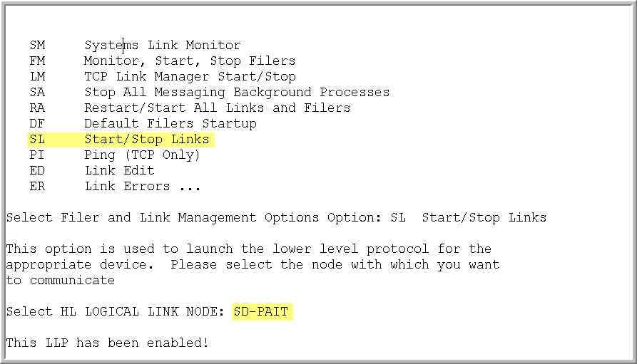

Edit the new SD-PAIT logical link:

Systems Link Monitor
Filer and Link Management Options ...
Message Management Options ...
Interface Developer Options ...
Site Parameter Edit

Select HL7 Main Menu Option: Interface Developer Options

EA Application Edit
EP Protocol Edit
EL Link Edit
VI Validate Interfaces
Reports ...

Select Interface Developer Options Option: EL Link Edit

Select HL LOGICAL LINK NODE: SD-PAIT

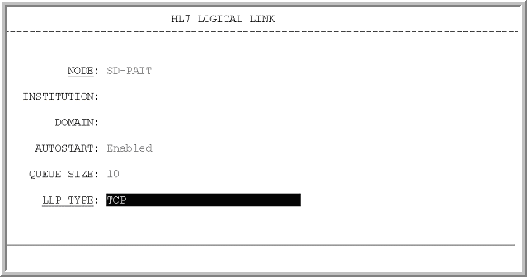

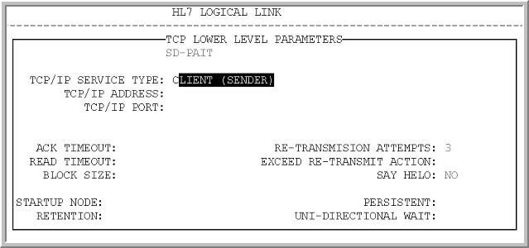

Enter the TCP/IP ADDRESS of your VistA Interface Engine

See Appendix B to determine your sites I.P. Address for the Interface Engine.

Enter the TCP/IP PORT – 9270

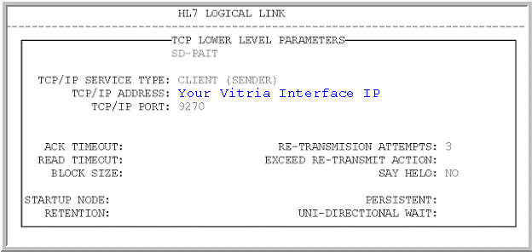

To begin the initial March 15th seeding run use Taskman option “One-time Option Queue” and select option SD-PAIT TASKED TRANSMISSION.

When prompted ‘Does this option need a DEVICE? NO//’ press return.

When prompted ‘Enter Particular Volume set if needed:’ press return.

When prompted ‘Requested Start Time: NOW//’ press return. Optionally, you may elect to schedule the initial seeding run to begin during off peak hours.

The initial seeding run will be executed only once, on March 15, 2004.

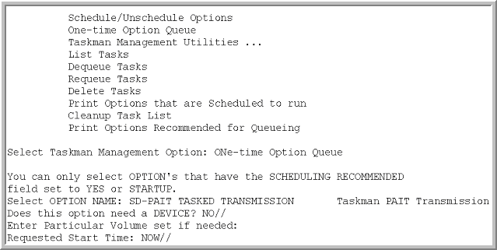

Using Taskman option Schedule/Unschedule Options schedule option SD-PAIT TASKED TRANSMISSION to run the 1st and 15th of every month. It is important to schedule the first tasked run to begin on 4.01.2004 (time is site selectable). This establishes the bi-monthly transmission schedule with the first transmission taking place on 4.01.2004

If your TASKED TRANSMISSION does not start on the 1st or 15th contact the National Help Desk (1 888 596 4357) before re-scheduling the transmission on a day other than the 1st or the 15th.
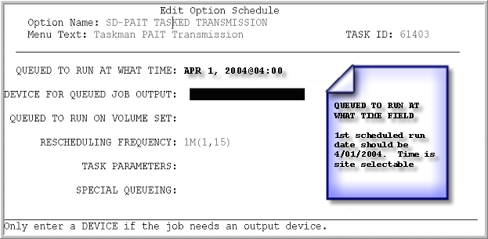

A MailMan message addressed to the SD-PAIT mail group will confirm completion of the tasked job.

User Options

Option “SD-PAIT REPORTS PAIT Reports Menu” provides four reports:

SD-PAIT PENDING Pending Transmissions
SD-PAIT REJECTED Rejected Transmissions
SD-PAIT ACK SUMMARY Acknowledgement Summary
SD-PAIT TRANSMISSION SUMMARY Transmission Summary

Pending Transmissions will list all transmitted HL7 messages whose status is Pending, but not designated as a future appointment. This report is a diagnostic tool useful for follow-up of inpatient appointments that have not been dispositioned.

Rejected Transmissions will list all transmitted HL7 messages that have been rejected by the AAC. The AAC will reject messages in which the data is not correctly formatted. Entries on this list warrant a review by the MAS ADPAC to validate patient demographic data.

Acknowledgement Summary lists all batches in Batch Control ID order. The report also indicates the Message Control ID, the Acknowledgement Date, and Acknowledgement Type.

Transmission Summary report may be used to determine the total number of patient appointment records, the run date, total number of batches, Batch Control ID, Message Control ID, and date/time stamp.

Option “ SD-PAIT MANUAL TRANSMISSION Manual Startup PAIT Transmission” can be used to start a transmission if needed

MailMan Messages

MailMan notification messages are generated for two events.

- Background processing has completed:

Subj: 500 - PAIT BACKGROUND JOB [#151708] 01/23/04@11:32 lines

The PAIT job has completed - TASK #: 60720 Log #: 1 on 1/23/04@11:32

Pending appointments: 10054
Final appointments: 1534
-----------
Total appointments: 11588 Number of batches: 3

Fac Log Bch Appt # Date finished IP Address Gen Sent Com R Com P Status
-----------------------------------------------------------------------
500| 1| 3| 11588|1/23/04@11:32|10.88.63.68| 7| 6| 6| 6| Enabled

You may monitor HL7 message transmission using option Systems Link Monitor from the HL7 Main Menu and viewing link SD-PAIT

Legend:

Fac - VistA Site Facility Number
Log - Run number
Bch - Number of generated batches
Appt # - Number of Appointments
Date finished - Date/time when the transmission has finished
IP Address - IP Address of HL Logical Link "SD_PAIT"
Gen - Number of batches generated ( including previous transmissions)
Send - Number of all sent batches (including previous transmissions)
Com R - Number of Commit Ack Received
Com P - Number of Commit Ack Processed
Status - Status of 'SD-PAIT" link at the end of transmission

2. Batch acknowledgement message from the AAC is received by the local HL7 package:

Subj: PAIT BATCH ACKNOWLEGEMENT 442179 [#1407] 01/29/04@12:18 9 lines
From: POSTMASTER In 'IN' basket. Page 1 *New*
-------------------------------------------------------------------------------
Station Number: 442
Batch Control ID: 442179
Message ID: 442179
Log Entry: 2
Run Date: Jan 29, 2004@10:02:27
Status: Acknowledged - with rejections
1 of 1 ACKs received for this run date

Use option SD-PAIT REJECTED Rejected Transmissions to view the rejections.

Subj: PAIT BATCH ACKNOWLEGEMENT [#9418309] 10/28/03@13:38 1 line
From: POSTMASTER In 'IN' basket. Page 1 *New*
-----------------------------------------------------------------------------
Batch 64918243649 has been acknowledged. There were no rejections.

Technical Information

SD*5.3*333 Imports the following components:

POST-INIT ROUTINE
SDP333P (May be deleted after install)

FILES - updated
  - PATIENT APPOINTMENT INFO LOG
404.472 PCMM HL7 ERROR CODE FILE

GLOBALS
^SDWL(409.6
^SCPT(404.472,

NEW AND MODIFIED PRINT TEMPLATES

SD-PAIT PAIT ACK SUMMARY
SD-PAIT PATIENT PENDING APPT
SD-PAIT REJECTED APPT
SD-PAIT TRANS SUMMARY

NEW AND MODIFIED SORT TEMPLATES

SD-PAIT PAIT ACK SOR
SD-PAIT PEND EXCL FUTURE
SD-PAIT REJECTED APPT
SD-PAIT TRANS SUMMARY

MAIL GROUP
SD-PAIT

MODIFIED ROUTINES

SDRPA00
SDRPA05
SDRPA06
SDRPA07
SDRPA08

NEW ROUTINE

SDRPA09

OPTIONS

SD-PAIT MANUAL TRANSMISSION
SD-PAIT TASKED TRANSMISSION
SD-PAIT REPORTS
SD-PAIT PENDING
SD-PAIT REJECTED
SD-PAIT TRANSMISSION SUMMARY
SD-PAIT ACK SUMMARY

PROTOCOLS

SD-PAIT-EVENT
SD-PAIT-SUBS

HL7 APPLICATION PARAMETERS

SD-AAC-PAIT
SD-SITE-PAIT

HL LOGICAL LINK

SD-PAIT

BACKGROUND JOB

SD-PAIT TASKED TRANSMISSION

SECURITY KEYS
NONE

BULLETINS

NO BULLETINS are generated with this patch. Please reference MAILMAN
NOTIFICATION MESSAGES listed above

Initial Seeding Run Times:

Site | Patients (File 2) | Batch Messages | Entries Added to file 409.6 | Run Time
REDACTED | 410,263 | 77 | 380,795 | 3.5 days
REDACTED | 72,589 | 21 | 102,425 | 1 day
REDACTED | 71,295 | 18 | 88,933 | 1 day
REDACTED | 213,732 | 27 | 133,397 | 1.5 days

GLOBAL GROWTH

Each entry added to file 409.6 takes approximately 250 bytes. A medium to large site will require at least 120MB of available space on the volume set containing the ^SDWL(409.6 global to accommodate the initial seeding process.

HL7 messages generated by the seeding process take approximately 4 Mb per batch message. A medium to large site will generate 60 to 100 batches on the initial seeding run which corresponds to at least 240Mb of available space on the volume set containing the HL7 globals.

^XMTP globals are created and used to record acknowledgment processing and have been defined to remain in the system for three days.

^XTMP(“SDRPA-”_BATCHNUMBER, [Diagnostics]

Appendix A – HL7 Specifications

HL7 Interface Specification for Patient Appointment Information Transmission

Introduction

This interface specification details the information needed for the Patient Appointment Information Transmission data reporting. This data transmission will be triggered by a TaskMan queued job in VistA. The basic communication protocol will be addressed, as well as the information that will be made available and how it will be obtained.

General

The formats of these messages conform to the Version 2.4 HL7 Interface Standards where applicable. HL7 custom message formats (“Z” segments) are used only when necessary.

1.2 Message Content

The table below describes the data fields and HL7 mappings:

Data item | Length | Type | Definition | HL7
Integration Control Number | 10 | Alpha-numeric | ICN is a VHA wide internal key, uniquely assigned to each PATIENT. The ICN is a 10 digit. | PID.3
Patient’s DFN | 8 | Numeric | The internal number of the patient from within the Patient file. | PID.3
Patient’s SSN | 10 | 9 Numeric, 1 Alpha | The social security number or the generated pseudo SSN of the patient. | PID.19
Last Name  First Name  Middle Name | 45 | Text | The name of the patient. Held as three distinct names with a combined maximum length of 45 characters | PID.5
Date Of Birth | 8 | Date | The date of birth of the patient. | PID.7
Current SC status | 1 | Text | Current service connected status, Y/N | ZSP.2
Current SC percentage | 3 | Numeric | Current service connected percentage | ZSP.3
Date Appointment Created | 8 | Date | The date the appointment was created | SCH.11
Desired Appointment Date | 8 | Date | The date the appointment was requested to take place. | SCH.11
Appointment Date | 12 | Date/time | The date the appointment was scheduled to be kept. | SCH.11
Appointment status | 3 | Text | See table 0278 | SCH.25
Next Available Request Flags | 1 | Numeric | See table 0276 | SCH.7
Cancellation Date | 12 | Date/time | If the appointment was cancelled by the clinic or the patient, the date of cancellation. | SCH.11
Reschedule Date | 12 | Date/time | The date an appointment was rescheduled for without auto-rebooking | SCH.11
Auto-rebook Flag | 1 | Numeric | See table 0276 | SCH.7
Auto-rebook Date | 12 | Date/time | Date of the auto-rebooked appointment | SCH.11
New to Facility/Clinic Flag | 1 | Text | NTF if the patient did not have a prior appointment at this facility in the past 24 months. SHB otherwise. | PV2.24
Enrollment Priority | 1 | Alpha numeric | See table VA0021 | ZEN
Service Connection Condition Flag | 1 | Numeric | See table SD008 | ZCL.2
Agent Orange Exposure | 1 | Numeric | See table SD008 | ZCL.2
Ionizing Radiation Exposure | 1 | Numeric | See table SD008 | ZCL.2
Environmental Contaminants | 1 | Numeric | See table SD008 | ZCL.2
Military Sexual Trauma | 1 | Numeric | See table SD008 | ZCL.2
Head and/or Neck Cancer | 1 | Numeric | See table SD008 | ZCL.2
Clinic IEN Number | 6 | Numeric | Internal Identifier of the Hospital Location the appointment was scheduled for. | AIL.3.1
Clinic Name | 30 | Text | Name of Clinic from file 44 | AIL.3.9
DSS Identifier of Clinic | 3 | Numeric | Stop code of the Hospital Location file the appointment was scheduled for. | AIL.4
DSS Credit Stop of Clinic | 3 | Numeric | Credit stop code of the Hospital Location file | AIL.5
Facility Number | 6 | Three digit numeric station number plus any modifiers | Station Number, field #99 from the Institution file | PV1.39
Provider |  | Text | IEN and name of provider associated with the  Hospital Location | AIP.3
Check out Date | 12 | Date/time | Date of appointment checkout. It is considered to be a kept appointment. | SCH.11
Appointment Type | 3 | Alpha | See Table 0277 | SCH.8
Scheduling Event Reason | 3 | Alpha | See Table VA087 | SCH.6
Admission Type | 4 | Numeric | See table SD009 | PV1.4
Consult Request Date | 12 | Date | The request date and time of the related consult if applicable – the DATE OF REQUEST field (#3) of the REQUEST/  CONSULTATION  file (#123). | SCH.11

Note: If the appointment is SC (Service Connected) related then only MST and
Head and/or Neck cancer may be identified as well. All other classifications
can be claimed only if the appointment is not SC.

SIU | SIU Message | Section
BSH | Batch Header | 2.3.2
{MSH | Message Header | 2.3.1
SCH | Schedule Activity Information | 2.3.9
PID | Patient Identification | 2.3.4
PV1 | Patient Visit | 2.3.5
PV2 | Patient Visit | 2.3.6
[{AIP}] | Appointment information - personnel resource segment | 2.3.7
{AIL} | Appointment Information | 2.3.8
[{ZCL}] | VA-Specific Outpatient Classification | 2.3.10
[{ZEN}] | VA Specific Enrollment | 2.3.11
{ZSP}} | VA-Specific Service Period | 2.3.12
BTS | Batch Trailer | 2.3.3

1.2.0 Data Capture and Transmission

A Taskman background job will be scheduled to run at specified intervals. The background job will collect and format data for HL7 batch transmission.

A determined number of appointments is generated into a temporary file. That file is sent to create HL7 transmission in a batch format. As soon as the batch is put into a queue, the temporary file is deleted and the process of generating data for transmission continues until all required data is generated and transmitted. That design allows for an immediate transmission after generation of a partial data, and prevents the temporary file from growing tremendously before it is sent for transmission. The process is repeated until all required data is generated and transmitted.

The follow up transmissions will be created as batch messages with all appointments made starting from the next date to the last scanned appointment creation date of the last transmission, and with previously sent appointments, if their statuses turn out to have one of the final values, see SCH.25. Filler Status in SIU Event Mapping Table. The previously sent appointments are evaluated for a possible final transmission from the Patient Transmission Info Log file (#409.6). Appointments entries in that file that were sent with the final status will be deleted after an acknowledgement of the successful transmission is received.

1.2.1 Batch Messages

Batch messages will be used to transmit patient appointment information. Each batch message may contain up to 5000 messages. One message will represent one patient appointment.

1.2.2 Batch Acknowledgements

Each batch message sent will be acknowledged at the application level.

1.2.3 Lower Level Protocol

TCP/IP will be used.

2 HL7 Control Segments

This section defines the HL7 control segments supported by VistA and implemented in this transmission. The messages are presented separately and defined by category. Segments are also described.

2.1 Message Definitions

Each message is composed of segments. Segments contain logical groupings of data. Segments may be optional or repeatable. A [ ] indicates the segment is optional, the { } indicates the segment is repeatable. For each message category there will be a list of HL7 standard segments or "Z" segments used for the message.

2.2 Segment Table Definitions

For each segment, the data elements are described in table format. The table includes the sequence number (SEQ), maximum length (LEN), data type (DT), required or optional (R/O), repeatable (RP/#), the table number (TBL #), the element name, and the VistA description. Each segment is described in the following sections.

2.3 Message Control Segments

This section describes the message control segments which are contained in message types described in this document. These are generic descriptions. Any time any of the segments described in this section are included in a message in this document, the VistA descriptions and mappings will be as specified here, unless otherwise specified in that section.

2.3.1 MSH - Message Header Segment
SEQ | LEN | DT | R/O | RP/# | TBL# | ELEMENT NAME | VISTA DESCRIPTION
1 | 1 | ST | R |  |  | Field Separator | Recommended value is ^ (caret)
2 | 4 | ST | R |  |  | Encoding Characters | Recommended delimiter values:  Component = ~ (tilde)  Repeat = | (bar)  Escape = \ (back slash)  Subcomponent = & (ampersand)
3 | 15 | ST |  |  |  | Sending Application | When originating from facility:  SD-SITE-PAIT  When originating from ACC:  SD-AAC-PAIT
4 | 20 | ST |  |  |  | Sending Facility | When originating from facility:  Station's facility number
5 | 30 | ST |  |  |  | Receiving Application | SD-AAC-PAIT
6 | 30 | ST |  |  |  | Receiving Facility | 200
7 | 26 | TS |  |  |  | Date/Time Of Message | Not used
8 | 40 | ST |  |  |  | Security | Not used
9 | 7 | CM | R |  | 0076  0003 | Message Type | 2 Components  - Message type  - Trigger event
10 | 20 | ST | R |  |  | Message Control ID | Batch and sequence number automatically generated by VISTA HL7 Package
11 | 1 | ID | R |  |  | Processing ID | P (production)
12 | 8 | ID | R |  |  | Version ID | 2.4 (Version 2.4)
13 | 15 | NM |  |  |  | Sequence Number | Not used
14 | 180 | ST |  |  |  | Continuation Pointer | Not used
15 | 2 | ID |  |  |  | Accept Acknowledgment Type | AL (always acknowledge)
16 | 2 | ID |  |  |  | Application Acknowledgment Type | AL (always acknowledge)
17 | 3 | ID |  |  |  | Country Code | USA

2.3.2 BHS – Batch Header Segment
SEQ | LEN | DT | R/O | RP/# | TBL# | ELEMENT NAME | VISTA DESCRIPTION
1 | 1 | ST | R |  |  | Batch Field Separator | Recommended value is ^
2 | 4 | ST | R |  |  | Batch Encoding Characters | Delimiter values:  Component = ~ (tilde)  Repeat = | (bar)  Escape = \ (back slash)  Subcomponent = &
3 | 15 | ST |  |  |  | Batch Sending Application | When originating from facility: SD-SITE-PAIT  When originating from AAC:  SD-ACC-PAIT
4 | 20 | ST |  |  |  | Batch Sending Facility | When originating from facility:  Station's facility number  when originating from AAC: 200
5 | 15 | ST |  |  |  | Batch Receiving Application | When originating from facility: SD-ACC-PAIT  When originating from AAC:  SD-SITE-PAIT
6 | 20 | ST |  |  |  | Batch Receiving Facility | When originating from facility:  Station's facility number  When originating from AAC: 200
7 | 26 | TS |  |  |  | Batch Creation Date/Time | Date and time batch message was created
8 | 40 | ST |  |  |  | Batch Security | Not used
9 | 20 | ST |  |  |  | Batch Name/ID/Type | Components  - Not used  - P  - SIU,S12  - 2.4  5. AL  6. AL
10 | 80 | ST |  |  | 0008 | Batch Comment | Components  - Acknowledgement Code  - Text Message
11 | 20 | ST |  |  |  | Batch Control ID | When originating from facility:  Automatically generated by VISTA HL7 Package  When Originating from AAC:  Acknowledgement msg #
12 | 20 | ST |  |  |  | Reference Batch Control ID | When originating from facility: Null  When originating from AAC:  Batch Control ID of batch message being acknowledged

2.3.3 BTS - Batch Trailer Segment
SEQ | LEN | DT | R/O | RP/# | TBL# | ELEMENT NAME | VISTA DESCRIPTION
1 | 10 | ST |  |  |  | Batch Message Count | Number of messages within batch
2 | 80 | ST |  |  |  | Batch Comment | Not used
3 | 100 | CM |  | Y |  | Batch Totals | Not used

2.3.4 PID - Patient Identification Segment
SEQ | LEN | DT | R/O | RP/# | TBL# | ELEMENT NAME | VISTA DESCRIPTION
1 | 4 | SI |  |  |  | Set ID - Patient ID | Sequential Number
2 | 17 | CK |  |  |  | Patient ID (External ID) | Primary Long ID
3 | 21 | CM | R |  |  | Patient ID (Internal ID) | Component  1. ICN  2. NULL  3. NULL  4. USVHA&&L  5. NI  Repetition  - DFN  - Null  - Null  - USVHA&&L  - PI
4 | 12 | ST |  |  |  | Alternate Patient ID | Not used
5 | 48 | PN | R |  |  | Patient Name | Component  - Family name  - Given name  - Middle initial  - Suffix
6 | 30 | ST |  |  |  | Mother's Maiden Name | Not used
7 | 26 | TS |  |  |  | Date of Birth | Date of birth
8 | 1 | ID |  |  |  | Sex | Not used
9 | 48 | PN |  |  |  | Patient Alias | Not used
10 | 1 | ID |  |  |  | Race | Not used
11 | 106 | AD |  |  |  | Patient Address | Zip Code

2.3.4 PID - Patient Identification Segment (continued)
12 | 4 | ID |  |  |  | County Code | Not used
13 | 40 | TN |  |  |  | Phone Number - Home | Not used
14 | 40 | TN |  |  |  | Phone Number - Business | Not used
15 | 25 | ST |  |  |  | Language - Patient | Not used
16 | 1 | ID |  |  |  | Marital Status | Not used
17 | 3 | ID |  |  |  | Religion | Not used
18 | 20 | CK |  |  |  | Patient Account Number | Not used
19 | 16 | ST |  |  |  | SSN Number - Patient | Social security number and pseudo indicator
20 | 25 | CM |  |  |  | Driver's Lic Num - Patient | Not used
21 | 20 | CK |  |  |  | Mother's Identifier | Not used
22 | 1 | ID |  |  |  | Ethnic Group | Not used
23 | 25 | ST |  |  |  | Birth Place | Not used
24 | 2 | ID |  |  |  | Multiple Birth Indicator | Not used
25 | 2 | NM |  |  |  | Birth Order | Not used
26 | 3 | ID |  |  |  | Citizenship | Not used
27 | 60 | CE |  |  |  | Veterans Military Status | Not used

2.3.5 PV1 - Patient Visit Segment
SEQ | LEN | DT | R/O | RP/# | TBL# | ELEMENT NAME | VISTA DESCRIPTION
1 | 4 | SI |  |  |  | Set ID - Patient Visit | Sequential Number
2 | 1 | ID |  |  | 0004 | Patient Class | Patient Class
3 | 12 | CM |  |  |  | Assigned Patient Location | Not used
4 | 4 | ID |  |  | 0007 | Admission Type | Refer to table SD009 (Purpose of Visit/Appointment Type)
5 | 20 | ST |  |  |  | Preadmit Number | Not used
6 | 12 | CM |  |  |  | Prior Patient Location | Not used
7 | 60 | CN |  |  |  | Attending Doctor | Not used
8 | 60 | CN |  |  |  | Referring Doctor | Not used
9 | 60 | CN |  |  |  | Consulting Doctor | Not used
10 | 3 | ID |  |  |  | Hospital Service | Not used
11 | 12 | CM |  |  |  | Temporary Location | Not used
12 | 2 | ID |  |  |  | Preadmit Test Indicator | Not used
13 | 2 | ID |  |  |  | Readmission Indicator | Not used
14 | 3 | ID |  |  |  | Admit Source | Not used
15 | 2 | ID |  |  |  | Ambulatory Status | Not used
16 | 2 | ID |  |  |  | VIP Indicator | Not used
17 | 60 | CN |  |  |  | Admitting Doctor | Not used
18 | 2 | ID |  |  |  | Patient Type | Not used
19 | 15 | NM |  |  |  | Visit Number | Not used
20 | 50 | CM |  |  |  | Financial Class | Not used
21 | 2 | ID |  |  |  | Charge Price Indicator | Not used
22 | 2 | ID |  |  |  | Courtesy Code | Not used
23 | 2 | ID |  |  |  | Credit Rating | Not used
24 | 2 | ID |  |  |  | Contract Code | Not used
PV1 - Patient Visit Segment (continued)
SEQ | LEN | DT | R/O | RP/# | TBL# | ELEMENT NAME | VISTA DESCRIPTION
25 | 8 | DT |  |  |  | Contract Effective Date | Not used
26 | 12 | NM |  |  |  | Contract Amount | Not used
27 | 3 | NM |  |  |  | Contract Period | Not used
28 | 2 | ID |  |  |  | Interest Code | Not used
29 | 1 | ID |  |  |  | Transfer to Bad Debt Code | Not used
30 | 8 | DT |  |  |  | Transfer to Bad Debt Date | Not used
31 | 10 | ID |  |  |  | Bad Debt Agency Code | Not used
32 | 12 | NM |  |  |  | Bad Debt Transfer Amount | Not used
33 | 12 | NM |  |  |  | Bad Debt Recovery Amount | Not used
34 | 1 | ID |  |  |  | Delete Account Indicator | Not used
35 | 8 | DT |  |  |  | Delete Account Date | Not used
36 | 3 | ID |  |  |  | Discharge Disposition | Not used
37 | 25 | CM |  |  |  | Discharged to Location | Not used
38 | 2 | ID |  |  |  | Diet Type | Not used
39 | 7 | ID |  |  |  | Servicing Facility | Facility number or Facility number+ suffix
40 | 1 | ID |  |  |  | Bed Status | Not used
41 | 2 | ID |  |  |  | Account Status | Not used
42 | 12 | CM |  |  |  | Pending Location | Not used
43 | 12 | CM |  |  |  | Prior Temporary Location | Not used
44 | 26 | TS |  |  |  | Admit Date/Time | Not used
45 | 26 | TS |  |  |  | Discharge Date/Time | Not used
46 | 12 | NM |  |  |  | Current Patient Balance | Not used
47 | 12 | NM |  |  |  | Total Charges | Not used
48 | 12 | NM |  |  |  | Total Adjustments | Not used
49 | 12 | NM |  |  |  | Total Payments | Not used
50 | 20 | CM |  |  |  | Alternate Visit ID | Not used

2.3.6 PV2 Patient Visit
SEQ | LEN | DT | R/ | RP/# | TBL# | ITEM# | ELEMENT NAME | VISTA DESCRIPTION
1 | 80 | PL | C |  |  | 0011 | Prior Pending Location | Not used
2 | 60 | CE | O |  |  | 0012 | Accommodation Code | Not used
3 | 60 | CE | O |  |  | 0013 | Admit Reason | Not used
4 | 60 | CE | O |  |  | 0014 | Transfer Reason | Not used
5 | 25 | ST | O |  |  | 0015 | Patient Valuables | Not used
6 | 25 | ST | O |  |  | 0016 | Patient Valuables Location | Not used
7 | 2 | IS | O |  |  | 0017 | Visit User Code | Not used
8 | 26 | TS | O |  |  | 0018 | Expected Admit Date/Time | Not used
9 | 26 | TS | O |  |  | 0019 | Expected Discharge Date/Time | Not used
10 | 3 | NM | O |  |  | 0071 | Estimated Length of Inpatient Stay | Not used
11 | 3 | NM | O |  |  | 0072 | Actual Length of Inpatient Stay | Not used
12 | 50 | ST | O |  |  | 0073 | Visit Description | Not used
13 | 90 | XCN | O |  |  | 0074 | Referral Source Code | Not used
14 | 8 | DT | O |  |  | 0075 | Previous Service Date | Not used
15 | 1 | ID | O |  |  | 0076 | Employment Illness Related Indicator | Not used
16 | 1 | IS | O |  |  | 0077 | Purge Status Code | Not used
17 | 8 | DT | O |  |  | 0078 | Purge Status Date | Not used
18 | 2 | IS | O |  |  | 0079 | Special Program Code | Not used
19 | 1 | ID | O |  |  | 0070 | Retention Indicator | Not used
20 | 1 | NM | O |  |  | 0071 | Expected Number of Insurance Plans | Not used
21 | 1 | IS | O |  |  | 0072 | Visit Publicity Code | Not used
22 | 1 | ID | O |  |  | 0073 | Visit Protection Indicator | Not used
23 | 90 | XON | O |  |  | 0074 | Clinic Organization Name | Not used
24 | 2 | IS | O |  | 0216 | 0075 | Patient Status Code | New to Facility/ Clinic
25 | 1 | IS | O |  |  | 0076 | Visit Priority Code | Not used
26 | 8 | DT | O |  |  | 0077 | Previous Treatment Date | Not used
27 | 2 | IS | O |  |  | 0078 | Expected Discharge Disposition | Not used
28 | 8 | DT | O |  |  | 0079 | Signature on File Date | Not used
29 | 8 | DT | O |  |  | 0070 | First Similar Illness Date | Not used
30 | 3 | IS | O |  |  | 0071 | Patient Charge Adjustment Code | Not used
31 | 2 | IS | O |  |  | 0072 | Recurring Service Code | Not used
32 | 1 | ID | O |  |  | 0073 | Billing Media Code | Not used
33 | 26 | TS | O |  |  | 0074 | Expected Surgery Date & Time | Not used
34 | 2 | ID | O |  |  | 0075 | Military Partnership Code | Not used
35 | 2 | ID | O |  |  | 0076 | Military Non-Availability Code | Not used
36 | 1 | ID | O |  |  | 0077 | Newborn Baby Indicator | Not used
37 | 1 | ID | O |  |  | 0078 | Baby Detained Indicator | Not used

2.3.7 AIP - Appointment Information - Personnel Resource Segment
SEQ | LEN | DT | R/O/C | RP/# | TBL# | ITEM# | ELEMENT NAME | VISTA DESCRIPTION
1 | 4 | SI | R |  |  | 00906 | Set ID - AIP | Sequential Number
2 | 3 | ID | C |  |  | 00763 | Segment Action code | Not used
3 | 80 | XCN | C | Y |  | 00913 | Personnel Resource ID | Component  - Provider IEN  - Family name  - Given name  - Middle name or initial  - Suffix
4 | 200 | CE | R |  |  | 00907 | Resource Role | Provider
5 | 200 | CE | O |  |  | 00899 | Resource Group | Not used
6 | 26 | TS | C |  |  | 01202 | Start Date/Time | Not used
7 | 20 | NM | C |  |  | 00891 | Start Date/Time Offset | Not used
8 | 200 | CE | C |  |  | 00892 | Start Date/Time Offset Units | Not used

2.3.8 AIL Appointment Information
SEQ | LEN | DT | R/O/C | RP/# | TBL# | ITEM# | ELEMENT NAME | VISTA DESCRIPTION
1 | 4 | SI | R |  |  | 00902 | Set ID - AIL | Sequential Number
2 | 1 | ID | C |  |  | 00763 | Segment Action Code | Not used
3 | 90 | PL | C |  |  | 00903 | Location Resource ID | Clinic Name  Components  1. Clinic IEN (20)  2. Null  3. Null  4. Null  5. Null  6. Null  7. Null  8. Null  9. Clinic name (60)
4 | 100 | CE | R |  | VA088 | 00904 | Location Type | DSS ID  Components  - DSS Clinic ID code (3)  - Description (40)  - ‘DSS Clinic ID” (13)
5 | 100 | CE | O |  | VA088 | 00905 | Location Group | DSS credit stop  - DSS credit stop code (3)  - Description (40)  - “DSS Credit Stop” (15)
6 | 26 | TS | C |  |  | 01202 | Start Date/Time | Not used
7 | 20 | NM | C |  |  | 00891 | Start Date/Time Offset | Not used
8 | 200 | CE | C |  |  | 00892 | Start Date/Time Offset Units | Not used
9 | 20 | NM | O |  |  | 00893 | Duration | Not used
10 | 200 | CE | O |  |  | 00894 | Duration Units | Not used
11 | 10 | IS | C |  |  | 00895 | Allow Substitution Code | Not used
12 | 200 | CE | C |  |  | 00889 | Filler Status Code | Not used

2.3.9 SCH Schedule Activity Information
SEQ | LEN | DT | R/O/C | RP/# | TBL# | ITEM# | ELEMENT NAME | VISTA DESCRIPTION
1 | 75 | EI | R |  |  | 00860 | Placer Appointment ID | Sequential Number
2 | 75 | EI | C |  |  | 00861 | Filler Appointment ID | Not used
3 | 5 | NM | C |  |  | 00862 | Occurrence Number | Not used
4 | 75 | EI | O |  |  | 00863 | Placer Group Number | Not used
5 | 200 | CE | O |  |  | 00864 | Schedule ID | Not used
6 | 3 | CE | O |  | VA087 | 00883 | Event Reason | Component  Scheduling Event Reason codes.
7 | 1 | CE | O |  | 0276 | 00866 | Appointment Reason | Appointment Reason
8 | 3 | CE | O |  | 0277 | 00867 | Appointment Type | Appointment Type Codes
9 | 20 | NM | O |  |  | 00868 | Appointment Duration | Not used
10 | 200 | CE | O |  |  | 01304 | Appointment Duration Units | Not used
11 | 200 | TQ | O | Y |  | 00884 | Appointment Timing Quantity | In the following order:  Date Appt Created  Desired Date  Appt Date (time)  Checkout Date (time)  Cancellation Date (time)  Auto-rebook Date(time)  Resched Date(time)
12 | 48 | XCN | O |  |  | 00874 | Placer Contact Person | Not used
13 | 40 | XTN | O |  |  | 00875 | Placer Contact Phone Number | Not used
14 | 106 | XAD | O |  |  | 00876 | Placer Contact Address | Not used
15 | 80 | PL | O |  |  | 00877 | Placer Contact Location | Not used
16 | 38 | XCN | R |  |  | 00885 | Filler Contact Person | Not used
17 | 40 | XTN | O |  |  | 00886 | Filler Contact Phone Number | Not used
18 | 106 | XAD | O |  |  | 00887 | Filler Contact Address | Not used
19 | 80 | PL | O |  |  | 00888 | Filler Contact Location | Not used
20 | 48 | XCN | R |  |  | 00878 | Entered by Person | Not used
21 | 40 | XTN | O |  |  | 00879 | Entered by Phone Number | Not used
22 | 80 | PL | O |  |  | 00880 | Entered by Location | Not used
23 | 75 | EI | O |  |  | 00881 | Parent Placer Appointment ID | Not used
24 | 75 | EI | O |  |  | 00882 | Parent Filler Appointment ID | Not used
25 | 200 | CE | R |  | 0278 | 00889 | Filler Status Code | Appointment Status

2.3.10 ZCL - VA-Specific Outpatient Classification Segment
SEQ | LEN | DT | R/O | RP/# | TBL# | VISTA ELEMENT NAME
1 | 4 | SI | R |  |  | SET ID
2 | 2 | ID | R |  | SD008 | Outpatient Classification Type
3 | 50 | ST |  |  |  | Value

2.3.11 ZEN - VA-Specific Enrollment Segment
SEQ | LEN | DT | R/O | RP/# | TBL# | VISTA ELEMENT NAME
1 | 4 | SI | R |  |  | SET ID
2 | 8 | DT |  |  |  | Not used
3 | 1 | ID |  |  |  | Not used
4 | 1 | ID |  |  |  | Not used
5 | 1 | ID |  |  |  | Not used
6 | 60 | TX |  |  |  | Not used
7 | 7 | ID |  |  |  | Not used
8 | 7 | ID |  |  |  | Not used
9 | 1 | ID |  |  | VA0021 | ENROLLMENT PRIORITY
10 | 8 | DT |  |  |  | not used

2.3.12 ZSP - VA-Specific Service Period Segment
SEQ | LEN | DT | R/O | RP/# | TBL# | VISTA ELEMENT NAME
1 | 4 | SI | R |  |  | SET ID
2 | 1 | ID | R |  | VA01 | Service Connected?
3 | 3 | NM |  |  |  | Service Connected Percentage
4 | 2 | ID |  |  |  | NOT USED
5 | 1 | ID |  |  |  | NOT USED

3.0 SUPPORTED AND USER-DEFINED HL7 TABLES

Table 0003 - Event type
VALUE | DESCRIPTION
S12 | SIU/ACK - Notification of new appointment booking
S14 | SIU/ACK - Notification of appointment modification
S15 | SIU/ACK - Notification of appointment cancellation
S26 | SIU/ACK Notification that patient did not show up for schedule appointment

Table 0004 – Patient Class
VALUE | DESCRIPTION
I | INPATIENT
O | OUTPATIENT
U | UNKNOWN

Table 0008 - Acknowledgment Code
VALUE | DESCRIPTION
AA | APPLICATION ACKNOWLEDGMENT: ACCEPT
AE | APPLICATION ACKNOWLEDGMENT: ERROR
AR | APPLICATION ACKNOWLEDGMENT: REJECT
MR | APPLICATION ACKNOWLEDGMENT: MANUAL REJECT
CA | ACCEPT ACKNOWLEDGMENT: COMMIT ACCEPT
CE | ACCEPT ACKNOWLEDGMENT: COMMIT ERROR
CR | ACCEPT ACKNOWLEDGMENT: COMMIT REJECT

The patch is prepared for ‘AR’ – THE WHOLE BATCH REJECTION but
It has not been expected to receive that code from the AAC at this time.
‘MR’ may be used instead.

Table 0076 - Message Type
VALUE | DESCRIPTION
SIU | SIU MESSAGE
ACK | GENERAL ACKNOWLEDGMENT

Table 0216 - Patient Status Codes
VALUE | DESCRIPTION
NTF | Patient did not have a prior appointment at this Facility in the past 24 months; New to parent and substation.
SHB | Patient did have a prior appointment at this parent and substation in the past 24 months; Registered here before.
OPN | Patient did not have a prior appointment at this substation but was registered with parent station.

The patient status code indicates if a patient is new to the facility or not. Both the parent station and the substations are evaluated as the facility. The parent station is evaluated with the primary DSS ID only; the substation is evaluated with both DSS ID stop code and the DSS credit stop code. The patient is considered new to the facility if he/she did not have another scheduled appointment in the same facility during the previous 24 months. The facility’s station number is determined from the Division (field #3.5) of the clinic’s Hospital Location file #44 entry. The division is retrieved from the Medical Center Division file #40.8 from which the Institution File Pointer field (#.07) is used to look up the Institution file #4 entry where the Station Number field (#99) is stored.

Table 0276 - Appointment Reason Codes
VALUE | DESCRIPTION
1 | Next Ava. Appt. Indicated by User
2 | Next Ava. Appt. Indicated by Calculation
3 | Next Ava. Appt. Indicated by User & Calculation
4 | Not Next Available with AutoRebook
5 | Not Next Available No AutoRebook
6 | Null (All others)

Table 0277 - Appointment Type Codes
VALUE | DESCRIPTION
AR | Action required
NAT | No action taken
F | Future
NC | Non count
NCF | Non count future
ABK | Auto re-book
O | Outpatient
I | Inpatient
RS | Re-schedule

Table 0278 Filler Status Codes
VALUE | DESCRIPTION
P | Pending
F | Final

Table VA01 - Yes/No
VALUE | DESCRIPTION
0 | NO
1 | YES
N | NO
Y | YES
U | UNKNOWN

Table SD008 - Outpatient Classification Type
VALUE | DESCRIPTION
1 | AGENT ORANGE
2 | IONIZING RADIATION
3 | SERVICE CONNECTED
4 | ENVIRONMENTAL CONTAMINANTS
5 | MILITARY SEXUAL TRAUMA
6 | HEAD AND/OR NECK CANCER

Table SD009 - Purpose of Visit & Appointment Type
VALUE | PURPOSE OF VISIT | APPOINTMENT TYPE
0101 | C&P | COMPENSATION & PENSION
0102 | C&P | CLASS II DENTAL
0103 | C&P | ORGAN DONORS
0104 | C&P | EMPLOYEE
0105 | C&P | PRIMA FACIA
0106 | C&P | RESEARCH
0107 | C&P | COLLATERAL OF VET.
0108 | C&P | SHARING AGREEMENT
0109 | C&P | REGULAR
0111 | C&P | SERVICE CONNECTED
0201 | 10-10 | COMPENSATION & PENSION
0202 | 10-10 | CLASS II DENTAL
0203 | 10-10 | ORGAN DONORS
0204 | 10-10 | EMPLOYEE
0205 | 10-10 | PRIMA FACIA
0206 | 10-10 | RESEARCH
0207 | 10-10 | COLLATERAL OF VET.
0208 | 10-10 | SHARING AGREEMENT
0209 | 10-10 | REGULAR
0211 | 10-10 | SERVICE CONNECTED
0301 | SCHEDULED VISIT | COMPENSATION & PENSION
0302 | SCHEDULED VISIT | CLASS II DENTAL
0303 | SCHEDULED VISIT | ORGAN DONORS
0304 | SCHEDULED VISIT | EMPLOYEE
0305 | SCHEDULED VISIT | PRIMA FACIA
0306 | SCHEDULED VISIT | RESEARCH
0307 | SCHEDULED VISIT | COLLATERAL OF VET.
0308 | SCHEDULED VISIT | SHARING AGREEMENT
0309 | SCHEDULED VISIT | REGULAR
0311 | SCHEDULED VISIT | SERVICE CONNECTED
0401 | UNSCHED. VISIT | COMPENSATION & PENSION
0402 | UNSCHED. VISIT | CLASS II DENTAL
0403 | UNSCHED. VISIT | ORGAN DONORS
0404 | UNSCHED. VISIT | EMPLOYEE
0405 | UNSCHED. VISIT | PRIMA FACIA
0406 | UNSCHED. VISIT | RESEARCH
0407 | UNSCHED. VISIT | COLLATERAL OF VET.
0408 | UNSCHED. VISIT | SHARING AGREEMENT
0409 | UNSCHED. VISIT | REGULAR
0411 | UNSCHED. VISIT | SERVICE CONNECTED

Value denotes a combination of Purpose of Visit & Appointment Type, which is known as “Admission Type” for the purposes of data transmission. This table is used in processing the ACRP HL7 transmission.

Note:

It has been determined that PV1 segment can contain the ‘empty’ value for sequence P1.4 and it has to be treated as acceptable. That might happen when a new appointment is scheduled in place of a previously canceled appointment, and if the original appointment has been already transmitted by PAIT.

Table VA0021 – Enrollment Priority
VALUE | DESCRIPTION
1 | Priority 1
2 | Priority 2
3 | Priority 3
4 | Priority 4
5 | Priority 5
6 | Priority 6
7 | Priority 7
8 | Priority 8

Table VA087 - Scheduling Event Reason
VALUE | DESCRIPTION
CI | Check-in
CO | Check-out
NS | No Show
CC | Cancel by clinic
CP | Cancel by patient
COE | Check-out by encounter
NM | No Match
CT | Cancelled Terminated

Table AAC001 - Error Code Set
VALUE | DESCRIPTION
100 | PATIENT DFN IS NOT NUMERIC OR IS MISSING
150 | CLINIC IEN IS NOT NUMERIC OR IS MISSING
200 | BHS STATION NUMBER AND STA3N ARE NOT EQUAL
250 | INVALID OR MISSING BHS STATION NUMBER
300 | INVALID OR MISSING STA3N
350 | HL7 DATE IS NOT IN PROPER FORMAT OR IS MISSING.
400 | DOB IS MISSING OR INVALID
450 | CREATE DATE OR APPT DATE IS MISSING
500 | CREATION DATE IS BEFORE SEPTEMBER 1, 2002
600 | RESCHEDULED DATE AND APPT TYPE ARE NOT IN AGREEMENT - Rescheduled date requires SCH.8 Appt type = ‘RS’ and vice versa
650 | CHECK OUT DATE AND EVENT REASON ARE NOT IN AGREEMENT - Check out date requires either SCH.6 Event reason = ‘CO’ or ‘COE’
700 | CANCELLATION DATE AND EVENT REASON ARE NOT IN AGREEMENT - Cancellation date requires SCH.6 Event reason = ‘CC’ or ‘CP’ or ‘NS’
750 | EVENT REASON AND FILLER STATUS ARE NOT IN AGREEMENT - All SCH.6 Event reason codes, except ‘CI’ require SCH.25 Filler status to be ‘F’ Final and accordingly only ‘CI’ and NULL should have SCH.25 Filler status to be ‘P’ Pending
800 | FILLER STATUS IS MISSING OR IS INVALID
850 | ADMIT TYPE IS INVALID (table SD009)
R | WHOLE BATCH REJECTED

R – whole batch reject may be currently generated only by manual batch rejection.

Table VA088 – DSS ID and DSS Credit Stop
Please note that this table is updated yearly and the current set up should be evaluated.
VALUE | DESCRIPTION | Allow Either | Primary | Secondary | Inactive Date
101 | EMERGENCY UNIT |  |  | S
102 | ADMITTING/SCREENING | E
103 | TELEPHONE TRIAGE |  | P
104 | PULMONARY FUNCTION | E
105 | X-RAY | E
106 | EEG | E
107 | EKG |  | P
108 | LABORATORY | E
109 | NUCLEAR MEDICINE | E
110 | CARDIOVASCULAR NUCLEAR MED | E |  |  | OCT 1,1998
111 | ONCOLOGICAL NUCLEAR MED | E |  |  | OCT 1,1998
112 | INFECTIOUS DISEASE NUCLEAR MED | E |  |  | OCT 1,1998
113 | RADIONUCLIDE TREATMENT | E |  |  | OCT 1,1998
114 | SING PHOTON EMISS TOMOGRAPHY | E |  |  | OCT 1,1998
115 | ULTRASOUND | E
116 | RESPIRATORY THERAPY | E
117 | NURSING (2ND ONLY) |  |  | S
118 | HOME TREATMENT SERVICES |  | P
119 | COMM NURSING HOME FOLLOW-UP | E
120 | HEALTH SCREENING | E
121 | RESIDENTIAL CARE (NON-MH) | E
122 | PUBLIC HEALTH NURSING | E
123 | NUTRITION/DIETETICS-INDIVIDUAL | E
124 | NUTRITION/DIETETICS-GROUP | E
125 | SOCIAL WORK SERVICE | E
126 | EVOKED POTENTIAL | E
127 | TOPOGRAPHICAL BRAIN MAPPING | E
128 | PROLONGED VIDEO-EEG MONITORING | E
129 | HYPERTENSION SCREENING | E |  |  | OCT 1,1991
130 | CHOLESTEROL SCREENING | E |  |  | OCT 1,1991
131 | BREAST CANCER SCREENING | E |  |  | OCT 1,1991
132 | MAMMOGRAM | E |  |  | OCT 1,1991
133 | CERVICAL CANCER SCREENING | E |  |  | OCT 1,1991
134 | PAP TEST | E |  |  | OCT 1,1991
135 | COLORECTAL CANCER SCREENING | E |  |  | OCT 1,1991
136 | FOBT - GUIAC SCREENING | E |  |  | OCT 1,1991
137 | ALCOHOL COUNSELING - MED CARE | E |  |  | OCT 1,1991
138 | SMOKING CESSATION | E |  |  | OCT 1,1991
139 | WEIGHT CONTROL | E |  |  | OCT 1,1991
140 | PHYS FITNESS/EXERCISE COUNSEL | E |  |  | OCT 1,1991
141 | VET IMMUNIZATION | E |  |  | OCT 1,1991
142 | COLORECTAL CA SCREEN DIG EXAM | E |  |  | OCT 1,1991
143 | PERSIAN GULF READJUST COUNSEL | E |  |  | JAN 1,1988
144 | RADIONUCLIDE THERAPY | E
145 | PHARM/PHYSIO NMP STUDIES | E
146 | PET | E
147 | TELEPHONE/ANCILLARY |  | P
148 | TELEPHONE/DIAGNOSTIC |  | P
149 | RADIATION THERAPY TREATMENT | E
150 | COMPUTERIZED TOMOGRAPHY (CT) | E
151 | MAGNETIC RESONANCE IMAGING/MRI | E
152 | ANGIOGRAM CATHETERIZATION | E
153 | INTERVENTIONAL RADIOGRAPHY | E
154 | MEG (MAGNETOENCEPHALOGRAPHY) | E
155 | INFO ASSISTS TECHNOLOGY | E
160 | CLINICAL PHARMACY |  |  | S
161 | TRANSITIONAL PHARMACY |  | P
163 | CHAPLAIN-CLINICAL SVCS-INDIV | E |  |  | OCT 1,2002
164 | CHAPLAIN-CLINICAL SVCS-GROUP | E |  |  | OCT 1,2002
165 | BEREAVEMENT COUNSELING | E
166 | CHAPLAIN SERVICE - INDIVIDUAL | E
167 | CHAPLAIN SERVICE - GROUP | E
168 | CHAPLAIN SERVICE - COLLATERAL | E
169 | TELEPHONE/CHAPLAIN |  | P
170 | HBPC - PHYSICIAN |  | P
171 | HBPC - RN/RNP/PA |  | P
172 | HBPC - NURSE EXTENDER |  | P
173 | HBPC - SOCIAL WORKER |  | P
174 | HBPC - THERAPIST |  | P
175 | HBPC - DIETITIAN |  | P
176 | HBPC - CLINICAL PHARMACIST |  | P
177 | HBPC - OTHER |  | P
178 | HBPC/TELEPHONE |  | P
179 | HOME TELEVIDEO CARE |  |  | S
180 | DENTAL | E
181 | TELEPHONE/DENTAL |  | P
185 | PHYS EXTND NP (NRS PRCNR) 2ND |  |  | S
186 | PHYS EXTND PA (PHYS ASST) 2ND |  |  | S
187 | PHYS EXTND CNS (CLN RN SPC)2ND |  |  | S
190 | ADULT DAY HEALTH CARE | E
201 | PHYSICAL MED & REHAB SVC | E
202 | RECREATION THERAPY SERVICE | E
203 | AUDIOLOGY | E
204 | SPEECH PATHOLOGY | E
205 | PHYSICAL THERAPY | E
206 | OCCUPATIONAL THERAPY | E
207 | PM&RS INCENTIVE THERAPY | E
208 | PM&RS COMPENSATED WORK THERAPY | E
209 | VIST COORDINATOR | E
210 | SPINAL CORD INJURY | E
211 | AMPUTATION FOLLOW-UP CLINIC | E
212 | EMG - ELECTROMYOGRAM | E
213 | PM&RS VOCATIONAL ASSISTANCE | E
214 | KINESIOTHERAPY | E
215 | SCI HOME CARE PROGRAM | E
216 | TELEPHONE/REHAB AND SUPPORT |  | P
217 | BROS (BLIND REHAB O/P SPEC) | E
218 | CAT BLIND REHAB | E
219 | TBI (TRAUMATIC BRAIN INJURY) | E
220 | VISOR (VISUAL IMPAIRMENT OUTPA | E
290 | OBSERVATION MEDICINE |  | P
291 | OBSERVATION SURGERY |  | P
292 | OBSERVATION PSYCHIATRY |  | P
293 | OBSERVATION NEUROLOGY |  | P
294 | OBSERVATION BLIND REHAB |  | P
295 | OBSERVATION SPINAL CORD |  | P
296 | OBSERVATION REHABILITATION |  | P
301 | GENERAL INTERNAL MEDICINE | E
302 | ALLERGY IMMUNOLOGY | E
303 | CARDIOLOGY | E
304 | DERMATOLOGY | E
305 | ENDO./METAB (EXCEPT DIABETES) | E
306 | DIABETES | E
307 | GASTROENTEROLOGY | E
308 | HEMATOLOGY | E
309 | HYPERTENSION | E
310 | INFECTIOUS DISEASE | E
311 | PACEMAKER | E
312 | PULMONARY/CHEST | E
313 | RENAL/NEPHROL(EXCEPT DIALYSIS) | E
314 | RHEUMATOLOGY/ARTHRITIS | E
315 | NEUROLOGY | E
316 | ONCOLOGY/TUMOR | E
317 | COUMADIN CLINIC | E
318 | GERIATRIC CLINIC | E
319 | GERIATRIC EVAL. & MGMT. (GEM) | E
320 | ALZHEIMER'S/DEMENTIA CLINIC | E
321 | GI ENDOSCOPY | E
322 | WOMEN'S CLINIC | E
323 | PRIMARY CARE/MEDICINE | E
324 | TELEPHONE/MEDICINE |  | P
325 | TELEPHONE/NEUROLOGY |  | P
326 | TELEPHONE/GERIATRICS |  | P
327 | MED MD PERFORM INVASVE OR PROC |  | P
328 | MEDICAL/SURGICAL DAY UNIT MSDU | E
329 | MEDICAL PROCEDURE UNIT | E
330 | CHEMOTHERAPY PROC. UNIT-MED. | E
331 | PRE-BED CARE MD (MEDICINE) | E
332 | PRE-BED CARE RN (MEDICINE) | E
333 | CARDIAC CATHETERIZATION | E
334 | CARDIAC STRESS TEST/ETT | E
335 | PADRECC PARKINSON'SDISEASERECC | E
350 | GERIATRIC PRIMARY CARE | E
351 | ADVNCD ILLNESS COOR CARE(AICC) | E
370 | LTC SCREENING (2ND ONLY) |  |  | S
401 | GENERAL SURGERY | E
402 | CARDIAC SURGERY | E
403 | ENT | E
404 | GYNECOLOGY | E
405 | HAND SURGERY | E
406 | NEUROSURGERY | E
407 | OPHTHALMOLOGY | E
408 | OPTOMETRY | E
409 | ORTHOPEDICS | E
410 | PLASTIC SURGERY | E
411 | PODIATRY | E
412 | PROCTOLOGY | E
413 | THORACIC SURGERY | E
414 | UROLOGY | E
415 | VASCULAR SURGERY | E
416 | AMB SURGERY EVAL BY NON-MD | E
417 | PROSTHETICS/ORTHOTICS | E
418 | AMPUTATION CLINIC | E
419 | ANESTHESIA PRE/POST-OP CONSULT | E
420 | PAIN CLINIC | E
421 | VASCULAR LABORATORY | E
422 | CAST CLINIC | E
423 | PROSTHETIC SUPPLY DISPENSED | E
424 | TELEPHONE/SURGERY |  | P
425 | TELEPHONE/PROSTHETICS/ORTHOTIC |  | P
426 | WOMEN SURGERY | E
427 | PRIMARY CARE/SURGERY | E |  |  | OCT 1,1997
428 | TELEPHONE/OPTOMETRY |  | P
429 | OUTPATIENT CARE IN OR |  | P
430 | CYSTO ROOM UNIT FOR OUTPATIENT | E
431 | CHEMOTHERAPY PROC. UNIT-SURG. | E
432 | PRE-BED CARE MD (SURGERY) | E
433 | PRE-BED CARE RN (SURGERY) | E
435 | SURGICAL PROCEDURE UNIT | E
436 | CHIROPRACTIC CARE IN MED CTR | E
449 | FITTING & ADJSTMNTS 2ND ONLY |  |  | S
450 | COMPENSATION & PENSION |  |  | S
451 to 456 | Local use |  |  | S
457 | TRANSPLANT |  |  | S
458 to 473 | Local use (delete 473 TBPPD SHOT) |  |  | S
474 | RESEARCH |  |  | S
475 to 479 | Local use |  |  | S
480 | COMPREHENSIVE FUNDOSCOPY |  |  | S
481 | BRONCHOSCOPY |  |  | S
482 to 485 | Local use |  |  | S
501 | HOMELESS MENTALLY ILL OUTREACH | E |  |  | OCT 1,1994
502 | MENTAL HEALTH CLINIC - IND | E
503 | MH RESIDENTIAL CARE IND | E
504 | IPCC MEDICAL CENTER VISIT | E |  |  | APR 1,1997
505 | DAY TREATMENT-INDIVIDUAL | E
506 | DAY HOSPITAL-INDIVIDUAL | E
507 | DRUG DEPENDENCE-INDIVIDUAL | E |  |  | APR 1,1997
508 | ALCOHOL TREATMENT-INDIVIDUAL | E |  |  | APR 1,1997
509 | PSYCHIATRY-MD INDIVIDUAL | E
510 | PSYCHOLOGY-INDIVIDUAL | E
511 | NEUROBEHAVIORAL-INDIVIDUAL | E |  |  | OCT 1,1993
512 | PSYCHIATRY CONSULTATION | E
513 | SUBSTANCE ABUSE - INDIVIDUAL | E
514 | SUBSTANCE ABUSE - HOME VISIT | E
515 | CWT/TR-HCMI | E |  |  | APR 1,1997
516 | PTSD - GROUP | E
516 | PTSD - GROUP | E
517 | CWT SUBSTANCE ABUSE | E |  |  | APR 1,1997
518 | CWT/TR-SUBSTANCE ABUSE | E |  |  | APR 1,1997
519 | SUBST USE DISORDER/PTSD TEAMS | E
520 | LONG-TERM ENHANCEMENT, INDIVID | E
521 | LONG-TERM ENHANCEMENT, GROUP | E
522 | HUD/VASH | E
523 | OPIOID SUBSTITUTION | E
524 | ACTIVE DUTY SEX TRAUMA | E
525 | WOMEN'S STRESS DISORDER TEAMS | E
526 | TELEPHONE/SPECIAL PSYCHIATRY | E |  |  | APR 1,1997
527 | TELEPHONE/GENERAL PSYCHIATRY |  | P
528 | TELE/HOMELESS MENTALLY ILL |  | P
529 | HCHV/HMI |  | P
530 | TELEPHONE/HUD-VASH |  | P
531 | MH PRIMARY CARE TEAM - IND | E
532 | PSYCHOSOCIAL REHAB - IND | E
533 | MH INTERVNTION BIOMED CARE IND | E
535 | MH VOCATIONAL ASSISTANCE - IND | E
536 | TELEPHONE/MH VOC ASSISTANCE |  | P
537 | TELEPHONE/PSYCHOSOCIAL REHAB |  | P
538 | PSYCHOLOGICAL TESTING | E
540 | PCT POST-TRAUMATIC STRESS-IND |  | P
541 | PTSD POST-TRAUMATIC STRESS | E |  |  | JAN 1,1991
542 | TELEPHONE/PTSD |  | P
543 | TELEPHONE/ALCOHOL DEPENDENCE | E |  |  | APR 1,1997
544 | TELEPHONE/DRUG DEPENDENCE | E |  |  | APR 1,1997
545 | TELEPHONE/SUBSTANCE ABUSE |  | P
546 | TELEPHONE/MHICM |  | P
547 | INTENSIVE SUBSTANCE ABUSE TRMT | E
550 | MENTAL HEALTH CLINIC-GROUP | E
551 | IPCC COMM CLN/DAY PROGRAM VST | E |  |  | APR 1,1997
552 | MENTAL HLT INT CASE MGT(MHICM) |  | P
553 | DAY TREATMENT-GROUP | E
554 | DAY HOSPITAL-GROUP | E
555 | DRUG DEPENDENCE-GROUP | E |  |  | APR 1,1997
555 | DRUG DEPENDENCE-GROUP | E |  |  | APR 1,1997
556 | ALCOHOL TREATMENT-GROUP | E |  |  | APR 1,1997
557 | PSYCHIATRY - MD GROUP | E
558 | PSYCHOLOGY-GROUP | E
559 | PSYCHOSOCIAL REHAB - GROUP | E
560 | SUBSTANCE ABUSE - GROUP | E
561 | PCT-POST TRAUMATIC STRESS-GRP |  | P
562 | PTSD - INDIVIDUAL | E
562 | PTSD - INDIVIDUAL | E
563 | MH PRIMARY CARE TEAM - GROUP | E
564 | MH TEAM CASE MANAGEMENT | E
565 | MH MEDICAL CARE ONLY-GROUP | E
566 | MH RISK-FACTOR-REDUCTION ED GR | E
567 | MHICM GRP MTLHLTH INTSV CS MGT |  | P
571 | READJUSTMENT COUNSELING-INDIV | E |  |  | JAN 31,1994
572 | READJUSTMENT COUNSELING-GROUP | E |  |  | JAN 31,1994
573 | MH INCENTIVE THERAPY - GROUP | E
574 | MH COMP WORK THERAPY (CWT) GRP | E
575 | MH VOCATIONAL ASSISTANCE-GRP | E
576 | PSYCHOGERIATRIC - INDIVIDUAL | E
577 | PSYCHOGERIATRIC CLINIC - GROUP | E
578 | PSYCHOGERIATRIC DAY PROGRAM | E
579 | TELEPHONE/PSYCHOGERIATRICS |  | P
580 | PTSD DAY HOSPITAL | E
581 | PTSD DAY TREATMENT | E
589 | NON-ACTIVE DUTY SEX TRAUMA | E
590 | COMM OUTREACH HOMELESS VETS | E
601 | ACUTE HEMODIAL TREATMENT | E |  |  | OCT 1,1990
602 | CHRON ASSISTED HEMODIAL TREAT |  | P
603 | LIM SELF CARE HEMODIAL TREAT |  | P
604 | HOME/SELF HEMODIAL TRAIN TREAT |  | P
605 | ACUTE PERITONEAL DIAL TREAT |  | P |  | OCT 1,1990
606 | CHRON ASSISTED PERIT DIALYSIS |  | P
607 | LIM SELF CARE PERIT DIALYSIS |  | P
608 | HOME/SELF PERIT DIALYSIS TRAIN |  | P
610 | CONTRACT DIALYSIS |  | P
611 | TELEPHONE/DIALYSIS |  | P
640 | SEND-OUT PROCS NOT FEE |  | P
641 | SEND-OUT PROCS-DOD NOT FEE |  | P
642 | SEND-OUT PROCS FEE |  | P
650 | CONTRACT NURSING HOME DAYS |  | P
651 | STATE NURSING HOME DAYS |  | P
652 | STATE DOMICILIARY HOME DAYS |  | P
653 | STATE HOSPITAL CARE |  | P
654 | NON VA RESIDENTIAL CARE DAYS |  | P
655 | COMMUNITY NON-VA CARE |  | P
656 | DOD NON-VA CARE |  | P
657 | ASSIST LIVING VENDOR WORK |  | P
660 | CHIROPRACTIC CARE OUTSIDE VA |  | P
670 | ASSIST LIVING, VHA-PAID STAFF |  | P
680 | HOME/COMMUN HEALTHCARE ASSESS | E
681 | VA-PAID HOME/COMMUN HEALTHCARE |  | P
682 | VA-REFER HOME/COMMUN CARE PROV |  | P
683 | NONVIDEO HOME TELEHEALTH MONIT |  | P
684 | NONVIDEO HOME TELEHEALTH INTER |  |  | S
690 | TELEMEDICINE |  |  | S
691 | PRE-EMP PHYS MILITRY PERSONNEL | E
692 | TELMD CNSLT SM STA 2ND ONLY |  |  | S
693 | TELMD CNSLT NOT SM STA 2NDONLY |  |  | S
701 | BLOOD PRESSURE CHECK |  |  | S
702 | CHOLESTEROL SCREENING |  |  | S | OCT 1,2002
703 | MAMMOGRAM (CAN BE PRIMARY) | E
704 | PAP TEST |  |  | S
705 | FOBT - GUIAC SCREENING |  |  | S | OCT 1,2002
706 | ALCOHOL SCREENING |  |  | S
707 | SMOKING CESSATION |  |  | S
708 | NUTRITION |  |  | S | OCT 1,2002
709 | PHY FIT/EXERCISE COUNSELING |  |  | S | OCT 1,2002
710 | INFLUENZA IMMUNIZATION |  |  | S
711 | INJURY COUNSEL/SEAT BELT USAGE |  |  | S | OCT 1,2002
712 | HEP C REGISTRY PATIENT |  |  | S
713 | GAMBLING ADDICTION (2ND ONLY) |  |  | S
714 | OTHER EDUCATION 2ND ONLY |  |  | S
715 | ONGOING TRTMT (NON-MH) 2ND |  |  | S
716 | POST SURG RTINE AFTRCARE 2ND |  |  | S
725 | DOMICILIARY OUTREACH SERVICES | E
726 | DOM AFTERCARE - COMMUNITY | E
727 | DOMICILIARY AFTERCARE - VA | E
728 | DOMICILIARY ADM SCREENING SVCS | E
729 | TELEPHONE/DOMICILIARY |  | P
730 | DOM GENERAL CARE | E
731 | PRRTP GENERAL CARE | E
801 | IN-VISN, OTHER VAMC 2ND ONLY |  |  | S
802 | OUT OF VISN, VA 2NDARY ONLY |  |  | S
803 | COMMERCIAL 2NDARY ONLY |  |  | S
900 | SPECIAL SERVICES | E |  |  | OCT 1,1998
902 | COMPUTED TOMOGRAPHY SCANS | E |  |  | APR 1,1989
903 | RADIATION THERAPY | E |  |  | APR 1,1989
904 | CHEMOTHERAPY | E |  |  | MAR 1,1989
905 | AMBULATORY SURGERY SERVICES | E |  |  | APR 1,1989
906 | BLOOD/BLOOD PRODUCTS TRANS. | E |  |  | APR 1,1989
907 | NUCLEAR MAGNETIC RESONANCE | E |  |  | APR 1,1989
999 | EMPLOYEE HEALTH |  | P

4.0 Appointment Selection Logic

The initial run of the Patient Appointment Information Transmission logic will review and select all pending patient appointments created one year prior to the run date. That date was determined to be Sep 1st, 2002. Additionally, pending appointments created since Sep 1st 2002 are submitted as well. There are two appointment statuses: pending and final. The appointment can be sent only once for a pending and once for a final status, for example, an appointment sent for the first time with a pending status will be sent again if its status is changed to final. An appointment with a final status, sent for the first time, will not be sent again.
The Patient Appointment Info Log file (#409.6) is created to track the transmitted appointments.
On subsequent transmissions all appointments with the Date Appointment Created after the prior transmission are added to the new transmission. The Patient Appointment Info Log file is examined for appointments whose statuses have changed from pending to final and they are also added to the new transmission by creating new entries in the Patient Appointment Info Log file. Those new entries are created with the Retention Flag field equals “N”, corresponding to the Final status. The Retention Flag in the original entry is changed from “Y” to “S” – Sent as Final or to “R” – Sent as Rejected if the original entry was rejected.

The final or pending status of an appointment is determined by its associated primary and secondary identifiers, Defined as SCH6 Event Reason and SCH.8 Appt Type. Please note that all ‘check-out (CO)’ appointments are considered to be final, including those that are still ‘action required (AR). That decision has been made on an assumption that the appointment is final when the ‘check-out’ process is initiated, meaning a patient is present for the appointment. The identifiers, SCH.6 Event Reason and SCH.8 Appointment Type, as well as pending versus final status, represented by SCH.25 Filler status, are mapped in the SIU Event Mapping Table.

The identifiers were determined to reflect the existing computed appointment status in VistA application. Additionally several new identifiers are defined, for allowing to trace continuity of canceled and rescheduled appointments, and for selecting proper appointments from the scheduled ‘non-count’ clinic group.

All update records should be Final and their previous base records, if any, should be Pending. With the update transmission you receive Pending and Final records but Finals may be new ones or updates to the previously sent Pending appointments. All new Pending records are generated starting from the last creation date from the previous transmission.

SIU Event Mapping Table
SIU Event | SCH.25 Filler status | SCH.6 Event Reason | SCH.8 Appt Type
S12 | Pending | Check-in (CI) | Action required (AR)
S12 | Pending |  | No Action Taken (NAT)
S12 | Pending |  | Future (F)
S12 | Pending |  | Non Count (NC)
S12 | Pending |  | Inpatient (I)
S12 | Pending |  | Non Count Future (NCF)
S26 | Final | No Show (NS)
S26 | Final | No Show (NS) | Auto Rebook (ABK)
S15 | Final | Cancelled by Clinic (CC) | Re-schedule (RS)
S 15 | Final | Cancelled by Clinic (CC)
S15 | Final | Cancelled by Clinic (CC) | Auto Rebook (ABK)
S15 | Final | Cancelled by Patient (CP) | Re-schedule (RS)
S15 | Final | Cancelled by Patient (CP)
S15 | Final | Cancelled by Patient (CP) | Auto Rebook (ABK)
S12 or S14 | Final | Check Out by Encounter (COE) | Non Count (NC)
S12 or S14 | Final | No Match (NM) | Non Count (NC)
S12 or S14 | Final | Check-out (CO) | Action required (AR)
S12 or S14 | Final | Check-out (CO) | Inpatient (I)
S12 or S14 | Final | Check-out (CO) | Out patient (O)
S15 | Final | Cancelled Terminated (CT)

The above table expresses all of the appointment attributes required for a given appointment state. Event reason and appointment type are interpreted as the primary and alternate identifiers.

Auto Rebook (ABK) – This appointment type represents an appointment that has been recently or originally rebooked. We may have appointments originally finalized in VistA as No Show with Auto Rebooking, but their status may be changed into any other status if No Show status is canceled in VistA. In this way the originally entered Auto Rebooking Date may be sent with different Event Reason and/or Appointment Type, not related to the Auto Rebooked Date.

Re-scheduled (RS) – This appointment type is assigned to each canceled appointment if another appointment for a clinic with the same DSS ID (stop code) was scheduled on the same date as the cancellation took place. That situation occurs very often when the auto-rebooking feature is not used. There is an assumption that the newly scheduled appointment is a continuation of the canceled one.

Cancelled Terminated (CT) – This is the Even Reason identifier used to finalize an appointment that was sent as pending and then, during the update process it has been determined that a new appointment is created for the same date and time. That situation causes the previous appointment record to be overridden by the new appointment record with a new creation date.

Future (F) – This Appointment Type applies to all appointments except created for
non-count Hospital Locations, that have Type: Non Count Future (NCF).

Non-count clinic appointments.

In the current VistA functionality, there are many non-count clinics that have scheduled appointments for valid patient care. Any site that is using Event Capture and/or the Surgery packages set up NON COUNT clinics for scheduled appointments. The encounters for these appointments are passed through a SEPARATE COUNT CLINIC with a status of CHECKED OUT. The process to capture those appointments has been established and it is described below.
Non Count Future (NCF) - Scheduled for non-count clinic for the future days starting from the next date to the running date

Check Out By Encounter (COE). If there is an outpatient encounter entry with the Originating Process Type field (#.08) value equal 2 – Stop code Addition for the same date, and both DSS Clinic Id and DSS Credit Stop match in non-count and count clinic then COE is assigned to the appointment and the count clinic data is returned with this final transmission for this appointment.

No Match (NM) This Event Reason is assigned if a related outpatient encounter, see above, has not been found. If this appointment is evaluated for the first time it is not sent at all. It will be sent with its final status if it was sent before as pending.

Non Count (NC) – This Appt Type without any value of the Event Reason is sent if its scheduled date already passed but not more than 2 days. That time is left because of a possible delay in updating a potential matching encounter.

4.1 Acknowledgement Processing Logic

Acknowledgements are processed in enhanced mode, full two-phased commit. A commit acknowledgement is requested and processed automatically by the VistA HL7 application. Application acknowledgements from the receiving AAC application may generate three types of messages: whole batch accept, whole batch accept with rejections, and whole batch reject. That last type has not been generated at this time and instead the SD-PAIT Manual Batch Rejection may be used.

4.2 Whole Batch Accept

The batch message and all included messages are accepted by the receiving AAC application. Upon receipt of this message the sending VistA application executes program logic to update entries in file 409.6, PATIENT APPOINTMENT INFO LOG, associated with the batch message. Internal cross-references are examined and those entries in which field #4, RETENTION FLAG, do not equal “Y” ( For YES - to be sent when 'Final') are deleted from the file.

4.3 Whole Batch Reject

The batch message and all included messages may be rejected by manual rejection and in the future by the receiving AAC application. Upon receipt of this message the sending VistA application executes program logic to update entries in file 409.6, PATIENT APPOINTMENT INFO LOG, associated with the batch message. Field #7, ERROR MESSAGE, is updated with the rejection code “R”. If Field #4, RETENTION FLAG, equals “Y” ( For YES - to be sent when 'Final') entry updates are complete. The sending application will send those records again, even if they are final,,based on the rejection identified in the Error Message field (# 7).
If the RETENTION FLAG equals “N” (For NO - was sent as 'Final') then the RETENTION FLAG is changed to “Y”, making that entry available for resending, and entry updates are complete. No entries in file 409.6 are deleted.

4.4 Whole Batch Accept with Rejections

The batch message is accepted, but some individual messages are rejected by the receiving AAC application. Upon receipt of this message the sending VistA application executes program logic to update entries in file 409.6, PATIENT APPOINTMENT INFO LOG, associated with the batch message. Individual message rejections are processed in the same fashion as a whole batch rejection and the remaining messages, those accepted, are processed as a whole batch accept.
Messages rejected individually may have the Error Message field (#7) updated with a pointer to one of rejection codes from table AAC001 –Error Code Set.

4.5 Rejected Appointments Processing

All entries in the PATIENT APPOINTMENT INFO LOG that were marked as rejected by the Acknowledgement processing, are evaluated during transmission as follows.

- There is not a verification if the rejected entry was corrected. The acknowledgement sends a notification about rejects and if the rejection codes are listed, they should be corrected before the follow-up transmission. Option SD-PAIT REJECTED should be used to generate a report of rejected appointments. If only a rejection code of “R” code was entered, nothing has to be done because such a message means that the whole batch was rejected and all related appointments will be sent again.

- The rejected appointment is transmitted, again it does not matter if has been corrected or not, and a new entry is created in the PATIENT APPOINTMENT INFO LOG with the current appointment status. The original entry marked as rejected is updated with “R” – Resent as Rejected in the Retention Flag field.

5.0 Messages Examples

Example Batch Message with the Consult Request Date – SCH.11

BHS^~|\&^SD-AAC-PAIT^200^SD-SITE-PAIT^500^20040408140937^^~P~ACK~2.4~AL~NE^AE^200404-5003^5003
MSH^~|\&^SD-SITE-PAIT^500^SD-AAC-PAIT^200^^^SIU~S12^5003236-1^D^2.4^^^AL^AL^USA
SCH^1^^^^^^4^NAT^^^~~~20030908~~~Date Appt Created|~~~~~~Desired Date|~~~200309180800~~~Appt
Date|~~~~~~Checkout Date|~~~~~~Cancellation Date|~~~~~~Auto-rebook Date|~~~~~~Resched
Date|~~~200309010930~~~Consult Request Date^^^^^^^^^^^^^^P
PID^1^^""~~~USVHA&&L~NI|7171938~~~USVHA&&L~PI^^WOLFIK~EDZIU^^19301212^^^^~~~~19107^^^^^^^^2081212
30P
PV1^1^O^^^^^^^^^^^^^^^^^^^^^^^^^^^^^^^^^^^^^500
PV2^^^^^^^^^^^^^^^^^^^^^^^^SHB
AIP^1^^1934~PETERSON~JAMES~R^Provider
AIL^1^^422~~~~~~~~CECELIA'S CLINIC^402~CARDIAC SURGERY~DSS Clinic ID^418~AMPUTATION CLINIC~DSS
Credit Stop
ZEN^1^^^^^^^^5
ZSP^1^N^
MSH^~|\&^SD-SITE-PAIT^500^SD-AAC-PAIT^200^^^SIU~S15^5003236-2^D^2.4^^^AL^AL^USA
SCH^1^^^^^CC^3^RS^^^~~~20030829~~~Date Appt Created|~~~20030829~~~Desired
Date|~~~200308291330~~~Appt Date|~~~~~~Checkout Date|~~~200308290940~~~Cancellation
Date|~~~~~~Auto-rebook Date|~~~200308291030~~~Resched Date|~~~200308200820~~~Consult Request Date ^^^^^^^^^^^^^^F
PID^1^^""~~~USVHA&&L~NI|7172069~~~USVHA&&L~PI^^YORTY~OUTPATIENT^^19710604^^^^~~~~17042^^^^^^^^509
060471P
PV1^1^U^^^^^^^^^^^^^^^^^^^^^^^^^^^^^^^^^^^^^500
PV2^^^^^^^^^^^^^^^^^^^^^^^^SHB
AIP^1^^1934~PETERSON~JAMES~R^Provider
AIL^1^^614~~~~~~~~YORTY'S CLINIC^329~MEDICAL PROCEDURE UNIT~DSS Clinic ID^~~DSS
Credit Stop
ZEN^1^^^^^^^^1
ZSP^1^Y^60
MSH^~|\&^SD-SITE-PAIT^500^SD-AAC-PAIT^200^^^SIU~S15^5003236-3^D^2.4^^^AL^AL^USA
SCH^1^^^^^CP^3^RS^^^~~~20030829~~~Date Appt Created|~~~20030829~~~Desired
Date|~~~200309010815~~~Appt Date|~~~~~~Checkout Date|~~~200308290856~~~Cancellation
Date|~~~~~~Auto-rebook Date|~~~200309010815~~~Resched Date|~~~200308010710~~~Consult Request Date ^^^^^^^^^^^^^^F
PID^1^^""~~~USVHA&&L~NI|7172424~~~USVHA&&L~PI^^VILELLA~JOEY~ASHLEY~III~MR^^19490
416^^^^~~~~33354^^^^^^^^244990005
PV1^1^U^^^^^^^^^^^^^^^^^^^^^^^^^^^^^^^^^^^^^500
PV2^^^^^^^^^^^^^^^^^^^^^^^^NTF
AIL^1^^312~~~~~~~~XXXXX^102~ADMITTING/SCREENING~DSS Clinic ID^104~PULMONARY FUNCTION~DSS Credit
Stop
ZSP^1^N^
BTS^3

Example Application Acknowledgement Message:

BHS^~|\&^SD-AAC-PAIT^200^SD-SITE-PAIT^500^20030918085247-0500^^~P~ACK|S12~2.4~AL~NE^AA~^104^5001738
MSA^AA^5001738^
BTS^1

Appendix B - VistA Interface Engine Site I.P. Addresses

You should know IP address from your messaging team, to be entered with SD-PAIT Logical Link. This is address to send PAIT in HL7 format to your local VIE box.

Appendix C – Trouble Shooting

File 409.6 ( PATIENT APPOINTMENT INFO LOG) is populated with SDPAIT transmission records and is self maintaining. Entries are purged automatically when a final status appointment is transmitted and acknowledgements received. No user or programmer intervention is required.

Members of the SD-PAIT mail group will receive notifications when batch transmissions are complete. Mail group members will also be notified when acknowledgements to the batch messages are received.

Mail Notifications

If mail message notifications are not received by members of the SD-PAIT mail group check the following:

Insure the SD-PAIT link is active by doing the following from the HL7 Main Menu

Select HL7 Main Menu Option:

Systems Link Monitor
Filer and Link Management Options ...
Message Management Options ...
Interface Developer Options ...
Site Parameter Edit

Select HL7 Main Menu Option: Filer and Link Management Options

SM Systems Link Monitor
FM Monitor, Start, Stop Filers
LM TCP Link Manager Start/Stop
SA Stop All Messaging Background Processes
RA Restart/Start All Links and Filers
DF Default Filers Startup
SL Start/Stop Links
PI Ping (TCP Only)
ED Link Edit
ER Link Errors ...

Select Filer and Link Management Options Option: SL Start/Stop Links

This option is used to launch the lower level protocol for the
appropriate device. Please select the node with which you want
to communicate

Select HL LOGICAL LINK NODE: SD-PAIT
This LLP has been enabled!

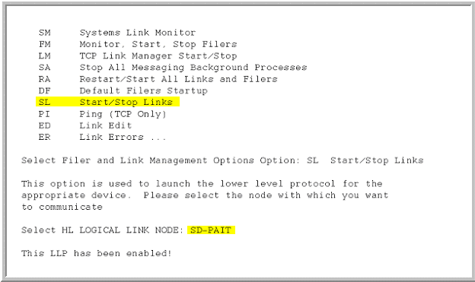

HL7 System Monitor

All outgoing HL7 messages are sent over this link. You can verify activity on this link with the System Monitor Utility of the HL7 package:

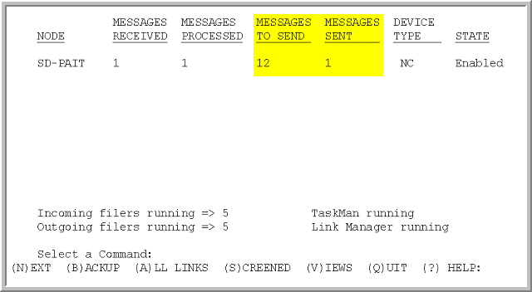

In the example screen above the TO SEND column lists 12 messages and the SENT column 1. If your SENT column does not increment to match the TO SEND column it may be necessary to stop and then start the SD-PAIT link as mentioned above.

VistA Interface Engine

REDACTED

XTMP Global

A temporary snapshot of each record deleted by the HL7 acknowledgement processing logic is created in Global ^XTMP(“SDRPA-”_BATCHNUMBER,
You may view this global to confirm acknowledgement processing.

VistA Reporting

Figure 1 indicates the reports that may be generated at each site after transmission has completed. By entering the first three letters of the desired report will initiate that report.

Acknowledgement Summary
Pending Transmissions
Rejected Transmissions
Transmission Summary

Figure 1

Acknowledgement Summary:

The Acknowledgement Summary may be used to verify the batch numbers generated from a particular site (Figure 2). This report lists all batches in Batch Control ID order. The report also indicates the Message Control ID, the Acknowledgement Date, and Acknowledgement Type. The following Acknowledgement Types are indicated:

Application Accept - AA
Application Error - AE
Application Reject - AR
Manual Rejection - MR

PAIT ACK SUMMARY FEB 27,2004 11:26 PAGE 1
APPLICATION ACK APPLICATION ACK
BATCH CONTROL ID MESSAGE CONTROL ID DATE/TIME TYPE
------------------------------------------------------------------------------------------------------------------------------------------------------------
TRANSMISSION FINISHED: FEB 20,2004 20:45
75611134952 75615626811 FEB 24,2004 08:38 APPLICATION ACCEPT
75611135142 75615627064 FEB 24,2004 08:39 APPLICATION ACCEPT
75611135273 75615627292 FEB 24,2004 08:40 APPLICATION ACCEPT
75611135591 75615627625 FEB 24,2004 08:41 APPLICATION ACCEPT
75611135943 75615628077 FEB 24,2004 08:42 APPLICATION ACCEPT
75611136242 75615628454 FEB 24,2004 08:43 APPLICATION ACCEPT
75611136597 75615628914 FEB 24,2004 08:44 APPLICATION ACCEPT
75611136841 75615629306 FEB 24,2004 08:45 APPLICATION ACCEPT
75611137250 75615629892 FEB 24,2004 08:46 APPLICATION ACCEPT
75611137757 75615630556 FEB 24,2004 12:49 APPLICATION ERROR
75611138197 75615631071 FEB 24,2004 12:50 APPLICATION ACCEPT
75611138675 75615631643 FEB 24,2004 12:50 APPLICATION ACCEPT
75611138981 75615632257 FEB 24,2004 12:51 APPLICATION ACCEPT
75611139225 75615632561 FEB 24,2004 12:52 APPLICATION ACCEPT
75611139441 75615632855 FEB 24,2004 12:53 APPLICATION ACCEPT
75611139687 75615633142 FEB 24,2004 12:54 APPLICATION ACCEPT
75611139729 75615633201 FEB 24,2004 12:54 APPLICATION ACCEPT
75611139775 75615633241 FEB 24,2004 12:55 APPLICATION ERROR
75611139829 75615633301 FEB 24,2004 12:56 APPLICATION ACCEPT
75611139855 75615633327 FEB 24,2004 12:56 APPLICATION ACCEPT
75611140007 75615633495 FEB 24,2004 12:57 APPLICATION ACCEPT
75611140038 75615633536 FEB 24,2004 12:58 APPLICATION ACCEPT
75611140066 75615633568 FEB 24,2004 12:59 APPLICATION ACCEPT
75611140072 75615633574 FEB 24,2004 13:00 APPLICATION ACCEPT
75611140100 75615633634 FEB 24,2004 13:00 APPLICATION ACCEPT
75611140118 75615633652 FEB 24,2004 13:01 APPLICATION ACCEPT
75611140124 75615633658 FEB 24,2004 13:02 APPLICATION ACCEPT
75611140140 75615633672 FEB 24,2004 13:02 APPLICATION ACCEPT
75611140150 75615633683 FEB 24,2004 13:03 APPLICATION ACCEPT
75611140160 75615633693 FEB 24,2004 13:04 APPLICATION ACCEPT
75611140170 75615633704 FEB 24,2004 13:04 APPLICATION ACCEPT
75611140176 75615633710 FEB 24,2004 13:05 APPLICATION ACCEPT
75611140188 75615633722 FEB 24,2004 13:05 APPLICATION ACCEPT
75611140190 75615633724 FEB 24,2004 13:05 APPLICATION ACCEPT
TRANSMISSION FINISHED: FEB 25,2004 16:02
75611182041 75615685674 FEB 26,2004 10:41 APPLICATION ACCEPT
75611182938 75615686799 FEB 26,2004 10:42 APPLICATION ERROR

Figure 2
Note: AR – The whole batch rejection from the AAC has not been implemented at this time and will be future enhancement. Figure 2 shows acknowledgements received for two transmissions.

Pending Transmission:

The Pending Transmission report (Figure 3) is to be used by VistA sites only to take an action of finalizing appointments with the appointment scheduled date (APPT_DATE) already in the past. These records should be “Check Out” or Cancelled. This report lists all Patient Pending records by Date Appointment Made. A print of the report is not included due to sensitive information.

Rejected Transmission:

The Rejected Transmission report should be used to review and correct patient records that the AAC rejected. Rejections can occur due to incomplete dates, invalid site/facility codes not matching the site sending the information, etc. for a particular site (Figure 3). See table AAC001 - Error Code Set for rejection code definition.

The VistA should use this report for correcting their patient appointment records. Once the VistA has corrected the record it will be sent to the National Data Base in the next bi-monthly update run and loaded into the National Database. The correction of rejected records is the VistA site’s responsibility.

REJECTED TRANSMISSION LOG FEB 27,2004 11:34 PAGE 1
ERROR
PATIENT APPT DATE SHORT DESCRIPTION MESSAGE
CLINIC
-----------------------------------------------------------------------------------------------------------------------------------------------------------------
ERROR MESSAGE: 350
PUBLIC,JOHN Q OCT 6,2003 15:56 HL7 date is not in proper format or is missing 350
FLU SHOT CLINIC

Figure 3
Note: The most commonly expected rejection codes are 350 and 200, see TABLE AAC001-Error Code Set. Error 350 is mostly caused by too old desired date of appointment, filed in VistA sub file 1900 of the Patient File.

Error 350
It has been also determined that in some situation the Rescheduled date has not acceptable date starting from 1800. That Rescheduled date is identified by PAIT if the following process:

1. An appointment is canceled without re-booking.
2. If there is another appointment created on the same day as the cancellation date, and for the same clinic there is an assumption that this is continuation of that scheduling, and that new scheduled date/time is included with the original appointment as the Reschedule Date.
3. The first available appointment meeting criteria listed in 2. is processed.
4. It came out that randomly some appointments have their scheduled date/time starting from 1800, and this date is causing rejection by the AAC as well.
5. If you cannot find an '"odd" date with your original appointment you should look for "ADSAM" cross reference in the Patient file with the cancellation date and the patient DFN, to see what "odd" appointments were scheduled, and if so to remove them after evaluation what else needs to be done.
6. Removal of that "odd" appointment would prevent the original appointment from being sent with The "bad", not acceptable Rescheduled Date.

Error 200
Error 200 indicates that an entry in the Hospital Location file #44 is configured with the DIVISION field (3.5) pointing to a Medical Center Division entry whose Institution pointer conflicts with the facility station number.

Hint: Correct the Hospital Location entry's Division field (3.5) to point to the correct Medical Center Division, or correct the Institution pointer of the Medical Center Division.

Transmission Summary:

The Transmission Summary report may be used to determine the total number of patient appointment records, the run date, total number of batches, Batch Control ID, Message Control ID, and date/time stamp (Figure 4). It can be requested by EVS, National Help Desk and /or AAC for matching transmitted batches with those received. at the AAC.

TRANSMISSION SUMMARY FEB 27,2004 11:35 PAGE 1
LAST
SCANNED # OF
RUN DATE DATE APPOINTMENTS

# OF BATCH CREATE
BATCHES BATCH CONTROL ID DATE/TIME MESSAGE CONTROL ID
----------------------------------------------------------------------------------------------------------------------------------------------
FEB 20,2004 FEB 19,2004 165317

34 75611134952 FEB 20,2004 12:20 75615626811
75611135142 FEB 20,2004 12:36 75615627064
75611135273 FEB 20,2004 12:51 75615627292
75611135591 FEB 20,2004 13:09 75615627625
75611135943 FEB 20,2004 13:28 75615628077
75611136242 FEB 20,2004 13:42 75615628454
75611136597 FEB 20,2004 13:58 75615628914
75611136841 FEB 20,2004 14:14 75615629306
75611137250 FEB 20,2004 14:36 75615629892
75611137757 FEB 20,2004 14:59 75615630556
75611138197 FEB 20,2004 15:21 75615631071
75611138675 FEB 20,2004 15:42 75615631643
75611138981 FEB 20,2004 16:01 75615632257
75611139225 FEB 20,2004 16:18 75615632561
75611139441 FEB 20,2004 16:35 75615632855
75611139687 FEB 20,2004 16:51 75615633142
75611139729 FEB 20,2004 17:04 75615633201
75611139775 FEB 20,2004 17:17 75615633241
75611139829 FEB 20,2004 17:34 75615633301
75611139855 FEB 20,2004 17:48 75615633327
75611140007 FEB 20,2004 18:03 75615633495
75611140038 FEB 20,2004 18:17 75615633536
75611140066 FEB 20,2004 18:31 75615633568
75611140072 FEB 20,2004 18:44 75615633574
75611140100 FEB 20,2004 18:58 75615633634
75611140118 FEB 20,2004 19:13 75615633652
75611140124 FEB 20,2004 19:26 75615633658
75611140140 FEB 20,2004 19:36 75615633672
75611140150 FEB 20,2004 19:46 75615633683
75611140160 FEB 20,2004 19:56 75615633693
75611140170 FEB 20,2004 20:08 75615633704
75611140176 FEB 20,2004 20:25 75615633710
75611140188 FEB 20,2004 20:41 75615633722
75611140190 FEB 20,2004 20:45 75615633724
FEB 25,2004 FEB 24,2004 8405

2 75611182041 FEB 25,2004 15:22 75615685674
75611182938 FEB 25,2004 15:59 75615686799

Figure 4
FORUM Server Reporting

The intended audience for the remainder of the document is Office of Information staff and included for information purposes.

EVS:

On the FORUM server there is a menu for running and viewing the reports for
VistA totals, ACK message status, Missing Sites, and Transmitted Sites. These
reports may be used to monitor the seeding and bi-monthly updates. These reports
will indicate specific activity from each site. The following figure is the menu option
available on the FORUM server. Currently there are three more options, and that menu looks as follows:

1 Completed Background Job Report
2 All Ack's Received Report
3 Missing Sites Report
4 Transmitted Sites Report
5 ACK Status Report
6 Site Message History
7 PAIT SUMMARY REPORT

Figure 1
Option 1 Completed Background Job Report

When the program completes at each VistA the “Completed Background Job Report” is populated with the number of patient appointment records that were transmitted to the National Database in Austin (Figure 2). Since the program sends this information in batches (5,000 records maximum) the total batch count is recorded. These two figures should be matched with the AAC Transmitted Site report (Option 4). If they do not match then there is reason to investigate the difference.

Sites - Completed Background Job FEB 27,2004 13:36 PAGE 1
SITE # OF # OF
NUMBER RUN COMPLETION DATE BATCHES APPOINTMENTS
---------------------------------------------------------------------------------------------------------------------------------------
656 FEB 20,2004 14:53 59 294917
756 FEB 21,2004 01:30 34 165317
659 FEB 21,2004 02:09 43 210278
649 FEB 22,2004 03:21 30 147223
649 FEB 25,2004 15:02 1 4985
756 FEB 25,2004 16:02 2 8405
656 FEB 26,2004 06:16 4 18691
659 FEB 26,2004 09:55 3 12708
--------
COUNT 8

Figure 2
Note: The above table includes both seeding and the update transmission from four VistA sites.

In the case they do not match, the Vitria IE monitoring reports will provide information on whether or not the patient appointment records were received and passed along to the Austin Automation Center (AAC). Use the following URL, ID, and password to connect to Messaging and Interface System’s site. The ID and password are case sensitive.
URL: http://vhaaacviev4:8080/ciev/hbase
ID =
Password =

Check with your site’s Information Resources Management (IRM) officer for access.

Option 2 All Ack's Received Report

The “All ACK’s Received Report” indicates at the summary level the number of ACK messages processed for each site and the date the process was completed (Figure 3). There is a count figure that indicates the number of sites reported. If in the event the site’s ACK message count do not match this can be an indicator that the AAC either did not receive the batch from VistA via the Vitria IE or AAC experienced a problem when processing the batch. In either case, the missing batch(es) will need to be identified and, at this time, the manual batch rejection initiated at the VistA site. To determine the missing batch(es) proceed to Option 5 to view the detailed ACK message status report and a related VistA site has to be contacted to run the Acknowledgement Summary report (VistA Reporting section) with Batch Control ID. They must be compared to the Batch Control ID’s received by the AAC.

All ACKs Received Report FEB 27,2004 13:40 PAGE 1
Site Run Completed Ack's
-------------------------------------------------------------------------
649 FEB 22,2004 30 of 30
649 FEB 25,2004 1 of 1
656 FEB 20,2004 59 of 59
656 FEB 26,2004 4 of 4
659 FEB 21,2004 43 of 43
659 FEB 26,2004 3 of 3
756 FEB 20,2004 34 of 34
756 FEB 25,2004 2 of 2
--------
COUNT 8

Figure 3

Option 3 Missing Sites Report

This option allows EVS and HSD&D to view which site transmissions were not received at the AAC during the seeding or specific update run. The report lists the sites that did not transmit by alphabetical order of Site Name.

Missing Site Report MAR 1,2004 15:23 PAGE 1
MISSING SITE
# SITE NAME REPORT DATE
--------------------------------------------------------------------------------------------------------
REDACTED ------------
COUNT 122
Figure 4

Option 4 Transmitted Sites Report

This report indicates the total number of patient appointment records and batch counts received at the AAC for each transmitted site along with the date received. This report should be used with “Completed Background Job Report” (Option 1) to determine if there are differences between what the VistA sites reported as transmitted and what the AAC reports as being received. In the case they do not match refer to the instructions outlined in Option 1.

Transmitted Sites Report MAR 1,2004 15:28 PAGE 1
SITE
# SITE NAME TOTAL RECORDS TOTAL BATCHES REPORT DATE
--------------------------------------------------------------------------------------------------------------------

REDACTED
-------
COUNT 4
Figure 5

Option 5 ACK Status Report

The “ACK Status Report” indicates at the detail level the receipt of each ACK message for each site (Figure 6). The last detail ACK message record indicates whether the site’s ACK message processing is complete (“Yes”). There is a sub count for each site indicating the number of ACK messages processed and count that indicates total ACK messages processed for all sites.

ACK STATUS REPORT FEB 27,2004 13:41 PAGE 1
SITE ACKS
NUMBER RUN ACK STATUS COMPLETE DATE/TIME
------------------------------------------------------------------------------------------------------------------------------
649 1 of 30 FEB 24,2004 10:44
649 3 of 30 FEB 24,2004 11:56
649 4 of 30 FEB 24,2004 11:56
649 5 of 30 FEB 24,2004 11:56
649 6 of 30 FEB 24,2004 11:56
649 7 of 30 FEB 24,2004 11:56
649 8 of 30 FEB 24,2004 11:56
649 9 of 30 FEB 24,2004 11:56
649 10 of 30 FEB 24,2004 11:56
649 11 of 30 FEB 24,2004 11:56
649 12 of 30 FEB 24,2004 11:56
649 13 of 30 FEB 24,2004 11:56
649 14 of 30 FEB 24,2004 11:56
649 15 of 30 FEB 24,2004 11:56
649 16 of 30 FEB 24,2004 11:57
649 17 of 30 FEB 24,2004 11:57
649 18 of 30 FEB 24,2004 11:57

ACK STATUS REPORT FEB 27,2004 13:41 PAGE 2
SITE ACKS
NUMBER RUN ACK STATUS COMPLETE DATE/TIME
------------------------------------------------------------------------------------------------------------------------------
649 2 of 30 FEB 24,2004 11:57
649 19 of 30 FEB 24,2004 14:49
649 20 of 30 FEB 24,2004 14:49
649 21 of 30 FEB 24,2004 14:50
649 22 of 30 FEB 24,2004 14:51
649 23 of 30 FEB 24,2004 14:52
649 24 of 30 FEB 24,2004 14:52
649 25 of 30 FEB 24,2004 14:53
649 26 of 30 FEB 24,2004 14:53
649 27 of 30 FEB 24,2004 14:54
649 28 of 30 FEB 24,2004 14:54
649 29 of 30 FEB 24,2004 14:55
649 30 of 30 YES FEB 24,2004 14:55
--------
SUBCOUNT 30

Figure 6
NOTE: An example in Figure 6 shows only one station. Please note that
Acknowledgements may be received in different order to the transmitted batches.

Each batch has a unique number making it easy to locate should a site’s VistA count not equal the count from the AAC. Once the batch control number(s) are located the investigator will need to access the VistA site’s Acknowledgement Summary report for the actual Batch Control ID(s) that will need to be manually rejected. The Austin Automation Center generate a summary report of batches received from all sites with a number of appointments and a number of rejections.

Option 6. Site Message History

PAIT TRANSMISSION LOG LIST JUL 13,2006 09:39 PAGE 1
SITE
NUMBER MESSAGE TYPE DATE/TIME
--------------------------------------------------------------------------------

358 STARTED TRANSMISSION JUL 1,2006 10:00
358 BACKGROUND JOB COMPLETE JUL 1,2006 10:12
358 ACKNOWLEDGMENT JUL 10,2006 13:59
402 STARTED TRANSMISSION JUL 1,2006 04:00
402 BACKGROUND JOB COMPLETE JUL 1,2006 04:48
402 ACKNOWLEDGMENT JUL 10,2006 14:01
402 ACKNOWLEDGMENT JUL 10,2006 14:01
402 ACKNOWLEDGMENT JUL 10,2006 14:01
402 ACKNOWLEDGMENT JUL 10,2006 14:01
402 ACKNOWLEDGMENT JUL 10,2006 14:02
402 ACKNOWLEDGMENT JUL 10,2006 14:02
402 ACKNOWLEDGMENT JUL 10,2006 14:03
402 ACKNOWLEDGMENT JUL 10,2006 14:03

You can follow up a history of PAIT for each site from its start to receiving acknowledgements.

Option 7. PAIT Summary Report

This report is a compilation of all messaging activity from VistA through VIE to the AAC, and gives the best overview of each PAIT activity.

National Help Desk Reporting

Missing Site Reporting

From the AAC:
One the 5th and 19th of every month the AAC will send to VHA National Help Desk an email message indicating those sites that the AAC did not receive patient appointment information transmissions. This report will include the site (facility) number and name. The corresponding report is also sent by the AAC to the Forum Server (see Option 3 in Forum Server Reporting).

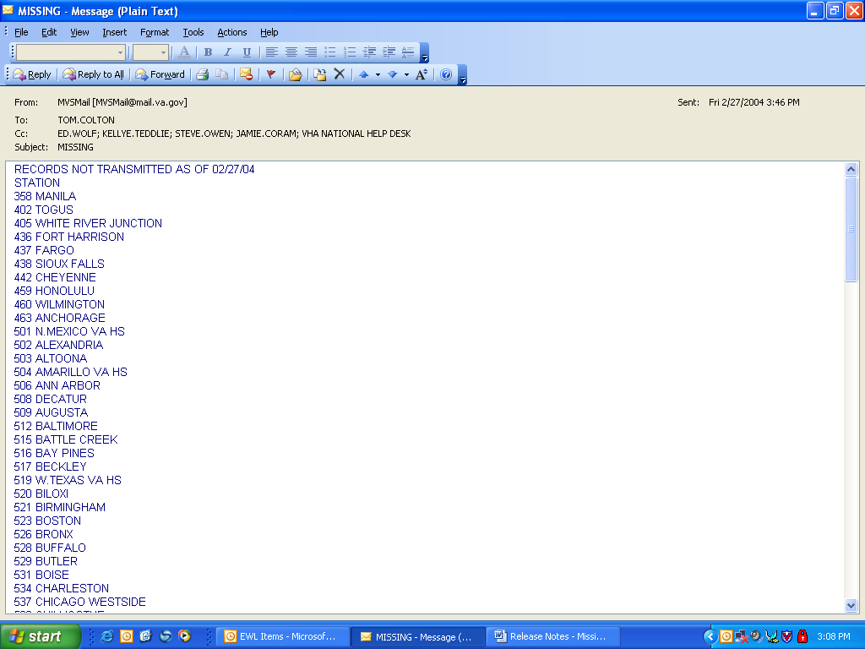

VHA National Help Desk
Upon receipt of the email from “MVSMail” listing the sites that did not transmit (Missing Site Report) the VHA National Help Desk will enter a Remedy Ticket the sites that did not transmit. The Remedy Ticket should be assigned to EVS who will begin the investigation process.

EVS
EVS will act upon the receipt of the Remedy Ticket by running the Complete Background Job Report on the FORUM server. This report will indicate whether the site actually gathered data and passed it to the local Vitria IE machine. If the report indicates no activity from the site, EVS will contact the site to determine why the site did not run. Based on the reason, EVS may need to contact other groups to provide assistance. In the case the report indicates there was activity, EVS may need to access the M&IS URL to review the Vitria IE activity reports. The M&IS URL, ID, and password are:
URL: http://vhaaacviev4:8080/ciev/hbase
ID =
Password =
Check with your site’s Information Resources Management (IRM) officer for access

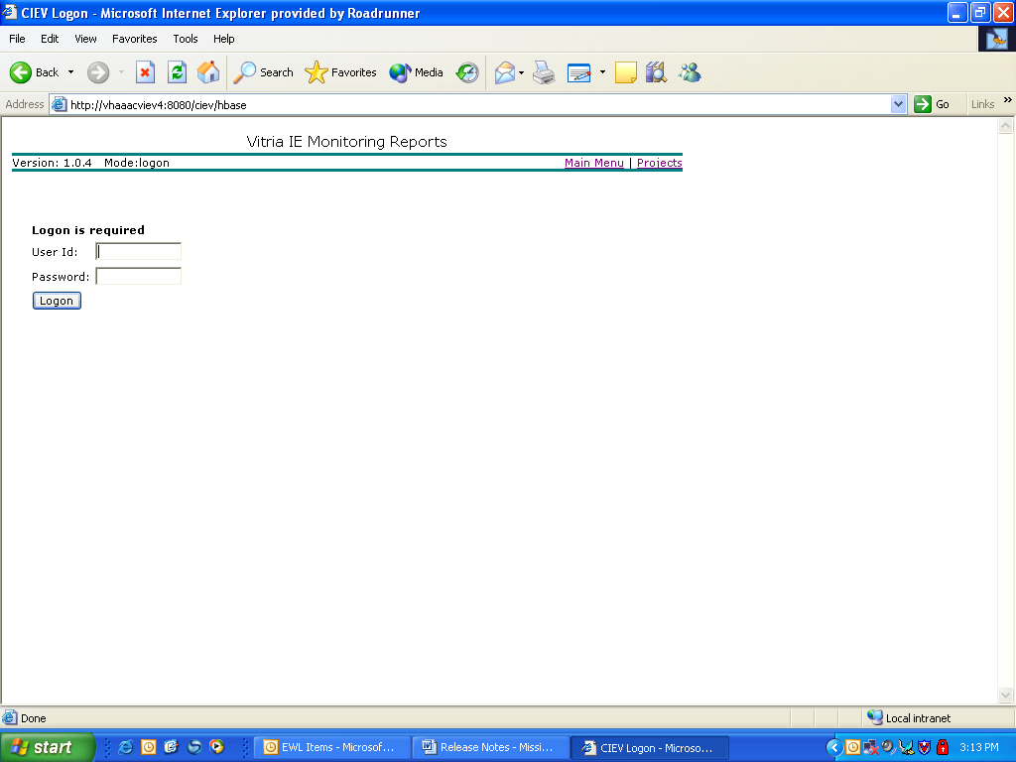

There are two reports that indicate activity of patient appointment records being sent to the AAC. The first indicates activity at the VistA site’s local Vitria IE (Remote Outgoing Batch Tallies). The report presents the Site ID, Name, Most Recent Date, and Batch Count.

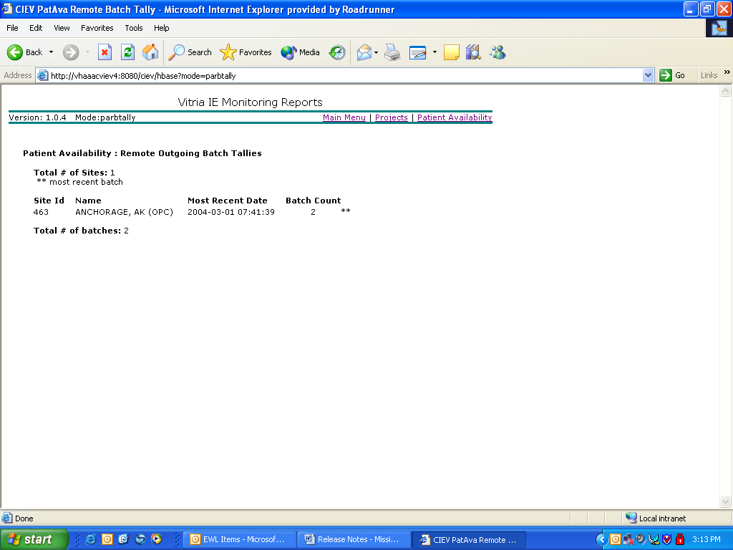

The second report indicates the files transferred (FTP) to the mainframe at the AAC (File Uploads to MVS). This report demonstrates the Site(s) ID, Name, and Batch Count that were included in the file transfer. It should be noted that the batch count indicated in a file sent to the AAC may not be the total batch count for that site.

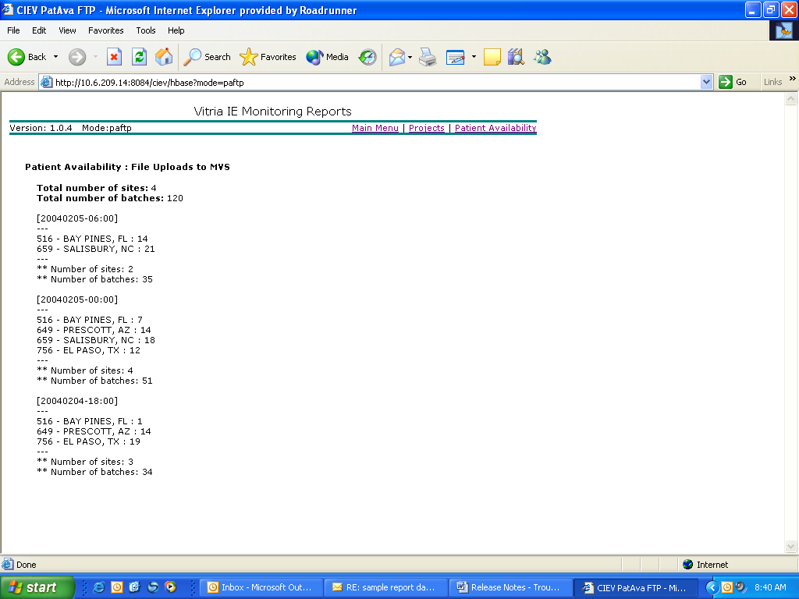

Examination of all files transferred will need to be performed and manually adding the batch counts for all files to determine if the site’s total batch count matches the count on the FORUM server.

- If the reports on the FORUM server indicate the site did not generate batches EVS will need to contact the site to find the responsible person who can determine or explain why the program did not run.
- If the reports on the FORUM server indicate the site did generate batches but did not transmit and the Vitria IE reports do not indicate the site’s activity, then EVS will need to contact M&IS for assistance..
- If the reports on the FORUM server and the Vitria IE reports indicate the site did transmit, then EVS will need to contact the AAC for assistance.
NOTE: The primary trouble shooting to determine the problem in communications should be done by following directions in the Trouble Shooting chapter.

VistA Communication Problems

VHA National Help Desk:

REDACTED

REDACTED
Figure 2

The above message, Figure 2 shows that the communication with Vitria was not established at all and none of generated batches were transmitted.

