Patient Assessment Documentation Package (PADP)

C3-C1 Conversion Project

RN Reassessment User Manual
for NUPA Version 1.0

April 2012

Department of Veterans Affairs
Office of Information and Technology (OIT)
Office of Enterprise Development (OED)

Revision History
Date | Revision | Description | Author
May 2010 | 1.0 | Initial version for 1.0 | REDACTED
August 2010 | 1.1 | Add content | REDACTED
August 2010 | 1.2 | Format content | REDACTED
September 2010 | 1.3 | Split manual into three manuals  - RN Reassessment  - User Manual | REDACTED
October 2010 | 1.4 | Updated content | REDACTED
November 2010 | 1.5 | Updated screen captures | REDACTED
December 2010 | 1.6 | - Changed dates  - Pulled issues from this doc for team review | REDACTED
January 2011 | 1.7 | - Changed dates to January 2011  - Updated with additional comments from Judy | REDACTED
February 2011 | 1.8 | Changed dates to February 2011 | REDACTED
March 2011 | 1.9 | - Changed dates to April 2011  - Updated with Judy’s comments | REDACTED
April 2011 | 1.10 | Updated RoboHelp with this file | REDACTED
May 2011 | 1.11 | - Changed dates to May 2011  - Added (NUPA*1*0) namespace | REDACTED
October 2011 | 1.12 | - Added C3-C1 Conversion Project  - Changed dates to October 2011  - Prepped for national release | REDACTED
November 2011 | 1.13 | - Changed dates to November 2011  - Updated for build v14  - Changed dates to December 2011  - Updated for build v15  - Changed title to RN Reassessment | REDACTED
December 2011 | 1.14 | - Changed dates to December 2011  - Changed Admission – RN Reassessment to RN Reassessment  - Updated for build v15  - Updated for new assessment executables  - Changed dates to January 2012  - Prepped for national release | REDACTED
January 2012 | 1.15 | - Changed NUPA 1.0 to NUPA Version 1.0  - Updated for build v16  - Changed dates to February 2012 | REDACTED
February 2012 | 1.16 | - Updated Neuro tab  - Updated the Unable to Complete the Assessment section | REDACTED
March 2012 | 1.17 | - Changed dates to March 2012  - Prepped for April national release  - Changed dates to April 2012  - Added Appendix A: Reassessment Contingency Note | REDACTED

Table of Contents
Introduction 1
Using the RN Reassessment 2
Opening RN Reassessment 2
No Previously Saved Information 3
Previously Entered Information Available for One Patient 3
Restore Patient’s Data/No 4
Restore Patient’s Data/Yes 4
Previously Entered Information Available for Two or More Patients 4
View the Patients?/No 5
View the Patients?/Yes 5
Patient not yet Assigned to an Inpatient Bed 7
Saving and Uploading Data 7
Auto Save 7
Manual Save 8
Upload Data 8
Save and Exit 9
Save Now 9
Exit 10
Signing Notes 11
Working in a Care Plan 12
Care Plan Table 13
Updating an Existing Problem/Intervention 14
Adding a New Intervention for an Existing Problem 19
Adding a New Problem/Intervention 20
Other Problems 22
Other Interventions 23
Working in the Consults 24
Working in the Template 26
Moving through the Template with a Mouse 26
Moving through the Template without a Mouse 27
Ctrl-Alt Keys 27
Go to Radiogroup 28
Viewing Previously Entered Data 28
Navigating the RN Reassessment Tabs 30
General Information (Gen Inf) 30
Adding an Allergy 31
Initiating a Social Work Consult for Advance Directives 33
Changing Emergency Contact Information 35
Education (Educ) 37
Pain (Pain) 39
IV (IV) 47
No IV/Vascular Access Devices 47
Peripheral Lines - IV Periph 48
Existing IV Lines 48
New IV Lines 50
Central IV Lines – IV Central 52
Dialysis Ports - IV Dialysis 54
General Observations/Comments – IV Comments 56
Care Plan - IV CP 57
Respiratory (Resp) 58
Cardiovascular (CV) 63
Neurology (Neuro) 66
Gastrointestinal (GI) 69
Genitourinary (GU) 75
Indwelling Catheter 78
Musculoskeletal (M/S) 80
Skin (Skin) 84
Documenting Pressure Ulcers 85
Pressure Ulcer Drop-downs 86
Documenting Skin Alterations 88
Skin Alteration Drop-downs 89
Psychosocial (P/S) 94
Restraints (Rest/Restr) 100
Mental Health (MH) 105
Functional (Func) 108
Discharge Planning (DP) 113
PCE Data (PCE) 116
Reminders Due (Display Only) 116
Clinical Maintenance 117
Reminder Inquiry 118
Resolve Inpatient Nursing Clinical Reminders 119
View Text (View Text) 121
Signing Note and Consults from within the Template 122
Unable to Complete the Assessment 124
Patient still cannot respond 125
Patient can respond 143
Updating the Reassessment Note 144
Glossary 145
Appendix A Reassessment Contingency Note 148

Introduction
The Patient Assessment Documentation Package (PADP) Version 1.0 is a Veterans Health Information Systems and Technology Architecture (VistA) software application that enables Registered Nurses (RNs) to document, in a standardized format, patient care during an inpatient stay. Although the content is standardized for use across the VA system, some parameters can be set to support the unique processes at individual medical centers.

PADP interfaces directly with several VistA applications, including Computerized Patient Record System (CPRS), Clinical Reminders, Consult Tracking, Allergy/Adverse Reaction Tracking, Mental Health Assistant, Vitals, and Patient Care Encounter (PCE).

PADP is a Delphi application, which supports RNs in documenting patient care during an inpatient stay. It includes the following templates:
- Admission – RN Assessment allows RNs to document the status of the patient at admission.
- Admission – Nursing Data Collection allows Licensed Practical Nurses (LPNs) and other nursing staff, including the RN, to enter basic patient data, such as vitals and belongings at the time of admission.
- RN Reassessment allows RNs to document the condition of the patient on a regular basis and any time during the inpatient stay.
- Interdisciplinary Plan of Care interfaces with admission and reassessment data, and allows additional information to be entered by the RN and other health care personnel (physicians, social workers, chaplain, etc.). All clinical staff can enter information into the Plan of Care. The Plan of Care can be printed and given to the patient when appropriate.

PADP consists of a KIDS build, NUPA 1.0, and four (4) Delphi GUI templates in three executables.
- The executable, Admassess.exe, contains the Admission - RN Assessment template and the Admission - Nursing Data Collection template.
- The executable, Admassess_Shift.exe, contains the RN Reassessment template.
- The executable, Admassess_Careplan.exe, contains the Interdisciplinary Plan of Care template.

Each template is associated with a note.
- The Admission - RN Assessment template is associated with the note: RN Admission Assessment
- The Admission - Nursing Data Collection template is associated with the note: Nursing Admission Data Collection
- The RN Reassessment template is associated with the note: RN Reassessment
- The Interdisciplinary Plan of Care template is associated with the note: Interdisciplinary Plan of Care

PADP adds to VistA, a new namespace (NUPA), four (4) Progress Notes, five (5) printouts, fourteen (14) files, thirty-six (36) parameters, and new health factors. The 5 printouts are:
- The Daily Plan® is a health summary designed to be given to the patient and family
- Plan of Care is a plan designed to guide the nursing staff
- Discharge Plan is for discharge planners
- Belongings is a list of patient belongings
- Safe Patient Handling is designed to guide the transfer of a patient

Using the RN Reassessment
Registered Nurses (RNs) use the RN Reassessment template to document inpatient care in a standardized format at regular times and as needed. With the reassessment template, you collect information associated with new problems and with required physical assessment documentation, such as skin condition, respiratory, genitourinary, and gastrointestinal status.

Opening RN Reassessment
You access the RN Reassessment through CPRS from the Tools menu.
- Open CPRS.
- Select a patient.
- Click Tools.
- Select RN Reassessment.
Enter a patient window automatically opens to the CPRS patient.
Note: You may have to re-enter your CPRS access and verify codes, depending on local site setup.
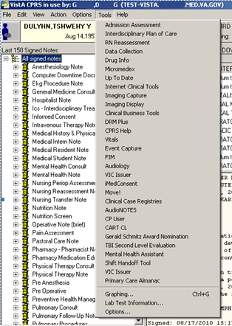
Access through CPRS

No Previously Saved Information
The Enter a patient window displays.
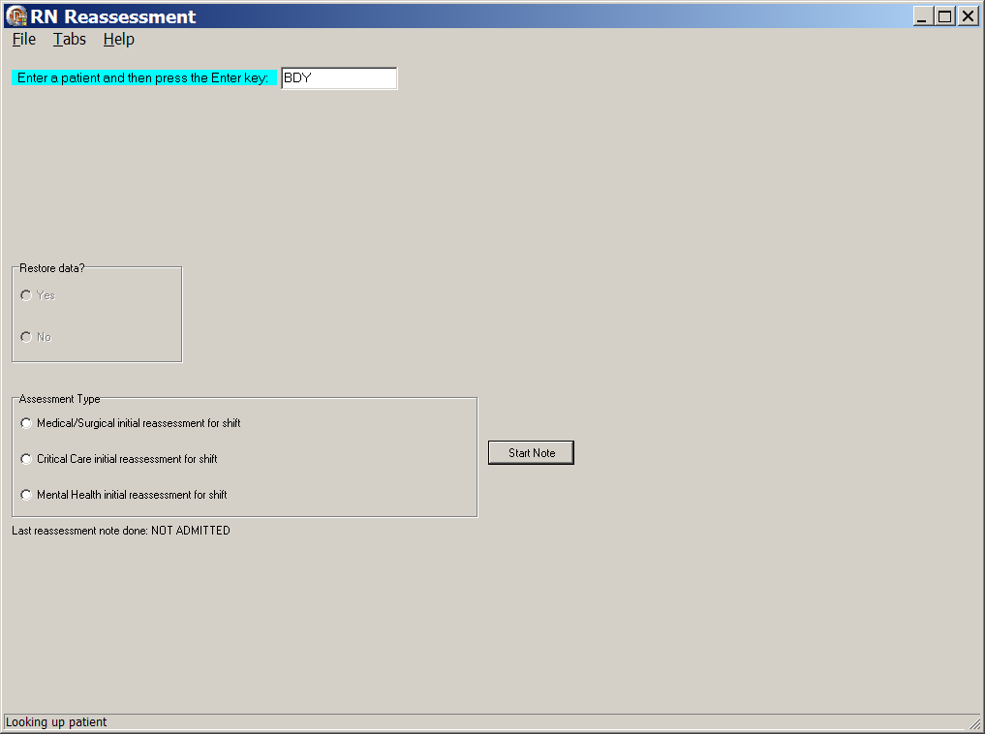
RN Reassessment, Enter a patient window with no previously saved information
- Select an Assessment Type.
- Click Start Note.
The reassessment template opens to the General Information tab for the CPRS patient.

Previously Entered Information Available for One Patient
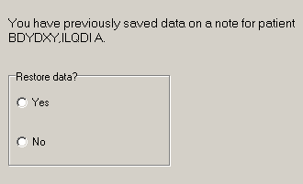
Patient selection window with previously entered information available for one patient

Restore Patient’s Data/No
If you previously entered data on one patient, you are prompted with: You have previously saved data on a note for patient <PADPPATIENT,ONE >
- Select an Assessment Type.
- Select No.
The patient’s information is deleted, but the Internal Entry Number (IEN) for the patient displays in the Enter a patient text box.
- Click Start Note.
The template opens to the General Information tab and you can enter new data for that CPRS patient.
- Optional: You can delete the IEN of that CPRS patient, enter the name of a different patient, and click Start Note.
Note: The Internal Entry Number (IEN) is a unique, computer-generated number that identifies a specific patient in your system. The IEN has no impact on the completed assessment, nor does it display again.

Restore Patient’s Data/Yes
If you previously entered data on one patient, you are prompted with: You have previously saved data on a note for patient <PADPPATIENT,ONE > m
- Select an Assessment Type.
- Select Yes.
- Click Start Note.
The template opens General Information tab for the CPRS patient with the data restored.
Note: PADP does a search for previously entered assessments/reassessments within the last 12 hours.

Previously Entered Information Available for Two or More Patients
If you have previously stored data from more than one patient, you are asked if you want to view a list of those patients.
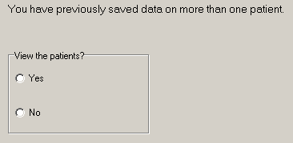
Patient selection window with previously entered information available for more than one patient

View the Patients?/No
If you say No, the patient’s name displays in the Enter a patient text box as a number that identifies the CPRS patient.
- Select Assessment Type.
- Click Start Note.
- The template opens to the General Information tab.

View the Patients?/Yes
- Select Yes.
- Select an Assessment Type.
Patient Selection window displays with a list of patients with saved data.
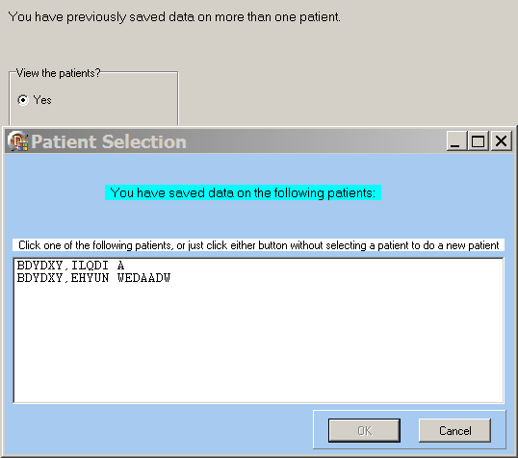
Patient Selection List

Patient on the List
- Select a name.
- Click OK.
The template opens to the General Information tab.

Patient not on the List
- Click Cancel.
The number that represents your CPRS patient is in the Enter a patient text box.
- Click the Start Note.
The template opens to the General Information tab.
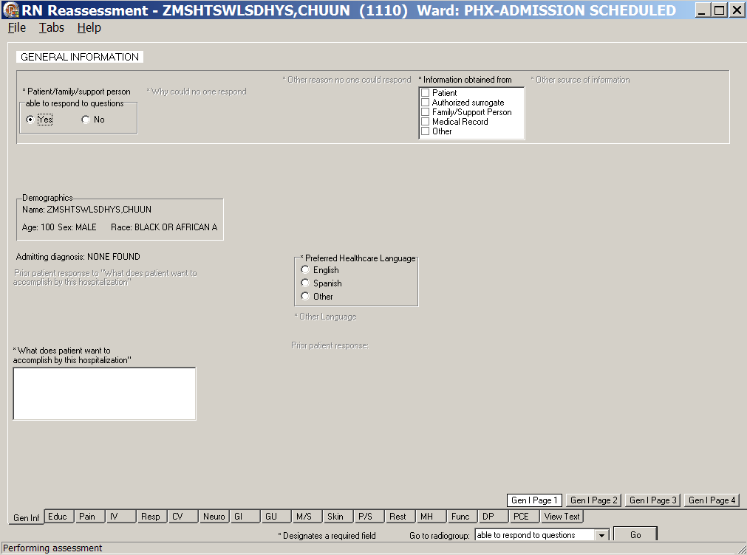
RN Reassessment, General Information (Gen Inf) tab window, Gen I Page 1

Patient not yet Assigned to an Inpatient Bed
When a patient is not assigned an inpatient bed, a location automatically displays over the General Information window.
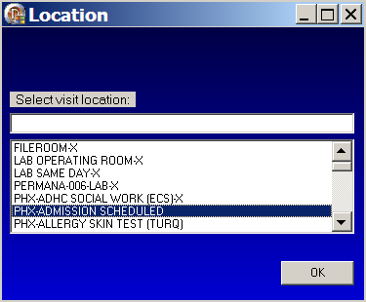
Location : Select visit location
- Select a current patient location, i.e., outpatient clinic.
Navigate quickly to the current location by entering the first letter of the location.
- Click OK.

Saving and Uploading Data

Auto Save
Data are saved automatically. Frequency of auto-save is set locally.
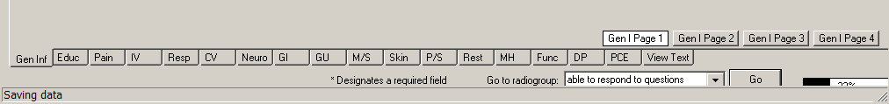
Saving data: percentage saved indicator
(bottom right corner of the window)

Manual Save
You can save data by using the File menu on any tab.
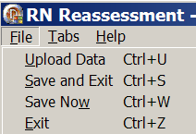
RN Reassessment window, File menu

Upload Data
To create a note you must upload the data into VistA and CPRS:
- Open the File menu on any tab and select Upload Data.
Results from your upload display, verifying that the data is uploaded.
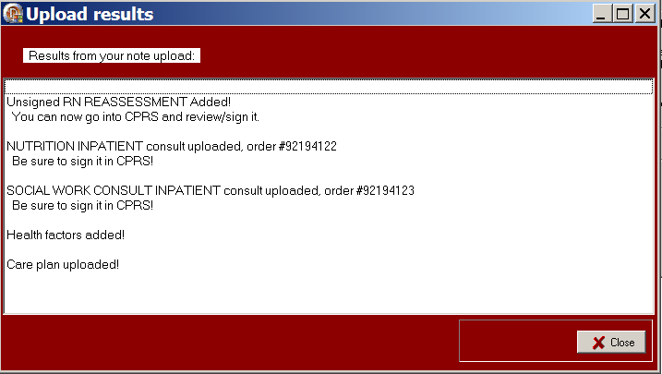
RN Reassessment, Upload results window
Note: The unsigned note, selected consults, and PCE data/Health Factors are uploaded into CPRS and VistA.
- If the information is incomplete, an Error Listing window displays indicating the pages within specific tabs that require attention.
- The tabs with pages that require attention are blue.
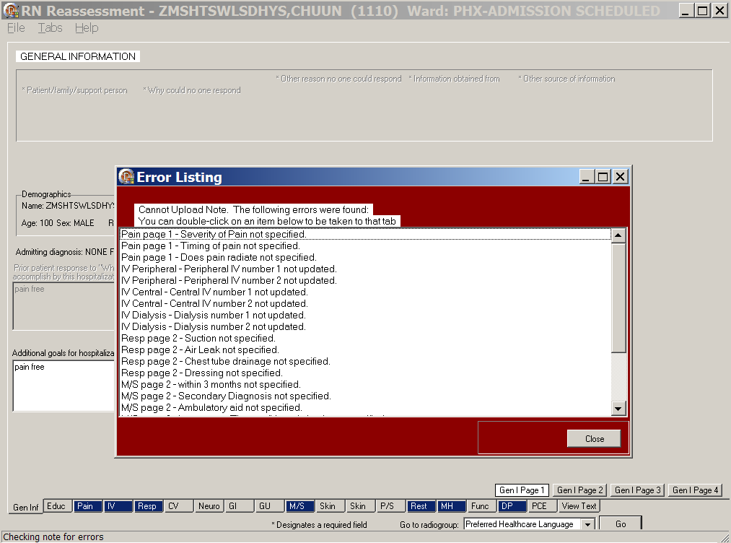
RN Reassessment, Error Listing window
- Once the pages are completed, the tab returns to gray.
- Double-click an item to go to the page that requires attention.
- When all the errors are completed, select Upload Data again.

Save and Exit
To save data and temporarily leave the template:
- Open the File menu on any tab.
- Select Save and Exit.
- When you reopen the template, your previously entered data is there.

Save Now
To save data, but not close the template and continue to enter data:
- Open the File menu on any tab.
- Select Save Now.
- Continue to enter data for the current patient.

Exit
- From any tab, click X in the top right corner of the window.
Warning message displays.
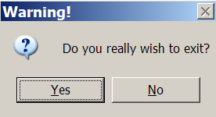
Warning : Do you really wish to exit?
- Click Yes.
or
- From any tab, open the File menu and click Exit.
Warning message displays.
- Click Yes.

Signing Notes
Go to CPRS to sign your uploaded, unsigned notes and consults.

You can also sign unsigned notes after the upload from the View Text tab in the template.

- Click View Text.
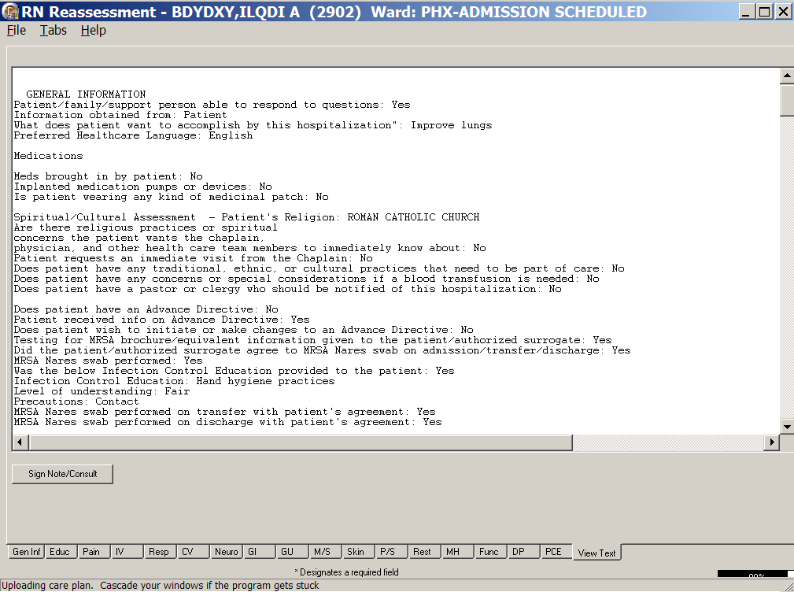
RN Reassessments, View Text tab after upload
- Click Sign Note/Consult.
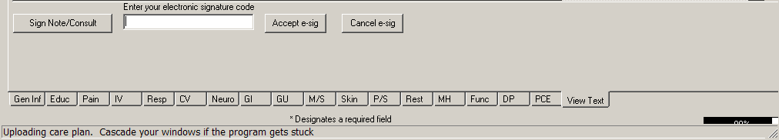
RN Reassessment, Sign Note/Consult Button
- Enter your electronic signature and click Accept e-sig.
- To prevent the signing of an uploaded note, click Cancel e-sig.
Note: If there is only a note to sign, the button is Note.
If there is a consult(s) to sign, the button is Sign Note/Consult.

Working in a Care Plan
The Care Plan page for each section of the RN Reassessment works the same way. The steps apply to each of the care plan (CP) pages.
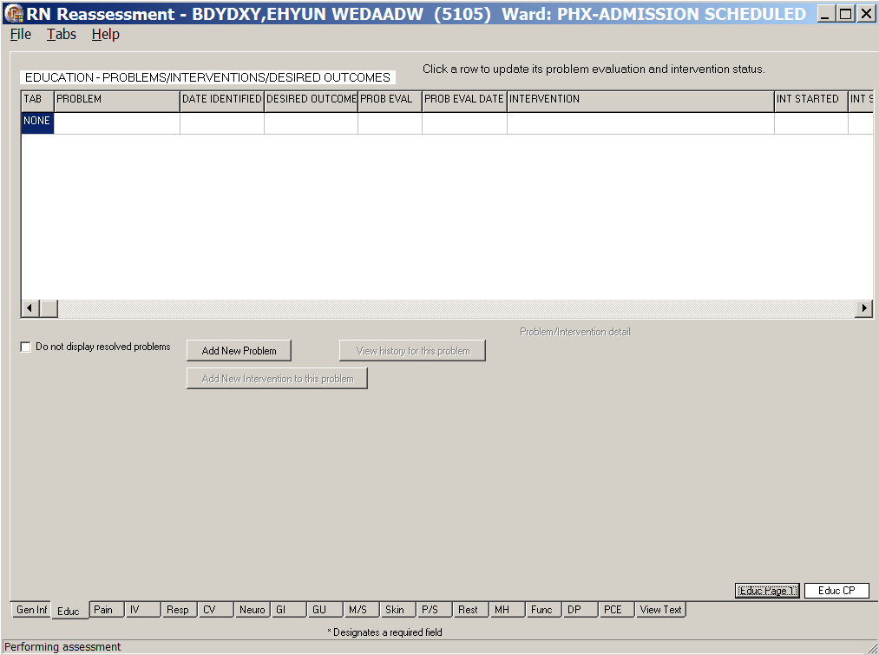
RN Reassessment, <Education> - Problems/Interventions/Desired Outcomes,
<Educ> CP window

Care Plan Table
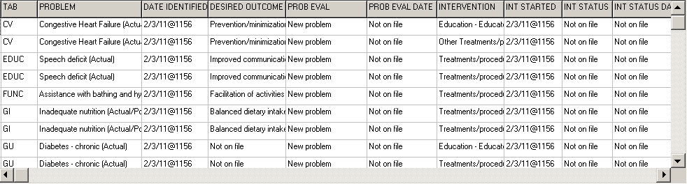
RN Reassessment, Problems/Interventions/Desired Outcomes table
The width of each Care Plan column is adjustable. There are ten columns in the Care Plan (Problems/Interventions/Desired Outcomes) table.

Column | Description
Tab | Tab in which the problem was identified in a previous assessment  Example  The problems came from the Mental Health Assessment, MH tab
Problem | Problem of concern from a previous assessment
Date Identified | Date the problem was identified
Desired Outcome | Preferred resolution of the problem
Prob Eval  (Problem Evaluation) | In relation to the problem, how are things going?  - No change/Stable  - Deteriorating  - Improving  - Resolved  - Unresolved at discharge
Prob Eval Date  (Problem Evaluation Date) | Date on which the problem was last evaluated
Intervention | The what to do for the patient you identify, so that the problem will improve/get better/not get worse
Int Started  (Intervention Started) | Date on which the intervention was initiated
Int Status  (Intervention Status) | In relation to the intervention, how should the staff proceed?  - Complete  - Continue  - Discontinue  - Pending (intervention was ordered but not started, such as a special bed or a lab test)  - Not on file (status not evaluated)
Int Stat Date  (Intervention Status Date) | Date on which the status of the intervention was evaluated

Updating an Existing Problem/Intervention
All care plans are updated the same way. If problems are entered during a previous assessment, the CP page from any tab is bold and italicized.
RN Reassessment, <Resp> tab
- Click <Resp> CP.
The <Respiratory> - Problems/Interventions/Desired Outcomes window displays.
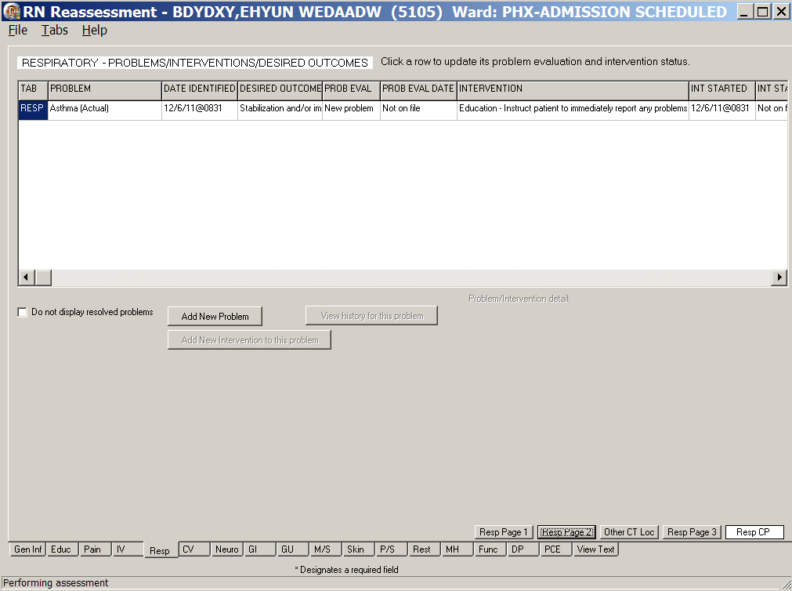
RN Reassessment, <Resp> CP window
- Click a problem.
Problem evaluation, Intervention status, and Problem/intervention detail become available.
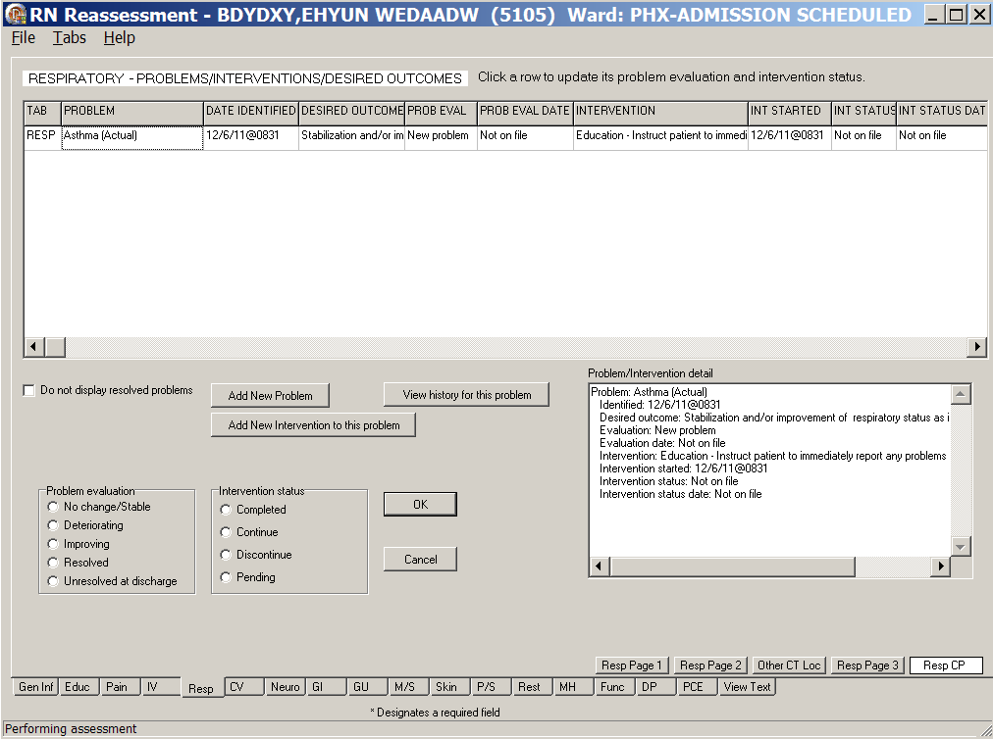
RN Reassessment, <Resp> CP window
- Select a problem evaluation and an intervention status for the selected problem.
Evaluate both the problem and the specific interventions each time you document.
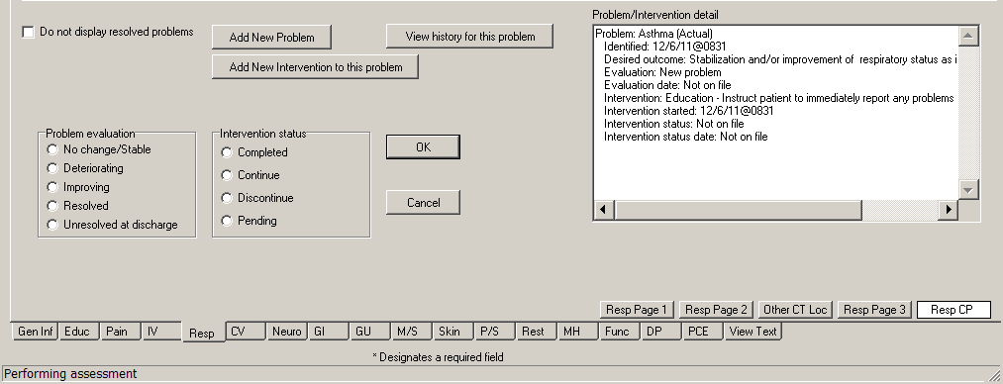
Problem evaluation, Intervention status, and Problem/Intervention detail
- Click OK.
Information displays.
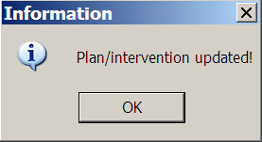
Information : Plan/intervention updated!
- Click OK to complete the problem/intervention.

- Review the care plan table.
The Prob Eval/Int Status are updated and the Prob Eval Date/Int Status Date are added.
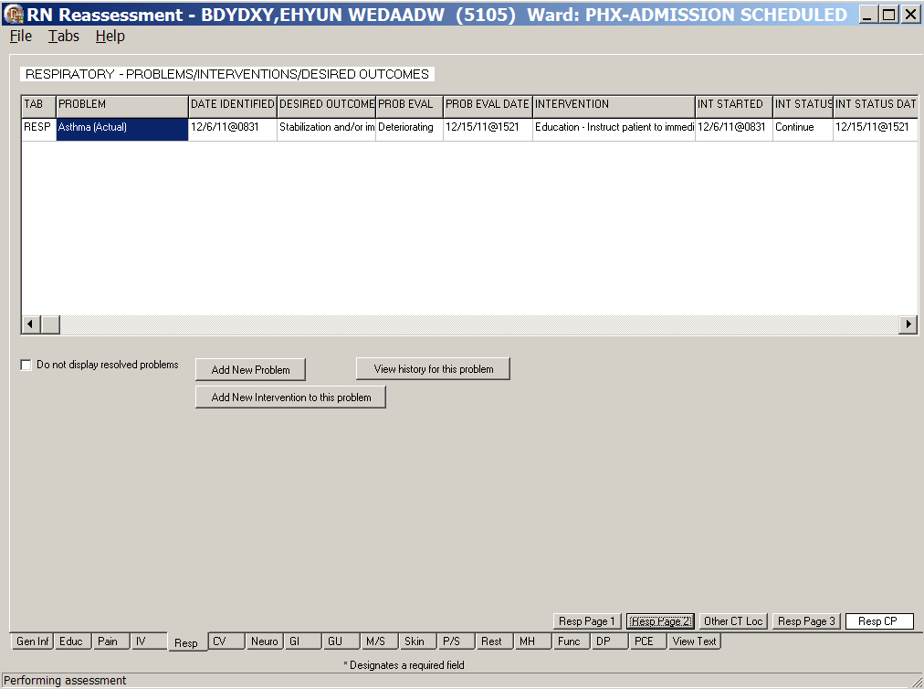
RN Reassessment, <Resp> CP window

- Click View history for this problem to view the history of the selected problem.
The Problem History displays.
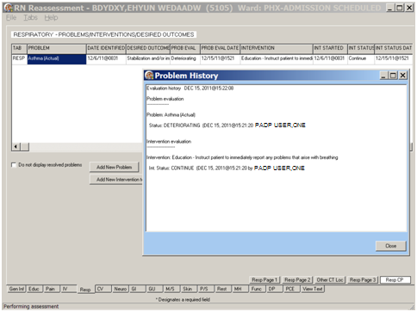
Problem History window
- Click Close.

Adding a New Intervention for an Existing Problem
- Click a problem.
- Click Add New Intervention to this problem.
The Add New Problem/Intervention window displays with the area and problem selected.
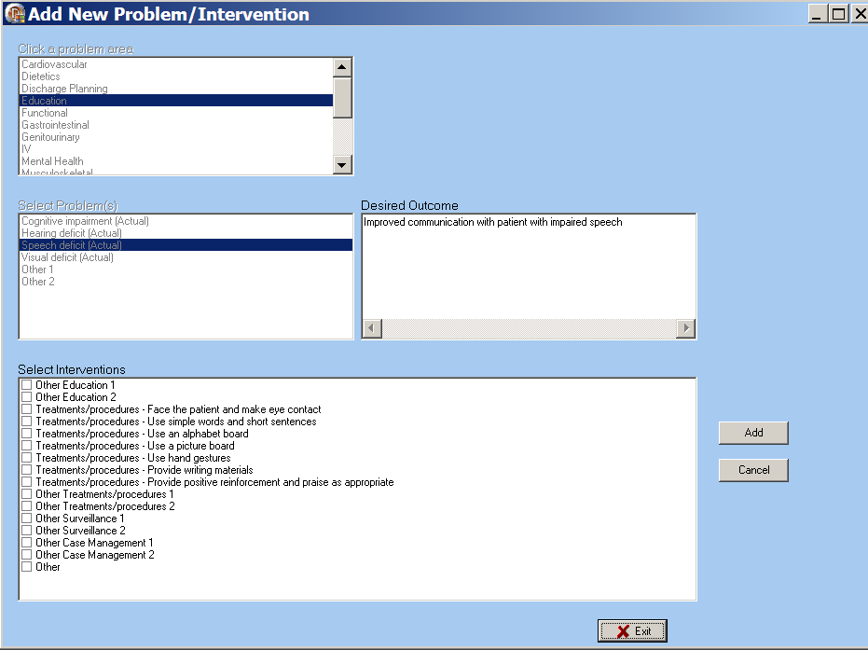
Add New Problem/Intervention window
- Select an intervention from the Select Interventions list box for the selected problem.
- Click Add.
Information displays.
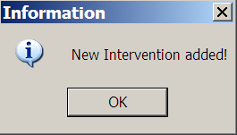
Information : New Intervention added!
- Click OK.
- Click Exit.

Adding a New Problem/Intervention
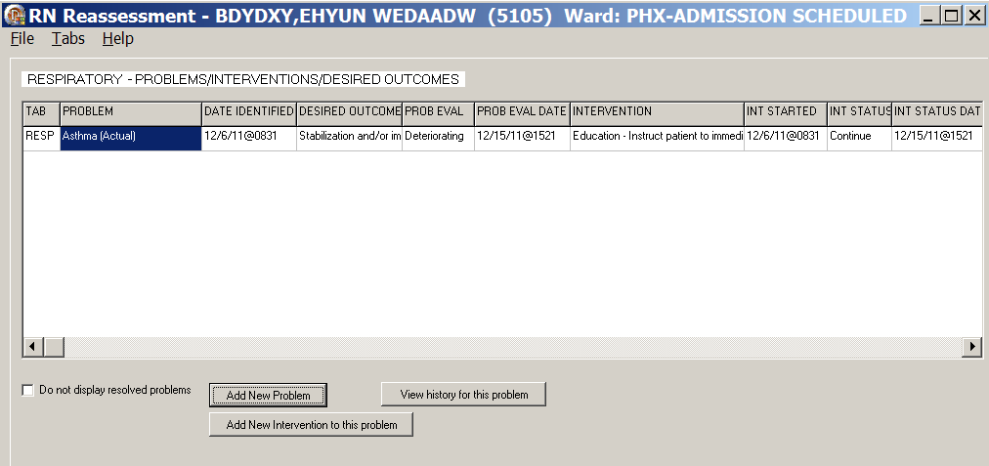
RN Reassessment, <Resp> CP window
- Click Add New Problem.
Add New Problem/Intervention window displays.
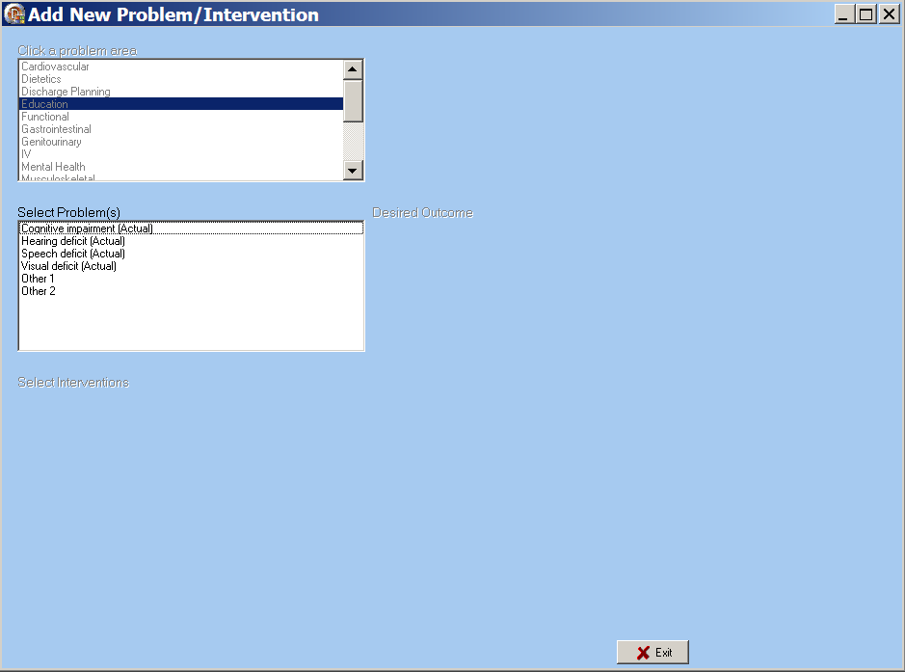
Add New Problem/Intervention window
Note: The Respiratory area is auto selected, because you are in the Resp CP.
- Select a problem from the Select Problem(s) list box.
You can select only one problem at a time.
The Desired Outcome text box and the Select Interventions list box display.
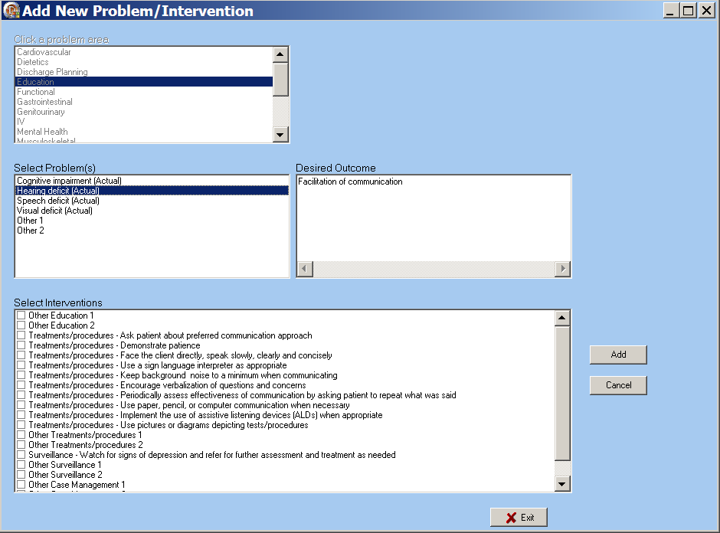
Add New Problem/Intervention window for problem/intervention options
- Select an intervention from the Select Interventions list box.
- Click Add.
Information displays.
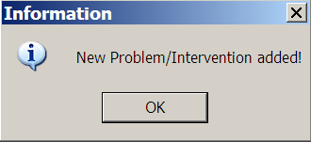
Information : New Problem/Intervention added!
- Click OK.
- Click Exit.

Other Problems
Some problems generate a to enter problems that are not on the predefined list.
- Select an Other problem in the Select Problems list box.
The Other problems displays.
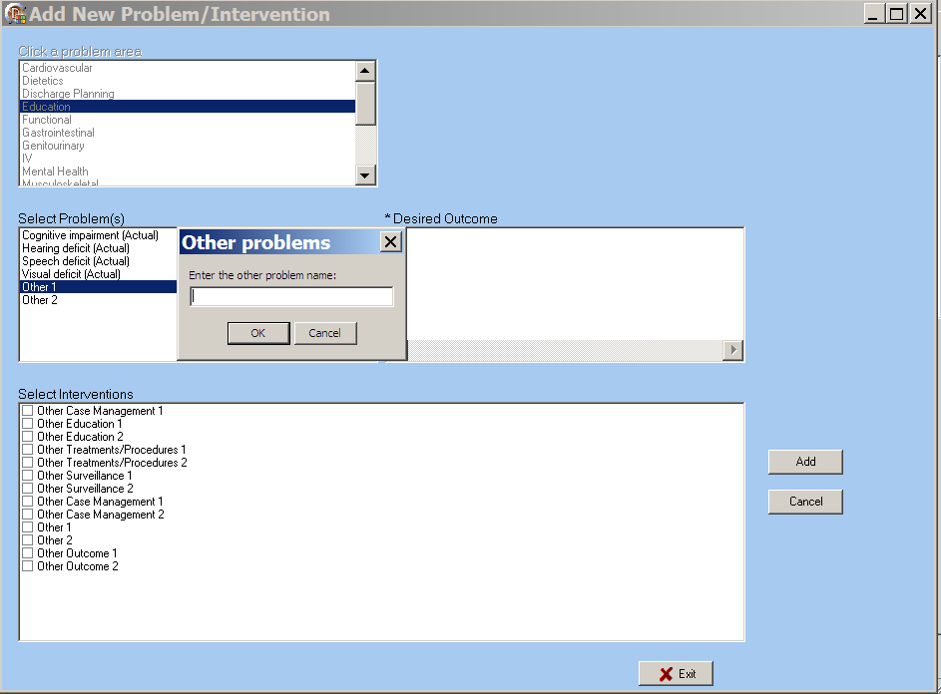
Add New Problem/Intervention window with Other
- Type the other problem into the text box.
- Click OK.
- Type a desired outcome into the Desired Outcome text box.
- Select one or more interventions from the Select Interventions list box.
- Click Add.
Information displays.
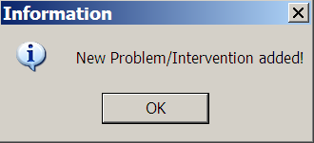
Information : New Problem/Intervention added!
- Click OK.
- Click Exit.
- To add more other problems, repeat steps 1-8, as necessary.

Other Interventions
Some interventions generate a to enter interventions that are not on the predefined list.
- Select an Other intervention in the Select Interventions list box.
The Other intervention displays.
- Type the other intervention into the text box.
- Click OK.
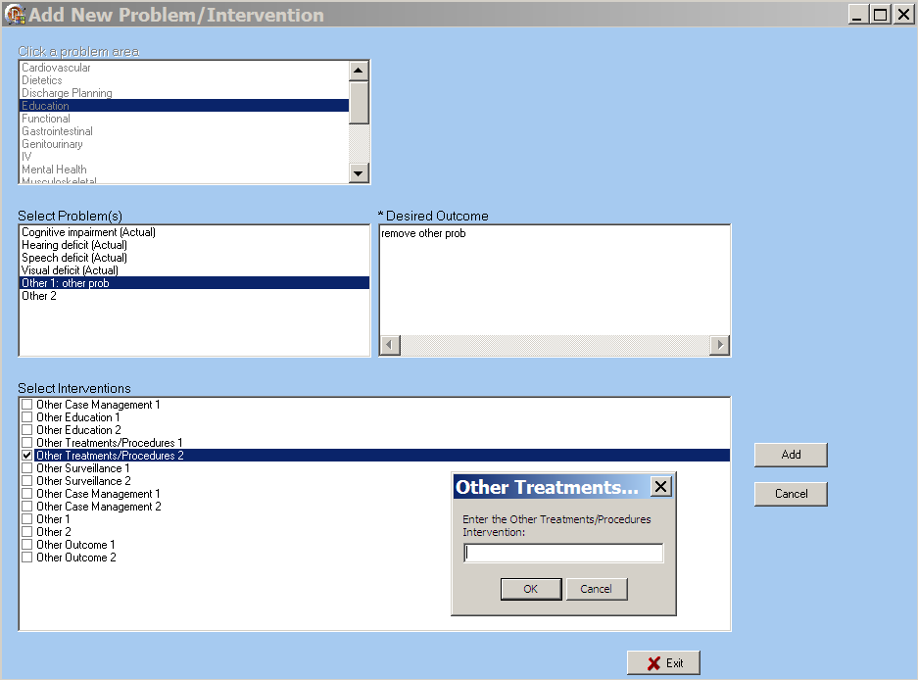
Add New Problem/Intervention window with Other
- Click Add to transfer the intervention to the care plan.
Information displays.
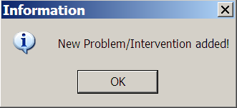
Information : New Problem/Intervention added!
- Click OK.
- Click Exit.

Working in the Consults
All the consults in Reassessment work the same way. The following steps apply to each of the consults. When a consult is required, a mandatory consult message is highlighted in red. Ordering a Chaplain Consult is an example of how to work in any of the consults.
Example – Ordering a Chaplain Consult
Order a Chaplain Consult from Gen Inf tab, Gen I Page 2 in the Spiritual/Cultural Assessment section.

The Chaplain Consult is mandatory when the patient answers Yes to any one of the following questions.
- Are there religious practices or spiritual concerns the patient wants the chaplain, physician, and other health care team members to immediately know about?
- Patient requests an immediate visit from the Chaplain?
- Does patient have a pastor or clergy who should be notified of this hospitalization?

- Select Yes and a message indicating the consult is mandatory displays:
Chaplain consult mandatory
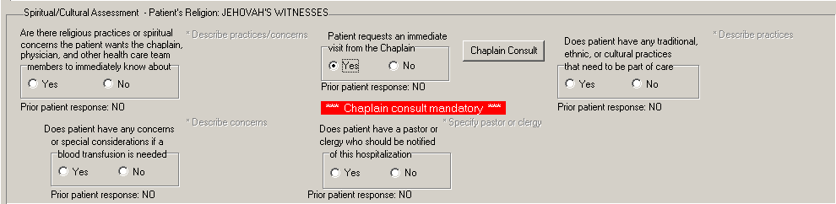
RN Reassessment, General Information (Gen Inf) tab, Gen I Page 2 window
Spiritual/Cultural Assessment
- Click <Chaplain Consult>.
The <INPATIENT CHAPLAIN> Consult window displays.
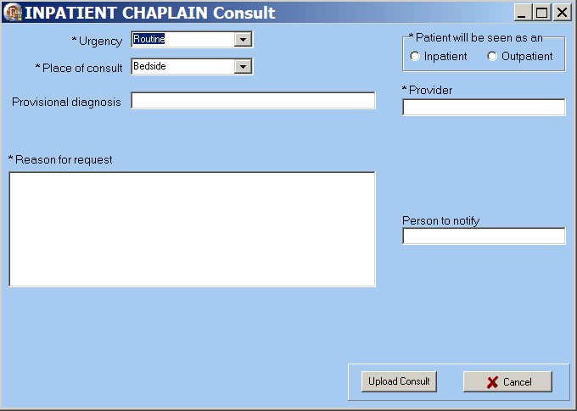
INPATIENT CHAPLAIN Consult window
- Complete all fields with asterisks; they are required fields.
- Click Upload Consult.
Information displays indicating the consult is uploaded with the reassessment note.
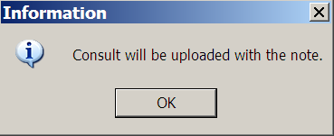
Information : Consult will be uploaded with the note.
- Click OK.
On the Gen Inf tab, Gen I Page 2, under the Chaplain Consult button, Will Send displays.
Note: Manage consults according to medical center policy. If nurses at your site do not order consults, upload a mandatory consult, but do not sign it.
The identified provider will be notified that there is a consult to sign.

Working in the Template
- To complete the template, move through the fields from left to right and then down.
- The active page displays first and the page tab is white.
- Each tab across the bottom is subdivided into pages, which display on the right above the bar of tabs.
- Each field with an asterisk (*) must have an entry.
- A field without an asterisk is optional.
- You must enter optional information where appropriate for the patient.

Moving through the Template with a Mouse
There are two ways to move from tab to tab within the template.
- Click a tab at the bottom of any of the RN Reassessment windows.
The selected tab opens.
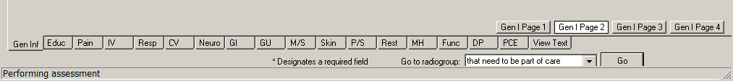
RN Reassessment tabs
- Open the Tabs menu and select a tab from the list.
The selected tab opens.
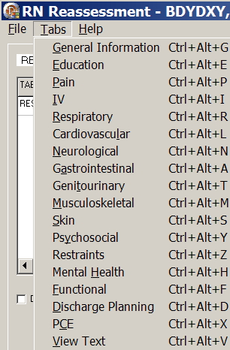
RN Reassessment window, Tabs menu

Moving through the Template without a Mouse

Ctrl-Alt Keys
You can move from tab to tab using Ctrl+Alt+<letter>. The list contains the keys to use for each of the tabs.

Tab | Keys
General Information | Ctrl +Alt+G
Education | Ctrl +Alt+E
Pain | Ctrl +Alt+P
IV | Ctrl +Alt+I
Respiratory | Ctrl +Alt+R
Cardiovascular | Ctrl +Alt+L
Neurological | Ctrl +Alt+N
Gastrointestinal | Ctrl +Alt+A
Genitourinary | Ctrl +Alt+T
Musculoskeletal | Ctrl +Alt+M
Skin | Ctrl +Alt+S
Psychosocial | Ctrl +Alt+Y
Restraints | Ctrl +Alt+Z
Mental Health | Ctrl +Alt+H
Functional | Ctrl +Alt+F
Discharge Planning | Ctrl +Alt+D
PCE | Ctrl +Alt+X
View Text | Ctrl +Alt+V

Go to Radiogroup
The Go to radiogroup is designed to navigate the templates with keyboard commands, when the mouse stops working during a patient assessment. It also satisfies the 508-compliant requirement, under Section 508 of the Rehabilitation Act, to be able to navigate the templates without using a mouse.
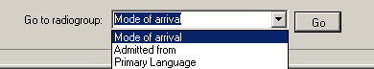
Go button
- Use the Tab key to move to the bottom of the page.
- Use the arrow keys to move up/down in the Go to radiogroup: list.
- Click Go.
or
- Click the drop-down arrow in the Go to radiogroup: drop-down list.
- Select a radiogroup.
- Click Go.

Viewing Previously Entered Data
Some of the information entered during the admission assessment or a reassessment is pulled forward to the current reassessment.
- Prior responses to many questions are embedded as read-only in the template. The responses do not show up in the new Progress Note.
- Although the prior response cannot be edited, in many places the information can be updated.

For example, the Primary Language is identified as English and can be updated.
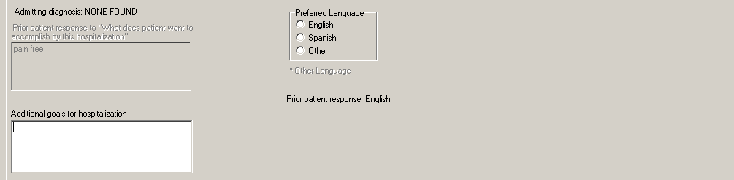
Prior patient response: English
Primary language

For example, Advance Directive information was not requested in the previous assessment. Now the patient requests information on Advance Directives and a consult can be sent.
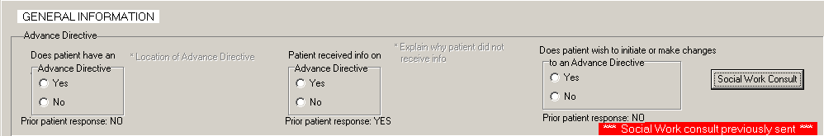
Prior response: No
Does patient wish to indicate or make changes to an Advance Directive
- Some data entered on one page in the template also displays on another page.
Information entered on the Psychosocial tab, P/S Page 3 displays on the Discharge Planning tab shaded in yellow.
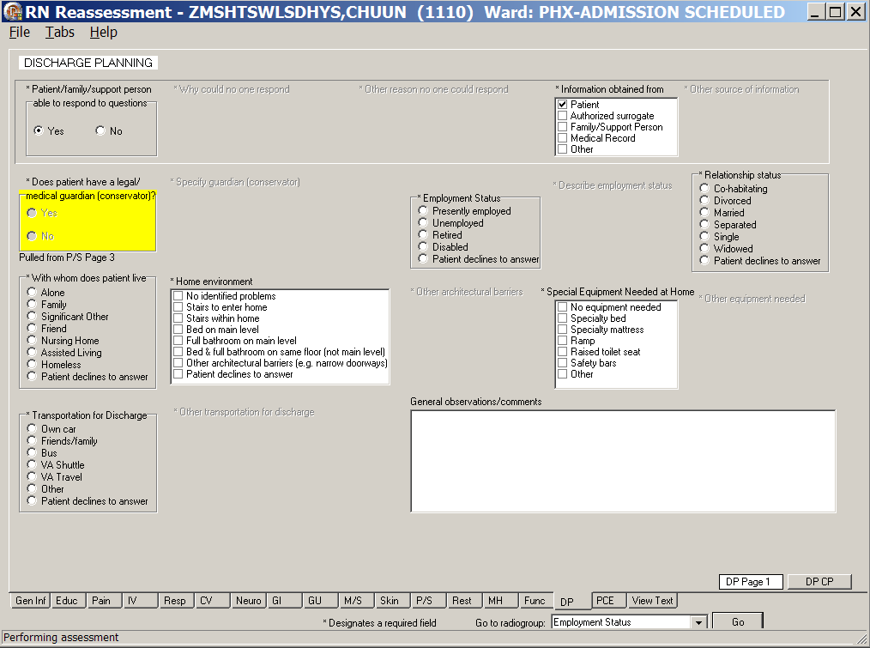
RN Reassessment, Discharge Planning (DP) tab, DP Page 1 window

Navigating the RN Reassessment Tabs
The RN Reassessment template has 18 tabs.

General Information (Gen Inf)
The RN Reassessment template opens to the General Information (Gen Inf) tab, the first tab at the bottom on the left.
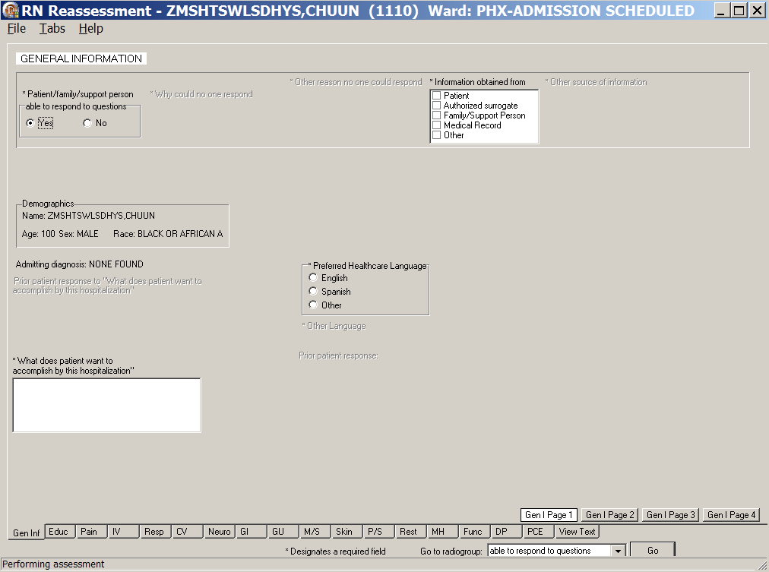
RN Reassessment, General Information (Gen Inf) tab, Gen I Page 1 window
Gen I Page 1 contains information that is similar to its equivalent on the RN Assessment. It is previously entered information and is read-only.

- Click Gen I Page 2.
Gen I Page 2 displays.
- Populate Gen I Page 2, if necessary.
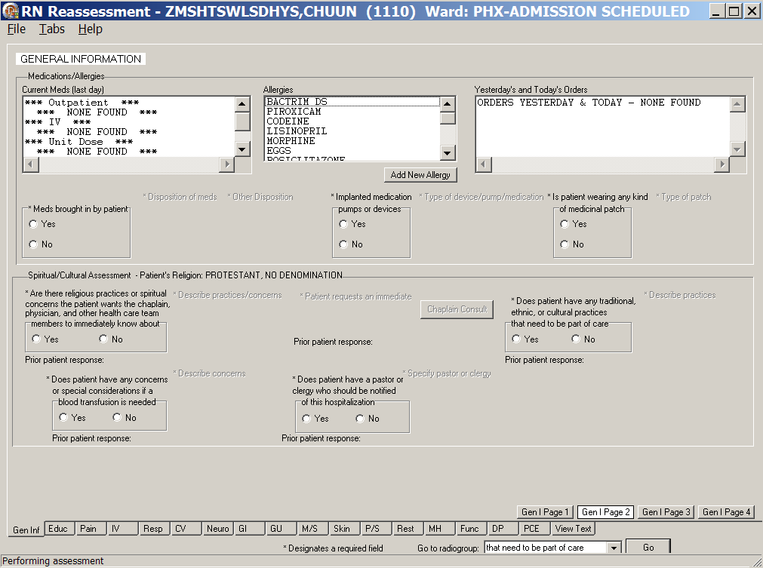
RN Reassessment, General Information (Gen Inf) tab, Gen I Page 2 window
Gen I Page 2 contains information that can be updated, as well as information that is read-only.
- Allergies are added on Gen I Page 2, in the Allergies text box.
- None of the fields on Gen I Page 2 is required during reassessment, provided a completed admission assessment is on file.

Adding an Allergy
Allergies/Adverse Reactions are uploaded immediately into the Allergy/Adverse Reaction Package when saved.
Note: Follow your local medical center policy with regard to adding allergies.
- Click Add New Allergy.
The Add New Allergies window displays.

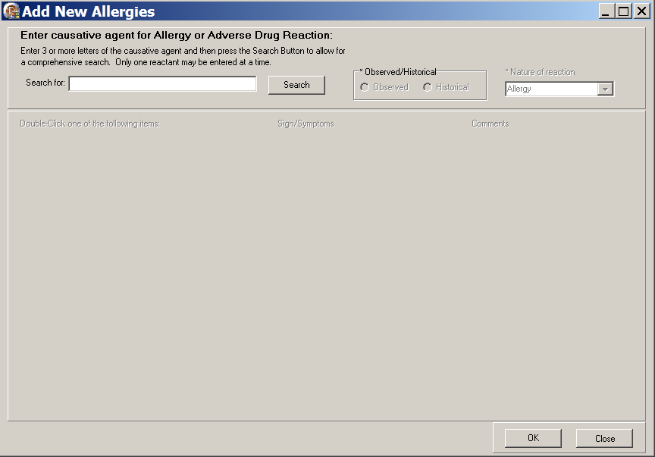
Add New Allergies window
- Type 3-5 letters of the reported allergy, into the Search for text box.
- Click Search.
- Double-click an allergy in the Allergy list.
The Sign/Symptoms list box displays.
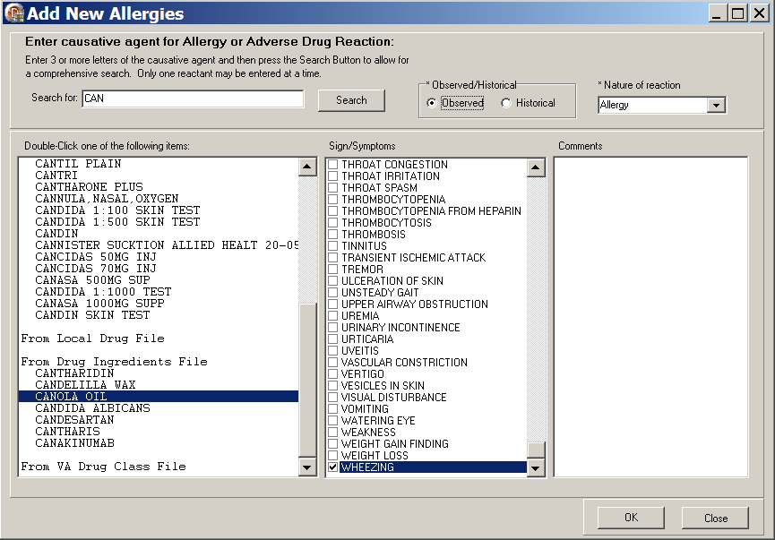
Add New Allergies window with Sign/Symptoms available
- In the Observed/Historical box, select Observed or Historical.
- In the Nature of reaction text box, select Allergy, Pharmacological, or Unknown.
- Select one or more reported signs/symptoms.
- Click OK and the allergy is saved in the Adverse Drug Reaction (ADR) file.
Information displays to confirm the allergy is saved.
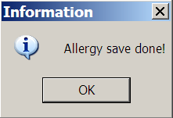
Information : Allergy save done!
- Click OK.
- Click Close.

Initiating a Social Work Consult for Advance Directives
All of the consults in RN Reassessment work the same way; refer to the instructions in Working in the Consults on page 24.

- Click Gen I Page 3.
Gen I Page 3 displays.
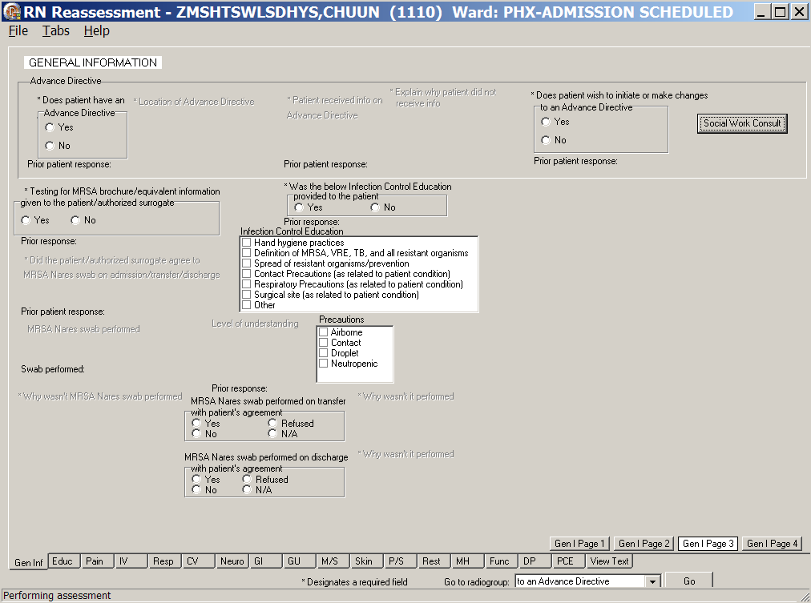
RN Reassessment, General Information (Gen Inf) tab, Gen I Page 3 window

- Populate Gen I Page 3.
- Make appropriate selections in the Advance Directive section.
If the patient wants to initiate or make changes to an Advance Directive, you are required to order a Social Work Consult.
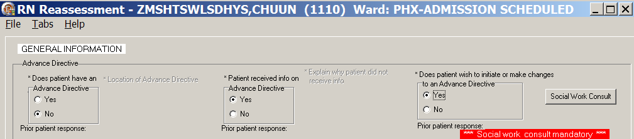
RN Reassessment, General Information (Gen Inf) tab, Gen I Page 3 window, Social Work Consult Mandatory
Note: You cannot upload a Progress Note, unless you order the Social Work consult.

Changing Emergency Contact Information
- Click Gen I Page 4.
Gen I Page 4 displays with the Emergency contact information, Support person contact information, and General observations/comments text boxes available for additional information.
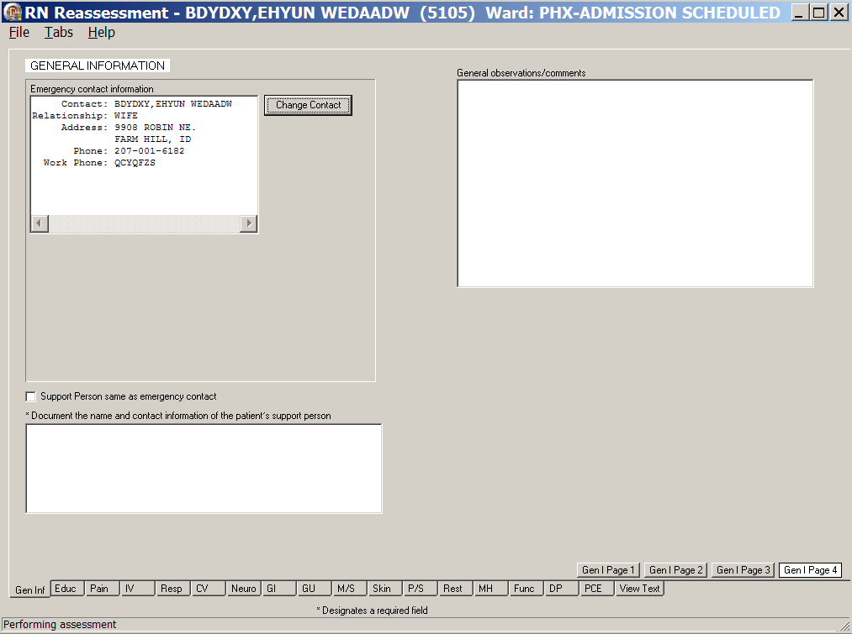
RN Reassessment, General Information (Gen Inf) tab, Gen I Page 4 window

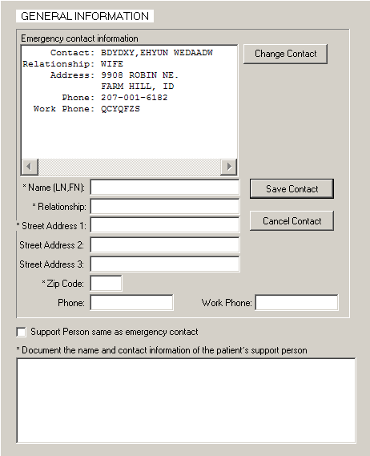
Emergency Contact and Support Person Information
- To update the emergency contact information, click Change Contact.
The Emergency contact information section expands.
- Complete all the fields with asterisks; they are required fields.
- Click Save Contact.
- To cancel the update, click Cancel Contact before you click Save Contact.
- Document the name and contact information of the patient’s support person.
It is required information.

Education (Educ)
The Education Tab contains the educational assessment and a readiness to learn. The Educational Assessment is unavailable when the patient cannot respond.

Educ Page 1 contains information that can be updated, but none of the fields on Educ Page 1 is required during reassessment.
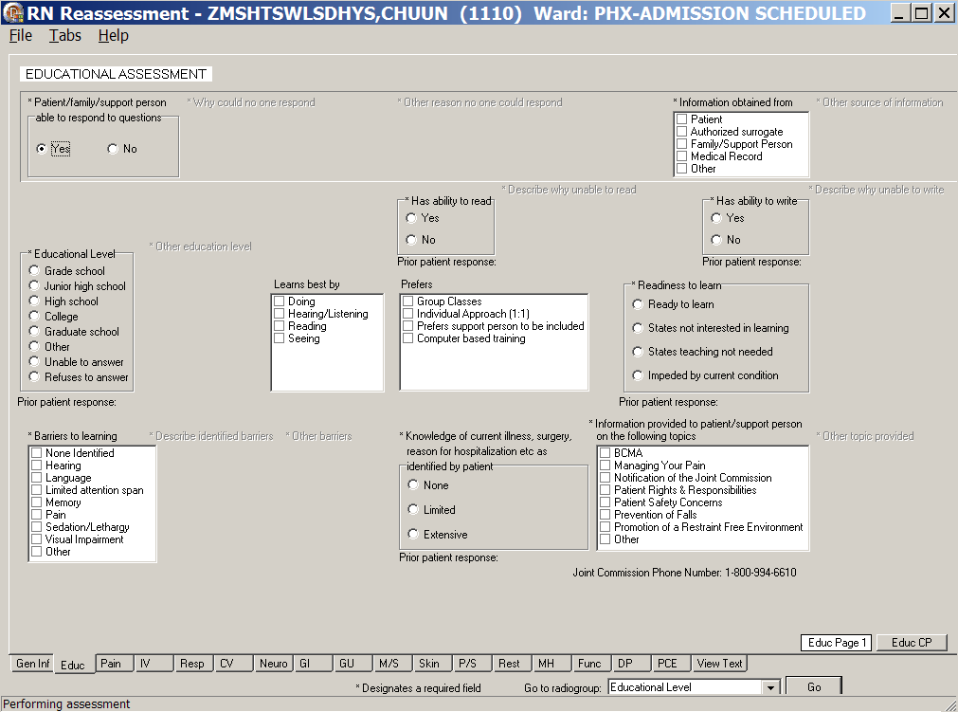
RN Reassessment, Educational Assessment (Educ) tab, Edu Page 1 window
- Click Educ.
Educ Page 1 displays.
- Update Educ Page 1, if necessary.

- Click Educ CP.
Educ CP displays.
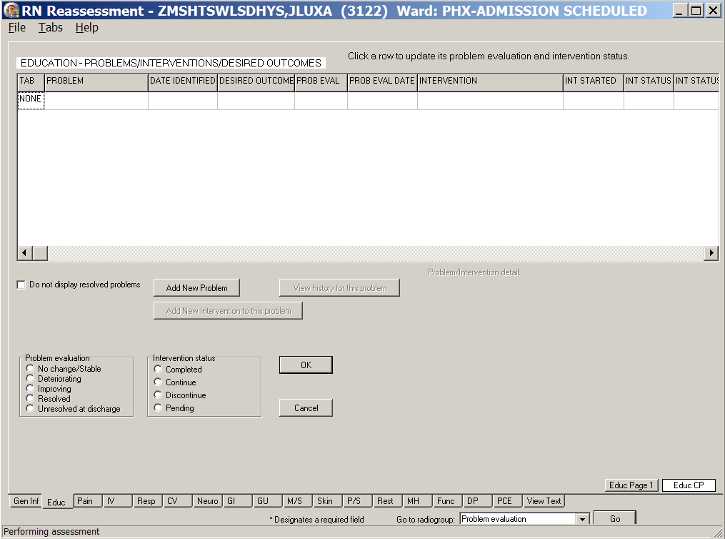
RN Reassessment, Educational Assessment (Educ) tab, Educ CP window
- Update Educ CP.
Refer to the instructions in Working in a Care Plan on page 12.

Pain (Pain)
The Pain tab in reassessment is similar to the tab in the Admission – RN Assessment.
- If Is pain is a problem for patient was documented as Yes in the Admission - RN Assessment, it is pulled into the RN Reassessment.
- If Is pain is a problem for patient was documented as No in the Admission - RN Assessment, the reassessment pages work like those in Admission – RN Assessment. If there is no pain at the time of the reassessment, all pain locations are unavailable.
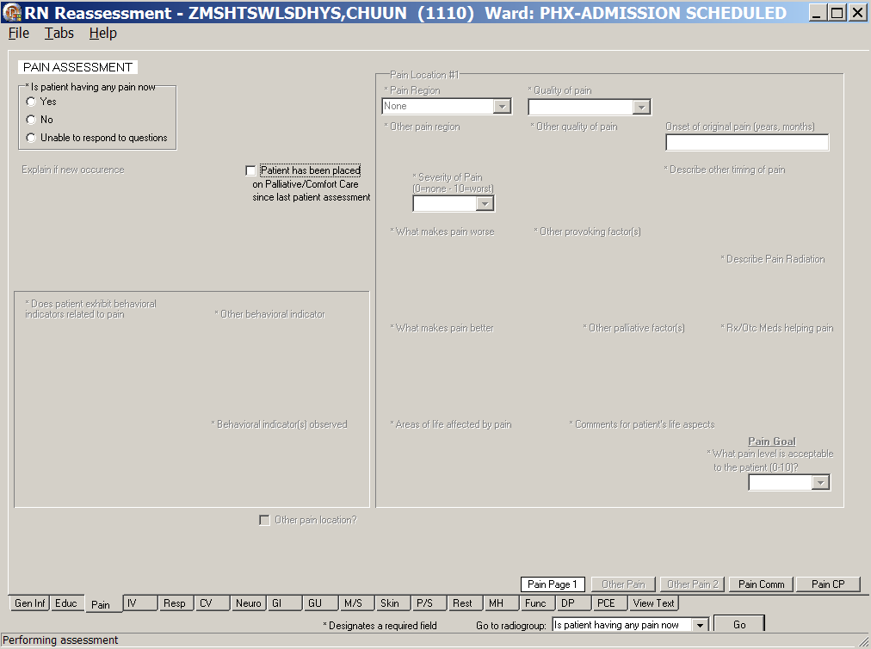
RN Reassessment, Pain Assessment (Pain) tab, Pain Page 1 window
- Click Pain.
Pain Page 1 displays.
- Populate Pain Page 1.
- Select a radio button in the Is pain a problem for the patient group. The fields that display vary depending on the response for this query.
- Yes
- No
- Unable to respond to questions
- Select a radio button in the Is patient on Palliative/Comfort Care group.
Is pain a problem for the patient/Yes
- If a patient reports that pain is a problem (even if there is no pain currently), select Yes.
- The Other Pain and Other Pain 2 pages are available when the patient identifies multiple pain locations. There are five pain location sections.
- Identify Pain Location #1 and document the behavioral indicators.
- Complete all fields with asterisks; they are required fields.
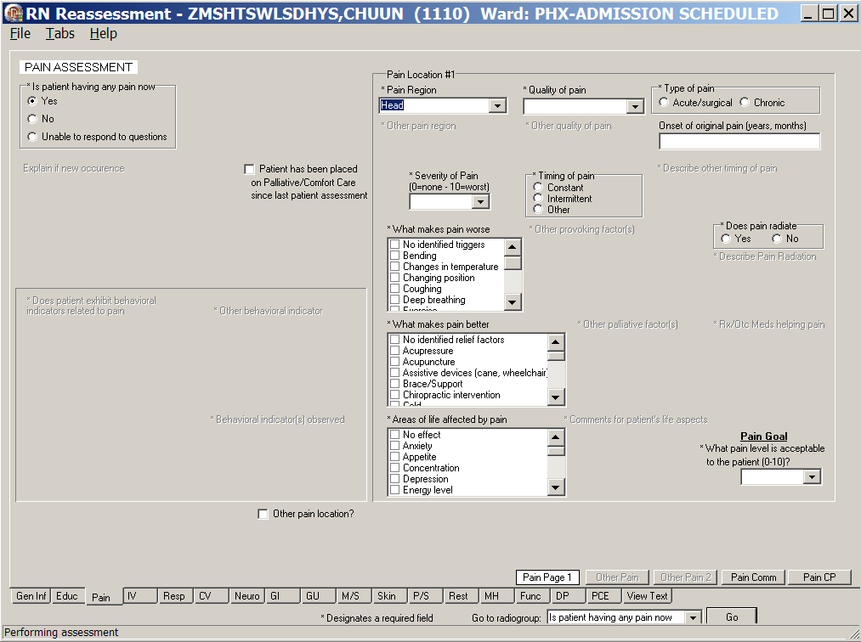
RN Reassessment, Pain Assessment (Pain) tab, Pain Page 1 window
Is Patient having any pain now with Yes selected
- When Pain Location #1 is complete and you have more pain locations to document, select the Other pain location ? check box.
Other Pain page displays.
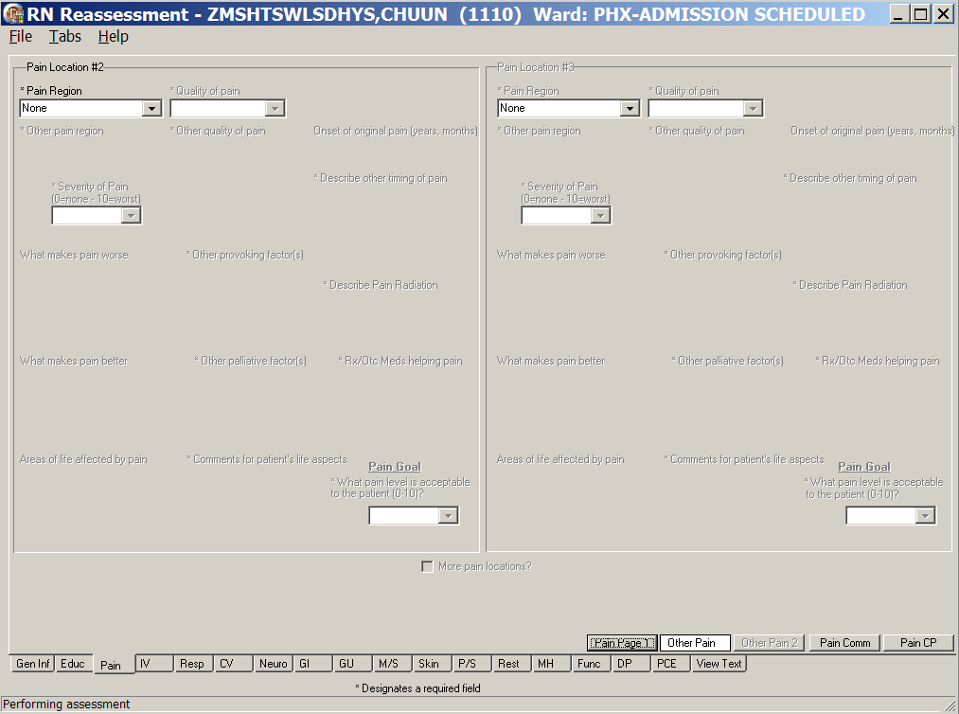
RN Reassessment, Pain Assessment (Pain) tab, Other Pain window
Pain Location #2 and Pain Location #3
- Optional: Populate the Other Pain page.
- Identify Pain Location #2/Pain Location #3 and document the behavioral indicators.
- Complete all fields with asterisks; they are required fields.

- When Pain Locations #2 and #3 are complete and you have more pain locations to document, select the More pain locations? check box.
Other Pain 2 displays.
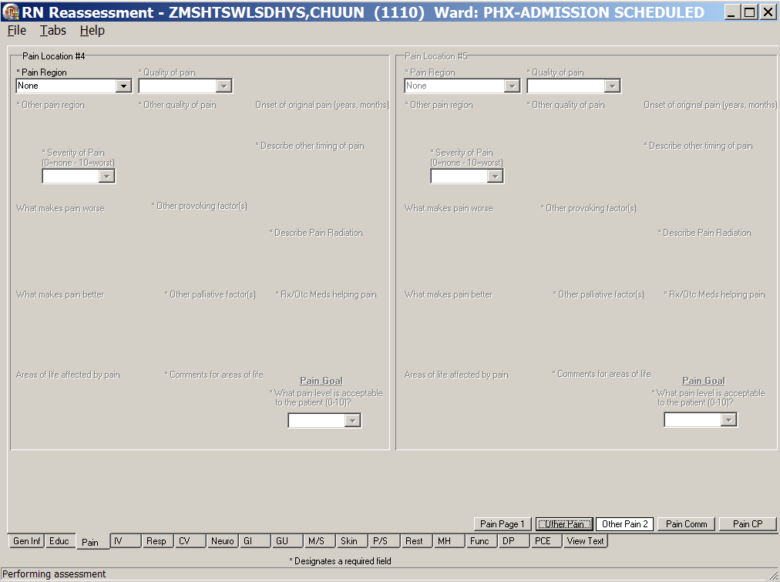
RN Reassessment, Pain Assessment (Pain) tab, Other Pain 2 window
Pain Location #4 and Pain Location #5
- Optional: Populate the Other Pain 2 page.
- Identify Pain Location #4/Pain Location #5 and document the behavioral indicators.
- Complete all fields with asterisks; they are required fields.
- If you require more than five pain locations, continue to document on the Pain Comm page in the General observations/comments text box.

Is pain a problem for the patient/No
When No is selected on Pain Page 1, many fields are unavailable and no documentation is necessary.
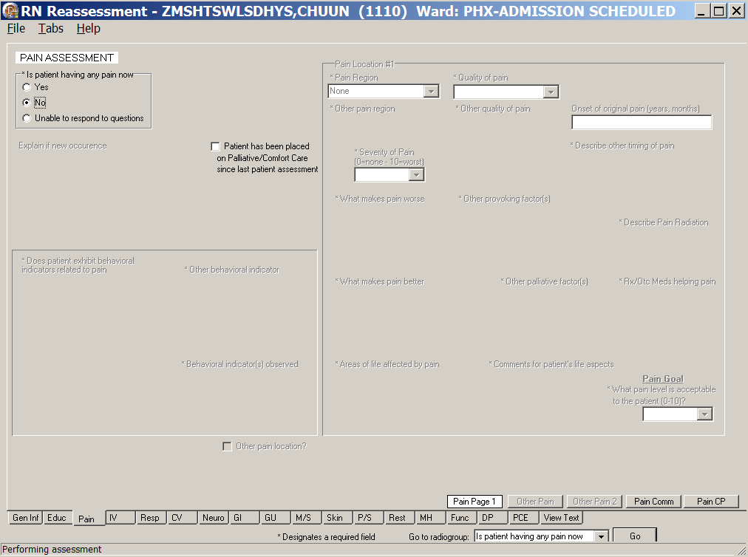
RN Reassessment, Pain Assessment (Pain) tab, Pain Page 1 window
Is patient having any pain now/No

Is pain a problem for the patient/Unable to respond to questions
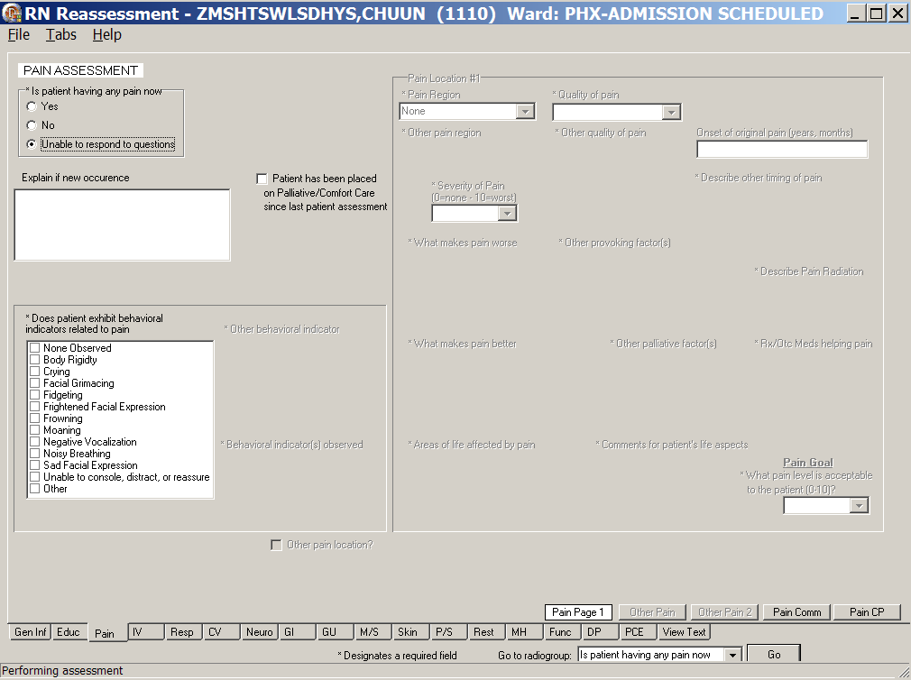
RN Reassessment, Pain Assessment (Pain) tab, Pain Page 1 window
Is patient having any pain now/Unable to respond to questions
- When Unable to respond to questions is selected on Pain Page 1
- Type an explanation for unable to respond in the Explain why patient unable to respond to questions text box.
- Select behavioral indicators in the Does patient exhibit behavioral indicators related to pain list box.
- Select a radio button in the Is patient on Palliative/Comfort Care group.

- Click Pain Comm.
Pain Comm displays.
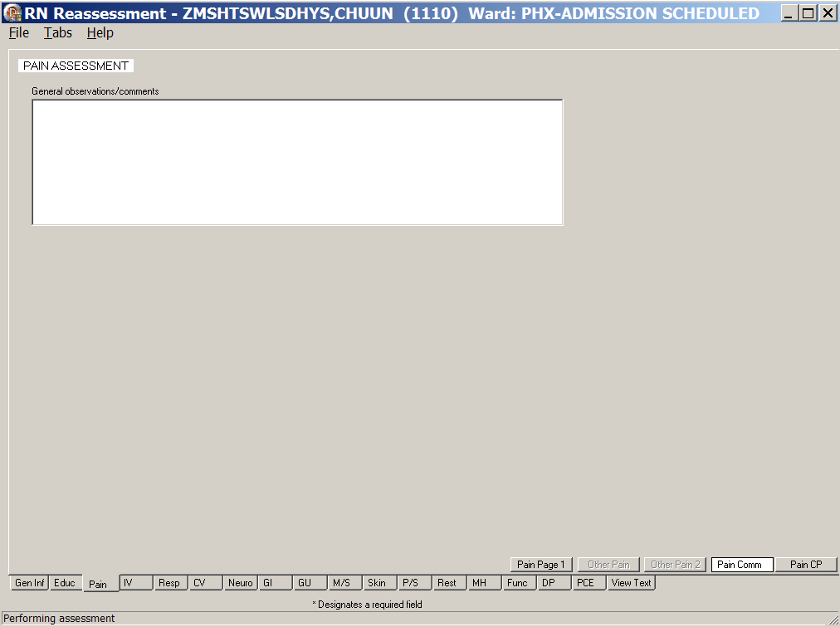
RN Reassessment, Pain Assessment (Pain) tab, Pain Comm window
- Populate Pain Comm, if necessary.
Use the General observations/comments text box for additional information.

- Click Pain CP.
Pain CP displays.
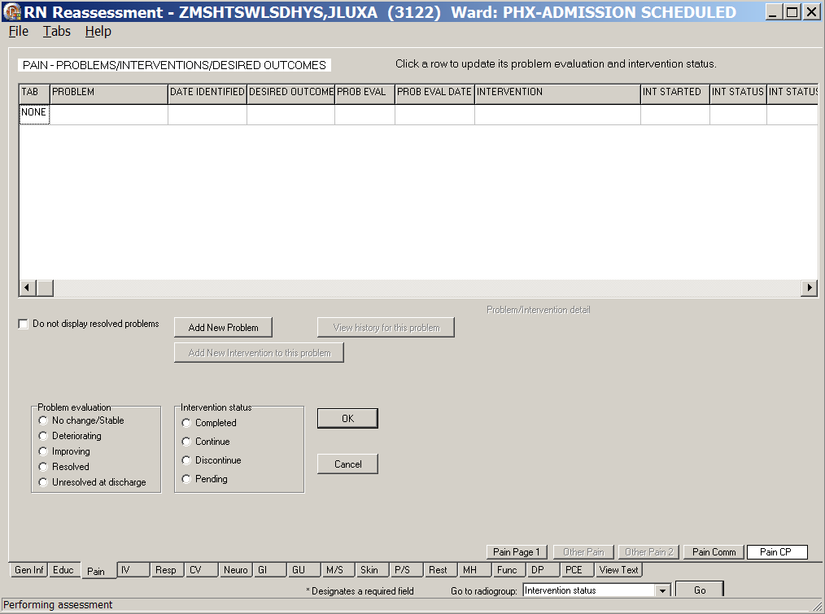
RN Reassessment, Pain – Problems/Interventions/Desired Outcomes, Pain CP window
- Populate Pain CP.
Refer to the instructions in Working in a Care Plan on page 12.

IV (IV)
On the IV tab, document new IV locations and Dialysis access, as well as update existing IV locations and Dialysis access.

No IV/Vascular Access Devices
- Click IV.
IV Periph displays.
- If a patient has no IVs or dialysis access in place, select the No IV/vascular access devices check box and none of the IV pages or Add New IV Location are available.
- Move to the next tab.
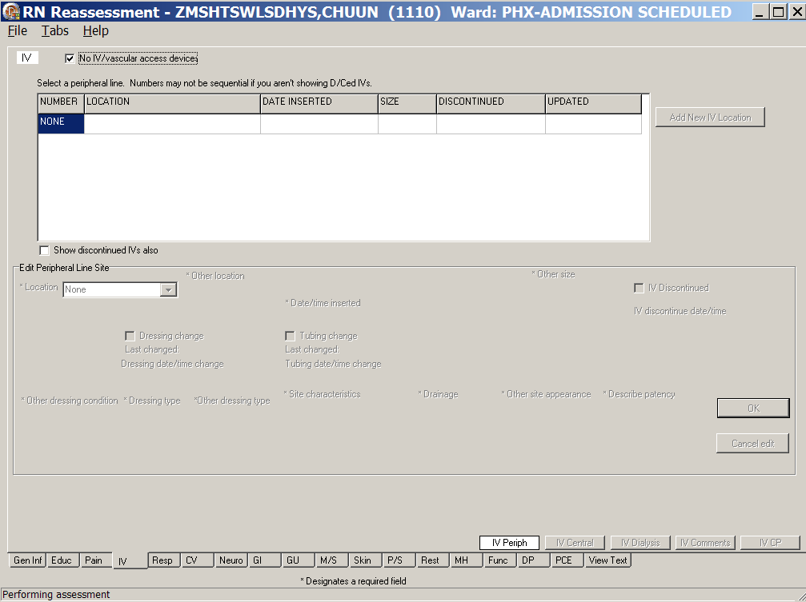
RN Reassessment, IV (IV) tab, IV Periph window
No IV/vascular access device selected

Peripheral Lines - IV Periph

Existing IV Lines
If IVs were present at time of the Admission – RN Assessment or in previous reassessments, those IVs display on the IV tab.
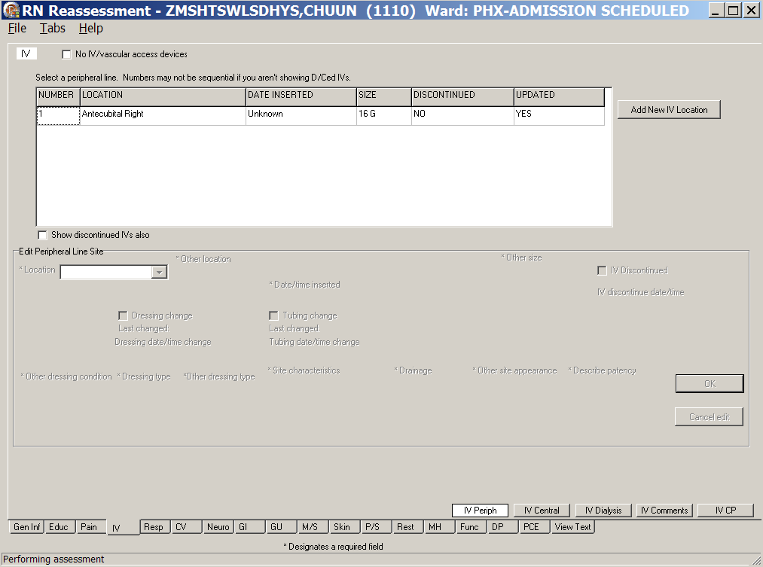
RN Reassessment, IV (IV) tab, IV Periph window
with an existing IV line
- Populate IV Periph.
- Select an existing IV and the edit fields for the selected IV are made available.
Complete all the fields with asterisks; they are required fields.

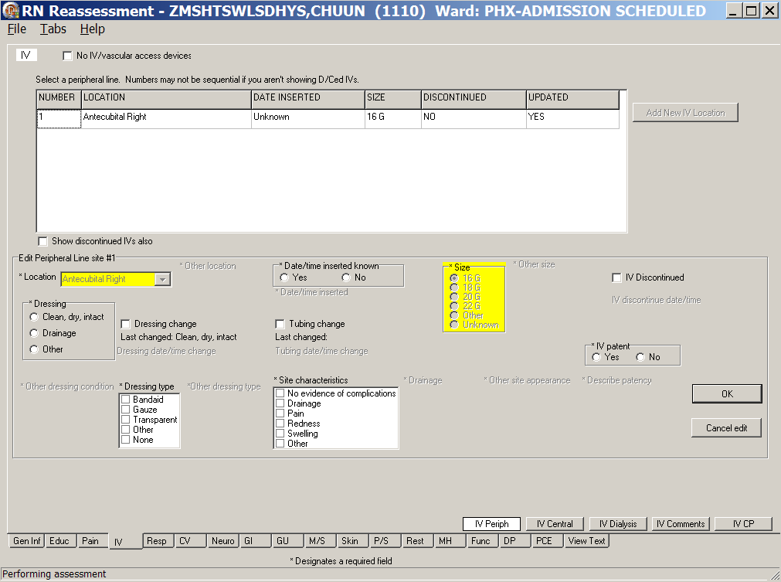
RN Reassessment, IV (IV) tab, IV Periph window with existing IV line
- To cancel entered data before upload, click Cancel edit.
- To upload updated information, click OK.

New IV Lines
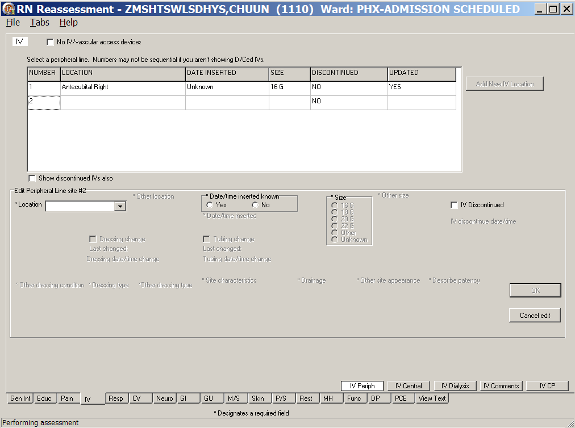
RN Reassessment, IV (IV) tab, IV Periph window
- Click Add New IV Location.
The Location drop-down list box displays in the Edit Peripheral Line site #1 section.
- Select a location and additional fields become available.
Complete all the fields with asterisks; they are required fields.
- To cancel entered data before upload, click Cancel edit.
- To upload updated information, click OK.
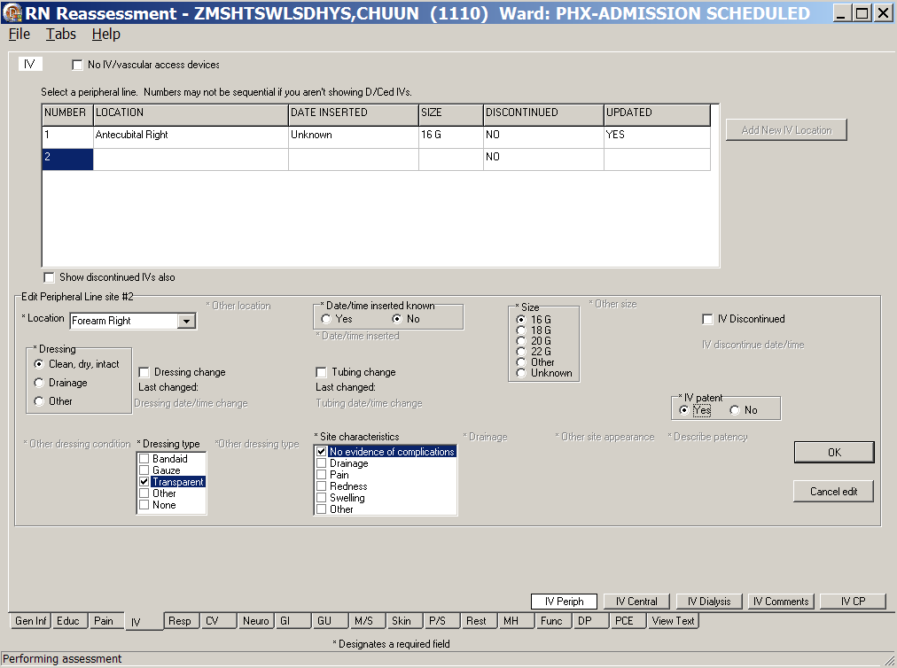
RN Reassessment, IV (IV) tab, IV Periph window with a peripheral line location
- To add another IV location, repeat steps 6 through 8.
Note: There is no limit to the number of IV locations you can enter.

Central IV Lines – IV Central
- Click IV Central.
IV Central displays.
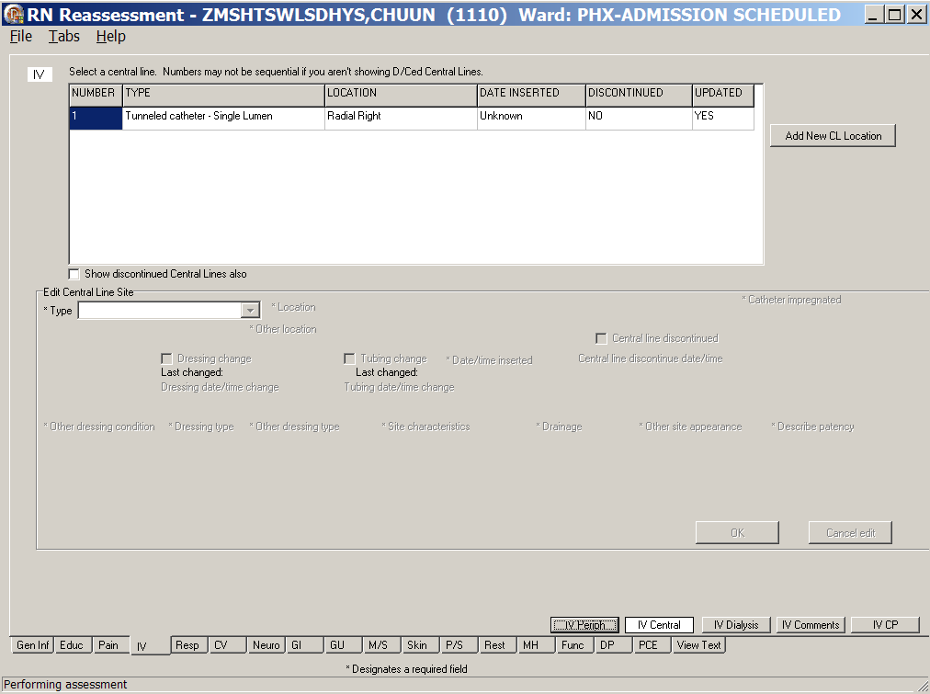
RN Reassessment, IV (IV) tab, IV Central window
- Populate IV Central.
- Click Add New CL Location.
The Type drop-down text box displays in the Edit Central Line site #1 section.
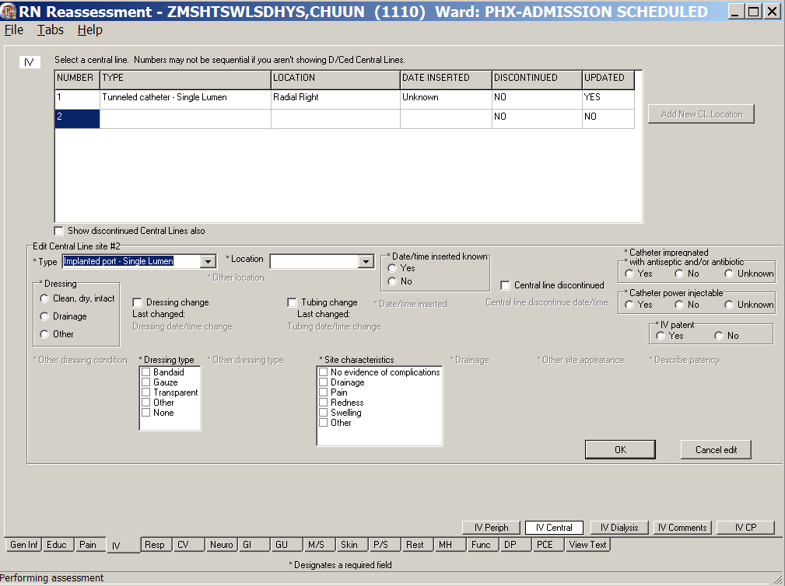
RN Reassessment, IV (IV) tab, IV Central window
- Select a type and a location.
Complete all the fields with asterisks; they are required fields.
- To cancel entered data before upload, click Cancel edit.
- To upload updated information, click OK.
- To add another central line, repeat steps 3 through 6.

Dialysis Ports - IV Dialysis
- Click IV Dialysis.
IV Dialysis displays.
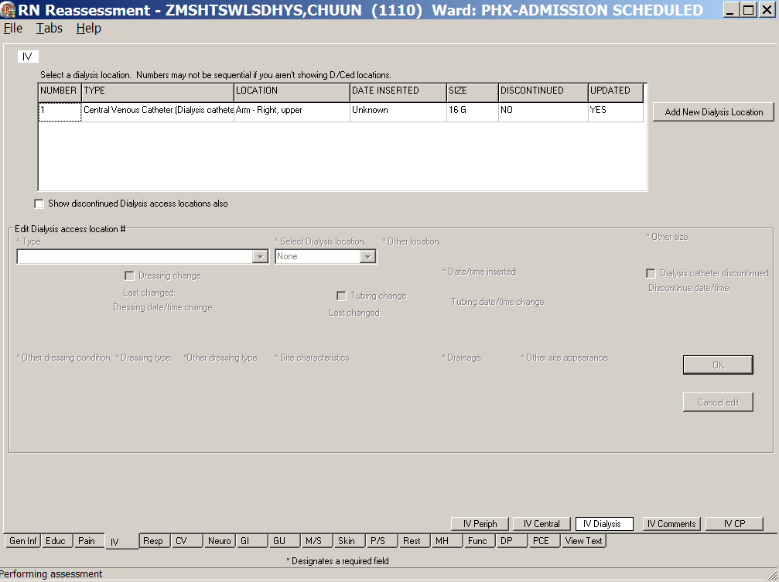
RN Reassessment, IV (IV) tab, IV Dialysis window
- Populate IV Dialysis.
- Click Add New Dialysis Location.
The Type and Select Dialysis location drop-down list boxes display in the Edit Dialysis access location #1 section.
- Select type and location.
Complete all the fields with asterisks; they are required fields.

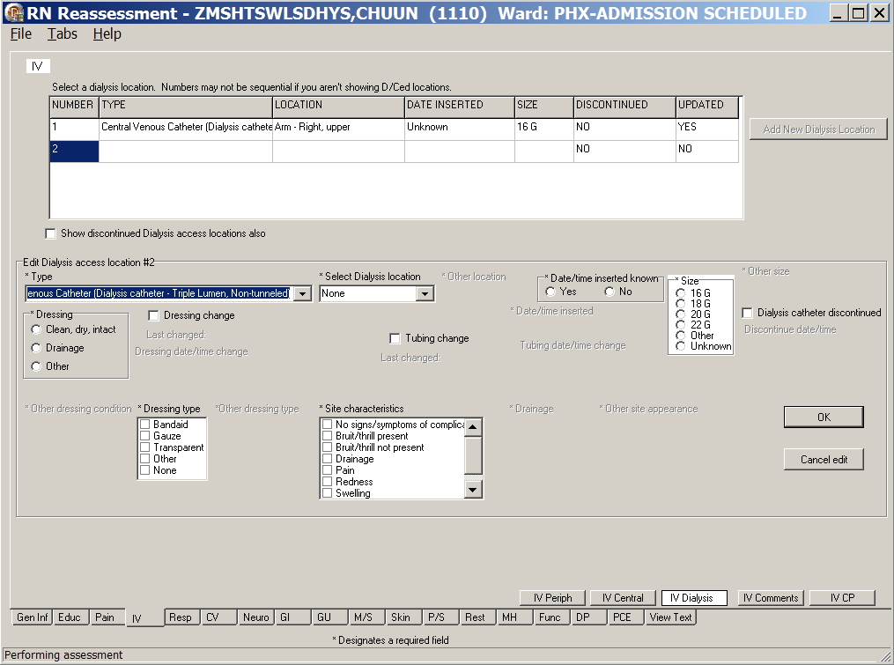
RN Reassessment, IV (IV) tab, IV Dialysis window
Note: When you select AV Fistula or AV Graft for Type, a warning message displays to advise against using the patient’s affected arm for BP or needle sticks.
You must place an arm band on the affected limb to prevent any mishaps.
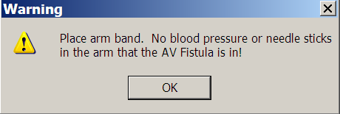
Warning: Place arm band.
No blood pressure or needle sticks in the arm that the AV Fistula or AV Graft is in!
- To cancel entered data before upload, click Cancel edit.
- To upload updated information, click OK.
- To add another dialysis access location, repeat steps 2 through 6.

General Observations/Comments – IV Comments
- Click IV Comments.
IV Comments displays.
- Populate IV Comments.
Use the General observations/comments text box for additional information.
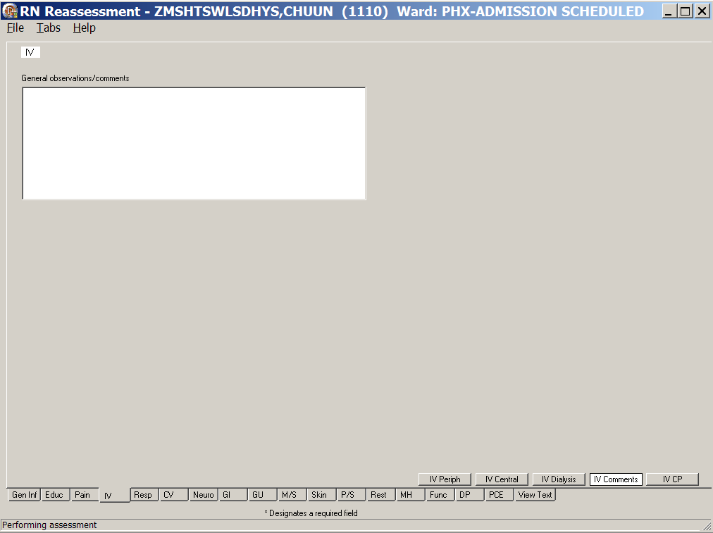
RN Reassessment, IV (IV) tab, IV Comments window

Care Plan - IV CP
- Click IV CP.
IV CP displays.
- Update IV CP.
- Add/update a problem evaluation and/or intervention status, if necessary.
Refer to the instructions in Working in a Care Plan on page 12.
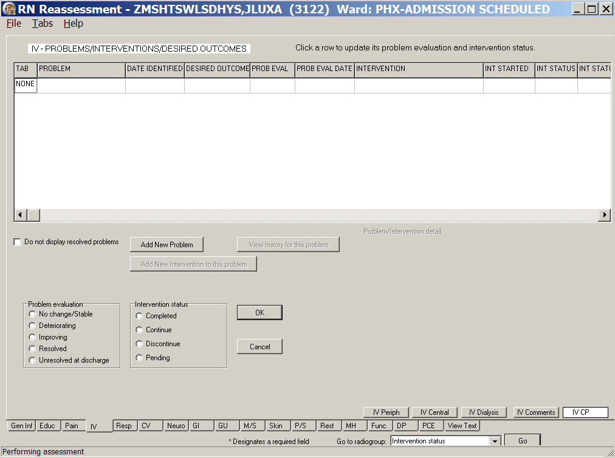
RN Reassessment, IV – Problems/Interventions/Desired Outcomes (IV) tab, IV CP window

Respiratory (Resp)
In the Respiratory tab, update or add breathing information to reflect the condition of the patient during a current reassessment.

Responses from the previous assessment/reassessment are hard-coded into the reassessment, but the information is not transferred into the Progress Note of the current assessment.
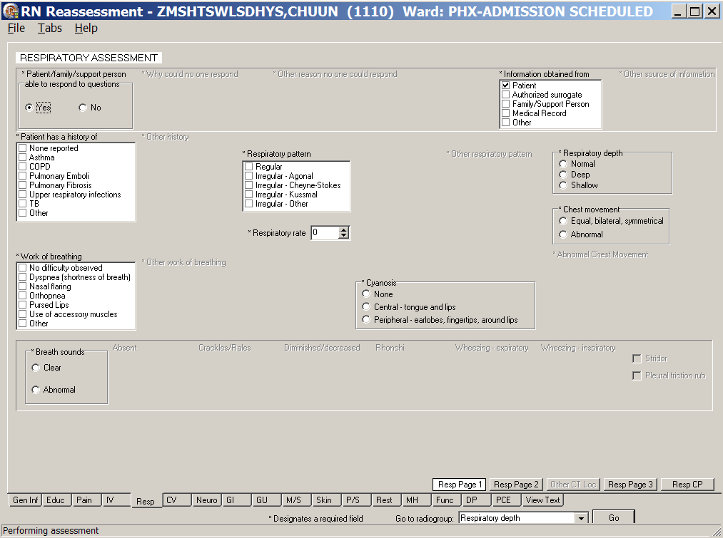
RN Reassessment, Respiratory Assessment (Resp) tab, Resp Page 1 window
- Click Resp.
Resp Page 1 displays.
- Populate Resp Page 1.
- Use the Respiratory rate box to enter the patient’s current respiratory rate.
- Complete all the fields with asterisks; they are required fields.

- Click Resp Page 2.
Resp Page 2 displays.
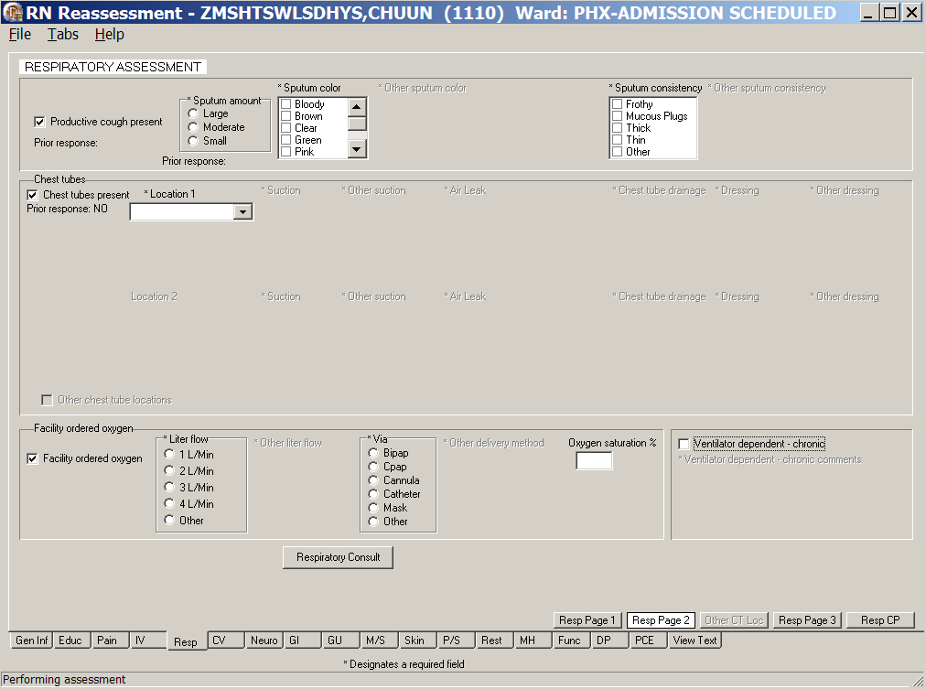
RN Reassessment, Respiratory Assessment (Resp) tab, Resp Page 2 window
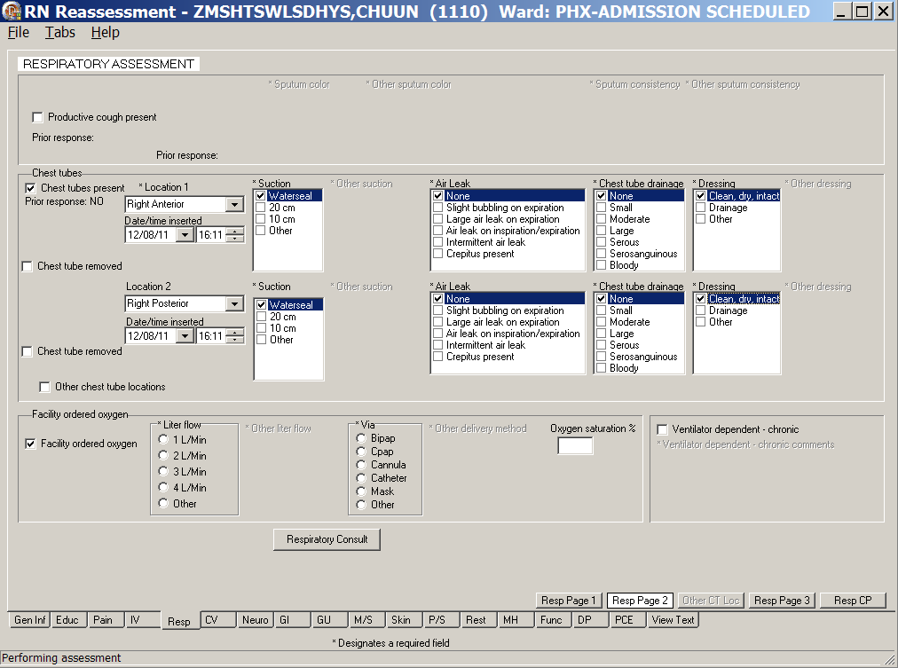
RN Reassessment, Respiratory Assessment (Resp) tab, Resp Page 2 window
Chest tube locations 1 and 2
- Populate Resp Page 2.
Complete all the fields with asterisks; they are required fields.
- If the Respiratory Consult is set up at your site, use the Respiratory Consult button to order the consult, in accordance to the condition of the patient and the policy of your medical center.
- Refer to the instructions in Working in the Consults on page 24.
- Select the Other chest tube locations check box.
The Other CT Loc page is made available.
- Click Other CT Loc.
Other CT Loc displays.
- Populate Other CT Loc, CT locations 3 and 4, if necessary.
Complete all the fields with asterisks; they are required fields.
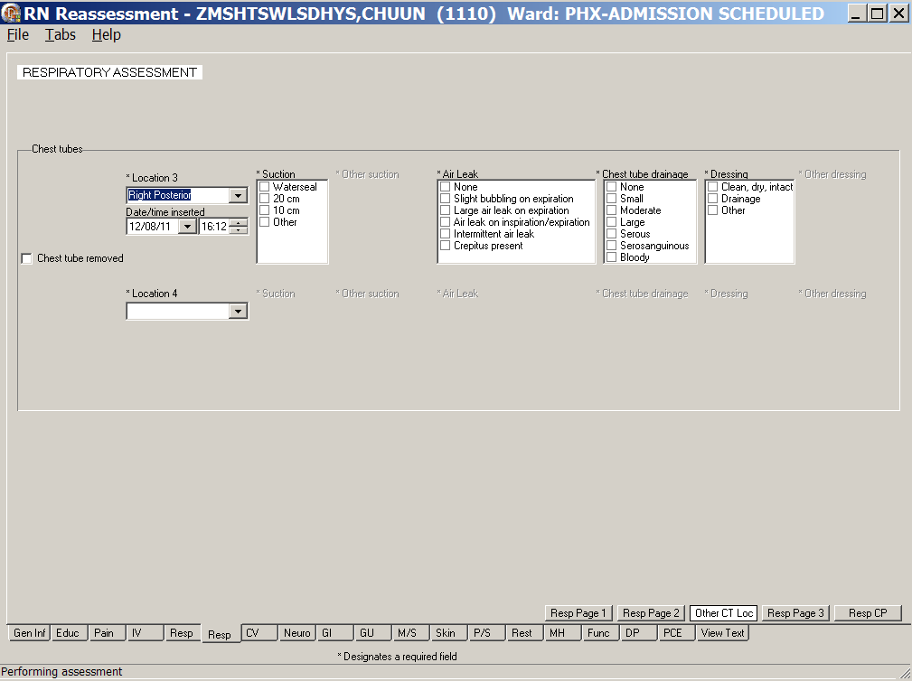
RN Reassessment, Respiratory Assessment (Resp) tab, Other CT Loc window
Other CT locations, Location 3 and Location 4
- Click Resp Page 3.
Resp Page 3 displays.
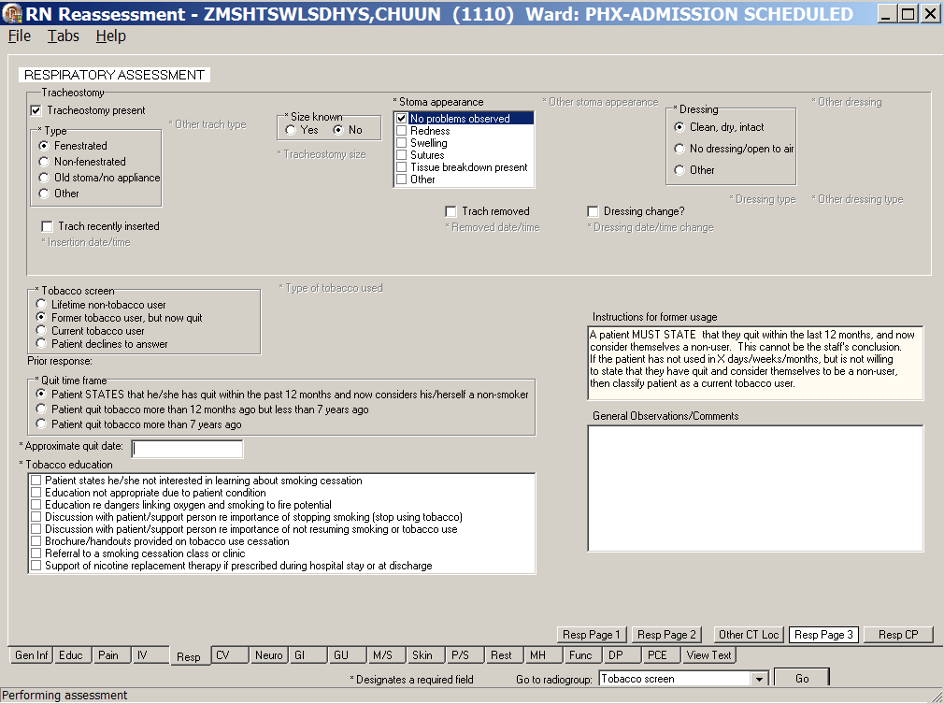
RN Reassessment, Respiratory Assessment (Resp) tab, Resp Page 3 window
contains the Tobacco screen
- Populate Resp Page 3, if necessary.
Complete all the fields with asterisks; they are required fields.
- Click Resp CP.
Resp CP displays.
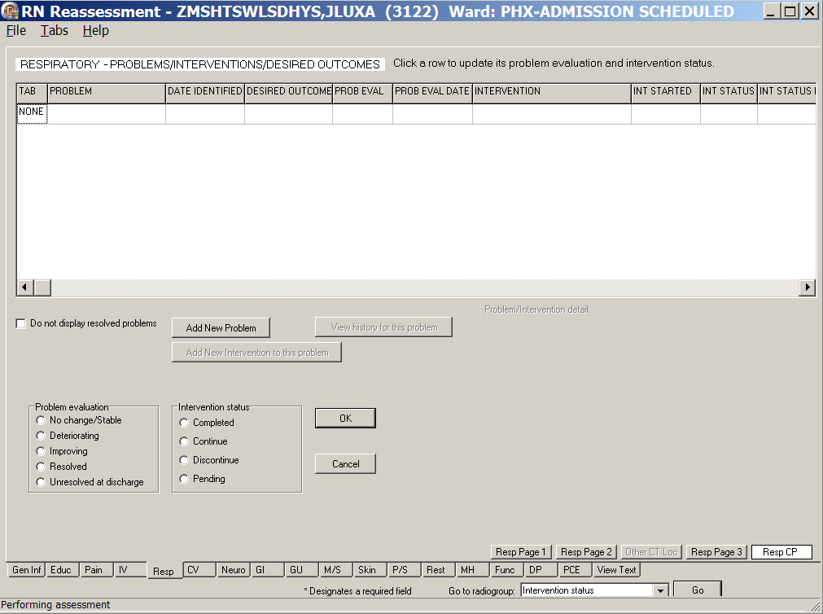
RN Reassessment, Respiratory – Problems/Interventions/Desired Outcomes (Resp) tab,
Resp CP window
- Update Resp CP, if necessary.
Refer to the instructions in Working in a Care Plan on page 12.

Cardiovascular (CV)
Document the cardiovascular reassessment of a patient in the Cardiovascular tab.
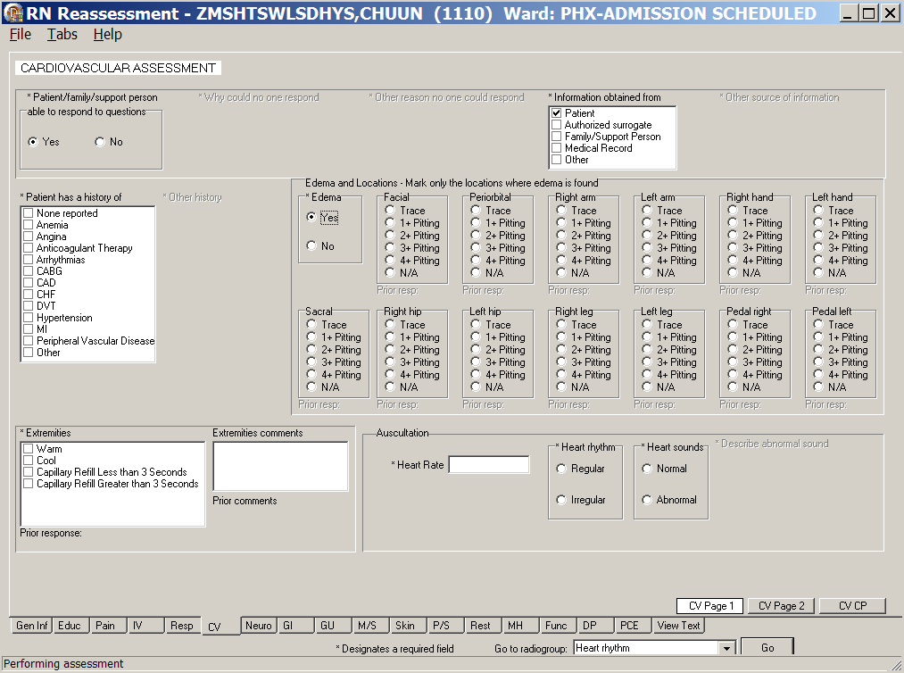
RN Reassessment, Cardiovascular Assessment (CV) tab, CV Page 1 window
- Click CV.
CV Page 1 displays.
- Populate CV Page 1.
- Complete all the fields with asterisks; they are required fields.
- Use the Extremities comments text box for additional information, if necessary.
- Click CV Page 2.
CV Page 2 displays.

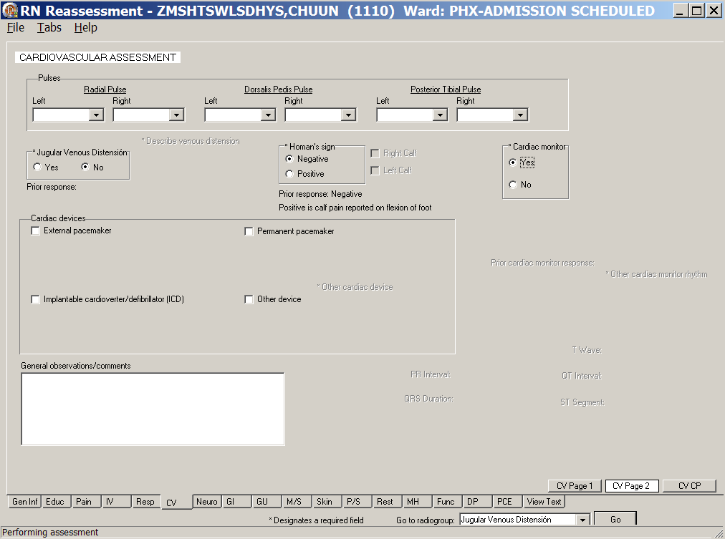
RN Reassessment, Cardiovascular Assessment (CV) tab, CV Page 2 window
Cardiac monitor selected
- Populate CV Page 2.
- Complete all the fields with asterisks; they are required fields.
- Use the General observations/comments text box for additional information.
- Click CV CP.
CV CP displays.
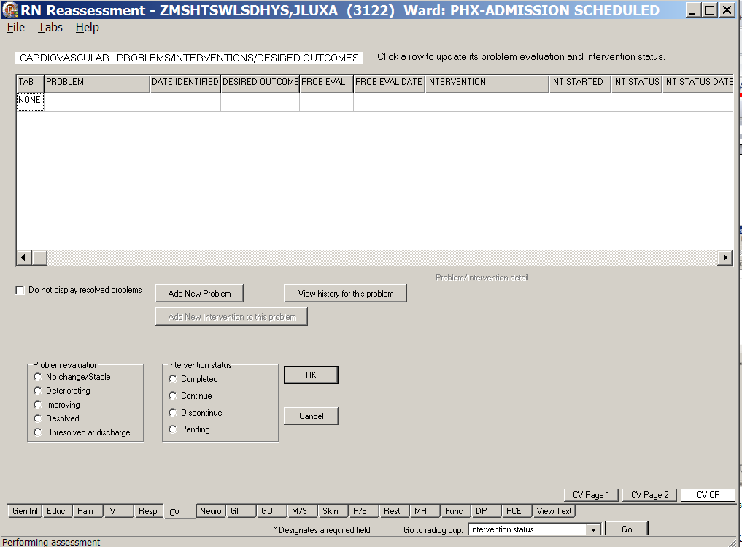
RN Reassessment, Cardiovascular – Problems/Interventions/Desired Outcomes (CV) tab,
CV CP window
- Update the CV CP, if necessary.
Refer to the instructions in Working in a Care Plan on page 12.

Neurology (Neuro)
Document the neurology reassessment of a patient in the Neurology tab.
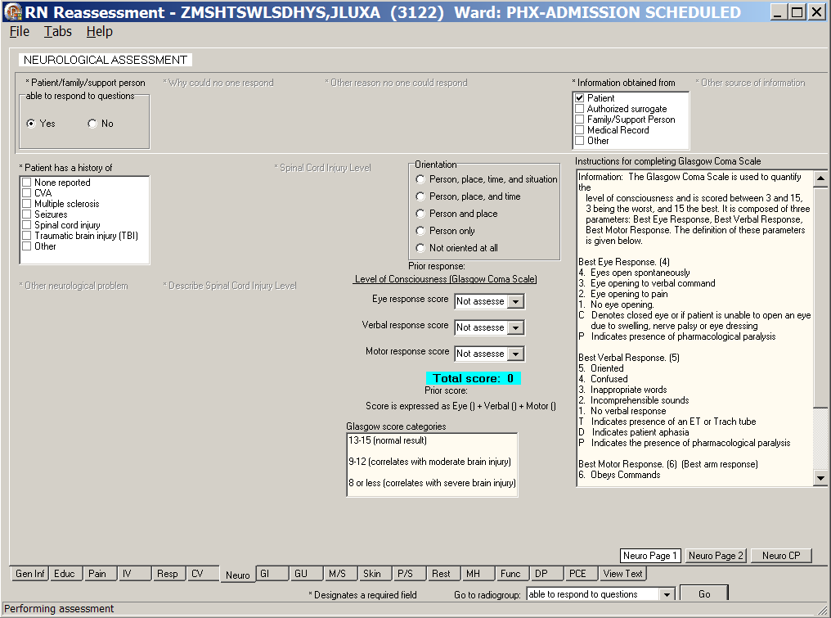
RN Reassessment, Neurological Assessment (Neuro) tab, Neuro Page 1 window
- Click Neuro.
Neuro Page 1 displays.
- Populate Neuro Page 1.
Complete all the fields with asterisks; they are required fields.
- Click Neuro Page 2.
Neuro Page 2 displays.

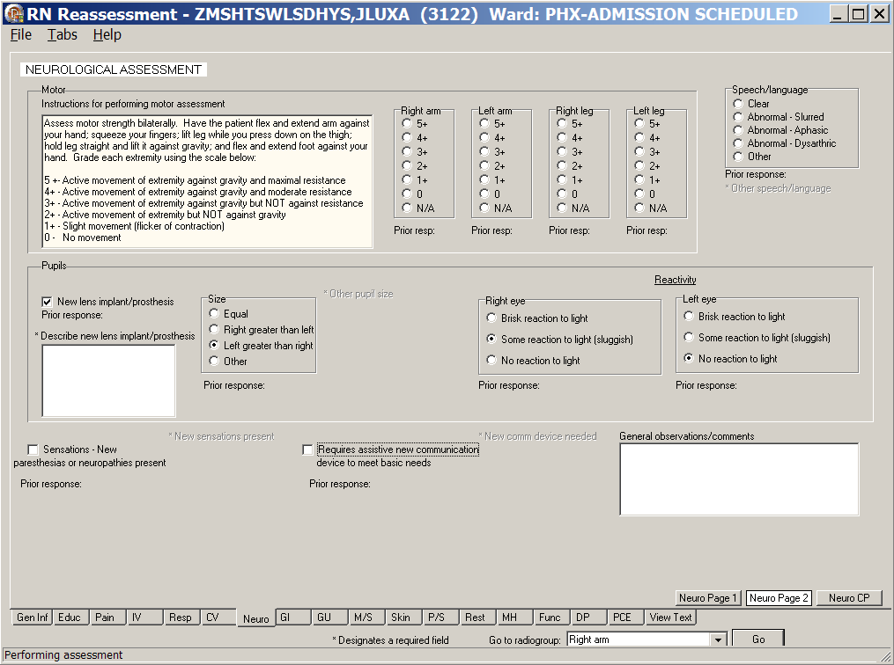
RN Reassessment, Neurological Assessment (Neuro) tab, Neuro Page 2 window
- Populate Neuro Page 2.
- Complete all the fields with asterisks; they are required fields
- Use the General observations/comments text box for additional information.
- Click Neuro CP.
Neuro CP displays.

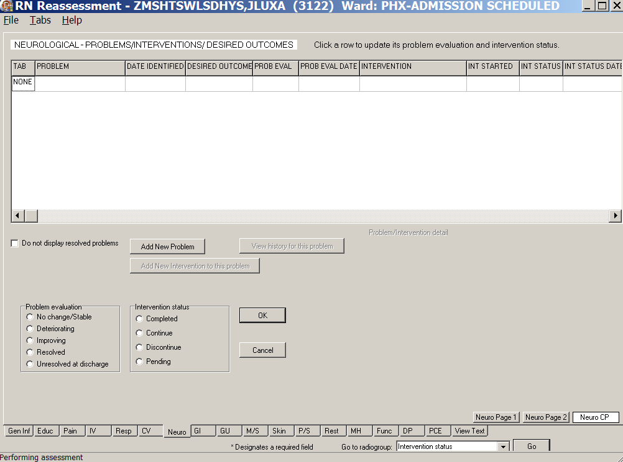
RN Reassessment, Neurological – Problems/Interventions/Desired Outcomes (Neuro) tab,
Neuro CP window
- Update Neuro CP, if necessary.
Refer to the instructions in Working in a Care Plan on page 12.

Gastrointestinal (GI)
Document the gastrointestinal reassessment of a patient in the Gastrointestinal tab.
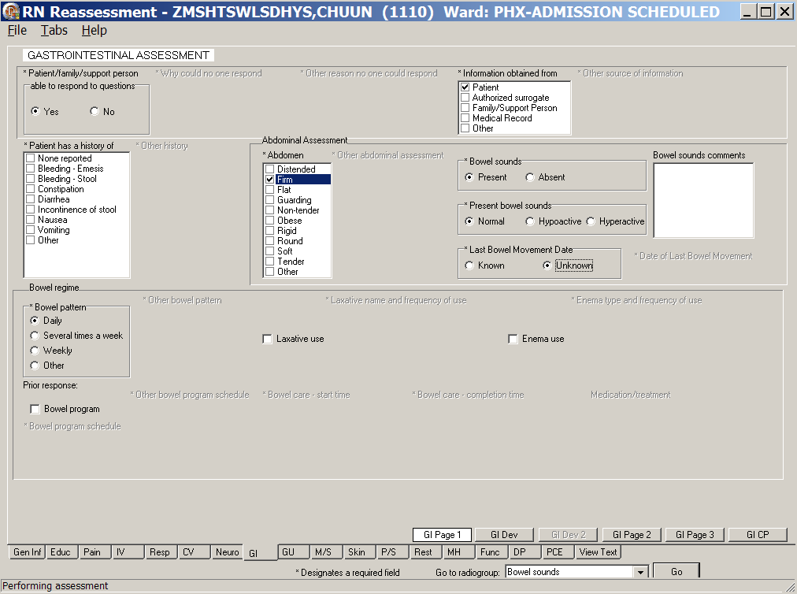
RN Reassessment, Gastrointestinal Assessment (GI) tab, GI Page 1 window
- Click GI.
GI Page 1 displays.
- Populate GI Page 1.
Complete all the fields with asterisks; they are required fields.
- Click GI Dev.
GI Page Dev displays.
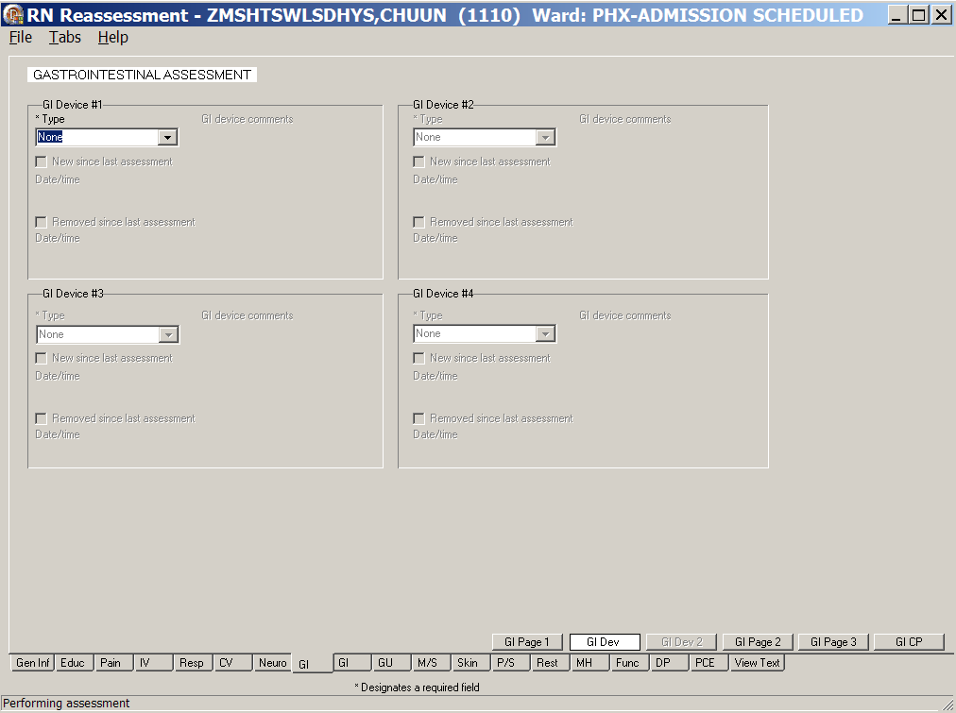
RN Reassessment, Gastrointestinal Assessment (GI) tab, GI Dev window
GI Devices #1-#4
- If there are no previous devices, the fields are void.
- If the patient has a device at the time of the previous assessment, it displays in GI Device #1.
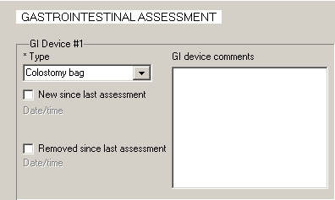
RN Reassessment, Gastrointestinal Assessment (GI) tab, GI Dev window,
GI Device #1
- Populate GI Dev.
Complete all the fields with asterisks; they are required fields.
- Click GI Dev 2.
GI Dev 2 displays.
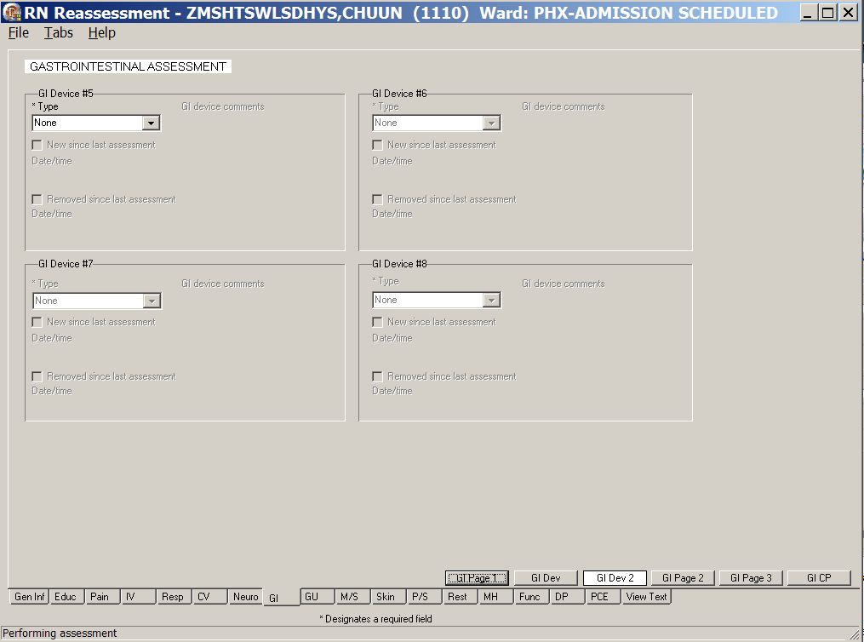
RN Reassessment, Gastrointestinal Assessment (GI) tab, GI Dev 2 window
GI Devices #5-#8
- Populate GI Dev 2, if necessary.
Complete all the fields with asterisks; they are required fields.
- Click GI Page 2.
GI Page 2 displays.
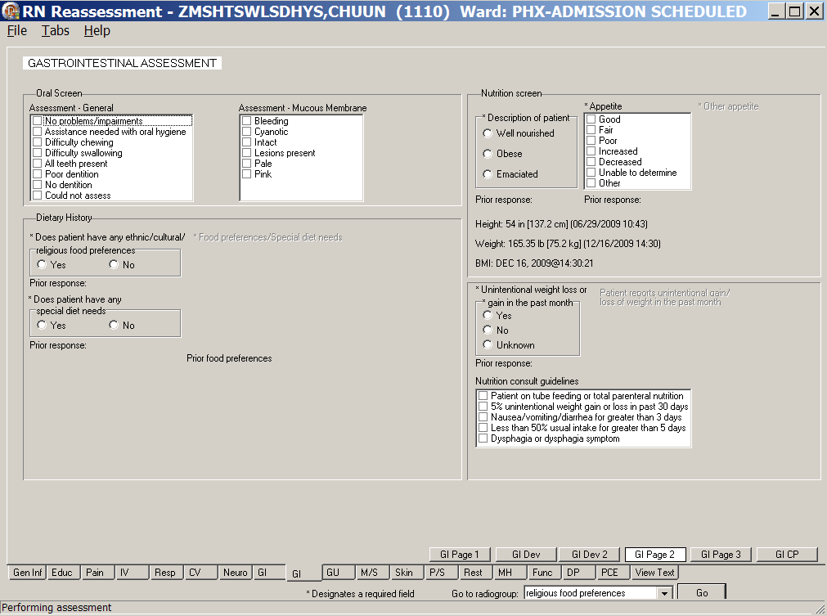
RN Reassessment, Gastrointestinal Assessment (GI) tab, GI Page 2 window
- Populate GI Page 2.
- Complete all the fields with asterisks; they are required fields.
- GI Page 2 contains the Nutrition Consult.
Refer to the instructions in Working in the Consults on page 24.
- Click GI Page 3.
GI Page 3 displays.
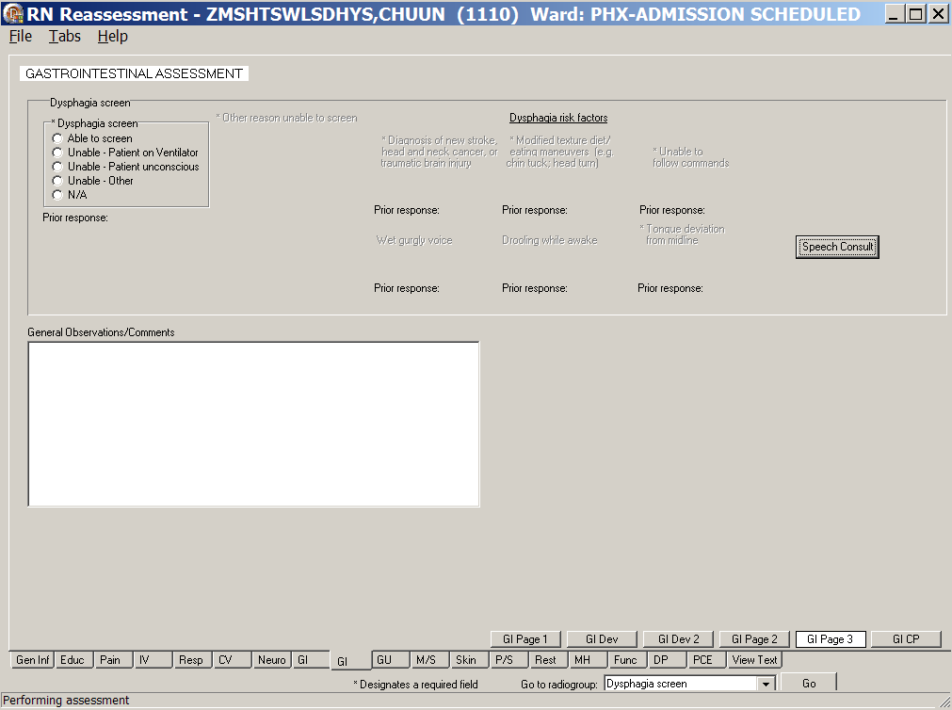
RN Reassessment, Gastrointestinal Assessment (GI) tab, GI Page 3 window
- Populate GI Page 3.
- Complete all the fields with asterisks; they are required fields.
- Use the General observations/comments text box for additional information.
- GI Page 3 contains the Speech Consult.
Refer to the instructions in Working in the Consults on page 24.
- Click GI CP.
GI CP displays.
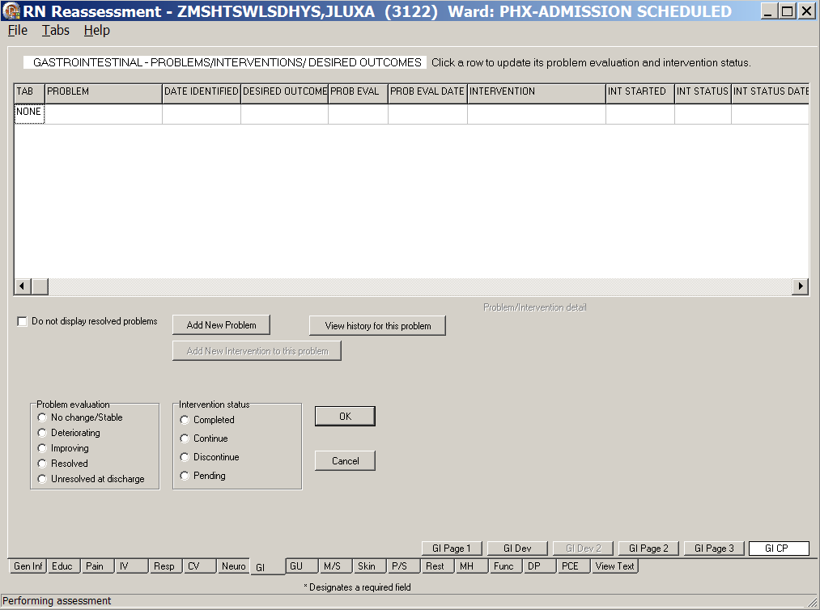
RN Reassessment, Gastrointestinal – Problems/Interventions/Desired Outcomes (GI) tab,
GI CP window
- Update the GI CP, if necessary.
Refer to the instructions in Working in a Care Plan on page 12.

Genitourinary (GU)
Document the genitourinary reassessment of a patient in the Genitourinary tab. If a patient has a GU device documented in a previous assessment, the device displays in the current reassessment.
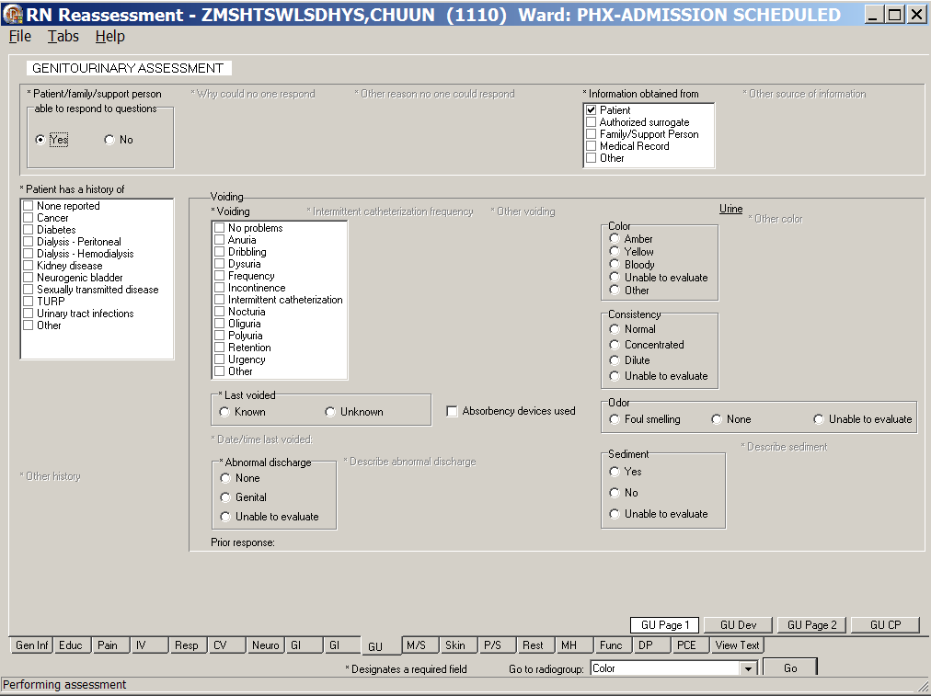
RN Reassessment, Genitourinary Assessment (GU) tab, GU Page 1 window
- Click GU.
GU Page 1 displays.
- Populate GU Page 1.
Complete all the fields with asterisks; they are required fields.
- Click GU Dev.
GU Dev displays.

- Populate GU Dev.
Complete all the fields with asterisks; they are required fields.
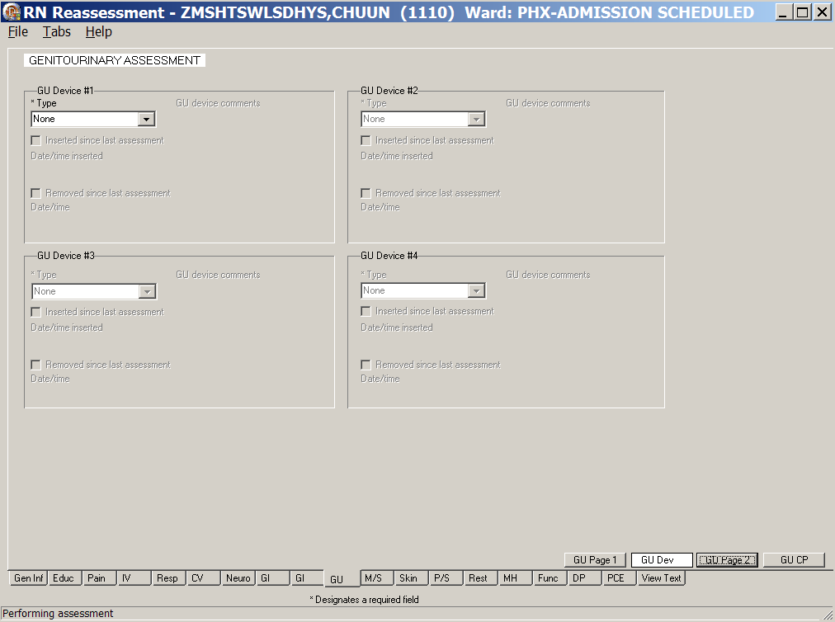
RN Reassessment, Genitourinary Assessment (GU) tab, GU Dev window
- Click GU Page 2.
GU Page 2 displays with the Indwelling Catheter field unavailable because there is no history of an indwelling catheter.
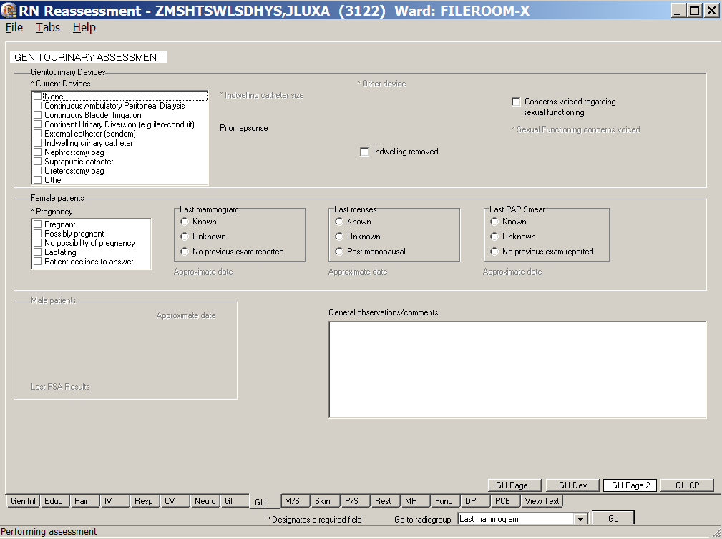
RN Reassessment, Genitourinary Assessment (GU) tab, GU Page 2 window
Female patient information available
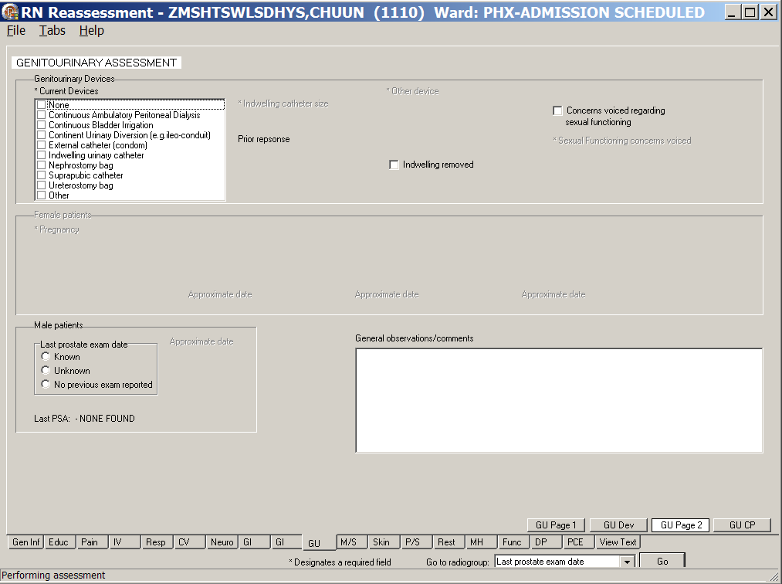
RN Reassessment, Genitourinary Assessment (GU) tab, GU Page 2 window
Male patient information available
Note: The sex-specific questions (male/female) are optional. The exception is for female patients; the pregnancy responses are required.
- Populate GU Page 2.
- Complete all the fields with asterisks; they are required fields.
- Use the General observations/comments text box for additional information.

Indwelling Catheter
If the presence of an indwelling catheter is documented, the size of the indwelling catheter is available when this data is not entered in a field that is pulled forward.
The size of the catheter can be entered in a previous reassessment on the GU Dev page in the General observations/comments text box.
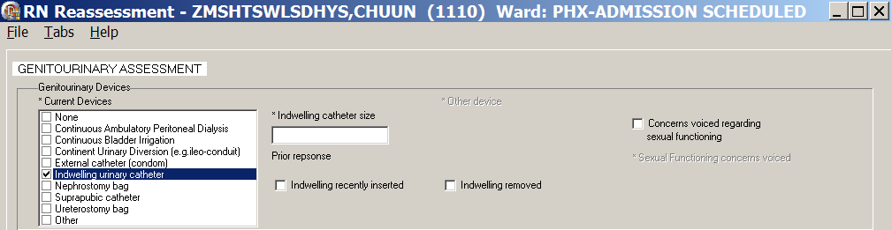
RN Reassessment, Genitourinary Assessment (GU) tab, GU Page 2 window
This data is pulled forward to the next reassessment template when entered in an admission assessment or a previous reassessment.

- Click GU CP.
GU CP displays.
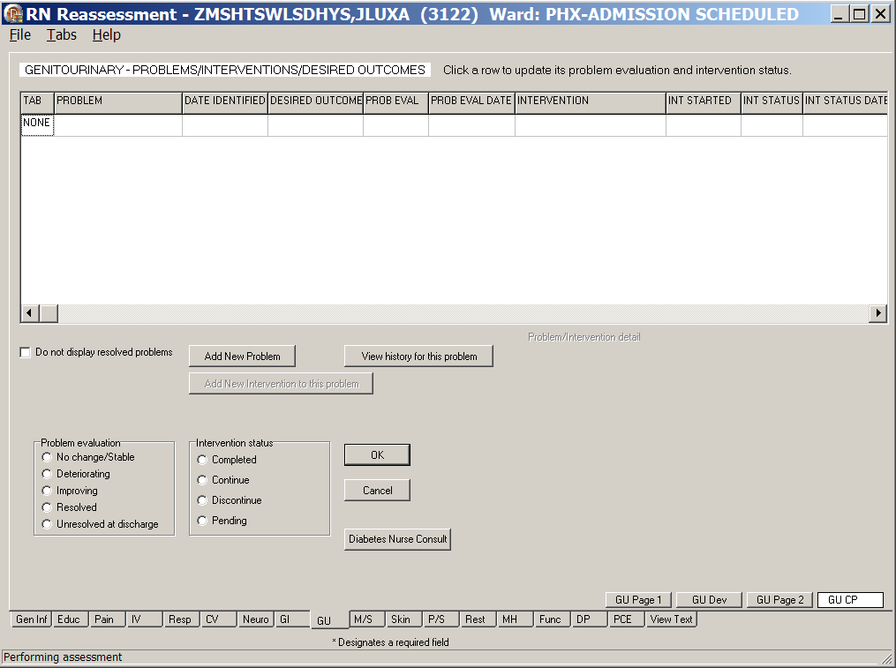
RN Reassessment, Genitourinary – Problems/Interventions/Desired Outcomes (GU) tab,
GU CP window
- Update GU CP, if necessary.
Refer to the instructions in Working in a Care Plan on page 12.

Musculoskeletal (M/S)
Document the musculoskeletal reassessment of a patient in the Musculoskeletal tab.

Directions for the Morse Fall Scale are on M/S Page 2. The directions are only on the template and are not transferred into the completed Progress Note.
- The Total Morse score for fall risk for the patient is calculated automatically as you select responses for history of falling, secondary diagnosis, ambulatory aid, gait/transferring, and marital status.
- The Morse Score is pulled forward to the M/S CP page to guide the entry of interventions.

- Click M/S.
M/S Page 1 displays.
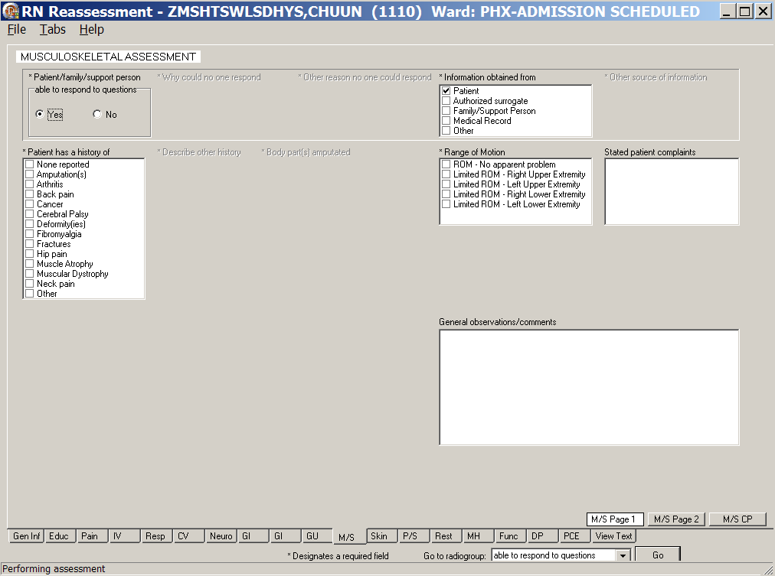
RN Reassessment, Musculoskeletal Assessment (M/S) tab, M/S Page 1 window
- Populate M/S Page 1.
- Complete all the fields with asterisks; they are required fields.
- Use the General observations/comments text box for additional information.

- Click M/S Page 2.
M/S Page 2 displays.
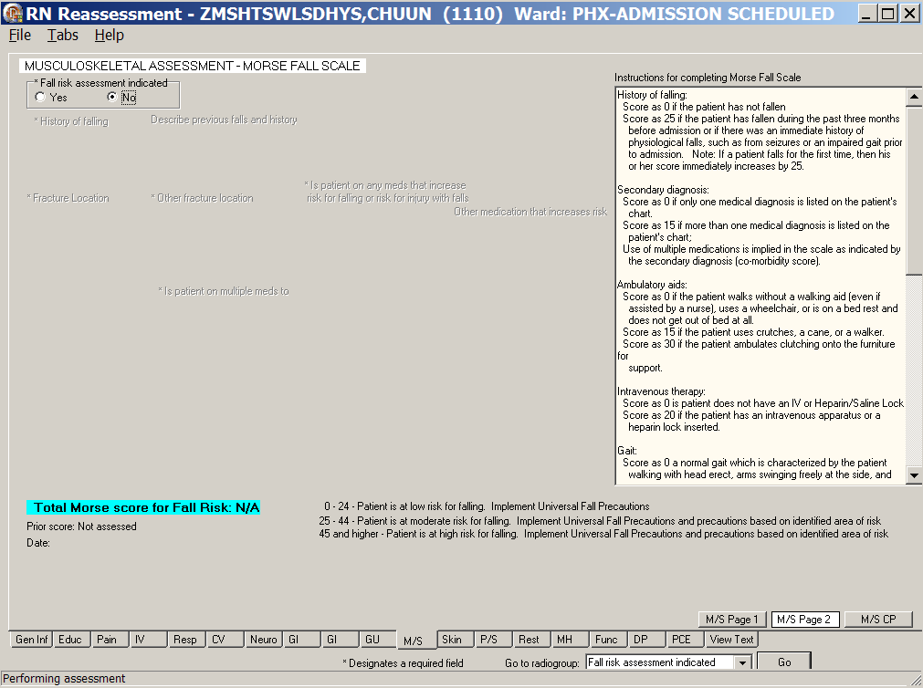
RN Reassessment, Musculoskeletal Assessment (M/S) tab, M/S Page 2 window
- Populate M/S Page 2.
Complete all the fields with asterisks; they are required fields.

- Optional: To complete a Morse Scale, select Yes for Fall risk assessment indicated.
If you select Yes, the fall risk assessment questions must be answered.
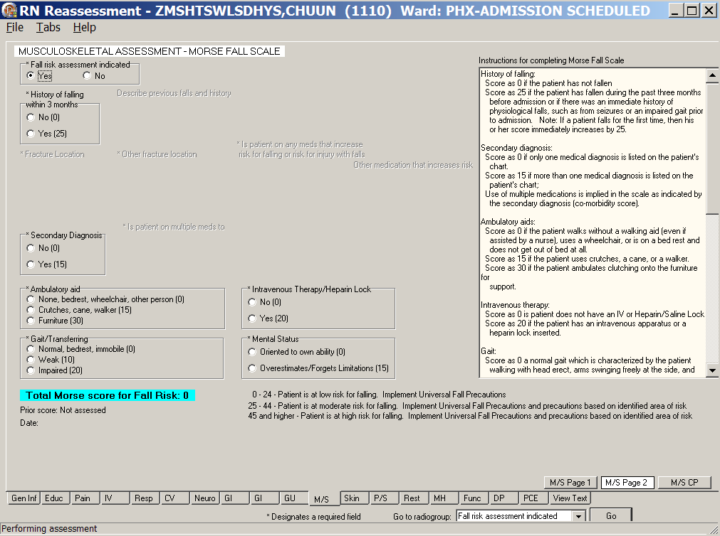
RN Reassessment, Musculoskeletal Assessment (M/S) tab, M/S Page 2 window
Morse Fall Scale
- Click M/S CP.
M/S CP displays.
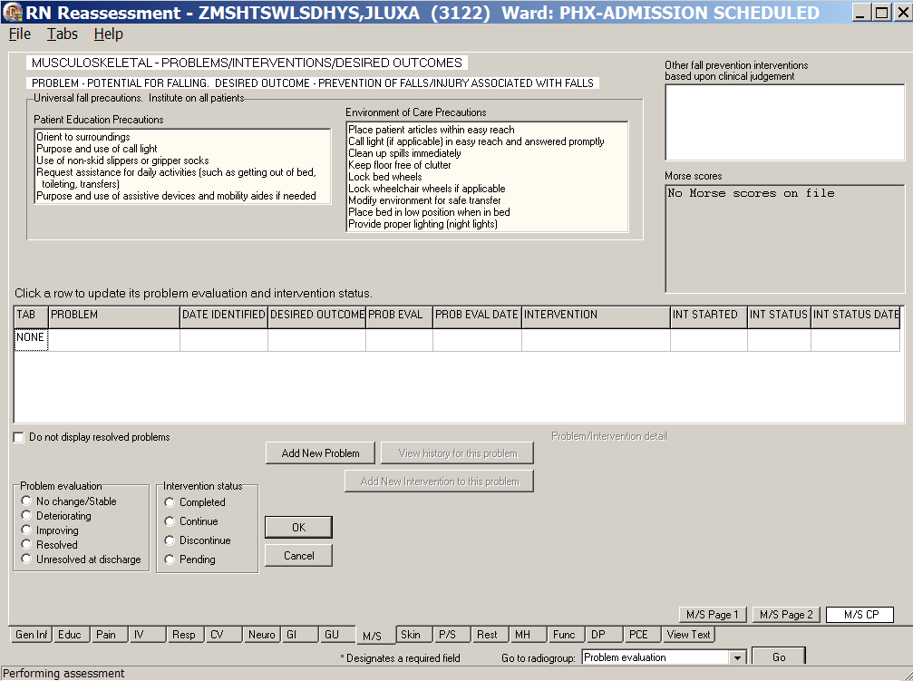
RN Reassessment, Musculoskeletal – Problems/Interventions/Desired Outcomes (M/S) tab,
M/S CP window
- Update M/S CP, if necessary.
Refer to the instructions in Working in a Care Plan on page 12.
Note: Universal Fall Precautions must be completed for all patients.

Skin (Skin)
Document the skin reassessment of a patient in the Skin tab. If a patient has pressure ulcers and skin alterations documented in a previous assessment, the information displays in the current reassessment.

Directions for the Braden Scale for Predicting Pressure Sore Risk are on Skin Page 3.
- The Total Score for the patient is calculated automatically as you select scores (1-4) for sensory perception, moisture, activity, mobility, nutrition, and friction and shear.
- The Braden Score is pulled forward to the Skin CP page to guide the entry of interventions.

Skin CP contains patient/caregiver skin care education, including risk for skin breakdown and prevention/treatment of problems related to skin integrity.
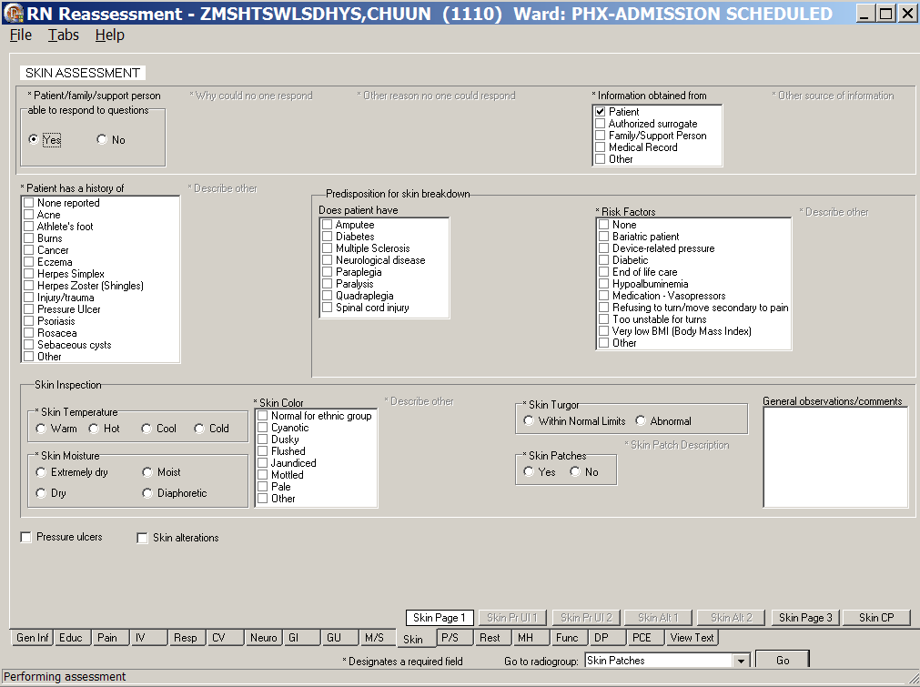
RN Reassessment, Skin Assessment (Skin) tab, Skin Page 1 window
- Click Skin.
Skin Page 1 displays.
- Populate Skin Page 1
- Complete all the fields with asterisks; they are required fields.
- Use the General observations/comments text box for additional information.

Documenting Pressure Ulcers
From the Skin Page 1 tab, select Pressure ulcers and the Skin Pr Ul 1 tab becomes available.
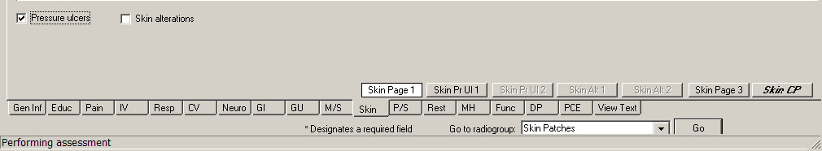
RN Reassessment, Skin Assessment (Skin) tab, Skin Page 1 window
Pressure ulcers selected
- Click Skin Pr Ul 1.
Skin Pr Ul 1 displays.
- Populate Skin Pr Ul 1.
- Enter Location, Stage, and Status for up to six pressure ulcer locations.
The fields with asterisks are required fields.
- Enter a Description of ulcer/dressing, if appropriate.
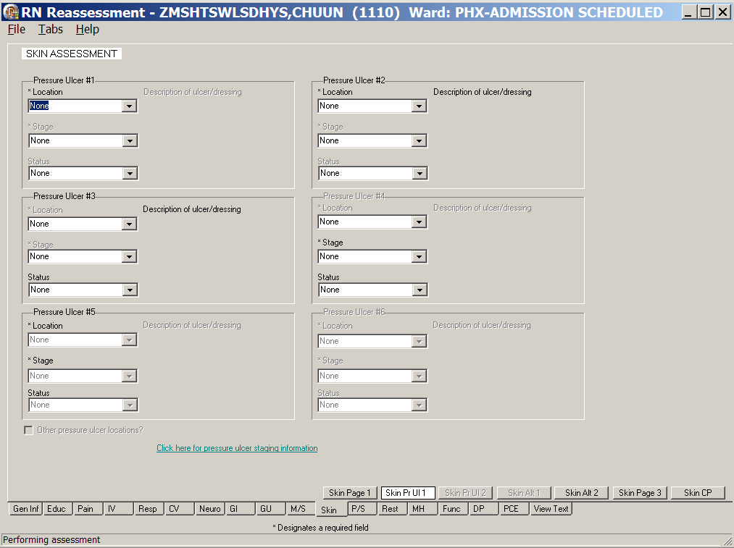
RN Reassessment, Skin Assessment (Skin) tab, Skin Pr Ul 1 window

Pressure Ulcer Drop-downs
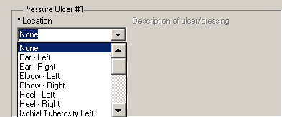
Skin Assessment - Pressure Ulcer/Location
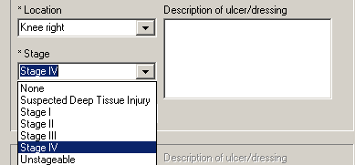
Skin Assessment - Pressure Ulcer/Stage
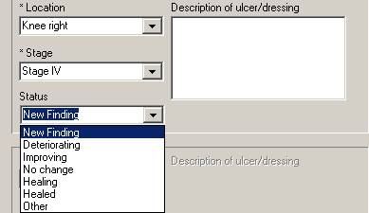
Skin Assessment - Pressure Ulcer/Status
- To enter more than six pressure ulcer locations, select the Other pressure ulcer locations? check box.
Skin Pr Ul 2 displays.
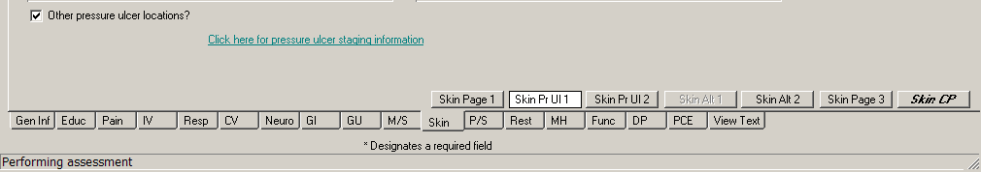
RN Reassessment, Skin Assessment (Skin) tab, Skin Pr Ul 1 window
Other pressure ulcer locations? selected
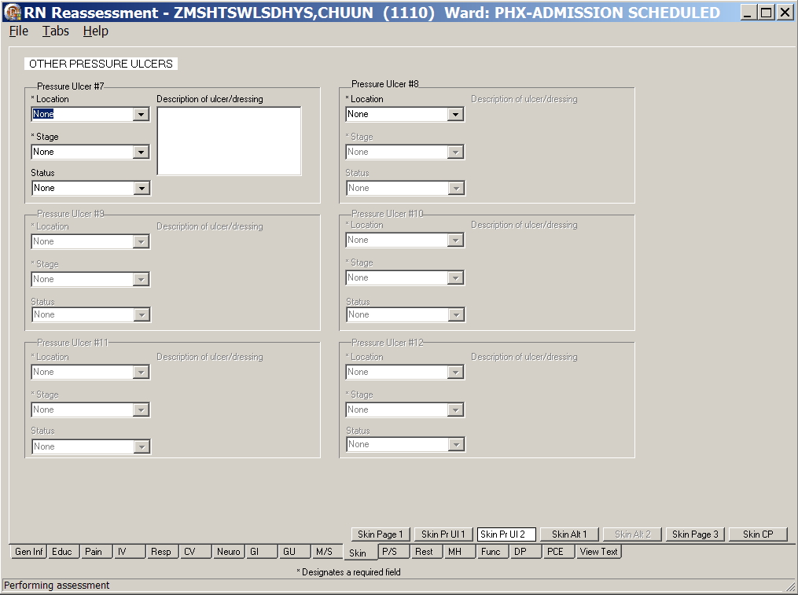
RN Reassessment, Skin Assessment (Skin) tab, Skin Pr Ul 2 window
- Populate Skin Pr Ul 2.
- Enter Location, Stage, and Status for six additional pressure ulcer locations.
The fields with asterisks are required fields.
- Enter a Description of ulcer/dressing, if appropriate.

Documenting Skin Alterations
From the Skin Page 1 tab, select Skin alterations and the Skin Alt 1 tab becomes available.
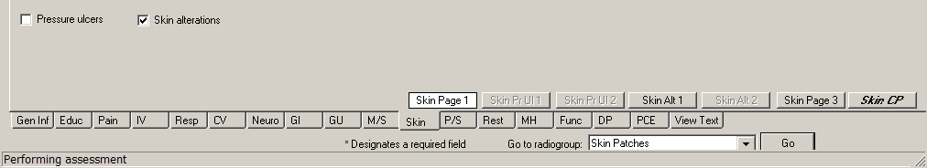
RN Reassessment, Skin Assessment (Skin) tab, Skin Page 1 window
Skin alterations selected
- Click Skin Alt 1.
Skin Alt 1 displays.
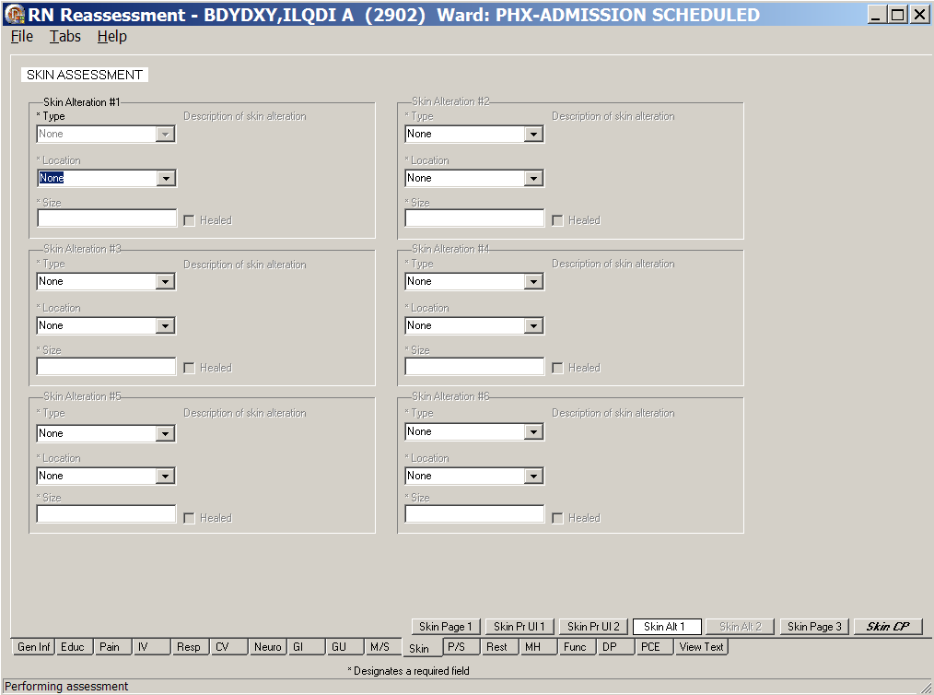
RN Reassessment, Skin Assessment (Skin) tab, Skin Alt 1 window
Skin Alterations #1-#6
- Populate Skin Alt 1.
- Enter Type, Location, and Size for up to six (#1-#6) skin alterations.
The fields with asterisks are required fields.
- Enter a Description for skin alteration, if appropriate.

Skin Alteration Drop-downs
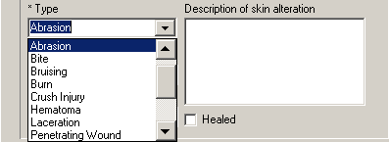
Skin Assessment – Skin Alteration/Type
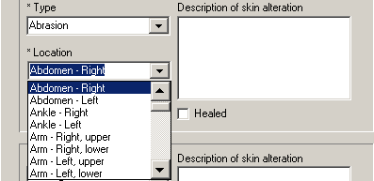
Skin Assessment – Skin Alteration/Location
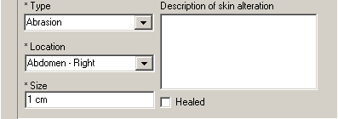
Skin Assessment – Skin Alteration/Size

- Click Skin Alt 2.
Skin Alt 2 displays.
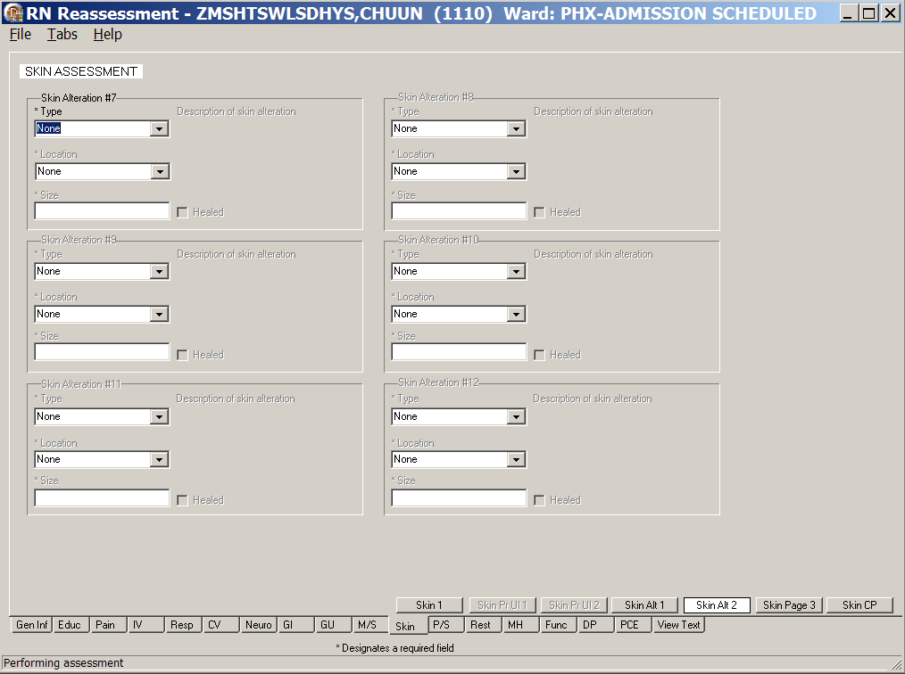
RN Reassessment, Skin Assessment (Skin) tab, Skin Alt 2 window
Skin Alterations #7-#12
- Populate Skin Alt 2.
- Enter Type, Location, and Size for six (#7-#12) additional skin alterations.
The fields with asterisks are required fields.
- Enter a Description of skin alteration, if appropriate.
- Click Skin Page 3.
Skin Page 3 displays.
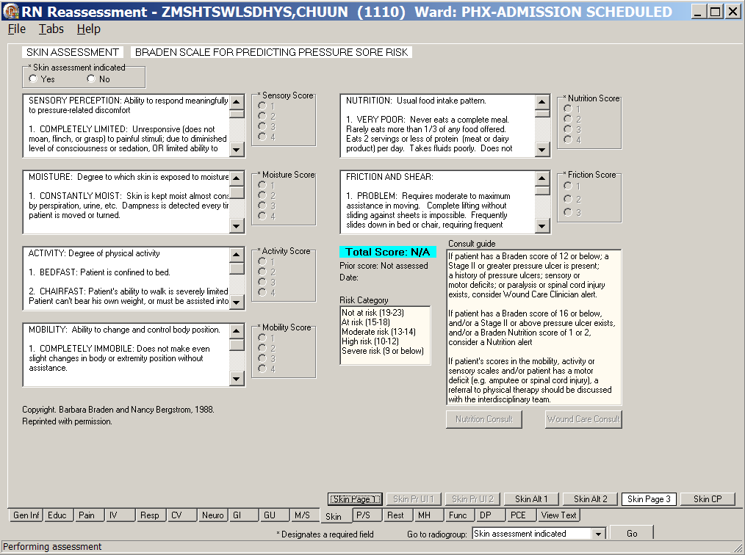
RN Reassessment, Skin Assessment (Skin) tab, Skin Page 3 window
Braden Score for Predicting Pressure Sore Risk
Note: Braden Scale for Predicting Pressure Sore Risk is optional in the reassessment.
- Populate Skin Page 3.
- Select Yes to Skin assessment indicated, to complete the Braden Scale for Predicting Pressure Sore Risk.
Complete all the fields with asterisks; they are required fields.
- Select No to Skin assessment indicated, to bypass the Braden Scale for Predicting Pressure Sore Risk.
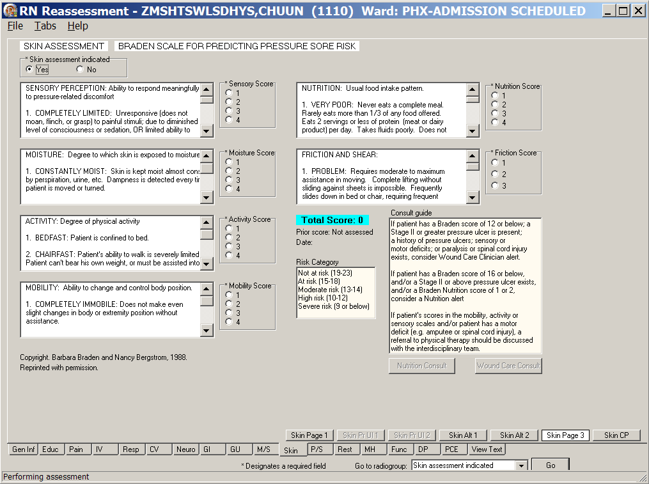
RN Reassessment, Skin Assessment (Skin) tab, Skin Page 3 window
Braden Score for Predicting Pressure Sore Risk
Skin assessment indicated selected
- Optional: Order a Nutrition Consult and/or Wound Care Consult from Skin Page 3, if necessary.
Refer to the instructions in Working in the Consults on page 24.
- Click Skin CP.
Skin CP displays.
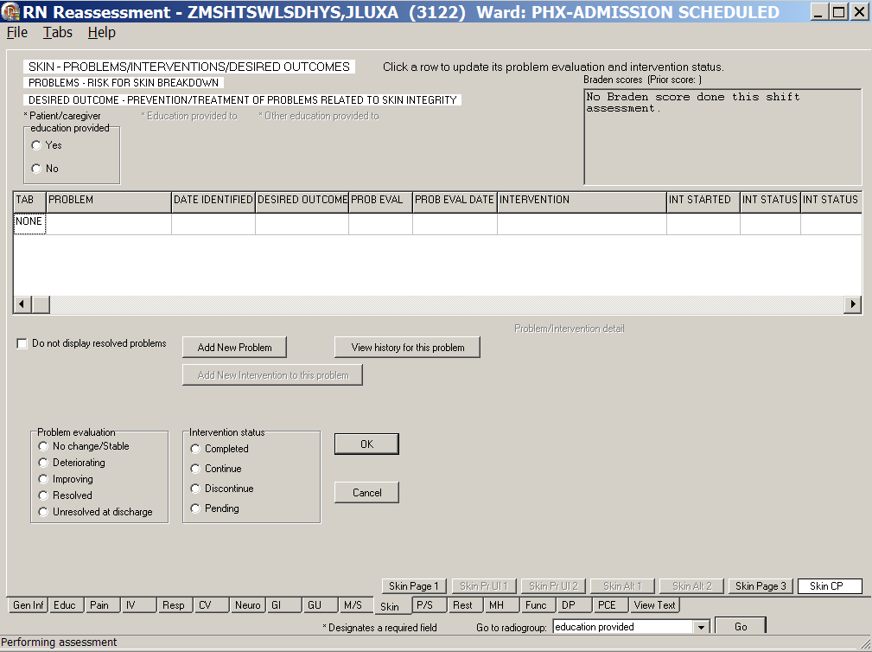
RN Reassessment, Skin – Problems/Interventions/Desired Outcomes (Skin) tab,
Skin CP window
- Update Skin CP, if necessary.
Refer to the instructions in Working in a Care Plan on page 12.

Psychosocial (P/S)
Document the psychosocial reassessment of a patient in the Psychosocial tab. This includes documentation for patients in restraints.

Directions for the Clinical Institute Withdrawal Assessment (CIWA) are on the CIWA page.
- The CIWA Score for the patient is calculated automatically as you select a response level for nausea/vomiting, tremor, paroxysmal sweats, anxiety, agitation, tactile disturbances, auditory disturbances, visual disturbances, headache, and orientation/clouding of sensorium.
- The CIWA Score is pulled forward to the P/S CP page to guide the entry of interventions.

- Click P/S.
P/S Page 1 displays.
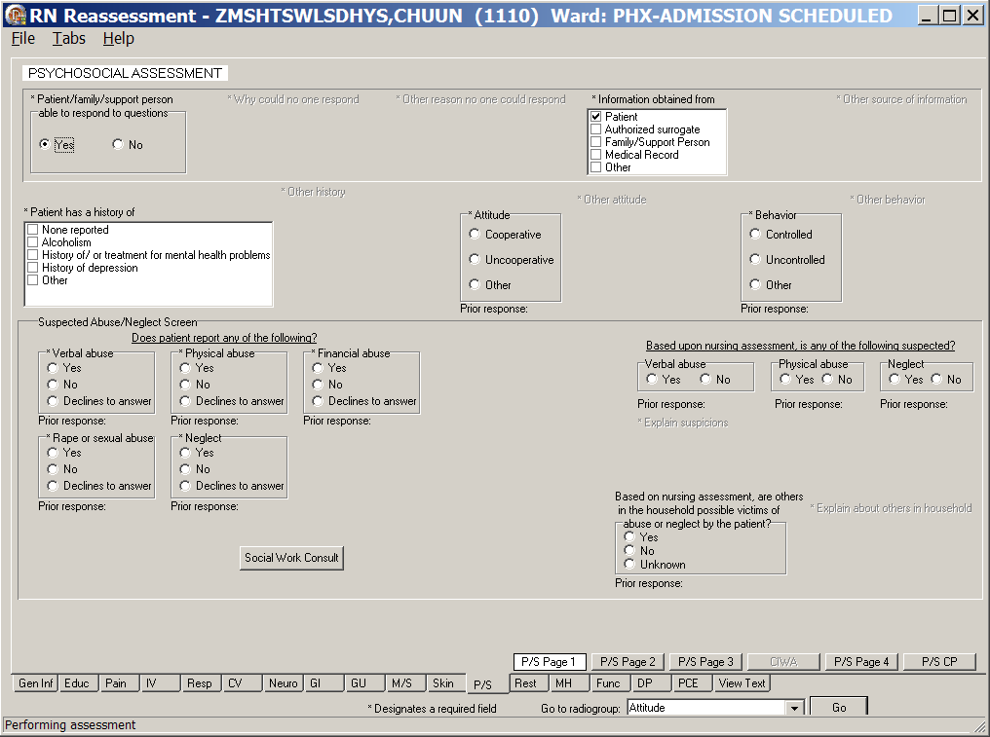
RN Reassessment, Psychosocial Assessment (P/S) tab, P/S Page 1 window
- Populate P/S Page 1.
- There are no required fields on P/S Page 1.
- If the patient answers Yes to any of the abuse questions, a Social Work Consult is required.
Refer to the instructions in Working in the Consults on page 24.
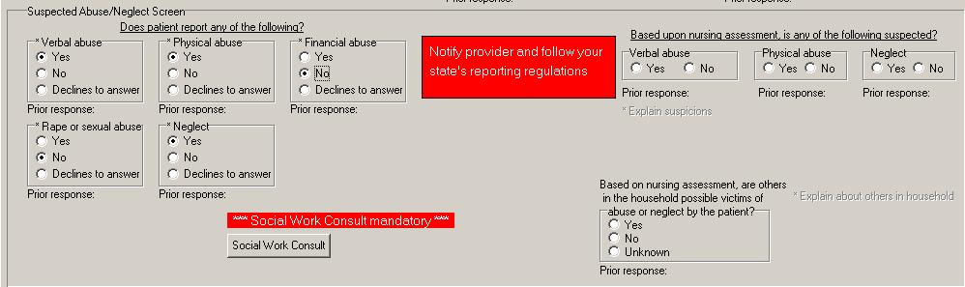
RN Reassessment, Psychosocial Assessment (P/S) tab, P/S Page 1 window, Required Social Work Consult
Note: For emphasis, the notify provider, send consult, and follow your state’s reporting regulations are highlighted in red.
- Click P/S Page 2.
P/S Page 2 displays (Optional Suicide Risk - Ask Patient).
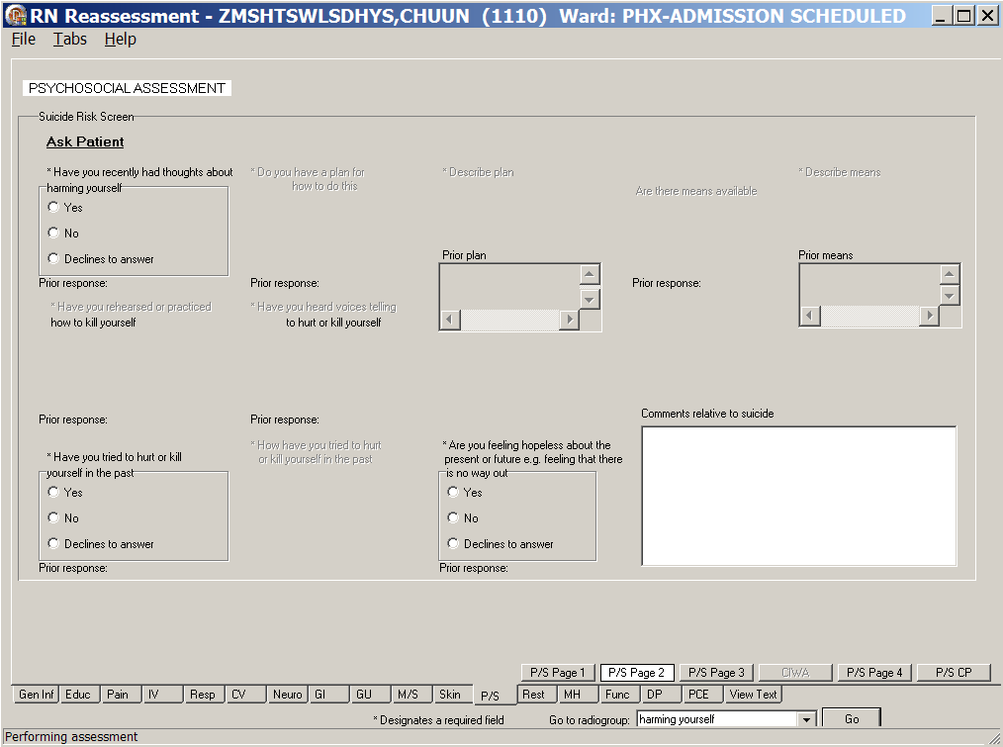
RN Reassessment, Psychosocial Assessment (P/S) tab, P/S Page 2 window
- Populate P/S Page 2.
- The questions on P/S Page 2 are optional.
- If a patient answers Yes to Have you recently had thoughts about harming yourself, you must Notify provider and Keep patient under close observation, according to medical center policy.
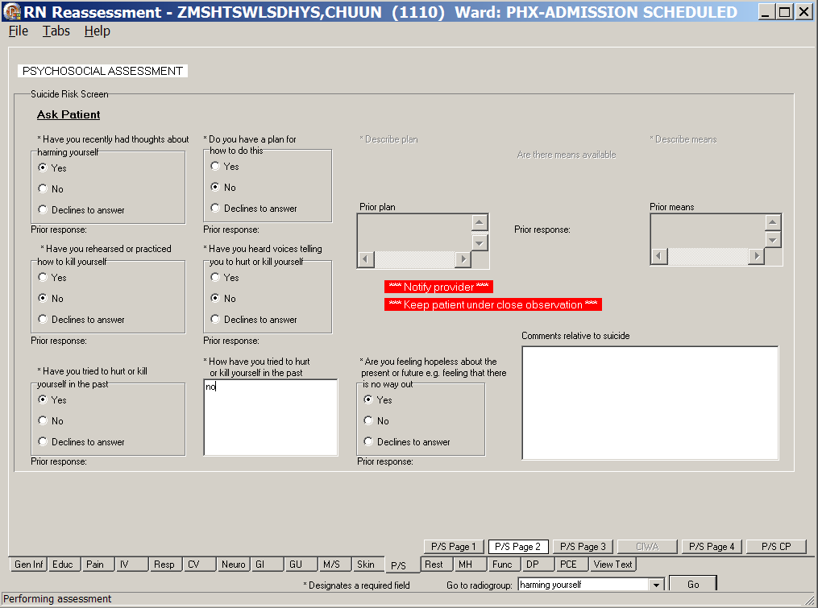
RN Reassessment, Psychosocial Assessment (P/S) tab, P/S Page 2 window
- Click P/S Page 3.
P/S Page 3 displays.
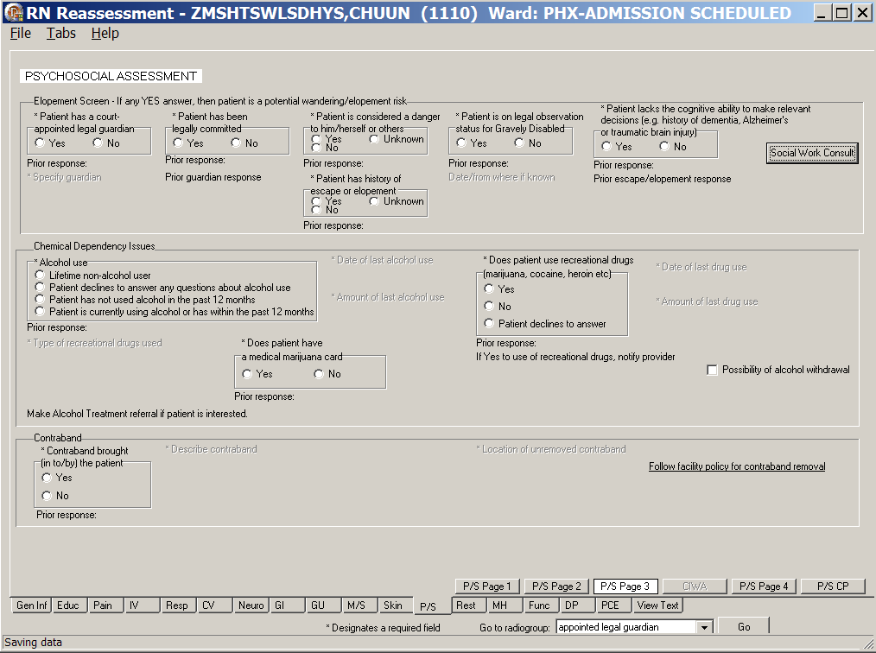
RN Reassessment, Psychosocial Assessment (P/S) tab, P/S Page 3 window
- Populate P/S Page 3.
- The questions are all optional; update, if necessary.
- If a patient answers Yes to any of the Elopement Screen questions, a Social Work Consult is required.
Refer to the instructions in Working in the Consults on page 24.
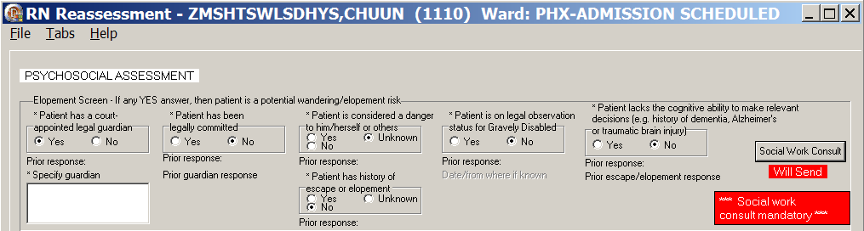
RN Reassessment, Psychosocial Assessment (P/S) tab, P/S Page 3 window, Social work consult mandatory
- P/S Page 3 contains the Alcohol use section.
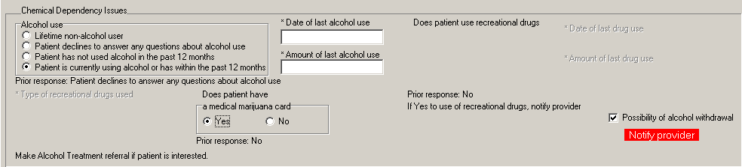
Alcohol use section
- If there is the possibility of alcohol withdrawal, select the Possibility of alcohol withdrawal check box to display the CIWA page.
- Complete all the CIWA fields with asterisks; they are required fields.
- Alert the physician of the possibility of alcohol withdrawal.
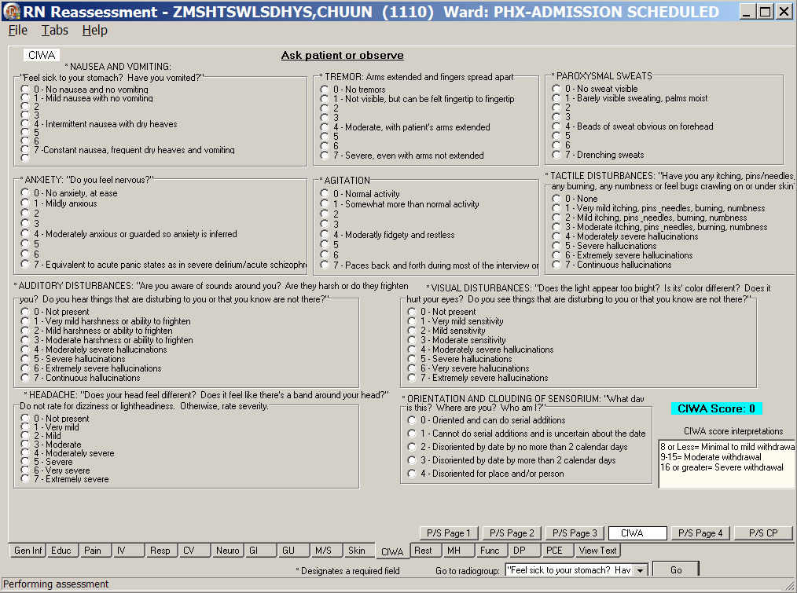
RN Reassessment, Psychosocial Assessment (P/S) tab, CIWA window
- Click P/S Page 4.
P/S Page 4 displays.
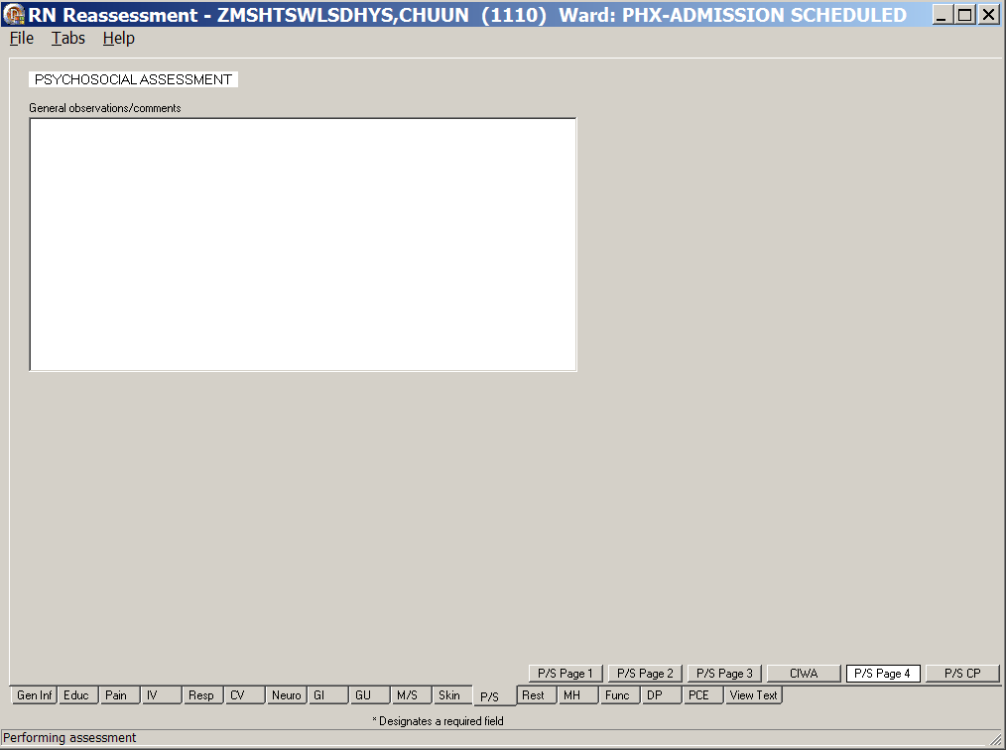
RN Reassessment, Psychosocial Assessment (P/S) tab, P/S Page 4 window
- Populate P/S Page 4.
Use the General observations/comments text box for additional information.
- Click P/S CP.
P/S CP displays.
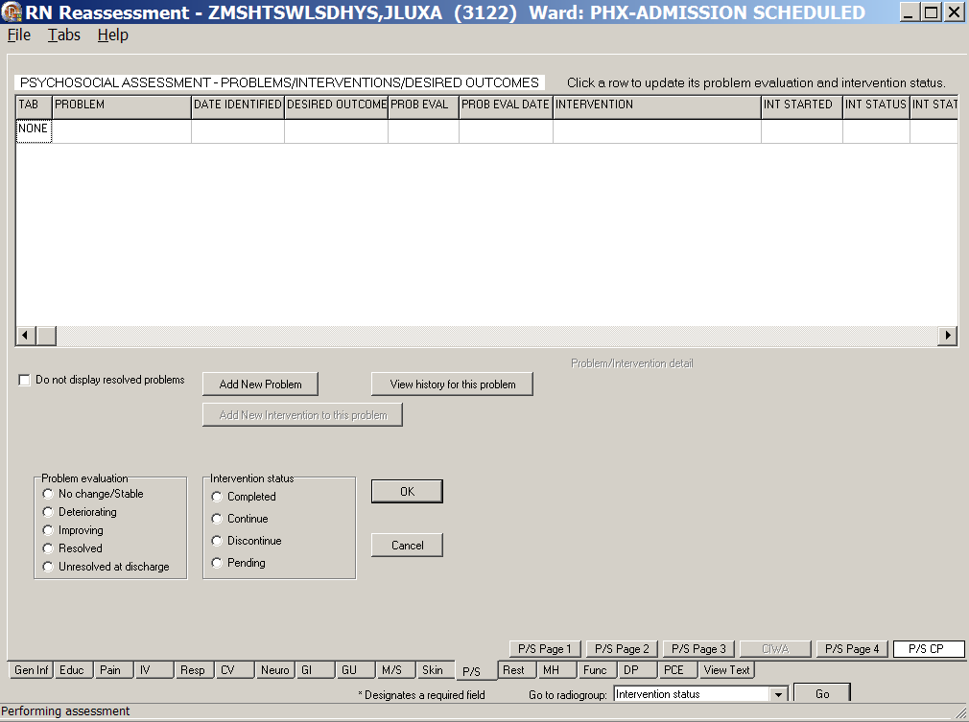
RN Reassessment, Psychosocial Assessment –Problems, Interventions, Desired Outcomes
(P/S) tab, P/S CP window
- Update P/S CP, if necessary.
Refer to the instructions in Working in a Care Plan on page 12.

Restraints (Rest/Restr)
There are two categories of restraints.
- Patient is pulling at lines/tubes used in their treatment or is unable to follow instructions, endangering their medical/surgical recovery. Patient is not violent or self-destructive
- Patient’s behavior is aggressive or violent presenting an immediate, serious danger to his/her safety or that of others
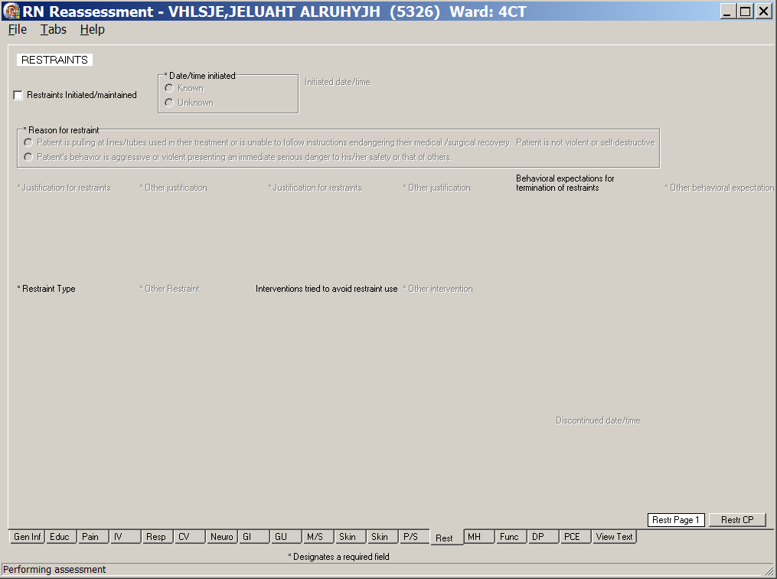
RN Reassessment, Restraints (Rest) tab, Restr Page 1 window
- Click Rest.
Restr Page 1 displays.
- Select the Restraints Initiated/maintained check box.
The reasons for restraint become available.
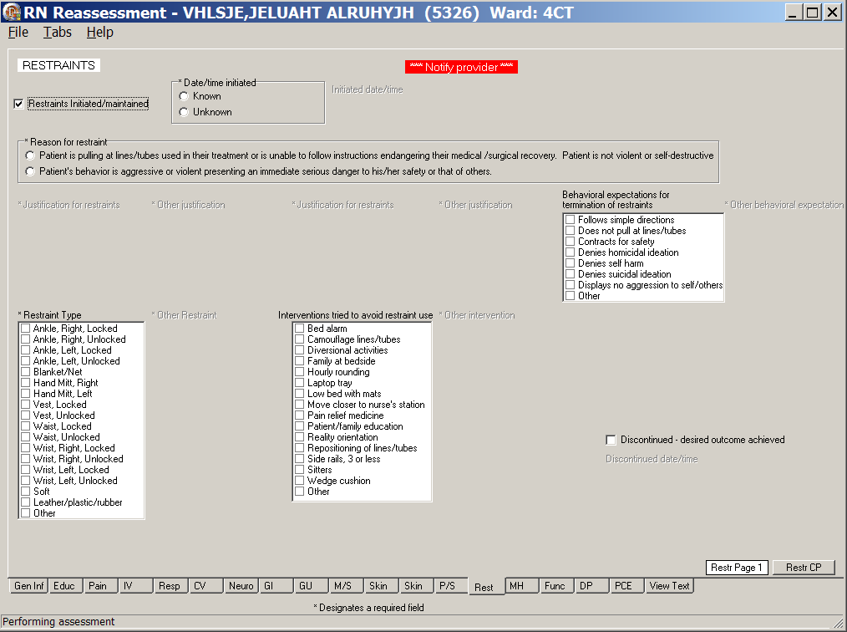
RN Reassessment, Restraints (Rest) tab, Restr Page 1 window
with restraints initiated/maintained selected

- When you select, Patient is pulling at lines/tubes …, the following window displays.
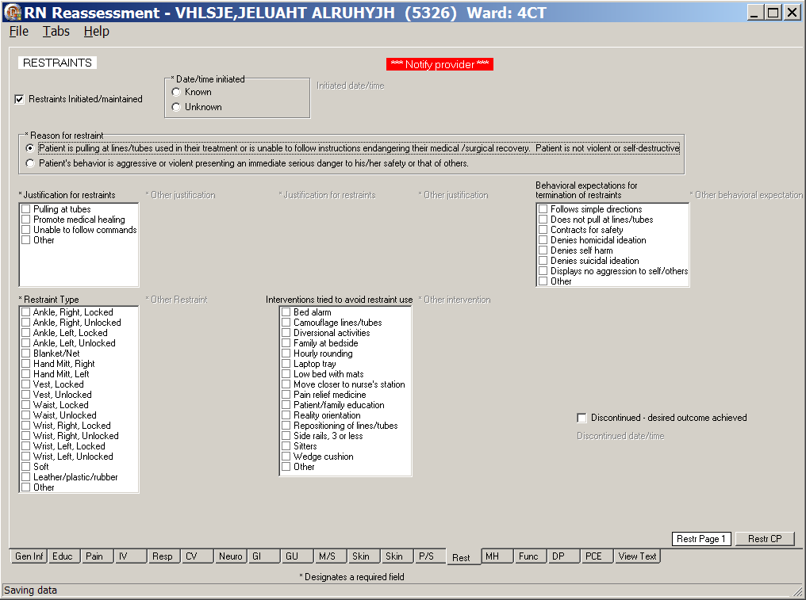
RN Reassessment, Restraints (Rest) tab, Restr Page 1 window
Patient is pulling at lines/tubes used in their treatment or is unable to follow instructions
endangering their medical/surgical recovery. Patient is not violent or self-destructive

- When you select, Patient’s behavior is aggressive or violent …, the following window displays.
RN Reassessment, Restraints (Rest) tab, Restr Page 1 window
Patient’s behavior is aggressive or violent
presenting an immediate serious danger to his/her safety or that of others
- Populate Restr Page 1.
- Select a Reason for restraint.
- Complete all the fields with asterisks; they are required fields.
Questions are based on standards for documenting seclusion or restraint.

- Click Restr CP.
Restr CP displays.
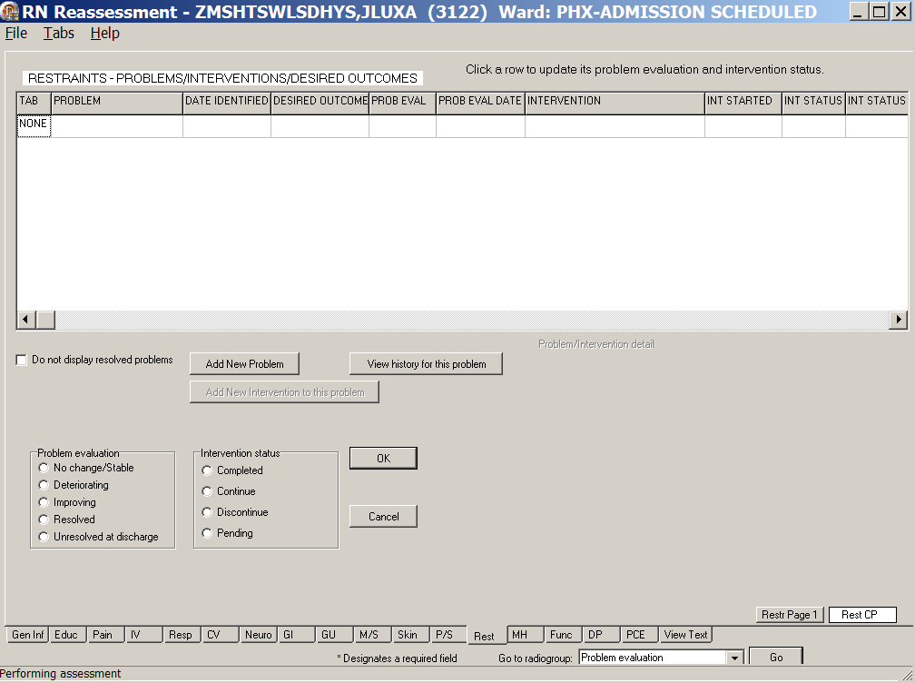
RN Reassessment, Restraints – Problems/Interventions/Desired Outcomes (Rest) tab,
Restr CP window
- Update Restr CP, if necessary.
Refer to the instructions in Working in a Care Plan on page 12.

Mental Health (MH)
The Mental Health tab is completed for patients admitted to acute psychiatry, or when any patient reports a new mental health problem.
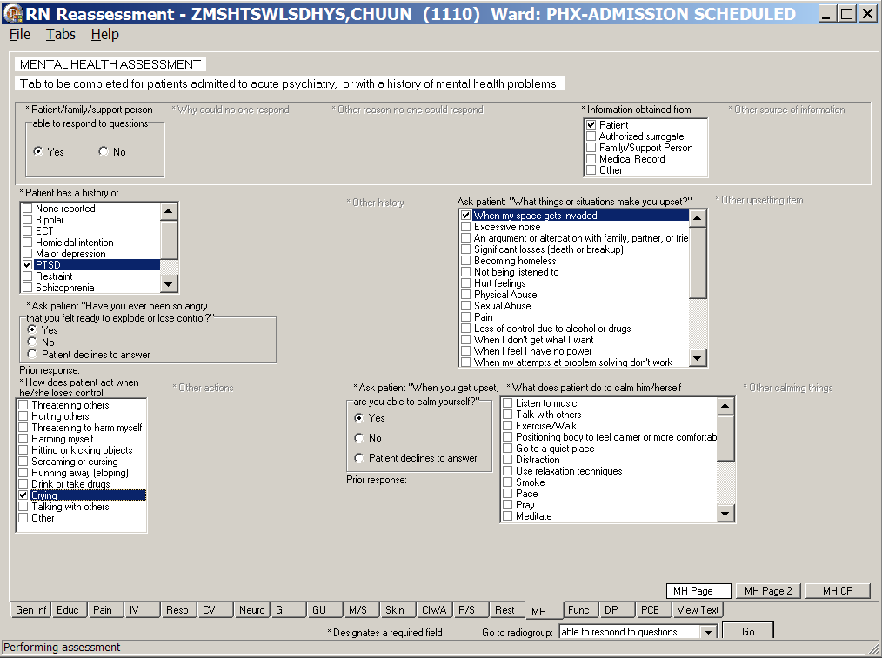
RN Reassessment, Mental Health Assessment (MH) tab, MH Page 1 window
- Click MH.
MH Page 1 displays.
- Populate MH Page 1.
Complete all the fields with asterisks; they are required fields.

- Click MH Page 2.
MH Page 2 displays.
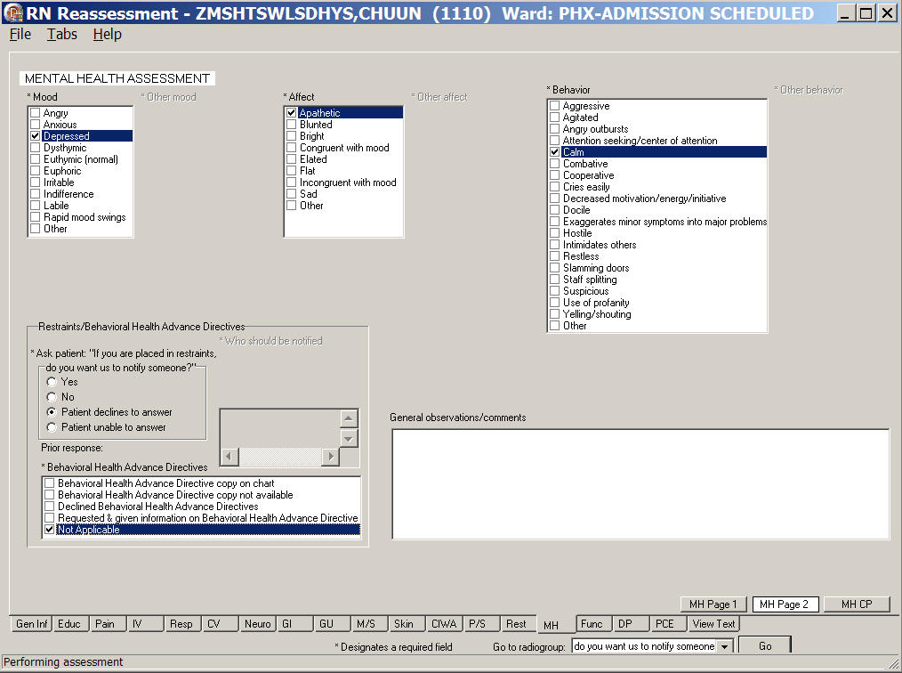
RN Reassessment, Mental Health Assessment (MH) tab, MH Page 2 window
- Populate MH Page 2.
- Complete all the fields with asterisks; they are required fields.
- Use the General observations/comments text box for additional information.
- Click MH CP.
MH CP displays.
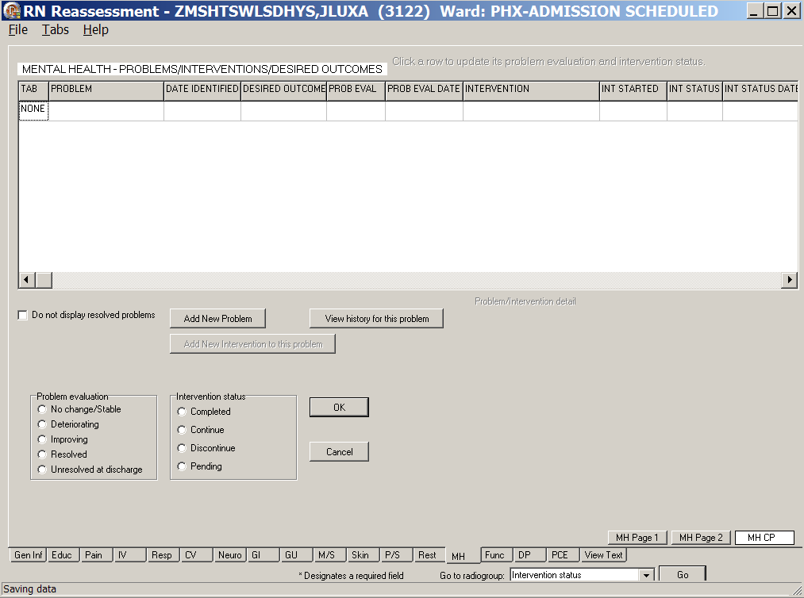
RN Reassessment, Mental Health Assessment (MH) tab, MH CP window
- Update MH CP, if necessary.
Refer to the instructions in Working in a Care Plan on page 12.

Functional (Func)
Document the functional (bathing, dressing, toileting, transferring, continence, and feeding) reassessment of a patient in the Functional tab.

Directions for the Katz Index of Independence in Activities of Daily Living are on Func Page 1. The Total Score for the patient is calculated automatically as you select Independence/Dependence for six activities.
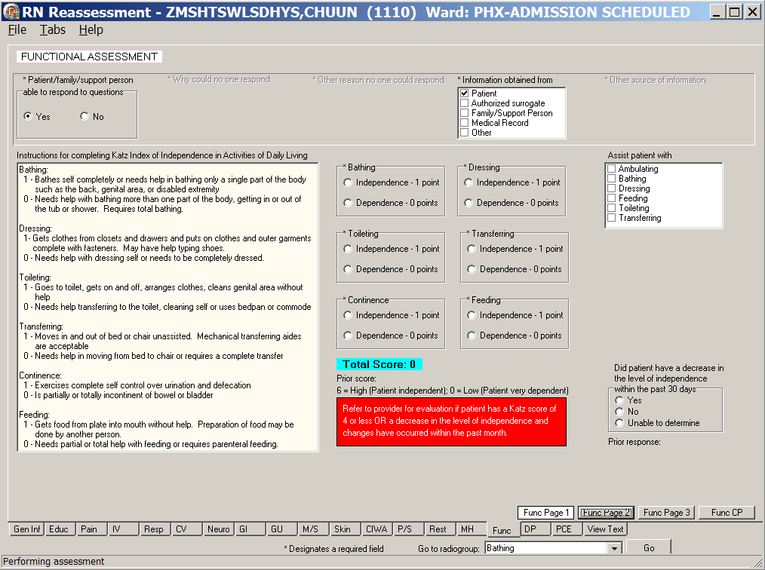
RN Reassessment, Functional Assessment (Func) tab, Func Page 1 window
- Click Func.
Func Page 1 displays.
- Update Func Page 1, if necessary.
The fields are optional.
Note: Refer to provider for evaluation, if patient has a Katz score of 4 or less, or a decrease in the level of independence and changes have occurred within the past month.

- Click Func Page 2.
Func Page 2 displays.
- If the patient is independent and cooperative, no additional entries are necessary on Func Page 2.
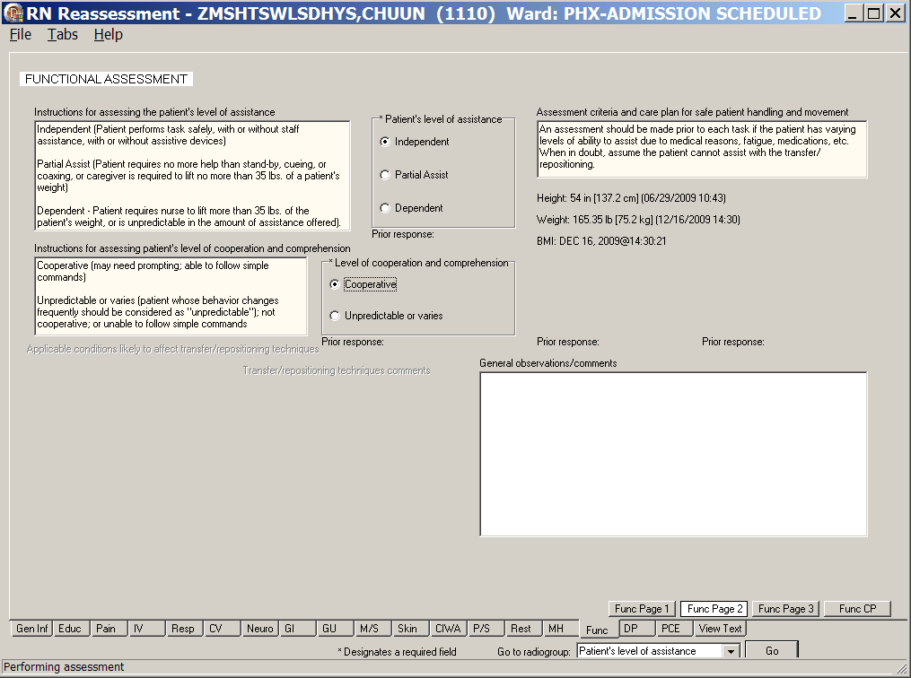
RN Reassessment, Functional Assessment (Func) tab, Func Page 2 window
when the patient is independent

- If the patient is dependent and completely uncooperative, additional entries are necessary on Func Page 2.
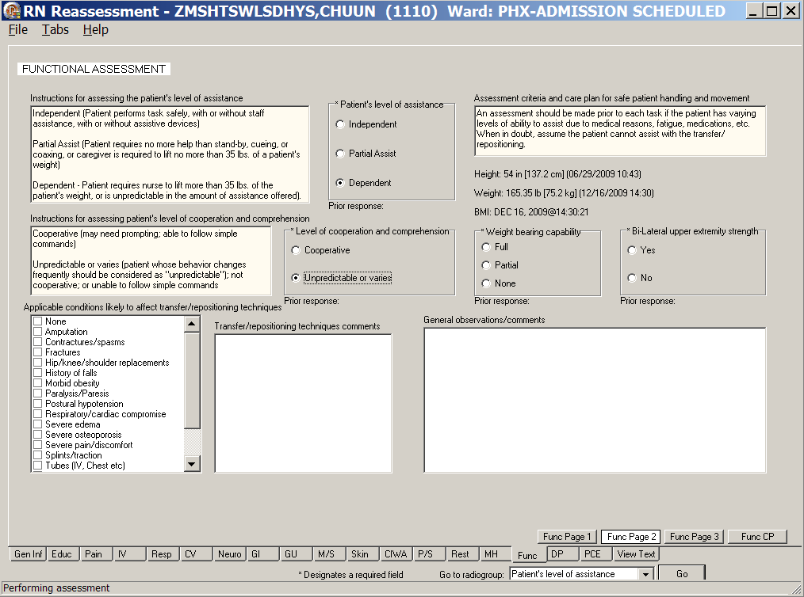
RN Reassessment, Functional Assessment (Func) tab, Func Page 2 window
when the patient is dependent
- Update Func Page 2, if necessary.
- Complete all the fields with asterisks; they are required fields.
- Use the General observations/comments text box for additional information.

- Click Func Page 3.
Func Page 3 displays.
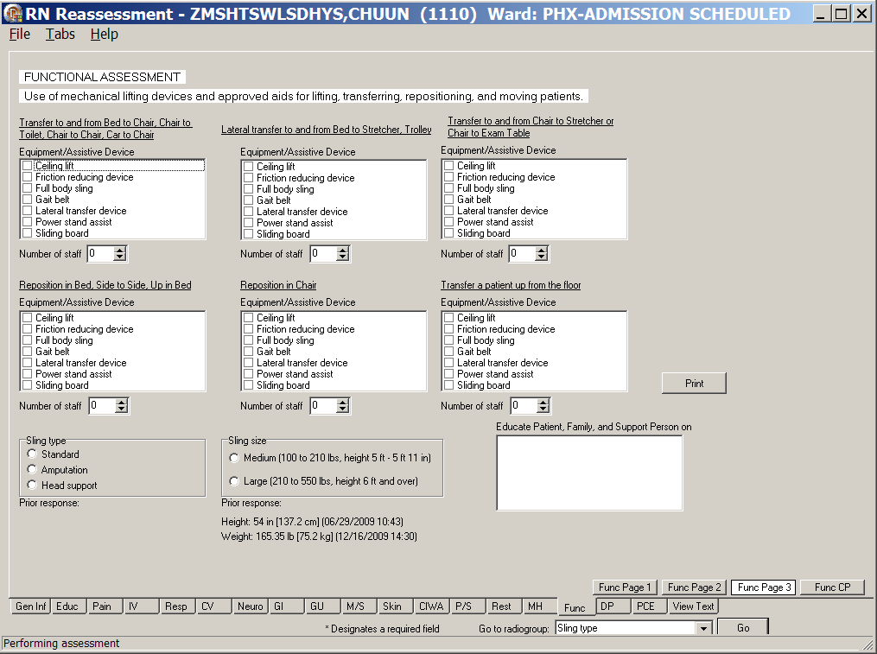
RN Reassessment, Functional Assessment (Func) tab, Func Page 3 window
- Populate Func Page 3.
- Complete the fields, if necessary.
- Click Print.
- Print Func Page 3 and give it to the staff handling the move of the patient.

- Click Func CP.
Func CP page displays.
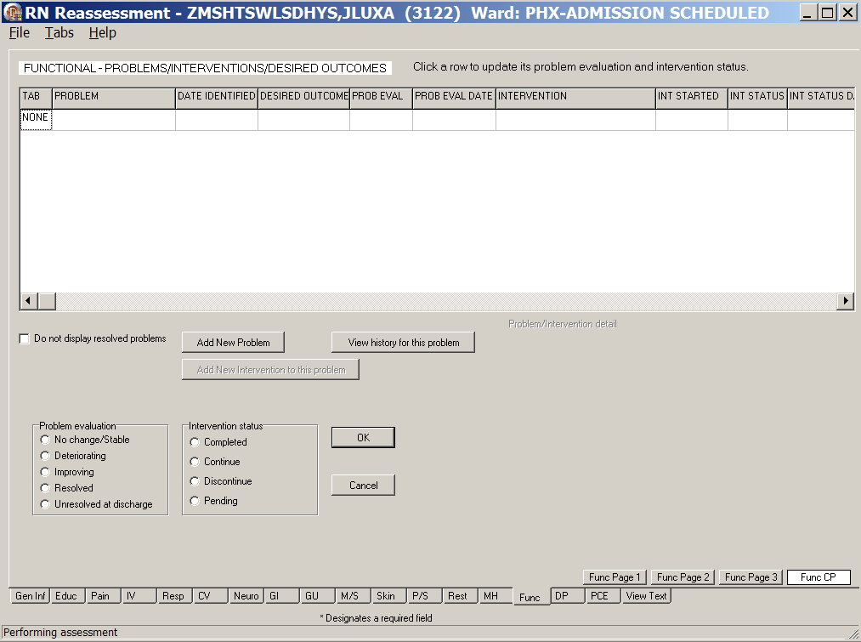
RN Reassessment, Functional – Problems/Interventions/Desired Outcomes (Func) tab,
Func CP window
- Update Func CP, if necessary.
Refer to the instructions in Working in a Care Plan on page 12 .

Discharge Planning (DP)
Document the discharge reassessment for a patient in the Discharge Planning tab.
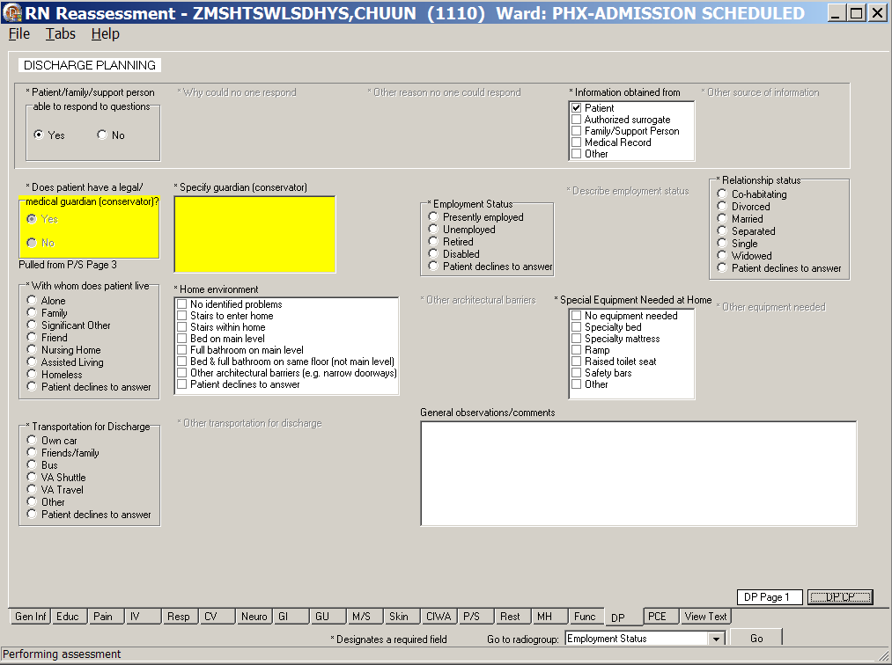
RN Reassessment, Discharge Planning (DP) tab, DP Page 1 window
- Click DP.
DP Page 1 displays.
- Populate PD Page 1, if available.
- If a DP Page 1 was completed during the admission assessment, none of the fields are active.
- Use the General observations/comments for additional information.
Note: The presence of the guardian and name of the legal guardian are pulled forward and can be edited on P/S Tab, Page 3.

- Click DP CP.
DP CP displays.
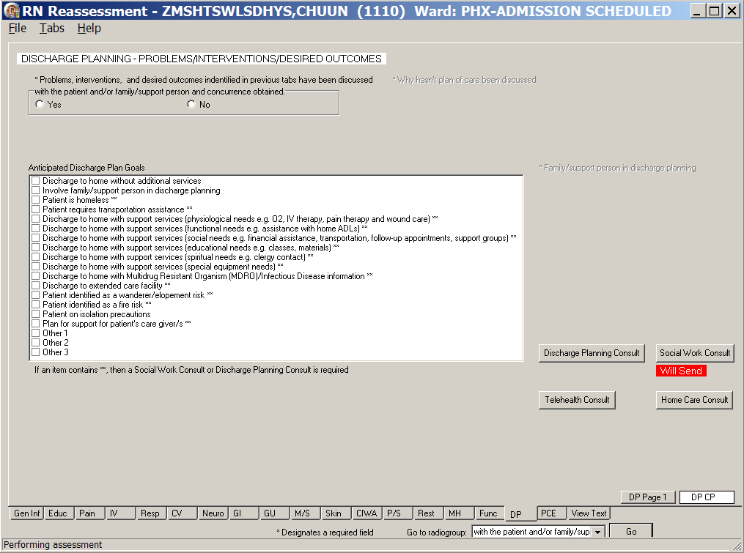
RN Reassessment, Discharge Planning – Problems/Interventions/Desired Outcomes (DP) tab,
DP CP window
- Populate DP CP.
- Complete the fields as necessary.
Refer to the instructions in Working in a Care Plan on page 12.
- Complete a Social Work Consult or Discharge Planning Consult, if required.
Refer to the instructions in Working in the Consults on page 24.

- Optional: Complete a Telehealth Consult or a Home Care Consult, if set up by your medical center.
Note: If an item in the Anticipated Discharge Plan Goals list box contains **, a Social Work Consult or Discharge Planning Consult is required.

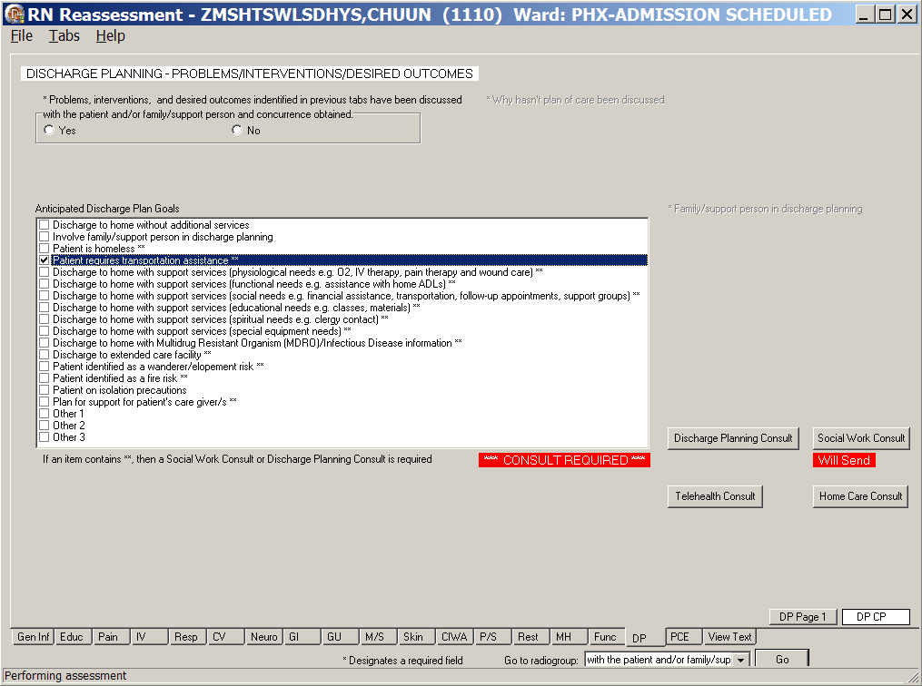
RN Reassessment, Discharge Planning – Problems/Interventions/Desired Outcomes (DP) tab,
DP CP window, Consult Required

PCE Data (PCE)
The PCE (Patient Care Encounter) Data tab is optional and may or may not be set up at your medical center. The PCE tab includes a list of all clinical reminders due for the patient, as well as specific nurse Clinical Reminders.

Use the PCE tab to document specific clinical reminders completed by the inpatient nurse.
Note: The clinical reminders must be set up by your facility.
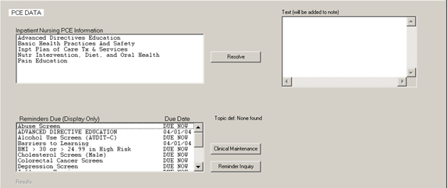
RN Reassessment, PCE Data (PCE) tab

Reminders Due (Display Only)
The list of all clinical reminders due for the patient is for display only. You cannot take action on the reminders from within the reassessment template.

Clinical Maintenance
- Select a clinical reminder in the Reminders Due list box.
- Click Clinical Maintenance.
Information displays in the Maintenance Results list box indicating when the reminder is due or was last done.
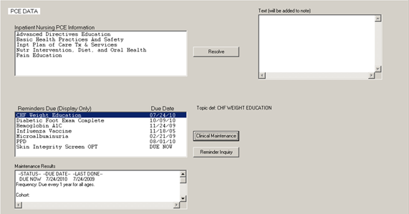
Clinical Maintenance

Reminder Inquiry
Click Reminder Inquiry.
Information displays in the Inquiry Results list box about the logic of the selected reminder.
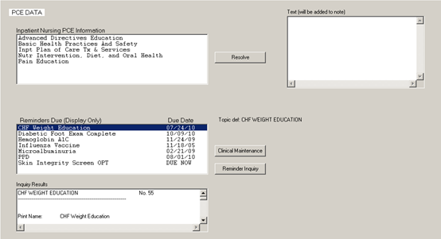
Reminder Inquiry

Resolve Inpatient Nursing Clinical Reminders
- Select an item in the Inpatient Nursing PCE Information list box.
Resolve Inpatient Nursing Clinical Reminders
- Click Resolve.
The Resolve Reminder Pain Risk, Mgmt, and Assessment window displays with items appropriate for the selected item.
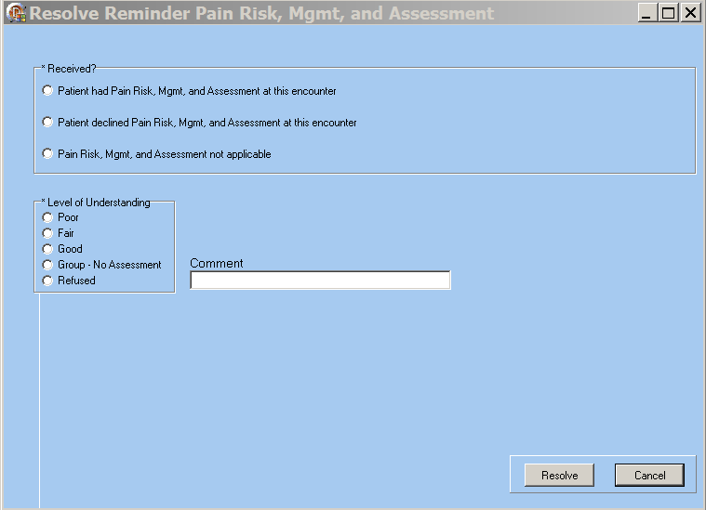
Resolve Reminder Pain Risk, Mgmt, and Assessment window
- Select an item from Received?
- Select an item from Level of Understanding.

- Click Resolve.
Information displays indicating the reminder is resolved.
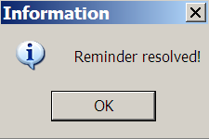
Information : Reminder resolved!
- Click OK.
The text that is added to the Progress Note displays in the Text (will be added to note) text box.
Text (will be added to note)

View Text (View Text)
The View Text tab is a review of all the information added/updated for a patient during the reassessment.
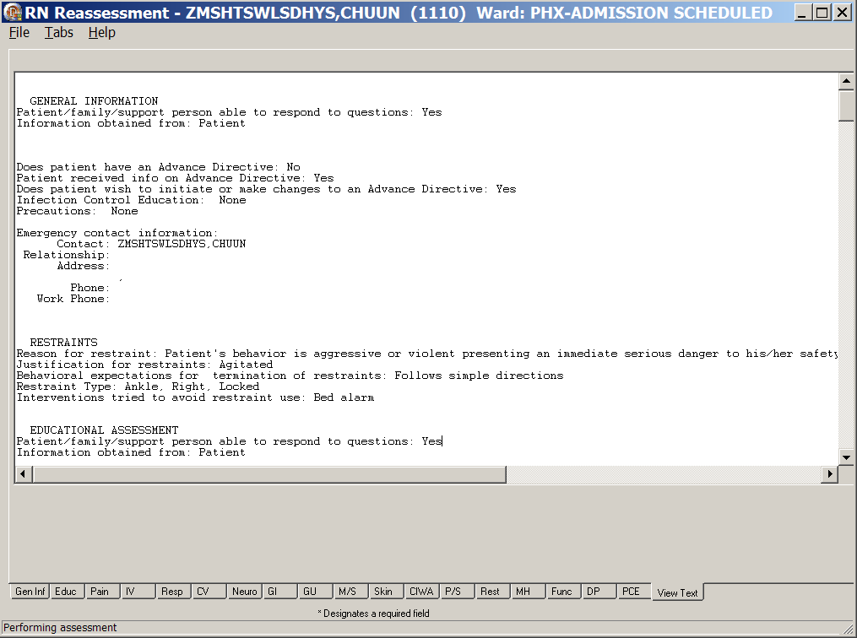
RN Reassessment, View Text tab
- Click View Text.
The View Text window scrolls through the admission reassessment for review.
- Review the patient admission reassessment.

Signing Note and Consults from within the Template
During the assessment, you may be prompted to enter mandatory consults that will be uploaded with the reassessment note.
Note: Manage consults according to medical center policy. If nurses at your site do not order consults, upload a mandatory consult, but do not sign it.
The identified provider will be notified that there is a consult to sign.
Go to CPRS to sign your uploaded, unsigned notes and consults.

You can also sign unsigned notes after the upload from the View Text tab in the template.

- Click View Text.
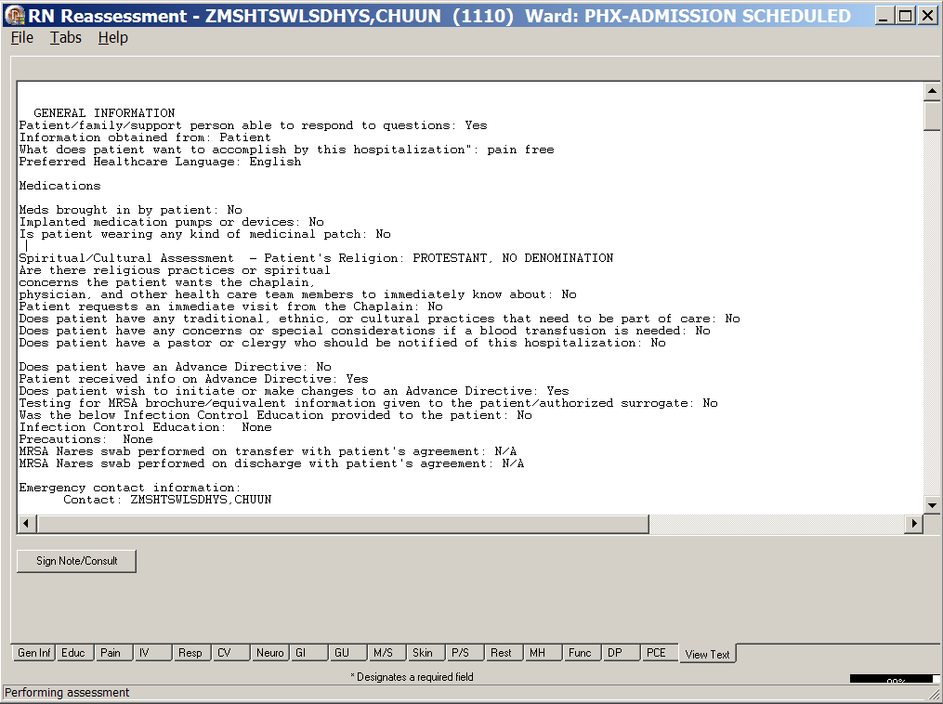
RN Reassessments, View Text Tab after Upload
- Click Sign Note/Consult.
If the button does not display, upload again.

Note: If there is only a note to sign, the button is Note.
If there is a consult to sign, the button is Sign Note/Consult.
RN Reassessment, Sign Note/Consult Button
- Enter your electronic signature and click Accept e-sig.
Information displays, Note signed!.
- Click OK.
- To prevent the signing of an uploaded note, click Cancel e-sig.
Note: It is safer to go to CPRS, read the note in CPRS, and sign the note in CPRS.
- An unsigned note can be edited.
- A signed note cannot be edited.

Unable to Complete the Assessment
An incomplete admission assessment is filed when the nurse is unable to complete an assessment because the patient cannot respond to admission assessment questions and there is no caregiver available to provide the necessary data. The reassessment that opens after the assessment is signed, allows you to enter the missing data.

- Open RN Reassessment.
Gen Inf tab, Gen I Page 1 displays,
- Select Yes or No for Patient/family/support person able to respond to questions.
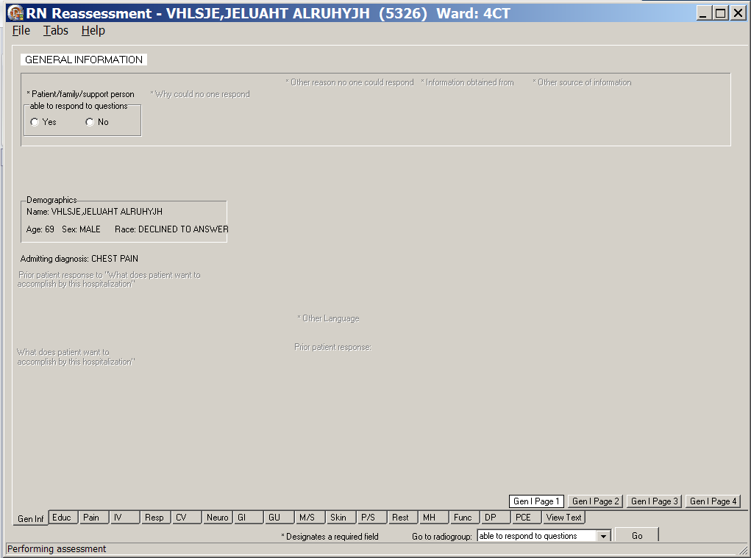
RN Reassessment, General Information (Gen Inf) tab, Gen I Page 1 window

Patient still cannot respond
- If the patient still cannot respond, select No and select a reason(s) *Why could no one respond.
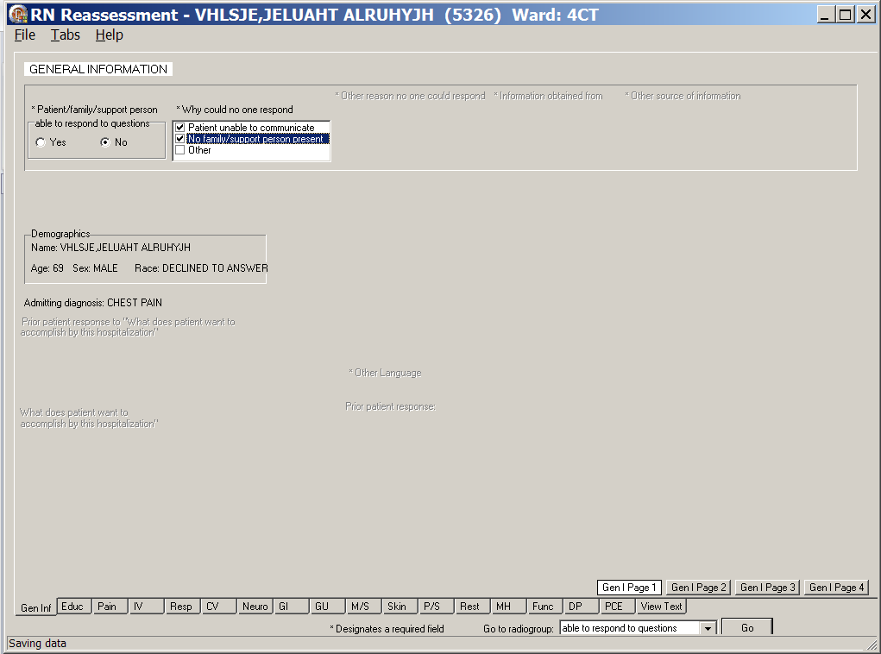
RN Reassessment, General Information (Gen Inf) tab, Gen I Page 1 window
with *Why could no one respond
- Continue through the reassessment tabs and pages.
- Complete all the fields with asterisks; they are required fields.
- Upload the information.

The following screen captures are examples of the tabs when No is selected for Patient/family/support person able to respond to questions.
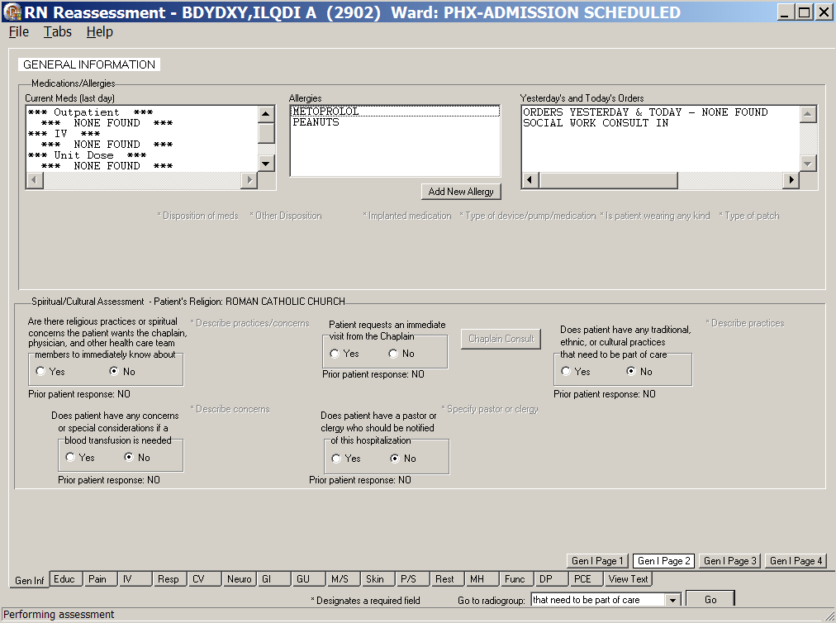
RN Reassessment, General Information (Gen Inf) tab, Gen I Page 2 window
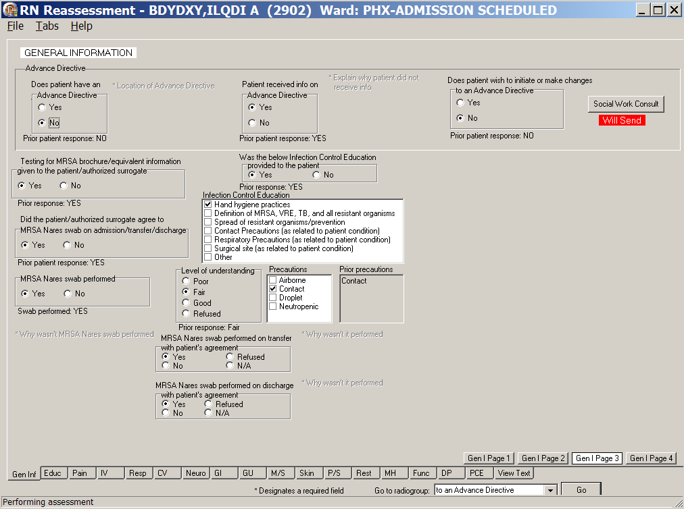
RN Reassessment, General Information (Gen Inf) tab, Gen I Page 3 window

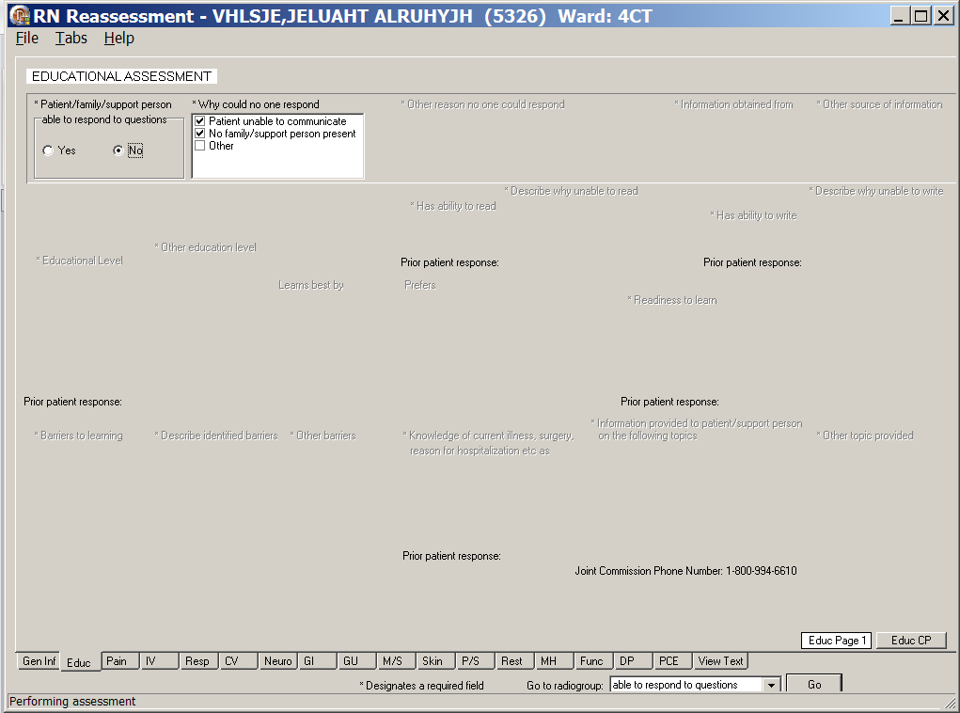
RN Reassessment, Educational Assessment (Educ) tab, Educ Page 1 window
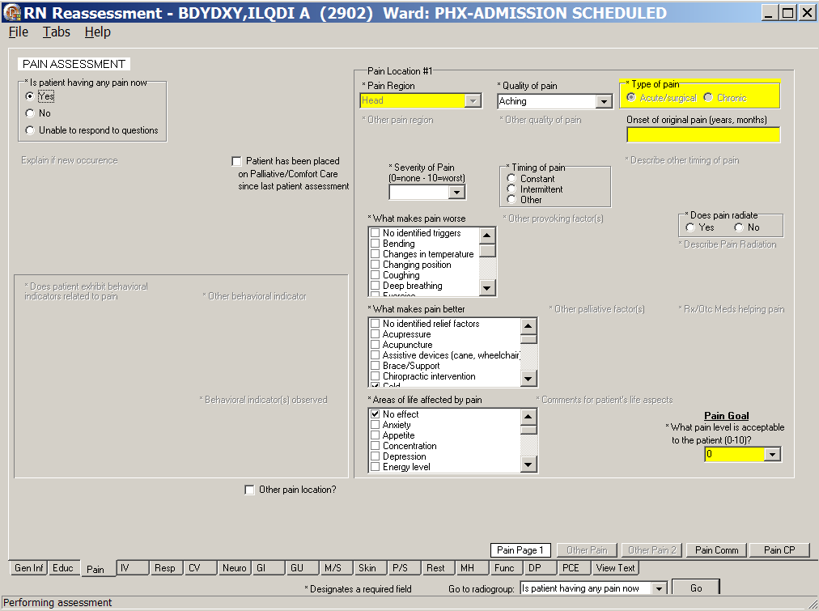
RN Reassessment, Pain Assessment (Pain) tab, Pain Page 1 window
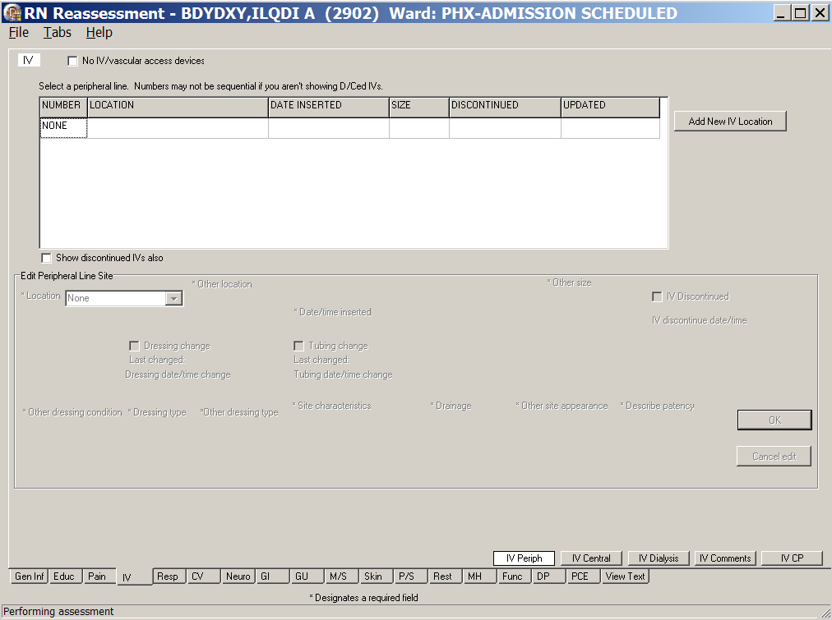
RN Reassessment, IV (IV) tab, IV Periph window
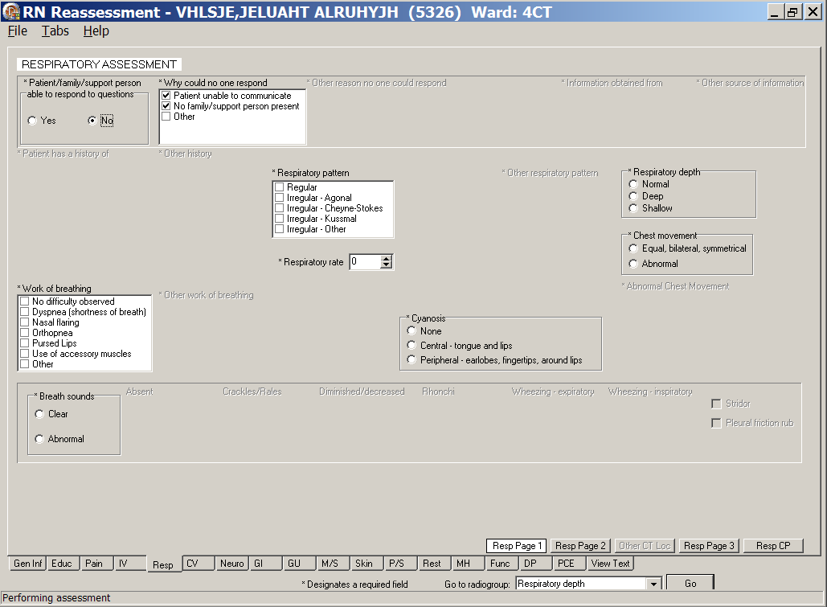
RN Reassessment, Respiratory Assessment (Resp) tab, Resp Page 1 window

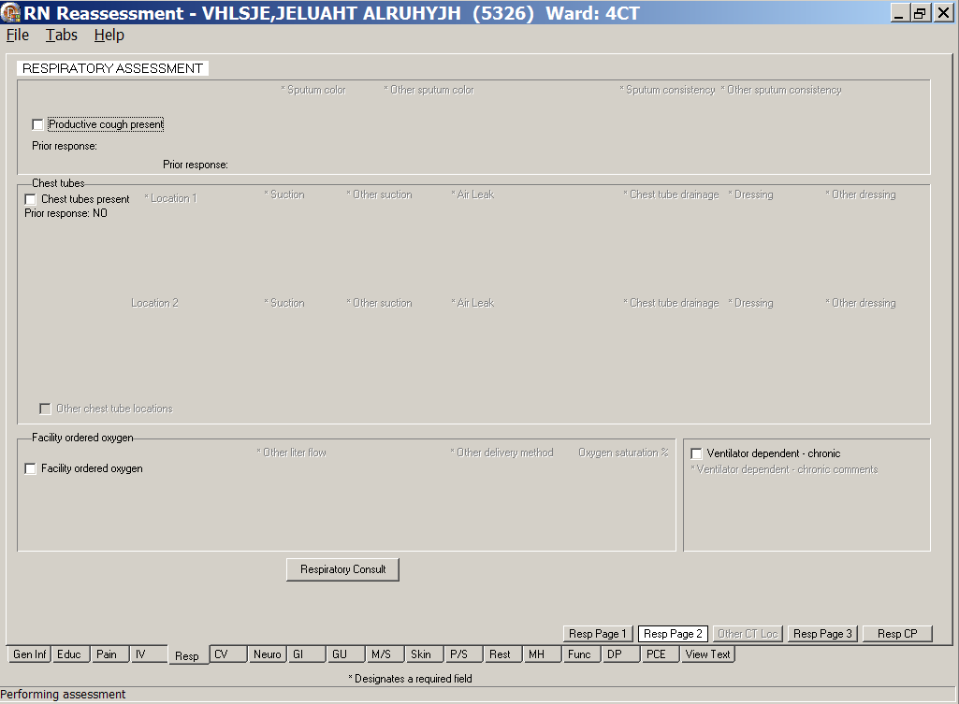
RN Reassessment, Respiratory Assessment (Resp) tab, Resp Page 2 window
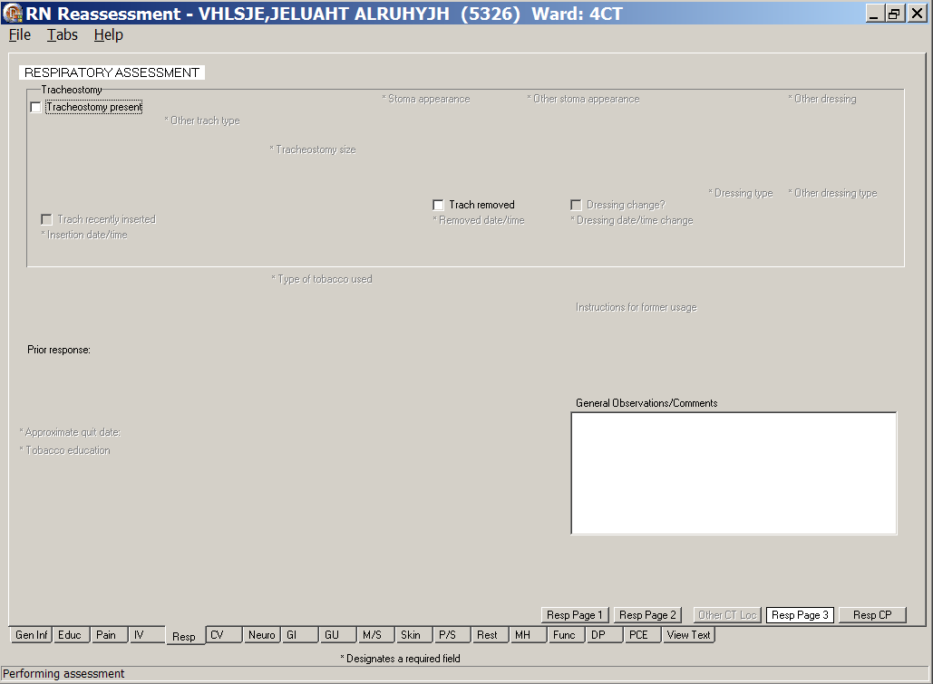
RN Reassessment, Respiratory Assessment (Resp) tab, Resp Page 3 window
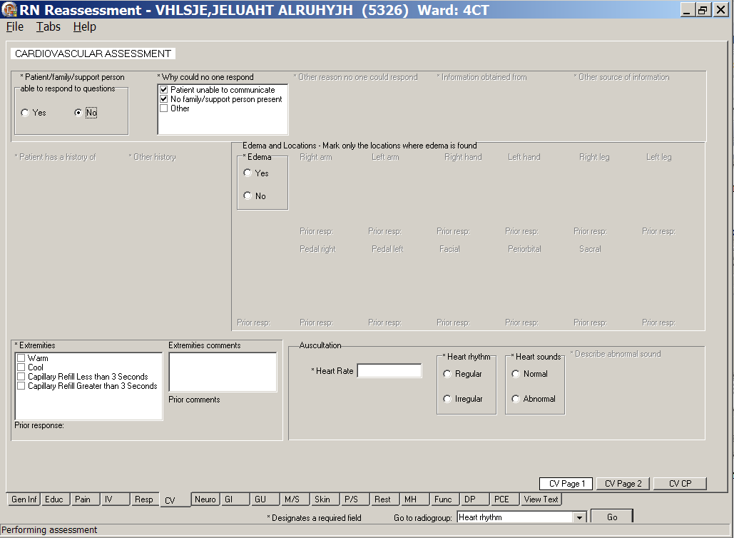
RN Reassessment, Cardiovascular Assessment (CV) tab, CV Page 1 window
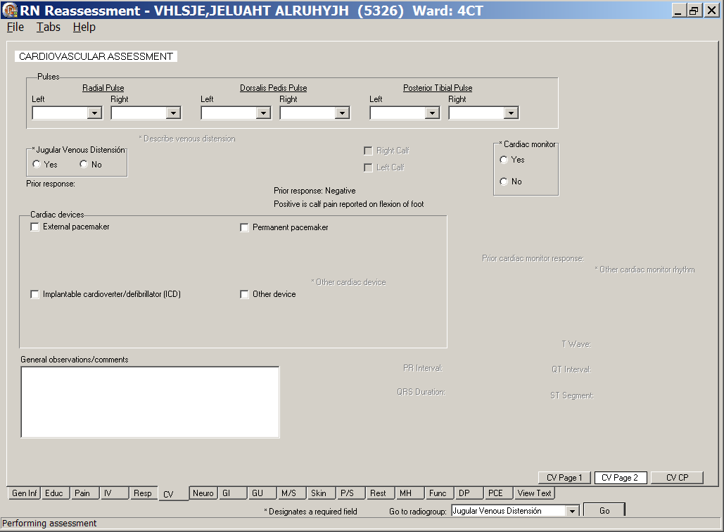
RN Reassessment, Cardiovascular Assessment (CV) tab, CV Page 2 window
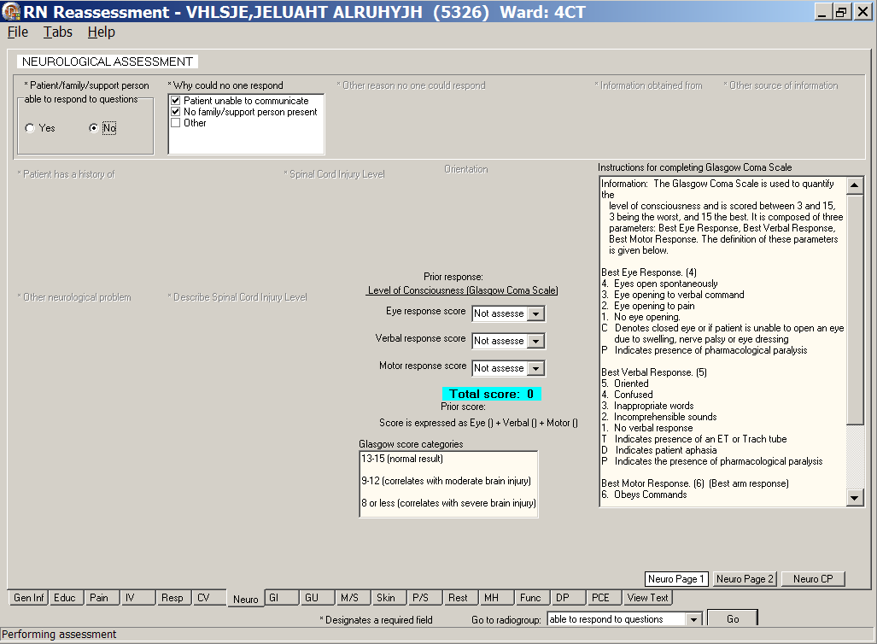
RN Reassessment, Neurological Assessment (Neuro) tab, Neuro Page 1 window
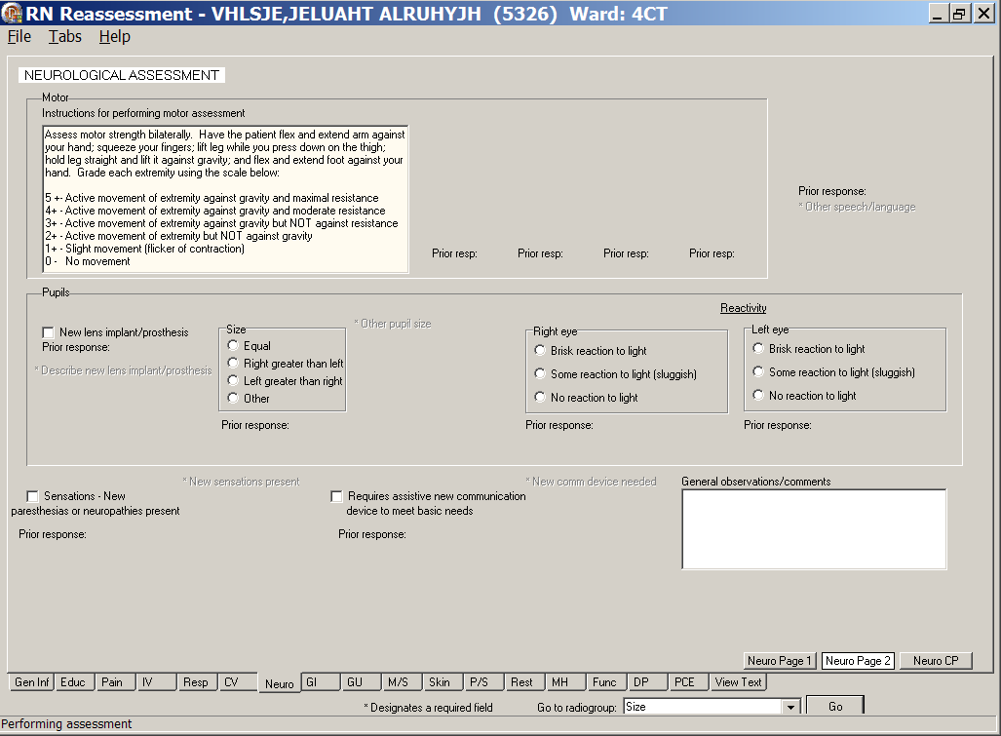
RN Reassessment, Neurological Assessment (Neuro) tab, Neuro Page 2 window
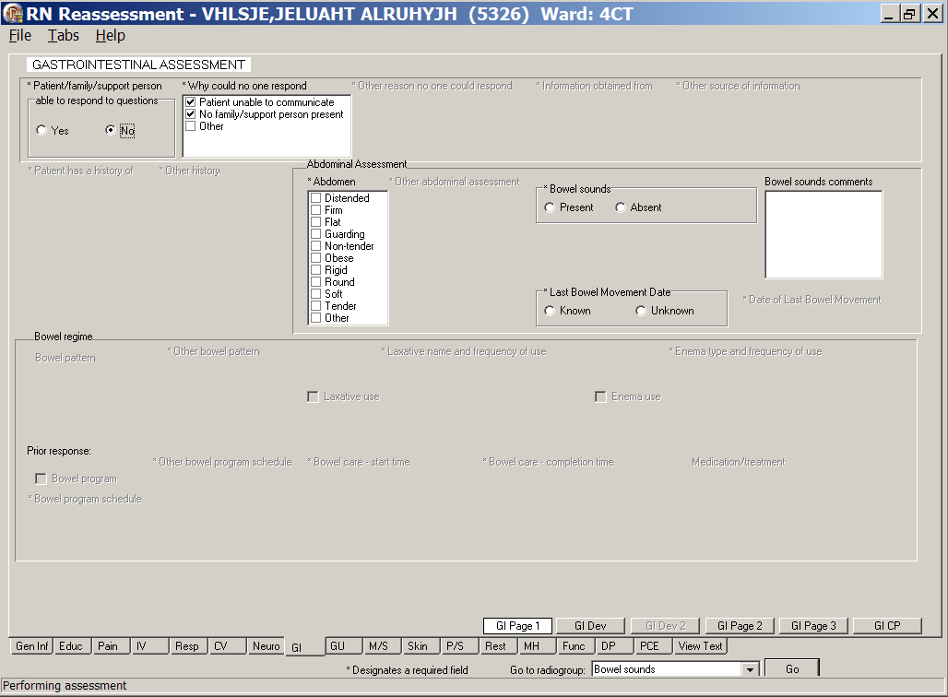
RN Reassessment, Gastrointestinal Assessment (GI) tab, GI Page 1 window
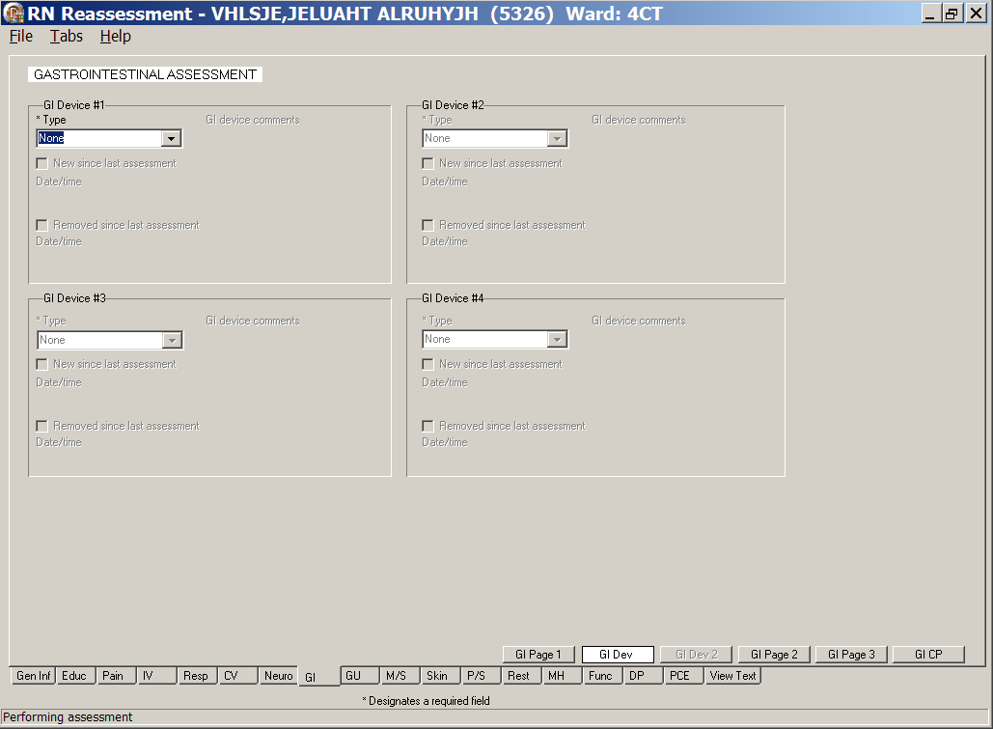
RN Reassessment, Gastrointestinal Assessment (GI) tab, GI Dev window

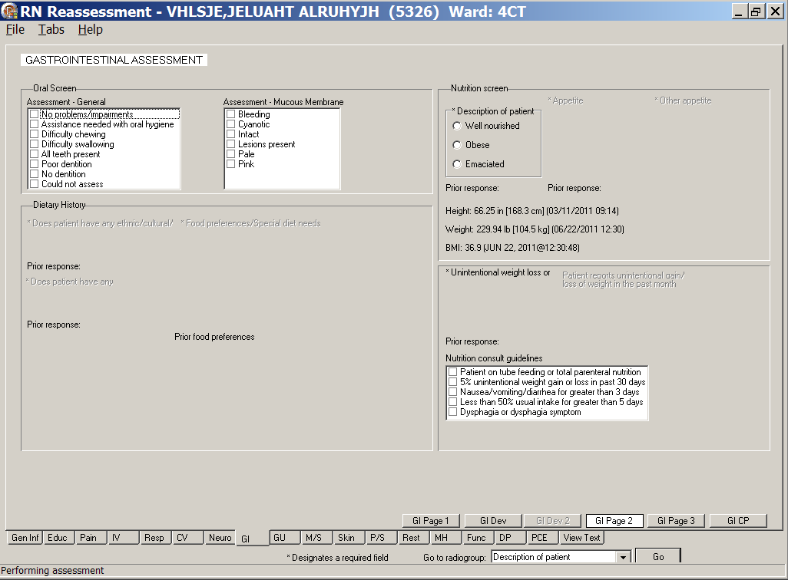
RN Reassessment, Gastrointestinal Assessment (GI) tab, GI Page 2 window
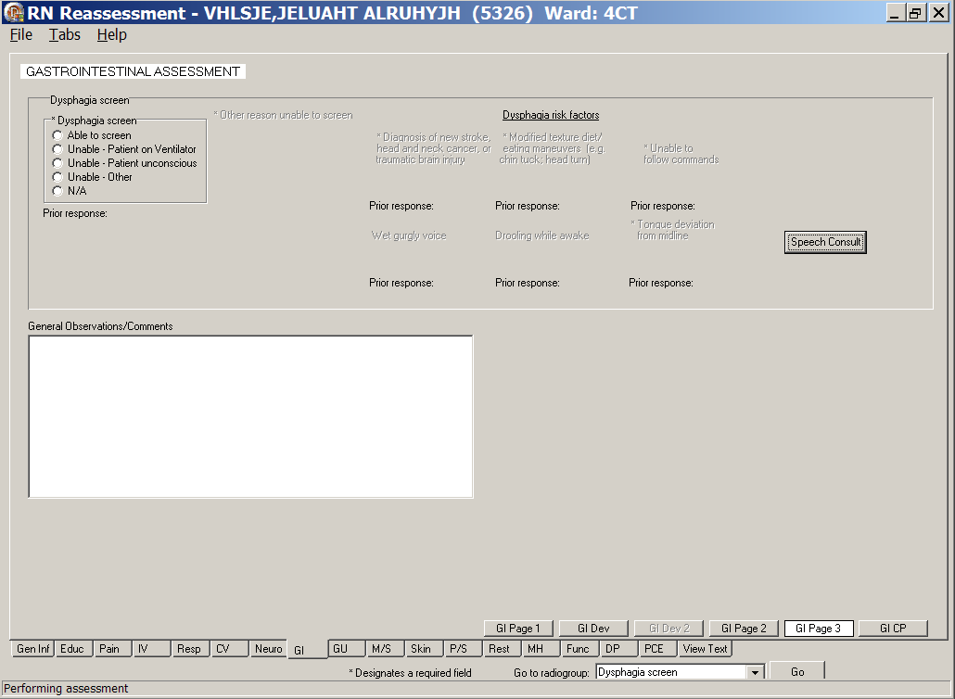
RN Reassessment, Gastrointestinal Assessment (GI) tab, GI Page 3 window
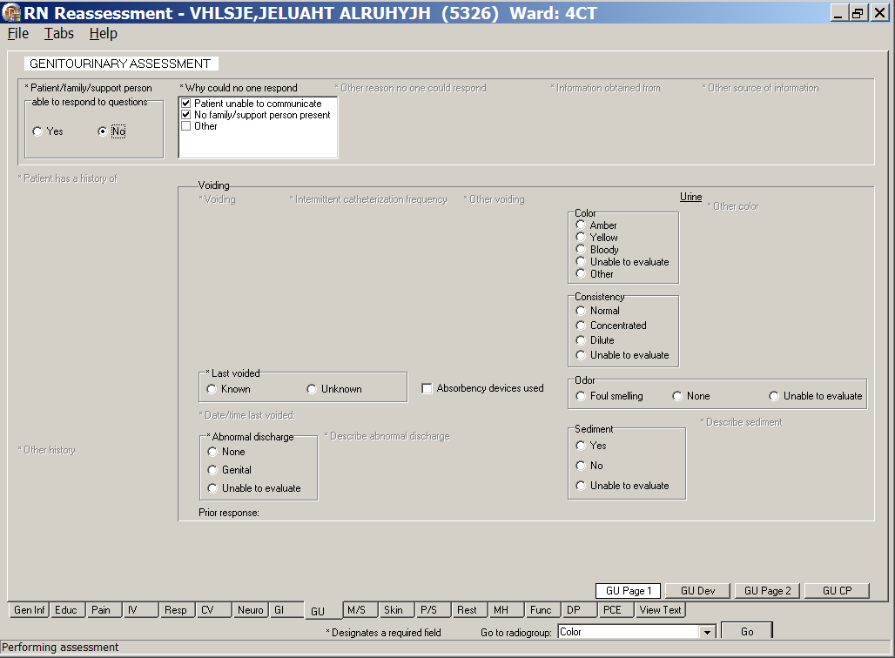
RN Reassessment, Genitourinary Assessment (GU) tab, GU Page 1 window
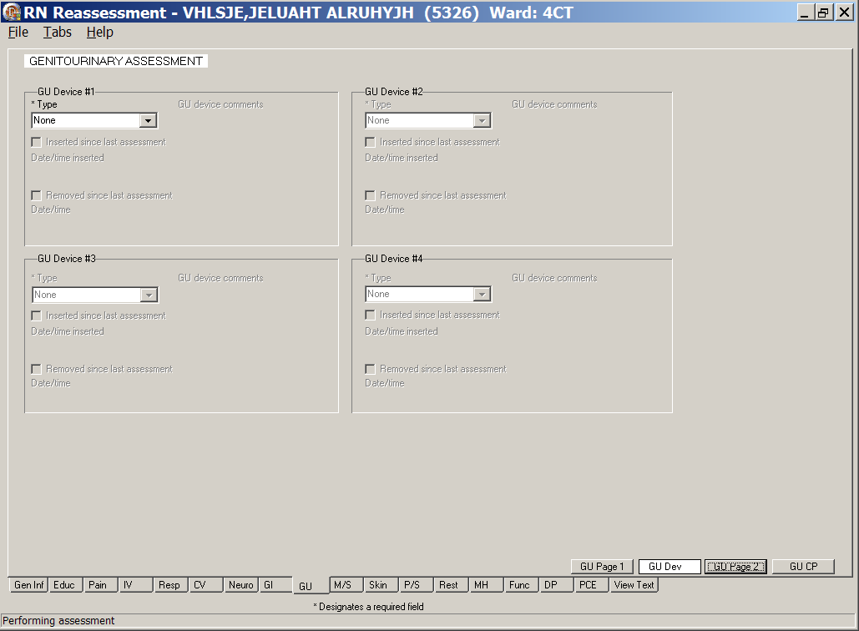
RN Reassessment, Genitourinary Assessment (GU) tab, GU Dev window

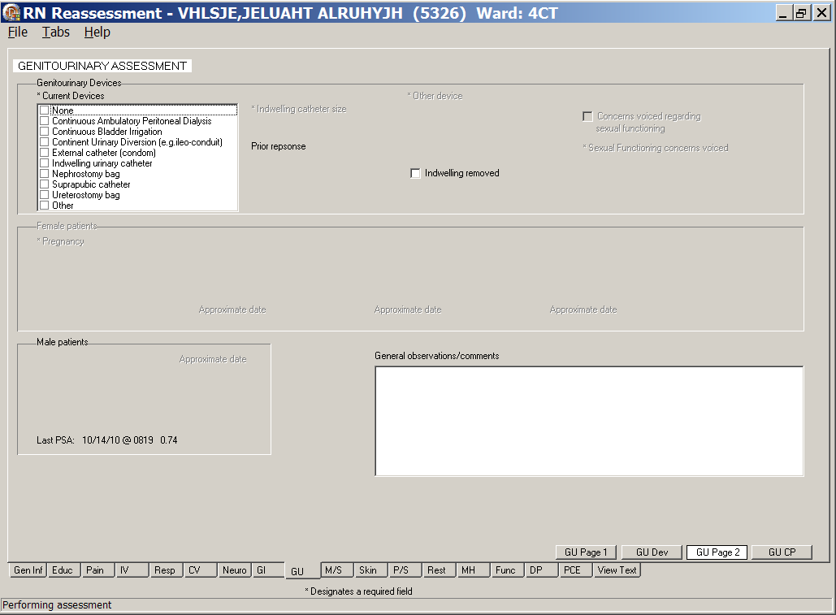
RN Reassessment, Genitourinary Assessment (GU) tab, GU Page 2 window
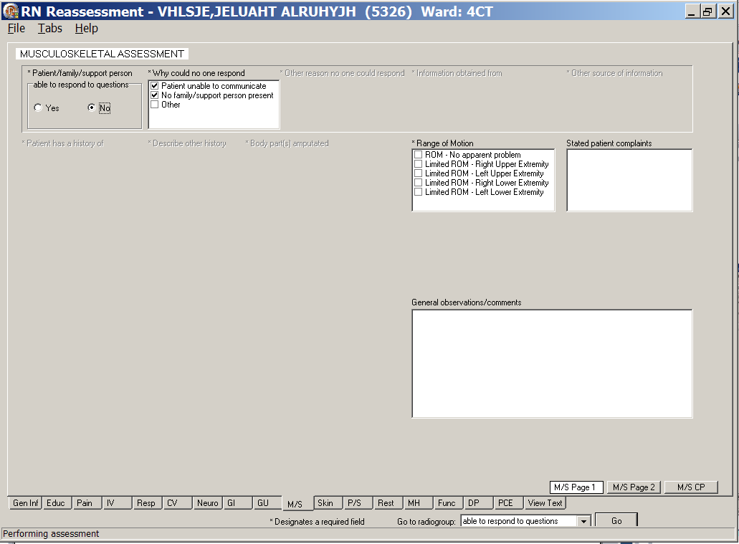
RN Reassessment, Musculoskeletal Assessment (M/S) tab, M/S Page 1 window

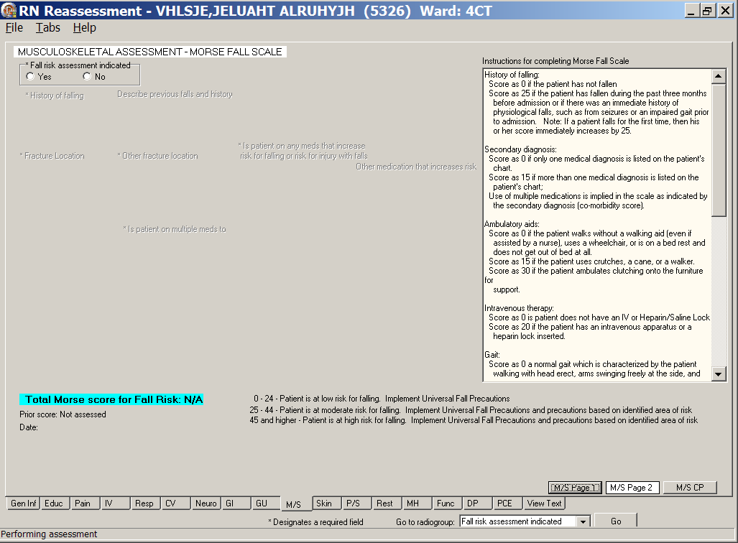
RN Reassessment, Musculoskeletal Assessment (M/S) tab, M/S Page 2 window
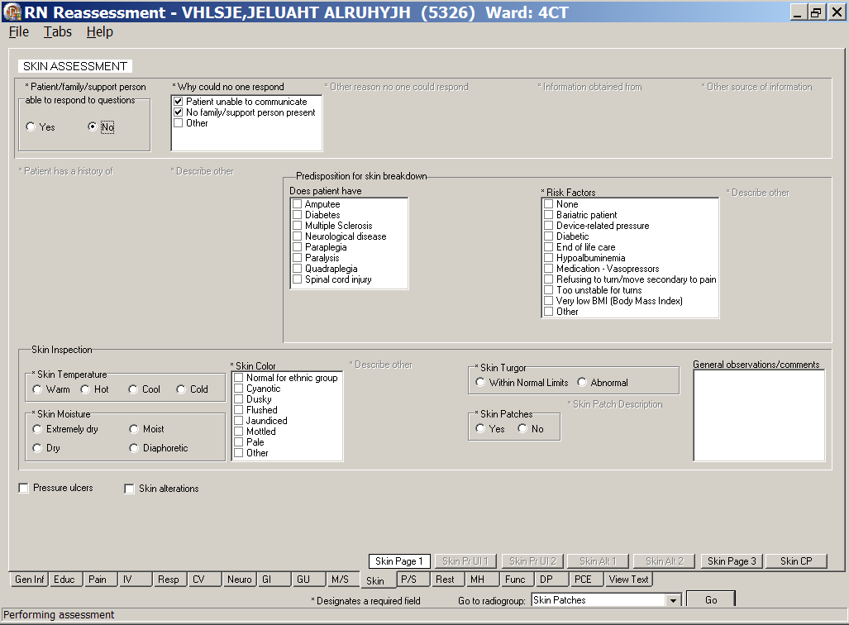
RN Reassessment, Skin Assessment (Skin) tab, Skin Page 1 window

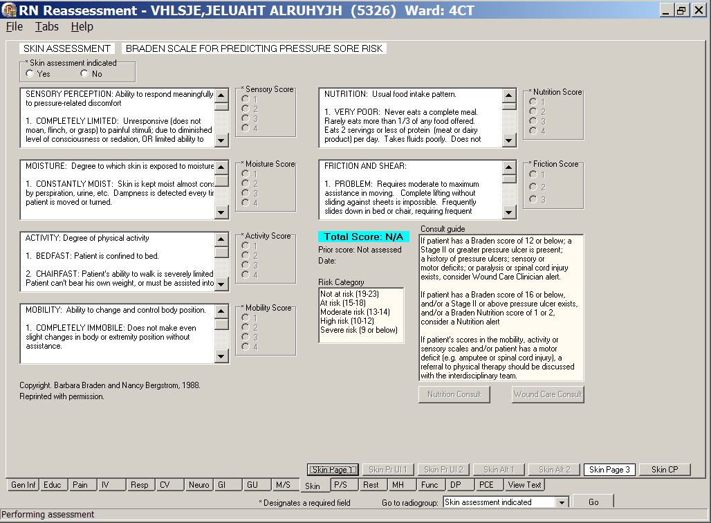
RN Reassessment, Skin Assessment (Skin) tab, Skin Page 3 window
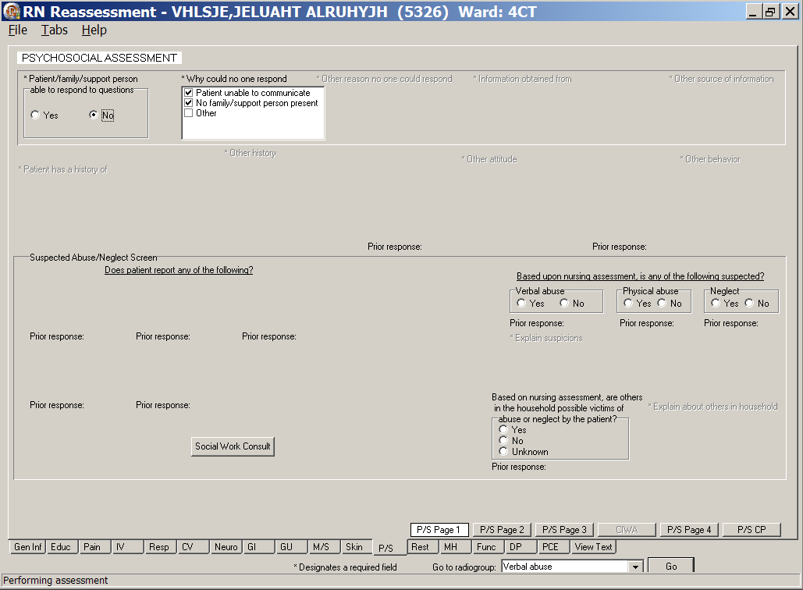
RN Reassessment, Psychosocial Assessment (P/S) tab, P/S Page 1 window

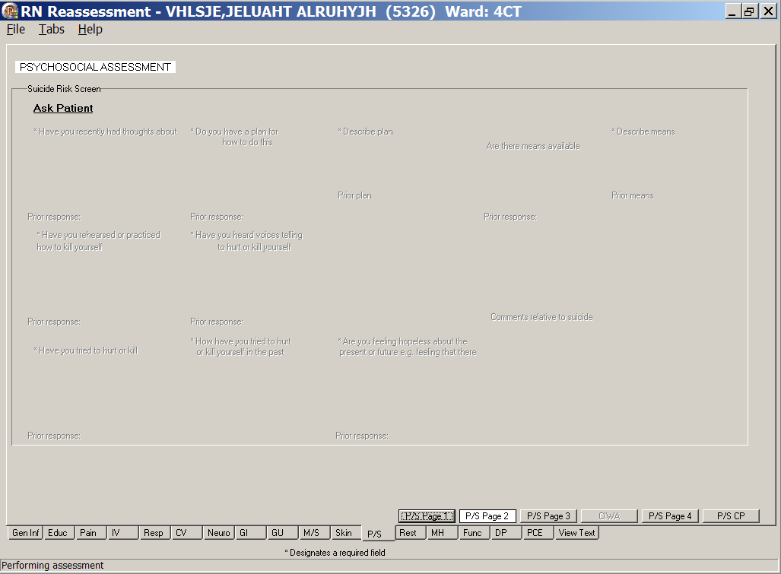
RN Reassessment, Psychosocial Assessment (P/S) tab, P/S Page 2 window
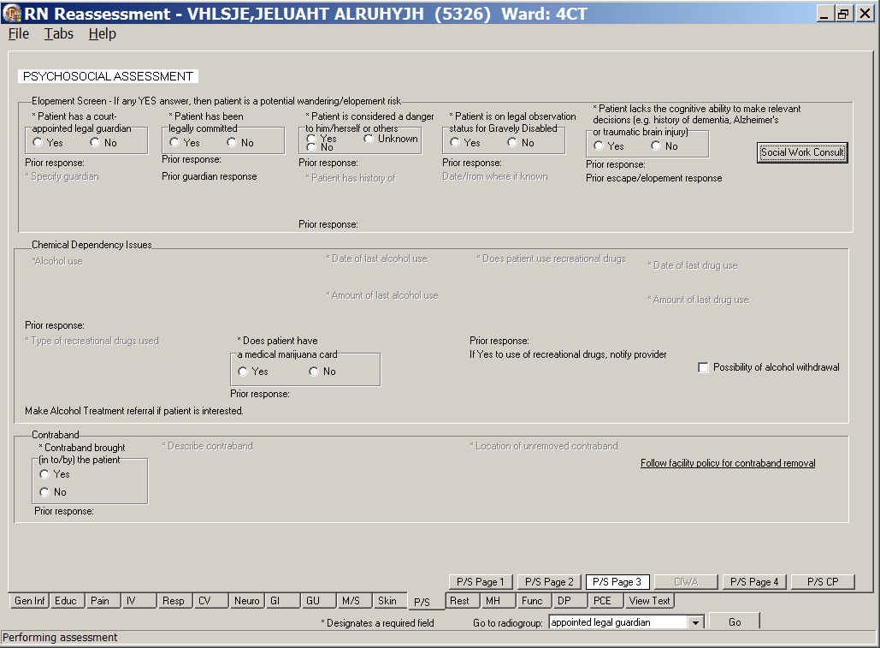
RN Reassessment, Psychosocial Assessment (P/S) tab, P/S Page 3 window
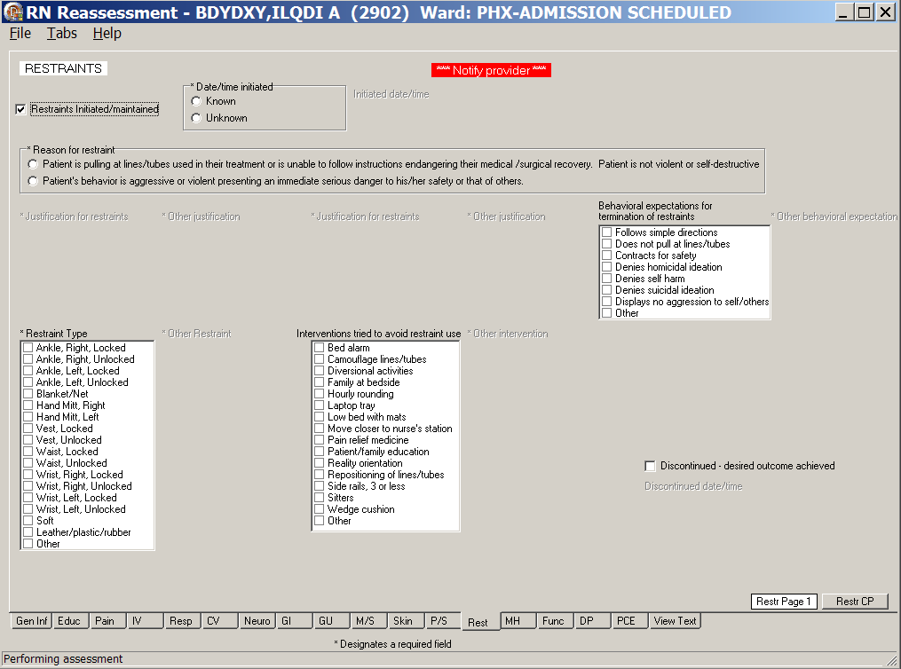
RN Reassessment, Restraints (Rest) tab, Restr Page 1 window
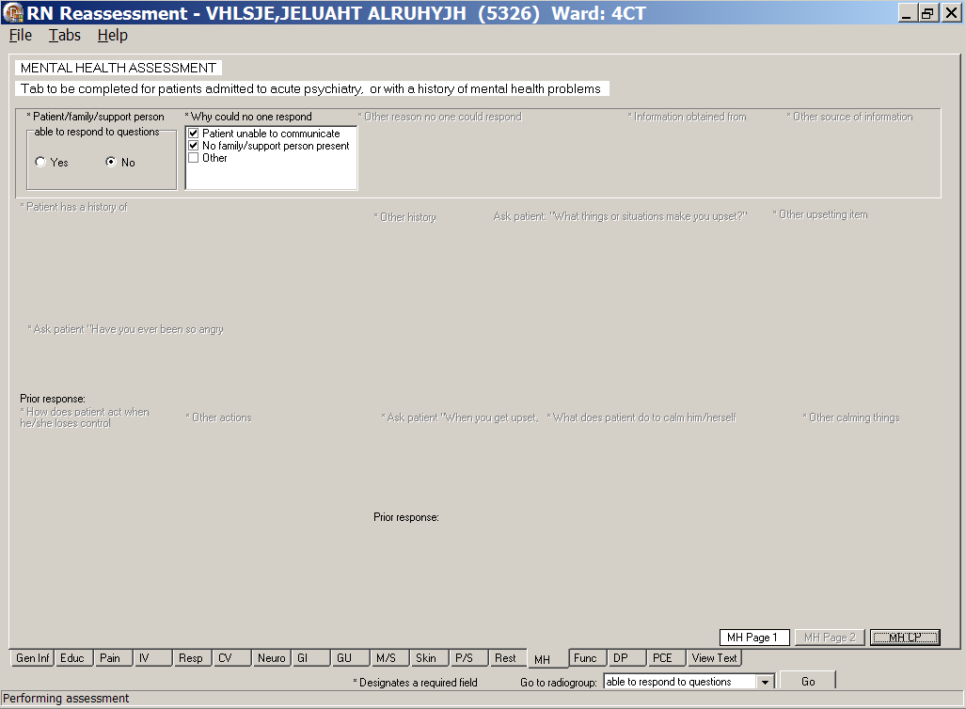
RN Reassessment, Mental Health Assessment (MH) tab, MH Page 1 window
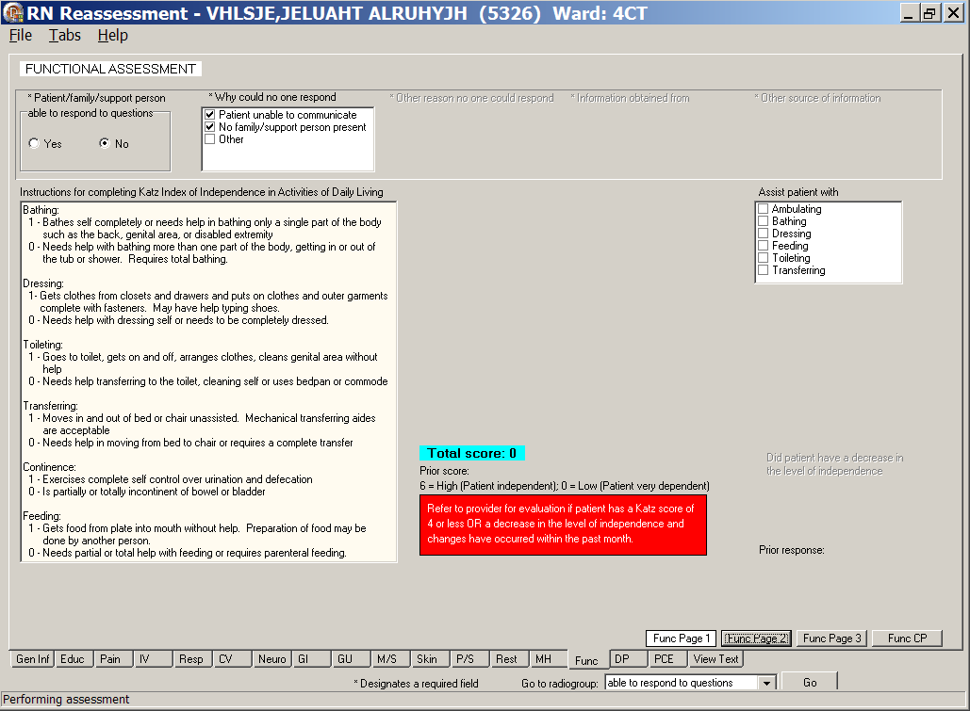
RN Reassessment, Functional Assessment (Func) tab, Func Page 1 window
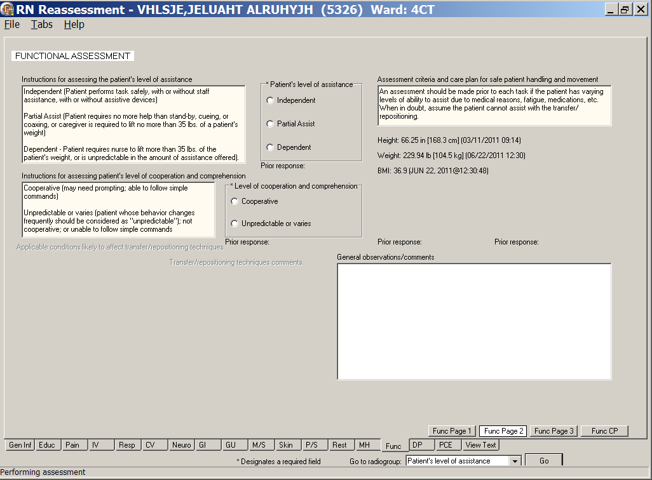
RN Reassessment, Functional Assessment (Func) tab, Func Page 2 window

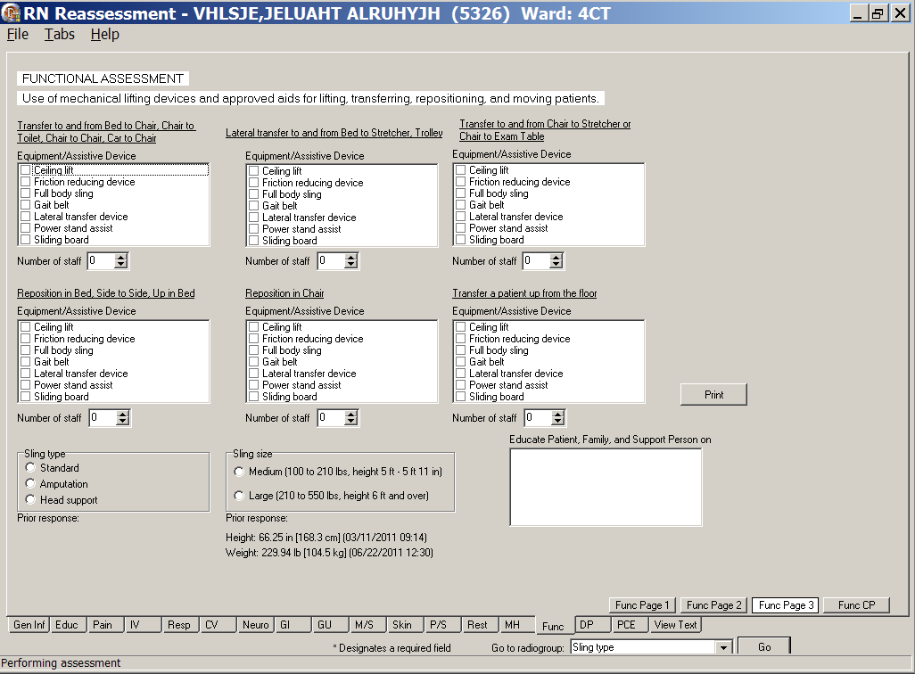
RN Reassessment, Functional Assessment (Func) tab, Func Page 3 window
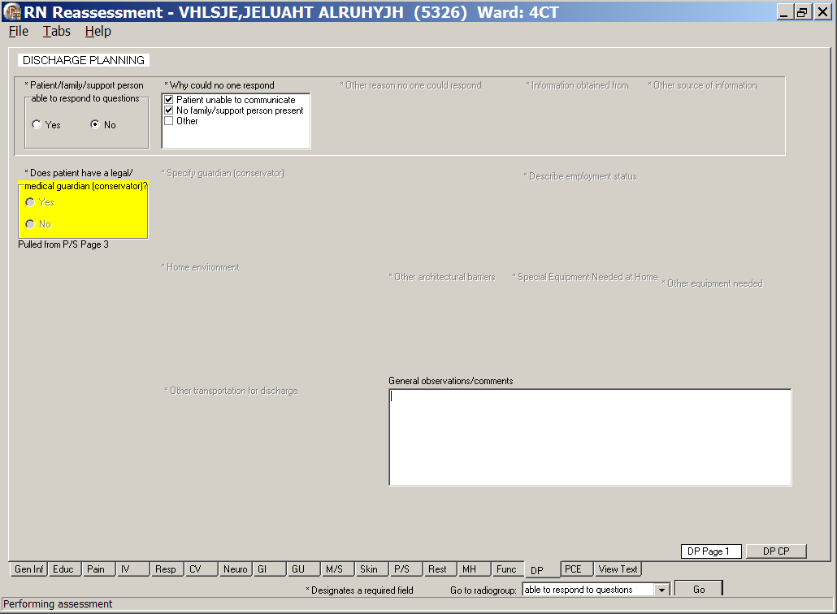
RN Reassessment, Discharge Planning (DP) tab, DP Page 1 window

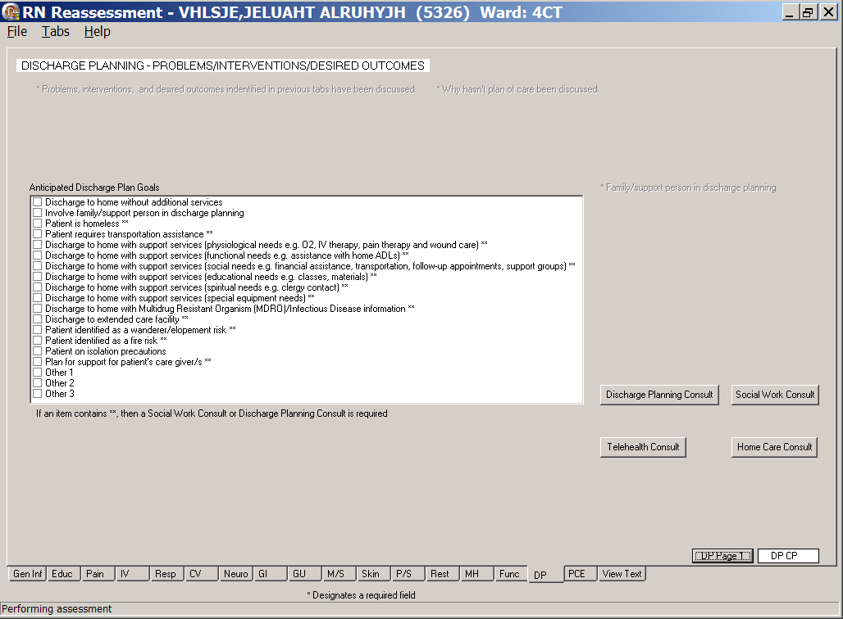
RN Reassessment, Discharge Planning (DP) tab, DP CP window

Patient can respond
- If the patient can respond, select Yes and select where the *Information obtained from.
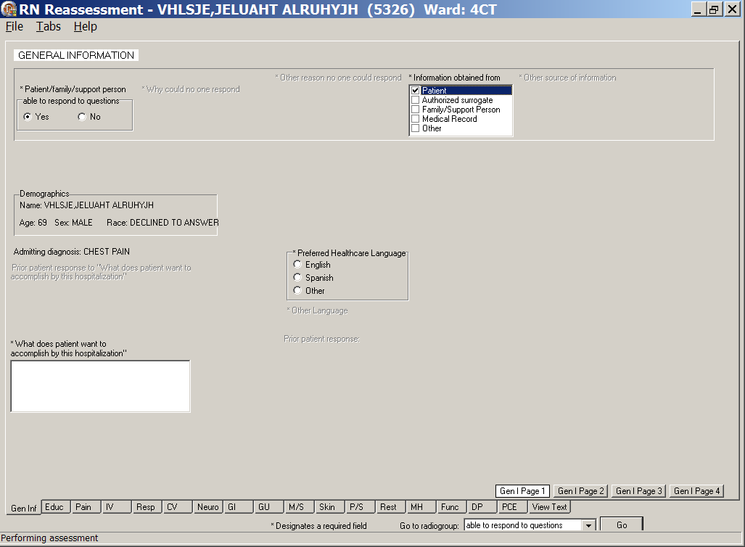
RN Reassessment, General Information (Gen Inf) tab, Gen I Page 1 window
- Continue through the reassessment tabs and pages.
- Complete all the fields with asterisks; they are required fields.
Note: For the content of the template, refer to the User Manual for Admission – RN Assessment.
- Upload the information.

Updating the Reassessment Note
PADP provides you with the ability to document simple updates during a tour of duty. You do not have to re-enter a completed reassessment every time you document. For another tour of duty, just return to the reassessment template and update information.

- In CPRS, open the Tools menu and select RN Reassessment.
RN Reassessment opens to the CPRS patient.
- If the patient had a reassessment completed within the last 24 hours, the following screen displays providing several choices for initial reassessment for shift and update reassessment (full reassessment completed previously on current shift).
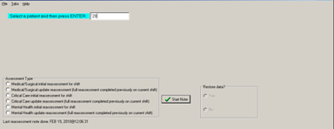
RN Reassessment window
with Assessment Types
Note: The template that opens is identical to the initial RN Reassessment with one exception-there are no required fields.
- Move to the tab that requires updating.
For example, to document that an IV was discontinued:
- Click IV.
- Select an IV to discontinue.
- Select the IV discontinued check box.
- Open the File menu and select Upload Data.
Data is uploaded.
- Sign note in CPRS or from the View Text tab.

Glossary
Term | Definition
ADPAC | Automated Data Processing Application Coordinator
ART | Adverse Reactions Tracking
BCE | Bar Code Expansion
BCE-PPI | Bar Code Expansion-Positive Patient Identification
BCMA | Bar Code Medication Administration
Belong | Belongings
CAC | Clinical Application Coordinator
CIWA | Clinical Institute Withdrawal Assessment.--CIWA
Class 1 (C1) | Software produced inside of the Office of Enterprise Development (PD) organization
Class 3 (C3) | Also known as Field Developed Software  Refers to all VHA software produced outside of the Office of Enterprise Development (PD) organization
CMS | Centers for Medicaid and Medicare Services
COTS | Commercial Off the Shelf
CP | Care Plan
CPRS | Computerized Patient Record System
CV | Cardiovascular Assessment
Delphi | Programming language used to develop the CPRS chart
DFN | Data File Number
DP | Discharge Planning
Educ | Educational Assessment
Func | Functional Assessment
Gen Inf | General Information tab
GI | Gastrointestinal Assessment
GU | Genitourinary Assessment
GUI | Graphical User Interface
ICD | International Classification of Diseases
ICN | The patient’s national identifier, Integration Control Number
IDPA | Interdisciplinary Patient Assessment - involves multiple disciplines responsible for assessing the patient from their perspective and expertise.
IDPC | Interdisciplinary Plan of Care - The entry of treatment plans by multiple disciplines to meet JCAHO requirements
IV | Intravenous
IV Central | Central IV lines
IV Dialysis | IV Dialysis ports
IV Periph | IV Peripheral lines
JCAHO | Joint Commission on Accreditation of Healthcare Organizations
LPN | Licensed Practical Nurse
M/S | Musculoskeletal Assessment
MAS | Medical Administration Service
MH | Mental Health Assessment
MRSA | Methicillin-Resistant Staphylococcus Aureus
NAA | Nursing Admission Assessment
Neuro | Neurological Assessment
NHIA | Nursing Healthcare Informatics Alliance
NPAT | National Patient Assessment Templates
NUPA | Namespace assigned to the Patient Assessment Documentation Package (PADP) by Database Administrator
OED | Office of Enterprise Development
OERR | Order Entry Results Reporting
OIT | Office of Information and Technology
ONS | Office of Nursing Services
Orient | Orientation to Unit
P/S | Psychosocial Assessment
PADP | Patient Assessment Documentation Package
Pain | Pain Assessment
PC | Plan of Care
PCE | Patient Care Encounter
PD | Product Development
PHR | Patient Health Record
Prob | Problems/Interventions/Desired Outcomes tab in the RN Reassessment
Resp | Respiratory Assessment
Rest (or Restr) | Restraints
RN | Registered Nurse
RPC | Remote Procedure Call
RSD | Requirements Specification Document
Section 508 | Under Section 508 of the Rehabilitation Act, as amended (29 U.S.C. 794d) Public Law 106-246 (http://va.gov/accessible) agencies must provide employees and members of the public who have disabilities access to electronic and information technology that is comparable to the access available to employees and members of the public who are not individuals with disabilities
Skin | Skin Assessment
SNOMED – CT | Systemized Nomenclature of Medicine Clinical Terms
TIU | Text Integration Utilities Program  All text in CPRS is stored in TIU
TJC | The Joint Commission
V/S | Vital Signs
VA | Department of Veterans Affairs
VAMC | Department of Veterans Affairs Medical Center
VANOD | VA Nursing Outcomes Database
VHA | Veterans Health Administration
VistA | Veterans Health Information Systems and Technology Architecture  An enterprise-wide information system built around an electronic health record used throughout the Department of Veterans Affairs medical system.
Vital Qualifiers | Provide detail in to the unit of measurement used with the vital signs.  Height in inches or centimeters?  Weight in pounds or kilograms?

For additional PADP information, refer to the user manuals for Admission – RN Assessment, Admission – Nursing Data Collection, and Interdisciplinary Plan of Care.

Documentation for NUPA Version 1.0 is also available on
- VA Software Documentation Library in the Clinical Section
http://www4.va.gov/vdl/
- PADP SharePoint for NUPA Version 1.0 http://vaww.oed.portal.va.gov/programs/class3_to_class1/padp/field_development

Appendix A
Reassessment Contingency Note

During system downtimes, print a copy of the attached Reassessment Contingency Note and use it to perform an RN Reassessment.

