BAR CODE MEDICATION ADMINISTRATION (BCMA)

PSB*3*2

RELEASE NOTES

March 2008

Department of Veterans Affairs
VistA Health Systems Design & Development

Table of Contents

Introduction 1
New Features 1
Modifications 2
Installation 3
Hardware Support 5
Examples of Control Codes 5
(This page included for two-sided copying.)

Introduction
This document provides a description of changes to the Bar Code Medication Administration (BCMA) software done in patch PSB*3*2. It addresses the addition of a new option Barcode Label Print [PSBO BZ] and the resolution of a Remedy ticket relating to duplicate wards.

New Features
The following list describes the new features provided by patch PSB*3*2.

The Barcode Label Print [PSBO BZ] option allows pharmacy personnel to create Unit Dose and Ward Stock medication labels with a barcode printer. This option gives sites the flexibility to add different types of barcode printers to their printing process and store their unique barcode printer control codes in their local Terminal Type file (#3.2) instead of the BCMA routine.

- The PSBO BZ option is very similar to the PSBO BL option with the exception that the controls codes for the barcode printer are stored in the Terminal Type file #3.2 rather than being hard coded in a routine.

Note: The Label Print [PSBO BL] option will still be accessible to users with the installation of the new Barcode Label Print [PSBO BZ] option.

The data input screens for both options are also the same. The following field lengths were modified:

- Lot number length was increased from 15 to 25 characters.

- Manufacturer length was decreased from 30 to 10 characters.
- Dosage length was decreased from 30 to 22 characters.

- The Barcode Label Print menu option appears at the end of the Medication Administration Menu Pharmacy [PSB PHARMACY] menu, as shown below.

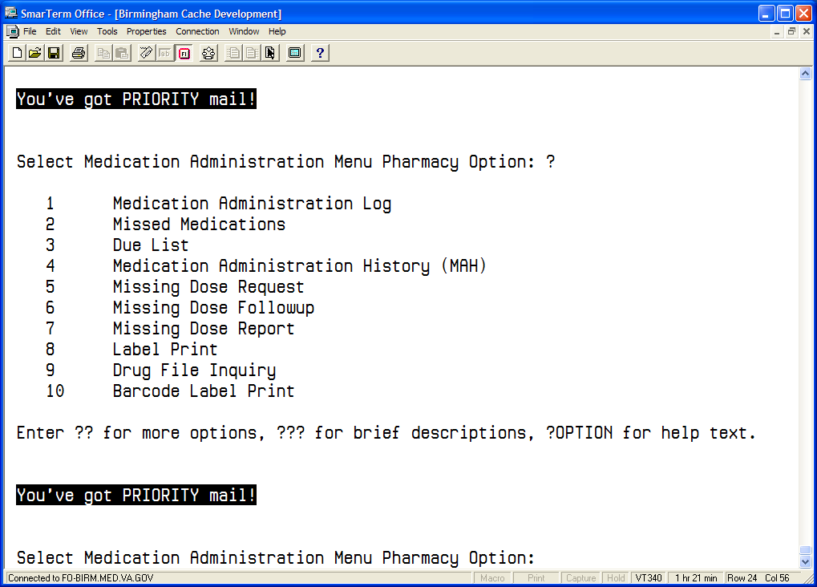

- Users can print bar code labels for medications that have an unknown or a future drug inactivation date.

- The Barcode Label Print [PSBO BZ] option will display all four digits of the calendar year for the expiration date on the bar code label.

- Users can also print a blank line for the Check By and Filled By fields if they want to manually record the proper information on the bar code label at a later time.

Modifications
The following modifications correct an error in previous versions of the application.

- The BCMA application no longer errors when accessing a patient who is assigned to a ward location having two entries with the same name (one active and one inactive) in the WARD LOCATION file (#42).

Installation
Follow the “Installation Instructions” section of PSB*3*2 patch description to install this patch.

The Barcode Label Print [PSBO BZ] option should be thoroughly tested in a site's TEST account before moving into the live or production account. Specifically, sites should ensure that the control codes set up for the barcode printer work appropriately.

Once this patch is installed, each site can update their TERMINAL TYPE file (#3.2) with the proper control codes for either the Zebra or Intermec barcode printers by using the automatic control code update function illustrated in the three simple steps below. This function can eliminate the manual process normally used to enter the coding logic associated with each control code stored in the TERMINAL TYPE file (#3.2). Sites should use this function to standardize the information assigned to each control code that is used in the barcode printing process.

Step 1: At the programmer or system prompt, enter D ^PSBOBLU

***Important Note***

Before you execute the automatic control code update function, create a new terminal type entry in your TERMINAL TYPE file (#3.2) to store the new barcode printer control codes. The new terminal type entry needs to be connected to the barcode printer device by inserting the new terminal type entry name into the SUBTYPE field (#3) for the barcode printer entry in your DEVICE file (#3.5).

This option allows you to automatically copy the BCMA pre-formatted control codes for the Zebra barcode printer or Intermec barcode printer to a device. Please select the appropriate BCMA pre-formatted control codes, and then select the appropriate device.

Step 2: Select one of the following:

- Zebra Control Codes
- Intermec Control Codes

Step 3: Select the appropriate barcode printer

Select 1 or 2: 1 Zebra Control Codes

DEVICE: ZEB4$PRT

Checking system status....

Are you sure that you want to copy the
BCMA CONTROL CODES to device: ZEB4$PRT

Step 3: Confirm copying process.

Enter Yes or No: NO// YES Copying Control Codes...

Done.

Hardware Support
This patch provides the control codes only for the Zebra 105SL and the Intermec 3400e. If you have other printers, you will be required to set up the appropriate control codes in the Terminal Type file #3.2. This may require that you contract the appropriate vendors for assistance in using/setting up these codes. Remember to thoroughly test your barcode control codes before moving into production.

Examples of Control Codes
Zebra 105 SL Printer Terminal Type Control Codes
Abbreviation | Full Name | Control Code
ET | End Text | N/A
ETF | End Text Field | N/A
EB | End Barcode | N/A
EBF | End Barcode Field | N/A
EL | End Label | W !,"^XZ"
FE | Format End | N/A
FI | Format Initialization | N/A
FI1 | Format Initialization 1 | N/A
FI2 | Format Initialization 2 | N/A
SB | Start Barcode | S PSBTYPE=$S(PSBSYM="I25":"B2N",PSBSYM="128":"BCN",1:"B3N") S:PSBSYM="" PSBBAR="NO-CODE" W !,"^BY2,3.0,80^FO20,100^"_PSBTYPE_",N,80,Y,N^FR^FD"_PSBBAR_"^FS"
SBF | Start Barcode Field | N/A
SL | Start Label | W !,"^XA",!,"^LH0,0^FS"
ST | Start Text | W !,"^FO"_PSBTYPE_"^A0N,30,20^CI13^FR^FD"_TEXT_"^FS"
STF | Start Text Field | S PSBTYPE=$S(PSBTLE="PSBDRUG":"20,25",PSBTLE="PSBDOSE":"20,60", PSBTLE="PSBNAME":"350,60",PSBTLE="PSBWARD":"350,90", PSBTLE="PSBLOT":"350,120", PSBTLE="PSBEXP":"350,150", PSBTLE="PSBMFG":"500,150", PSBTLE="PSBFCB":"350,180",1:"0,0")
Zebra Bar Code Label - Field Position Map
Abbreviation | Control Code ( Field Coordinates) | Description
EB | FO20,150 | “No – Code” statement
SB | FO20,100 " | Bar Code Graph
STF | PSBTLE="PSBDRUG":"20,25" | Drug Name
 | PSBTLE="PSBDOSE":"20,60", | Dosage
 | PSBTLE="PSBNAME":"350,60" | Patient Name and Quality
 | PSBTLE="PSBWARD":"350,90", | Ward Location
 | PSBTLE="PSBLOT":"350,120", | Lot Number
 | PSBTLE="PSBEXP":"350,150", | Expiration Date
 | PSBTLE="PSBMFG":"500,150", | Manufacturer
 | PSBTLE="PSBFCB":"350,180" | Filled By/Checked By

Intermec 3400e Printer Terminal Type Control Codes
Abbreviation | Full Name | Control Code
ET | End Text | N/A
ETF | End Text Field | N/A
EB | End Barcode | N/A
EBF | End Barcode Field | W "<STX>H8;o50,40;f3;c0;h1;w1;d0,80;<ETX>",!
EL | End Label | W "<STX><ETB><ETX>",!
FE | Format End | N/A
FI | Format Initialization | W "<STX><ESC>C<ETX>",!,"<STX><ESC>P<ETX>",!,"<STX>E2;F2<ESC><ETX  >",!
FI1 | Format Initialization 1 | W "<STX>H7;o30,260;f3;c0;h1;w1;d0,80;<ETX>",!,"<STX>H6;o50,440;f  3;c0;h1;w1;d0,20;<ETX>",!,"<STX>H5;o50,260;f3;c0;h1;w1;d0,20;<ETX>",!,"<STX>H4;o70,260;f3;c0;h1;w1;d0,35;<ETX>",!
FI2 | Format Initialization 2 | W "<STX>H3;o90,260;f3;c0;h1;w1;d0,35;<ETX>",!,"<STX>H2;o110,260;  f3;c0;h1;w1;d0,35;<ETX>",!,"<STX>H1;o110,40;f3;c0;h1;w1;d0,30;<ETX>",!,"<STX>H0; o130,40;f3;c0;h1;w1;d0,60;<ETX>",!
SB | Start Barcode | W "<STX>"_TEXT_"<ETX>",!
SBF | Start Barcode Field | S PSBTYPE=$S(PSBSYM="I25":"c2,0",PSBSYM="128":"c6,0",1:"c0,0") W  "<STX>B8;o85,40;f3;"_PSBTYPE_";h50;w1;i1;do,25;p@;<ETX>",!,"<STX>I8;h1;w1;<ETX>",!
SL | Start Label | W "<STX>R;<EXT>",!,"<STX><ESC>E2<EXT>",!
ST | Start Text | W "<STX>"_TEXT_"<CR><ETX>",!
STF | Start Text Field | N/A

Example: Intermec Bar Code Label - Field Position Map
Abbreviation | Control Code ( Field Coordinates) | Description
EB | <STX>H8;o50,40;f3;c0;h1;w1;d0,80;<ETX> | “No – Code” statement
FI1 | <STX>H7;o30,260;f3;c0;h1;w1;d0,80;<ETX> | Filled By/Checked By
 | <STX>H6;o50,440;f3;c0;h1;w1;d0,20;<ETX>" | Manufacturer
 | <STX>H5;o50,260;f3;c0;h1;w1;d0,20;<ETX> | Expiration Date
 | <STX>H4;o70,260;f3;c0;h1;w1;d0,35;<ETX> | Lot Number
FI2 | <STX>H3;o90,260;f3;c0;h1;w1;d0,35;<ETX> | Ward Location
 | <STX>H2;o110,260;f3;c0;h1;w1;d0,35;<ETX> | Patient Name and Quality
 | <STX>H1;o110,40;f3;c0;h1;w1;d0,27;<ETX> | Dose
 | <STX>H0;o130,40;f3;c0;h1;w1;d0,60;<ETX> | Drug Name
SBF | <STX>B8;o85,40;f3;"_PSBTYPE_";h50;wl;il;do;25;p@;  <ETX><STX>I8;h1;w1;<ETX>" | Bar Code Graph

