BAR CODE MEDICATION ADMINISTRATION (BCMA)
MANAGER’S USER MANUAL

Version 3.0
February 2004

(Revised September 2012)

Department of Veterans Affairs Product Development

Revision History

Each time this manual is updated, the Title Page lists the new revised date and this page describes the changes. If the Revised Pages column lists “All,” replace the existing manual with the reissued manual. If the Revised Pages column lists individual entries (e.g., 25, 32), either update the existing manual with the Change Pages Document or print the entire new manual.

Date | Revised Pages | Patch Number | Description
09/2012 | i, 12, 16 | PSB*3*68 | Added site parameter to allow sites to select the maximum number of hours that new BCMA site parameter, Injection Site History, will display on the VDL during the administration of injectable medications.  REDACTED
01/2012 | i, 8, 12, 14, 14a-14b | PSB*3*58 | Added site parameter to allow sites to administer non-nurse verified medication orders with no warnings displayed, to display a warning before administering non-nurse verified medication orders, or to prohibit administration of non-nurse verified medication orders.  PRN Effectiveness Entry Parameter maximum increased from 240 to 960 minutes.  REDACTED
01/2011 | i, iii-iv, 12-  13, 54, 57,  59-64 | PSB*3*42 | Removed field Scratch HFS Directory from the Parameters Tab, and replaced corresponding Site Parameters screen capture.  Added Appendix A describing the new parameter tab created for the Indian Health Service (IHS) project.  Updated Glossary and Index for Indian Health Service. REDACTED
10/2009 | i, iii-iv, 48a- 48b, 56 | PSB*3*47 | Added information for the new Immunizations Documentation by BCMA Nightly Task [PSB PX BCMA2PCE TASK] option that is added to the Bar Code Medication Administration Manager [PSB MGR] menu. PCE added to the glossary.  REDACTED
01/2009 | All | PSB*3*28 | Reissue of manual to add new functionality in patch PSB*3*28 including the addition of a new unable to scan option, email notification feature, mode of patient record access and five rights override administration.  REDACTED

September 2012 BCMA V. 3.0 Manager’s User Manual i
PSB*3*68

ii BCMA V. 3.0 Manager’s User Manual January 2009

Defining and Updating Site Parameters for Your Division (cont.)  TIP:  Modifying the “BCMA On-line” parameter affects all users signing on to your division.  Multi-division sites must disable access to each site. | Working with the Facility Tab  The Facility Tab, on the BCMA Site Parameters Main Screen, provides the following functions:  Facility Information (Read-Only): This area provides read-only information populated by the INSTITUTION  file (#4).  BCMA On-Line: This option (check box) under the “BCMA Status for Division” section lets IRM personnel enable or disable all GUI BCMA options. It does not affect CHUI BCMA options.  - If the “BCMA On-Line” check box is checked, the system is on-line and all GUI BCMA options are available.  - If the “BCMA On-line” check box is not checked, all users currently logged on to GUI BCMA options will not be affected. However, when a user attempts to log on to the GUI options, the following Error message displays:  Example: Error Message When BCMA Not Active for Your Site  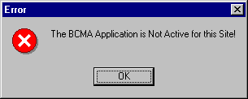  - If the “BCMA On-Line” check box is checked and you try to take it off-line by deselecting the check box, the following Warning message displays:  Example: Warning Message When All BCMA Users Are Being Disabled for Your Division  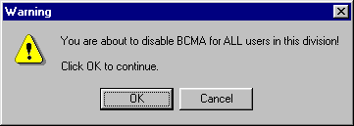

January 2009 BCMA V. 3.0 Manager’s User Manual 11

Defining and Updating Site Parameters for Your Division (cont.) | Working with the Parameters Tab  You can activate the Parameters Tab by placing the cursor over the Tab, and then clicking once on it. Doing so activates the site parameters for this Tab.  Keyboard Shortcut: Press ALT+P to display the Parameters Tab.  This section describes the fields and check boxes available on the Parameters Tab.  Example: Site Parameters Available Parameters Tab  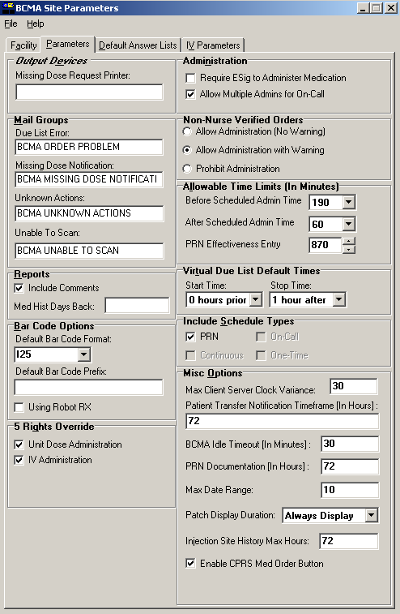
12 BCMA V. 3.0 Manager’s User Manual September 2012 PSB*3*68

Defining and Updating Site Parameters for Your Division (cont.)  TIP:  The Continuous, One-Time, and On-Call Schedule Type parameter check boxes are “checked” and  “disabled “to ensure that these Schedule Types automatically display on the CHUI Due List and on the BCMA VDL. | Working with the Parameters Tab (cont.)  - Virtual Due List Default Times Area  Start Time and Stop Time: This option lets you enter the number of hours before and after NOW that GUI BCMA will initially display orders on a patient’s VDL (i.e., patient record).  - Include Schedule Types Area  These check boxes let you select the default display for the CHUI Menu Option Due List [PSBO DL] and the BCMA VDL. The PRN check box controls the default display of PRN medications on the VDL. Your VAMC can choose to have the PRN Schedule Types display on the VDL by default, or to display PRN medications once the clinician selects the PRN Schedule Type check box on the VDL. All other Schedule Types will display by default and cannot be changed.  - Individual client settings are not allowed.  - Misc Options Area  Max Client/Server Clock Variance: This field lets you specify the number of minutes allowed for a variance, between the Client clock and the Server clock time.  - If outside the range, a Warning message displays.  Patient Transfer Notification Timeframe In Hours: This field lets you define the number of hours, before the current system time, that a patient movement must be less than for the movement type (usually a transfer) to display on the BCMA VDL. The allowable entry for this parameter is a minimum value of 2 and a maximum value of 99. The default is 72 hours.  - Individual client settings are not allowed.  BCMA Idle Timeout In Minutes: This field lets you define the number of minutes before BCMA becomes inactive. The default  is 1 minute.

January 2009 BCMA V. 3.0 Manager’s User Manual 15

Defining and Updating Site Parameters for Your Division (cont.)  TIP:  Users can double click on the PRN Effectiveness Activity in the BCMA Clinical Reminders marquee to document ALL PRN medication orders needing effectiveness documentation. | Working with the Parameters Tab (cont.)  - Misc Options Area (cont.)  PRN Documentation In Hours: This field lets you define the minimum number of hours from NOW that BCMA V. 3.0 will search for PRN medication orders needing effectiveness comments. The four most recent PRN orders that need documentation display within the PRN Effectiveness mouse-over list in the “BCMA Clinical Reminders” marquee, which is located in the lower, right-hand corner of the VDL. BCMA displays PRN medications based on the current admission or the site parameter timeframe (whichever is greater). The allowable entry for this parameter is a minimum value of 1 and a maximum value of 999. The default is 72 hours.  - Individual client settings are not allowed.  Max Date Range: This field lets you specify the maximum number of days allowed for the IV Bag Status and Medication Therapy reports. A warning message will display if the user attempts to run these reports beyond the number of days allowed by this site parameter. No default.  Patch Display Duration: This field lets you specify the number of days after an order’s Stop Date that a “Given” patch will continue to display on the VDL and Cover Sheet. The allowed values are: Always Display and 7-14 days. The display date will be calculated by adding the number of days defined in the site parameter to the Stop Date of the order. If the value of the site parameter is Always Display, then the patch will continue to display on the VDL until it is marked as removed using the Due List–regardless of the order Stop Date. The default is Always Display.  Injection Site History Max Hours: This field lets you specify the maximum number of hours that previous injection sites will display on the VDL, during the administration of injectable medications for the current patient. The allowable entry for this parameter is a minimum value of 1 and a maximum value and default of 72 hours.  Enable CPRS Med Order Button: Selecting this button allows clinicians to use the CPRS Med Order Button in BCMA V. 3.0 to electronically order, document, review, and sign verbal- and phone-type STAT and NOW (One-Time) medication orders that they are administering to patients.  - Clinicians can access the CPRS Med Order Button functionality only if they hold the PSB CPRS MED BUTTON security key.  - Clinicians must be able to accept and sign orders in CPRS to use the CPRS Med Order Button functionality in BCMA V. 3.0.

16 BCMA V. 3.0 Manager’s User Manual September 2012 PSB*3*68

