Department of Veterans Affairs

Mobile Applications (Apps) Phase Two (MAP2)

Ask A Pharmacist (AAP)
User Manual

Software Version 1.0

February 2016

Revision History
Note: The revision history cycle begins once changes or enhancements are requested after the document has been baselined.
Date | Revision | Description | Author
3/4/2016 | 1.0 | Baselined after v 1.0
04/29/2015 | 0.1 | Create initial document

Table of Contents
1. Introduction 1
1.1. Purpose 1
1.2. Overview 1
1.3. Project References 2
1.3.1. Help Desk 2
1.4. Organization of the Manual 2
1.5. Acronyms and Abbreviations 3
2. System Summary 4
2.1. System Configuration 4
2.2. Data Flows 5
2.3. User Access Levels 6
3. Getting Started 7
3.1. Opening Ask a Pharmacist 7
3.2. System Menu 7
3.3. Navigating Ask a Pharmacist 9
3.3.1. Navigating a Feature 10
3.4. Exit System 14
3.5. Image Library 14
3.6. Caveats and Exceptions 15
4. Using Ask a Pharmacist 16
4.1. Home Screen 16
4.2. Home, Features, About, and Help 17
4.2.1. Home 17
4.2.2. Features 18
4.2.3. About and Help 20
4.3. My HealtheVet Pharmacy Services 22
4.3.1. FAQ – My HealtheVet 24
4.3.2. Medication Articles on My HealtheVet 25
4.3.3. Medical Library 27
4.3.4. Prescription History 30
4.3.5. Rx Refill 31
4.3.6. Rx Refill Guide 32
4.3.7. Send a Secure Message 32
4.3.8. Track My Medications 33
4.4. Pill and Bottle Information 36
4.4.1. Pill Bottle Information 37
4.4.2. Pill Identification 39
4.5. VA Trusted Medication Resources 40
4.5.1. Consumer Drug, Herbal & Supplement Information 42
4.5.2. Drug Interactions and Adverse Drug Events 42
4.5.3. FAQ – VA National Medication Formulary 47
4.5.4. Know Your Medication Label 47
4.5.5. Medication Administration 47
4.5.6. Medication Disposal 48
4.5.7. Pill Identification 48
4.6. About VA Pharmacies 49
4.6.1. Find My Facility 51
4.6.2. How VA Pharmacies Operate 52
4.6.3. How VA Pharmacists Help Veterans 52
4.7. Send a Secure Message 53
5. Troubleshooting 55

Table of Figures
Figure 1: Data Flow 5
Figure 2: AAP Home Screen, Tablet View 7
Figure 3: AAP Home Screen, Phone View 8
Figure 4: Home Screen 9
Figure 5: Feature Menu 10
Figure 6: Feature Menu, Phone View 11
Figure 7: AAP Article, Tablet View 12
Figure 8: AAP Article, Phone View 13
Figure 9: Leaving AAP 14
Figure 10: Information icon 14
Figure 11: Fading Bottom of Screen 15
Figure 12: Menu Icon 15
Figure 13: Menu Arrow and Back Arrow 15
Figure 14: Home Screen 16
Figure 15: Features Drop Down, Tablet View 18
Figure 16: Features Drop Down, Phone View 19
Figure 17: About Window, Tablet View 20
Figure 18: Help Window, Phone View 21
Figure 19: My HealtheVet Pharmacy Services 22
Figure 20: Leaving AAP Pop-up 24
Figure 21: My HealtheVet FAQ 24
Figure 22: Medication Articles Example 25
Figure 23: Medical Library 27
Figure 24: Veterans Health Library 28
Figure 25: MHV MedlinePlus Web Site 29
Figure 26: MedlinePlus Homepage 30
Figure 27: My HealtheVet Home Page 31
Figure 28: Rx Refill Guide 32
Figure 29: Track My Medications Menu 33
Figure 30: UPS My Choice 34
Figure 31: My USPS.com 35
Figure 32: Home Screen 36
Figure 33: Pill Bottle Information 37
Figure 34: Pillbox, Pill Identification 39
Figure 35: Home Screen 40
Figure 36: VA Trusted Medication Resources Menu 41
Figure 37: Drug Interactions Checker 42
Figure 38: MedlinePlus Allergy Information 43
Figure 39: MedWatch Online Voluntary Reporting Form 44
Figure 40: Medical Product Safety Information 45
Figure 41: FDA, Avoiding Drug Interactions 46
Figure 42: SafeMedication, How to Administer 47
Figure 43: Medication Disposal 48
Figure 44: Home Screen 49
Figure 45: About VA Pharmacies 50
Figure 46: Find VA Locations 51
Figure 47: Home Screen 53

Introduction
The Ask A Pharmacist (AAP) mobile application provides users access to vetted information in an easy to use website link format without users needing to worry about locating valid information on their own via the Internet and/or potentially untrusted sources.
AAP also allows Veterans with verified My HealtheVet (MHV) accounts to access pharmacy services and secured messaging through their MHV account.

Purpose
The purpose of this AAP User Manual is to provide an overview, access procedures, and functionality usage procedures for the software. Also included in this manual is a general overview of the AAP application.

Overview
Veterans Health Administration (VHA), Patient Care Services (PCS), Pharmacy Benefits Management (PBM) requests a mobile application that expands patient care services by providing trusted medication resources and answers to frequently asked medication questions developed by Department of Veterans Affairs (VA) pharmacists to VA patients and their caregivers. The application also serves as a link to Secure Messaging (SM) resources on My HealtheVet (MHV) so that patients and/or caregivers can learn how to submit specific questions directly related to their local VHA pharmacy. The application also links to medication functionality within MHV. The application also consists of a landing page containing links to various internal and external medication resources and information (e.g., trusted sources of information, other VA Medical Centers [VAMC]), as well as Frequently Asked Questions (FAQ).
There are five application features available on the home screen along with their related links:
- My HealtheVet Pharmacy Services
- Pill and Bottle Information
- Trusted Medication Resources
- About VA Pharmacies
- Send a Secure Message
Additionally, once Veterans and/or caregivers become “In-Person Authenticated” (IPA), they can submit specific questions for a prompt, personal response through Secure Messaging (SM). Providing an additional route of communication can ultimately lead to streamlining the pharmacy workflow and increasing patient satisfaction.
This application also allows front line triage staff to handle the majority of AAP submitted questions via SM.

Project References

Help Desk
REDACTED

Organization of the Manual
Section 1: Introduction
The Introduction section provides the purpose of this manual, an overview of the AAP application, an overview of the software used, project references, contact information for the user to seek additional information, and an acronyms and abbreviations list for this manual.
Section 2: System Summary
The System Summary section provides a graphical representation of the equipment, communication, and networks used by the system, user access levels, how the software will be accessed, and contingencies and alternative modes of operation.
Section 3: Getting Started
The Getting Started section gives provides a general walk-through of the system from initiation through exit, enabling the user to understand the sequence and flow of the system.
Section 4: Scenario
The Scenario section gives the user the “how to” information on using AAP, including many step-by-step procedures.
Section 5: Troubleshooting
The Troubleshooting section provides guidance for troubleshooting the AAP application.

Acronyms and Abbreviations
The following table contains a list of acronyms and abbreviations, and their definitions, used in this manual.
Table 1: Acronyms and Abbreviations
Acronym | Definition
AAP | Ask A Pharmacist
ADR | Adverse Drug Reaction
App | Application
CT | Central Time zone
DS Logon | Department of Defense Self-Service Logon
EULA | End-user License Agreement
FAQ | Frequently Asked Questions
FDA | United States Food and Drug Administration
ID | Identification
IPA | In-Person Authentication
MHV | My HealtheVet
NIH | National Institutes of Health
NLM | National Library of Medicine
OS | Operating System
PBM | Pharmacy Benefits Management
PCS | Patient Care Services
ROI | Release Of Information
RX | Prescription
SM | Secure Messaging
SME | Subject Matter Expert
UPS | United Parcel Service Inc.
USPS | United States Postal Service
VA | Department of Veterans Affairs
VAMC | VA Medical Center
VANF | VA National Formulary
VHA | Veterans Health Administration

System Summary
The Ask A Pharmacist (AAP) mobile application provides patients with access to general information on their medications, the ability to interact with a pharmacist, and access to frequently asked questions (FAQs). It also provides access for caregivers on behalf of a patient.
Patients and caregivers are able to obtain information on:
- Pill Identification
- Drug/Drug Interactions
- Contacting Local VAMCs
- Drug Allergies and Adverse Drug Reactions
- Articles on MHV that pertain to medications and their use
- Role of VA Pharmacist
- How VA Pharmacy Works
- Prescription (Rx) refill and tracking
- Drug FAQs
- Proper medication administration, self- management, and disposal
- Reporting and tracking of adverse drug events

System Configuration
AAP is an application intended to be used on personal mobile phones and tablets. These devices must have active Wi-Fi connectivity in order for the application to function fully. The application can be used on the following browsers:
- Internet Explorer 9 and higher
- Safari 7 and higher

Data Flows
The following is a graphic representation of the flow of data through the AAP application and Secure Messaging.
Figure 1: Data Flow
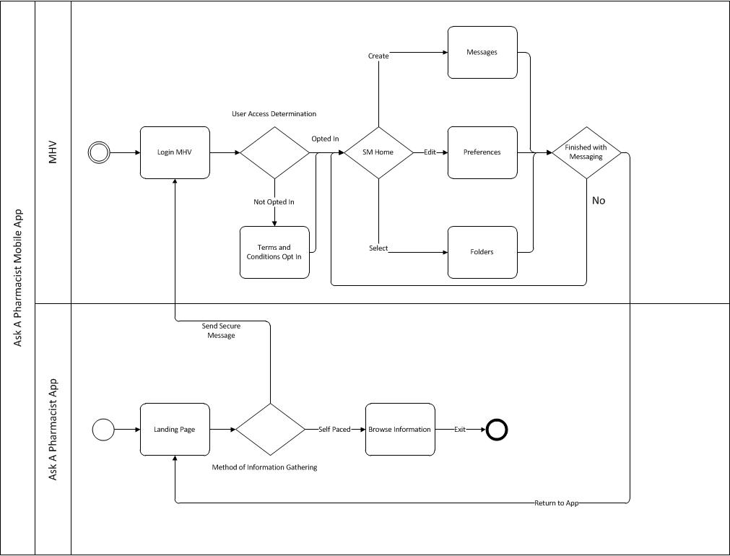

User Access Levels
Table 2 describes the three levels of user access within this application.
Table 2: User Access Levels
Name | Description | AAP Access | MHV Access
Primary Users | Patients/Caregivers | View content, Navigate links | All Account Types: Access My Medications  Advanced Account: Access all Pharmacy Features  Premium Account: Access all Pharmacy Features, Access Secure Messaging (Opt-in Required)
Secondary Users | Clinical Providers | View content, Navigate links
Secondary Users | Ask A Pharmacist Mobile App SMEs (Administrator) | View content, Navigate links | Update AAP FAQ content

Getting Started

Opening Ask a Pharmacist
Once you have installed Ask A Pharmacist (AAP) from VA App Store onto your mobile device, open Ask A Pharmacist by tapping its icon. The first time you open the application you will see the End User Licensing Agreement (EULA) pop-up. Scroll down to the bottom and tap ‘Accept’ to proceed to the AAP Home Screen.
Note: Since the screens look different in each case, this user manual will present pictures of AAP screens as they appear on both tablets and phones.

System Menu
The AAP Home Screen contains five Application Features as well as About and Help. Figure 2 illustrates AAP Home screen in the tablet view. Tapping on a feature takes you to its list of articles, sources of information, and links to related topics or services both within AAP and web sites external to the application.
Figure 2: AAP Home Screen, Tablet View
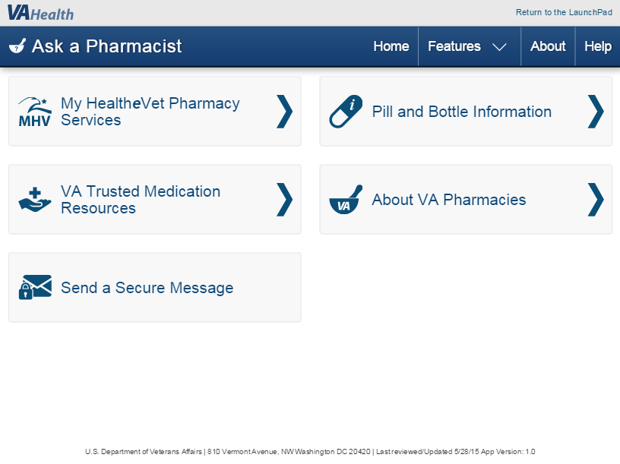

Figure 3 provides an illustration of the phone view of the AAP Home screen (shown on the left side of the figure). The image on the right side of the figure displays how to access ‘About’ and ‘Help’ by tapping the menu icon in the upper right.
Figure 3: AAP Home Screen, Phone View
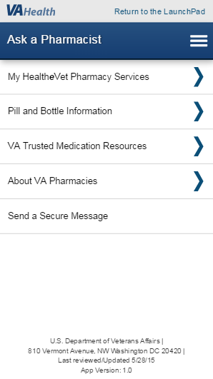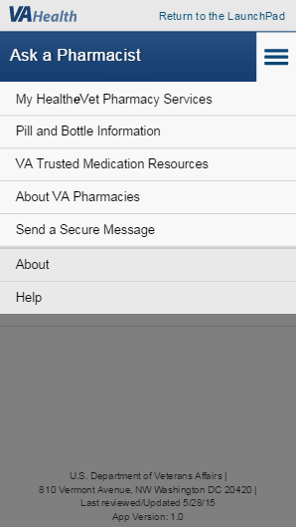

Navigating Ask a Pharmacist
Tapping on one of the five AAP features opens a menu of that feature’s related links. To illustrate how to navigate AAP, tap on ‘About VA Pharmacies’ on the AAP home screen.
Figure 4: Home Screen
Tablet View
Phone View

Navigating a Feature
Tapping ‘About VA Pharmacies’ on the home screen opens a menu of its related links.
Figure 5: Feature Menu
Tablet View
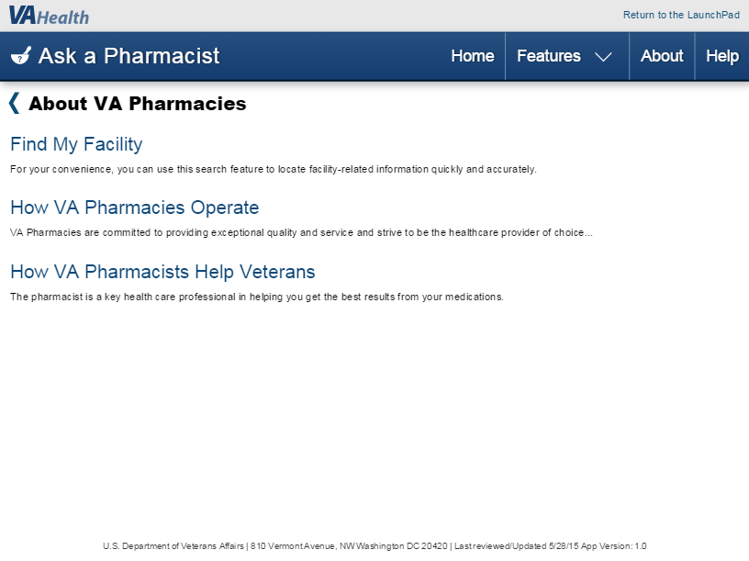
Phone View
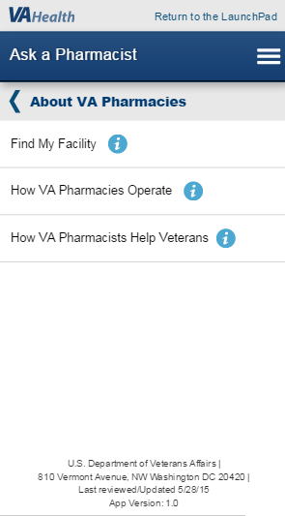
Using the phone view, tap the icon next to each related link to open its description.
Figure 6: Feature Menu, Phone View
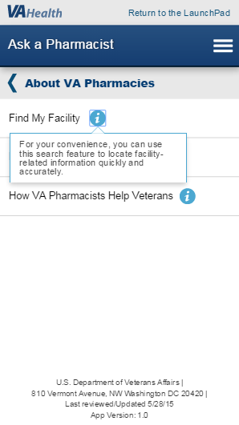

There are two basic types of links encountered in AAP.
First, when you tap ‘How VA Pharmacies Operate’, you will proceed to an AAP article, as shown in Figure 7.
Figure 7: AAP Article, Tablet View
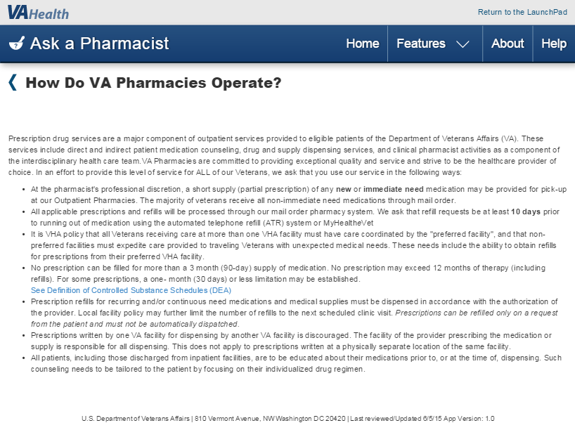
Using tablets, as shown in Figure 7: tap the Back Arrow on your mobile device to return; tap ‘Home’ to go to the AAP Home screen; tap ‘Features’ to go to one of the five AAP feature sections.

Figure 8 illustrates the AAP article when viewed on a phone. Use your browser’s scrolling tool to read the entire article.
Figure 8: AAP Article, Phone View
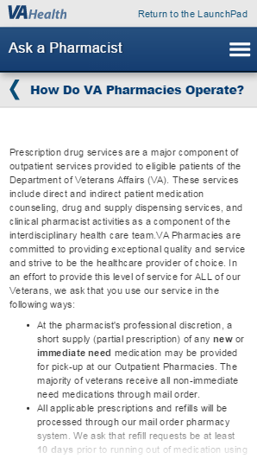
Using mobile phones, tap the Back Arrow on your mobile device’s browser, or tap the menu icon in the upper right to go to one of the five AAP feature sections.

Second, when you tap ‘Find My Facility’, a window pops up advising that you are leaving Ask A Pharmacist to go to an external website. Tap ‘Continue’, as shown in Figure 9, or tap ‘Cancel’ to remain on the current page. You can select “Do not show this message again” if you choose not to see this pop-up again.
Figure 9: Leaving AAP
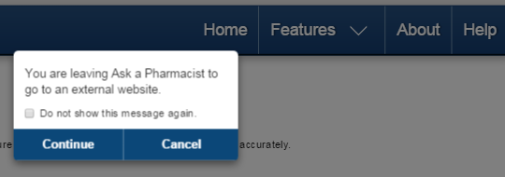
After tapping ‘Continue’, your device will open the external web site in your browser. To return to AAP, tap your browser’s Back Arrow or close the current Tab or Window.
Section 4 Using Ask a Pharmacist of this user manual offers step-by-step instructions for each feature of AAP and descriptions the features and their related links.

Exit System
It is not necessary to log in to or out of AAP. When you are finished using the application, simply close its browser screen.

Image Library
The following images (Figures 10 through 13) are used to help you navigate through the AAP application.
Figure 10: Information icon
The blue circled lower-case i is an icon indicating there is a description of this feature. Tap it to read the description.
Figure 11: Fading Bottom of Screen
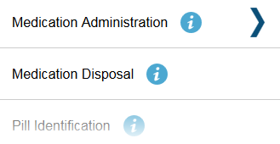
When the screen fades out at the bottom, it means that there is more content to view. Scroll down with your browser’s tools to view the continued content.
Figure 12: Menu Icon
The menu icon is commonly referred to as the ‘Hamburger Icon’. Tap on it to view a drop-down menu list.
Figure 13: Menu Arrow and Back Arrow
The Menu arrow appears next to a listing on a menu to indicate there is a sub-menu to look at. Tap on the feature to view its sub-menu.
The Back arrow appears next to the title of the current AAP screen you are viewing. Tap on it to return to the previous screen.

Caveats and Exceptions
Some of the external web sites available through AAP require registration, enrollment, or enhanced account status in order to fully utilize a service. Advice and instructions are available at the particular external web site.

Using Ask a Pharmacist
Many of the features and related links offered by Ask A Pharmacist (AAP), including My HealtheVet (MHV) resources and Secure Messaging, require registering with MHV as a VA Patient and acquiring a Premium Account via In-Person Authentication (IPA). Online Authentication is another option for users who have a connected eBenefits DS Logon (Department of Defense Self-Service Logon) and a MHV VA Patient account.
AAP is downloaded and installed from VA App Store onto your mobile device. Select the Ask A Pharmacist icon. The first time you open the application you will see the End User Licensing Agreement (EULA) pop-up. Scroll down to the bottom and tap ‘Accept’ to proceed to the AAP Home screen.

Home Screen
When you have installed AAP onto your mobile phone or tablet, tap the AAP icon on your device. The Home screen for AAP will appear.
Figure 14 illustrates the AAP Home screen as viewed with a tablet and a mobile phone device.
In the furthest upper right corner of the screen, the link ‘Return to the LaunchPad’ is available to shop for other VA applications.
Figure 14: Home Screen
Tablet View
Phone View

Home, Features, About, and Help
The dark blue ribbon along the top of the Home screen contains this application’s name and navigation tools. Using tablets, there are four options that you can choose. Using phones, there is a menu icon that can be tapped to display navigation options.

Home
If you are using a tablet, you can return to the Home screen from any location within AAP by tapping ‘Home’. When using a phone, tap the menu icon, and the list of five features appears along with ‘About’ and ‘Help’ (see Figure 3). Your device’s browser also provides ‘Previous’ and ‘Next’ navigation tools.

Features
- Using Features with Tablets
With a tablet, tap on ‘Features’ from any location within AAP, and a drop down menu appears. Tap on one of the five AAP features in the menu to go to that feature as shown in Figure 15.
Figure 15: Features Drop Down, Tablet View
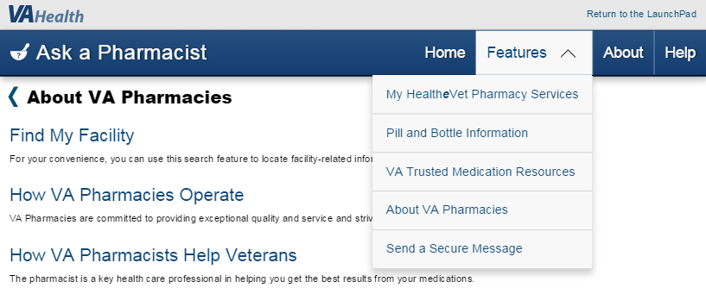

- Using Features with a Mobile Phone
When using a phone, tapping the menu icon to the right on the blue ribbon drops down a window that provides links to the five AAP features as well as ‘About’ and ‘Help’ (see Figure 16).
Figure 16: Features Drop Down, Phone View

About and Help
When you tap on ‘About’ and ‘Help,’ you can reference information and assistance resources regarding the Ask A Pharmacist application.

‘About’ Ask A Pharmacist
Tapping on the ‘About’ link in the top right of your tablet provides a window with general information about AAP along with a description of its functionality. Figure 17 illustrates the ‘About’ window when viewed on a Tablet.
Figure 17: About Window, Tablet View
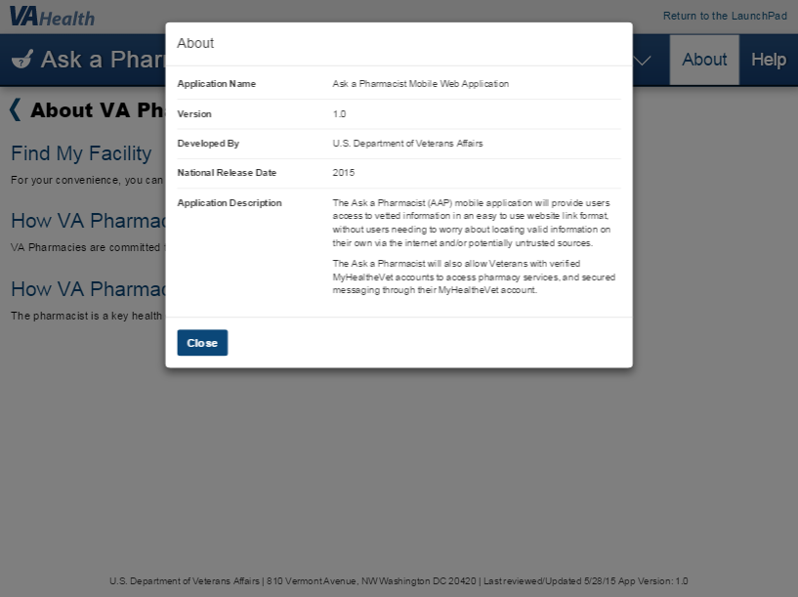
When using a phone, access the ‘About’ information after tapping the menu icon in the upper right corner.
Tap ‘Close’ to return to the previous screen.

‘Help’ Information in AAP
Tapping ‘Help’ produces a window with links to assistance resources, a toll-free phone number to call, user manuals, videos, and Frequently Asked Questions (FAQs). Reference information, such as browsers that support the application, are also available.
Using a phone, tap the menu icon in the upper right, then tap on ‘Help’ to see information as shown in Figure 18.
Scroll down, if necessary, and tap ‘Close’ at the bottom to return to the previous screen.
Figure 18: Help Window, Phone View
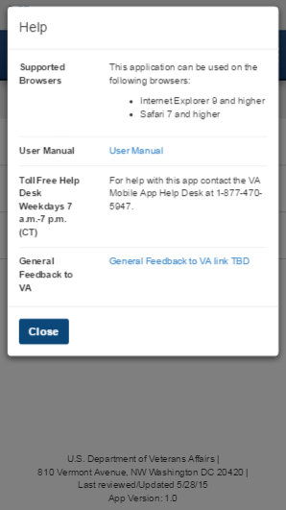
When using a tablet, access the ‘Help’ information by tapping ‘Help’ in the upper right corner of the dark blue title ribbon.

My HealtheVet Pharmacy Services
My HealtheVet is the primary Internet connection between Veterans and their health care benefits. This section introduces the many services available through MHV.
On the Home screen, tap ‘My HealtheVet Pharmacy Services’ for a menu of related links. In order to have full access to all of this feature’s resources, you should be registered with MHV as a VA Patient and upgrade to a Premium account.
Figure 19 illustrates views of the related links available after tapping ‘My HealtheVet’ from your Home screen.
Figure 19: My HealtheVet Pharmacy Services
Tablet View
Scroll down to view all related links in the menu.
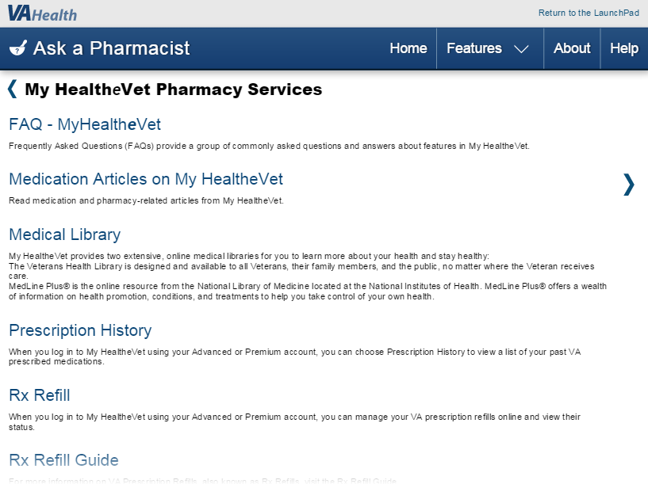

Phone View
Scroll down to view all related links in the menu.
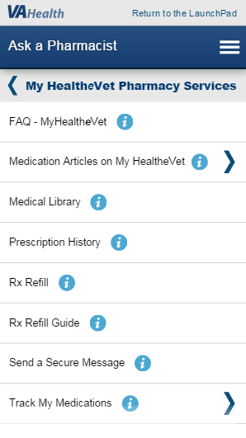

FAQ – My HealtheVet
When you tap ‘FAQ – My HealtheVet’, a window pops up to inform you that you are leaving AAP to go to an external website. This window appears every time a link to an external website is tapped. You can tap ‘Continue’ to go to the website or ‘Cancel’ to remain on your current screen. You have the option of tapping the box next to the instruction ‘Do not show this message again’ if you do not want this window to pop up again.
Figure 20 illustrates the pop-up window informing you that you are leaving AAP.
Figure 20: Leaving AAP Pop-up
Tap ‘Continue’ to leave AAP and proceed to the “My HealtheVet Frequently Asked Questions” web page (shown in Figure 21) to access a collection of commonly asked questions and answers about features in MHV.
Figure 21: My HealtheVet FAQ
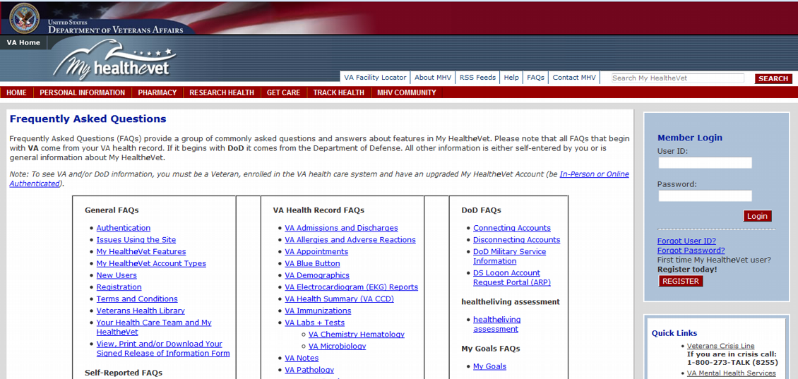
Note: This web site is external to AAP. It could look different than the example above.
Tap your browser's Back Arrow, or close the current Tab or Window to return to AAP.

Medication Articles on My HealtheVet
This feature presents a collection of articles available on the MHV web site for easy identification and location from AAP.
Tapping ‘Medication Articles on My HealtheVet’ opens another menu containing links to medication and pharmacy-related articles from MHV.
Figure 22: Medication Articles Example
Tablet View
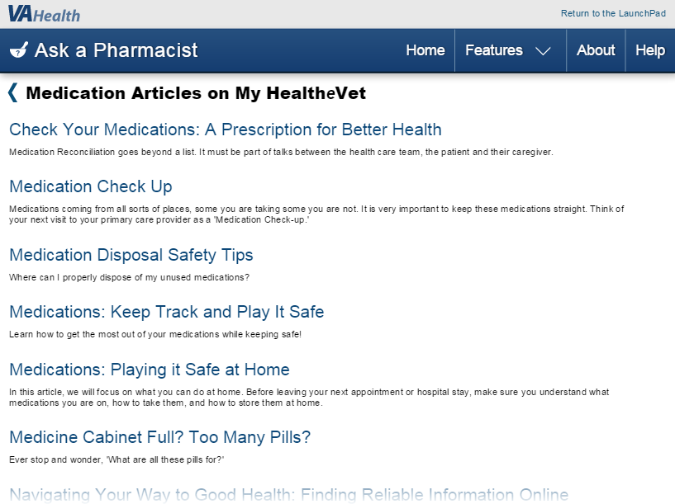

Phone View
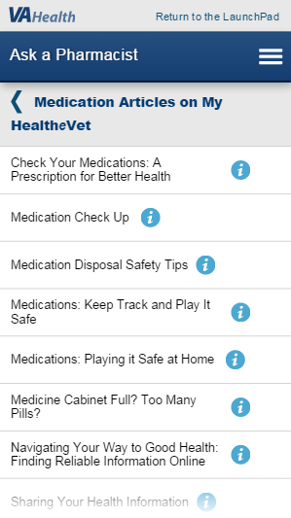
Tap an article title, then tap ‘Continue’ to leave AAP and proceed to that article’s web page.
Tap your browser's Back Arrow or close the current Tab or Window of the selected external web site to return to AAP.

Medical Library
Tap ‘Medical Library’, then tap ‘Continue’ to leave AAP and proceed to a MHV web page, as shown in Figure 23, where links are provided to two extensive, online medical libraries.
Figure 23: Medical Library
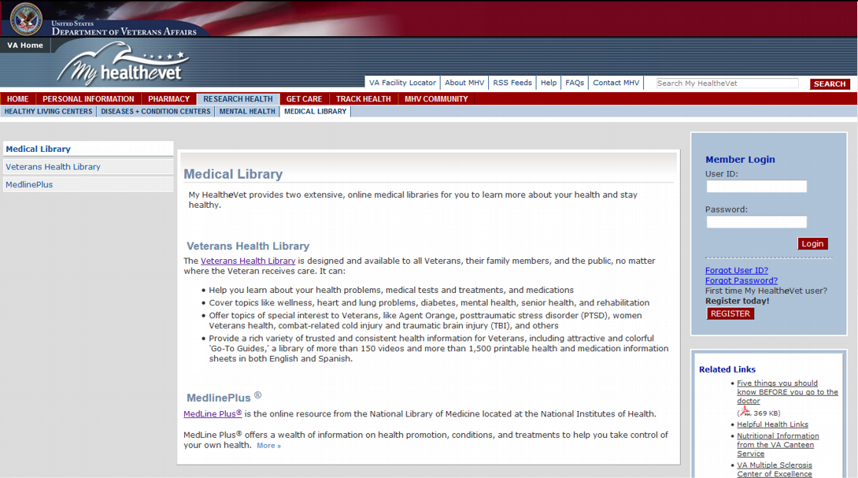
Note: This web site is external to AAP. It could look different than the example above.
Tap your browser's Back Arrow, or close the current Tab or Window, to return to AAP.

Veterans Health Library
This library is designed for and available to all Veterans, their family members, and the public, no matter where the Veteran receives care. It offers articles, videos, and printable information on topics of general health as well as topics of special interest to Veterans.
Tap on the link Veterans Health Library to proceed there.
Figure 24: Veterans Health Library
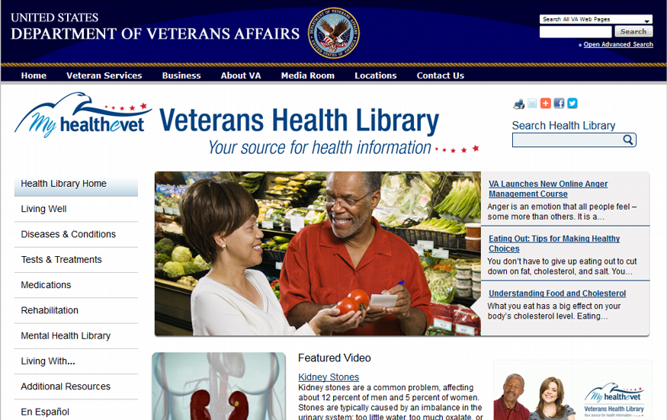
Note: This web site is external to AAP. It could look different than the example above.
Tap your browser's Back Arrow, or close the current Tab or Window, to return to AAP.

MedlinePlus ®
This web page provides various links to MedlinePlus®. This is the online resource of the National Library of Medicine (NLM), from the National Institutes of Health (NIH), offering information on health promotion, conditions, and treatments to help you take control of your own health. Figure 26 provides an illustration of the MedlinePlus® home page.
Tap the MedlinePlus ® on the MHV Medical Library web page to proceed to another MHV web page as shown in Figure 25.
Figure 25: MHV MedlinePlus Web Site
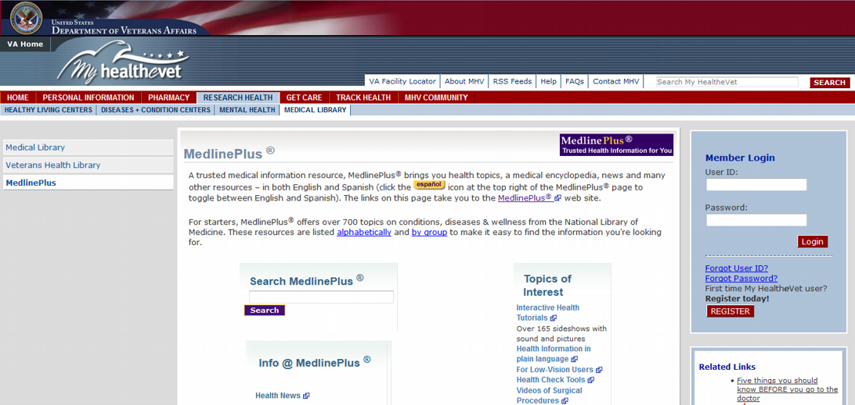
Note: This web site is external to AAP. It could look different than the example above.

Figure 26: MedlinePlus Homepage
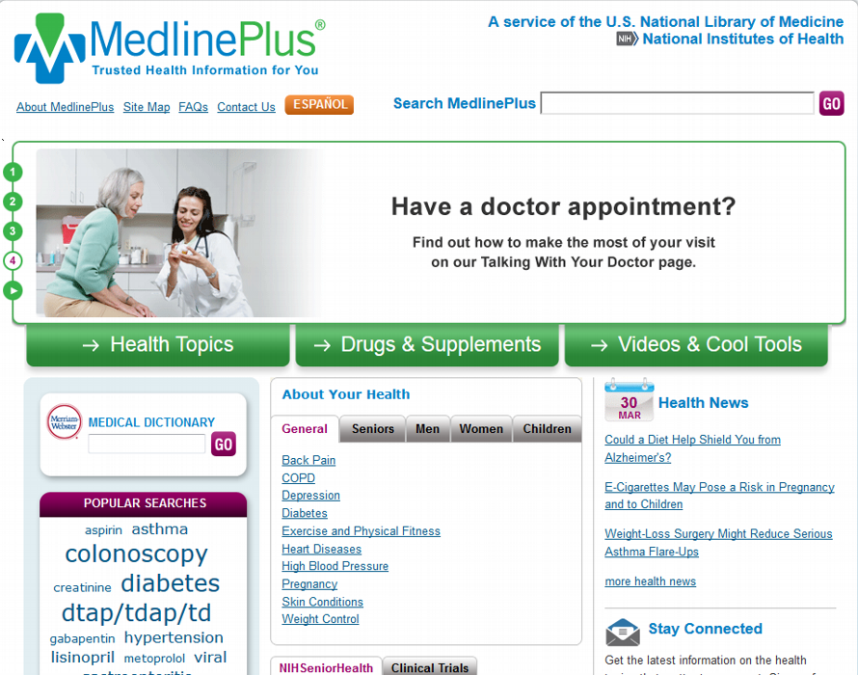
Note: This web site is external to AAP. It could look different than the example above.
Tap your browser's Back Arrow, or close the current Tab or Window, to return to AAP.

Prescription History
If you are a registered MHV user and have selected the ‘VA Patient’ checkbox during registration, you can view a list of your past VA prescribed medications.
To view your prescription history, tap ‘Prescription History’, then tap ‘Continue’ to leave AAP and proceed to the MHV web page offering information about viewing prescription history.

Rx Refill
Rx Refill provides a timesaving, convenient way to refill prescriptions and monitor details of each medication, such as refill status, date of last refill, the VA facility medication is received from, number of refills remaining, and the progress of a refill request. When you log in to MHV using your Premium account, you can manage your VA prescription refills online and all of the Rx Refill services. For prescription refill information, tap ‘Rx Refill’, then tap ‘Continue’ to leave AAP and proceed to the MHV FAQ page discussing their RX Refill service.
Figure 27: My HealtheVet Home Page
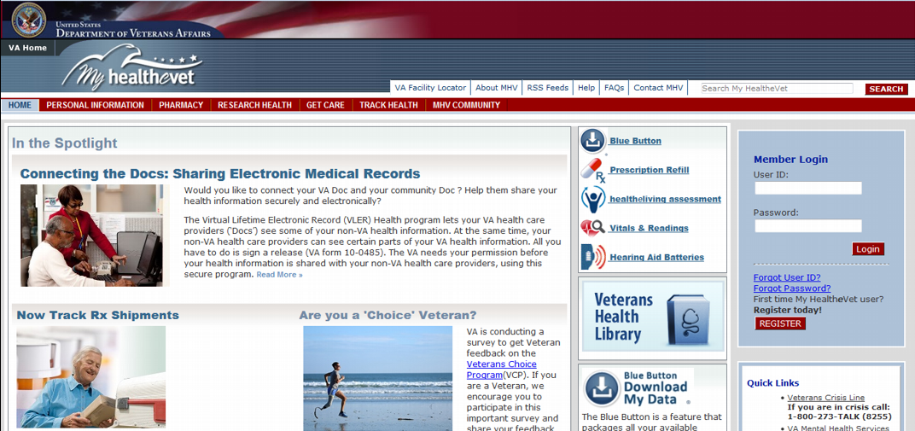
Note: This web site is external to AAP. It could look different than the example above.
Tap your browser's Back Arrow, or close the current Tab or Window, to return to AAP.

Rx Refill Guide
Rx Refill Guide connects to the MHV web page where detailed descriptions of Rx Refill’s services, requirements, and step-by-step instructions are provided. Tap ‘Rx Refill Guide’, then tap ‘Continue’ to go to the MHV web site.”
Figure 28 illustrates the MHV website ‘VA Online Rx Refill for Veterans’. Tap your browser's Back Arrow, or close the current Tab or Window, to return to AAP.
Figure 28: Rx Refill Guide
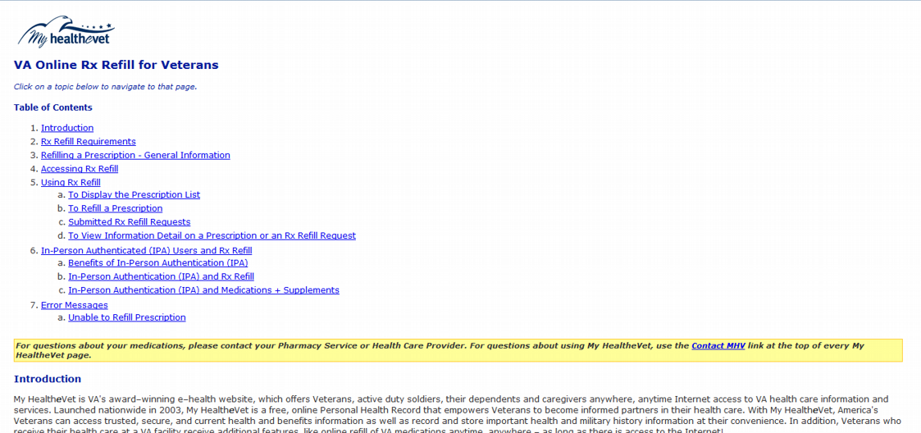
Note: This web site is external to AAP. It could look different than the example above.

Send a Secure Message
Secure Messaging (SM) is similar to email and can be used to ask about VA appointments, medications, lab results, or seek answers to routine medical questions from your VA health team.
To use the Secure Messaging feature, you must be receiving health care services from VA, have registered on My HealtheVet as a “VA Patient,” and have a Premium My HealtheVet account.
After registering on MHV as a VA Patient, there are two ways to upgrade to a Premium MHV account.
- In-Person Authentication (IPA)
Print, read, and sign the VA Release of Information (ROI) form (10-5345a-MHV). Take a copy of the signed form and government issued photo identification to the local VA health facility and give it to a qualified VA staff member to upgrade your account.
- Online Authentication
This is an option for those who have both a connected eBenefits DS Logon Premium account and MHV VA Patient account.
Tap ‘Send a Secure Message’ then tap ‘Continue’ to proceed to the MHV article describing Secure Messaging.

Track My Medications
These are three VA-vetted ways to track the delivery progress of your medication prescriptions. Once you choose a method to have your medications delivered, this feature provides links and instructions for each method. Tap ‘Track My Medications’ to open another menu containing related links as shown in Figure 29.
Figure 29: Track My Medications Menu
Tablet View
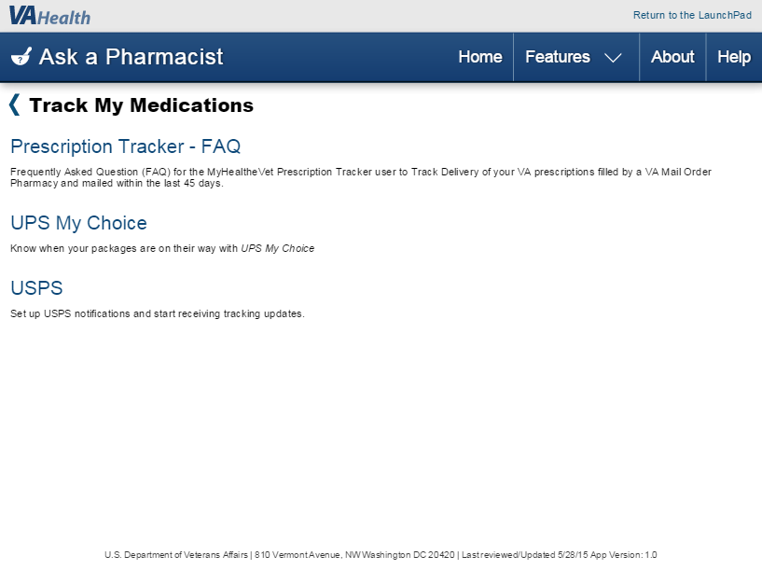
Phone View
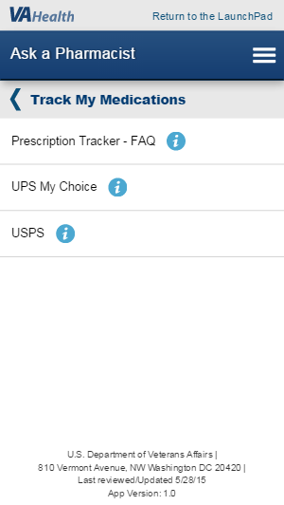
- Prescription Tracker – FAQ
Tap ‘Prescription Tracker – FAQ’, then tap ‘Continue’ to go to links on the MHV Frequently Asked Questions web page to view FAQ for the My HealtheVet Prescription Tracker. This can be used to track delivery of VA prescriptions filled by a VA Mail Order Pharmacy and mailed within the last 45 days.
Tap your browser's Back Arrow, or close the current Tab or Window, to return to AAP.
- UPS My Choice
Here you can learn about and register for ‘UPS My Choice’, a service that tracks the status of your deliveries if you choose to have them delivered by United Parcel Service Inc. (UPS).
Tap ’UPS My Choice’, then tap ‘Continue’ to go to the UPS website as shown in Figure 30.
Figure 30: UPS My Choice
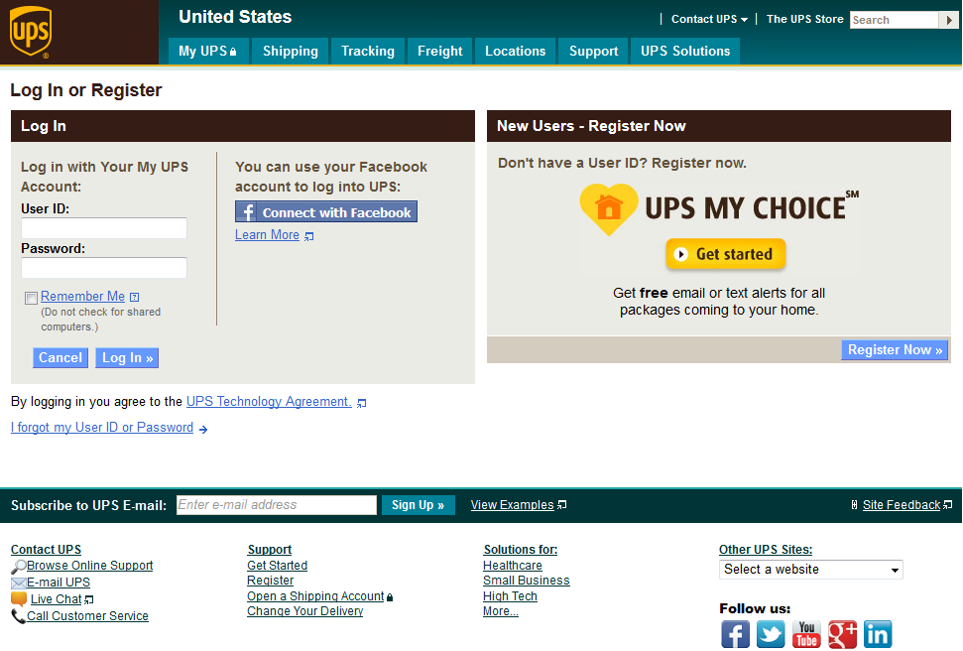
Note: This web site is external to AAP. It could look different than the example above.
Tap your browser's Back Arrow, or close the current Tab or Window, to return to AAP.

- USPS
Here you can learn about and register for ‘My USPS.com’, a service that tracks the status of your deliveries if you choose to have them delivered by United States Postal Service (USPS).
Tap ’USPS’, then tap ‘Continue’ to go to the USPS web site as shown in Figure 31.
Figure 31: My USPS.com
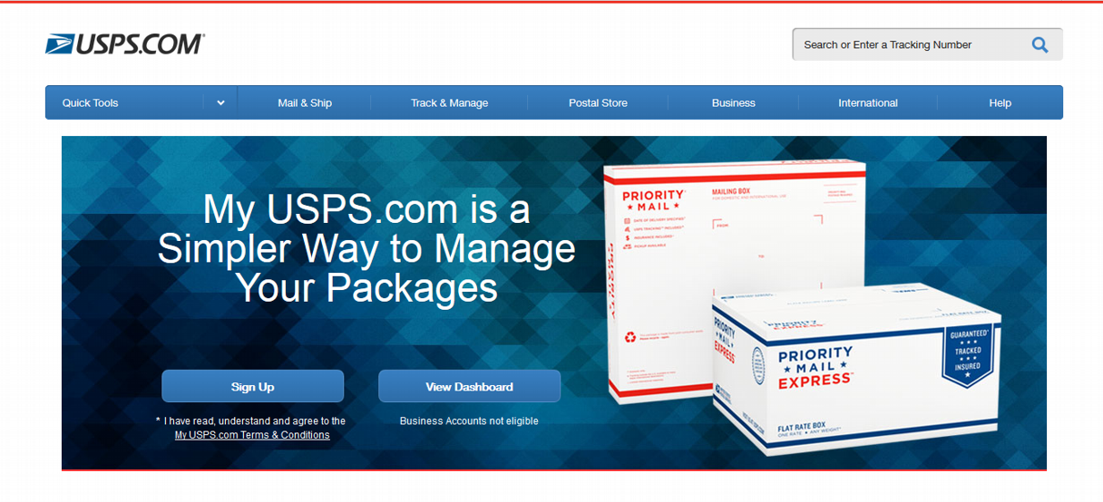
Note: This web site is external to AAP. It could look different than the example above.
Tap your browser's Back Arrow, or close the current Tab or Window, to return to AAP.

Pill and Bottle Information
This feature provides a detailed description of the data on your medication’s label and a link to identify unknown medications. On the Home screen, tap ‘Pill and Bottle Information’ for a menu of related links as shown in Figure 32.
Figure 32: Home Screen
Tablet View
Phone View

Pill Bottle Information
VA medications have standardized labels that provide the patient important information about their prescription. Tap ‘Pill Bottle Information’ to view a graphical representation of a typical medicine bottle with descriptions and explanations of the information it contains.
Figure 33: Pill Bottle Information
Tablet View
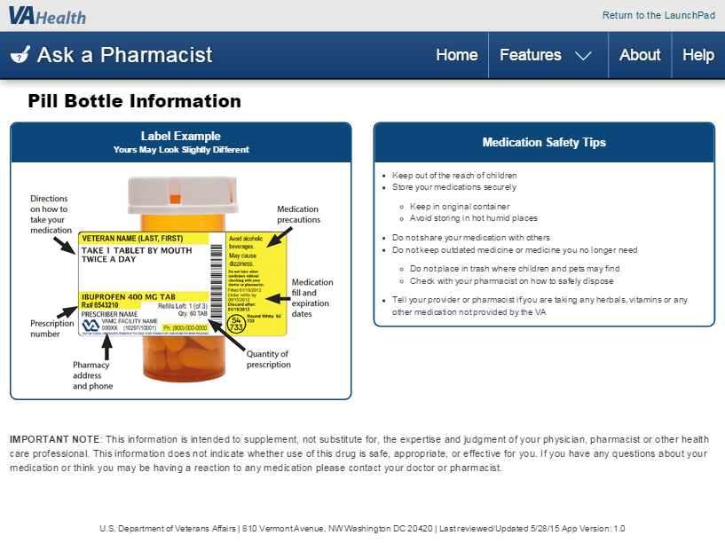
Tap your browser’s Back arrow to return, or tap ‘Home’ or ‘Features,’ to go to other AAP locations.
Phone View
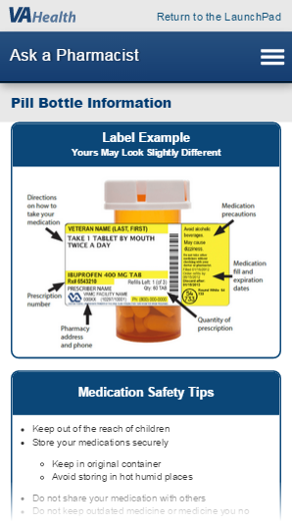
Tap your browser’s Back arrow to return, or tap the Menu icon, to go to other AAP locations.

Pill Identification
This resource aids in the identification of unknown pills (oral, solid dosage form medications). It combines images of pills with appearance and other information to enable you to visually search for and identify them. There is also information available about the contents of a pill, clinical trials, and safety information
Tap ‘Pill Identification’, then tap ‘Continue’ to leave AAP and proceed to Pillbox, the NLM/NIH web site. Click ‘OK’ on the pop up stating that “if this is an emergency, call 911 or the National Poison Help Hotline at 1-800-222-1222,” as well as a disclaimer. Click ‘OK’ to arrive at the Pillbox web site depicted in Figure 34.
Figure 34: Pillbox, Pill Identification
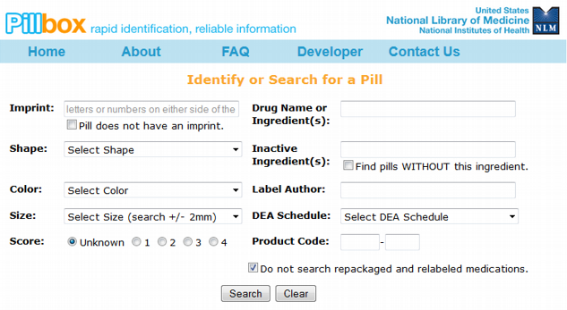
Note: This web site is external to AAP. It could look different than the example above.
Tap your browser's Back Arrow, or close the current Tab or Window, to return to AAP.

VA Trusted Medication Resources
VA Trusted Medication Resources provides links to VA web pages or VA vetted and approved web sites offering information on the proper use or disposal of medications, understanding drug interactions, and availability of medications through VA.
On the AAP Home screen, tap ‘VA Trusted Medication Resources’ as shown in Figure 35, to view a menu of VA-vetted web sites and other sources of medication-related information, as shone in Figure 36.
Figure 35: Home Screen
Tablet View
Phone View
Figure 36: VA Trusted Medication Resources Menu
Tablet View
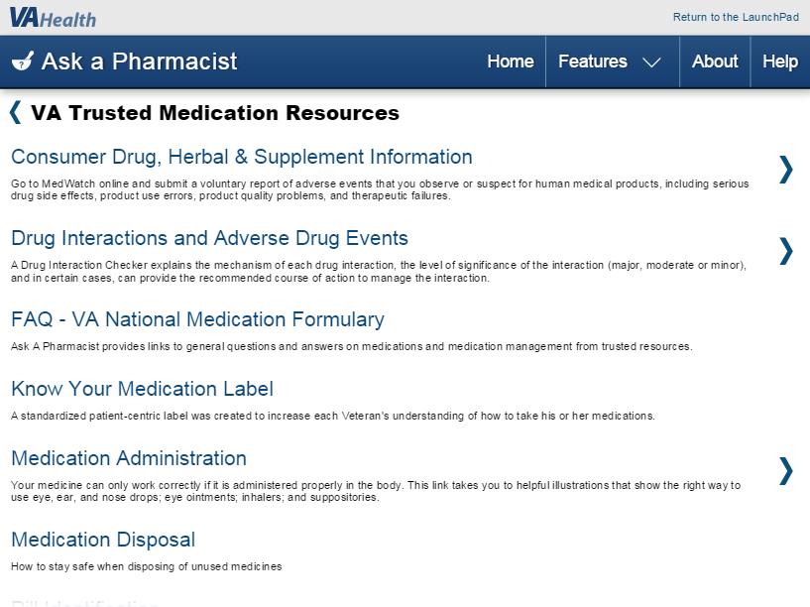
Phone View
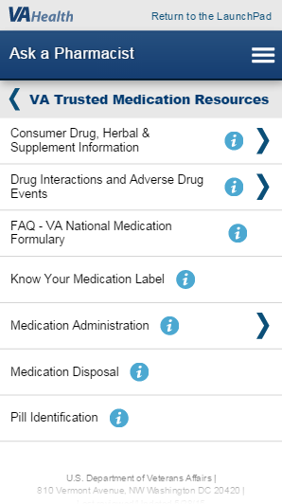

Consumer Drug, Herbal & Supplement Information
Many drugs and medications are available commercially without a prescription. These drugs can have a significant impact on the user. This feature provides information and resources about over-the-counter drugs, herbal and other supplements, as well as VA-prescribed medications.
Tap ‘Consumer Drug, Herbal & Supplement Information’ to open its menu of related subject areas. Tapping each subject area opens links to external web resources.
Choose from the titles listed in the menu, tap on an article title, then tap ‘Continue’ to leave AAP and proceed to the external web location of the article or resource. When finished, tap your browser's Back Arrow, or close the current Tab or Window to return to AAP.

Drug Interactions and Adverse Drug Events
It is often the case where more than one medication is being used. This feature provides resources to learn about interactions between drugs, drug allergies, and adverse reactions to medication. Tap ‘Drug Interactions and Adverse Drug Events’ to open its menu of related links.
- Tap ‘Adverse Drug Event Information’ to open its sub-menu of links to the following external web sites:
Drug Interactions Checker.
Tap ‘Drug Interactions Checker,’ then tap ‘Continue’ to proceed to Drugs.com web site’s Drug Interactions Checker page. Tap ‘I Agree’ on the End-user License Agreement (EULA) and proceed to the web page, shown in Figure 37, where you can learn about interactions between drugs that you’ve selected from the site’s database, the relative level of significance of a given interaction, and in certain cases, a recommended course of action to manage the interaction.
Figure 37: Drug Interactions Checker
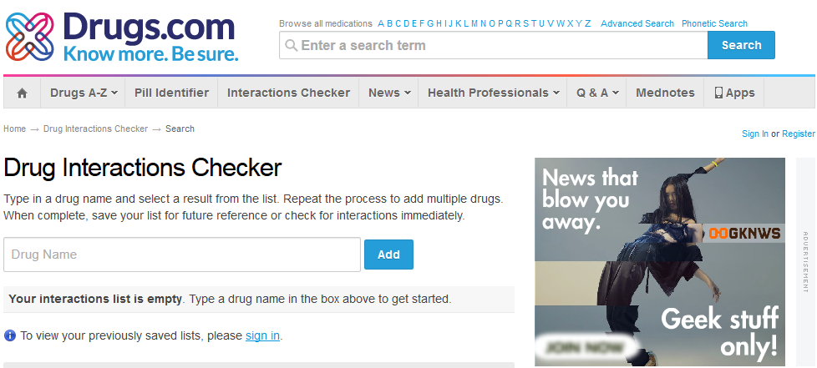
Note: This web site is external to AAP. It could look different than the example above.
Tap your browser’s Back Arrow, or close the current Tab or Window, to return to AAP.
Medline Allergy Information.
Tap ‘Medline Allergy Information’, then tap ‘Continue’ to proceed to the NIH MedlinePlus web page for information about drug allergies and descriptions of allergy symptoms.
Figure 38: MedlinePlus Allergy Information
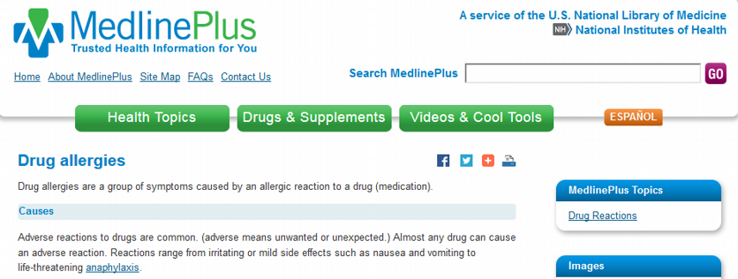
Note: This web site is external to AAP. It could look different than the example above.
Tap your browser’s Back Arrow, or close the current Tab or Window, to return to AAP.

Report adverse drug events to FDA MedWatch
Tap ‘Report adverse drug events to FDA MedWatch’, then tap ‘Continue’ to proceed to the FDA web site “MedWatch Online Voluntary Reporting Form.” There are instructions and guidelines provided to aid in completing the report. Figure 39 illustrates the start page for filing your report.
Figure 39: MedWatch Online Voluntary Reporting Form
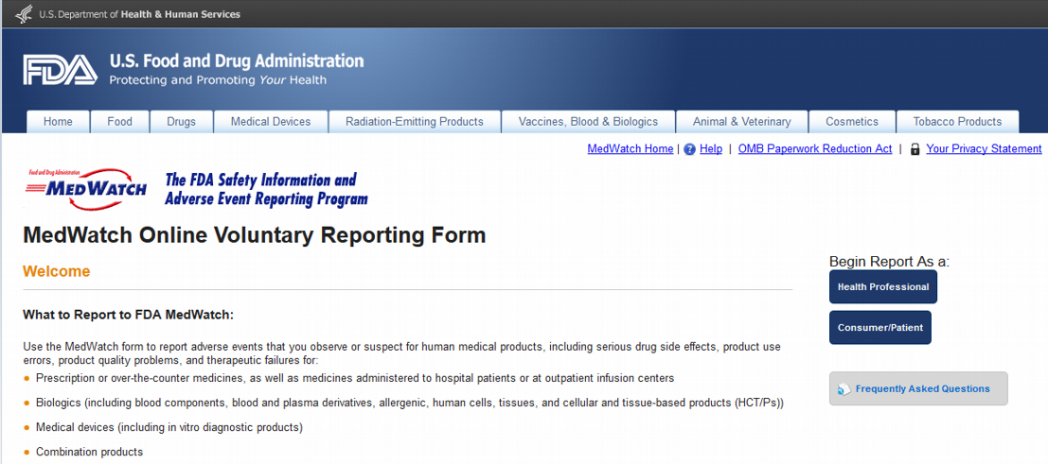
Note: This web site is external to AAP. It could look different than the example above.
Tap your browser’s Back Arrow, or close the current Tab or Window, to return to AAP.

Track adverse drug events in FDA.
Tap ‘Track adverse drug events in FDA’, then tap ‘Continue’ to proceed to the FDA web site “Medical Product Safety Information”, shown in Figure 40, for an updated listing of safety alerts for human medical products (drugs, medical devices, nutritionals, cosmetics).
Figure 40: Medical Product Safety Information
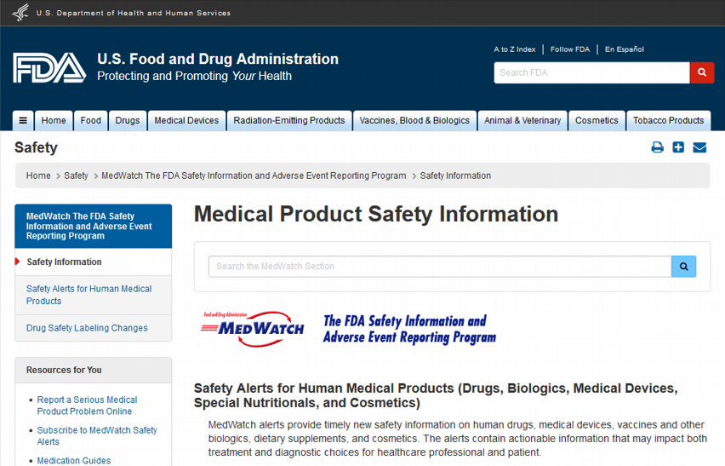
Note: This web site is external to AAP. It could look different than the example above.
Tap your browser’s Back Arrow, or close the current Tab or Window, to return to AAP.

- Drug Interaction Information
Drug Interaction Information articles break down possible interactions of medications with food and beverages, dietary supplements, interactions between different drugs, and tips to avoid problems.
Tap ‘Drug Interaction Articles’ to view its sub-menu of links to the United States Food and Drug Administration (FDA) “Avoiding Drug Interactions” web page.
Tap one of the topic titles, then tap ‘Continue’ to proceed to information related to that topic.
Figure 41: FDA, Avoiding Drug Interactions
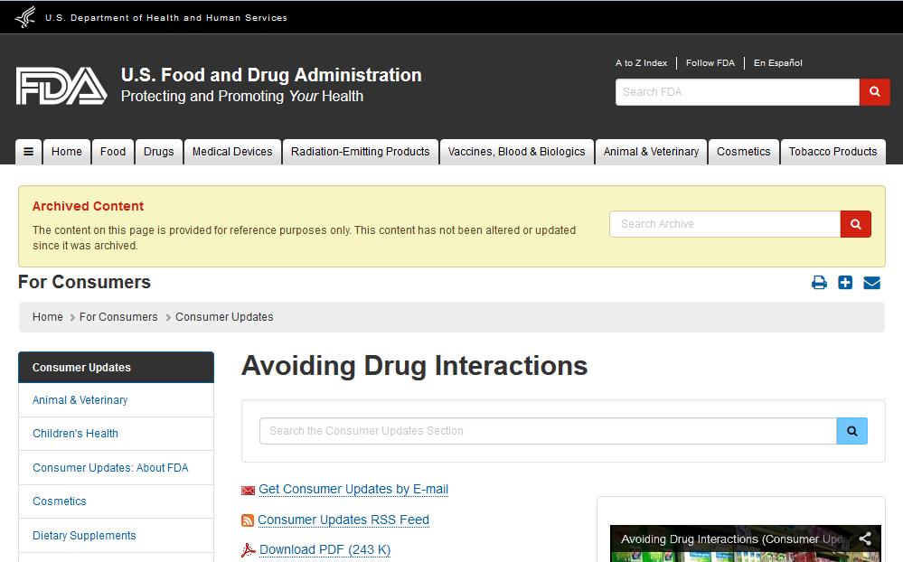
Note: This web site is external to AAP. It could look different than the example above.
Tap your browser’s Back Arrow, or close the current Tab or Window, to return to AAP.

FAQ – VA National Medication Formulary
The VA National Formulary (VANF) provides pharmaceutical products of high quality and best value and assures that these products are available to eligible Veterans.
Tap ‘FAQ – VA National Medication Formulary’ to view an AAP article offering answers to frequently asked questions about VANF and troubleshooting issues associated with using its services.
Tap your browser's Back Arrow to return. Tap ‘Home’ or ‘Features’ to go to other AAP locations.

Know Your Medication Label
VA medications have standardized labels that provide the patient important information about their prescription. Tap ‘Know Your Medication Label’ to proceed to the AAP Pill Bottle Information page.
Tap your browser’s Back Arrow, or tap ‘Home’ or ‘Features’ to go to other AAP locations.

Medication Administration
Different types of medication require different methods to get them in the body. This feature offers a list of the best practices when using a medication.
Tap ‘Medication Administration’ to open its menu of related links to external web resources. Tap ‘How to properly administer a medication’, then tap ‘Continue’ to leave AAP and proceed to the SafeMedication web site where instructions and illustrations on the correct way to use eye, ear, and nose drops; information on eye ointments, inhalers, and suppositories are offered.
Figure 42: SafeMedication, How to Administer
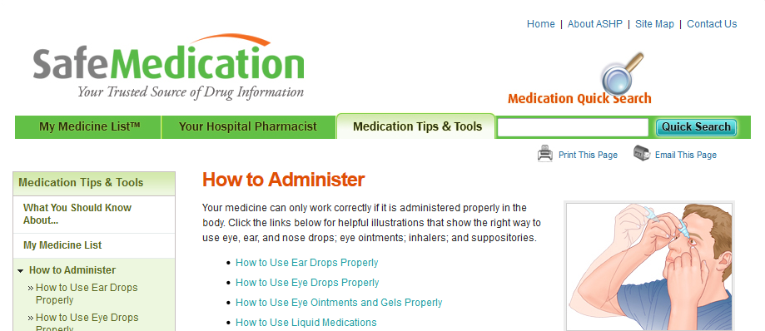
Note: This web site is external to AAP. It could look different than the example above.
Tap your browser’s Back Arrow, or close the current Tab or Window, to return to AAP.

Medication Disposal
Unused medications can harm people who improperly handle them, can change properties when kept after expiration dates, and can affect the environment if disposed of improperly. This resource addresses these issues.
Tap here, then tap ‘Continue’ to leave AAP and proceed to the Pharmacy Benefits Management Services VA Center for Medication Safety web page offering guidelines for the proper and safe disposal of unused medications.
Figure 43: Medication Disposal
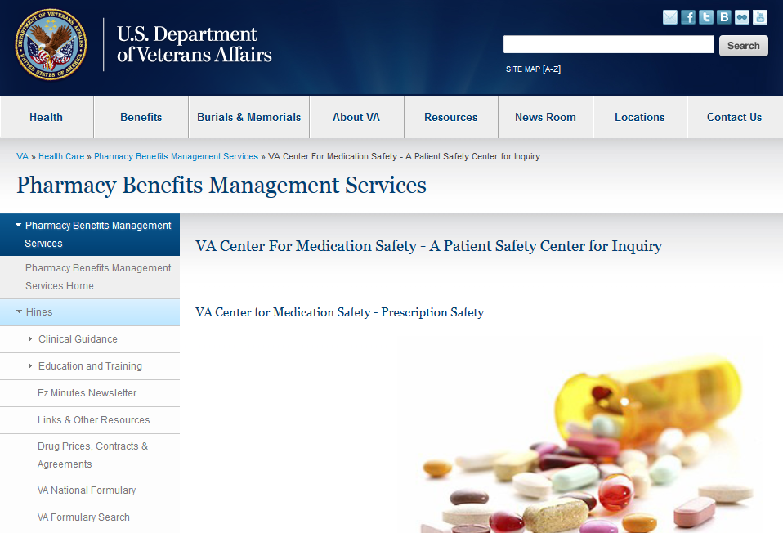
Note: This web site is external to AAP. It could look different than the example above.
Tap your browser’s Back Arrow, or close the current Tab or Window, to return to AAP.

Pill Identification
This resource aids in the identification of unknown pills (oral, solid dosage form medications). It combines images of pills with appearance and other information to enable you to visually search for and identify them. There is also information available about the contents of a pill, clinical trials, and safety information
Tap ‘Pill Identification’, then tap ‘Continue’ for a link to the resource Pillbox. Tap ‘OK’ on the pop-up.
Tap your browser’s Back Arrow, or close the current Tab or Window, to return to AAP.

About VA Pharmacies
This feature offers general information about the many ways VA Pharmacies serve Veterans, above and beyond being the Veteran’s source for getting medication. Procedures for using VA Pharmacy services are described, and a link is provided to locate VA Pharmacies around the world.
On the Home screen, tap ‘About VA Pharmacies’ to open a menu of related links.
Figure 44: Home Screen
Tablet View
Phone View
The “About VA Pharmacies” screen opens and provides the information as shown in Figure 45.
Figure 45: About VA Pharmacies
Tablet View
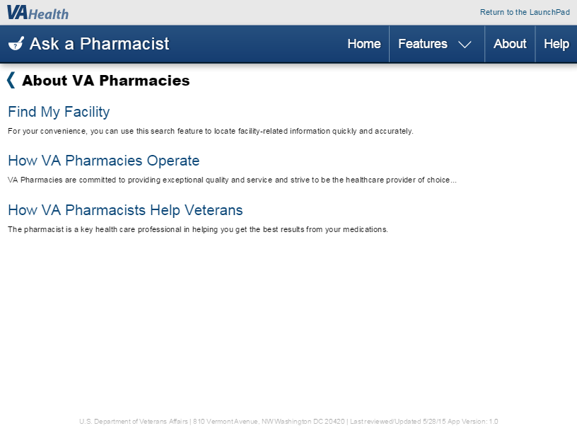
Phone View
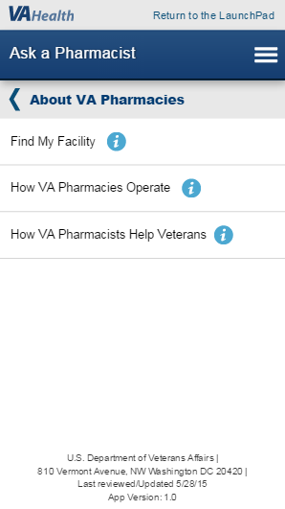

Find My Facility
Use this resource to locate the VA Centers near you. You can narrow your search to find the particular kind of VA service you are interested in.
Tap ‘Find My Facility’, then tap ‘Continue’ to leave AAP and proceed to the VA “Locations” web page. VA locations can be found by entering your address to access locations near you or by tapping on a state or geographical region to access locations within that region.
Figure 46: Find VA Locations
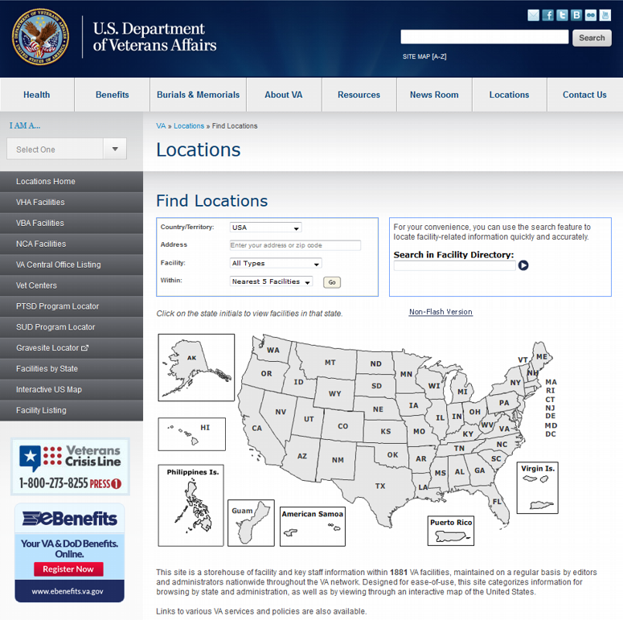
Note: This web site is external to AAP. It could look different than the example above.
Tap your browser's Back Arrow, or close the current Tab or Window, to return to AAP.

How VA Pharmacies Operate
Prescription drug services are a major component of outpatient services provided to eligible patients of the VA. Services include direct and indirect patient medication counseling, drug and supply dispensing, and clinical pharmacist activities as part of the Veteran’s health care team.
Tap ‘How VA Pharmacies Operate’ to open an informational page outlining VA Pharmacy operation procedures and the range of services available to Veterans.
Tap your browser’s Back Arrow to return. Tap ‘Home’ or ‘Features’ to go to other AAP locations.

How VA Pharmacists Help Veterans
Pharmacists are medication experts. They know what makes up the different drugs, how the drugs work, and the drugs’ effect on the patient.
Tap ‘How VA Pharmacists Help Veterans’ to open an informational page describing the roles and services pharmacists provide for Veterans, how to upgrade your account and which additional services you would be eligible for once your account is upgraded.
Tap your browser’s Back Arrow to return. Tap ‘Home’ or ‘Features’ to go to other AAP locations.

Send a Secure Message
Secure Messaging is similar to email and can be used to ask about VA appointments, medications, lab results, or seek answers to routine medical questions from your VA health team.
To use the Secure Messaging feature, you must be receiving health care services from VA, have registered on My HealtheVet as a “VA Patient,” and have a Premium My HealtheVet account.
After registering on MHV as a VA Patient, there are two ways to upgrade to a Premium MHV account.
In-Person Authentication (IPA)
Print, read, and sign the VA Release of Information (ROI) form (10-5345a-MHV). Take a copy of the signed form and government issued photo identification to the local VA health facility and give it to a qualified VA staff member to upgrade your account.
Online Authentication
This is an option for those who have both a connected eBenefits DS Logon Premium account and MHV VA Patient account.
On the AAP Home screen, pictured in Figure 47, tap ‘Send a Secure Message’, then tap ‘Continue’ to proceed to the MHV article describing Secure Messaging.
Figure 47: Home Screen
Tablet View

Phone View

Troubleshooting
Below are resources to help resolve questions or difficulties found when using the Ask A Pharmacist (AAP) application.
REDACTED

Some of the external web sites available through AAP require registration, enrollment, or enhanced account status in order to fully utilize a service. Advice and instructions are available at the particular external web site.

