Pharmacy Inbound Electronic Prescription Controlled Substance Version 5.0

VistA Patch # PSD*3.0*89

Installation Guide
November 2021
Version 1.0
Department of Veterans Affairs
Office of Information and Technology (OI&T)

Revision History

Date | Version | Description | Author
11/2021 | 1.0 | Initial draft | Liberty IT

Table of Contents

Table of Contents 3
1 Introduction 1
1.1 Dependencies 1
1.2 Constraints 1
2 Roles and Responsibilities 2
3 Deployment 3
3.1 Timeline 3
3.1.1 Deployment Topology 4
3.1.2 Site Information (Locations, Deployment Recipients) 4
3.1.3 Site Preparation 5
3.2 Resources 5
3.2.1 Facility Specifics 5
3.2.2 Hardware 5
3.2.3 Software 5
3.2.4 Communications 5
3.2.4.1 Deployment/Installation/Back-Out Checklist 5
4 Installation 6
4.1 Pre-installation and System Requirements 6
4.1.1 Pre/Post Installation Overview 6
4.2 Platform Installation and Preparation 6
4.3 Download and Extract Files 6
4.4 Database Creation 7
4.5 Installation Scripts 7
4.6 Cron Scripts 7
4.7 Access Requirements and Skills Needed for the Installation 7
4.8 Installation Procedure 7
4.8.1 Patch Verification 8
4.9 Post-Installation Instructions 8
4.10 Routine Information 8
4.11 Database Tuning 8
5 Back-Out Procedure 9
5.1 Back-Out Strategy 9
5.2 Back-Out Considerations 9
5.3 Back-Out Criteria 9
5.4 Back-Out Risks 9
5.5 Authority for Back-Out 9
5.6 Back-Out Procedure 9
6 Rollback Procedure 10

Introduction
This document describes how to deploy and install the Pharmacy Inbound Electronic Prescription Controlled Substance v5.0 VistA Patch (PSD*3.0*89).
The purpose of this plan is to provide a single, common document that describes how, when, where, and to whom the IEP patch PSD*3.0*89 will be deployed and installed, as well as how it is to be backed out and rolled back, if necessary. The plan also identifies resources, communications plan, and rollout schedule. Specific instructions for installation, back-out, and rollback are included in this document.

Dependencies
Patch PSD*3.0*89 possesses a direct application dependency on the VistA Outpatient
Pharmacy (OP) v.7.0 application and Controlled Substance v3.0 application. Patches PSO*7*617, PSD*3*73, and PSD*3*83 are required to be installed before PSD*3.0*89.

Constraints

There are no constraints for patch PSD*3.0*89.

Roles and Responsibilities
This section outlines the roles and responsibilities for managing the deployment of the patch PSD*3.0*89.
Table 1: Deployment, Installation, Back-out, and Rollback Roles and Responsibilities

ID | Team | Phase / Role | Tasks | Project Phase (See Schedule)
1 | Field Operations (FO), Enterprise Operations (EO), or Enterprise Program Management Office (EPMO) (depending upon project ownership) | Deployment | Plan and schedule deployment (including orchestration with vendors) | Deployment
2 | FO, EO, or EPMO  (depending upon project ownership) | Deployment | Determine and document the roles and responsibilities of those involved in the deployment. | Design/Build
3 | FO, or EO | Deployment | Test for operational readiness | Design/Build
4 | FO or EO | Deployment | Execute deployment | Design/Build
5 | FO or EO | Installation | Plan and schedule installation | Deployment
6 | Regional Project Manager (PM)/ Field Implementation Services (FIS)/ Office of Policy and Planning (OPP) PM | Installation | Ensure authority to operate and that certificate authority security documentation is in place | Design/Build
7 | Regional PM/FIS/OPP PM/ Nat’l Education & Training | Installations | Coordinate training | Deployment
8 | FO, EO, or Product Development (depending upon project ownership) | Back-out | Confirm availability of back- out instructions and back-out strategy (what are the criteria that trigger a back-out) | Deployment
9 | FO, EO, or Product Development (depending upon project ownership) | Post Deployment | Hardware, Software and System Support | Maintenance

Deployment
Patch PSD*3.0*89 is being released as part of the Pharmacy Inbound Electronic Prescription Controlled Substance v5.0 enhancement along with patch PSO*7.0*617. Patches PSO*7.0*617 and PSD*3.0*89 will be distributed via the FORUM Patch Module and may be deployed at any site without regard to deployment status at other sites.

Timeline
The deployment and installation is scheduled to run for a period of thirty days, as depicted in the Master Deployment Schedule.

Table 2: Master Deployment Schedule

VIP Build | Delivery Dates
N/A

Deployment Topology
Patch PSD*3.0*89 will be released to all VistA sites.
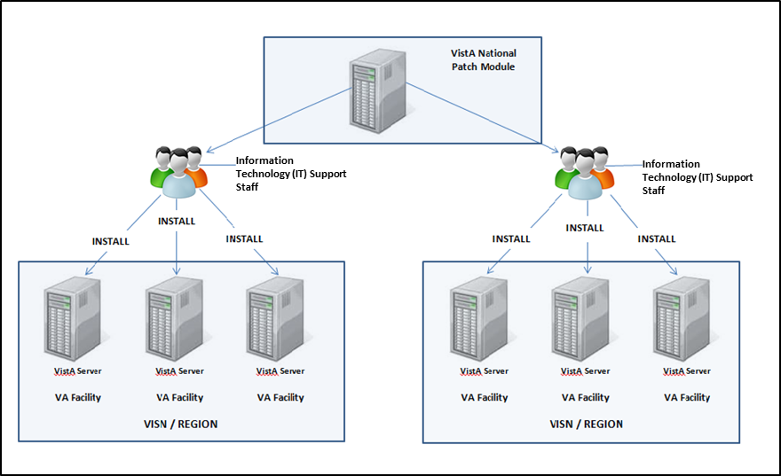
Figure 1: Deployment Topology (Targeted Architecture)

Site Information (Locations, Deployment Recipients)
During IOC testing, patch PSD*3.0*89 will be deployed at the following sites:
      - VA Honolulu Regional Office
      - Health Administration Center (Meds by Mail)
      - Indianapolis, IN VA Medical Center
      - Central Texas, Temple VA Medical Center Pharmacy
      - Erie, PA VA Medical Center
PSD*3.0*89 will be delivered to the Information Technology (IT) support staff responsible for the VistA installation at those sites. The software will be installed in the IOC test and production environments.
After National Release, Patch PSD*3.0*89 will be deployed at all sites running the Outpatient Pharmacy v.7.0 application.

Site Preparation
To prepare for the site, patches: PSO*7*617, PSD*3*73, and PSD*3*83 are required to be installed before PSD*3.0*89.

Resources
Deployment of Patch PSD*3.0*89 requires an up-to-date VistA environment running the
Controlled Substance v3.0 application, as well as designated IT support available to perform the patch installation.

Facility Specifics
There are no facility-specific deployment or installation features of patch PSD*3.0*89.

Hardware
Patch PSD*3.0*89 does not require additional hardware capabilities other than what is currently used by a VistA installation at the sites.

Software
The following table describes software specifications required at each site prior to deployment.
Table 3: Software Specifications

Required Software | Make | Version | Configuration | Manufacturer | Other
Outpatient Pharmacy |  | 7.0 | Standard | VHA
Controlled Substance |  | 3.0 | Standard | VHA
Please see the Roles and Responsibilities table in Section 2 for details about who is responsible for preparing the site to meet these software specifications.

Communications
No notifications are required for deployment of patch PSD*3.0*89 other than the patch description released through Forum.

3.2.4.1 Deployment/Installation/Back-Out Checklist
Sites should fill out the table below indicating who performed an activity and when it was performed prior to installation.

Table 4: Deployment/Installation/Back-Out Checklist

Activity | Day | Time | Individual who completed task
Deploy -The Deploy activity is performed when the patch is sent to site(s) by the National Patch Module or Release Agent.
Install - The Install activity is performed when the patch is installed at the site(s).
Back-Out - The optional Back-Out activity is performed in the event the patch must be uninstalled, or removed, from the site(s).

Installation

Pre-installation and System Requirements
Access to the National VA Network and to the local network of each site is required to perform the installation, as well as the authority to install patches.

Pre/Post Installation Overview
There are no pre-installation or post-installation steps for this patch.

Platform Installation and Preparation
Patch PSD*3.0*89 does not require any platform installation or preparation.

Download and Extract Files
The documentation, described in the table below, will be in the form of Adobe Acrobat files. Documentation can be found on the VA Software Documentation Library at: http://www.va.gov/vdl/. Documentation can also be found at REDACTED.

Table 5: Installation Documentation

Title | File Name | FTP Mode
CONTROLLED SUBSTANCES (CS) TECHNICAL MANUAL | PSD_3_P89_TM.docx  PSD_3_P89_TM.pdf | Binary
CONTROLLED SUBSTANCES (CS) SUPERVISOR’S USER MANUAL | PSD_3_P89_UM_SUPV.docx  PSD_3_P89_UM_SUPV.pdf | Binary
Release Notes | PSD_3_P89_RN.docx  PSD_3_P89_RN.pdf | Binary
IG | PSD_3_P89_IG.docx  PSD_3_P89_IG.pdf | Binary

Database Creation
No new database is required for patch PSD*3.0*89.

Installation Scripts
No installation scripts are required for installation of patch PSD*3.0*89.

Cron Scripts
No Cron scripts are required for installation of patch PSD*3.0*89.

Access Requirements and Skills Needed for the Installation
Access to the National VA Network and to the local network of each site to receive patch PSD*3.0*89 is required to perform the installation, as well as the authority to install patches.
Knowledge of, and experience with, the Kernel Installation and Distribution System (KIDS) software is required. For more information, see Section V, Kernel Installation and Distribution System, in the Kernel 8.0 & Kernel Toolkit 7.3 Systems Management Guide.

Installation Procedure
This patch may be installed with users on the system, but it is recommended that it be installed during non-peak hours to minimize potential disruption to users. Staff should not be processing prescriptions while patch is being installed. This patch should take less than 5 minutes to install.

There are no Menu Options to disable.

- Distribution Load:
Load the KIDS Distribution from the Packman Message using the Packman function "Install/Check Message."
- From the Kernel Installation and Distribution System Menu, select
the Installation Menu. From this menu, you may elect to use the
following options. When prompted for the INSTALL NAME enter:
PSD*3.0*89
- Backup a Transport Global - This option will create a backup build of patch
components. Respond “BUILD” at the “Select one of the following: B
Build or R Routines” prompt. **THIS IS CRITICAL TO ACCURATE PATCH
BACKUP ON YOUR SYSTEM. **
- Compare Transport Global to Current System - This option will allow you to view all
changes that will be made when this patch is installed. It compares all components of this patch (routines, DDs, templates, etc.).
- Verify Checksums in Transport Global - This option will allow you to ensure the
integrity of the routines that are in the transport global.
- KIDS Installation:
  - Install the patch using the KIDS Installation Menu action
"Install Package(s)" and the install name PSD*3.0*89.
- Respond "NO" at the "Want KIDS to INHIBIT LOGONs during the install?" prompt.
- Respond "NO" at the "Want to DISABLE Scheduled Options,
Menu Options, and Protocols?" prompt.
- The KIDs install should take less than 1 minute.

Patch Verification
Kernel Installation & Distribution System-> Utilities-> Install. File Print option can be used to check for any errors plus the status of the install being Completed.

Post-Installation Instructions

There are no post-installation steps for this patch.

Routine Information

The second line of each of these routines now looks like:
;;3.0;CONTROLLED SUBSTANCES;**[Patch List]**;Feb 13,1997;Build 18

The checksums below are new checksums, and
can be checked with CHECK1^XTSUMBLD.

Routine Name: PSDDSOR
Before: B86052358 After:B114292387 **40,42,45,67,73,89**
Routine Name: PSDDSOR1
Before: B34383843 After: B41609547 **40,67,73,83,89**
Routine Name: PSDDSOR2
Before: B23181227 After: B68638251 **40,42,45,73,89**

Database Tuning
No database tuning is required before or after deployment of PSD*3.0*89.

NOTE: Installation of PSD*3.0*89 is completed. The following procedure is to be followed only if PSD*3.0*89 needs to be backed out.

Back-Out Procedure
NOTE: Due to the complexity of this patch (because of the data dicionarges), it is not recommended for back-out. However, in the event that a site decides to back-out this patch, the site should contact the NSD at 855-NSD-HELP (673-4357) and reference “Inbound eRx” to submit a YourIT ServiceNow ticket; the development team will assist with the process.

Back-Out Strategy
The development team recommends that sites log a help desk ticket if it is a nationally released patch; otherwise, the site should contact the product development team directly for specific
solutions to their unique problems.

Back-Out Considerations
The back-out should only be done if the local facility management determines that the Patch PSD*3.0*89 is not appropriate for that facility and should only be done as a last resort.

Back-Out Criteria
Local Facility Management would need to determine patch PSD*3.0*89 is not appropriate for their facility.

Back-Out Risks
By backing out PSD*3.0*89, the local facility will not have the use of enhanced report features for eRx controlled substance prescriptions.

Authority for Back-Out
Local Facility Management has the authority to back-out patch PSD*3.0*89.

Back-Out Procedure

The Back-out Procedure consists of restoring the routines introduced by the Patch PSD*3.0*89. Ensure the ‘Backup a Transport Global’ step in section 4.8 of this document is followed, so a backup of all the routines is available.
The backout procedure for this patch should only occur when there is concurrence from the Enterprise Product Support and Inbound ePrescribing development teams, because of
the complexity and risk involved in a backout. Normal installation back-up using KIDS will back up only Mumps routines. For all non-routine components of this build, Enterprise Product Support will have a build available if needed.
The back-out is to be performed by persons with programmer-level access.

Rollback Procedure
There is no data associated with patch PSD*3.0*89.

