PROSTHETICS Delayed Order Report (DOR)
PATCH RMPR*3*59

INSTALLATION GUIDE

Version 3.0

June 2003

Department of Veterans Affairs
VistA Health System Design and Development (HSD&D)

Table of Contents

Patch RMPR*3*59 Installation Guide 1
Overview 1
Client Installation 3
Extract the file 6
Install the DOR File 8

Patch RMPR*3*59 Installation Guide

Overview

Introduction | With Patch RMPR*3*59, Prosthetics offers the Delayed Order Report (DOR) feature, which is a GUI windows-based functionality available to users. This DOR Installation Guide will help IRM and users to download the GUI portion of the patch. See the patch description for the instructions for the VistA portion of this patch. There are two user manuals that pertain to this patch:  - Automated Delayed Order Report (DOR) User Manual  - Prosthetics Main Menu User Manual  The new Prosthetics Main Menu window allows you to now access the NPPD Detail Display functionality as well as the Delayed Order Report.

IMPORTANT: Purging Suspense files BEFORE Installation | Each local site has the capability to purge obsolete data; typically the default setting is set at 365 days. When the patch for the Delayed Orders Report is released, it may take several hours to load due to a large suspense file. Thus purging is probably best done on the weekend or evenings.  Purging will eliminate the amount of time to run the installation. The loading time can be reduced if everyone identifies ahead of time the suspense data, which is no longer necessary and purges it prior to installation. Recommendation: It is recommended to keep no more than two years of suspense data.  VPRs will need to work with their IRM staff to make the default adjustment. When data is purged, there is an automatic print queue. You will need to over ride or send the data to a null device (non-printing source). This will save reams of paper. Do NOT send this data to the printer or it will print every record that is purged! Also, if a job is halted, make sure the records you want to purge actually were purged.

Important: Remove the NPPD Detail Display | You must uninstall the NPPD Detail Display application. To do this, go to the Control Panel Add/Remove Programs option and select the NPPD Detail Display item. Click the REMOVE button and the program will automatically uninstall.

RPC Broker | The assumption is made that the user’s PC has the required RPC Broker Client Workstation set up. If this is not the case, the user should first install this software. The installation is beyond the scope of this installation guide, but the RPC Broker files and installation instructions can be found on this VA’s RPC Broker web page: REDACTED. These files must be installed before running the DOR GUI application.

Continued on next page
Overview, Continued

HOSTS file | A link must be established between the client and the server via the PC’s Hosts file and the PC’s Windows Registry. The Hosts file (no extension) is in the following:  C:\Windows for Windows 95 or 98  C:\WinNt\System32\Drivers\Etc for Windows NT 4  If the Hosts file does not exist, it must be created. (There may be a hosts sample file already in place.) Note that if you create the file with Notepad, Notepad automatically adds a .txt extension. To remove the extension, use Explorer to rename it, leaving off the .txt extension.

Client Installation

Hosts File | If the Hosts file already exists, do not delete anything.

Steps | Follow these instructions for updating the Hosts file.

Step | Action
1 | If the user needs to access only one DOR GUI server, and the ServerPort is 9200, then add a line to the Hosts file, as shown in the example (on the next page) using the IP address provided by the server administrator. (There must be at least one space between the address and the name. There can be no spaces in the name itself.)  Continue to the next page.

Notepad – Sample HOSTS file | 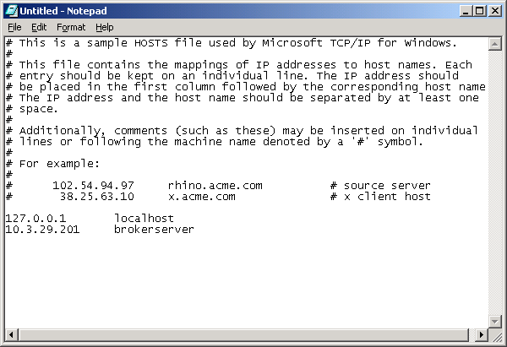

Continued on next page
Client Installation, Continued

Steps (continued) | Continue to follow these instructions for updating the Hosts file (if the Hosts file already exists.)

Step | Action
2 | If the user needs to access only one DOR GUI Server and the ServerPort is not 9200, then add one line to the Hosts file as shown in scenario 1 on the previous page, and run the ServerList utility described in scenario 3 below, or use the command line parameters shown in the next section.
3 | If the user needs to access multiple DOR GUI Servers and/or the ServerPort is NOT 9200, and the DOR GUI Server names to the Hosts file:  - 152.111.222.333 BrokerServer1 (The names can be anything you  like.)  - 152.111.222.444 BrokerServer2

Continued on next page
Client Installation, Continued

Multiple servers | Then run the ServerList Utility, installed in the C:\Program Files\Vista\PROS file of the GUI install package.  - The left windowpane of the ServerList utility shows those servers that have been set up as Host Servers in the HOSTS file.  - The right windowpane shows those servers that have been set up as BrokerServers.

Steps | Continue to follow these instructions for updating the Hosts file.

Step | Action
4 | To enable a BrokerServer, double-click on the name in the left window to move it to the right window, and then enter the corresponding ServerPort number.  Note: The order of the names in the right list is the order they will be displayed in the drop-down box when starting the DOR GUI feature. If only one server is listed on the right, then you won’t see the drop down box – it will automatically select that server as the default).

“Del” column | A left-click in the “Del” column marks and un-marks server for deletion. See the following ServerList screen print for an example.

ServerList | 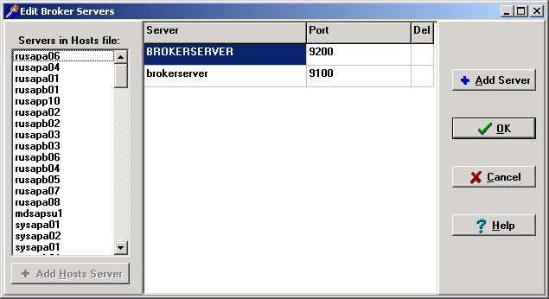

Extract the file

Anonymous directory | The file for this patch can be obtained from the ANONYMOUS.SOFTWARE directory at one of the OI Field Offices. The preferred method is to FTP the file from DOWNLOAD.VISTA.MED.VA.GOV, which will transmit the file from the first available server.  Alternatively, you may elect to retrieve the file from a specific OI Field Office. The documentation can be read via the Adobe Acrobat Reader browser program. The .EXE file is binary file and must be transferred using binary file transfer tools.

Steps | To begin the install process and unzip the files, follow these steps:

Step | Action
1 | From the Anonymous Directory, download the file RMPR_3_59.EXE.
2 | Double click the RMPR_3_59.exe icon.

Warning: Wrong filename | Warning: If the filename is RMPR_3_59.exe;1 when you try to download it, then you must rename it to RMPR_3_59.exe so that the filename does not have an “;1” in it.

Rename the file | To change the filename, right click on RMPR_3_59.exe;1, (executable application) and select the Rename option. Then delete the “;1” from the filename.

Continued on next page
Extract the file, Continued

Unzipping files | The file RMPR_3_59.EXE is a zip file that contains the “setup” files needed for the automated installation. The files will unzip to the C:\PROS folder for setup purposes. As an alternative to extracting these files to every client computer, IRM staff can unzip this file to a shared folder (directory) on a network server and then run the installation “SETUP.EXE” remotely.  Recommendation: Do not change the file folder, as future patches will need to overwrite these files.

WinZip dialog box sample (Your dialog box will contain the most current version number for the files.) | 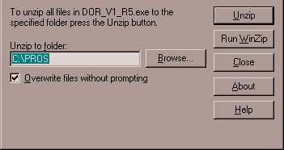

Steps (continued) | To continue to unzip the files, follow these steps:

Step | Action
3 | In the WinZip Self-Extractor dialog box, click the Unzip button (as shown above).
4 | A successful message box displays when the unzip process has completed. (See below.)
5 | Click the OK button on the WinZip Self-Extractor confirmation box.
6 | The WinZip Self-Extractor dialog box continues to display (as shown above).
7 | Click the Close button.

Successful message box | 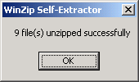

Install the DOR File

Automatic Wizard | Once you have extracted the files onto your c-drive, you can perform an installation using an automatic wizard that is provided for you. This feature has combined several steps to make installation easy.

Steps | To begin the installation, follow these steps:

Step | Action
1 | Open the My Computer icon on your desktop by double clicking it.
2 | Double click the C-drive in your Windows Explorer view.
3 | Double click the folder that contains the files: PROS.

Windows Explorer | 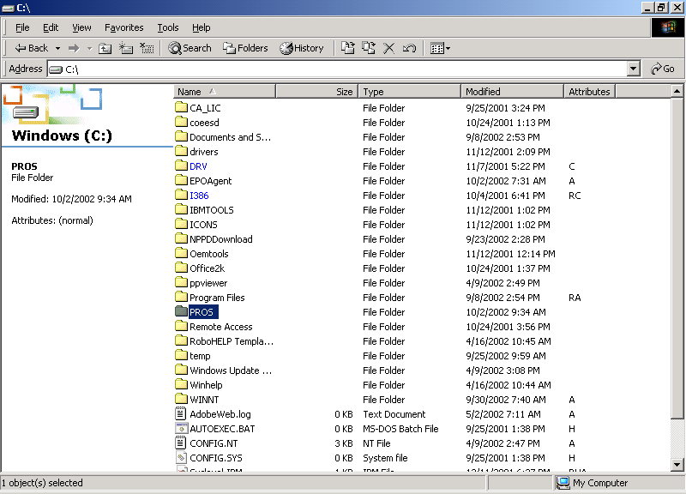

Continued on next page
Install the DOR File, Continued

Steps (continued) | To run the installation program, follow these steps:

Step | Action
4 | Double click the Setup.exe file in the C\:PROS folder shown on your Windows Explorer view.

Windows Explorer | 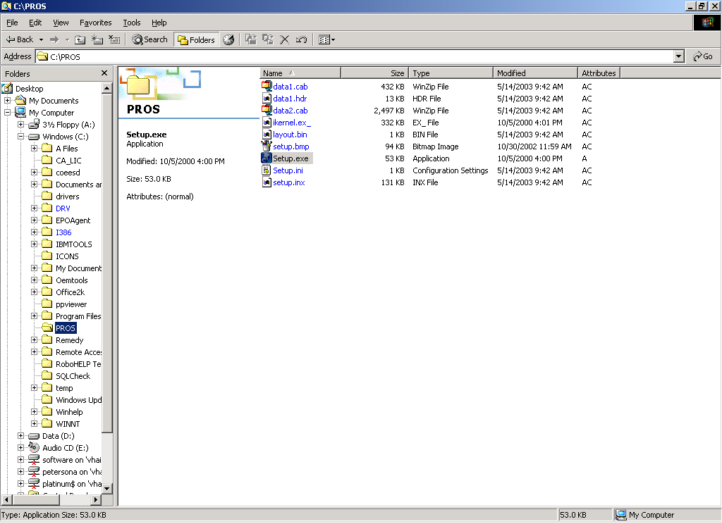

Continued on next page
Install the DOR File, Continued

Steps (continued) | To run the wizard for the DOR installation, follow these steps:

Step | Action
5 | The Install Shield Wizard begins and displays the download process.
6 | Click the Next button on the first window of the Install Shield Wizard for the DOR.

Install Shield Wizard | 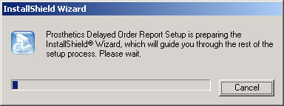

NPPD Detail Display Setup | 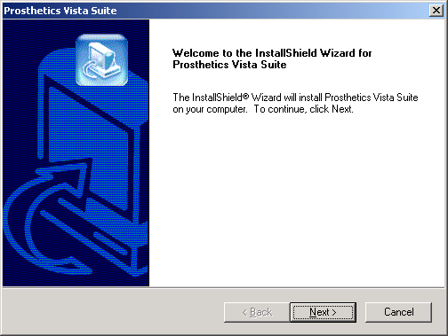

Continued on next page
Install the DOR File, Continued

Steps (continued) | To continue the installation, follow these steps:

Step | Action
7 | Click the Yes button on the License Agreement if you agree to the terms of the license.  Note: If you choose No, the setup will automatically close.

License Agreement | 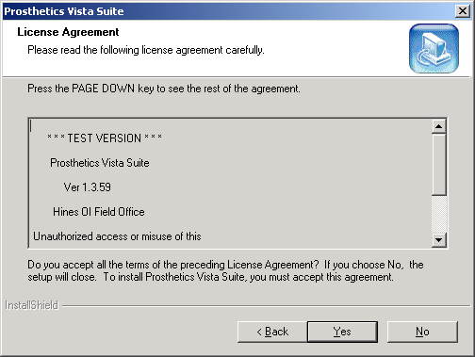

Continued on next page
Install the DOR File, Continued

Recommendation | The destination folder “C:\Program Files\Vista\PROS” has been established by VA policy so as not to conflict with other VA programs. It is recommended that you do NOT change this portion of the path.

Steps | To continue the installation, follow these steps:

Step | Action
8 | Click the Next button on the Destination Location dialog box.
9 | Click OK on the confirmation box. Notice that it states that the PROS file folder was created.

File Destination Location | 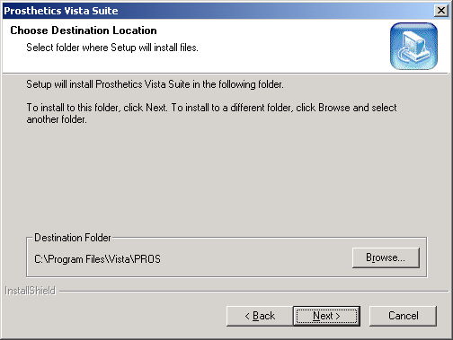

Create Directory message | 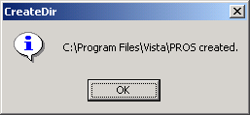

Continued on next page
Install the DOR File, Continued

Steps (continued) | To continue the installation, follow these steps:

Step | Action
10 | Click the Next button on the Start Copy Files dialog box.

Start Copying Files | 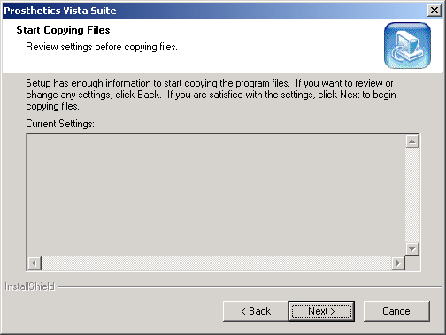

Continued on next page
Install the DOR File, Continued

Steps (continued) | To continue to install the Prosthetics feature onto your desktop, follow these steps:

Step | Action
11 | The Install Shield Wizard will be complete with this step.
12 | Click the Finish button.

Install Shield Wizard | 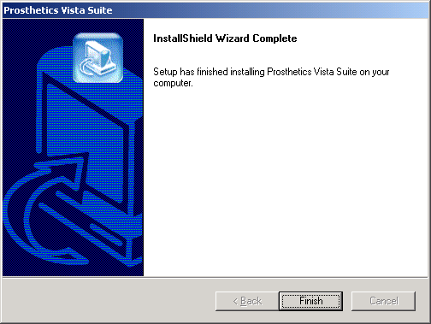

Installation Complete | The application is now installed on C:\Program Files\Vista\PROS. An icon has been placed on your desktop to run the DOR application. The application can also be run from Start Programs Prosthetics Vista Suite.

Uninstall procedures | To uninstall the application, go to the Control Panel Add/Remove Programs option and select the Prosthetics Vista Suite item. Click the REMOVE button and the program will automatically uninstall. To complete the full removal, the setup files will need to be deleted from the file location you selected.

