Prosthetics
Remove IFCAP Item Description
From 2319

Release Notes

Patch RMPR*3*99

Version 3.0

November 2004

Department of Veterans Affairs
VISTA Health System Design and Development (HSD&D)

Table of Contents

Remove IFCAP Item Description from 2319 Release Notes 1
Patch RMPR*3*99 Overview 1
NIF IFCAP Changes in the 2319 (Roll and Scroll) 3
View Prosthetics Item Transactions (Read Only) 6
GUI 2319 Button on DOR Menu – Appliance Transactions (Tab 4) 7
GUI 2319 Button on DOR Menu - Home Oxygen (Tab 8) 9

Appendix A 11
Glossary 11

Remove IFCAP Item Description from 2319 Release Notes
Patch RMPR*3*99 Overview

Introduction | Patch RMPR*3*99 (Remove IFCAP Item Description from 2319) was developed for Prosthetics to provide an interim solution for the continuation of the National Item File (NIF) data cleansing effort.  On the national level, the IFCAP Item file is pulled from each facility’s database and merged into a VISN database. Then the VISN’s NIF team reviews the Items and edits, deletes and adds descriptions (which are considered to be the “data cleansing” process).  If the IFCAP Item (at the national level) was a Prosthetic Item that was changed, added or deleted, then the Prosthetic Patient Treatment Record (2319) was historically being changed to match the data cleansing changes.  Patch RMPR*3*99 prevents the Prosthetic 2319 from historically being changed when data cleansing happens. This patch protects the PROSTHETICS ITEM DESCRIPTIONS in our Prosthetic 2319 from being overridden when the NIF make changes to the IFCAP DESCRIPTIONS.

Patch RMPR*3*99 changes | Patch RMPR*3*99 affects multiple Prosthetics Menu options. All three types of the Prosthetics 2319 have changes including:  1) Roll and Scroll  2) Read Only Roll and Scroll  3) GUI 2319 from the Delayed Order Report (DOR) application.  This patch will change the Prosthetics 2319 Appliance Transactions and Home Oxygen Items, switching the IFCAP Item Description to the HCPCS Description display.

Note to IRM | There is no new .EXE file to install. All the changes are M routines and a new cross reference in File 660. The IFCAP Item Description will remain in the database until phase 2 of the NIF implementation.  This is the menu option name that IRM references: RMPR VIEW 2319 READ ONLY.  Note: Please read these Release Notes for further information.

Continued on next page
Patch RMPR*3*99 Overview, Continued

No HCPCS entered prior to 1997 | Since HCPCS codes were not used prior to 1997, you will continue to see the IFCAP Item Description that was selected at that time. This is considered to be protected data and will not change.  Even though the Appliance Transaction (Screen 4) column heading displays HCPCS (in the Roll and Scroll), the information will continue to display the original IFCAP Item Description for those transactions entered prior to 1997.  Even though the GUI version of the Appliance Transaction (Tab 4) displays Item as the column header, it is actually the IFCAP Item for those transactions entered prior to 1997. The column heading was not changed to HCPCS.

NIF IFCAP Changes in the 2319 (Roll and Scroll)

2319 Roll and Scroll changes | Access the Prosthetics Official’s Menu option, Display/Print Patient 2319 (23) to view the Appliance Transactions (Screen 4) or Home Oxygen (Screen 8). Below are the sample screens for the Roll and Scroll 2319 that were affected by the NIF IFCAP changes.

Display/Print Patient 2319 Menu (23) | Select Prosthetic Official's Menu Option: DD <Enter> Display/Print  23 Display/Print Patient 2319  TI Transaction Inquiry  IP Print All Prosthetic Items  BI Print Prosthetic Billings for MAS  IH Item History  SE Search for Recalled Item  SI Site Parameter Inquiry  VI Vendor Inquiry  Select Display/Print Option: 23 <Enter> Display/Print Patient 2319

Select the patient | Select PROSTHETIC PATIENT: PROSPATIENT,ONE <Enter> LOMA LINDA VAMC 6-10-31  000040707 YES 70% SC VETERAN LL/SD/ MODULE III - GIM PCP:  PROSPROVIDER,ONE CX **ADVANCE DIRECTIVE - NO **  DEVICE: HOME// <Enter> VIRTUAL CONNECTION Right Margin: 80// <Enter>  Current Disability Codes are:  AO/DIS ALL OTHER S/C S/C

Select the Appliance Transactions (Screen 4) | Select one of the following:  1 PATIENT DEMOGRAPHICS  2 CLINIC ENROLLMENTS/CORRESPONDENCE  3 ENTITLEMENT INFORMATION  4 APPLIANCE TRANSACTIONS  5 AUTO ADAPTIVE INFORMATION  6 CRITICAL COMMENTS  7 ADD/EDIT DISABILITY CODE  8 HOME OXYGEN ITEMS  Enter 10-2319 screen to VIEW (1-8),'^' to EXIT, or 'return' to continue : 4 <Enter> APPLIANCE TRANSACTIONS  HHUU,UXKHUS G SSN: 000-04-0707 DOB: JUN 10,1931 CLAIM# SS

Continued on next page
NIF IFCAP Changes in the 2319 (Roll and Scroll), Continued

HCPCS Column | Notice the HCPCS column heading below is highlighted. This is the column of data that has been changed with Patch RMPR*3*99 to the HCPCS Description from the IFCAP Item Description (which was the Item column heading).

New HCPCS Column Title  The Item Description is new!!  ======= | Date Qty HCPCS Type Vendor Sta Serial Delivery Date Tot Cost  1. 05/29/02 1 AUTO BLOOD I VENDOR,ONE 605 05/29/02 42.01  2. 07/26/00 1 VASCULAR G I VENDOR1,ONE 605 019579 07/26/00 99.19  End of Appliance/Repair records for this veteran!  +=Turned-In *=Historical Data I=Initial X=Repair S=Spare R=Replacement  Enter 1-2 to show full entry, '^' to exit or `return` to continue. 1 <Enter>  PROSPATIENT,ONE SSN: 000-00-0001 LOMA LINDA VAMC DOB: 99-99 -1931  APPLIANCE/REPAIR LINE ITEM DETAIL <4-1>  TYPE OF FORM: STOCK ISSUE INITIATOR: PROSPROVIDER,THREE  DATE: MAY 29, 2002  DELIVER TO:  TYPE TRANS: INITIAL ISSUE QTY: 1 SOURCE: COMMERCIAL  VENDOR: PROSVENDOR,ONE  VENDOR PHONE: 800-555-5555  28690 N. Any DRIVE  LAKE FORREST, ILLINOIS 60045  DELIVERY DATE: MAY 29, 2002  TOTAL COST: $42.01 OBL:  REMARKS: [If you type a specific note here, it appears on Screen 4 under the transaction with notes…see below.]  DISABILITY SERVED: SC/OP  ITEM DESCRIPTION: BLOOD PRESSURE UNIT DIGITAL  APPLIANCE: BLOOD PRESSURE UNIT DIGITAL  PSAS HCPCS: A4670 AUTO BLOOD PRESSURE MONITOR  ICD-9 Code: 401.9 HYPERTENSION NOS  CPT MODIFIER:  DESCRIPTION: AUTO BLOOD PRESSURE MONITOR  EXTENDED DESCRIPTION:  AUTOMATIC BLOOD PRESSURE MONITOR  Enter RETURN to continue or '^' to exit:

Remarks | If you enter a specific note in the Remarks field, it will be easier to locate it to identify it for future Item needs. The note displays on Screen 4 below the transaction.

Item Description / Appliance prompt | The IFCAP Item Description field display above is new. This is the field you should review to determine which Prosthetic Item was provided to the patient. You should no longer review the Appliance field. When the Item Description and the Appliance field are identical (as shown above), then the “new note” that is described on the next page will not appear. See next page.

Continued on next page
NIF IFCAP Changes in the 2319 (Roll and Scroll), Continued

Item Description NEW Note | With Patch RMPR*3*99, whenever an IFCAP Item Description has been changed, edited or deleted, you will see a new note under this field as follows:  *** See Above for Original Item Description ***  Due to the data cleansing, the Appliance field (which was the original Item selected) has a new description and the original description is now the Item Description field.

After Patch Install - Item Description with NOTE  =======  ======= | TYPE OF FORM: STOCK ISSUE  INITIATOR: PROSPROVIDER,ONE  DATE: MAY 29, 2002  DELIVER TO:  TYPE TRANS: INITIAL ISSUE QTY: 1 SOURCE: COMMERCIAL  VENDOR: PROSVENDOR,ONE  VENDOR PHONE: 800-555-5555  28690 N. Any DRIVE  LAKE FORREST, ILLINOIS 60045  DELIVERY DATE: MAY 29, 2002  TOTAL COST: $42.01 OBL:  REMARKS:  DISABILITY SERVED: SC/OP  ITEM DESCRIPTION: BLOOD PRESSURE UNIT DIGITAL  *** See Above For Original Item Description ***  APPLIANCE: BLOOD PRESSURE CUFF DIGITAL  PSAS HCPCS: A4670 AUTO BLOOD PRESSURE MONITOR  ICD-9 Code: 401.9 HYPERTENSION NOS  CPT MODIFIER:  DESCRIPTION: AUTO BLOOD PRESSURE MONITOR  EXTENDED DESCRIPTION:  AUTOMATIC BLOOD PRESSURE MONITOR  Enter RETURN to continue or '^' to exit:

Example above | To interpret the example above, the original Item Description was “Blood Pressure Unit Digital.” Due to data cleansing, the description was changed to “Blood Pressure Cuff Digital.”  The Appliance Field was changed to the new description: “Blood Pressure Cuff Digital” and the original or saved description appears in the new field: Item Description.

View Prosthetics Item Transactions (Read Only)

“Read Only” patch change | The change with Patch RMPR*3*99 that was previously explained also affects the Roll and Scroll version of Prosthetics and provides the following new (Read only) menu option:  View Prosthetics Item Transactions  Below is a sample screen.

View 2319 (Read Only) | Select OPTION NAME: VIEW PROSTHETICS ITEM TRANSACT <Enter> RMPR VIEW 2319 READ ONLY  View Prosthetics Item Transactions  SITE: SUPPORT ISC// <Enter> 578A5  Select PROSTHETIC PATIENT: PROSPATIENT, ONE <Enter> SUPPORT ISC 4-5-61 000111111  YES SC VETERAN  PATIENT IS DECEASED. DATE OF DEATH WAS OCT 21,1993@08:00  Would you Like to continue Processing this Patient? NO// YES <Enter>  DEVICE: HOME// <Enter> TELNET Right Margin: 80// <Enter>  Select one of the following:  I ITEM TRANSACTIONS  H HOME OXYGEN ITEMS  Enter DATA screen to VIEW (Item Transactions or Home Oxygen),'^' to EXIT, or 'return' to continue :

GUI 2319 Button on DOR Menu – Appliance Transactions (Tab 4)

Delayed Order Reports (DOR) | The GUI 2319 Appliance Transactions (Tab 4) window from the Delayed Order Report (DOR) below shows the heading: Item column; however this information is now the HCPCS Description with Patch RMPR*3*99.  The column heading Item will not be changed to HCPCS.

Appliance Transactions (Tab 4) | 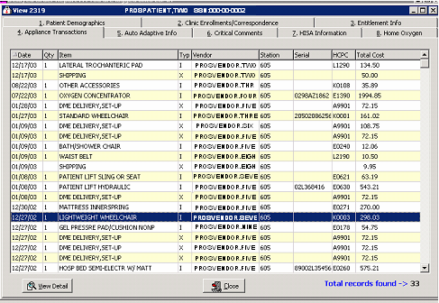

Next Step | Click the View Detail button at the bottom of this window to display the Appliance Transaction Detail window and proceed to the next page.

Continued on next page
GUI 2319 Button on DOR Menu – Appliance Transactions (Tab 4), Continued

Appliance Field | The Appliance field listed in the Transaction Detail window below is protected from changes to IFCAP (from the NIF group’s data cleansing).  The example below, “Wheelchair 9000XT 18-inch” in the Appliance field will remain the same with Patch RMPR*3*99.  Note: The Appliance field below will always display the originally selected IFCAP Item Description. The new “Item Description: field in Roll and Scroll and the new note “See Above…” is not necessary in the GUI 2319. This is because the GUI 2319 IFCAP Item Description will always be displayed and protected from changes.

Transaction Detail window | 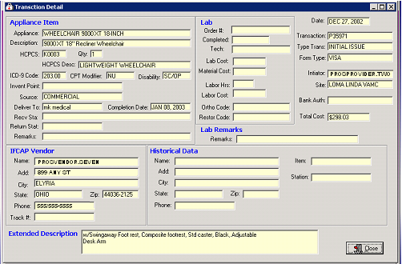

Close button | To close the Transaction Detail window and return to the View 2319 window, click the Close button.

GUI 2319 Button on DOR Menu - Home Oxygen (Tab 8)

Home Oxygen (Tab 8) | The 2319 in the Delayed Order Report (DOR) shown below of the Home Oxygen (Tab 8) window shows the Item column which is the HCPCS Description with Patch RMPR*3*99.

Home Oxygen window | 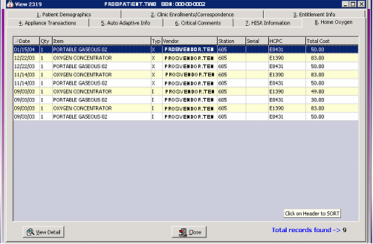

View Detail button | Click the View Detail button at the bottom of this window to display the Home Oxygen Detail and proceed to the next page.

Continued on next page
GUI 2319 Button on DOR Menu - Home Oxygen (Tab 8), Continued

Home Oxygen (Tab 8) Transaction Detail | Notice the Appliance field on the Transaction Detail window from the Home Oxygen (Tab 8) remains the same, even when changes are made to the NIF IFCAP Item Description.  Note: The Appliance field below will always display the originally selected IFCAP Item Description. The new “Item Description: field in Roll and Scroll and the new note “See Above…” is not necessary in the GUI 2319. This is because the GUI 2319 IFCAP Item Description will always be displayed and protected from changes.

Transaction Detail | 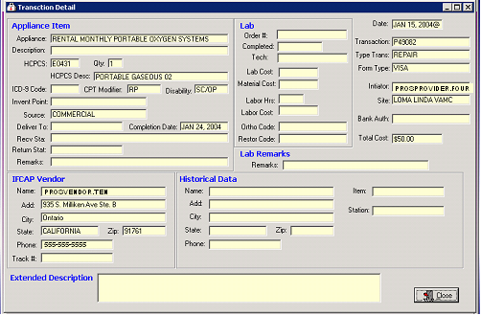

Appendix A
Glossary

DOR | Delayed Order Report – Prosthetics application.

GUI | Graphical User Interface. This is a windows-based application with buttons and tabs instead of prompts in a Roll and Scroll environment for an application. Microsoft Windows is a GUI environment.

HCPCS | Healthcare Common Procedure Coding System – formerly Health Care Financing Administration Common Procedures Coding System - is distributed by Centers for Medicare & Medicaid Services (CMS) and the Health and Human Services (HHS) for all other substances, equipment, supplies, or other items used in Health Care Services. These items include, but are not limited to: medical supplies; orthotic and prosthetic devices; and durable medical equipment.

NIF | The National Item File (NIF) database is used to standardize naming practices so that facilities will be able to identify, track and evaluate purchases.  The NIF is also a group that works on this database file.

VistA | Veterans Health Information Systems and Technology Architecture, formerly known as Decentralized Hospital Computer Program, encompasses the complete information environment at VA medical facilities. It consists of hardware, software packages, and comprehensive support for system-wide and station specific, clinical and administrative automation needs.

