

QUASAR Audiogram Module  
Release Notes

Patch ACKQ*3.0*13

July 2007

Department of Veterans Affairs

Health Systems Design & Development

# Introduction

**QUASAR** (Quality: Audiology and Speech Analysis and Reporting) is a VistA software package written for the Audiology and Speech Pathology Service (ASPS). QUASAR is used to enter, edit, and retrieve data for each audiometric exam of a patient and provides for the transmission of this data to various programs.

Patch ACKQ*3.0*13 adds the ability to retrieve data directly from certain audiometric devices, and combines the Edit and Display components into one application. Recommended users (not doing data entry or capture), can use the Graph Display tab to view a graphic display of a record.

The **QUASAR Audiogram Module** is a Windows-based GUI interface, developed to simplify and enhance the entry, display, and use of information obtained during an audiometric exam of a patient.

The Audiogram Edit component (ACKQROES3E.exe) is a Windows-based software application that allows clinicians to enter, edit, and view a patient's audiometric exam record and a patient's audiogram graph. You access the component from the Computerized Patient Record System (CPRS) Tools menu.

The **QUASAR Audiogram Module** includes components that reside on two systems: the local facility VistA system and the Denver Acquisition & Logistics Center (Denver ALC) system. The local facility components include a VistA file, 'M' routines and options, remote procedure calls, and a Delphi executable. The Denver ALC ROES*3.0 (Remote Order Entry System) order processing application incorporates patient-specific audiometric information that is taken from data transmitted to a national database from the QUASAR Audiogram Module. The information is used by vendors to produce customized hearing related items.

## Overview

The QUASAR Audiogram Module currently contains an interface to the Denver Acquisition & Logistics Center (DALC) database. The data is passed from the Quality: Audiology and Speech Analysis and Reporting (QUASAR) application (AUDIOMETRIC EXAM DATA file #509850.9) to the DALC database utilizing the VA VistA MailMan interface. The existing functionality of the software is maintained.

The following vendors supplied DLLs that implement a simple interface to the QUASAR Audiogram Module:

* Viasys Grason Stadler GSI 61
* GN Otometrics Madsen-Aurical
* Interacoustics AC40

When the QUASAR Audiogram Module requests audiometric measurements, the vendor software responds with the memory address of a small Extensible Markup Language (XML) document representing the results of the request. The Audiogram Module retrieves the results and feeds the information into the VistA/QUASAR Audiometric Exam database.

## Related Documentation

The *Release Notes* briefly describe the major changes for the QUASAR Audiogram Module generated by Patch ACKQ*3.0*13. Related documentation is located in the VistA Document Library:

<http://www.va.gov/vdl/>

* For installation/implementation information, refer to the *QUASAR Audiogram Module Installation and Implementation Guide* for Patch ACKQ*3.0*13.
* For information on functionality, refer to the *QUASAR* *Package User Manual* for Patch ACKQ*3.0*13.
* For information on technical changes, refer to the *QUASAR Audiogram Module Technical Manual and Security Guide* for Patch ACKQ*3.0*13.

## Audiogram Display through CPRS

Any doctor with access to the local system can view the Audiogram Display within the application to aid in treatment and diagnosis decisions. They can continue to view the display as assigned in patch ACKQ*3.0*12. For information on Audiogram Display, refer to the User Manual, Technical Manual, Installation Guide, and Release Notes for the *Audiometric Exam Module*, November 2005 in the VistA Document Library.

<http://www.va.gov/vdl/application.asp?appid=97>

# Interface/Audiometer Anomalies

## All Models

* There are interface/audiometer anomalies that apply to all models about which you need to know, in order to import data from the audiometer to the Audiogram Module.
* If the audiometer is connected to the computer through a COM port, you must connect the audiometer to COM1.
* The QUASAR Audiogram Module GUI must be in focus to import data from an audiometer using the **F10** key on the keyboard.

## GSI 61/Viasys

* A firmware upgrade with installation instructions is needed for the GSI 61, in order to use the audiometer with the interface. You need to work directly with the vendor in the firmware procurement process.
* **Remote** needs to be enabled on the GSI 61, in order for the audiometer to connect with the interface.
* When doing Word Recognition Testing (WRT), if you get a discrimination score of 0%, you must enter the value manually; otherwise it overrides/replaces the Speech Reception Threshold (SRT) values.
* The factory settings for the dip switches may have to be adjusted.

**Factory Settings for the GSI 61 Dip Switches**

The GSI 61 dip switch factory settings may have been changed to accommodate a local interface program; therefore, the VA-developed link between the GSI 61 and CPRS may not work correctly. The internal dip switch settings must be set to the factory settings for the device to properly communicate with the software and CPRS.

To help the local user ensure the correct settings, the photos show the dip switches with factory settings.

**Dip Switch Board S1**

The S1 board is located on the **lower** circuit board panel inside the GSI 61 and to the right of the center of the device. The dip switches are numbered **1-8** from *left to right* on the panel.

Set all (**1-8**) dip switches to the **OFF** position.

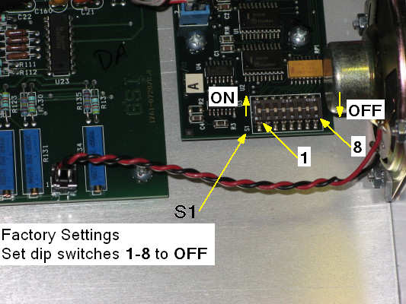

**Dip Switch Board S1**

**Dip Switch Boards S902 and S901**

The S901 and S902 boards are located on the **upper** circuit board panel inside the GSI 61 and to the left of the center of the device. The dip switches are numbered **1-8** from *right to left* on the panel.

* **S 902** – set dip switch **2** to the **ON** position and   
   set dip switches **1**, **3**, **4**, **5**, **6**, **7**, and **8** to the **OFF** positions.
* **S 901** – set dip switches **2** and **7** to the **ON** position and   
   set dip switches **1**, **3**, **4**, **5**, **6**, and **8** to the **OFF** positions.

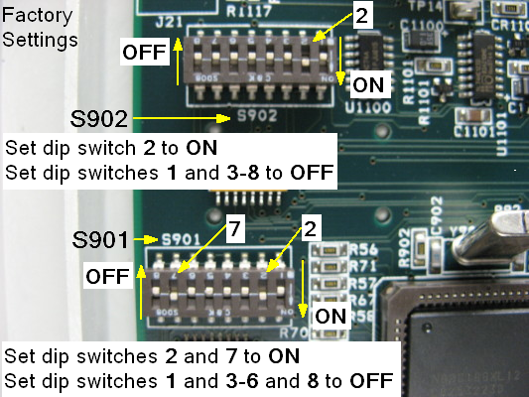

**Dip Switch Boards S901 and S902**

## AC40/Interacoustics

* Only for Word Recognition Testing (WRT) values, press **Store** on the AC 40 before importing data to the GUI.
* When importing SRT and WRT values with the AC40, a **Type of Test** pop-up displays. Click **SRT** or **WRT** to indicate the type of test you are performing. Your response dictates where the data is placed.

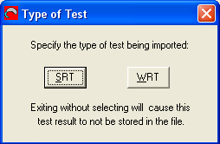

## Madsen-Aurical/GN Otometrics

* The Madsen-Aurical audiometer requires an upgrade to the AURICAL Plus software before using the interface. You must provide the serial number of the audiometer to the vendor in order to secure a software license key for the upgraded software. You need to work directly with the vendor in the software/license key procurement process.

Contact REDACTED (Product Manager) from GN Otometrics to obtain the software upgrade and the license key. E-mail Peter at: REDACTEDIf the AURICAL Plus software installation requests the NOAH version you are using, you must have the latest version of NOAH installed.

* Since the Madsen-Aurical is a black box audiometer (data dump), collecting WRT values appropriately requires additional steps.

In the AURICAL Plus software:

1. Gather Air and Bone test data for the left and right ears.
   1. Click **Store** and thenImage of the Aurical Plus software check mark.

In the Audiogram Module:

1. Click **Import Data**.
   1. Click **File** and select **Save**. Save All Changes pop-up displays.
   2. Click **Yes**.

In the AURICAL Plus software:

1. Click **Test Mode** and select **New Audiogram**. Clear pop-up displays.
   1. Select **Tone Audiometer** data.
   2. Click **OK**.
   3. Click **Test Mode** and select **Speech Audiogram**.

In the AURICAL Plus software:

1. Gather SRT test data for the left and right ears.
2. Click **Store** and thenImage of the Aurical Plus software check mark.

In the Audiogram Module:

1. Click **Import Data**.
   1. Click **File** and select **Save**. Save All Changes pop-up displays.
   2. Click **Yes**.

In the AURICAL Plus software:

1. Click **Test Mode** and select **New Audiogram**. Clear pop-up displays.
   1. Select **Speech Audiometer** data.
   2. Click **OK**.
   3. Click **Test Mode** and select **Speech Audiogram**.

In the AURICAL Plus software:

1. Gather WRT test data for the left and right ears for column **1**.
2. Click **Store** and thenImage of the Aurical Plus software check mark.

In the Audiogram Module:

1. Click **Import Data**. Data populates column **1** – left and right ears.
   1. Click **File** and select **Save**. Save All Changes pop-up displays.
   2. Click **Yes**.

In the AURICAL Plus software:

1. Manually delete the values in the test boxes for the left and right ears.  
   (Highlight a value and press **Delete** on the keyboard for each.)
2. Gather WRT test data for the left and right ears for column **2**.
3. Click **Store** and thenImage of the Aurical Plus software check mark.

In the Audiogram Module:

1. Click **Import Data**. Data populates column **2** – left and right ears.
   1. Click **File** and select **Save**. Save All Changes pop-up displays.
2. Click **Yes**.

In the AURICAL Plus software:

1. Manually delete the values in the test boxes for the left and right ears.  
   (Highlight a value and press **Delete** on the keyboard for each.)
2. Gather WRT test data for the left and right ears for column **3**.
3. Click **Store** and thenImage of the Aurical Plus software check mark.

In the Audiogram Module:

1. Click **Import Data**. Data populates column **3** – left and right ears.
   1. Click **File** and select **Save**. Save All Changes pop-up displays.
2. Click **Yes**.

You can follow the same steps for columns **4** and **5**. A 6th test and each one thereafter, replace the data in column 5.

# Monitor/Keyboard Placement

Patch ACKQ*3.0*13 requires attention be given to the setup of the keyboard and monitor.

* PC keyboard and PC monitor must be connected (cable) to the PC running the Audiogram Module.
* Locate the keyboard adjacent to or directly below the audiometer device controls.
* Locate the PC monitor in a physical position, such that the clinician can comfortably view and analyze the data imported to the Audiogram Module.

# Patch ACKQ*3.0*13 GUI Enhancements

Patch ACKQ*3.0*13 enhances the functionality of the Audiogram Module. The Audiogram Module Interface allows the transfer of data, point by point, from the audiometer device to the grids in the Pure Tones and Speech Audiometry tabs of the Audiogram Edit window. The interface also allows the transfer of data in batch mode (data dump). The data elements are associated with a selected patient in CPRS. Using clinical judgment supported by common practice standards, the user is able to edit the data values retrieved from the audiometer.

* Import Data button is added to the Audiogram Edit window; available on four tabs.
* Audiogram Display is integrated into Audiogram Edit as a new tab, Graph Display.
* Within the Pure Tones tab, all Final or Masked field labels are changed to Masked.  
  Masked is used only for maskedvalues.
* Frequency 1500 is added to the Pure Tones tab in the Bone Conduction section.
* Short-cuts are added to the menus.
* Hide/Show Import Button is added to the File menu.
* Flip Tabs option is removed from the File menu.
* The Device menu is added with menu options: Configure Audiometer, Check Audiometer, and Import Data.

1. Configure Audiometer - to pass data from an audiometer to the Audiogram Module, an audiometer must be configured for the first time. Each ensuing time the Audiogram Module is opened, the configured audiometer is remembered. You can import data from the audiometer for all subsequent sessions.
   1. Check Audiometer - during subsequent uses of an audiometer, you can verify and monitor the connection without reconfiguring.

* The Options/Graph menu is added with menu options: Overlap, Separate, and VA form 10-2364.
* The algorithm for selecting the data points to graph on the audiogram graph is changed; if there is no final value, use the Retest value rather than the lower of the two, Initial or Retest.
* Status Bar is added to the bottom of the Audiogram Edit window with Pane 1 identifying the audiometer, Pane 2 indicating whether or not the audiometer is connected, and Pane 3 displaying informational messages.
* Within the Speech Audiometry tab under Rollover, Applied Max drop-down list boxes are added for the left and right ear. You select the Word Recognition test (default, 1, 2, 3, 4, or 5) to use to calculate the PB Max value.   
  If a test is not specified by the user, the Audiogram Module utilizes current logic for displaying the PB Max value as the default behavior. Some Word Recognition tests may include half-list values that cannot be reported as PB Max for some exam types.
* For an audiometer capable of being reset, each time Audiogram Module is opened, the data stored in the audiometer’s local repository is cleared or set to default, in preparation for a new patient. For an audiometer not capable of being reset, you must manually reset it.
* The graph display reflects imported data dynamically.
* Value boundary validation is part of data imports. When a value is outside the upper range of acceptable, valid values, the highest permitted value for a field displays with + (plus sign) to the right of it.
* On the Graph Display tab, for the Overlap and Separate views of the audiogram, Rollover Index for R and L, and Pure Tone Averages for R and L/Two/Three/Four are added to the display.
* On the Graph Display tab, for the Overlap view of the audiogram, IAR and CAR for R and L, and Right and Left for SRT-1and 2, Mask-1and 2, MCL, and UCL are added to the display.
* To import data from an audiometer successfully with **F10** key, the Audiogram Edit window must be in focus and active.
* Values greater than the maximum acceptable for a frequency are converted to the maximum value with a + (indicating *no response*) to its right; a message displays in Pane 3.
* Values less than the minimum acceptable for a frequency are converted to the minimum value; a message displays in Pane 3.

# Patch ACKQ*3.0*13 MUMPS Changes

Two fields are added to the data dictionary: Applied Max R and Applied Max L.

Several fields of the AUDIOMETRIC EXAM DATA file (#509850.9) are expanded from the previous length of 1-2 characters to 1-4 characters.

New checksums are added to the Routines.