One Consult - Order to Consult - Radiology Consult Solution

Community Care Imaging Orders to Consult

Training Guide
February 2021
Department of Veterans Affairs
Office of Information and Technology (OI&T)

Revision History
NOTE: The revision history cycle begins once changes or enhancements are requested after the document has been baselined.
Date | Revision | Description | Author
03/18/2019 | 1.0 | Initial Release | AbleVets
February 2021 |  | Page 12, 16-18 – New Justifications and the CDW tags they create. RA*5*170 | Radiology Sustainment
Table of Contents
1. Creating Community Care Consults as an Ordering Provider 1
2. Placing Imaging Orders on Hold 6
3. Placing Orders in Scheduled 8
4. Creating Community Care Consults as a Radiology Technician 10

Creating Community Care Consults as an Ordering Provider
To create a Community Care Consult as AUTO consults to be sent directly to Community Care from Radiology Orders, follow the steps listed below:
- Log into CPRS as an Ordering Provider.
- From the File menu, select Patient. The Patient Selection dialog box displays.
Figure 1: Patient Selection Dialog Box
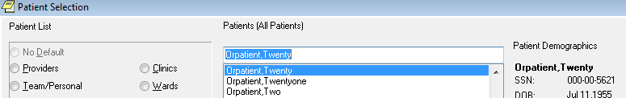
- From the Patients (All Patients) drop-down menu, select a patient.
- Click OK. The patient file displays.
Figure 2: Patient File in CPRS
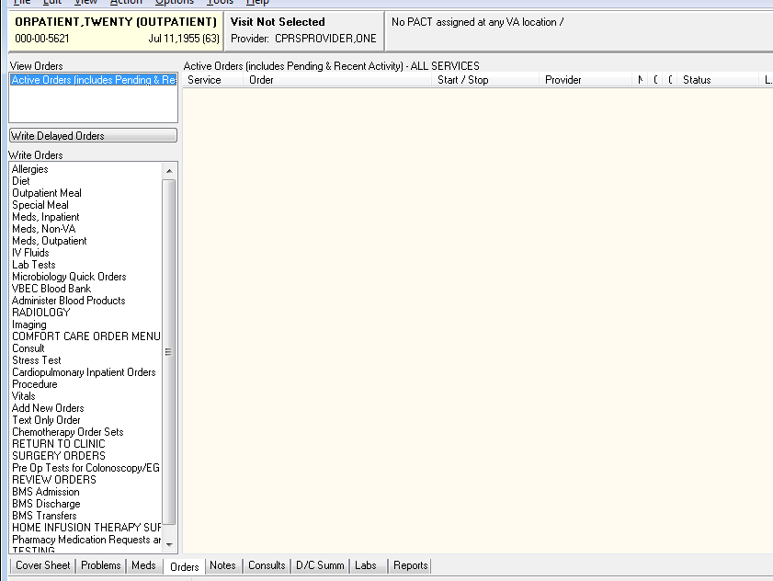
- From the Orders tab, select Imaging. The Location for Current Activities dialog box displays.
Figure 3: Location for Current Activities Dialog Box
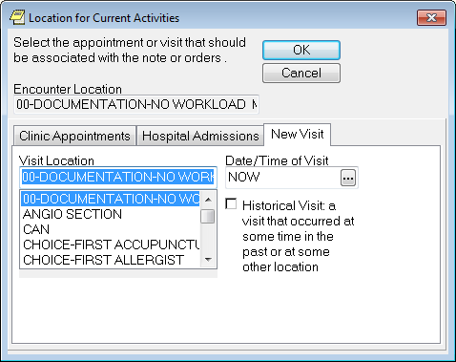
- In the Visit Location field, enter a location or select from the list.
- Click OK. The Order an Imaging Procedure dialog box displays.
Figure 4: Order an Imaging Procedure Dialog Box
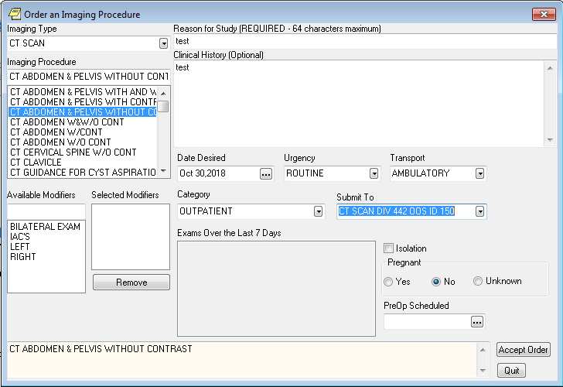
- From the Imaging Type drop-down menu, select the image type.
- Complete the remaining sections in the Imaging Procedure form.
- Click Accept Order and Quit. The Unsigned Imaging Order displays in CPRS.
Do not click Quit if you need to order additional Imaging Procedures that will be submitted to different locations. Enter each Imaging Procedure order and click Accept Order. Once you have entered all the Imaging Procedures, then you can click Quit.
Figure 5: Unsigned Imaging Order in CPRS
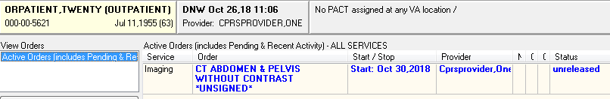
- Right-click the imaging order(s) and sign the order(s).
Figure 6:
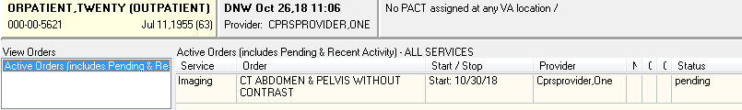
- Double click on Order Details. The Order Details window displays.
Figure 7: Order Details Window
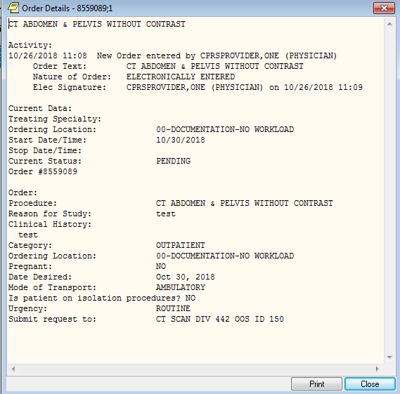
- Click Print or Close.
- Make two additional orders and sign them.
Figure 8: Additional Signed Orders
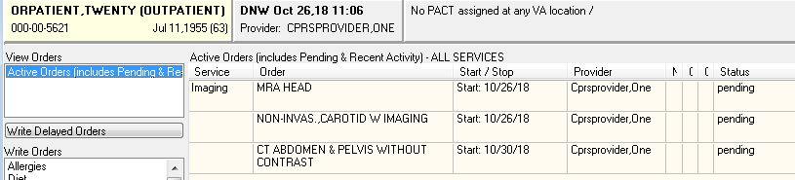

Placing Imaging Orders on Hold
- From the main radiology menu, select Hold a Request.
Figure 9: Hold a Request Menu Option
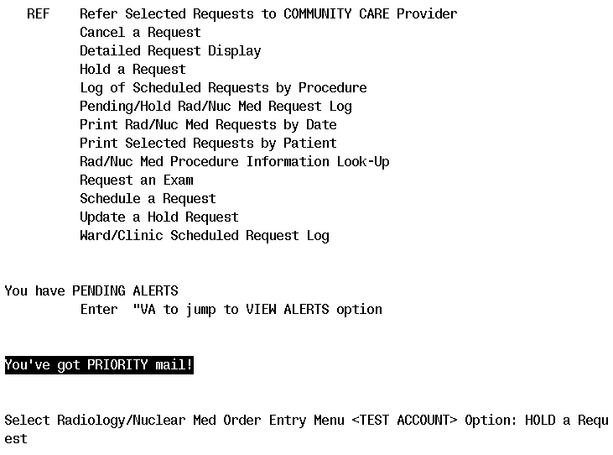
- Select the patient that you are working on in CPRS.
Figure 10: Patient Information
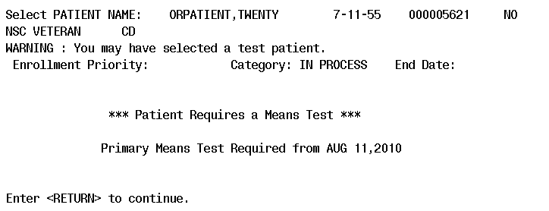
- Select one of the orders and select a reason.
Figure 11: Selected Order
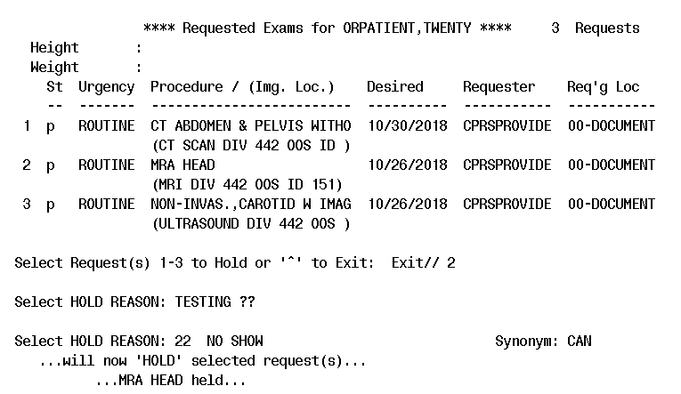
- In CPRS, refresh the patient to show the order is now on hold.
Figure 12: Order Hold Status Displayed
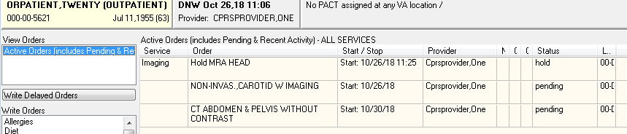

Placing Orders in Scheduled
- From the main radiology menu, select Schedule a Request.
Figure 13: Schedule a Request Menu Option
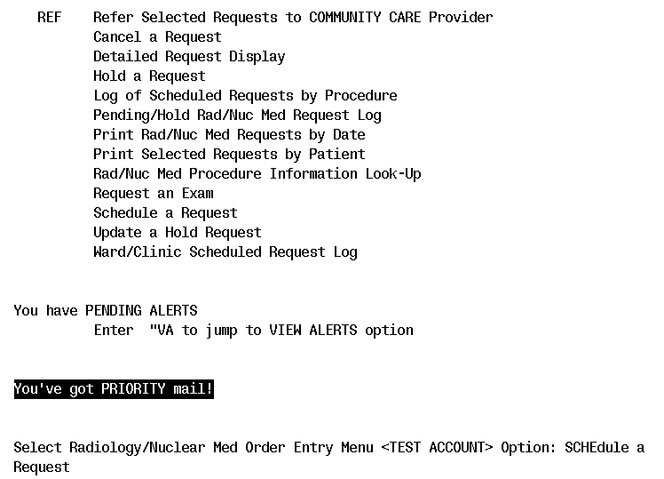
- Select the patient that you are working on in CPRS.
Figure 14: Patient Information
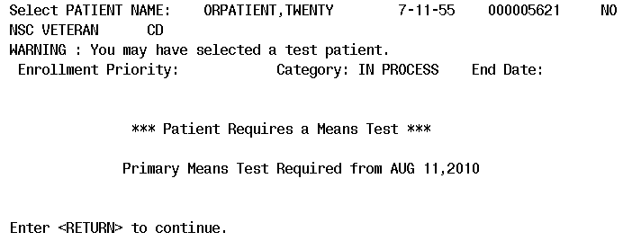
- Select the imaging order and enter a date (and time if required).
Figure 15: Selected Order
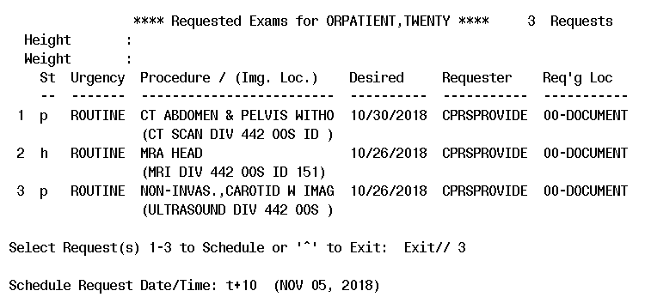
- In CPRS, refresh the patient to show the order is now in Scheduled status.
Figure 16: Scheduled Status
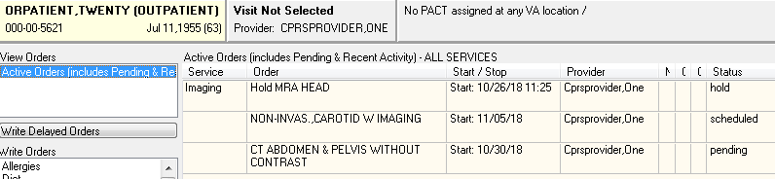

Creating Community Care Consults as a Radiology Technician
- Log into VistA as a Radiology Technician and, from the Radiology/Nuclear Med Order Entry Menu, select REF, and then select the patient:
Figure 17: REF Option
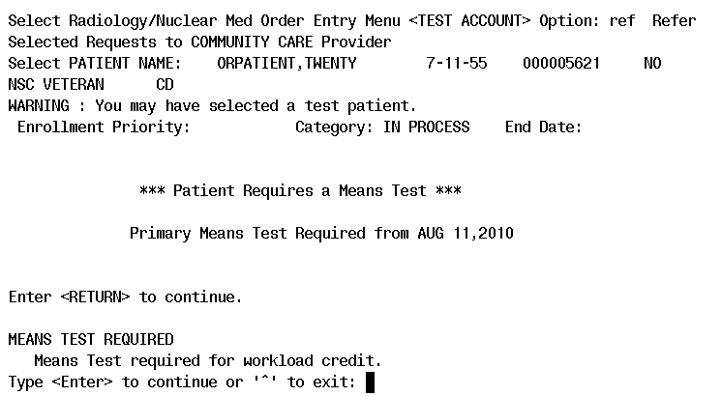
- From the list of pending requests, select the correct procedure(s). Notice that all pending, hold, or scheduled requests, for this patient, display and are available to be referred to community care.
Figure 18: List of Pending Requests
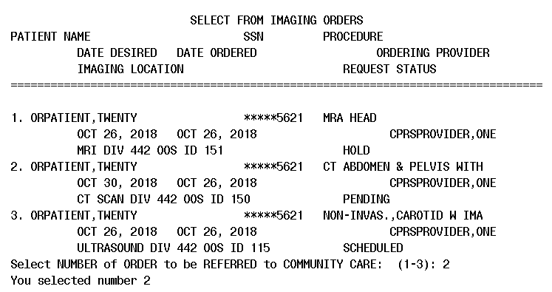
- Select the Justification for Community Care.
Figure 19: Justification for Community Care
Select one of the following:

1 VA appointment is greater than wait time standard
2 VA facility does not provide the required service
3 Veteran lives more than drive time standards
4 Grandfathered
5 Hardship
6 No Full Service VHA Facility
7 1703(e) Eligibility
8 Best medical interest of Veteran (per Licensed Independent Provider only)

Enter response:

If imaging type selected is mammography, you will be prompted to answer the following additional question:
Select one of the following
1. Diagnostic Mammography
2. Screening Mammography
Figure 20: Medical Reason
Enter response: 2 VA facility does not provide the required service

Consult with UCID: 442_884085 has been created
- From the File menu within CPRS, select Refresh Patient Information.
Figure 21: Refreshed Patient Information
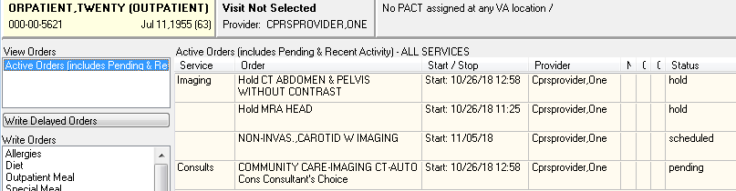
You can see that the imaging order that was just converted to a consult is now on hold, and a consult order has been created.
- Navigate to the VistA roll-and-scroll and redisplay the imaging orders for the patient.
Figure 22: Imaging Orders
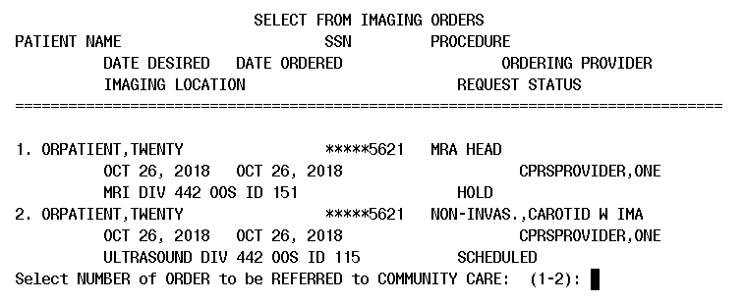
You can see that there are now only two orders left for conversion to consults, and the imaging order that was previously processed, and is on hold, does not show
- Select one of the above imaging orders, and enter any Justification for Community Care.
- Go back to CPRS and refresh the patient.
Figure 23: Refreshed Patient Information
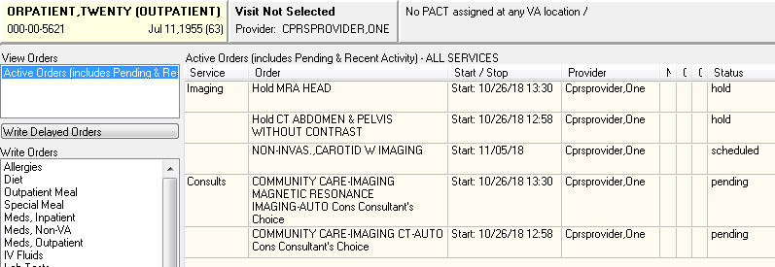
- Repeat steps 6, 7, and 8 on the last imaging order, then refresh the patient again in CPRS.
Figure 24: Refreshed Patient Data
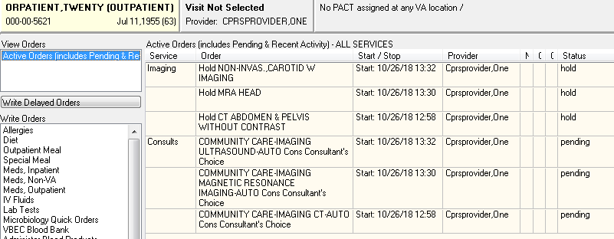
- You can double-click on any one of the Consult orders to show details.
Figure 25: Order Details
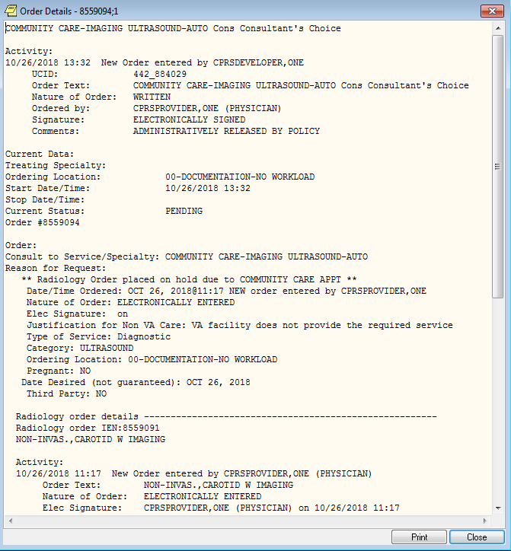
The original radiology order is embedded in the Consult order detail
- Then go to the Consults tab and click on any consult in the left-hand panel to show the Consult Detail.
Figure 26: Consult Detail
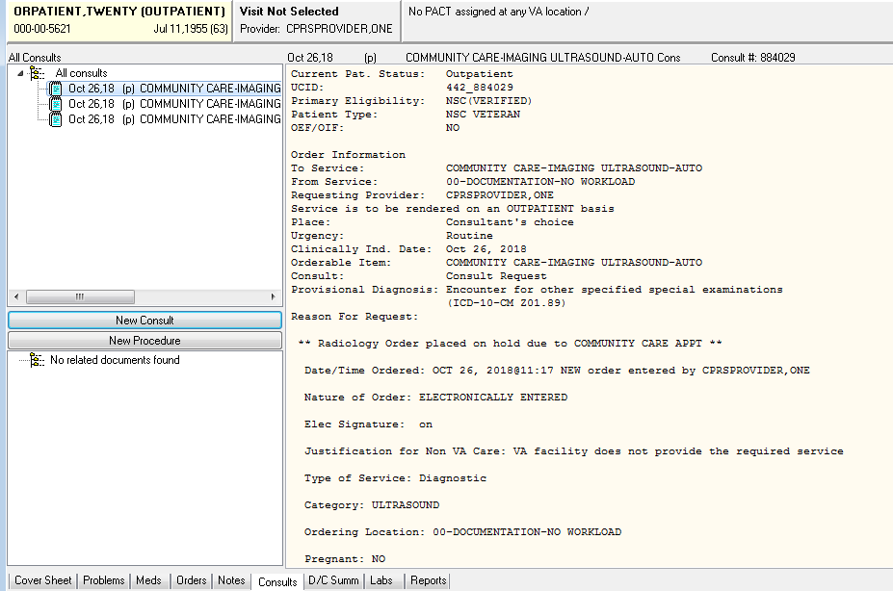
- At the bottom of the Consult Detail you will see that a comment has been added which contains tags that are headed by #COI#; these are tags that are used by CDW when importing data for use in national reports.
Figure 27: Tags Displayed
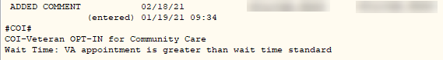
- These CDW tags will vary depending upon the Justification for Community Care option chosen. The following show all possible tags:
Figure 28: Justification for Community Care: VA facility does not provide the required service:
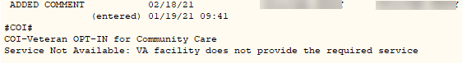
Figure 29: Justification for Community Care: Veteran lives more than drive time standards
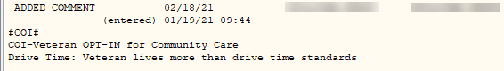
Figure 30: Justification for Community Care: Grandfathered
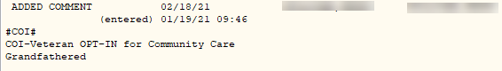
Figure 31: Justification for Community Care: Hardship
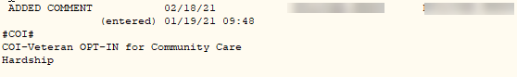
- If Justification for Community Care: 1703(e) Eligibility is chosen an EXPLAIN prompt appears.
Figure 32: Explain prompt
Enter response: 7 1703(e) Eligibility
EXPLAIN: This is an explanation for choosing justification 1703(e). If it's really long, the lines will wrap when displayed in CPRS. It can be up to 240 characters in length. Hope that is enough.................

- The following CDW tag will then be created.
Figure 33: 1703(e) Eligibility
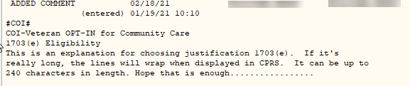

On the options above where an explanation is entered, the field can be three (3) to 240 characters in length. If the length of the text is greater than 74 characters, for it to be readable in CPRS, the text will be broken down into two (2) or more lines. The text will be broken on a word, never in the middle of a word.

Figure 34: Best medical interest of Veteran (per Licensed Independent Provider only)
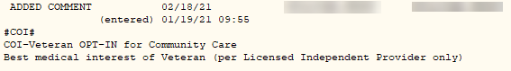
Figure 35: Order Details
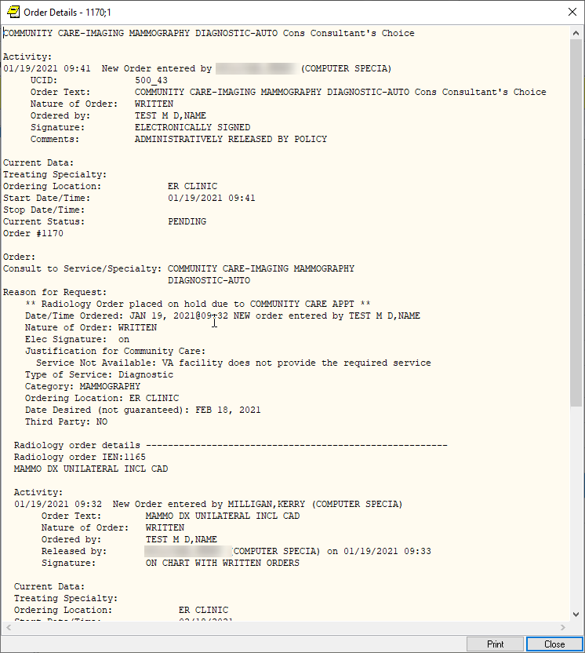
- Click Print or Close.

