

VistA Blood Establishment Computer Software (VBECS) Version 1.5.2

Patch Installation Guide

June 2011

Department of Veterans Affairs
Product Development
This page intentionally left blank.
Unauthorized access or misuse of this system and/or its data is a federal crime. Use of all data must be in accordance with VA security and privacy policies.

The U.S. Food and Drug Administration classifies this software as a medical device. Unauthorized modifications will render this device an adulterated medical device under Section 501 of the Medical Device Amendments to the Federal Food, Drug, and Cosmetic Act. Acquiring and implementing this software through the Freedom of Information Act requires the implementer to assume total responsibility for the software and become a registered manufacturer of a medical device, subject to FDA regulations. Adding to or updating VBECS software without permission is prohibited.

This page intentionally left blank.

Revision History
Date | Revision | Description | Author
09-08-10 | 1.0 | Modified VistA Blood Establishment Computer Software (VBECS) Version 1.5.1, Version 2.0:  Global: Replaced “August 2010” with “September 2010” in the footer.  Global: Replaced “1.5.1” with “1.5.2”.  Global: Replaced “2.0” with “1.0” in the footer.  Global: Replaced “…060910” with” …090210”.  Global: Changed 1.5.1.1 to 1.5.2.1.  Global: Changed “200,811,979” to “199,854,323”.  Changed 1.5.0.4 to 1.5.1.1 where applicable.  Replaced Figures: 1, 6, 7, 8, 9, 10, 11, 13, 14, 15, 16, 17, 19, 21, 30, 31, 33, 34, 35, 37, 38, 39, 40, 41, 43 and 45.  VBECS Versions section: Changed “In future releases, the VBECS version” to “The VBECS version”.  Delete Patch Files section (Test and Production), Step 2 second bullet item: Added “mmddyy represents the current date”.  Appendix A: Changed “1504” to “1534” in both examples.  Appendix B, VBECS Admin AD Group table column: Changed “TBD” to the actual group name for the Manchester, Providence and Clarksburg facilities.  Appendix B: Removed the extra “s” from the last column of the first row of Table 1.  Appendix B: Removed the blank row from Row 8 of Table 1.  Appendix B: Updated the Server Administrative Group and VBECS Admin AD Group names for Facility# 618, Minneapolis.  Removed Appendix H and all references to Appendix H. | BBM team
01-05-11 | 2.0 | Modified VistA Blood Establishment Computer Software (VBECS) Version 1.5.2, Version 1.0:  Title page: Changed “Office of Enterprise Development” to “Product Development”.  Global: Replaced “September 2010” with “January 2011” in the footer.  Global: Replaced “1.0” with “2.0” in the footer.  Global: Replaced 1.5.2.1 with 1.5.2.2.  Global: Replaced “…090210” with” …010311”.  Global: Changed “199,854,323” to “200,054,059”.  Replaced Figures: 1, 8, 9, 10, 11, 12, 13, 15, 16, 17, 18, 19, 21, 23, 34, 35, 36, 37, 38, 39, 41, 42, 43, 44, 45, 47 and 49.  VBECS Version Numbers section: Split into two paragraphs and reworded 1st sentence of second paragraph.  Execute VBECS Patch Scripts against the Cluster (Test and Production): Step 10: Revised warning box.  Download the VBECS 1.5.2.2 Patch File section (Test and Prod):  - Reordered the steps by moving Step 3 to Step1.  - Added Steps 2 through 6 to verify if temp folder exists on the active and passive nodes (DR 3948)  - Step 12 changed “VHAMASTER” to “YOUR_DOMAIN” in example  Prerequisite for Installation (Test): Revised Steps 1 and 3.  Prerequisite for Installation (Production): Revised Steps 2 and 4.  Appendix B – Server Administrative Group and VBECS Admin AD Group table columns: Updated the columns and changed “TBD” to the actual group name for VISNs 1 through 5. | BBM team
03-01-11 | 3.0 | Modified VistA Blood Establishment Computer Software (VBECS) Version 1.5.2, Version 2.0:  Global: Replaced “January 2011” with “March 2011” in the footer.  Global: Replaced “2.0” with “3.0” in the footer.  Global: Changed “nnn- represents ‘vha’ or ‘region name’ (e.g. RO1)” to “nnn – represents the top-level domain (e.g. ‘vha’, or ‘r01’)”.  Download and Verify the Contents of the VBECS Patch (Test and Production Installation):  - Section 1: Download the VBECS 1.5.2.2 Patch File - Reworded Step 1b (DR 4012).  - Section 2: Verify the Contents of the VBECS 1.5.2.2 Patch File - Revised Steps 8 through16 (DR 4012).  Section 5: Delete Patch Files (Test and Production Installation):  - Revised Step 2 and replaced Figures 24 and 47 (DR 4012).  - Revised warning text message after Step 7 (DR 4012).  Updated Appendices E and F, Section 2: Verify the contents of the VBECS 1.5.2.2 Patch File (DR 4012).  Execute VBECS Patch Test Scripts against the Cluster (Test and Prod): Updated second Warning boxes to read “emails” instead of “messages”.  Execute VBECS Patch Test Scripts against the Cluster (Test and Prod): Updated the Warning boxes in Steps 14 to direct the user to Appendix G for a possible resolution before filing a Remedy ticket.  Verify the Contents of the VBECS 1.5.2.2 Patch File (Prod): Changed “Appendix E” to “Appendix F” in Steps 9 and 11. | BBM team
05-10-11 | 4.0 | Modified VistA Blood Establishment Computer Software (VBECS) Version 1.5.2, Version 3.0:  Global: Replaced “March 2011” with “June 2011” in the footer.  Global: Replaced “3.0” with “4.0” in the footer.  Section1: Download the VBECS 1.5.2.2 Patch File (Test and Prod)  - Replaced Steps 7 through 19 with new Steps 7 through 10 (DR 4030).  Replaced Figures 12 and 34 with updated screen captures. (DR 4030).  Verify the Contents of the VBECS 1.5.2.2 Patch File (Test and Prod):  - Changed “Contains is 397 Files, 45 Folders” to “Contains 396 Files, 45 Folders” in Step 8.  - Moved Step 12 to after Step 9, making it the new Step 10 and renumbering the subsequent steps.  - Added “Click OK” to the beginning of Step 13.  Updated Appendices E and F: Section1: Download the VBECS 1.5.2.2 Patch File (DR 4030) | BBM team
06-15-11 | 5.0 | Modified VistA Blood Establishment Computer Software (VBECS) Version 1.5.2, Version 4.0:  Global: Replaced “4.0” with “5.0” in the footer.  Installation Procedure for the Test and Production Environments: Added message “Server name representations in the document:  For Region 1sites; R01YYYNODXXX01, YYY represents the Data Center location (SCR or DVR) and XXX represents the Site Code.  For all other sites; VHAXXXNODZ1, XXX represents the Site Code.” (DR 4144)  Download the VBECS 1.5.2.2 Patch File (Test and Prod):  Step 9: Changed “double-click the file” to “click and save the file”.  After Step 9, added a warning box message to refer to Appendix H if download errors are encountered. (DR 4144)  Execute VBECS Patch Scripts against the Cluster (Test and Prod):  Deleted Step 8 to verify if VistA patches were applied, since there are no VistA patches for this release and updated Section 4 in Appendices E and F. (DR 4144)  Appendix G (Troubleshooting): Added VBECS FTP Download Security Alert.  Added Appendix H: Adding VBECS FTP Site to the Trusted Sites in Internet Explorer. (DR 4144) | BBM team

This page intentionally left blank.
Table of Contents

Revision History iii
Table of Contents vii
Introduction 1
VBECS Version Numbers 1
Related Manuals and Reference Materials 2
Orientation 3
How This Installation Guide Is Organized 3
Warnings 3
Screen Shots 3
Product Support 3
Problems? 3
Installation Procedure for the Test Environment 5
Download and Verify the Contents of the VBECS Patch 5
1 Download the VBECS 1.5.2.2 Patch File 5
2 Verify the Contents of the VBECS 1.5.2.2 Patch File 8
3 Prerequisites for Installation 12
4 Execute VBECS Patch Scripts against the Cluster 13
5 Delete Patch Files 18
Installation Procedure for the Production Environment 19
Download and Verify the Contents of the VBECS Patch 19
1 Download the VBECS 1.5.2.2 Patch File 19
2 Verify the Contents of the VBECS 1.5.2.2 Patch File 22
3 Prerequisites for Installation 26
4 Execute VBECS Patch Scripts against the Cluster 27
5 Delete Patch Files 32
Glossary 33
Appendices 35
Appendix A: Installation Logs 35
Appendix B: Active Directory Server Administrator Groups 37
Appendix C: Instructions for Capturing Screen Shots for Installation Records 41
Appendix D: Setup Detailed Folders View 43
Appendix E: VBECS Patch Installation Record Form for the Test Environment 45
Installation Procedure for the Test Environment 45
1 Download the VBECS 1.5.2.2 Patch File 45
2 Verify the Contents of the VBECS 1.5.2.2 Patch File 45
3 Prerequisites for Installation 45
4 Execute VBECS Patch Scripts against the Cluster 45
5 Delete the Patch Files 45
Appendix F: VBECS Patch Installation Record Form for the Production Environment 47
Installation Procedure for the Production Environment 47
1 Download the VBECS 1.5.2.2 Patch File 47
2 Verify the Contents of the VBECS 1.5.2.2 Patch File 47
3 Prerequisites for Installation 47
4 Execute VBECS Patch Scripts against the Cluster 47
5 Delete Patch Files 47
Appendix G: Troubleshooting Messages 49
Appendix H: Adding VBECS FTP Site to the Trusted Sites in Internet Explorer 53
Notes 57
Index 59

Introduction
The VistA Blood Establishment Computer Software (VBECS) system replaces the previous blood bank software (VistA Blood Bank v5.2) at the Department of Veterans Affairs (VA). The main purpose of VBECS is to automate the daily processing of blood inventory and patient transfusions in a hospital transfusion service.
VBECS is an improved Blood Bank application that facilitates ongoing compliance with Food and Drug Administration (FDA) standards for medical devices and enhances the VA Veterans Health Administration’s (VHA’s) ability to produce high-quality blood products and services to veterans. The system follows blood bank standards, standards of national accrediting agencies, FDA regulations, and VA policies.
Unauthorized access or misuse of this system and/or its data is a federal crime. Use of all data must be in accordance with VA security and privacy policies.

The U.S. Food and Drug Administration classifies this software as a medical device. Unauthorized modifications will render this device an adulterated medical device under Section 501 of the Medical Device Amendments to the Federal Food, Drug, and Cosmetic Act. Acquiring and implementing this software through the Freedom of Information Act requires the implementer to assume total responsibility for the software and become a registered manufacturer of a medical device, subject to FDA regulations. Adding to or updating VBECS software without permission is prohibited.

This document describes how server support staff members [Information Resource Management (IRM) or data center personnel] install VBECS. It describes the scripts that must be executed and the arguments that must be supplied. It specifies how to read script output and the actions that must be performed as a result of the output.

VBECS Version Numbers
The VBECS 1.5.2 patch release represents a change in how the application version will be displayed to you, the customer. In previous VBECS patch releases, the user documentation referred to the VBECS version in a 4-digit format (e.g., 1.5.0.4 – where 1.5.0 represents the patch version and 4 is the patch build number). The build number is used by VBECS support for diagnostic and troubleshooting purposes.

In this and future releases, the VBECS version will be represented with only the first 3 digits (e.g., 1.5.2) and will appear that way in all user documentation to simplify readability. The full 4-digit version can still be found under the Help, About window in VBECS (Figure 1) and will appear in patch installation guides where build specific files are referenced.
Figure 1: Example of Help, About VBECS
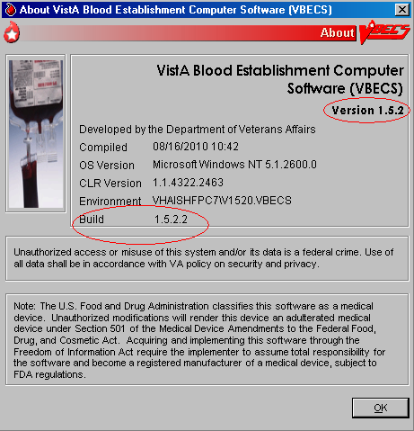

Related Manuals and Reference Materials
None

Orientation

How This Installation Guide Is Organized
Maintain the order of the steps for successful installation.
This guide is organized as follows:
See the Installation Procedure for the Test Environment section for installing the test environment.
See the Installation Procedure for the Production Environment section for installing the production environment.
See Appendix A: Installation Logs for the location of logs that may be useful in troubleshooting.
See Appendix G: Troubleshooting Messages for examples of troubleshooting messages.
A section for notes is included at the end of the document.

Warnings
Outlined text with a caution icon is used throughout the guide to highlight warnings, limitations, and cautions:
Warnings, limitations, cautions
Read and follow these caution statements and warnings.

Screen Shots
Because VBECS is a medical device, screen shots must be captured at verification points throughout the installation to meet regulatory requirements for objective evidence and documentation.
A (camera) at the beginning of each step that requires a screen capture will identify these points. For more information, see Appendix C: Instructions for Capturing Screen Shots for Installation Records.
Screen shots included in this guide are examples only and may not display actual data.

Product Support

Problems?
Contact your Information Resource Management (IRM) or Laboratory Automated Data Processing Application Coordinator (ADPAC) if you encounter problems and for training support.

VA Service Desk Primary Contact
For Information Technology (IT) support, call the VA Service Desk (VASD), 888-596-HELP (4357) (toll free), 24 hours per day, 7 days per week. [Users with access to the VASD-supported request tool (e.g., Remedy) may file a ticket in lieu of calling the VASD.]

VA Service Desk Alternate Contacts
- During business hours: As an alternate to the toll-free number, call 205-554-4710 (or 205-554-4711 through 205-554-4725), Monday through Friday (excluding holidays), 8:00 a.m. to 7:30 p.m. (Eastern Time).
- Outside business hours: Call 205-554-3459 (or 205-554-3460 through 205-554-3465, 205-554-3472, 205-554-3475, or 205-554-3482 through 205-554-3485).
- Web site: http://vaww.itsupportservices.va.gov/vasd_home.asp [VA Service Desk (VASD)]
- Email: vhacionhd@va.gov

Installation Procedure for the Test Environment

Do not deviate from the instructions in this guide.

No users are permitted on the system during the patch installation. Any users on the system at the start of the patch process will be disconnected.

Coordinate the patch installation with the blood bank supervisor. Notify the supervisor that the patch installation requires one to two hours of downtime without interruption.

Server name representations in the document:
For Region 1sites; R01YYYNODXXX01, YYY represents the Data Center location (SCR or DVR) and XXX represents the Site Code.
For all other sites; VHAXXXNODZ1, XXX represents the Site Code.
Use the Microsoft Word .doc format of the document when copying and pasting sections of the document.

Download and Verify the Contents of the VBECS Patch

Download the VBECS 1.5.2.2 Patch File
Prerequisites for VBECS FTP Download:
- The installer must be a server administrator in accordance with Appendix B: Active Directory Server Administrator Groups.
- The installer must be a member of the VBECS Admin AD Group in accordance with Appendix B: Active Directory Server Administrator Groups.

To download the VBECS 1.5.2.2 patch file from the VBECS FTP Site:
- Complete Sub-steps a through d to save a copy of Appendix E: VBECS Patch Installation Record Form for the Test Environment to the local workstation. Any reference to Appendix E after the document is initially saved will be referring to the saved copy.
- Open VistA Blood Establishment Computer Software (VBECS) 1.5.2 Patch Installation Guide.
- Using the .doc format of this document, select the contents of Appendix E: VBECS Patch Installation Record Form for the Test Environment and copy and paste into a new Word document.
- Add a header to the document as “VBECS Patch Installation Record <Cluster_name> 1.5.2 Test <mmddyy>” and a footer containing “Page X of Y”.
- Save Appendix E: VBECS Patch Installation Record Form for the Test Environment as “VBECS Patch Installation Record <Cluster_name> 1.5.2 Test <mmddyy>”
(e.g., VBECS Patch Installation Record VHAXXXCLUZ1 1.5.2 Test 070809 or
VBECS Patch Installation Record R01YYYCLUXXX01 1.5.2 Test 070809); where <mmddyy> represents the current date.
- Open a remote desktop connection to the cluster being patched.
- Open Windows Explorer, and type \\VHAXXXNODZ1\C$ or \\R01YYYNODXXX01\C$ and press Enter (Figure 2).
Figure 2: Verify Temp folder on NODZ1
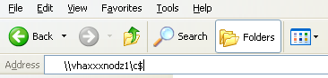
- If a folder named “temp” does not exist, click File, New, Folder. Name this folder “temp” (Figure 3).
Figure 3: Creating the Temp Folder
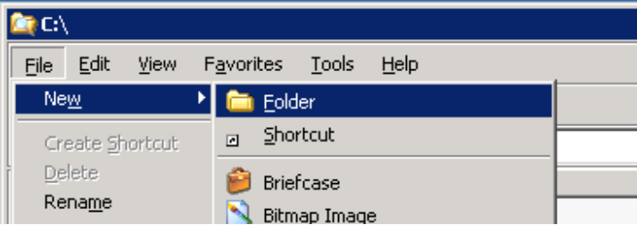
- In the Windows Explorer window already opened, type \\VHAXXXNODZ2\C$ or \\R01YYYNODXXX02\C$ and press Enter (Figure 4).
Figure 4: Verify Temp folder on NODZ2
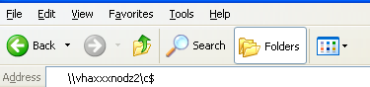
- If a folder named “temp” does not exist, click File, New, Folder. Name this folder “temp” (Figure 3).
- Right-click Start, Explorer. In the address field, type ftp://10.3.21.76:20001 (Figure 5) and press Enter.
Figure 5: ftp://10.3.21.76:20001
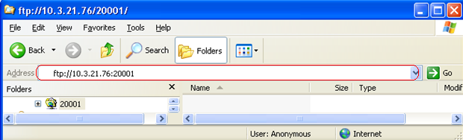
- At the User name prompt of the Log On As dialog, type your_domain and your_user_name (e.g. YOUR_DOMAIN\YOUR_USER_NAME) and at the Password prompt, type your password (Figure 6).
Figure 6: Log On As
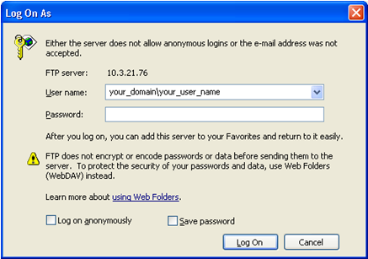
If access problems are encountered, please file a Remedy ticket. Do not proceed until the ticket is resolved.
- Click the Log On button. Right-click the VBECS_Patch_1.5.2.2_010311.zip and select copy (Figure 7). (** if the VBECS_Patch_1.5.2.2_010311.zip appears as a link, click and save the file in the targeted location specified in Step 10).
Figure 7: VBECS_Patch_1.5.2.2_010311.zip File
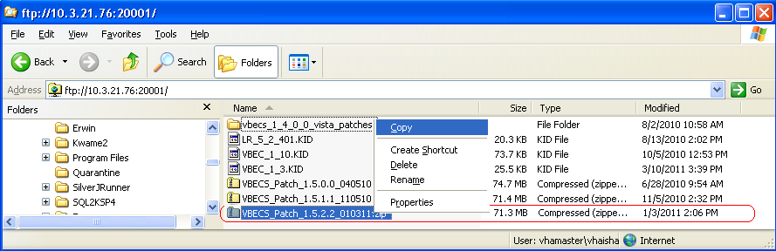
If you encounter the 'Your current settings do not allow you do download files from this location' error, see Appendix H: Adding VBECS FTP Site to the Trusted Sites in Internet Explorer for instructions on how to resolve the problem.
- Using Windows Explorer, navigate to the C:\Temp folder. Right-click and select Paste. The VBECS_Patch_1.5.2.2_010311.zip will be copied to this location.

Verify the Contents of the VBECS 1.5.2.2 Patch File
- On the remote desktop connection to the cluster already open, use Windows Explorer to navigate to the c:\temp folder.
- Right-click on the VBECS_Patch_1.5.2.2_010311.zip file and select Extract All (Figure 8).
Figure 8: Example of Extracting Patch Contents
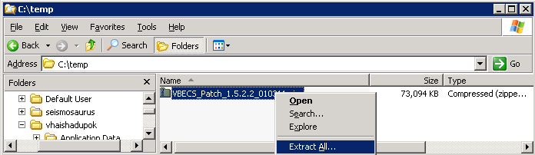
- After the Extraction Wizard opens, click Next.
- Click Next to extract the contents of the patch zip file to the temp directory (Figure 9).
Figure 9: Extraction Wizard
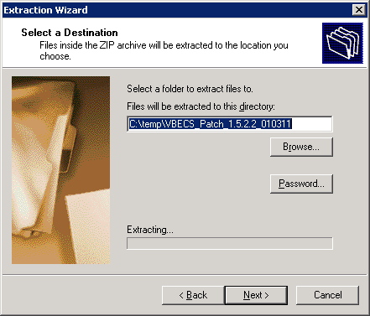
- After the extraction completes, uncheck Show extracted files and click Finish (Figure 10).
Figure 10: Extraction Complete
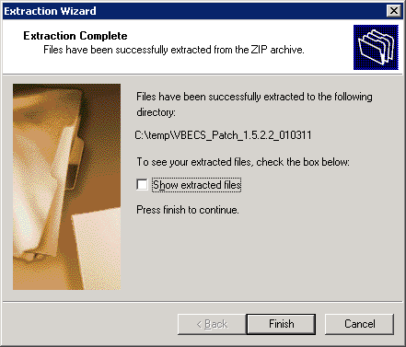
- Verify that the extraction completes and a C:\temp\VBECS_Patch_1.5.2.2_010311 folder is created.
- Using Windows Explorer, right-click on the VBECS_Patch_1.5.2.2_010311 folder and select Properties (Figure 11).
Figure 11: Example of Folder Properties
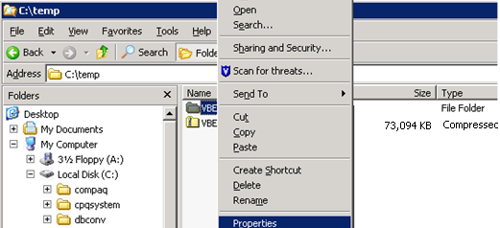
- In the VBECS_Patch_1.5.2.2_010311 Properties window (Figure 12), verify:
  - Size is 190 MB (200, 054, 059 bytes)
  - Contains 396 Files, 45 Folders
If the number of files and number of bytes do not match, stop and file a Remedy ticket. Do not proceed until the ticket is resolved.
- After verifying that the contents of the VBECS_Patch_1.5.2.2_010311 file match, check the box in Appendix E: VBECS Patch Installation Record Form for the Test Environment.
- In the Attributes section, uncheck the Read-only check box (Figure 12).
- Capture a screen shot of the VBECS_Patch_1.5.2.2_010311 Properties window.
- Insert the screen shot in Appendix E: VBECS Patch Installation Record Form for the Test Environment.
Figure 12: VBECS Patch folder Properties
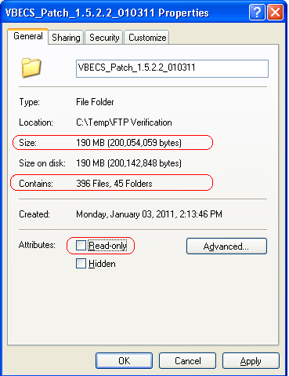
- Click OK. In the Confirm Attribute Changes window, select the Apply Changes to this folder, subfolders and files option if it is not selected, and click OK (Figure 13).
Figure 13: Confirm Attribute Changes
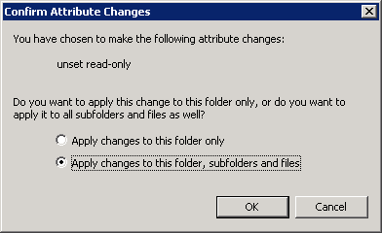
- Using Windows Explorer, navigate to the c:\temp folder.
- Select the VBECS_Patch_1.5.2.2_010311.zip file.
- While holding the Shift key, press the Delete key. Click Yes to confirm file deletion (Figure 14).
Figure 14: Delete Zip File
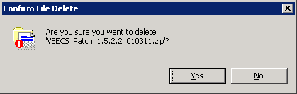

Prerequisites for Installation
- VBECS 1.5.1.1 is installed and validated.
- Verify VistA Test account is up to date with all released patches.
- Verify that there are no active user sessions on the servers.
- Refer to the latest approved version of the VistA Blood Establishment Computer Software (VBECS) Installation Guide, Appendices titled Server Configuration and Password List for details on Server Names, IP addresses, passwords, etc.
- On the remote desktop connection to the cluster already open, execute the steps in Appendix D: Setup Detailed Folders View to show file extensions on the installation workstation.

Execute VBECS Patch Scripts against the Cluster
Patching the servers will require a reboot. Plan to execute the VBECS patch scripts when no active users are on the servers. The system warns active users that they will be disconnected during the configured timeout period.

After the upgrade, warning emails with the subject ‘Operations Manager Critical Error Alert’ are normal and should be ignored. They are merely noting that changes have been made to the various VBECS files which is expected during a software upgrade.

Do not run any additional applications on the server while the patch is executing.
- On the remote desktop connection to the cluster already open, use Windows Explorer to navigate to the c:\temp\VBECS_Patch_1.5.2.2_010311 folder and double-click the prepare.bat file (Figure 15).
Figure 15: VBECS Patch Folder
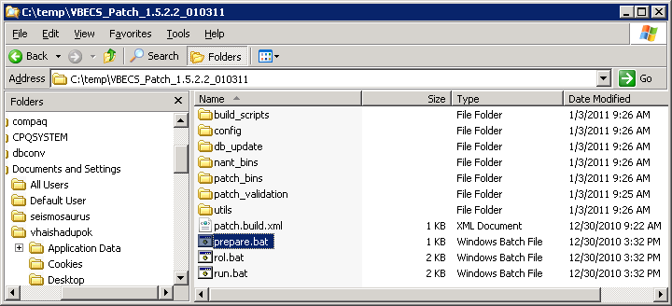
- A VBECS Patch shortcut is created (Figure 16).
Figure 16: VBECS Patch Shortcut
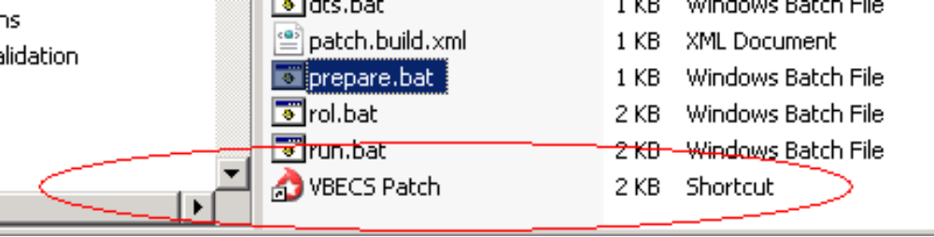
- Double-click on the VBECS Patch shortcut to initiate the VBECS patch configuration.
- A VBECS Patch form will open.
- Enter the following for the required fields (Figure 17).
  - Cluster IP Address – This is the IP address of the VBECS cluster [initially noted for installation on the Server Configuration Checklist in the VistA Blood Establishment Computer Software (VBECS) Installation Guide]. Verify this information with a system administrator. It will be used to identify the clustered servers on which the patch will be installed.
  - Contact E-mail – This is the email address of the contact person or group.
  - Contact Name – This is the full name (usually the patch installer) displayed in the patch installation shutdown message. Users will contact this person if the patch installation interferes with their work.
  - Contact Phone – This is the telephone number of the contact person.
  - Message TimeOut – This is the number of minutes current VBECS users will be warned they have to complete activities before patching disconnects their session. . If there are no users on the system override the default 10 minute value by entering -1. Users will not be warned if this value is -1.
  - SQL Server Name – This is the name of the VBECS SQL server [initially noted for installation on the Configuration Checklist in the VistA Blood Establishment Computer Software (VBECS) Installation Guide]. Verify this information with a system administrator. It will be used to identify the database to be patched.
  - VBECS Environment – This is the VBECS environment. Select test to patch VBECS Test environment.
Figure 17: Example of VBECS Patch Form
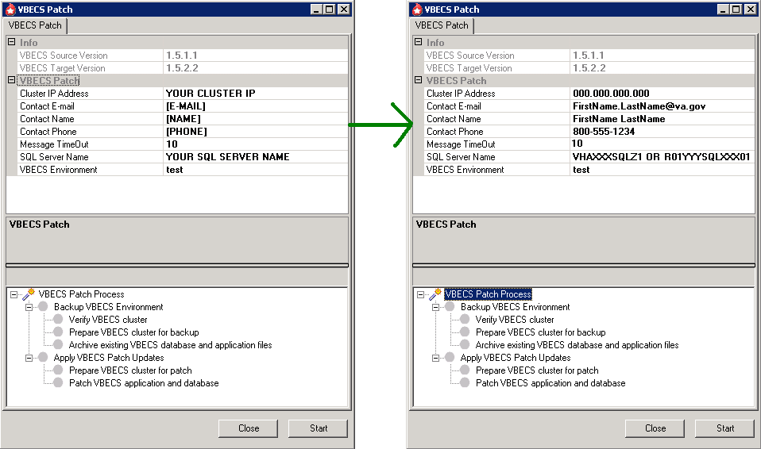
- Click Start.
- A prompt to verify that all correct VistA patches are installed appears (Figure 18).
Figure 18: Required VistA Patches Dialog
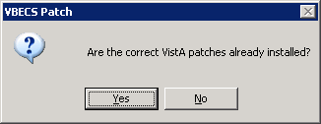
- Click Yes to proceed on required VistA patches dialog. The VBECS Patch process starts. The patch will complete within 30 minutes.
- Refer to Figure 19 for the following:
- A green “patch is working” animation () in the bottom left of the VBECS Patch form will be in motion while the patching is in progress.
- The blue progress bar in the middle of form () will increment based on the overall patch progress.
- VBECS Patch Process checkpoints are displayed in the lower portion of the form. A green check mark indicates that the VBECS Patch process step completed successfully.

If the patch takes longer than 5 minutes to complete the first 3 checks, file a Remedy ticket immediately. Do not release VBECS for use until the ticket is resolved.

If a Patch fails to successfully complete within 30 minutes, file a Remedy ticket immediately. Do not stop the patch process and do not release VBECS for use until the ticket is resolved.

Figure 19: Example of VBECS Patch Process Form
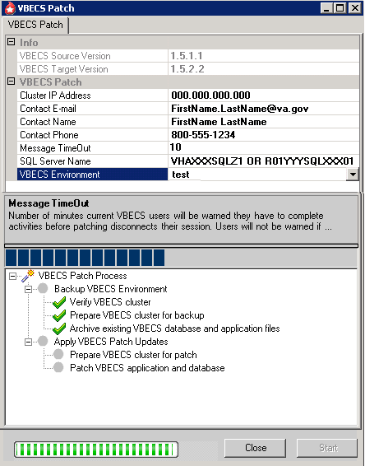
- Active users (users connected to the system through remote desktop) will receive a message indicating the number of minutes they have to complete their work and log out (Message TimeOut argument entered in Step 5). The patch will not make any system changes during this timeout period (Figure 20).
Figure 20: Example of Messenger Service
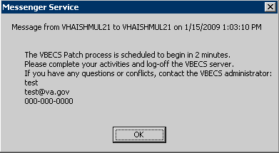
- Click OK, after the timeout period had expired, a message signifying the final opportunity to abort the patch installation is displayed (Figure 21).
Figure 21: VBECS Patch: Continue Patch Message
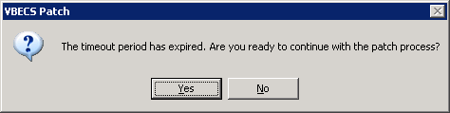
- Click Yes to continue with the patch installation. IMPORTANT: If active users exist, their sessions on the VBECS server will be automatically terminated. Click No to abort the current patching attempt and restart the patch process at a later time.
- When the patch script finishes successfully a “VBECS Patch process completed successfully” message will be received (Figure 22).
Figure 22: VBECS Patch Process Complete Message
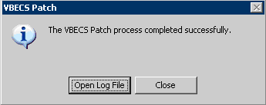
If a Patch Failure message is displayed, go to Appendix G: Troubleshooting Messages. If no solution to the failure message is found, please file a Remedy ticket immediately. Do not proceed or release VBECS for use until the ticket is resolved.
- Capture a screen shot of VBECS Patch process completed successfully.
- Insert the screen shot in Appendix E: VBECS Patch Installation Record Form for the Test Environment.
- A log file will be created in the
L:\VBECS_Archive\VBECSRecords\VBECS_<mmddyy>_1.5.1.1_to_1.5.2.2\test directory, with <cluster>.<nnn.med.va.gov>_VBECS_1.5.2.2_test_<hhmm>.log as the file name, where:
- <mmddyy> represents the current date.
- <hhmm> represents the hour and minute the patch began execution.
- <nnn> represents top-level domain (e.g. ‘vha’ or ‘r01’).
For example, vhaxxxcluz1.vha.med.va.gov_VBECS_1.5.2.2_test_0928.log.
By design, there may be non-fatal errors and warnings within the log file output. Ignore warnings and non-fatal errors upon successful completion of the VBECS Patch process.

- Record the name of the log file in Appendix E: VBECS Patch Installation Record Form for the Test Environment.
- Click Close to close the VBECS Patch success message.
- Click Close on the VBECS Patch main window to exit the patch application.

Delete Patch Files
To delete the VBECS 1.5.2.2 Patch files:
- Open a remote desktop connection to the cluster, and use Windows Explorer to navigate to the c:\temp folder.
- Select the VBECS_Patch_1.5.2.2_010311 folder.
- While holding down the Shift key, press the Delete key. Click Yes to confirm file deletion (Figure 23).
Figure 23: Example of Patch Files for Deletion
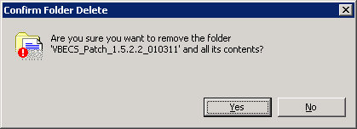
- Check the box in Appendix E: VBECS Patch Installation Record Form for the Test Environment.
- Print Appendix E: VBECS Patch Installation Record Form for the Test Environment and initial and date the printed copy. Save this with your records of previous VBECS installations.
- Manually check the box on the printed copy of Appendix E: VBECS Patch Installation Record Form for the Test Environment verifying that the form was printed, initialed and dated.
- Notify the blood bank that the patch has been successfully installed in the Test account and request the blood bank to verify that the Test account can receive orders.

For new VBECS installations: Begin VistA Database Conversion in accordance with Blood Bank Pre-Implementation Data Validation, Mapping, and Conversion ADPAC Guide if the conversion process has not already been completed.
Installation Procedure for the Production Environment

Do not deviate from the instructions in this guide.

No users are permitted on the system during the patch installation. Any users on the system at the start of the patch process will be disconnected.

Coordinate the patch installation with the blood bank supervisor. Notify the supervisor that the patch installation requires one to two hours of downtime without interruption.

Server name representations in the document:
For Region 1sites; R01YYYNODXXX01, YYY represents the Data Center location (SCR or DVR) and XXX represents the Site Code.
For all other sites; VHAXXXNODZ1, XXX represents the Site Code.
Use the Microsoft Word .doc format of the document when copying and pasting sections of the document.

Download and Verify the Contents of the VBECS Patch

Download the VBECS 1.5.2.2 Patch File
Prerequisites for VBECS FTP Download:
- The installer must be a server administrator in accordance with Appendix B: Active Directory Server Administrative Groups.
- The installer must be a member of the VBECS Admin AD Group in accordance with Appendix B: Active Directory Server Administrative Groups.

To download the VBECS 1.5.2.2 patch file from the VBECS FTP Site:
- Complete Sub-steps a through d to save a copy of Appendix F: VBECS Patch Installation Record Form for the Production Environment to the local workstation. Any reference to Appendix F after the document is initially saved will be referring to the saved copy.
- Open VistA Blood Establishment Computer Software (VBECS) 1.5.2 Patch Installation Guide.
- Using the .doc format of this document, select the contents of Appendix F: VBECS Patch Installation Record Form for the Production Environment and copy and paste into a new Word document.
- Add a header to the document as “VBECS Patch Installation Record <Cluster_name> 1.5.2 Prod <mmddyy>” and a footer containing “Page X of Y”.
- Save Appendix F: VBECS Patch Installation Record Form for the Production Environment as “VBECS Patch Installation Record <Cluster_name> 1.5.2 Prod <mmddyy>”
(e.g., VBECS Patch Installation Record VHAXXXCLUZ1 1.5.2 Prod 070809 or VBECS Patch Installation Record R01YYYCLUXXX01 1.5.2 Test 070809); where <mmddyy> represents the current date.
- Open a remote desktop connection to the cluster being patched.
- Open Windows Explorer, and type \\VHAXXXNODZ1\C$ or \\R01YYYNODXXX01\C$ and press Enter (Figure 24).
Figure 24: Verify Temp folder on NODZ1
- If a folder named “temp” does not exist, click File, New, Folder. Name this folder “temp” (Figure 25).
Figure 25: Creating the Temp Folder
- In the Windows Explorer window already opened, type \\VHAXXXNODZ2\C$ or \\R01YYYNODXXX02\C$ and press Enter (Figure 26).
Figure 26: Verify Temp folder on NODZ2
- If a folder named “temp” does not exist, click File, New, Folder. Name this folder “temp” (Figure 25).
- Right-click Start, Explorer. In the address field, type ftp://10.3.21.76:20001 (Figure 27) and press Enter.
Figure 27: ftp://10.3.21.76:20001
- At the User name prompt On the Log On As dialog, type your_domain and your_user_name (e.g. YOUR_DOMAIN\YOUR_USER_NAME) and at the Password prompt, type your password (Figure 28).
Figure 28: Log On As
If access problems are encountered, please file a Remedy ticket. Do not proceed until the ticket is resolved.
- Click the Log On button. Right-click the VBECS_Patch_1.5.2.2_010311.zip and select copy (Figure 29). (** if the VBECS_Patch_1.5.2.2_010311.zip appears as a link, click and save the file in the targeted location specified in Step 10).
Figure 29: VBECS_Patch_1.5.2.2_010311.zip File
If you encounter the 'Your current settings do not allow you do download files from this location' error, see Appendix H: Adding VBECS FTP Site to the Trusted Sites in Internet Explorer for instructions on how to resolve the problem.
- Using Windows Explorer, navigate to the C:\Temp folder. Right-click and select Paste. The VBECS_Patch_1.5.2.2_010311.zip will be copied to this location.

Verify the Contents of the VBECS 1.5.2.2 Patch File
- On the remote desktop connection to the cluster already open, use Windows Explorer to navigate to the c:\temp folder.
- Right-click on the VBECS_Patch_1.5.2.2_010311.zip file and select Extract All (Figure 30).
Figure 30: Example of Extracting Patch Contents
- After the Extraction Wizard opens, click Next.
- Click Next to extract the contents of the patch zip file to the temp directory (Figure 31).
Figure 31: Extraction Wizard

- After the extraction completes, uncheck Show extracted files and click Finish (Figure 32).
Figure 32: Extraction Completed
- Verify that the extraction completes and a c:\temp\VBECS_Patch_1.5.2.2_010311 folder is created.
- Using Windows Explorer, right-click on the VBECS_Patch_1.5.2.2_010311 folder and select Properties (Figure 33).
Figure 33: Example of Folder Properties
- In the VBECS_Patch_1.5.2.2_010311 Properties window (Figure 34), verify:
  - Size is 190 MB (200, 054, 059 bytes)
  - Contains 396 Files, 45 Folders
If the number of files and number of bytes do not match, stop and file a Remedy ticket. Do not proceed until the ticket is resolved.
- After verifying that the contents of the VBECS_Patch_1.5.2.2_010311 file match, check the box in Appendix F: VBECS Patch Installation Record Form for the Production Environment.
- In the Attributes section, uncheck the Read-only check box (Figure 34).
- Capture a screen shot of the VBECS_Patch_1.5.2.2_010311 Properties window.
- Insert the screen shot in Appendix F: VBECS Patch Installation Record Form for the Production Environment.
Figure 34: VBECS Patch folder Properties
- Click OK. In the Confirm Attribute Changes window, select the Apply Changes to this folder, subfolders and files option if it is not selected and click OK (Figure 35).
Figure 35: Confirm Attribute Changes
- Using Windows Explorer, navigate to the c:\temp folder.
- Select VBECS_Patch_1.5.2.2_010311.zip file.
- While holding the Shift key, press the Delete key. Click Yes to confirm file deletion (Figure 36).
Figure 36: Delete Zip File

Prerequisites for Installation
- VBECS 1.5.1.1 is installed.
- VBECS 1.5.2.2 is installed and validated in the Test environment.
- Verify VistA Production account is up to date with all released patches.
- Verify that there are no active user sessions on the servers.
- Refer to the latest approved version of the VistA Blood Establishment Computer Software (VBECS) Installation Guide, Appendices titled Server Configuration and Password List for details on Server Names, IP addresses, passwords, etc.
- Using the remote desktop connection to the cluster already open, execute the steps in Appendix D: Setup Detailed Folders View to show file extensions on the installation workstation.

Execute VBECS Patch Scripts against the Cluster
Patching the servers will require a reboot. Plan to execute the VBECS patch when no active users are on the servers. The system warns active users that they will be disconnected during the configured timeout period.

After the upgrade, warning emails with the subject ‘Operations Manager Critical Error Alert’ are normal and should be ignored. They are merely noting that changes have been made to the various VBECS files which is expected during a software upgrade.

Do not run any additional applications on the server while the patch is executing.
- On the remote desktop connection to the cluster already open, use Windows Explorer to navigate to the c:\temp\VBECS_Patch_1.5.2.2_010311 folder and double-click the prepare.bat file (Figure 37).
Figure 37: VBECS Patch Folder
- A VBECS Patch shortcut is created (Figure 38).
Figure 38: VBECS Patch Shortcut

- Double-click on the VBECS Patch shortcut to initiate the VBECS patch configuration.
- A VBECS Patch form will open.
- Enter the following for the required fields (Figure 39).
- Cluster IP Address – This is the IP address of the VBECS cluster [initially noted for installation on the Server Configuration Checklist in the VistA Blood Establishment Computer Software (VBECS) Installation]. Verify this information with a system administrator. It will be used to identify the clustered servers on which the patch will be installed.
- Contact E-mail – This is the email address of the contact person or group.
- Contact Name – This is the full name (usually the patch installer) displayed in the patch installation shutdown message. Users will contact him if the patch installation interferes with their work.
- Contact Phone – This is the telephone number of the contact person.
- Message TimeOut – This is the number of minutes current VBECS users will be warned they have to complete activities before patching disconnects their session. . If there are no users on the system override the default 10 minute value by entering -1. Users will not be warned if this value is -1.
- SQL Server Name – This is the name of the VBECS SQL server [initially noted for installation on the Configuration Checklist under SQL Server Information in the VistA Blood Establishment Computer Software (VBECS) Installation]. Verify this information with a system administrator. It will be used to identify the database to be patched.
- VBECS Environment – This is the VBECS environment. Select prod to patch VBECS Production environment.
Figure 39: Example of VBECS Patch Form
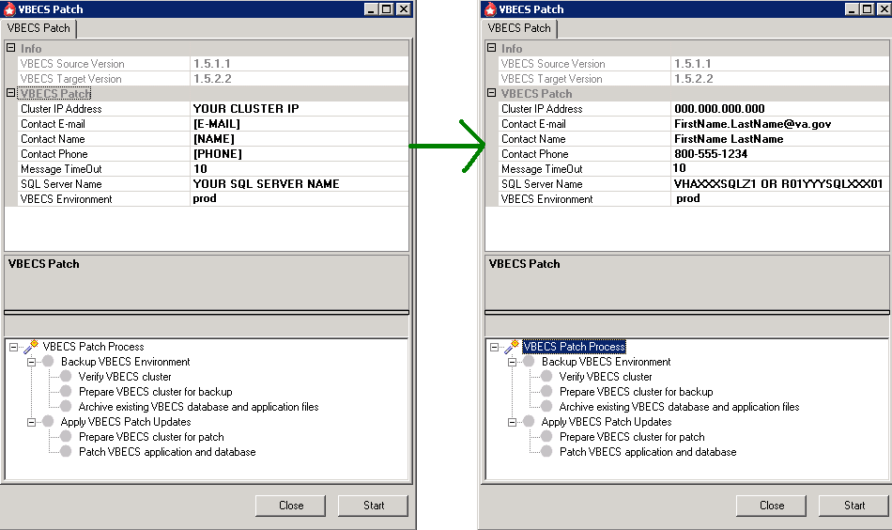
- Click Start.
- A prompt to verify that all correct VistA patches are installed appears (Figure 40).
Figure 40: Required VistA Patches Prompt
- Click Yes to proceed on required VistA patches dialog. The VBECS Patch process starts. The patch will complete within 30 minutes.
- Refer to Figure 41 for the following:
- A green “patch is working” animation () in the bottom left of the VBECS Patch form will be in motion while the patching is in progress.
- The blue progress bar in the middle of form () will increment based on the overall patch progress.
- VBECS Patch Process checkpoints are displayed in the lower portion of the form. A green check mark indicates that VBECS Patch process step completed successfully.

- If the patch takes longer than 5 minutes to complete the first 3 checks, file a Remedy ticket immediately. Do not release VBECS for use until the ticket is resolved.

If a Patch fails to successfully complete within 30 minutes, file a Remedy ticket immediately. Do not stop the patch process and do not release VBECS for use until the ticket is resolved.

Figure 41: Example of VBECS Patch Process Form
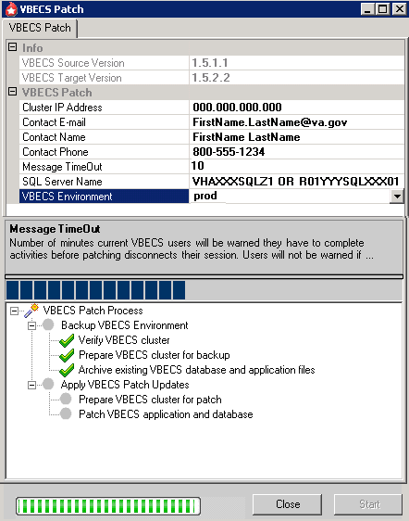
- Active users (users connected to the system through remote desktop), will receive a message indicating the number of minutes they have to complete their work and log out (Message TimeOut argument entered in Step 5). The patch will not make any system changes during this timeout period (Figure 42).
Figure 42: Example of Messenger Service
- Click OK, after the timeout period had expired, a message signifying the final opportunity to abort the patch installation is displayed (Figure 43).
Figure 43: VBECS Patch: Continue Patch Message
- Click Yes to continue with the patch installation. IMPORTANT: If active users exist, their sessions on the VBECS server will be automatically terminated. Click No to abort the current patching attempt and restart the patch process at a later time.
- When the patch script finishes successfully a “VBECS Patch process completed successfully” message will be received (Figure 44).
Figure 44: VBECS Patch Process Complete Message
If a Patch Failure message is displayed, go to Appendix G: Troubleshooting Messages. If no solution to the failure message is found, please file a Remedy ticket immediately. Do not proceed or release VBECS for use until the ticket is resolved.
- Capture a screen shot of VBECS Patch process completed successfully.
- Insert the screen shot in Appendix F: VBECS Patch Installation Record Form for the Production Environment.
- A log file will be created in the
L:\VBECS_Archive\VBECSRecords\VBECS_<mmddyy>_1.5.1.1_to_1.5.2.2\prod directory, with <cluster>.<nnn.med.va.gov>_VBECS_1.5.2.2_prod_<hhmm>.log as the file name, where:
- <mmddyy> represents the current date.
- <hhmm> represents the hour and minute the patch began execution.
- <nnn> represents top-level domain (e.g. ‘vha’ or ‘r01’).
For example, vhaxxxcluz1.vha.med.va.gov_VBECS_1.5.2.2_prod_0928.log.

By design, there may be non-fatal errors and warnings within the log file output. Ignore warnings and non-fatal errors upon successful completion of the VBECS Patch process.

- Record the name of the log file in Appendix F: VBECS Patch Installation Record Form for the Production Environment.
- Click Close to close the VBECS Patch success message.
- Click Close on the VBECS Patch main window to exit the patch application.

Delete Patch Files
To delete the VBECS 1.5.2.2 Patch files:
- On the remote desktop connection to the cluster already open, use Windows Explorer to navigate to c:\temp folder.
- Select the VBECS_Patch_1.5.2.2_010311 folder.
- While holding down the Shift key press the Delete key. Click Yes to confirm file deletion (Figure 45).
Figure 45: Example of Patch Files for Deletion
- Check the box in Appendix F: VBECS Patch Installation Record Form for the Production Environment.
- Print Appendix F: VBECS Patch Installation Record Form for the Production Environment and initial and date the printed copy. Save this with your records of previous VBECS installations.
- Manually check the box on the printed copy of Appendix F: VBECS Patch Installation Record Form for the Production Environment verifying that the form was printed, initialed and dated.
- Notify the blood bank that the patch has been successfully installed in the Production account and request the blood bank to verify that the Production account can receive orders.

For new VBECS installations: Begin VistA Database Conversion in accordance with Blood Bank Pre-Implementation Data Validation, Mapping, and Conversion ADPAC Guide if the conversion process has not already been completed
Glossary

Acronym, Term | Definition
.NET | Microsoft’s framework for Web services and component software (pronounced “dot net”).
CPS (formerly EPS, formerly EVS) | Clinical Product Support.
IRM | Information Resource Management.
Remote Desktop Connection (formerly Terminal Services) | The connectivity tool used to access VBECS on the server.
VBECS | VistA Blood Establishment Computer Software.
Veterans Health Information Systems and Technology Architecture (VistA) | Formerly the Decentralized Hospital Computer Program (DHCP) of the Veterans Health Administration (VHA), Department of Veterans Affairs (VA). VistA software, developed by the VA, is used to support clinical and administrative functions at VA Medical Centers nationwide. It is written in M and, via the Kernel, runs on all major M implementations regardless of vendor. VistA is composed of packages that undergo a verification process to ensure conformity with name spacing and other VistA standards and conventions.

This page intentionally left blank.

Appendices

Appendix A: Installation Logs
Parts of the installation produce logs, which can help resolve installation issues. The logs and their locations are as follows:
- VBECS Patch Scripts on the cluster.

- When the patch is executed for the Test environment, a log file will be created in:
  - L:\VBECS_Archive\VBECSRecords\VBECS_<mmddyy>_1.5.1.1_to_1.5.2.2\test\<cluster>.<nnn.med.va.gov>_VBECS_1.5.2.2_test_<hhmm>.log as the file name, where:
    - <mmddyy> represents the date the patch was run.
    - <hhmm> represents the hour and minute the patch began execution.
    - <nnn> represents top-level domain (e.g. ‘vha’ or ‘r01’).

For example, vhaxxxcluz1.vha.med.va.gov_VBECS_1.5.2.2_test_1534.log.

- When the patch is executed for the Prod environment, a log file will be created in:
  - L:\VBECS_Archive\VBECSRecords\VBECS_<mmddyy>_1.5.1.1_to_1.5.2.2\prod\<cluster>.<nnn.med.va.gov>_VBECS_1.5.2.2_prod_<hhmm>.log as the file name, where:
    - <mmddyy> represents the date the patch was run.
    - <hhmm> represents the hour and minute the patch began execution.
    - <nnn> represents top-level domain (e.g. ‘vha’ or ‘r01’).

For example, vhaxxxcluz1.vha.med.va.gov_VBECS_1.5.2.2_prod_1534.log.

This page intentionally left blank.

Appendix B: Active Directory Server Administrator Groups
Each site has two user groups in Active Directory (VHA.med.va.gov\VBECS\VBECS Users) that support VBECS. Members of the administrative group can access the administrative component of VBECS. Members of the user group can access functional components of VBECS. Multidivisional sites share groups. Table 1 lists all group names.
Table 1: Group Names
VISN | Facility # | Facility | Server Administrative Group | VBECS Admin AD Group
1 | 523 | Boston (Boston HCS) | vhaBHS VbecsServerAdmins | vhaBHS Vbecs Administrators
1 | 608 | Manchester | vhaMANVbecsServerAdmins | vhaMANVbecsAdministrators
1 | 631 | Northampton | vhaNHMVbecsServerAdmins | vhaNHMVbecsAdministrators
1 | 650 | Providence | vhaPROVbecsServerAdmins | vhaPROVbecsAdminstrators
1 | 402 | Togus | vhaTOGVbecsServerAdmins | vhaTOGVbecs Administrators
1 | 689 | West Haven (Connecticut HCS) | vhaCONVbecsServerAdmins | vhaCONVbecsAdministrators
1 | 405 | White River Junction | vhaWRJVbecsServerAdmins | vhaWRJVbecsAdministrators
2 | 528A8 | Albany (Upstate New York HCN) MC | VhaUNYVbecsServerAdmins | vhaUNYVbecsAdministrators
2 | 528A6 | Bath (Upstate New York HCN) | VhaUNYVbecsServerAdmins | vhaUNYVbecsAdministrators
2 | 528 | Buffalo (Upstate New York HCN) | VhaUNYVbecsServerAdmins | vhaUNYVbecsAdministrators
2 | 528A5 | Canandaigua VA Medical Center | VhaUNYVbecsServerAdmins | vhaUNYVbecsAdministrators
2 | 528A7 | Syracuse (Upstate New York HCS) | VhaUNYVbecsServerAdmins | vhaUNYVbecsAdministrators
3 | 526 | Bronx | vhaBRXVbecsServerAdmins | vhaBRXVbecsAdministrators
3 | 620A4 | Castle Point (Hudson Valley HCS) | vhaHVHVbecsServerAdmins | vhaHVHVbecsAdministrators
3 | 561 | East Orange (New Jersey HCS) | vhaNJHVbecsServerAdmins | vhaNJHVbecsAdministrators
3 | 630 | New York (New York Harbor HCS) New York | vhaNYHVbecsServerAdmins | vhaNYHVbecsAdministrators
3 | 630A4 | New York (New York Harbor HCS) Brooklyn | vhaNYHVbecsServerAdmins | vhaNYHVbecsAdministrators
3 | 632 | Northport | vhaNOPVbecsServerAdmins | vhaNOPVbecsAdminstrators
4 | 503 | Altoona | vhaALTVbecsServerAdmins | vhaALTVbecsAdministrators
4 | 529 | Butler | vhaBUTVbecsServerAdmins | vhaBUTVbecsAdministrators
4 | 540 | Clarksburg | vhaCLAVbecsServerAdmins | vhaCLAVbecsAdministrators
4 | 542 | Coatesville | vhaCOAVbecsServerAdmins | vhaCOAVbecsAministrators
4 | 562 | Erie | vhaERIVbecsServerAdmins | vhaERIVbecsAdministrators
4 | 595 | Lebanon | vhaLEBVbecsServerAdmins | vhaLEBVbecsAdministrators
4 | 642 | Philadelphia | vhaPHIVBECS_ADM | vhaPhiladelphiaBBAdmin
4 | 646 | Pittsburgh University Drive (Pittsburgh HCS) | vhaPTHVbecsServerAdmins | vhaPTHVbecsAdministrators
4 | 693 | Wilkes-Barre | vhaWBPVbecsServerAdmins | vhaWBPVbecsAdministrators
4 | 460 | Wilmington | vhaWIMVbecsServerAdmins | vhaWIMVbecsAdministrators
5 | 512 | Baltimore (Maryland HCS) | vhaBALVbecsServerAdmins | vhaBALVbecsAdministrators
5 | 512A5 | Perry Point (Maryland HCS) | vhaBALVbecsServerAdmins | vhaBALVbecsAdministrators
5 | 613 | Martinsburg | vhaMWVVbecsServerAdmins | vhaMWVVbecsAdministrators
5 | 688 | Washington | vhaWASVbecsServerAdmins | vhaWAS Vbecs Administrators
6 | 637 | Asheville | vhaASHVbecsServerAdmins | vhaASHVbecsAdministrators
6 | 517 | Beckley | vhaBECVbecsServerAdmins | vhaBECVbecsAdministrators
6 | 558 | Durham | vhaDURAdmin | v06DURVbecsAdministrators
6 | 565 | Fayetteville NC | vhaFNCVbecsServerAdmins | vhaFNCVbecsAdministrators
6 | 590 | Hampton | vhaHAMVbecsServerAdmins | vhaHAMVbecsAdministrators
6 | 652 | Richmond | vhaRICVbecsServerAdmins | vhaRICVbecsAdministrators
6 | 658 | Salem | vhaSAMVbecsServerAdmins | vhaSAMVbecsAdmins
6 | 659 | Salisbury (Heffner) | vhaSBYVbecsServerAdmins | vhaSBYVbecsAdministrators
7 | 508 | Atlanta | vhaATGVbecsServerAdmins | vhaATGVbecsAdministrators
7 | 509 | Augusta | vhaAUGVbecsServerAdmins | vhaAUGVbecsAdministrators
7 | 521 | Birmingham MC | vhaBIRVbecsServerAdmins | vhaBIRVbecsAdministrators
7 | 534 | Charleston | vhaCHAVbecsServerAdmins | vhaCHAVbecsAdministrators
7 | 544 | Columbia SC | vhaCMSVbecsServerAdmins | vhaCMSVbecsAdministrators
7 | 557 | Dublin | vhaDUBVbecsServerAdmins | vhaDUBVbecsAdministrators
7 | 619 | Montgomery (Central Alabama HCS) | vhaCAVVbecsServerAdmins | vhaCAVVbecsAdministrators
7 | 619A4 | Tuskegee (Central Alabama HCS) | vhaCAVVbecsServerAdmins | vhaCAVVbecsAdministrators
8 | 516 | Bay Pines MC | vhaBAYVbecsServerAdmins | vhaBAYVbecsAdministrators
8 | 573 | Gainesville (N Florida/S Georgia HCS) | vhaNFLVbecsServerAdmins | vhaNFL VbecsAdministrators
8 | 573A4 | Lake City (N Florida/S Georgia HCS) | vhaNFLVbecsServerAdmins | vhaNFL VbecsAdministrators
8 | 672 | San Juan | vhaSAJVbecsServerAdmins | vhaSAJVbecsAdministrators
8 | 546 | Miami | vhaMIAVbecsServerAdmins | vhaMIAVbecsAdministrators
8 | 673 | Tampa | vhaTAMVbecsServerAdmins | vhaTAMVbecsAdministrators
8 | 548 | West Palm Beach | vhaWPBVbecsServerAdmins | vhaWPBVbecsAdministrators
9 | 581 | Huntington | vhaHUNVbecsServerAdmins | vhaHUNVbecsAdministrators
9 | 596 | Lexington | vhaLEXVbecsServerAdmins | vhaLEXVbecsAdministrators
9 | 603 | Louisville | vhaLOUVbecsServerAdmins | vhaLOUVbecsAdministrators
9 | 614 | Memphis | vhaMEMVbecsServerAdmins | vhaMEMVbecsAdministrators
9 | 621 | Mountain Home | VhaMOUVbecsServerAdmins | vhaMOUVbecsAdministrators
9 | 626 | Nashville (Tennessee Valley HCS) | vhaTVHVbecsServerAdmins | vhaTVHVbecsAdministrators
9 | 626A4 | Murfreesboro (Tennessee Valley HCS) | vhaTVHVbecsServerAdmins | vhaTVHVbecsAdministrators
10 | 538 | Chillicothe | vhaCLLVbecsServerAdmins | vhaCLLVbecsAdministrators
10 | 539 | Cincinnati | v10CINAdmin | v10CinVbecsAdministrators
10 | 541 | Cleveland Wade Park | v10CLEAdmin | vHACLEVbecsAdministrators
10 |  | Columbus | v10COSVbecsServerAdmins | v10COSVbecsAdministrators
10 | 552 | Dayton | v10DAYVbecsServerAdmins | vhaDAYVbecsAdministrators
11 | 506 | Ann Arbor | vhaANN_VbecsServerAdmins | vhaANN_VbecsAdministrators
11 | 515 | Battle Creek | vhaBACVbecsServerAdmins | vhaBACVbecsAdministrators
11 | 550 | Danville (Illiana HCS) | vhaDANVbecsServerAdmins | vhaDANVbecsAdministrators
11 | 553 | Detroit Allen Park | vhaDETVbecsServerAdmins | vhaDETVbecsAdministrators
11 | 610 | Marion IN (Northern Indiana HCS) | vhaNINVbecsServerAdmins | VhaNinVbecsAdministrators
11 | 610A4 | Fort Wayne (Northern Indiana HCS) | vhaNINVbecsServerAdmins | VhaNinVbecsAdministrators
11 | 583 | Indianapolis | vhaIND_VBECS_ADMIN | vhaIindianapolisBBAdmin
11 | 655 | Saginaw | vhaSAGVbecsServerAdmins | vhaSAGVbecsAdmin
12 | 537 | Chicago Westside (Chicago HCS) | v12CHSVbecsServerAdmins | v12CHSVbecsAdministrators
12 | 578 | Hines VA Hospital | v12HINVbecsServerAdmins | v12HINVbecsAdministrators
12 | 585 | Iron Mountain | vhaIROVbecsServerAdmins | vhaIROVbecsAdministrators
12 | 607 | Madison | v12MADVbecsServerAdmins | v12MADVbecsAdministrators
12 | 695 | Milwaukee | v12MIWVbecsServerAdmins | v12MIWVbecsAdministrators
12 | 556 | North Chicago | v12NCHVbecsServerAdmins | v12NCHVbecsAdministrators
12 | 676 | Tomah | vhaTOMVbecsServerAdmins | vhaTOMVbecsAdministrators
15 | 589 | Kansas City (Heartland West HCS) | v15KANVbecsAdministrator | v15KANVbecsAdministrator
15 | 589A4 | Columbia MO (Heartland West HCS) | v15KANVbecsAdministrator | v15KANVbecsAdministrator
15 | 589A5 | Topeka (Eastern Kansas HCS) | v15KANVbecsAdministrator | v15KANVbecsAdministrator
15 | 589A6 | Leavenworth (Eastern Kansas HCS) | v15KANVbecsAdministrator | v15KANVbecsAdministrator
15 | 589A7 | Wichita | v15KANVbecsAdministrator | v15KANVbecsAdministrator
15 | 657 | St. Louis (Heartland East HCS) | STL VBECS Server Administration | EasternOrbitVbecsAdmin
15 | 657A4 | Poplar Bluff (Heartland East HCS) | STL VBECS Server Administration | EasternOrbitVbecsAdmin
15 | 657A5 | Marion IL | STL VBECS Server Administration | EasternOrbitVbecsAdmin
16 | 502 | Alexandria | vhaALXVbecsServerAdmins | vhaALXVbecsAdministrators
16 | 520 | Biloxi (VA Gulf coast HCS) | v16BILVbecsServerAdmins | v16BILVbecsAdministrators
16 | 564 | Fayetteville AR | v16FAVVbecsServerAdmins | v16FAVVbecsAdministrators
16 | 580 | Houston | vhaHOUVbecsServerAdmins | vhaHOUVbecsAdministrators
16 | 586 | Jackson | v16JACVbecsServerAdmins | v16JACVbecsAdministrators
16 | 598 | Little Rock (Central AR Veterans HCS) | v16LITVbecsServerAdmins | v16LITVbecsAdministrators
16 | 623 | Muskogee | vhaMUSVbecsServerAdmins | vhaMUSVbecsAdministrators
16 | 629 | New Orleans (SE Louisiana HCS)
16 | 635 | Oklahoma City | v16OKLVbecsServerAdmins | v16OKLVbecsAdministrators
16 | 667 | Shreveport | v16SHVVbecsServerAdmins | v16SHVVbecsAdministrators
17 | 549 | Dallas (North Texas HCS) | v17NTXVbecsServerAdmins | v17NTXVbecsAdministrators
17 | 671 | San Antonio (South Texas HCS) | v17STXVbecsServerAdmins | v17STXVbecsAdministrators
17 | 671A4 | Kerrville (South Texas HCS) | v17STXVbecsServerAdmins | v17STXVbecsAdministrators
17 | 674 | Temple (Central Texas HCS) | v17CTXVbecsServerAdmins | v17CTXVbecsAdministrators
18 | 501 | Albuquerque (New Mexico HCS) | R01VbecsServerAdmins | R01ABQVbecsAdministrators
18 | 504 | Amarillo | R01VbecsServerAdmins | R01AMAVbecsAdministrators
18 | 519 | Big Spring (VA W Texas HCS) | R01VbecsServerAdmins | R01BIGVbecsAdministrators
18 | 644 | Phoenix | R01VbecsServerAdmins | R01PHOVbecsAdministrators
18 | 649 | Prescott (VA Northern Arizona HCS) | R01VbecsServerAdmins | R01PREVbecsAdministrators
18 | 678 | Tucson (VA Southern Arizona HCS) | R01VbecsServerAdmins | R01TUCVbecsAdministrators
19 | 442 | Cheyenne | R01VbecsServerAdmins | R01CHYVbecsAdministrators
19 | 554 | Denver (Eastern Colorado HCS) | R01VbecsServerAdmins | R01DENVbecsAdministrators
19 | 436 | Fort Harrison (Montana HCS) | R01VbecsServerAdmins | R01FHMVbecsAdministrators
19 | 575 | Grand Junction | R01VbecsServerAdmins | R01GRJVbecsAdministrators
19 | 660 | Salt Lake City | R01VbecsServerAdmins | R01SLCVbecsAdministrators
20 | 531 | Boise | R01VbecsServerAdmins | R01BOIVbecsAdministrators
20 | 648 | Portland (/Vancouver) | R01VbecsSServerAdmins | R01PORVbecsAdministrators
20 | 653 | Roseburg  (VA Roseburg HCS) | R01VbecsServerAdmins | R01ROSVbecsAdministrators
20 | 663 | Seattle (Puget Sound HCS) | R01VbecsServerAdmins | R01PugVbecsAdministrators
20 | 663A4 | American Lake (Puget Sound HCS) | R01VbecsServerAdmins | R01PugVbecsAdministrators
20 | 668 | Spokane | R01VbecsServerAdmins | R01SPOVbecsAdministrators
21 | 570 | Fresno (VA Central California HCS) | R01VbecsServerAdmins | R01FREVbecsAdministrators
21 | 640 | Palo Alto (Palo Alto HCS ) | R01VbecsServerAdmins | R01PALVbecsAdministrators
21 | 640A4 | Livermore (Palo Alto HCS) | R01VbecsServerAdmins | R01PALVbecsAdministrators
21 | 612 | Martinez (Northern California HCS) | R01VbecsServerAdmins | R01MACVbecsAdministrators
21 | 612A4 | Sacramento (Northern California HCS) | R01VbecsServerAdmins | R01MACVbecsAdministrators
21 | 654 | Reno (VA Sierra Nevada HCS) | R01VbecsServerAdmins | R01RenVbecsAdministrators
21 | 662 | San Francisco | R01VbecsServerAdmins | R01SFCVbecsAdministrators
22 | 605 | Loma Linda | R01VbecsServerAdmins | R01LOMVbecsAdministrators
22 | 600 | Long Beach | R01VbecsServerAdmins | R01LONVbecsAdministrators
22 | 664 | San Diego | R01VbecsServerAdmins | R01SDCVbecsAdministrators
22 | 691 | West Los Angeles (Greater Los Angeles HCS) | R01VbecsServerAdmins | R01GLAVbecsAdministrators
23 | 636 | Omaha (NWIHS) | v23OMAVbecsServerAdmins | v23OMAVbecsAdministrators
23 | 636A6 | Des Moines (Central Plains Network) | v23OMAVbecsServerAdmins | v23OMAVbecsAdministrators
23 | 636A8 | Iowa City | v23OMAVbecsServerAdmins | v23OMAVbecsAdministrators
23 | 437 | Fargo | v23FARVbecsServerAdmins | v23FARVbecsAdministrators
23 | 568 | Fort Meade(Black Hills HCS) | v23BHHVbecsServerAdmins | v23BHHVbecsAdministrators
23 | 568A4 | Hot Springs (Black Hills HCS) | v23BHHVbecsServerAdmins | v23BHHVbecsAdministrators
23 | 618 | Minneapolis | v23MINVbecsServerAdmins | v23MINVbecsAdministrators
23 | 438 | Sioux Falls | v23SUXVbecsServerAdmins | V23SUXVbecsAdministrators
23 | 656 | St. Cloud | v23STCVbecsServerAdmins | V23STCVbecsAdministrators
CPS | NA | Salt Lake City and Albany | R01VbecsServerAdmins | R01SLCVbecsAdministrators

Appendix C: Instructions for Capturing Screen Shots for Installation Records
Throughout the installation guide, the user is asked to capture screen shots at various points in the installation to confirm that the installation was performed correctly. These points are indicated by the camera icon:.
To capture a screen shot:
- When the screen you wish to capture is displayed, press Ctrl + Alt + Print Screen key.
- In the VBECS Patch Installation Record Form for the Test (or Production) Environment, place the cursor where you want to insert the picture.
- Press Ctrl + V to paste.
This page intentionally left blank.

Appendix D: Setup Detailed Folders View
- Click Start, My Computer.
- Select View, Details (Figure 46).
Figure 46: Details Menu
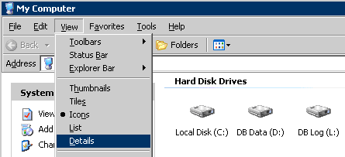
- Select Tools, Folder Options (Figure 47).
Figure 47: Folder Options Menu
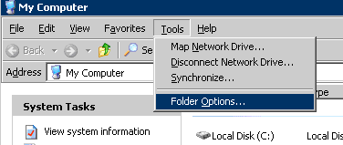
- Select the View tab. Make sure the “Hide extensions for known file types” check box is clear (Figure 48).
- Click Apply to All Folders (Figure 48).
Figure 48: Folder Options Dialog
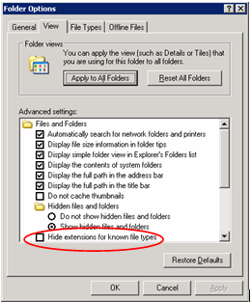
- At the prompt, click Yes to set the folders on your computer to match the current folder’s view settings. Click OK to close the Properties dialog.

Appendix E: VBECS Patch Installation Record Form for the Test Environment

VBECS Patch Installation Record for the Test Environment
Complete each section of this installation record as you complete the corresponding installation steps:
- Insert screen shots, as indicated.
- Replace the text in angle brackets and delete the brackets.
- To select a check box, double-click it, and then click the Checked radio button under Default value.
- Copy and paste the contents of this appendix into a separate Word document.
- Print, sign and date the completed appendix.
- Add all printed documents related to Appendix E to the package for the Validation Records.

Installation Procedure for the Test Environment

Download the VBECS 1.5.2.2 Patch File
N/A

Verify the Contents of the VBECS 1.5.2.2 Patch File
Step 9: Verified the VBECS_Patch_1.5.2.2_010311 file contents.
Step 12: Screen Shot: VBECS_Patch_1.5.2.2_010311 Properties
<Insert screen shot.>

Prerequisites for Installation
N/A

Execute VBECS Patch Scripts against the Cluster
Step 15: Screen shot: VBECS Patch process completed successfully.
<Insert screen shot.>
Step 17: VBECS Patch Log Output File Name
Log File:

Delete the Patch Files
Step 4: Deleted the VBECS 1.5.2.2 patch files on server.
Step 6: Verified that Appendix E was printed, initialed and dated.

List problems occurring in the installation process.

Name (Print.) |  | Title
Signature |  | Date

Give this patch installation record for the test environment to the blood bank supervisor, or follow your records retention policy.

Appendix F: VBECS Patch Installation Record Form for the Production Environment

VBECS Patch Installation Record for the Production Environment
Complete each section of this installation record as you complete the corresponding installation steps:
- Insert screen shots, as indicated.
- Replace the text in angle brackets and delete the brackets.
- To select a check box, double-click it, and then click the Checked radio button under Default value.
- Copy and paste the contents of this appendix into a separate Word document.
- Print, sign and date the completed appendix.
- Add all printed documents related to Appendix F to the package for the Validation Records.

Installation Procedure for the Production Environment

Download the VBECS 1.5.2.2 Patch File
N/A

Verify the Contents of the VBECS 1.5.2.2 Patch File
Step 9: Verified the VBECS_Patch_1.5.2.2_010311 file contents.
Step 12: Screen Shot: VBECS_Patch_1.5.2.2_010311 Properties.
<Insert screen shot.>

Prerequisites for Installation
N/A

Execute VBECS Patch Scripts against the Cluster
Step 15: Screen shot: VBECS Patch process completed successfully.
<Insert screen shot.>
Step 17: VBECS Patch Log Output File Name
Log File:

Delete Patch Files
Step 4: Deleted the VBECS 1.5.2.2 Patch files on server.
Step 6: Verified that Appendix F was printed, initialed and dated.

List problems occurring in the installation process.

Name (Print.) |  | Title
Signature |  | Date

Give this patch installation record for the production environment to the blood bank supervisor, or follow your records retention policy.

Appendix G: Troubleshooting Messages

Error Message | Example Screen Shot | Solution
An invalid IP address was specified. | 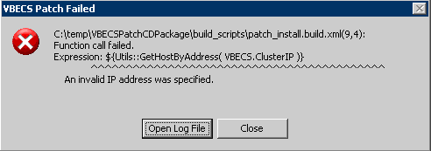 | An invalid IP was supplied as an input argument.  OR  The IP address was formatted correctly, but does not point to a VBECS server.  Provide the correct IP Address.
All connections to the <Database Name> database must be terminated before patching. | 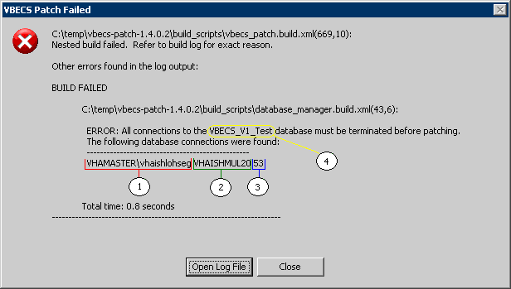 | A user has an active connection to the Database of the target environment.  The information listed for each open connection is:  1. User Login ID  2. Computer Name  3. SQL Process ID  4. Database Name  Contact the Database Administrator. Ask the DB Admin to kill all user processes running on the server.
The SQL Server does not exist or access denied. | 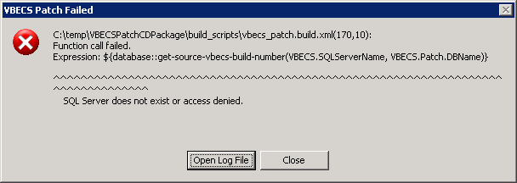 | The SQL Server Name supplied does not exist, cannot be accessed or the patcher does not have permission to use it.  Check the SQL Server Name and Verify patches Database rights with the DB Admin.
VBECS application configuration file version [S.S.S.S] on <ACTIVE CLUSTER NODE> doesn’t match the version this patch was intended for [T.T.T.T] Patch Process cannot continue.  ** [S.S.S.S] -Source  ** [T.T.T.T] -Target | 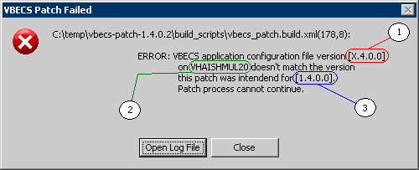 | The database version does not match the version the patch was coded to update.  - BuildNumber version found in the VBECS.exe.config file.  - Cluster node containing the suspect file.  - Target Patch version.  Contact the VBECS Administrator to resolve build number discrepancies (i.e., this patch may already be installed).
The Passive Cluster node should not have active resources. | 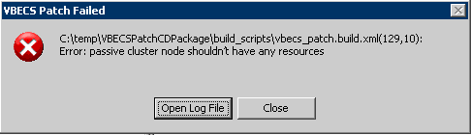 | The Passive node has active resources.  Contact the VBECS Administrator to resolve cluster configuration issues.
The Start button of the VBECS GUI Patch is disabled | 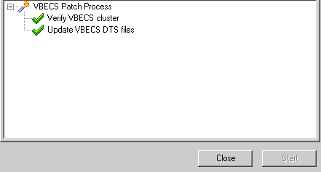 | Either the patch is running or the patch has completed.  Click Close.  Open a new VBECS Patch form by double-clicking shortcut.
Access denied | 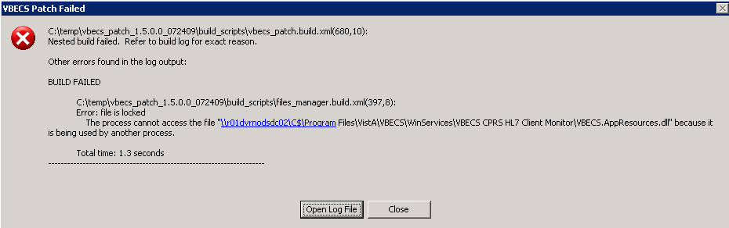 | The VBECS Services were not stopped or the patch files are Read-only.
VBECS Patch Failed | 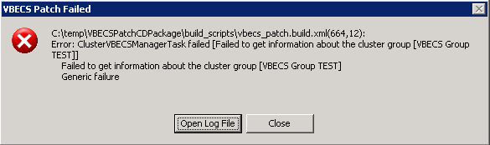 | The VBECS Group Test (VBECS Test Services) may have been stopped.  Right click on VBECS Group Test and select Bring Online.
Remote Desktop Disconnected | 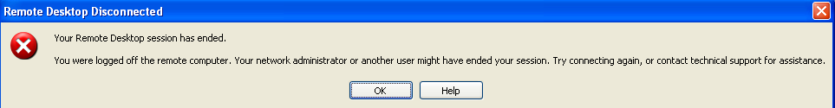 | The user applying the patch has an active session at the server (KVM) console. Log off the server console and repeat the patch process.
VBECS FTP Download Security Alert | 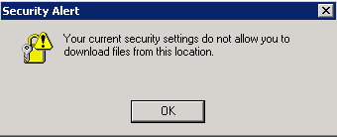 | Refer to Appendix H: Adding VBECS FTP Site to the Trusted Sites in Internet Explorer

This page intentionally left blank.

Appendix H: Adding VBECS FTP Site to the Trusted Sites in Internet Explorer
- Open a remote desktop connection to Cluster Node 1 (e.g. VHAXXXNODZ1 or R01YYYNODXXX01).
- Open Internet Explorer and select Tools, Internet Options (Figure 49).
Figure 49: Example of Internet Explorer Window
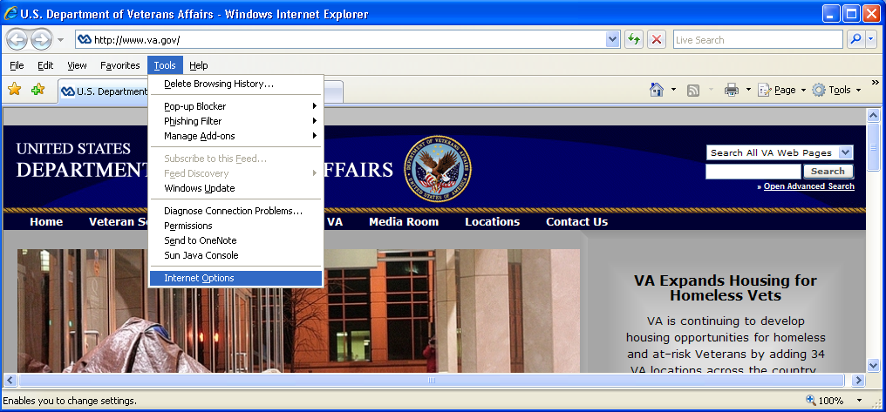

- Select the Security tab (Figure 50).
Figure 50: Example of Internet Explorer Internet Options Security tab
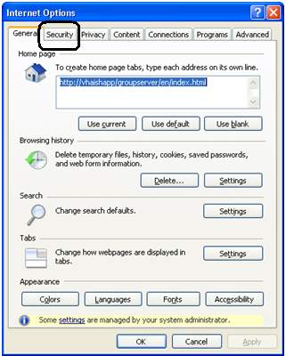
- Select Trusted sites (Figure 51).
Figure 51: Example of Internet Options Trusted Sites
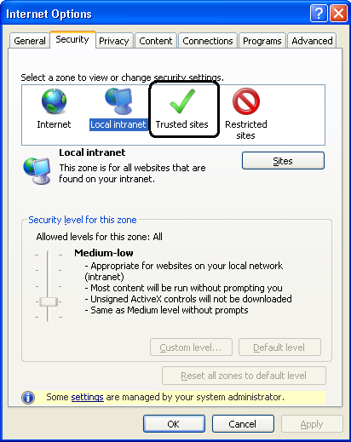

- Click Sites (Figure 52).
Figure 52: Example of Select a Zone to View or Change Security Settings
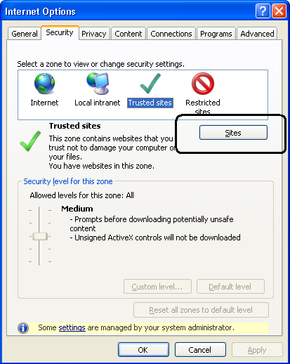
- Make sure Require server verification… is unchecked. Enter ftp://10.3.21.76 and click the Add button (Figure 53).
Figure 53: Example of Adding the VBECS FTP to the Trusted Sites
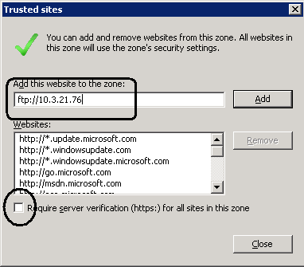
- Close all windows.
- Log off Cluster Node 1.
- Repeat Steps 1through 8 for Cluster Node 2 (e.g.,VHAXXXNODZ2 or R01YYYNODXXX02).
This page intentionally left blank.

Notes

This page intentionally left blank.

Index

D
Delete Patch Files
Prod 32
Test 18
Download and Verify the Contents of the VBECS Patch 5, 19
Download the VBECS 1.5.2.2 Patch File 5
Download the VBECS 1.5.2.2 Patch File 19
E
Execute VBECS Patch Scripts against the Cluster
Prod 27
Test 13
H
How This Installation Guide Is Organized 3
I
Installation Logs 35
Installation Procedure for the Production Environment 19
Instructions for Capturing Screen Shots for Installation Records 41
Introduction 1
P
Prerequisites for Installation
Production 26
Test 12
Problems? 3
Product Support 3
R
Related Manuals and Reference Materials 2
S
Screen Shots 3
Set Up Detailed Folders View 43
V
VA Service Desk 3
VBECS Patch Installation Record Form for the Production Environment 47
VBECS Patch Installation Record Form for the Test Environment 45
Verify the Contents of the VBECS 1.5.2.2 Patch File 8
Verify the Contents of the VBECS 1.5.2.2 Patch File 22

This is the last page of VistA Blood Establishment Computer Software (VBECS) 1.5.2
Patch Installation Guide.

