VistA Imaging System TeleReader Configurator

User Guide
March 2022
Department of Veterans Affairs
Office of Enterprise Development (OED)
Office of Information and Technology (OIT)
.
Revision History
NOTE: The revision history cycle begins once changes or enhancements are requested after the document has been baselined.
Date | Revision | Description | Author
3/01/2022 | 3 | All sections reviewed and updates applied to bring User Manual current with TeleReader Configurator patches up to and proceeding MAG*3.0*320 | Liberty IT Solutions
7/15/2013 | 2 | Updated for national release of Patch 127. Revised sections Adding a Consult Type to the TeleReader Unread List; Editing a Consult Type; Configuring TeleReader Readers. Added section Cloning  TeleReader Profiles.
5/11/2011 | 1.1 | Updated for National Release P106, new section added called “Configuring TeleReader with a Thin Client”.
8/26/2010 | 1.0 | Updated for National Release.
8/19/2010 | 0.9f | Updated Unread List Page.
8/18/2010 | 0.9e | Replaced Reader Page Screen Shot with correct spelling of Privilege.
8/11/2010 | 0.9d | Updated for Release.
8/10/2010 | 0.9c | Made some additional formatting changes.
8/04/2010 | 0.9b | 2nd iteration based on 1st product review comments
7/20/2010 | 0.9a | Initial draft.
Artifact Rationale
Per the Veteran-focused Integrated Process (VIP) Guide, the User’s Guide is required to be completed prior to Critical Decision Point #2 (CD2), with the expectation that it will be updated as needed. A User Guide is a technical communication document intended to give assistance to people using a particular system, such as VistA end users. It is usually written by a technical writer, although it can also be written by programmers, product or project managers, or other technical staff. Most user guides contain both a written guide and the associated images. In the case of computer applications, it is usual to include screenshots of the human-machine interfaces, and hardware manuals often include clear, simplified diagrams. The language used is matched to the intended audience, with jargon kept to a minimum or explained thoroughly. The User Guide is a mandatory, build-level document, and should be updated to reflect the contents of the most recently deployed build. The sections documented herein are required if applicable to your product.
Table of Contents
1. Introduction 1
1.1. Terms of Use 1
1.2. Purpose 1
1.3. What is TeleReader Configurator 1
1.3.1. Documentation Conventions 1
1.3.2. References and Resources 1
1.4. CPRS Graphical User Interface (GUI) 2
2. Signing in to TeleReader 2
3. Using TeleReader Configurator 4
3.1. TeleReader Configurator Main Screen 4
3.2. Menus 4
3.2.1. Contents 5
3.2.2. Message Log 5
3.2.3. About Screen 5
3.2.4. Acquisition Site Setup 6
3.2.5. Reading Site Setup 6
3.2.6. Field Help Text 6
3.2.7. Global Settings 6
3.2.8. Exit 7
4. Configuring an Acquisition Site 7
4.1. Configuring the TeleReader Unread List 7
4.2. Adding a Consult Type to the TeleReader Unread List 8
4.3. Editing a Consult Type 9
4.4. Deleting a Consult Type from the Unread List 10
5. Configuring the Modality Worklist 10
5.1. Adding a Consult Type to the Modality Worklist 11
5.2. Adding Clinics to a Modality Worklist Consult Type 13
5.3. Editing a Modality Worklist Consult Type 13
5.4. Deleting a Modality Worklist Consult Type 14
6. Configuring a Reading Site 14
6.1. Configuring Rights to Acquisition Sites 15
6.2. Adding an Acquisition Site 15
6.3. Editing, Activating/Deactivating an Acquistion Site 16
6.4. Delete an Acquisition Site 17
6.5. Configuring TeleReader Readers 17
7. Configuring Readers 17
7.1. Adding New TeleReader Readers 18
7.2. Adding Additional Privileges to a Reader 19
7.3. Activate/Deactivate Privileges 20
7.4. Deleting a Reader or Reader Privileges 20
7.5. Cloning TeleReader Profiles 21
7.6. Configuring TeleReader Global Settings 23

Figure 1: TeleReader PIV Login 2
Figure 2: Certificate Selection 3
Figure 3: ActivClient PIN 3
Figure 4: VistA Sign-on 4
Figure 5: TeleReader Configurator Main Screen 4
Figure 7: View Log File Screen 5
Figure 8: About Screen 6
Figure 6: Field Text Help 6
Figure 9: Acquisition Site Consult Setup Screen 7
Figure 10: Add TeleReader Consult Type Dialog 8
Figure 11: Selet Unread List Trigger Field 9
Figure 12: Consult Types to be Added to the TeleReader Unread List 9
Figure 13: Edit TeleReader Consult Type Dialog 10
Figure 14: Modality Worklist Screen 11
Figure 15: Add Modality Worklist Consult Type Dialog 11
Figure 16: CPT Code Lookup Procedure 12
Figure 17: Select Clinic(s) Dialog 13
Figure 18: Edit Modality Worklist Consult Type Dialog 14
Figure 19: Reader Setup Screen 15
Figure 20: Add Acquisition Site Dialog 16
Figure 21: Edit Acquisition Site Dialog 17
Figure 22: Reader Setup 18
Figure 23: Add New Reader Dialog 18
Figure 24: Add to Reader/Privileges Dialog 19
Figure 25: Reader Privileges Delete Conformation Dialog 20
Figure 26: TeleReader Configurator Main Screen 21
Figure 27: Reader Setup (Read/Privileges Screen) 21
Figure 28: Select Reader(s) to be Cloned Screen 22
Figure 29: No Matches Were Found Dialog 22
Figure 30: Confirmation of Cloning Dialog 23
Figure 31: TeleReader Global System Settings Dialog 23

Introduction

Terms of Use
FDA regulations require that each Imaging software distribution is documented and tracked by the VistA Imaging project.

Purpose
This document is intended for site VistA Imaging application administrators to facilitate configuring the TeleReader application for both Acquisition and Reading sites. This document is specific to the TeleReader Configurator application and does not contain information for users of the TeleReader application. VistA Imaging product documentation is also available in the VA Software Document Library (VDL).

What is TeleReader Configurator
The TeleReader Configurator is a Veterans Health Information Systems and Technology Architecture (VistA) Computer application. The TeleReader Configurator enables the user to configure a separate, VistA Imaging TeleReader application using the TeleReader Configurator’s Graphical User Interface (GUI).
The TeleReader application, first introduced with release MAG*3.0*46, was configured using VistA FileMan and VistA Imaging package options. The TeleReader Configurator GUI was developed to replace VA FileMan as the preferred method for configurating the TeleReader by application administrators.
Acquisition and Reading Site configuration activities in TeleReader Configurator configuration is required for both the Acquisition Site and the Reading Site. The TeleReader application works in conjunction with the Consult Request Tracking package (GMRC) to enable a user to obtain a list of imaging studies that are ready to be interpreted.

Documentation Conventions
Symbol | Description
 | NOTE: Used to inform the reader of general information including references to additional reading material
 | CAUTION: Used to caution the reader to take special notice of critical information

References and Resources
Related Manuals:
- VistA Imaging System TeleReader User Manual
- VistA Imaging System Technical Manual.

CPRS Graphical User Interface (GUI)
TeleReader Configurator is designed to run on the Microsoft Windows operating environment. TeleReader Configurator application eliminates the need for a site administrator to access VistA files and fields directly for configuration activities.
The terminal or text-based version of TeleReader Configurator is not covered in this manual.

Signing in to TeleReader
TeleReader now uses a more secure access method called two-factor authentication (sometimes called 2FA). Two-factor authentication simply means that you use your Personal Identification Verification (PIV) card and your Personal Identification Number (PIN) to gain access to TeleReader. If you experience a problem with two-factor authentication, you can select Cancel on the dialog that requests a certificate and enter your access and verify code to log in to TeleReader.

NOTE: To use the new two-factor authentication, each user’s Active Directory entry must be “Bound” for each VistA instance. So, if you can access one VistA system, but a different one that you access does not work, you will need to contact support to verify that your Active Directory entry has been bound to all of the accounts you access.

To login to TeleReader with your PIV card, follow these steps:
Open the application.
If the Connect To dialog appears, click the down-arrow, select the appropriate account (if more than one exists), and click OK.
In the Windows Security dialog, select the certificate associated with your PIV card and press Enter. If there are multiple certificates, choose the one that is for “internal PIV authentication.” You can see that by hovering over the name for the certificate as shown below.
Figure 1: TeleReader PIV Login
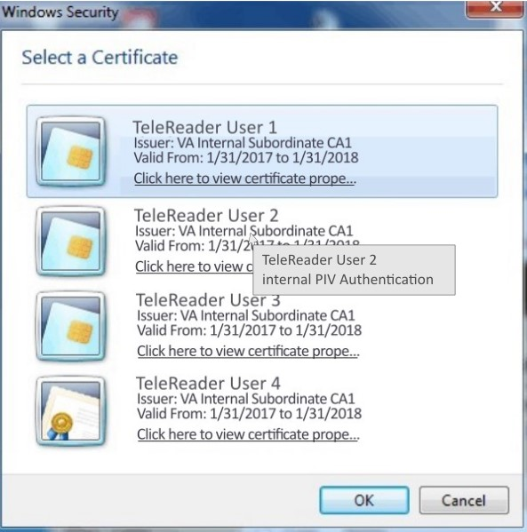
Note: If there is a problem with your PIV or PIN, you can select Cancel to revert to using your access and verify codes.
Figure 2: Certificate Selection
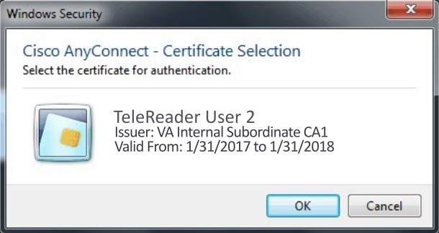

Type your PIN into the dialog that appears and press Enter.
Figure 3: ActivClient PIN
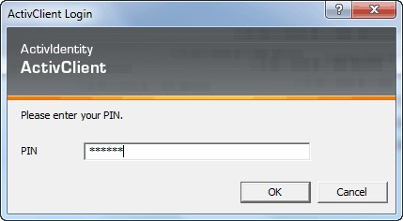

If you lose your PIV card or forget it, there is an alternative way to log into TeleReader using your access and verify code. Each user should be assigned an access code and a verify code. You will need to check with your local facility to get your access and verify codes, if necessary.
To login to TeleReader with your access and verify code, follow these steps:
- Double-click the TeleReader icon on your desktop. The VistA logo window and the VistA Sign-on dialog will appear.
- If the Connect To dialog appears, click the down-arrow, select the appropriate account (if more than one exists), and click OK.
- Type your access code into the Access Code field and press the Tab key.
- Type the verify code into the verify code field and press the Enter key or click OK.
Note: You can also type the access code, followed by a semicolon, followed by the verify code. Once you have done this press the Enter key or click OK.
Figure 4: VistA Sign-on
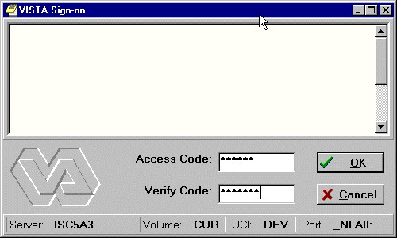

Using TeleReader Configurator

TeleReader Configurator Main Screen
Upon login, the user is presented the TeleReader Configurator main screen. Within this screen, the user has several menu options to select from along with buttons which take the user to additional screens for configuring Acquisition Site Settings, Reading Site Settings, and Global Settings.
Figure 5: TeleReader Configurator Main Screen
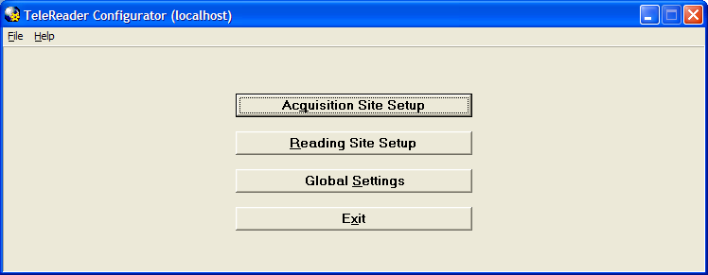

Menus
Menus are available on several screens within the application. On the Main Screen the menu options are:
- File: The File Menu drop down contains options that are equivalent to buttons on that screen and an option to close the screen, or in the case of the main screen, exit the application.
- Help: In addition to the standard ‘Contents’ menu item, the TeleReader Configurator Main Screen Help Menu contains selections to view the System Message Log and Application About Box. The Main Screen title bar displays the login server in parentheses.

Contents
The Contents option in the Help Menu invokes a new window presenting a .pdf version of the current TeleReader Configurator User Manual.

Message Log
From the TeleReader Configurator, under the Help Menu, click Message Log. The View Log File Screen opens.
Figure 7: View Log File Screen
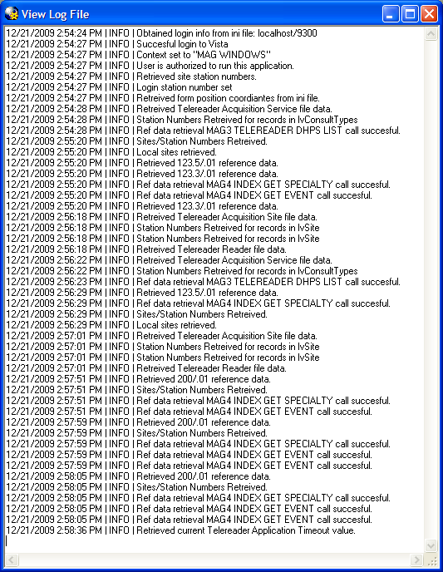
The System Log tracks application activity and can be used to troubleshoot problems in the system. The TeleReader Configurator adds information to the log from start up to close. After the user closes the application, the Log is saved to a .log file in: C:\ProgramData\VistA\Imaging\Log
with a timestamp. One Log file is created per session.
NOTE: As the number of files in the directory grows, the administrator can delete the older files as necessary.

About Screen
The About option shows information about the application, such as version number.
Figure 8: About Screen
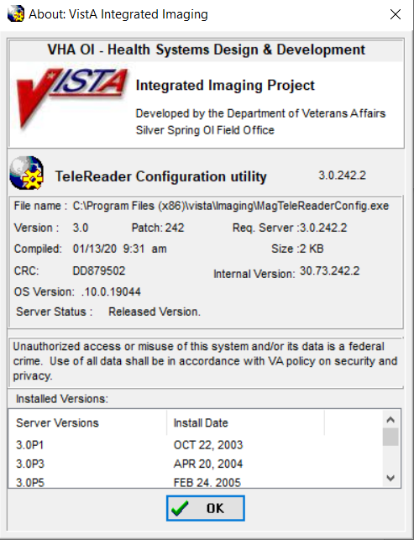

Acquisition Site Setup
The Acquisition Site Setup button opens the Acquisition Site Consult Setup Screen.

Reading Site Setup
The Reading Site Setup button opens the Reader Setup Screen.

Field Help Text
Any screen that adds or edits configuration settings will have text available for each field on that screen. To invoke the help text for that field, press the F1 key while focus is on that control (combo box, edit box).
Figure 6: Field Text Help
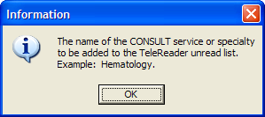

Global Settings
The Global Settings button opens the TeleReader Global System Settings Screen.

Exit
Immediately closes the TeleReader Configurator Application.

Configuring an Acquisition Site
To configure an Acquisition Site, from the TeleReader Configurator Main Screen page click the Acquisition Site Setup button. This opens the Acquisition Site Consult Setup Screen.
Figure 9: Acquisition Site Consult Setup Screen
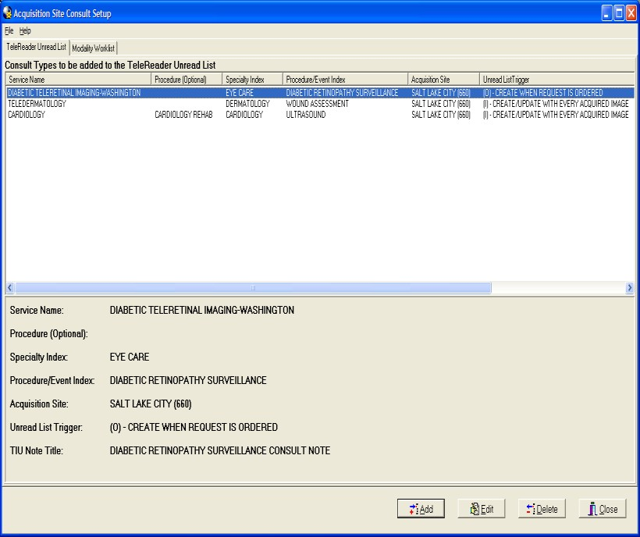
The Acquisition Site Consult Setup Screen has two pages. The TeleReader Unread List page configures which Consult Types VistA Imaging will add to the TeleReader Unread List when a Consult is ordered. This is the default page when the screen is opened.
The Modality Worklist Screen configures which Consult Types will be added to the DICOM Modality Worklist when a Consult is ordered.

Configuring the TeleReader Unread List
The TeleReader Unread List page displays all Consult Types currently configured to appear on the TeleReader Unread List. Only Consults listed are configured for use with the TeleReader. The bottom panel shows the detail of the selected Service Name. The display is updated as Consult Types are added to /edited/deleted from the TeleReader Unread List.

Adding a Consult Type to the TeleReader Unread List
To add a new Consult Type to the TeleReader Unread List, click the Add button on the TeleReader Unread List page.
The Add TeleReader Consult Type appears.
Figure 10: Add TeleReader Consult Type Dialog
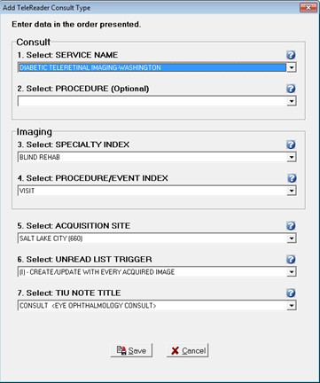
The Add TeleReader Consult Type Dialog has six required fields and one optional field. The fields are:
- Service Name: Service Name of the Consult Type to be added to the Unread List.
- Procedure: This field is optional. Some services do not have associated procedures. If you select a service that has no associated procedures, the Procedure field is disabled.
- Specialty Index: Specialty Index of the Consult Type to be added to the Unread List.
- Procedure/Event Index: The drop-down list is a subset of the selected Specialty Index. This field is required when adding or updating a Consult Type.
- Acquisition Site: The Acquisition Site defaults to the Login site.
- Unread List Trigger: The Unread List Trigger field defaults to ‘(I) – CREATE/UPDATE WITH EVERY ACQUIRED IMAGE’.
Figure 11: Select Unread List Trigger Field
- TIU Note Title: The TIU note to be associated with the consult and closing that consult out in CPRS.
When a selection is made for all required fields, the Save button is enabled.

Editing a Consult Type
To edit the values of a Consult Type from the TeleReader Unread List page, highlight the Service Name row on the Consult Types to be added to the TeleReader Unread List and click Edit.
Figure 12: Consult Types to be Added to the TeleReader Unread List
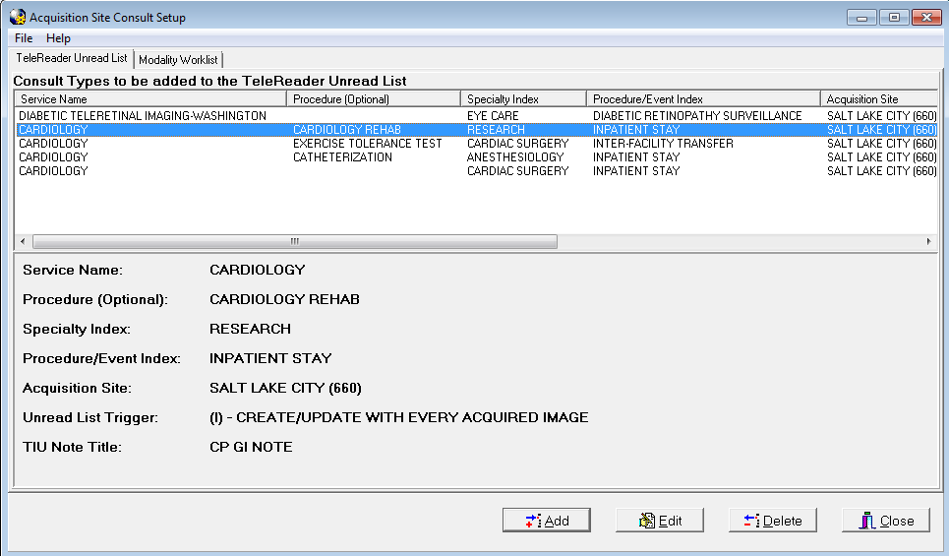
The Edit TeleReader Consult Type Dialog appears.
Figure 13: Edit TeleReader Consult Type Dialog
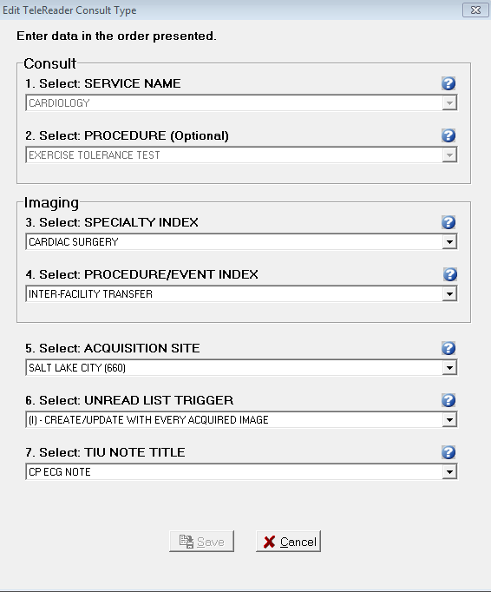
The Edit TeleReader Consult Type Dialog populates with current values of the selected Consult Type.
The Service Name field displays the Service Name originally selected for the consult type. The field is disabled and cannot be changed.
The Procedure: Optional field displays the procedure originally associated with the Service Name for this consult type. The field is disabled and cannot be changed.
The remaining fields on the screen are enabled and can be edited.
Once a change has been made to the screen, the Save button is enabled.

Deleting a Consult Type from the Unread List
To delete a Consult Type, from the TeleReader Unread List page select the Service Name and click the Delete button. A dialog appears, asking the user for confirmation. The user can either cancel the action or click OK to confirm the deletion of the Consult Type.

Configuring the Modality Worklist
To configure Consult Types to the Modality Worklist, from the Acquisition Site Consult Setup Screen page click the Modality Worklist tab.
Figure 14: Modality Worklist Screen
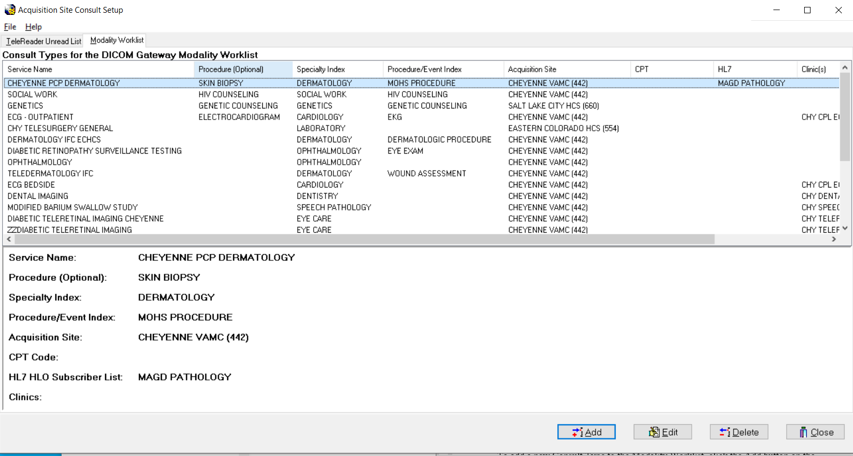
The Modality Worklist Screen displays all Consult Types currently configured to appear on the DICOM Modality Worklist when a Consult of that type is ordered. The display is updated as Consult Types are added to, edited, or deleted from the Modality Worklist.

Adding a Consult Type to the Modality Worklist
To add a new Consult Type to the Modality Worklist, click the Add button on the Modality Worklist Screen and the Add Modality Worklist Consult Type Screen appears.
Figure 15: Add Modality Worklist Consult Type Dialog
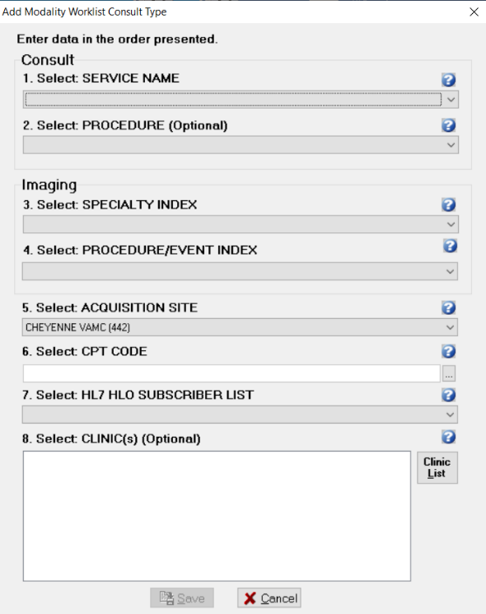

The Add Modality Worklist Consult Type Dialog has the following three required fields and additional optional fields:
- Service Name: Service Name of the Consult Type to be added to the Modality Worklist.
- Procedure (Optional): This field is optional. Some services do not have associated clinical procedures. If you select a service that has no associated procedures, the Procedure field is disabled.
- Specialty Event Index: Specialty Index of the Consult Type to be added to the Unread List.
- Procedure/Event Index (Optional): The drop-down list is a subset of the selected Specialty Index. This field is optional when adding or updating a Modality Worklist.
- Acquisition Site: The Acquisition Site defaults to the login site.
- CPT Code (Optional): CPT code associated to the consult or procedure request may be selected here. It is recommended that this field be left un-populated at this time.
If it is determined the modality worklist should be aligned to a specific CPT code, clicking the ellipses button will show a Lookup Procedure window where the user may search for a CPT code to apply either by number or by partial word search.
Figure 16: CPT Code Lookup Procedure
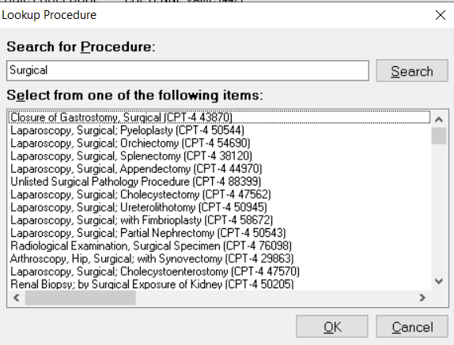
HL7 HLO Subscriber List (Optional): The optional drop-down identifies receivers of the HL7 message that is generated for the consult or procedure request. It is recommended that this field be left un-populated at this time.
Clinic(s) (Optional): The Clinic(s) list box can have one or more selections and is optional. For more instruction on how to add clinics read the section below. It has been recommended that this field be left un-populated initially until site-specific workflow dictates that a particular modality worklist requires a Clinic.
When a selection is made for all required fields, the Save button is enabled.

Adding Clinics to a Modality Worklist Consult Type
Adding Clinics to a Consult Type means that the information for an appointment scheduled at that clinic of that Consult Type will appear on the Modality Worklist. The patient will be required to be checked into the Clinic for their appointment before the worklist will become available. To add clinics to the Consult Type, click the Clinic List button and the Select Clinic(s) Dialog opens.
Figure 17: Select Clinic(s) Dialog
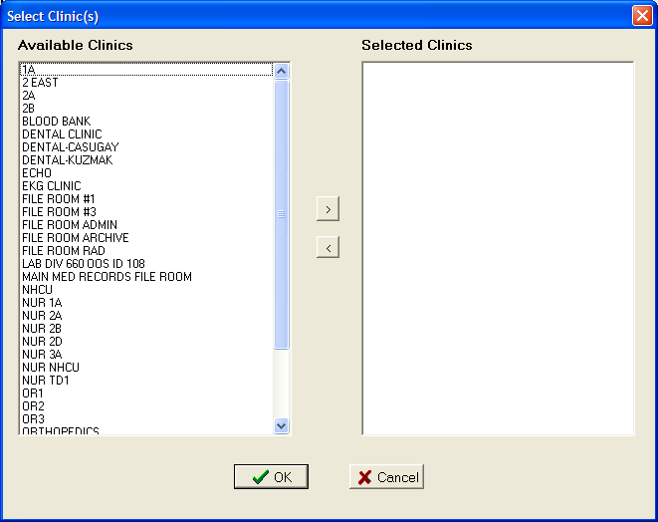
The Select Clinic(s) Dialog has two list boxes. Available Clinics displays the list of Clinics that can be associated with the Consult Type. Selected Clinics will display Clinics as they are selected by the user to add to the Consult type.
To select a Clinic to add to the Consult Type, from the Available Clinics list either double click on an item or select the item and click the button. Those items will move from Available Clinics to Selected Clinics. To remove a Selected Clinic back to the Available Clinics list either double click the item in the Selected Clinics list or select it and click the button.
To save the selections click OK. The Select Clinic(s) dialog closes and the Clinic(s) list on the Add Modality Worklist Consult Type Dialog displays the selected Clinics.

Editing a Modality Worklist Consult Type
To edit the values of a Modality Worklist Consult Type, from the Modality Worklist Screen, select the Service Name then click the Edit button and the Edit Modality Worklist Consult Type Screen appears.
Figure 18: Edit Modality Worklist Consult Type Dialog
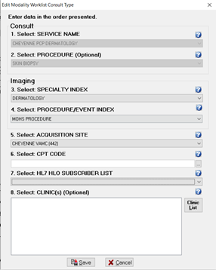
The Edit Modality Worklist Consult Type Dialog populates with current values of the selected Consult Type. The Service Name combo box is disabled and cannot be changed. Once a change is made to the screen the Save button is enabled.

Deleting a Modality Worklist Consult Type
To delete a Modality Worklist Consult Type, on the Modality Worklist Screen, select the Service Name and click the Delete button. A dialog appears, asking the user for confirmation. The user can either cancel the action or click OK to confirm the deletion of the Consult Type.

Configuring a Reading Site
To configure a Reading Site, from the TeleReader Configurator Main Screen page, click the Reading Site Setup button. This opens the Reader Setup Screen.
Figure 19: Reader Setup Screen
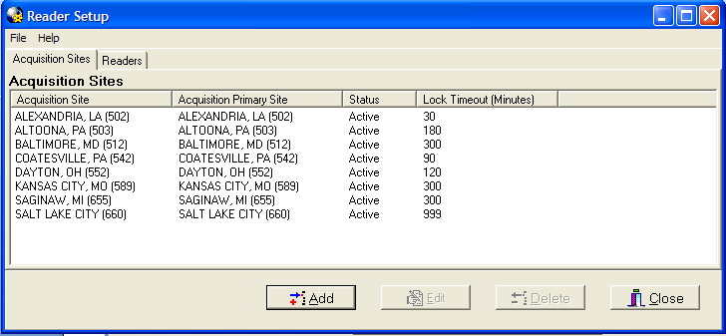
The Reader Setup Screen has two pages. The Acquisition Sites page configures which Acquisition Sites’ Unread List local Readers have rights too. This is the default page when the screen is opened.
The Readers page configures user level rights to Acquisition Sites’ Unread List.
NOTE: At the user level, rights are referred to as Privileges.

Configuring Rights to Acquisition Sites
The Acquisition Sites page displays all Acquisition Site Unread Lists for which local Readers have rights. The display is updated as Acquisition Site rights are added
/edited/deleted for local Readers.

Adding an Acquisition Site
To add a new Acquisition Site, click the Add button on the Acquisition Site page and the Add Acquisition Site Dialog appears.
Figure 20: Add Acquisition Site Dialog
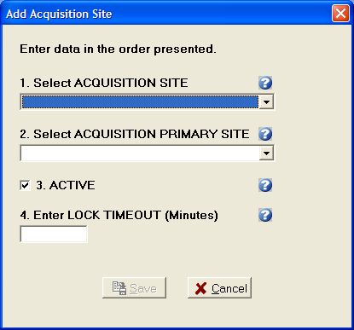
The Acquisition Site Dialog has the following four required fields:
- Acquisition Site: The acquisition site where the Unread List Consults were ordered.
- Acquisition Primary Site: The primary site of the acquisition site; enter the institution of the main VistA server.
- Active: Status of the acquisition site. If the status is not active, local Readers will not be able to result Consults from that sites Unread List through TeleReader. The Active checkbox defaults to checked (the Rights to that site are active).
- Lock Timeout: Lock Timeout configures the amount of time (in minutes) a consult will remain locked on the Unread List before automatically unlocking. If this field is undefined, the application will default to 180 minutes. Max value is 99999, no decimals allowed.
When all fields are completed, the Save button is enabled.

Editing, Activating/Deactivating an Acquisition Site
To edit the values or change the Active Status of an Acquisition Site, from the Acquisition Site page select the Site then click the Edit button and the Edit Acquisition Site Dialog appears.
Figure 21: Edit Acquisition Site Dialog
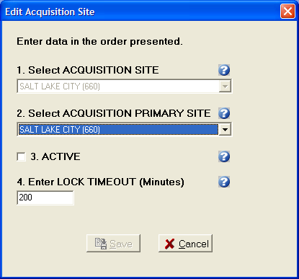
The Edit Acquisition Site Dialog populates with the current values of the selected Acquisition Site. The Acquisition Site combo box is disabled and cannot be changed. Once a change is made to the screen the Save button is enabled. To deactivate the site to local Readers, uncheck the Active check box. To reactivate the site at a later time, open the Edit Acquisition Site Dialog for the site and check to Active check box.

Delete an Acquisition Site
To delete an Acquisition Site, on the Acquisition Site page, select the Site and click the Delete button. A dialog appears, asking the user for confirmation. The user can either Cancel the action or click OK to confirm the deletion of the Acquisition Site.

Configuring TeleReader Readers
To configure a reader for TeleReader from the Reader Setup screen, click the Readers tab. The Readers/Privileges screen opens.

Configuring Readers
To configure a Readers of images and their privileges, from the TeleReader Configurator Main Screen page, click the Reading Site Setup button. Select the Readers tab.
Figure 22: Reader Setup
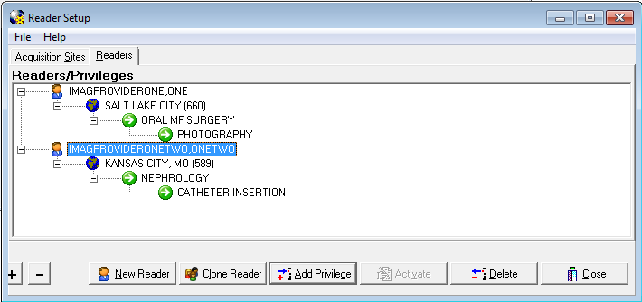
The Readers/Privileges screen displays the list of readers configured to use TeleReader to review consults and the specialties/procedures assigned to them. Any reader who needs to use the TeleReader application must be configured on this page to have access to the unread list.
The view can be collapsed by clicking the (-) button and by the clicking the (+) button. The screen opens with an expanded view by default.
As readers and reader privileges are added/deleted/activated/inactivated the view is updated.

Adding New TeleReader Readers
To add a new Reader, from the Reader page, click the New Reader button and the Add New Reader Dialog appears.
Figure 23: Add New Reader Dialog
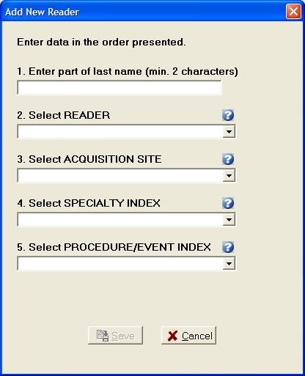
The Add New Reader Dialog has the following four required fields and a Reader lookup edit box:
- Reader: When adding a new Reader, enter a partial last name (at least first 2 characters) in the first edit box and press ENTER. The Reader combo box drop down will be the populated with the list of matches against the last name string. The first match in the list (alphabetically) will default as the selection.
- Acquisition Site: The drop-down list of sites will be those added to the Acquisition Site page.
- Specialty Index: Specialty Index of the that Acquisition sites Unread List Consult Type.
- Procedure/Event Index: The drop-down list from the Procedure/Event Index combo box will be a subset of the selected Specialty Index.
When all fields are completed, the Save button is enabled.

Adding Additional Privileges to a Reader
To Add Privileges to an existing Reader, select the appropriate Privilege from the screen view and click the Add Privileges button. The Add to Dialog opens.
For example, to add a new Acquisition Site for a Reader, select the Reader on the view and click the Add Privilege button. To add a new Specialty to one of the Reader’s Acquisition Sites, select the Acquisition Site then click the Add Privilege button. To Add a new Procedure to an Exiting Reader/Acquisition Site/Specialty select that Specialty.
Figure 24: Add to Reader/Privileges Dialog
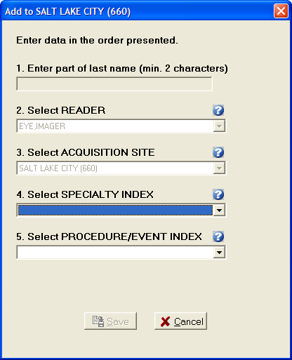
The user is adding a new Specialty to the Salt Lake City Acquisition Site for Reader Eye, Imager. That Privilege (Acquisition Site) and all higher-level Privileges (Reader) are disabled and cannot be changed. Because the Reader cannot be changed, the Reader lookup edit box is disabled as well. When all required selections on the dialog are completed the Save button is enabled.

Activate/Deactivate Privileges
To activate/deactivate a Privilege on the Readers/Privileges view, select the appropriate Privilege and click the Activate/Deactivate button. The button’s text will display Activate when the selected Privilege is inactive and will display Deactivate when on an Active Privilege.
Readers do not have an active status. When a Reader is selected, the Activate/Deactivate button will be disabled.
Explicit/Implicit Deactivation
When Deactivating an Active Privilege, then all Child Privileges will be deactivated as well. All Deactivated Privileges will have an icon change for their given node (Grayed out globe for Acquisition Site, Gray Pause button for Specialty Index, Procedure index). The explicitly Deactivated Privilege will have the text ‘[INACTIVE]’ appended to it. To Activate the Privilege and its Child Privileges select the appropriate node and click Activate. The Privilege and all Child Privilege will become Active with the icon
changing (colored in globe, green play button) and the ‘[INACTIVE]’ text removed.
NOTE: If a Child Privilege had been explicitly deactivated at an earlier time, it will remain so, even after the Parent Privilege is activated until the
Child Privilege is explicitly activated.

Deleting a Reader or Reader Privileges
To Delete a Reader or Reader Privilege from the Reader Setup page, select that Reader/Reader Privilege and click the Delete button. A dialog appears, asking the user for confirmation. The user can either cancel the action or click OK to confirm the deletion.
If a Reader or Privilege is deleted, all sub-Privileges are deleted as well.
Complete privilege Set
Each Reader must have at least one Acquisition Site. Each Acquisition Site must have at least one Specialty. Each Specialty must have at least one Procedure. If deleting a Privilege makes a Reader or Parent Privilege incomplete, it will be deleted as well, and the confirmation dialog message will state this. For example, if an Acquisition Site Privilege is deleted and is the only Site that Reader has then reader will be deleted as well.
Figure 25: Reader Privileges Delete Conformation Dialog
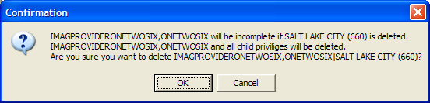

Cloning TeleReader Profiles
Once a reader profile is set up, a site administrator can clone the profile to provide consistent profiles for other readers who perform the same function. This is particularly helpful for facilities who may experience turn-over as new Resident Providers arrive each year.
To clone a reader profile, from the TeleReader Configurator main screen, click the Reading Site Setup button.
Figure 26: TeleReader Configurator Main Screen
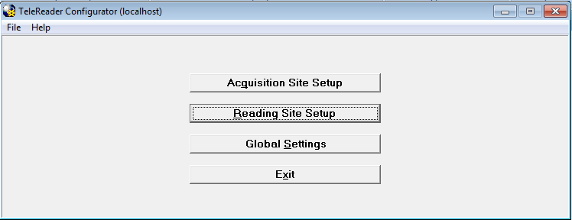
The Reader Setup screen opens.
Figure 27: Reader Setup (Read/Privileges Screen)
From the Readers/Privileges tree view, select the reader whose privileges you want to clone. The reader is highlighted in blue. Click the Clone Reader button. The Select Readers to be Cloned screen opens.
Figure 28: Select Reader(s) to be Cloned Screen
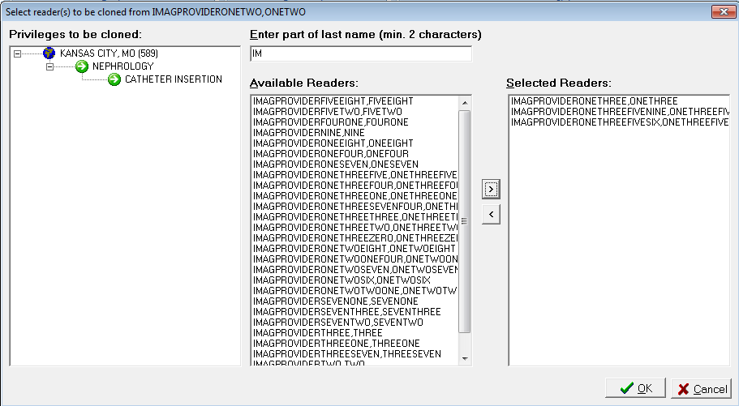
The Privileges to be cloned panel displays the site name and lists the privileges that will be cloned to new readers. In the Enter part of last name field, enter at least the first two characters of the last name of the reader to which you want to clone the selected privileges. The list of readers with no assigned privileges whose names match the search string populates in the Available Readers panel. Use the add arrow () and the delete arrow () to move readers from the Available Readers panel to the Selected Readers panel and vice versa. You can also move readers back and forth by double-clicking on the reader name or selecting the name and pressing Ctrl + Enter.
NOTE: If TeleReader Configurator does not find readers whose names match the search string you enter in the Enter Part of Last Name field, a No Matches Found dialog displays. To return to the previous screen and enter another search string, click the OK button.

Figure 29: No Matches Were Found Dialog
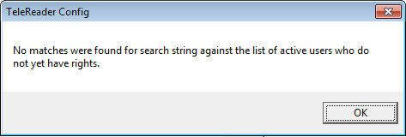
NOTE: You cannot clone privileges to a reader with an existing TeleReader profile. You must delete that reader’s privileges first. For instructions about deleting a reader’s privileges, see the section titled Deleting a Reader or a Reader Privilege.
Complete the selection of readers to whom you want to clone the privileges. When the Selected Readers panel is populated, the OK button activates.
Click OK to confirm the cloning. Click Cancel to cancel the cloning.
A confirmation of cloning action dialog opens, listing the users for whom profiles will be created with the cloned profile.
Figure 30: Confirmation of Cloning Dialog
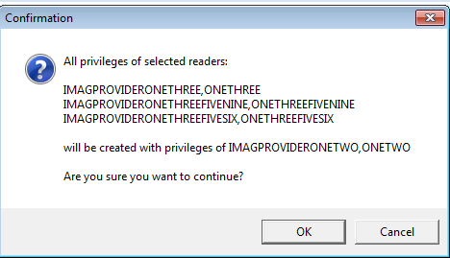
Click OK to confirm the cloning. Click Cancel to cancel the cloning.

Configuring TeleReader Global Settings
To configure Global Settings, from the TeleReader Configurator Main Screen click the Global Settings button. This opens the TeleReader Global System Settings Screen.
Figure 31: TeleReader Global System Settings Dialog
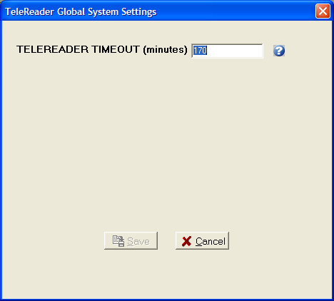

The number of minutes that the TeleReader application will remain active before closing due to inactivity. If this field is undefined, the application will not timeout. Max value is 999999, no decimals allowed.

