VistARad Quick Reference

Manager Basics

Opening an Exam
A
- Click the tab of the exam list you want to use. Some lists have sub- tabs.

- In the exam list, select the exam you want to open. You can skip this step if you are working through the list; the first exam is automatically selected.

- To open an exam: Press
<Enter> or click Open. Or double- click the selected exam..
C D
B
E
- As the exam is opened, one or more priors may be opened as well. The current exam is locked; prior exams are not.

What if...
...I can’t find the exam I want?
Press <Ctrl+L> or click Patient Lookup A
Exam List | Contains
Patient Exams | Two subtabs; one showing all exams for selected patient in Manager, the other showing all exams for the active patient in the Viewer/Browser.
Unread | All exams waiting to be interpreted.
Custom lists | Site-defined subtabs; usually tabs divide unread exams into groups based on modality, imaging location, etc.
Exam History | Entries for each exam opened in the last three days.
Recent* | Interpreted exams waiting to be verified.
All Active* | Combines Unread and Recent lists.
Monitored Sites* | Provides access to exam lists from remote sites; each remote exam list shown as a separate subtab.

Types of Exam Lists

and then enter the patient’s name or ID.

...I don’t see the requisition?
Select the exam in the Manager and click
Requisition B .

...I don’t want priors?
Instead of clicking the Open button, click the [Open/No Prior] button C .

...I get an “exam locked” message? Someone else is interpreting the exam. You can still open the exam for reference purposes, but you cannot interpret it yourself.

...I get an “exam reserved” message?

* Optional lists. To display tabs for these lists, choose View | Settings | Manager | General. Then in the List Order area, select the appropriate checkboxes.

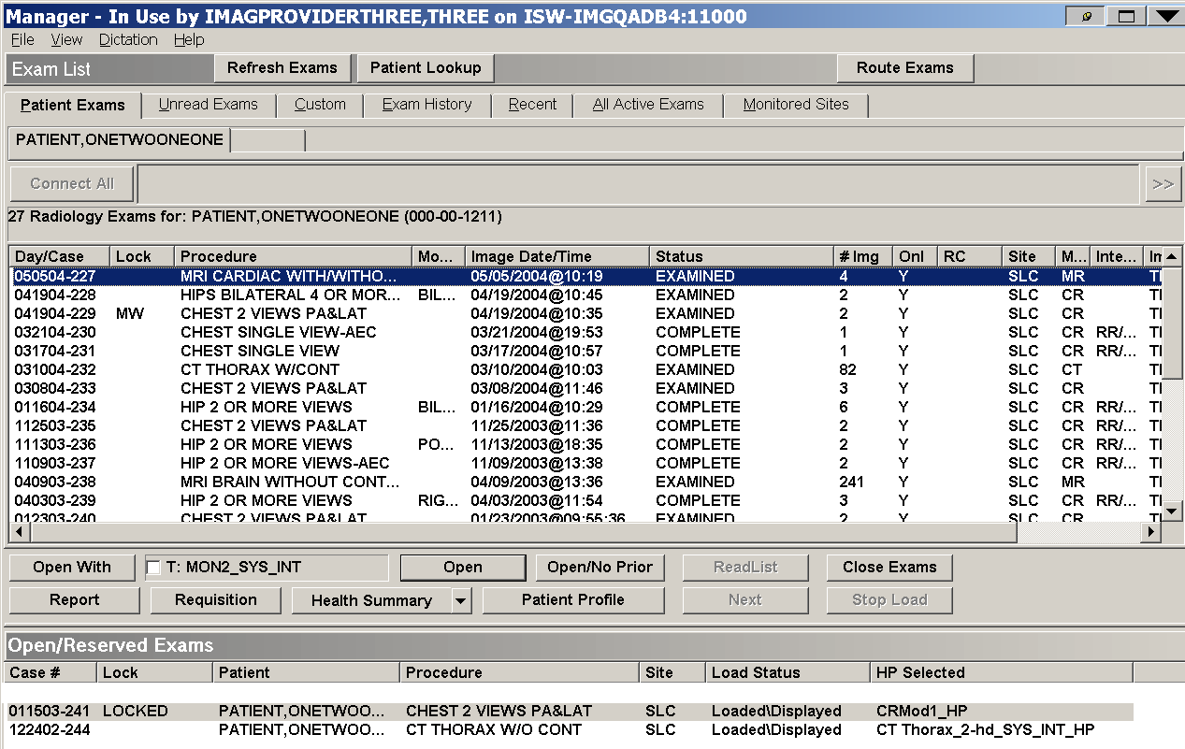
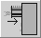
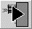
You can cancel their reserve and interpret the exam yourself, or you can honor the reserve and open the exam for reference purposes.

...I don’t see any images?
The automatically-selected hanging protocol may not be appropriate for the exam being opened. Images can be loaded manually (See Exam Display on the right).

Keyboard Shortcuts
<Ctrl+W> Display VistARad window list
<Ctrl+L> Patient Lookup
<Ctrl+N> Next Exam (in ReadList)
<Ctrl+P> Change active patient in Viewer
<Ctrl+Q> Close exam

Exam Display
Exams opened using an appropriate hanging protocol will automatically display in the Viewer window.
You can also manually load images into the Viewer or the Browser:
- Click in the toolbar (see next page) to display the Preview window.
- To load images into the Viewer, drag each image thumbnail from the Preview to an open area (viewport) in the Viewer
- To load images into the Browser, double- click an image thumbnail in the Preview window. The entire exam will be loaded into the browser.
- To close the exam, press CTRL+Q or click in the Viewer toolbar.

Using ReadList
- Select an exam list that contains unread exams.
- Click the ReadList button (DD).
- Wait until the first exam displays. Subsequent exams will load very quickly.
- Review the exam.
- Proceed to the next exam by pressing CTRL+N, clicking Next in the Manager (EE),
or by clicking in the Viewer toolbar.

- Repeat steps 4 and 5 until you have reviewed all exams in the list.
- You can optionally cancel ReadList by clicking Stop ReadList in the Manager. (Stop ReadList replaces the ReadList button when ReadList is active).

Viewport Controls

Title Bar
Shows case-related
information

Layout Tool Switch between stack and tile views

Viewport Elements

Paging Buttons Click to move up or down through stack
Close Button Clears viewport; does not close exam.

Contents Bar

Icon Bar
See details below

Tick Marks

Mensurated Scale
Displays measured scale
next to image

Compression Indicator
Right-click for options

VOI/LUT Indicator
Right-click for options

Info Area
Shows image-related information; click to open
Details window

Shortcut Menu (right-click image to open)

Icon Bar Details
Click to start or stop cineloop. Open pull-down menu to control cine speed, direction, and range.
Open to set Calibrate, Sort, and Link options.
Click to turn on Link feature. Open pull-down menu to control which attributes are linked.
Click to turn on Copy Attributes feature. Open
Turn on indicated tool (affects left mouse
button)

Apply indicated scale function

Show the orientation (left, right, above,

Apply predefined display attributes to images in viewport

Display annotations from current session, previous sessions, or both

pull-down menu to control what is copied.
Click to mark image
below) of the image Hide or display any
Annotation Overlays
associated with the

(adds image to Scrapbook window).
Click to turn on Apply To feature. Open pull-down menu to control which settings are affected.
Click to open report (if the report is not entered, the requisition is opened instead).
Display Mensurated
Scale to left of image

Create draggable magnified area

Copy current image to
Scout window

Copy current or all series to 3D software
image

Restore original display attributes
Measure length, area, angle, etc., in image

Copy image, image set or exam to Teaching Files section of Scrapbook

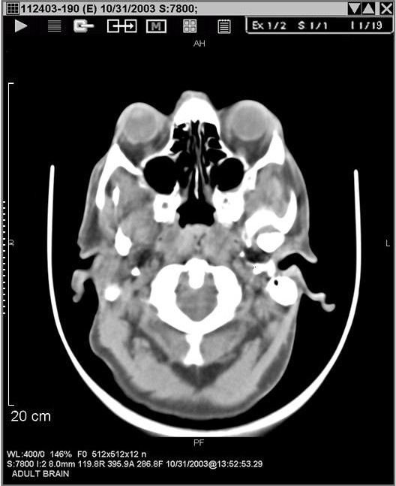
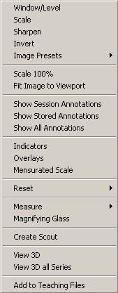
Options enabled only if Voxar 3D Workstation software is installed and integrated with VistARad.

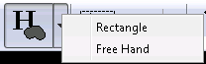
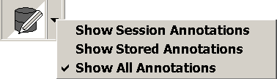
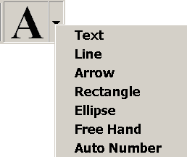
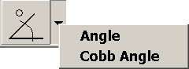
Expanded Annotation Buttons
The Show//Hide tool displaying its Show All Annotations icon
The Drawing tool
displaying its Text icon
The Angle Measuring tool displaying its Cobb Angle icon
Annotation Tools
A down arrow ▼ adjacent to a toolbar button indicates more options. The appearance of each button will change according to which of its tools is currently selected. To access its other functions, click the arrow to the right of each Annotation tool.
The Hounsfield Area Measuring tool displaying its Free Hand icon
Toolbar Buttons Used in the Viewer, Browser and Scrapbook Windows
The Monitor Configuration button is available only in the main Viewer window. These buttons are not available in the main Viewer window.
There are several annotation/measurement tools available; to select a different tool, click the arrow next to the button.
Monitor Conf uratio
Sele t H ngin P otocol or Template
M as re Line
e sure Angle
Measure Hounsfield
Annotation Edit/S le
Hide/Sho An ot tions
Chan
ayout
Ann ta i n Tool
Au o Window/Level
Window Level
Scale: Alter Size of Display
Sharpen/Smooth
Invert Black/White Values
Flip
Rotate
Show Preview/Browser
Show Scrapbook
Show Scout Window
Show Ma ager & eports
Cl s / pdate Exam
N t Exam in ReadList
Click for Next/Previous
Create a Teaching File
pen th
IRC Browser
ig n
g
r
c a
e u
M a
e ct
ge L
n
a
w
o t o
t
R
n
o e U
ex
O
e M

Preview Window

Thumbnail View

One exam per row; one thumbnail per image set, displayed left to right.

Drag to manually load image set into viewport. Double-click to load exam into Browser

Memory usage bar
Click to switch to list view

List View

Image sets grouped under exam headers, one image set per row

Exam row header Click to switch to
thumbnail view

Image set is loaded
and visible
Click to purge image set from memory

Drag to manually load image set into viewport. Double-click to load exam into Browser

Image set is partially loaded

Image set is hidden

Click to pause loading

Click to resume loading

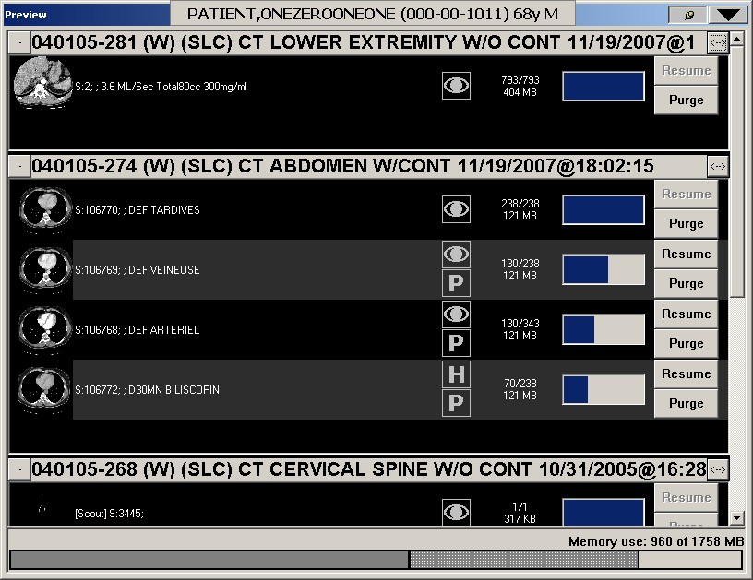
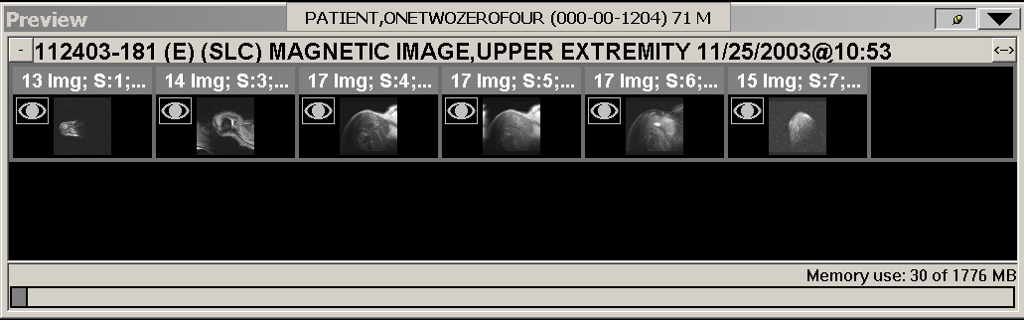
Click to show exam row header only

Image count & Image set size
Image loading progress indicator

