Enhanced Image Viewer User Guide

Revision 11.0 MAG*3.0*185

Department of Veterans Affairs
Office of Information and Technology (OI&T)

Revision History
NOTE: The revision history cycle begins once changes or enhancements are requested after the document has been baselined.

Date | Revision | Description | Author
09/29/16 | 1.0 | Initial Draft | REDACTED
02/14/17 | 2.0 | Formatting updates and added reference to Enhanced Image Viewer. Removed Radiology Viewer section | REDACTED
3/24/2017 | 3.0 | Date Updates | REDACTED
04/06/2017 | 4.0 | Updated for MAG*3.0*170 | REDACTED
04/13/2017 | 5.0 | Formatting and screenshot updates | REDACTED
4/18/2017 | 6.0 | Formatting updates | REDACTED
6/27/2017 | 7.0 | Updated for MAG*3.0*177 | REDACTED
9/6/2017 | 8.0 | Date Updates | REDACTED
10/4/2017 | 9.0 | Removed ECG references. Date Updates | REDACTED
10/12/2017 | 10.0 | Initial MAG*3.0*185 Updates and Incorporated comments from reviewers. | REDACTED
11/6/2017 | 11.0 | Additional MAG*3.0*185 Updates | REDACTED

Table of Contents
- Introduction 1
  - Purpose 1
  - Document Orientation 1
    - Organization of the Manual 1
    - Coordination 2
    - Disclaimers 2
      - Software Disclaimer 2
      - Documentation Disclaimer 3
    - Documentation Conventions 3
    - References and Resources 3
  - Enterprise Service Desk and Organizational Contacts 3
- Enhanced Image Viewer Overview 4
  - How the Enhanced Image Viewer Works 4
  - Main Enhanced Image Viewer Window 5
  - Enhanced Image Viewer Web-Based Application 6
- Viewing Images 7
  - Launching the Viewer 7
  - Loading Images 8
  - Working with Images 8
    - Viewing Images and Manipulating View Layout 9
    - Viewing Stacked Images 10
    - Using the Image Navigation Toolbar 11
    - Document Viewer 13
  - Using the Enhanced Image Viewer Toolbar 15
    - Viewing Information on an Image 17
    - Changing the Settings of an Image 18
    - Changing the Study Layout 20
    - Using the Measurements Tools 20
    - Using the RGB Tool 21
  - Closing the Enhanced Image Viewer 22
- Troubleshooting 23
Glossary 24
Appendix – Supported File Extensions 25

Introduction

Purpose
This manual describes the Enhanced Image Viewer. It is intended for clinicians who use hosting applications such as eHMP and JLV and need access to images. This manual assumes that a current version of the Enhanced Image Viewer is installed and that users are familiar with the Microsoft Windows environment.

Document Orientation

Organization of the Manual
This document contains the following sections to assist in walking the reader through accessing and using the Enhanced Image Viewer application:
Section 1 – Introduction
Describes the document and is designed to aid the reader in how best to follow the document.
Section 2 – Enhanced Image Viewer Overview
Describes how the Enhanced Image Viewer works. Explains the main Enhanced Image Viewer Window and how the Enhanced Image Viewer handles images.
Section 3 – Using the Enhanced Image Viewer
Describes how to use the Enhanced Image Viewer. References the image manipulation toolbars and explains how close the viewer.
Section 4 – Troubleshooting
Describes how to access some of the information contained in the Enhanced Image Viewer that will assist the user in troubleshooting some issues that may occur when using the application.
Glossary
Defines the Acronyms and Terms used and referenced in this document. Appendix – Supported File Extensions
Describes the various file extensions of those images supported and that can be viewed with the Enhanced Image Viewer application.

Coordination
Use of the Enhanced Image Viewer is subject to the following provisions:

Caution: Federal law restricts this device to use by or on the order of either a licensed practitioner or persons lawfully engaged in the manufacture or distribution of the product.

The Enhanced Image Viewer is not intended for the primary interpretation of radiology exams. When the Enhanced Image Viewer is installed on approved and properly maintained hardware, primary interpretation of other image types is permissible by licensed practitioners at their discretion.

The FDA classifies VistA Imaging, and the Enhanced Image Viewer (as a component of VistA Imaging) as a medical device. Unauthorized modification to VistA Imaging, including the Enhanced Image Viewer, such as the installation of unapproved software, will adulterate the medical device. The use of an adulterated medical device violates US federal law (21CFR820).

Disclaimers
This is a controlled document. No changes to this document may be made without the express written consent of the VistA Imaging Office of Enterprise Development group.
While every effort has been made to assure the accuracy of the information provided, this document may include technical inaccuracies and/or typographical errors. Changes are periodically made to the information herein and incorporated into new editions of this document.
Product names mentioned in this document may be trademarks or registered trademarks of their respective companies, and are hereby acknowledged.
VistA Imaging Office of Enterprise Development Department of Veterans Affairs
Internet: REDACTED
Imaging VI SharePoint: REDACTED

Software Disclaimer
This software was developed at the Department of Veterans Affairs (VA) by employees of the Federal Government in the course of their official duties. Pursuant to title 17 Section 105 of the United States Code this software is not subject to copyright protection and is in the public domain. VA assumes no responsibility whatsoever for its use by other parties, and makes no guarantees, expressed or implied, about its quality, reliability, or any other characteristic. We would appreciate acknowledgement if the software is used. This software can be redistributed and/or modified freely if any derivative works bear some notice that they are derived from it, and any modified versions bear some notice that they have been modified.

Documentation Disclaimer
The appearance of external hyperlink references in this manual does not constitute endorsement by the Department of Veterans Affairs (VA) of this Web site or the information, products, or services contained therein. The VA does not exercise any editorial control over the information you may find at these locations. Such links are provided and are consistent with the stated purpose of the VA.

Documentation Conventions
This document uses the following conventions:

- Controls, options, and button names are shown in Bold.
- A vertical bar is used to separate menu choices. For example: “Click File | Open” means: “Click the File menu, then click the Open option.”
- Keyboard key names are shown in bold and in brackets.
- Sample output is shown in monospace.
- When this document is used online, hyperlinks are indicated by blue text.
- Useful or supplementary information is shown in a Tip.
- Important or required information is shown in a NOTE.
- Critical information is indicated by:

References and Resources
Additional information about VistA Imaging can be found at:
- VistA Imaging: http://www.va.gov/vdl/application.asp?appid=105

1.3. Enterprise Service Desk and Organizational Contacts
REDACTED

Enhanced Image Viewer Overview

How the Enhanced Image Viewer Works
The Enhanced Image Viewer adds image display capabilities to hosting applications in the same way the Clinical Display application adds image display capabilities to the Computerized Patient Record System (CPRS). The Enhanced Image Viewer is a web-based application and currently provides a subset of features of Clinical Display. The image viewer will be enhanced over time to include all features of Clinical Display.
With the Enhanced Image Viewer, a user can display images associated with progress notes or radiology reports.
The Enhanced Image Viewer can be launched from a hosting application such as eHMP or JLV.

Note that certain Clinical Display features (such as filters) and image types (such as EKG images stored on MUSE servers) are not currently available in the Enhanced Image Viewer.

Main Enhanced Image Viewer Window
The image below (Figure 1) shows the main Enhanced Image Viewer window and its various components.
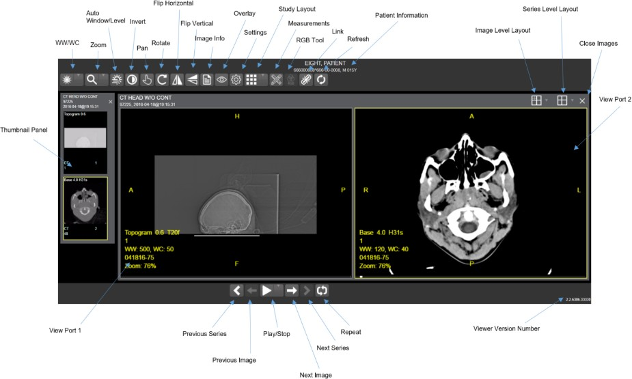

Figure 1

Enhanced Image Viewer Web-Based Application
The Enhanced Image Viewer Web Application enables users to access patient images using VA approved versions of Internet Explorer. The Enhanced Image Viewer can be accessed using hosting applications such as eHMP and JLV.

The Enhanced Image Viewer Web Application allows users to locate and display any patient images available to the VA from VistA Imaging, including DoD images.

Viewing Images

Launching the Viewer
Upon launching the viewer, the following loading screen (Figure 2) will display:

Figure 2

The first time a study is launched, the images will be pre-processed and loaded into a cache on the VIX server. After the images are cached, the next time that study is selected, the study will take less time to load.
If there is trouble loading an image or multiple images, the following screen will display (Figure 3) with the option to either proceed or empty the cache and try again. If the proceed option is selected, the study will load without the problem images. If the cache is emptied, the viewer will attempt to re-process all the images for the study.
Figure 3

Loading Images
When the Enhanced Image Viewer window opens, it displays thumbnail placeholders until the thumbnails themselves are retrieved. See table in section 3.3.1 for an example of a thumbnail.
To display images associated with thumbnails,
- On the left side of the Enhanced Image Viewer window, locate the thumbnail for the desired image.
- Click the desired thumbnail. A progress window will be display as shown below (Figure 4), until the loading of the image is complete:
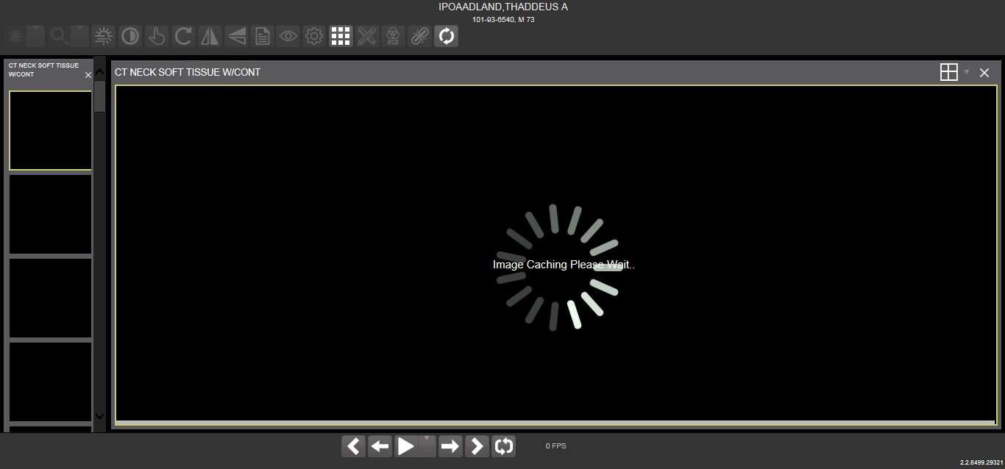

Working with Images
Figure 4

The functions described below are used to change how the images are displayed.

NOTE: Any changes made to the images as described below apply only to the current session. They will not be saved for subsequent sessions.

Viewing Images and Manipulating View Layout

Button Icon | Button Name and Function | Description
 | Image Level Layout | The image level layout button allows users to select how many images within each series are displayed within the view port for each series.
 | Series Level Layout | The image series layout button manipulates how many series within the study will display on the view port.
 | Close Images | The close images button will close the currently selected image from the view port.
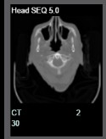 | Thumbnail | The title of the series appears at the top left of the thumbnail. The type of image appears at the bottom left, with the number of images in the series directly below that. The series number is found on the bottom right of the thumbnail. For DICOM images, the modality code appears on the bottom left.

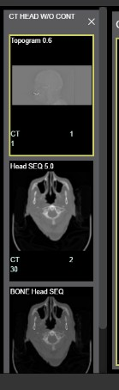 | Thumbnail Panel | To adjust the size of the thumbnail panel, click and drag the right edge of the panel. This will affect how many thumbnails are shown per row within the panel, but will not alter the size of the thumbnails. When hovering over the view port and viewing non-stacked images, use the mouse wheel to scroll between the different series displayed in the thumbnail panel. Drag and drop can be used to drag thumbnails to the view port. A yellow outline will appear around the thumbnail that is currently being viewed in the view port.
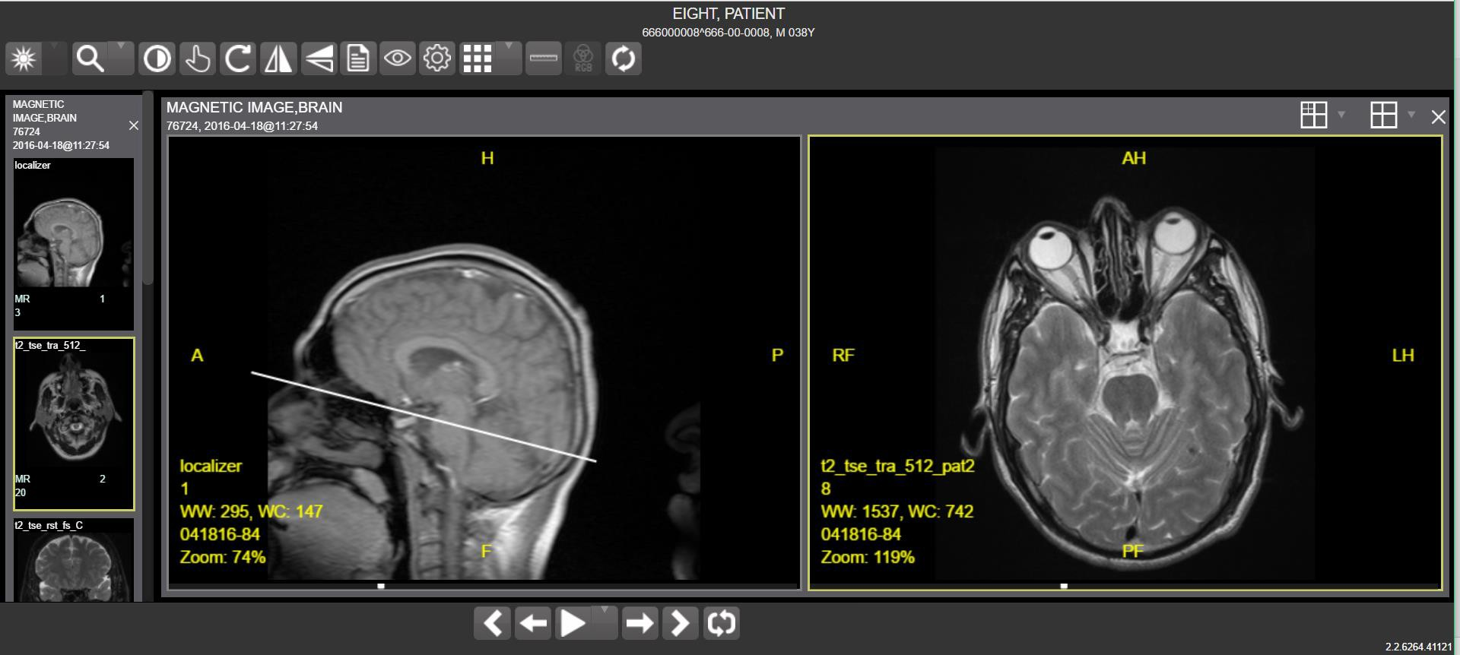
Scout Line
    - Viewing Stacked Images
When viewing a stacked image series, use the mouse wheel to scroll between the images in the stack. Upon scrolling, if multiple series are displayed in the view port, scout lines will appear on the images of the other series in a different plane to indicate what part of the body the series is displaying. See Figure 5 below.

Figure 5
Enhanced Image Viewer User Guide November 2017

Using the Image Navigation Toolbar
The navigation toolbar will appear automatically when applicable.. See Figure 6 below:

Figure 6

Button Icon | Button Name and Function | Description
 | Previous Series and Next Series | The previous and next series buttons allow users to toggle between the various image series in the study.
 | Previous Image and Next Image | The previous and next image buttons allow users to scroll through the images within the currently selected series.
 | Play and Stop | The play and stop buttons will begin and end playing through a cine image series.
 | Repeat | When the repeat series button is selected, the current series will repeat. When it is deselected, all the series will play through before repeating the current series.

- While a series is playing, a number will appear next to the image navigation toolbar. The first number is the frame rate the series is currently playing, and the second number is the frame rate the series was recorded at. See Figure 7 below.

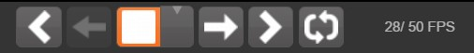
Figure 7

- NOTE: The first time a series plays, it may play slower as the images are caching. Once the images are cached, the series will play faster.

Document Viewer
When viewing a document, the document viewer will load and the image viewer toolbars will be disabled. See Figure 8 below for an example of the document viewer.

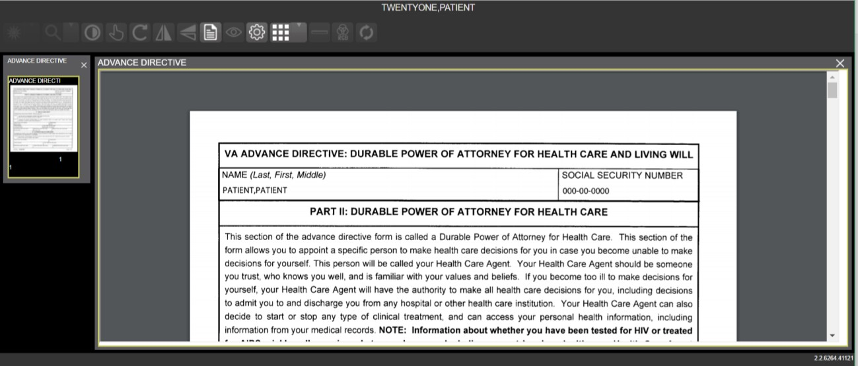

Printing an Image
Figure 8

To print an image, right click on the image and a drop down bar will display. See Figure 9 below for an example.
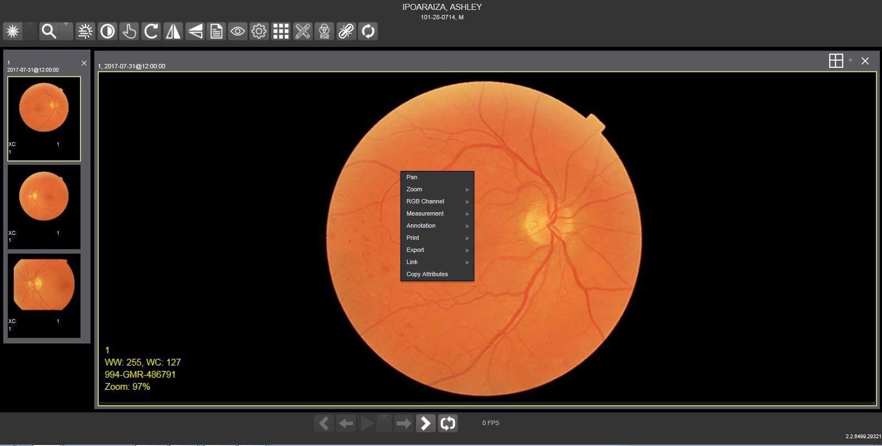

Figure 9

After selecting the print option, user may select from print options. The user will also need to select a print reason and enter their digital signature. After print options are selected, the image will open in a new tab in a printable form. The user can now print the image by pressing File | Print, or Ctrl+P. See Figure 10 below for an example.

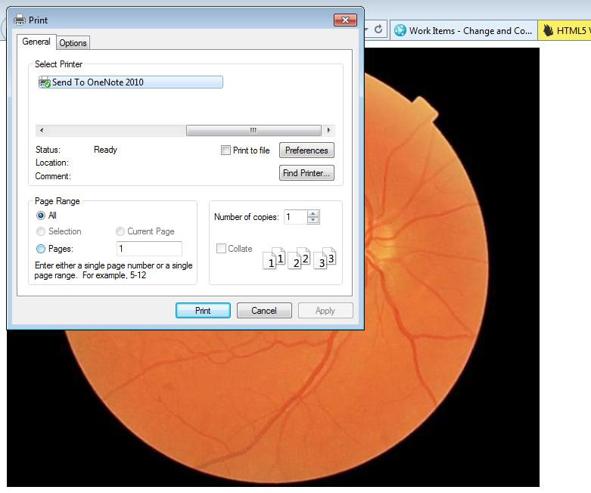
Figure 10

Using the Enhanced Image Viewer Toolbar
The toolbar provides access to a variety features of the Viewer while viewing an image. Dependent upon the type of image, some of these capabilities may be unavailable (will be grayed out indicating that the specific functionality is not accessible). See Figure 11 below for an example of a grayed out toolbar button. See Figure 12 below for an image of the toolbar.
Figure 11
Figure 12

Button Icon | Button Name and Function | Description
 | WW/WC  (Window/Level) | Provides the ability to set the WW/WC (Window/Level) View. When the WW/WC button is selected, click and drag on the desired image to alter the grayscale value of the image. For CT images, a CT preset menu will be available with the following options: Default, the Abdomen, the Bone, the Brain, the Head/Neck, the Lung, or to Customize.
 | Zoom | Provides the ability to resize the image to 100%, or Fit to Window, or Fit Width to Window, or Fit Height to Window, or to Customize the sizing. When the Zoom button is selected, click and drag the image to zoom in and out.
 | Auto Window/Level | Provides the ability to click and drag on selected image to adjust the window/level.
 | Invert | Inverts the image.

 | Pan | When selected, click and drag the image to pan and view the desired area.
 | Rotate | Rotates the Image 90 degrees’ counter- clockwise.
 | Flip Horizontal | Flips the Image horizontally.
 | Flip Vertical | Flips the Image vertically.
 | View Image Info | Views the DICOM Attributes and Metadata for the Image.
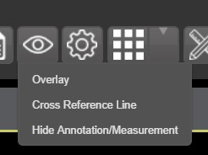 | Overlay | “Overlay” toggles the overlay on and off. “Cross Reference Line” toggles the scout lines on and off. “Hide Annotation/Measurement” either shows or hides the annotations and measurements the user has created on the image.
 | Settings | Provides the ability to set the Cine, Measurement and Layout Preferences. For more information on the settings,  see section 4.2 below.
 | Study Level | Provides the ability to set the Study Level to 1x1, 1x2, 1x3, 2x1, 2x2, 2x3, 3x1, 3x2, or 3x3.
 | Measurements | Provides the ability to access the 2D Length, the Angle Tool, 2D Point, 2D Length Calibration, or Delete All. For more information on the measurement options, see section 4.4 below.
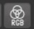 | RGB Tool | Access the RGB Tool. For more information on the RGB tool, see section 4.5 below.
 | Link | Allows user to select two image stacks and scroll simultaneously.
 | Refresh | Provides the ability to refresh the image to its original settings.

Viewing Information on an Image
- To view an image’s information, select the Image Info Button.
- To view the DICOM information, select DICOM Header.
- A screen showing the DICOM Attributes will display as shown below (Figure 13):
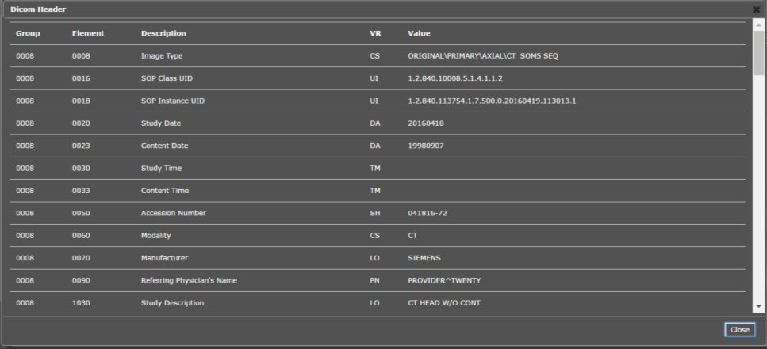
Figure 13
- To view the Imaging Data for the Image, select the Imaging Data option.
- A screen showing the Image Metadata will display as shown below (Figure 14):
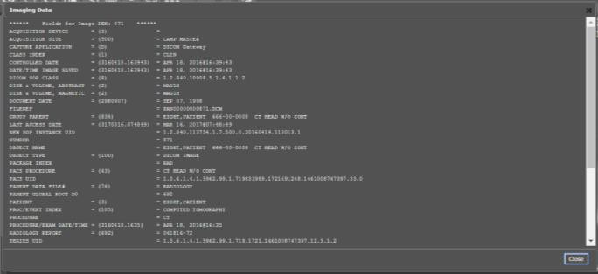
Figure 14

Changing the Settings of an Image
- Select the Settings button to view or update the settings options.
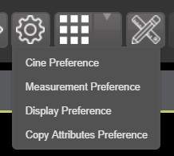
- The following screen will be displayed (Figure 15):
Figure 15

- To view or update the Cine Settings, select the Cine Preference and the following screen
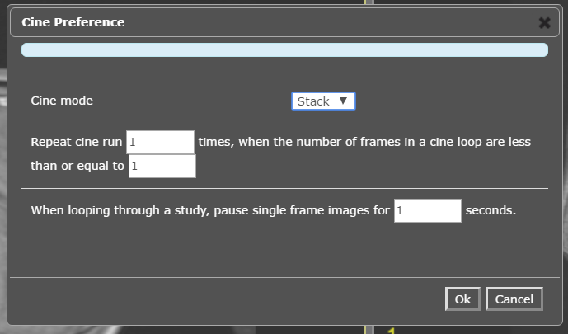
will display (Figure 16):
Figure 16

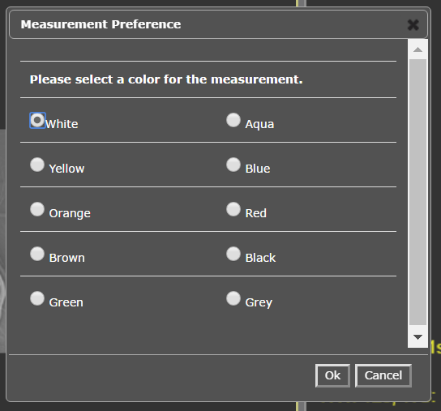
- To view or update the Measurement settings, select the Measurement Preference and the following screen will display (Figure 17):
Figure 17

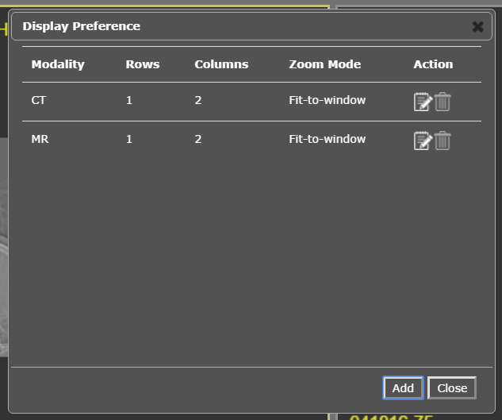
- To view or update the Display settings, select the Display Preference and the following screen will display (Figure 18): (Once display settings are selected, the user preferences will be saved for the next time the user opens a study of the same type)

Figure 18

- To view or update the Copy Attributes Preferences, select Copy Attributes Preference and the following screen will display (Figure 19):

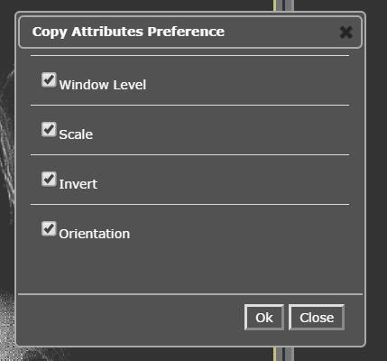

Figure 19

Changing the Study Layout
- To change the study layout, select the Study Layout Button.
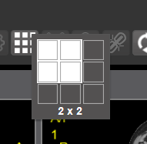
- The following screen will display (Figure 20):
Figure 20
- Select the study level that you best suits your purpose.

Using the Measurements Tools
- To use the various measurement tools, select the Measurements Button.

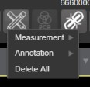
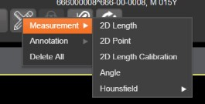
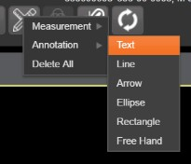
- The following screen will display (Figures 21. 22, 23):
Figure 21 Figure 22 Figure 23
- The 2D Length option draws the necessary line(s) to obtain desired measurements.
- The Angle Tool draws the necessary line(s) to measure the desired angle.
- The 2D Point tool places the necessary dots to obtain desired measurements. This option is typically used for ultrasound studies to measure velocity.
- The 2D Length Calibration option calibrates measurements to ensure accurate data. Images with DICOM info use the DICOM info to inform measurement calibration, but images without this data need calibration to show accurate data. See Figure 24 below.

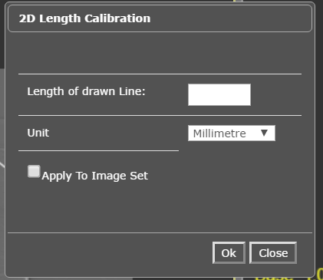

Figure 24
- The Hounsfield tool takes circular and rectangular density measurements. See Figure 25 below.
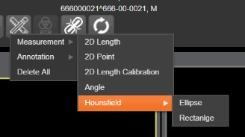
Figure 25
- The Text tool allows users to create text boxes on the image.
- The Line tool draws straight lines on the image.
- The Arrow tool draws straight arrows on the image.
- The Ellipse tool draws ellipses on the image.
- The Rectangle tool draws rectangles on the image.
- The Free Hand tool connects points that have been specified by the user to create any desired shape.
- To delete all of the measurements and markings that you have made on the current image, select the Delete All option.

Using the RGB Tool
The RGB Tool button filters the image for certain color channels to allow for various observations. When selected, a drop-down menu (Figure 26) will appear that allows the user to select the desired color channel.

Figure 26

Closing the Enhanced Image Viewer
To close the Enhanced Image Viewer window, click the “X” on the tab in the browser. See Figure 27 below.

Figure 27
NOTE: The Enhanced Image Viewer closes automatically with a different patient selection.

Troubleshooting
To display version information and message history about the Enhanced Image Viewer, click the Viewer Version Number located in the lower right corner of the Enhanced Image Viewer window. See Figure 28 below.
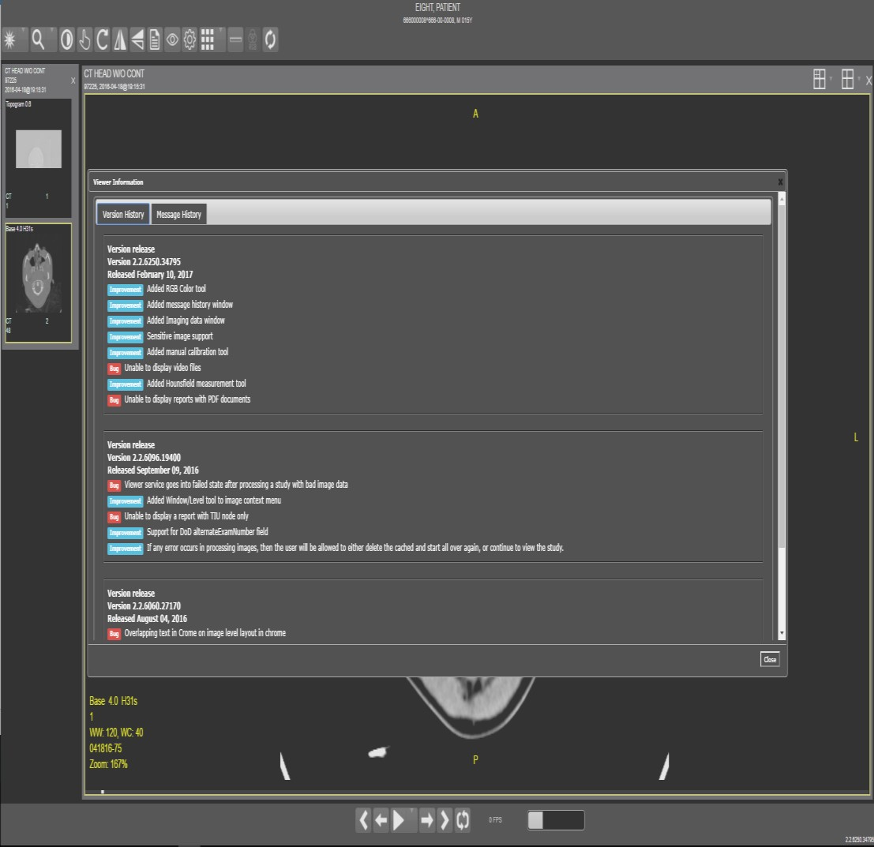
Viewer Version Number
Figure 28
To exit the window, click the “X” in the top right corner.

The Imaging Info found in the top toolbar can also be used for troubleshooting. See section
3.4.1 for more info.

Glossary

Acronym /Term | Definition
Enhanced Image Viewer | Enhanced Image Viewer
CPRS | Computerized Patient Record System
DICOM | Digital Imaging and Communications in Medicine
eHMP | Enterprise Health Management Platform
EKG | Electrocardiogram
FAQ | Frequently Asked Questions
FDA | Food and Drug Administration
ID | Identifier or Identification
JLV | Joint Legacy Viewer
Multi-frame | A DICOM image that contains multiple two-dimensional pixel planes in a single file. When the file is displayed, each plane (frame) is presented as a separate image. This separation is automatically handled in the Radiology Viewer.
MUSE | A third-party cardiology information system used to store and manage EKG (electrocardiogram) images. If a VA facility stores their images in MUSE, they will not be accessible to the Enhanced Image Viewer.
VA | Veteran Affairs
VistA | Veterans Health Information System and Technology Architecture

Appendix – Supported File Extensions

Extension | Description | Associated Viewer
756 | Historical 756 | Radiology Viewer or Full Resolution Viewer depending on image type.
ABS | Abstract file | Abstract area
ASC | ASCII text file | Not Supported
AVI | Motion video | Video Player
BIG | X-ray file 2000K | Radiology Viewer
BMP | Bitmap | Full Resolution Viewer
BW | Black and white | Radiology Viewer or Full Resolution Viewer depending on image type.
DCM | DICOM | Radiology Viewer
DOC | MS Word document | Microsoft Word
DOCX | MS Word document | Microsoft Word
HTM | Web HTM document | Not Supported
HTML | Web HTML document | Not Supported
JPG | JPEG full color | Full Resolution Viewer
MHT | MIME HTML web page archive | Not Supported
MHTML | MIME HTML web page archive | Not Supported
MP3 | Motion video MPEG-3 | Not Supported
MP4 | Motion video MPEG-4 | Not Supported
MPEG | Motion video MPG | Not Supported
MPG | Motion video MPG | Not Supported
PAC | X-ray PAC image | Radiology Viewer
PDF | Adobe PDF | Full Resolution Viewer
RTF | Rich text format | MS Word
TGA | TARGA image | Radiology Viewer

TIF | Tagged Image File Format | Full Resolution Viewer
WAV | Audio wave file | Not Supported

