VITALS / MEASUREMENTS
INSTALLATION GUIDE

Patch GMRV*5.0*3

April 2006

Department of Veterans Affairs
Health System Design & Development
Provider Systems

This page intentionally left blank for double-sided printing.

Table of Contents

Overview 1
Introduction 1
Purpose 1
Related Manuals 1
System Requirements 2
M Server Requirements 2
Client Requirements 2
Installation Instructions 3
Pre-Installation Instructions 3
M Server Installation 4
Client Installation 6
Customizing the Client Installation 8

This page intentionally left blank for double-sided printing.

Overview

Purpose
The purpose of this installation guide is to provide instructions for use by the technical staff who will install Patch 3 for Vitals 5.0. Please note that this installation guide does NOT contain instructions for installing the Vitals 5.0 package: this guide only covers Patch 3 installation.

Introduction
Patch GMRV*5.0*3 contains changes to the Gen. Med. Rec. – Vitals package (aka Vitals/Measurements). The package namespaces are GMRV and GMV.
- This patch includes a Dynamic Link Library (DLL) file. This file will be used by CPRS v26. When CPRS v26 is installed on your system, it will call this DLL when a user wishes to enter patient vitals/measurements data via the CPRS package.
- This patch modifies the current Vitals.exe file which is the Graphical User Interface (GUI) for entering patient vitals/measurements data via the Vitals/Measurements package to keep it consistent with the DLL interface.
- This patch modifies the current Vitals.exe to use the Clinical Context Object Workgroup (CCOW) standard. After this patch is installed, when the user runs more than one GUI application at a time with patients selected, the Vitals.exe file will know if a patient selection change was made in the other applications. The Vitals.exe may switch to another patient automatically or allow the user to “break context” and select a different patient.

Related Manuals
The following documents can be downloaded from the VistA Documentation Library (VDL) at http://www.va.gov/vdl/ under Vitals/Measurements:
Vitals/Measurements User Manual 5.0
Vitals/Measurements Release Notes GMRV*5.0*3
Vitals/Measurements Technical Manual and Package Security Guide 5.0

System Requirements

M Server Requirements
The following packages and patches must be installed and fully patched for the installation environment:
1. VA FileMan V. 22 or greater
2. Kernel V. 8.0 or greater
3. Kernel Toolkit V. 7.3 or greater
4. Kernel RPC Broker V. 1.1 or greater
5. PIMS V. 5.3 or greater
6. Intake and Output V. 4.0
7. Health Summary V. 2.7 or greater
8. Nursing V. 4.0 or greater

Client Requirements
The client (disk) storage requirements are:
Type of Data Size
Vitals.exe (user) 1900 k
VitalsManager (manager) 1200 k
GMV_VitalsViewEnter.dll 1500 k

Help Files (user) 50 k
Help Files (manager) 25 k
Help File (dll) 36 k

The installation environment on the VistA client workstation requires:
1. Workstations must be running Windows NT (V4 or later) or Windows 2000
2. Workstations must be connected to the local area network (LAN)
3. 12 megabytes of disk space must be available
4. RPC Broker Workstation may be installed (optional)

Installation Instructions
This section contains instructions for preparing for the installation, installing the M Server, installing the Client, and customizing the Client. Examples and screen shots are included for your reference.

Pre-Installation Instructions
Before attempting to install this patch, complete the following steps:
- Coordinate the installation with the CAC, package ADPAC and IRMS.
- Forward the GMRV*5.0*3 patch message from FORUM to your system. The FORUM message contains the KIDS build.
- Download the VITL5_P3.ZIP file. The following files are included in this ZIP file:

File Name Contents Retrieval Format
GMV_VitalsViewEnter.dll Dynamic Link Library file Binary
GMV_VitalsViewEnter.hlp Help file for DLL Binary
GMV_VitalsViewEnter.cnt Help file TOC for DLL Binary
VITL5_P3_IG.PDF Patch GMRV*5.0*3 Installation Guide Binary
VITL5_P3_RN.PDF Patch GMRV*5.0*3 Release Notes Binary
VITL5_TM.PDF Technical Manual (all pages) Binary
VITL5_UM.PDF User Manual (all pages) Binary
VITL5_P3.EXE Installation Wizard Binary
VITL5_P3.SRC.ZIP Source Code Binary

The preferred method is to FTP the ZIP file from:

REDACTED

This transmits the ZIP file from the first available FTP server. Sites may also elect to retrieve the ZIP directly from a specific server:

CIO Field Office FTP Address Directory

REDACTED

- After you have saved the ZIP file, double click on it to “Unzip” it. Highlight all of the files and click the Extract button. Save the files to a directory of your choice.

M Server Installation
Note: The M Server installation must be done before the Client installation.
- On the VistA system, set the variables DUZ and DUZ(0) by executing the command
D ^XUP. Verify DUZ(0) = @.
- Load the GMRV*5*3 KIDS build from the MailMan message.
- Use the KIDS installation menu option [XPD MAIN] and select Installation and then Install Package(s) and select GMRV*5.0*3. See the M Server sample installation below for additional information.
Users may remain on the system at the time of installation, though it should be installed when entry of patient vitals data is low. The software should be installed when use of the Vitals/Measurements package is minimal. Follow your facility’s policy regarding the rebuilding of the menu trees upon patch completion.

M Server – sample installation

> D ^XUP

Setting up programmer environment
Terminal Type set to: C-VT100

Select OPTION NAME: XPD MAIN Kernel Installation & Distribution System

Edits and Distribution ...
Utilities ...
KIDS Installation ...
Patch Monitor Main Menu ...

Select Kernel Installation & Distribution System Option: INSTALLation

1 Load a Distribution
2 Verify Checksums in Transport Global
3 Print Transport Global
4 Compare Transport Global to Current System
5 Backup a Transport Global
6 Install Package(s)
Restart Install of Package(s)
Unload a Distribution

Select Installation Option: 6 Install Package(s)
Select INSTALL NAME: GMRV*5.0*3 Loaded from Distribution 11/22/05@14:34:20
=> GMRV*5*3 ;Created on Nov 22, 2005@10:25:46

This Distribution was loaded on Nov 22, 2005@14:34:20 with header of
GMRV*5*3 ;Created on Nov 22, 2005@10:25:46
It consisted of the following Install(s):
GMRV*5.0*3
Checking Install for Package GMRV*5.0*3

Install Questions for GMRV*5.0*3

Want KIDS to Rebuild Menu Trees Upon Completion of Install? YES// NO

Want KIDS to INHIBIT LOGONs during the install? YES// NO
Want to DISABLE Scheduled Options, Menu Options, and Protocols? YES//

Enter options you wish to mark as 'Out Of Order': GMV V/M GUI
Vitals/Measurements GUI Application

Enter options you wish to mark as 'Out Of Order': GMRV V/M ENTRY MENU
Vitals/Measurement Data Entry

Enter options you wish to mark as 'Out Of Order': GMRV ERROR EDIT
Edit a Vital/Measurement Entered in Error

Enter options you wish to mark as 'Out Of Order': <return>

Enter protocols you wish to mark as 'Out Of Order': <return>

Delay Install (Minutes): (0-60): 0// <return>

Enter the Device you want to print the Install messages.
You can queue the install by enter a 'Q' at the device prompt.
Enter a '^' to abort the install.

DEVICE: HOME// <return>

Install Started for GMRV*5.0*3 :
Nov 22, 2005@14:37:03

Build Distribution Date: Nov 22, 2005

Installing Routines:
Nov 22, 2005@14:37:03

Installing PACKAGE COMPONENTS:

Installing REMOTE PROCEDURE

Installing OPTION
GMRV*5.0*3
────────────────────────────────────────────────────────────────────────

Installing PARAMETER DEFINITION
Nov 22, 2005@14:37:03

Running Post-Install Routine: ^GMV3PST

Updating system parameters.

Updating DLL parameter.

Updating Routine file...

Updating KIDS files...

GMRV*5.0*3 Installed.
Nov 22, 2005@14:37:04

Install Message sent #47150
────────────────────────────────────────────────────────────────────────
┌────────────────────────────────────────────────────────────┐
100% │ 25 50 75 │
Complete └────────────────────────────────────────────────────────────┘

Install Completed

Client Installation
Note: The M Server installation must be done before the VistA Client installation.
- Double click on the VITL5_P3.exe file in the directory where you placed it. This file is an installation wizard that contains the updated versions for:
Vitals.exe
VitalsManager.exe
Vitals.hlp
Vitals.cnt
VitalsManager.hlp
VitalsManager.cnt
Roboex32.dll
An InstallShield welcome screen opens. Click Next to start the installation.

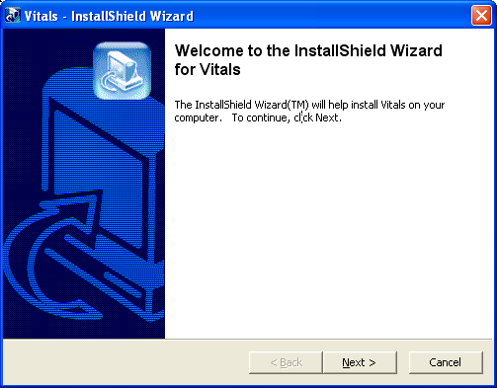

- Several dialog boxes will then quickly flash across the screen before the “Modify, repair or remove the program” dialog box appears.
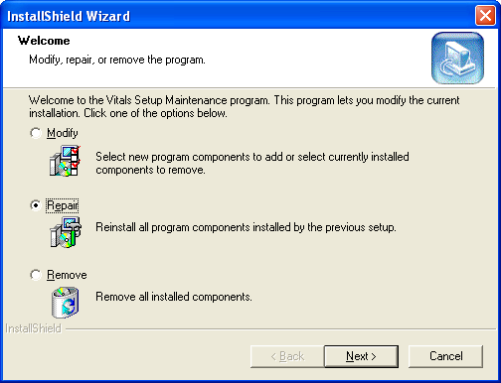
- Select Repair, then click Next. The Install wizard will verify settings and replace all existing files on your workstation with the newer versions. If the installation files are located on the client PC, the installation should complete in less than one minute. Installations over the network may be slower because of server traffic or connectivity issues.
- When all files have been copied, the InstallShield Wizard Complete screen will open. Click Finish to finalize the client installation.
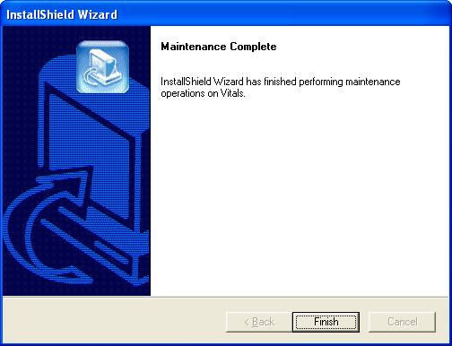

- If you are running the Vitals.exe and VitalsManager.exe files from a server, move the following files to the server:
\Program Files\VistA\Vitals\Vitals.exe
\Program Files\VistA\Vitals\VitalsManager.exe
\Program Files\VistA\Vitals\Help\Vitals.hlp
\Program Files\VistA\Vitals\Help\Vitals.cnt
\Program Files\VistA\Vitals\Help\VitalsManager.hlp
\Program Files\VistA\Vitals\Help\VitalsManager.cnt
\Program Files\VistA\Vitals\Help\Roboex32.dll
- Place the new GMV_VitalsViewEnter.dll, GMV_VitalsViewEnter.hlp, and GMV_VitalsViewEnter.cnt files in the “Program Files\vista\Common Files” directory of the workstation or server where CPRS v26 is (or will be) located. For example, if CPRS will be installed on the C:\ drive, the three DLL related files must be copied into the C:\ Program Files\vista\Common Files directory. If this directory path does not exist, you must create it.
IMPORTANT: These files must not be installed in the same folder as CPRS v26. When CPRS is installed, it will look for these three files in the specified directory path. If CPRS cannot find the DLL and its supporting files, the users will not be able to enter patient vitals/measurements data.
Note: The GMV_VitalsViewEnter.dll does not have to be registered in the Windows registry.
The Client installation is complete.

Customizing the Client Installation
By default, the client installation installs and builds the icons and “Program Files\vista\Vitals” folders without any command line switches. Vitals/Measurements utilizes the ServerList utility of the RPC Broker for selecting a server to connect to if it is configured on the client workstation. Instructions for configuration and utilization of the ServerList utility can be found in the RPC Broker documentation located on the VDL.
If the ServerList utility has not been configured on the client, both Vitals and Vitals Manager applications will, by default, attempt to connect to the server identified in the users HOSTS file as BROKERSERVER on Listener Port 9200.
To override these default parameters, use the following procedure to add command line parameters to the application shortcuts.

- On the client desktop, right-click the Vitals icon and select Properties. The Vitals Properties window opens. Click the Shortcut tab (Figure 1) to display the current target settings.
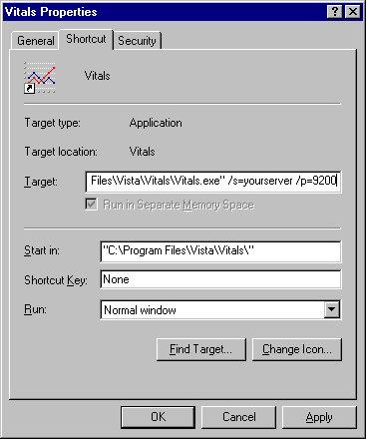
Figure 1

In this example, the application will attempt to connect to the server identified in your HOSTS file as yourserver and will use listener port 9200.
- Enter a different parameter or switch in the Target field. The command line parameters available from the command prompt or within Windows shortcut definitions are:

Vitals.exe [/server=servername] [/port=listenerport] [/tempdir=temporarydirectory] [/helpdir=helpdirectory] [/debug={on|off}] [/noccow] [/ccow=patientonly]

VitalsManager.exe [/server=servername] [/port=listenerport] [/helpdir=helpdirectory] [/debug={on|off}]

The following table describes each of the available parameters and switches.

Switches | Description | Example
/server | Specifies an alternate server to connect to. The server must be defined in the clients hosts file.  Default Hosts. file locations:  NT 4.0/W2K = c:\winnt\system32\drivers\etc\hosts.  Windows 9x = c:\windows\hosts.  Default = BROKERSERVER | /server=vista
/port | Specifies an alternate listener port on the selected server. This is the TCP/IP port that the broker is running on VistA server.  Default = 9200 | /port=9200
/tempdir | Location accessible to the client workstation and current user for storage of temporary scratch files.  Default = application_directory\temp | /tempdir=C:\temp
/helpdir | Location of the Vitals/Measurements windows help files.  Default = application_directory\help | /helpdir=C: \help
/debug | Set the debug mode for both the RPC Broker and the Vitals/Measurements application.  Default = Off. | /debug=On
/noccow | The application will not check the CCOW context at all. This switch will force the user to sign on and select a patient when invoking the Vitals GUI. | /noccow
/ccow=patientonly | The application will use CCOW, but will be set to check for patient context only. Automatic sign on will be disabled, but the automatic selection of a patient will be enabled. If a patient is already selected in an open application, Vitals will automatically open the patient being used by that application. | /ccow=patientonly

