Automated Safety Incident Surveillance Tracking System (ASISTS) V. 2.0

Patch OOPS*2*15 Release Notes

September 2008

Department of Veterans Affairs
Office of Enterprise Development
Management & Financial Systems

Preface

Purpose of the Release Notes
The Release Notes document describes the new features and functionality of Patch OOPS*2*15.

Reference Numbering System
This document uses a numbering system to organize its topics into sections and show the reader how these topics relate to each other. For example, section 1.3 means this is the main topic for the third section of Chapter 1. If there were two subsections to this topic, they would be numbered 1.3.1 and 1.3.2. A section numbered 2.3.5.4.7 would be the seventh subsection of the fourth subsection of the fifth subsection of the third topic of Chapter 2. This numbering system tool allows the reader to more easily follow the logic of sections that contain several subsections.

Table of Contents
Chapter 1 - Introduction 1
1.1 Overview 1
Chapter 2 - Functional Changes 3
2.1 Main Menu Options 3
2.2 Modification to the option Create Accident/Illness Report 4
2.3 Modify the Complete/Validate/Sign Accident Report (2162) 5
2.4 Modify Print Report of Accident (2162) 8
2.5 Modified the Print Accident Report Status 9
2.6 Error messages (in Help) updated 9
2.7 Added new bulletin: OOPS INCIDENT OUTCOME REQUIRED 9
2.8 Modification to the CA-7 (Request for Compensation) (Enter/Edit form) 11
2.9 Modifications to the Print CA-7 Report Option 12
2.10 Change to Log of Needlestick Report 14
Chapter 3 - Bug Fixes 16
3.1 Bug fixes without Remedy Tickets 16
3.1.1 Error when the Occupational Series and Title field is longer than 30 16
3.1.2 Problem with the Print Accident Report Status (now Print Incident Report Status report) 16
3.1.3 Create Accident/Illness Report (now Create Incident Report) 16
3.1.4 Create Accident/Illness Report (now Create Incident Report) 17
3.1.5 CA-1 (Enter/Edit Form) 17
3.1.6 Print CA1/CA2 17
3.1.7 Log of Needlestick Report 17
3.2 Bug fixes with Remedy Tickets 17
3.2.1 HD0000000130515 17
3.2.2 HD0000000152026 17
3.2.3 HD0000000183787 17
3.2.4 HD0000000206374 17

Chapter 1 - Introduction

1.1 Overview

The main purpose of this release is to implement changes regarding privacy act requirements, modify the Accident report, update the Request for Compensation Form (CA-7), and minor bug fixes.

The information contained in this document is not intended to replace the User Manual or On-line help documentation. New functionality is briefly discussed so that readers are aware of high level functional changes. The User Manual or On-line help should be used to obtain detailed information regarding specific functionality.

Chapter 2 - Functional Changes

2.1 Main Menu Options

The menu options available to the Occupational Health, Safety Officer and Workers’ Compensation (WC) specialist have been modified to ensure that the privacy of individuals in ASISTS is protected. This involved removing or modifying options on menus.

The following options have been removed from the Occupational Health menu.

Print CA1/CA2
Approve Workers' Comp Signing for Employee

The following options have been removed from the Safety menu.

Print CA1/CA2
Approve Workers' Comp Signing for Employee
Complete/Validate/Sign CA1
Complete/Validate/Sign CA2

The following options have been removed from the Workers’ Compensation menu.

Create Accident/Illness Report
Create Amendment
Complete/Validate/Sign Accident Report (2162)
Classify Incident Outcome
Display Incident Outcome Report
Display Incidence Rates Worksheet

The following option has been modified.

Electronically Sign for Employee - removed requirements that the Safety officer and Occupational Health must approve the Workers’ Compensation specialist signing for the employee.

Additionally, modifications have been made to the terminology of the Accident/Illness form by removing references to Form 2162. All references to “Accident/Illness (2162)” have been changed to “Incident”.
Specifically, the following options have been renamed.

From: Create Accident/Illness Report
To: Create Incident Report

From: Complete/Validate/Sign Accident Report (2162)
To: Complete/Validate/Sign Incident Report

From: Print Report of Accident (2162)
To: Print Report of Incident

From: Print Accident Report Status
To: Print Incident Report Status

From: Manual Transmit of National Database (2162) Data
To: Manual Transmit of National Database Data

From: Incident Reports
To: Summary Incident Reports

Modification to the option Create Accident/Illness Report

The option name and screen title was changed to Create Incident Report.

Added SEVERITY OF INJURY prompt in the Incident information panel and modified the logic so that if the incident is an injury, this information is collected. If the incident is an illness, the illness type is collected. The appropriate prompt is displayed based on the incident type.

The Severity of Injury valid codes are:

1 No Treatment Required
2 First Aid Only
3 Medical Treatment
4 Disabling Injury
5 Fatality

The following six prompts in the Quick OSHA Log Assessment panel have had the default values changed from ‘No’ to ‘None Selected’.

Was there Loss of Consciousness
Hospitalized overnight as in-patient
Treated in non-VA Emergency Room
Was prescription strength medication ordered/given
Was non-Rx medication ordered/given at Rx strength
Initial return to work status
The None Selected radio button was added and is now the default when the user opens the form. The default value must be changed before a new case can be created. The ‘None Selected’ choice was necessary so that a screen-reader user could tab into the radio group to maintain 508 compliance.

A “behind the scenes” change was made to the M code. The employee address fields: street, city, state, zip code, and home phone number will no longer be “pulled” from the PAID Employee file (#450) and inserted as default values when creating a new case. These prompts are required and the user will now have to enter those fields before saving the data.

Modify the Complete/Validate/Sign Accident Report (2162)

The name of the option was changed to Complete/Validate/Sign Incident Report.

A new tab, Other Factors, has been added to collect additional information relating to the cause of the incident.

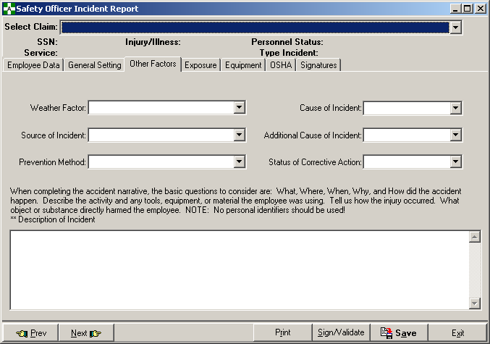

The six new prompts (with valid responses) are as follows.

Weather Factor
Snow/Ice
Dust Storm
Lightning
High Temperature
Low Temperature
Humidity
Fog
Rain
Windstorm
Weather - N.E.C.
Weather Not a Factor

Source of Incident
Unpowered Equipment, Furnishings, Supplies
Powered Equipment, Appliances, Machines
Building Material, Feature or Condition
Toxic Substance, Radiation Source
Vehicle
Person
Patient Handling

Cause of Incident
Equipment or Environment
Person
Nature
Cause Unknown

Prevention Method
Training
More Staff
Motivation
Better Equipment or Material
Better Planning/Coordination
Improved written Procedures
More Funds for Hazard Elimination
Personnel Action
Preventive - N.E.C.
None
Additional Cause of Incident
Equipment or Environment
Person
Nature
No additional Cause

Status of Corrective Action
Taken
Requested and Anticipated
Requested
None

These fields must be answered before the supervisor can electronically sign the form.

Additionally, the General Settings tab was modified by moving the Description of Incident prompt to the Other Factors tab. The verbiage “Note: No personal identifiers should be used!” was added to the descriptive prompt narrative.

The General Setting tab has been modified as shown below.

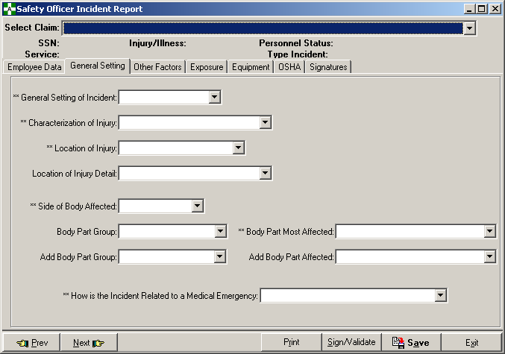

The text “(No personal identifiers should be used)” was added to the Corrective Action and Safety Comments prompt on the Signatures tab as shown below.

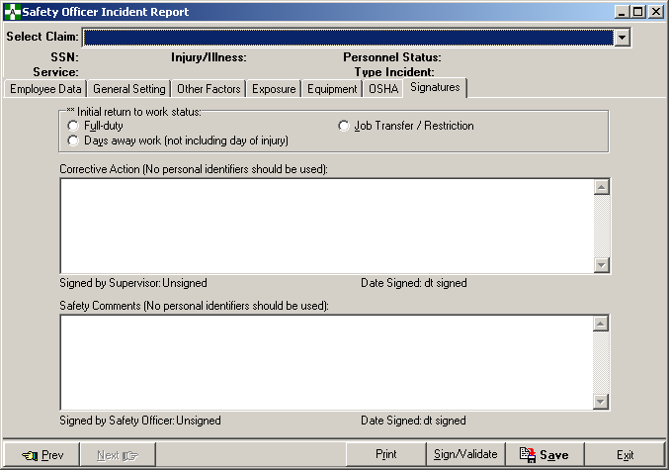

Modify Print Report of Accident (2162)

The name of the option was changed to Print Report of Incident.

The report title was changed to Veterans Health Administration Incident report.

A new Report Type was added to the immediate right of Case number on page 1 of the report. The value of this block is derived from the database. If the case has been amended, Report Type = Corrected, otherwise the value is Initial.

The SSN display was changed from the actual value to xxx-xx-NNNN where only the last 4 numbers of the SSN are displayed.

The Date of Birth (DOB) block was changed to the Age at Time of Incident. The age is derived from the DOB and Date/Time of Occurrence.
FORM 2162 was removed from the bottom left hand corner of page 1 of the report.

The report run date and time was added at the bottom right hand corner of each page of the report.

Page 3 of the report was modified by inserting the following new fields at the top of the page and adjusting the OSHA fields towards the bottom.

Weather Factor
Source of Incident
Cause of Incident
Prevention Method
Additional Cause of Incident
Status of Corrective Action

Modified the Print Accident Report Status

- The name of the option was changed to Print Incident Report Status.
- The report title was changed to Incident Report Status.
- The SSN display was changed from nnn-nn-nnnn to xxx-xx-nnnn.

Error messages (in Help) updated

The error messages have been updated in the Complete/Validate/Sign Incident Report CA-1, Complete/Validate/Sign Incident Report CA-2, Witness Form (for the CA-1), and in the Print Incident Report Status options to remove references to the 2162 Form (Accident Report) and replace them with Incident or Incident Report.

Added new bulletin: OOPS INCIDENT OUTCOME REQUIRED

A bulletin will now be sent to the Safety mail group if the response to the Initial Return to Work Status prompt entered in the Create Incident Report or modified in the Complete/Validate/Sign Incident Report is “Days away work” or “Job Transfer/Restriction”.

Example

Subj: ASISTS - Incident Outcome Required [#214] 05/06/08@13:53 8 lines
From: ASISTS, USER In 'IN' basket. Page 1
-----------------------------------------------------------------------
A new incident has been entered or an existing incident has been
modified where the Initial Return to Work Status for the incident
is "Days Away Work" or "Job Transfer/Restriction".

The Case Number is: 2008-000XX

An entry in the Classify Incident Outcome option is required to
record the dates and the incident outcome for this case.

Modification to the CA-7 (Request for Compensation) (Enter/Edit form)

A new prompt was added in the CA7-Request for Compensation enter/edit form in Section 15. It must be completed before the WC specialist can electronically sign the form. The only data validation completed is that it must be a valid date and cannot precede the date the form was created. An example screen is shown below.

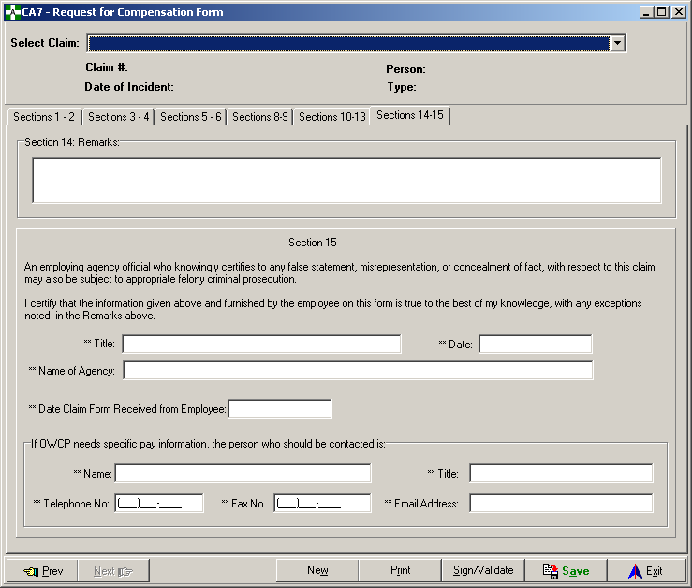

Correction of an unreported bug fix is included involving Section 6 - The radio buttons were getting reset to “unchecked” after data from the claim had been loaded. This resulted in data being potentially "erased" without the user being aware.

Correction of an unreported bug fix where the signature was not displayed if the user or WC specialist had signed the form - It appeared that the form had not been signed when it had. Additionally, the sign/validate button was not properly enabled when a user entered the form. Corrected the problem so the user could click the sign/validate button and be prompted to sign the form.

Modifications to the Print CA-7 Report Option

Section 1 - Changed the “expires” date from 08/31/2005 to 10/31/2008.

Section 3 - Text in this section has been changed as follows.

From: Have you worked outside your federal job during the period(s) claimed in Section
2? (Include salaried, self-employed, commission, volunteer, etc.)

To: You must report all earnings from employment (outside your federal job); include
any employment for which you received a salary, wage income, sales
commissions, piecework, or payment of any kind during the period(s) claimed in
Section 2. Include self-employment, involvement in business enterprises, as well
as service with the military forces. Fraudulent concealment of employment or
failure to report income may result in forfeiture of compensation benefits and/or
criminal prosecution. Have you worked outside your federal job for the period(s)
claimed in Section 2?

Section 6c - Added check boxes for the retirement field. If the data value = CSRS then the CSRS box is checked, if FERS then the FERS checkbox should be checked, if SSA then the SSA checkbox should be checked, and if not one of those 3, then the Other check box should be checked.

Changed form reference at bottom right corner of page 1 to: Form CA-7 Rev. June 2005.

Section 10c - Added "D-Z only" underneath the line next to the Class field.

Section 13 - Removed the lines in this section which resulted in underlined text when data was entered in that field.

Section 15 - Increased the size of this section to facilitate adding the new field, Date Claim Form Received from Employee.
A new Privacy Act paragraph (completely new page 4) has been added with the following text.

In accordance with the Privacy Act of 1974, as amended (5 U.S.C. 552a), you are here by
notified that: (1) The Federal Employees' Compensation Act, as amended and extended
(5 U.S.C. 8101, et seq.) (FECA) is administered by the Office of Workers' Compensation
Programs of the U. S .Department of Labor, which receives and maintains personal
information on claimants and their immediate families. (2) Information which the Office
has will be used to determine eligibility for and the amount of benefits payable under the
FECA, and may be verified through computer matches or other appropriate means. (3)
Information may be given to the Federal agency which employed the claimant at the time
of injury in order to verify statements made, answer questions concerning the status of
the claim, verify billing, and to consider issues relating to retention, rehire, or other
relevant matters. (4) Information may also be given to other Federal agencies, other
government entities, and to private-sector agencies and/or employers as part of
rehabilitative and other return-to-work programs and services. (5) Information may be
disclosed to physicians and other healthcare providers for use in providing treatment or
medical/vocational rehabilitation, making evaluations for the Office, and for other
purposes related to the medical management of the claim. (6) Information may be given
to Federal, state and local agencies for law enforcement purposes, to obtain information
relevant to a decision under the FECA, to determine whether benefits are being paid
properly, including whether prohibited dual payments are being made, and, where
appropriate, to pursue salary/administrative offset and debt collection actions required or
permitted by the FECA and/or the Debt Collection Act. (7) Disclosure of the claimant's
social security number (SSN) or tax identifying number (TIN) on this form is mandatory.
The SSN and/or TIN, and other information maintained by the Office, may be used for
identification, to support debt collection efforts carried on by the Federal government,
and for other purposes required or authorized by law. (8) Failure to disclose all requested
information may delay the processing of the claim or the payment of benefits, or may
result in an unfavorable decision or reduced level of benefits.

Note: This notice applies to all forms requesting information that you might receive
from the Office in connection with the processing and adjudication of the claim you
filed under the FECA.

Note: The current hardcopy form can be downloaded from:
http://www.dol.gov/libraryforms/go-us-dol-form.asp?FormNumber=362

Change to Log of Needlestick Report

The Include Names of Persons Involved prompt has been removed from the Enter/Edit screen. Prior to this change, the name field would either be blank or contain the words “Privacy Case”.

The report entry form now appears as shown below.

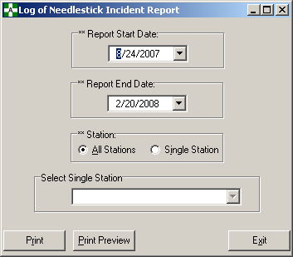

A lost time indicator has been added back into the report. It was removed with Patch OOPS*2*7. A new column has been added, Lost Time, which will contain either Yes or No. If the response for the prompt INITIAL RETURN TO WORK STATUS is DAYS AWAY WORK, then the Lost Time column will be Yes; otherwise the Lost Time column will be No.

Chapter 3 - Bug Fixes

Bug fixes without Remedy Tickets

Error when the Occupational Series and Title field is longer than 30
An error will occur when sending a claim to the Department of Labor when the Occupational Series and Title field (pulled from the PAID EMPLOYEE File #450) is longer than 30 characters. Modified the M server side code to only accept the first 30 characters when auto populating an ASISTS claim with this data. This modification will only be apparent to the user if the occupation for the employee is truncated in the CA-1 or CA-2.

Problem with the Print Accident Report Status (now Print Incident Report Status report)
There was a condition where an Incident Report Status report would not print data when there were cases that met the criteria and should have been included on the report. This was the result of a variable not being removed properly in all cases. The input transform for eight date fields has been modified to remove the offending variable.

In the ASISTS ACCIDENT REPORTING File (#2260), the fields are:

DATE/TIME STUB CREATED
DATE OUTCOME CREATED
LAST EDIT DATE
DATE/TIME WORK STOPPED (CA-1)
DATE PAY STOPPED (CA-1)
DATE 45 DAY PERIOD BEGAN
DATE/TIME RETURNED TO WORK
DATE/TIME WORK STOPPED (CA-2)
DATE/TIME PAY STOPPED (CA-2)
DATE/TIME RETURNED TO WORK

In the ASISTS SITE PARAMETER FILE, STATION SUBFILE (#2262.315), the field is: OSHA MONTH/YEAR

Create Accident/Illness Report (now Create Incident Report)
Proper time error checking did not occur in this option when the Incident was an Illness, the Date First Aware of Illness had been previously entered, and the Incident was changed to an Injury. Data validation has been added to check for time in the Date of Incident field if a date has been entered and the Incident is changed from an Illness to an Injury.

Create Accident/Illness Report (now Create Incident Report)
The error message on the “Treated in non-VA Emergency Room” field in the Quick OSHA Log Assessment panel (QOLA) has been changed to better reflect the missing field. It now states: “Please enter if Individual treated in a non-VA Emergency Room”. Previously the indication for a non-VA condition was omitted.

CA-1 (Enter/Edit Form)
On the Physician tab of this option, the labels for the physician fields were shifted to the right and cut off when the fields were required. When the fields were not required, the labels displayed properly. Fixed the labels so that they properly display the entire label whether required or not.

Print CA1/CA2
The date in block 22, Date of Injury, on page 2 of the CA-1 printed over the line to the right into block 23, Date of Notice. Moved the display of the Date of Injury slightly to the left so that it prints entirely in the block.

Log of Needlestick Report
If the report criteria resulted in no data being found, the printed message on the report read: THERE IS NO DATA TO REPORT FOR. The message has been changed to: THERE IS NO DATA TO REPORT FOR THIS TIME FRAME.

Bug fixes with Remedy Tickets

HD0000000130515
Modifications have been completed so that page numbers print correctly on the OSHA 300 Log with more than 9 pages. Previously, the page numbers over 9 did not print at the bottom of the report.

HD0000000152026
Prior to the modification made to ASISTS, a separated employee or terminated non-paid employee could have a new Incident report created for them. These individuals would show up in the listing of valid employees. Modifications were completed so that separated employees and terminated non-paid employees could not be selected.

HD0000000183787
When the Regular From or To hours was midnight, the PM box on the CA-1 was checked rather than the AM checkbox. The problem was corrected so the appropriate checkbox was checked for all times.

HD0000000206374
Prior to the correction, in the Create Incident Report or the Complete/Validate/Sign Incident Report, a user was able to select a terminated Supervisor or Secondary Supervisor. Modifications were made so that individuals terminated from the NEW PERSON File (#200) would not be included for selection.

