Compensation and Pension Record Interchange (CAPRI)
(CAPRI GUI v. DVBA_27_143_12)

Release Notes Patch DVBA*2.7*143 November 2009

Department of Veterans Affairs Office of Enterprise Development Management & Financial Systems

Preface

Purpose of the Release Notes
The Release Notes document describes the new features and functionality of Patch DVBA*2.7*143.

Reference Numbering System
This document uses a numbering system to organize its topics into sections and show the reader how these topics relate to each other. For example, section 1.3 means this is the main topic for the third section of Chapter 1. If there were two subsections to this topic, they would be numbered 1.3.1 and
1.3.2. A section numbered 2.3.5.4.7 would be the seventh subsection of the fourth subsection of the fifth subsection of the third topic of Chapter 2. This numbering system tool allows the reader to more easily follow the logic of sections that contain several subsections.

CAPRI iii
Table of Contents
- Overview 1
- Defect Fixes 2
  - Defect Fixes with Remedy Tickets 2
    - HD0000000344256: Error Message in CAPRI after a screensaver was pushed to all Region 5 2
    - HD0000000295597: CAPRI no longer allows copy/paste on C&P Exam Request screen 2
  - Defect Fixes without Remedy Tickets 3
    - Defect - Non-compliant Department of Veteran Affairs Seal 3
    - Defect - Error when attempting to enter a new patient having a single character first name. 3
    - Defect - "Problem detecting your division" displays after selecting remote site 4
    - Defect - Semicolon-delimited Access/Verify code entry causes CAPRI to re-prompt for credentials 4
- Enhancements 5
  - Add Foreign Address Support to CAPRI 5
    - Modify the Enter New Patient screen for Foreign Address Entry 5
    - Modify the Address Verification screen for Foreign Address Entry 6
    - Modify the Admin Tab for Foreign Address Entry 8
    - Modify the Compensation and Pension Exam Status Inquiry to support Foreign Addresses 8
  - Add Foreign Address Support to the AMIE package in VistA 9
  - Restore Local Bi-Directional Health Information Exchange (BHIE) Connectivity 10
    - Fix the Verify Code Change Problem 10
  - Support VA/DoD Disability Evaluation System (DES) Examinations 10
    - TRICARE and SHARING AGREEMENT Warning Messages 11
  - Control CAPRI Client/Server Version Synchronization 13
  - Development platform upgrade to Delphi 2006 14
- Known Anomalies 15
  - Duplex Printer Setting 15
  - CAPRI Remote Window - Can no longer enter a facility name with a space 15
- CAPRI GUI v143 Upgrade Note 16
  - Backwards Compatibility Issue 16
- Software and Documentation Retrieval 17
  - VistA Patch DVBA*2.7*143 17
  - CAPRI GUI v143 Client Software & User Documentation 17

Overview
The main purpose of this patch is to release a new version of the Compensation & Pension Record Interchange (CAPRI) Graphical User Interface (GUI) that includes defect fixes and enhancements to the user interface and VistA server modifications to support user interface modifications.
CAPRI GUI v143 and patch (DVBA*2.7*143) provide defect fixes and enhancements for the CAPRI GUI and the Automated Medical Information Exchange (AMIE) package.
The information contained in this document is not intended to replace the CAPRI User Manual. The software defects and enhancements are briefly discussed so that readers are aware of high level functional changes. The CAPRI User Manual should be used to obtain detailed information regarding specific functionality.

CAPRI 1

Defect Fixes
The following section is an overview of the reported defects that have been addressed and corrected in the CAPRI GUI v143 and VistA patch (DVBA*2.7*143) release. These defect fixes were either reported through Remedy tickets or directly to the CAPRI development team.

Defect Fixes with Remedy Tickets

HD0000000344256: Error Message in CAPRI after a screensaver was pushed to all Region 5 desktops.
Duplicate Remedy Tickets: HD0000000345144, HD0000000356973.

Issue
When a screensaver was pushed to all Region 5 desktops, immediately after the push, CAPRI users experienced a Win32 API function failed error when the screensaver engaged while they were using the application. The error was duplicated by launching CAPRI, opening an exam template for a patient, letting the PC sit idle until the screensaver engaged, and then moving the mouse. When the mouse was moved, almost immediately an error was displayed and the CAPRI application would shut down.
On testing, it was determined that the error and shut down occurred specifically when the user’s mouse was over the CAPRI application when the screensaver engaged. The problem was caused by a Windows API call (Mouse.CursorPos) that fails when the screensaver activates. The active desktop is changed by a screensaver, which causes CAPRI to error when attempting to retrieve the current cursor position using the Windows API.

Solution
To prevent this error, the Windows API (Mouse.CursorPos) has been replaced with a call to another Windows API (Windows.GetCursorPos).

HD0000000295597: CAPRI no longer allows copy/paste on C&P Exam Request screen.
Duplicate Remedy Ticket: None

Issue
User can no longer cut and paste on the Add New C&P Exam dialogue via the shortcut keys or the right-click menu.

Solution
The code pertaining to the cut and paste functionality was rewritten in relation to the upgrade to Delphi 2006, which in turn corrected the faulty logic. The cut and paste functionality should now work via the menu option, short cut keys, or the right click menu.

Defect Fixes without Remedy Tickets

Defect - Non-compliant Department of Veteran Affairs Seal

Issue
When the CAPRI application is attempting to establish a network connection, the Establishing Network Connection dialog presented to the user contained an image of a non-compliant Department of Veterans Affairs seal. Specifically, the non-compliant seal graphic contained an eagle with brown tail feathers.

Solution
The Establishing Network Connection dialog has been modified, replacing the non-compliant seal with a compliant image. Specifically, the compliant seal graphic contains an eagle with white tail feathers.
.

Defect - Error when attempting to enter a new patient having a single character first name.

Issue
A Veterans Service Representative at the Togus Regional Office reported a problem when attempting to enter a new patient using CAPRI. The patient had a first name consisting only of a single character (i.e. "J"). When they had entered the required fields on the Enter New Patient window and clicked on the Click to Continue button, the "Invalid Argument - Must be LAST, FIRST or IEN" error was displayed.
The CAPRI software requires that the patients' names have at least 2 characters in both the first name and last name fields. The error was returned because this patient had only a single

CAPRI 3

character for a first name. To correct this problem, the CAPRI software and validation routines needed to be changed to only require a single character for a patient's first name.

Solution
In this patch, the CAPRI software and validation routines have been updated to verify that a new patient being entered has at least a single character for a first name and at least two characters for a last name.

Defect - "Problem detecting your division" displays after selecting remote site

Issue
When the INSTITUTION (#4) file record number of the user's assigned Division does not match the Station number, CAPRI generates two dialog boxes and shuts down. The first dialog box contains the text: "There was a problem detecting your division. Please notify IT support". The second dialog box is an "Application Exception" and contains the text: "FMGets1.Record Number (IENS) is not initialized". The defect impacts only CAPRI remote users logging in through the CLAIMS system.

Solution
The CAPRI logic has been modified to resolve the remote user's Division by utilizing the Station Number instead of the Division record number (i.e. internal entry number).

Defect - Semicolon-delimited Access/Verify code entry causes CAPRI to re-prompt for credentials

Issue
When the user enters the Access and Verify separated by a semicolon into the VistA login dialog box Access code field, CAPRI displays the login dialog box several times after connecting to a remote site. The silent login was only functioning when both the Access and Verify code fields were populated.

Solution
The custom CAPRI RPCBroker was modified to recognize the semicolon-delimited Access/Verify as a valid entry for performing silent logins.

Enhancements
The following section is an overview of the enhancements that have been added in this CAPRI GUI v143 and VistA patch (DVBA*2.7*143) release.

Add Foreign Address Support to CAPRI.
CAPRI needed to be modified to support the release of Enrollment VistA Changes Release 2 project. This release fulfills the business need to implement the ability to enter Foreign Address for a patient's permanent, temporary, and confidential addresses.

Modify the Enter New Patient screen for Foreign Address Entry.
Users must be able to enter foreign address information when entering a new patient. To that end, three new fields have been added to the address section of the Enter New Patient screen. The Enter New Patient screen is accessed from the Patient Selector screen by clicking the "Enter New Pt." button.
      - Country
      - Province
      - Postal Code
The new Country field contains a drop down list of all of the available countries. For new records, the Country field defaults to "UNITED STATES". The value selected in the Country field determines how the Zip+4, County, State, Province, and Postal Code fields will be displayed.
      - When "UNITED STATES" is selected as the Country, CAPRI displays the Zip+4, County, and State fields and hides the Province and Postal Code fields.
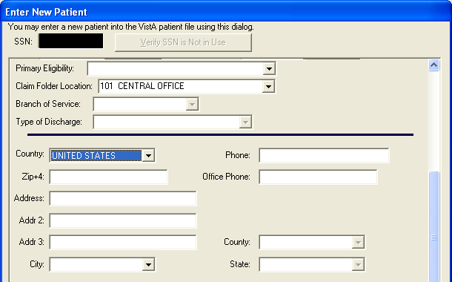

      - When "UNITED STATES" is not selected as the Country, CAPRI displays the Province and Postal Code fields and hides the Zip+4, County, and State fields.

CAPRI 5

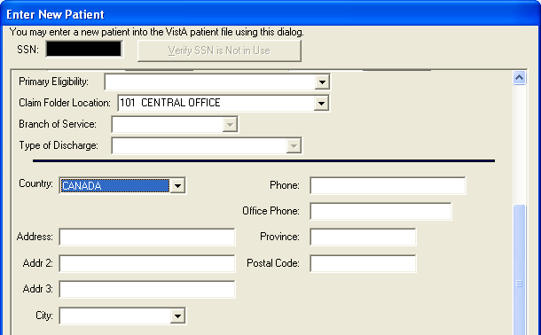
In addition, when a valid value is entered in the Zip+4 field, the City, County, and State fields will be populated automatically. If more than one city corresponds to a Zip code, then the preferred city will populate the City field, but the user may select alternate cities with that Zip code from the City field dropdown list.
When the Country is set to "UNITED STATES", users must select the appropriate values from the dropdown lists for the City, County, and State fields. Users may only free type values into these fields when the user possesses the "EAS GMT COUNTY EDIT" Security Key.

Modify the Address Verification screen for Foreign Address Entry.
When adding a new C&P exam request for a patient, users must be able to view and enter foreign address information for patients when verifying the address. To that end, three new fields have been added to the Permanent Address and Temporary Address sections of the Address Verification screen. The Address Verification screen is accessed from the C&P Exam tab by clicking the "Add a New Request" button.
      - Country
      - Province
      - Postal Code
The new Country field contains a drop down list of all of the available countries. The value selected in the Country field determines how the Zip+4, County, State, Province, and Postal Code fields will be displayed.
      - When "UNITED STATES" is selected as the Country, CAPRI displays the Zip+4, County, and State fields and hides the Province and Postal Code fields.

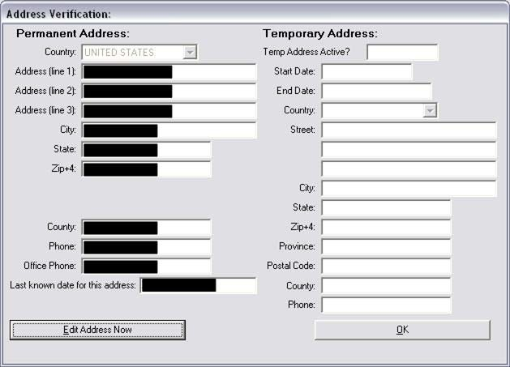

      - When "UNITED STATES" is not selected as the Country, CAPRI displays the Province and Postal Code fields and hides the Zip+4, County, and State fields.
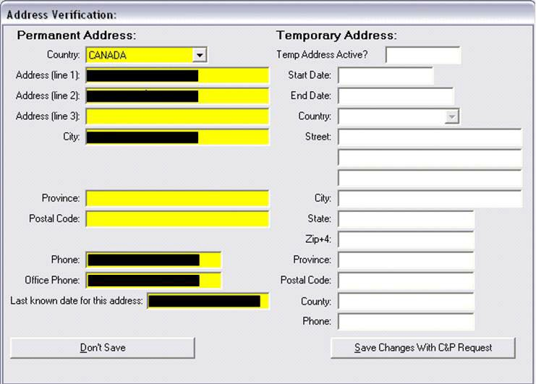

CAPRI 7

Modify the Admin Tab for Foreign Address Entry.
Users need to be able to view the appropriate address information on the Admin Tab for patients with foreign addresses. To that end, five new fields have been added to the Permanent Address and Temporary Address sections of the Admin Tab.
      - Country
      - Province
      - Postal Code
      - Last Updated
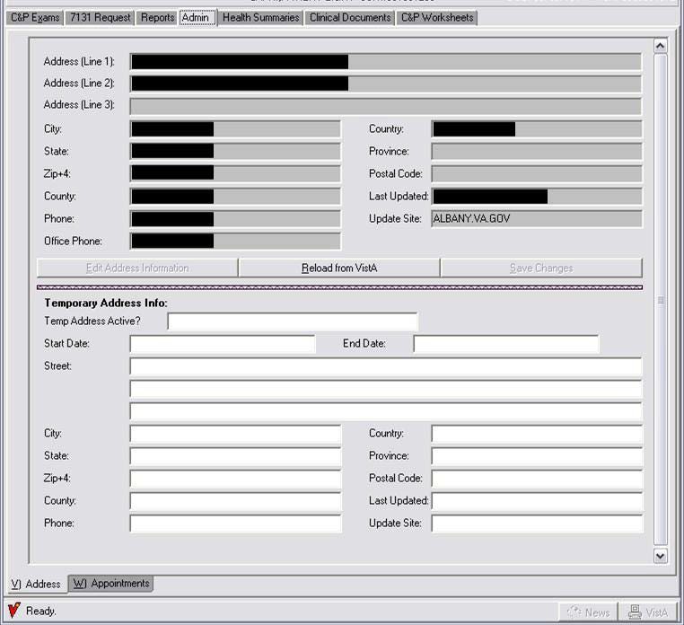
      - Update Site

Modify the Compensation and Pension Exam Status Inquiry to support Foreign Addresses
The Compensation and Pension Exam Status Inquiry needed to be modified to display the appropriate labels when a patient had a foreign address. The Compensation and Pension Exam Status Inquiry is accessed by clicking on the Status Inquiry button on the C&P Exams tab in CAPRI. The following changes have been made to the address section:

      - When the country is "UNITED STATES", CAPRI displays the label "City, State, Zip+4:".
      - When the country is not "UNITED STATES", CAPRI displays the label "City, Province, Postal Code:".
      - The Country is displayed on line following "City, State, Zip+4" or "City, Province, Postal Code".

Add Foreign Address Support to the AMIE package in VistA.
The AMIE package in VistA needed to be modified to support the release of Enrollment VistA Changes Release 2 project. This release fulfills the business need to implement the ability to enter a Foreign Address for a patient's permanent, temporary, and confidential addresses.
Specifically, the Inquiry for C&P Requests [DVBA C INQUIRY] option needed to be modified to display the appropriate labels when a patient had a foreign address. The following changes have been made to the address section:
- When the country is "UNITED STATES", CAPRI displays the fields for "City, State, Zip+4:".
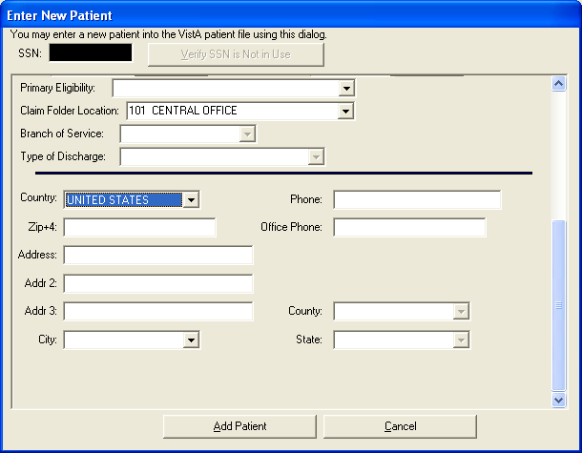

- When the country is not "UNITED STATES", CAPRI displays the fields "City, Province, Postal Code:".

CAPRI 9

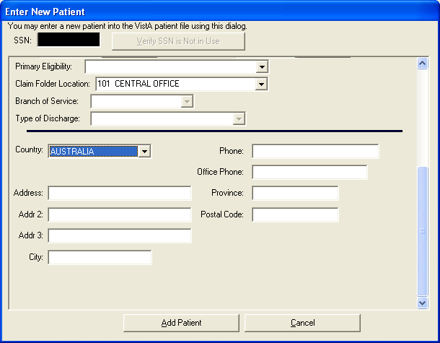

Restore Local Bi-Directional Health Information Exchange (BHIE) Connectivity and Fix Verify Code Change problem
The Broker Security Enhancement (BSE) implementation in the previously released CAPRI GUI (DVBA*2.7*140) required the disabling of the CAPRI 'DOD tab' to prevent direct access from CAPRI to the Federal Health Information Exchange (FHIE) for CAPRI local users (non- CLAIMS).
This patch implements an enhancement to BSE that allows a local CAPRI user to connect to a central server and the DOD tab functionality has been restored for local users.

Fix the Verify Code Change Problem
Internal Software Quality Assurance testing by the CAPRI development team revealed that when the RPCBroker dialog (ChangeVISTA Verify Code) is utilized to change the user's Verify Code, subsequent silent logins potentially fail. CAPRI has been modified to prevent silent login failures when a user changes their VistA Verify Code using the 'Change VISTA Verify Code' dialog window.

Support VA/DoD Disability Evaluation System (DES) Examinations
The joint VA/DOD Disability Evaluation System (DES) pilot program needed to be able to better identify the number of DES exams performed. In support of this pilot program, the following changes have been made to the CAPRI Enter New Patient screen. The Enter New Patient screen is accessed from the Patient Selector screen by clicking the "Enter New Pt." button.

- The Primary Eligibility selections have been modified to include "TRICARE".
- The Primary Eligibility selections have been modified to include "SHARING AGREEMENT".
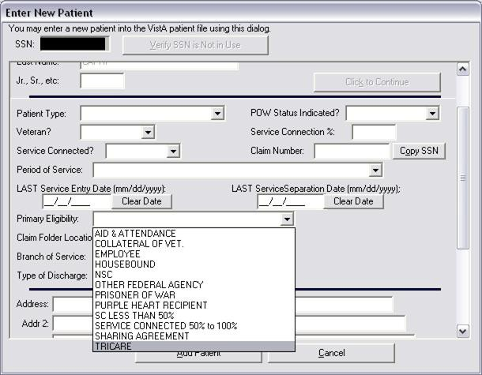
- The Patient Type selections have been modified to include "TRICARE".

TRICARE and SHARING AGREEMENT Warning Messages
When a Patient Type of TRICARE is selected, a reminder dialog box is displayed to the user “NOTE: Primary Eligibility for this type should be TRICARE” and CAPRI populates the Primary Eligibility field with “TRICARE”.

CAPRI 11

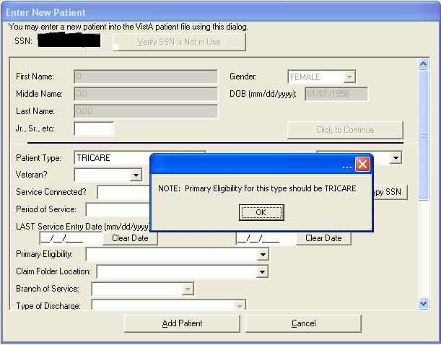

When a Patient Type of ACTIVE DUTY is selected, a reminder dialog box is displayed to the user “NOTE: Primary Eligibility for this type should be SHARING
AGREEMENT” and CAPRI populates the Primary Eligibility field with “SHARING AGREEMENT”.
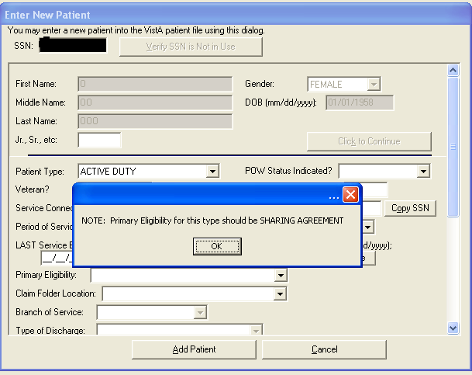

When a user has chosen ACTIVE DUTY as the Patient Type and set Primary Eligibility as something other than SHARING AGREEMENT, a reminder box displays the message

“NOTE: Primary Eligibility for an ACTIVE DUTY patient type should be SHARING AGREEMENT”.
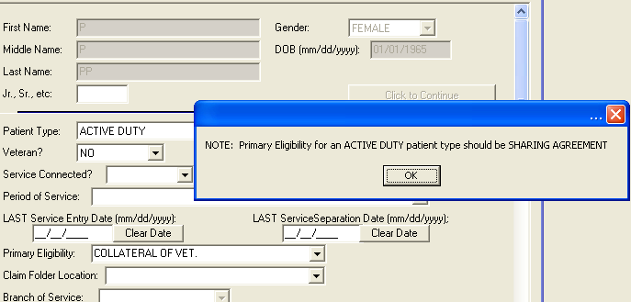

When a user has chosen TRICARE as the Patient Type and set Primary Eligibility as something other than TRICARE, a reminder box displays the message “NOTE: Primary Eligibility for a TRICARE patient type should be TRICARE”.
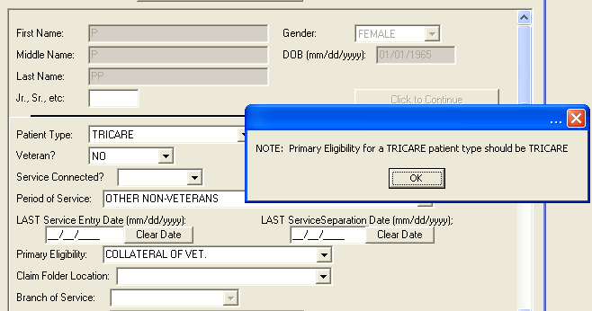

Control CAPRI Client/Server Version Synchronization
The CAPRI GUI client obtains the version of the CAPRI software running on the VistA server by calling the DVBA VERSION remote procedure call (RPC). The RPC derived the server version from hard-coded values in the RPC routine, VERSION^DVBAB1, which required distribution of the RPC routine anytime the server version of CAPRI was modified.

Enhancements were made to the RPC routine to obtain the VistA server version of the CAPRI software from CAPRI/AMIE package parameters defined in the PARAMETERS (#8989.5) file. This allows development staff greater flexibility for setting and deriving the CAPRI server version through manipulation of version parameters.

CAPRI 13

Development platform upgrade to Delphi 2006
The development platform for the CAPRI GUI was upgraded for this effort. Previously released versions of the CAPRI GUI were compiled with Delphi 5 and this version of the CAPRI GUI (v143) has been compiled with Delphi 2006. The technical changes made for this upgrade should not impact the current functionality within CAPRI.

Known Anomalies
The following section describes the known anomalies within CAPRI GUI v143 and VistA patch DVBA*2.7*143. These anomalies will be fixed in the next CAPRI GUI v149 and VistA patch DVBA*2.7*149.

Duplex Printer Setting
The Veteran’s Benefits Admistration (VBA) reported that the duplex printer setting in the printer properties is being ignored. When a printer is set to print on both sides of the paper, the setting is disregarded and the printer will only print on one side of the paper. This issue will be addressed in a future CAPRI GUI patch, at which time the duplex printer property will be honored and the printer will print on both sides of the paper.

Risk/Impact: Low impact to users.

Workaround: Users are still able to print without duplex availability.

Comments: The duplex printer setting issue only affects VBA. This anomaly will be fixed in the next CAPRI GUI patch DVBA*2.7*149.

CAPRI Remote Window - Can no longer enter a facility name with a space
The Health Revenue Center (HRC) reported an issue when attempting to switch facilities within the CAPRI Remote window. When typing in the beginning characters (e.g. "New") of a facility name containing more than one word (e.g. "New York"), CAPRI does not recognize the space and next word in the name. Instead, CAPRI defaults to the first facility name in the list that contains the characters entered by the user. For example, if a user attempts to enter the facility "New York", CAPRI defaults to "New Jersey" since "Jersey" precedes "York" alphabetically in the facility list. This issue will be addressed in a future CAPRI GUI patch.

Risk/Impact: Low impact to users.

Workaround: Users are still able access the facility in the facility list by typing the first letter of the site name (e.g. "New”) and arrowing or scrolling down to access the facility they would like to select.

Comments: The CAPRI Remote Window issue only affects the Health Revenue Center remote (Claims) users. This anomaly will be fixed in the next CAPRI GUI patch DVBA*2.7*149.

CAPRI 15

CAPRI GUI v143 Upgrade Note
Once the installation of patch DVBA*2.7*143 has been completed, CAPRI users should be upgraded to the new released version of the CAPRI GUI (DVBA_27_143_12.exe).

Please refer to the DVBA*2.7*143 patch description for specific instructions regarding the installation of the CAPRI GUI v143 software.

Backwards Compatibility Issue
If CAPRI users are not upgraded, any Compensation & Pension Worksheet Module (CPWM) exam templates opened and saved using the new CAPRI GUI v143 (DVBA_27_143_12.exe) will not be backwards compatible with older versions of the CAPRI GUI (i.e. CAPRI GUI v140).
Users of older versions of the CAPRI GUI will experience errors when attempting to open CPWM exam templates saved using the CAPRI GUI v143.

Software and Documentation Retrieval

VistA Patch DVBA*2.7*143
The VistA server software is being distributed as a PackMan patch message through the National Patch Module (NPM). The KIDS build for this patch is DVBA*2.7*143.

CAPRI GUI v143 Client Software & User Documentation
The CAPRI GUI v143 client software is being distributed as executable DVBA_27_143_12.exe.

The CAPRI GUI v143 client software and documentation for this patch may be retrieved directly using FTP. The preferred method is to FTP the files from:

REDACTED

This transmits the files from the first available FTP server.
Sites may also elect to retrieve software directly from a specific server as follows:

OI&T Field Office | FTP Address | Directory
Albany | REDACTED | [anonymous.software]
Hines | REDACTED | [anonymous.software]
Salt Lake City | REDACTED | [anonymous.software]

File Name | Format | Description
DVBA_27_P143_12.ZIP | Binary | ZIP archive containing the CAPRI GUI v143 Client Application executable:  DVBA_27_143_12.EXE
DVBA_27_P143_UM.PDF | Binary | Updated CAPRI User Manual
DVBA_27_P143_RN.PDF | Binary | Release Notes

The VistA Documentation Library (VDL) web site will also contain the updated CAPRI User Manual. This web site is usually updated within 1-3 days of the patch release date.
The VDL web address for CAPRI documentation is: http://www.va.gov/vdl/application.asp?appid=133

CAPRI 17

