Compensation and Pension Record Interchange (CAPRI)

Audio Template Workflow
Patch: DVBA*2.7*150

November 2009

Department of Veterans Affairs Office of Enterprise Development Management & Financial Systems

Revision History

Initiated on 02/09/2009

Date | Description (Patch # if applicable) | Project  Manager | Technical  Writer
12/15/2009 | CAPRI Audio Template Workflow DVBA*2.7*150 was created based on the Audio template released with Patch DVBA*2.7*139.  CAPRI Audio Template Workflow DVBA*2.7*150 has been updated to include changes made by patch DVBA  *2.7*150  - Section 2 – Replaced History screen shot, expanded Note to Examiners, changed Tinnitus section  - Section 3 – Replaced Physical Exam tab screen shot, Added Description of speech recognition performance section  - Section 5 – Replaced Diagnosis tab screen shot, moved For VA purposes paragraph; added tinnitus pop-up messages, edited Degree of Loss,  Also:  - Added Revision History and Preface  - Corrected minor header and footer formatting issues  - Changed formatting of field description in Heading 1 and Heading 2 | REDACTED | REDACTED

Preface
Reference Numbering System
This document uses a numbering system to organize its topics into sections and to show the reader how these topics relate to each other. For example, the information in section 1.3 is the main topic for the third section of Chapter 1. If there were two subsections to this topic, they would be numbered 1.3.1 and 1.3.2. A section numbered 2.3.5.4.7 would be the seventh subsection of the fourth subsection of the fifth subsection of the third topic of Chapter 2. This numbering system tool allows the reader to more easily follow the logic of sections that contain several subsections.

Table of Contents

- Introduction 1
  - Purpose 1
  - Overview 1
- History Tab 2
  - Screenshot of Audio - History Tab 2
  - Note to Examiners 2
  - Records Review 4
    - Comments on records 4
  - Chief Complaint 5
  - Pertinent Service History 5
  - History of Military, Occupational, and Recreational Noise Exposure 5
  - Pertinent Family and Social History, history of ear disease, head or ear trauma 5
  - Tinnitus 5
    - Is there a claim for tinnitus 5
    - Is there a current complaint of tinnitus 5
- Physical Exam Tab 8
  - Screenshot of Audio - Physical Exam Tab 8
  - Puretone Threshold Testing 8
    - Measure puretone thresholds in decibels 8
    - Right Ear 8
    - Left Ear 9
    - Puretone thresholds should not exceed 105 decibels 9
    - The puretone threshold at 500 Hz is not used 9
    - Failure to respond will be indicated with a “+” 9
    - Speech Recognition Score Maryland CNC Word List 9
    - When only puretone results should be used to evaluate hearing loss 11
- Tests Tab 12
  - Screenshot of Audio - Tests Tab 12
  - Report middle ear status and confirm type of loss 12
    - In cases where there is poor inter-test reliability 12
  - Include results of all diagnostic and clinical tests 12
- Diagnosis Tab 13
  - Screenshot of Audio - Diagnosis Tab 13
  - Was a Medical Opinion Requested 13
  - For VA purposes, impaired hearing is considered to be a disability 14
  - Audiologic Test Results Summary 14
    - Side 14
    - Type of loss 14
    - Additional comments on hearing loss 14
    - Submit 14
    - Summary 15
  - Diagnosis 15
  - Is hearing loss present 15
  - Is tinnitus as likely as not a symptom associated with the hearing loss 16
  - Is there a condition, which if treated, might lead to changes in hearing 16
  - Is there need for medical followup for an ear or hearing problem 16
  - Describe Effects of the Problem on Usual Occupational Activities 16
  - Effect on occupation 16
    - Resulting work problems 16
    - What effects of this disability impact on occupational activities 17
  - Describe the effects of the problem on usual daily activities 17
  - Are there effects on usual daily activities 17
    - Ambulating 17
    - Dressing 17
    - Feeding 17
    - Bathing 17
    - Driving 17
    - Toileting 17
    - Grooming 17
    - Describe other effect on usual daily activities 17

Introduction
  - Purpose
This document provides a high level overview of the contents found on the Audio Template that was released in CAPRI patch DVBA*2.7*150. This document serves as a workflow process guide.

  - Overview
The Audio Template contains the following four tabs:
    - History
    - Physical Exam
    - Tests
    - Diagnosis
A common business rule used within the Audio Template is (for all multi-line free text entry areas the user is provided) the ability to expand the details in an additional free text memo-box when the Details button is selected.

Figure 1.2.a: Details Button

Figure 1.2.b: Additional Free Text Memo-box

A number of questions on the Audio Template are mandatory and require a response (value) prior to the exam being marked as completed. Some answers to questions may activate a pop- up window with an additional Close, Submit, or OK button.

November 2009 CAPRI Audio Template Workflow DVBA*2.7*150 1

History Tab
  - Screenshot of Audio - History Tab

Figure 2.1: Audio - History Tab
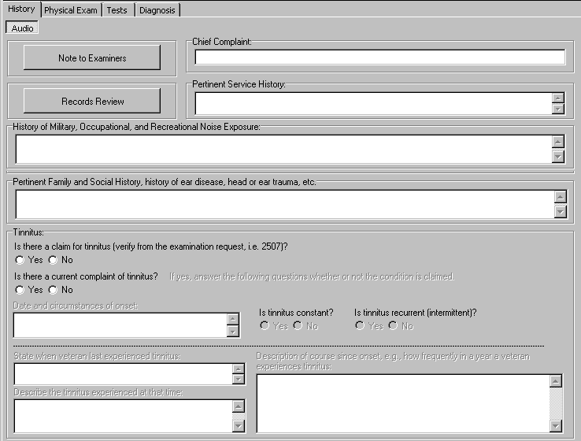

  - Note to Examiners (Label/Button)

When the Note to Examiners button is selected, a pop-up window labeled Audio: Note to Examiners is displayed:

Figure 2.1: Audio: Note to Examiners
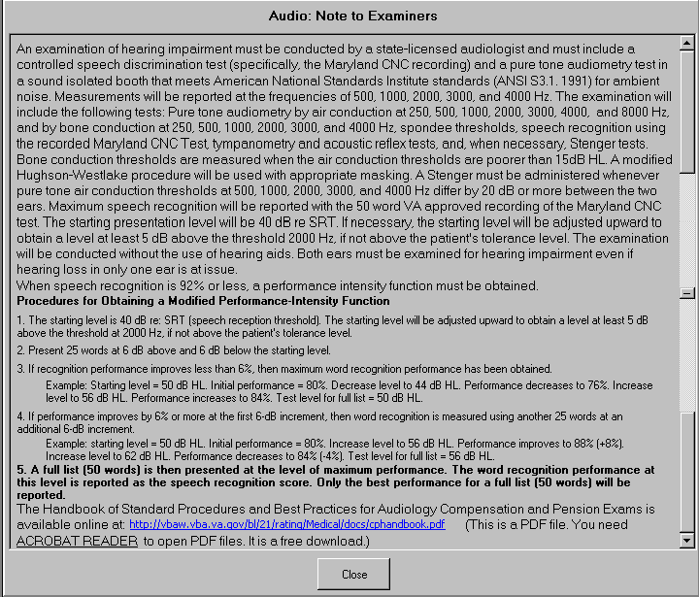

An examination of hearing impairment must be conducted by a state-licensed audiologist and must include a controlled speech discrimination test (specifically, the Maryland CNC recording) and a pure tone audiometry test in a sound isolated booth that meets American National Standards Institute standards (ANSI S3.1. 1991) for ambient noise. Measurements will be reported at the frequencies of 500, 1000, 2000, 3000, and 4000 Hz. The examination will include the following tests: Pure tone audiometry by air conduction at 250, 500, 1000, 2000, 3000, 4000, and 8000 Hz, and by bone conduction at 250, 500, 1000, 2000, 3000, and 4000 Hz, spondee thresholds, speech recognition using the recorded Maryland CNC Test, tympanometry and acoustic reflex tests, and, when necessary, Stenger tests. Bone conduction thresholds are measured when the air conduction thresholds are poorer than 15dB HL. A modified Hughson-Westlake procedure will be used with appropriate masking. A Stenger must be administered whenever pure tone air conduction thresholds at 500, 1000, 2000, 3000, and 4000 Hz differ by 20 dB or more between the two ears. Maximum speech recognition will be reported with the 50 word VA approved recording of the Maryland CNC test. The starting presentation level will be 40 dB re SRT. If necessary the starting level will be adjusted upward to obtain a level of at least 5 dB above the threshold 2000 Hz, if not above the patient’s tolerance level. The examination will be conducted without the use of hearing aids.
Both ears must be examined for hearing impairment even if hearing loss in only one ear is at issue. When speech recognition is 92% or less, a performance intensity function must be obtained.

Procedures for Obtaining a Modified Performance-Intensity Function

- The starting level is 40 dB re: SRT (speech reception threshold). The starting level will be adjusted upward to obtain a level at least 5 dB above the threshold at 2000 Hz, if not above the patient’s tolerance level.

- Present 20 words at 6 dB above and 6 dB below the starting level.

- If recognition performance improves less than 6%, then maximum word recognition performance has been obtained.
Example: Starting level = 50dB HL. Initial performance = 80%. Decrease level to 44 dB HL. Performance decreases to 76%. Increase level to 56 dB HL. Performance increases to 84%. Test level for full list = 56 dB HL.

- If performance improves by 6% or more at the first 6-dB increment then word recognition is measured using another 25 words at an addition 6-dB increment.
Example: starting level = 50 dB HL. Initial performance = 80%. Increase level to 56 dB HL. Performance improves to 88% (+8%). Increase level to 62 dB HL. Performance decreases to 84% (-4%). Test level for full list = 56 dB HL.

- A full list (50 words) is then presented at the level of maximum performance. The word recognition performance at this level is reported as the speech recognition score. Only the best performance for a full list (50 words) will be reported.
The Handbook of Standard Procedures and Best Practices for Audiology Compensation and Pension Exams is available online at: http://vbaw.vba.va.gov/bl/21/rating/Medical/docs/cphandbook.pdf (This is a PDF file. You need ACROBAT READER to open PDF files. It is a free download.)

  - Records Review (Button/Read-Only Text/Action)

The Audio: Review of Records panel allows the user to annotate the C File Review and the Medical Record Review. For each review, one of the following associated actions may be selected: Reviewed, Not Requested by VARO, or Requested by VARO but not available. The review of records questions must be completed.

Example:
C File Review:
    - Reviewed
    - Not Requested by VARO
    - Requested by VARO but not available

Medical Record Review:
    - Reviewed
    - Not Requested by VARO
    - Requested by VARO but not available

2.3.1 Comments on records: (Label/Free Text Box)
The user may provide comments on the review of the records.

If the user closes the Audio: Review of Records pop-up window either without a making a C File Review selection or having selected Requested by VARO but not available, then the following instructions display in a pop-up window:

C File must be reviewed before submitting the report

If the user closes the Audio: Review of Records pop-up window either without a making a Medical Record Review selection or having selected Requested by VARO but not available, then the following instructions display in a pop-up window:

Medical Records must be reviewed before submitting the report

  - Chief Complaint: (Label/Free Text Box)

  - Pertinent Service History: (Label/Free Text Box)

  - History of Military, Occupational, and Recreational Noise Exposure: (Label/Free Text Box)
  - Pertinent Family and Social History, history of ear disease, head or ear trauma, etc. (Label/Free Text Box)
  - Tinnitus: (Section Label/Read Only Text)
At first, the Tinnitus section has only two questions enabled:

    - Is there a claim for tinnitus (verify from the examination request, i.e. 2507)? (Yes/No) (Label/Radio Button)

    - Is there a current complaint of tinnitus? (Yes/No) (Label/Radio Button)

Figure 2.8.2: History Tab – Tinnitus Section
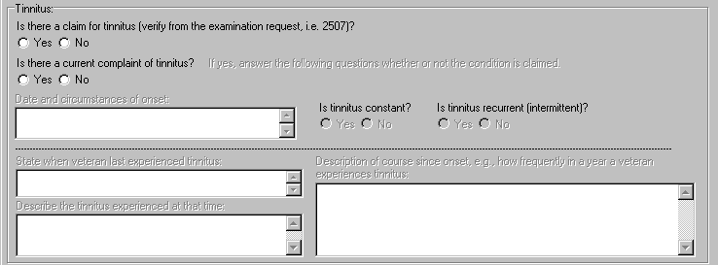

Depending on how these two questions are answered, other sections may be enabled.

If Yes is answered for Is there a claim for tinnitus?, and Yes is answered for Is there a current complaint of tinnitus?, then these sections are enabled:

      - If yes, answer the following questions whether or not the condition is claimed. (Label/Read Only Text)

      - Is tinnitus constant? (Yes/No) (Label/Radio Button)

Figure 2.8.2.2: History Tab – Tinnitus Section
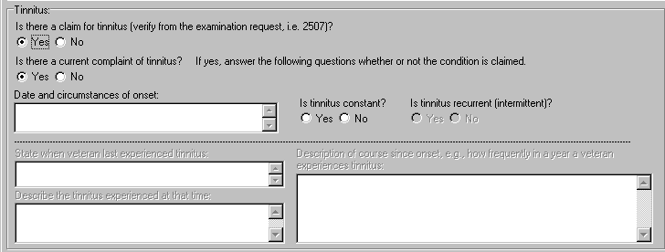

This subsection has additional sections that may be enabled depending on which answer the user selects for the Is tinnitus constant? question. If Yes is selected, then nothing further is enabled pertaining to this question. If No is selected, then this field is enabled:

        - Is tinnitus recurrent (intermittent)? (Yes/No) (Label/Radio Button)

      - Date and circumstances of onset: (Label/Free Text Box)

If No is selected for Is there a claim for tinnitus?, and Yes is selected for Is there a current complaint of tinnitus?, the same fields are enabled as if Yes were answered for both questions.
Figure 2.8.2.3: History Tab – Tinnitus Section
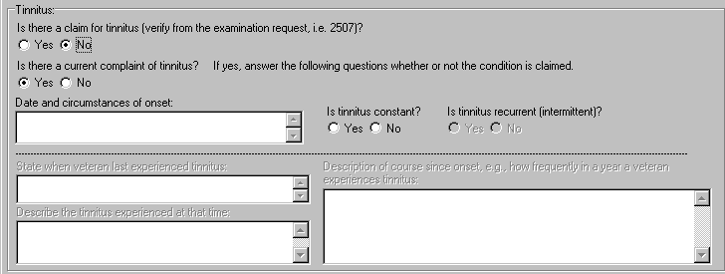

If Yes is selected for Is there a claim for tinnitus?, and No is selected for Is there a current complaint of tinnitus?, then the following fields are enabled:

      - State when veteran last experienced tinnitus: (Label/Free Text Box)

      - Describe the tinnitus experienced at that time: (Label/Free Text Box)

      - Description of course since onset, e.g., how frequently in a year a veteran experiences tinnitus: (Label/Free Text Box)

Figure 2.8.2.6a: History Tab – Tinnitus Section
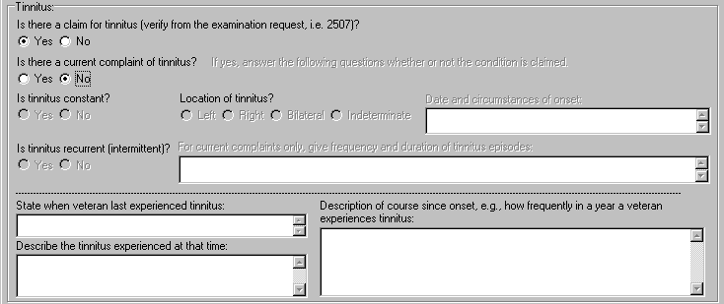

If No is selected for Is there a claim for tinnitus?, and No is selected for Is there a current complaint of tinnitus?, then no other tinnitus questions are enabled.
Figure 2.8.2.6b: History Tab – Tinnitus Section
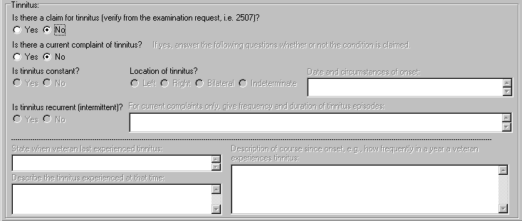

Physical Exam Tab
  - Screenshot of Audio - Physical Exam Tab

Figure 3.1: Audio - Physical Exam Tab
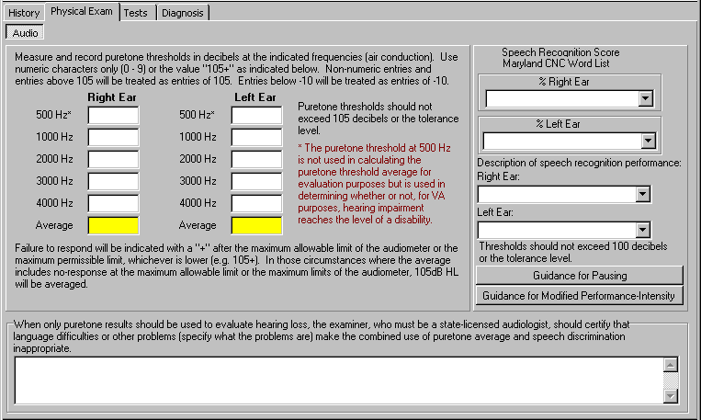

  - Puretone Threshold Testing
The following sections pertain to puretone threshold testing.

    - Measure and record puretone thresholds in decibels at the indicated frequencies (air conduction). Use numeric characters only (0 – 9) or the value “105+” as indicated below. Non-numeric entries and entries above 105 will be treated as entries of
105. Entries below -10 will be treated as entries of -10. (Read Only Text)

    - Right Ear (Label)

      - 500 Hz* (Label/Free Text Box)

      - 1000 Hz (Label/Free Text Box)

      - 2000 Hz (Label/Free Text Box)

      - 3000 Hz (Label/Free Text Box)

      - 4000 Hz (Label/Free Text Box)

      - Average (Label/Automatic Calculation)

    - Left Ear (Label)

      - 500 Hz* (Label/Free Text Box)

      - 1000 Hz (Label/Free Text Box)

      - 2000 Hz (Label/Free Text Box)

      - 3000 Hz (Label/Free Text Box)

      - 4000 Hz (Label/Free Text Box)

      - Average (Label/Automatic Calculation)

    - Puretone thresholds should not exceed 105 decibels or the tolerance level. (Label/Read Only Text)
    - * The puretone threshold at 500 Hz is not used in calculating the puretone threshold average for evaluation purposes but is used in determining whether or not, for VA purposes, hearing impairment reaches the level of a disability. (Read Only Text)

    - Failure to respond will be indicated with a “+” after the maximum allowable limit of the audiometer or the maximum permissible limit, whichever is lower (e.g. 105+). In those circumstances where the average includes no-response at the maximum allowable limit or the maximum limits of the audiometer, 105dB HL will be averaged. (Read Only Text)

    - Speech Recognition Score Maryland CNC Word List (Label/Read Only Text)

      - % Right Ear (Label/List Box)
This field has selections that include Could not test, Too unreliable to score, and even numbers ranging from 0 through 100.

      - % Left Ear (Label/List Box)
This field has selections that include Could not test, Too unreliable to score, and even numbers ranging from 0 through 100.

      - Thresholds should not exceed 100 decibels or the tolerance level. (Label/Read Only Text)

      - Description of speech recognition performance: (Label/Read Only Text)

      - Right Ear: (Label/List Box)
This field has selections that include Excellent (Normal) 100 – 94%, Good 92 – 80%, Fair 78 – 70%, and Poor < 70%.

      - Left Ear: (Label/List Box)
This field has selections that include Excellent (Normal) 100 – 94%, Good 92 – 80%, Fair 78 – 70%, and Poor < 70%.

      - Thresholds should not exceed 100 decibels or the tolerance level. (Label/Read Only Text)

      - Guidance for Pausing (Label/Button)
When the Guidance for Pausing button is selected, a pop-up window labeled Audio: Pausing Guidance is displayed:
Figure 3.2.7.8: Audio: Pausing Guidance
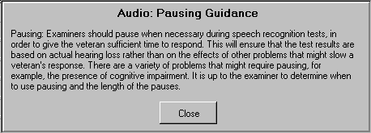

Pausing: Examiners should pause when necessary during speech recognition tests, in order to give the veteran sufficient time to respond. This will ensure that the test results are based on actual hearing loss rather than on the effects of other problems that might slow a veteran’s response. There are a variety of problems that might require pausing, for example, the presence of cognitive impairment. It is up to the examiner to determine when to use pausing and the length of the pauses.

      - Guidance for Modified Performance-Intensity (Label/Button)
When the Guidance for Modified Performance-Intensity button is selected, a pop-up window labeled Audio: Modified Performance-Intensity Function Guidance is displayed:
Figure 3.2.7.9: Audio: Modified Performance-Intensity Function Guidance
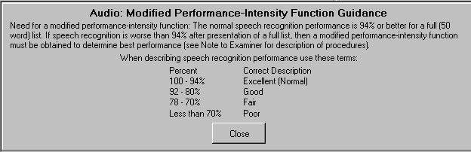

Need for a modified performance-intensity function: The normal speech recognition performance is 94% or better for a full (50 word) list. If speech recognition is worse than 94% after presentation of a full list, then a modified performance-intensity function must be

obtained to determine best performance (see Note to Examiner for description of procedures).
When describing speech recognition performance use these terms: Percent Correct Description
100 – 94% Excellent (Normal)
92 – 80% Good
78 – 70% Fair
Less than 70% Poor

    - When only puretone results should be used to evaluate hearing loss, the examiner, who must be a state-licensed audiologist, should certify that language difficulties or other problems (specify what the problems are) make the combined use of puretone average and speech discrimination inappropriate. (Label/Free Text Box)

Tests Tab
  - Screenshot of Audio - Tests Tab

Figure 4.1: Audio - Tests Tab
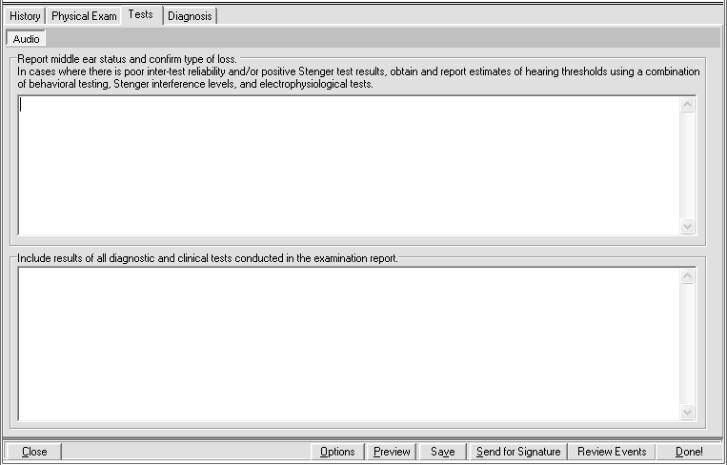

  - Report middle ear status and confirm type of loss. (Section Label)

4.2.1 In cases where there is poor inter-test reliability and/or positive Stenger test results, obtain and report estimates of hearing thresholds using a combination of behavioral testing, Stenger interference levels, and electrophysiological tests. (Label/Free Text Box)

  - Include results of all diagnostic and clinical tests conducted in the examination report. (Label/Free Text Box)

Diagnosis Tab
  - Screenshot of Audio - Diagnosis Tab

Figure 5.1: Audio - Diagnosis Tab
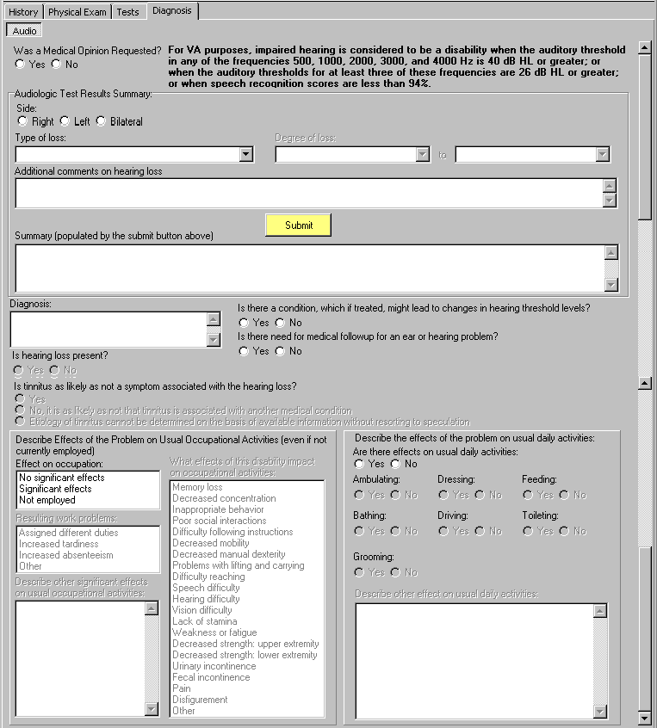
  - Was a Medical Opinion Requested? (Yes/No) (Label/Radio Button)

If Yes is selected, a pop-up window displays the following:

November 2009 CAPRI Audio Template Workflow DVBA*2.7*150 13

Figure 5.2: Medical Opinion Pop-up Message
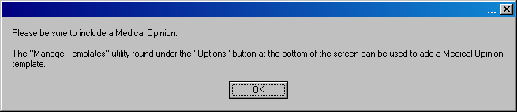

Please be sure to include a Medical Opinion.

The “Manage Templates” utility found under the “Options” button at the bottom of the screen can be used to add a Medical Opinion template.

  - For VA purposes, impaired hearing is considered to be a disability when the auditory threshold in any of the frequencies 500, 1000, 2000, 3000, and 4000 Hz is 40 dB HL or greater; or when the auditory thresholds for at least three of these frequencies are 26 dB HL or greater; or when speech recognition scores are less than 94%. (Section Label/Read Only Text)
  - Audiologic Test Results Summary: (Section Label)

    - Side: (Right/Left/Bilateral) (Label/Radio Buttons)

    - Type of loss: (Label/Drop-Down Box)
The options available for this field are Clinically normal, Hearing loss not disabling (per 38 CFR 3.385), Sensorineural, Mixed, Conductive, and Central.

If Sensorineural, Mixed, Conductive, or Central is selected, the following is enabled:

      - Degree of loss: (Label/Two Drop-Down Boxes)

Figure 5.4.2.1: Degree of loss
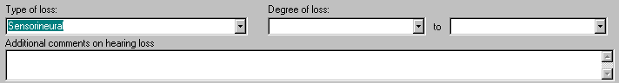

The degree of loss can be specified by selecting the upper and lower bounds of the hearing loss from the two drop-down boxes. The options available are: Normal (Only available for first box), Mild (26 – 40 HL), Moderate (41 – 54 HL). Moderately severe (55 – 69 HL). Severe (70 – 89 HL), and Profound (90+ HL).

    - Additional comments on hearing loss (Label/Free Text Area)

    - Submit (Label/Button/Action)

User must enter Side, Type of Loss, and Degree of Loss as indicated before selecting
Submit. Otherwise, a pop-up window displays a request for any missing information.

Figure 5.4.4a: Pop-up Request – Missing Side
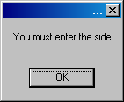

Figure 5.4.4b: Pop-up Request –Missing Type of Loss
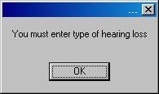

Figure 5.4.4c: Pop-up Request –Missing Degree of Loss
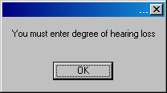

    - Summary (populated by the submit button above) (Label/Free Text Area)
The Summary field is populated when the user clicks Submit.

  - Diagnosis: (Label/Free Text Box)

  - Is hearing loss present? (Yes/ No) (Label/Radio Buttons)

This question will be enabled only if the response is Yes to either question located on the History Tab: Is there a claim for tinnitus or Is there a current complaint of tinnitus? (See section 2.8)
If No is selected for this field, then the following message is displayed:

Figure 5.6: Tinnitus Pop-up – Regional Office
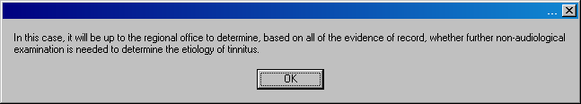

In this case, it will be up to the regional office to determine, based on all of the evidence of record, whether further non-audiological examination is needed to determine the etiology of tinnitus.

If Yes is selected for this field, then the following question becomes enabled:

5.6.1 Is tinnitus as likely as not a symptom associated with the hearing loss? (Yes/No, it is as likely as not that tinnitus is associated with another medical condition/Etiology of tinnitus cannot be determined on the basis of available information without resorting to speculation) (Label/Radio Buttons)

If either option other than Yes is selected, a pop-up window displays the following:
Figure 5.7: Tinnitus Pop-up – VBA Regional Office
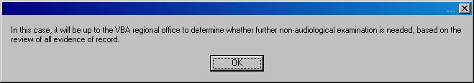

In this case, it will be up to the VBA regional office to determine whether further non- audiological examination is needed, based on the review of all evidence of record.

  - Is there a condition, which if treated, might lead to changes in hearing threshold levels? (Yes/No) (Label/Radio Buttons)
  - Is there need for medical followup for an ear or hearing problem? (Yes/No) (Label/Radio Buttons)
  - Describe Effects of the Problem on Usual Occupational Activities (even if not currently employed) (Section Label/Read Only Text)
  - Effect on occupation: (Label/Select Box with the following options:)
The options available for this field are: No significant effects, Significant effects, and Not employed.
If either Significant effects or Not employed is selected, then the following fields are enabled:

    - Resulting work problems: (Label/Multi-Select Box)
The options available for this field are: Assigned different duties, Increased tardiness, Increased absenteeism, and Other.

If Other is selected, then the following field is enabled:

      - Describe other significant effects on usual occupational activities: (Label/Free Text Box)

    - What effects of this disability impact on occupational activities: (Label/Multi-Select Box)
The options available for this field are: Memory loss, Decreased concentration, Inappropriate behavior, Poor social interactions, Difficulty following instructions, Decreased mobility, Decreased manual dexterity, Problems with lifting and carrying, Difficulty reaching, Speech difficulty, Hearing difficulty, Vision difficulty, Lack of stamina, Weakness or fatigue, Decreased strength: upper extremity, Decreased strength: lower extremity, Urinary incontinence, Fecal incontinence, Pain, Disfigurement, and Other.

  - Describe the effects of the problem on usual daily activities: (Section Label/Read Only Text)

  - Are there effects on usual daily activities: (Yes/No) (Label/Radio Buttons)

If Yes is selected, then the following fields are enabled:

    - Ambulating: (Yes/No) (Label/Radio Buttons)

    - Dressing: (Yes/No) (Label/Radio Buttons)

    - Feeding: (Yes/No) (Label/Radio Buttons)

    - Bathing: (Yes/No) (Label/Radio Buttons)

    - Driving: (Yes/No) (Label/Radio Buttons)

    - Toileting: (Yes/No) (Label/Radio Buttons)

    - Grooming: (Yes/No) (Label/Radio Buttons)

    - Describe other effect on usual daily activities: (Label/Free Text Box)

