Compensation and Pension Record Interchange (CAPRI)

Aid and Attendance or Housebound Examination
Template Workflow
Patch: DVBA*2.7*151

March 2010

Department of Veterans Affairs Office of Enterprise Development Management & Financial Systems

Revision History

Date | Description (Patch # if applicable) | Project Manager | Technical Writer
12/30/2009 | Initial release | REDACTED | REDACTED
3/11/2010 | Physical Exam Tab  - Lower Extremities Functional Limitations form, Remove "Other" option and associated free text box from left and right lower extremity functional limitation or-lists  - Changed workflow –  exchanged 3.3.2 and 3.3.3 to reflect template | REDACTED | REDACTED

Table of Contents

- Introduction 1
  - Purpose 1
  - Overview 1
- History Tab 2
  - Screenshot of Aid and Attendance - History Tab 2
  - Instructions 2
  - Records Review 2
    - Comments on records 3
  - Is the veteran permanently bedridden 3
  - Is the veteran hospitalized 3
    - Date admitted 3
    - Name of hospital 3
    - City/State 3
  - Can the veteran travel beyond current domicile 3
  - Mode of travel to this exam 3
    - Alone 3
    - Accompanied public transportation 3
    - Accompanied private vehicle 4
    - Accompanied specially equipped van 4
    - Accompanied ambulance 4
    - Other 4
  - Describe typical daily activities 4
  - Does the individual use an orthopedic or prosthetic appliance 4
    - Describe what, if any, assistance is required 4
  - Ability of veteran to protect self from daily hazards/dangers 4
    - Dizziness 4
    - Memory loss 4
    - Does imbalance affect the ability to ambulate 5
    - Which self-care skills is the veteran unable to perform 5
    - Are there other body parts or system impairments 5
- Physical Exam Tab 6
  - Screenshot of Aid and Attendance- Physical Exam Tab 6
  - Vital Signs 6
    - Temperature 6
    - Pulse 6
    - Respiratory rate 6
    - Blood pressure 6
    - Height 6
    - Weight 6
    - Build 6
    - Posture 7
    - Gait 7
    - Current nutritional status 7
    - Weight change 7
  - Limitations 7
    - Can the veteran walk without the assistance of another person 7
    - Circumstances the veteran can leave the home 8
    - Does the veteran need aid for ambulation 8
    - Apart from amputations, are the functional impairments permanent 8
    - Is the best corrected vision 5/200 or worse in both eyes 8
    - Does the cervical spine have limitation of motion or deformity 8
    - Does the thoracolumbar spine have limitation of motion or deformity 8
    - Is function of the upper extremities normal 9
    - Is function of the lower extremities normal 9
    - Describe further details of functional disabilities 10
- Tests Tab 11
  - Screenshot of Aid and Attendance – Tests Tab 11
  - As appropriate, please include all diagnostic or clinical test results 11
  - Diagnostic and clinical test results 11
  - Were the results of all tests included on the exam report 11
- Diagnosis Tab 12
  - Screenshot of Aid and Attendance – Diagnosis Tab 12
  - Was a Medical Opinion Requested 12
  - Capacity to Handle Financial Affairs 12
    - NOTE: mental competency, for VA benefits purposes 12
    - Does the veteran know the amount of his/her benefit payment 13
    - Does the veteran know the amounts of his/her monthly bills 13
    - Does the veteran prudently handle payments 13
    - Does the veteran personally handle money and pay bills 13
    - Do you believe the veteran is capable of managing his/her financial affairs 13
    - Do you believe a Social Work assessment is necessary 13
  - Diagnosis 13
  - Comments 13

Introduction
  - Purpose
This document provides a high level overview of the contents found on the Aid and Attendance Template that was released in CAPRI patch DVBA*2.7*151. This document serves as a workflow process guide.

  - Overview
The Audio Template contains the following four tabs:
    - History
    - Physical Exam
    - Tests
    - Diagnosis

A common business rule used within the Audio Template is (for all multi-line free text entry areas the user is provided) the ability to expand the details in an additional free text memo-box when the Details button is selected.

Figure 1.2.a: Details Button

Figure 1.2.b: Additional Free Text Memo-box

A number of questions on the Aid and Attendance Template are mandatory and require a response (value) prior to the exam being marked as completed. Some answers to questions may activate a pop- up window with an additional Close, Submit, or OK button.

March 2010 CAPRI Aid and Attendance Template Workflow Patch DVBA*2.7*151 1

History Tab
  - Screenshot of Aid and Attendance - History Tab

Figure 2.1: Aid and Attendance - History Tab
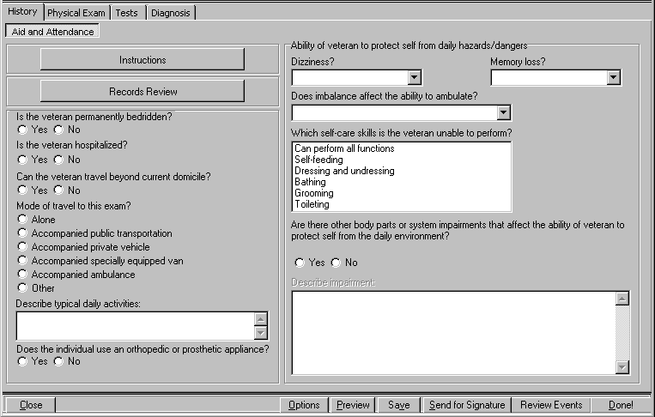

  - Instructions (Label/Button)
When the Instructions button is selected, a window titled Aid and Attendance: Instructions is displayed. The content of the window follows:

Once the existence of at least one disability rated at 100% has been established, additional benefits may be payable if the veteran requires:

- The regular assistance of another person in attending to the ordinary activities of daily living,

- Assistance of another in protecting himself or herself from the ordinary hazards of his or her daily environment, and/or

- If the veteran is restricted to his or her home or the immediate vicinity thereof, including the ward or immediate clinical area, if hospitalized.

  - Records Review (Label/Button)

When the Records Review button is selected, a pop-up window labeled Aid and Attendance: Review of Records is displayed.

This panel allows the user to annotate the C File Review and the Medical Record Review. For each review, one of the following associated actions may be selected: Reviewed, Not Requested by VARO, or Review requested by VARO but not available. The review of records questions must be completed.

C File Review:
    - Reviewed
    - Not requested by VARO
    - Requested by VARO but not available

Medical Record Review:
    - Reviewed
    - Not requested by VARO
    - Requested by VARO but not available

2.3.1 Comments on records: (Free Text Box)
The user may provide comments on the review of the records.

If the user closes the Aid and Attendance: Review of Records pop-up window without making a C File Review selection, then the following instructions display in a pop-up window:

C File must be reviewed before submitting the report

If the user closes the Aid and Attendance: Review of Records pop-up window without making a
Medical Record Review selection, then the following instructions display in a pop-up window:

Medical Records must be reviewed before submitting the report

  - Is the veteran permanently bedridden? (Yes/No) (Label/Radio Buttons)

  - Is the veteran hospitalized? (Yes/No) (Label/Radio Buttons)
If Yes is selected for this field a pop-up window titled Aid and Attendance: Hospitalization is displayed.

    - Date admitted: (Label/Free-Text Box, followed by “mm/yyyy”)

    - Name of hospital: (Label/Free-Text Box)

    - City/State: (Label/Free-Text Box)

  - Can the veteran travel beyond current domicile? (Yes/No) (Label/Radio Buttons)

  - Mode of travel to this exam? (Label)
There are six radio button options for this field. Selecting any item except Alone causes a pop-up window labeled Aid and Attendance: Accompanied Travel to open.

    - Alone (Label/Radio Button)

    - Accompanied public transportation (Label/Radio Button)

    - Accompanied private vehicle (Label/Radio Button)

    - Accompanied specially equipped van (Label/Radio Button)

    - Accompanied ambulance (Label/Radio Button)

    - Other (Label/Radio Button)

      - Aid and Attendance: Accompanied Travel

        - Type of attendant if required: (Multi-Select List Box)
The options available for this field are Family member, Friend, Nurse, Nurse’s aide, and Other.
When Other is selected for Type of attendant if required, then the following field is enabled:

          - Category of attendant (Label/Free-Text Box)

        - When the Other option for the Mode of travel to this exam field is selected, the following field on the Aid and Attendance: Accompanied Travel window is enabled.

        - Describe mode of travel: (Label/Free-Text Box)

  - Describe typical daily activities: (Label/Free-Text Box)

  - Does the individual use an orthopedic or prosthetic appliance? (Yes/No) (Label/Radio Buttons).
If Yes is selected, a pop-up window displays the following

This does not include the adjustment of appliances which normal persons would be unable to adjust without aid, such as supports, belts, lacing at the back etc.

After the message is acknowledged, the Aid and Attendance: Orthopedic/Prosthetic Appliance window is opened.

2.9.1 Describe what, if any, assistance is required to adjust it and how frequent the need is: (Label/Free Text Box)

  - Ability of veteran to protect self from daily hazards/dangers (Section Label)

    - Dizziness? (Label/Single-Select Drop Down Box)
The options available for this field are: Never, Less than weekly, Weekly but less than daily, Once or more per day, and Constantly.

    - Memory loss? (Label/Single-Select Drop Down Box)

The options available for this field are: None, Mild (occasional), Moderate short-term, Moderate long-term, Moderate both, Severe short-term, Severe long-term, and Severe both.

    - Does imbalance affect the ability to ambulate? (Label/Single-Select Drop Down Box)
The options available for this field are: Never, Occasionally (< weekly), Weekly (1 or more), and
Constantly (or nearly).

    - Which self-care skills is the veteran unable to perform? (Label/Multi-Select List Box)
The options available for selection are Can perform all functions, Self-feeding, Dressing and undressing, Bathing, Grooming, and Toileting.

If Can perform all functions is selected, then no other options can be selected.

    - Are there other body parts or system impairments that affect the ability of veteran to protect self from the daily environment? (Yes/No)(Label/Radio Buttons) If Yes is selected, then the following field is enabled:

      - Describe impairment: (Label/Free-Text Box)

Physical Exam Tab
  - Screenshot of Aid and Attendance- Physical Exam Tab

Figure 3.1: Aid and Attendance - Physical Exam Tab
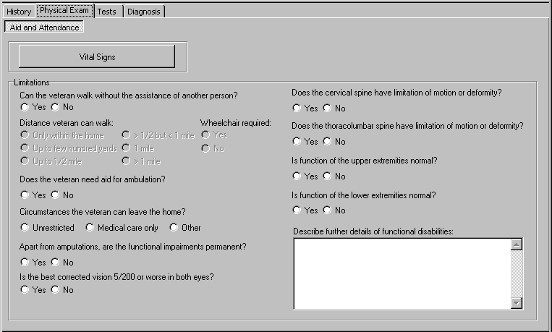

  - Vital Signs (Label/Button)

When the Vital Signs button is selected, a pop-up window labeled Aid and Attendance: Vital Signs.

    - Temperature: (Label/Free-Text Box)

    - Pulse: (Label/Free-Text Box)

    - Respiratory rate: (Label/Free-Text Box)

    - Blood pressure: (Label/Two Free-Text Boxes separated by “/”)

    - Height: (Label/Free-Text Box) (inch/cm) (Label/Radio Buttons)

    - Weight: (Label/Free-Text Box followed by “Pounds”)

    - Build: (Label/Single-Select Drop Down Box)

March 2010 CAPRI Aid and Attendance Template Workflow Patch DVBA*2.7*151 6

The options available for this field are: Average, Muscular, Frail, Lanky, Squat, and Other.

If Other is selected, then the following field is enabled:

      - Other (Label/Free-Text Box)

    - Posture: (Label/Single-Select Drop Down Box)

The options available for this field are: Normal, Stooped, Sway-back, Flat-back, Kyphotic, Lordotic, Slouched, Military-type, and Other.

If Other is selected, then the following field is enabled:

      - Other (Label/Free-Text Box)

    - Gait: (Label/Multi-Select List Box)
The options available for this are: Normal, Ataxic, Antalgic, Stuttering, Hemiplegic, Unable to walk, and Other.

If Normal is selected, then no other options can be selected. If Other is selected, then the following field is enabled:
      - Describe other gait: (Label/Free-Text Box)

    - Current nutritional status: (Good/Overweight/Obese/Underweight/Malnourished/Cachectic) (Label/Radio Buttons)

    - Weight change: (None/Loss/Gain) (Label/Radio Buttons)
If Loss is selected, then the following field is enabled.

      - Weight Loss (percent of weight loss compared to baseline) (average weight in the 2 years preceding onset of disease) (Label/Single-Select Drop Down Box) (Options are: <10%, 10%, 20%, 30%, 40% or more)

If Gain is selected, then the following field is enabled.

      - Weight Gain (percent of weight gain compared to baseline) (average weight in the 2 years preceding onset of disease) (Label/Single-Select Drop Down Box) (Options are: <10%, 10%, 20%, 30%, 40% or more)

  - Limitations (Section Label)

    - Can the veteran walk without the assistance of another person? (Yes/No) (Label/Radio Buttons)

If Yes is selected for Can the veteran walk without the assistance of another person?, then the following field is enabled:

      - Distance veteran can walk: (Label/Radio Buttons)
The options available for this field are: Only within the home, Up to few hundred yards, Up to 1/2 mile, >1/2 mile but < 1 mile, 1 mile, and > 1 mile.

If No is selected for Can the veteran walk without the assistance of another person?, then the following field is enabled:

      - Wheelchair required: (Yes/No) (Label/Radio Buttons)

    - Circumstances the veteran can leave the home? (Unrestricted/Medical care only/Other)(Label/Radio Buttons)
If Other is selected for this field, then a pop-up window titled Aid and Attendance: Other Restrictions displays the following field:

      - Describe other restrictions: (Label/Free-Text Box)

    - Does the veteran need aid for ambulation? (Yes/No) (Label/Radio Buttons)
If Yes selected for this field, then a pop-up window titled Aid and Attendance: Assistance displays the following field:

      - Please choose the type(s) of aid required: (Label/Multi-Select List Box)
The options available for this field are: Brace, One cane, Two canes, Walker, One crutch, and Two crutches.

    - Apart from amputations, are the functional impairments permanent? (Yes/No)(Label/Radio Buttons)

    - Is the best corrected vision 5/200 or worse in both eyes? (Yes/No)(Label/Radio Buttons)

    - Does the cervical spine have limitation of motion or deformity? (Yes/No)(Label/Radio Buttons)
If Yes is selected for this field, then a pop-up window titled Aid and Attendance: Cervical Spine
displays the following field:

      - Describe: (Label/Free-Text Box)

    - Does the thoracolumbar spine have limitation of motion or deformity? (Yes/No)(Label/Radio Buttons)

If Yes is selected for this field, then a pop-up window titled Aid and Attendance: Thoracolumbar Spine displays the following fields:

      - Describe: (Label/Free-Text Box)

      - Does the abnormality interfere with breathing: (Yes/No)(Label/Radio Buttons)
    - Is function of the upper extremities normal? (Yes/No)(Label/Radio Buttons)
If No is selected, then a pop-up window titled Aid and Attendance: Upper Extremity Functional Limitation is displayed.

      - Is there an upper extremity amputation? (Yes/No)(Label/Radio Buttons)
If Yes is selected, then the following field is enabled.

        - State exact level of amputation (or length of stump) and whether use of a prosthesis is feasible: (Label/Free-Text Box)
      - Left upper extremity strength and coordination: (Normal/Mild or moderate impairment/Severe impairment)(Label/Radio Buttons)
      - Right upper extremity strength and coordination: (Normal/Mild or moderate impairment/Severe impairment)(Label/Radio Buttons)
      - Ability for self feeding: (Normal/Some difficulty/Marked difficulty/Cannot perform) (Label/Radio Buttons)
      - Ability to dress and undress: (Normal/Some difficulty/Marked difficulty/Cannot perform) (Label/Radio Buttons)
      - Ability to self bathe: (Normal/Some difficulty/Marked difficulty/Cannot perform) (Label/Radio Buttons)
      - Ability to self groom: (Normal/Some difficulty/Marked difficulty/Cannot perform) (Label/Radio Buttons)

      - Toileting ability: (Normal/Some difficulty/Marked difficulty/Cannot perform) (Label/Radio Buttons)

    - Is function of the lower extremities normal? (Yes/No)(Label/Radio Buttons)
If No is selected, then a pop-up window titled Aid and Attendance: Lower Extremity Functional Limitations is displayed.

      - Is there lower extremity amputation: (Yes/No) (Label/Radio Buttons)
If Yes is selected, then the following field is enabled:

        - State exact level of amputation (or length of stump) and whether use of a prosthesis is feasible: (Label/Free-Text Box)
      - Left lower extremity functional limitations: (Label/Multi-select list box)
The options available for this field are: None, Limitation of joint motion, Muscle weakness, Paralysis, Atrophy, Contractures, and Lack of coordination.

If None is selected, then no other options may be selected.

      - Right lower extremity functional limitations: (Label/Multi-select list box)
The options available for this field are: None, Limitation of joint motion, Muscle weakness, Paralysis, Atrophy, Contractures, and Lack of coordination.

If None is selected, then no other options may be selected.

      - Is weight bearing normal: (Yes/No) (Label/Radio Buttons)
If No is selected for this field, then the following field is enabled.

        - Describe abnormal weight bearing: (Label/Free-Text Box)

      - Is propulsion normal: (Yes/No) (Label/Radio Buttons)
If No is selected for this field, then the following field is enabled.

        - Describe abnormal propulsion: (Label/Free-Text Box)

      - Is balance normal: (Yes/No) (Label/Radio Buttons)
If No is selected for this field, then the following field is enabled.

        - Describe abnormal balance: (Label/Free-Text Box)

      - Are there other functional limitations of the lower extremity: (Yes/No) (Label/Radio Buttons)
If Yes is selected for this field, then the following field is enabled.

        - Describe other functional limitations: (Label/Free-Text Box)

    - Describe further details of functional disabilities: (Label/Free-Text Box)

Tests Tab
  - Screenshot of Aid and Attendance – Tests Tab

Figure 4.1: Aid and Attendance - Tests Tab
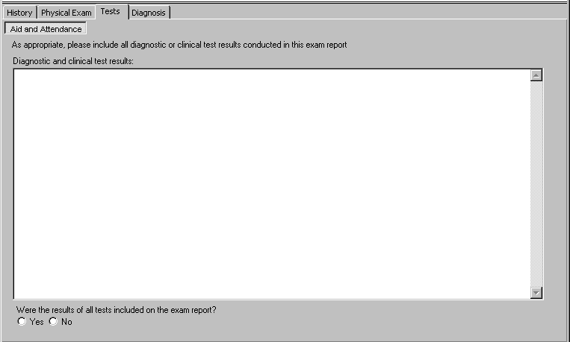

  - As appropriate, please include all diagnostic or clinical test results conducted in this exam report (Label/Read-Only Text)
  - Diagnostic and clinical test results: (Label/Free Text Box)

  - Were the results of all tests included on the exam report? (Yes/No) (Label/Radio Buttons)

Diagnosis Tab
  - Screenshot of Aid and Attendance – Diagnosis Tab

Figure 5.1: Aid and Attendance - Diagnosis Tab
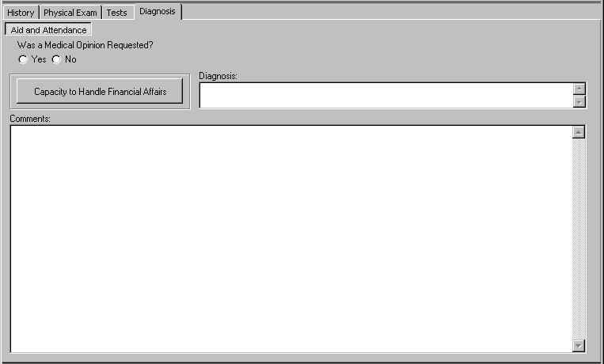

  - Was a Medical Opinion Requested? (Yes/No) (Label/Radio Buttons)

If Yes is selected, then the following message is displayed in a Pop-up window:

Please be sure to include a Medical Opinion.

The “Manage Templates” utility found under the “Options” button at the bottom of the screen can be used to add a Medical Opinion template.

  - Capacity to Handle Financial Affairs (Label/Button)

When the Capacity to Handle Financial Affairs button is selected, a pop up window labeled Aid and Attendance: Mental Competency is displayed.

    - NOTE: mental competency, for VA benefits purposes, refers only to the ability of the veteran to manage VA benefit payments in his or her own best interest, and not to any other subject. Mental incompetency, for VA benefits purposes, means that the veteran, because of injury or disease, is not capable of managing benefit payments in his or her best interest. In order to assist raters in making a legal determination as to competency, please address the following questions: (Label/Read-Only Text)

March 2010 CAPRI Aid and Attendance Template Workflow Patch DVBA*2.7*151 12

    - Does the veteran know the amount of his/her benefit payment: (Yes/No) (Label/Radio Buttons)

    - Does the veteran know the amounts of his/her monthly bills: (Yes/No) (Label/Radio Buttons)

    - Does the veteran prudently handle payments: (Yes/No) (Label/Radio Buttons)

    - Does the veteran personally handle money and pay bills: (Yes/No) (Label/Radio Buttons)

    - Do you believe the veteran is capable of managing his/her financial affairs: (Yes/No) (Label/Radio Buttons)
If either Yes or No is selected, the following request is enabled:

      - Please provide example(s) to support your conclusion: (Label/ Free Text Box)

    - Do you believe a Social Work assessment is necessary to make this determination: (Yes/No) (Label/Radio Buttons)
If Yes is selected, a free text box is enabled requesting the following:

      - Please explain why: (Label/ Free Text Box)

  - Diagnosis: (Label/Free-Text Box)

  - Comments: (Label/Free-Text Box)

March 2010 CAPRI Aid and Attendance Template Workflow Patch DVBA*2.7*151 13

