Compensation and Pension Record Interchange (CAPRI)

CAPRI Templates - Standard Objects, Phase II

Release Notes Patch: DVBA*2.7*151 January 2010

Department of Veterans Affairs Office of Enterprise Development Management & Financial Systems

Preface

Purpose of the Release Notes
The Release Notes document describes the new features and functionality of the CAPRI Templates - Standard Objects, Phase II (DVBA*2.7*151) patch.
The information contained in this document is not intended to replace the CAPRI User Manual. The CAPRI User Manual should be used to obtain detailed information regarding specific functionality.

Table of Contents
- Overview 1
  - Standardized Panels 1
  - Template Defect Corrections 1
  - Template Workflow Documents 1
    - TRAUMATIC BRAIN INJURY Template Workflow 1
    - AID AND ATTENDANCE OR HOUSEBOUND EXAMINATION Template Workflow 2
- Associated Remedy Tickets and New Service Requests 3
- Functional Overview 4
  - Standardized Panels 4
  - Standard Object Templates 4
  - Defect Fixes without Remedy Tickets 4
    - Defect - Inconsistent report format for non-specific weight changes 4
    - Defect - Missing data on Cardiac Exam report 5
    - Defect - Inconvenient tabbing order on Vital Signs panel 5
    - Defect - GENERAL MEDICAL EXAMINATION template 5
    - Defect - Single digit Tonometry reading not appearing on reports 6
    - Defect - Incorrect terms on the EPILEPSY AND NARCOLEPSY template 6
    - Defect - When a BLANK TEMPLATE and a MEDICAL OPINION template 6
    - Defect - HYPERTENSION template not clear on METs assessment requirement 6
    - Defect - TRAUMATIC BRAIN INJURY template not prompting for behavioral signs 7
    - Defect - AID AND ATTENDANCE OR HOUSEBOUND EXAMINATION template 7
- Enhancements 8
  - Standard Object Enhancements 8
    - Standardized Panels 8
    - AID AND ATTENDANCE OR HOUSEBOUND EXAMINATION Template 15
    - BRAIN AND SPINAL CORD Template 15
    - COLD INJURY PROTOCOL EXAMINATION Template 16
    - CUSHINGS SYNDROME Template 17
    - DIABETES MELLITUS Template 17
    - GENERAL MEDICAL EXAMINATION Template 17
    - GULF WAR GUIDELINES Template 18
    - NEUROLOGICAL DISORDERS, MISCELLANEOUS Template 18
    - PERIPHERAL NERVES Template 18
    - PRISONER OF WAR PROTOCOL EXAMINATION Template 19
    - SOCIAL AND INDUSTRIAL SURVEY Template 19
    - SPINE Template 19
    - TRAUMATIC BRAIN INJURY Template 20
- Software and Documentation Retrieval 21
  - VistA Patch DVBA*2.7*151 21
  - User Documentation 21

Table of Figures
Figure 4.1.1.1a: History Tab 8
Figure 4.1.1.1b: Trauma 9
Figure 4.1.1.1c: Neoplasm 9
Figure 4.1.1.2a: Physical Exam Tab 10
Figure 4.1.1.2b: Residuals of Neoplasm 10
Figure 4.1.1.2c: Detailed Reflex Exam 10
Figure 4.1.1.2d: Sensory Function Exam 11
Figure 4.1.1.2e: Detailed Motor Exam 12
Figure 4.1.1.3a: Diagnosis Tab 13
Figure 4.1.1.3b: Employment History 13
Figure 4.1.1.3c: Mental Competency 14
Figure 4.1.1.3d: Diagnosis 15

Overview

Standardized Panels
Standardized Panels, which contain standardized components known collectively as Standard Objects, have been developed for Compensation & Pension Record Interchange (CAPRI) to standardize the exam questions being asked across Compensation & Pension Worksheet Module (CPWM) templates as they relate to certain body systems.

A major benefit of Standardized Panels, and Standard Objects in general, is the elimination of duplicate data entry for CAPRI CPWM templates that are merged and contain the same set of questions on individual templates. After data has been entered into a Standard Object on one of the merged templates, it will appear on all other merged templates which share its Standard Objects.

Revised report coding for the Standard Objects has also been developed so that the report format for each Standardized Panel or other Standard Object is consistent across templates.

These new Standard Objects will be incorporated into the set of CPWM templates in a three- phase approach. The first phase of this initiative, CAPRI TEMPLATES - STANDARD OBJECTS, PHASE I (Patch DVBA*2.7*142), was released on December 2, 2009. CAPRI TEMPLATES - STANDARD OBJECTS, PHASE II (Patch DVBA*2.7*151) is the second
phase of the initiative.

Template Defect Corrections
Several modifications have been made to templates to correct both functional and textual defects. The affected templates include:
    - AID AND ATTENDANCE OR HOUSEBOUND EXAMINATION
    - BLANK TEMPLATE
    - EPILEPSY AND NARCOLEPSY
    - EYE EXAMINATION
    - GENERAL MEDICAL EXAMINATION
    - GULF WAR GUIDELINES
    - HYPERTENSION
    - PRISONER OF WAR PROTOCOL EXAMINATION
    - TRAUMATIC BRAIN INJURY

Template Workflow Documents
Template workflow documents provide an overview of the contents found on a CAPRI template and serve as a workflow process guide.

TRAUMATIC BRAIN INJURY Template Workflow
The TRAUMATIC BRAIN INJURY Template Workflow document has been updated to include changes made by patch DVBA*2.7*151 (CAPRI Templates - Standard Objects, Phase II). The TRAUMATIC BRAIN INJURY Template Workflow document revisions correspond to the TRAUMATIC BRAIN INJURY template changes detailed in section 3.

AID AND ATTENDANCE OR HOUSEBOUND EXAMINATION Template Workflow
The AID AND ATTENDANCE OR HOUSBOUND EXAMINATION Template
Workflow document is being nationally released as an initial version.

Associated Remedy Tickets and New Service Requests
There are no Remedy tickets or New Service Requests associated with the CAPRI Templates - Standard Objects, Phase II (DVBA*2.7*151) patch.

Functional Overview
The following is an overview of the changes and primary functionality that will be delivered in this patch.

Standardized Panels
Content for a number of Standardized Panels has been approved by the Veterans Benefits Administration Veterans Affairs Central Office (VBAVACO). They are listed here, grouped by the template tab page to which each is related:
    - HISTORY - Trauma, Neoplasm
    - PHYSICAL EXAM - Residuals of Neoplasm, Motor Function, Sensory Function, Reflexes
    - DIAGNOSIS - Employment History, Financial Affairs, Diagnosis

Standard Object Templates
This patch adds the Standard Objects listed above to the following templates, if they apply.
    - AID AND ATTENDANCE OR HOUSEBOUND EXAMINATION
    - BRAIN AND SPINAL CORD
    - COLD INJURY PROTOCOL EXAMINATION
    - CUSHINGS SYNDROME
    - DIABETES MELLITUS
    - GENERAL MEDICAL EXAMINATION
    - GULF WAR GUIDELINES
    - NEUROLOGICAL DISORDERS, MISCELLANEOUS
    - PERIPHERAL NERVES
    - PRISONER OF WAR PROTOCOL EXAMINATION
    - SOCIAL AND INDUSTRIAL SURVEY
    - SPINE
    - TRAUMATIC BRAIN INJURY

Defect Fixes without Remedy Tickets
The following defects that were reported directly to the CAPRI development team are being addressed:

Defect - Inconsistent report format for non-specific weight changes

Problem
On several templates, weight changes without a specified quantity appear on reports with inconsistent formats.

Solution
On the following templates: AID AND ATTENDANCE OR HOUSEBOUND EXAMINATION; COLD INJURY PROTOCOL EXAMINATION; DIABETES MELLITUS; GENERAL MEDICAL EXAMINATION; GULF WAR GUIDELINES;

HYPERTENSION; NEUROLOGICAL DISORDERS, MISCELLANEOUS; PRISONER OF WAR PROTOCOL EXAMINATION; TRAUMATIC BRAIN INJURY, weight
changes without a specified quantity will appear on reports as:
"WEIGHT CHANGE: Gain - baseline percentage change not provided." or "WEIGHT CHANGE: Loss - baseline percentage change not provided."

Defect - Missing data on Cardiac Exam report

Problem
On the DIABETES MELLITUS, GENERAL MEDICAL EXAMINATION, GULF WAR GUIDELINES, HYPERTENSION, and PRISONER OF WAR PROTOCOL
EXAMINATION templates, Physical Exam Tab, the Cardiac Exam section of the report does not display information entered into the "Describe and state significance of extra heart sounds noted:" memo box unless "Other" is selected in the "Extra heart sounds:" list box.

Solution
The Cardiac Exam report on these templates has been altered so that information entered into the "Describe and state significance of extra heart sounds noted:" memo box is included in the report, whether or not "Other" is selected in the "Extra heart sounds:" list box.

Defect - Inconvenient tabbing order on Vital Signs panel

Problem
On the GENERAL MEDICAL EXAMINATION, GULF WAR GUIDELINES, and
PRISONER OF WAR PROTOCOL EXAMINATION templates, the tabbing order on the Vital Signs panel is inconvenient for clinicians. This issue was raised by Dr. Sven Ljaamo of the VA Healthcare Network Upstate New York.

Solution
On these templates, the tabbing order on the Physical Exam tab, Vital Signs panel has been changed to facilitate data entry during exams.

Defect - GENERAL MEDICAL EXAMINATION template is missing the Mental Competency panel on the Diagnosis tab

Problem
On the GENERAL MEDICAL EXAMINATION template, the Mental Competency panel (Capacity to Handle Financial Affairs button) is missing from the Diagnosis tab.

Solution
The Mental Competency panel has been restored to the Diagnosis tab of the GENERAL MEDICAL EXAMINATION template.

Defect - Single digit Tonometry reading not appearing on reports

Problem
On the EYE EXAMINATION template, Physical Exam tab, Tonometry section, a single digit pressure reading entered into the Right or Left Eye Pressure input box does not appear on reports.

Solution
The EYE EXAMINATION template, Physical Exam tab, Tonometry section, has been changed so that single digit entries in the Right or Left Eye Pressure input box will appear on reports.

Defect - Incorrect terms on the EPILEPSY AND NARCOLEPSY template

Problem
On the EPILEPSY AND NARCOLEPSY template, the terms "conclusive" and "non- conclusive" appear where "convulsive" and "non-convulsive" are the correct terms.

Solution
The EPILEPSY AND NARCOLEPSY template has been edited. The term "non- conclusive" has been replaced with "non-convulsive". The term "conclusive" has been replaced with "convulsive".

Defect - When a BLANK TEMPLATE and a MEDICAL OPINION template are merged, unintended data sharing occurs

Problem
When a BLANK TEMPLATE and MEDICAL OPINION template are merged, data entered in the BLANK TEMPLATE, Free Text area appears in the MEDICAL OPINION template, Medical Opinion Summary text area (and vice versa).

Solution
This patch eliminates the overlap. Data entered in either the BLANK TEMPLATE, Free Text area or the MEDICAL OPINION template, Summary text area no longer appears in the other.

Defect - HYPERTENSION template not clear on METs assessment requirement

Problem
The METs information on the HYPERTENSION template was confusing to some providers as to whether or not METs assessment is needed for hypertension due to the Note to Examiners instructions located within the Cardiac Exam panel on the Physical Exam tab.

Solution
On the HYPERTENSION template the following two changes were made:
      - Test tab, the "Stress test results: METs" section has been removed from the template.

      - Physical Exam tab, Cardiac Exam panel, the Examiners Note has been modified to remove METs exercise testing from the note.

Defect - TRAUMATIC BRAIN INJURY template not prompting for behavioral signs due to co-morbidity or TBI

Problem
The TRAUMATIC BRAIN INJURY template is not adequately prompting examiners to indicate whether behavioral signs and symptoms are due to a co-morbid mental disorder or to TBI.

Solution
On the TRAUMATIC BRAIN INJURY template, Physical Exam tab, when the examiner answers “Yes” to the question “Psychiatric Manifestations Present?”, a pop-up message is presented: “When a mental disorder is present, state, or ask the mental disorders examiner to state, to the extent possible, which emotional/behavioral signs and symptoms are part of a co-morbid mental disorder and which represent residuals of TBI. If it is not possible to make such a determination without speculation, so state.”

Defect - AID AND ATTENDANCE OR HOUSEBOUND EXAMINATION template contains repetitious questions about lower extremity functional limitations

Problem
The AID AND ATTENDANCE OR HOUSEBOUND EXAMINATION template, Physical
Exam tab, Lower Extremities Functional Limitations form, contains repetitious questions. Input options provided by selecting "Other" from either the Right or Left lower extremity functional limitations list box and associated "Describe functional restrictions..." memo box are already available using the "Are there other functional limitations of the lower extremity" buttons and "Describe other functional limitations" memo box.

Solution
Remove "Other" as an option under Right and Left lower extremities functional limitations. Remove "Describe functional restrictions..." memo boxes under the Right and Left lower extremities functional limitations list boxes.

Enhancements
The following section is an overview of the enhancements that have been added in the CAPRI Templates
- Standard Objects, Phase II (DVBA*2.7*151) patch.

Standard Object Enhancements

Standardized Panels
The Veterans Benefits Administration Veterans Affairs Central Office (VBAVACO) approved the content for the Standardized Panels. These Standardized Panels were applied to the CAPRI CPWM template History tab, Physical Exam tab, and Diagnosis tab for thirteen templates in Standard Objects Phase II.

Standardized History Tab
Figure 4.1.1.1a: History Tab
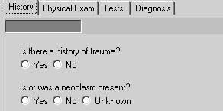

Figure 4.1.1.1b: Trauma
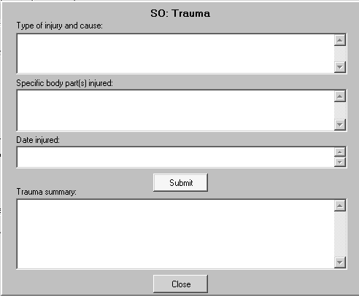

Figure 4.1.1.1c: Neoplasm
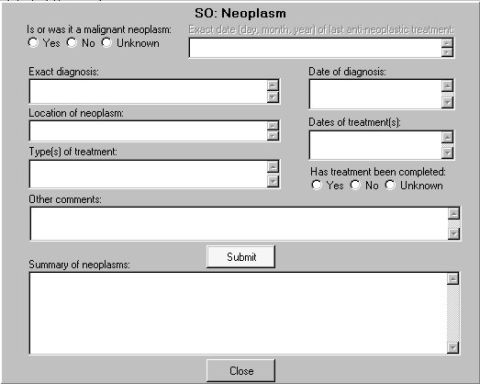

Standardized Physical Exam Tab
Figure 4.1.1.2a: Physical Exam Tab

Figure 4.1.1.2b: Residuals of Neoplasm
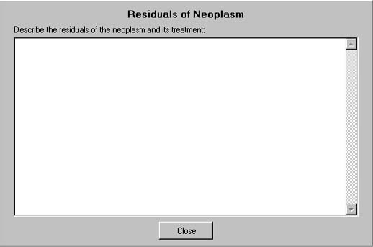

Figure 4.1.1.2c: Detailed Reflex Exam
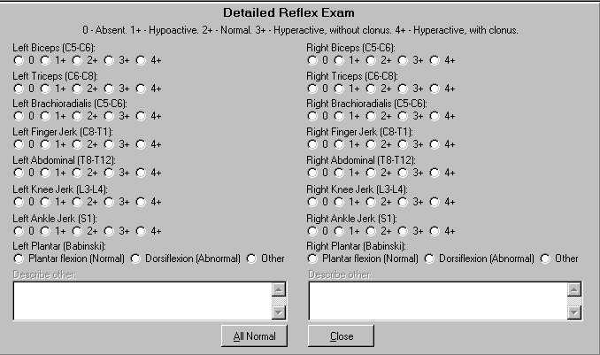

Figure 4.1.1.2d: Sensory Function Exam
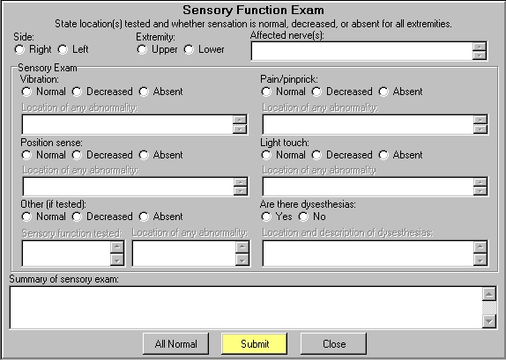

Figure 4.1.1.2e: Detailed Motor Exam
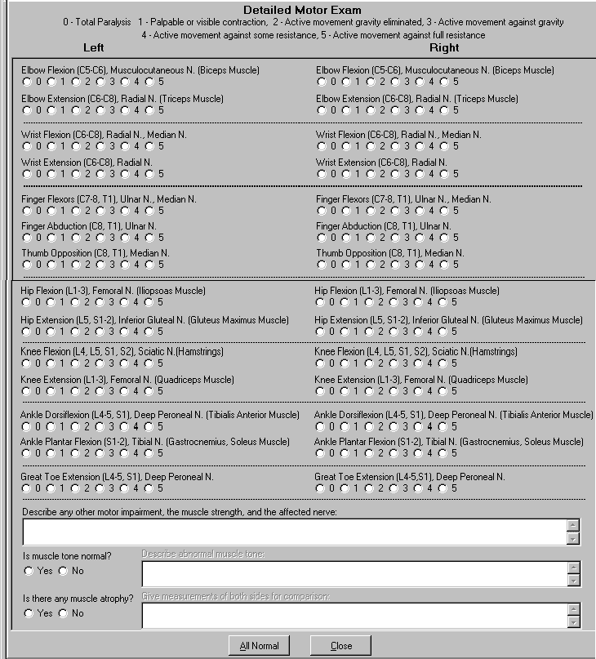

Standardized Diagnosis Tab
Figure 4.1.1.3a: Diagnosis Tab
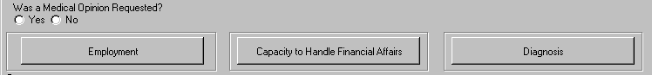

Figure 4.1.1.3b: Employment History
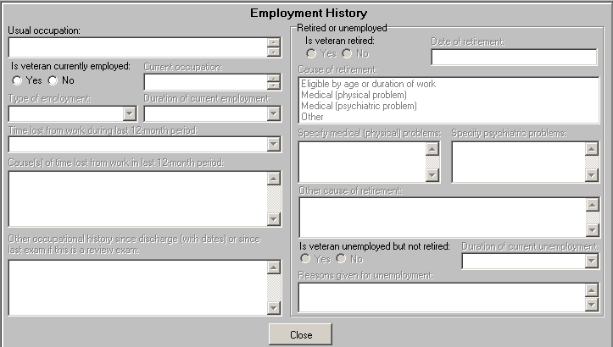

Figure 4.1.1.3c: Mental Competency
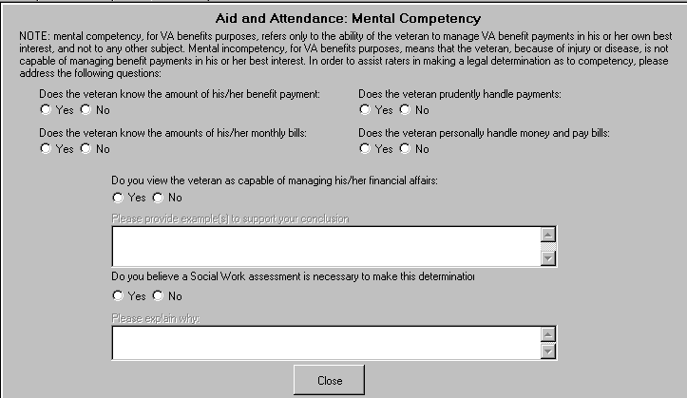

Figure 4.1.1.3d: Diagnosis
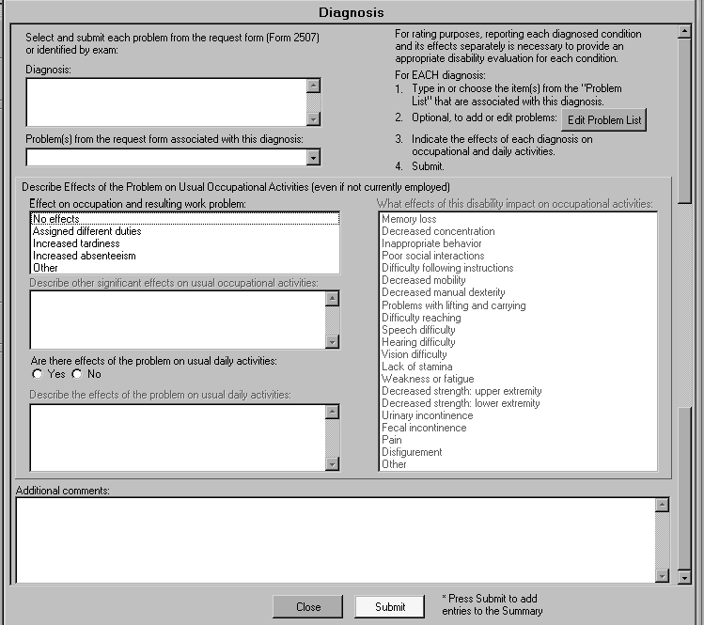

AID AND ATTENDANCE OR HOUSEBOUND EXAMINATION Template
The following Standard Object was added to the AID AND ATTENDANCE OR HOUSEBOUND EXAMINATION template:

Diagnosis Tab
Standardized Panels for the Diagnosis tab include:
- Mental Competency

BRAIN AND SPINAL CORD Template
The following Standard Objects were added to the BRAIN AND SPINAL CORD template:

History Tab
Standardized Panels for the History tab include:
- Trauma
- Neoplasm

Physical Exam Tab
Standardized Panels for the Physical Exam tab include:
- Residuals of Neoplasm
- Detailed Motor Exam
- Sensory Function Exam
- Detailed Reflex Exam

Diagnosis Tab
Standardized Panels for the Diagnosis tab include:
- Employment History
- Mental Competency
- Diagnosis

COLD INJURY PROTOCOL EXAMINATION Template
The following Standard Objects were added to the COLD INJURY PROTOCOL EXAMINATION template:

History Tab
Standardized Panels for the History tab include:
- Trauma
- Neoplasm

Physical Exam Tab
Standardized Panels for the Physical Exam tab include:
- Residuals of Neoplasm
- Detailed Motor Exam
- Sensory Function Exam
- Detailed Reflex Exam

Diagnosis Tab
Standardized Panels for the Diagnosis tab include:
- Employment History
- Diagnosis

CUSHINGS SYNDROME Template
The following Standard Objects were added to the CUSHINGS SYNDROME template:

History Tab
Standardized Panels for the History tab include:
- Neoplasm

Physical Exam Tab
Standardized Panels for the Physical Exam tab include:
- Residuals of Neoplasm
- Detailed Motor Exam

Diagnosis Tab
Standardized Panels for the Diagnosis tab include:
- Employment History

DIABETES MELLITUS Template
The following Standard Objects were added to the DIABETES MELLITUS template:

Physical Exam Tab
Standardized Panels for the Physical Exam tab include:
- Detailed Motor Exam
- Sensory Function Exam
- Detailed Reflex Exam

GENERAL MEDICAL EXAMINATION Template
The following Standard Objects were added to the GENERAL MEDICAL EXAMINATION template:

Physical Exam Tab
Standardized Panels under the Neuro button on the Physical Exam tab include:
- Detailed Motor Exam
- Sensory Function Exam
- Detailed Reflex Exam

Diagnosis Tab
Standardized Panels for the Diagnosis tab include:

- Mental Competency

GULF WAR GUIDELINES Template
The following Standard Objects were added to the GULF WAR GUIDELINES template:

Physical Exam Tab
Standardized Panels under the Neuro button on the Physical Exam tab include:
- Detailed Motor Exam
- Sensory Function Exam
- Detailed Reflex Exam

NEUROLOGICAL DISORDERS, MISCELLANEOUS Template
The following Standard Objects were added to the NEUROLOGICAL DISORDERS, MISCELLANEOUS template:

History Tab
Standardized Panels for the History tab include:
- Trauma
- Neoplasm

Physical Exam Tab
Standardized Panels for the Physical Exam tab include:
- Residuals of Neoplasm

Diagnosis Tab
Standardized Panels for the Diagnosis tab include:
- Employment History
- Diagnosis

PERIPHERAL NERVES Template
The following Standard Objects were added to the PERIPHERAL NERVES template:

History Tab
Standardized Panels for the History tab include:
        - Trauma
        - Neoplasm

Physical Exam Tab
Standardized Panels for the Physical Exam tab include:
        - Residuals of Neoplasm
        - Detailed Motor Exam
        - Sensory Function Exam
        - Detailed Reflex Exam

Diagnosis Tab
Standardized Panels for the Diagnosis tab include:
        - Employment History

PRISONER OF WAR PROTOCOL EXAMINATION Template
The following Standard Objects were added to the PRISONER OF WAR PROTOCOL EXAMINATION template:

Physical Exam Tab
Standardized Panels under the Neuro button on the Physical Exam tab include:
        - Detailed Motor Exam
        - Sensory Function Exam
        - Detailed Reflex Exam

SOCIAL AND INDUSTRIAL SURVEY Template
The following Standard Objects were added to the SOCIAL AND INDUSTRIAL SURVEY template:

Summary Tab
Standardized Panel for the Summary tab includes:
        - Employment History

SPINE Template
The following Standard Objects were added to the SPINE template:

History Tab
Standardized Panels for the History tab include:
        - Trauma
        - Neoplasm

Physical Exam Tab
Standardized Panels for the Physical Exam tab include:
        - Residuals of Neoplasm
        - Detailed Motor Exam
        - Sensory Function Exam
        - Detailed Reflex Exam

Diagnosis Tab
Standardized Panels for the Diagnosis tab include:
        - Employment History
        - Diagnosis

TRAUMATIC BRAIN INJURY Template
The following Standard Objects were added to the TRAUMATIC BRAIN INJURY template:

Physical Exam Tab
Standardized Panels for the Physical Exam tab include:
        - Detailed Motor Exam
        - Sensory Function Exam
        - Detailed Reflex Exam

Diagnosis Tab
Standardized Panels for the Diagnosis tab include:
        - Employment History
        - Mental Competency
        - Diagnosis

Software and Documentation Retrieval

VistA Patch DVBA*2.7*151
The VistA software is being distributed as a PackMan patch message through the National Patch Module (NPM). The KIDS build for this patch is DVBA*2.7*151.

User Documentation
The user documentation for this patch may be retrieved directly using FTP. The preferred method is to FTP the files from:

REDACTED

This transmits the files from the first available FTP server. Sites may also elect to retrieve software directly from a specific server as follows:

OI&T Field Office | FTP Address | Directory
REDACTED | REDACTED | REDACTED
REDACTED | REDACTED | REDACTED
REDACTED | REDACTED | REDACTED

The following files will be available:

File Name | Format | Description
DVBA_27_P151_RN.PDF | Binary | Release Notes
DVBA_27_P151_TBI_WF.PDF | Binary | TRAUMATIC BRAIN INJURY  Workflow
DVBA_27_P151_A_AND_A_WF.PDF | Binary | AID AND ATTENDANCE OR HOUSEBOUND EXAMINATION  Workflow

Documentation may also be retrieved from the VistA Documentation Library (VDL) on the Internet at the following address. This web site is usually updated within 1-3 days of the patch release date.http://www.va.gov/vdl/application.asp?appid=133

