Compensation and Pension Record Interchange (CAPRI)

Traumatic Brain Injury (TBI)

Template Workflow
Patch: DVBA*2.7*151
January 2010

Department of Veterans Affairs Office of Enterprise Development Management & Financial Systems

Revision History
Initiated on 02/09/2009

Date | Description (Patch # if applicable) | Project  Manager | Technical  Writer
11/30/2009 | Manual updated to include changes made by patch DVBA *2.7*151  - Section 3 – Updated questions on the Physical Exam tab  Also:  - Added Revision History and Preface  - Corrected minor header and footer formatting issues  - Changed formatting of field description in Heading 1 and Heading 2 | REDACTED | REDACTED

Preface
Reference Numbering System
This document uses a numbering system to organize its topics into sections and to show the reader how these topics relate to each other. For example, the information in section 1.3 is the main topic for the third section of Chapter 1. If there were two subsections to this topic, they would be numbered 1.3.1 and
1.3.2. A section numbered 2.3.5.4.7 would be the seventh subsection of the fourth subsection of the fifth subsection of the third topic of Chapter 2. This numbering system tool allows the reader to more easily follow the logic of sections that contain several subsections.

Table of Contents

- Introduction 1
  - Purpose 1
  - Overview 1
- History Tab 2
  - Screenshot of TBI - History Tab 2
  - Note to Examiner 2
  - Definition of TBI 3
  - Records Review 6
    - Comments on records 7
  - Problems Claimed or Identified by Exam 7
    - Instructions 7
    - 1. Build Problem List 7
    - 2. Document Problems 8
    - 3. Review Documentation 10
  - History Tab - Questions 11
    - What was the severity of the initial injury 11
    - Comments 11
    - Has the condition stabilized 11
    - Inquire specifically about each symptom 11
    - For each of the following symptoms that is present 11
- Physical Exam Tab 18
  - Screenshot of TBI- Physical Exam Tab 18
  - Vital Signs & General Appearance 18
    - Pulse 19
    - Blood Pressure 19
    - Current weight 19
    - Height 19
    - Weight change 19
    - Dominant hand 19
    - General appearance 19
  - Reflex Exam 19
    - 0 - Absent. 1+ - Hypoactive. 2+ - Normal. 3+ - Hyperactive 20
    - Left Biceps (C5-C6) 20
    - Left Triceps (C6-C8) 20
    - Left Brachioradialis (C5-C6) 20
    - Left Finger Jerk (C8-T1) 20
    - Left Abdominal (T8-T12) 20
    - Left Knee Jerk (L3-L4) 20
    - Left Ankle Jerk (S1) 20
    - Left Plantar (Babinski) 20
    - Right Biceps (C5-C6) 21
    - Right Triceps (C6-C8) 21
    - Right Brachioradialis (C5-C6) 21
    - Right Finger Jerk (C8-T1) 21
    - Right Abdominal (T8-T12) 21
    - Right Knee Jerk (L3-L4) 21
    - Right Ankle Jerk (S1) 21
    - Right Plantar (Babinski) 21
    - All Normal 21
  - Sensory Exam 22
    - State location(s) tested and whether sensation is normal, decreased, or absent 22
    - Side 22
    - Extremity 22
    - Affected nerve(s) 22
    - Sensory Exam 22
  - Motor Function 24
    - 0 - Total Paralysis, 1 - Palpable or visible contraction 26
    - Left 26
    - Right 26
    - Describe any other motor impairment 27
    - Is muscle tone normal 27
    - Is there any muscle atrophy 27
    - All Normal 27
  - Physical Exam Tab – Questions 28
    - Is there impairment of the Autonomic Nervous System 28
    - Is there a gait abnormality 28
    - Is there imbalance or tremor 28
    - Is there evidence of spasticity or rigidity 28
    - Is there evidence of fasciculations 29
    - Is there evidence of cranial nerve dysfunction on screening 29
    - Are there hearing problems on screening 29
    - If abnormalities are found 29
    - Is there endocrine dysfunction due to TBI 29
    - Is there skin breakdown due to neurologic problems 29
    - Are there vision problems on screening 29
    - Psychiatric manifestations present 30
    - Conduct a screening examination 30
    - Assessment of cognitive impairment 30
    - Other abnormal findings on physical exam 33
- Tests Tab 34
  - Screenshot of TBI – Tests Tab 34
  - Skull X-Rays if there is a bony defect 34
  - Describe results of any neuropsychological testing 34
  - Include results of all diagnostic and clinical tests 34
- Diagnosis Tab 35
  - Screenshot of TBI – Diagnosis Tab 35
  - Was a Medical Opinion Requested 35
    - Please be sure to include a Medical Opinion 35
  - Did the veteran have a TBI during service 35
  - Employment 35
    - Usual occupation 36
    - Is veteran currently employed 36
    - Retired or unemployed 37
    - Is the veteran unemployed but not retired 37
  - Diagnosis 38
    - Select and submit each problem from the request form 39
    - Diagnosis 39
    - Problem(s) from the request form associated with this diagnosis 39
    - Is this diagnosis associated with a service related TBI 39
    - The following is instructional text 39
    - Describe Effects of the Problem on Usual Occupational Activities 39
    - Effect on occupation 39
    - Describe the effects of the problem on usual daily activities 40
    - Are there effects of the problem on usual daily activities 40
    - Additional comments 40
    - Submit 40
    - * Press Submit to add entries to the Summary 40
  - Capacity to Handle Financial Affairs 40
    - NOTE: mental competency, for VA benefits purposes 41
    - Does the veteran know the amount of his/her benefit payment 41
    - Does the veteran know the amounts of his/her monthly bills 41
    - Does the veteran prudently handle payments 41
    - Does the veteran personally handle money and pay bills 41
    - Do you believe the veteran is capable of managing his/her financial affairs 41
    - Do you believe a Social Work assessment is necessary 41
  - Additional exams recommended 42
  - Additional comments concerning functional impairment 42
  - Summary of diagnosis 42

Introduction
  - Purpose
This document provides a high level overview of the contents found on the Traumatic Brain Injury (TBI) Template that was released in CAPRI patch DVBA*2.7*151. This document serves as a workflow process guide.

  - Overview
The Audio Template contains the following four tabs:
- History
- Physical Exam
- Tests
- Diagnosis

A common business rule used within the TBI Template is (for all multi-line Free Text entry areas the user is provided) the ability to expand the details in an additional Free Text memo-box when the Details button is selected.

Figure 1.2.a: Details Button

Figure 1.2.b: Additional Free Text Memo-box

A number of questions on the TBI Template are mandatory and require a response (value) prior to the exam being marked as completed. Some answers to questions may activate a pop-up window with an additional Close, Submit, or OK button.

January 2010 CAPRI Traumatic Brain Injury Template Workflow Patch DVBA*2.7*151 1

History Tab
  - Screenshot of TBI - History Tab
Figure 2.1: Traumatic Brain Injury - History Tab
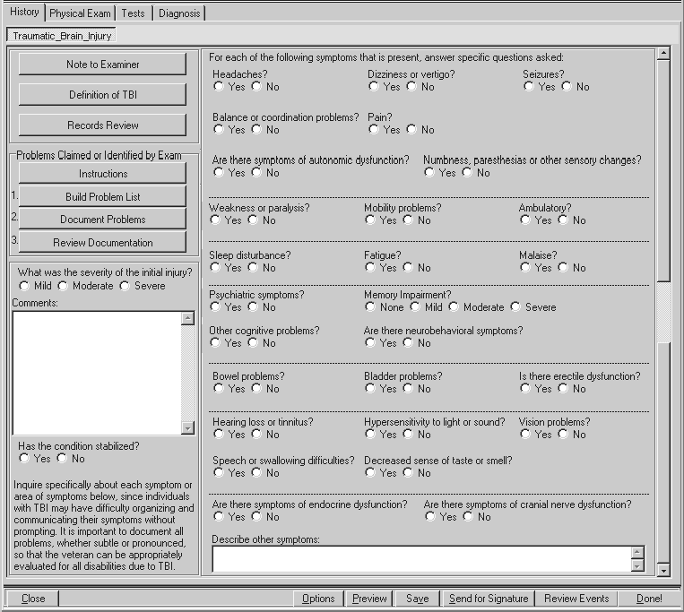
  - Note to Examiner (Label/Button)

When the Note to Examiner button is selected, a pop-up window labeled TBI: Note to Examiners
displays the following:

Figure 2.2: Note to Examiners
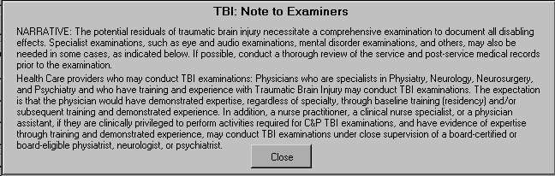

NARRATIVE: The potential residuals of traumatic brain injury necessitate a comprehensive examination to document all disabling effects. Specialist examinations, such as eye and audio examinations, mental disorder examinations, and others, may also be needed in some cases, as indicated below. If possible, conduct a thorough review of the service and post-service medical records prior to the examination.
Health Care providers who may conduct TBI examinations: Physicians who are specialists in Physiatry, Neurology, Neurosurgery, and Psychiatry and who have training and experience with Traumatic Brain Injury may conduct TBI examinations. The expectation is that the physician would have demonstrated expertise, regardless of specialty, through baseline training (residency) and/or subsequent training and demonstrated experience. In addition, a nurse practitioner, a clinical nurse specialist, or a physician assistant, if they are clinically privileged to perform activities required for C&P TBI examinations, and have evidence of expertise through training and demonstrated experience, may conduct TBI examinations under close supervision of a board-certified or board-eligible physiatrist, neurologist, or psychiatrist.

  - Definition of TBI (Label/Button)

When the Definition of TBI button is selected, a pop-up window labeled TBI: Definition displays the following:

Figure 2.3: TBI: Definition
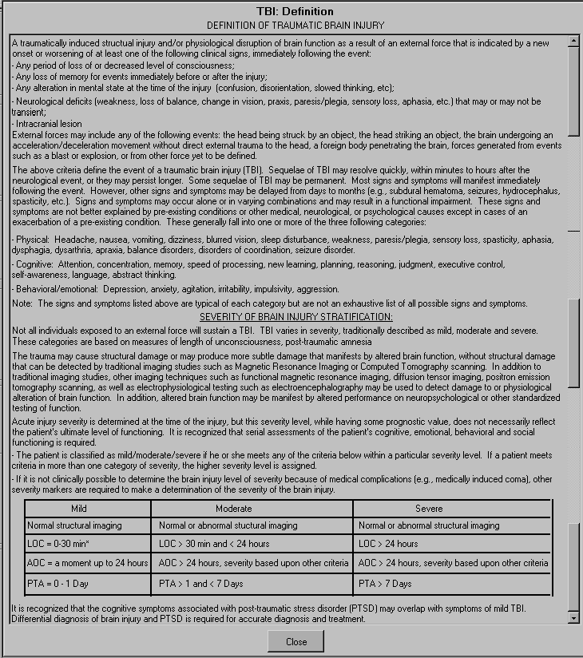

DEFINITION OF A TRAUMATIC BRAIN INJURY
A traumatically induced structural injury and/or physiological disruption of brain function as a result of an external force that is indicated by a new onset or worsening of at least one of the following clinical signs, immediately following the event:
- Any period of loss of or decreased level of consciousness;
- Any loss of memory for events immediately before or after the injury;
- Any alteration in mental state at the time of the injury (confusion, disorientation, slowed thinking, etc.);

- Neurological deficits (weakness, loss of balance, change in vision, praxis, paresis/plegia, sensory loss, aphasia, etc.) that may or may not be transient;
- Intracranial lesion
External forces may include any of the following events: the head being struck by an object, the head striking an object, the brain undergoing an acceleration/deceleration movement without direct external trauma to the head, a foreign body penetrating the brain, forces generated from events such as a blast or explosion, or from other force yet to be defined.

The above criteria define the event of a traumatic brain injury (TBI). Sequelae of TBI may resolve quickly, within minutes to hours after the neurological event, or they may persist longer. Some sequelae of TBI may be permanent. Most signs and symptoms will manifest immediately following the event. However, other signs and symptoms may be delayed from days to months (e.g., subdural hematoma, seizures, hydrocephalus, spasticity, etc.). Signs and symptoms may occur alone or in varying combinations and may result in a functional impairment. These signs and symptoms are not better explained by pre-existing conditions or other medical, neurological, or psychological causes except in cases of an exacerbation of a pre-existing condition. These generally fall into one or more of the three following categories:

- Physical: Headache, nausea, vomiting, dizziness, blurred vision, sleep disturbance, weakness, paresis/plegia, sensory loss, spasticity, aphasia, dysphagia, dysarthria, apraxia, balance disorders, disorders of coordination, seizure disorder.

-Cognitive: Attention, concentration, memory, speed of processing, new learning, planning, reasoning, judgment, executive control, self-awareness, language, abstract thinking.

-Behavioral/emotional: Depression, anxiety, agitation, irritability, impulsivity, aggression.

Note: The signs and symptoms listed above are typical of each category but are not an exhaustive list of all possible signs and symptoms.

SEVERITY OF BRAIN INJURY STRATIFICATION:
Not all individuals exposed to an external force will sustain a TBI. TBI varies in severity, traditionally described as mild, moderate and severe. These categories are based on measures of length of unconsciousness, and post- traumatic amnesia

The trauma may cause structural damage or may produce more subtle damage that manifests by altered brain function, without structural damage that can be detected by traditional imaging studies such as Magnetic Resonance Imaging or Computed Tomography scanning. In addition to traditional imaging studies, other imaging techniques such as functional magnetic resonance imaging, diffusion tensor imaging, positron emission tomography scanning, as well as electrophysiological testing such as electroencephalography may be used to detect damage to or physiological alteration of brain function. In addition, altered brain function may be manifest by altered performance on neuropsychological or other standardized testing of function.

Acute injury severity is determined at the time of the injury, but this severity level, while having some prognostic value, does not necessarily reflect the patient’s ultimate level of functioning. It is recognized that serial assessments of the patient’s cognitive, emotional, behavioral and social functioning is required.

-The patient is classified as mild/moderate/severe if he or she meets any of the criteria below within a particular severity level. If a patient meets criteria in more than one category of severity, the higher severity level is assigned.

-If it is not clinically possible to determine the brain injury level of severity because of medical complications (e.g., medically induced coma), other severity markers are required to make a determination of the severity of the brain injury.

Mild | Moderate | Severe
Normal structural imaging | Normal or abnormal structural imaging | Normal or abnormal structural imaging
LOC = 0-30 min* | LOC > 30 min and < 24 hours | LOC > 24 hours
AOC = a moment up to 24 hours | AOC > 24 hours, severity based upon other criteria | AOC > 24 hours, severity based upon other criteria
PTA = 0 -1 Day | PTA > 1 and < 7 Days | PTA > 7 Days

It is recognized that the cognitive symptoms associated with post-traumatic stress disorder (PTSD) may overlap with symptoms of mild TBI. Differential diagnosis of brain injury and PTSD is required for accurate diagnosis and treatment.

  - Records Review (Label/Button)

When the Records Review button is selected, a pop-up window labeled TBI: Review of Records is displayed.

Figure 2.4: Review of Records
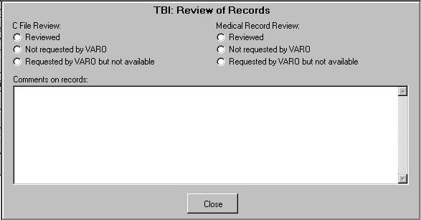

This panel allows the user to annotate the C File Review and the Medical Record Review. For each review, one of the following associated actions may be selected: Reviewed, Not Requested by VARO, or Review requested by VARO but not available. The review of records questions must be completed.

Example:

C File Review:
    - Reviewed
    - Not Requested by VARO
    - Review requested by VARO but not available

Medical Record Review:
    - Reviewed
    - Not Requested by VARO
    - Review requested by VARO but not available

2.4.1 Comments on records: (Free Text Box)
The user may provide comments on the review of the records.

If the user closes the TBI: Review of Records pop-up window without making a C File Review selection, then the following instructions display in a pop-up window:

C File must be reviewed before submitting the report

If the user closes the TBI: Review of Records pop-up window without making a Medical Record Review selection, then the following instructions display in a pop-up window:

Medical Records must be reviewed before submitting the report

  - Problems Claimed or Identified by Exam (Section Label/Read Only Text)

    - Instructions (Label/Button)
When the Instructions button is selected, a pop-up window labeled TBI: Instructions displays the following instructions:

Figure 2.5.1: TBI Instructions
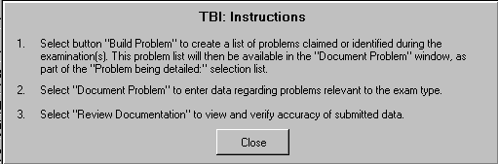

      - Select button “Build Problem” to create a list of problems claimed or identified during the examination(s). This problem list will then be available in the “Document Problem” window, as part of the “Problem being detailed:” selection list.
      - Select “Document Problem” to enter data regarding problems relevant to the exam type.
      - Select “Review Documentation” to view and verify accuracy of submitted data.

    - 1. Build Problem List (Labels/“1” left of Button)
When the Build Problem List button is selected, a pop-up window displays the following:

Figure 2.5.2: Problem List
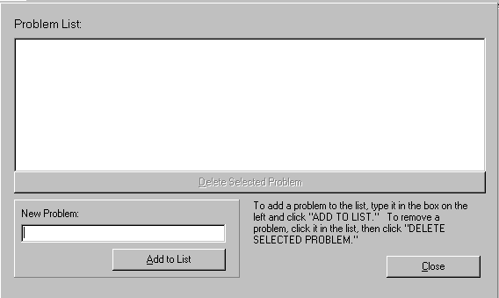

      - Problem List: (Label/ Text Box populated by “Add to List”)
This section displays all the problems populated when the Add to List button is selected.

      - New Problem: (Label/Free Text Box and “Add to List” (Button/Submit function))
To add a problem, enter it in this box.

      - Add to List (Label/Button)
Click the Add to List button to add the new problem to the Problem List.

      - Delete Selected Problem (Label/Button/Action/Enabled when Problem in Problem list is highlighted)
To remove a problem, select it by clicking on its name in the problem list, and then click the
Delete Selected Problem button.

      - To add a problem to the list, type it in the box on the left and click “ADD TO LIST.” To remove a problem, click it in the list, then click “DELETE SELECTED PROBLEM.” (Read Only Text)

    - 2. Document Problems (Labels/“2”left of Button)
When the Document Problems button is selected, a pop-up window labeled TBI: Problem Specific History displays the following:

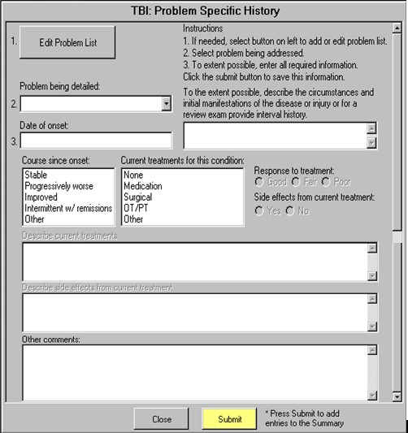
Figure 2.5.3: Problem Specific History

      - Instructions (Read Only Text)
        - If needed, select button on left to add or edit problem list.
        - Select problem being addressed.
        - To extent possible, enter all required information. Click the submit button to save this information.

      - 1. Edit Problem List (Order Number/Button Label)
When the Edit Problem List button is selected, a pop-up window that allows editing of Problem List entries is displayed. (Reference Section 2.4.2 Build Problem List for usage instructions)

      - 2. Problem being detailed: (Label/Order Number/Free Text Box/Drop Down List)
The drop down list of selectable items is populated from the Add to List button on the Problem List pop-up window display.

      - 3. Date of onset: (Order Number/Label/Free Text Box)
The date when the problem selected in the Problem being detailed box occurred is entered in this text box.

      - To the extent possible, describe the circumstances and initial manifestations of the disease or injury or for a review exam provide interval history. (Label/Free Text Box)

      - Course since onset: (Label/Single Select List Box)
The options available for selection are Stable, Progressively worse, Improved, Intermittent w/ remissions, and Other.

      - Current treatments for this condition: (Label/Single Select List Box)
The options available for selection are None, Medication, Surgical, OT/PT, and Other. If None, is selected no other items may be selected.
If Medication, Surgical, OT/PT, or Other is selected, then the following fields are enabled:

        - Response to treatment: (Good/Fair/Poor) (Label, Radio Buttons)

        - Side effects from current treatment: (Yes/No) (Label/Radio Buttons)
If Yes is selected, then the following field will be enabled:

          - Describe current treatments (Label/Free Text Box)

          - Describe side effects from current treatment (Label/Free Text Box)

      - Other comments: (Label/Free Text Box)

      - Submit (Label/Button/Action)

      - * Press Submit to add entries to the Summary (Read Only Text)

If entries are not made in one or more fields of the TBI: Problem Specific History panel, then when the Submit button is selected, a message reminds the user to enter the missing information.

Submit Instructions:

You must specify the problem currently being detailed. You must enter the date.
You must enter the circumstances and initial manifestation of the disease. What is the course since onset?
Are there current treatments?

    - 3. Review Documentation (Labels/”3” left of Button)
When the Review Documentation button is selected, a pop-up window displays a Free Text box with the following label: TBI: Summary of Problem Specific History.
(Free Text/Edit Text/Populated when 2. Document Problems (TBI: Problem Specific History) is used)

  - History Tab - Questions
A common rule for the following History Tab radio-button questions is that once a question enables a pop-up window with additional questions, a Re-open button is provided to re-access the window when that window is closed. Each pop-up window has a Close button.

    - What was the severity of the initial injury? (Mild/Moderate/Severe) (Label/Radio Buttons)

    - Comments: (Label/Free Text Box)

    - Has the condition stabilized? (Yes/No) (Label/Radio Buttons)
If No is selected, a pop-up window labeled TBI: Stability of Condition displays the following question:

      - When is stability expected: (Weeks/ Months/ 1 year/ 2 or more years) (Label/Radio Buttons)

    - Inquire specifically about each symptom or area of symptoms below, since individuals with TBI may have difficulty organizing and communicating their symptoms without prompting. It is important to document all problems, whether subtle or pronounced, so that the veteran can be appropriately evaluated for all disabilities due to TBI. Also document all negative responses. (Read Only Text)

    - For each of the following symptoms that is present, answer specific questions asked: (Read Only Text)

      - Headaches? (Yes/No) (Label/Radio Buttons)
If Yes is selected, a pop up window labeled TBI: Headaches requests the following information:

        - Frequency, severity, duration, and if they most resemble migraine, tension- type, or cluster headaches: (Label/Free Text Box)

      - Dizziness or vertigo? (Yes/No) (Label/Radio Buttons)
If Yes is selected, a pop-up window labeled TBI: Dizziness or Vertigo requests the following information:

        - Describe the frequency: (Label/Free Text Box)

      - Seizures? (Yes/No) (Label/Radio Buttons)
If Yes is selected, a pop-up window labeled TBI: Seizures requests the following information:

        - Describe type and frequency of seizures: (Label/Free Text Box)

      - Balance or coordination problems? (Yes/No) (Label/Radio Buttons)
If Yes is selected, a pop-up window labeled TBI: Balance and Coordination Problems requests the following information:

        - State any problems: (Label/Free Text Box)

      - Pain? (Yes/No) (Label/Radio Buttons)
If Yes is selected, a pop-up window labeled TBI: Pain requests the following information:

        - Frequency, severity, duration, location and likely cause: (Label/Free Text Box)

      - Are there symptoms of autonomic dysfunction? (Yes/No) (Label/Radio Buttons)
If Yes is selected, a pop-up window labeled TBI: Autonomic Dysfunction requests the following information:

        - Describe any symptoms of autonomic dysfunction (heat intolerance, excess or decreased sweating, etc): (Label/Free Text Box)

      - Numbness, paresthesias or other sensory changes? (Yes/No) (Label/Radio Buttons)
If Yes is selected, a pop-up window labeled TBI: Numbness, Paresthesias or Sensory Change
requests the following information:

        - Location and type: (Label/Free Text Box)

      - Weakness or paralysis? (Yes/No) (Label/Radio Buttons)
If Yes is selected, a pop-up window labeled TBI: Weakness or Paralysis requests the following information:

        - Describe the location of weakness or paralysis: (Label/Free Text Box)

      - Mobility Problems? (Yes/No) (Label/Radio Buttons)
If Yes is selected, a pop-up window labeled TBI: Mobility Problems displays the following request:

        - State symptoms: (Label/Free Text Box)

      - Ambulatory? (Yes/No) (Label/Radio Buttons)
If Yes is selected, a pop-up window labeled TBI: Ambulatory requests the following information:

        - What device, if any, is needed to assist walking: (Label/Free Text Box)

      - Sleep disturbance? (Yes/No) (Label/Radio Buttons)
If Yes is selected, a pop-up window labeled TBI: Sleep Problems requests the following information:

        - Describe the type and frequency of sleep problems: (Label/Free Text Box)

      - Fatigue? (Yes/No) (Label/Radio Buttons)
If Yes is selected, a pop-up window labeled TBI: Fatigue requests the following information:

        - Describe the severity of fatigue: (Label/Free Text Box)

      - Malaise? (Yes/No) (Label/Radio Buttons)

      - Psychiatric symptoms? (Yes/No) (Label/Radio Buttons)
If Yes is selected, a pop-up window labeled TBI: Psychiatric Symptoms displays the following request:

        - Describe mood swings, anxiety, depression, other: (Label/Free Text Box)

      - Memory Impairment? (None/Mild/Moderate/Severe) (Label/Radio Buttons)

      - Other cognitive problems? (Yes/No) (Label/Radio Buttons)
If Yes is selected, a pop-up window labeled TBI: Other cognitive problems is displayed.

        - Other cognitive symptoms present: (Label/Multi-Select List Box)
The options available for this field are: Decreased attention, Difficulty concentrating, Difficulty with executive functions (speed of information processing, goal setting, planning, organizing, prioritizing, etc.), and Other.

If Other is selected, then the following request is enabled.

        - Describe other cognitive symptoms: (Label/Free Text Box)

      - Are there neurobehavioral symptoms? (Yes/No) (Label/Radio Buttons)
If Yes is selected, a pop-up window labeled TBI: Neurobehavioral Symptoms displays the following request:

        - Describe symptoms such as irritability, restlessness, etc

      - Bowel problems? (Yes/No) (Label/Radio Buttons)
If Yes is selected, a pop-up window labeled TBI: Bowel Problems requests the following information:

Figure 2.6.5.18: TBI: Bowel Problems
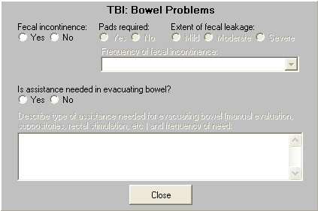

        - Fecal incontinence: (Yes/No) (Label/Radio Buttons)
If Yes is selected, the following requests are enabled:

          - Pads required: (Yes/No) (Label/Radio Buttons)

          - Extent of fecal leakage: (Mild/Moderate/Severe) (Label/Free Text Box)

          - Frequency of fecal incontinence: (Label/ Single-Select Drop Down List Box)
The options available for this field are: Occasional leakage, Occasional involuntary bowel movement, Frequent involuntary bowel movements, and Persistent loss of sphincter control.

        - Is assistance needed in evacuating bowel: (Yes/No) (Label/Radio Buttons)
If Yes is selected, the following request is enabled:

2.6.5.18.2.1.1 Describe type of assistance needed for evacuating bowel (manual evaluation, suppositories, rectal stimulation, etc.) and frequency of need: (Label/Free Text Box)

      - Bladder problems? (Yes/No) (Label/Radio Buttons)
If Yes is selected, a pop-up window labeled TBI: Bladder Problems requests the following information:

Figure 2.6.5.19: TBI: Bladder Problems
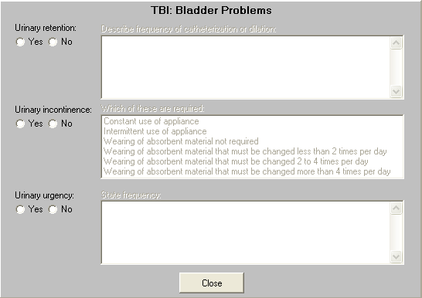

        - Urinary retention: (Yes/No) (Label/Radio Buttons)
If Yes is selected, the following request is enabled:

          - Describe frequency of catheterization or dilation: (Label/Free Tex Box)

        - Urinary incontinence: (Yes/No) (Label/Radio Buttons)
If Yes is selected, the following request is enabled:

          - Which of these are required: (Label/Multi-Select List Box)
The options available for this field are: Constant use of appliance, Intermittent use of appliance, Wearing of absorbent material not required, Wearing of absorbent material that must be changed less than 2 times per day, Wearing of absorbent material that must be changed 2 to 4 times per day, and Wearing of absorbent material that must be changed more than 4 times per day.

        - Urinary urgency: (Yes/No) (Label/Radio Buttons)
If Yes is selected, the following request is enabled:

          - State frequency: (Label/Free Text Box)

      - Is there erectile dysfunction? (Yes/No) (Label/Radio Buttons)
If Yes is selected, a pop-up window labeled TBI: Erectile Dysfunction requests the following information:

        - Most likely cause: (Label/ Single-Select Drop Down List)
The options available for this field are: Prostate surgery, Urethral or bladder surgery, Medication, Diabetic neuropathy, Vascular disease, Neurologic disease, Endocrine disease, Psychological condition, Trauma, Other type of surgery, and Other cause.

If Trauma is selected, then the following field is enabled.

          - Specify Trauma (Label/Free Text Box)

If Other type of surgery is selected, then the following field is enabled.

          - Specify other type of surgery (Label/Free Text Box)

If Other cause is selected, then the following field is enabled.

          - Specify other cause (Label/Free Text Box)

        - Is vaginal penetration with ejaculation possible: (Yes/No) (Label/Radio Buttons)
If Yes is selected, then the following is enabled.

          - Is ejaculation retrograde: (Yes/No) (Label/Radio Buttons)

        - Treatment (Label/Multiple Selection List Box)
The options available for this field are: None, Oral medication, Penile injections, Transurethral medication, Penile implant, Vacuum pump device, Psychotherapy, and Other.

While None is selected, no other treatments can be selected.
If Other is selected, then the Describe other: Free Text field is enabled.
If any Treatment is selected, then the Effective in allowing intercourse (Yes/No) radio button field is enabled.

      - Hearing loss or tinnitus? (Yes/No) (Label/Radio Buttons)
If Yes is selected, a pop-up window labeled TBI: Hearing Problems is displayed:

        - Describe: (Label/Free Text Box)

      - Hypersensitivity to light or sound? (Yes/No) (Label/Radio Buttons)
If Yes is selected, a pop-up window labeled TBI: Hypersensitivity to Sound or Light displays the following request:

        - Describe hypersensitivity: (Label/Free Text Box)

      - Vision problems? (Yes/No) (Label/Radio Buttons)
If Yes is selected, a pop-up window labeled TBI: Visual Problems requests the following information:

        - Describe vision problems: (Label/Free Text Box)

      - Speech or swallowing difficulties? (Yes/No) (Label/Radio Buttons)
If Yes is selected, a pop-up window labeled TBI: Speech or Swallowing Difficulties displays the following request:

        - Severity and specific type of problem-expressive aphasia?, difficulty with articulation because of injuries to mouth?, aspiration due to difficulty swallowing?, etc: (Label/Free Text Box)

      - Decreased sense of taste or smell? (Yes/No) (Label/Radio Buttons)
If Yes is selected, a pop-up window displays the following instructional guidance:

        - Follow examination protocol for Sense of Smell and Taste.

      - Are there symptoms of endocrine dysfunction? (Yes/No) (Label/Radio Buttons)
If Yes is selected, a pop-up window labeled TBI: Endocrine Dysfunction displays the following request:

        - Describe endocrine dysfunction: (Label/Free Text Box)

      - Are there symptoms of cranial nerve dysfunction? (Yes/No) (Label/Radio Buttons)
If Yes is selected, a pop-up window labeled TBI: Cranial Nerve Dysfunction displays the following request:

        - Describe cranial nerve dysfunction: (Label/Free Text Box)

      - Describe other symptoms: (Label/Free Text Box)

Physical Exam Tab
  - Screenshot of TBI- Physical Exam Tab

Figure 3.1: Traumatic Brain Injury - Physical Exam Tab
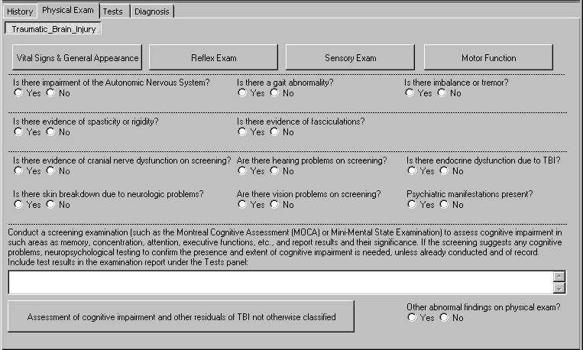

  - Vital Signs & General Appearance (Label/Button)

When the Vital Signs & General Appearance button is selected, a pop-up window labeled TBI: Vital Signs displays the following:

Figure 3.2: Vital Signs
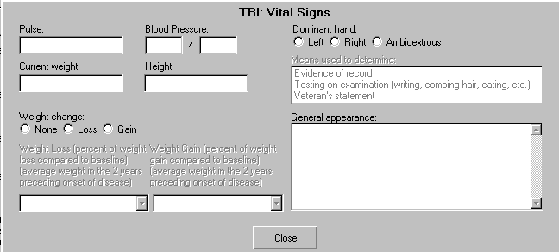

January 2010 CAPRI Traumatic Brain Injury Template Workflow Patch DVBA*2.7*151 18

    - Pulse: (Label/Free Text Box)

    - Blood Pressure: (Label/Text Box “/” Text Box)

    - Current weight: (Label/Free Text Box)

    - Height: (Label/Free Text Box)

    - Weight change: (None, Loss, Gain) (Label/Radio Buttons)
If Loss is selected, then the following request is enabled:

      - Weight Loss (percent of weight loss compared to baseline) (average weight in the 2 years preceding onset of disease) (<10%, 10%, 20%, 30%, 40% or more) (Label/Single-Select Drop Down List Box)
If Gain is selected, then the following request is enabled:

      - Weight Gain (percent of weight gain compared to baseline) (average weight in the 2 years preceding onset of disease) (<10%, 10%, 20%, 30%, 40% or more) (Label/Single-Select Drop Down List Box)

    - Dominant hand: (Left, Right, Ambidextrous) (Label/Radio Buttons)
If Left, Right, or Ambidextrous is selected, then the following request is enabled:

      - Means used to determine: (Label/Multi-Select List Box)
Evidence of record
Testing on examination (writing, combing hair, eating, etc.) Veteran’s statement

    - General appearance: (Label/Free Text Box)

  - Reflex Exam (Label/Button)

When the Reflex Exam button is selected, a pop-up window labeled TBI: Detailed Reflex Exam displays the following:

Figure 3.3: Detailed Reflex Exam
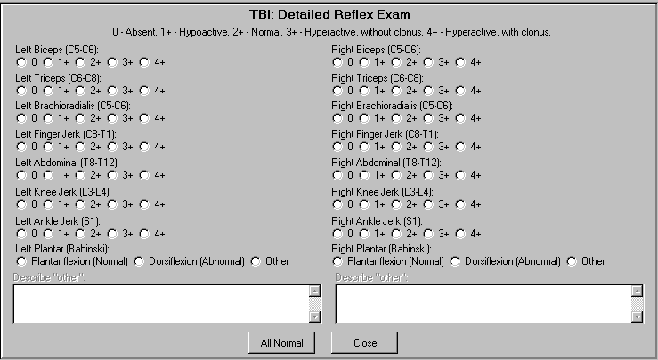

    - 0 - Absent. 1+ - Hypoactive. 2+ - Normal. 3+ - Hyperactive, without clonus. 4+ - Hyperactive, with clonus. (Read Only Text)

    - Left Biceps (C5-C6): (0, 1+, 2+, 3+, 4+) (Label/Radio Buttons)

    - Left Triceps (C6-C8): (0, 1+, 2+, 3+, 4+) (Label/Radio Buttons)

    - Left Brachioradialis (C5-C6): (0, 1+, 2+, 3+, 4+) (Label/Radio Buttons)

    - Left Finger Jerk (C8-T1): (0, 1+, 2+, 3+, 4+) (Label/Radio Buttons)

    - Left Abdominal (T8-T12): (0, 1+, 2+, 3+, 4+) (Label/Radio Buttons)

    - Left Knee Jerk (L3-L4): (0, 1+, 2+, 3+, 4+) (Label/Radio Buttons)

    - Left Ankle Jerk (S1): (0, 1+, 2+, 3+, 4+) (Label/Radio Buttons)

    - Left Plantar (Babinski): (Plantar flexion (Normal), Dorsiflexion (Abnormal), Other) (Label/Radio Buttons)
If Other is selected, then the following is enabled:

      - Describe “other”: (Label/Free Text Box)

    - Right Biceps (C5-C6): (0, 1+, 2+, 3+, 4+) (Label/Radio Buttons)

    - Right Triceps (C6-C8): (0, 1+, 2+, 3+, 4+) (Label/Radio Buttons)

    - Right Brachioradialis (C5-C6): (0, 1+, 2+, 3+, 4+) (Label/Radio Buttons)

    - Right Finger Jerk (C8-T1): (0, 1+, 2+, 3+, 4+) (Label/Radio Buttons)

    - Right Abdominal (T8-T12): (0, 1+, 2+, 3+, 4+) (Label/Radio Buttons)

    - Right Knee Jerk (L3-L4): (0, 1+, 2+, 3+, 4+) (Label/Radio Buttons)

    - Right Ankle Jerk (S1): (0, 1+, 2+, 3+, 4+) (Label/Radio Buttons)

    - Right Plantar (Babinski): (Plantar flexion (Normal), Dorsiflexion (Abnormal), Other) (Label/Radio Buttons)
If Other is selected, then the following is enabled:

      - Describe “other”: (Label/Free Text Box)

    - All Normal (Label/Button/Action)
When the All Normal button is selected, normal values are automatically populated to the following:
Left/Right Biceps (C5-C6): 2+ Left/Right Triceps (C6-C8): 2+ Left/Right Brachioradialis (C5-C6): 2+ Left/Right Finger Jerk (C8-T1): 2+ Left/Right Abdominal (T8-T12): 2+ Left/Right Knee Jerk (L3-L4): 2+ Left/Right Ankle Jerk (S1): 2+
Left/Right Plantar (Babinski): Plantar flexion (Normal)

  - Sensory Exam (Label/Button)
When the Sensory Exam button is selected, a pop-up window labeled TBI: Sensory Function Report
displays the following:

Figure 3.4: Sensory Function Report
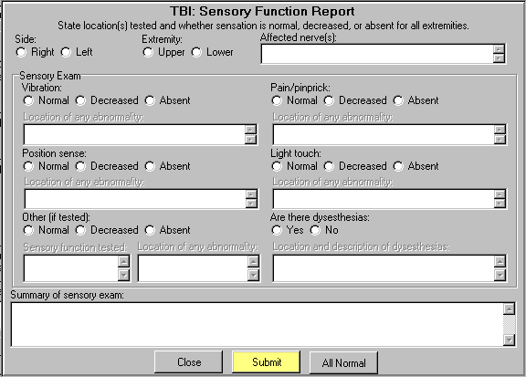

    - State location(s) tested and whether sensation is normal, decreased, or absent for all extremities. (Read Only Text)

    - Side: (Right/Left) (Label/Radio Buttons)

    - Extremity: (Upper/Lower) (Label/Radio Buttons)

    - Affected nerve(s): (Label/Free Text Box)

    - Sensory Exam (Subsection Label)

      - Vibration: (Normal/Decreased/Absent) (Label/Radio Buttons)
If Decreased or Absent is selected, the following request is enabled:

        - Location of any abnormality: (Label/Free Text Box)

      - Pain/pinprick:(Normal/Decreased/Absent) (Label/Radio Buttons)
If Decreased or Absent is selected, the following request is enabled:

        - Location of any abnormality: (Label/Free Text Box)

      - Position sense: (Normal/Decreased/Absent) (Label/Radio Buttons)
If Decreased or Absent is selected, the following request is enabled:

        - Location of any abnormality: (Label/Free Text Box)

      - Light touch: (Normal/Decreased/Absent) (Label/Radio Buttons)
If Decreased or Absent is selected, the following request is enabled:

        - Location of any abnormality: (Label/Free Text Box)

      - Other (if tested): (Normal/Decreased/Absent) (Label/Radio Buttons)
If Decreased or Absent is selected, the following requests are enabled:

        - Sensory function tested: (Label/Free Text Box)

        - Location of any abnormality: (Label/Free Text Box)
If Normal is selected, only the Sensory function tested: request is enabled.

      - Are there dysesthesias: (Yes/No) (Label/Radio Buttons)
If Yes is selected, the following request for information is enabled.

        - Location and description of dysesthesias: (Label/Free Text Box)

      - Summary of sensory exam: (Label/Free Text Box/Populated when Submit button is selected)

      - All Normal (Label/Button/Action)
If the All Normal button is selected, normal values are automatically populated for the following:
Vibration: Normal Position sense: Normal Pain/pinprick: Normal Light touch: Normal
Are there dysesthesias: No

      - Submit (Label/Button/Action)
If entries are not made in one or more fields of the TBI: Sensory Function Report panel, then when the Submit button is selected, a variety of messages are displayed on a pop-up window to remind the user to enter the missing information, according to what is needed.
You must enter the side examined.
You must enter the extremity examined. You must enter the vibration exam.
You must enter the pain exam.
You must enter the position sense exam. You must enter the light touch exam.
Are dysesthesias present?
You must enter the nerve(s) examined.
You must enter the location of any abnormality of the vibration exam. You must enter the location of any abnormality of the pain exam.
You must enter the location of any abnormality of the position exam. You must enter the location of any abnormality of the light touch exam.
You must enter the location of any abnormality of the other types of exams. You must enter the other sensory function tested.

You must enter the location and description of any dysesthesias.

  - Motor Function (Label/Button)

When the Motor Function button is selected, a pop-up window is displayed:

Figure 3.5a: Detailed Motor Exam
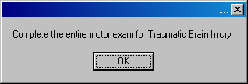

Complete the entire motor exam for Traumatic Brain Injury.

After the user selects OK, another pop-up window labeled TBI: Detailed Motor Exam displays the following:

Figure 3.5b: Detailed Motor Exam
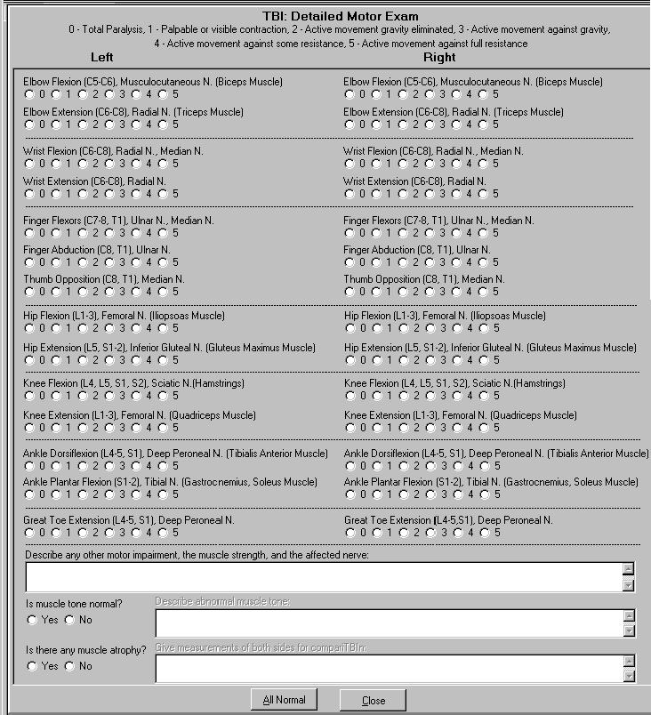

    - 0 - Total Paralysis, 1 - Palpable or visible contraction, 2 - Active movement gravity eliminated, 3 - Active movement against gravity, 4 - Active movement against some resistance, 5
- Active movement against full resistance (Read Only Text)

    - Left (Read Only Text)

      - Elbow Flexion (C5-C6), Musculocutaneous N. (Biceps Muscle) (0, 1, 2, 3, 4, 5) (Label/Radio Buttons)

      - Elbow Extension (C6-C8), Radial N. (Triceps Muscle) (0, 1, 2, 3, 4, 5) (Label/Radio Buttons)

      - Wrist Flexion (C6-C8), Radial N., Median N. (0, 1, 2, 3, 4, 5) (Label/Radio Buttons)

      - Wrist Extension (C6-C8), Radial N. (0, 1, 2, 3, 4, 5) (Label/Radio Buttons)

      - Finger Flexors (C7-8, T1), Ulnar N., Median N. (0, 1, 2, 3, 4, 5) (Label/Radio Buttons)

      - Finger Abduction (C8, T1), Ulnar N. (0, 1, 2, 3, 4, 5) (Label/Radio Buttons)

      - Thumb Opposition (C8, T1), Median N. (0, 1, 2, 3, 4, 5) (Label/Radio Buttons)

      - Hip Flexion (L1-3), Femoral N. (Iliopsoas Muscle) (0, 1, 2, 3, 4, 5) (Label/Radio Buttons)

      - Hip Extension (L5, S1-2), Inferior Gluteal N. (Gluteus Maximus Muscle) (0, 1, 2, 3, 4, 5) (Label/Radio Buttons)

      - Knee Flexion (L4, L5, S1, S2), Sciatic N. (Hamstrings) (0, 1, 2, 3, 4, 5) (Label/Radio Buttons)

      - Knee Extension (L1-3), Femoral N. (Quadriceps Muscle) (0, 1, 2, 3, 4, 5) (Label/Radio Buttons)

      - Ankle Dorsiflexion (L4-5, S1), Deep Peroneal N. (Tibialis Anterior Muscle) (0, 1, 2, 3, 4, 5) (Label/Radio Buttons)

      - Ankle Plantar Flexion (S1-2), Tibial N. (Gastrocnemius, soleus Muscle) (0, 1, 2, 3, 4, 5) (Label/Radio Buttons)

      - Great Toe Extension (L4-5, S1), Deep Peroneal N. (0, 1, 2, 3, 4, 5) (Label/Radio Buttons)

    - Right (Read Only Text)

      - Elbow Flexion (C5-C6), Musculocutaneous N. (Biceps Muscle) (0, 1, 2, 3, 4, 5) (Label/Radio Buttons)

      - Elbow Extension (C6-C8), Radial N. (Triceps Muscle) (0, 1, 2, 3, 4, 5) (Label/Radio Buttons)

      - Wrist Flexion (C6-C8), Radial N., Median N. (0, 1, 2, 3, 4, 5) (Label/Radio Buttons)

      - Wrist Extension (C6-C8), Radial N. (0, 1, 2, 3, 4, 5) (Label/Radio Buttons)

      - Finger Flexors (C7-8, T1), Ulnar N., Median N. (0, 1, 2, 3, 4, 5) (Label/Radio Buttons)

      - Finger Abduction (C8, T1), Ulnar N. (0, 1, 2, 3, 4, 5) (Label/Radio Buttons)

      - Thumb Opposition (C8, T1), Median N. (0, 1, 2, 3, 4, 5) (Label/Radio Buttons)

      - Hip Flexion (L1-3), Femoral N. (Iliopsoas Muscle) (0, 1, 2, 3, 4, 5) (Label/Radio Buttons)

      - Hip Extension (L5, S1-2), Inferior Gluteal N. (Gluteus Maximus Muscle) (0, 1, 2, 3, 4, 5) (Label/Radio Buttons)

      - Knee Flexion (L4, L5, S1, S2), Sciatic N. (Hamstrings) (0, 1, 2, 3, 4, 5) (Label/Radio Buttons)

      - Knee Extension (L1-3), Femoral N. (Quadriceps Muscle) (0, 1, 2, 3, 4, 5) (Label/Radio Buttons)

      - Ankle Dorsiflexion (L4-5, S1), Deep Peroneal N. (Tibialis Anterior Muscle) (0, 1, 2, 3, 4, 5) (Label/Radio Buttons)

      - Ankle Plantar Flexion (S1-2), Tibial N. (Gastrocnemius, soleus Muscle) (0, 1, 2, 3, 4, 5) (Label/Radio Buttons)

      - Great Toe Extension (L4-5, S1), Deep Peroneal N. (0, 1, 2, 3, 4, 5) (Label/Radio Buttons)

    - Describe any other motor impairment, the muscle strength, and each affected nerve: (Label/Free Text Box)

    - Is muscle tone normal? (Yes/No) (Label/Radio Buttons)
If No is selected, the text box to the right is enabled:

      - Describe abnormal muscle tone: (Label/Free Text Box)

    - Is there any muscle atrophy? (Yes/No) (Label/Radio Buttons)
If Yes is selected, the text box to the right is enabled:

      - Give measurements of both sides for comparison: (Label/Free Text Box)

    - All Normal (Label/Button/Action)
If the All Normal button is selected, normal values are automatically populated for the following:
Left/Right Elbow Flexion (C5-C6), Musculocutaneous N. (Biceps Muscle): 5 Left/Right Elbow Extension (C6-C8), Radial N. (Triceps Muscle): 5 Left/Right Wrist Flexion (C6-C8), Radial N., Median N.: 5

Left/Right Wrist Extension (C6-C8), Radial N.: 5
Left/Right Finger Flexors (C7-8, T1), Ulnar N., Median N.: 5 Left/Right Finger Abduction (C8, T1), Ulnar N.: 5
Left/Right Thumb Opposition (C8, T1), Median N.: 5 Left/Right Hip Flexion (L1-3), Femoral N. (Iliopsoas Muscle): 5
Left/Right Hip Extension (L5, S1-2), Inferior Gluteal N. (Gluteus Maximus Muscle): 5 Left/Right Knee Flexion (L4, L5, S1, S2), Sciatic N. (Hamstrings): 5
Left/Right Knee Extension (L1-3), Femoral N. (Quadriceps Muscle): 5
Left/Right Ankle Dorsiflexion (L4-5, S1), Deep Peroneal N. (Tibialis Anterior Muscle): 5 Left/Right Ankle Plantar Flexion (S1-2), Tibial N. (Gastrocnemius, Soleus Muscle): 5 Left/Right Great Toe Extension (L4-5, S1), Deep Peroneal N.: 5
Is muscle tone normal?: Yes
Is there any muscle atrophy?: No

  - Physical Exam Tab – Questions

A common rule for the following Physical Exam tab radio-button questions is that once a question enables a pop-up window with additional questions, a Re-open button to re-access the window is provided when that window is closed. Each pop-up window has a Close button.

    - Is there impairment of the Autonomic Nervous System? (Yes/No) (Label/Radio Buttons)
If Yes is selected, a pop-up window labeled TBI: Autonomic Nervous System Dysfunction is displayed:

      - Describe any impairment of the autonomic nervous system, such as orthostatic (postural) hypotension (if present, state if associated with dizziness or syncope on standing), hyperhidrosis, delayed gastric emptying, heat intolerance, etc.: (Label/Free Text Box)

    - Is there a gait abnormality? (Yes/No) (Label/Radio Buttons)
If Yes is selected, then a pop-up window labeled TBI: Gait Abnormality displays the following request:

      - Describe any gait abnormality. A tandem gait assessment (walking in a straight line with one foot directly in front of the other) is recommended. (Label/Free Text Box)

    - Is there imbalance or tremor? (Yes/No) (Label/Radio Buttons)
If Yes is selected, then a pop-up window labeled TBI: Imbalance or Tremor displays the following request:

      - Describe any imbalance or tremor: (Label/Free Text Box)

    - Is there evidence of spasticity or rigidity? (Yes/No) (Label/Radio Buttons)
If Yes is selected, then a pop-up window labeled TBI: Spasticity or Rigidity displays the following request:

      - Describe any spasticity or rigidity and follow the Joints examination protocol to report any resulting limitation of motion: (Label/Free Text Box)

    - Is there evidence of fasciculations? (Yes/No) (Label/Radio Buttons)
If Yes is selected, then a pop-up window labeled TBI: Fasciculations displays the following request:

      - Describe any fasciculations: (Label/Free Text Box)

    - Is there evidence of cranial nerve dysfunction on screening? (Yes/No) (Label/Radio Buttons)
If Yes is selected, an instructional warning displays the following in a pop-up window:

      - Please follow Cranial Nerves examination protocol. (Read-Only Text)
Once the instructional warning is acknowledged, a pop-up window labeled TBI: Cranial Nerve Dysfunction displays the following request:

      - Describe cranial nerve dysfunction on screening: (Label/Free Text Box)

      - *Follow Cranial Nerve Template (Label/Read Only Text below Free Text Box)

    - Are there hearing problems on screening? (Yes/No) (Label/Radio Buttons)
If Yes is selected, the following information displays in a pop-up window:

    - If abnormalities are found, or there are symptoms or a claim of hearing impairment, request an audiology exam. (Read-Only Text)
After the instructional warning is acknowledged, a pop-up window labeled TBI: Hearing Problems
displays the following request:

      - Describe hearing findings on screening. Refer for audio exam if hearing loss or tinnitus is found on screening or claimed: (Label/Free Text Box)

    - Is there endocrine dysfunction due to TBI? (Yes/No) (Label/Radio Buttons)
If Yes is selected, a pop-up box labeled TBI: Endocrine Dysfunction displays the following request:

      - Describe any evidence of endocrine dysfunction due to TBI. If evidence of endocrine dysfunction is identified or suspected, select and follow the additional appropriate examination protocol for the type of endocrine disorder identified: (Label/Free Text Box)

    - Is there skin breakdown due to neurologic problems? (Yes/No) (Label/Radio Buttons)
If Yes is selected, a pop-up window labeled TBI: Skin Breakdown is displayed with the following request:

      - Describe any areas of skin breakdown due to neurologic problems: (Label/Free Text Box)

    - Are there vision problems on screening? (Yes/No) (Label/Radio Buttons)
If Yes is selected, an instructional warning will appear:

      - If abnormalities are found, or there are symptoms or a claim of eye impairment, request an eye exam by a specialist. (Read-Only Text)
After the instructional warning is acknowledged, a pop-up window labeled TBI: Vision Problems
will display the following request:

      - Describe vision findings on screening. Refer for eye exam if vision problem is found on screening or claimed. (Label/Free Text Box)

    - Psychiatric manifestations present? (Yes/No) (Label/Radio Buttons)
If Yes is selected, a pop-up window is displayed:

If a mental disorder is suggested, request a Mental Disorders or PTSD examination protocol by a mental disease specialist.

When a mental disorder is present, state, to the extent possible, which emotional behavioral signs and symptoms are part of a co-morbid mental disorder and which represent residuals of TBI. If it is impossible to make such a determination without speculation, so state.

After this message is acknowledged, a pop-up window labeled TBI: Psychiatric Manifestations
displays the following request for information:

      - Conduct a screening examination for psychiatric manifestations, including neurobehavioral effects. If a mental disorder is suggested, request a mental disorder exam or PTSD exam, as appropriate, by a mental disease specialist. (Label/Free Text Box)

    - Conduct a screening examination (such as Montreal Cognitive Assessment (MOCA) or Mini-Mental State Examination) to assess cognitive impairment in such areas as memory, concentration, attention, executive functions, etc., and report results and their significance. If the screening suggests any cognitive problems, neuropsychological testing to confirm the presence and extent of cognitive impairment is needed, unless already conducted and of record. Include test results in the examination report under the Tests panel: (Label/Free Text Box)

    - Assessment of cognitive impairment and other residuals of TBI not otherwise classified (Label/Button)
If this button is selected, a pop-up window labeled TBI: Other Cognitive Impairment and Other Residuals displays the following:

      - Instruction: Check the specific choice under each of the 10 items below that best describes the item. (Label/Read Only Text)

      - I. Memory, attention, concentration, and executive functions (Label/Read Only Text)
- No complaints of impairment of memory, attention, concentration, or executive functions.(Label/Checkbox)
- A complaint of mild memory loss (such as having difficulty following a conversation, recalling recent conversations, remembering names of new acquaintances, or finding words, or often misplacing items), attention, concentration, or executive functions, but without objective evidence on testing. (Label/Checkbox)

- Objective evidence on testing of mild impairment of memory, attention, concentration, or executive functions resulting in mild functional impairment. (Label/Checkbox)
- Objective evidence on testing of moderate impairment of memory, attention, concentration, or executive functions resulting in moderate functional impairment. (Label/Checkbox)
- Objective evidence on testing of severe impairment of memory, attention, concentration, or executive functions resulting in severe functional impairment. (Label/Checkbox)

      - II. Judgment (Label/Read Only Text)
- Normal (Label/Checkbox)
- Mildly impaired judgment. For complex or unfamiliar decisions, occasionally unable to identify, understand, and weigh the alternatives, understand the consequences of choices, and make a reasonable decision.(Label/Checkbox)
- Moderately impaired judgment. For complex or unfamiliar decisions, usually unable to identify, understand, and weigh the alternatives, understand the consequences of choices, and make a reasonable decision, although has little difficulty with simple decisions. (Label/Checkbox)
- Moderately severely impaired judgment. For even routine and familiar decisions, occasionally unable to identify, understand, and weigh the alternatives, understand the consequences of choices, and make a reasonable decision.(Label/Checkbox)
- Severely impaired judgment. For even routine and familiar decisions, usually unable to identify, understand, and weigh the alternatives, understand the consequences of choices, and make a reasonable decision. For example, unable to determine appropriate clothing for current weather conditions or judge when to avoid dangerous situations or activities. (Label/Checkbox)

      - III. Social interaction (Label/Read Only Text)
- Social interaction is routinely appropriate.(Label/Checkbox)
- Social interaction is occasionally inappropriate. (Label/Checkbox)
- Social interaction is frequently inappropriate. (Label/Checkbox)
- Social interaction is inappropriate most or all of the time. (Label/Checkbox)

      - IV. Orientation (Label/Read Only Text)
- Always oriented to person, time, place, and situation.(Label/Checkbox)
- Occasionally disoriented to one of the four aspects (person, time, place, situation) of orientation. (Label/Checkbox)
- Occasionally disoriented to two of the four aspects (person, time, place, situation) of orientation or often disoriented to one aspect of orientation. (Label/Checkbox)
- Often disoriented to two or more of the four aspects (person, time, place, situation) of orientation. (Label/Checkbox)
- Consistently disoriented to two or more of the four aspects (person, time, place, situation) of orientation. (Label/Checkbox)

      - V. Motor activity (Label/Read Only Text)
- Motor activity normal. (Label/Checkbox)
- Motor activity normal most of the time, but mildly slowed at times due to apraxia (inability to perform previously learned motor activities, despite normal motor function). (Label/Checkbox)

- Motor activity mildly decreased or with moderate slowing due to apraxia. (Label/Checkbox)
- Motor activity moderately decreased due to apraxia. (Label/Checkbox)
- Motor activity severely decreased due to apraxia. (Label/Checkbox)

      - VI. Visual spatial orientation (Label/Read Only Text)
- Normal.(Label/Checkbox)
- Mildly impaired. Occasionally gets lost in unfamiliar surroundings, has difficulty reading maps or following directions. Is able to use assistive devices such as GPS (global positioning system). (Label/Checkbox)
- Moderately impaired. Usually gets lost in unfamiliar surroundings, has difficulty reading maps, following directions, and judging distance. Has difficulty using assistive devices such as GPS (global positioning system). (Label/Checkbox)
- Moderately severely impaired. Gets lost in familiar surroundings, unable to use assistive devices such as GPS (global positioning system). (Label/Checkbox)
- Severely impaired. May be unable to touch or name own body parts when asked by the examiner, identify the relative position in space or two different objects, or find the way from one room to another in familiar environment. (Label/Checkbox)

      - VII. Subjective symptoms (Label/Read Only Text)
- Subjective symptoms that do not interfere with work; instrumental activities of daily living; or work, family or other close relationships. Examples are: mild or occasional headaches, mild anxiety.(Label/Checkbox)
- Three or more subjective symptoms that mildly interfere with work; instrumental activities of daily living; or work, family, or other close relationship. Examples of findings that might be seen at this level of impairment are: intermittent dizziness, daily mild to moderate headaches, tinnitus, frequent insomnia, hypersensitivity to sound, hypersensitivity to light. (Label/Checkbox)
- Three or more subjective symptoms that moderately interfere with work; instrumental activities of daily living; or work, family, or other close relationships. Examples of findings that might be seen at this level of impairment are: marked fatigability, blurred or double vision, headaches requiring rest periods during most days. (Label/Checkbox)

      - VIII. Neurobehavioral effects (Label/Read Only Text)
- One or more neurobehavioral effects that do not interfere with workplace interaction or social interaction. Examples of neurobehavioral effects are: irritability, impulsivity, unpredictability, lack of motivation, verbal aggression, physical aggression, belligerence, apathy, lack of empathy, moodiness, lack of cooperation, inflexibility, and impaired awareness of disability. Any of these effects may range from slight to severe, although verbal and physical aggression are likely to have a more serious impact on workplace interaction and social interaction than some of the other effects. (Label/Checkbox)
- One or more neurobehavioral effects that occasionally interfere with workplace interaction, social interaction, or both but do not preclude them. (Label/Checkbox)
- One or more neurobehavioral effects that frequently interfere with workplace interaction, social interaction, or both but do not preclude them. (Label/Checkbox)
- One or more neurobehavioral effects that interfere with or preclude workplace interaction, social interaction, or both on most days or that occasionally require supervision for safety of self or others. (Label/Checkbox)

      - IX. Communication (Label/Read Only Text)
- Able to communicate by spoken and written language (expressive communication), and to comprehend spoken and written language. (Label/Checkbox)
- Comprehension or expression, or both, of either spoken or written language is only occasionally impaired. Can communicate complex ideas. (Label/Checkbox)
- Inability to communicate either by spoken language, written language, or both, more than occasionally but less than half of the time, or to comprehend spoken language, written language, or both, more than occasionally but less than half of the time. Can generally communicate complex ideas. (Label/Checkbox)
- Inability to communicate either by spoken language, written language, or both, at least half of the time but not all of the time, or to comprehend spoken language, written language, or both, at least half of the time but not all of the time. May rely on gestures or other alternative modes of communication. Able to communicate basic needs. (Label/Checkbox)
- Complete inability to communicate either by spoken language, written language, or both, or to comprehend spoken language, written language, or both. Unable to communicate basic needs. (Label/Checkbox)

      - X. Consciousness (Label/Read Only Text)
- Normal (Label/Checkbox)
- Persistently altered state of consciousness, such as vegetative state, minimally responsive state, coma. (Label/Checkbox)

      - Additional comments on the above 10 items: (Label/Free Text Box)
- “Instrumental activities of daily living” refers to activities other than self-care that are needed for independent living, such as meal preparation, doing housework and other chores, shopping, traveling, doing laundry, being responsible for one’s own medications, and using a telephone. These activities are distinguished from “Activities of daily living,” which refer to basic self-care and include bathing or showering, dressing, eating, getting in or out of bed or a chair, and using the toilet.
- Some items include examples in the choices, but the specific examples given need not be present to select a particular choice. (Read Only Text)

      - All Normal (Label/Button)
Selecting the All Normal button selects choice “a” for all ten items.

    - Other abnormal findings on physical exam? (Yes/No) (Label/Radio Buttons)
If Yes is selected, a pop-up window labeled TBI: Other Abnormality displays the following request:

      - Describe other abnormal findings on physical exam: (Label/Free Text Box)

Tests Tab
  - Screenshot of TBI – Tests Tab

Figure 4.1: Traumatic Brain Injury - Tests Tab
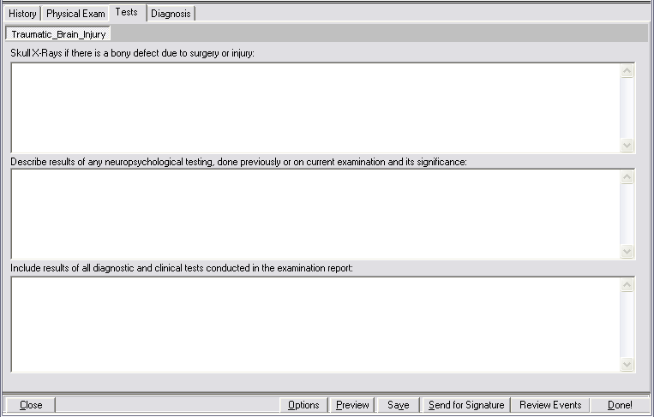

  - Skull X-Rays if there is a bony defect due to surgery or injury: (Label/Free Text Box)

  - Describe results of any neuropsychological testing, done previously or on current examination and its significance: (Label/Free Text Box)

  - Include results of all diagnostic and clinical tests conducted in the examination report: (Label/Free Text Box)

Diagnosis Tab
  - Screenshot of TBI – Diagnosis Tab

Figure 5.1: Traumatic Brain Injury - Diagnosis Tab
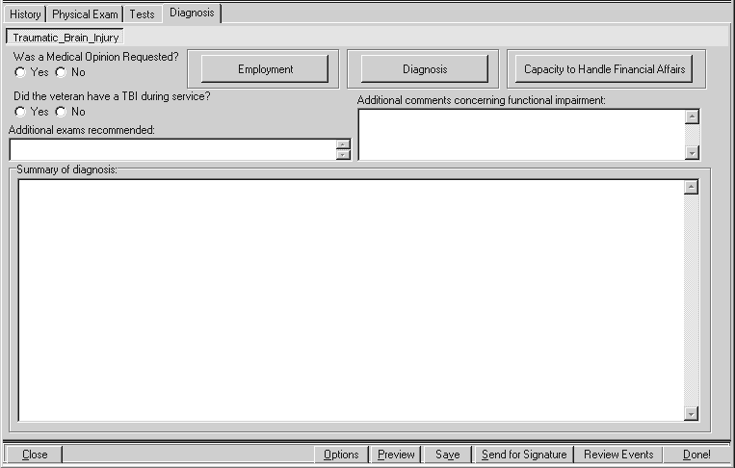

  - Was a Medical Opinion Requested? (Yes/No) (Label/Radio Buttons)

If Yes is selected, then the following message is displayed in a pop-up window:

5.2.1 Please be sure to include a Medical Opinion.

The “Manage Templates” utility found under the “Options” button at the bottom of the screen can be used to add a Medical Opinion template.

  - Did the veteran have a TBI during service? (Yes/No)(Label/Radio Buttons)

If Yes is selected, then the question Is this diagnosis associated with a service related TBI? is enabled in the TBI: Diagnosis panel.

  - Employment (Label/Button)

When the Employment button is selected, a pop-up window labeled TBI: Employment History displays the following:

January 2010 CAPRI Traumatic Brain Injury Template Workflow Patch DVBA*2.7*151 35

Figure 5.4: Employment History
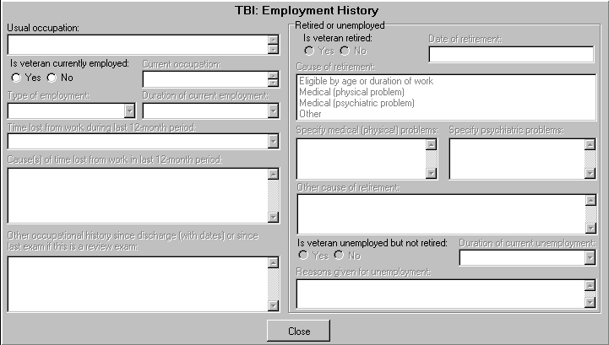

    - Usual occupation: (Label/Free Text Box)

    - Is veteran currently employed: (Yes/No) (Label/Radio Buttons)
If No is selected, then Retired or unemployed section is enabled.
If Yes is selected, then the following requests for information are enabled:

      - Current occupation: (Label/Free Text Box)

      - Type of employment: (Label/ Single-Select Drop Down Box)
The following options are available for selection: Fulltime, Part-time, Self-employed, Seasonal or
Other.

      - Duration of current employment: (Label/ Single-Select Drop Down Box)
The following options are available for selection: Less than 1 year, 1 to 2 years, 2 to 5 years, 5 to 10 years, 10 to 20 years, More than 20 years.

      - Time lost from work during last 12-month period: (Label/ Single-Select Drop Down Box )
The following drop down values for Time lost from work during last 12-month period are provided: 0, Less than 1 week, 2 weeks, 3 weeks, 4 weeks, 5 weeks, 6 weeks, 7 weeks up to 52 weeks. If any time lost is entered, the following request for information is enabled:

        - Cause(s) of time lost from work in last 12-month period: (Label/Free Text Box)

      - Other occupational history since discharge (with dates) or since last exam if this is a review exam: (Label/Free Text Box)

    - Retired or unemployed (Section Label)

      - Is veteran retired: (Yes/No)(Label/Radio Buttons)
If No is selected, then the user proceeds to the enabled question Is veteran unemployed but not retired:
If Yes is selected the following requests for information are enabled:

      - Date of retirement: (Label/Free Text Box)

      - Cause of retirement: (Label/Multi Selection Box)
The following causes are available for selection (one or more may be selected at a time):
Eligible by age or duration of work Medical (physical problem) Medical (psychiatric problem)
Other

- If Eligible by age or duration of work is selected, then no other questions are enabled.
- If Medical (physical problem) is selected, then the Free Text box labeled: Specify medical (physical) problems: is enabled.
- If Medical (psychiatric problem) is selected, then the Free Text box labeled: Specify psychiatric problems: is enabled.
- If Other is selected, then the Free Text box labeled: Other cause of retirement: is enabled.

    - Is the veteran unemployed but not retired: (Yes/No) (Label/Radio Buttons)
If Yes is selected, the following requests for information are enabled:

      - Duration of current unemployment: (Label/Single-Select Drop Down Box/Free Text Box)
The user may select from the following options, or enter a response: Less than 1 year, 1 to 2 years, 2 to 5 years, 5 to 10 years, 10 to 20 years, More than 20 years.

      - Reasons given for unemployment: (Label/Free Text Box)

  - Diagnosis (Label/Button)

When the Diagnosis button is selected, a pop-up window labeled TBI: Diagnosis is displayed.

Figure 5.5: Diagnosis
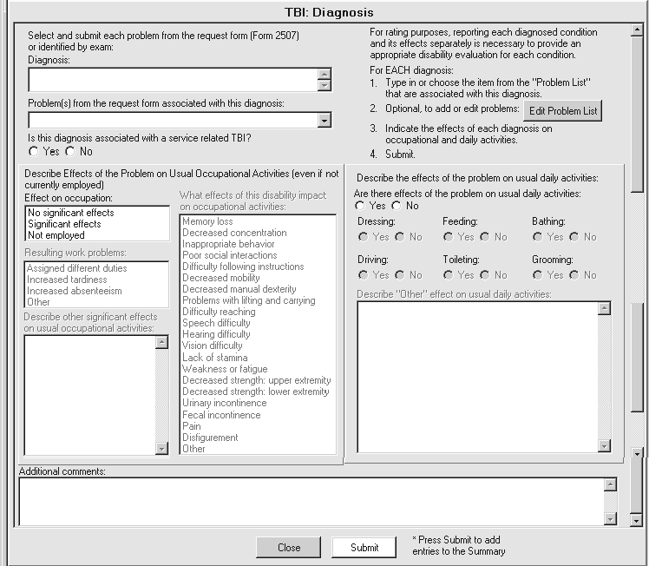

    - Select and submit each problem from the request form (Form 2507) or identified by exam: (Label)

    - Diagnosis: (Label/Free Text Box)

    - Problem(s) from the request form associated with this diagnosis: (Label/Free Text Box/ Populated by “Problem List”)

    - Is this diagnosis associated with a service related TBI? (Yes/No) (Label/Radio Buttons)

    - The following is instructional text that is a constant display and one Edit Problem List button requiring action:
For rating purposes, reporting each diagnosed condition and its effects separately is necessary to provide an appropriate disability evaluation for each condition.
For EACH diagnosis:
      - Type in or choose the item from the Problem List that are associated with this diagnosis.
      - Optional, to add or edit problems:
      - Indicate the effects of each diagnosis on occupational and daily activities.
      - Submit.

5.5.5.1 Edit Problem List (Label/Button)
When the Edit Problem List button is selected, a pop-up window allowing for editing of Problem List entries is displayed. (Reference the Build Problem List section for usage instructions).
    - Describe Effects of the Problem on Usual Occupational Activities (even if not currently employed) (Section Label)

    - Effect on occupation: (Label/ Single-Select List Box Selection)
The following options are available for selection: No significant effects, Significant effects, and Not employed.

If either Significant Effects or Not employed is selected, the following requests for information are enabled.

      - Resulting work problems: (Label/Multi-Select List Box Selected Item)
The following options are available for selection: Assigned different duties, Increased tardiness, Increased absenteeism, and Other.

If Other is selected, the following request for information is enabled:

        - Describe other significant effects on occupational activities: (Label/Free Text Box)

      - What effects of this disability impact on occupational activities: (Label/List Box Selected Items)
The following options are available for selection: Memory loss, Decreased concentration, Inappropriate behavior, Poor social interactions, Difficulty following instructions, Decreased mobility, Decreased manual dexterity, Problems with lifting and carrying, Difficulty reaching,

Speech difficulty, Hearing difficulty, Vision Difficulty, Lack of stamina, Weakness or fatigue, Decreased strength: upper extremity, Decreased strength: lower extremity, Urinary incontinence, Fecal incontinence, Pain, Disfigurement, and Other.

    - Describe the effects of the problem on usual daily activities: (Section Label)

    - Are there effects of the problem on usual daily activities? (Yes/No)(Label/Radio Buttons)
If Yes is selected, following requests for information are enabled:

      - Dressing (Yes/No) (Label/Radio Buttons)

      - Feeding (Yes/No) (Label/Radio Buttons)

      - Bathing (Yes/No) (Label/Radio Buttons)

      - Driving (Yes/No) (Label/Radio Buttons)

      - Toileting (Yes/No) (Label/Radio Buttons)

      - Grooming (Yes/No) (Label/Radio Buttons)

      - Describe “Other” effect on usual daily activities: (Label/Free Text Box)

    - Additional comments: (Label/Free Text Box)

    - Submit (Label/Button)
When the Submit button is selected with no diagnosis entered, the following warnings are displayed:

      - You must enter a diagnosis

      - You must enter the effects of the condition on occupational activities.

      - Does the condition affect usual daily activities?

    - * Press Submit to add entries to the Summary (Read-Only text)
When the Submit button is selected, the Summary of diagnosis: text box on the Diagnosis tab is populated.

  - Capacity to Handle Financial Affairs (Label/Button)

When the Capacity to Handle Financial Affairs button is selected, a pop up window labeled TBI: Mental Competency displays the following:

Figure 5.6: Mental Competency
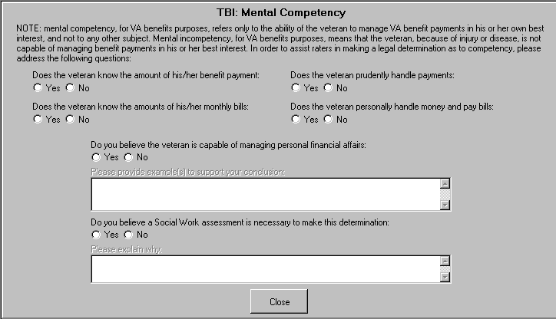

    - NOTE: mental competency, for VA benefits purposes, refers only to the ability of the veteran to manage VA benefit payments in his or her own best interest, and not to any other subject. Mental incompetency, for VA benefits purposes, means that the veteran, because of injury or disease, is not capable of managing benefit payments in his or her best interest. In order to assist raters in making a legal determination as to competency, please address the following questions: (Read Only Text)

    - Does the veteran know the amount of his/her benefit payment: (Yes/No) (Label/Radio Buttons)

    - Does the veteran know the amounts of his/her monthly bills: (Yes/No) (Label/Radio Buttons)

    - Does the veteran prudently handle payments: (Yes/No) (Label/Radio Buttons)

    - Does the veteran personally handle money and pay bills: (Yes/No) (Label/Radio Buttons)

    - Do you believe the veteran is capable of managing his/her financial affairs: (Yes/No) (Label/Radio Buttons)
If either Yes or No is selected, the following request is enabled:

      - Please provide example(s) to support your conclusion: (Label/ Free Text Box)

    - Do you believe a Social Work assessment is necessary to make this determination: (Yes/No) (Label/Radio Buttons)
If Yes is selected, a Free Text box is enabled requesting the following:

      - Please explain why: (Label/ Free Text Box)

  - Additional exams recommended: (Label/Free Text Box)

  - Additional comments concerning functional impairment: (Label/Free Text Box)

  - Summary of diagnosis: (Label/Free Text Box/Populated by Submit on TBI: Diagnosis)

