Compensation and Pension Record Interchange (CAPRI)

Prostate Cancer

Disability Benefits Questionnaire (DBQ)

Workflow

April 2011

Department of Veterans Affairs
Office of Enterprise Development
Management & Financial Systems

Revision History

Date | Description (Patch # if applicable) | Author | Technical Writer
11/02/2010 | Document created | REDACTED | N/A
4/1/2011 | Revisions for patch DVBA*2.7*163 | REDACTED | N/A
4/7/11 | Changed mandatory logic to “Please describe the appliance used for the voiding dysfunction.”  Changed If yes, describe: to If yes, describe the appliance | REDACTED | N/A

Table of Contents

1 Introduction 1
1.1 Purpose 1
1.2 Overview 1
2 Prostate Cancer DBQ 2
2.1 Name of patient/Veteran 2
2.2 Section 1. Diagnosis 3
2.3 Section 2. Medical history 6
2.4 Section 3. Treatment 7
2.5 Section 4. Voiding dysfunction 11
2.6 Section 5. Urinary tract/kidney infection 19
2.7 Section 6. Erectile dysfunction 22
2.8 Section 7. Retrograde ejaculation 24
2.9 Section 8. Residual conditions and/or complications 26
2.10 Section 9. Other pertinent physical findings, complications, conditions, signs and/or symptoms 27
2.11 Section 10. Diagnostic testing 29
2.12 Section 11. Functional impact 31
2.13 Section 12. Remarks, if any 31
3 Prostate Cancer DBQ-AMIE Worksheet 33

Table of Figures and Tables

Figure 1: Template Example: DBQ - Standard VA Note 1
Figure 2: Print Example: DBQ – Standard VA Note 1
Figure 3: Template Example: DBQ – Prostate Cancer – Name of patient/Veteran 2
Figure 4: Print Example: DBQ – Prostate Cancer – Name of patient/Veteran 2
Figure 5: Template Example: DBQ – Prostate Cancer – 1. Diagnosis 5
Figure 6: Print Example: DBQ – Prostate Cancer – 1. Diagnosis 5
Figure 7: Template Example: DBQ – Prostate Cancer – 2. Medical history 6
Figure 8: Print Example: DBQ – Prostate Cancer – 2. Medical history 6
Figure 9: Template Example: DBQ – Prostate Cancer – 3. Treatment 10
Figure 10: Print Example: DBQ – Prostate Cancer – 3. Treatment 10
Figure 11: Template Example: DBQ – Prostate Cancer – 4. Voiding dysfunction 17
Figure 12: Print Example: DBQ – Prostate Cancer – 4. Voiding dysfunction 18
Figure 13: Template Example: DBQ – Prostate Cancer – 5. Urinary tract/kidney infection 21
Figure 14: Print Example: DBQ – Prostate Cancer – 5. Urinary tract/kidney infection 21
Figure 15: Template Example: DBQ – Prostate Cancer – 6. Erectile dysfunction 24
Figure 16: Print Example: DBQ – Prostate Cancer – 6. Erectile dysfunction 24
Figure 17: Template Example: DBQ – Prostate Cancer –7. Retrograde ejaculation 25
Figure 18: Print Example: DBQ – Prostate Cancer – 7. Retrograde ejaculation 26
Figure 19: Template Example: DBQ – Prostate Cancer – 8. Residual conditions and/or complications 26
Figure 20: Print Example: DBQ – Prostate Cancer – 8. Residual conditions and/or complications 27
Figure 21: Template Example: DBQ – Prostate Cancer – 9. Other pertinent physical findings, complications, conditions, signs and/or symptoms 29
Figure 22: Print Example: DBQ – Prostate Cancer – 9. Other pertinent physical findings, complications, conditions, signs and/or symptoms 29
Figure 23: Template Example: DBQ – Prostate Cancer – 10. Diagnostic testing 30
Figure 24: Print Example: DBQ – Prostate Cancer – 10. Diagnostic testing 30
Figure 25: Template Example: DBQ – Prostate Cancer – 11. Functional impact 31
Figure 26: Print Example: DBQ – Prostate Cancer – 11. Functional impact 31
Figure 27: Template Example: DBQ – Prostate Cancer – 12. Remarks, if any 32
Figure 28: Print Example: DBQ – Prostate Cancer – 12. Remarks, if any 32

Table 1: Rules: DBQ – Prostate Cancer – Name of patient/Veteran 2
Table 2: Rules: DBQ – Prostate Cancer – 1. Diagnosis 3
Table 3: Rules: DBQ – Prostate Cancer – 2. Medical history 6
Table 4: Rules: DBQ – Prostate Cancer – 3. Treatment 8
Table 5: Rules: DBQ – Prostate Cancer – 4. Voiding dysfunction 12
Table 6: Rules: DBQ – Prostate Cancer – 5. Urinary tract/kidney infection 20
Table 7: Rules: DBQ – Prostate Cancer – 6. Erectile dysfunction 23
Table 8: Rules: DBQ – Prostate Cancer – 7. Retrograde ejaculation 25
Table 9: Rules: DBQ – Prostate Cancer – 8. Residual conditions and/or complications 26
Table 10: Rules: DBQ – Prostate Cancer – 9. Other pertinent physical findings, complications, conditions, signs and/or symptoms 28
Table 11: Rules: DBQ – Prostate Cancer – 10. Diagnostic testing 30
Table 12: Rules: DBQ – Prostate Cancer – 11. Functional impact 31
Table 13: Rules: DBQ – Prostate Cancer – 12. Remarks, if any 31

Introduction

Purpose
- This document provides a high level overview of the contents found on the PROSTATE CANCER Disability Benefits Questionnaire (DBQ). The DBQ can be populated via an online template within the CAPRI C&P Worksheets tab and then printed OR it can be printed via AMIE (AUTOMATED MEDICAL INFORMATION EXCHANGE) and then manually populated. This document contains the edit rules for the template as well as an example of how the template will look online in CAPRI or printed from CAPRI. It also contains the layout for the AMIE worksheet to depict how it will look when printed from AMIE.

- For more detailed information on standard template functionality not covered in this document, please refer to the C&P Worksheet Tab Functionalities section of the CAPRI GUI User Guide.

Overview
- The PROSTATE CANCER DBQ provides the ability to capture information related to Prostate Cancer and its treatment.

- Each DBQ template contains a standard footer containing a note stating that “VA may request additional medical information, including additional examinations if necessary to complete VA’s review of the Veteran’s application.” (see Figure 1 and 2).

Figure 1: Template Example: DBQ - Standard VA Note

Figure 2: Print Example: DBQ – Standard VA Note

NOTE: VA may request additional medical information, including additional

examinations if necessary to complete VA's review of the Veteran's application.

- A number of fields on the PROSTATE CANCER template are mandatory and require a response (value) prior to the exam being marked as completed. Some questions may activate a Pop-up window displaying information as to each question that needs to be answered before the template can be completed.

Prostate Cancer DBQ

Name of patient/Veteran
- All questions in this section may be answered as described by the rules below. If all mandatory questions are not answered, the error message(s) will appear in a popup window as depicted below.

Table 1: Rules: DBQ – Prostate Cancer – Name of patient/Veteran
Field/Question | Field Disposition | Valid Values | Format | Error Message
Prostate Cancer | Enabled, Read-Only | N/A | N/A | N/A
Disability Benefits Questionnaire | Enabled, Read-Only | N/A | N/A | N/A
Name of patient/Veteran: | Enabled, Mandatory | N/A | Free Text | Please enter the name of the patient/Veteran.
Your patient is applying to the U. S. Department of Veterans Affairs (VA) for disability benefits. VA will consider the information you provide on this questionnaire as part of their evaluation in processing the Veteran’s claim. | Enabled, Read-Only | N/A | N/A | N/A

Figure 3: Template Example: DBQ – Prostate Cancer – Name of patient/Veteran
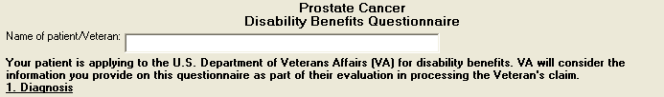

Figure 4: Print Example: DBQ – Prostate Cancer – Name of patient/Veteran
Prostate Cancer
Disability Benefits Questionnaire
Name of patient/Veteran:
Your patient is applying to the U.S. Department of Veterans Affairs (VA)
for disability benefits. VA will consider the information you provide on this
questionnaire as part of their evaluation in processing the Veteran's claim.

Section 1. Diagnosis
- The question “Does the Veteran now have or has he ever been diagnosed with prostate cancer?” must be answered before the template can be completed.
- If it is answered with Yes, all other questions requiring an answer as described by the rules in this document must be answered before the template can be completed.
- If it is answered with No, the rationale supporting this is required. The remainder of the template may be completed without answering any additional questions or the user may input answers to any of the optional questions as indicated by the rules described in this document.

- All questions will be printed even if they have not been answered.

- If all mandatory questions are not answered, the error message(s) will appear in a popup window as depicted below and must be answered before this template can be completed.

Table 2: Rules: DBQ – Prostate Cancer – 1. Diagnosis
Field/Question | Field Disposition | Valid Values | Format | Error Message
1.Diagnosis | Enabled, Read-Only | N/A | N/A | N/A
Does the Veteran now have or has he ever been diagnosed with prostate cancer? | Enabled, Mandatory; Choose one valid value | [Yes; No] | N/A | Please answer the question: Does the Veteran now have or has he ever been diagnosed with prostate cancer?
If no, provide rationale (e.g. Veteran has never had prostate cancer): | If Does the Veteran now have or has he ever been diagnosed with prostate cancer? = No; Enabled, Mandatory  Else; Disabled | N/A | Free Text | Please provide the rationale for indicating the Veteran has not been diagnosed with prostate cancer.
If yes, provide only diagnoses that pertain to prostate cancer. | If Does the Veteran now have or has he ever been diagnosed with prostate cancer? = Yes; Enabled, Read-Only  Else; Disabled | N/A | N/A | N/A
Diagnosis #1: | If Does the Veteran now have or has he ever been diagnosed with prostate cancer? = Yes; Enabled, Mandatory  Else; Enabled, Optional | N/A | Free Text | Please enter a value in the 'Diagnosis #1' field.
ICD code: | If Does the Veteran now have or has he ever been diagnosed with prostate cancer? = Yes; Enabled, Mandatory  Else; Enabled, Optional | N/A | Free Text | Please enter the ICD code for diagnosis #1.
Date of diagnosis: | If Does the Veteran now have or has he ever been diagnosed with prostate cancer? = Yes; Enabled, Mandatory  Else; Enabled, Optional | N/A | Free Text | Please enter the date of diagnosis #1.
Diagnosis #2: | Enabled, Optional | N/A | Free Text | N/A
ICD code: | If Does the Veteran now have or has he ever been diagnosed with prostate cancer? = Yes and Diagnosis #2 is populated; Enabled, Mandatory  Else; Enabled, Optional | N/A | Free Text | Please enter the ICD code for diagnosis #2.
Date of diagnosis: | If Does the Veteran now have or has he ever been diagnosed with prostate cancer? = Yes and Diagnosis #2 is populated; Enabled, Mandatory  Else; Enabled, Optional | N/A | Free Text | Please enter the date of diagnosis #2.
Diagnosis #3: | Enabled, Optional | N/A | Free Text | N/A
ICD code: | If Does the Veteran now have or has he ever been diagnosed with prostate cancer? = Yes and Diagnosis #3 is populated; Enabled, Mandatory  Else; Enabled, Optional | N/A | Free Text | Please enter the ICD code for diagnosis #3.
Date of diagnosis: | If Does the Veteran now have or has he ever been diagnosed with prostate cancer? = Yes and Diagnosis #3 is populated; Enabled, Mandatory  Else; Enabled, Optional | N/A | Free Text | Please enter the date of diagnosis #3.
If there are additional diagnoses that pertain to prostate cancer, list using above format: | Enabled, Optional | N/A | Free Text | N/A

Figure 5: Template Example: DBQ – Prostate Cancer – 1. Diagnosis
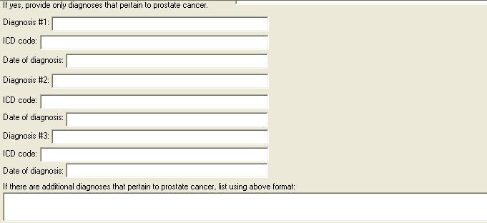

Figure 6: Print Example: DBQ – Prostate Cancer – 1. Diagnosis
1. Diagnosis
------------
Does the Veteran now have or has he ever been diagnosed with prostate
cancer? [X] Yes [ ] No
If no, provide rationale (e.g. Veteran has never had prostate cancer):
If yes, provide only diagnoses that pertain to prostate cancer.
Diagnosis #1:
ICD code:
Date of diagnosis:
Diagnosis #2:
ICD code:
Date of diagnosis:
Diagnosis #3:
ICD code:
Date of diagnosis:
If there are additional diagnoses that pertain to prostate cancer, list
using above format:

Section 2. Medical history
- All questions in this section may be answered as described by the rules below. If all mandatory questions are not answered, the error message(s) will appear in a popup window as depicted below.

Table 3: Rules: DBQ – Prostate Cancer – 2. Medical history
Field/Question | Field Disposition | Valid Values | Format | Error Message
2.Medical history | Enabled; Read Only | N/A | N/A | N/A
a. Describe the history (including onset and course) of the Veteran’s prostate cancer condition (brief summary): | If Does the Veteran now have or has he ever been diagnosed with prostate cancer? = Yes; Enabled, Mandatory  Else; Optional | N/A | Free Text | Please describe the history, including onset and course, of the Veteran's prostate cancer condition.
b. Indicate status of disease: | If Does the Veteran now have or has he ever been diagnosed with prostate cancer? = Yes; Enabled, Mandatory, Choose one valid value  Else; Disabled | [Active;  Remission] | N/A | Please indicate the status of the disease.

Figure 7: Template Example: DBQ – Prostate Cancer – 2. Medical history
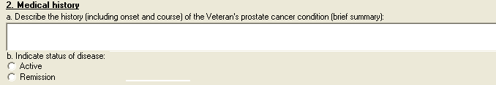

Figure 8: Print Example: DBQ – Prostate Cancer – 2. Medical history
2. Medical history
------------------
a. Describe the history (including onset and course) of the Veteran's
prostate cancer condition (brief summary):
b. Indicate status of disease:
[ ] Active
[ ] Remission

Section 3. Treatment
- All questions in this section may be answered as described by the rules below. If all mandatory questions are not answered, the error message(s) will appear in a popup window as depicted below.
Table 4: Rules: DBQ – Prostate Cancer – 3. Treatment
Field/Question | Field Disposition | Valid Values | Format | Error Message
3.Treatment | Enabled; Read Only | N/A | N/A | N/A
Has the Veteran completed any treatment for prostate cancer or is the Veteran currently undergoing any treatment for prostate cancer? | If Does the Veteran now have or has he ever been diagnosed with prostate cancer? = Yes; Enabled, Mandatory, Choose one valid value  Else; Enabled, Optional | [Yes; No, watchful waiting] | N/A | Please answer the question: Has the Veteran completed any treatment for prostate cancer or is the Veteran currently undergoing any treatment for prostate cancer?
If yes, indicate treatment type(s) (check all that apply): | If the previous question = Yes; Enabled, Mandatory, Choose one or more valid values  Else; Disabled | Treatment completed, currently in watchful waiting status;  Surgery:  Radical prostatectomy, Transurethral resection prostatectomy, Other (describe):  Other surgical procedure (describe),  Date of surgery: ;  Radiation therapy :  Date of completion of treatment or anticipated date of completion: ;  Brachytherapy :  Date of treatment: ;  Antineoplastic chemotherapy:  Date of most recent treatment:  Date of completion of treatment or anticipated date of completion: ;  Androgen Deprivation Therapy (Hormonal Therapy):  Date of most recent treatment: ,  Date of completion of treatment or anticipated date of completion: ;  Other therapeutic procedure and/or treatment (describe):  Date of procedure: ,  Date of completion of treatment or anticipated date of completion: ] | N/A | Please check all applicable treatment type(s).
Other surgical procedure (describe): | If treatments include Surgery and other surgical procedure; Enabled, Mandatory  Else; Disabled | N/A | Free Text | Please describe the other surgical procedure performed.
Date of surgery: | If treatments include Surgery and other surgical procedure; Enabled, Mandatory  Else; Disabled | N/A | Free Text | Please enter the date of surgery.
Date of completion of treatment or anticipated date of completion: | If treatment = Radiation therapy; Enabled, Mandatory  Else; Disabled | N/A | Free Text | Please enter the radiation therapy's date of completion (actual or anticipated).
Date of treatment: | If treatments include Brachytherapy; Enabled, Mandatory  Else; Disabled | N/A | Free Text | Please enter the date of brachytherapy treatment.
Date of completion of treatment or anticipated date of completion: | If treatments include Antineoplastic chemotherapy; Enabled, Mandatory  Else; Disabled | N/A | Free Text | Please enter the antineoplastic chemotherapy treatment's date of completion (actual or anticipated).
Date of completion of treatment or anticipated date of completion: | If treatments include Androgen Deprivation Therapy (Hormonal Therapy); Enabled, Mandatory  Else; Disabled | N/A | Free Text | Please enter the androgen deprivation therapy (hormonal therapy) treatment's date of completion (actual or anticipated).
Other therapeutic procedure and/or treatment (describe): | If treatments include Other therapeutic procedure and/or treatment; Enabled, Mandatory  Else; Disabled | N/A | Free Text | Please describe the other therapeutic procedure and/or treatment performed.
Date of procedure: | If treatment = Other therapeutic procedure and/or treatment; Enabled, Mandatory  Else; Disabled | N/A | Free Text | Please enter the date the other therapeutic procedure and/or treatment was performed.
Date of completion of treatment or anticipated date of completion: | If treatments include Other therapeutic procedure and/or treatment; Enabled, Mandatory  Else; Disabled | N/A | Free Text | Please enter the other therapeutic procedure and/or treatment's date of completion (actual or anticipated).

Figure 9: Template Example: DBQ – Prostate Cancer – 3. Treatment
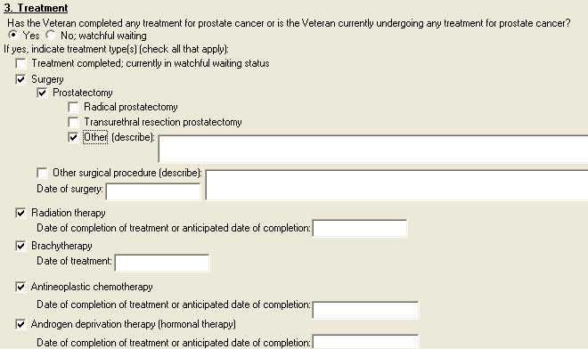

Figure 10: Print Example: DBQ – Prostate Cancer – 3. Treatment
3. Treatment
------------
Has the Veteran completed any treatment for prostate cancer or is the
Veteran currently undergoing any treatment for prostate cancer?
[X] Yes [ ] No; watchful waiting
If yes, indicate the treatment type(s) (check all that apply):
[ ] Treatment completed; currently in watchful waiting status
[X] Surgery
[X] Prostatectomy
[ ] Radical prostatectomy
[ ] Transurethral resection prostatectomy
[ ] Other (describe):
[ ] Other surgical procedure (describe):
Date of surgery:
[X] Radiation therapy
Date of completion of treatment or anticipated date of
completion:
[X] Brachytherapy
Date of treatment:
[X] Antineoplastic chemotherapy
Date of completion of treatment or anticipated date of
completion:
[X] Androgen deprivation therapy (hormonal therapy)
Date of completion of treatment or anticipated date of
completion:
[X] Other therapeutic procedure and/or treatment (describe):
Date of procedure:
Date of completion of treatment or anticipated date of
completion:

Section 4. Voiding dysfunction
- All questions in this section may be answered as described by the rules below. If all mandatory questions are not answered, the error message(s) will appear in a popup window as depicted below.
Table 5: Rules: DBQ – Prostate Cancer – 4. Voiding dysfunction
Field/Question | Field Disposition | Valid Values | Format | Error Message
4.Voiding dysfunction | Enabled; Read Only | N/A | N/A | N/A
Does the Veteran have a voiding dysfunction? | If Does the Veteran now have or has he ever been diagnosed with prostate cancer? = Yes; Enabled, Mandatory, Choose one valid value  Else, Enabled, Optional | [Yes; No] | N/A | Please answer the question: Does the Veteran have a voiding dysfunction?
If yes, provide etiology of voiding dysfunction: | If Does the Veteran have a voiding dysfunction? = Yes, Enabled, Mandatory  Else, Disabled | N/A | Free Text | Please provide the etiology of the voiding dysfunction.
If the Veteran has a voiding dysfunction, complete the following questions: | If Does the Veteran have a voiding dysfunction? = Yes; Enabled; Read-Only  Else; Disabled | N/A | N/A | N/A
a. Does the voiding dysfunction cause urine leakage? | If Does the Veteran have a voiding dysfunction? = Yes, Enabled, Mandatory, Choose one valid value  Else; Disabled | [Yes; No] | N/A | Please provide an answer to the question: Does the voiding dysfunction cause urine leakage?
Indicate severity (check one): | If Does the voiding dysfunction cause urine leakage? = Yes, Enabled, Mandatory, Choose one valid value  Else; Disabled | [Does not require/does not use absorbent material; Requires absorbent material that is changed less than 2 times per day; Requires absorbent material that is changed 2 to 4 times per day; Requires absorbent material that is changed more than 4 times per day; Other, describe:] | N/A | Please check the applicable statement pertaining to the voiding dysfunction causing urine leakage.
Other, Describe: | If Does the voiding dysfunction cause urine leakage? = Other, Enabled; Mandatory  Else; Disabled | N/A | Free Text | Please describe the other severity of the urine leakage.
b. Does the voiding dysfunction require the use of an appliance? | If Does the Veteran have a voiding dysfunction? = Yes, Enabled, Mandatory, Choose one valid value  Else, Enabled, Optional | [Yes; No] | N/A | Please provide an answer to the question: Does the voiding dysfunction require the use of an appliance?
If yes, describe the appliance: | If Does the voiding dysfunction require the use of an appliance? = Yes; Enabled, Mandatory  Else; Disabled | N/A | Free Text | Please describe the appliance used for the voiding dysfunction.
c. Does the voiding dysfunction cause increased urinary frequency? | If Does the Veteran have a voiding dysfunction? = Yes, Enabled, Mandatory; Choose one valid value  Else; Disabled | [Yes; No] | N/A | Please provide an answer to the question: Does the voiding dysfunction cause increased urinary frequency?
If yes, check all that apply: | If Does the voiding dysfunction cause increased urinary frequency? = Yes; Enabled, Mandatory; Choose one valid value for Daytime and one valid value for Nighttime  Else; Disabled | [Daytime voiding interval between 2 and 3 hours; Daytime voiding interval between 1 and 2 hours; Daytime voiding interval less than 1 hour;] AND [Nighttime awakening to void 2 times; Nighttime awakening to void 3 to 4 times; Nighttime awakening to void 5 or more times] | N/A | Please check the applicable statement(s) pertaining to the increased urinary frequency.
d. Does the voiding dysfunction cause signs or symptoms of obstructed voiding? | If Does the Veteran have a voiding dysfunction? = Yes, Enabled, Mandatory; Choose one valid value  Else; Disabled | [Yes; No] | N/A | Please provide an answer to the question: Does the voiding dysfunction cause signs or symptoms of obstructed voiding?
If yes, check all signs and symptoms that apply: | If Does the voiding dysfunction cause signs or symptoms of obstructed voiding? = Yes; Enabled, Mandatory; Choose one or more valid values  Else; Disabled | [Hesitancy; Slow or weak stream; Decreased force of stream; Stricture disease requiring dilatation 1 to 2 times per year; Stricture disease requiring periodic dilatation every 2 to 3 months; Recurrent urinary tract infections secondary to obstruction; Uroflowmetry peak flow rate less than 10 cc/sec; Post void residuals greater than 150 cc; Urinary retention requiring intermittent or continuous catheterization; Urinary retention requiring continuous catheterization; Other, describe:] | N/A | Please check one or more boxes to indicate the signs and symptoms of obstructed voiding.
If checked, is hesitancy marked? | If Voiding dysfunction signs and symptoms include Hesitancy; Enabled, Mandatory; Choose one valid value  Else; Disabled | [Yes; No] | N/A | Please indicate whether or not hesitancy is marked.
If checked, is stream markedly slow or weak? | If Voiding dysfunction signs and symptoms include Slow or weak stream; Enabled, Mandatory; Choose one valid value  Else; Disabled | [Yes; No] | N/A | Please indicate whether or not stream is markedly slow or weak.
If checked, is force of steam markedly decreased? | Voiding dysfunction signs and symptoms include Decreased force of stream; Enabled, Mandatory; Choose one valid value  Else; Disabled | [Yes; No] | N/A | Please indicate whether or not force of steam is markedly decreased.
Other, describe: | If Voiding dysfunction signs and symptoms include Other; Enabled, Mandatory  Else; Disabled | N/A | Free Text | Please describe the other signs and symptoms of obstructed voiding.

Figure 11: Template Example: DBQ – Prostate Cancer – 4. Voiding dysfunction
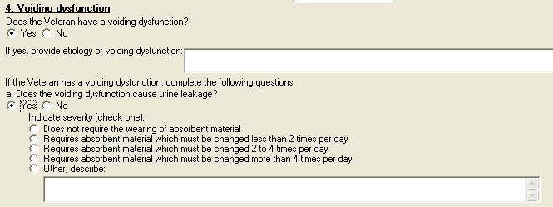
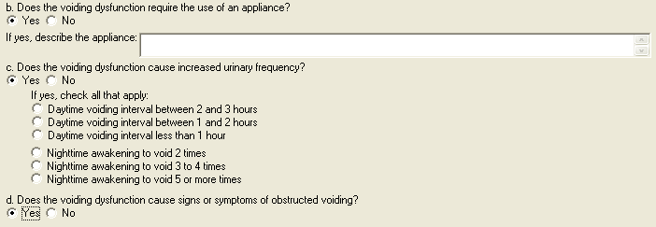
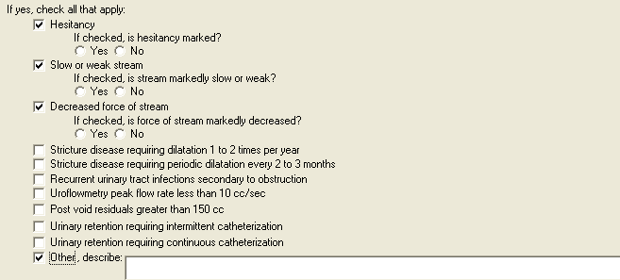

Figure 12: Print Example: DBQ – Prostate Cancer – 4. Voiding dysfunction
4. Voiding dysfunction
----------------------
Does the Veteran have a voiding dysfunction?
[X] Yes [ ] No
If yes, provide etiology of voiding dysfunction:
If the Veteran has a voiding dysfunction, complete the following questions:
a. Does the voiding dysfunction cause urine leakage?
[X] Yes [ ] No
Indicate severity (check one):
[ ] Does not require the wearing of absorbent material
[ ] Requires absorbent material which must be changed less than 2
times per day
[ ] Requires absorbent material which must be changed 2 to 4
times per day
[ ] Requires absorbent material which must be changed more than 4
times per day
[ ] Other, describe:
b. Does the voiding dysfunction require the use of an appliance?
[X] Yes [ ] No
If yes, describe the appliance:
c. Does the voiding dysfunction cause increased urinary frequency?
[X] Yes [ ] No
If yes, check all that apply:
[ ] Daytime voiding interval between 2 and 3 hours
[ ] Daytime voiding interval between 1 and 2 hours
[ ] Daytime voiding interval less than 1 hour
[ ] Nighttime awakening to void 2 times
[ ] Nighttime awakening to void 3 to 4 times
[ ] Nighttime awakening to void 5 or more times
d. Does the voiding dysfunction cause signs or symptoms of obstructed
voiding?
[X] Yes [ ] No
If yes, check all that apply:
[X] Hesitancy
If checked, is hesitancy marked?
[ ] Yes [ ] No
[X] Slow or weak stream
If checked, is stream markedly slow or weak?
[ ] Yes [ ] No
[X] Decreased force of stream
If checked, is force of stream markedly decreased?
[ ] Yes [ ] No
[ ] Stricture disease requiring dilatation 1 to 2 times per year
[ ] Stricture disease requiring periodic dilatation every 2 to 3
months
[ ] Recurrent urinary tract infections secondary to obstruction
[ ] Uroflowmetry peak flow rate less than 10 cc/sec
[ ] Post void residuals greater than 150 cc
[ ] Urinary retention requiring intermittent catheterization
[ ] Urinary retention requiring continuous catheterization
[X] Other, describe:

Section 5. Urinary tract/kidney infection
- All questions in this section may be answered as described by the rules below. If all mandatory questions are not answered, the error message(s) will appear in a popup window as depicted below.
Table 6: Rules: DBQ – Prostate Cancer – 5. Urinary tract/kidney infection
Field/Question | Field Disposition | Valid Values | Format | Error Message
5.Urinary tract/kidney infection | Enabled; Read Only | N/A | N/A | N/A
Does the Veteran have a history of recurrent symptomatic urinary tract or kidney infections? | If Does the Veteran now have or has he ever been diagnosed with prostate cancer? = Yes; Enabled, Mandatory, Choose one valid value  Else, Enabled, Optional | [Yes; No] | N/A | Please answer the question: Does the Veteran have a history of recurrent urinary tract or kidney infections?
If yes, provide etiology: | If Does the Veteran have a history of recurrent symptomatic urinary tract infections? = Yes; Enabled, Mandatory  Else; Disabled | N/A | Free Text | Please provide the etiology of the recurrent symptomatic urinary tract or kidney infections.
If the Veteran has had recurrent symptomatic urinary tract or kidney infections, indicate all treatment modalities that apply: | If Does the Veteran have a history of recurrent symptomatic urinary tract or kidney infections? = Yes; Enabled, Mandatory, Choose one valid value  Else; Disabled | [No treatment; Long-term drug therapy; Hospitalization; Drainage; Continuous intensive management; Intermittent intensive management; Other, describe:] | N/A | Please check one or more boxes to indicate applicable treatment modalities for recurrent symptomatic urinary tract or kidney infections.
If checked, list medications used for urinary tract infection and indicate dates for courses of treatment over the past 12 months: | If Treatments include Long-term drug therapy; Enabled, Mandatory  Else; Disabled | N/A | Free Text | Please list medications used for urinary tract or kidney infection and their treatment dates over the past 12 months.
If checked, indicate frequency of hospitalization: | If Treatments include Hospitalization; Enabled, Mandatory; Choose one valid value  Else; Disabled | [1 or 2 per year; More than 2 per year] | N/A | Please indicate the frequency of hospitalization.
If checked, indicate dates when drainage performed over the past 12 months: | If Treatments include Drainage; Enabled, Mandatory  Else; Disabled | N/A | Free Text | Please indicate the dates that drainage was performed over the past 12 months.
If checked, indicate types of treatment and medications used over the past 12 months. | If Treatments include Continuous intensive management; Enabled, Mandatory  Else; Disabled | N/A | Free Text | Please describe the types of treatment and medications for continuous intensive management used over the past 12 months.
If checked, indicate types of treatment and medications used over past 12 months: | If Treatments include Intermittent intensive management; Enabled, Mandatory  Else; Disabled | N/A | Free Text | Please describe the types of treatment and medications for intermittent intensive management used over the past 12 months.
Other, describe: | If Treatments include Other; Enabled, Mandatory  Else; Disabled | N/A | Free Text | Please describe other treatment modalities used for urinary tract or kidney infections.

Figure 13: Template Example: DBQ – Prostate Cancer – 5. Urinary tract/kidney infection
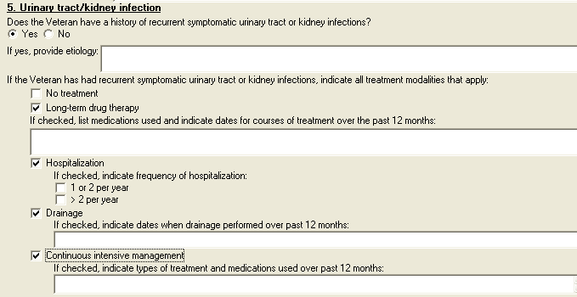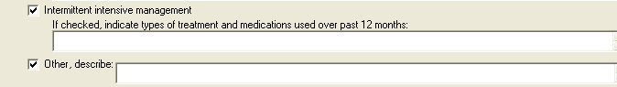

Figure 14: Print Example: DBQ – Prostate Cancer – 5. Urinary tract/kidney infection
5. Urinary tract/kidney infection
---------------------------------
Does the Veteran have a history of recurrent symptomatic urinary tract
infections?
[X] Yes [ ] No
If yes, provide etiology:
If the Veteran has had recurrent symptomatic urinary tract or kidney
infections, indicate all treatment modalities that apply:
[ ] No treatment
[X] Long-term drug therapy
If checked, list medications used for urinary tract infection
and indicate dates for courses of treatment over the past 12
months:
[X] Hospitalization
If checked, indicate frequency of hospitalization:
[ ] 1 or 2 per year
[ ] More than 2 per year
[X] Drainage
If checked, indicate dates when drainage performed over past
12 months:
[ ] Continuous intensive management
If checked, indicate types of treatment and medications used
over past 12 months:
[X] Intermittent intensive management
If checked, indicate types of treatment and medications used
over past 12 months:
[X] Other, describe:

Section 6. Erectile dysfunction
- All questions in this section may be answered as described by the rules below. If all mandatory questions are not answered, the error message(s) will appear in a popup window as depicted below.

Table 7: Rules: DBQ – Prostate Cancer – 6. Erectile dysfunction
Field/Question | Field Disposition | Valid Values | Format | Error Message
6. Erectile dysfunction | Enabled; Read Only | N/A | N/A | N/A
a. Does the Veteran have erectile dysfunction? | If Does the Veteran now have or has he ever been diagnosed with prostate cancer? = Yes; Enabled, Mandatory, Choose one valid value  Else, Enabled, Optional | [Yes; No] | N/A | Please provide an answer to the question: Does the Veteran have erectile dysfunction?
If yes, provide etiology: | If Does the Veteran have erectile dysfunction? = Yes; Enabled, Mandatory, Choose one valid value  Else; Disabled | N/A | Free Text | Please provide the etiology of erectile dysfunction.
b. If the Veteran has erectile dysfunction is it as likely as not (at least 50% probability) attributable to one of the diagnoses in Section 1, including residuals of treatment for this diagnosis? | If Does the Veteran have erectile dysfunction? = Yes; Enabled, Mandatory, Choose one valid value  Else; Disabled | [Yes; No] | N/A | Please answer whether or not erectile dysfunction is attributable to one of the diagnoses in Section 1, including its residuals of treatment.
If yes, specify the diagnosis to which the erectile dysfunction is as likely as not attributable: | If previous question = Yes; Enabled; Mandatory  Else; Disabled | N/A | Free Text | Please specify the diagnosis to which erectile dysfunction is as likely as not attributable.
c. If the Veteran has erectile dysfunction, is he able to achieve an erection sufficient for penetration and ejaculation (without medication)? | If Does the Veteran have erectile dysfunction? = Yes; Enabled, Mandatory, Choose one valid value  Else; Disabled | [Yes; No] | N/A | Please answer whether or not the Veteran is able to achieve an erection sufficient for penetration and ejaculation (without medication).
If no, is the Veteran able to achieve an erection sufficient for penetration and ejaculation (with medication)? | If previous question = No; Enabled; Mandatory; Choose one valid value  Else; Disabled | [Yes; No] | N/A | Please answer whether or not the Veteran is able to achieve an erection sufficient for penetration and ejaculation (with medication).

Figure 15: Template Example: DBQ – Prostate Cancer – 6. Erectile dysfunction
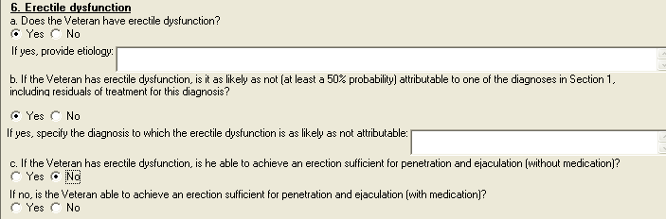

Figure 16: Print Example: DBQ – Prostate Cancer – 6. Erectile dysfunction
6. Erectile dysfunction
----------------------
a. Does the Veteran have erectile dysfunction?
[X] Yes [ ] No
If yes, provide etiology:
b. If the Veteran has erectile dysfunction, is it as likely as not (at
least 50% probability) attributable to one of the diagnoses in Section 1,
including residuals of treatment for this diagnosis?
[X] Yes [ ] No
If yes, specify the diagnosis to which the erectile dysfunction is
as likely as not attributable:
c. If the Veteran has erectile dysfunction, is he able to achieve an
erection sufficient for penetration and ejaculation (without medication)?
[ ] Yes [ ] No
If no, is the Veteran able to achieve an erection sufficient for
penetration and ejaculation (with medication)?
[ ] Yes [ ] No

Section 7. Retrograde ejaculation
- All questions in this section may be answered as described by the rules below. If all mandatory questions are not answered, the error message(s) will appear in a popup window as depicted below.

Table 8: Rules: DBQ – Prostate Cancer – 7. Retrograde ejaculation
Field/Question | Field Disposition | Valid Values | Format | Error Message
7. Retrograde ejaculation | Enabled; Read Only | N/A | N/A | N/A
a. Does the Veteran have retrograde ejaculation? | If Does the Veteran now have or has he ever been diagnosed with prostate cancer? = Yes; Enabled, Mandatory, Choose one valid value  Else, Enabled, Optional | [Yes; No] | N/A | Please provide an answer to the question: Does the Veteran have retrograde ejaculation?
If yes, provide etiology of retrograde ejaculation. | If Does the Veteran have retrograde ejaculation?= Yes; Enabled, Mandatory  Else; Disabled | N/A | Free Text | Please provide the etiology of retrograde ejaculation.
b. If the Veteran has retrograde ejaculation, is the retrograde ejaculation as likely as not (at least a 50% probability) attributable to prostate cancer, including treatment or residuals of treatment for prostate cancer? | If Does the Veteran have retrograde ejaculation?= Yes; Enabled, Mandatory, Choose one valid value  Else; Disabled | [Yes; No] | N/A | Please answer whether or not retrograde ejaculation is attributable to one of the diagnoses in Section 1, including its residuals of treatment.
If yes, specify the diagnosis to which the retrograde ejaculation is as likely as not attributable: | If previous question = Yes; Enabled, Mandatory  Else; Disabled | N/A | Free Text | Please specify the diagnosis to which retrograde ejaculation is as likely as not attributable.

Figure 17: Template Example: DBQ – Prostate Cancer –7. Retrograde ejaculation
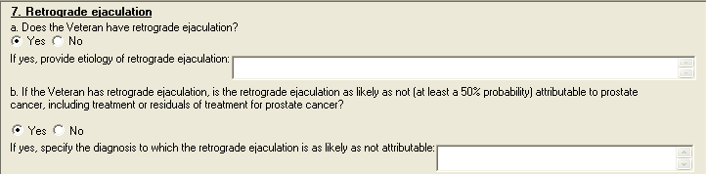

Figure 18: Print Example: DBQ – Prostate Cancer – 7. Retrograde ejaculation
7. Retrograde ejaculation
-------------------------
a. Does the Veteran have retrograde ejaculation?
[X] Yes [ ] No
If yes, provide etiology of retrograde ejaculation:
b. If the Veteran has retrograde ejaculation, is the retrograde ejaculation
as likely as not (at least a 50% probability) attributable to prostate cancer,
including treatment or residuals of treatment for prostate cancer?
[X] Yes [ ] No
If yes, specify the diagnosis to which the retrograde ejaculation is
as likely as not attributable:

Section 8. Residual conditions and/or complications
- All questions in this section may be answered as described by the rules below. If all mandatory questions are not answered, the error message(s) will appear in a popup window as depicted below.

Table 9: Rules: DBQ – Prostate Cancer – 8. Residual conditions and/or complications
Field/Question | Field Disposition | Valid Values | Format | Error Message
8. Residuals of conditions and/or complications | Enabled, Read-Only | N/A | N/A | N/A
a. Does the Veteran have any other residual complications of prostate cancer or treatment for prostate cancer? | If Does the Veteran now have or has he ever been diagnosed with prostate cancer? = Yes; Enabled, Mandatory, Choose one valid value  Else, Enabled, Optional | [Yes; No] | N/A | Please provide an answer to the question: Does the Veteran have any other residual complications of prostate cancer or treatment for prostate cancer?
If yes, describe: | If Does the Veteran have any other residual complications of prostate cancer or treatment for prostate cancer?= Yes, Enabled, Mandatory  Else; Disabled | N/A | Free Text | Please describe any other residual complications.

Figure 19: Template Example: DBQ – Prostate Cancer – 8. Residual conditions and/or complications
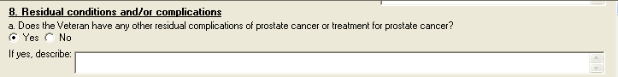

Figure 20: Print Example: DBQ – Prostate Cancer – 8. Residual conditions and/or complications
8. Residual conditions and/or complications
-------------------------------------------
a. Does the Veteran have any other residual complications of prostate
cancer or treatment for prostate cancer?
[X] Yes [ ] No
If yes, describe:

Section 9. Other pertinent physical findings, complications, conditions, signs and/or symptoms
- All questions in this section may be answered as described by the rules below. If all mandatory questions are not answered, the error message(s) will appear in a popup window as depicted below.
Table 10: Rules: DBQ – Prostate Cancer – 9. Other pertinent physical findings, complications, conditions, signs and/or symptoms
Field/Question | Field Disposition | Valid Values | Format | Error Message
9. Other pertinent physical findings, complications, conditions, signs and/or symptoms | Enabled; Read-Only | N/A | N/A | N/A
a. Does the Veteran have any scars (surgical or otherwise) related to any conditions or to the treatment of any conditions listed in the Diagnosis section above? | If Does the Veteran now have or has he ever been diagnosed with prostate cancer? = Yes; Enabled, Mandatory, Choose one valid value  Else; Enabled, Optional | [Yes; No] | N/A | Please indicate whether or not the Veteran has any scars (surgical or otherwise) related to any conditions (or their treatment) listed in the Diagnosis section.
If yes, are any of the scars painful and/or unstable, or is the total area of all related scars greater than 39 square cm (6 square inches)? | If Does the Veteran have any scars (surgical or otherwise) related to any conditions or to the treatment of conditions listed in the Diagnosis section above? = Yes; Enabled, Mandatory, Choose one valid value  Else; Enabled, Optional | [Yes; No] | N/A | Please answer whether or not any of the scars are painful and/or unstable, or if the total area of all related scars is greater than 39 square cm (6 square inches).
If yes, also complete a Scars Questionnaire. | If If yes, are any of the scars painful and/or unstable, or is the total area of all related scars greater than 39 square cm (6 square inches)? = Yes; Enabled, Read-Only  Else; Disabled | N/A | N/A | N/A
b. Does the Veteran have any other pertinent physical findings, complications, conditions, signs or symptoms? | If Does the Veteran now have or has he ever been diagnosed with prostate cancer? = Yes; Enabled, Mandatory, Choose one valid value  Else; Enabled, Optional | [Yes; No] | N/A | Please provide an answer to the question: Does the Veteran have any other pertinent physical findings, complications, conditions, signs or symptoms?
If yes, describe (brief summary): | If Does the Veteran have any other pertinent physical findings, complications, conditions, signs or symptoms= Yes; Enabled, Mandatory  Else; Disabled | N/A | Free Text | Please describe any other pertinent findings, complications, signs and/or symptoms.

Figure 21: Template Example: DBQ – Prostate Cancer – 9. Other pertinent physical findings, complications, conditions, signs and/or symptoms
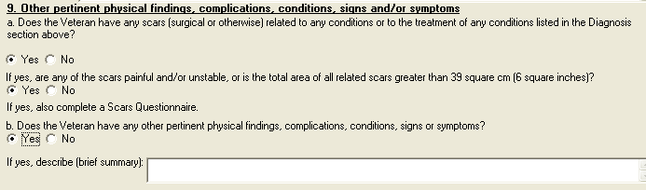

Figure 22: Print Example: DBQ – Prostate Cancer – 9. Other pertinent physical findings, complications, conditions, signs and/or symptoms
9. Other pertinent physical findings, complications, conditions, signs
and/or symptoms
----------------------------------------------------------------------
a. Does the Veteran have any scars (surgical or otherwise) related to any
conditions or to the treatment of any conditions listed in the Diagnosis
section above?
[X] Yes [ ] No
If yes, also complete a Scars Questionnaire for each scar.
b. Does the Veteran have any other pertinent physical findings,
complications, conditions, signs and/or symptoms?
[X] Yes [ ] No
If yes, describe (brief summary):

Section 10. Diagnostic testing

- All questions in this section may be answered as described by the rules below. If all mandatory questions are not answered, the error message(s) will appear in a popup window as depicted below.

Table 11: Rules: DBQ – Prostate Cancer – 10. Diagnostic testing
Field/Question | Field Disposition | Valid Values | Format | Error Message
10. Diagnostic testing | Enabled, Read-Only | N/A | N/A | N/A
NOTE: If laboratory test results are in the medical record and reflect the Veteran’s current condition, repeat testing is not required. | Enabled, Read-Only | N/A | N/A | N/A
Are there any significant diagnostic test findings and/or results? | If Does the Veteran now have or has he ever been diagnosed with prostate cancer? = Yes; Enabled, Mandatory, Choose one valid value  Else; Enabled, Optional | [Yes; No] | N/A | Please provide an answer to the question: Are there any significant diagnostic test findings and/or results?
If yes, provide type of test or procedure, date and results (brief summary): | If Are there any significant diagnostic test findings and/or results= Yes; Enabled, Mandatory  Else; Disabled | N/A | Free Text | Please provide type of test or procedure, date and results.

Figure 23: Template Example: DBQ – Prostate Cancer – 10. Diagnostic testing
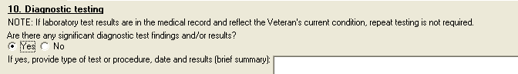

Figure 24: Print Example: DBQ – Prostate Cancer – 10. Diagnostic testing
10. Diagnostic testing
----------------------
NOTE: If laboratory test results are in the medical record and reflect the
Veteran's current condition, repeat testing is not required.
Are there any significant diagnostic test findings and/or results?
[X] Yes [ ] No
If yes, provide type of test or procedure, date and results (brief
summary):

Section 11. Functional impact
- All questions in this section may be answered as described by the rules below. If all mandatory questions are not answered, the error message(s) will appear in a popup window as depicted below.

Table 12: Rules: DBQ – Prostate Cancer – 11. Functional impact
Field/Question | Field Disposition | Valid Values | Format | Error Message
11. Functional Impact | Enabled, Read-Only | N/A | N/A | N/A
Does the Veteran’s prostate cancer impact his ability to work? | If Does the Veteran now have or has he ever been diagnosed with prostate cancer? = Yes; Enabled, Mandatory, Choose one valid value  Else; Disabled | [Yes; No] | N/A | Please provide an answer to the question: Does the Veteran's prostate cancer impact his ability to work?
If yes, describe the impact of the Veteran’s prostate cancer, providing one or more examples: | If Does the Veteran’s prostate cancer impact his ability to work? = Yes; Enabled, Mandatory  Else; Disabled | N/A | Free Text | Please describe the impact of prostate cancer on the Veteran's ability to work, providing one or more examples.

Figure 25: Template Example: DBQ – Prostate Cancer – 11. Functional impact
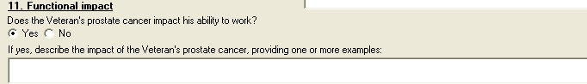

Figure 26: Print Example: DBQ – Prostate Cancer – 11. Functional impact
11. Functional impact
-----------------
Does the Veteran's prostate cancer impact his ability to work?
[X] Yes [ ] No
If yes, describe the impact of the Veteran's prostate cancer,
providing one or more examples:

Section 12. Remarks, if any
- All questions in this section may be answered as described by the rules below.
Table 13: Rules: DBQ – Prostate Cancer – 12. Remarks, if any
Field/Question | Field Disposition | Valid Values | Format | Error Message
12. Remarks, if any | Enabled, Optional | N/A | Free Text | N/A

Figure 27: Template Example: DBQ – Prostate Cancer – 12. Remarks, if any

Figure 28: Print Example: DBQ – Prostate Cancer – 12. Remarks, if any
12. Remarks, if any
------------------

Prostate Cancer DBQ-AMIE Worksheet
The DBQ-AMIE worksheets are accessed via the Print Blank C&P Worksheet menu [DVBA C
PRINT BLANK C&P WORKSHE] option. Select the “DBQ PROSTATE CANCER” worksheet.
DBQ-AMIE worksheets should be sent to a printer.

Prostate Cancer
Disability Benefits Questionnaire

Name of patient/Veteran: _______________________ SSN: ________________

Your patient is applying to the U. S. Department of Veterans Affairs
(VA) for disability benefits. VA will consider the information you
provide on this questionnaire as part of their evaluation in processing
the Veteran's claim.

1. Diagnosis

Does the Veteran now have or has he ever been diagnosed with prostate
cancer?
___ Yes ___ No

If no, provide rationale (e.g. Veteran has never had prostate cancer):

_____________________________________________________________________________

If yes, provide only diagnoses that pertain to prostate cancer.

Diagnosis #1: ____________________
ICD code: ________________________
Date of diagnosis: _______________

Diagnosis #2: ____________________
ICD code: ________________________
Date of diagnosis: _______________

Diagnosis #3: ____________________
ICD code: ________________________
Date of diagnosis: _______________

If there are additional diagnoses that pertain to prostate cancer, list using
above format: _______________________________________________________________

2. Medical history

a. Describe the history (including onset and course) of the Veteran's
prostate cancer condition (brief summary): _______________________________

__________________________________________________________________________

b. Indicate status of disease:
___ Active
___ Remission

Page: 2

Disability Benefits Questionnaire for
Prostate Cancer

3. Treatment

Has the Veteran completed any treatment for prostate cancer or is the
Veteran currently undergoing any treatment for prostate cancer?
___ Yes ___ No; watchful waiting

If yes, indicate treatment type(s) (check all that apply):

___ Treatment completed; currently in watchful waiting status
___ Surgery
___ Prostatectomy
___ Radical prostatectomy
___ Transurethral resection prostatectomy
___ Other (describe)______________________________________________
___ Other surgical procedure (describe): _____________________________
Date of surgery: ____________
___ Radiation therapy
Date of completion of treatment or anticipated date of
completion:__________________
___ Brachytherapy
Date of treatment: __________
___ Antineoplastic chemotherapy
Date of completion of treatment or anticipated date of
completion: _________________
___ Androgen deprivation therapy (hormonal therapy)
Date of completion of treatment or anticipated date of
completion: _________________
___ Other therapeutic procedure and/or treatment (describe): _____________
______________________________________________________________________
Date of procedure: __________
Date of completion of treatment or anticipated date of
completion: _________________

Page: 3

Disability Benefits Questionnaire for
Prostate Cancer

4. Voiding dysfunction

Does the Veteran have a voiding dysfunction?
___ Yes ___ No

If yes, provide etiology of voiding dysfunction: ____________________________
If the Veteran has a voiding dysfunction, complete the following questions:

a. Does the voiding dysfunction cause urine leakage?
___ Yes ___ No
Indicate severity (check one):
___ Does not require the wearing of absorbent material
___ Requires absorbent material which must be changed less than 2
times per day
___ Requires absorbent material which must be changed 2 to 4 times
per day
___ Requires absorbent material which must be changed more than 4
times per day
___ Other, describe: ____________________________________________________

b. Does the voiding dysfunction require the use of an appliance?
___ Yes ___ No

If yes, describe the appliance: __________________________________________________________

c. Does the voiding dysfunction cause increased urinary frequency?
___ Yes ___ No

If yes, check all that apply:
___ Daytime voiding interval between 2 and 3 hours
___ Daytime voiding interval between 1 and 2 hours
___ Daytime voiding interval less than 1 hour
___ Nighttime awakening to void 2 times
___ Nighttime awakening to void 3 to 4 times
___ Nighttime awakening to void 5 or more times

Page: 4

Disability Benefits Questionnaire for
Prostate Cancer

d. Does the voiding dysfunction cause signs or symptoms of obstructed
voiding?
___ Yes ___ No

If yes, check all that apply:
___ Hesitancy
If checked, is hesitancy marked?
___ Yes ___ No
___ Slow or weak stream
If checked, is stream markedly slow or weak?
___ Yes ___ No
___ Decreased force of stream
If checked, is force of stream markedly decreased?
___ Yes ___ No
___ Stricture disease requiring dilatation 1 to 2 times per year
___ Stricture disease requiring periodic dilatation every 2 to 3
months
___ Recurrent urinary tract infections secondary to obstruction
___ Uroflowmetry peak flow rate less than 10 cc/sec
___ Post void residuals greater than 150 cc
___ Urinary retention requiring intermittent catheterization
___ Urinary retention requiring continuous catheterization
___ Other, describe: _____________________________________________________

Page: 5

Disability Benefits Questionnaire for
Prostate Cancer

5. Urinary tract/kidney infection

Does the Veteran have a history of recurrent symptomatic urinary tract or
kidney infections?
___ Yes ___ No

If yes, provide etiology: ___________________________________________________

If the Veteran has had recurrent symptomatic urinary tract or kidney
infections, indicate all treatment modalities that apply:
___ No treatment
___ Long-term drug therapy
If checked, list medications used and indicate dates for courses of
treatment over the past 12 months: ___________________________________
______________________________________________________________________
___ Hospitalization
If checked, indicate frequency of hospitalization:
___ 1 or 2 per year
___ > 2 per year
___ Drainage
If checked, indicate dates when drainage performed over past 12
months: ______________________________________________________________
___ Continuous intensive management
If checked, indicate types of treatment and medications used
over past 12 months: _________________________________________________
___ Intermittent intensive management
If checked, indicate types of treatment and medications used
over past 12 months: _________________________________________________
___ Other, describe: _____________________________________________________

Page: 6

Disability Benefits Questionnaire for
Prostate Cancer

6. Erectile dysfunction

a. Does the Veteran have erectile dysfunction?
___ Yes ___ No

If yes, provide etiology: ___________________________________________________

b. If the Veteran has erectile dysfunction, is it as likely as not (at least
a 50% probability) attributable to one of the diagnoses in Section 1,
including residuals of treatment for this diagnosis?
___ Yes ___ No

If yes, specify the diagnosis to which the erectile dysfunction is as likely
as not attributable: ________________________________________________________

c. If the Veteran has erectile dysfunction, is he able to achieve an erection
sufficient for penetration and ejaculation (without medication)?
___ Yes ___ No

If no, is the Veteran able to achieve an erection sufficient for penetration
and ejaculation (with medication)?
___ Yes ___ No

7. Retrograde ejaculation

a. Does the Veteran have retrograde ejaculation?
___ Yes ___ No

If yes, provide etiology of the retrograde ejaculation: _____________________

b. If the Veteran has retrograde ejaculation, is it as likely as not (at
least a 50% probability) attributable to one of the diagnoses in Section 1,
including residuals of treatment for this diagnosis?
___ Yes ___ No

If yes, specify the diagnosis to which the retrograde ejaculation is as
likely as not attributable: _________________________________________________

8. Residual conditions and/or complications

a. Does the Veteran have any other residual conditions and/or complications
due to prostate cancer or treatment for prostate cancer?
___ Yes ___ No

If yes, describe: ___________________________________________________________

Page: 7

Disability Benefits Questionnaire for
Prostate Cancer

9. Other pertinent physical findings, complications, conditions, signs and/or
symptoms

a. Does the Veteran have any scars (surgical or otherwise) related to any
conditions or to the treatment of any conditions listed in the Diagnosis
section above?
___ Yes ___ No

If yes, are any of the scars painful and/or unstable, or is the total area
of all related scars greater than 39 square cm (6 square inches)?
___ Yes ___ No
If yes, also complete a Scars Questionnaire.

b. Does the Veteran have any other pertinent physical findings,
complications, conditions, signs or symptoms?
___ Yes ___ No

If yes, describe(brief summary): ____________________________________________

10. Diagnostic testing

NOTE: If laboratory test results are in the medical record and reflect the
Veteran's current condition, repeat testing is not required.

Are there any significant diagnostic test findings and/or results?
___ Yes ___ No

If yes, provide type of test or procedure, date and results (brief summary):

_____________________________________________________________________________

Page: 8

Disability Benefits Questionnaire for
Prostate Cancer

11. Functional impact

Does the Veteran's prostate cancer impact his ability to work?
___ Yes ___ No

If yes, describe the impact of the Veteran's prostate cancer, providing one
or more examples: ___________________________________________________________

_____________________________________________________________________________

12. Remarks, if any: ________________________________________________________

Physician signature: _____________________________________ Date: ____________

Physician printed name: __________________________________ Phone: ___________

Medical license #: _______________________________________ Fax: _____________

Physician address: __________________________________________________________

NOTE: VA may request additional medical information, including additional
examinations if necessary to complete VA's review of the Veteran's
application.

