Compensation and Pension Record Interchange (CAPRI)
(CAPRI GUI v. DVBA_27_184_08)

Release Notes

Patch DVBA*2.7*184

April 2013

Department of Veterans Affairs
Office of Enterprise Development

Preface
Purpose of the Release Notes
The Release Notes document describes the enhancements and/or defects addressed in Patch DVBA*2.7*184.
Reference Numbering System
This document uses a numbering system to organize its topics into sections and show the reader how these topics relate to each other. For example, section 1.3 means this is the main topic for the third section of Chapter 1. If there were two subsections to this topic, they would be numbered 1.3.1 and 1.3.2. A section numbered 2.3.5.4.7 would be the seventh subsection of the fourth subsection of the fifth subsection of the third topic of Chapter 2. This numbering system tool allows the reader to more easily follow the logic of sections that contain several subsections.

Table of Contents
1 Overview 1
2 Customer – Veteran Health Administration (VHA) and Veterans Benefits Admistration (VBA) 1
2.1 Defect Fixes with Remedy Tickets 1
2.1.1 HD0000000622883 (INC000000622883) – AMIE is sending unencrypted email upon adding or cancelling C&P Exams 1
2.2 Enhancements 2
2.2.1 Utilize the new Virtual VA (VVA) web service to automatically file the completed exam results to VVA upon releasing of the exam request to the Regional Office (RO). 2
2.2.2 Create a new menu option for the retrieval and displaying of available documents in the Veteran/Service Member’s electronic claim folder 2
2.2.3 Rename the priority of exam codes “DCS-DES Claimed Condition By Svcmbr” and “DFD-DES Fit for Duty” priority of exam code to a single code of “IDES”. 4
3 Customer – Veterans Benefits Administration (VBA)/Virtual VA (VVA) 5
3.1 Enhancement 5
3.1.1 New “Document Type” of “DoD Documents” for record transmission to VVA 5
4 Customer – CAPRI Remote Users 5
4.1 Enhancement 5
4.1.1 Change to Fully Qualified Domain Name (FQDN) on CLAIMS Server 5
5 Software and Documentation Retrieval 6
5.1 VistA Patch DVBA*2.7*184 6
5.2 CAPRI GUI v184 Client Software & User Documentation 6
5.3 Related Documents 7

Overview
The main purpose of this patch is to release a new version of the Compensation & Pension Record Interchange (CAPRI) Graphical User Interface (GUI) that includes defect fixes and enhancements to the user interface to support user interface modifications.
CAPRI GUI v184 and patch (DVBA*2.7*184) provide defect fixes and enhancements for the CAPRI GUI and the Automated Medical Information Exchange (AMIE) package.
The information contained in this document is not intended to replace the CAPRI GUI User Manual. The software defects and enhancements are briefly discussed so that readers are aware of high level functional changes. The CAPRI GUI User Manual should be used to obtain detailed information regarding specific functionality.

Customer – Veteran Health Administration (VHA) and Veterans Benefits Admistration (VBA)

Defect Fixes with Remedy Tickets

HD0000000622883 (INC000000622883) – AMIE is sending unencrypted email upon adding or cancelling C&P Exams
Issue
When adding or cancelling a C&P Exam, AMIE sends out email notifications that contain PII if the user has an Outlook email address defined in the New Person File (200).
- This only happens when a user has an email address defined in the New Person File and the user adds a new exam using AMIE option DVBA C ADD ADDITIONAL EXAM or cancels and exam using AMIE option DVBA C CANCEL REQUESTS/EXAMS.
- If the user adds an exam via CAPRI this notification DOES NOT GET SENT to the Outlook email address.
Solution
The routines that generate emails for AMIE options DVBA C ADD ADDITIONAL EXAM and DVBA C CANCEL REQUESTS/EXAMS have been modified to remove all patient identifiable data and replace it with the internal patient number (DFN) which can be used as a patient lookup.

Enhancements

Utilize the new Virtual VA (VVA) web service to automatically file the completed exam results to VVA upon releasing of the exam request to the Regional Office (RO).
Issue
Utilize the new Virtual VA (VVA) web service to automatically file the completed exam results to VVA upon the releasing of the exam request to the RO.
.
Solution
When an examiner completes an exam from the signature validation screen it will automatically be transmitted to Virtual VA. The examiner will need to acknowledge the Virtual VA Transmission Status window as shown below.
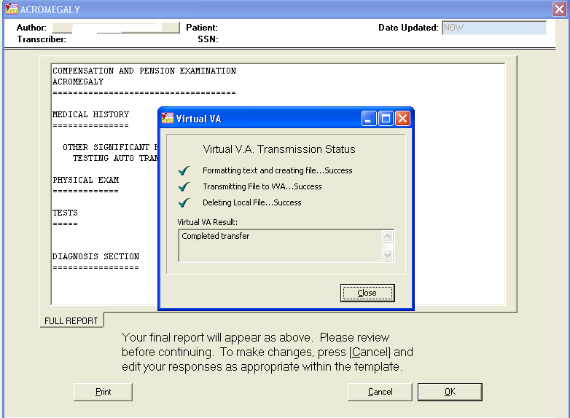

.

Create a new menu option for the retrieval and displaying of available documents in the Veteran/Service Member’s electronic claim folder
Issue
Create a new option for the retrieval and display of available documents in the Veteran/Service Member’s electronic claim folder that will enable VHA users to connect to VVA to retrieve a listing of all available documents in the associated eFolder(s).
Solution
FILE|GET DOCS FROM VIRTUAL VA has been created to allow CAPRI VHA users to retrieve and view documents in the Veteran/Service Members eFolder(s) in Virtual VA. By default, users will “not” be able to view restricted documents. Restricted documents are only available to CAPRI users that hold the DVBA VVA HOSPITAL ROLE security key.

***IMPORTANT NOTE***

With the introduction of “Get Docs from Virtual VA” in patch DVBA*2.7*184, there was an issue discovered with opening large TIFF files with the current Windows Photo Viewer, which is the default viewer on Windows 7 workstations for TIFF files. For this reason it is imperative that prior to the installation of CAPRI Patch DVBA*2.7*184 from a network share drive, the system administrators (IRM Staff) *MUST* validate that workstations running on Windows 7 have Microsoft Office Document Imaging 2007 (MODI) installed prior to installing DVBA*2.7*184.08 from a network share drive. This notice does not impact workstations running on Windows XP.

If you are upgrading CAPRI in workstation’s local hard drive, this pre-requisite should already have been met by an Action Item initiated by ESE. Reference national change order CO161098FY13.
However if one or more of your workstations have windows 7 and these don’t have a CAPRI.EXE on local hard disk, i.e. in case of new installs or running CAPRI from a Network Share then on those workstations this pre-requisite has *not* been automatically met. You can meet this pre-requisite by following the instructions on this link
Microsoft Office (2007) Document Imaging Build Document
In this document you may use either the SCCM method or the manual method.

All workstations that will run CAPRI.EXE, MUST have this MODI package installed in order to view large .TIFF files. Even if running CAPRI from the network, this package MUST still be installed on the workstation.

To access the GET DOCS FROM VIRTUAL VA:
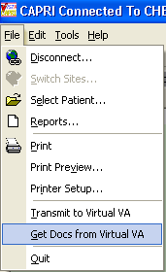
The “RETRIEVE DOCUMENTS FROM VIRTUAL VA” window will be displayed and allow the CAPRI user to open documents for the selected veteran, by clicking on document and choosing “View Selected Document” button or by double clicking on the document. This window allows the user to sort by column and view the sort in Ascending or Descending order.
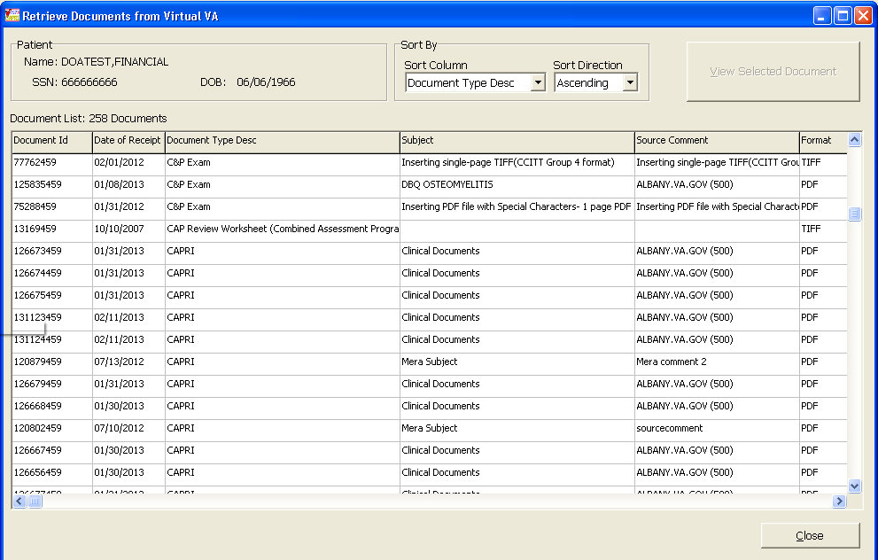

Rename the priority of exam codes “DCS-DES Claimed Condition By Svcmbr” and “DFD-DES Fit for Duty” priority of exam code to a single code of “IDES”.
Issue
A request has been made to rename the priority of exam codes “DCS-DES Claimed Condition By Svcmbr” and “DFD-DES Fit for Duty” to a single priority of exam code “IDES” in the 2507 Exam Request. Reports for the 2507 Exam Requests will change to reflect the use of IDES.
Solution
Modifications have been made to CAPRI and AMIE to convert the “DCS-DES Claimed Condition By Svcmbr” and “DFD-DES Fit for Duty” to a single priority of exam code “IDES in the C&P Exam and the following reports.
- AMIS 290 Reports
- Insufficient Exam Report

Customer – Veterans Benefits Administration (VBA)/Virtual VA (VVA)

Enhancement
The following section is an overview of the VBA enhancement that has been added in the CAPRI GUI v184 release.

New “Document Type” of “DoD Documents” for record transmission to VVA
Issue
New Document type of “DoD Documents” is needed for record transmissions to VVA via Web Service Interface for DoD tab users.
Solution
New Document type of “DoD Document” will now be transmitted to Virtual VA for DoD tab users.

Customer – CAPRI Remote Users

Enhancement
The following section is an overview of the enhancement for CAPRI REMOTE USERS that has been added in the CAPRI GUI v184 release.

Change to Fully Qualified Domain Name (FQDN) on CLAIMS Server
Issue
The DNS Admin and the VistA support team for Falling Waters found that dynamic updates for REDACTED, REDACTED and REDACTED are not allowed; therefore, new FQDNs were needed as follows for of which they have control to dynamically update.

FQDN (old) FQDN (new)
REDACTED REDACTED
REDACTED REDACTED
REDACTED REDACTED

Solution
Added two additional FQDN names that allow initial connection to the CLAIMS server: REDACTED replaces REDACTED and REDACTED replaces REDACTED. The old FQDN entries will remain in place to allow backward compatibility until everyone is updated.

Software and Documentation Retrieval

VistA Patch DVBA*2.7*184
                - The VistA server software is being distributed as a PackMan patch message through the National Patch Module (NPM). The KIDS build for this patch is DVBA*2.7*184.

CAPRI GUI v184 Client Software & User Documentation
                - The CAPRI GUI v184 client software is being distributed as executable CAPRI.exe contained in the zip file [DVBA_27_P184_08.ZIP]. The installed executable for this patch is client version 184.08 with a size of 14.4 MB.
                - The CAPRI GUI v184 client software and documentation for this patch may be retrieved directly using FTP. The preferred method is to FTP the files from:
                - REDACTED
                - This transmits the files from the first available FTP server. Sites may also elect to retrieve software directly from a specific server as follows:
OI&T Field Office | FTP Address | Directory
Albany | REDACTED | [anonymous.software]
Hines | REDACTED | [anonymous.software]
Salt Lake City | REDACTED | [anonymous.software]

                - The following files will be available:
File Name | Retrieval Format | Contents
DVBA_27_P184_08.zip | Binary | File(s) indented below:  - CAPRI.exe - CAPRI v184 executable  - VACAPRIVVA.dll – Virtual VA dynamically linked library  - CAPRI.map - CAPRI error map  - CAPRISession.r2w - Reflections session configuration  - ssh_config - Secure Shell configuration  - CAPRI_GUI_ISG.doc - CAPRI GUI Installation Supplemental Guide  - CAPRI_Help.chm
DVBA_27_P184_RN.PDF | Binary | Patch Release Notes (This document)
DVBA_27_P184_UM.PDF | Binary | Updated CAPRI GUI User Manual

Related Documents
The VA (Software) Documentation Library (VDL) web site will also contain the DVBA*2.7*184 Release Notes and updated CAPRI GUI User Manual. This website is usually updated within 1-3 days of the patch release date.
The VDL web address for CAPRI documentation is: http://www.va.gov/vdl/application.asp?appid=133

