Compensation and Pension Record Interchange (CAPRI)
(CAPRI GUI v. DVBA_27_185_09)

Release Notes

Patch DVBA*2.7*185

August 2013

Department of Veterans Affairs
Office of Enterprise Development

Preface
Purpose of the Release Notes
The Release Notes document describes the enhancements and/or defects addressed in Patch DVBA*2.7*185.
Reference Numbering System
This document uses a numbering system to organize its topics into sections and show the reader how these topics relate to each other. For example, section 1.3 means this is the main topic for the third section of Chapter 1. If there were two subsections to this topic, they would be numbered 1.3.1 and 1.3.2. A section numbered 2.3.5.4.7 would be the seventh subsection of the fourth subsection of the fifth subsection of the third topic of Chapter 2. This numbering system tool allows the reader to more easily follow the logic of sections that contain several subsections.

Table of Contents
1 Overview 1
2 Customer – Veteran Health Administration (VHA) and/or Veterans Benefits Admistration (VBA) 1
2.1 Defect Fixes with Remedy Tickets 1
2.1.1 INC000000842748 – CAPRI - losing formatting when reviewing 1
2.1.2 INC000000397878 – Date of TIU note is wrong (Duplicate INC000000594245) 1
2.2 Enhancements 2
2.2.1 VHA - Integrate the DemTran functionality into CAPRI as CAPRI Contract Referral (CCR) 2
2.2.2 VHA – Modify CAPRI to incorporate new version of PNCS, which supports the ability to increase the “vertical” size of the template display window 4
2.2.3 VHA – Add question to “signature validation” screen that controls whether exam request is a C&P Exam or non C&P Exam 4
2.2.4 VHA and/or VBA – Provide ability to “turn off” Get Docs from Virtual VA menu option 6
2.2.5 VHA and/or VBA – Modify “Restricted Access Message” for IVM and PGF documents in “Get Docs from Virtual VA” menu 7
2.2.6 VBA – Modify email status notifications to include “Priority of Exam” and to be sent when each exam is complete 7
2.2.7 VBA – Add ability to create comma delimited file to CAPRI Reports 7
2.3 Defects without Remedy Tickets 8
2.3.1 VHA and/or VBA – “Pending Form 7131 Requests” report missing pending report names under Items Pending Section 8
3 Software and Documentation Retrieval 9
3.1 VistA Patch DVBA*2.7*185 9
3.2 CAPRI GUI v185 Client Software & User Documentation 9
3.3 Related Documents 10

Overview
The main purpose of this patch is to release a new version of the Compensation & Pension Record Interchange (CAPRI) Graphical User Interface (GUI) that includes defect fixes and enhancements to the user interface to support user interface modifications.
CAPRI GUI v185 and patch (DVBA*2.7*185) provide defect fixes and enhancements for the CAPRI GUI and the Automated Medical Information Exchange (AMIE) package.
The information contained in this document is not intended to replace the CAPRI GUI User Manual. The software defects and enhancements are briefly discussed so that readers are aware of high level functional changes. The CAPRI GUI User Manual should be used to obtain detailed information regarding specific functionality.

Customer – Veteran Health Administration (VHA) and/or Veterans Benefits Admistration (VBA)

Defect Fixes with Remedy Tickets

INC000000842748 – CAPRI - losing formatting when reviewing

Issue
When providers receive messages that are sent using the review events window in CAPRI they are not delivered as they were typed. When more than one line is typed and a single carriage return is used after that line, the lines in the comments section all run together with no spaces.

Solution
The GUI Comments memo box, "FMMemoStyle", property was changed from msWrapped to msByLines so the message will now display as typed.

INC000000397878 – Date of TIU note is wrong (Duplicate INC000000594245)

Issue
The Date of Note displayed under “Clinical Documents” tab is wrong and seems to come from another veteran’s appointment.

Solution
CAPRI has been modified to clear out the Appointment Pointer IEN (anuApptPointer) and the Visit ID IEN (VisitIDIEN) when creating a Clinical document (TIUNote) to assure that nothing is left over from a previous patient appointment.

Enhancements

VHA - Integrate the DemTran functionality into CAPRI as CAPRI Contract Referral (CCR)
Issue
Integrate functionality created for the Disability Examination Management Tracking, Referral and Notification (DemTRAN) application into CAPRI and rename it to CAPRI Contract Referral (CCR).
- The Disability Examination Management (DEM) Contract presents a contract vehicle for VA Medical Center (VAMC) Compensation and Pension (C&P) Clinics and Integrated Disability Evaluation System (IDES) sites to outsource disability examinations to contract clinicians. The Disability Examination Management Tracking, Referral and Notification (DemTRAN) utility was created by the Chief Business Office (CBO) Business Engineering Services Team (BEST) for use within the Disability Clinics of the VAMCs or Military Installations to facilitate referral of disability exams to vendors (contractors) who are awarded contracts through the Disability Examination Management (DEM) Contract. DemTran is built upon the existing AMIE/CAPRI 2507 exam management framework and essentially inserting a new step into existing 2507 processes; DemTran facilitates the communication of an exam request (residing in the VistA AMIE Request file) to a specific vendor and the retrieval of the exam results once completed by the vendor; placing those retrieved results back into appropriate AMIE exam result storage locations.

.
Solution
DemTRAN, now known as, CAPRI Contract Referral (CCR) has been integrated into CAPRI and is available under the Tools menu. Please refer to “CAPRI Help” for Overview of the CCR process.

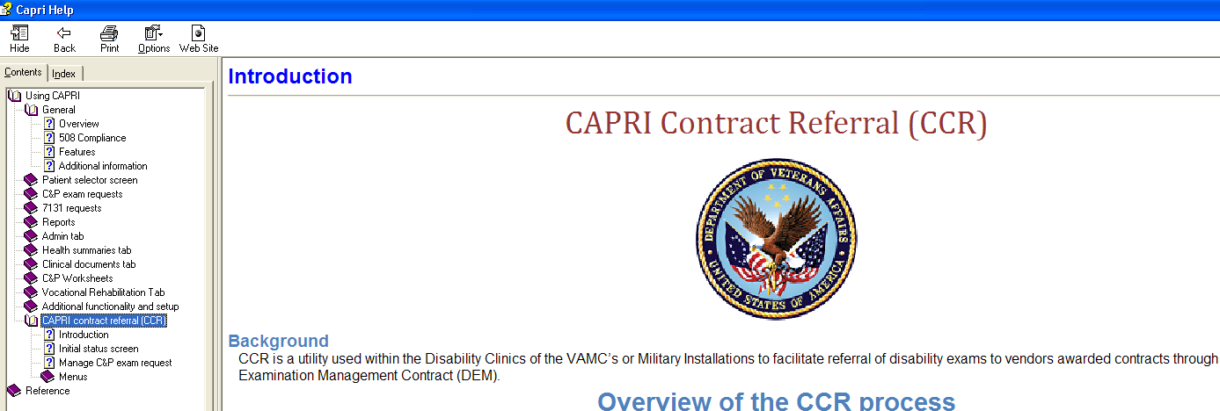

CCR will be available to users who hold the following security key assigned:
DVBA CONTRACTED EXM CCRUSER
DESCRIPTION: This security key will allow the CAPRI user access to the CCR menu. Without this key, CAPRI users will not see the option.

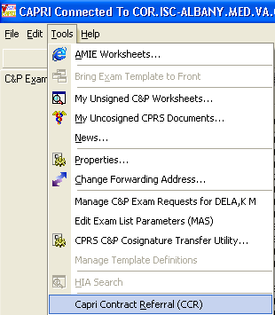

CCR users that will need access to the “Admin Tools” menu within CCR will need the following security key assigned:
DVBA CONTRACTED EXM SPRVSR
DESCRIPTION: This security key will allow the CAPRI user access to the following options under Admin Tools:
- Add/Edit Contractors
- Delete Exam Check-Out
- Edit Exam Check-In

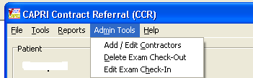

.

VHA – Modify CAPRI to incorporate new version of PNCS, which supports the ability to increase the “vertical” size of the template display window
Issue
CAPRI currently displays a fixed-size window when displaying a template.

Solution
CAPRI has been modified to incorporate a new version of PNCS, which supports the ability to increase the vertical size of the template display window, allowing for more vertical screen real estate. This change will dramatically change the user perception of the template and increase overall usability.

**Note**: This enhancement will not be fully functional until all the “DBQs” have been modified to accommodate this change.

VHA – Add question to “signature validation” screen that controls whether exam request is a C&P Exam or non C&P Exam
Issue
Add a question to the CAPRI Signature Validation screen that controls whether to treat this exam request as a C&P exam or a non-C&P exam (for instance, if a veteran takes a DBQ to their Primary Care Provider without a C&P exam request on file).

Solution
The question “Is this report a C&P evaluation in response to a request (2507) submitted by the VBA?” has been added to the “Signature Validation” screen. If answered "yes", CAPRI will maintain its current functionality. If answered "no", CAPRI will not filter the Note Title list (i.e. will display all titles), hide the section allowing the user to tie the exam back to an AMIE 2507 request, thus only creating the progress note for storage in the TIU Documents file.

**Please Note**
- Exam Results will be stored as a progress note “only” and will not be automatically shared with VBA.
- If a “non” C&P exam is sent for co-signature, please note that this note will be marked complete and will “not” be displayed in the “CPRS Co-Signature Alert Resolution” screen.
- Non C&P exams will “not” be transmitted to Virtual VA (VVA).

- If “NO” is chosen the following will be displayed. The Examiner will then choose an appointment, if applicable, or choose “No appointment was necessary (ie: opinion only report).

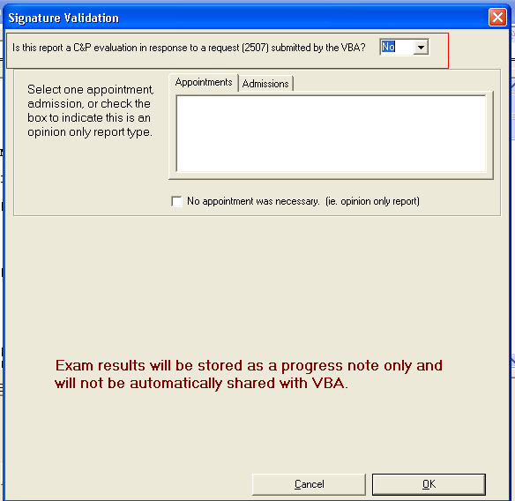

- Once an appointment or “no appointment was necessary” is chosen the following will be displayed and the examiner will choose a “Title”, enter his/her “Electronic Sig. Code”, and click “OK”.

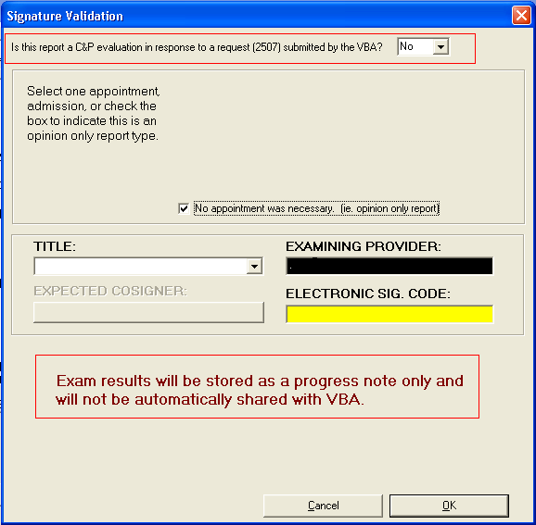

VHA and/or VBA – Provide ability to “turn off” Get Docs from Virtual VA menu option

Issue
CAPRI patch 184 introduced "Get Docs From Virtual VA" functionality. This functionality is visible and available to all users of CAPRI. The business requires the ability to turn this functionality on or off on a per-user basis.

Solution
Security key “DVBA CAPRI DENY_GETVBADOCS” has been created. When the CAPRI user is assigned the DVBA CAPRIDENY_GETVBADOCS security key, the user will not see the "Get Docs from Virtual VVA" option.

**Note:** If the user does not have the key assigned, the user can see "Get Docs from Virtual VA" from within CAPRI.

VHA and/or VBA – Modify “Restricted Access Message” for IVM and PGF documents in “Get Docs from Virtual VA” menu

Issue
Virtual VA has requested the modification of the 'Restricted Access Message' for document type 10, PGF docs, and document type 11, IVM documents.

Solution
When the user clicks on the "restricted document" or "view selected document", a message will display stating "Fiduciary Document- Access Not Permitted" and "Federal Tax Information- Access Not Permitted" respectively. This message will display in any case in which these documents are selected. The user's security key assignment will have no bearing on the message received.

VBA – Modify email status notifications to include “Priority of Exam” and to be sent when each exam is complete

Issue
Modify email status notifications to include “Priority of exam” and to be sent when “each” exam is complete.

Solution
The exam priority value (e.g., Initial SC, Initial NSC, POW, etc.) has been added to the exam status e-mail. An email will now be created for each complete exam, in addition to the
e-mail created for each completed 2507 request.

VBA – Add ability to create comma delimited file to CAPRI Reports

Issue
Add ability to create comma delimited file to CAPRI Reports

Solution
Added the ability for CAPRI to create a comma delimited file for the following reports:

- Pending C&P Exams
- Pending C&P Exams on Consolidated Remote Reports menu
- Insufficient Exam Report – Detailed Only. Summary is “not” available in comma delimited format
- Pending Form 7131 Requests
- Request Status by Date Range
- Exam Requests by Date Range
- Admission Report for SC Veterans
- Admission Inquiry By Date
- Special Report for A&A/Pension
- Discharge Report
- CNH Report of Admissions/Discharges
- Re-Admission Report
- CNH Stays in Excess of 90 Days
- CNH Roster Print
- Incompetent Veterans Report
- Template Activity –Sort by and Show will “not” be available in comma delimited format as Excel offers the ability to sort.

Defects without Remedy Tickets

VHA and/or VBA – “Pending Form 7131 Requests” report missing pending report names under Items Pending Section

Issue
Pending report names are not displayed in the “Items Pending” section of the Pending Form 7131 Requests” report.

Solution
The “Pending Form 7131 Requests” report has been modified to display the Pending report name under the “Items Pending” section.

Ex:
Pending 7131 Report

PENDING REQUEST REPORT FOR ALBANY
ALL REGIONAL OFFICES, ALL DIVISIONS
Processed on: 07/11/2013

Original Division: TEST2

VETERAN,JOE
SSN: XXX-XX-XXXX
Claim no: XXXXXXX
Activity date: 05/14/1991
Elapsed days: 5381
Items Pending:
COMPETENCY REPORT (TEST2)
Requested by: TESTER,JOE L AT 500ABCD

Software and Documentation Retrieval

VistA Patch DVBA*2.7*185
                - The VistA server software is being distributed as a PackMan patch message through the National Patch Module (NPM). The KIDS build for this patch is DVBA*2.7*185.

CAPRI GUI v185 Client Software & User Documentation
                - The CAPRI GUI v185 client software is being distributed as executable CAPRI.exe contained in the zip file [DVBA_27_P185_09.ZIP]. The installed executable for this patch is client version 185.08 with a size of 14.4 MB.
                - The CAPRI GUI v185 client software and documentation for this patch may be retrieved directly using FTP. The preferred method is to FTP the files from:
                - REDACTED
                - This transmits the files from the first available FTP server. Sites may also elect to retrieve software directly from a specific server as follows:
OI&T Field Office | FTP Address | Directory
Albany | REDACTED | [anonymous.software]
Hines | REDACTED | [anonymous.software]
Salt Lake City | REDACTED | [anonymous.software]

                - The following files will be available:
File Name | Retrieval Format | Contents
DVBA_27_P185_09.zip | Binary | File(s) indented below:  - CAPRI.exe - CAPRI v185 executable  - VACAPRIVVA.dll – Virtual VA dynamically linked library  - CAPRI.map - CAPRI error map  - CAPRISession.r2w - Reflections session configuration  - ssh_config - Secure Shell configuration  - CAPRI_GUI_ISG.doc - CAPRI GUI Installation Supplemental Guide  - CAPRI_Help.chm
DVBA_27_P185_RN.PDF | Binary | Patch Release Notes (This document)
DVBA_27_P185_UM.PDF | Binary | Updated CAPRI GUI User Manual

Related Documents
The VA (Software) Documentation Library (VDL) web site will also contain the DVBA*2.7*185 Release Notes and updated CAPRI GUI User Manual. This website is usually updated within 1-3 days of the patch release date.
The VDL web address for CAPRI documentation is: http://www.va.gov/vdl/application.asp?appid=133

