Compensation and Pension Record Interchange (CAPRI)
(CAPRI GUI v. DVBA_27_189_03)

Release Notes

Patch DVBA*2.7*189

March 2015

Department of Veterans Affairs
Office of Enterprise Development

Preface
Purpose of the Release Notes
The Release Notes document describes the enhancements and/or defects addressed in Patch DVBA*2.7*189.
Reference Numbering System
This document uses a numbering system to organize its topics into sections and show the reader how these topics relate to each other. For example, section 1.3 means this is the main topic for the third section of Chapter 1. If there were two subsections to this topic, they would be numbered 1.3.1 and 1.3.2. A section numbered 2.3.5.4.7 would be the seventh subsection of the fourth subsection of the fifth subsection of the third topic of Chapter 2. This numbering system tool allows the reader to more easily follow the logic of sections that contain several subsections.

Table of Contents
1 Overview 1
2 Customer – Veterans Benefits Administration (VBA) 1
2.1 Enhancements 1
2.1.1 Update Cancellation Reasons – C&P Exams tab 1
2.1.2 Store and display cancellation comments – C&P Exams tab 3
2.1.3 Request Status by Date Range report – File|Reports 3
2.1.4 Update Insufficient Reasons – C&P Exams tab 4
2.1.5 Add the ability to store/display “YES/NO” value depending on whether C&P Exam Request is “New” or “Insufficient” – C&P Exams tab 5
2.1.6 Remove “Priority of Exam” and new field of “Claim Type” – C&P Exams tab 7
2.1.7 Add new field Special Consideration(s) – C&P Exams tab 8
3 Customer – Veteran Health Administration (VHA) 10
3.1 Defects with Remedy Ticket 10
3.1.1 INC000001112581 - CAPRI was updated, patch DVBA*2.7*187, exams are not being released to the Regional office 10
4 Customer – Veterans Benefits Administration (VBA) 11
4.1 Defects without Remedy Ticket 11
4.1.1 Double line displays on FILE menu when user does not have VVA or DAS security keys 11
5 Software and Documentation Retrieval 11
5.1 VistA Patch DVBA*2.7*189 11
5.2 CAPRI GUI v189 Client Software & User Documentation 11
5.3 Related Documents 12

Overview
The main purpose of this patch is to release a new version of the Compensation & Pension Record Interchange (CAPRI) Graphical User Interface (GUI) that includes defect fixes and enhancements to the user interface to support user interface modifications.
CAPRI GUI v189 and patch (DVBA*2.7*189) provide defect fixes and enhancements for the CAPRI GUI and the Automated Medical Information Exchange (AMIE) package.
The information contained in this document is not intended to replace the CAPRI GUI User Manual. The software defects and enhancements are briefly discussed so that readers are aware of high level functional changes. The CAPRI GUI User Manual should be used to obtain detailed information regarding specific functionality.

Customer – Veterans Benefits Administration (VBA)

Enhancements

Update Cancellation Reasons – C&P Exams tab

VBA has requested that C&P Exam Cancellation Reasons be modified as follows:

After installation of CAPRI VistA patch, DVBA*2.7*189 the following cancellation reasons will be selectable by a user:

- DUPLICATE REQUEST
- EXAM REQUESTED AT DIFFERENT LOCATION
- EXAM REQUESTED IN ERROR
- INCOMPLETE REQUEST
- UNABLE TO CONTACT VETERAN
- VETERAN DIED
- VETERAN FAILED TO REPORT
- VETERAN FAILED TO RSVP
- VETERAN HOSPITALIZED
- VETERAN IS EMPLOYEE
- VETERAN REFUSED EXAM
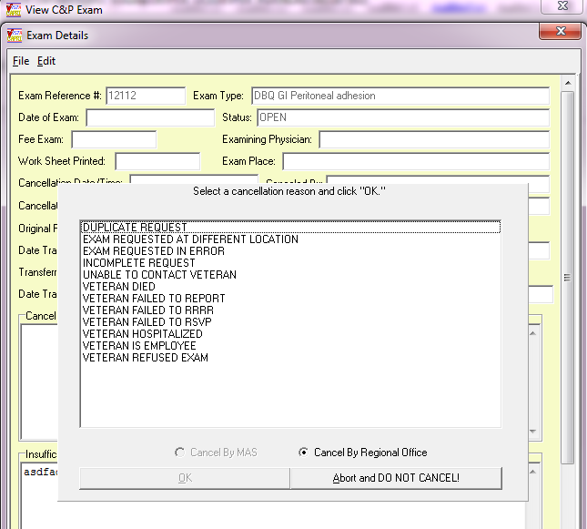

The following cancellation reasons will no longer be displayed:

- ADEQUATE MEDICAL EVIDENCE
- DUPLICATE EXAM
- EMPLOYEE
- EXAM NAME DELETED FROM FILE
- FAILED TO REPORT
- INCORRECT JURISDICTION
- INCORRECT TEST ORDERED
- NO EXAMS ORDERED
- NOT ENOUGH INFORMATION
- UNDELIVERED NOTIFICATION
- VET REFUSED EXAM THIS LOCATION
- VETERAN CANCELLED EXAM FOR DBQ
- VETERAN WITHDREW CLAIM

Store and display cancellation comments – C&P Exams tab

CAPRI has been modified to save cancellation comments entered on the Exam Details window of the C&P Exam Request.

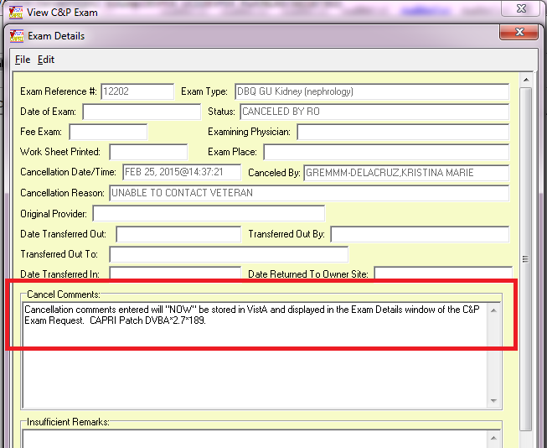

Request Status by Date Range report – File|Reports

Request Status by Date Range report has been modified to display the Cancellation Reason and Cancellation comments on both the plain text display and CSV Comma Delimited Export (excel component)

Plain Text display:
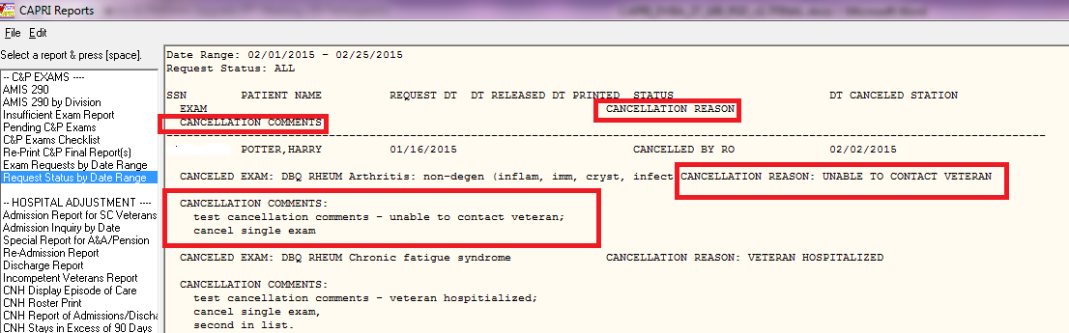

Excel Component display:

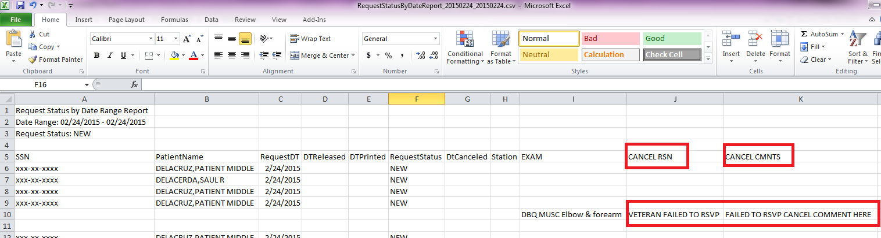

Update Insufficient Reasons – C&P Exams tab

VBA has requested that C&P Exam Insufficient Reasons be modified as follows:

After installation of CAPRI VistA patch, DVBA*2.7*189 the following insufficient reasons will be selectable by a user:

- CASE REQUIRED EXAM BY A SPECIALIST
- CONFLICTING INFORMATION IN REPORT
- FAILED TO ADDRESS ALL CONDITIONS REQUESTED
- FAILED TO COMPLY WITH BVA REMAND INSTRUCTIONS
- FAILED TO PROVIDE DIAGNOSIS
- FAILED TO PROVIDE MEDICAL OPINION
- FAILED TO PROVIDE RATIONALE
- FAILED TO PROVIDE REQUESTED/REQUIRED INFORMATION
- IN-PERSON EXAMINATION WAS NOT PERFORMED

*Note: not all new insufficient reasons are displayed in this screen shot, this is just to show where the insufficient reasons are selectable**
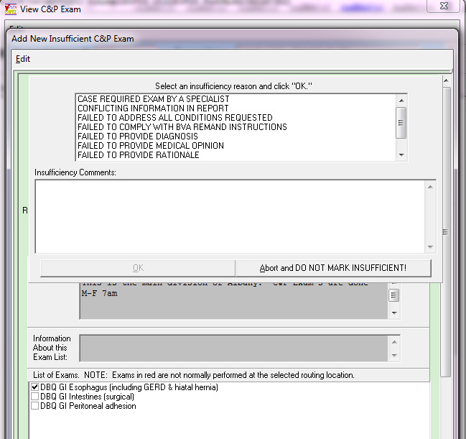

The following insufficient reasons will no longer be displayed:

- DIAGNOSIS INCONSISTENT WITH EVIDENCE
- EXAM PREVIOUSLY RETURNED AS INSUFFICIENT, RETURN AGAIN
- INSUFFICIENT
- EYE EXAM IS INSUFFICIENT
- FAILED TO PERFORM REQUESTED SPECIALIST EXAM
- FAILED TO PROVIDE ADDITIONAL EXAM RECOMMENDED BY EXAMING PHYSICIAN
- FAILED TO PROVIDE RANGE OF MOTION
- FAILED TO PROVIDE REQUESTED MEDICAL OPINION
- FAILED TO PROVIDE TEST ROUTINELY DONE FOR SPECIFIC CONDITION
- FAILED TO REVIEW TEST RESULTS BEFORE MAKING DIAGNOSIS
- OTHER

Add the ability to store/display “YES/NO” value depending on whether C&P Exam Request is “New” or “Insufficient” – C&P Exams tab

CAPRI has been modified to display a new field called “Insufficient” on the “Add New C&P Exam” window and the new window “Add New Insufficient C&P Exam”.

If a new C&P Exam Request is generated the “Add New C&P Exam” window will now contain the field “Insufficient” and display a default value of “NO”. This field is NOT editable.

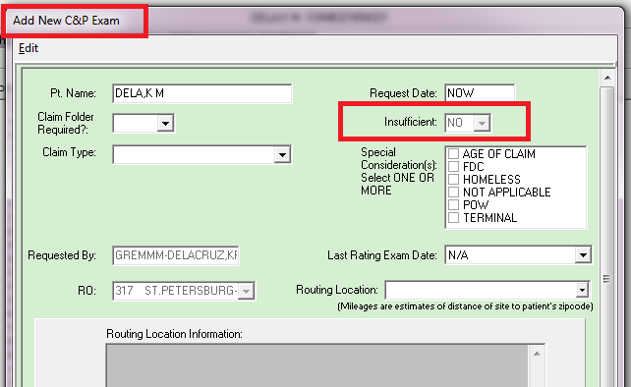

If a C&P Exam Request that has a status of “Completed, Printed by RO” or “Released to RO, Not Printed” is marked insufficient then the “Add New Insufficient C&P Exam” window is displayed and the Insufficient field has a default value of “YES” and is NOT editable.

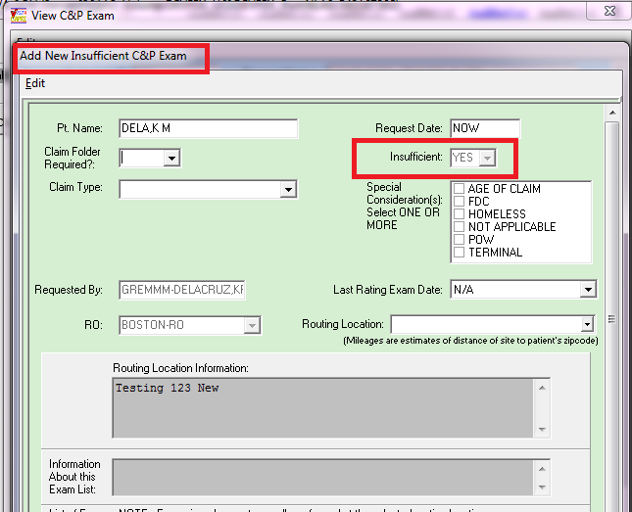

Remove “Priority of Exam” and new field of “Claim Type” – C&P Exams tab

The “Add New C&P Exam” and “View C&P Exam” windows have been modified to no longer display the “Priority of Exam” field and now display “Claim Type” field.

The “Claim Type” field is required and will only allow selection of one of the following values. If Claim type is not chosen a message will be displayed to the user “Please select one Claim Type” upon sending an exam request or saving changes to an exam request.

Claim Type will now be displayed on the Outlook email messages for completed and cancelled exams and mailman messages instead of Priority of Exam.

Claim Type values:

- BDD
- BDD – DOD SHA
- IDES
- INCREASE ONLY
- ORIGINAL
- QUICK START
- SUPPLEMENTAL

Add New C&P Exam window
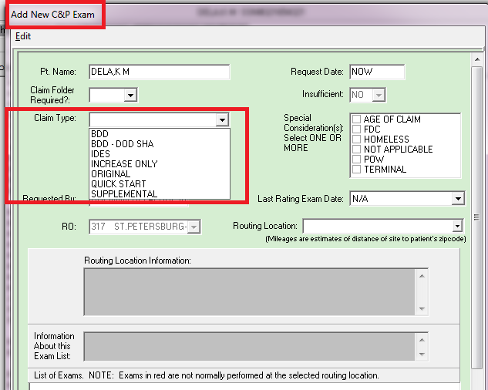

View C&P Exam window
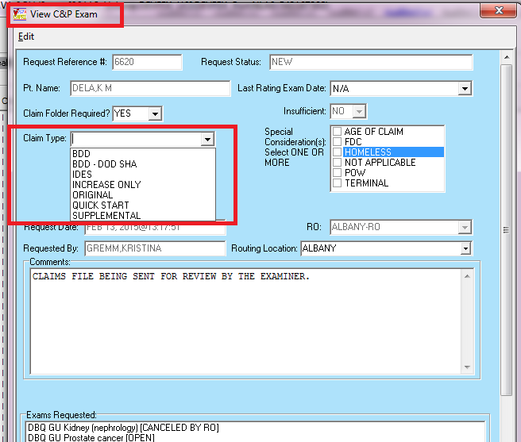

Add new field Special Consideration(s) – C&P Exams tab

The “Add New C&P Exam” and “View C&P Exam” windows have been modified to contain/display new field “Special Consideration(s)”.

The “Special Consideration(s)” field is required and will allow selection of multiple values. However, if “Not Applicable” is chosen no other values are availabe for selection.

If one or more values are not chosen a message will be displayed to the user “Please select ONE OR MORE Special Considerations or select “Not Applicable” upon sending an exam request or saving changes to an exam request.

Special Consideration(s) will now be displayed on the Outlook email messages for completed and cancelled exams and mailman messages.

Special Consideration(s) values:

- AGE OF CLAIM
- FDC
- HOMELESS
- NOT APPLICABLE
- POW
- TERMINAL

Add New C&P Exam window
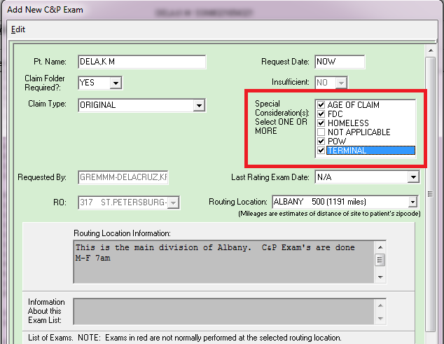

View C&P Exam window
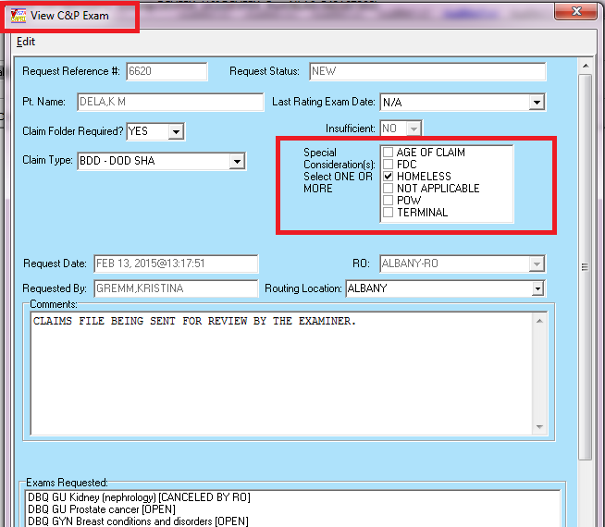

Customer – Veteran Health Administration (VHA)

Defects with Remedy Ticket

INC000001112581 - CAPRI was updated, patch DVBA*2.7*187, exams are not being released to the Regional office

After installing DVBA*2.7*187.12 GUI 12 sites reported the following error in Capri when trying to complete a template via the C&P Worksheets tab.

It was determined that the sites receiving this error had modified the standard patient DFN number. CAPRI has been modified to accommodate the custom DFN number and will no longer cause and error when completing a template(s).
Error Encountered
Functionwas: M Erro=<SYNTAX>S4+12^DICL2 Last REF=^DVB(396.3,48072,0)-I Error was : M Error - Use ^XTER
That is message received in capri GUI.
Vista is also seeing similar error in error trap:
$ZE= <SYNTAX>S4+12^DICL2
Last Global Ref: ^DVB(396.3,48072,0)
. . I 1 X DISCREEN(DISCR) S DISKIP='$T

Customer – Veterans Benefits Administration (VBA)

Defects without Remedy Ticket

Double line displays on FILE menu when user does not have VVA or DAS security keys

Double line displays on the FILE menu when user does not have security keys DVBA CAPRI GETDOCSFROMVLER and DVBA CAPRI GETVBADOCS.

CAPRI as been modified to disable extra menu bar line when a user does not have the DVBA CAPRI GETDOCSFROMVLER and DVBA CAPRI GETVBADOCS security keys.

Software and Documentation Retrieval

VistA Patch DVBA*2.7*189
                - The VistA server software is being distributed as a PackMan patch message through the National Patch Module (NPM). The KIDS build for this patch is DVBA*2.7*189.

CAPRI GUI v189 Client Software & User Documentation
                - The CAPRI GUI v189 client software is being distributed as executable CAPRI.exe contained in the zip file [DVBA_27_P189_03.ZIP]. The installed executable for this patch is client version 189.03 with a size of 16.4 MB.
                - The CAPRI GUI v189 client software and documentation for this patch may be retrieved directly using FTP. The preferred method is to FTP the files from: REDACTED

                - This transmits the files from the first available FTP server. Sites may also elect to retrieve software directly from a specific server as follows:
OI&T Field Office | FTP Address | Directory
Albany | REDACTED | [anonymous.software]
Hines | REDACTED | [anonymous.software]
Salt Lake City | REDACTED | [anonymous.software]

                - The following files will be available:

File Name | Retrieval Format | Contents
DVBA_27_P189_03.zip | Binary | File(s) indented below:  - CAPRI.exe - CAPRI v189 executable  - VACAPRIVVA.dll – Virtual VA dynamically linked library  - CAPRI_Help.chm  - CAPRI.map - CAPRI error map  - CAPRISession.r2w - Reflections session configuration  - ssh_config - Secure Shell configuration  - CAPRI_GUI_ISG.doc - CAPRI GUI Installation Supplemental Guide  - Libeay32.dll - VLER /DAS dynamically linked library  - Ssleay32.dll - VLER /DAS dynamically linked library  - QPDF.exe - Support PDF compression and Linearization  - QPDF13.dll - Support PDF compression and Linearization  - LIBGCC_S_DW2-1.dll - Support PDF compression and Linearization  - LIBSTDC++-6.dll - Support PDF compression and Linearization
DVBA_27_P189_RN.PDF | Binary | Patch Release Notes (This document)
DVBA_27_P189_UM.PDF | Binary | Updated CAPRI GUI User Manual
CAPRI_SYSADMINTECH GUIDE_DVBA_27_TM.PDF | Binary | Updated CAPRI System Administration  And Technical Guide

Related Documents
The VA (Software) Documentation Library (VDL) web site will also contain the DVBA*2.7*189 Release Notes and updated CAPRI GUI User Manual. This website is usually updated within 1-3 days of the patch release date.
The VDL web address for CAPRI documentation is: http://www.va.gov/vdl/application.asp?appid=133

