Integrated Funds Distribution, Control Point Activity, Accounting and Procurement (IFCAP)

Accounting Technician
User’s Guide

Version 5.1

October 2000

Revised July 2021

Department of Veterans Affairs
Office of Information and Technology
Product Development

Revision History

Initiated on 12/29/04
Date | Revision | Description | Author(s)
07/2021 | 13.0 | Patch PRC*5.1*223  13-2 - Changed the option Queue Single Receiving Report for Transmission with the following message:  “**> Out of order: No longer available, partial filing non-compliant” | REDACTED  SQA Analyst
10/2019 | 12.0 | Reviewed document; made minor formatting changes | REDACTED  Program Analyst
10/2017 | 11.0 | Patch PRC*5.1*198 (NIF/IFCAP IMF Interface Enhancement)  Section 10.4 Vendor File Edit, added “In order to edit the VENDOR NAME and PAYMENT ADDRESS fields for a Medical/Surgical Prime (MSPV) Vendor (vendor numbers above 949,999), the Fiscal user must hold the PRCHVEN security key.”  Updated footers with current revision date.  Added “MSPV” to the Glossary | REDACTED  IMF/IFCAP Developer  REDACTED  Functional Analyst  REDACTED  Technical Writer
01/2014 | 10.0 | Patch PRC*5.1*174 (IFCAP/eCMS Interface)  10.12 – Added the name of security key to the following sentence, “This option is available to Fiscal users who have the PRCHJFIS Security Key.”  10.12 – Added new Transaction Report –eCMS/IFCAP option to Accounting Utilities Menu.  10.12.1 – Added “Note: At the DEVICE: HOME// prompt, the report can either be displayed to the screen or sent to a printer. The latter choice is appropriate when the report is long.”  13 – Added Transaction Report – eCMS/IFCAP to Menu Outline. | REDACTED
02/2013 | 9.0 | Patch PRC*5.1*161 query user for if they wish to view the 1358 details. See pages 4-1, 4-2. | REDACTED
01/2013 | 8.0 | As of Patch PRC*5.1*162, completion of a payment batch using the Finalize a Batch option in VistA Fee Basis will automatically generate a new transaction that is sent to Central Fee. This new transaction will replace all use of 994 code sheets in IFCAP.  The Fee Basis - IFCAP Code Sheet Menu [PRC FEE GECS MAIN MENU] and all associated options were removed from the Accounting Technician Menu [PRCFA ACCTG TECH] as this functionality is no longer necessary. | REDACTED
09/2012 | 7.5 | Patch PRC*5.1*167 Updates (eCMS Interface to IFCAP): added eCMS term to the Glossary | REDACTED
10/2011 | 7.0 | Patch PRC*5.1*158 Modification of title for IFCAP VA Form 1358. See pages 3-1, 4-13, 13-1. | REDACTED
08/2011 | 6.0 | Remedy Ticket HD512314 make option lists complete. See page 8-7 to 8-8. | REDACTED
07/2011 | 5.0 | Patch PRC*5.1*153 – New message interface with Austin for 1358 Obligations see pp. 4-5, 4-10. | REDACTED
01/05/2011 | 4.0 | Changes to the manual based on implementation of the Segregation of Duties functionality, per patch PRC*5.1*148. Includes the removal of the Obligation Data option. | REDACTED
05/31/07 | 3.0 | Added information covering the use of the Logistics Data Query Tool (LDQT), per patch PRC*5.1*103. | REDACTED
02/06/06 | 2.0 | Added New option, Print Obligated 1358s, per patch PRC*5.1*79. | REDACTED
12/29/04 | 1.1 | PDF file checked for accessibility to readers with disabilities. | REDACTED
12/29/04 | 1.0 | Updated to comply with SOP 192-352 Displaying Sensitive Data. | REDACTED

PREFACE
This manual is designed to provide you, the Accounting Technician, with the information necessary to obligate purchase orders and 1358s, process receiving reports, amendments, and adjustment vouchers, make General Post Fund transactions, and track invoices for payment into the Financial Management System (FMS). The Integrated Funds Distribution, Control Point Activity, Accounting and Procurement (IFCAP) package automates functions in Acquisition and Materiel Management (A&MM), Fiscal and for all VA Services that request supplies and services. The goal of IFCAP is to integrate these three areas and allow users to share procurement and financial information.
THIS PAGE INTENTIONALLY LEFT BLANK

TABLE OF CONTENTS

1 Introduction 1
1.1 The Role of the Accounting Technician 1
1.2 How to Use This Guide 1
1.2.1 Hypertext and Hyperlinks 1
1.2.2 Procedure Steps 2
1.2.3 Typographical Conventions 3
1.3 FileMan Date Conventions 4
1.4 Package Management, Legal Requirements and Security Measures 4
1.5 Package Operation 4
1.6 Funds Obligation Flowchart 6
2 Inspect Purchase Orders and Requisitions 2-1
2.1 Introduction 2-1
2.2 Purchase Order Number 2-1
2.3 Invoice Address 2-1
2.4 Cost Center 2-1
2.5 Fiscal Source Code 2-1
2.6 Budget Object Code 2-2
3 Obligating and Amending Purchase Orders 3-1
3.1 Introduction 3-1
3.2 Is there Adequate Funding for the Purchase Order? 3-1
3.3 Obligating a Purchase Order 3-1
3.3.1 Menu Path 3-1
3.3.2 Select Order Number 3-2
3.3.3 Display Order Information 3-2
3.3.4 Obligation Date 3-3
3.3.5 Post Using Status of Funds Tracker 3-3
3.3.6 Enter Transaction Amount 3-3
3.4 Amend a Purchase Order 3-4
3.4.1 Is There Adequate Funding for the Amendment? 3-4
3.4.2 Obligate an Amendment 3-4
4 Obligating and Adjusting 1358 Transactions 4-1
4.1 Inspect the 1358 for Correctness 4-1
4.2 Is There Adequate Funding for the 1358? 4-1
4.3 Obligate the 1358 4-1
4.3.1 Menu Path 4-1
4.3.2 Enter Station Number 4-1
4.3.3 Review Balances 4-3
4.3.4 Enter Obligation Number 4-3
4.3.5 Enforcing Segregation of Duties on 1358s 4-4
5 Enforcing Segregation of Duties in Online Certification System for 1358 Obligation 5-1
5.1 Adjustments to 1358s 5-1
5.1.1 Introduction 5-1
5.1.2 Inspect the Adjustment for Correctness 5-2
5.1.3 Is There Adequate Funding for the Adjustment? 5-2
5.1.4 Adjust the 1358 5-2
5.1.5 Enforcing Segregation of Duties on 1358 Adjustments 5-4
5.1.6 Enforcing Segregation of Duties in Online Certification System for 1358 Adjustments 5-6
5.2 Display or Print Obligated 1358s 5-6
5.3 Display/Print 1358 5-7
6 Review and Forward Receiving Reports for Payment 6-1
6.1 Introduction 6-1
6.2 Dollar Amounts 6-1
6.2.1 Menu Path 6-1
6.2.2 Review Order 6-2
6.2.3 Review Receiving Report 6-2
7 Process 1358 Invoices for Payment 7-1
7.1 Introduction 7-1
7.2 Menu Path 7-1
7.2.1 Select Station Number 7-1
7.2.2 Assign Liquidation Number 7-2
7.2.3 Select Budget Object Code 7-2
7.3 Verifying Payment Transmission 7-3
7.3.1 Menu Path 7-3
7.3.2 Enter and Verify Transmission 7-3
8 Resolving Error Messages 8-1
8.1 FMS Error Processing 8-1
8.2 Stack Status Report 8-2
8.3 FMS Inquiry Rejected Obligation Documents Menu 8-4
8.4 Payment Error Processing 8-8
9 Purchase Card Options 9-1
9.1 Purchase Card Transaction Print Menu 9-1
9.2 Detailed Report of Unpaid PC Transactions by FCP 9-1
9.2.1 Enter Parameters and Display 9-1
9.3 Fiscal Daily Review 9-1
9.3.1 Enter Parameters and Display 9-1
9.4 History of Purchase Card Transactions 9-2
9.4.1 Enter Parameters and Display 9-3
9.5 Reconciled Purchase Card Transactions 9-3
9.5.1 Enter Parameters and Display 9-4
9.6 Unreconciled Purchase Card Transactions 9-4
9.6.1 Enter Parameters and Display 9-5
9.7 ET-FMS Document Display 9-5
9.7.1 Enter Parameters and Display 9-5
9.8 ET-FMS Document Rebuild 9-6
9.9 Purchase Card Transaction Status 9-6
9.9.1 Enter Parameters and Display 9-6
9.10 Monitor Reconciled Orders by Card Holder 9-7
9.10.1 Enter Parameters and Display 9-7
9.11 BOC Report for OA&MM/Fiscal 9-8
9.11.1 Enter Parameters and Display 9-8
10 Accounting Utilities 10-1
10.1 Introduction 10-1
10.2 Update Status of Funds Balances 10-1
10.2.1 Enter Parameters and Display 10-1
10.3 Lookup Vendor ID Number 10-1
10.3.1 Enter Parameters and Display 10-2
10.4 Vendor File Edit 10-2
10.4.1 Enter Parameters and Display 10-2
10.5 Edit BOC in Item File 10-3
10.5.1 Enter Parameters and Display 10-3
10.6 Clear Program Lock 10-4
10.6.1 Enter Parameters and Display 10-4
10.7 Undelivered Orders Reconciliation Report 10-5
10.7.1 Enter Parameters and Display 10-5
10.8 Fiscal Pending Action 10-6
10.8.1 Enter Parameters and Display 10-6
10.9 History - Code Sheet/Obligation (PAT) Number 10-6
10.9.1 Enter Parameters and Display 10-6
10.10 Review Vendor Request 10-8
10.10.1 Enter Parameters and Display 10-9
10.11 Setup Accounts Receivable Selected Vendor 10-13
10.11.1 Enter Parameters and Display 10-13
10.12 Transaction Report – eCMS/IFCAP 10-14
10.12.1 Enter Parameters and Display 10-14
11 FMS Code Sheet Menu 11-1
11.1 Introduction 11-1
11.2 Menu Choices 11-1
11.2.1 Transmission Records/Code Sheets 11-1
11.2.2 Enter Parameters and Display 11-1
11.2.3 Retransmit Stack File Document 11-2
11.2.4 User Comments 11-2
12 The Logistics Data Query Tool 12-1
13 Menu Outline 13-1
14 Glossary 14-1
15 Index i

Figures

Figure 3-1 Menu Path 3-1
Figure 3-2 - Select Order Number 3-2
Figure 3-3 - Display Order Information 3-2
Figure 3-4 - Obligation Date 3-3
Figure 3-5 Post Using Status of Funds Tracker 3-3
Figure 3-6 Enter Transaction Amount 3-4
Figure 3-7 Menu Path 3-5
Figure 3-8 Enter Electronic Signature 3-5
Figure 3-9 Display Amendment 3-6
Figure 3-10 Display Amendment 3-7
Figure 4-1 Menu Path 4-1
Figure 4-2 Setup Parameters 4-2
Figure 4-3 Review Balances 4-3
Figure 4-4 Enter Obligation Number 4-3
Figure 4-5 Enforcing Segregation of Duties on 1358s 4-4
Figure 5-1 Menu Path 5-2
Figure 5-2 Setup Parameters 5-2
Figure 5-3 Review Balances 5-3
Figure 5-4 Segregation of Duties on Adjustments 5-5
Figure 5-5 Setup Parameters and Display 5-7
Figure 6-1 Setup Parameters and Display 6-1
Figure 6-2 Review Order 6-2
Figure 6-3 Review Receiving Report 6-3
Figure 7-1 Menu Path 7-1
Figure 7-2 Select Station Number 7-2
Figure 7-3 Assign Liquidation Number 7-2
Figure 7-4 Select BOC 7-3
Figure 7-5 Enter and Verify Transmission 7-3
Figure 8-1 Outgoing Message to FMS 8-2
Figure 8-2 Confirmation Message Returning from Austin 8-2
Figure 8-3 Confirmation Message Returning from Austin 8-3
Figure 8-4 Menu Path and Display 8-4
Figure 8-5 Enter Parameters and Display 8-5
Figure 8-6 Payment Voucher Inquiry 8-9
Figure 8-7 FMS Payment Voucher Error Processing 8-10
Figure 9-1 Detailed Report of Unpaid PC Transactions by FCP 9-1
Figure 9-2 Fiscal Daily Review 9-2
Figure 9-3 History of Purchase Card Transactions 9-3
Figure 9-4 Reconciled Purchase Card Transactions 9-4
Figure 9-5 Unreconciled Purchase Card Transactions 9-5
Figure 9-6 ET-FMS Document Display 9-6
Figure 9-7 Purchase Card Transaction Status 9-7
Figure 9-8 Monitor Reconciled Orders by Card Holder 9-8
Figure 9-9 BOC Report for OA&MM/Fiscal 9-9
Figure 10-1 Update Status of Funds Balances 10-1
Figure 10-2 Lookup Vendor ID Number 10-2
Figure 10-3 Vendor File Edit 10-3
Figure 10-4 Edit BOC in Item File 10-4
Figure 10-5 Edit BOC in Item File 10-4
Figure 10-6 Undelivered Orders Reconciliation Report 10-5
Figure 10-7 Fiscal Pending Action 10-6
Figure 10-8 History - Code Sheet/Obligation (PAT) Number 10-6
Figure 10-9 Review Vendor Entry (RE) 10-9
Figure 10-10 Edit Vendor Request (EV) 10-10
Figure 10-11 Delete Vendor Request (DV) 10-11
Figure 10-12 Send Vendor Request (SD) 10-12
Figure 10-13 Send Vendor Request (SD) 10-12
Figure 10-14 Quit Review Vendor Request (Q) 10-13
Figure 10-15 Setup AR Selected Vendor 10-13
Figure 11-1 FMS Code Sheet Menu 11-1
Figure 11-2 FMS Code Sheet Menu 11-1
Figure 11-3 Retransmit Stack File Document 11-2
Figure 11-4 User Comments 11-2
Figure 13-1 Accounting Technician Menu Outline 13-2

Tables
Table 1-1Icons Used in Boxed Notes 3

Introduction

The Role of the Accounting Technician
As an Accounting Technician, you have an important role in the way the Department of Veterans Affairs manages its finances. Accounting Technicians control, coordinate and direct a variety of financial documents and reports and ensure their timely, accurate disposition. Accounting Technicians inspect purchase orders and requisitions, obligate and amend transactions of funds, and review and forward invoices and receiving reports for payment. Accounting Technicians rely on Control Point Officials and Purchasing Agents to provide accurate information about the obligations that the Accounting Technician charges to the Control Point. They also rely on the Warehouse Clerks to process receiving reports quickly and accurately, and the Purchasing Agents and Requisition Clerks to process amendments and adjustment vouchers quickly and accurately. Vendors rely on the Accounting Technician to make sure that the receiving reports are promptly transmitted for payment and that certified invoices are processed according to the Prompt Payment Act.

How to Use This Guide
This guide explains how to perform the role of the Accounting Technician by dividing that role into small, manageable tasks. The authors of this guide have listed these tasks in successive order so that each instruction builds on the functionality and information from the previous instructions. This will allow new Accounting Technicians to use this guide as a tutorial by following the instructions from beginning to end. Experienced Accounting Technicians can use this guide as a reference tool by using the index and table of contents.
Before you plunge into learning about your job as Accounting Technician, please take a few moments to familiarize yourself with how this guide is put together.
- Read all of 1. It explains how to interpret the graphics and typestyles used in this guide.
- If this is your first exposure to using VistA, you should become familiar with terminology and functions that are used throughout VistA applications. There are several manuals and guides that provide a foundation for use of Kernel, FileMan, and MailMan. These documents replace the old DHCP User’s Guide to Computing, which is obsolete. You will find these at:
Kernel: VA Software Document Library – Kernel
FileMan: VA Software Document Library - FileMan
MailMan: VA Software Document Library - MailMan
- Read the remainder of this guide.

Hypertext and Hyperlinks
This document contains “hypertext” that provides links to other parts of this document or to other related documents. Hypertext is a computer-based text retrieval system that enables you to access particular locations in electronic documents by clicking on hyperlinks in those documents. If you are viewing this document on your computer screen (as opposed to reading a printed copy), you will find certain hyperlinked words or phrases.
- An internal or “cross-reference” hyperlink allows you to “jump” to another part of this document. Typically, these hyperlinks will be imbedded in sentences like “See the IFCAP Glossary in 14.” Although such internal cross-references may not be shown in blue, if you move your mouse over such phrases, a pop-up box will display the link, like this:

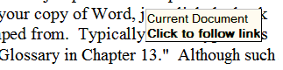

If you have the Web toolbar enabled in your copy of Word, just click the back icon on the toolbar to return to where you jumped from.
- Another kind of internal hyperlink uses “bookmarks” to direct you to other locations in this document. These are normally presented in a blue font. Again, click the back icon on the toolbar to return to the point where you jumped from.

Links to web pages or Internet sites should open in your web browser (typically Internet Explorer®). Use the browser’s “back” button to return to this document. Since Internet Explorer and Word are both Microsoft products, do not close the browser window, since this may (under certain circumstances) also close this document.
- Links to some external documents (for example, other Word documents) may (depending on your system settings) open in Word. Such links are also usually presented in a blue font. For example, note the shortcut graphic with blue hyperlink to the other online documents shown in the boxed note below. Use the back icon on the menu bar to return to where you jumped from.

In either case, you may click (or, depending on your computer’s operating system or software version, you may have to hold down the <Ctrl> key while clicking) on the link to see the other document or move to the specified place in this document.

Procedure Steps
- Procedures that you perform in an exact order will list the steps involved. Look for Step numbers as in the following samples:
- Select the FMS Exception option.
- Enter the latest date that you want to retain entries. IFCAP will delete all entries recorded before that retention date.
- There are also paragraphs that simply discuss a process. In these instances, you do not need to perform any process discussed using a particular order.

Typographical Conventions
This guide uses a few conventions to help identify, clarify, or emphasize information.
- Type: The word “type” is used in this guide to mean straightforward typing at your terminal keyboard.
- Keys: In this guide, computer keys that you press, but which do not result in words appearing on your screen, are represented inside <angle brackets> using the Courier New font (examples: <Ctrl>+<S>, <Enter>).
- <Enter>: The term <Enter> is used to indicate that you must send whatever you have been typing on your keyboard to the computer. When you have completed typing your response, you send it to the computer by pressing the return or enter key once.
- Emphasis: Italic text (such as must or not) is used to emphasize or draw your attention to a situation or process to perform. Pay close attention to statements containing italic text.
- Program and Utility Names: Names of software programs and utilities appear in bold type (like FileMan).
- Menus, Options, File and Field Names: Names of menus, menu options, files, and similar items are shown in the Courier New font (as in “Select the FMS Exception option”).
- Alert Icons: Whenever you need to be aware of something important or informative, the Guide will display a boxed note with an icon to alert you; icons are shown in Table 1-1. Look for these icons in the left and right margins of the document.
Table 1-1Icons Used in Boxed Notes
Icon | Meaning
 | Warning: Something that could adversely affect your use of the Query Tool or of the material available in the IFCAP databases.
 | Tip: Advice on how to more easily navigate or use the Guide or the software.
 | Information: or Note: Additional information that might be helpful to you or something you need to know about, but which is not critical to understanding or use of the software.
 | Technical Note: Information primarily of interest to software developers, IRM or Enterprise VistA Support (EVS) personnel. Most users can usually safely ignore such notes.
 | Question: A question that might come to your mind (hopefully, followed by an Answer!)

FileMan Date Conventions
Throughout the guide, FileMan date conventions have been used. A date-valued response can be entered in a variety of ways. The following is a typical help prompt for a date field:
Examples of Valid Dates:
JAN 20 1957 or 20 JAN 57 or 1/20/57 or 012057
T (for TODAY), T+1 (for TOMORROW), T+2, T+7, etc.
T-1 (for YESTERDAY), T-3W (for 3 WEEKS AGO), etc.
If the year is omitted, the computer uses CURRENT YEAR. Two digit year
assumes no more than 20 years in the future, or 80 years in the past.
Note: If you do not specify the year when you enter a date, IFCAP will assume that you are referring to the current calendar year. This could cause some confusion around the fiscal year turnover period when you are more likely to be entering dates for next year (when the current Fiscal Year is the same as the next Calendar Year).

Package Management, Legal Requirements and Security Measures
Only authorized Control Point users are able to enter, edit, or view requests or any other information for a particular Control Point. This is a security measure that prevents users from altering the requests of others. Due to the nature of the information being processed by IFCAP, special attention has been paid to limiting usage to authorized individuals. Individuals in the system who have authority to approve actions, at whatever level, have an electronic signature code. This code is required before the documents pass on to a new level for processing or review. Like the access and verify codes used when gaining access to the system, the electronic signature code will not be visible on the terminal screen. These codes are also encrypted so that they are unreadable even when viewed in the user file by those with the highest levels of access. Electronic signature codes are required by IFCAP at every level that currently requires a signature on paper.

Package Operation
IFCAP automates fiscal, budgetary, procurement, inventory, invoice tracking and payment activities. To accomplish all of these tasks, IFCAP consists of several functional components, each responsible for a similar set of tasks:
- Funds Distribution (Fiscal Component)
- Funds Control (Control Point Component)
- Processing Requests (Control Point Component)
- Purchase Orders/Requisitions (A&MM Component)
- Accounting (Fiscal Component)
- Receiving (A&MM Component)
- Inventory (A&MM/Control Point Component)

Different kinds of IFCAP users have different menus. If the menus in this manual include options that you do not see on your screen, do not panic! The instructions in this manual only use the options that you have as an Accounting Technician. If you do not know what to enter at an IFCAP prompt, enter one, two or three question marks and IFCAP will list your available options or explain the prompt. The more question marks you enter at the prompt, the more information IFCAP will provide.
The options you use on IFCAP have been divided into groups based upon the type of work you do. When you select these options, IFCAP will ask you a series of questions. If you do not understand the question or are unsure of how to respond, enter a question mark (?) and the computer will explain the question, or allow you to choose from a list of responses.
The main menu for the Accounting Technician contains these sub-menus:

- Accounting Utilities Menu - This menu allows you to edit vendor files, clear a program lock, and review undelivered orders and reports.
- Document Processing Menu - This menu allows you to correct errors, and inspect, forward, or return obligations, receiving reports, amendments, purchase orders, and service orders.
- FMS Code Sheet Menu - This menu allows you to create, edit, delete, and review manual code sheets, and determine the status of transmission stacks.
- Receiving Report Transmission Menu - This menu allows you to change the transmission date of a queued receiving report, retransmit a receiving report, and delete a report from the transmission queue.
- Reprint Menu - This menu allows you to print receiving reports, purchase orders, and service orders.

Funds Obligation Flowchart

Inspect Purchase Orders and Requisitions

Introduction
This chapter explains how to inspect purchase orders and requisitions before obligating funds for purchase from the Control Point.

Purchase Order Number
Does the purchase order number follow the correct numbering system? If it does not, return the purchase order or requisition to Acquisition and Material Management (A&MM). Call the contracting officer listed on the purchase order or requisition and advise that the purchase order number is incorrect.

Invoice Address
Does the address in IFCAP in the Mail Invoice To: field correspond to the method of payment? If not, return the purchase order or requisition to Acquisition and Material Management (A&MM). Call the contracting officer listed on the purchase order or requisition and inform them that the invoice address is incorrect. All certified purchase orders should list Fiscal Service in the Mail Invoice To: field.

Cost Center
Compare the cost center to the requesting service. The cost center should agree in some way or other to the function of the service, for example, 822400 would be a valid cost center for Pharmacy Service. If the Cost Center is wrong, you can change it by following these three steps:
- From the Accounting Technician Menu, select Document Processing Menu
- From the Document Processing Menu , select Obligation Processing.
- Enter the purchase order number. When IFCAP asks if the information on the purchase order is correct, answer ‘N’ and enter the correct cost center. At the Should The Cost Center Or BOC Information Be Edited At This Time? prompt, answer Y. Change the cost center.
You may also return the purchase order or requisition to the Purchasing Agent. The Purchasing Agent can return it to the Control Point for correction. If the service continues to send purchase orders or requisitions with an incorrect cost center, ask the Budget Analyst to review the list of available cost centers for the Control Point.

Fiscal Source Code
Compare the fiscal source code to the vendor. The vendor should have the correct fiscal source code. If not, return the purchase order or requisition to Fiscal Service or A&MM. If the service continues to send purchase orders or requisitions with an incorrect source code, ask the Purchasing Agent in Acquisition and Materiel Management (A&MM) to change the source code for the vendor.

Budget Object Code
Compare the Budget Object Code (BOC) number on the purchase order or requisition to the transaction code descriptions in VA HANDBOOK 4671.2.
The BOC should match the budget object code descriptions. If not, you can change it by following these three steps:
- From the Accounting Technician Menu), select Document Processing Menu
- From the Document Processing Menu, select Obligation Processing.
- Enter the purchase order number. When IFCAP asks if the information on the purchase order is correct, answer ‘N’ and enter the correct BOC.
You may also return the purchase order or the requisition to Acquisition and Material Management Service for return to the service. If the service continues to send purchase orders or requisitions with an incorrect budget object code, ask the Budget Analyst to change the list of available budget object codes for the Control Point.

Obligating and Amending Purchase Orders

Introduction
Purchase orders are orders to a vendor to deliver items. The 2138 has a receipt date and a single, private vendor. This is different from the 1358 Obligation forms, which are for services.

Is there Adequate Funding for the Purchase Order?
Control Points cannot process a request if the request exceeds the amount of their allotted funds. At the end of a fiscal year, some Control Points are given the authority to over-commit funds so that they can obtain bids or quotes for next year's purchases. You should receive a daily report from the Austin Finance Center called the Status of Allowance Report, listing the funds available for each Control Point. Check this document closely for availability of funds, especially at the close of a fiscal year.

Obligating a Purchase Order

Menu Path
From the Accounting Technician’s Menu, select Document Processing Menu. From the Document Processing Menu, select Obligation Processing.
Figure 3-1 Menu Path
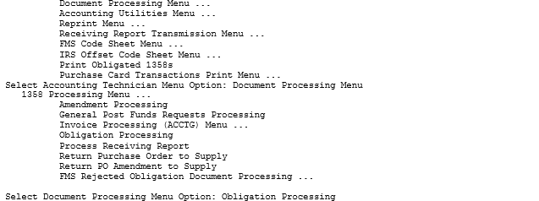

Select Order Number
Enter a STATION NUMBER and a PURCHASE Order Number at the appropriate prompts. If you do not know the Purchase Order Point, enter three question marks (???) at the prompt and IFCAP will display the available orders.
Figure 3-2 - Select Order Number
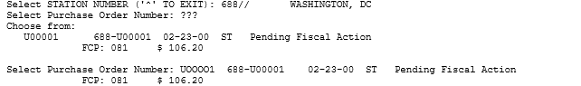

Display Order Information
IFCAP will display the purchase order and ask if the Control Point and cost center information are correct. If not, answer N to edit the information. Otherwise, enter Y. IFCAP will display the cost of the order and its effect on the uncommitted and un-obligated balances of the Control Point. IFCAP will also display the status of funds balance for the Control Point. The status of funds balance is the funds available to the Control Point at the time the purchase order is being obligated. If the un-obligated balance is greater than the net cost of the order, then you can obligate the order. Otherwise, return the order to the Purchasing Agent or Requisition Clerk.
Figure 3-3 - Display Order Information
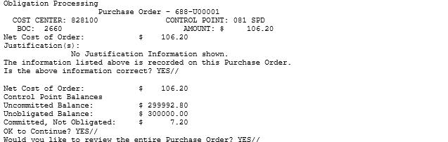

Obligation Date
Enter the date the purchase order is obligated at the Select Obligation Processing Date: prompt. This date determines the accounting period, fiscal quarter, etc., of the purchase order for FMS records. IFCAP will ask you if the purchase order is ready to transmit to FMS. The invoice will be paid when the invoice and the receiving report are in agreement. Payment occurs 23 to 30 days after the invoice as received or the goods were received, whichever is later.
Figure 3-4 - Obligation Date
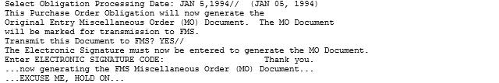

Post Using Status of Funds Tracker
IFCAP may ask you if you want to post this purchase order to the Fiscal Status of Funds Tracker, a financial tracking option used at some facilities. If you see this prompt, enter a Control Point name. If you do not know the Control Point, enter three question marks (???) at the Select Control Point Name: prompt and IFCAP will display a list of the available Control Points.
If you do not see this prompt, it is ok. It means your site has opted not to use that functionality.
Figure 3-5 Post Using Status of Funds Tracker
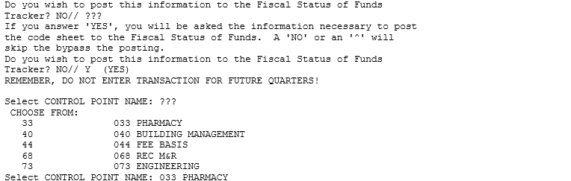

Enter Transaction Amount
Enter a TRANSACTION AMOUNT. Enter the amount as an increase if the transaction is a refund, rebate or some other transaction that returns obligated money to the Control Point; enter additional expenses as deductions.
IFCAP will show the effect of the transaction on the estimated balance and ask you if you want to post the transaction now or wait until later.
If this transaction affects additional Control Points, enter another Control Point at the Select Next Control Point Name: prompt. Otherwise, enter a caret (^) at the prompt. You can print the purchase order to the printer designated for Fiscal Service and Supply Service, or you can enter N at the Do You Wish To Queue The Purchase Order To Another Printer?: prompt and specify another printer. Enter another station number at the Select Station Number: prompt if you have another transaction to enter. Otherwise, enter a caret (^) at the prompt to return to the Document Processing menu.
Figure 3-6 Enter Transaction Amount
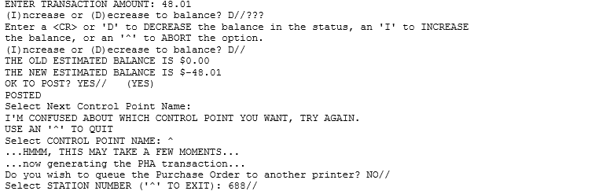

Amend a Purchase Order

Is There Adequate Funding for the Amendment?
Control Points cannot process an amendment if the amendment exceeds the amount of their allotted funds. At the end of a fiscal year some Control Points are given the authority to over commit funds so that they can obtain bids or quotes for next year's purchases. You should receive a daily report from the Austin Finance Center called the 'Status of Funds Report,' listing the funds available for each Control Point. Check this document closely for availability of funds, especially at the close of a fiscal year. This information is also available on an FMS report called the Object Class by Allowance Report.

Obligate an Amendment
Amendments add, delete, or adjust items on a purchase order before the item is received. Amendments are different from adjustments, which adjust the quantity of an item on a receiving report after it is processed by Fiscal Service.

Menu Path
From the Accounting Technician’s Menu, select Document Processing Menu. From the Document Processing Menu, select Obligation Processing.
Figure 3-7 Menu Path
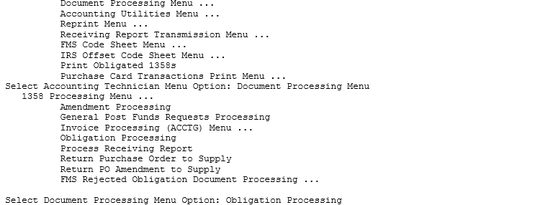

Enter Electronic Signature
Enter a STATION NUMBER, FISCAL YEAR, and your ELECTRONIC SIGNATURE CODE. Enter the Purchase Order Number. If you do not know the purchase order number, enter three question marks (???) to have IFCAP will list the available purchase orders. Enter an AMENDMENT. If you do not know the amendment number, enter three question marks (???) and IFCAP will list the available amendment numbers.

Figure 3-8 Enter Electronic Signature
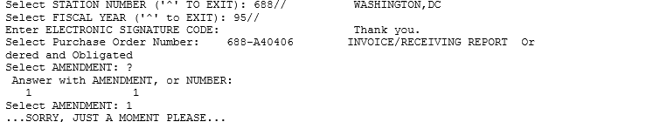

Display Amendment
IFCAP will show the amendment, the contractor, and the requisition or purchase order affected by the amendment.
Figure 3-9 Display Amendment
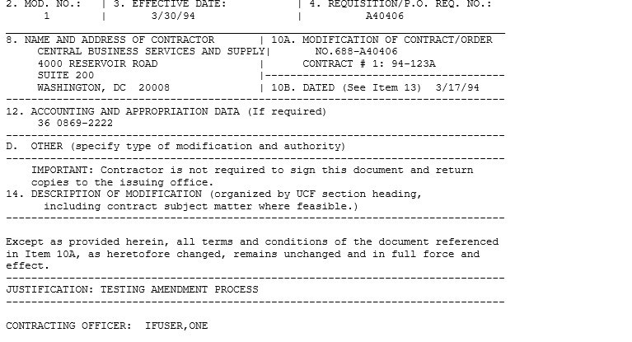

Approve and Obligate the Amendment
At the Are You Ready To Approve And Obligate This Amendment?: prompt, answer “Y” to approve and obligate the amendment. Verify that the Budget Object Code information is correct. You may also print the amendment.
Enter the date the purchase order is obligated at the Select Obligation Processing Date: prompt. Answer Y at the Transmit this Document to FMS? prompt. Enter your ELECTRONIC SIGNATURE CODE. Enter another purchase order number at the Select Purchase Order Number: prompt, or press <Enter> to return to the Document Processing Menu.
Figure 3-10 Display Amendment
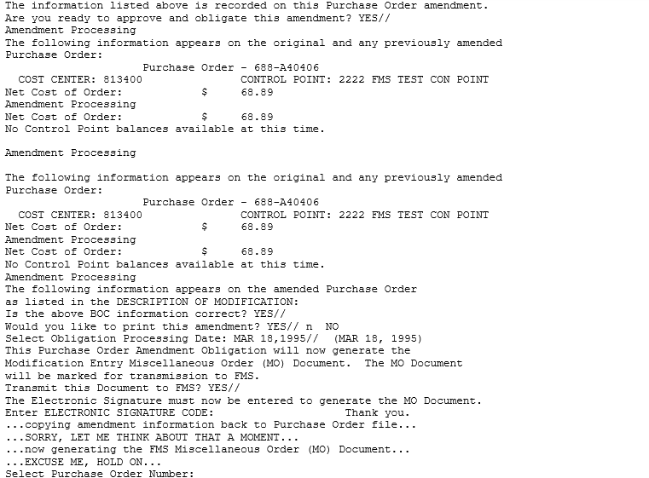
THIS PAGE INTENTIONALLY LEFT BLANK

Obligating and Adjusting 1358 Transactions

Inspect the 1358 for Correctness
Are the cost center and budget object code (BOC) appropriate for this purchase? Is the Purpose (justification) adequate? Is the Purpose sufficiently explained? If the cost center or budget object code is wrong, you can correct them during the obligation process. If the Purpose (justification) is incorrect or inappropriate, return the 1358 to the service.

Is There Adequate Funding for the 1358?
Control Points cannot process a 1358 if the 1358 exceeds the amount of their allotted funds. At the end of a fiscal year some Control Points are given the authority to over commit funds so that they can obtain bids or quotes for next year's purchases. You should receive a daily report from the Austin Finance Center called the 'Status of Funds Report,' listing the funds available for each Control Point. Check this document closely for availability of funds, especially at the close of a fiscal year. This information is also available on an FMS report called the Object Class by Allowance Report.

Obligate the 1358

Menu Path
From the 1358 Processing Menu, select Obligate 1358.
Figure 4-1 Menu Path
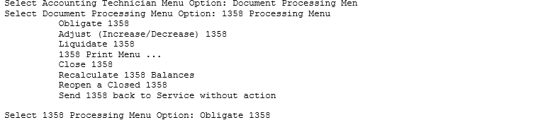

Enter Station Number
Enter a STATION NUMBER and a FISCAL YEAR. Enter the TRANSACTION NUMBER of the 1358 you wish to obligate. You will be able to view the Authority, Sub-authority, Service Start Date and Service End Date on the screen.
You will be asked to review the 1358 request:
Would you like to review this request?? No// Y (Yes)
Responding NO will continue with the 1358 Obligating. Responding YES will then display all the detailed information on the 1358 to ascertain full 1358 compliance prior to obligating. Once the display has completed you will be asked:
Would you like continue obligating this 1358?? Yes// N (No)
Responding NO will exit the Obligate 1358 option. Responding YES will allow continuation of the 1358 Obligate processing.
At the Will this 1358 Obligation Need To Be Accrued In FMS? prompt, enter Y if this obligation should be distributed among multiple accounting periods. Otherwise, enter N. Confirm that the information is correct.
Enter N at the Are these Auto Accrual values correct? prompt to edit the Cost Center or BOC. Otherwise, enter Y.
Enter Y at the Is the above information correct? prompt to continue.
Figure 4-2 Setup Parameters
Select STATION NUMBER ('^' TO EXIT): 688// WASHINGTON, DC
Select FISCAL YEAR ('^' to EXIT): 00//
Select CONTROL POINT ACTIVITY TRANSACTION NUMBER:
1358 TRANSACTION - 688-11-1-110-0009
COST CENTER: 842100 AMOUNT: $ 19999.00
BOC #1: 2580 AMOUNT #1: $ 19999.00

AUTHORITY: 2 FEE BASIS
SUB: C HOMEMAKER/HOME HEALTH AID
SERVICE START DATE: Oct 01, 2010
SERVICE END DATE: Oct 31, 2010

MONTHLY HHA COSTS <= this is the Purpose(Justification)

VENDOR: HOLDRENS INC

Would you like to review this request?? No// Y (Yes) Yes will display 1358
No will continue obligation
.
.
Would you like continue obligating this 1358?? Yes// Y (Yes) Only seen if ‘Yes’ to review
Yes, will continue obligation
No will exit obligation processing

Editing Auto Accrual information...

This 1358 Obligation appears to be for services.
Will this 1358 Obligation need to be accrued in FMS? YES//

CURRENT VALUES FOR AUTO ACCRUAL FOR 1358:
ENDING DATE FOR SERVICE: OCT 31, 2010
AUTO ACCRUAL FLAG: NO

Are these Auto Accrual values correct? YES//NO

CURRENT VALUES FOR AUTO ACCRUAL FOR 1358:
ENDING DATE FOR SERVICE: OCT 31, 2010//
AUTO ACCRUAL FLAG: NO// YES

CURRENT VALUES FOR AUTO ACCRUAL FOR 1358:
ENDING DATE FOR SERVICE: OCT 31, 2010
AUTO ACCRUAL FLAG: Yes

Are these Auto Accrual values correct? YES//

Review Balances
Look at the un-obligated balance of the Control Point. If the amount of the 1358 is less than the un-obligated balance, enter Y at the OK To Continue? prompt. Otherwise, enter N and return the 1358 to Fiscal Service.
Figure 4-3 Review Balances
Uncommitted Balance: $ 977607.00
Unobligated Balance: $ 999004.00
Committed, Not Obligated: $ 21397.00
to Continue? YES//

Enter Obligation Number
Enter an obligation number for the 1358. Answer Y at the Transmit this document to FMS? prompt. Enter your ELECTRONIC SIGNATURE CODE. Enter a Station Number at the Select Station Number: prompt to obligate another 1358 or enter a caret (^) at the prompt to return to the 1358 Processing Menu.
Figure 4-4 Enter Obligation Number
ENTER A NEW 1358 Obligation Number OR A COMMON NUMBERING SERIES
1358 Obligation Number: c15 688-C15 ACCOUNTING TECHNICIAN
Are you adding '688-C15003' as a new 1358 Obligation Number? y (Yes)

Select Obligation Processing Date: OCT 8,2010// (OCT 08, 2010)

This FMS document will be transmitted on 10/08/10 and will
affect the accounting period of October 2010. The Accounting
Period affected in FMS will be 0111.

Is this OK? YES//

This 1358 Obligation will now generate the
Original Entry Service (SO) Order Document. The SO Document
will be marked for transmission to FMS.

Transmit this Document to FMS? YES//
The Electronic Signature must now be entered to generate the SO Document.

Enter ELECTRONIC SIGNATURE CODE:
Sorry, but that's not your correct electronic signature code.
Enter ELECTRONIC SIGNATURE CODE: Thank you.

...now generating the FMS Service Order (SO) Document...
...EXCUSE ME, I'M WORKING AS FAST AS I CAN...
...updating 1358 Obligation balances...
...Excuse me, Let me think about this for a moment...
...Control Point has been notified of this transaction...

Enforcing Segregation of Duties on 1358s
If you select a 1358 transaction for Obligation and you were a Requestor or Approver on that 1358 transaction, you will be advised of the Role you already performed on the transaction and will not be permitted to Obligate the 1358.
Figure 4-5 Enforcing Segregation of Duties on 1358s
Select 1358 Processing Menu Option: Obligate 1358
Select STATION NUMBER ('^' TO EXIT): 688// WASHINGTON, DC
Select FISCAL YEAR ('^' to EXIT): 11//
Select CONTROL POINT ACTIVITY TRANSACTION NUMBER:688-11-1-110-0009
1358 TRANSACTION - 688-11-1-110-0009

COST CENTER: 842100 AMOUNT: $ 19999.00

BOC #1: 2580 AMOUNT #1: $ 19999.00

AUTHORITY: 2 FEE BASIS
SUB: C HOMEMAKER/HOME HEALTH AID
SERVICE START DATE: Oct 01, 2010
SERVICE END DATE: Oct 31, 2010

MONTHLY HHA COSTS

You are the Approver on this 1358 transaction.
Per Segregation of Duties, the Approver is not permitted to Obligate the 1358

Enforcing Segregation of Duties in Online Certification System for 1358 Obligation
An interface exists between the IFCAP application and the Online Certification System (OLCS) located at the Financial Services Center (FSC) in Austin, Texas. The interface will support the validation of the Certifier of Payment role in the OLCS.
The interface is a one-way data exchange of 1358 Obligation data from the IFCAP application to the OLCS using VistA MailMan messages. The mail messages support segregation of duties within OLCS by providing OLCS with the names of the requestor, approver, and obligator on every 1358 transaction as it is obligated in IFCAP. Segregation of duties prevents a user from functioning in more than one role on a 1358. The OLCS will verify that a certifier processing an invoice for a 1358 in OLCS is not the requestor, approver, or obligator on that 1358 in IFCAP.
IFCAP triggers a VistA MailMan message to the OLCS when a 1358 is obligated (i.e. Electronic Signature Code is entered). The exchange of 1358 Obligation data from the IFCAP to the Online Certification System will occur in the background and be transparent to IFCAP end-users.
ENTER A NEW 1358 Obligation Number OR A COMMON NUMBERING SERIES
1358 Obligation Number: c15 688-C15 ACCOUNTING TECHNICIAN
Are you adding '688-C15003' as a new 1358 Obligation Number? y (Yes)

Select Obligation Processing Date: OCT 8,2010// <Enter> (OCT 08, 2010)

This FMS document will be transmitted on 10/08/10 and will
affect the accounting period of October 2010. The Accounting
Period affected in FMS will be 0111.

Is this OK? YES// <Enter>

This 1358 Obligation will now generate the
Original Entry Service (SO) Order Document. The SO Document
will be marked for transmission to FMS.

Transmit this Document to FMS? YES// <Enter>
The Electronic Signature must now be entered to generate the SO Document.

Enter ELECTRONIC SIGNATURE CODE:
Sorry, but that's not your correct electronic signature code.
Enter ELECTRONIC SIGNATURE CODE: Thank you.

...now generating the FMS Service Order (SO) Document...
...EXCUSE ME, I'M WORKING AS FAST AS I CAN...
IFCAP will trigger a VistA MailMan message to the OLCS when a 1358 is obligated (No message is displayed to the user).

...updating 1358 Obligation balances...
...Excuse me, Let me think about this for a moment...
...Control Point has been notified of this transaction...

Adjustments to 1358s

Introduction
Control Points may require changes to their obligated 1358 during the month. IFCAP links the 1358 adjustment to the original 1358 by the obligation number and increases or decreases the obligated total automatically.

Inspect the Adjustment for Correctness
Is the Purpose of the adjustment sufficiently explained? Decrease adjustments should have a minus sign preceding the dollar amount; was the adjustment correctly entered as a decrease or an increase? If not, return the adjustment to the Control Point.

Is There Adequate Funding for the Adjustment?
Control Points cannot process an adjustment if the adjustment exceeds the amount of their allotted funds. At the end of a fiscal year some Control Points are given the authority to over commit funds so that they can obtain bids or quotes for next year's purchases. You should receive a daily report from the Austin Finance Center called the 'Status of Allowance Report,' listing the funds available for each Control Point. Check this document closely for availability of funds, especially at the close of a fiscal year. This information is also available on an FMS report called the Object Class by Allowance Report.

Adjust the 1358

Menu Path
From the Accounting Technician’s Menu, select Document Processing Menu.
Figure 5-1 Menu Path
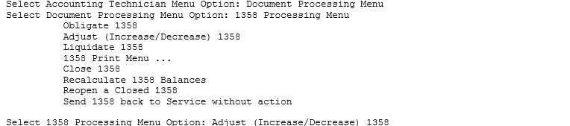

Enter Station Number
Enter a station number and a fiscal year. Enter the transaction number for the adjustment. If you do not know the transaction number, enter three question marks at the prompt and IFCAP will display the available transactions.
Figure 5-2 Setup Parameters
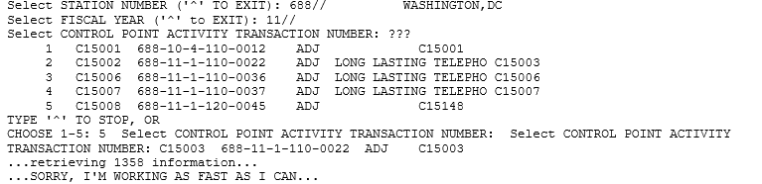

Review Balances
IFCAP will list the service balance, the fiscal balance, and the adjustment amount. The service balance is the balance on the 1358 after the Control Point Clerk enters authorizations. The fiscal balance is the balance on the 1358 after Fiscal Service enters payments (liquidations). IFCAP will also list the cost center and the budget object code for the original 1358 and for the adjustment, and the auto accrual values. Enter N at the Is the above information correct?: prompt to edit the Cost Center or BOC. At the Will this 1358 Obligation Need To Be Accrued In FMS? prompt, Enter Y if this obligation should be distributed among multiple accounting periods. Otherwise, enter N. Confirm that the information is correct.
Figure 5-3 Review Balances
PROCESS 1358 ADJUSTMENT Obligation #: 688-C15003

Service Balance: $ 19,999.00
Fiscal Balance: $ 19,999.00
Amount of Adjustment: $ 777.00

ORIGINAL ADJUSTMENT

COST CENTER: 842100 842100

BOC #1: 2580 2580

Editing Auto Accrual information...

CURRENT VALUES FOR AUTO ACCRUAL FOR 1358:
ENDING DATE FOR SERVICE: OCT 31, 2010
AUTO ACCRUAL FLAG: YES

Are these Auto Accrual values correct? YES//

Returning to Obligation processing...

The information listed above is recorded on this 1358 Obligation Adjustment.
Is the above information correct? YES//

Enter Electronic Signature
IFCAP will list the transaction number of the adjustment, the current amount obligated on the 1358, the total amount of authorizations for the 1358, the total liquidations (payments) for the 1358, the authorization balance (payments authorized by the Control Point), the liquidation balance (the balance on the 1358 after Fiscal Service enters payments), and the amount of the adjustment. Enter Y at the OK to Continue? prompt. Enter Y at the Transmit this Document to FMS? prompt. Enter your ELECTRONIC SIGNATURE CODE. IFCAP will compute the adjustment and record the adjustment. Enter a caret (^) at the Select Station Number: prompt to return to the 1358 Processing Menu.

Enforcing Segregation of Duties on 1358 Adjustments
Per Segregation of Duties on 1358s, you will be advised if you already signed the 1358 transaction as a Requestor or Approver and you will not be permitted to Obligate the Adjustment.
Figure 5-4 Segregation of Duties on Adjustments
Select 1358 Processing Menu Option: ADJust (Increase/Decrease) 1358
Select STATION NUMBER ('^' TO EXIT): 688// WASHINGTON, DC
Select FISCAL YEAR ('^' to EXIT): 11//
Select CONTROL POINT ACTIVITY TRANSACTION NUMBER: C15002 688-11-1-110-0023 ADJ
IFVENDOR C15002
...retrieving 1358 information...

...HMMM, THIS MAY TAKE A FEW MOMENTS...

PROCESS 1358 ADJUSTMENT Obligation #: 688-C15002

Service Balance: $ 556.00
Fiscal Balance: $ 556.00
Amount of Adjustment: $ 111.00

ORIGINAL ADJUSTMENT

COST CENTER: 842100 842100

BOC #1: 2580 2580

VENDOR: IFVENDOR
CONTRACT: GS-98-99827F
CONTRACT ENDING DATE: OCT 31, 2010

Editing Auto Accrual information...

CURRENT VALUES FOR AUTO ACCRUAL FOR 1358:
ENDING DATE FOR SERVICE: OCT 31, 2010
AUTO ACCRUAL FLAG: YES

Are these Auto Accrual values correct? YES//

Returning to Obligation processing...

The information listed above is recorded on this 1358 Obligation Adjustment.
Is the above information correct? YES//

Adjustment Transaction # 688-11-1-110-0023 1358 # 688-C15002

Current amount obligated on 1358: $ 556.00

Total Authorizations: $ 556.00 Total Liquidations: $ 556.00
Authorization Balance: $ 0.00 Liquidation Balance: $ 0.00

Amount of Adjustment: 111.00

You are the Requestor on this 1358 transaction. Per Segregation of Duties, the Requestor is not permitted to Obligate the 1358.
No further processing is being taken on this 1358 adjustment obligation.
It has NOT been obligated.

Enforcing Segregation of Duties in Online Certification System for 1358 Adjustments
An interface exists between the IFCAP application and the Online Certification System (OLCS) located at the Financial Services Center (FSC) in Austin, Texas. The interface will support the validation of the Certifier of Payment role in the OLCS.
The interface is a one-way data exchange of 1358 Obligation data from the IFCAP application to the OLCS using VistA MailMan messages. The mail messages support segregation of duties within OLCS by providing OLCS with the names of the requestor, approver, and obligator on every 1358 transaction as it is obligated in IFCAP. Segregation of duties prevents a user from functioning in more than one role on a 1358. The OLCS will verify that a certifier processing an invoice for a 1358 in OLCS is not the requestor, approver, or obligator on that 1358 in IFCAP.
IFCAP will trigger a VistA MailMan message to the OLCS when a 1358 increase/decrease adjustment is obligated (i.e. Electronic Signature Code is entered). The exchange of 1358 Obligation data from the IFCAP application to the Online Certification System will occur in the background and be transparent to IFCAP end-users.
Adjustment Transaction # 688-11-1-110-0022 1358 # 688-C15003

Current amount obligated on 1358: $ 19,999.00

Total Authorizations: $ 19,999.00 Total Liquidations: $ 19,999.00
Authorization Balance: $ 0.00 Liquidation Balance: $ 0.00

Amount of Adjustment: 777.00

OK to Continue? YES//
Select Obligation Processing Date: OCT 8,2010// (OCT 08, 2010)

This FMS document will be transmitted on 10/08/10 and will
affect the accounting period of October 2010. The Accounting
Period affected in FMS will be 0111.

Is this OK? YES//

This 1358 Obligation Adjustment will now generate the
Modification Entry Service (SO) Order Document. The SO Document
will be marked for transmission to FMS.

Transmit this Document to FMS? YES//
The Electronic Signature must now be entered to generate the SO Document.

Enter ELECTRONIC SIGNATURE CODE: Thank you.
IFCAP will trigger a VistA MailMan message to the OLCS when a 1358 is obligated (No message will be displayed to the user.)

...now generating the FMS Service Order (SO) Document...
...HMMM, I'M WORKING AS FAST AS I CAN...
...updating obligation balances....please hold...
...adjustment completed...

Display or Print Obligated 1358s
Enter a date range and device to obtain a list of obligated 1358s with a dollar value of $0 and higher. Your previous entries for the START and GO TO P.O. DATES will appear as the defaults.
The report includes information such as P.O. #, Authority, Sub-authority, Service Start and End Dates, Amount and Requestor; and Vendor and Contract information, if it was entered when the 1358s were created.
This option should be printed at 132 columns.
Figure 5-5 Setup Parameters and Display
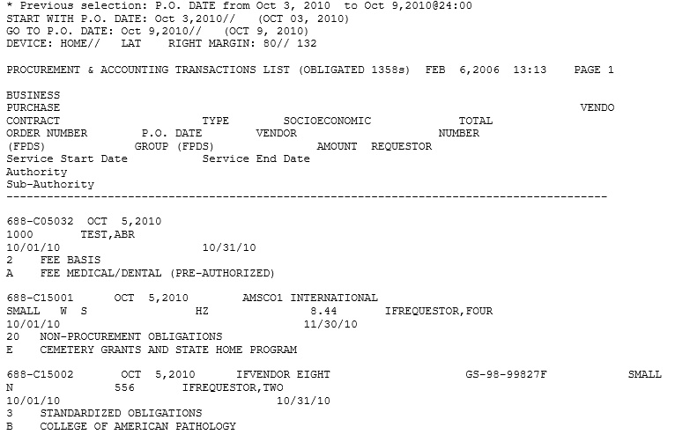

Display/Print 1358
You may view a 1358 using the Display/Print 1358 option on the 1358 Print Menu.
You may select the brief version of the 1358 or the standard ‘full’ version of the 1358 form.
Select 1358 Print Menu Option: DISPLAY/PRINT 1358
Brief or Standard output? (B/S): B//

Select STATION NUMBER ('^' TO EXIT): 688// WASHINGTON, DC
Select OBLIGATION NUMBER: C15003 688-C15003 10-08-10 1358 Obligated - 1358

FCP: 110 $ 20776.00

SERVICE START DATE: 10/01/10 SERVICE END DATE: 10/31/10
AUTHORITY: 2 FEE BASIS
SUB: C HOMEMAKER/HOME HEALTH AID

Do you wish to view the Authorization information? No// NO
DEVICE: TELNET

Obligation #: 688-C15003
Total Authorization: $ 0.00 Total Liquidation: $ 0.00
|AUTHORIZATION/ORDER REC| LIQUIDATION RECORD
Date/Time Reference No|Indiv/Daily Cumul | Liq. Amt | Unliq Bal.
___________________________________________________________________________
10/08/10 | OBLIGATION | | | 19999.00| 19999.00
10/08/10 | ADJUSTMENT | | | 777.00| 20776.00
____________________________________________________________

Do you wish to view another 1358? YES//No

Brief or Standard output? (B/S): B// s
Select OBLIGATION NUMBER: C05026 688-10-4-110-0051

Would you like to print the Description field for each 1358 Daily Record entry? No// y (Yes)
Would you like to print the daily records for each authorization? NO// y YES
Would you like to print descriptions for each detailed daily record? NO// y YES
DEVICE: HOME// TELNET Right Margin: 80//
688-10-4-110-0051 OCT 15, 2010@17:52:38 PAGE 1
________________________________________________________________________________
1358 OBLIGATION OR CHANGE: STANDARDIZED OBLIGATIONS
FEE BASIS PURCHASE CARD
________________________________________________________________________________
Originator of Request:
Requestor: |Date Requested: |Obligation No.:
IFUSER,TWO |SEP 23, 2010 | 688-C05026
________________________________________________________________________________
Vendor: |Contract Number:
|
________________________________________________________________________________
Name and Title Approving Off.: |Signature: |Date Signed:
IFUSER,FOUR |/ES/IFUSER FOUR |SEP 23, 2010@17:49:27
SERVICE CHIEF | |
________________________________________________________________________________
FUND CERTIFICATION: The supplies and services listed on this request are
properly chargeable to the following allotments, the available balances of
which are sufficient to cover the cost thereof, and funds have been obligated.
________________________________________________________________________________
Appropriation & Acct. Symbols: |Obligated By: |Date Obligated:
688-3600160-110-842100-2580 010042116 |/ES/USER ACCT TECH |SEP 23, 2010
________________________________________________________________________________

688-10-4-110-0051 688-C05026 PAGE 2
________________________________________________________________________________
1358 OBLIGATION OR CHANGE: STANDARDIZED OBLLIGATIONS
FEE BASIS PURCHASE CARD
________________________________________________________________________________
Appropriation & Acct. Symbols: |Obligated By: |Date Obligated:
688-3600160-110-842100-2580 010042116 |/ES/USER ACCT TECH |SEP 23, 2010
________________________________________________________________________________
________________________________________________________________________________
AUTHORITY: 3 SUB:F

_SERVICE START DATE: 09/01/10 SERVICE END DATE: 11/01/10
________________________________________________________________________________
Purpose:
MORE APPTS. FOR TWO MONTHS
________________________________________________________________________________
ESTIMATED OBLIGATION RECAP
DATE REF# CPA# AMOUNT BALANCE
09/23 0001 688-10-4-110-0051 $ 456.00 $ 456.00
09/27 0002 688-10-4-110-0058 $ 828.00 $ 1284.00
________________________________________________________________________________
AUTHORIZATION & ORDER RECORD LIQUIDATION RECORD

AUTH. AUTH. CUMULATIVE UNLIQ
DATE SEQ# REFERENCE AMOUNT BALANCE AUTH. AMT. LIQUID BAL
________________________________________________________________________________
10/15 0003 1ST WEEK COSTS $ 235.50 $ 0.00 $ 235.50 $ 0.00
10/15 0003-1
2 PTS $ 235.50

10/15 0004 2ND WEEKS COSTS $ 275.00 $ 93.25 $ 510.50 $ 0.00
10/15 0004-1
1 PT VISIT $ 181.75

10/15 0005 3RD WEEKS COSTS $ 325.00 $ 325.00 $ 835.50 $ 0.00

TOTALS $ 835.50 $ 418.25 $ 835.50 $ 1284.00

VA FORM 4-1358a-ADP (NOV 1987)

Review and Forward Receiving Reports for Payment

Introduction
This chapter explains how to make sure that the information on the received order report is correct.

Dollar Amounts
Compare the dollar amounts on the receiving report to the purchase order. To view the IFCAP record of the purchase order, follow the steps in this section.

Menu Path
From the Accounting Technician Menu, select Document Processing Menu.
From the Document Processing Menu, select Process Receiving Report.
Enter a STATION NUMBER and a FISCAL YEAR.
At the Select PURCHASE ORDER NUMBER: prompt, enter the PAT number for the receiving report. If you do not know the PAT number, enter three question marks (???) at the prompt and IFCAP will display the available transactions.
Figure 6-1 Setup Parameters and Display
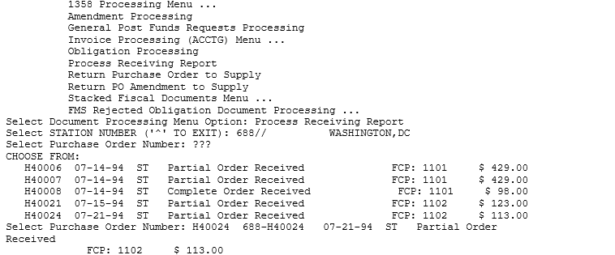

Review Order
You may review the purchase order if you like. The purchase order lists the vendor, the shipping address, the cost center, and each item.
Figure 6-2 Review Order
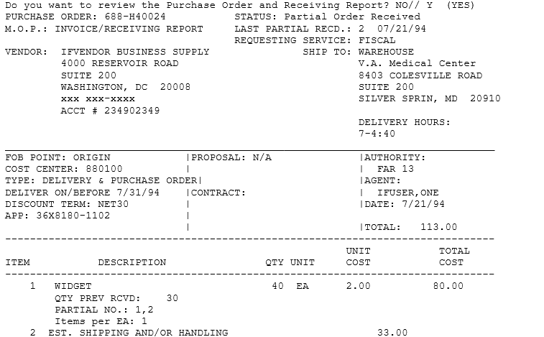

Review Receiving Report
You may also review the receiving report. The receiving report lists each time that the service recorded the partial receipt of an order. This report lists the items that were received, the amount, and the cost. You may process one of the partial receipts. Enter your electronic signature code. Transmit the report to Austin. Enter a caret (^) at the Select Station Number: prompt to return to the Document Processing Menu.

Tip: If there is a shipping charge, it will appear on the first partial receiving report.

Figure 6-3 Review Receiving Report
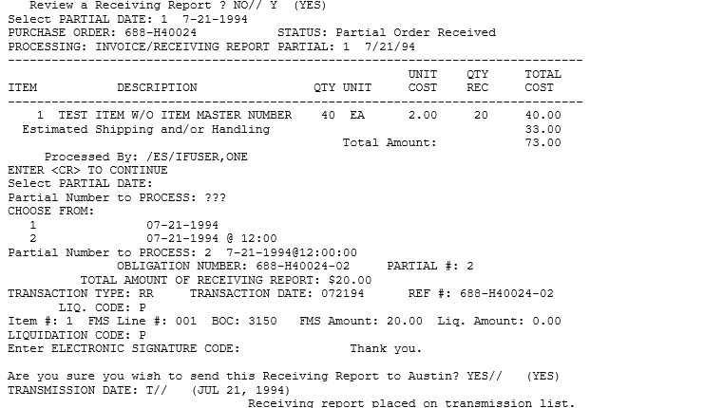
THIS PAGE INTENTIONALLY LEFT BLANK

Process 1358 Invoices for Payment

Introduction
After an invoice is sent to the Certifying Official (usually the Control Point Official) to be certified for payment, the Certifying Official returns it to the accounting office, where the Voucher Audit Clerk (or Accounting Technician if there is no Voucher Audit Clerk at your station) records the certification in IFCAP. (See the Voucher Auditor Manual for options used to process the Certified Invoices).

Menu Path
From the Accounting Technician Menu, select Document Processing Menu.
From the Document Processing Menu, select Invoice Processing (ACCTG) Menu.
From the Invoice Processing (ACCTG) Menu, select Invoice Processing for Payment.
Figure 7-1 Menu Path
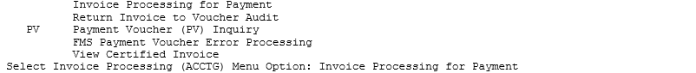

Select Station Number
Select a STATION NUMBER. Enter the INVOICE TRACKING ID NUMBER recorded on the invoice before it was sent to the Certifying Official. Compare the purchase orders on the invoice and the IFCAP record of the invoice amount to make sure that they are the same. If the amounts are different, verify that there is no clerical error, then call the Control Point Official to correct the discrepancy. You may also display or print the 1358.
Figure 7-2 Select Station Number
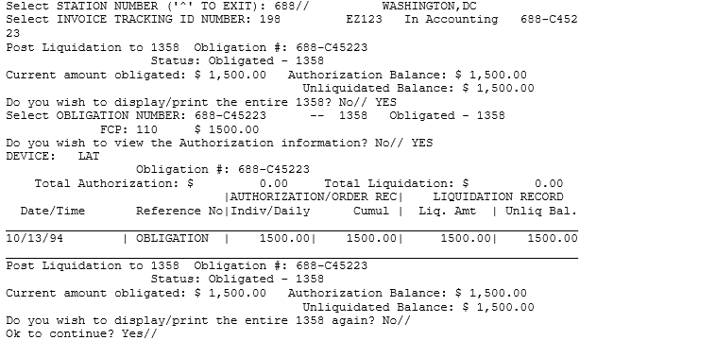

Assign Liquidation Number
IFCAP will assign an entry number to the liquidation. Enter the date that you want the liquidation to take effect and the amount of the liquidation. Enter a reference for the liquidation and comments. Enter N at the Would You Like To Enter Another Liquidation For This Obligation? prompt if you are finished entering liquidations. You may also select another 1358.
Figure 7-3 Assign Liquidation Number
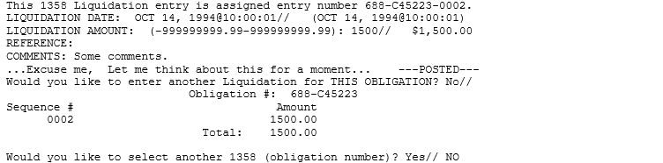

Select Budget Object Code
At the Select BOC: prompt, enter the BOC for the 1358. If you do not know the BOC for this item, enter three question marks (???) and IFCAP will list the available budget object codes. Enter Y at the OK To Process This Payment To FMS? prompt. Enter your ELECTRONIC SIGNATURE CODE. Enter another station number at the Select Station Number: prompt to process another invoice for payment or enter a caret (^) at the prompt to return to the Invoice Processing (ACCTG) Menu.
Figure 7-4 Select BOC
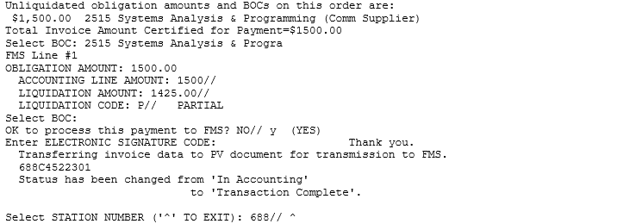

Verifying Payment Transmission
Eventually, a CAPPS report will print, listing the payment transmission you created. Look at the invoices on the report to see if any of your invoice payments are rejected. If you have rejects, use the following steps to edit and retransmit corrected payment information.

Menu Path
From the Accounting Technician Menu, select Document Processing Menu.
From the Document Processing Menu, select Invoice Processing (ACCTG) Menu.

Enter and Verify Transmission
Enter the correct information about the invoice payment at the prompts.
Figure 7-5 Enter and Verify Transmission
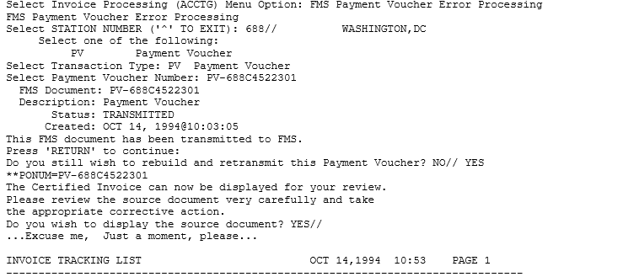
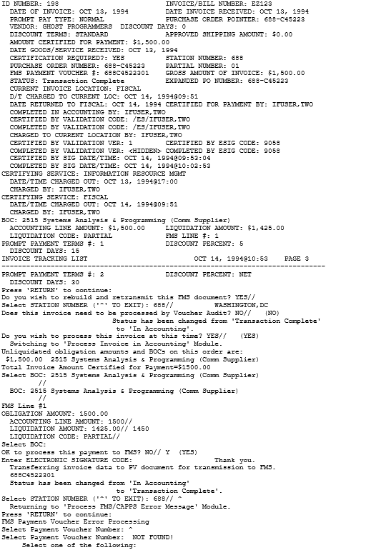
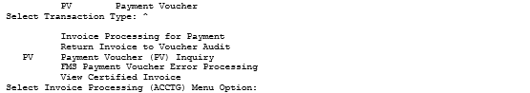

Resolving Error Messages

FMS Error Processing
FMS documents are generated automatically as a result of certain IFCAP processes. For example, creation and generation of ceiling transactions in IFCAP results in Sub-allowance (SA) documents being created and transmitted to FMS. Additionally, when Accounting obligates purchase orders or invoices for payment, various types of FMS documents are automatically sent to Austin.
In designing the interface with FMS, IFCAP developers have built-in various edit checks to prevent rejection of FMS documents. An example of such functionality is the Required Fields File, explained earlier in this document, which ensures that all fields required for a given fund and type of FMS document are present on that FMS document before transmitting it to FMS. Even so, it is impossible to prevent every scenario that might cause FMS documents to reject. It is far less likely that the documents that IFCAP creates automatically will reject, compared with the documents that users create manually, using the FMS Code Sheet Menu’s Create a Code Sheet option. That is because the automatic document processes contain more built-in protection against document rejection in FMS.
Because rejection of FMS documents is, to some extent, inevitable, there are options in IFCAP to assist users in correction and retransmission of the rejected documents. IFCAP will allow the user to correct errors by correcting the source document, then rebuilding the document and retransmitting it to FMS.
Once FMS has tried to process a document that rejects, it will send an error message containing all relevant FMS error codes to the appropriate recipients the following day. Appropriate recipients are those who are defined in the FCP file (420) to receive FMS notifications for their FCP. When the user has corrected a rejected document, the new document will automatically transmit to Austin. The only exceptions are the Budget documents, SA, ST, and AT, which must be generated again with the Generate Budget Code Sheets option of the Fund Distribution Module.
IFCAP transactions being transmitted to the FMS system in Austin are in the form of a mail message.
Figure 8-1 Outgoing Message to FMS
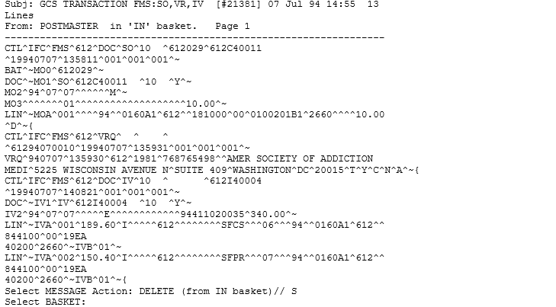

Once a message is received in the FMS system, a mail message is returned to the site confirming acceptance of the message.
Confirmation Message returning from Austin:
Figure 8-2 Confirmation Message Returning from Austin
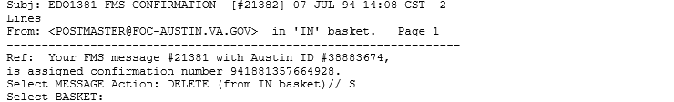

If FMS rejects a document from IFCAP, the FMS mail group will receive an electronic mail message from FMS notifying them of the rejected document. The message will include the FMS error code, along with a brief description of the error. The action the user must take to correct the rejected document varies according to the type of document that has rejected. See the FMS Handbook for a list of FMS error codes.

Stack Status Report
The Accounting Technician Menu has an option to allow inquiry into all documents and give users the status on each document. The data can be gathered by document type, status or a group of status. The user can see the document with or without code sheet information.
Figure 8-3 Confirmation Message Returning from Austin
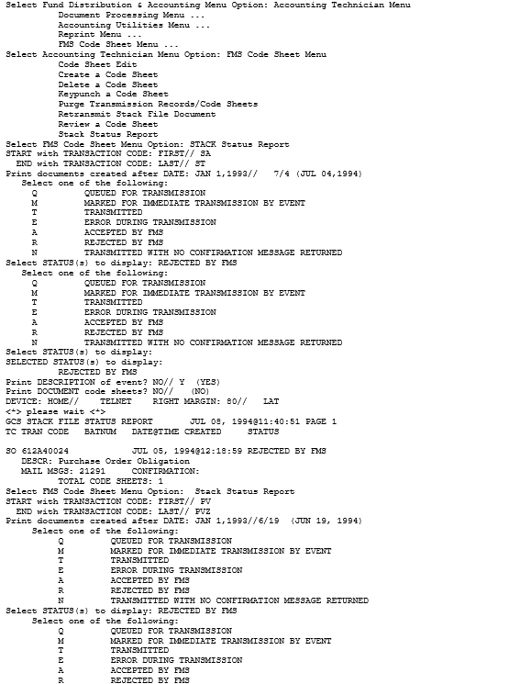
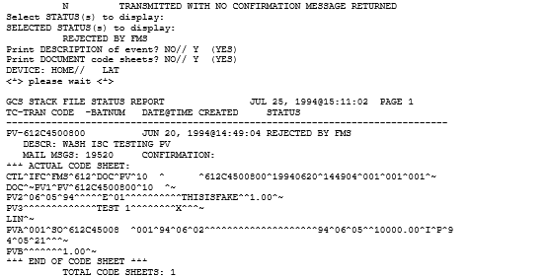

FMS Inquiry Rejected Obligation Documents Menu
The FMS Inquiry Rejected Obligation Documents menu allows correction of errors to any (MO or SO) document by reviewing and editing the original purchase order or 1358 document. Once edited the document is rebuilt and transmitted to FMS.
Figure 8-4 Menu Path and Display
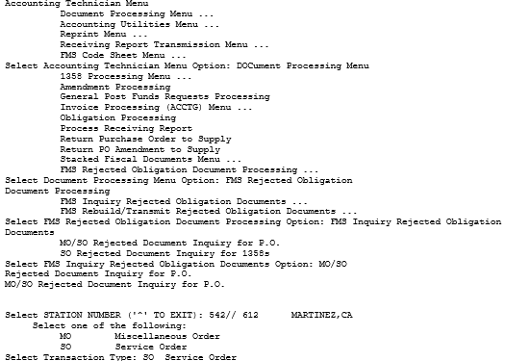
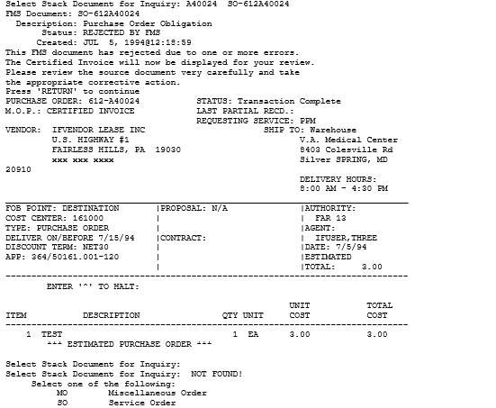
Figure 8-5 Enter Parameters and Display
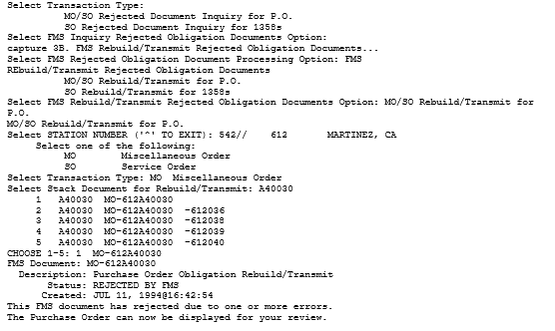
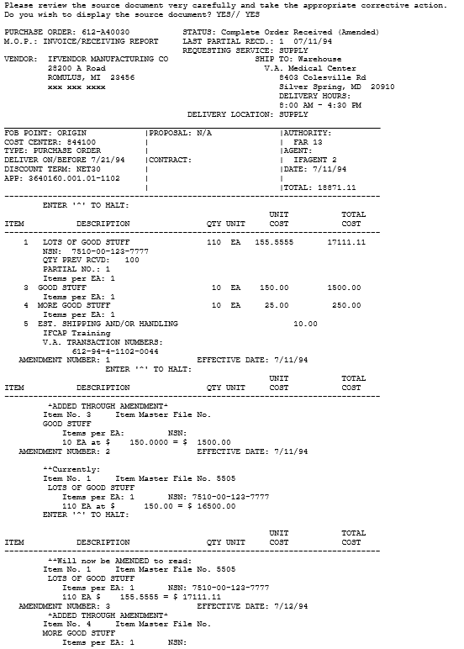
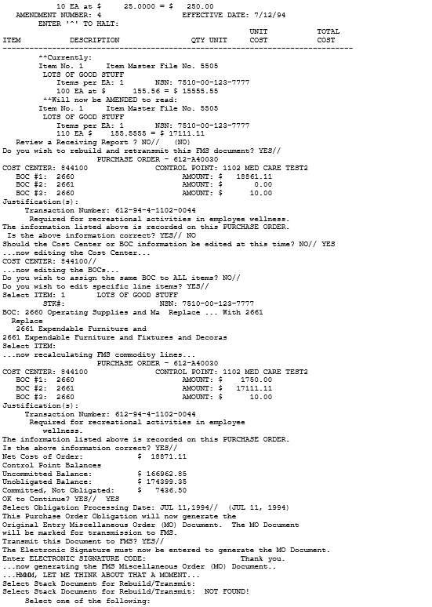
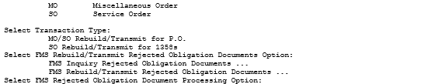

Payment Error Processing
Payment Vouchers (PVs) transmitted to FMS are sometimes rejected by FMS. The Accounting Technician has two options to help view and correct such documents and return corrected document to FMS for processing.
Figure 8-6 Payment Voucher Inquiry
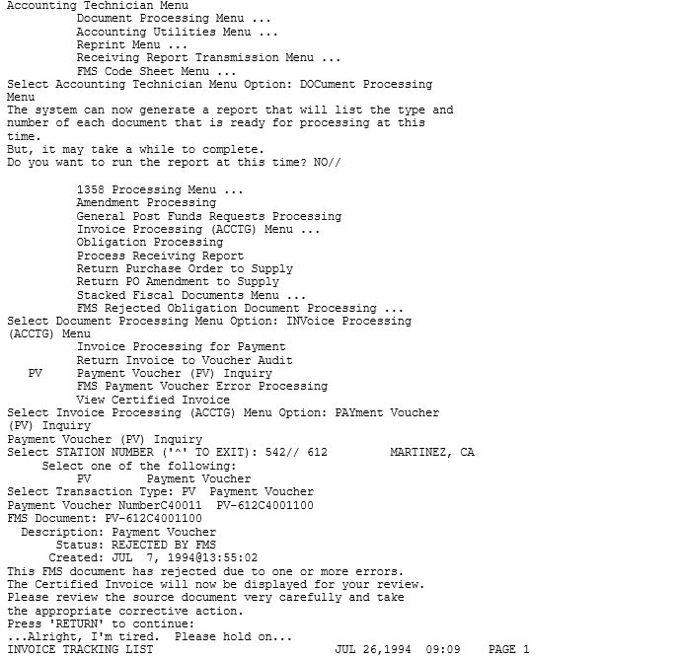

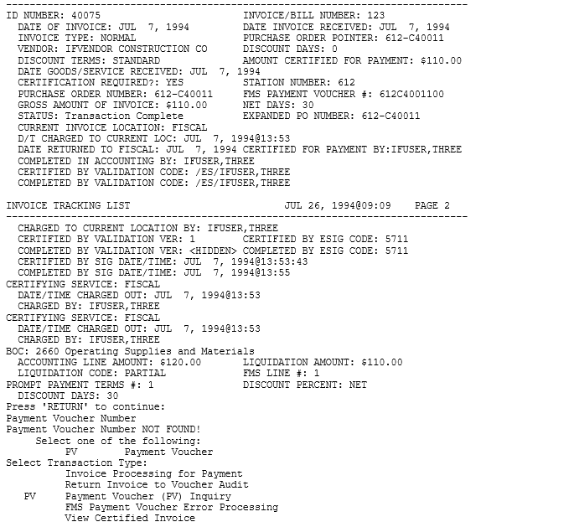
Figure 8-7 FMS Payment Voucher Error Processing
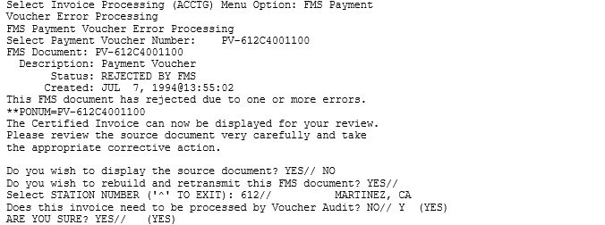
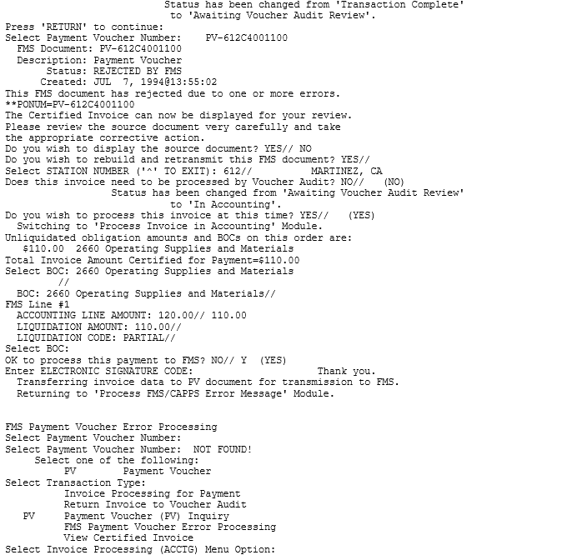

Purchase Card Options

Purchase Card Transaction Print Menu
The Purchase Card Transaction Print menu has a number of options that assist the accounting technician with the monitoring of the Purchase Card program.

Detailed Report of Unpaid PC Transactions by FCP
This option displays the unpaid purchase card total for each control point.

Enter Parameters and Display
Figure 9-1 Detailed Report of Unpaid PC Transactions by FCP
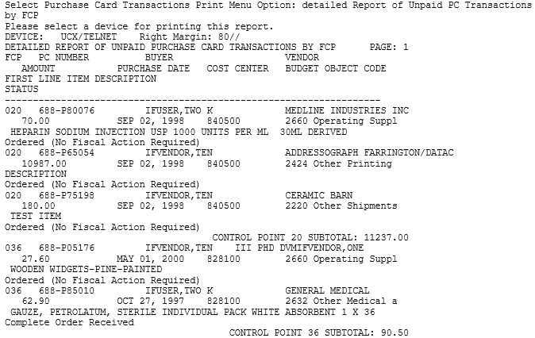

Fiscal Daily Review
This option creates a report showing buyer, vendor, and status information for purchase card orders within a selected date range.

Enter Parameters and Display
Enter a beginning date and ending date for the report.
Specify whether you want to see Delivery Orders.
Figure 9-2 Fiscal Daily Review
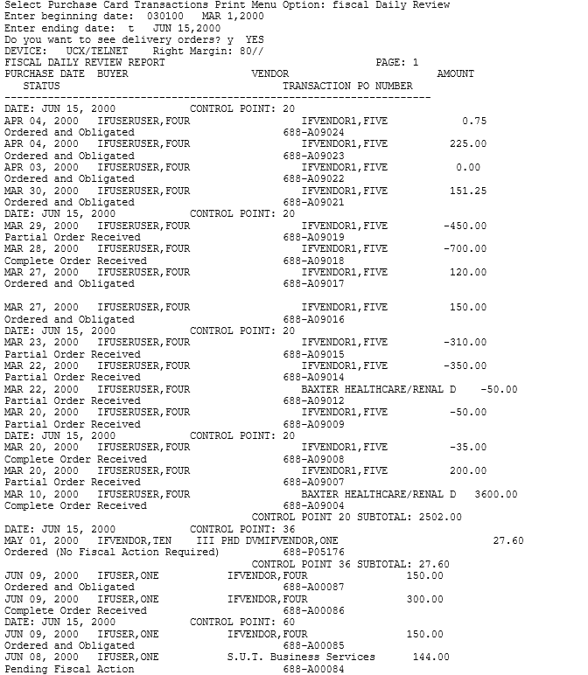

History of Purchase Card Transactions
This option creates a report of purchase card orders sorted by unpaid, paid or both status, for a selected date range.

Enter Parameters and Display
Enter a beginning date and ending date for the report.
The report can list paid orders, unpaid orders or both types of orders. At the Status: prompt enter P for paid orders; U for unpaid orders; or B for both types of orders.
Figure 9-3 History of Purchase Card Transactions
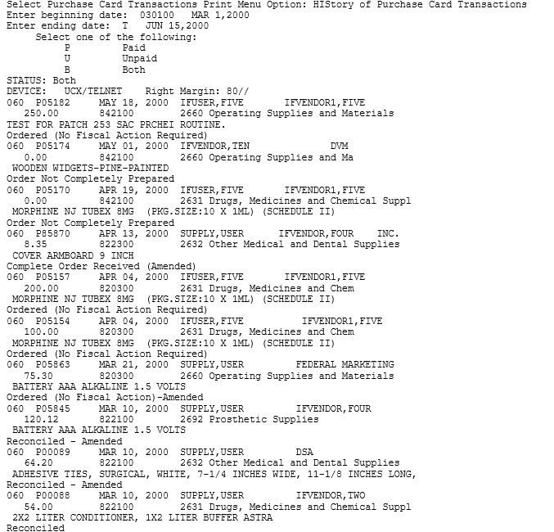

Reconciled Purchase Card Transactions
This option creates a report of reconciled purchase card orders sorted by user and card number. A reconciled order has been paid in full and completed received.

Enter Parameters and Display
Enter a STATION NUMBER, beginning date and ending date for the report. Select a DEVICE for displaying the report.
Figure 9-4 Reconciled Purchase Card Transactions
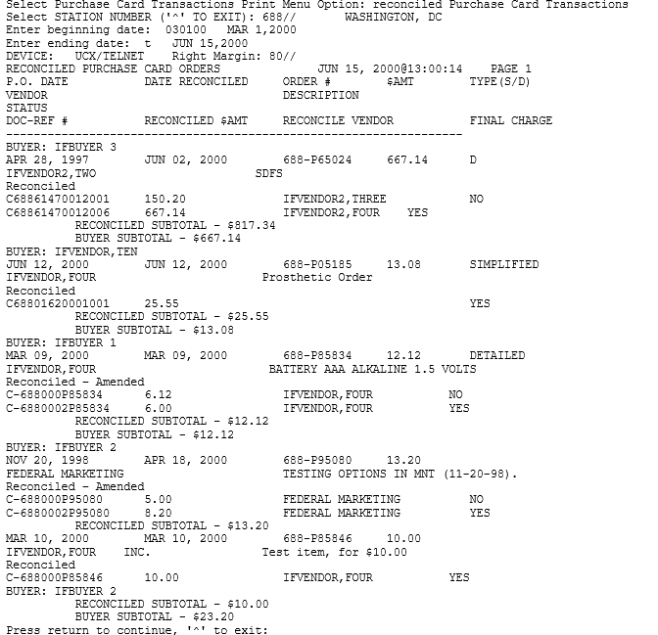

Unreconciled Purchase Card Transactions
This option creates a report of the unreconciled purchase card orders.

Enter Parameters and Display
Enter a STATION NUMBER, beginning date and ending date for the report. Select a DEVICE for displaying the report.
Figure 9-5 Unreconciled Purchase Card Transactions

ET-FMS Document Display
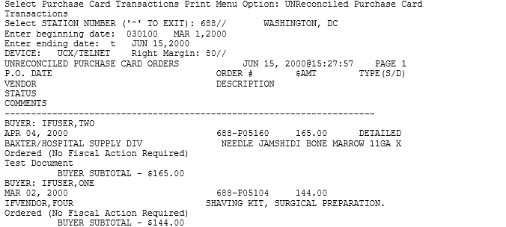

Enter Parameters and Display
Enter a STATION NUMBER. At the Transaction Type: prompt, select ET. Enter the FMS ET Document ID, or two question marks (??) to see your choices.
Figure 9-6 ET-FMS Document Display
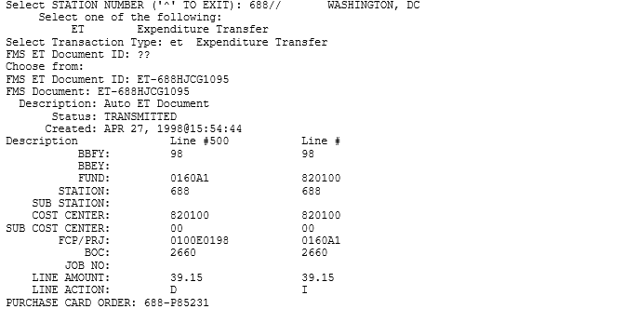

ET-FMS Document Rebuild
This option will rebuild erroneous/rejected ET-documents.

Purchase Card Transaction Status
This option creates a report listing accounting and item data for a purchase card order.

Enter Parameters and Display
Enter a STATION NUMBER. At the P.O./REQ. NO.: prompt, enter the Purchase Card obligation number, or a question mark (?) to see your choices.

Figure 9-7 Purchase Card Transaction Status
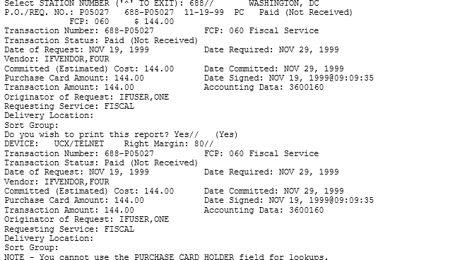

Monitor Reconciled Orders by Card Holder
This option is used to print vendor, accounting element, cost, and status information for reconciled orders.

Enter Parameters and Display
At the START WITH RECONCILE DATE: prompt, press <Enter> to accept the default RECONCILE DATE or to sort in sequence, starting from a certain reconcile date, type that reconcile date or enter '@' to include null reconcile date values. At the START WITH CARD HOLDER: prompt, press <Enter> to start with the first card holder and see all card holders, or to sort in sequence, starting from a certain card holder, type that card holder or enter '@' to include null card holder values
Select a DEVICE for displaying the report.

Figure 9-8 Monitor Reconciled Orders by Card Holder
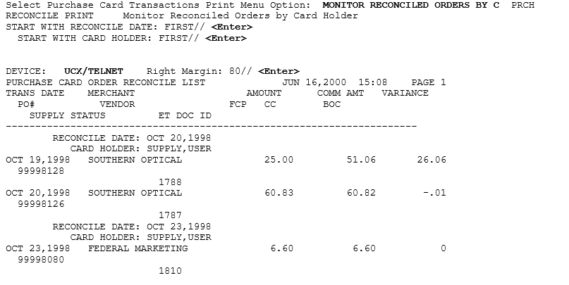

BOC Report for OA&MM/Fiscal
This report will allow users to specify a date and name range to print any Purchase Card transactions which include BOC numbers 2696 to 2699. It is used by OA&MM/Fiscal to perform Supply Funds reconciliation.

Enter Parameters and Display
At the START WITH CARD HOLDER: prompt, press <Enter> to accept the default FIRST and see all card holders, or enter a specific card holder.
At the START WITH TRANSACTION DATE: prompt, press <Enter> to start at the beginning of the file, or enter a specific TRANSACTION DATE.
Select a DEVICE for displaying the report.
Figure 9-9 BOC Report for OA&MM/Fiscal
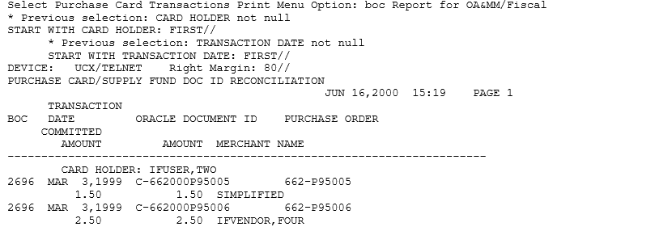

Accounting Utilities

Introduction
This chapter lists the options contained on the Utilities Menu. These options enable the Accounting Technician to Edit a BOC on an item in the ITEM file, Review VRQs, establish AR Vendors in the IFCAP Vendor file, edit entries in the Vendor file, clear a lock if necessary, lookup a vendor ID number in the Vendor file, and print a report of documents awaiting Fiscal action.

Update Status of Funds Balances
This option was more useful when IFCAP was not being updated automatically if adjustments were made to the control point balances in the corporate ( now FMS) system. It allows the Accounting Technician to manually enter the current balance of the control point, as listed on the Status of Allowance report, into the IFCAP system thereby enabling the technician to see the effect of any transaction input into IFCAP against the actual balance recorded in FMS. To utilize this feature the field STATUS OF FUNDS TRACKING: in File 411 must be set to YES. This is done by the IFCAP Coordinator using the Site Parameter option. It would have to be set individually for each station on the computer system.

Enter Parameters and Display
At the Select FUND CONTROL POINT STATION NAME: prompt, enter the appropriate Station Number.
At the Select CONTROL POINT: prompt, enter the CONTROL POINT.
At the STATUS OF FUNDS BALANCE: prompt, enter the actual balance of the control point per the Status of Allowance report from FMS.
Figure 10-1 Update Status of Funds Balances
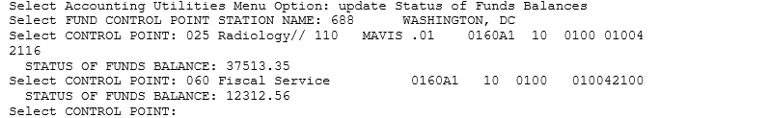

Lookup Vendor ID Number
This option is designed to permit Fiscal Service to lookup the Vendor ID Number, Alternate Address Indicator and Payment address information for any vendor in the vendor file.

Enter Parameters and Display
At the Select FUND CONTROL POINT STATION NAME: prompt, enter the appropriate Station Number.
At the Select CONTROL POINT: prompt, enter the CONTROL POINT.
At the Select Vendor Name or PO Number: prompt, enter the Vendor Name or purchase order number.
Figure 10-2 Lookup Vendor ID Number
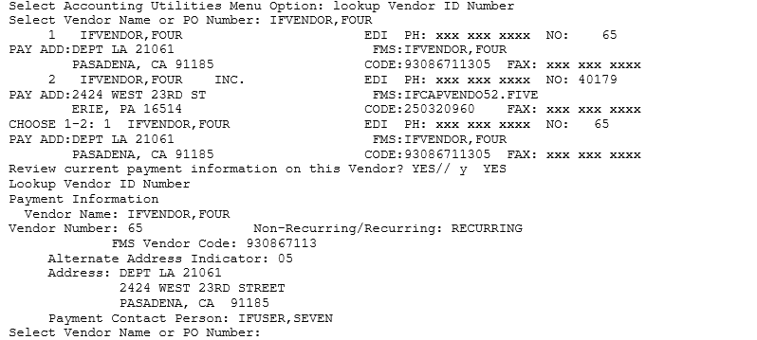

Vendor File Edit
This option permits the Fiscal Service to edit the VENDOR NAME and PAYMENT ADDRESS fields of an entry in the Vendor File. In order to edit the VENDOR NAME and PAYMENT ADDRESS fields for a Medical/Surgical Prime (MSPV) Vendor (vendor numbers above 949,999), the Fiscal user must hold the PRCHVEN security key.
NOTE: Changes made in this patch to security key permissions have no impact on the existing VRQ (FMS Vendor Request Document) process.

Enter Parameters and Display
Enter a STATION NUMBER.
At the VENDOR NAME: prompt, enter the name of the vendor you wish to edit, or enter two question marks (??) to see a list of those available.
If you changed any critical data fields, IFCAP may ask if you need to send a Vendor Request (VRQ) to Austin. If so, answer YES to generate a VRQ. If you made no change to critical fields, IFCAP will not ask you the question.
Figure 10-3 Vendor File Edit
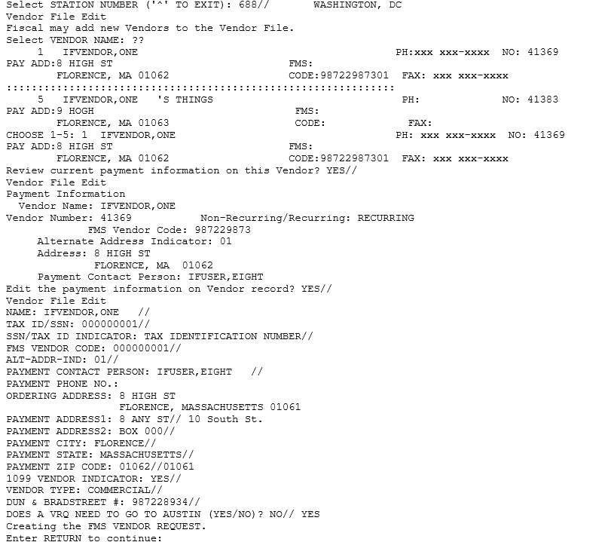

Edit BOC in Item File
This option allows the user to edit the Budget Object Code (BOC) on an item in the Item File.

Enter Parameters and Display
At the Select ITEM MASTER NUMBER: prompt, enter the item number you want to edit, or enter two question marks (??) to see a list of those available.
At the BOC: prompt, enter the BOC you wish to apply to the item.
Figure 10-4 Edit BOC in Item File
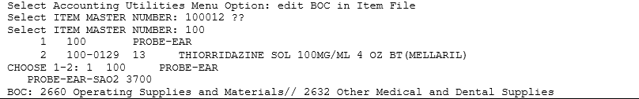

Clear Program Lock
This option allows the Accounting Technician to clear the system if a particular program lock is set. It might happen that two individuals try to batch documents at the same time.

Enter Parameters and Display
At the Select FISCAL LOCK TYPE: prompt, enter the Lock to be cleared, or enter two question marks (??) to see a list of those available.
Figure 10-5 Edit BOC in Item File
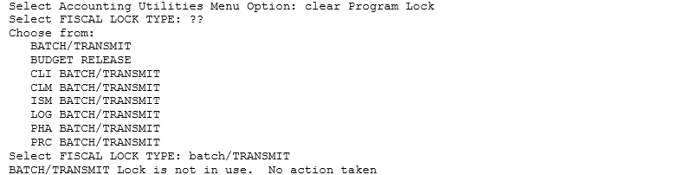

Undelivered Orders Reconciliation Report
This option generates the 850 Undelivered Orders Reconciliation Report. This report is very resource intensive and should be scheduled to run in off-hours. The option can be invoked manually. This report is restricted to purchase orders from a single station and can be limited to a date range. The default date range is from T-90 days to T.

Enter Parameters and Display
Enter a STATION NUMBER.
At the Select BEGINNING DATE: prompt, enter a beginning date, or press <Enter> to accept the default 90-day period.
At the Select ENDING DATE: prompt, enter an ending date, or press <Enter> to accept the default.
Enter a DEVICE.
Figure 10-6 Undelivered Orders Reconciliation Report
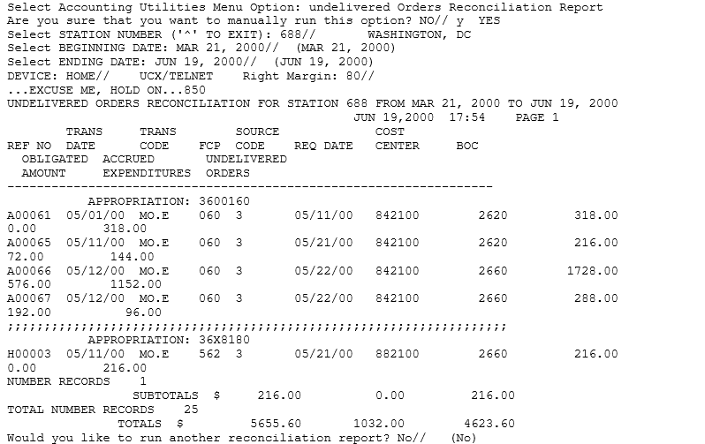

Fiscal Pending Action
This option will print all fiscal pending action 1358 and P.O. for fiscal obligation.

Enter Parameters and Display
Enter a DEVICE.
Figure 10-7 Fiscal Pending Action
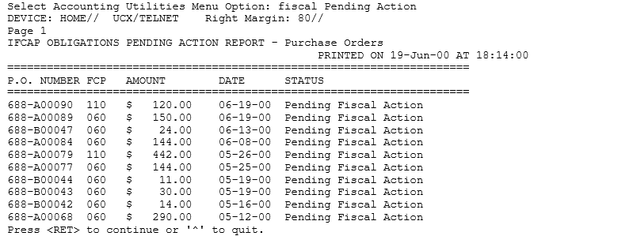

History - Code Sheet/Obligation (PAT) Number
This option allows the user to view the code sheets which have been prepared for a specific obligation number/purchase order.

Enter Parameters and Display
At the PURCHASE ORDER NUMBER: prompt, enter the obligation number you wish to view.
Figure 10-8 History - Code Sheet/Obligation (PAT) Number
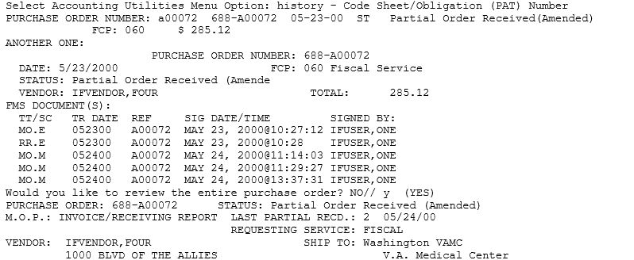
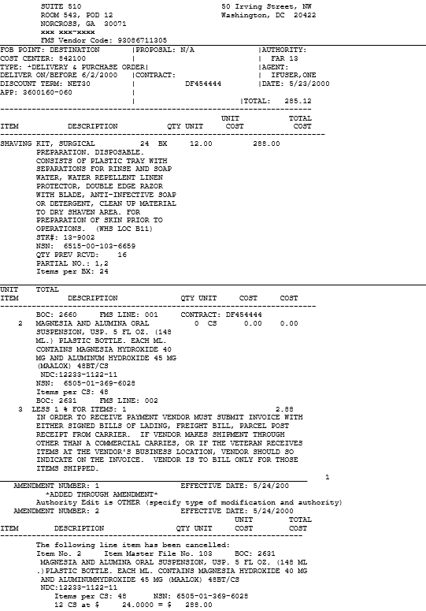
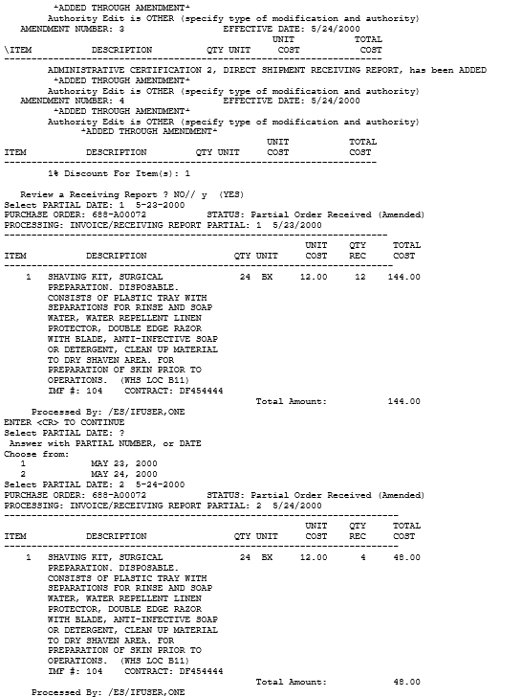

Review Vendor Request
This option allows Fiscal to review Vendor Requests before they are sent to Austin. This option was added to reduce the number of VRQs going to Austin. Reviewers are expected to check the VENDOR file in FMS, get any information available, and edit the vendor locally rather than sending a VRQ to Austin.

Enter Parameters and Display
At the Select VRQ Action: prompt, select the action, or enter two question marks (??) to see a list of actions.
Figure 10-9 Review Vendor Entry (RE)
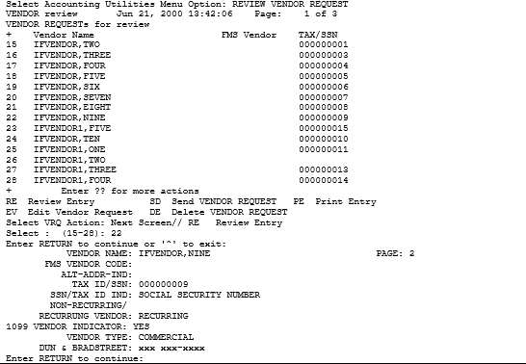

Edit Vendor Request
If you look up the Vendor in the Austin vendor file and find that the vendor information is there, you can edit the Vendor entry in IFCAP and enter the necessary data by selecting the Action code EV (Edit Vendor Request):
Figure 10-10 Edit Vendor Request (EV)
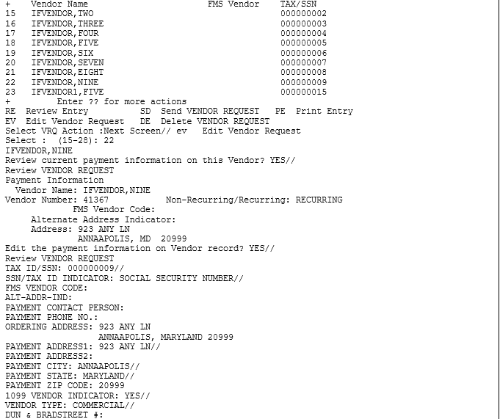

Delete Vendor Request
If you find that you do not want to send the VRQ to Austin, select the Action code DV (Delete Vendor Request). This will ensure that no VRQ is sent to the Austin Vendorizing unit.
Figure 10-11 Delete Vendor Request (DV)
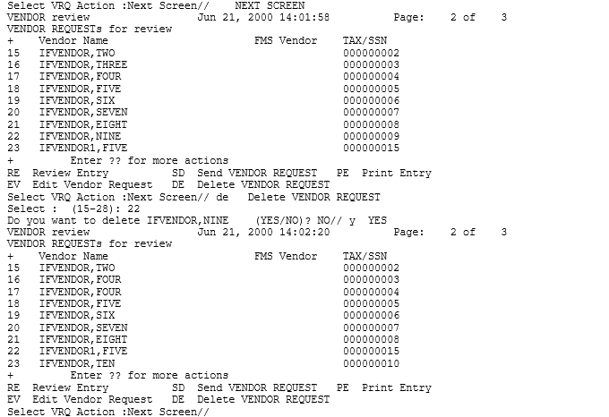

Send Vendor Request
If you determine that the Vendor does not exist in the Austin Vendor file, select the Action code SD (Send Vendor Request) to submit the VRQ to Austin.

Figure 10-12 Send Vendor Request (SD)
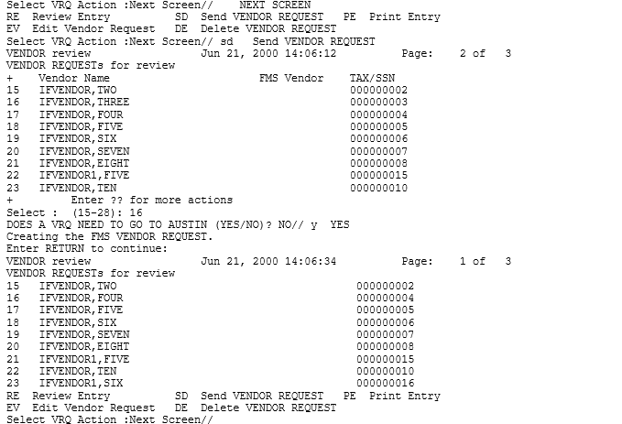

Print Vendor Request
To print a copy of the Vendor request, enter PE at the Select VRQ Action: prompt.
Figure 10-13 Send Vendor Request (SD)
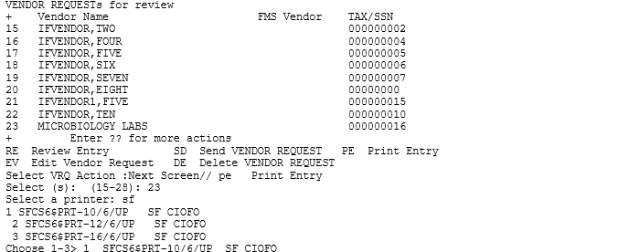

Quit from Review Vendor Request
To exit from the review option, enter Q (for Quit) at the Select VRQ Action: prompt.
Figure 10-14 Quit Review Vendor Request (Q)
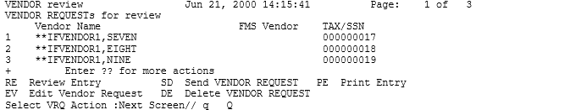

Setup Accounts Receivable Selected Vendor
This option handles creation and editing of a VRQ for vendor records chosen by Accounts Receivable users. Once the VRQ is “created,” it will be reviewed by Fiscal or sent directly to Austin. The CAN FISCAL ADD VENDORS? flag in the ADMIN. ACTIVITY SITE PARAMETER (#411) file will govern whether Fiscal Service or Supply Service edits these vendor records. If the flag is set to YES, Fiscal will edit these records. Otherwise, Supply will have the honor. Fiscal will be able to review the Vendor Request, edit the Vendor entry, delete the request or send the VRQ to Austin. The option works the same way as the Review Vendor Request option.

Enter Parameters and Display
At the Select EDIT Action: prompt, enter ER to edit the record.
Figure 10-15 Setup AR Selected Vendor
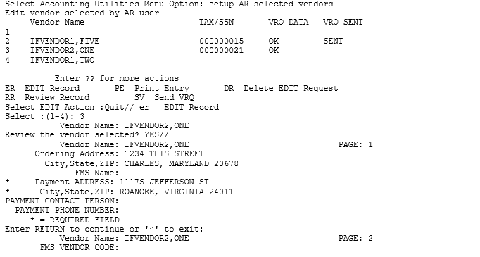
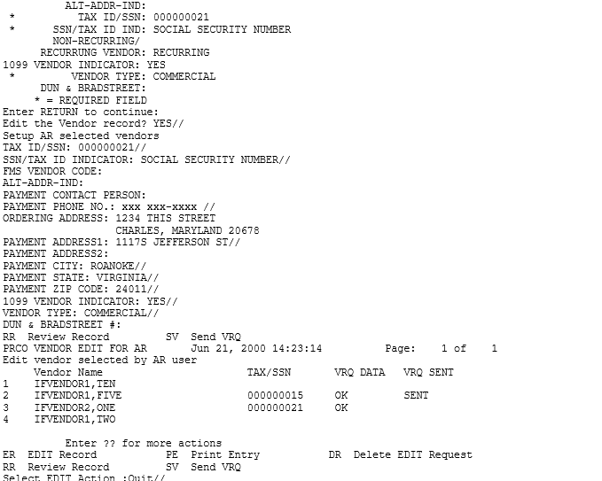

Transaction Report – eCMS/IFCAP
This report displays information about HL7 transactions that occur between eCMS and IFCAP at your station. This option is available to Fiscal users who have the PRCHJFIS Security Key. The report is generated from data stored in the IFCAP/ECMS TRANSACTION file (#414.06).

Enter Parameters and Display
A report can be generated for a single 2237, a single eCMS Contact, a date range, a specific Station Number, a specific fund control point, a specific messaging Event type, multiple Event types or ALL the records.
Note: if your Station is using the IFCAP sub-station functionality, a report can be generated for a specific sub-station.
Note: At the DEVICE: HOME// prompt, the report can either be displayed to the screen or sent to a printer. The latter choice is appropriate when the report is long.

Select Accounting Utilities Menu <TEST ACCOUNT> Option: TRansaction Report - eCM
S/IFCAP
Select a single 2237 TRANSACTION NUMBER? NO//
Select a single eCMS Contact? NO//
Select ALL DATES: (SEP 04, 2012 - JUL 26, 2013)? NO//
Starting date: TODAY// (JUL 01, 2013)
Ending date: TODAY// (JUL 26, 2013)
Select a single STATION NUMBER? NO//
Select a single FUND CONTROL POINT? NO//
TRANSACTION EVENTS:

1 Sent to eCMS (includes resent 2237s)
2 Returned to Accountable Officer
3 Returned to Control Point
4 Cancelled within eCMS

Select one or more of the above events: 1-4// 2,3
Display event ERROR TEXT? NO//

All eCMS 2237s matching your selections below will be displayed:
All eCMS Contacts
Dates: (JUL 01, 2013 - JUL 26, 2013)
All Stations and Substations
All Fund Control Points
Event Types selected are:
2 = Returned to Accountable Officer
3 = Returned to Control Point
A note will display for any errors, but not the full text.

DEVICE: HOME// TELNET RIGHT MARGIN: 80//

JUL 26, 2013@10:54 eCMS/IFCAP TRANSACTION LOG REPORT p. 1

eCMS 2237: ALL eCMS Contact: ALL Station: ALL
Report Date Range: JUL 01, 2013 - JUL 26, 2013 Control Point: ALL
Events: Returned to AO, Returned to CP

IFCAP Reference Message Event Event Date
____________________________________________________________________________
886-13-4-013-0034 RETURN TO CONTROL POINT JUL 02, 2013@17:33:10
ACKNOWLEDGED: JUL 02, 2013@17:33:11
eCMS CONTACT: eCMS.User1@med.va.gov PHONE: 501-234-5678
RETURN/CANCEL DATE: JUL 02, 2013@16:33:08
REASON: Returned to the Control Point Level in IFCAP

987-13-4-013-0035 RETURN TO CONTROL POINT JUL 02, 2013@18:17:43
ACKNOWLEDGED: JUL 02, 2013@18:17:44
eCMS CONTACT: Ecms.User2@med.va.gov PHONE: 444-333-2222
RETURN/CANCEL DATE: JUL 02, 2013@17:17:39
REASON: Returned to the Control Point Level in IFCAP

Enter RETURN to continue or '^' to exit:

JUL 26, 2013@10:54 eCMS/IFCAP TRANSACTION LOG REPORT p.5

eCMS 2237: ALL eCMS Contact: ALL Station: ALL
Report Date Range: JUL 01, 2013 - JUL 26, 2013 Control Point: ALL
Events: Returned to AO, Returned to CP

IFCAP Reference Message Event Event Date
_____________________________________________________________________________
987-13-4-013-0058 RETURN TO ACCOUNTABLE OFFICER JUL 17, 2013@13:55:28
ACKNOWLEDGED: JUL 17, 2013@13:55:29
eCMS CONTACT: Ecms.User7@med.va.gov PHONE: 987-654-3210
RETURN/CANCEL DATE: JUL 17, 2013@12:55:24
REASON: Returned to the Accountable Officer Level in IFCAP
This RETURN TO ACCOUNTABLE OFFICER has ACKNOWLEDGMENT ERROR TEXT.

987-13-4-019-0021 RETURN TO CONTROL POINT JUL 11, 2013@18:12:48
ACKNOWLEDGED: JUL 11, 2013@18:12:49
eCMS CONTACT: Ecms.User1@med.va.gov PHONE: 501-234-5678
RETURN/CANCEL DATE: JUL 11, 2013@17:12:47
REASON: Returned to the Control Point Level in IFCAP

Enter RETURN to continue or '^' to exit:
JUL 26, 2013@10:54 eCMS/IFCAP TRANSACTION LOG REPORT p. 8

eCMS 2237: ALL eCMS Contact: ALL Station: ALL
Report Date Range: JUL 01, 2013 - JUL 26, 2013 Control Point: ALL
Events: Returned to AO, Returned to CP

IFCAP Reference Message Event Event Date
_____________________________________________________________________________
987-13-4-081-0040 RETURN TO CONTROL POINT JUL 11, 2013@17:10:55
ACKNOWLEDGED: JUL 11, 2013@17:10:56
eCMS CONTACT: Ecms.User9@med.va.gov PHONE: xxx xxx-xxxx
RETURN/CANCEL DATE: JUL 11, 2013@16:10:53
REASON: Returned to the Control Point Level in IFCAP

987-13-4-5082-0027 RETURN TO CONTROL POINT JUL 11, 2013@16:07:38
ACKNOWLEDGED: JUL 11, 2013@16:07:39
eCMS CONTACT: Ecms.User11@med.va.gov PHONE: xxx xxx-xxxx
RETURN/CANCEL DATE: JUL 11, 2013@15:07:34
REASON: Returned to the Control Point Level in IFCAP

END OF REPORT

FMS Code Sheet Menu

Introduction
It is possible to create FMS documents manually using the FMS Code Sheet Menu. These options should be used only for creating those FMS documents that IFCAP does not generate automatically (e.g., AO, TO).
Use of the manual code sheet option may mean you have to enter more fields on the document than you would enter if creating the document directly on-line in FMS. Although the menu refers to “code sheets,” you are actually creating FMS documents. Using the options on this menu you may create, edit, delete, review, retransmit and purge the documents. Documents created using this menu are stored in the Generic Code Sheet (#2100.1) file and appear on the Stack Status Report in the same way as the documents generated automatically.

Menu Choices
Figure 11-1 FMS Code Sheet Menu
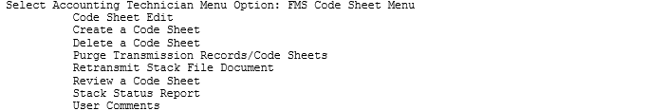

Transmission Records/Code Sheets
This routine will delete Code Sheets from the Code Sheet file and Batch and Transmission records from the Transmission Record file. Deletion is based on the date a batch and a code sheet is created.

Enter Parameters and Display
Enter a STATION NUMBER.
At the Batch Type: prompt, enter FINANCIAL MANAGEMENT.
At the Enter the number of days you wish to retain code sheets: prompt, enter the number of days you wish to retain code sheets.
Figure 11-2 FMS Code Sheet Menu
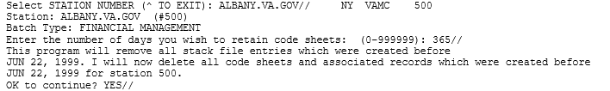

Retransmit Stack File Document
If you need to retransmit a document, you can use this option to select a document in the Generic Code Sheet (#2100.1) file and retransmit the document. It will reset the Current Status to TRANSMITTED.

Note: Documents with a current status of FINAL - NO FURTHER ACTIVITY ALLOWED cannot be retransmitted.

Figure 11-3 Retransmit Stack File Document
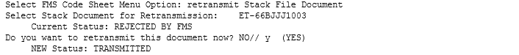

User Comments
This option permits you to add text to the FMS document record in the Generic Code Sheet (#2100.1) file.
Figure 11-4 User Comments
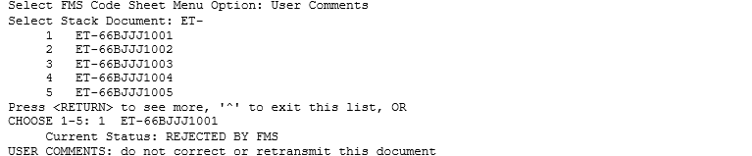

The Logistics Data Query Tool
The Logistics Data Query Tool is designed to assist Chief Logistics Officers; Materiel Managers; Purchasing Agents; and members of the Facility Logistics Staff (including Inventory Managers; Supply, Processing, and Distribution (SPD) Technicians; Management Analysts; Warehouse Clerks; or Supply System Analysts). The Query Tool can be used to quickly access, analyze and verify IFCAP and Prosthetics procurement data and display it using a graphical user interface to the VistA data. You can sign-on to VistA, find data, view the data, or easily move the data into a Microsoft® Excel® spreadsheet.
The Query Tool is a Windows software application that acts as a “front-end” to enable you to more easily find, display, and export VistA data. The Query Tool is a substitute for the VA FileMan utility program which has traditionally been used to look directly at the MUMPS globals (files) which store VistA data. The Query Tool enables you to…
- Search for data and display data by a range of dates
- Sort and rearrange the view of the data; display the data in a custom view
- Export the data into a Microsoft Excel spreadsheet file
Information on what the Query Tool can do for you can be found in the Logistics Data Query Tool Manual.

*The Logistics Data Query Tool Manual is available online at…
VA Software Document Library - IFCAP.

THIS PAGE INTENTIONALLY LEFT BLANK

Menu Outline
This chapter lists each menu option assigned the standard menu configuration for an Accounting Technician. Main menu options are flush left. Subordinate options are spaced to the right. For example, if you wanted to use the “Single Receiving Report Reprint in Fiscal” option, you would select “Reprint Menu”, then “Receiving Report Reprint Menu”, then “Single Receiving Report Reprint in Fiscal”.
NOTE: The Fee Basis - IFCAP Code Sheet Menu [PRC FEE GECS MAIN MENU] and all associated options were removed from the Accounting Technician Menu [PRCFA ACCTG TECH] as this functionality is no longer necessary.
Figure 13-1 Accounting Technician Menu Outline
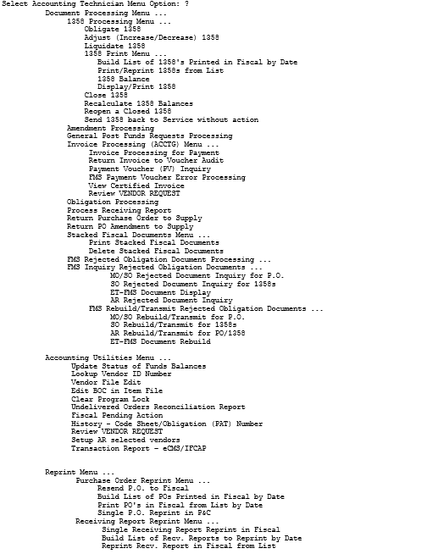
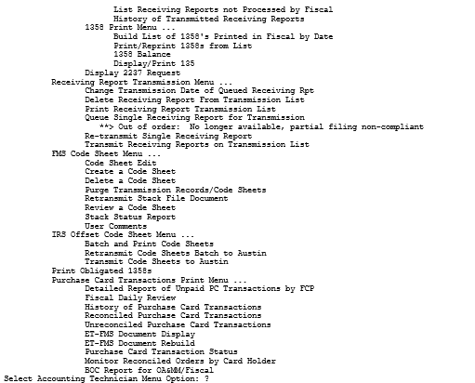

Glossary
This glossary defines terms in this manual that users might find unfamiliar.

0-9
Term | Definition / Discussion
1358 | VA Form 1358, Estimated Obligation or Change in Obligation
2138 | VA Form 90-2138, Order for Supplies or Services (first page of a VA Purchase Order)
2139 | VA Form 90-2139, Order for Supplies or Services (Continuation) (continuation sheet for Form 90-2138)
2237 | VA Form 90-2237, Request, Turn-in and Receipt for Property or Services (used to request goods and services)

A
Term | Definition / Discussion
A&MM | See Acquisition and Materiel Management (Service)
AACS | Automated Allotment Control System—Central computer system developed by VHA to disburse funding from VACO to field stations.
Accounting Technician | Fiscal employee responsible for obligation and payment of received goods and services.
Acquisition and Materiel Management (Service) (A&MM) | VA Service responsible for contracting and for overseeing the acquisition, storage, and distribution of supplies, services, and equipment used by VA facilities
Activity Code | The last two digits of the AACS number. It is defined by each station.
ADP Security Officer | The individual at your station who is responsible for the security of the computer system, both its physical integrity and the integrity of the records stored in it. Includes overseeing file access.
Agent Cashier | The person in Fiscal Service (often physically located elsewhere) who makes or receives payments on debtor accounts and issues official receipts.
ALD Code | Appropriation Limitation Department. A set of Fiscal codes which identifies the appropriation used for funding.
Allowance table | Reference table in FMS that provides financial information at the level immediately above the AACS, or sub-allowance level.
Amendment | A document which changes the information contained in a specified Purchase Order. Amendments are processed by the Purchasing & Contracting section of A&MM and obligated by Fiscal Service.
AMIS | Automated Management Information System.
Application Coordinator | The individuals responsible for the implementation, training and trouble-shooting of a software package within a service. IFCAP requires there be an Application Coordinator designated for Fiscal Service, A&MM Service.
Approve Requests | The use of an electronic signature by a Control Point Official to approve a 2237, 1358 or another request form and transmit said request to A&MM/Fiscal.
Approving Official | A user that approves reconciliations to ensure that they are correct and complete.
Authorization | Each authorization represents a deduction from the balance of a 1358 to cover an expense. Authorizations are useful when you have expenses from more than one vendor for a single 1358.
Authorization Balance | The amount of money remaining that can be authorized against the 1358. The service balance minus total authorizations.

B
Term | Definition / Discussion
Batch Number | A unique number assigned by the computer to identify a batch (group) of Code Sheets. Code Sheets may be transmitted by Batch Number or Transmission Number.
Breakout Code | A set of A&MM codes which identifies a vendor by the type of ownership (e.g., Minority-owned, Vietnam Veteran Owned, Small Business Total Set Aside, etc.).
Budget Analyst | Fiscal employee responsible for distributing and transferring funds.
Budget Object Code | Fiscal accounting element that tells what kind of item or service is being procured. Budget object codes are listed in VA Handbook 4671.2
Budget Sort Category | Used by Fiscal Service to identify the allocation of funds throughout their facility.

C
Term | Definition / Discussion
CC | Credit Charge entry identifier used by FMS and CCS for charges paid to Vendor thru Credit Card payment process.
CCS | The Credit Card System. This is the database in Austin that processes the credit card information from the external Credit Card Vendor system (currently CitiDirect), and then passes information on to FMS and IFCAP.
Ceiling Transactions | Funding distributed from Fiscal Service to IFCAP Control Points for spending. The Budget Analyst initiates these transactions using the Funds Distribution options.
Chief Logistics Office (CLO) | The Chief Logistics Office (CLO) develops and fosters logistics best practices for the Veterans Health Administration. Through the VHA Acquisition Board the CLO develops the annual VHA Acquisition plan that forms the basis for VHA’s acquisition strategy. This strategy seeks to procure high quality health care products and services in the most cost-effective manner. This includes the attainment of socio-economic procurement goals. The CLO also develops and implements a comprehensive plan for the standardization of healthcare supplies and equipment. This includes the development and administration of clinical product user groups.  The CLO is also responsible for developing improvements to supply chain management within VHA. This includes the establishment and monitoring of logistics benchmarking data. The CLO serves as liaison for logistics staff in each of the 21 VISNs.  The head of CLO is the Chief Prosthetics and Clinical Logistics Officer (CPCLO).
Chief Prosthetics and Clinical Logistics Officer (CPCLO) | The official in charge of the VHA Chief Logistics Office (CLO), also called the Clinical Logistics Office.
CLA | See Clinical Logistics Analyst
Classification of Request | An identifier a Control Point can assign to track requests that fall into a category (e.g., Memberships, Replacement Parts, Food Group III).
Clinical Logistics Analyst (CLA) | Logistics refers to how resources are acquired, transported and stored along the supply chain. By having an efficient supply chain and proper logistical procedures, an organization can cut costs and increase efficiency. Clinical logistics refers specifically to resources used for clinical purposes. A CLA is a person who examines processes, methods and data for clinical logistics operations.
Clinical Logistics Office | See Chief Logistics Office (CLO).
Clinical Logistics Report Server (CLRS) | The CLRS project allows the extraction of selected procurement and inventory data from VHA facilities to a centralized Clinical Logistics Report Server. The server supports the collection, tracking, and reporting of National Performance Measures, assisting the Under Secretary for Health (USH) in evaluating facility performance in the areas of consolidation of high tech equipment, standardization, socioeconomic goal accomplishment, acquisition, and inventory management.
CLRS | See Clinical Logistics Report Server (CLRS).
Common Numbering Series | This is a pre-set series of Procurement and Accounting Transaction (PAT) numbers used by Purchasing and Contracting, Personal Property Management, Accounting Technicians and Imprest Funds Clerks to generate new Purchase Orders/Requisitions/Accounting Transactions on IFCAP. The Application Coordinators establish the Common Numbering Series used by each facility.
Control Point | Financial element, existing ONLY in IFCAP, which corresponds to a set of elements in FMS that include the Account Classification Code (ACC) and define the Sub-Allowance on the FMS system. Used to permit the tracking of monies to a specified service, activity or purpose from an Appropriation or Fund.
Control Point Clerk | The user within the service who is designated to input requests (2237s) and maintain the Control Point records for a Service.
Control Point Official | The individual authorized to expend government funds for ordering of supplies and services for their Control Point(s). This person has all the options the Control Point Clerk has plus the ability to approve requests by using their electronic signature code.
Control Point Official’s Balance | A running record of all the transactions generated and approved for a Control Point from within IFCAP. Effects changes to the control point that are initiated directly from within the FMS system. Provides information that shows the total amount of funds committed, obligated and remaining to be spent for a specified fiscal quarter.
Control Point Requestor | The lowest level Control Point user, who can only enter temporary requests (2237s, 1358s) to a Control Point. This user can only view or edit their own requests. A Control Point Clerk or Official must make these requests permanent before they can be approved and transmitted to A&MM.
Cost Center | Cost Centers are unique numbers which define a service. One cost center must be attached to every Fund Control Point. This enables costs to be captured by service. Cost centers are listed in VA Handbook 4671.1.

D
Term | Definition / Discussion
Date Committed | The date that you want IFCAP to commit funds to the purchase.
Default | A suggested response that is provided by the system.
Deficiency | When a budget has obligated and expended more than it was funded.
Delinquent Delivery Listing | A listing of all the Purchase Orders that have not had all the items received by the Warehouse on IFCAP. It is used to contact the vendor for updated delivery information.
Delivery Order | An order for an item that the VA purchases through an established contract with a vendor who supplies the items.
Direct Delivery Patient | A patient who has been designated to have goods delivered directly to him/her from the vendor.
Discount Item | This is a trade discount on a Purchase Order. The discount can apply to a line item or a quantity. This discount can be a percentage or a set dollar value.

E
Term | Definition / Discussion
eCMS | The VA’s electronic Contract Management System hosted at the Austin Information Technology Center in Austin, Texas.
EDI | See Electronic Data Interchange (EDI).
EDI Vendor | A vendor with whom the VA has negotiated an arrangement to submit, accept and fill orders electronically.
EDI X12 | “X12” is the U.S. standard ANSI ASC X12, which is the predominant standard used in North America. Thus, “EDI X12” refers to electronic data interchanges which meet the X12 standard. Also seen as “X12 EDI.”
Electronic Data Interchange (EDI) | Electronic Data Interchange is a method of electronically exchanging business documents according to established rules and formats.
Electronic Signature | The electronic signature code replaces the written signature on all IFCAP documents used within your facility. Documents going off-station will require a written signature as well.
Expenditure Request | A Control Point document that authorizes the expenditure of funds for supplies and/or services (e.g., 2237, 1358, etc.).

F
Term | Definition / Discussion
FCP | Fund Control Point (see Control Point).
Federal Tax ID | A unique number that identifies your station to the Internal Revenue Service.
FileMan | The FileMan modules are the “building blocks” for all of VistA. FileMan includes both a database management system (DBMS) and user interface.  Source: http://www.hardhats.org/fileman/FMmain.html
Fiscal Balance | The amount of money on a 1358 and any adjustments to that 1358 that have been obligated by Fiscal Service. This amount is reduced by any liquidations submitted against the obligation.
Fiscal Quarter | The fiscal year is broken into four three-month quarters. The first fiscal quarter begins on October 1.
Fiscal Year | Twelve month period from October 1 to September 30.
FMS | Financial Management System, the primary accounting system for administrative appropriations. FMS has a comprehensive database that provides for flexible on-line and/or batch processing, ad-hoc reporting, interactive query capability and extensive security. FMS is concerned with budget execution, general ledger, funds control, accounts receivable, accounts payable and cost accounting.
FOB | Freight on Board. A FOB of “Destination” means that the vendor has included shipping costs in the invoice, and no shipping charges are due when the shipper arrives at the warehouse with the item. A FOB of “Origin” means the Vendor has paid shipping costs directly to the shipper and then will include them on their Invoice.
FPDS | Federal Procurement Data System.
FTEE | Full Time Employee Equivalent. An FTEE of 1 stands for 1 fiscal year of full-time employment. This number is used to measure workforces. A part-time employee that worked half days for a year would be assigned an FTEE of 0.5, as would a full-time employee that worked for half of a year.
Fund Control Point | IFCAP accounting element that is not used by FMS. See also control point.
Funds Control | A group of Control Point options that allow the Control Point Clerk and/or Official to maintain and reconcile their funds.
Funds Distribution | A group of Fiscal options that allows the Budget Analyst to distribute funds to Control Points and track Budget Distribution Reports information.

G
Term | Definition / Discussion
GBL | Government Bill of Lading. A document that authorizes the payment of shipping charges in excess of $250.00.
GL | General Ledger.
Globals | Globals are variables which are automatically and transparently stored on disk and persist beyond program, routine, or process completion. Globals are used exactly like ordinary variables, but with the caret character prefixed to the variable name.  Globals are stored in highly structured data files by MUMPS and accessed only as MUMPS globals. VistA file definitions and data are both stored in globals.

I
Term | Definition / Discussion
Identification Number | A computer-generated number assigned to a code sheet.
IFCAP | The VA’s Integrated Funds Distribution Control Point Activity, Accounting and Procurement system.
Imprest Funds | Monies used for cash or 3rd party draft purchases at a VA facility.
Integrated Supply Management System (ISMS) | ISMS is the system which replaced LOG I for Expendable Inventory.
ISMS | See Integrated Supply Management System.
Item File | A listing of items specified by A&MM service as being purchased repetitively. This file maintains a full description of the item, related stock numbers, vendors, contract numbers and a procurement history.
Item History | Procurement information stored in the Item File. A history is kept by Fund Control Point and is available to the Control Point at time of request.
Item Master Number | A computer-generated number used to identify an item in the Item File.

J
Term | Definition / Discussion
Justification | A written explanation of why the Control Point requires the items requested. Adequate justification must be given if the goods are being requested from other than a mandatory source.

K
Term | Definition / Discussion
Kernel | The Kernel is the software “scaffolding” that supports all VistA applications. The Kernel system permits any VistA software application to run without modification to its base structure no matter what hardware or software vendor the application was built on.  The Kernel includes several management tools including device, menu, programming, operations, security/auditing, task, user, and system management. Its framework provides a structurally sound computing environment that permits controlled user access, menus for choosing various computing activities, the ability to schedule tasks, application development tools, and numerous other management and operation tools.  Source: http://hardhats.org/kernel/KRNmain.html

L
Term | Definition / Discussion
Liquidation | The amount of money posted to the 1358 or Purchase Order as a payment to the vendor. They are processed through payment/invoice tracking.
LOG I | LOG I is the name of the Logistics A&MM computer located at the Austin Automation Center. This system continues to support the Consolidated Memorandum of Receipt.

M
Term | Definition / Discussion
M | The Massachusetts General Hospital Utility Multi-Programming System, or alternatively M, is a programming language originally created for use in the healthcare industry. M is designed to make writing database-driven applications easy while simultaneously making efficient use of computing resources. The most outstanding, and unusual, design feature of M is that database interaction is transparently built into the language. Many parts of VistA are written in M.
MailMan | Mailman is an integrated data channel in VistA for the distribution of:  - Patches (Kernel Installation and Distribution System or KIDS builds)  - Software releases (KIDS builds)  - Computer-to-computer communications (HL7 transfers, Servers, etc.)  - Person-to-person messaging (email)  Source: http://www.hardhats.org/cs/mailman/MMmain.html
Mandatory Source | A Federal Agency that sells supplies and services to the VA, Defense Logistics Agency (DLA), General Services Administration (GSA), etc.
MSC Confirmation Message | A MailMan message generated by the Austin Message Switching Center that assigns an FMS number to an IFCAP transmission of documents.
MSPV | Medical/Surgical Prime Vendor
MUMPS | See M.

O
Term | Definition / Discussion
Obligation | The commitment of funds. The process Fiscal uses to set aside monies to cover the cost of an Order.
Obligation (Actual) Amount | The actual dollar figure obligated by Fiscal Service for a Purchase Order. The Control Point’s records are updated with actual cost automatically when Fiscal obligates the document on IFCAP.
Obligation Number | The 6-character number assigned to orders, requisitions and 1358s. (i.e. C prefix number that Fiscal Service assigns to the 1358.)
Option | A Vista Option is an application component defined in VA Kernel to control user and remote server access to VistA applications. Options can appear on menu “trees” of options, through which the user navigates to execute application software. Types of options include menu (to allow grouping of options); edit (to edit application files via VA FileMan); inquire (to query the database via VA FileMan); print (to execute reports via VA FileMan); run routine (to execute custom application software); server (to process remote procedure calls via MailMan); and Broker (to process GUI remote procedure calls via Kernel Broker).
Organization Code | Accounting element functionally comparable to Cost Center but used to organize purchases by the budget that funded them, not the purposes for spending the funds.
Outstanding 2237 | A&MM report that lists all the IFCAP generated 2237s pending action in A&MM.

P
Term | Definition / Discussion
Partial | A Receiving Report (VA document that shows receipt of goods) for only some of the items ordered on a Purchase Order.
Partial Date | The date that a warehouse clerk created a receiving report for a shipment.
PAT Number | Pending Accounting Transaction number – the primary FMS reference number. See also Obligation Number.
Personal Property Management | A section of A&MM Service responsible for screening all requests for those items available from a Mandatory Source, VA Excess or Bulk sale. They also process requisitions for goods from Federal Agencies and equipment requests. In addition, they maintain the inventory of Warehouse stocked items and all equipment (CMRs) at the facilities they support.
POA | Purchase Order Acknowledgment. The message received electronically from an EDI vendor acknowledging the placement of an order.
PPM | Personal Property Management, now referred to at most sites as Acquisition and Materiel Management Service.
Program Code | Accounting element that identifies the VA initiative or program that the purchase will support.
Prompt Payment Terms | The discount given to the VA for paying the vendor within a set number of days (e.g., 2% 20 days means the VA will save 2% of the total cost of the order if the vendor is paid within 20 days of receipt of goods).
Purchase Card | A card, similar to a credit card, that Purchase Card Users use to make purchases. Purchase Cards are not credit cards but debit cards that spend money out of a deposited balance of VA funds.
Purchase Card Coordinator | A person authorized by a VA station to monitor and resolve delinquent purchase card orders, help VA services record, edit and approve purchase card orders in a timely manner, assign purchase cards to IFCAP users, and monitor the purchase card expenses of VAMC services.
Purchase Card Orders | Orders funded by a purchase card.
Purchase Card User | A person who uses a purchase card. Purchase Card Users are responsible for recording their purchase card orders in IFCAP.
Purchase History Add (PHA) | Information about purchase orders which is automatically sent to Austin for archiving. This same transaction is also used to send a PO for EDI processing.
Purchase History Modify (PHM) | Information about amendments which is automatically sent to Austin for archiving.
Purchase Order | A government document authorizing the purchase of the goods or services at the terms indicated.
Purchase Order Acknowledgment | Information returned by the vendor describing the status of items ordered (e.g., 10 CRTs shipped, 5 CRTs backordered).
Purchase Order Status | The status of completion of a purchase order (e.g., Pending Contracting Officer’s Signature, Pending Fiscal Action, Partial Order Received, etc.).
Purchasing Agents | A&MM employees legally empowered to create purchase orders to obtain goods and services from commercial vendors.

Q
Term | Definition / Discussion
Quarterly Report | A Control Point listing of all transactions (Ceilings, Obligations, Adjustments) made against a Control Point’s Funds.
Quotation for Bid | Standard Form 18. Used by Purchasing Agents to obtain written bids from vendors. May be created automatically and transmitted electronically within the Purchasing Agent’s module.

R
Term | Definition / Discussion
Receiving Report | The VA document used to indicate the quantity and dollar value of the goods being received.
Reconciliation | Comparing of two records to validate IFCAP Purchase Card orders. Purchase Card Users compare IFCAP generated purchase card order data with the CC transaction sent from the CCS system in Austin.
Reference Number | Also known as the Transaction Number. The computer-generated number that identifies a request. It is comprised of the: Station Number-Fiscal Year-Quarter - Control Point – 4-digit Sequence Number.
Repetitive (PR Card) Number | See Item Master Number.
Repetitive Item List  (RIL) | A method the Control Point uses to order items in the Item File. The Control Point enters the Item Master Number, the quantity and vendor and IFCAP can sort and generate 2237 requests from the list. A RIL can be created by using the Auto-Generate feature within the Inventory portion of the package.
Requestor | See Control Point Requestor.
Requisition | An order from a Government vendor.
Running Balance | A running record of all the transactions generated and approved for a Control Point. Provides information that shows the total amount of funds committed, obligated, and remaining to be spent for a specified fiscal quarter.

S
Term | Definition / Discussion
Section Request | A temporary request for goods and/or services entered by a Control Point Requestor. These requests may or may not be made permanent by the Control Point Clerk/Official.
Service Balance | The amount of money on the on the original 1358 and any adjustments to that 1358 when created by that service in their Fund Control Point. This amount is reduced by any authorizations created by the service.
SF-18 | Request for Quotation.
SF-30 | Amendment of Solicitation/Modification of Contract.
Short Description | A phrase which describes the item in the Item Master file. It is restricted to 3 to 60 characters and consists of what the item is, the kind of item, and the size of item (e.g., GLOVE-SURGICAL MEDIUM).
Site Parameters | Information (such as Station Number, Cashier’s address, printer location, etc.) that is unique to your station. All of IFCAP uses a single Site Parameter file.
Sort Group | An identifier a Control Point can assign to a project or group of like requests. It is used to generate a report that will tell the cost of requests.
Sort Order | The order in which the budget categories will appear on the budget distribution reports.
Special Remarks | A field on the Control Point Request that allows the CP Clerk to enter information of use to the Purchasing Agent or vendor. This field can be printed on the Purchase Order.
Stacked Documents | The purchase orders, receiving reports, and 1358s which are sent electronically to Fiscal and stored in a file for printing at a later time rather than being printed immediately.
Status of Funds | Fiscal’s on-line status report of the monies available to a Control Point. FMS updates this information automatically.
Sub-control Point | A user defined assignment of all or part of a ceiling transaction to a specific category (sub-control point) within a Control Point, Transactions can then be posted against this sub-control point and a report can be generated to track use of specified funding within the overall control point.
Sub-cost Center | A subcategory of Cost Center. IFCAP will not utilize a ‘sub-cost center’ field but will send FMS the last two digits of the cost center as the FMS ‘sub-cost center’ field.

T
Term | Definition / Discussion
Tasked Job | A job, usually a printout, that has been scheduled to run at a predetermined time. Tasked jobs are set up to run without having a person watching over them.
TDA | See “Transfer of Disbursing Authority.”
Total Authorizations | The total amount of the authorizations created for the 1358 obligation.
Total Liquidations | The total amount of the liquidations against the 1358 obligation.
Transaction Number | The number of the transaction that funded a Control Point (See Budget Analyst User’s Guide). It consists of the Station Number – Fiscal Year – Quarter – Control Point – Sequence Number.
Transfer of Disbursing Authority | The method used to allocate funds to a VA facility.
Transmission Number | A sequential number given to a data string when it is transmitted to the Austin DPC; used for tracking message traffic.
Type Code | A set of A&MM codes that provides information concerning the vendor size and type of competition sought on a purchase order.

U
Term | Definition / Discussion
Unit of Issue | A description of the quantity/packaging combination in which the item is issued to the end user; it may be different from the Unit of Purchase, which is the combination used when the item is procured from the vendor. For example, a vendor may sell an item in cases of 24 cans, but the end user receives individual cans from that case.
Unit of Purchase | A description of the quantity/packaging combination in which VA purchases the item from the vendor; it may be different from the Unit of Issue, which is the combination used to issue the item to the end user. See also Unit Conversion Factor.
Unit Conversion Factor | A number which expresses the ratio between the unit of measure and the unit of issue. Among other things, the conversion factor (which is part of the vendor data) is used at order release to calculate the due-ins and due-outs. Supply stations receive the conversion factor at the time of order release and use it to translate the order quantities into supply station amounts. If an item is procured, stocked and issued using the same units, then the conversion factor would be 1.

V
Term | Definition / Discussion
Vendor file | An IFCAP file of vendor information solicited by the facility. This file contains ordering and billing addresses, contract information, FPDS information and telephone numbers. The debtor’s address may be drawn from this file but is maintained separately. If the desired vendor is not in the file, contact A&MM Service to have it added.
Vendor ID Number | The ID number assigned to a vendor by the FMS Vendor unit.
VRQ | FMS Vendor Request document. When a new vendor is added to IFCAP a VRQ message is sent electronically to the Austin FMS Vendor unit to determine if the vendor exists in the central vendor system. If the vendor is not in the system, Austin will confirm information and establish the vendor in the central file. If vendor exists in central file already, Austin will verify the data. See also VUP.
VUP | Vendor Update Message. This message is sent electronically from the FMS system to ALL IFCAP sites to ensure that the local vendor file contains the same data as the central vendor file in Austin. This message will contain the FMS Vendor ID for the vendor and the Alternate Address Indicator if applicable. See also VRQ.

X
Term | Definition / Discussion
X12 EDI | See EDI X12.

THIS PAGE INTENTIONALLY LEFT BLANK

Index

<Alt> 1-3
A&MM 1-5, 2-1
Accounting Technician 1-1, 1-6, 3-1, 3-5, 5-2, 6-1, 7-1, 7-3, 8-2, 8-8, 13-1
Budget Object Code (BOC) 2-2, 4-1, 4-2, 5-3, 7-2
click 1-2
Clinical Logistics Office 12-1
Clinical Logistics Office Menu 12-1
Create a Code Sheet 8-1
documents
available 1-2
Financial Services Center 5-1, 5-6
FMS 1-6, 3-3, 3-6, 4-1, 4-2, 4-3, 5-2, 5-3, 7-2, 8-1, 8-2, 8-4, 8-8
FMS Payment Voucher Error Processing 8-9
hyperlink
internal 1-2
hyperlinks 1-2
icon
Information 1-3
Technical Note 1-3
Tip 1-3
Warnings 1-3
icons
for boxed notes 1-3
IFCAP 1-3
Invoice Processing for Payment 7-1
manual
online 12-1
Manual 1-3
Obligate 1358 4-1
Obligation Processing 3-1, 3-3, 3-5, 3-6
OLCS 5-1, 5-6
Online Certification System 5-1, 5-6
operating system 1-2
Process Receiving Report 6-1
Purchase Order 1-5, 2-1, 3-1, 3-4, 3-6
Query Tool 1-3
Segregation of Duties 5-1, 5-6
Single Receiving Report Reprint in Fiscal 13-1
Source Code 2-1
Stack Status Report 8-2

THIS PAGE INTENTIONALLY LEFT BLANK

