Veteran Health Identification Card (VHIC 4.27)

User Guide
Volume 1 - Card Request – All Users

December 2023

Department of Veterans Affairs
Office of Information and Technology (OI&T)

Revision History
NOTE: The revision history cycle begins once changes or enhancements are requested after the document has been baselined.
Date | Revision | Description | Author
12/14/2023 | 14.1 | No changes to functionality Updated Date and Version Number | REDACTED
09/18/2023 | 14 | Updated to reflect changes in VIP 26 | REDACTED
06/17/2023 | 13 | Updated to reflect new functionality for VIP 25 ( Foreign Address Confirmation) , removed duplicate card request information and added links to basic request information. | REDACTED
03/18/2023 | 12 | Updated Toolkit proofing screenshots, Updated Card Request data to reflect new functionality for VIP 24 | REDACTED
12/17/2022 | 11.2 | No changes to functionality Updated Date and Version Number | REDACTED
09/18/2022 | 11.1 | No changes to functionality Updated Date and Version Number | REDACTED
06/18/2022 | 11 | Updated to reflect changes to functionality in VIP 21 | REDACTED
04/18/2022 | 10 | Updated to reflect changes to functionality in VIP 20 | REDACTED
09/18/2021 | 9.1 | Updated screenshots in order to make VDL redaction easier | REDACTED
06/20/2021 | 9 | Updated to reflect changes to functionality in VIP 17 | REDACTED
03/04/2021 | 8 | Updated to reflect changes to functionality in VIP 16 | REDACTED
12/19/2020 | 7 | Updated to reflect changes to functionality in VIP 15 | REDACTED
06/20/2020 | 6 | Updated to reflect changes to VHIC application during VIP 13 application release | REDACTED
02/15/2020 | 5 | Updated to reflect changes to VHIC application during VIP 12 application | REDACTED
11/01/2019 | 4 | Updated to reflect changes made in the VIP 10 release- validation for ICN input fields on all search screens and added usage tips | REDACTED
09/19/2019 | 3 | Updated to reflect changes to VHIC 4.9 functionality | REDACTED
08/30/2019 | 2.4 | Updated guide to match Style Guide | REDACTED
08/30/2018 | 2.3 | As part of RTC Task# 808827, updated Alt text on four (4) revised images, re-ran TOCs, and checked pagination. Converted this document to a Section 508 compliant PDF. | REDACTED
08/23/2018 | 2.3 | In Section 4, updated Figures 4-20, 4-21, 4-33, and 4-35 to include a message at the bottom of the figure window for how to delete the current MVI Value. This work was completed under RTC Task # 808827. | REDACTED
04/20/2018 | 2.2 | As part of new Section 4, entitled, “Proofing Veteran before Requesting a VHIC Card” added Alt text to all images and figures. Re-ran TOCs and fixed content/figure pagination issues in the Word document. Revision History number set to “2.2” and document converted to Section 508 compliant PDF for uploading, with Word document, to RTC Jazz Tools as well as SharePoint. Completed editing 04/11/2018 for 04/20/2018 delivery. | REDACTED
04/20/2018 | 2.2 | Updated to reflect changes to Proofing process within MVI Toolkit, updated TOCs | REDACTED
01/24/2018 | 2.1 | Accepted all changes as approved on anomaly logs, re-paginated document, re-ran TOCs, and created Section 508 compliant PDF for uploading, with Word document, to RTC Jazz Tools as well as SharePoint. | REDACTED
01/19/2018 | 2.1 | Re-paginated document. Readied document for creating Section 508 compliant PDF. | REDACTED
01/17/2018 | 2.1 | Applied change from third anomaly log dated 011718 and e-mail direction from same date. | REDACTED
01/16/2018 | 2.1 | Applied changes from second anomaly log dated 011618. | REDACTED
01/12/2018 | 2.1 | Applied changes from first anomaly log dated 010418. | REDACTED
12/28/2017 | 2.1 | Updated document images to include “Skip to Content” link where necessary. Re-ran TOCs, added Alt Text to all images and figures, and changed document date from “August 2017” to “January 2018.” Updated Appendix entitled “VHIC Roles.” | REDACTED
08/17/2017 | 2.0 | After receiving documentation updates, re-completed steps from 08/08/17 Revision History entry. Also, fixed figure numbering transition between Figure 2-10 and Figure 2-12. | REDACTED
08/08/2017 | 2.0 | Added Alt text to all images and figures. Accepted all changes remaining in document, re-ran TOCs, and fixed content/figure pagination issues in the Word document. Revision History number set to “2.0” and document converted to Section 508 compliant PDF as part of VHIC 4.8. | REDACTED
07/21/2017 | 2.0 | Updated to include standard image for “Veteran Image.” | REDACTED
07/18/2017 | 2.0 | Updated with content and images for first draft for VHIC 4.8. | REDACTED
04/15/2017 | 1.7 | Updated for VIP 2 Changes | REDACTED
08/12/2016 | 1.6 | Completed technical writer review of document. Ran Spelling and Grammar, added Alt text to all images, and re-ran TOCs. | REDACTED
08/10/2016 | 1.6 | Updated content and Images for VHIC 4.7 | REDACTED
01/06/2016 | 1.5 | Updated content and Images | REDACTED
07/07/2015 | 1.4 | Updated content and Images | REDACTED
07/07/2015 | 1.3 | Rebuilt to capture content overhaul to VHIC System and divided this guide into three separate parts | REDACTED
05/20/2015 | 1.2 | Updated Content and Images to reflect the Maintenance Releases | REDACTED
01/13/2015 | 1.1 | Updated content and Images | REDACTED
09/18/2014 | 1.0 | Rebuilt to capture content overhaul to VHIC System | REDACTED
Table of Contents
1. Introduction 1
1.1. Purpose 1
1.2. Document Orientation 1
1.2.1. Organization of the Manual 1
1.2.2. Assumptions 1
1.2.3. Disclaimers 2
1.2.4. Documentation Conventions 2
1.3. Enterprise Service Desk and Organizational Contacts 2
2. Veteran Health Identification Card – What is it? 3
2.1. Accessing the VHIC Application 4
2.2. Browser 4
2.2.1. Browser Incompatibility Issue 4
2.3. Proper Navigation of the VHIC Application 4
2.4. Roles within VHIC 5
2.4.1. VHIC Associate 6
2.4.2. VHIC Supervisor 6
2.4.3. VHIC Administrator 6
2.4.4. VHIC Technical Administrator (Tier 3) 6
2.4.5. VHIC Auditor 6
2.4.6. VHIC Read-Only User 6
2.4.7. VHIC Card Replacement Veteran Enrollment Services Users 7
3. Getting Started 7
3.1. Single Sign-On Internal (SSOi) 7
3.2. Logging On 7
3.3. System Menu 8
3.3.1. VHIC Administrator and Technical Administrator Tier 3 8
3.3.2. VHIC Associate and Supervisor 8
3.3.3. VHIC Auditor and Read-Only User 9
3.4. VHIC System Status Banner 10
4. Proofing Veteran before Requesting a VHIC Card 11
4.1. Accessing the Identity Management Toolkit 11
4.1.1. Accessing the Identity Management Toolkit Directly 11
4.1.2. Accessing Identity Management Toolkit from within the VHIC Application 12
4.2. Proofing Process and Steps 13
4.2.1. Looking up the Veteran 13
4.2.2. Primary View 17
4.2.3. If Level of Assurance is Level 1 – Complete Proofing 20
4.2.4. If Level of Assurance is Level 2 – Continue to Issue VHIC 27
4.2.5. Proofing Task Opened in Error, Trait Edit Needed 28
4.2.6. Logging out of Identity Management Toolkit 31
5. Creating a VHIC Card – The Card Request Process 32
5.1. New VHIC Card Request 33
5.1.1. Veteran Level 2 Proofed through Identity Management Toolkit 33
5.1.2. Status Section 48
5.1.3. New VHIC: Veteran has NOT been Level 2 Proofed through Identity Management Toolkit 54
5.1.4. Resuming an On Hold VHIC Request: 59
5.2. VHIC Card Replacement 63
5.2.1. VHIC Replacement for Veteran Level 2 Proofed through Identity Management Toolkit 63
5.2.2. Step 5: Save Card Request 67
5.3. On Hold Reasons Explained 69
5.3.1. Veteran Not Proofed: 69
5.3.2. Enrollment Services Unavailable 71
5.3.3. Eligibility Pending 71
5.3.4. Bad Data – Other 72
5.3.5. No EDIPI 73
5.3.6. Imprecise Date of Birth 74
5.3.7. Manual Review Required 76
5.3.8. No Facility Address 77
5.4. Requesting a VHIC for a Veteran within ten (10) days of a previous VHIC request 77
5.5. Requesting a VHIC for a Veteran with an existing Date of Death 78
6. Card Deactivations 78
7. Reports 79
8. Troubleshooting 79

Table of Figures
Figure 1: Example of what the VHIC looks like 3
Figure 2: VHIC Navigation Buttons 4
Figure 3: VHIC Administrator 5
Figure 4: VHIC Associate and VHIC Supervisor menu 5
Figure 5: VHIC Auditor and VHIC Read-Only User menu 5
Figure 6: SSOi Login Screen 7
Figure 7. VHIC Administrator View 8
Figure 8: VHIC Associate and VHIC Supervisor Home screen 9
Figure 9: VHIC Auditor and VHIC Read-Only User Home screen 9
Figure 10: VHIC System Status Banner 10
Figure 11: VHIC Preferred Browser Reminder 10
Figure 12: Identity Management Toolkit SSOi Logon Screen 11
Figure 13. Step 1: Enter Search Terms with Identity Management Toolkit hyperlink 12
Figure 14: Step 5 - Save Card Request with Identity Management Toolkit hyperlink 13
Figure 15: Identity Management Toolkit Search Screen 14
Figure 16: Identity Management Toolkit Quick Search with Traits 14
Figure 17: Identity Management Toolkit Quick Search - MPI Search Results 14
Figure 18: Identity Management Toolkit Quick Search with ICN 15
Figure 19: Identity Management Toolkit Search Screen; Click Search 15
Figure 20: Identity Management Toolkit Search For Person screen 16
Figure 21: Identity Management Toolkit Search For Person screen; Click Search 17
Figure 22. SSN Verification Status is Invalid 18
Figure 23. SSN Verification Shows Blank 18
Figure 24: Identity Management Toolkit Primary View Screen 19
Figure 25: Tasks/Requests tab highlighted 20
Figure 26: Tasks/Requests screen; click Proofing Tab 20
Figure 27: New Proofing Task Button Selected 21
Figure 28: Identification Confirmation Message 21
Figure 29: Task Details screen; Click Person Verification 21
Figure 30: Identity Management Toolkit Person Verification screen 22
Figure 31: Data Review Tab Trait Verification 23
Figure 32: Data Verification Indicator 23
Figure 33: Verification Document Instruction 24
Figure 34: Verification Document Section; Enter document details 25
Figure 35: Person Verification Updated Message 25
Figure 36: Refresh View button 26
Figure 37: Imprecise Date of Birth Reported in Toolkit 26
Figure 38: Task/Request Tab; Resolved Tasks 27
Figure 39: The Veteran's ICN is highlighted vii
Figure 40: The Veteran's ICN is highlighted vii
Figure 41: Step 1: Enter Search Terms - ICN has been entered 28
Figure 42: Person Verification Task; Trait Edit Needed 29
Figure 43: Processing Error Message 29
Figure 44: Person Verification; Task Notes Tab Selection 30
Figure 45: Unassign Person Verification Task 30
Figure 46: Log Off link located in the menu bar 31
Figure 47: Log Off link located in the Navigation pane 31
Figure 48: Identity Management Toolkit Idle message 31
Figure 49: Card Request Navigation Bar 32
Figure 50: Navigation Bar Step appearance by state 32
Figure 51: Enter Search Terms screen 34
Figure 52: Help icon 34
Figure 53: Enter Search Terms screen 34
Figure 54: Invalid ICN Error Message 36
Figure 55: Veteran Not Eligible Message 37
Figure 56: Veteran Eligibility Undetermined 37
Figure 57. Deceased Veteran Search Results 37
Figure 58. Full Name Including Preferred Name 38
Figure 59: Select Veteran screen 38
Figure 60: Capture Veteran Image screen 39
Figure 61: Capture Veteran Image screen – Take New Picture 39
Figure 62: Capture Veteran Image screen – Capture Image 41
Figure 63: Capture Veteran Image screen – Accept new photo; click Next 41
Figure 64: Capture Veteran Image screen – Upload from File 42
Figure 65: Capture Veteran Image screen – Upload photo; click Browse 43
Figure 66: Capture Veteran Image screen – Upload photo; click Upload 43
Figure 67: Capture Veteran Image screen – Edit photo; click Next 44
Figure 68: Capture Veteran Image screen – Reuse Existing Photo; click Next 44
Figure 69: Capture Veteran Image screen – Reuse Existing Photo; click OK 45
Figure 70: Greyscale Photo Error 45
Figure 71: Replace Picture 46
Figure 72: Select Mailing Address screen with bad facility address 47
Figure 73: Save Card Request review screen 49
Figure 74: Branch of Service Selection 50
Figure 75. Veteran With Foreign Mailing Address 50
Figure 76. Confirm Foreign Address Setting 51
Figure 77: Verify Veteran Photo 52
Figure 78: Photo Does Not Meet VHIC Standards 53
Figure 79: New Card Request Submitted 54
Figure 80: Save Card Request review screen 54
Figure 81: Save Request With On Hold Status 55
Figure 82: Validate Veteran Photo 56
Figure 83: Photo Does Not Meet VHIC Standards 57
Figure 84: Card Request Saved on Hold – Veteran Not Proofed 58
Figure 85: Step 4 Status On Hold. 60
Figure 86: Save Card Request review screen; click Submit 61
Figure 87: Verify Veteran Photo 61
Figure 88: Photo Does Not Meet VHIC Standards 62
Figure 89: Card Request Submitted 63
Figure 90: Replacement Card Step 4 64
Figure 91: Card Request Status section 65
Figure 92: Replacement Reason drop-down list 66
Figure 93: Poor Quality Replacement Reasons 66
Figure 94: Damaged Replacement Reasons 66
Figure 95: Incorrect Information Replacement Reasons 67
Figure 96: Save Card Request review screen 68
Figure 97: Photo Does Not Meet VHIC Standards 68
Figure 98: Replacement Card Request Submitted 69
Figure 99: Veteran Not Proofed Warning message on Step 4: Select Mailing Address 70
Figure 100: Reason for Hold: Veteran Not Proofed 70
Figure 101: Card Request Status: On Hold - Veteran Not Proofed 70
Figure 102: Reason for Hold: Enrollment Unavailable 71
Figure 103: Reason for Hold: Eligibility Pending 71
Figure 104: Reason for Hold: Bad Data – Name Spelled Wrong 72
Figure 105: Card Request Status: Replacement on Hold - Bad Data: Name Spelled Wrong 72
Figure 106: Reason for Hold: Bad Data Unchecked 73
Figure 107: Reason for Hold: No EDIPI 73
Figure 108: On Hold Request Confirmation Box 74
Figure 109: Active Request Exists in System Message 74
Figure 110: Reason for Hold: No EDIPI 75
Figure 111: On Hold Request Confirmation Request 75
Figure 112: Saved on Hold 76
Figure 113: Manual Review Required Hold. 76
Figure 114 No Facility Address 77
Figure 115: Replacement Card has been requested within the past 10 days 77
Figure 116: Deceased Veteran Notification 78

Table of Tables
Table 1: Enterprise Service Desk Contact Information 3
Table 2: Who can process a card request? 32

Introduction

Purpose
The purpose of this User Guide is to provide general system information, as well as accessibility and user roles with the VHIC application. This User Guide will provide a detailed walkthrough of creating a Veteran Health Identification Card request using the VHIC application.

Document Orientation

Organization of the Manual
This User Guide is divided into sections to allow you to quickly obtain the information you need.
The first section will provide an overview of what a VHIC is and what the eligibility requirements are, and the various user roles and their accessibility within the VHIC application.
The second and third sections will walk the user through the Roles and Requirements needed to access the VHIC application, as well as some general guidelines on using the VHIC application.
The fourth section will give the user step-by-step details of how to complete the Identity Proofing process before starting a card request for a Veteran. The VHIC user must verify the Veteran’s Identity Proofing Level is at Level 2 in the Identity Management Toolkit.
The fifth section explains the process involved with creating a VHIC Card Request for a Veteran. A step-by-step process will navigate the VHIC Associate through the screens in the VHIC application. Once all of the required information has been provided, the final step in the process will allow a VHIC request to be submitted for processing.
Each day, these card requests are transmitted from the VHIC system to a vendor to print and mail the cards to the Veterans, the preferred facility, or the requesting facility. Typically, the cards are received in 7-10 business days from date of request. To ensure the VHIC is received at the appropriate address, the VHIC Associate must verify that the correct address is used, and the Print Vendor verifies that the address is valid. If the U.S. Postal Service cannot deliver the card, it is returned to the requesting facility.
The last three sections provide references on where to find information on Reporting, Card Deactivation, and Troubleshooting.

Assumptions
This guide has been written with the following assumed experience/skills of the audience:
- User has basic knowledge of the operating system (such as the use of commands, menu options, and navigation tools).
- User has been provided the appropriate active roles required for the VHIC application.
- User is using Google Chrome or Microsoft Edge to do their job of either Creating a VHIC Card Request, Running Reports, or Managing VHICs depending on user roles.
- User has validated access to the VHIC application.
- User has completed any prerequisite training.

Disclaimers

Software Disclaimer
This software was developed at the Department of Veterans Affairs (VA) by employees of the Federal Government in the course of their official duties. Pursuant to title 17 Section 105 of the United States Code this software is not subject to copyright protection and is in the public domain. VA assumes no responsibility whatsoever for its use by other parties, and makes no guarantees, expressed or implied, about its quality, reliability, or any other characteristic. We would appreciate acknowledgement if the software is used. This software can be redistributed and/or modified freely provided that any derivative works bear some notice that they are derived from it, and any modified versions bear some notice that they have been modified.

Documentation Disclaimer
The appearance of external hyperlink references in this manual does not constitute endorsement by the Department of Veterans Affairs (VA) of this Web site or the information, products, or services contained therein. The VA does not exercise any editorial control over the information you may find at these locations. Such links are provided and are consistent with the stated purpose of the VA.

Documentation Conventions
This manual uses several methods to highlight different aspects of the material:
- Descriptive text is presented in a proportional font (as represented by this font).
- “Screenshots” of computer online displays (i.e., character-based screen captures/dialogs) and are shown in a non-proportional font and enclosed within a box. Also included are Graphical User Interface (GUI) Microsoft Windows images (i.e., dialogs or forms).
- Links to cross referenced sections and screenshots will be shown in italic font (such as this)
- User's responses to online prompts (e.g., manual entry, taps, clicks, etc.) will be [boldface] type and enclosed in brackets.

Enterprise Service Desk and Organizational Contacts
The support contact information documented herein is intended to restore normal service operation as quickly as possible and minimize the adverse impact on business operations, ensuring that the best possible levels of service quality and availability are maintained.

The following table lists the contact information needed by site users for troubleshooting purposes. Support contacts are listed by description of the incident escalation and contact information (phone number and options to select).

Table 1: Enterprise Service Desk Contact Information
Issue | Contact Info
For Provisioning Issues | Contact the Enterprise Service Desk at REDACTED  When contacted by a support specialist, be ready to supply the employee’s full name, VA user ID and email address.
For Proofing Issues | Contact the Enterprise Service Desk at REDACTED,  When contacted by a support specialist, be ready to supply the Veterans' full name, full SSN, and DOB.
For All Other VHIC System Issues | Contact the Enterprise Service Desk at REDACTED, When contacted by a support specialist, be ready to supply the Veterans' full name, full SSN, and DOB.

Veteran Health Identification Card – What is it?
The VHIC serves as an identification mechanism for Veterans that are enrolled in the VA Healthcare system and supports efficiencies at VA medical facilities throughout the United States. Although not required by Veterans to receive medical care at a VA facility, it does enable Veterans to check in for VA appointments more quickly. The VHIC system is a web-based application that VHIC Associates use to issue VHICs to enrolled Veterans.

Figure 1: Example of what the VHIC looks like
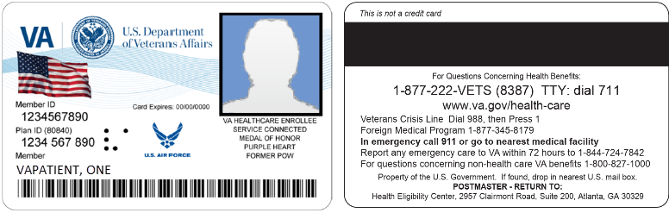

In order to be able to receive a VHIC, a Veteran must meet the following eligibility criteria:
- Be eligible for VA medical benefits
- Be enrolled in the VA Healthcare system
- Be Level 2 proofed at a VA medical facility
- Veteran identity must be recognized in the Master Person Index (MPI), which is managed by the Identity and Access Management (IAM) of the VA

Accessing the VHIC Application
VHIC is a web-based application that users will access via a web browser. The recommended browser is Google Chrome or Microsoft Edge . The VHIC URL is REDACTED and is case sensitive – it must be entered exactly as shown. After successfully logging in to the VHIC application, users should bookmark this site for easy access in the future. Instructions on how to do just that can be found here: REDACTED.

The best time to bookmark the site is after the user is in the application itself rather than attempting to bookmark the Login screen.

Browser
Once users are logged into their VA desktop, they will access VHIC using Google Chrome or Microsoft Edge by either entering the URL listed above or via the bookmark saved during an earlier session. Please do NOT use the Refresh button at the top of your browser window if you mistype the VHIC URL. The Refresh button will redirect you to the VA website. Please re-enter the VHIC URL and try again.

Browser Incompatibility Issue
In some instances, users may experience image misplacement or misalignment. This is most likely due to the current browser compatibility settings. You will want to ensure that the browser is not set to Compatibility View. This process is explained in the Veteran Health Identification Card User Guide - Volume 4 - Troubleshooting document.

Proper Navigation of the VHIC Application
The correct way to navigate through the VHIC application is to use the [Back] and [Next] buttons that are located at the bottom of each screen instead of using the Browser’s built in Back button. Please do NOT use the [Back] button at the top of your browser window to navigate back to a previous screen; this will cause errors to occur.
Figure 2: VHIC Navigation Buttons

The VHIC user can also navigate to the different features within the VHIC application by clicking on one of the navigation links located in the header near the top left of the screen. The user’s assigned role will determine which links are available as seen below. To see the full home screens for each user role, refer to the 3.3 System Menu section.

Figure 3: VHIC Administrator

Figure 4: VHIC Associate and VHIC Supervisor menu

Figure 5: VHIC Auditor and VHIC Read-Only User menu

Roles within VHIC
The VHIC application is built to accommodate a specific set of pre-established user roles. During the provisioning process, the VHIC user will have a role assigned to them, which will determine what aspects of the VHIC application are available to them. The following breaks down the specific roles and the areas of access that accompany each role.

If, while utilizing the VHIC application, a user finds they do not have access to items they feel they should have access to or find that they have access to items they should not, based on the definitions listed below, the VHIC user should report this information to their VHIC Supervisor. The VHIC Supervisor should then verify that the proper role has been assigned.

VHIC Associate
The VHIC Associate role shall be assigned to individuals responsible for processing a card request and resolving card request issues. Associates have the ability to create a card request and have access to a limited number of reports.

VHIC Supervisor
The VHIC Supervisor shall automatically inherit all access and privileges given to the VHIC Associate. The VHIC Supervisor role is allowed to submit a request for user access to the VHIC application. VHIC Supervisors have the ability to create a card request and have access to most available reports (excluding national versions).

VHIC Administrator
The VHIC Administrator role is reserved for the VHIC Program Team at the Health Eligibility Center (HEC) which is responsible for the creation and maintenance of all other VHIC accounts/roles. The VHIC Administrator shall automatically inherit privileges given to the VHIC Supervisor. Administrators have the ability to create a card request, manage cards, and have access to all available reports.

VHIC Technical Administrator (Tier 3)
The VHIC Technical Administrator (Tier 3) is a role reserved for system developers. They inherently possess access and privileges given to the VHIC Administrator. Technical Administrators (Tier 3) have the ability to create a card request and have access to all available reports as well as access to the Administration page.

VHIC Auditor
The VHIC Auditor role shall be assigned to users with read-only access to the VHIC System. The VHIC Auditor does not have the ability to create a card request but does have access to all available reports.

VHIC Read-Only User
The VHIC Read-Only User role shall be assigned to users with read-only access to the VHIC System. The VHIC Read-Only user does not have the ability to create a card request but does have access to a limited number of reports.

VHIC Card Replacement Veteran Enrollment Services Users
The VHIC Card Replacement User role shall be assigned to Enrollment System (VES) users with limited access to the VHIC System. The VHIC Card Replacement user does not have the ability to create a new card request but does have access to the Card Replacement functionality.

Detailed information on VHIC Roles and Access levels can be found in the Veteran Health Identification Card (VHIC) Roles and Access Guide document.

Getting Started

Single Sign-On Internal (SSOi)
Once users are logged into their VA desktop, they will access VHIC using Google Chrome or Microsoft Edge (IE) by either entering the REDACTED listed above or via the bookmark saved during an earlier session.
Users will be presented with the Single Sign On – internal (SSOi) login screen (shown below).
Here the VHIC user will need to use their PIV card to log into the VHIC application.

Figure 6: SSOi Login Screen
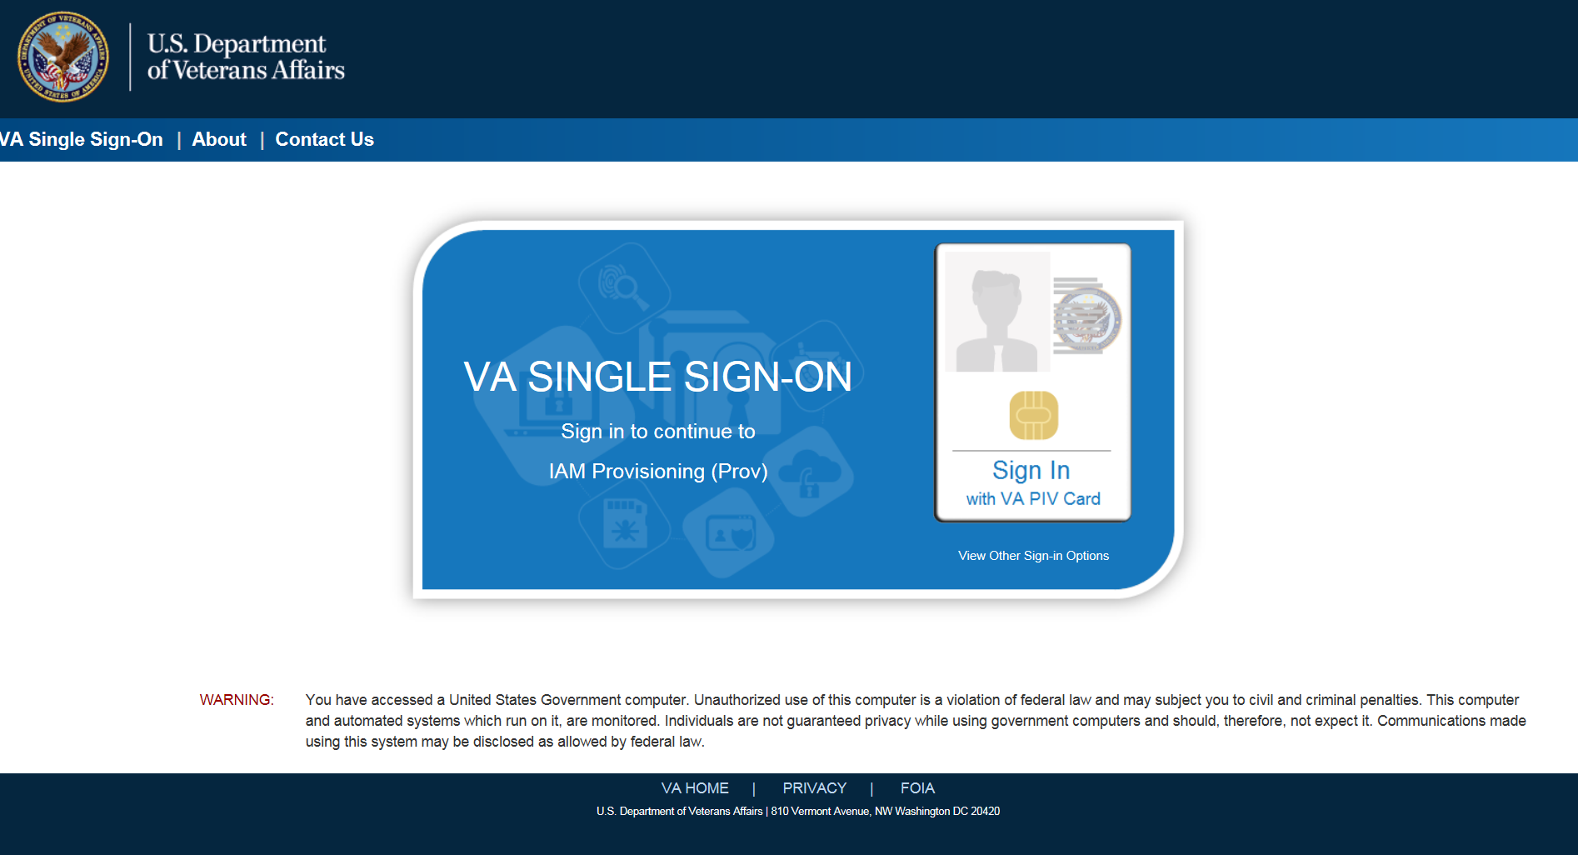

Logging On
The VHIC application is built to accommodate a specific set of pre-established user roles. During the provisioning process, the VHIC user will have a role assigned to them, which will determine what aspects of the VHIC application are available to them. The roles are listed below. For more information on the areas of access that accompanies each role, please refer to VHIC Roles and Access document.

System Menu
Depending on the VHIC users’ role, they will be presented different Home screens upon logging into the VHIC application.

NOTE: As IE is no longer supported by Microsoft, you will need to copy the URL link and open in Chrome or Edge.

VHIC Administrator and Technical Administrator Tier 3
The VHIC Administrator and VHIC Technical Administrator Tier 3 users will be presented with three menu options: Card Request, Reports and Card Management. They can navigate to each of these application modules by either clicking on one of the links located in the header at the top left of the screen or by clicking on one of the icon buttons in the middle of the screen.
Figure 7. VHIC Administrator View
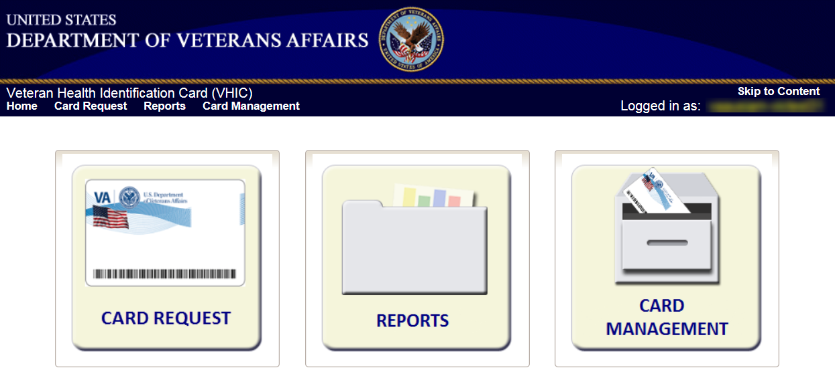

VHIC Associate and Supervisor
The VHIC Associate and VHIC Supervisor users will be presented with two menu options: Card Request and Reports. They can navigate to each of these application modules by either clicking on one of the links located in the header at the top left of the screen or by clicking on one of the icon buttons in the middle of the screen.

Figure 8: VHIC Associate and VHIC Supervisor Home screen
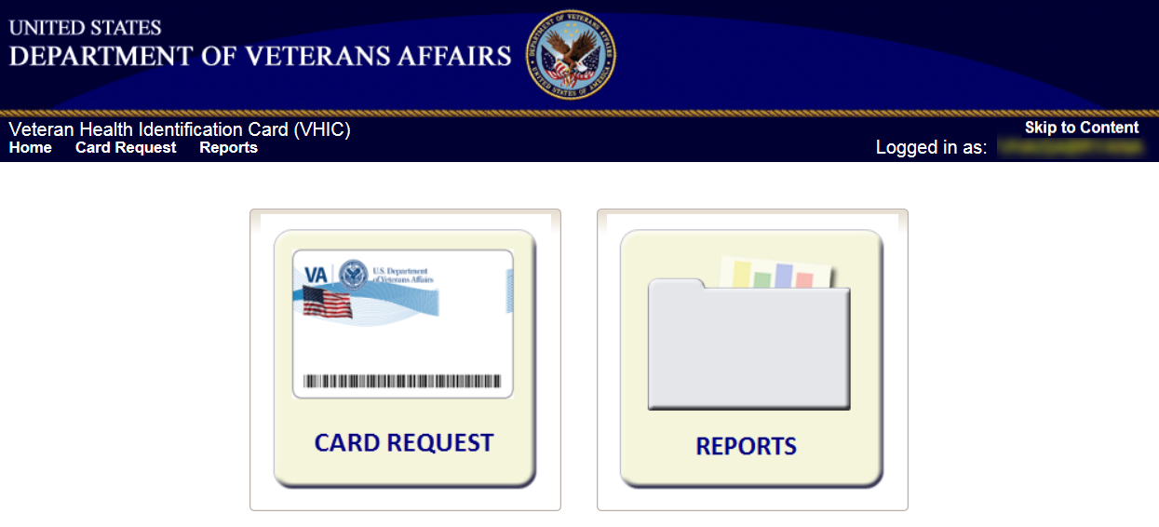

VHIC Auditor and Read-Only User
The VHIC Auditor and VHIC Read-Only users will be presented with the Reports menu option. They can navigate to Reports by clicking on the icon button in the middle of the screen.

Figure 9: VHIC Auditor and VHIC Read-Only User Home screen
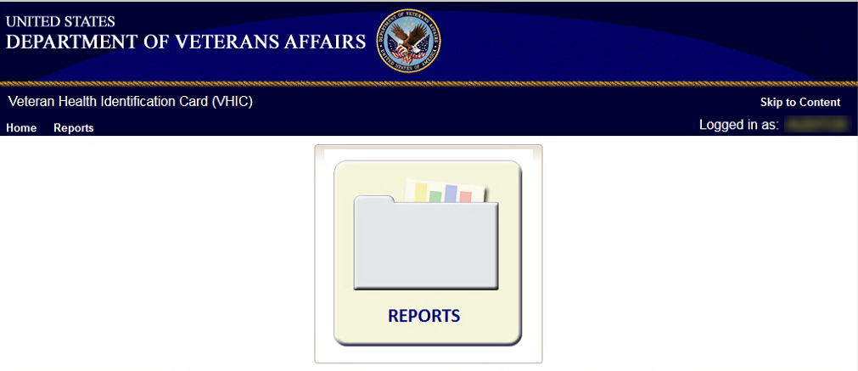

VHIC System Status Banner
The VHIC System will display a Status Banner at the top of the screen to notify users of reported issues with the system and/or during maintenance activities that do not require downtime such as high volume or preferred browser reminder as seen below.
Figure 10: VHIC System Status Banner
REDACTED

Figure 11: VHIC Preferred Browser Reminder
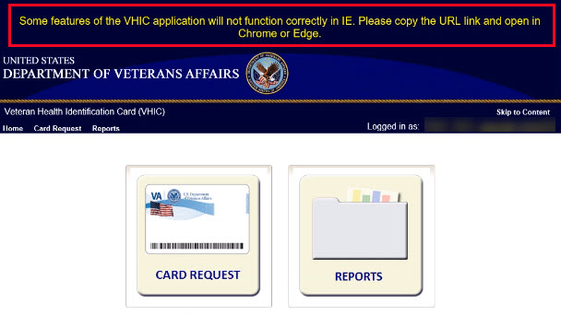

Proofing Veteran before Requesting a VHIC Card
The level 2 proofing process is a method to verify the identity of Veterans. VA requires Veterans to provide approved identification documents to access Personal Identifiable Information (PII), Personal Health Information (PHI) and request a Veterans Health Identification Card (VHIC).

Accessing the Identity Management Toolkit

Accessing the Identity Management Toolkit Directly
The VHIC user will need to go to the Identity Management Toolkit application to look up the Veteran and verify their proofing level and if needed complete the proofing process. The Identity Management Toolkit can be accessed by using the URL in the next section entitled “SSOi.”

SSOi
SSOi: REDACTED
Figure 12: Identity Management Toolkit SSOi Logon Screen

The URLs are case sensitive – they must be entered exactly as shown. After successfully logging into the Identity Management Toolkit application, users should bookmark this site for easy access in the future.

The best time to bookmark the site is after the user is in the application itself rather than attempting to bookmark the Login screen.

Accessing Identity Management Toolkit from within the VHIC Application

Step 1 of the VHIC Application
When the VHIC user starts the Card Request process, they will see a message on Step 1: Enter Search Terms. “IMPORTANT: Have you Identity Proofed the Veteran in Identity Management Toolkit? (Click here to open Identity Management Toolkit in another window)”
The VHIC user can click on the blue words “REDACTED” which is a hyperlink that will take the user to the Identity Management Toolkit application. Please see 4.2 Proofing Process and Steps below.
Figure 13. Step 1: Enter Search Terms with Identity Management Toolkit hyperlink
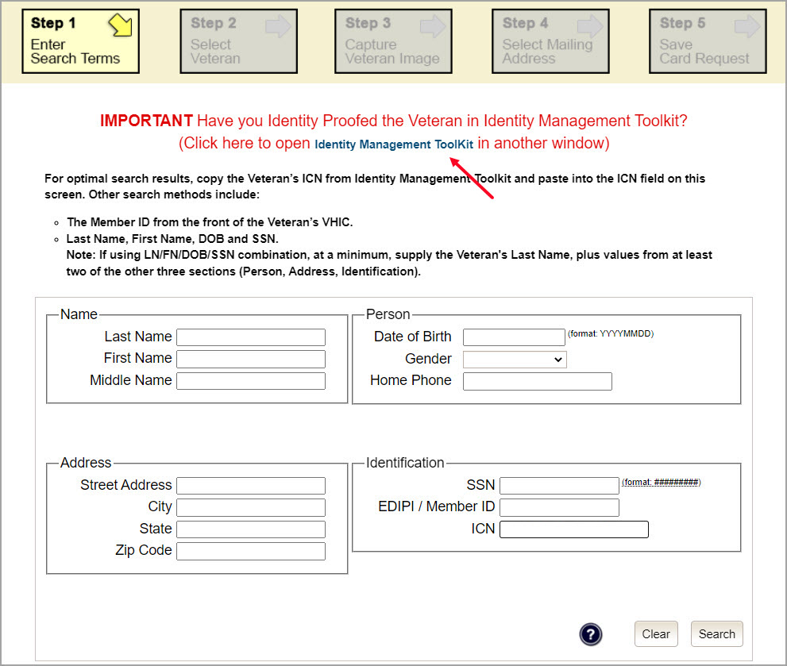

Step 5 of the VHIC Application
The VHIC user will also see a message at the bottom of the Step 5: Save Card Request AFTER a card request has been saved on hold due to Veteran Not Proofed.

IMPORTANT: This Veteran still needs to have their Identity Proofing completed.
Follow the steps below:
- Copy the Veteran’s ICN above and click here to open the REDACTED in another window.
- Complete Proofing for the Veteran in Identity Management Toolkit (see 4.2 Proofing Process and Steps)
- Enter the Veteran’s ICN on Step 1 of the VHIC Card Request Process.
- Complete card request process and submit.

The VHIC user can click on the blue words “REDACTED” which is a hyperlink that will take the user to the Identity Management Toolkit application.
Figure 14: Step 5 - Save Card Request with Identity Management Toolkit hyperlink
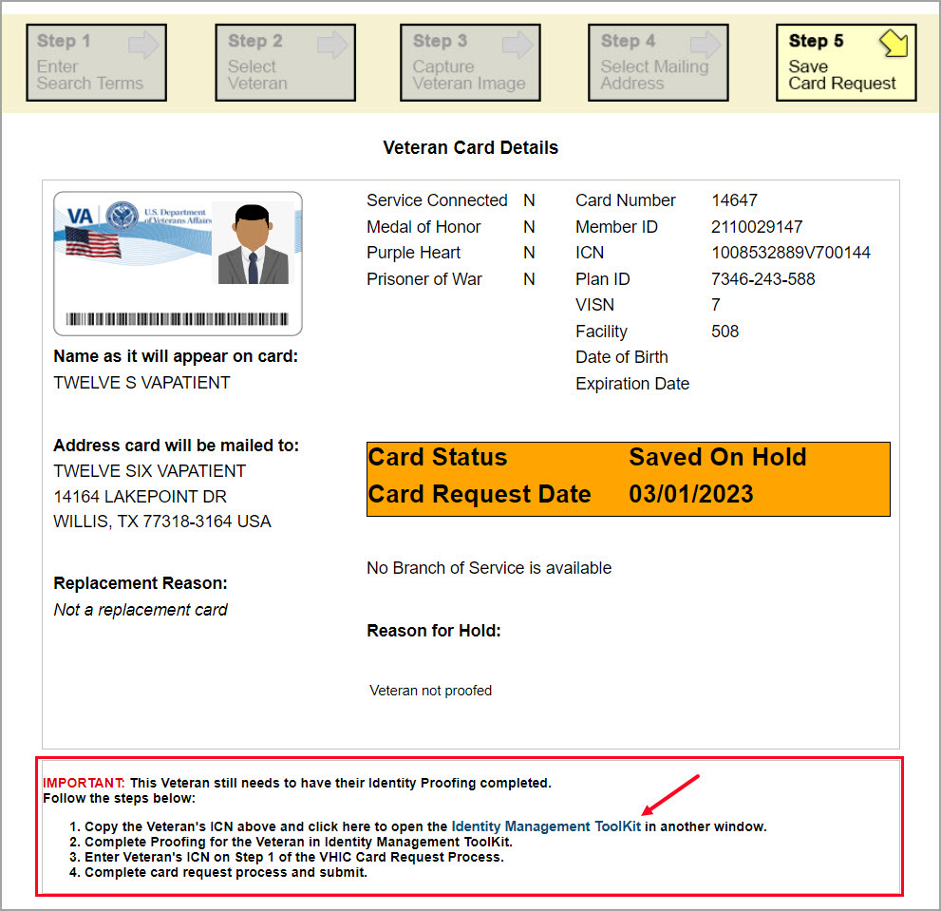

Proofing Process and Steps
This section will give the VHIC user the step-by-step details of the proofing process in the Identity Management Toolkit.

Looking up the Veteran
When you first log into the Identity Management Toolkit application, you will be able to search for the Veteran by either entering the Veteran’s ICN or their Identity traits in the Quick Search section. You can also click on the [Search] link on the left side of the screen to be taken to the full identity traits search page to enter more traits as needed.
Figure 15: Identity Management Toolkit Search Screen
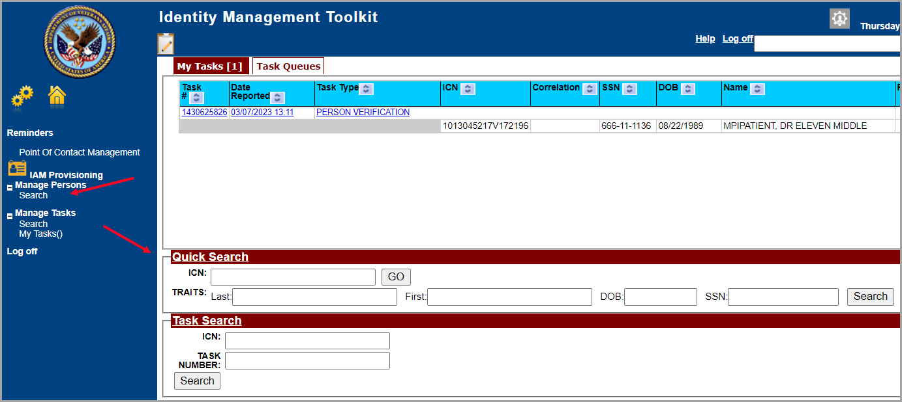

Quick Search

Quick Search with Identity Traits
Enter the Identity Traits for the Veteran that you want to start an Identity Proofing for. Once you have entered the traits and click the [Search] button.
Figure 16: Identity Management Toolkit Quick Search with Traits
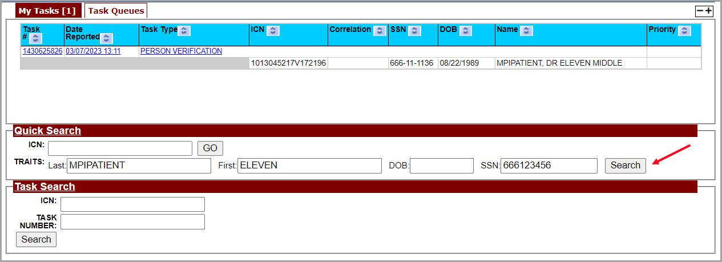

MPI requires at least two additional traits other than middle name for a valid search and will take you the Primary View screen for the Veteran located. More details will be provided in the section entitled Primary View.
Figure 17: Identity Management Toolkit Quick Search - MPI Search Results
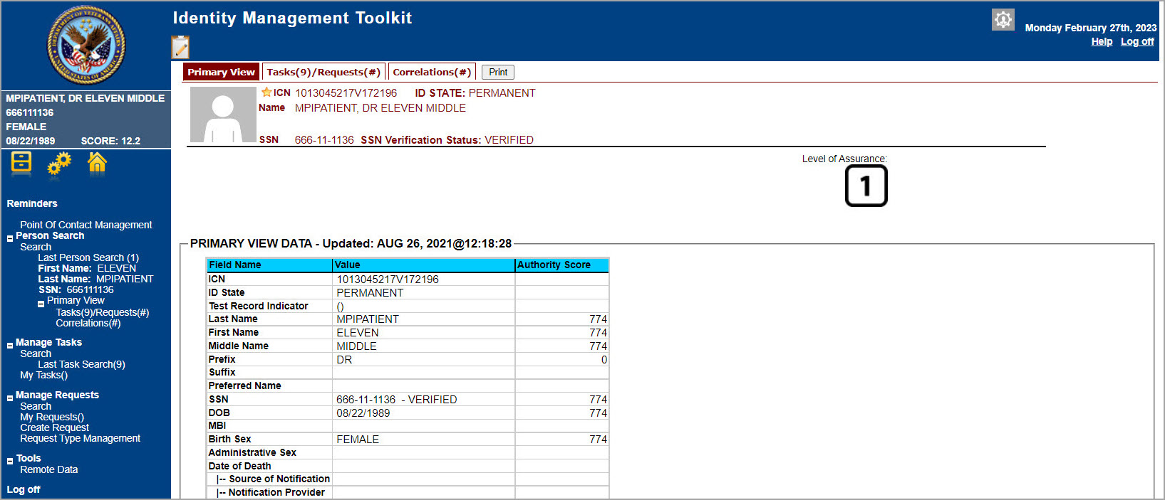

Quick Search with ICN
Enter the Veteran’s ICN in the ICN field then click the [GO] button. This will take you the Primary View screen for the selected Veteran as shown in the section entitled Primary View.
Figure 18: Identity Management Toolkit Quick Search with ICN
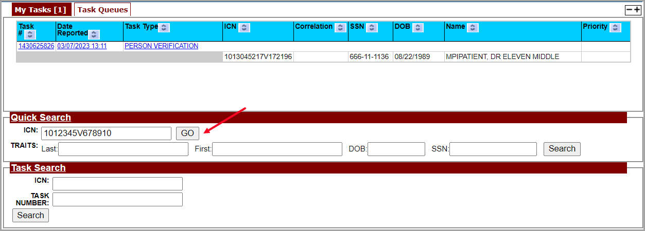

Person Search
When you are on the Home screen of the Identity Management Toolkit and you want to be able to enter more identity traits to search for the Veteran, click on the Search link on the left side of the screen.
Figure 19: Identity Management Toolkit Search Screen; Click Search
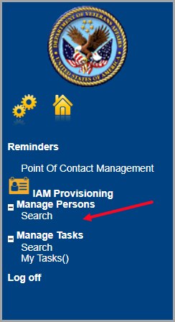

This will take you to the Search For Person screen. On this screen you can either enter only the Veteran’s ICN and click the [Search] button or enter as many of the Veteran’s Identity Traits that you need in order to find the Veteran record that you are looking for and click the [Search] button.
If you are using a criteria-based search, the Last name plus two other fields (not including Middle Name) are required.
Figure 20: Identity Management Toolkit Search For Person screen
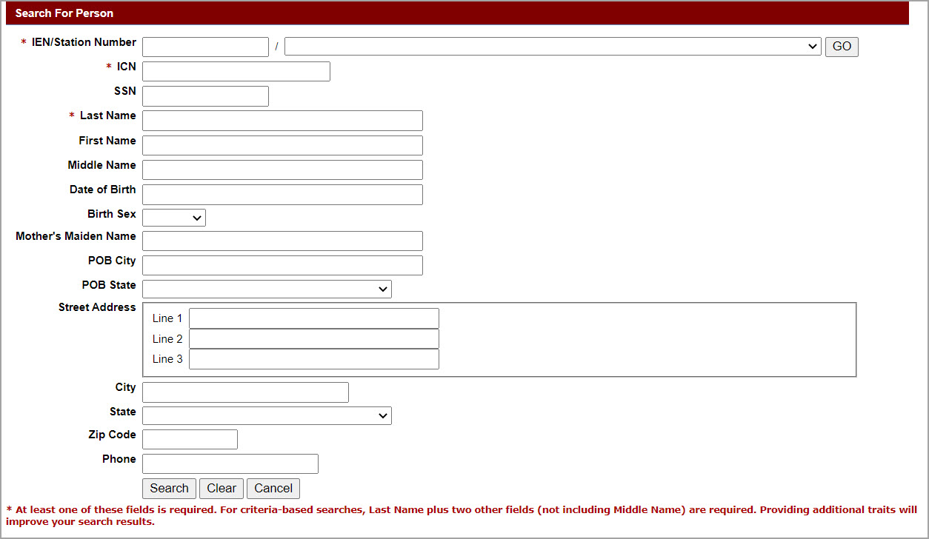

Once you have entered the search criteria for the Veteran you are looking for, click the [Search] button. This will take you the Primary View screen for the selected Veteran as shown below in section the section entitled Primary View.
Figure 21: Identity Management Toolkit Search For Person screen; Click Search
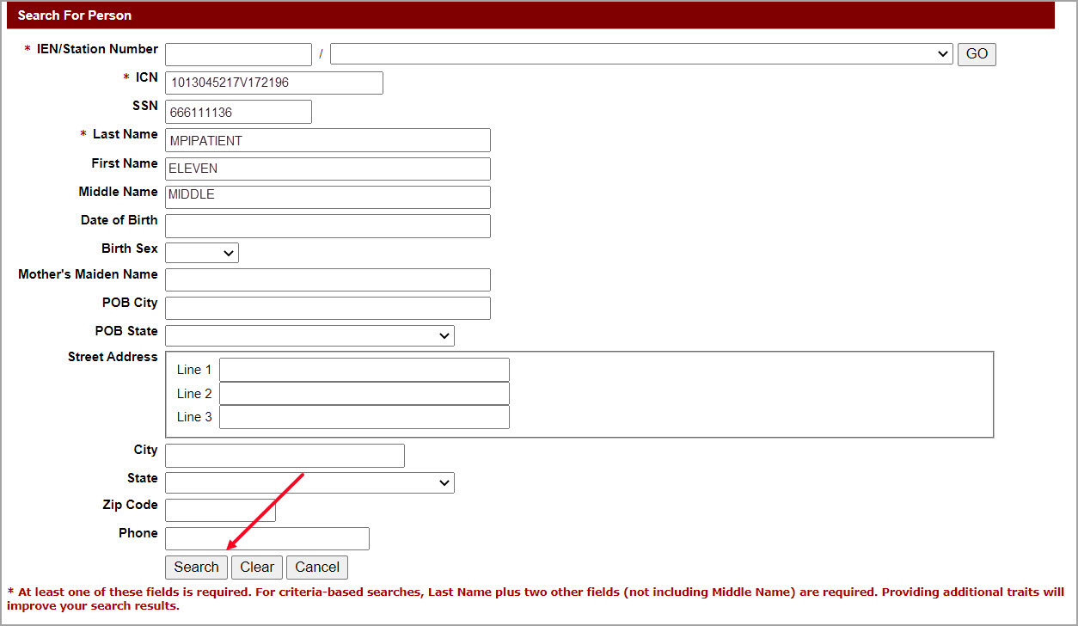

Primary View
Once you have looked up the Veteran that you are searching for, you will be taken to the Primary View Data screen. Confirm the SSN Verification Status and that the traits displayed in the Primary View Data section is correct and take note of the Level of Assurance.

NOTES:
- If the SSN shows as Invalid (as in Figure 22) or the Verification Status is blank (seen in Figure 23) the Veteran can NOT be proofed.
- Do not open a Proofing Task. Instead refer the Veteran to the MPI POC.
- If the Proofing Task has been opened, follow the steps outlined in Section 4.2.5 Proofing Task Opened in Error, Trait Edit Needed.

Figure 22. SSN Verification Status is Invalid
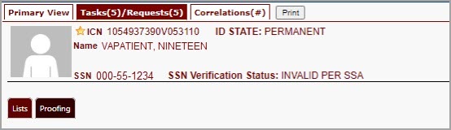

Figure 23. SSN Verification Shows Blank
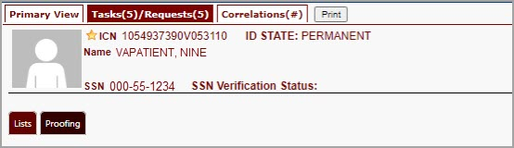

Figure 24: Identity Management Toolkit Primary View Screen
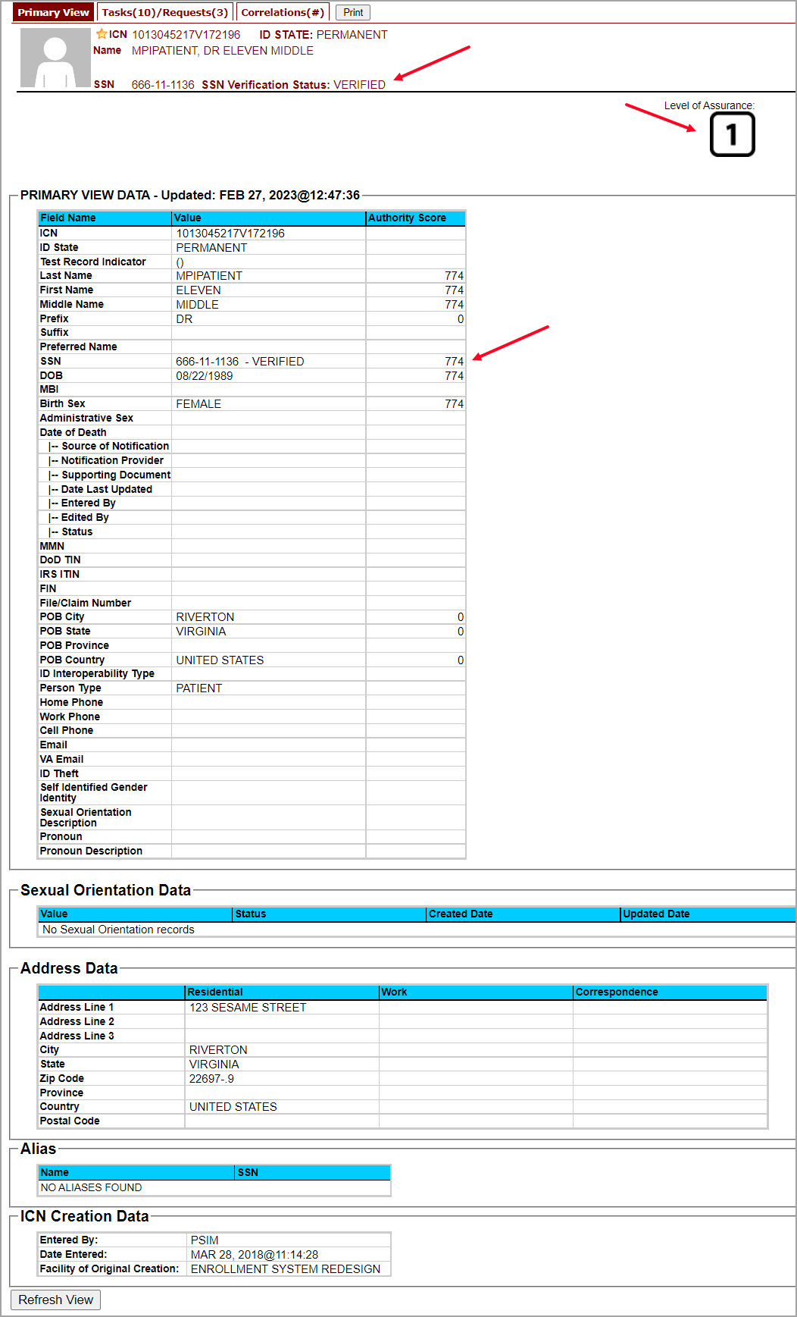

If Level of Assurance is Level 1 – Complete Proofing
If the traits in the Primary View are correct and the Level of Assurance is displayed as Level 1, click on the 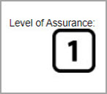 or on the Tasks/Requests tab at the top of the screen to complete the proofing process. Pay attention to the SSN Verification Status, it will be handled slightly differently if the SSN Verification Status for the Veteran is not “Verified”. The person verification will not be completed without HC IdM approval.

NOTE: You will be verifying identity traits with supporting documentation. Any identity traits that are incorrect or have legally changed need to be updated, see your MPI POC and do not open a Proofing task. If the address needs to be updated, see the Veteran Enrollment System POC and do not open a Proofing task.

Figure 25: Tasks/Requests tab highlighted
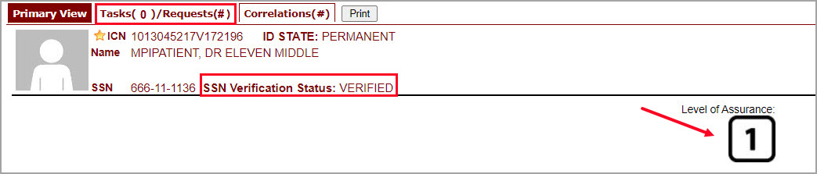

Once you are on the Tasks/Requests screen, click on the Proofing Tab button.
Figure 26: Tasks/Requests screen; click Proofing Tab
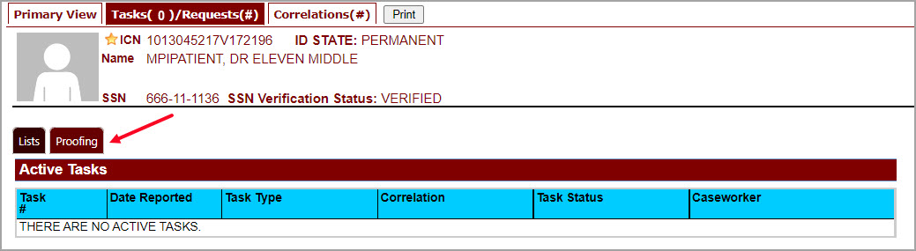

With the Proofing Tab selected, you will be able to see a list of all Verification Tasks (if any) and a list of Active Tasks for the selected ICN. In order to create a new Proofing Task, select the New Proofing Task button or Level of Assurance 1 button or add a Figure showing the New Proofing button.
Figure 27: New Proofing Task Button Selected

The system will inform you that legal documentation is required to complete the task and must be attached if identity trait changes are made.

Figure 28: Identification Confirmation Message
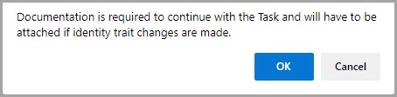

Selecting “OK” creates a Person Verification Task and takes you to the Task Details screen. Now click on the Person Verification tab at the top of the screen in order to work the Task.

Figure 29: Task Details screen; Click Person Verification
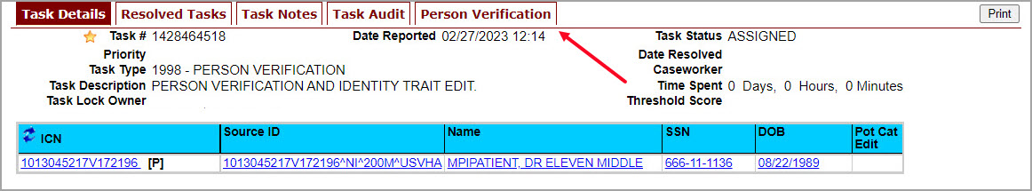

When you get to the Person Verification screen, you will see the Veteran’s information from the Primary View screen populated under MPI Value column. Notice that there are multiple tabs on the Person Verification screen. You will need to walk through and complete each tab in order to complete the Person Verification process.

NOTE: If any changes need to be made to the Veteran’s Identity Information, those changes will need to be updated before the proofing process can be completed. The Veteran will need to be directed to the appropriate MPI POC and the VHIC Clerk will need to follow the procedures outlined in 4.2.5 if the Proofing Task was opened.

Figure 30: Identity Management Toolkit Person Verification screen
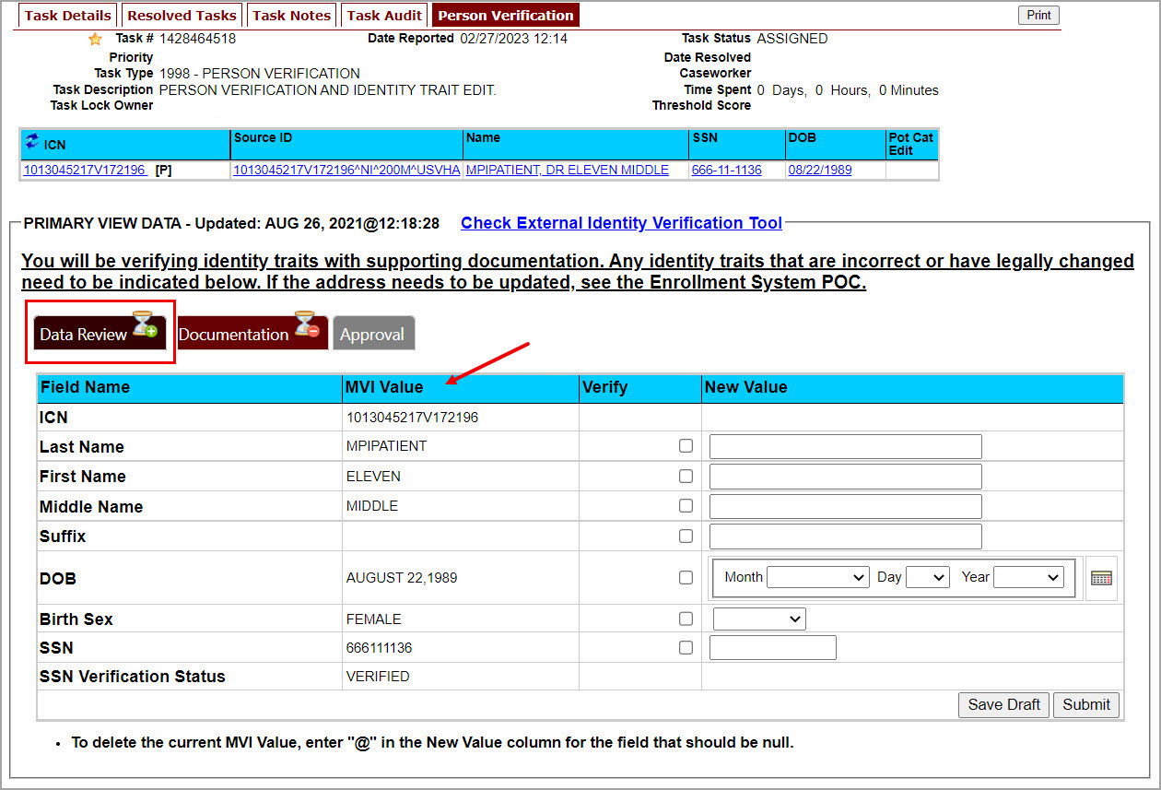

Next you will need to verify the information in the MPI Value column with the information on the documents that were submitted for proof of identity.
Select the check box in the Verify column that corresponds to the appropriate trait. The cell in the Verify column will turn green to indicate that they have been authenticated. You do not need to select the verification box if there is no value for a trait in the Primary View such as the Suffix field in the below example. Once the traits are verified, you will have the options to Submit, or Save a Draft of your work.

Figure 31: Data Review Tab Trait Verification
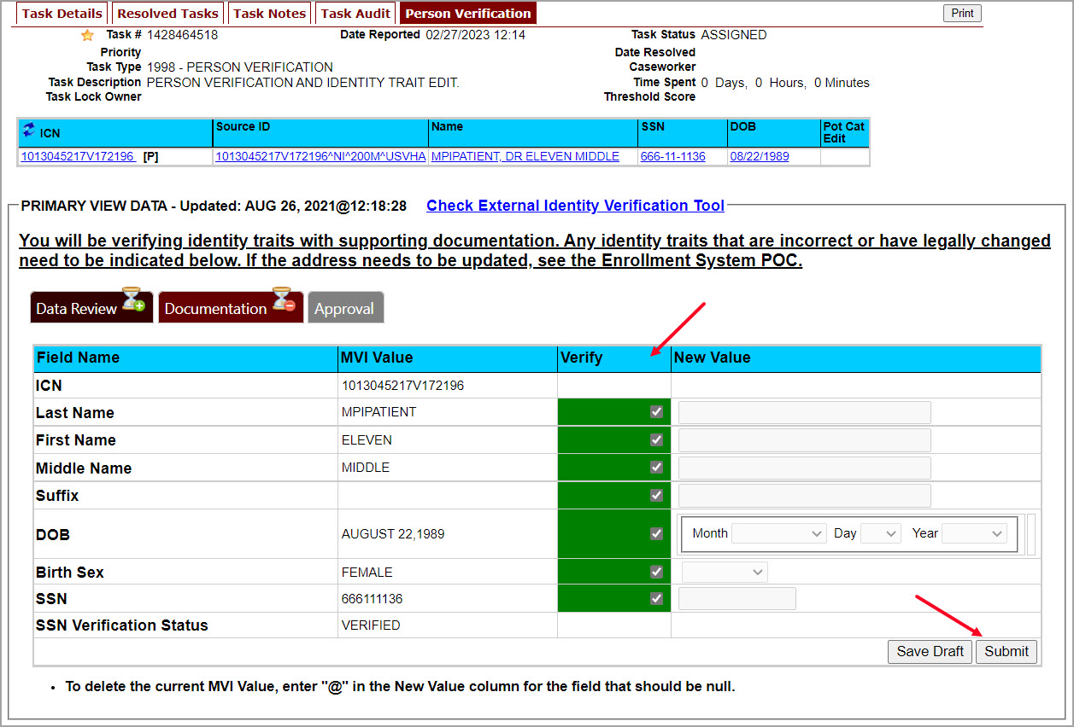

Once you click submit, you will be moved to the second tab, Documentation. Please note that the Data Review tab now contains a green check mark. This indicates that the information has been submitted and that you are ready to move on to the next step in the process. You will not be able to Submit or Save Draft on the Documentation tab until the verification on the Data Review tab has been submitted.
Figure 32: Data Verification Indicator
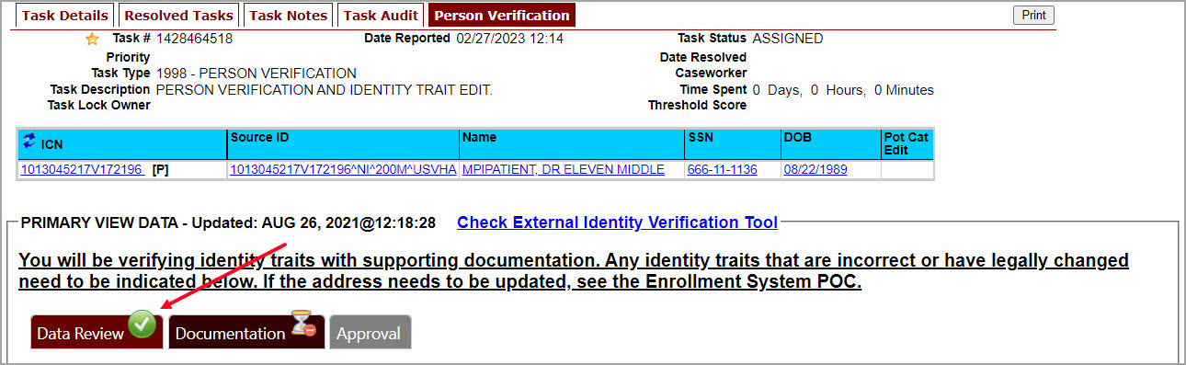

On the Documentation tab you will see the verified Identity Traits, a Verification Document(s) Instruction section, and a Verification Document(s) section.

The Verification Document(s) Instruction section lists the documents allowed by the VA for the support of a change, such as Level of Assurance.
Figure 33: Verification Document Instruction
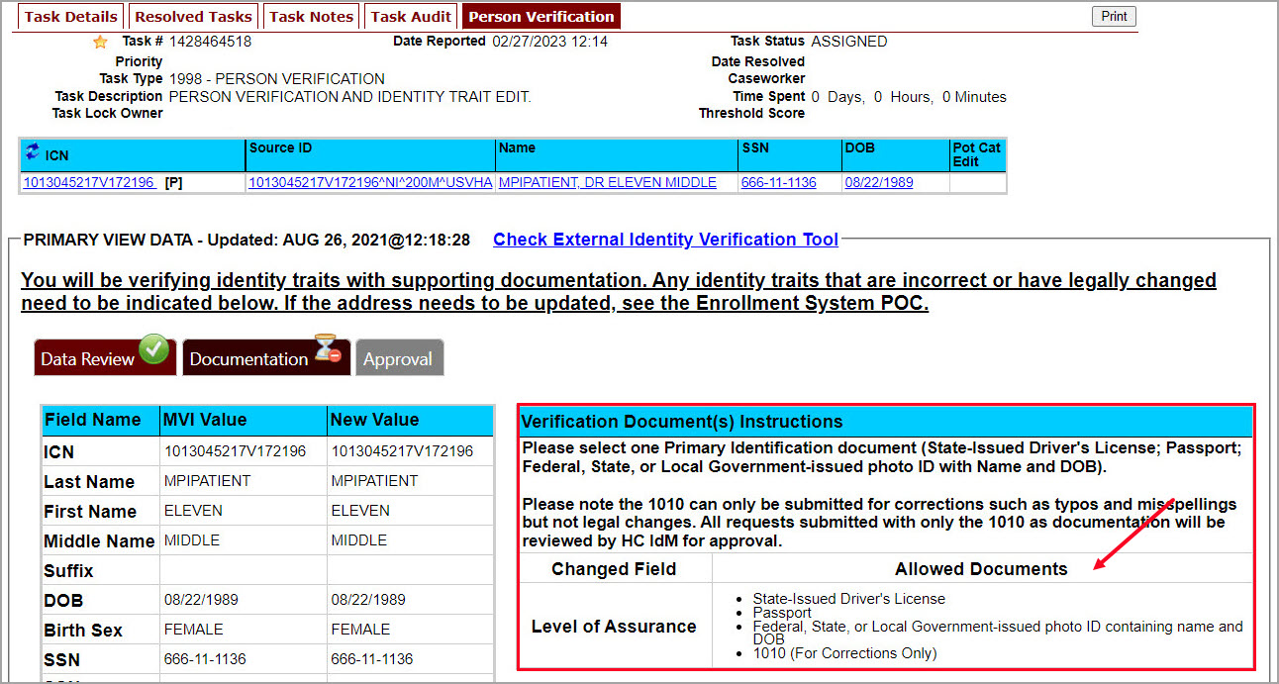

Once you have selected the check box indicating the type of Verification Document you reviewed, enter the details of those documents in the fields provided.
Note the Green Check in the Allowed Documents box. This is a system check indicating that this is a valid document type for this action. You may Save a Draft at this time or click Submit to move forward with the Identity Proofing.

Figure 34: Verification Document Section; Enter document details
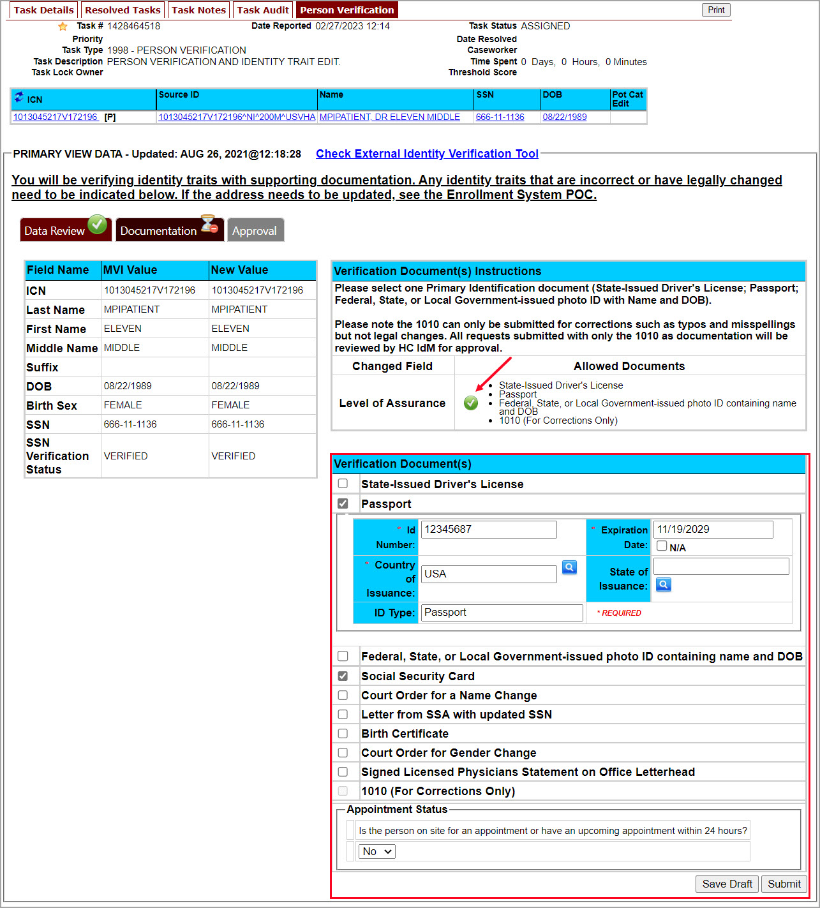

After you click the submit button, you will be returned to the Primary View screen where you will see a message at the top of the screen saying, “Task complete. Person Traits Verified” and you can confirm that the Level of Assurance has been updated to 2.
Figure 35: Person Verification Updated Message
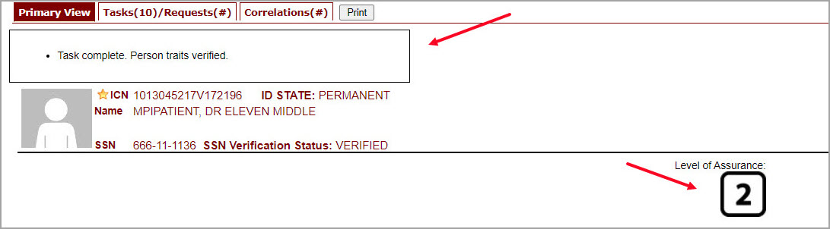

If for some reason the Level of Assurance is still showing as Level 1, then scroll to the bottom of the Primary View screen and click on the [Refresh View] button. The Level of Assurance should then be updated to Level 2.
Figure 36: Refresh View button
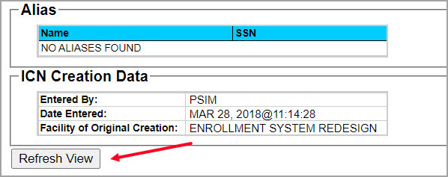

NOTE: It is possible for an Identity Management Toolkit veteran record to indicate LOA 2 without a precise Date of Birth (MM/DD/YY). Even though the LOA is 2, the card request will be placed into an On Hold status until resolved. See Section 5.3.6 Imprecise Date of Birth for more information
Figure 37: Imprecise Date of Birth Reported in Toolkit
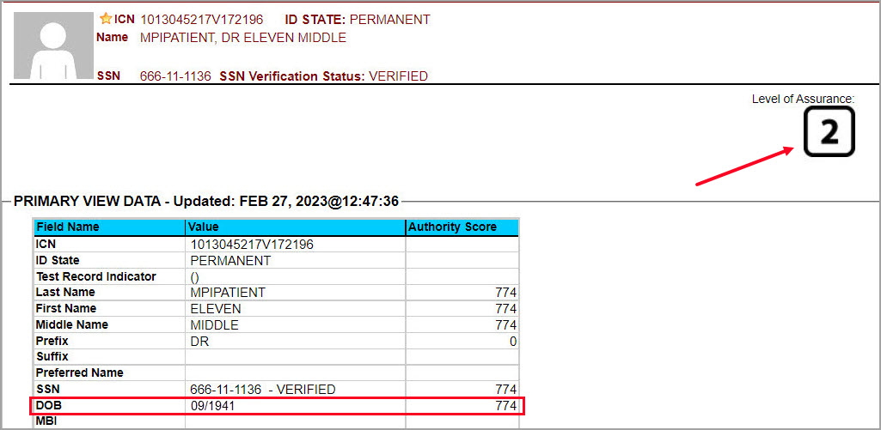

Selecting the Tasks/Requests Tab will show the list of Resolved Tasks, you may confirm the resolution of your Person Verification Task here as well.
Figure 38: Task/Request Tab; Resolved Tasks
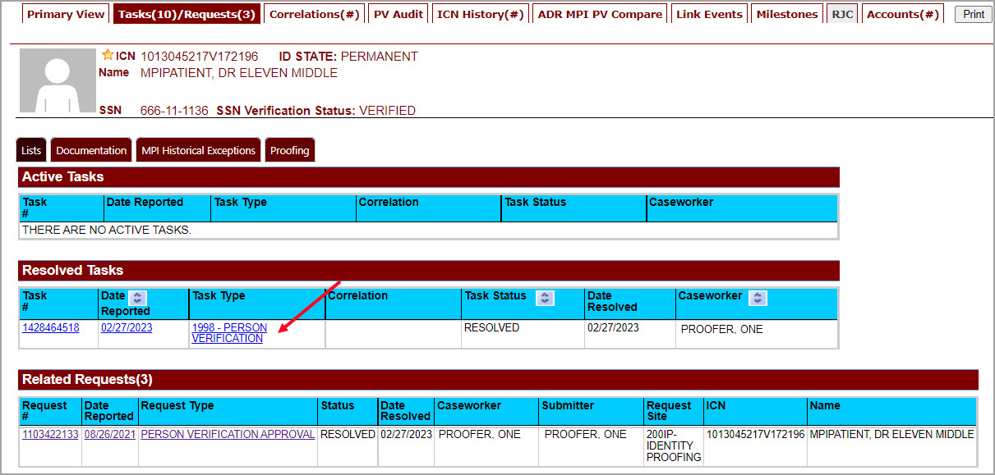

Once the proofing task has been completed and the Level of Assurance has been updated to Level 2, highlight the Veteran’s ICN at the top of the screen and copy it, either by clicking [Ctrl + C] or right clicking on the highlighted number and selecting copy from the menu that displays.
Figure 39: The Veteran's ICN is highlighted
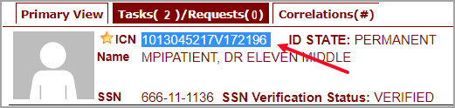

If Level of Assurance is Level 2 – Continue to Issue VHIC
If the Level of Assurance is displayed as Level 2 on the Primary View screen, copy the Veteran’s ICN from the top of the Identity Management Toolkit screen ( as in Error! Not a valid bookmark self-reference.) and use that to search for the Veteran on Step 1: Enter Search Terms of the Card Request process in the VHIC application.

Figure 40: Step 1: Enter Search Terms - ICN has been entered
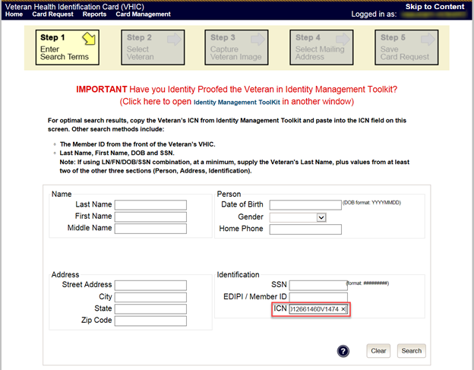

Proofing Task Opened in Error, Trait Edit Needed
VHIC Proofers do not possess the access levels in the MPI Toolkit that are required for making changes to identity traits. If you open a Person Verification Task before verifying the Veteran’s address and identity traits and realize that the SSN is Not Verified or a Trait Change such as Middle Name correction is needed as shown in the below example, please follow the process below.

Verify the correct information by selecting the corresponding check boxes in the Verify column. Enter the correct information in the New Value column and Save Draft. You will not be able to submit this change.

Figure 41: Person Verification Task; Trait Edit Needed
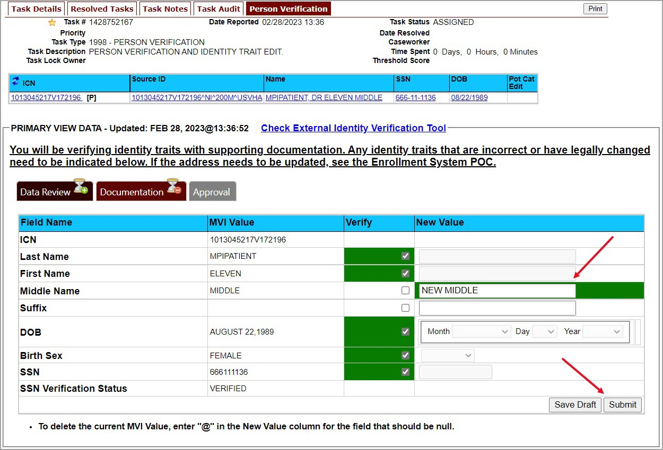

Clicking the Submit button will result in the following Pop-up Message and you will not be able to move forward with completing the Person Verification Task, nor will you be able to close the newly opened Task.
Figure 42: Processing Error Message
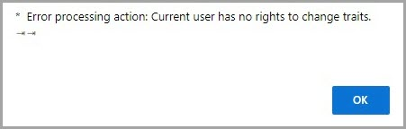

Selecting “OK” on the Pop-up Message will return you to the Person Verification Tab. Select the Task Notes tab at the top of the screen.
Figure 43: Person Verification; Task Notes Tab Selection
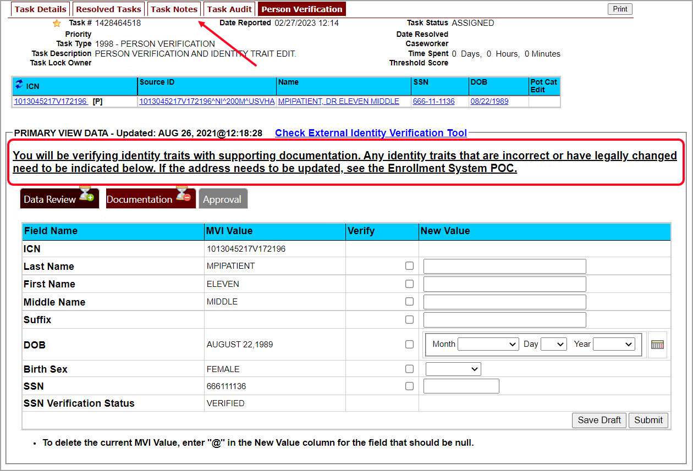

On the Task Notes tab, highlight the Task Number at the top of the screen and copy it, either by clicking [Ctrl + C] or right clicking on the highlighted number and selecting copy from the menu that displays. You will need to supply this number to your the appropriate POC (MPI for Identity Trait edits or Veteran Enrollment System POC for Address change.) Under New Status, change the status of your Person Verification Task to Unassign and select Save.
Figure 44: Unassign Person Verification Task
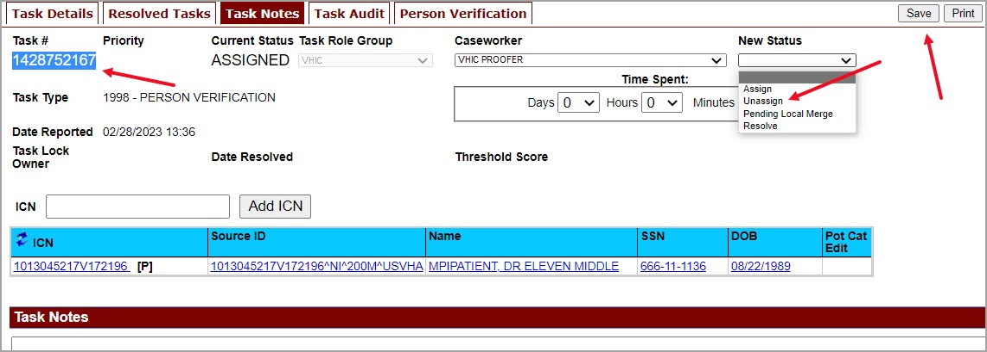

Contact the appropriate POC. Provide them with the Task Number and details. They will assign the Task to themselves and complete the Trait Edit.

Logging out of Identity Management Toolkit
To Log Off:
- Click Log off in the menu bar. You can log off from most of the pages except the logon screen. Logoff is also available from the Navigation Bar. Examples are shown in Figures 46 and 47.
Figure 45: Log Off link located in the menu bar

Figure 46: Log Off link located in the Navigation pane
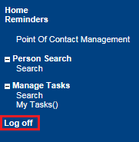

- IdM TK has a built-in idle feature. After 60 minutes of inactivity, the idle warning message is displayed as seen in Figure 47: Identity Management Toolkit Idle message. Enter your password and click Submit. After you log back on, you are returned to the screen you were previously working on. If you do not have a password, exit the browser, and log in through VHIC link/SSOi again.
Figure 47: Identity Management Toolkit Idle message
REDACTED

Creating a VHIC Card – The Card Request Process
Table 2: Who can process a card request?
At a Glance… | VHIC Role
Who can process a card request? | Administrator, Supervisor, Associate, Tech Admin (Tier 3)

This section will walk the VHIC user through the process of creating a card for a Veteran. During the card request process, issues may arise that will require the card to be put on hold. These cases will be covered in section 5.6 On Hold Reasons Explained.

The card issuance process follows numbered steps shown next.
- Enter Search Terms
- Select Veteran
- Capture Veteran Image
- Select Mailing Address
- Save Card Request

Figure 48: Card Request Navigation Bar
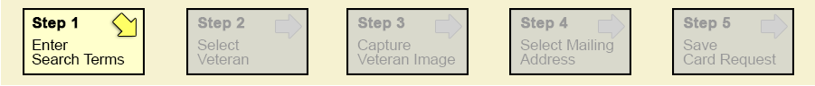

NOTE The appearance of the step block will change to indicate the step you are currently working by appearing to be the brightest. See the illustration below.

Figure 49: Navigation Bar Step appearance by state
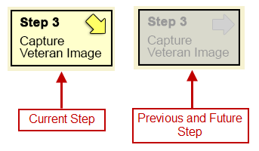

These steps are fully explained below. We will now walk through each of the steps required to complete a VHIC card request for New VHICs and Replacement VHICs. We will also go over the steps for placing a card request on hold as well as taking a card request off hold.

New VHIC Card Request

Veteran Level 2 Proofed through Identity Management Toolkit

Step 1: Enter Search Terms

The first step in the process is to find the Veteran in the system. This is accomplished by entering enough search criteria to trigger a match within Master Person Index (MPI). The top of the screen offers guidance regarding the set of traits recommended to ensure a best match is found. These are guidelines and not necessarily the required set of traits that must be entered.

However, for optimal search results, copy the Veteran’s ICN from the Identity Management Toolkit and paste it into the ICN field on this screen.

Other search methods include:
- The Member ID from the front of the Veteran’s VHIC.
- Last Name, First Name, DOB and SSN.

NOTE: If using LN/FN/DOB/SSN combination, at a minimum, supply the Veteran's Last Name, plus values from at least two of the other three sections (Person, Address, and Identification).

The more traits entered, the more likely a match will be returned.

Figure 50: Enter Search Terms screen
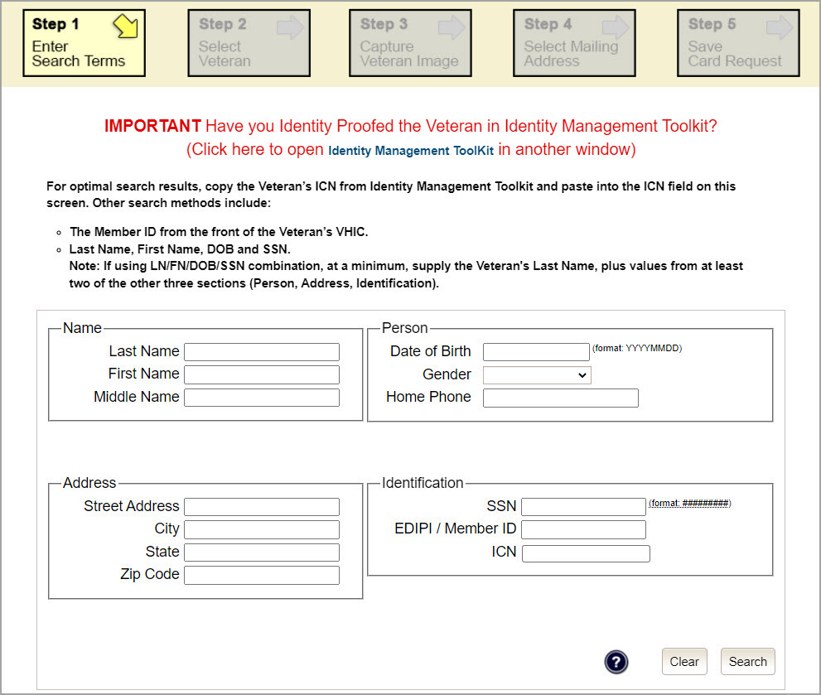

Additional guidance is also available on-screen by clicking on the blue circle containing a question mark.

Figure 51: Help icon

This type of help is available throughout the application and will provide additional detail or clarification for that particular step or section.
Once the information has been entered into the required fields, click on [Search] to proceed to the next step.
Figure 52: Enter Search Terms screen
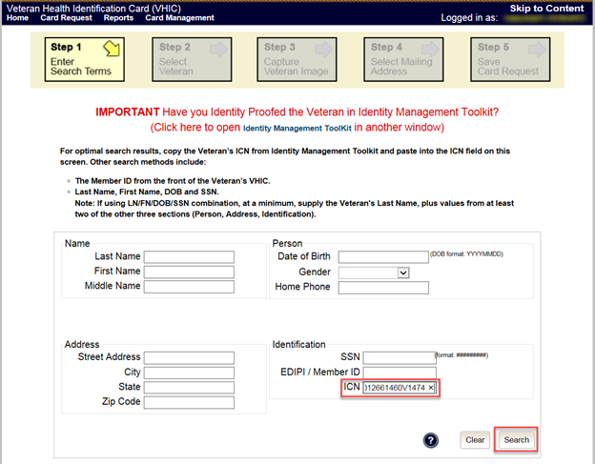

NOTE:
Entering an Invalid ICN will result in an error message such as the one seen in Figure 53: Invalid ICN Error Message. Examples of errors include:
- Invalid ICN. ICN must be 17 characters
- Invalid ICN. ICN must not contain special characters
- Invalid ICN format. Please enter valid ICN format, 17 chars (10 digits + V + 6 digits)

Figure 53: Invalid ICN Error Message
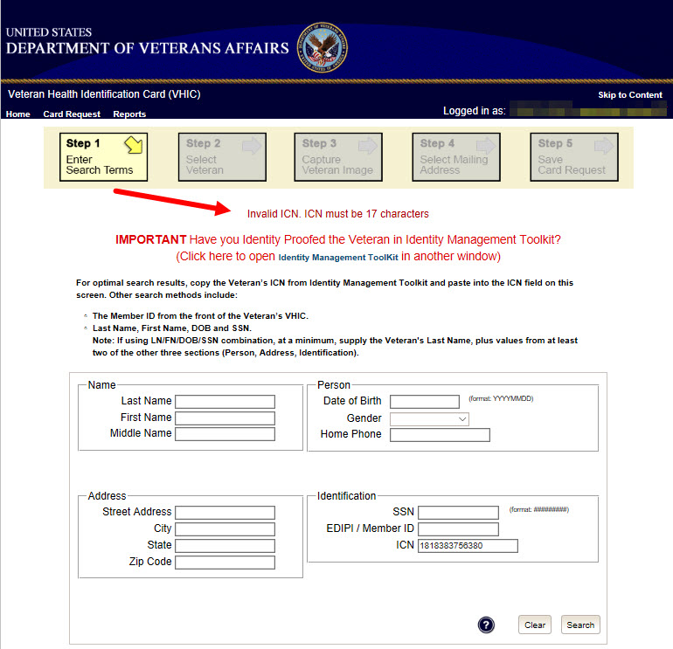

NOTE: While searching for the Veteran, the system will look for eligibility for a VHIC card. If the Veteran is not eligible or if their eligibility is in question the VHIC user will receive one of the following messages. The Veteran will need to be referred to Veteran Enrollment Services.

Figure 54: Veteran Not Eligible Message
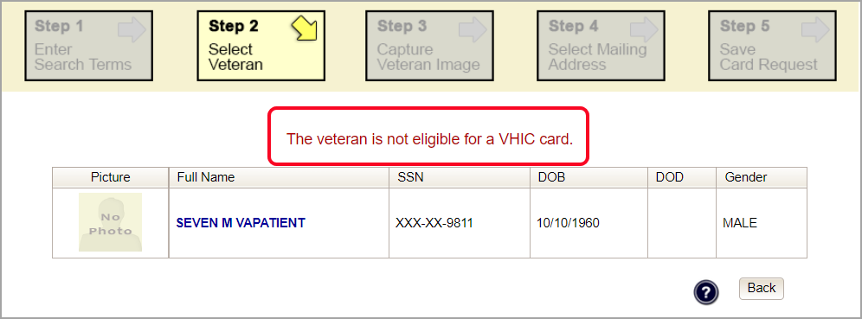

Figure 55: Veteran Eligibility Undetermined
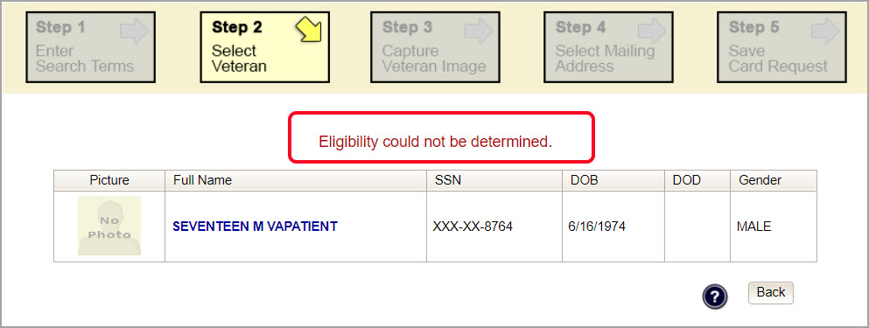

NOTE: Should the search result in a deceased Veteran, a message will show at the top of the screen.
Figure 56. Deceased Veteran Search Results
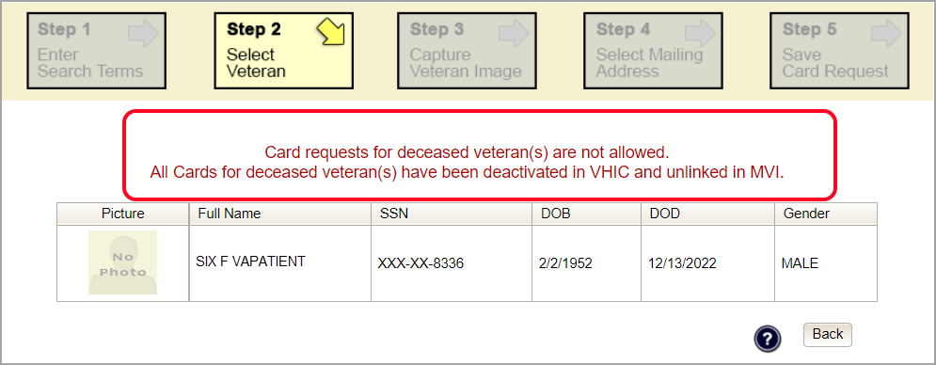

NOTE: If the Veteran has a Preferred Name on file it will appear within parenthesis where the Full Name appears as seen below.
Figure 57. Full Name Including Preferred Name
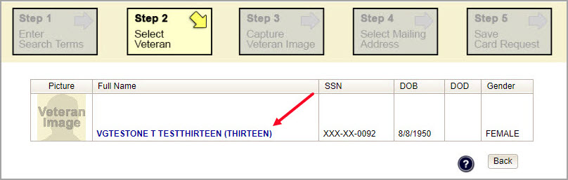

Step 2: Select Veteran
Once the search has completed, the results of that search will be displayed on screen. From the list provided (up to 10 matches may be returned), select the appropriate Veteran by clicking on the Veteran’s name which is hyperlinked.

If the correct Veteran is not in the list, click the [Back] button and verify the traits entered are correct. If the traits are correct, try adding additional information to aid in triggering a match.
Figure 58: Select Veteran screen
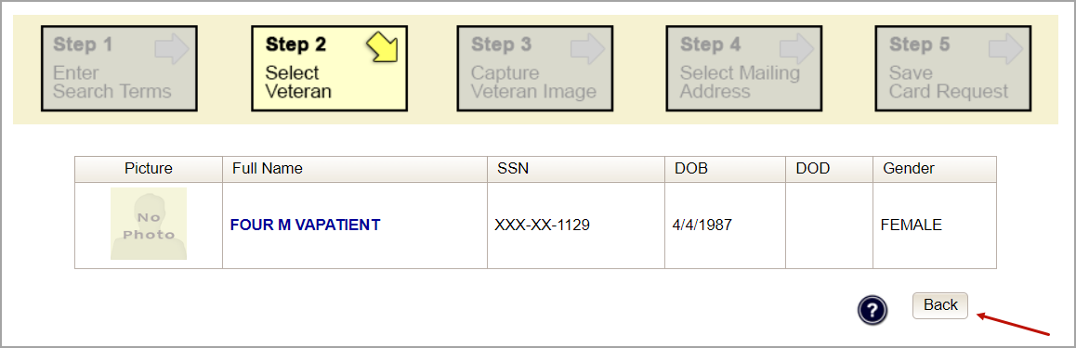

Step 3: Capture Veteran Image
Once a selection has been made, the next step in the process is to capture the Veteran image. VHIC provides several ways to handle this operation: Take New Picture, Upload from file, or Reuse Existing Image.

Figure 59: Capture Veteran Image screen
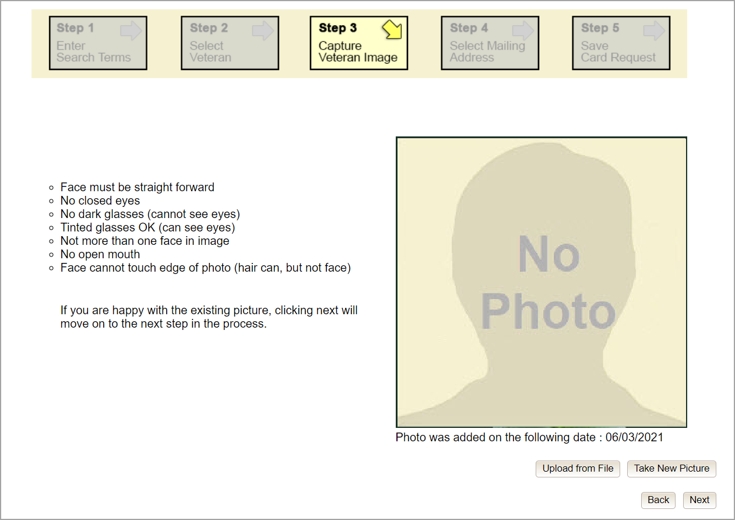

Take New Picture
Upon arriving to the Capture Veteran Image page, if there is no useable image for the Veteran already on file, a “No Photo” image will appear in the image capture area. Click [Take New Picture] to capture the Veteran’s image. The camera should become active, and the Veteran should be visible in the image capture window.
Figure 60: Capture Veteran Image screen – Take New Picture
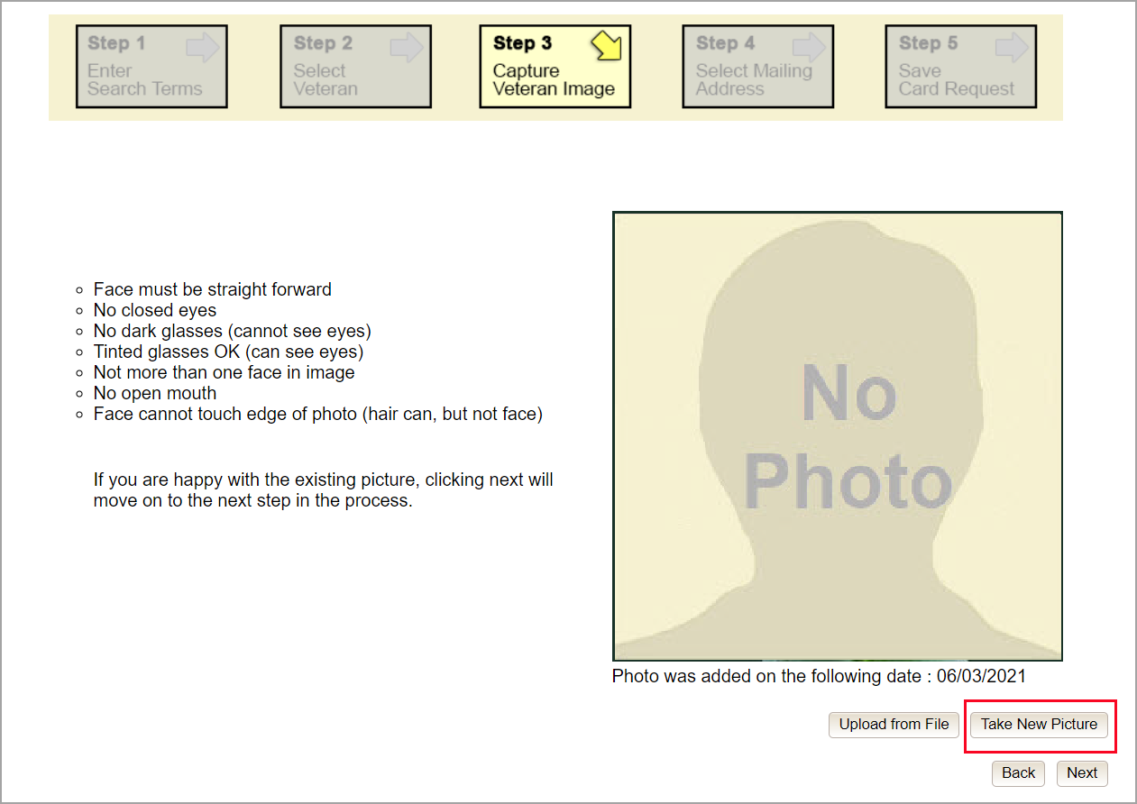

Using the provided silhouette, ensure that that the Veteran is lined up properly. Prior to clicking [Capture Image] ensure the additional image capture guidelines (see VHA Directive 1601A.01 for details) provided on screen are met:
- Photo must be taken against a light-colored solid background for clarity
- Face must be straight forward
- No closed eyes
- No dark glasses (cannot see eyes)
- No hats (may obstruct facial photo)
- Tinted glasses OK (can see eyes)
- Not more than one face in image
- No open mouth
- Face cannot touch edge of photo (hair can, but not face)
- Photos will not be taken if the Veteran refuses to remove items that may result in an obstructed facial photo.
NOTE: No other background (U.S. flag, state flag, etc.) is permitted for use with the VHIC card photo.

Figure 61: Capture Veteran Image screen – Capture Image
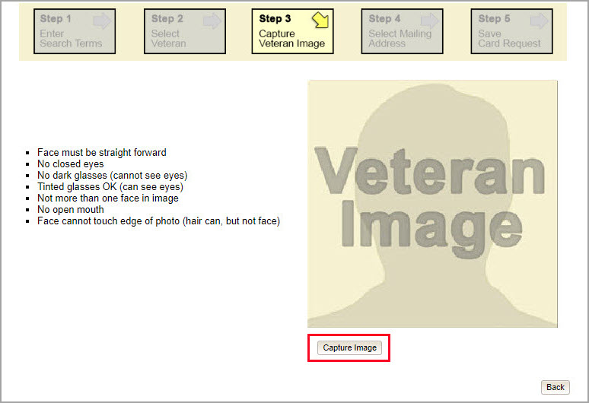

Once the image is captured, take a moment to review that the image meets all desired guidelines before proceeding. If the image is acceptable, click [Next] to continue to the next step.
Figure 62: Capture Veteran Image screen – Accept new photo; click Next
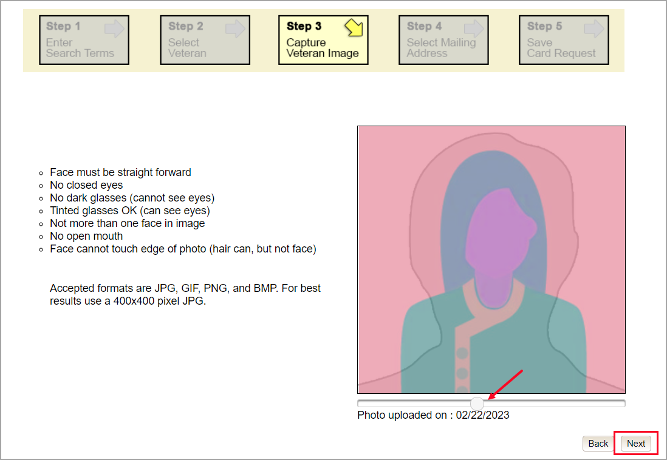

NOTE: If the image does not meet the guidelines or the Veteran would prefer a new photo be taken or uploaded, this can be done at this point as well by clicking the [Back] button to take a new picture or upload a photo.

Upload from File
In some cases, it may be necessary to upload an image for a Veteran (i.e., they are unable to be present during the card request process due to health issues, etc.) In these cases, VHIC offers the option to upload a photo by selecting the [Upload from File] option.
Figure 63: Capture Veteran Image screen – Upload from File
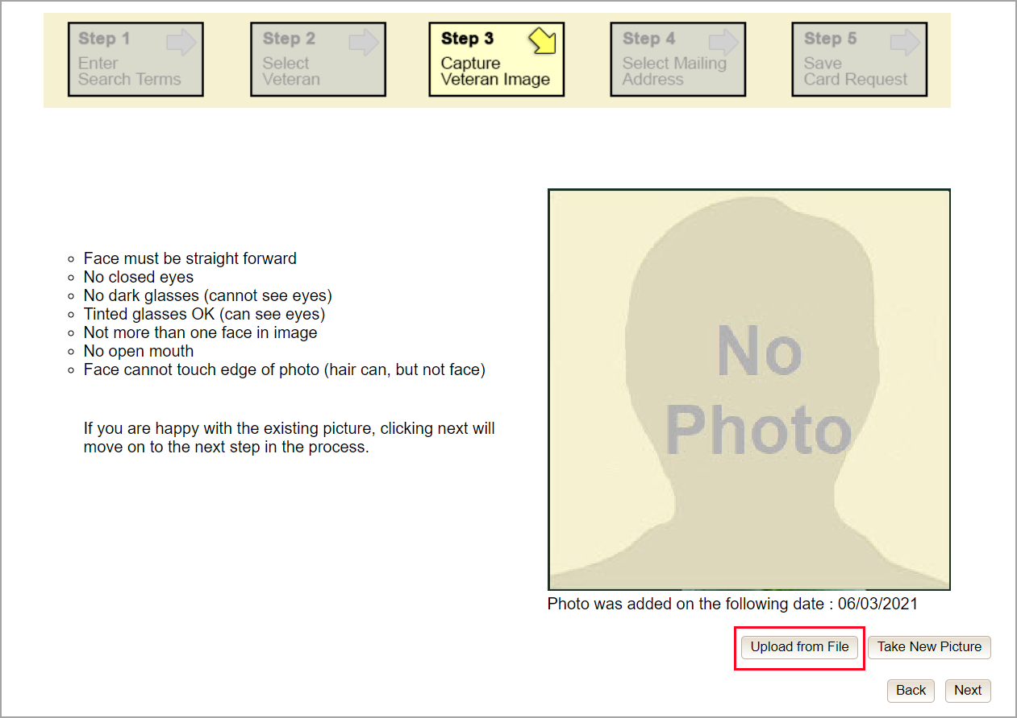

Once this option is selected, a [Choose File] button will appear next to a text field. Clicking this button will open up another window to allow for the desired image to be located and selected. The accepted file formats are JPG, GIF, PNG, and BMP. For best results use a 400x400 pixel JPG image. It should also be noted that any adjustments that need to be made to the image to meet the specified guidelines, such as crop and resize, this should be done before the image is uploaded.

Figure 64: Capture Veteran Image screen – Upload photo; click Browse
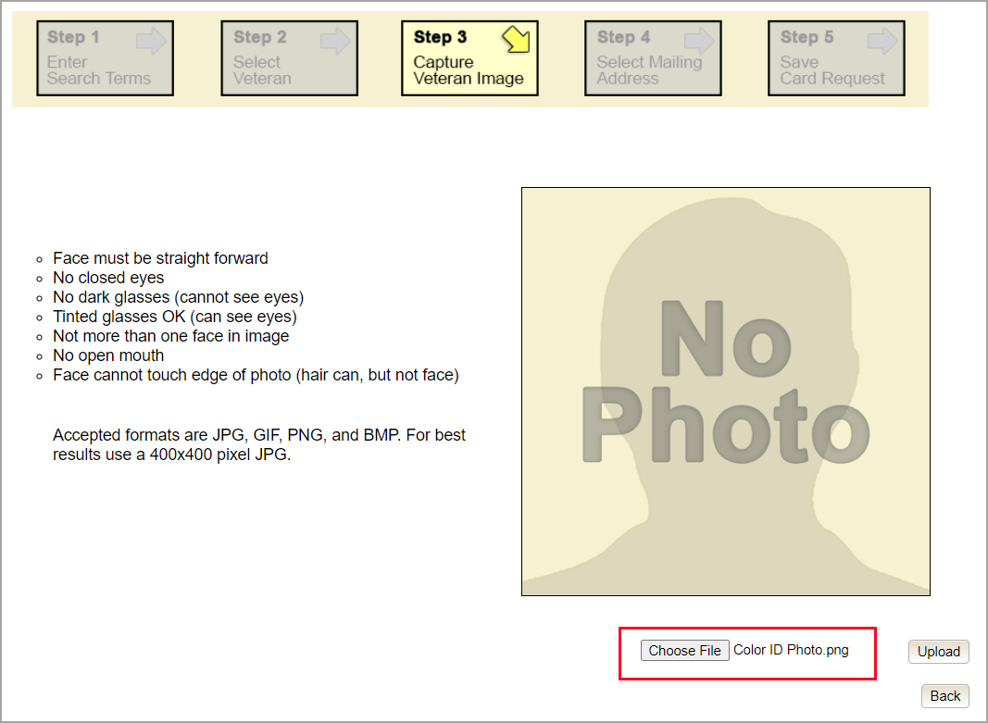

Once the file has been selected, an [Upload] button will become available. Clicking this will import the image and it will now be visible in the image capture area.
Figure 65: Capture Veteran Image screen – Upload photo; click Upload
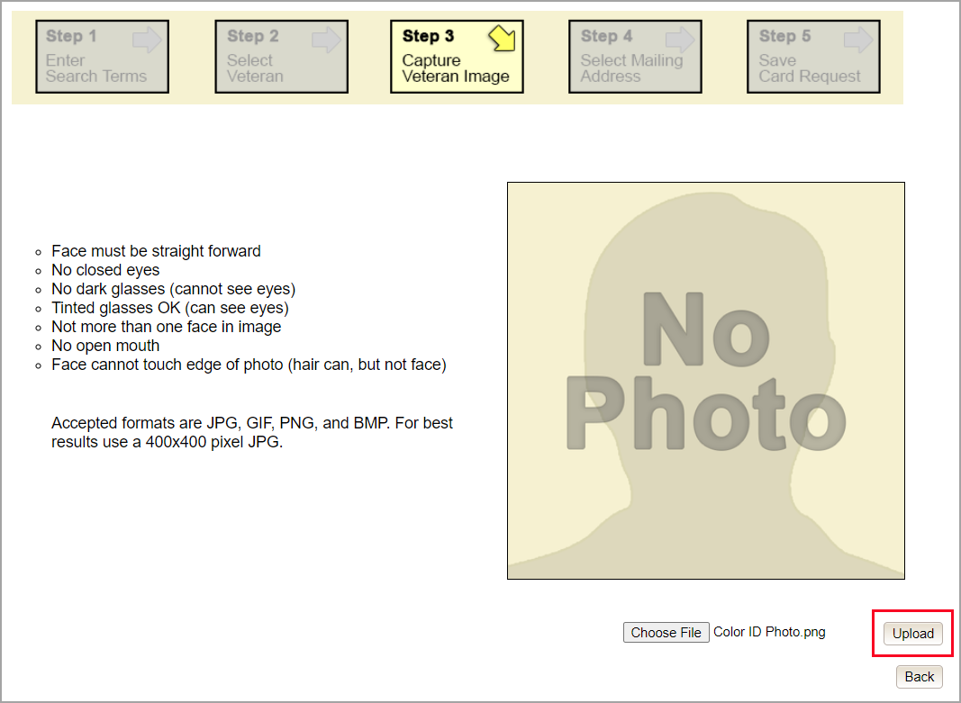

The user can move the slider below the image window to zoom the image in or out to match the silhouette, the image can also be dragged to line the Veteran’s face inside the silhouette as well.

Once again, be sure to review the image to ensure it meets the specified guidelines before clicking the [Next] button to continue.
Figure 66: Capture Veteran Image screen – Edit photo; click Next

Reuse Existing Image
In the event the Veteran has an existing photo in the system that is less than ten years old, this will appear in the image capture area upon entry to Step 3. If this image meets the required guidelines, it may be reused for the current card request process. Simply click [Next] to continue on to Step 4.
Figure 67: Capture Veteran Image screen – Reuse Existing Photo; click Next
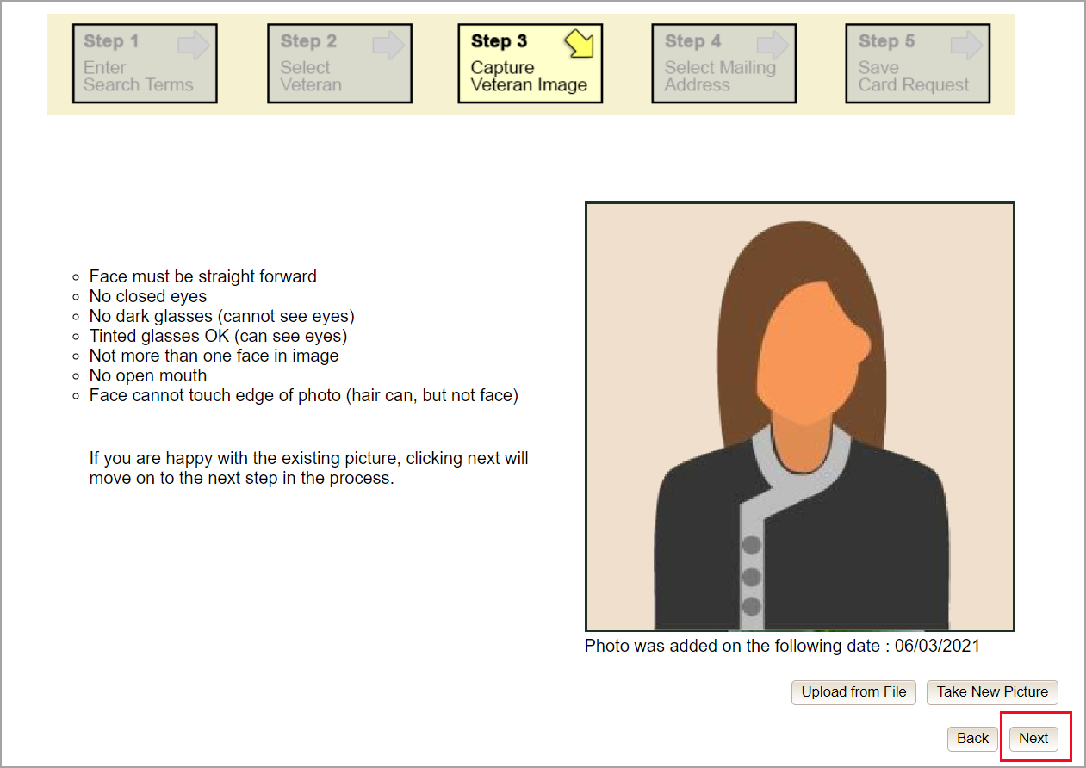

The VHIC application will ask the user to confirm that they want to reuse the existing photo for this Veteran. Click the [OK] button to continue to Step 4: Verify Identity Attributes.
Figure 68: Capture Veteran Image screen – Reuse Existing Photo; click OK
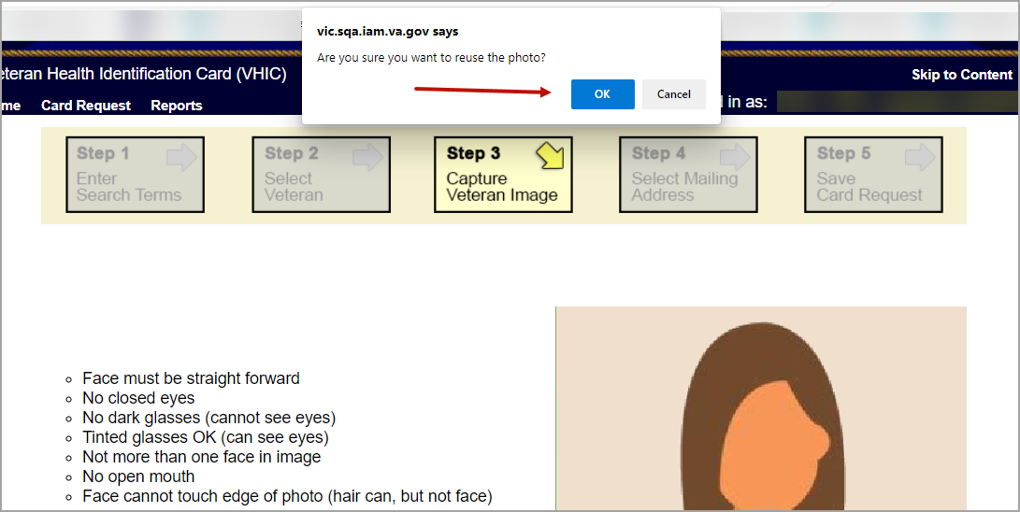

NOTE: Greyscale pictures are not permitted to appear on the VHIC card. Attempts to use a greyscale photo will result in an error and you will need to use the [Back] button to capture or upload a new photo.
Figure 69: Greyscale Photo Error
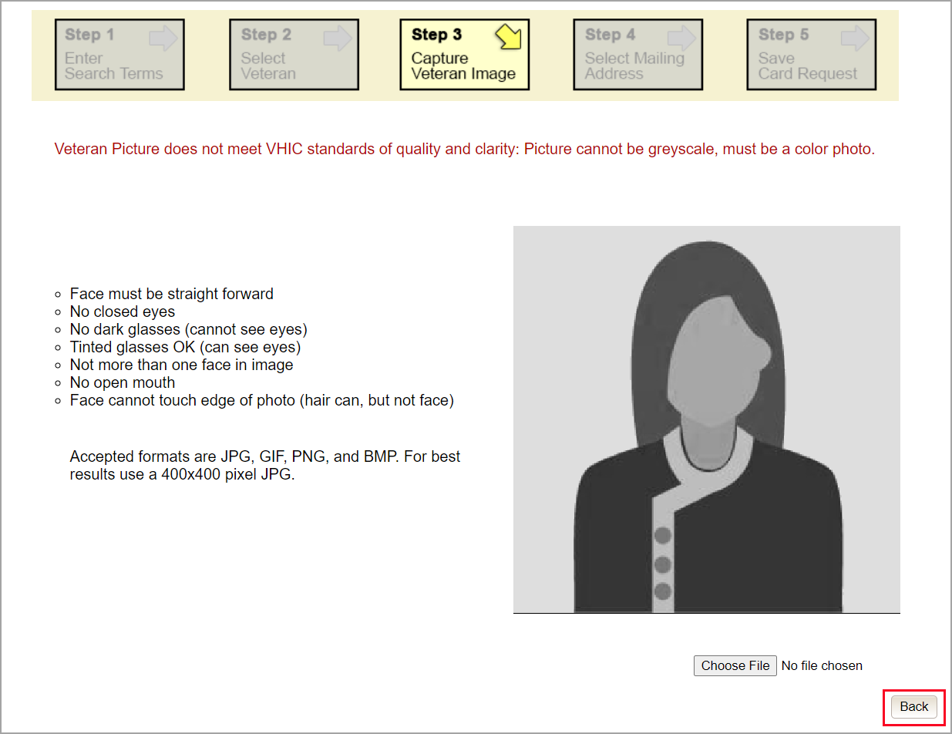

NOTE: If the image does not meet the guidelines or the Veteran would prefer a new photo be taken or uploaded, this can be done at this point as well by selecting either [Upload from File] or [Take New Picture].
Figure 70: Replace Picture
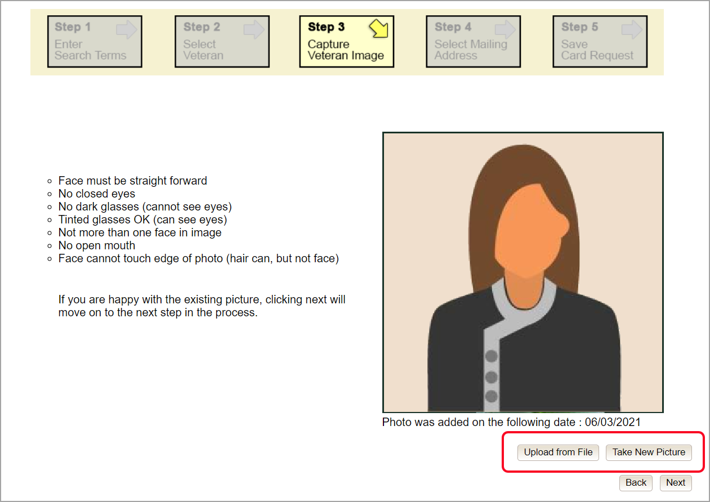

Step 4: Select Mailing Address
This screen displays the information retrieved from the Master Person Index (MPI) and the Veteran Enrollment System (VES) for the selected Veteran. The purpose of this screen is to verify the displayed information, and to determine where the Veteran’s card should be mailed.

Figure 71: Select Mailing Address screen with bad facility address
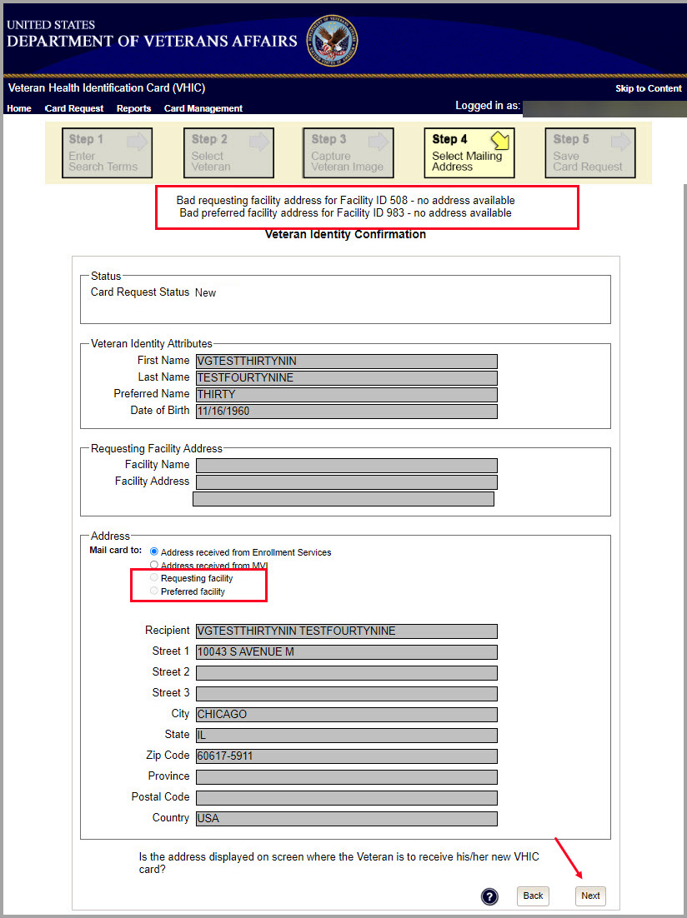

This step provides several mailing options for the card:
- Mail to the address received from Veteran Enrollment Services
- Mail to the address received from MPI
- Mail to the requesting facility. If requesting facility is not known a message will be displayed above for the on-hold condition and the Requesting facility button will be grayed out as in Figure 71: Select Mailing Address screen with bad facility address.
- Mail to the preferred facility. If no preferred facility information has been received from ES or the preferred facility address is flagged as bad, a message stating why, as well as additional guidance on how to proceed, will be displayed near the top of the screen. The Associate MUST choose one of the remaining viable address options for mailing the card in order to proceed with the card request process. Selecting a radio button will automatically update the address information based on the selection. The process cannot continue until the appropriate radio button has been selected.

NOTE: If Enrollment has flagged the Veteran’s address as bad, a message stating why, as well as additional guidance on how to proceed, will be displayed near the top of the screen. At this point, if the Veteran opts to not update their information with ES, the Associate MUST choose one of the remaining viable address options for mailing the card in order to proceed with the card request process.

NOTE: If MPI has flagged the Veteran’s address as bad, a message stating why, as well as additional guidance on how to proceed, will be displayed near the top of the screen. At this point, if the Veteran opts not to update their information with MPI or ES, the Associate MUST choose one of the remaining viable address options for mailing the card in order to proceed with the card request process. Selecting a radio button will automatically update the address information based on the selection. The process cannot continue until the appropriate radio button has been selected.

Selecting a radio button will automatically update the address information based on the selection. The process cannot continue until the appropriate radio button has been selected.

If the information on the screen is a correct match, select the [Next] button in the lower right hand to move forward.

Status Section
At the top of the Step 4 screen is the Status section. When going through the card request process, one of the following Card Request Status options will be displayed:
- New (first time card request for veteran)
- Replacement (veteran is replacing a prior card
- On Hold (request is already in progress, returning to correct selections, update photo, or change status)

Step 5: Save Card Request
Step 5 – Save Card Request – gives the VHIC user and the Veteran one more opportunity to review all of the information on the screen for accuracy.
Figure 72: Save Card Request review screen
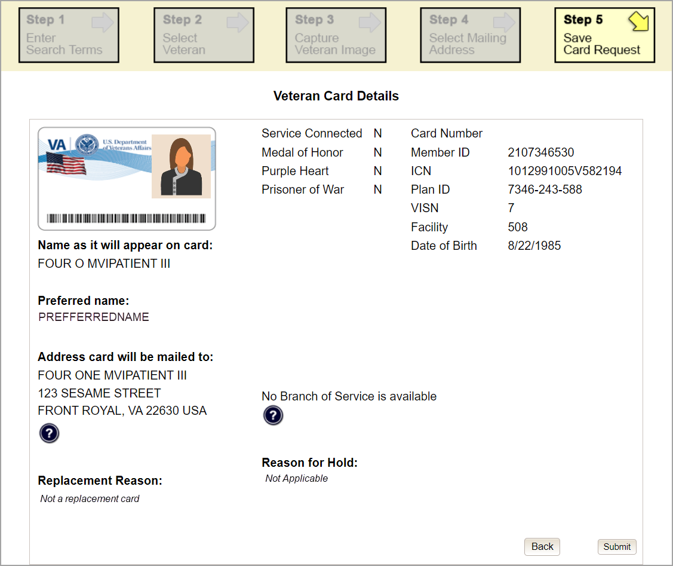

This screen contains the following information for review:
- Name as it will appear on card
- Address card will be mailed to (this also contains the name as it will appear in the mailing address)
- Replacement reason (if applicable)
- Reason for hold (if applicable)
- Service connected status
- Medal of Honor status
- Purple Heart status
- Prisoner of War status
- Branch of Service selection
- Date of Birth

Other fields that either will be populated or will populate upon final submission are:
- Card Number (populates upon final submission)
- Member ID
- ICN
- Member Benefit Plan ID
- VISN and Facility where request is being processed

Branch of Service
If available, the Veteran’s Branch of Service options will be displayed on screen. The Veteran should be given the opportunity to select which logo they would prefer to appear on their card or if they would like to decline the logo option altogether (default). The appropriate radio button should be selected based upon the Veteran’s preference. Only those branches of service that are listed in the Veteran Enrollment System and in which the Veteran has served will be shown. This will need to be chosen before submitting the card request.

NOTE: Only one Branch of Service logo can appear on the card; those with more than one branch will have to select one or decline to show any logo.

Figure 73: Branch of Service Selection
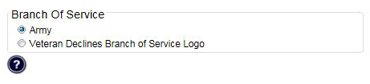

Mailing Address Verification
Veterans with a foreign mailing address, have different postage requirements. The system defaults this value based on predefined rules. Leave the default in-place unless specific instruction has been provided by administrators to alter selection.
Figure 74. Veteran With Foreign Mailing Address
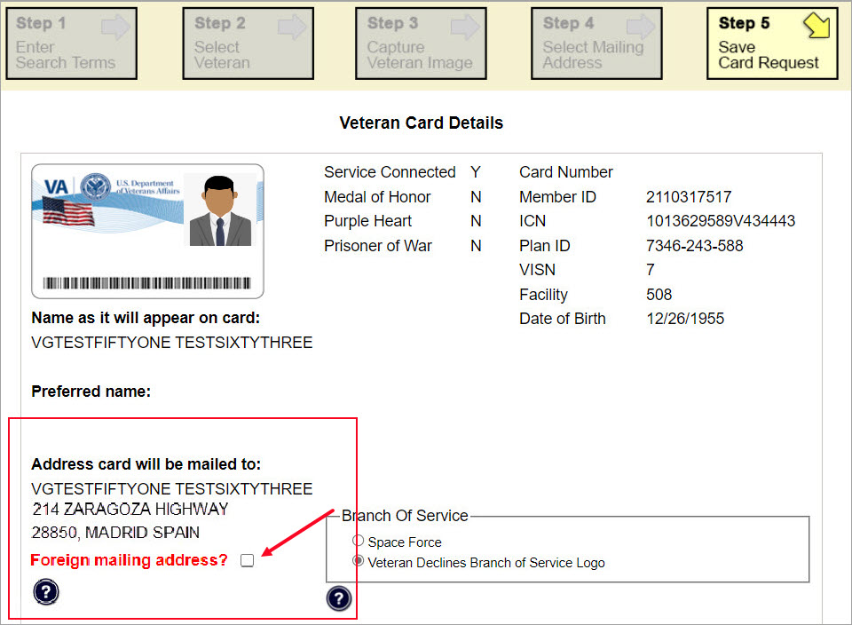

If a change to the default is made (Veteran has a foreign mailing address) A pop-up message will appear asking you to confirm the Foreign Address Setting. Click Yes to continue or Cancel to return.
Figure 75. Confirm Foreign Address Setting
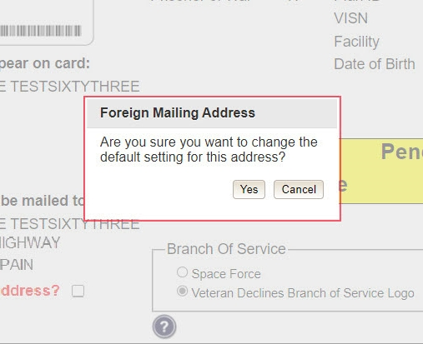

After the card and information have been confirmed, click the Submit button at the bottom of the page to advance the request.

Photograph Verification
After reviewing and approving the card details the VHIC user will click the [Submit] button. A pop-up box will appear requiring the clerk to acknowledge that they have approved the final picture that will be submitted for card printing. Selecting ok will allow the process to continue and submitting the request possible.
Figure 76: Verify Veteran Photo
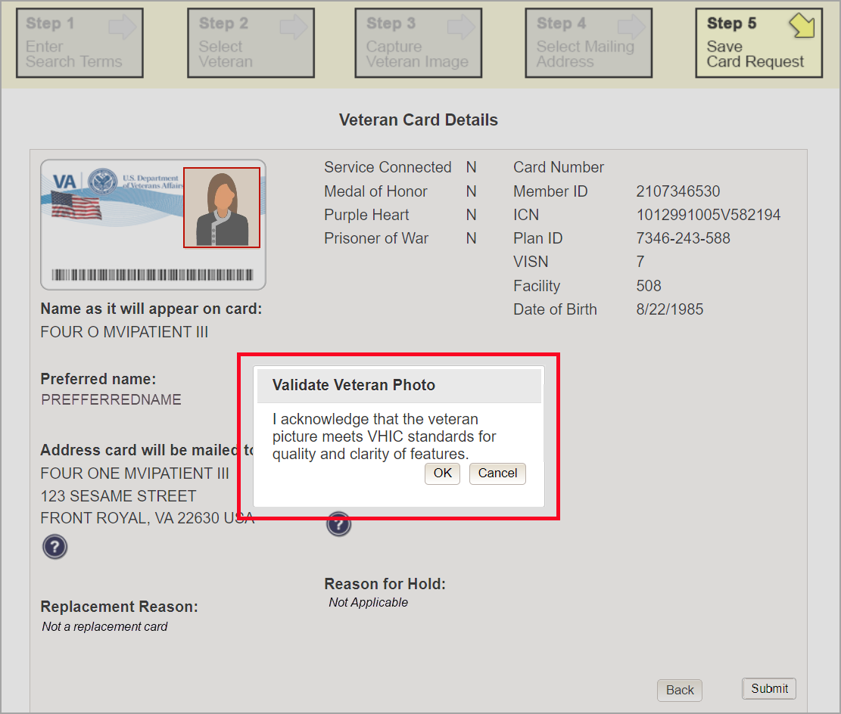

Should a new photograph be needed, the user may select [Cancel] and use the [Back] button to return to Step 3: Capture Veteran Image.
Figure 77: Photo Does Not Meet VHIC Standards
REDACTED

Once veteran photo has been approved the user may continue with the request.

Submit Card Request: New
If the card is a new request, meaning the Veteran has never had a VHIC prior to this request; the Replacement Reason section will state the following: Not a replacement card.

Upon submission, a Card Number will be generated as well as an Expiration Date and Card Request Date. The colored field will change from yellow to green and the corresponding Card Status will change from Pending to Submitted.

Figure 78: New Card Request Submitted
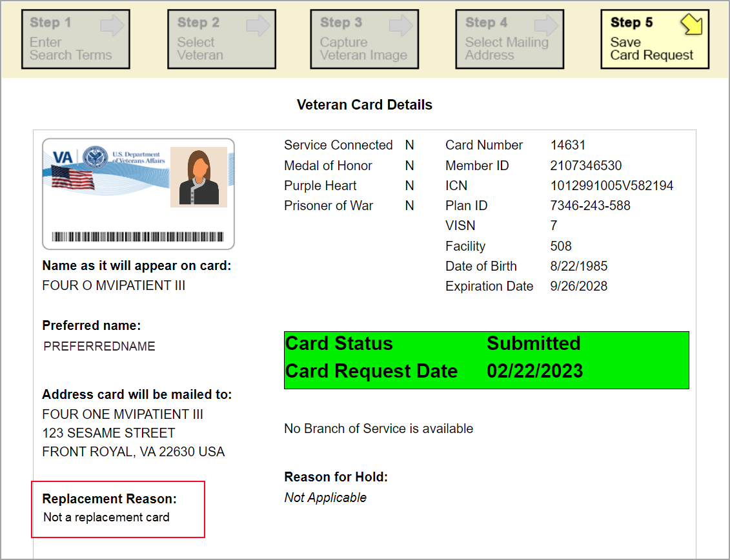

New VHIC: Veteran has NOT been Level 2 Proofed through Identity Management Toolkit
Should the Veteran not be Level 2 proofed after completing Steps 1-4 of the card request process (Beginning with Creating a VHIC Card – The Card Request Process) the process changes.

Step 5: Save Card Request Veteran Not Proofed
Since this Veteran has NOT had their Identity Proofing completed in the Identity Management Toolkit prior to starting the card request process, the Reason for Hold section will state the following: Veteran Not Proofed. The VHIC user will only be presented with the [Back] and [Hold] buttons. When the [Hold] button is selected a pop up will appear for the VHIC user to confirm this action. Selecting [OK] will save the request and put the request On Hold.
Figure 79: Save Card Request review screen
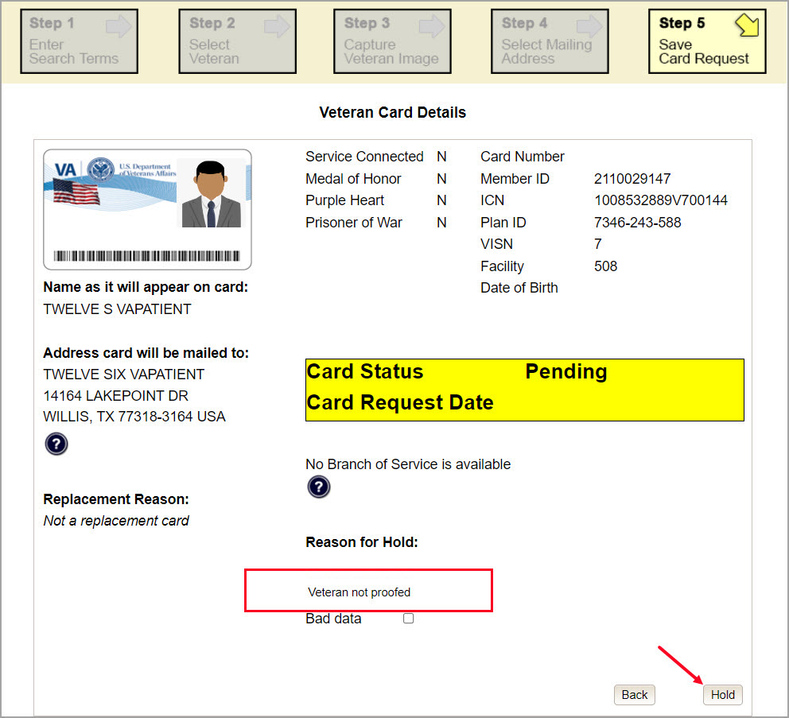

The Veteran Detail information should still be reviewed for accuracy and Branch of Service information confirmed before selecting the [Hold] button to continue. A pop-up box will appear for the hold status to be verified and for the VHIC Associate to confirm that they are aware the request will appear on tracking reports.
Figure 80: Save Request With On Hold Status
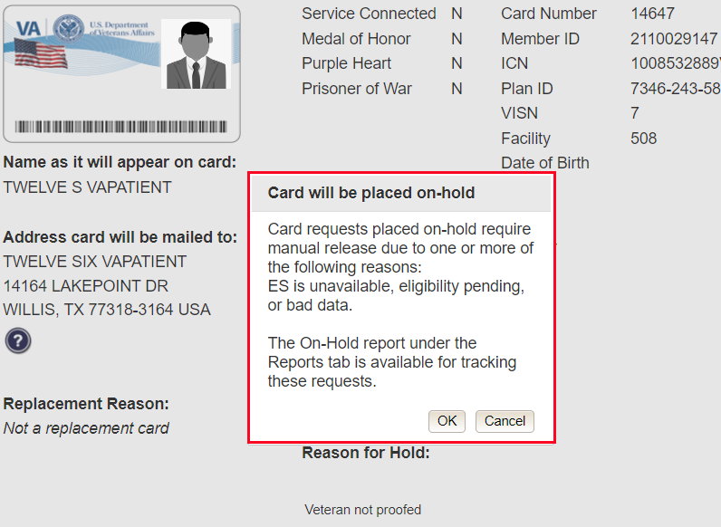

Photograph Verification
After confirming the status of the request. A second pop-up box will appear requiring the clerk to acknowledge that they have approved the final picture that will be submitted for card printing. Selecting [OK] will allow the process to continue and submitting the request possible.
Figure 81: Validate Veteran Photo
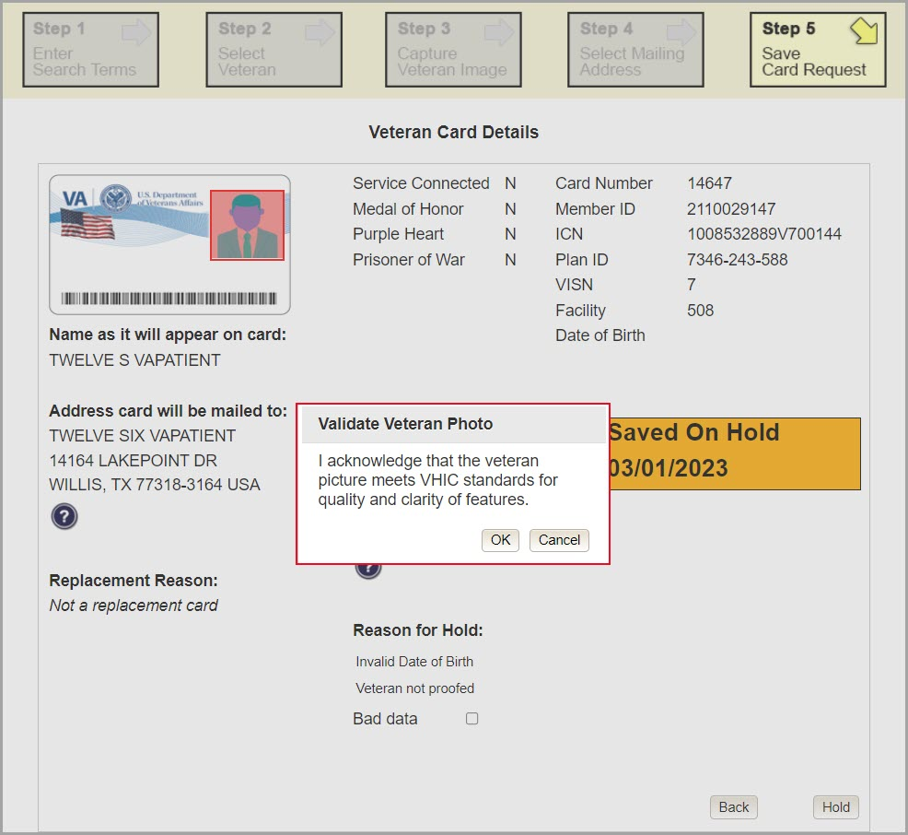

Should a new photograph be needed, the user may select [Cancel] and use the [Back] button to return to Step 3: Capture Veteran Image..

Figure 82: Photo Does Not Meet VHIC Standards
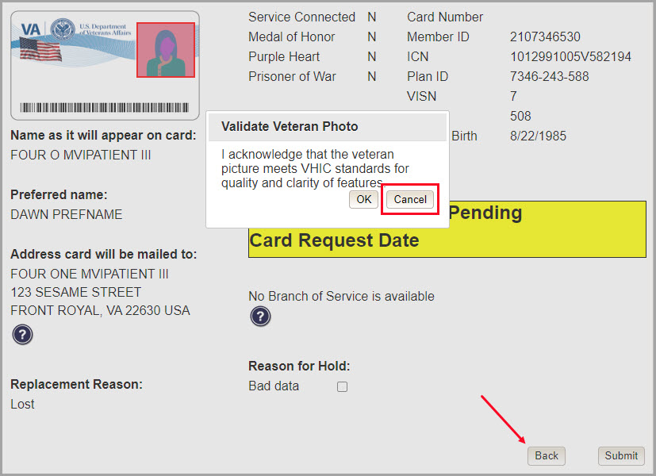
Once veteran photo has been approved by the user, they may continue with the request.

Upon submission, a Card Number will be generated as well as the Card Request Date. The colored field will change from yellow to orange and the corresponding Card Status will change from Pending to Saved on Hold.

Figure 83: Card Request Saved on Hold – Veteran Not Proofed

Since the Veteran that this card request was for still needs to be proofed, the VHIC system will display the message below that will include the next steps that the VHIC clerk will need to follow to complete the proofing process.

IMPORTANT: This Veteran still needs to have their Identity Proofing completed. See 4.2 Proofing Process and Steps before requesting a VHIC card.

Follow the steps below:
- Copy the Veteran's ICN above and click here to open REDACTED in another window.
- Complete Proofing for the Veteran in Identity Management Toolkit.
- Enter Veteran's ICN on Step 1 of the VHIC Card Request Process.
- Complete card request process and submit.

The words REDACTED are a hyperlink that the VHIC user can click on to be able to open the Identity Management Toolkit application in another browser window.

Resuming an On Hold VHIC Request:
When the Associate resumes a card request that has been placed On Hold, they will still be taken through the same steps as though it was a New Card or a Replacement. The Associate won’t be shown that this is an On Hold Request until they get to Step 4.

Step 4 Status Section Request on Hold
At the top of the Step 4 screen is the Status section. Since this card request for the Veteran was placed on hold, the status of On Hold will be listed along with the On Hold reason. Review the Veteran Identity Attributes and Mailing Address to ensure the information has not changed since the request was placed On Hold.

Once the review is complete and the information verified click the [Next] button to continue.
Figure 84: Step 4 Status On Hold.
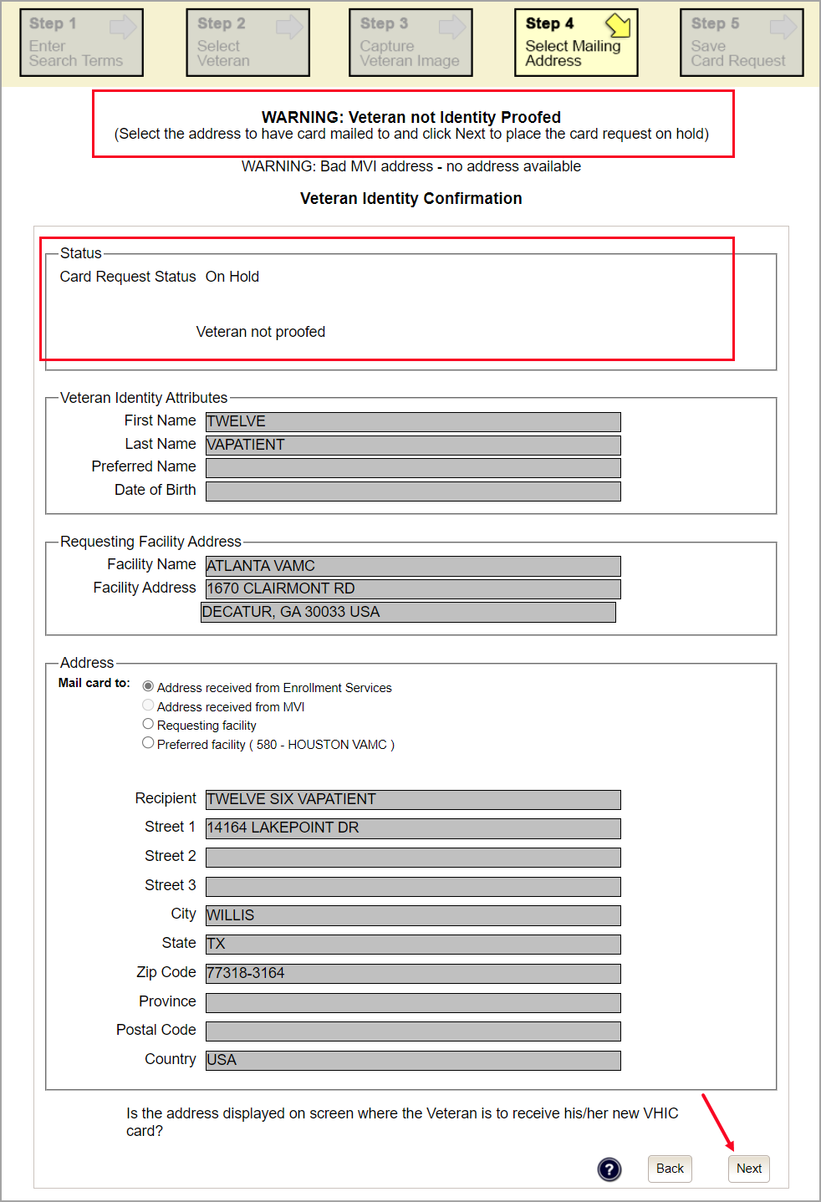

Step 5 Completing the On Hold Card Request
Once reaching Step 5, the VHIC user can now click [Submit] to remove the On Hold status and complete the card request.
Figure 85: Save Card Request review screen; click Submit
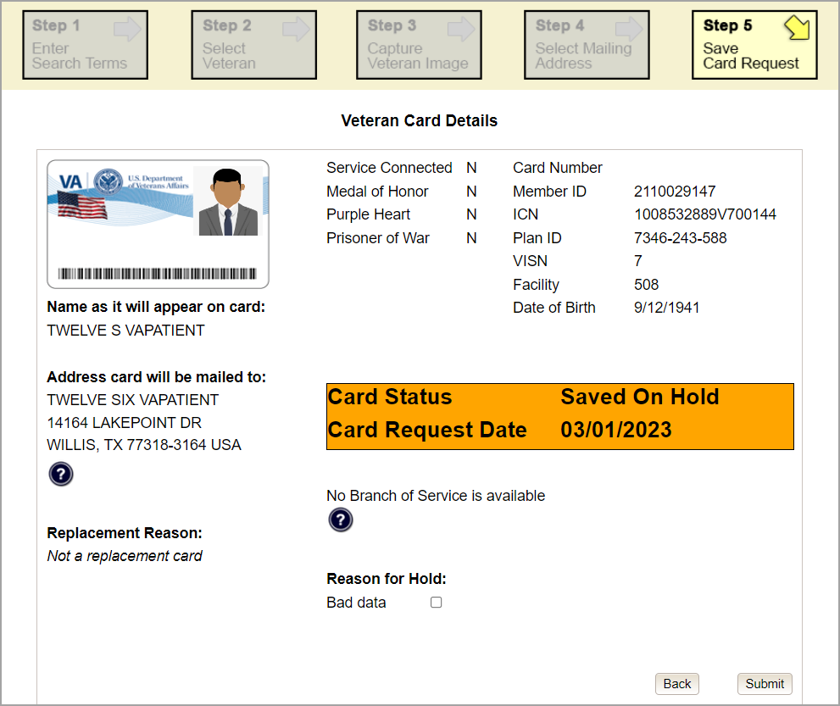

Photograph Verification
After reviewing and approving the card details the VHIC user will click the [Submit] button. A pop-up box will appear requiring the clerk to acknowledge that they have approved the final picture that will be submitted for card printing. Selecting ok will allow the process to continue and submitting the request possible.
Figure 86: Verify Veteran Photo
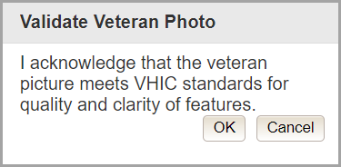

Should a new photograph be needed, the user may select [Cancel] and use the [Back] button to return to Step 3: Capture Veteran Image.
Figure 87: Photo Does Not Meet VHIC Standards
REDACTED

Once veteran photo has been approved the user may continue with the request.
The below screen shows that the Card Request was submitted successfully.

If a Branch of Service was selected on the previous screen. The designated choice will appear here, as well as the Expiration Date and the Replacement Reason.

Figure 88: Card Request Submitted
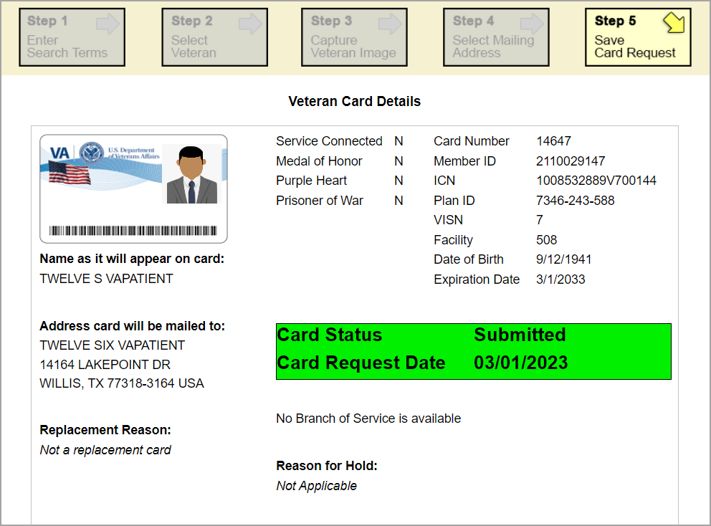

VHIC Card Replacement

VHIC Replacement for Veteran Level 2 Proofed through Identity Management Toolkit
Placing a request for a Replacement VHIC Card follows the same steps as creating a New Card Request found in New VHIC Card Request until the user reaches Step 4. If the Veteran has an existing VHIC card the user will notice some different options.

Step 4: Review Verified Identity Attributes
This screen displays the information retrieved from the Master Person Index (MPI) and the Veteran Enrollment System (VES) for the selected Veteran. Even though this is a replacement card, these attributes should be review for accuracy and Reason for Replacement information entered.

Figure 89: Replacement Card Step 4
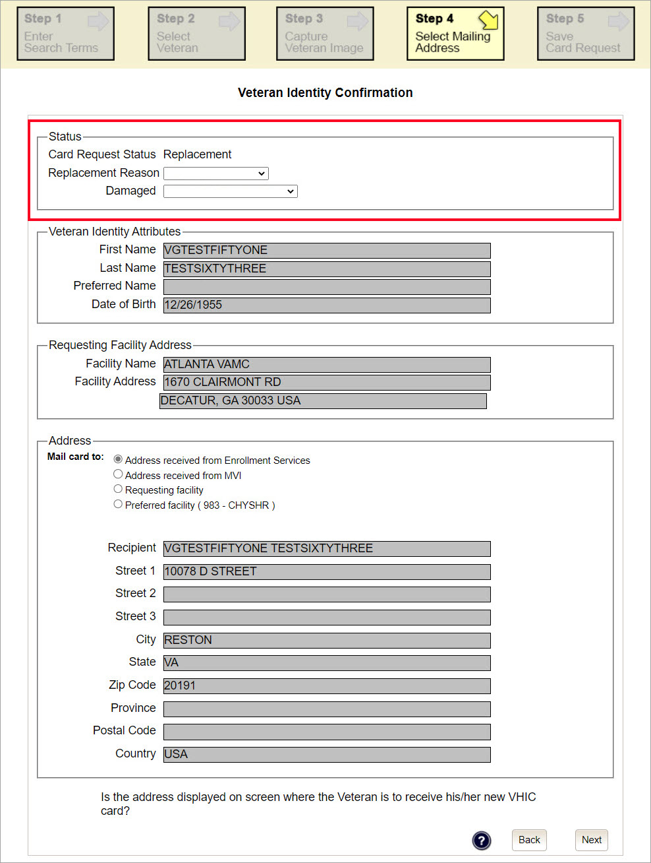

Status Section
At the top of the Step 4 screen is the Status section. When going through the card request process, one of the following Card Request Status options will be displayed: New, Replacement, or On Hold. If the card was previously placed on hold, the reason it was placed on hold will be listed here as well. If this is not the first card for the Veteran, the status of Replacement will be listed along with a drop-down list for selecting a Replacement Reason.
Figure 90: Card Request Status section

If the Card Request Status is Replacement, a selection must be made from the drop-down list as to why the card is being replaced. The available options are: Damaged, Expired, Incorrect Information, Lost, Poor Quality, or Stolen.

Replacement Options
If the Card Request Status is Replacement, a Replacement Reason will have to be provided before the card request process can continue. Based on the primary replacement reason selected, a secondary reason may need to be provided. The options selected here will appear on the final Step 5 screen under Replacement Reason.

The following are the available primary replacement reasons:
- Damaged
- Deactivated
- Expired
- Incorrect information
- Lost
- Poor Quality
- Stolen

Figure 91: Replacement Reason drop-down list
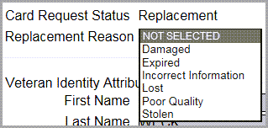

If Poor Quality is selected as a primary replacement reason, one of the following must be selected:
- Photo
- Text
Other
Figure 92: Poor Quality Replacement Reasons
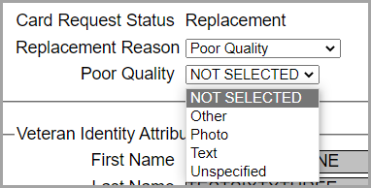

If Damaged is selected as a primary replacement reason, one of the following must be selected:
- Barcode not working
- Magnetic stripe not working
- Other physical damage

Figure 93: Damaged Replacement Reasons
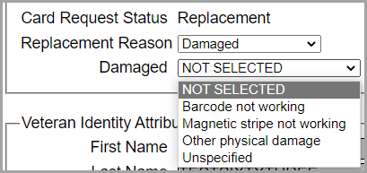

If Incorrect Information is selected as a primary replacement reason, one of the following must be selected:
- Branch of Service
- Date of Birth
- Member ID
- ICN
- Member Benefit Plan ID
- Name
- Photo
- Prisoner of War
- Purple Heart
- Service Connected
- Other

Figure 94: Incorrect Information Replacement Reasons
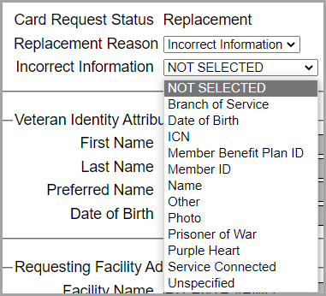

Step 5: Save Card Request
This brings us to Step 5 – Save Card Request. This screen allows the VHIC Admin to verify all of the information shown on the screen as being correct.

If the information on the screen is a correct match, and the Branch of Service is confirmed, select the [Submit] button in the lower right hand to move forward.
Figure 95: Save Card Request review screen
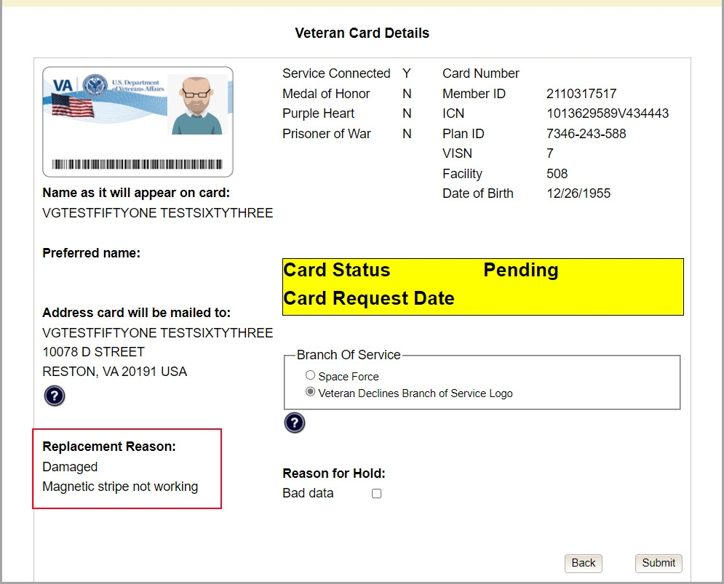

Photograph Verification
As with any Card Request, the Veteran Photo must be verified before the request can be submitted.
Should a new photograph be needed, the user may select [Cancel] and use the [Back] button to return to Step 3: Capture Veteran Image.

Figure 96: Photo Does Not Meet VHIC Standards

Once veteran photo has been approved the user may continue with the request.

Save Card Request: Replacement
Saving and submitting a replacement card request is essentially the same as submitting a new card request. The only variation will be the replacement reason. The selections made earlier in Step 4 will be reflected on this screen under the Replacement Reason section.
Figure 97: Replacement Card Request Submitted
REDACTED

On Hold Reasons Explained

Veteran Not Proofed:
User did NOT complete the proofing process using the Identity Management Toolkit application PRIOR to creating a VHIC request.

If the VHIC user started the VHIC card request BEFORE going into the Identity Management Toolkit application and completing the proofing process, the VHIC application will display the Warning message on Step 4 of the card request process indicating that the Veteran has NOT been Identity Proofed. The VHIC user will see Veteran not proofed as the Reason for Hold on Step 5. The VHIC application will allow you to save the card request on hold. The card request will be saved for 30 days.

Figure 98: Veteran Not Proofed Warning message on Step 4: Select Mailing Address
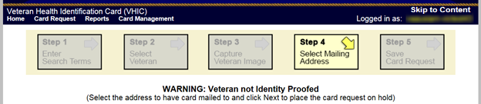

Figure 99: Reason for Hold: Veteran Not Proofed
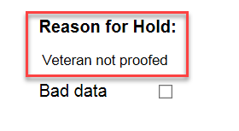

Once the VHIC user completes the Identity Proofing in the Identity Management Toolkit application, they can return to the VHIC application to take the card request off hold. The VHIC user will start a card request as they would normally. The VHIC user will see the On Hold Reason – Veteran Not Proofed displayed on Step 4 of the card request process.
Figure 100: Card Request Status: On Hold - Veteran Not Proofed
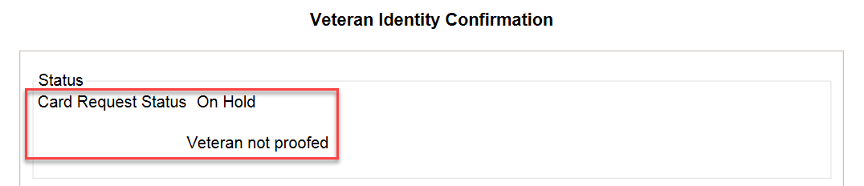

Continue with the card request process and submit the card request as outlined in section 4.3 Resuming an On Hold VHIC Request: Veteran NOT Level 2 Proofed Hold Reason

NOTE: There is a background job that runs every morning at 8:00 a.m. Eastern Time that will check the proofing status of any cards placed on hold. As long as there are no other issues with the card request, the job will submit the card request to the print vendor.

Enrollment Services Unavailable
If you get to Step 6 and see the message “Enrollment Unavailable” displayed under Reason for Hold, which means that VHIC is unable to communicate to Enrollment Services at this time, select the Branch of Service (if available) and click on the [Hold] button. This will save the card request for 30 days.
Figure 101: Reason for Hold: Enrollment Unavailable
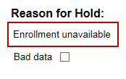

Next, log a ticket by calling the Enterprise Service Desk at REDACTED, option #3 (Applications), then option #1 or create a ticket through the [yourIT] shortcut on your desktop.

NOTE: There is a background job that runs every morning at 8:00 a.m. Eastern Time that will check the eligibility status of any cards placed on hold.
- If the Eligibility status is confirmed as “Eligible” and there are no other issues with the card request, the job will submit the card request to the print vendor.
- If the Eligibility status is confirmed as “Not Eligible”, the card request will be terminated, and no card will be issued.

Eligibility Pending
If you get to Step 6 and see the message “Eligibility Pending” displayed under Reason for Hold, which means that Veteran Enrollment Services has returned an eligibility status of “Pending” at this time, select the Branch of Service (if available) and click on the [Hold] button. This will save the card request for seven (7) days.
Figure 102: Reason for Hold: Eligibility Pending
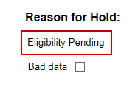

NOTE: The Veteran should go to Veteran Enrollment Services to have the record updated as needed. There is a background job that runs every morning at 8:00 a.m. Eastern Time that will check the eligibility status of any cards placed on hold.
- If the Eligibility status is confirmed as “Eligible” and there are no other issues with the card request, the job will submit the card request to the print vendor.
- If the Eligibility status is confirmed as “Not Eligible” or is not updated within Seven (7) days, the card request will be terminated, and no card will be issued.

Bad Data – Other
If you get to Step 6: Save Card Request and any information that is displayed on the screen needs to get changed/updated, click the checkbox next to Bad Data under Reason for Hold. A Details field with be displayed and you can enter a description on what information needs to be updated. Then select the Branch of Service (if available) and click on the [Hold] button. This will save the card request for 30 days.
Figure 103: Reason for Hold: Bad Data – Name Spelled Wrong
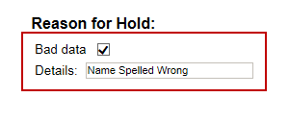

The Veteran should go to Veteran Enrollment Services to have the record updated as needed. A card request placed on hold with Bad Data as the Reason for Hold will NOT be updated and submitted by the background job.

The Veteran will need to return to complete the card request after they have had the information updated. You will need to start a card request as you would normally. On Step 4 of the card request process, you will see the On Hold Reason – Bad Data: (reason entered when saved) displayed.
Figure 104: Card Request Status: Replacement on Hold - Bad Data: Name Spelled Wrong
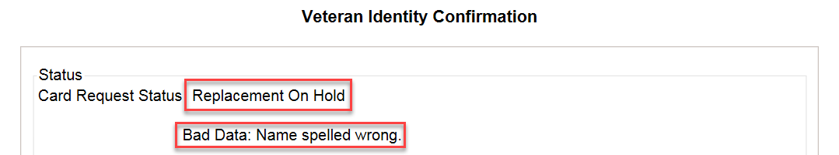

Continue with the card request process. When you get to Step 6, you will need to uncheck the checkbox next to Bad Data in order to be able to submit the card request.
Figure 105: Reason for Hold: Bad Data Unchecked
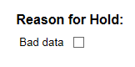

No EDIPI
If you get to Step 6 and see the message “No EDIPI” displayed under Reason for Hold, it means that the VA does not have Defense Enrollment Eligibility Reporting System (DEERS) data for that individual at this time. Select the Branch of Service (if available) and click on the [Hold] button. This will save the card request for thirty (30) days and a request will be generated for HC IdM remediation once you select the hold button.
Figure 106: Reason for Hold: No EDIPI
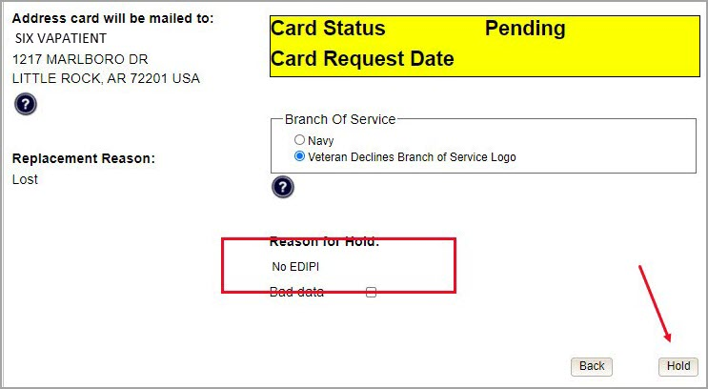

A Confirmation message will appear, select the [OK] button.
Figure 107: On Hold Request Confirmation Box
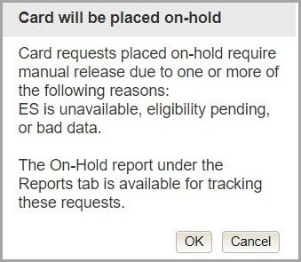

If a second request is generated before the thirty (30) days, the user will get a message indicating that a request is open in the system.
Figure 108: Active Request Exists in System Message
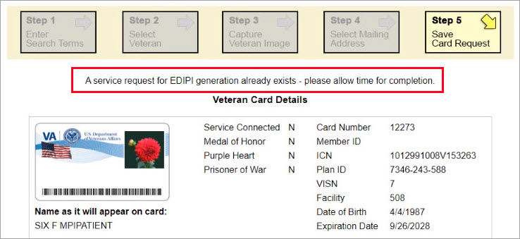

Imprecise Date of Birth
If you get to Step 6 and see the message “Invalid Date of Birth” displayed under Reason for Hold, it means that the VA received an imprecise Date of Birth, such as Month/year instead of Month/Date/Year. A request needs to be created for HC IdM remediation. Select the Branch of Service (if available) and click on the [Hold] button. This will save the card request for thirty (30) days and generate the remediation request for HC IdM.

Figure 109: Reason for Hold: No EDIPI
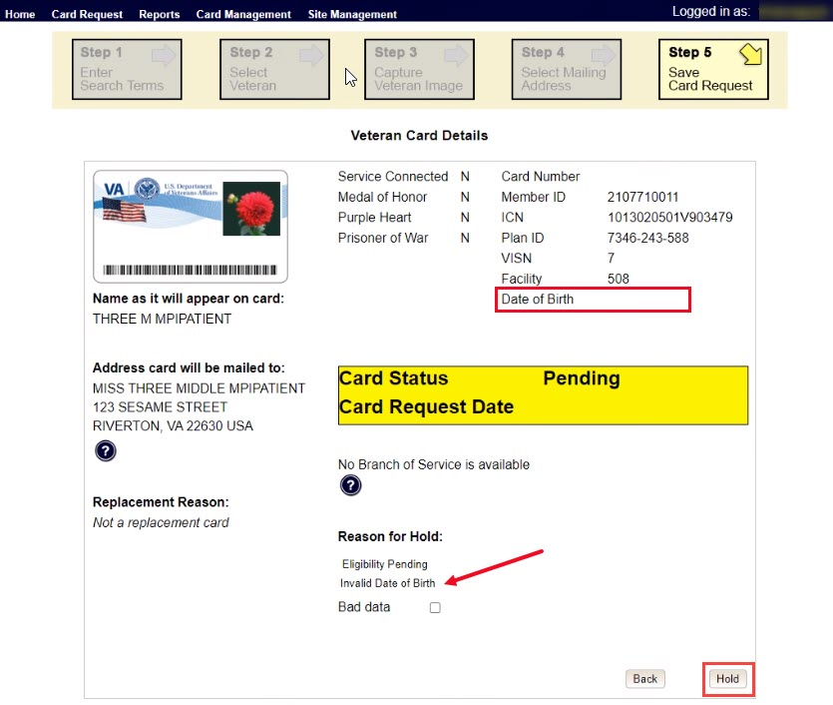

A Confirmation request message will appear, select the [OK] button.
Figure 110: On Hold Request Confirmation Request

The screen will change showing that the Card Request Status has been updated and saved.
Figure 111: Saved on Hold
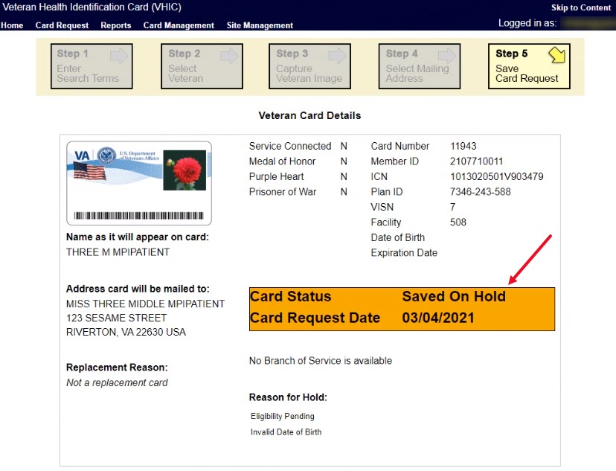

Manual Review Required
If you get to Step 5 and see the message “Manual Review Required” displayed under Reason for Hold, it means that the veteran has submitted their request through the VA Self Service Portal and the request could not be completed without VA review. The hold could be due to an error with the picture, information change request, etc. Once the manual review has been completed a background process will clear the hold. Submitting the request Unchecking the Card Hold manually will not clear the hold even if the TK task has been successfully processed. See VHIC User Guide Vol 6 Self Service Process for information about this type of request.
Figure 112: Manual Review Required Hold.
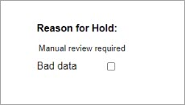

No Facility Address
If you get to Step 5 and see the message “No Facility Address” displayed under Reason for Hold, it means that there is no facility address on file.
Figure 113 No Facility Address
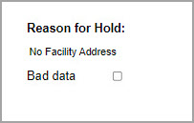

Requesting a VHIC for a Veteran within ten (10) days of a previous VHIC request
VHIC Users will not be able to request a new VHIC for a Veteran if there has been a previous request made within the past ten (10) days. They will be shown a message on Step 2 of the VHIC card request process stating:
“This Veteran has a recent VHIC request in process. Please remind the Veteran the VHIC should be received with 10 days after the request was submitted.”
Figure 114: Replacement Card has been requested within the past 10 days
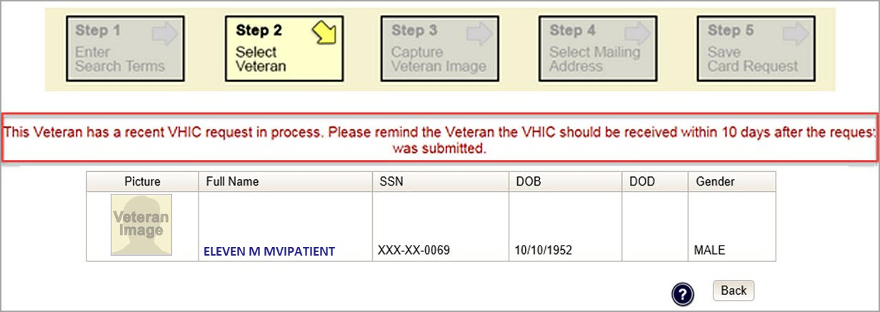

If for some reason a new VHIC request must be made to include any changes within 10 days of the previous card request, ONLY the VHIC Administrator will be able to submit a new card request. In this instance, the VHIC user will need to submit a request to the VHA HEC VHIC Program Team mail group via an encrypted message to deactivate the submitted card request. Once the VHIC user is notified that their card request has been deactivated, they can submit a new card request with the corrected information

Information to include in the request are listed below:
- Veteran’s First and Last Name
- Member ID and/or Card Number
- Site Point of Contact
- Reason for needing a new card requested within 10 days of the previous request.

NOTE: If the Member ID and/or Card Number are not available, provide the Date of Birth and SSN instead.

Requesting a VHIC for a Veteran with an existing Date of Death
VHIC Users will not be able to request a new VHIC for a Veteran if a Date of Death has been reported for them. They will be shown a message on Step 2 of the VHIC card request process stating:
Card requests for deceased veteran(s) are not allowed. All Cards for deceased veteran(s) have been deactivated in VHIC and unlinked in MPI.

Figure 115: Deceased Veteran Notification
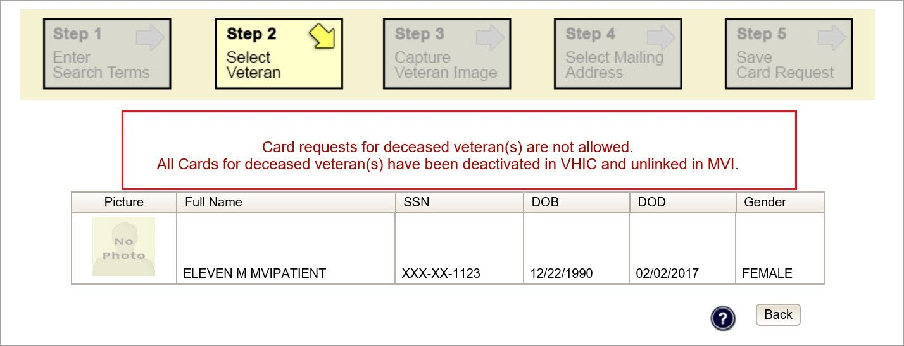

The Veteran should be referred to Veteran Enrollment Services. This could be to either the facility enrollment department (possibly parent facility), or the HEC Enrollment & Eligibility Division for assistance.

Card Deactivations
Card deactivations can ONLY be completed by the VHIC Administrator. The VHIC user will need to submit a request to the VHA HEC VHIC Program Team mail group via an encrypted message.
Information to include in the request are listed below:
- Veteran’s First and Last Name
- Member ID and/or Card Number
- Site Point of Contact
- One of the following deactivation reasons:
  - Cancelled/Declined (enrollment)
  - Damaged
  - Deceased
  - Identity Theft
  - Lost
  - Stolen
  - Other – With detailed explanation

NOTE: If the Member ID and/or Card Number are not available, provide the Date of Birth and SSN instead.

NOTE: Once the VHIC user is notified that their card request has been deactivated, they can submit a new card request with the corrected information.

VHIC Administrators can find detailed information on how to deactivate all of the VHICs for a given Veteran in the Veteran Health Identification Card User Guide - Volume 3 – Admins document.

Reports
A comprehensive walkthrough of all of the different reports that are available to VHIC users and the types of metrics that can be obtained, as well as an explanation of the user role permissions for accessing the reports are included in the Veteran Health Identification Card User Guide - Volume 2 - Reports document.

Troubleshooting
For a through set of troubleshooting guidelines, please refer to the Veteran Health Identification Card User Guide - Volume 4 - Troubleshooting document.

