DEPARTMENT OF VETERANS AFFAIRS
O F F I C E O F I N F O R M A T I O N A N D T E C H N O L O G Y E N T E R P R I S E S Y S T E M S E N G I N E E R I N G
D E S K T O P T E C H N O L O G I E S
ESE VSS Kiosk Baseline Resource Document
Version 1.2
January 3, 2017

Revision History

Date | Reason for Changes | Version | Author
09/22/2016 | Initial Document | 1.0 | REDACTED
09/22/2016 | Review and edit as needed | 1.0 | REDACTED
10/20/2016 | Added upgrade instruction | 1.1 | REDACTED
10/21/2016 | Reviewed upgrade instructions | 1.2 | REDACTED
01/03/2017 | Reviewed, corrected typographical errors, regenerated TOC and posted | 1.2 | REDACTED

Table of Contents
Revision History i
Purpose 1
Hardware 1
Applications 1
Build Method 1
Computer Naming 1
Active Directory 1
Group Policy Objects 2
Encryption 2
Links 2
Contacts 3
VSS Kiosk Build Process (New Build) 3
Service Account 3
Imaging 3
Printer Setup 3
Setup Default VSS Website 7
Setup auto logon 9
Move machine to final VSS OU in AD 10
Verify GPOs 10
Complete 10
VSS Kiosk Build Process (Upgrade Existing) 10
Domain Infrastructure Division 10
SCCM Team 11
Local IT Team 11
Setup Default VSS Website 13
Complete 16

Purpose
This document describes the content that should be used in the configuration of computers for the VSS Kiosk Baseline project. The information is from the viewpoint of ESE Desktop Technologies (DT) who was asked to add the required computer drivers to the build process and packaged the required application for use in SCCM to makeup a VSS Kiosk Baseline. The internal ESE Desktop Technologies Change Order Number (CO#) is CO250016FY15. The VSS kiosk is used for a volunteer to log their volunteering hours and print a meal ticket if they work the required hours needed to receive a meal.

Hardware
- VSS Kiosk Baseline uses Windows 7 x64 architecture
- All hardware listed in the REDACTED section 8.4 is supported for this document.

Applications
The following REDACTED provides a list of applications that are for this baseline. No additional applications should be installed and only the applications and listed versions are authorized for this baseline.

Build Method
In order to build the VSS Kiosk Baseline computer, use the Baseline collection variable with the Windows 7 OSD task sequence to install the required applications listed for the VSS Kiosk Baseline. This process is detailed in the REDACTED
In order to maintain this baseline please refer to the REDACTED for the 1VA collection to exclude from standard application deployments. This REDACTED is for SCCM 2007 baseline management.

Computer Naming
Follow the VA naming convention REDACTED Device Type=SP and The first three characters of Device ID= Project name
Example: ISA-SPVSSXXXXX
Location Code = ISA- Device Type = SP
Device ID = VSSXXXXX (the five XXXXX is up to each site)

Active Directory
Management of the location in Active Directory (AD) will be handled by the Domain Infrastructure Division but it will be up to the person setting up the kiosk to verify everything is in place and correct before proceeding and if not take action to get it completed by contacting the Domain Infrastructure Division. The required OU for the VSS kiosk is listed below
root\Specialized Systems\Kiosks\VSS\yourkiosk\

Group Policy Objects
Management of the location in Active Directory (AD) will be handled by the Directory Services teams but it will be up to the person setting up the kiosk to verify everything is in place and get corrected by contacting the Domain Infrastructure Division before proceeding if not correct.
Actions performed by the Domain Infrastructure Division
- Create a new blank GPO named VA ESE DT VSS KIOSK Standards vX” (x = current version) and import the VA ESE DT VSS KIOSK Standards vX GPO located REDACTED into it.
- Link the new GPO to root\Specialized Systems\Kiosks\VSS\
In GPMC select the Delegation tab for the VSS Kiosk GPO and click the Advanced button in the lower right hand corner. Next click Add and search for your domains standard delegation group (usually VHAxxxAllAccountAdmins) and click OK, then in the permissions section of that dialog window check Deny for the “Apply group policy” option (make sure you are highlighting the group you added), then click Apply and then OK.
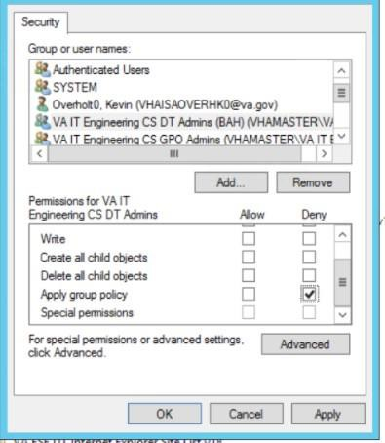
- All standards GPO’s listed here should be inherited or linked to the above mentioned OU.

Note: To assure the proper settings are in place for the kiosks, make sure the kiosk OU is set so that the appropriate kiosk policy has the highest precedence. Also note as indicated in the standards list any VA Banner GPO should not be applied to any kiosks systems in a domain, this allows for the proper functioning of the auto-login feature.

Encryption
Symantec Endpoint Encryption (SEE) Autologon will be used for the VSS kiosk baseline

Links
Systems Engineering and Design Review (SEDR) # TBD ESE Desktop Technology REDACTED
SMA baseline REDACTED is located under “Windows Desktops”

ESE Desktop Technology REDACTED

Contacts
If you have any questions or comments, you can reach out to the proper group. The following is a list of what ESE has available:
- OSD – Contact your regional Client Tech team and they will help or reach out to ESE national team for assistance as needed.
- Application install issues – Use the Build Documents for each application found in this document.
- Kiosk application functional issue – Contact the business owner of the kiosk Virginia Hoover.
- Group Policy – Issues applying the GPO Follow normal trouble shooting methods and procedures for GPO help.
- Active Directory or Service Account issues- Follow normal trouble shooting methods and procedures for AD help
- Application or solution use and setup issues (not install issues, see above) –

VSS Kiosk Build Process (New Build)

Service Account

Contact the Domain Infrastructure Division for the service account name and password.

Imaging

- Image your system using the information from above Build Method section for the VSS baseline. Make sure it is named according to proper naming standards for your location and this VSS kiosk baseline computer.
Note: Do NOT install any other applications including overlays or overlay applications. Contact your regional client tech team for guidance.
- Verify your computer applications match the REDACTED and there are no additional applications installed and listed under the Unapproved Applications table.
You can also use REDACTED to verify locally while you wait for the SCCM report to get its updated data from this newly imaged computer.

Printer Setup

- Logon to the computer with the service account you created in the service account section above.
- Navigate to C:\Kiosk\VSS\Star_SP700_USB_Printer_Setup and run setup.exe to install the SP700 printer drivers, you will need to use an admin credentials to install the printer drivers.

Note: Make sure the printer is not attached prior to loading drivers. Use the Typical setup of the driver. Once the drivers are loaded the computer will require a reboot, only upon rebooting is it OK to plug in the USB SP700 printer to the computer.
The Stat SP700 USB printer is the supported printer for VSS Kiosks, it is recommended to only use supported hardware. If alternate printers and drivers other than what is supported are used it is the sole responsibility of the local IT at that location to support them.
If for some reason you are using a nonstandard printer the drivers will still need to be installed in this manner with the exception of downloading your own specific driver files for your printer, not those in the location listed in (B) above, other printers and drivers were not tested at time of build.
- Log onto the computer again using the service account and make sure the Printer shows up in Devices and Printers, at this time set it as the default printer.
- Right click on the printer in Devices and Printers and select Printer Properties
- Follow the highlighted steps in the screen shots below
Select Advanced
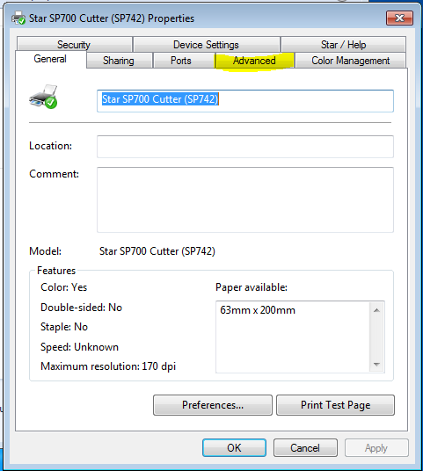

Printing Defaults
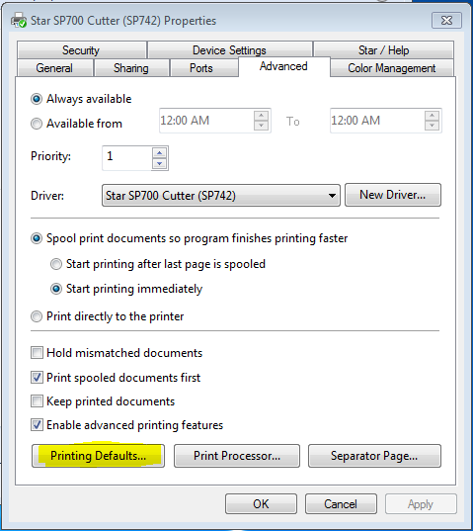
Advanced
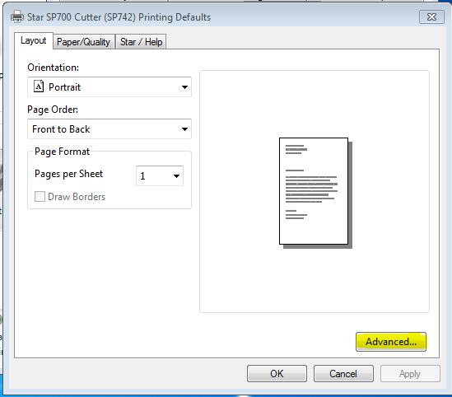

Make absolutely sure the paper size is set as 63mm x 200mm
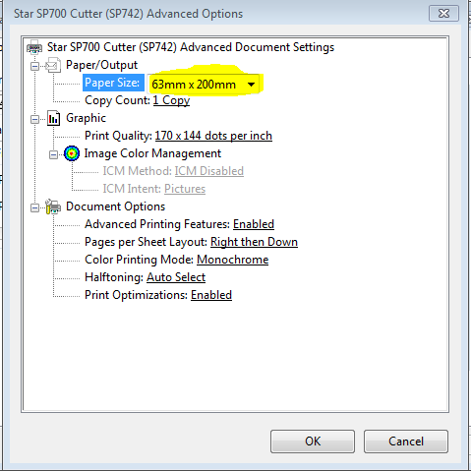
- Open Internet Explorer and click on the Tools cog in the upper right hand corner
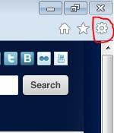
- Select Print > Page setup, make sure all the setting (i.e. Page Size, Margins, Headers and Footers) are equal to what is set in the highlighted areas below.
Page Size: 63mm x 200mm
Margins: Left and Right @ 0.1” and Top and Bottom @ 0.75”
Headers and Footers: Change all regions to Empty

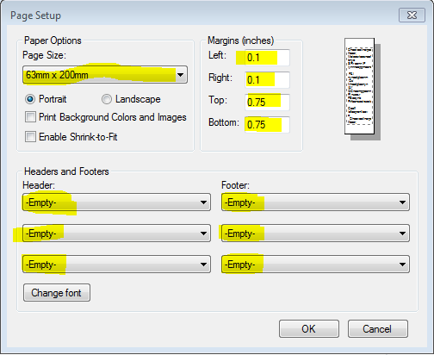

Setup Default VSS Website

- If you are not still logged on from the previous step, logon to the kiosk system with your administrative eToken account.

- When logged in as an administrator, navigate to C:\KIOSK\VSS and you should see the
Run_KIOSK_Script.bat file.
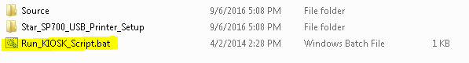
- Right click the Run_KIOSK_Script.bat file and choose Run as administrator
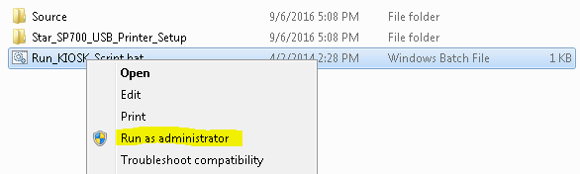

- You will see the following screen. Choose your site from the dropdown menu, and click the “Submit” button.
REDACTED

- This is the VSS site for your location, copy the entire site URL from the address bar then close IE.
REDACTED

- Paste the URL into the remaining VSS Homepage Configuration window that is behind the IE window you were just in during your previous step.
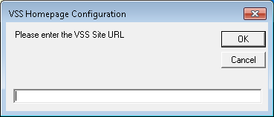
- Click OK. Your VSS Kiosk IE home page is set to your specific site. Note: re-open IE to confirm your home page.

Setup auto logon

- Logon to the kiosk system with your administrative eToken account.
- Navigate to the C:\Kiosk folder you should see an Autologon.exe file.
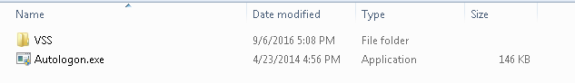

- Right click the Autologonexe file and select Run as administrator.
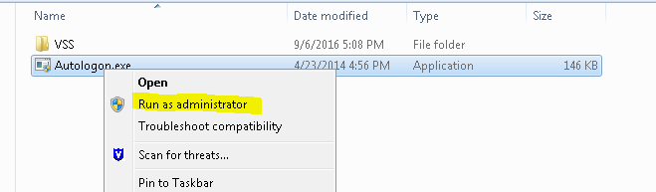
- Fill in information on the following dialog box then click [Enable]
  - Username – which is the service account created in the document.
  - Domain – which should be the FQDN of the domain. Example: REDACTED
  - Password
NOTE: Make absolutely sure you put the correct password in this field, if after a reboot later in this document the autolog does not Autologon you can rerun these steps to verify you entered the password correctly)

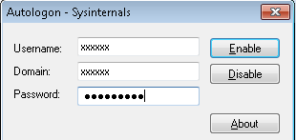

Move machine to final VSS OU in AD

After Autologon, default VSS website and the Printer are setup, contact the Domain Infrastructure Division to have your computer account moved to the VSS kiosk computer object to the specialized OU, root\Specialized Systems\Kiosks\VSS, in Active Directory.

Verify GPOs

- After Domain Infrastructure Division moves the machine account to the VSS OU in AD, logon using your eToken and run the command line (cmd.exe) as Administrator.

- Type gpupdate /force, to update the policy.

- Type gpresult /R and verify the GPO “VA ESE DT VSS KIOSK Standards vX” (x = current version) is applied as well as other baseline GPOs listed above under Group Policy section Note: Sometimes it takes an hour or so for the computer to receive the updated GPOs and you will need to give it more time

Complete

o Once you have done all procedures above, the machine should be running as a kiosk after a restart.

VSS Kiosk Build Process (Upgrade Existing)

Domain Infrastructure Division

1. In GPMC select the Delegation tab for the VSS Kiosk GPO and click the Advanced button in the lower right hand corner. Next click Add and search for your domains standard delegation group (usually VHAxxxAllAccountAdmins) and click OK, then in the permissions section of that dialog window check Deny for the “Apply group policy” option (make sure you are highlighting the group you added), then click Apply and then OK.

REDACTED

SCCM Team

Advertise the 1VA - VSS Kiosk Upgrade task sequence for manual installation by the local IT Team.
- Operating System Deployment > Task Sequences > VA Central Site Task Sequences >
Production
  - Task ID: 1VA0064D
  - Task ID: R0300463
  - Package ID: CM2001DB
Note: Please use the search functionality to locate the task sequence in SCCM 2012
Note: This Task Sequence includes the following items which are necessary for a successful upgrade:
- Kiosk Autologon
- VSS SQA Print Monitor
- VSS Hydration Package
- Java (at current version at time of installation)
- Internet Explorer11

Local IT Team

If the current kiosk is setup according to the original resource document instructions there is no reason to remove the computer account from its final OU location to complete the upgrade process however you will need to visit the kiosk to complete the upgrading task.
Once the 1VA - VSS Kiosk Upgrade has been advertised, visit your VSS kiosk and hold the power button for 2 seconds, this should log out the service account and bring you to a logon screen, plug in your eToken at this point and log in with your token credentials.
Proceed to Control Panel > Run Advertised Programs (32 bit)

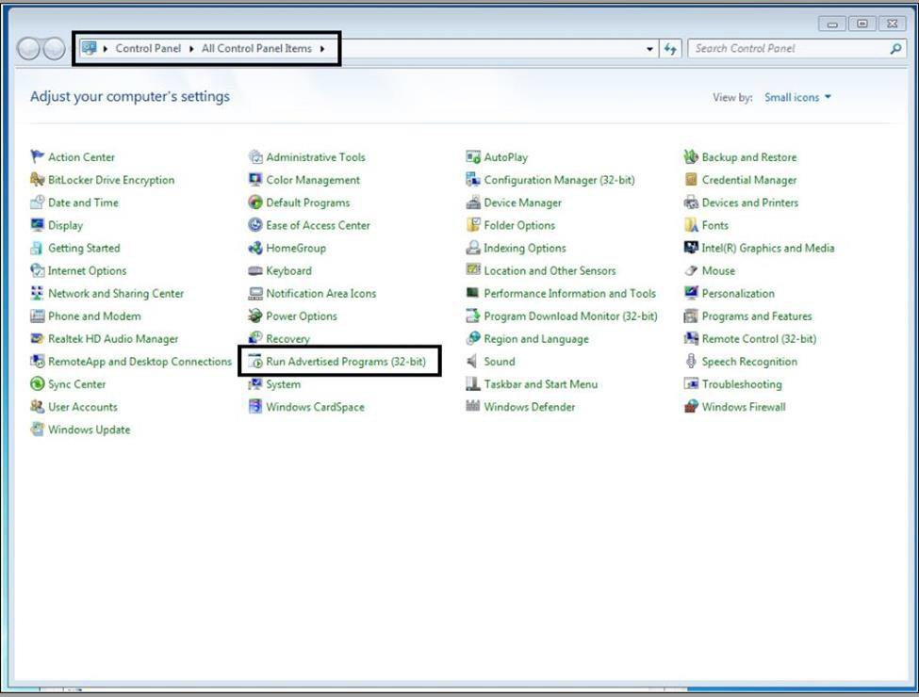

When in “Run Advertised Programs” choose the Area as “Software Distribution” and the Category as “What’s New” since this will be a newly advertised manual Task Sequence.
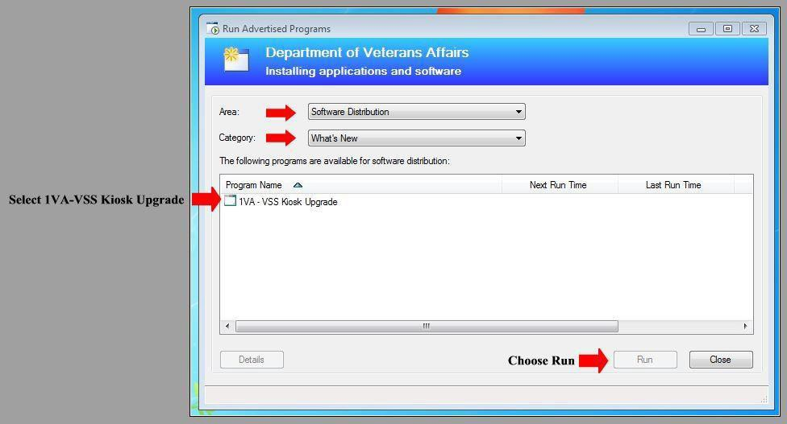
Run the 1VA-VSS Kiosk Upgrade

Verify the installs of the following applications in Programs and Features before moving forward: Kiosk Autologon – VSS SQA Print Monitor – VSS Hydration Package – Java (current version at time of installation)
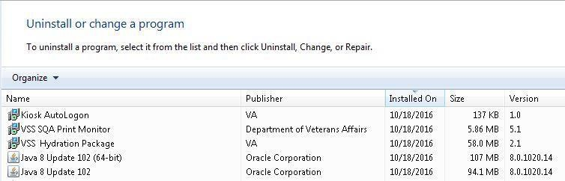
Verify browser is at IE11 (In browser under Help > About Internet Explorer)

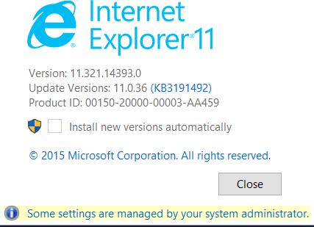

Setup Default VSS Website

Make sure your Domain Infrastructure team has performed their step in the Group Policy Objects section of this document.
Logon to the kiosk system with your eToken account again.
When logged in as an administrator, navigate to C:\KIOSK\VSS and you should see the
Run_KIOSK_Script.bat file.
Right click the Run_KIOSK_Script.bat file and choose Run as administrator

NOTE: If you see a message saying Internet Explorer is open kill the processes iexplore.exe currently open for all users.
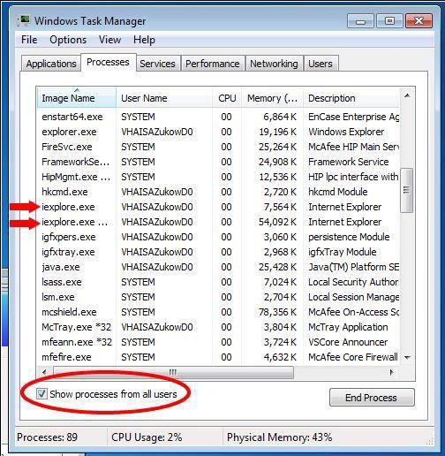

You will see the following screen. Choose your site from the dropdown menu, and click the “Submit” button.
REDACTED

This is the VSS site for your location, copy the entire site URL from the address bar then close IE.
REDACTED

Paste the URL into the remaining VSS Homepage Configuration window that is behind the IE window you were just in during your previous step.
Click OK. Your VSS Kiosk IE home page is set to your specific site.
NOTE: Re-open IE to confirm your home page.

Complete

Once you have completed all procedures and steps above in upgrade section, the machine will be running as an upgraded VSS kiosk with a new default website and printing method.

