Collaborative Terminology Tooling & Data Management (CTT&DM)

Native Domain Standardization (NDS)
Providers Domain
Deployment, Installation, Back-Out, and Rollback Guide
XU*8.0*671

November, 2017
Department of Veterans Affairs
Office of Information and Technology (OI&T)

Revision History

Date | Version | Description | Author
11/30/2017 | 1.0 | Delivery to VA | Management (ManTech Mission Solutions and Services Group)
11/28/2017 | 0.5 | Technical writer review and section 508 compliance check | REDACTED
11/28/2017 | 0.4 | Updated section 4.3 to remove Albany as a download site | REDACTED
07/03/2017 | 0.3 | Technical Writer Review | REDACTED (ManTech Mission Solutions and Services Group)
06/29/2017 | 0.2 | Made updates | REDACTED (ManTech Mission Solutions and Services Group)
02/15/2016 | 0.1 | Initial Draft | REDACTED (ManTech Mission Solutions and Services Group)

Artifact Rationale
This document describes the Deployment, Installation, Back-out, and Rollback Plan for new products going into the VA Enterprise. The plan includes information about system support, issue tracking, escalation processes, and roles and responsibilities involved in all those activities. Its purpose is to provide clients, stakeholders, and support personnel with a smooth transition to the new product or software, and should be structured appropriately, to reflect particulars of these procedures at a single or at multiple locations.
Per the Veteran-focused Integrated Process (VIP) Guide, the Deployment, Installation, Back-out, and Rollback Plan is required to be completed prior to Critical Decision Point #2 (CD #2), with the expectation that it will be updated throughout the lifecycle of the project for each build, as needed.

Table of Contents
1 Introduction 5
1.1 Purpose 5
1.2 Dependencies 5
1.3 Constraints 5
2 Roles and Responsibilities 5
3 Deployment 6
3.1 Timeline 6
3.2 Site Readiness Assessment 6
3.2.1 Deployment Topology (Targeted Architecture) 6
3.2.2 Site Information (Locations, Deployment Recipients) 7
3.2.3 Site Preparation 7
3.3 Resources 7
3.3.1 Facility Specifics 7
3.3.2 Hardware 8
3.3.3 Software 8
3.3.4 Communications 8
3.3.4.1 Deployment/Installation/Back-Out Checklist 8
4 Installation 8
4.1 Pre-installation and System Requirements 8
Creating a Local Patch Backup 9
4.2 Platform Installation and Preparation 10
4.3 Download and Extract Files 10
4.4 Database Creation 11
4.5 Installation Scripts 11
4.6 Cron Scripts 11
4.7 Access Requirements and Skills Needed for the Installation 11
4.8 Installation Procedure 11
4.9 Installation Verification Procedure 12
4.10 System Configuration 13
4.11 Database Tuning 13
5 Back-Out Procedure 13
5.1 Back-Out Strategy 14
5.2 Back-Out Considerations 14
5.2.1 Load Testing 14
5.2.2 User Acceptance Testing 14
5.3 Back-Out Criteria 14
5.4 Back-Out Risks 14
5.5 Authority for Back-Out 14
5.6 Back-Out Procedure 14
5.7 Back-out Verification Procedure 17
ROUTINES 17
DATA DICTIONARIES 17
6 Rollback Procedure 18
6.1 Rollback Considerations 18
6.2 Rollback Criteria 18
6.3 Rollback Risks 19
6.4 Authority for Rollback 19
6.5 Rollback Procedure 19
6.6 Rollback Verification Procedure 19

Introduction
This document describes how to deploy and install Providers Native Domain Standardization patch XU*8.0*671, as well as how to back-out the product and rollback to a previous version or data set. This document is a companion to the project charter and management plan for this effort.

Purpose
The purpose of this plan is to provide a single, common document that describes how, when, where, and to whom the Providers Native Domain Standardization patch XU*8.0*671 will be deployed and installed, as well as how it is to be backed out and rolled back, if necessary. The plan also identifies resources, communications plan, and rollout schedule. Specific instructions for installation, back-out, and rollback are included in this document.

Dependencies
The Providers Native Domain Standardization patch XU*8.0*671 possesses a direct application dependency on the VistA Kernel 8.0 application (XU) and on the Health Data & Informatics 1.0 application (HDI).

Constraints
Providers Native Domain Standardization patch XU*8.0*671 possesses the following constraints:
- The update to the VistA PERSON CLASS file (#8932.1) shall not affect the current functionality or conflict with applications that utilize this file.
- The fields being added to these files should only be visible on the back end and to those requesting the information, not the GUI applications used by clinicians within the VA.

Roles and Responsibilities
Table 1: Deployment, Installation, Back-out, and Rollback Roles and Responsibilities
Team | Phase / Role | Tasks
OIT Regional Support | Deployment | Plan and schedule deployment (including orchestration with vendors)
CTT&DM NDS Project Team | Deployment | Determine and document the roles and responsibilities of those involved in the deployment.
OIT Regional Support | Deployment | Test for operational readiness
OIT Regional Support | Deployment | Execute deployment
OIT Regional Support | Installation | Plan and schedule installation
CTT&DM NDS Project Team | Installations | Coordinate training
OIT Regional Support | Back-out | Confirm availability of back-out instructions and back-out strategy (what are the criteria that trigger a back-out)
CTT&DM NDS Project Team | Post Deployment – Warranty Period | Hardware, Software and System Support
OIT Regional Support | Post Deployment – Post Warranty | Hardware, Software and System Support

Deployment
The deployment is planned as a concurrent online rollout. During IOC testing and after national release, patch XU*8.0*671 will be distributed via the FORUM Patch Module, and may be deployed at any site without regard to deployment status at other sites.

Timeline
The deployment and installation is scheduled to run for a period of thirty days, as depicted in the master deployment schedule

Site Readiness Assessment
This section discusses the locations that will receive the CTT&DM NDS patch XU*8.0*671 deployment.
The XU*8.0*671 patch must be manually installed, or manually queued for installation, at each VistA instance at which it is deployed, using the standard Kernel Installation Distribution System (KIDS) software. The XU*8.0*671 patch should be installed at all VA VistA instances running the VistA Kernel v.8.0 application, and will update the M (Mumps) server software in each VistA instance’s Kernel namespace.

Deployment Topology (Targeted Architecture)
The deployment topology for the CTT&DM NDS patch XU*8.0*671, during IOC testing and after national release, is described below:
Figure 1: Patch XU*8.0*671 Topology
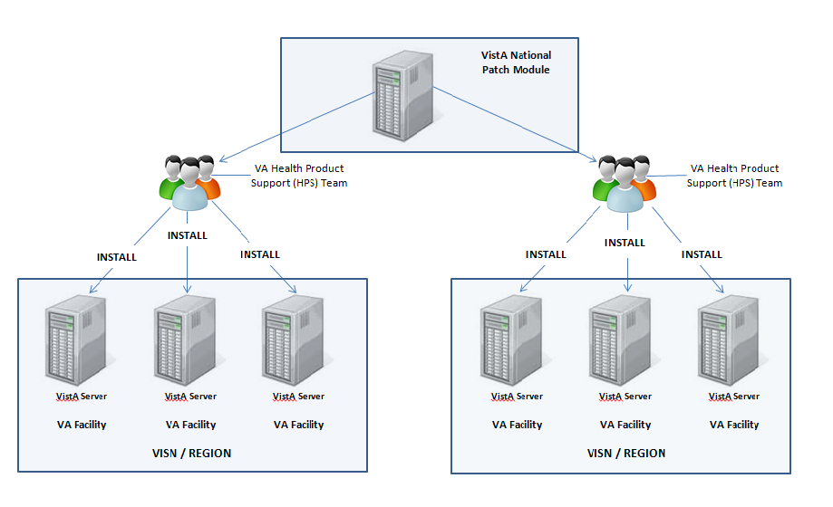

Site Information (Locations, Deployment Recipients)
During IOC testing, CTT&DM NDS patch XU*8.0*671 will be deployed at the following sites:
REDACTED
After national release, CTT&DM NDS patch XU*8.0*671 will be deployed at all sites running the VistA Kernel v.8.0 application.

Site Preparation
No special preparation is required by the site prior to deployment.

Resources
Deployment of CTT&DM NDS patch XU*8.0*671 requires a fully patched VistA environment running the Kernel v.8.0 application, as well as a Health Product Support (HPS) team member available to perform the patch installation.

Facility Specifics
There are no facility-specific deployment or installation features of CTT&DM NDS patch XU*8.0*671.

Hardware
CTT&DM NDS patch XU*8.0*671 requires no site hardware specifications during, or prior to, deployment.

Software
The following table describes software specifications required at each site prior to deployment.
Table 2: Software Specifications
Required Software | Make | Version | Configuration | Manufacturer | Other
Health Data & Informatics (HDI) patch HDI*1.0*18 |  | 1.0 | Standard | VHA
VistA Kernel (XU) patch XU*8*677 |  | 8.0 | Standard | VHA
VistA Kernel |  | 8.0 | Standard | VHA
Please see the Roles and Responsibilities table in Section 2 above for details about who is responsible for preparing the site to meet these software specifications.

Communications
No notifications are required for deployment of CTT&DM NDS patch XU*8.0*671.

Deployment/Installation/Back-Out Checklist
Table 3: Deployment/Installation/Back-Out Checklist
Activity | Day | Time | Individual who completed task
Deploy
Install
Back-Out

Installation

Pre-installation and System Requirements
Pre/Post Installation Overview:
It is recommended that a Local Patch Backup is created that can be re-installed in the event that patch XU*8.0*671 must be backed out. The approximate time to create the saved local patch is 30 minutes.

Patch Dependencies
Patch HDI*1.0*18 must be installed prior to installing this patch.
Patch XU*8*677 must be installed prior to installing this patch.
Knowledge of, and experience with, the Kernel Installation and Distribution System (KIDS) software is required. For more information, see Section V, Kernel Installation and Distribution System, in the Kernel 8.0 & Kernel Toolkit 7.3 Systems Management Guide.

Pre-Installation Instructions:
    - Creating a Local Patch Backup
Perform the following procedure to create a Local Patch Backup.
- From the KIDS (Kernel Installation & Distribution System) Menu, select ‘Edits and Distribution’.
- Select ‘Create a Build Using Namespace’.
- Enter a local patch name and identifier, suggested name ZXU*8.0*671.
- When prompted ‘BUILD PACKAGE FILE LINK:’, press <Enter>.
- When prompted ‘BUILD TYPE: SINGLE PACKAGE//’, press <Enter>.
- When prompted ‘BUILD TRACK PACKAGE NATIONALLY: YES//’, enter NO.
- When prompted ‘Namespace:’, press <Enter>.
- When prompted ‘Select Edits and Distribution Option’, select: ‘Edit a Build’.
- Enter the local patch name from step 3 (ZXU*8.0*671).
- For the ‘Description:’ enter the following: “this is a local backup for XU*8.0*671. This patch should only be installed in the event that XU*8.0*671 needs to be backed out.”
- In the ‘COMMAND:’ field, enter ‘Next Page’.
- For ‘File List’ Enter 8932.1 for PERSON CLASS File.
- In ‘Send Full or Partial DD’ field, enter FULL.
- In the ‘Update the Data Dictionary:’ field, enter YES.
- In the ‘Send Security Code:’ field, enter YES.
- In the ‘Data Comes With File:’ field, enter YES.
- In the DD Export Options dialog, move cursor to the COMMAND: prompt, enter ‘Close’
- In the File List dialog, move cursor to the ‘COMMAND:’ prompt, enter ‘Next Page’.
- In the Build Components section, move cursor to ROUTINE and press <Enter>.
**NOTE: If patch XU*8.0*671 has not been previously installed the routines listed in steps 20, 21, and 22 will list as not found, since they are new with this patch
- In the first blank row in the ROUTINE dialog, enter XU671PO, and ‘Send To Site’.
- In the next blank row in the ROUTINE dialog, enter XUPC991, and ‘Send to Site’.
- In the next blank row in the ROUTINE dialog, enter XUPCZRT, and ‘Send to Site’.
- Move cursor to the ‘COMMAND:’ prompt in the ROUTINE dialog, enter ‘Close’.
- Move cursor to the ‘COMMAND:’ prompt in the BUILD COMPONENTS dialog, enter ‘Save’, then enter ‘Exit’.
- When returned to the Edits and Distribution menu, select option ‘Transport a Distribution’.
- Enter the ‘local package name and identifier’ that was created in Step 3. (ZXU*8.0*671).
- At the ‘Another Package Name:’ press <Enter>.
- At the ‘OK to continue? Prompt, select YES//’ press <Enter>.
- If creating a Host File transport, perform the following steps:
  - At the ‘Transport through (HF) Host File or (PM) PackMan:’ prompt, enter HF.
  - At the ‘Enter a Host File:’ prompt, enter the system file to which the Local Patch Backup will be saved. (ZXU_8_0_671.KID).
  - At the ‘Header Comment:’ Enter ‘Local Backup of XU*8.0*671’.
  - At the Edits and Distribution Menu, press <Enter>.
  - At the KIDS Menu press <Enter>.
- If creating a PackMan transport, perform the following steps:
  - At the ‘Transport through (HF) Host File or (PM) PackMan:’ enter PM.
  - At the ‘Header Comment:’ enter ‘Local Backup of XU*8.0*671’
  - For the description of Packman Message, Enter: ‘This is a saved backup for the providers patch install for XU*8.0*671. This local build will be used in the event that the above mentioned installs need to be backed out.’
  - At ‘EDIT Option:’ press <Enter>.
  - At the ‘Do you wish to secure this message? NO// prompt, Enter ‘NO’.
  - At the ‘Send mail to:’ prompt, Enter your name.
  - At the ‘Select basket to send to: IN//’ prompt: press <Enter>.
  - At the ‘And Send to:’ prompt: Enter any additional persons that may need to have the local patch.
  - At The ‘Select Edits and Distribution <TEST ACCOUNT> Option:’ press <Enter>.

Platform Installation and Preparation
Patch XU*8.0*671 does not require any platform installation or preparation.

Download and Extract Files
CTT&DM NDS patch XU*8.0*671 is being released as a FORUM Patch via the Patch Module, therefore, the patch must be downloaded from FORUM, and forwarded to the destination site, in the form of a Packman message.
Documentation describing the new functionality introduced by this patch is available. The preferred method is to retrieve files from REDACTED This transmits the files from the first available server. Sites may also elect to retrieve files directly from a specific server.
Sites may retrieve the software and/or documentation directly using Secure File Transfer Protocol (SFTP) from the ANONYMOUS.SOFTWARE directory at the following OI Field Offices:
Hines: REDACTED
Salt Lake City: REDACTED
The documentation will be in the form of Adobe Acrobat files. Documentation can also be found on the VA Software Documentation Library at: http://www4.va.gov/vdl/

Title: Deployment, Installation, Back-Out, Rollback Guide XU*8.0*671
File Name: xu_8_0_671_ig.doc
xu_8_0_671_ig.pdf
FTP Mode: Binary

Database Creation
No new database is required for the CTT&DM NDS patch XU*8.0*671.

Installation Scripts
No installation scripts are required for installation of CTT&DM NDS patch XU*8.0*671.

Cron Scripts
No CRON scripts are required for installation of CTT&DM NDS patch XU*8.0*671.

Access Requirements and Skills Needed for the Installation
Access to national VA network, as well as the local network of each site to receive CTT&DM NDS patch XU*8.0*671 is required to perform the installation, as well as authority to create and install patches.
Knowledge of, and experience with, the Kernel Installation and Distribution System (KIDS) software is required. For more information, see Section V, Kernel Installation and Distribution System, in the Kernel 8.0 & Kernel Toolkit 7.3 Systems Management Guide.

Installation Procedure
Installation Instructions:
- Choose the PackMan message containing this patch.
- Choose the INSTALL/CHECK MESSAGE PackMan option.
- From Kernel Installation and Distribution System Menu, select the Installation Menu. From this menu, you may elect to use the following options. When prompted for the INSTALL NAME, enter the patch XU*8.0*671:
- Backup a Transport Global - This option will create a backup message of any routines exported with this patch. It will not backup other changes such as DDs or templates.
- Compare Transport Global to Current System - This option will allow you to view all changes that will be made when this patch is installed. It compares all components of this patch routines, DDs, templates, etc.).
- Verify Checksums in Transport Global - This option will allow you to ensure the integrity of the routines that are in the transport global.
- From the Installation Menu, select the Install Package(s) option and choose the patch to install.
- When prompted 'Want KIDS to Rebuild Menu Trees Upon Completion of Install? NO//', respond NO.
- When prompted 'Want KIDS to INHIBIT LOGONs during the install? NO//', respond NO.
- When prompted 'Want to DISABLE Scheduled Options, Menu Options, and Protocols? NO//' , respond NO.
- If prompted 'Delay Install (Minutes): (0 - 60): 0//' respond 0.

Installation Verification Procedure
Installation of routines in CTT&DM NDS patch XU*8.0*671 may be verified by running the Kernel checksum tool from the VistA server command line after installation:
D CHECK1^XTSUMBLD
The checksums produced by the checksum tool should match the numeric portion of the “After:” checksums in the CTT&DM NDS patch XU*8.0*671 patch description.
Example, Checksum for routines as displayed by Kernel checksum tool CHECK1^XTSUMBLD:
XU671PO value = 2327306
XUPC991 value = 3017841
XUPCZRT value = 37485068The “After:” checksum for routines as displayed in the patch description:
Routine Name: XU671PO
Before: n/a After: 2327306 **671**
Routine Name: XUPC991
Before: n/a After: 3017841 **671**
Routine Name: XUPCZRT
Before: n/a After: 37485068 **671**

Installation of Data Dictionaries in CTT&DM NDS patch XU*8.0*671 may be verified by running the FileMan Data Listing tool from the VistA server command line after installation. The new fields will print in the output if installation was successful.

Example, verification of fields installed with XU*8.0*671 using FileMan Data Listing:
D P^DI
Select OPTION: DATA DICTIONARY UTILITIES
Select DATA DICTIONARY UTILITY OPTION: LIST FILE ATTRIBUTES
START WITH What File: PERSON CLASS// (1217 entries)
GO TO What File: PERSON CLASS// (1217 entries)
Select SUB-FILE:
Select LISTING FORMAT: STANDARD// BRIEF
ALPHABETICALLY BY LABEL? No// (No)
Start with field: FIRST// 99.97 REPLACED BY VHA STANDARD TERM
Go to field: 99.991 EFFECTIVE DATE/TIME
DEVICE: ;;9999 DEC Windows Right Margin: 80// 132

OUTPUT, FileMan brief Data Listing verifying successful installation:
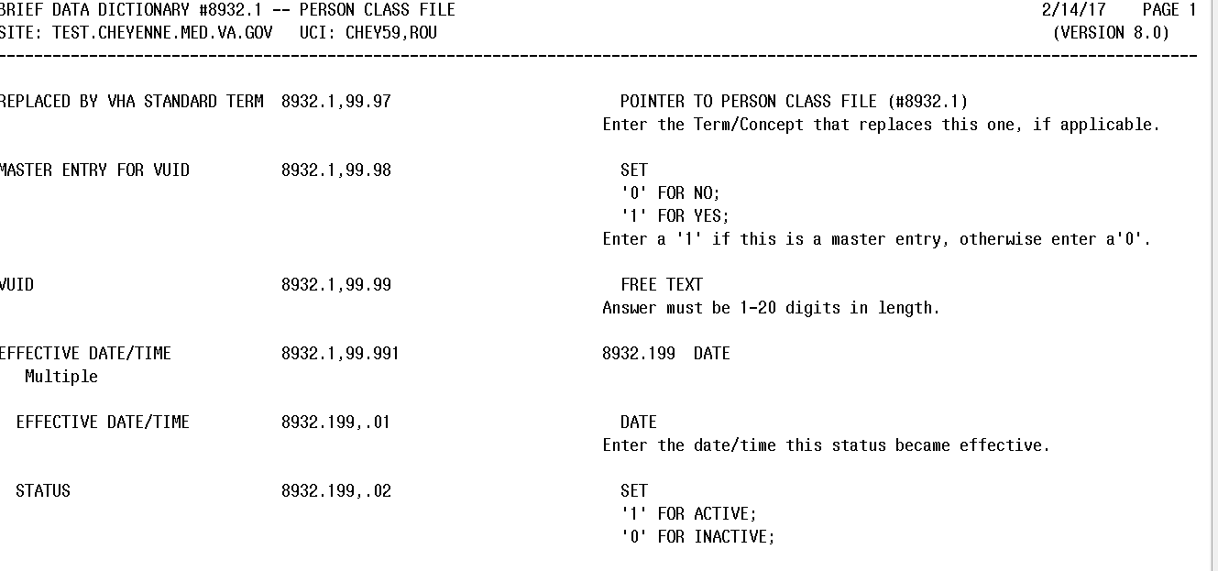

System Configuration
No System Configuration is required before or after deployment of CTT&DM NDS patch XU*8.0*671.

Database Tuning
No Database Tuning is required before or after deployment of CTT&DM NDS patch XU*8.0*671.

Back-Out Procedure
NOTE: Due to the complexity of this patch (because of the data dictionary changes), it is not recommended for back-out. However, in the event that a site decides to back-out of this patch, the site should contact the National Service Desk (NSD) to submit a CA SDM ticket; the development team will assist with the process.
Perform the back-out procedure to load the locally made patch created in Section 4. The back-out is to be performed by persons with programmer-level access, and in conjunction with the STS team.

Back-Out Strategy
The Back-out Strategy is to load the locally made patch that was created in Section 4.

Back-Out Considerations
The back-out should only be done in the event that the local facility management determines that the patch XU*8.0*671 is not appropriate for that facility, and should only be done as a last resort.

Load Testing
No load testing is required for patch XU*8.0*671.

User Acceptance Testing
N/A

Back-Out Criteria
Local Facility Management would need to determine patch XU*8.0*671 is not appropriate for their facility.

Back-Out Risks
By backing out XU*8.0*671, the local facility will not receive the STS data push from the respective Standards Development Organizations for the Providers domain.

Authority for Back-Out
The Local Facility Management has the authority to back-out patch XU*8.0*671.

Back-Out Procedure
NOTE: Due to the complexity of this patch (because of the data dictionary changes), it is not recommended for back-out. However, in the event that a site decides to back-out this patch, the site should contact the National Service Desk (NSD) to submit a CA SDM ticket; the development team will assist with the process.

Perform the back-out procedure to load and install the locally made patch created in Section 4.2, delete the new imported routines, and delete the new REPLACED BY VHA STANDARD TERM (#99.97) field, MASTER ENTRY FOR VUID (#99.98) field, and VUID (#99.99) field, and the EFFECTIVE DATE/TIME (#99.991) multiple field in the Providers PERSON CLASS (#8932.1) file.
The following is an example of the steps that would be executed for the fields being removed. The back-out is to be performed by persons with programmer privileges, and in conjunction with the STS Team. File Manager should be used to delete the new fields added with XU*8.0*671. This will automatically also remove all sub-fields and data.

Back-Out Procedure
The following will need to be executed from the programmers prompt (User input depicted below in bold italicized font):
Delete new routines using ROUTINE DELETE:
D ^%ZTRDEL

ROUTINE DELETE

All Routines? No => No

Routine: XU671PO
Routine: XUPC991
Routine: XUPCZRT
1 routine

3 routines to DELETE, OK: NO// Y
XU671PO
XUPC991
XUPCZRT
Done.

Delete new fields and data from PERSON CLASS (#8932.1) file:
D P^DI
Select OPTION: MODIFY FILE ATTRIBUTES
Do you want to use the screen-mode version? YES// NO
MODIFY WHAT FILE: // 8932.1 PERSON CLASS (#8932.1)
(2346 entries)
Select FIELD: REPLACED BY VHA STANDARD TERM
LABEL: REPLACED BY VHA STANDARD// @
SURE YOU WANT TO DELETE THE ENTIRE 'REPLACED BY VHA STANDARD TERM' FIELD? Y (Yes)
OK TO DELETE 'REPLACED BY VHA STANDARD TERM' FIELDS IN THE EXISTING ENTRIES? Yes// Y (Yes).....

Select FIELD: MASTER ENTRY FOR VUID
LABEL: MASTER ENTRY FOR VUID// @
SURE YOU WANT TO DELETE THE ENTIRE 'MASTER ENTRY FOR VUID' FIELD? Y (Yes)
OK TO DELETE 'MASTER ENTRY FOR VUID' FIELDS IN THE EXISTING ENTRIES? Yes// Y (Yes).....

Select FIELD: VUID
LABEL: VUID// @
SURE YOU WANT TO DELETE THE ENTIRE 'VUID' FIELD? Y (Yes)
OK TO DELETE 'VUID' FIELDS IN THE EXISTING ENTRIES? Yes// Y (Yes).....

Select FIELD: EFFECTIVE DATE/TIME (multiple)
LABEL: EFFECTIVE DATE/TIME// @
SURE YOU WANT TO DELETE THE ENTIRE 'EFFECTIVE DATE/TIME' FIELD? Y (Yes)
OK TO DELETE 'EFFECTIVE DATE/TIME' FIELDS IN THE EXISTING ENTRIES? Yes// Y (Yes).....

The steps for the load and installation of the locally made patch are very similar to the installation steps listed in section 4.8.
- Choose the PackMan message containing this patch.
- Choose the INSTALL/CHECK MESSAGE PackMan option.
- From Kernel Installation and Distribution System Menu, select the Installation Menu. From this menu, you may elect to use the following options. When prompted for the INSTALL NAME, enter the local patch from section 4.8, ZXU*8.0*671.
- From the Installation Menu, select the Install Package(s) option and choose the patch to install.
- When prompted 'Want KIDS to Rebuild Menu Trees Upon Completion of Install? NO//'
- When prompted 'Want KIDS to INHIBIT LOGONs during the install? NO//'
- When prompted 'Want to DISABLE Scheduled Options, Menu Options, and Protocols? NO//'
- If prompted 'Delay Install (Minutes): (0 - 60): 0//' respond 0.

Back-out Verification Procedure
    - ROUTINES
After backing out patch XU*8.0*671 by installing the local patch from section 4.8, routine back-out may be verified by running the Kernel checksum tool from the VistA server command line after installation:
D CHECK1^XTSUMBLD
The checksums produced by the checksum tool should match the numeric portion of the “Before:” checksums in the CTT&DM NDS patch XU*8.0*671 patch description.
For patch XU*8.0*671, since the routines are new, the “Before:” checksums from the patch description are “n/a”. If routine back-out was successful, the checksum tool will display the message “Routine not in this UCI” in place of a checksum.

Patch description “Before” checksums are “n/a”:
Routine Name: XU671PO
Before: n/a After: 2327306 **671**
Routine Name: XUPC991
Before: n/a After: 3017841 **671**
Routine Name: XUPCZRT
Before: n/a After: 37485068 **671**

After back-out, checksum tool displays “Routine not in this UCI”:
D CHECK1^XTSUMBLD

New CheckSum CHECK1^XTSUMBLD:

Select one of the following:

P Package
B Build

Build from: Build

This will check the routines from a BUILD file.
Select BUILD NAME: XU*8.0*671 KERNEL
XU671PO value = 2327306 Routine not in this UCI
XUPC991 value = 3017841 Routine not in this UCI
XUPCZRT value = 37485068 Routine not in this UCI
done

    - DATA DICTIONARIES
After backing out Patch XU*8.0*671, successful back-out of the fields installed by the patch may be verified by running a global listing from the VistA server command line after installation.

The fields in the PERSON CLASS file (#8932.1) deleted during back-out are:
The REPLACED BY VHA STANDARD TERM field (#99.97).
The MASTER ENTRY FOR VUID field (#99.98).
The VUID field (#99.99).
The EFFECTIVE DATE/TIME multiple field (#99.991)

A global listing should be performed for the following global nodes, after which nothing should be listed if back-out was successful:
Global ^DD(8932.1,99.97
Global ^DD(8932.1,99.98
Global ^DD(8932.1,99.99
Global ^DD(8932.1,99.991
Example, global listing of backed out globals:
D ^%G
Device:
Right Margin:
Screen size for paging (0=nopaging)? =>
Global ^DD(8932.1,99.97
<nothing should print>

Global ^DD(8932.1,99.98
<nothing should print>

Global ^DD(8932.1,99.99
<nothing should print>

Global ^DD(8932.1,99.991
<nothing should print>

Rollback Procedure
N/A

Rollback Considerations
N/A

Rollback Criteria
N/A

Rollback Risks
N/A

Authority for Rollback
N/A

Rollback Procedure
N/A

Rollback Verification Procedure
N/A

