VistA Data Extraction Framework (VDEF)

REDACTED

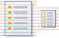
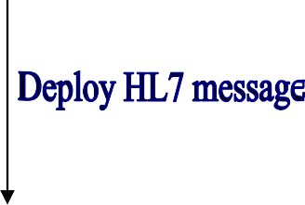
VDEF Overall Diagram

VDEF domain applications & Trigger request

- Domain applications:
  - Allergies
  - Outpatient Pharmacy
  - Vitals

Trigger
  - adds entry to VDEF Request Queue (FIFO)
  - then VDEF task processes the trigger event

VDEF Activities within Messaging

VistA Data Extraction Framework (VDEF)
  - Extract LIVE data from VistA database
  - Generate HL7 message (using HL7 v2.4 standard)
  - Hand off HL7 message to HL7 application

HL7 Engine (v1.6)
  - Deliver HL7 message to VIE

VistA Interface Engine (VIE)
  - Deliver HL7 message to Receiving Facility

- Receiving Facility - Health Data Repository system (HDR / HDR II)
  - Parse HL7 message and store data on target systems

VDEF’s Events & Message Types

Vitals Package: GEN. MED. REC. – VITALS ORU-R01-VTLS PATIENT VITALS

Allergy Package: ADVERSE REACTION TRACKING ORU-R01-ALGY ALLERGY UPDATE/INSERT ORU-R01-ADAS ALLERGY ASSESSMENT
ORU-R01-ADRA ADVERSE REACTION REPORT

Outpatient Pharmacy Package: OUTPATIENT PHARMACY RDE-O11-PRES OP PHARM PRESCRIPTION
RDS-O13-PPAR OP PHARM PRESCRIPTION PARTIAL
RDS-O13-PREF OP PHARM PRESCRIPTION REFILL

VDEF Export VistA data

Convert VistA data into HL7 Message

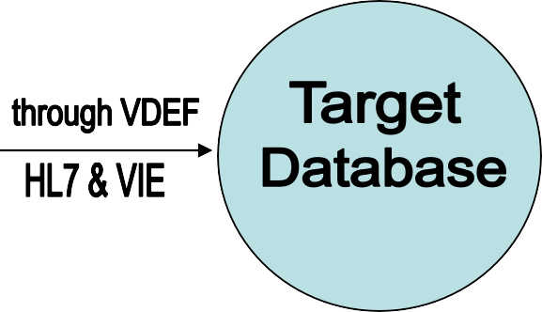

VistA database

VDEF Main Menu

Select Systems Manager Menu Option: VDEF VDEF Configuration and Status

Site Site-Wide Parameters Req Request Queue Parameters
ActR Activate/Inactivate Requestor
SusR Suspend/Run Request Queue
Cust VDEF Custodial Package Activate/Inactivate API VDEF Event API Activate/Inactivate
Stat Status of VDEF components Sch Request Processor Schedule

VDEF – Site-Wide Parameters

Site Site-Wide Parameters Req Request Queue Parameters
ActR Activate/Inactivate Requestor SusR Suspend/Run Request Queue
Cust VDEF Custodial Package Activate/Inactivate API VDEF Event API Activate/Inactivate
Stat Status of VDEF components Sch Request Processor Schedule

Select VDEF Configuration and Status Option: SITE Site-Wide Parameters

VDEF SYSTEM: TEST.REDACTED.MED.VA.GOV// VDEF MONITOR DELAY: 30S//

VDEF – Request Queue Parameters

Select VDEF Configuration and Status Option: Req Request Queue Parameters

Select Request Queue: ??
MAINTENANCE

Select Request Queue: MAINTENANCE ARCHIVAL PARAMETER: 30D 23H 59M 59S// CHECKED OUT TIME LIMIT: 10M//
REQUEST QUEUE WAKEUP PERIOD: 10S//

VDEF – Activate/Inactivate Requestor

Select VDEF Configuration and Status Option: ActR Activate/Inactivate Requestor

Select Requestor: MAINTENANCE

Inactivating a requestor has a significant effect on the synchronization of VistA and remote system(s). All VDEF requests made while the requestor is inactive will be PERMANENTLY lost. Make sure you really want to turn it off.

REQUESTOR ACTIVATION FLAG: ACTIVE//

VDEF – Suspend/Run Request Queue

Site Site-Wide Parameters
Req Request Queue Parameters
ActR Activate/Inactivate Requestor SusR Suspend/Run Request Queue
Cust VDEF Custodial Package Activate/Inactivate API VDEF Event API Activate/Inactivate
Stat Status of VDEF components Sch Request Processor Schedule

Select VDEF Configuration and Status Option: SusR Suspend/Run Request Queue

Select Request Queue: MAINTENANCE SUSPENDED FLAG: RUNNING//

VDEF – VDEF Custodial Package Activate/Inactivate

Select VDEF Configuration and Status Option: Cust VDEF Custodial Package Activate/Inactivate

Select Custodial Package: ??

Choose from:
OUTPATIENT PHARMACY GEN. MED. REC. - VITALS
ADVERSE REACTION TRACKING

Select Custodial Package: OUTPATIENT PHARMACY PSO

Inactivating a custodial package has a significant effect on the synchronization of VistA and remote system(s). All VDEF requests for HL7 messages associated with this custodial package made while the package is inactivated will be PERMANENTLY lost. Make sure you really want to turn this custodial package off.

ACTIVATION STATUS: ACTIVE// ?
Sending messages for this package is "A"ctive or "I"nactive Choose from:
A ACTIVE
I INACTIVE ACTIVATION STATUS: ACTIVE//

VDEF – VDEF Event API Activate/Inactivate

Select VDEF Configuration and Status Option: API VDEF Event API Activate/Inactivate

Select VDEF API Event: ??

Choose from:
- ORU-R01-VTLS PATIENT VITALS Status: ACTIVE Pkg: GEN. MED. REC. - VITALS HL7 Engine: HL7 1.6
- ORU-R01-ALGY ALLERGY UPDATE/INSERT Status: ACTIVE Pkg: ADVERSE REACTION TRACKING HL7 Engine: HL7 1.6
- ORU-R01-ADAS ALLERGY ASSESSMENT Status: ACTIVE Pkg: ADVERSE REACTION TRACKING HL7 Engine: HL7 1.6
- ORU-R01-ADRA ADVERSE REACTION REPORT Status: ACTIVE Pkg: ADVERSE REACTION TRACKING HL7 Engine: HL7 1.6
- RDE-O11-PRES OP PHARM PRESCRIPTION Status: ACTIVE Pkg: OUTPATIENT PHARMACY HL7 Engine: HL7 1.6
- RDS-O13-PPAR OP PHARM PRESCRIPTION PARTIAL Status: ACTIVE Pkg: OUTPATIENT PHARMACY HL7 Engine: HL7 1.6
- RDS-O13-PREF OP PHARM PRESCRIPTION REFILL Status: ACTIVE Pkg: OUTPATIENT PHARMACY HL7 Engine: HL7 1.6

Select VDEF API Event: 5 OP PHARM PRESCRIPTION Status: ACTIVE Pkg: OUTPATIENT PHARMACY HL7 Engine: HL7 1.6

Inactivating a VDEF API event will cause all requests for that API to be PERMANENTLY lost. Make sure you really want to turn this API event off.

API EVENT ACTIVE FLAG: ACTIVE//

VDEF – Status of VDEF Components

Select VDEF Configuration and Status Option: Stat Status of VDEF components

VDEF Status - JUN 03, 2009@19:26:52
Logical Link Status
VDEFVIE1: stopped or caught up VDEFVIE2: stopped or caught up VDEFVIE3: stopped or caught up

Requestor Status
MAINTENANCE: Activated Dest.: VISTA HL7 Req. Queue: MAINTENANCE

Request Processor Status MAINTENANCE: Running
Current Task # [Proc]: 1440227 [20C008F5] Task status: Active-Running Requests waiting for purge: 1271405 last request#: 2934699 Checked Out(98) Queued Up(>1000) Errored Out(0)

VDEF – Request Processor Schedule

Site Site-Wide Parameters
Req Request Queue Parameters ActR Activate/Inactivate Requestor SusR Suspend/Run Request Queue
Cust VDEF Custodial Package Activate/Inactivate API VDEF Event API Activate/Inactivate
Stat Status of VDEF components Sch Request Processor Schedule

Select VDEF Configuration and Status Option: Sch Request Processor Schedule

Select Request Queue: MAINTENANCE
No Scheduling Rules currently defined for this queue
Select Entry:

HL7 – System Link Monitor
SYSTEM LINK MONITOR for REDACTED VAMC (T System)

NODE | MESSAGES  RECEIVED | MESSAGES  PROCESSED | MESSAGES  TO SEND | MESSAGES  SENT | DEVICE  TYPE | STATE
VDEFVIE1 | 10 | 10 | 10 | 10 | NC | Enabled
VDEFVIE2 | 437 | 437 | 764 | 437 | NC | Enabled
VDEFVIE3 | 620 | 620 | 620 | 620 | NC | Enabled

Incoming filers running => 1 TaskMan running Outgoing filers running => 1 Link Manager running
Monitor current [next job 0.1 hr]
Select a Command:
(N)EXT (B)ACKUP (A)LL LINKS (S)CREENED (V)IEWS (Q)UIT (?) HELP:

VDEF – File 579.3 VDEF Request Queue

VDEF Request Queue before HL7 message is generated:
^VDEFHL7(579.3,1,1,3307,0)=3307^Q^RDE^O11^^1^1^3080827.173717^^^^^^^^^^5
^VDEFHL7(579.3,1,1,3307,.05,0)=^579.311^2^2
^VDEFHL7(579.3,1,1,3307,.05,1,0)=1^SUBTYPE=PRES
^VDEFHL7(579.3,1,1,3307,.05,2,0)=2^IEN=1614645
^VDEFHL7(579.3,1,1,3307,1,"B",1,1)=
^VDEFHL7(579.3,1,1,3307,1,"B",2,2)=

VDEF Request Queue after HL7 message is generated:
^VDEFHL7(579.3,1,1,3307,0)=3307^P^RDE^O11^^1^1^3080827.173717^3080827.17392^3080 827.17392^^44233620030^3080827.17392^^^^^5
^VDEFHL7(579.3,1,1,3307,.05,0)=^579.311^2^2
^VDEFHL7(579.3,1,1,3307,.05,1,0)=1^SUBTYPE=PRES
^VDEFHL7(579.3,1,1,3307,.05,2,0)=2^IEN=1614645
^VDEFHL7(579.3,1,1,3307,1,"B",1,1)=
^VDEFHL7(579.3,1,1,3307,1,"B",2,2)=

VDEF – HL7 Message Header File (File-773)

File-773 : HL7 Message Administration

^HLMA(33620030,0)=35387771^44233620030^O^D^^33620030^210^6776^^^
133^132^1^^^^210
^HLMA(33620030,"MSH",0)=^773.01^1^1
^HLMA(33620030,"MSH",1,0)=MSH^~|\&^HDRPRES^442~TEST.REDACTED. MED.VA.GOV~DNS^PSO VDEF IE SIDE^200HD~HDR.MED.VA.GOV~DNS^20080827173920- 0500^^RDE~O11^44233620030^T^2.4^^^AL^NE^USA
^HLMA(33620030,"P")=1

VDEF – HL7 Message Header File (File-773)

HL7 MESSAGE ADMINISTRATION:

NUMBER: 33620030 DATE/TIME ENTERED: AUG 27, 2008@17:39:20 MESSAGE ID: 44233620030 TRANSMISSION TYPE: OUTGOING
PRIORITY: DEFERRED INITIAL MESSAGE: AUG 27, 2008@17:39:20 LOGICAL LINK: VDEFVIE3
SUBSCRIBER PROTOCOL: PSO VDEF RDE O11 OP PHARM PRES HR
SENDING APPLICATION: HDRPRES RECEIVING APPLICATION: PSO VDEF IE SIDE MESSAGE TYPE: ACK LOGICAL LINK - IN QUEUE: VDEFVIE3
MSH:
MSH^~|\&^HDRPRES^442~TEST.REDACTED.MED.VA.GOV~DNS^PSO VDEF IE SIDE^200HD~HDR.MED.VA.GOV~DNS^20080827173920-0500^^RDE~O11^44233620030^T^2.4^^^AL^NE^USA|
STATUS: PENDING TRANSMISSION MESSAGE SIZE (c): 1705

VDEF – HL7 Message Text

File-772 : HL7 Message Text
^HL(772,35387771,0)=3080827.17392^133^^O^^44235387771^^35387771^D^6777^^^^M
^HL(772,35387771,"IN",0)=^^15^15^3080827^
^HL(772,35387771,"IN",1,0)=PID^1^6661234567V666123^6661234567V666123~~~USVHA&&0363~NI~VA FACILITY ID&200M&L|666123456~~~USSSA&&0363~SS~VA FACILITY ID&442&L|666123~~~USVHA&&0363~PI~VA FACILITY ID&442&L|66612345~~~USVBA&&0363~PN~VA FACILITY ID&442&L^^OPPATIENT~ONE~~~~~L^OPMOTHER
^HL(772,35387771,"IN",2,0)=~~~~~~M^19500509^M^^1111-3-SLF~~2222~1111-3~~CDC^666 ADDRESS
~""~CITY~ST~66666~""~P~""~021|~~CITY~ST~~~N^021^(777)777-7777~PRN~PH|(111)111-1111~ORN~CP^""^^W^29^^666123456^^^3333-3-
SLF~~4444~5555-5~~CDC^AAAABBBB MA^^^^^^""^^
^HL(772,35387771,"IN",3,0)=
^HL(772,35387771,"IN",4,0)=ORC^RE^3389378~442_52_39.3^1614645~442_52_.001^^CM^^~~~20070305~20070404
~~FILL/EXPIRATION|~~~~20070305~~ISSUED|~~~20070305~20070305~~DISPENSED/LAST DISPENSED^^20070305165017-
0500^2229~OPENTER~ONE~~~~~VistA200^^2453~OPORDER~ONE~D~~~MD~RE^^^
^HL(772,35387771,"IN",5,0)=^^442~REDACTED VAM\T\ROC~442_52_20~5203651~REDACTED VAM\T\ROC~NCPDP^^^^REDACTED VAMC^^^^4500659~ACTIVE~99VA_52_100
^HL(772,35387771,"IN",6,0)=
^HL(772,35387771,"IN",7,0)=RXE^&ONE TABLET~~~20070305~20070404~~FILL/EXPIRATION^4003067~OXYCODONE HCL 5MG /ACETAMINOPHEN 325MG TAB~99VA_52_6~00406-0512-01~~NDC^0^^0~~442_52_6^63~TAB~442_50.7_.02^ ~TAKE~442_52.0113_8|~TID~442_52.0113_7|~F CHRONIC PAIN~442_52_114|~FOR CHRONIC
^HL(772,35387771,"IN",8,0)=PAIN~442_52_115^~~~~~WINDOW^^21^^0^^666111111~OPPARM~ONE~M~~~~PHARMACIST^856897 ^^^20070305165648- 0500^^^TAKE ONE TABLET BY MOUTH THREE TIMES A DAY FOR CHRONIC PAIN~~442_52_10.2 ^D7^^^^^^^^^344~OXYCODONE 5MG \T\ ACETAMINOPHEN 325MG TAB~442_50_.01
^HL(772,35387771,"IN",9,0)=
^HL(772,35387771,"IN",10,0)=RXR^1~ORAL (BY MOUTH)~442_52.0113_6
^HL(772,35387771,"IN",11,0)=
^HL(772,35387771,"IN",12,0)=FT1^1^^^20070305^^CG^893~OXYCODONE/ACETAMINOPHEN~442_52_39.2^^^^^0.0338^^^^^^OPT SC^^6666~OPPROVIDER~ONE~~~~~442_52_38
^HL(772,35387771,"IN",13,0)=
^HL(772,35387771,"IN",14,0)=OBX^1^CE^WAS THE PATIENT COUNSELED^^4500630~NO~99VA_52_41^^^^^^F
^HL(772,35387771,"IN",15,0)=
^HL(772,35387771,"P")=3^3080827.17392
"S")=1548^1

VDEF – HL7 Message Text

HL7 MESSAGE TEXT
NUMBER: 35387771 DATE/TIME ENTERED: AUG 27, 2008@17:39:20 SERVER APPLICATION: HDRPRES TRANSMISSION TYPE: OUTGOING
MESSAGE ID: 44235387771 PARENT MESSAGE: AUG 27, 2008@17:39:20 PRIORITY: DEFERRED
RELATED EVENT PROTOCOL: PSO VDEF RDE O11 OP PHARM PRES VS MESSAGE TYPE: SINGLE MESSAGE
MESSAGE TEXT:
PID^1^6661234567V666123^6661234567V666123~~~USVHA&&0363~NI~VA FACILITY ID&200M&L|666123456~~~USSSA&&0363~SS~VA FACILITY ID&442&L|666123~~~USVHA&&0363~PI~VA FACILITY ID&442&L|66612345~~~USVBA&&0363~PN~VA FACILITY ID&442&L^^OPPATIENT~ONE~~~~~L^OPMOTHER
~~~~~~M^19500509^M^^1111-3-SLF~~2222~1111-3~~CDC^666 ADDRESS ~""~CITY~ST~66666~""~P~""~021|~~CITY~ST~~~N^021^(777)777- 7777~PRN~PH|(111)111-1111~ORN~CP^""^^W^29^^666123456^^^3333-3-SLF~~4444~5555-5~~CDC^AAAABBBB MA^^^^^^""^^
ORC^RE^3389378~442_52_39.3^1614645~442_52_.001^^CM^^~~~20070305~20070404~~FILL/EXPIRATION|~~~~20070305~~ISSUED|~~~20070305~20070 305~~DISPENSED/LAST DISPENSED^^20070305165017-
0500^2229~OPENTER~ONE~~~~~VistA200^^2453~OPORDER~ONE~D~~~MD~RE^^^^^442~REDACTED VAM\T\ROC~442_52_20~5203651~REDACTED VAM\T\ROC~NCPDP^^^^REDACTED VAMC^^^^4500659~ACTIVE~99VA_52_100
RXE^&ONE TABLET~~~20070305~20070404~~FILL/EXPIRATION^4003067~OXYCODONE HCL 5MG /ACETAMINOPHEN 325MG TAB~99VA_52_6~00406-0512- 01~~NDC^0^^0~~442_52_6^63~TAB~442_50.7_.02^ ~TAKE~442_52.0113_8|~TID~442_52.0113_7|~F CHRONIC PAIN~442_52_114|~FOR CHRONIC
PAIN~442_52_115^~~~~~WINDOW^^21^^0^^666111111~OPPARM~ONE~M~~~~PHARMACIST^856897 ^^^20070305165648-0500^^^TAKE ONE TABLET BY MOUTH THREE TIMES A DAY FOR CHRONIC PAIN~~442_52_10.2 ^D7^^^^^^^^^344~OXYCODONE 5MG \T\ ACETAMINOPHEN 325MG TAB~442_50_.01
RXR^1~ORAL (BY MOUTH)~442_52.0113_6
FT1^1^^^20070305^^CG^893~OXYCODONE/ACETAMINOPHEN~442_52_39.2^^^^^0.0338^^^^^^OPT SC^^6666~OPPROVIDER~ONE~~~~~442_52_38 OBX^1^CE^WAS THE PATIENT COUNSELED^^4500630~NO~99VA_52_41^^^^^^F

STATUS: SUCCESSFULLY COMPLETED
DATE/TIME PROCESSED: AUG 27, 2008@17:39:20
NO. OF CHARACTERS IN MESSAGE: 1548 NO. OF EVENTS IN MESSAGE: 1

VDEF – Messaging Work Bench

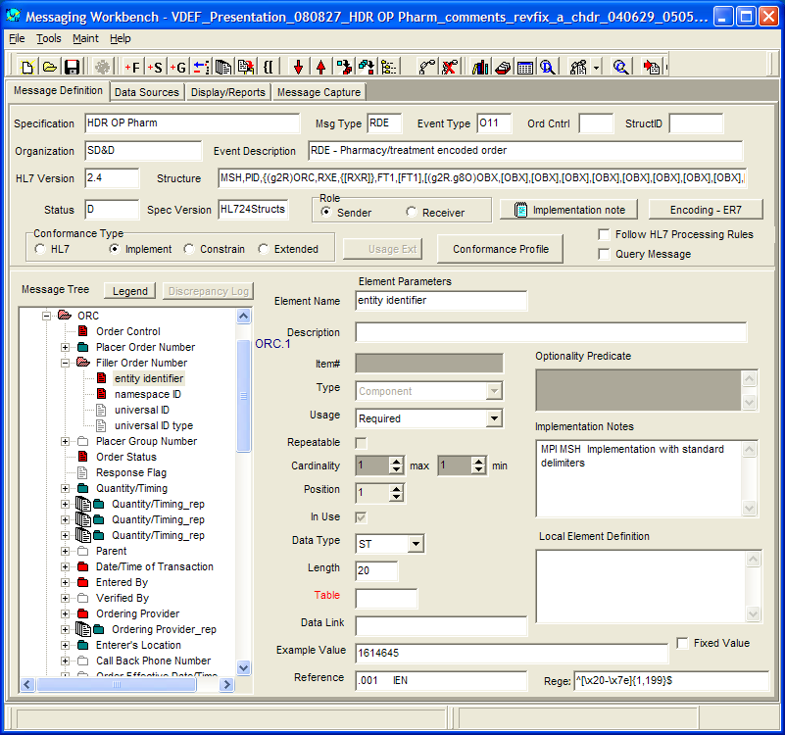

VDEF – Error Messages

Error Message in VDEF File-579.3:
^VDEFHL7(579.3,1,1,2190679,0)=2190679^E^ORU^R01^^1^1^3080605.114245^3080610.114852^^^^^^^^^1
^VDEFHL7(579.3,1,1,2190679,.05,0)=^579.311^2^2
^VDEFHL7(579.3,1,1,2190679,.05,1,0)=1^SUBTYPE=VTLS
^VDEFHL7(579.3,1,1,2190679,.05,2,0)=2^IEN=10515224
^VDEFHL7(579.3,1,1,2190679,1,"B",1,1)=
^VDEFHL7(579.3,1,1,2190679,1,"B",2,2)=
^VDEFHL7(579.3,1,1,2190679,"ERRMSG")=Invalid data in file GMR(120.5) for IEN 10515224

Examples of VDEF Alerts in FORUM:
- RECORD <IEN> IN QUEUE <QUEUE NAME> HUNG IN CHECKED OUT STATUS.
Reason: IEN in VDEF REQUEST QUEUE has been in the Checked Out status longer than the allowed time period.

- VDEF HAS REQUEUED CHECKED OUT RECORDS. NO ACTION NEEDED.
Reason: VDEF queue process has re-queued one or more requests that were hung in the Checked Out status

- VDEF HAS REQUEUED ERRORED OUT RECORDS. NO ACTION NEEDED.
Reason: VDEF queue process has re-queued one or more requests that were in the Error Out status

VDEF - Advantages

Standardize HL7 Messages
- Reuse code and API calls

Reuse Message Segments and Fields
- Simplify regeneration of HL7 message if needed

Verify data before HL7 message is generated
- Generate HL7 message from LIVE data that will not duplicate or overwrite previous HL7 message

Monitor HL7 message generation process
- Document individual HL7 field in Messaging Work Bench

Provide VDEF Alerts
- And much more . . .

VDEF – Job Requirement :
Decode VistA data into HL7 message

VDEF Application

Questions ??

