Patient Advocate
Tracking System

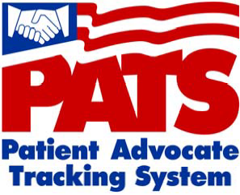

The Patient Advocate Tracking System (PATS) will soon replace the legacy Patient Representative System (Patient Rep).

In Patient Rep, you received alerts to respond to a patient complaint or view a compliment.

In the PATS application, you will receive an Outlook email with a link to view patient information.

There are two types of notifications.
Informational Notifications are FYI; no response is required on your part.
Action Request Notifications require a response from you within a specified period of time.

I received an email Notification. What do I do?

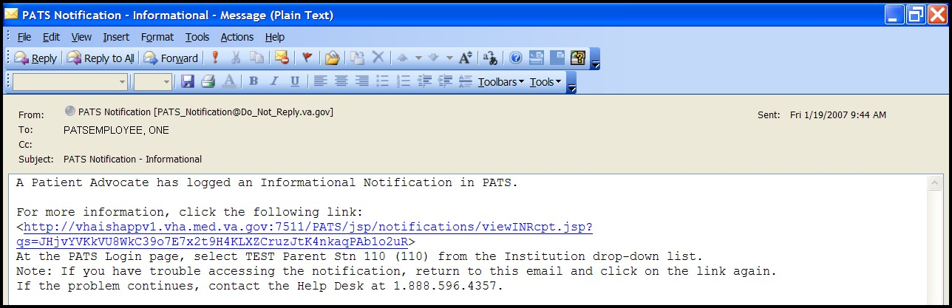This is an example of an email sent to the recipient of an Informational Notification.

The recipient should make a note of the Institution mentioned in the email (Test Parent Stn 110) and then click on the link.

When you click on the email link, the PATS Logon page displays.

- 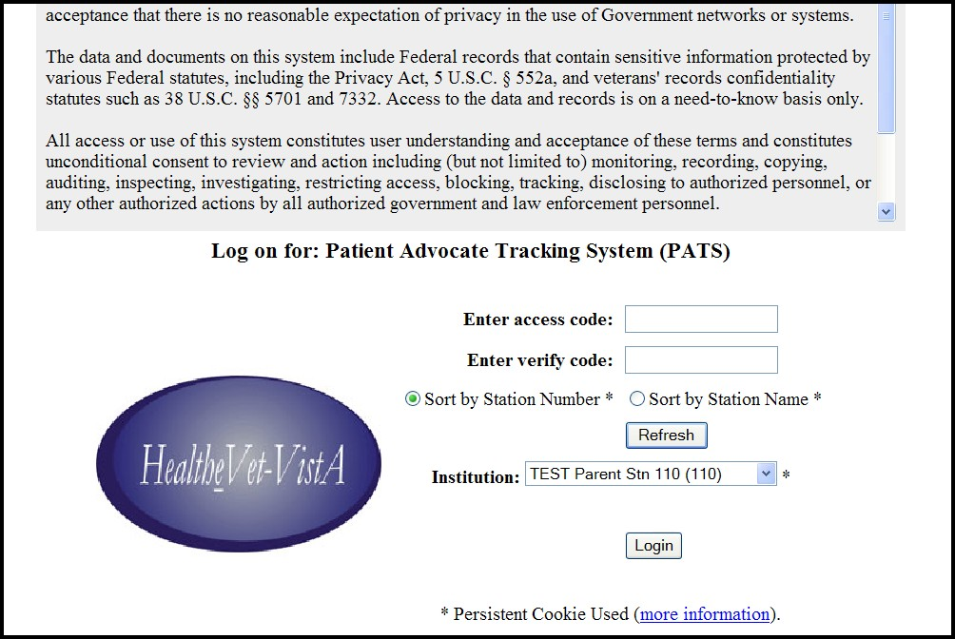Enter VistA Access and Verify codes

- Click the Login button

Select the Institution listed in the email from the drop-down list.
- Enter your VistA Access and Verify codes.

Press the Login button.

After you log on, the View Informational Notification page displays.
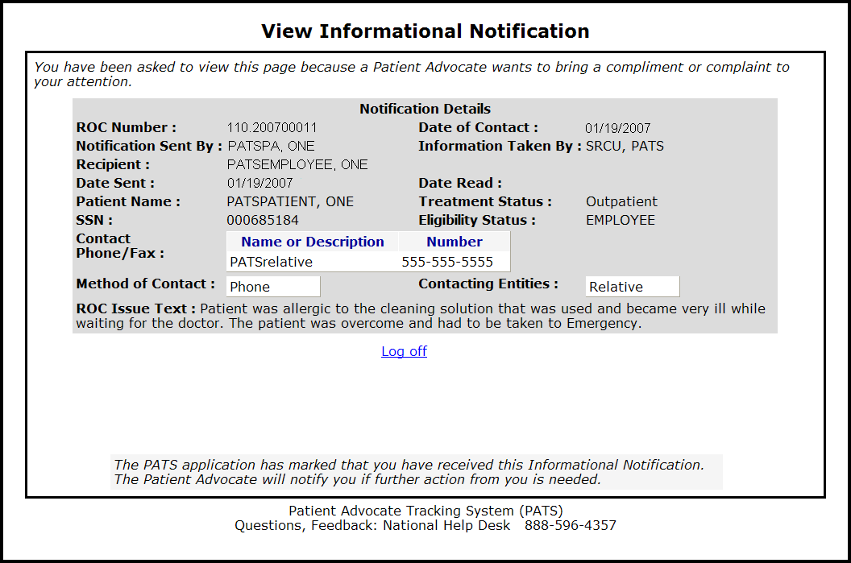

Review the information and then press the Log off link to finish.

Next, we’ll view an Action Request Notification.

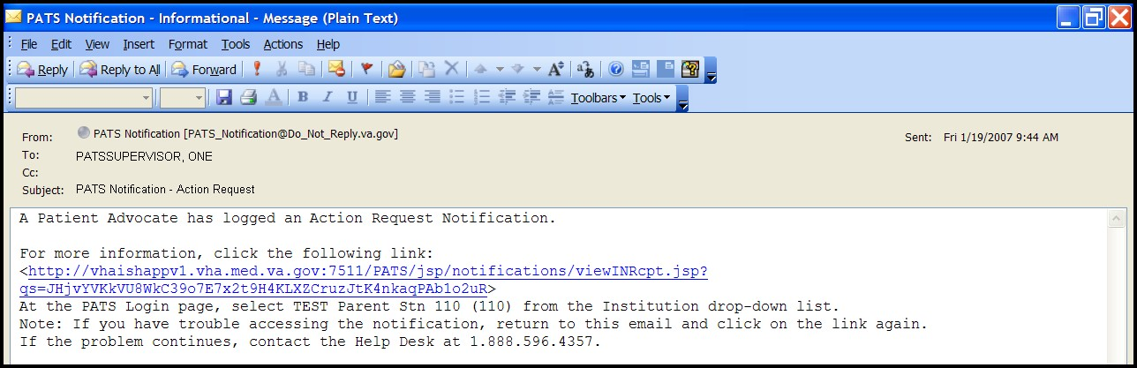This is an example of an email sent to the recipient of an Action Request Notification.

The recipient should make a note of the Institution mentioned in the email (Test Parent Stn 110) and then click on the link.

When you click on the email link, the PATS Logon page displays.

  - Enter VistA Access and Verify codes

  - Click the Login button

Select the Institution listed in the email from the drop-down list.
- Enter your VistA Access and Verify codes.

Press the Login button.

Here is an example of a View Action Request Notification page.
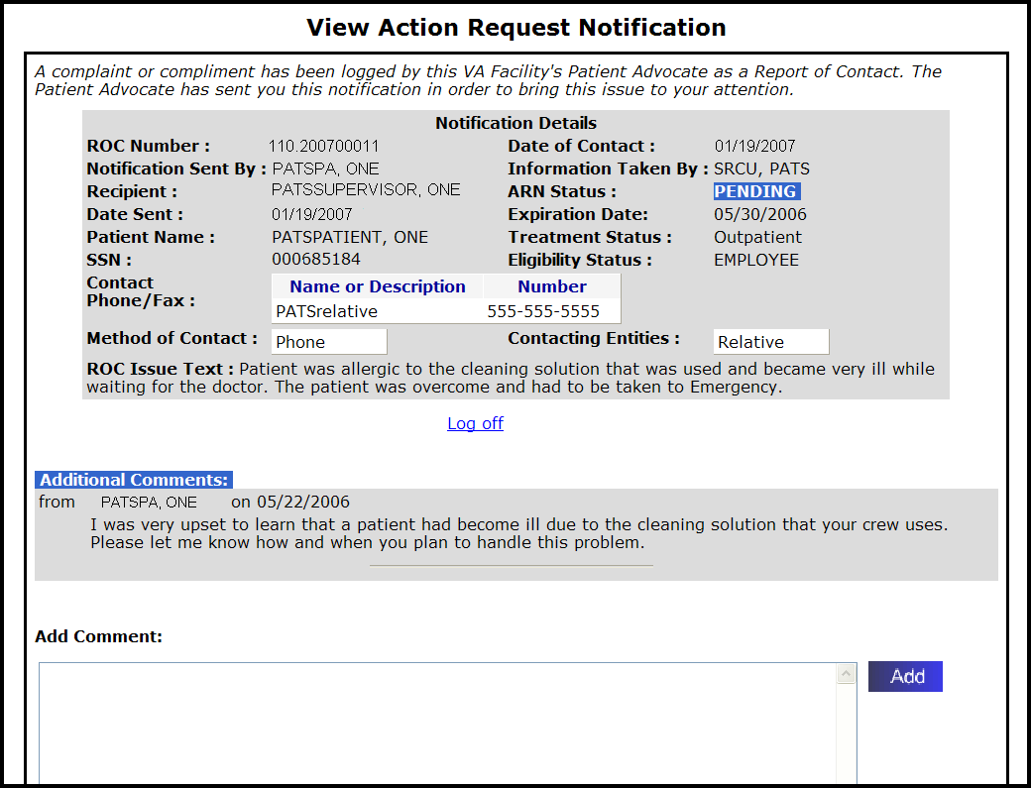
The Patient’s concern is detailed in ROC Issue Text section. Patient Advocate comments are in the Additional Comments section.

Review the information and enter a response in the Add Comment section. Press the Add button and then the Log off link to finish.

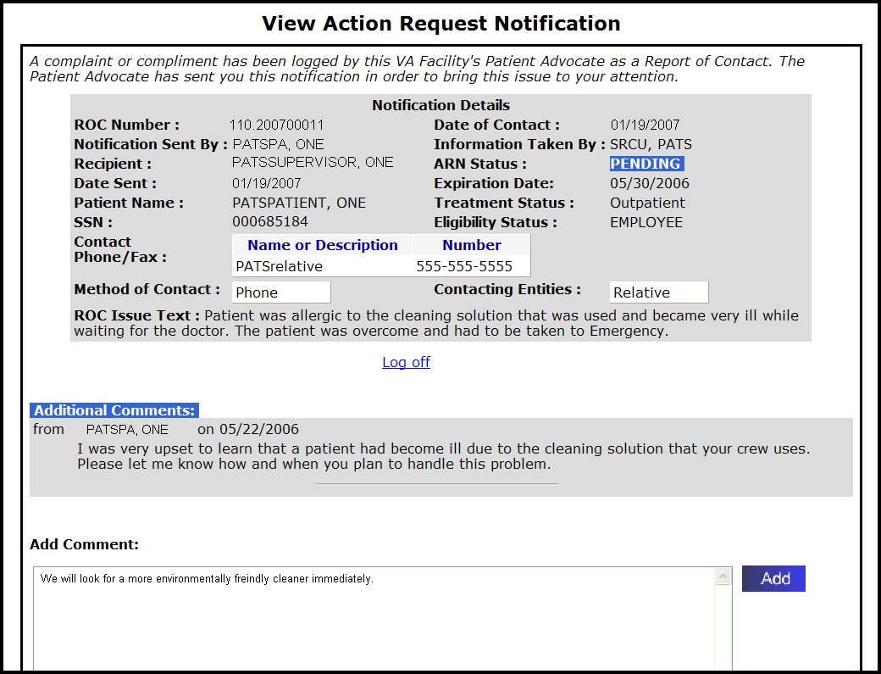3

1

2

The advocate is notified by email that a response has been made to the Action Request Notification.

Timeliness is Important!

VHA Handbook 1003.4

- Patients Must Have Their Complaints Addressed in a Timely Manner

  - There must be sufficient staffing devoted to the Patient Advocacy Program to ensure timely resolution of complaints, identification and resolution of system issues, and tracking, trending and reporting to appropriate areas. Response to complaints occurs as soon as possible, but no longer than 7 days after the complaint is made. Should the complaint require more than 7 days, staff are responsible for continuously updating the patient on the status of the complaint and/or resolution. NOTE: Privacy complaints are to be processed in accordance with VHA Handbook 1605.1, Privacy and Release of Information.

