Enrollment System Modernization (ESM) Phase 3

Veterans Health Administration (VHA) Enrollment System (VES) 6.0

Release Notes
February 2022
Department of Veterans Affairs (VA)
Office of Information and Technology (OIT)

Table of Contents
1 Introduction 1
2 Purpose 2
3 Audience 2
4 This Release 2
4.1 Enhancements and Modifications 2
4.2 Defects and Fixes 8
4.3 Known Issues 9
5 Product Documentation 9

List of Tables
Table 1: VES 6.0 ESM Enhancements and Modifications 2
Table 2: VES 6.0 EHRM Enhancements and Modifications 4
Table 3: ES 6.0 CP&E Enhancements and Modifications 8
Table 4: Sustainment Defects and Fixes in VES 6.0 8
List of Figures
Figure 1: Self-Reported Registration Only Reason Dropdown 3
Figure 2: Demographics Tab - New Subtab Order 3
Figure 3: Enrollment Tab - Application Fields 4
Figure 4: Enrollment Tab History View - Application Fields 4
Figure 5: Add Associate – Relationship Fields 6
Figure 6: Update Associate – Relationship Fields 6
Figure 7: Associate Change History Screen 7

Introduction
The mission of the VA OIT Enterprise Program Management Office is to provide benefits to Veterans and their families. To meet this overarching goal, OIT is charged with providing high quality, effective and efficient IT services and Operations and Maintenance (O&M) to persons and organizations that provide point-of-care services to our Veterans.
The VA’s goals for its Veterans and families include:
- Make it easier for Veterans and their families to receive the right benefits and meet their expectations for quality, timeliness and responsiveness.
- Improve the quality and accessibility of health care, benefits and memorial services while optimizing value.
- Provide world-class health care delivery by partnering with each Veteran to create a personalized, proactive strategy to optimize health and well-being, while providing state-of-the-art disease management.
- Ensure awareness and understanding of the personalized, proactive and patient-driven health care model through education and monitoring.
- Provide convenient access to information regarding VA health benefits, medical records, health information, expert advice and ongoing support needed to make informed health decisions and successfully implement the Veteran’s personal health plans.
- Receive timely, high quality, personalized, safe, effective and equitable health care, not dependent upon geography, gender, age, culture, race, or sexual orientation.
- Strengthen collaborations with communities and organizations, such as the Department of Defense (DoD), Department of Health and Human Services (DHHS), academic affiliates and other service organizations.
To assist in meeting these goals, the Eligibility and Enrollment program provides enterprise-wide enhancements and sustainment for the following systems/applications:
- The VHA Enrollment System (VES) is the authoritative system for VA enrollment and Community Care static eligibility determinations.
- Income Verification Match/Enrollment Database assists in determining priority grouping for health care eligibility.
- Veterans Information Systems and Technology Architecture (VistA) Registration, Eligibility & Enrollment shares information with other VistA applications and enables registration and preliminary eligibility determinations and enrollment at VA Medical Centers (VAMC). VES makes the final eligibility determinations.
- The Veteran’s On-Line Application (VOA), now referred to as Health Care Application (HCA), enables Veterans to self-enroll in VA health care and is another entry point for records to be added to VES.
ESM defines VHA Profiles (VHAP) for which a client (Veteran, service member, or beneficiary) is eligible and ties them to the authority for care. Key enhancements to be completed include pending eligibility determination, fixes to VES, date of death, internal controls, workflow, Veterans Financial Assessment, converting of Military Service Data Sharing (MSDS) to Enterprise Military Information Service, Manage Relationships, Veteran Contact Service and support for Enrollment System Community Care (ESCC).

Purpose
The purpose of this Release Notes document is to announce the release of the VES 6.0. This release, developed in Java technology, contains ESM Phase 3 development and upgrade efforts. This release includes enhancements and defect fixes to support Electronic Health Record Modernization (EHRM), Claims Processing & Eligibility (CP&E), ESCC and VES Sustainment.

Audience
This document targets users and administrators of VES 6.0 and applies to the changes made between this release and any previous release for this software.

This Release
VES will be upgraded from Version 5.19.2 to Version 6.0 and hosted by Amazon Web Services.
The following sections provide a summary of the enhancements and updates to the existing software and any known issues for VES 6.0.

Enhancements and Modifications
Table 1 shows the ESM enhancements and modifications included in the VES 6.0 release as tracked in Atlassian Jira.
Table 1: VES 6.0 ESM Enhancements and Modifications
Jira Epic # | Summary
VES-12280 | Demographics Integration with VA Profile (VES)
VES-17482 | Add Self-Reported Registration Only Reasons - Clinical Evaluation and Immunizations (VES)
VES-18028 | View the Application Signature Date and Method after Add A Person (AAP)
VES-18029 | Change Subtab Order Under Demographics
With version 6.0, VES is updated to support demographic data integration with VA Profile (VA Profile is to become the authoritative source for demographic data).
- VES will send updates to VA Profile when demographic data for Ethnicity, Race, Religion or Marital Status is added, updated or deleted in VES.
- Demographics messages sent to VA Profile are viewable on the VA Profile Messages screen.
- VES now allows editing of the Benefit Applied For, Race, Ethnicity and Religion fields on the Identity Traits and Personal tabs on the Demographics screen. (Those fields were previously editable only when in Add A Person and became view-only after registration was completed.)
- VES shares demographic information with VistA via Health Level 7 (HL7) messaging; VES populates the Race and Ethnicity fields with DECLINED TO ANSWER when the value exists in VES and is set to null or deleted in VistA.
VES is updated to add four new Self-Reported Registration Only (SRRO) Reasons: 4th Mission, Clinical Evaluation, HUD-VASH and Immunizations.
- The new SRRO reasons are shared with VistA via HL7 messaging.
- The new SRRO reasons are described in the Help Text and are displayed in the dropdown in VES.
NOTE: The Veteran Indicator must be "Yes" to select "Clinical Evaluation" as the Self-Reported Registration Only Reason.
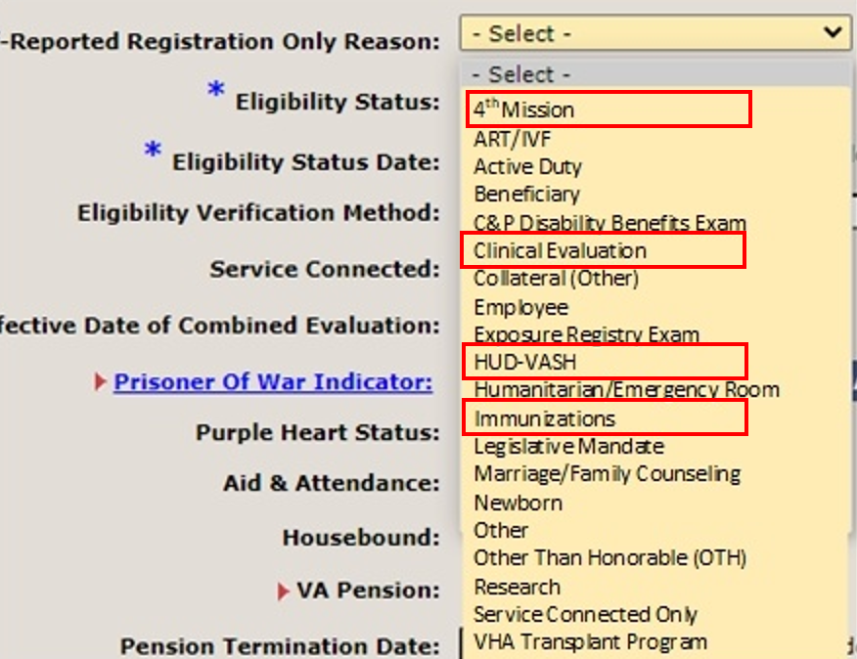
Figure 1: Self-Reported Registration Only Reason Dropdown
The following minor user interface updates are included with VES 6.0:
- The subtab order under the Demographics tab is changed so that the Addresses subtab comes before the Associates subtab.
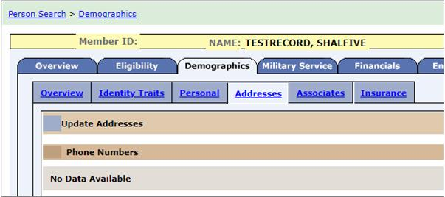
Figure 2: Demographics Tab - New Subtab Order

- After AAP, "Application Signature Date" and "Application Method" are displayed, in editable mode, on the Enrollment tab.
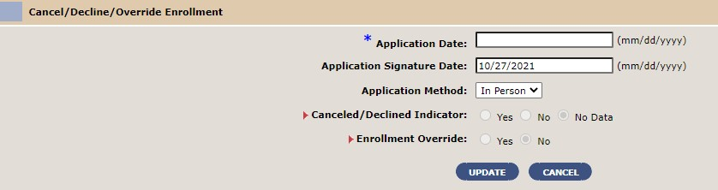
Figure 3: Enrollment Tab - Application Fields
- After AAP, under the Enrollment tab’s History view, the fields “Application Signature Date” and “Application Method” are displayed between the “Application Date” and “Enrollment Status” fields.
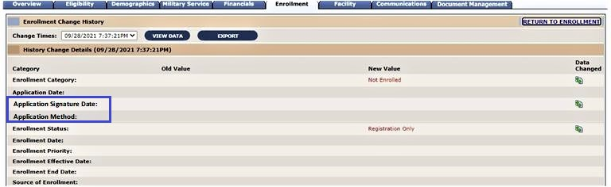
Figure 4: Enrollment Tab History View - Application Fields
Table 2 shows the EHRM enhancements and modifications included in the VES 6.0 release as tracked in Atlassian Jira.
Table 2: VES 6.0 EHRM Enhancements and Modifications
Jira Epic # | Summary
VES-2441 | NOK/EC Relationship Dropdown - VES
VES-8329 | Rename ADTSA VHAP (VES)
VES is enhanced to provide a defined list of values for the user to choose from (instead of a free-text field) when adding or updating the relationship for one of the Next of Kin (NOK), Emergency Contact (EC) or Designee roles. This will ensure the relationships in VES and VistA match standardized values that the DoD's Defense Manpower Data Center (DMDC) supports and shares across the VA and DoD.

- The database is modified to include a new standardized field to capture relationship information; the new field is displayed to users as “Relation Type” and limits the types of relationships for NOK, EC, and Designee to the following list of acceptable values:
  - BROTHER
  - CHILD-IN-LAW
  - DAUGHTER
  - EXTENDED FAMILY MEMBER
  - FATHER
  - GRANDCHILD
  - HUSBAND
  - MOTHER
  - NIECE/NEPHEW
  - SISTER
  - SON
  - STEPCHILD
  - UNRELATED FRIEND
  - WARD
  - WIFE
- The Demographics > Associates > Add Associate and Demographics > Associates > Update Associates screens are modified to support the standardized types of relationships. VES displays UNRELATED FRIEND as "UNRELATED FRIEND/OTHER" on the drop-down list.

  - When a user adds a new person and includes NOK, EC or Designee during registration, the system auto-populates the existing Relationship fields on the Demographics > Associates > Add Associates screen and allows the user to update them before saving.
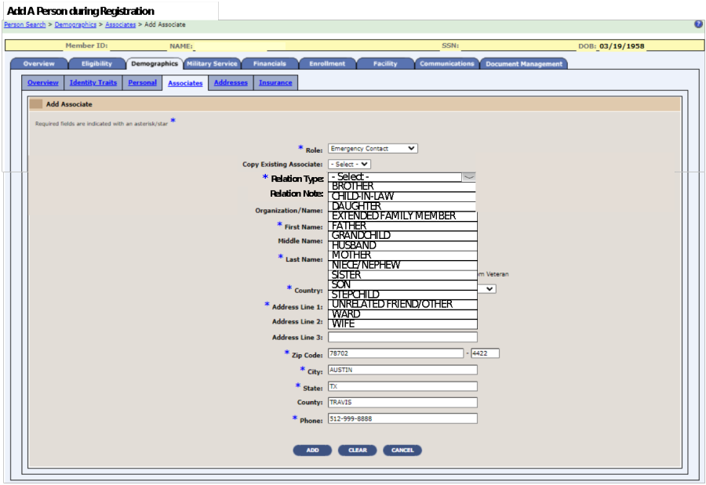
Figure 5: Add Associate – Relationship Fields
  - When a user updates the patient's NOK, EC or Designee, VES auto-populates the previously free-text field on the Demographics > Associates > Update Associates screen and allows the user to update it before saving.
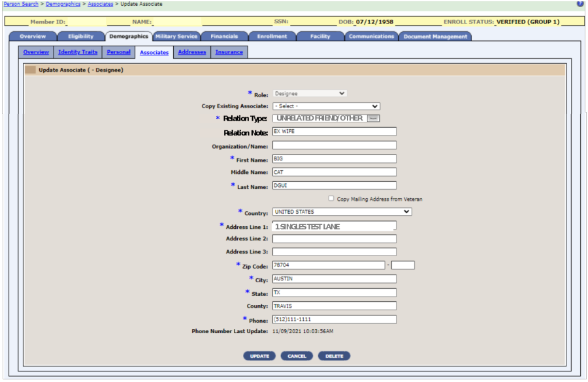
Figure 6: Update Associate – Relationship Fields
- VES displays changes to Relation Type, Last Update Date and Last Updated By fields on the Associate Change History screen.
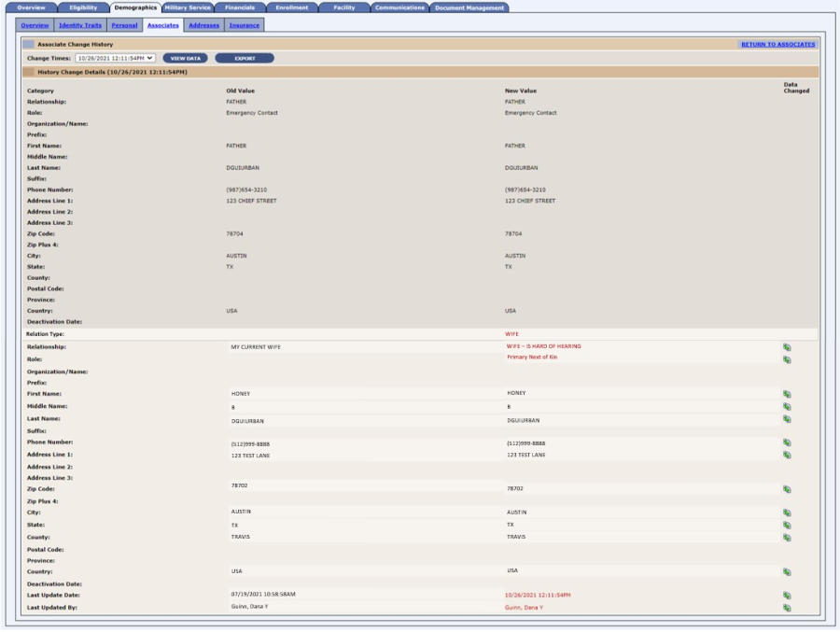
Figure 7: Associate Change History Screen
- VES shares relationship information with VistA and VA Profile via existing messaging processes.
In order to support billing activities in the Cerner system, VES is updated to store and display two new and two revised VHAPs.
- The VHAPs are displayed on the (Reference > VHA Profiles) and (Person Search > Eligibility > VHA Profiles) screens.
- Active Duty (AD) – NEW
- Joint Incentive Fund (JIF) – NEW
- VA DoD Sharing Medical Resources (SHAGR) – REVISED
- TRICARE (TRI) – REVISED
- VES will share the new and revised VHAPs with VistA via HL7 messaging.

Table 3 shows the CP&E enhancements and modifications included in the ES 6.0 release as tracked in Atlassian Jira.
Table 3: ES 6.0 CP&E Enhancements and Modifications
Jira Epic # | Summary
VES-18176 | Civilian Health and Medical Program of the Department of Veterans Affairs (CHAMPVA) Standard
VES-18177 | CHAMPVA Foreign
VES-18178 | CHAMPVA Caregiver
ES is updated to store and display two new and four revised VHAPs.
** NOTE: These VHAPS will not be assigned until the CP&E users start using VES. **
- Camp Lejeune Family (CL) - NEW
- CHAMPVA Caregiver (CHAMPVACG) - NEW
- CHAMPVA Standard (CHAMPVA) (Note: This VHAP includes CHAMPVA Foreign) – REVISED
- Beneficiary Spina Bifida (SB) – REVISED
- Beneficiary Children of Women of Vietnam Veterans (CWVV) – REVISED
- Veteran Foreign Medical Program (FMP) – REVISED

Defects and Fixes
Table 4 lists the sustainment defects and fixes and corresponding Jira issue numbers included in VES 6.0.
Table 4: Sustainment Defects and Fixes in VES 6.0
Jira Issue # | Summary
VES-11850 | Defect: The Financial > Add Dependent page should display (mm/dd/yyyy) date format next to the Inactive Date text box.  Fix: Added date format next to Inactive Date text box.
VES-13054 | Defect: When processing financial information, the system displays a 404 error after a dependent (child) SSN is clicked.  Fix: Fixed invalid path on Financial Details screen when multiple children are added.
VES-13815 | Defect: VES sends an “explicit” add to Master Person Index (MPI) during a search.  Fix: Set explicit add to “false” when no result is found on a search.
VES-14295 | Defect: There is an exception in the VA Profile contact inbound process.  Fix: Updated code to fix the exception.
VES-15315 | Defect: Online Help "?" is not displayed when the Document Management tab is selected.  Fix: Updated code to properly display the “?” for Online Help.
VES-16273 | Defect: Fortify: Cross-Site Scripting – Persistent (531 Issues)  The method _jspService() in a file sends unvalidated data to a web browser on line #.  Fix: Analysis found that VES filters and code correctly handle the data.
VES-16274 | Defect: Fortify: Cross-Site Scripting – Reflected (1305 issues)  The method _jspService() in changePassword.jsp sends unvalidated data to a web browser on line 51.  Fix: Updated code to strip the unvalidated data.
VES-17452 | Defect: An outbound message is not triggered to VA Profile from the date of death flow.  Fix: Added a wrapper method, which triggers the outbound message to VA Profile, to the code.
VES-18255 | Defect: The Recalculate Veterans Choice Eligibility job is spamming MPI calls.  Fix: Updated code to send the existing traits to MPI, which reduces the calls by one for each site.
VES-18337 | Defect: The Web Service Description Language is missing values in enumeration restriction.  Fix: Added the missing enumerations.
VES-18397 | Defect: The legacy batch process needs to be cleaned up.  Fix: Cleaned up the legacy batch process.
VES-20063 | Defect: Log4j needs to be upgraded to version 2.17.1.  Fix: Updated Log4j for the Veterans Affairs/Department of Defense Identity Repository (VADIR) database.

Known Issues
No known or open issues were identified in this release.

Product Documentation
The following documents apply to this release:
- VES 6.0 Release Notes are uploaded to the VA Software Document Library.
- Additional reference documentation related to this release is stored in GitHub.

