Eligibility and Enrollment (E&E)

Veterans Health Administration (VHA) Enrollment System (VES) 6.2.2

Release Notes
October 2022
Department of Veterans Affairs (VA)
Office of Information and Technology (OIT)

Table of Contents
1 Introduction 1
2 Purpose 2
3 Audience 2
4 This Release 2
4.1 Enhancements and Modifications 2
4.2 Known Issues 3
5 Product Documentation 4

List of Tables
Table 1: VES 6.2.2 Enhancements and Modifications 2

Introduction
The mission of the VA OIT Development, Security, and Operations is to provide benefits to Veterans and their families. In order to meet this overarching goal, OIT is charged with providing high quality, effective and efficient IT services and Operations and Maintenance (O&M) to persons and organizations that provide point-of-care services to our Veterans.
The VA’s goals for its Veterans and families include:
- Make it easier for Veterans and their families to receive the right benefits and meeting their expectations for quality, timeliness and responsiveness.
- Improve the quality and accessibility of health care, benefits and memorial services while optimizing value.
- Provide world-class health care delivery, by partnering with each Veteran to create a personalized, proactive strategy to optimize health and well-being, while providing state of the art disease management.
- Ensure awareness and understanding of the personalized, proactive and patient-driven health care model through education and monitoring.
- Provide convenient access to information regarding VA health benefits, medical records, health information, expert advice and ongoing support needed to make informed health decisions and successfully implement the Veteran’s personal health plans.
- Receive timely, high quality, personalized, safe, effective and equitable health care, not dependent upon geography, gender, age, culture, race, or sexual orientation.
- Strengthen collaborations with communities and organizations, such as the Department of Defense (DoD), Department of Health and Human Services (DHHS), academic affiliates and other service organizations.
To assist in meeting these goals, the Eligibility and Enrollment (E&E) program will provide enterprise wide enhancements and sustainment for the following systems/applications:
- The VHA Enrollment System (VES) is the authoritative system for VA enrollment and Community Care static eligibility determinations.
- Income Verification Match (IVM)/Enrollment Database (EDB) assists in determining priority grouping for health care eligibility.
- Veterans Information Systems and Technology Architecture (VistA) Registration, Eligibility & Enrollment (REE) shares information with other VistA applications and enables registration and preliminary eligibility determinations and enrollment at VA Medical Centers (VAMC). VES makes the final eligibility determinations.
- The Veteran’s On-Line Application (VOA), now referred to as Health Care Application (HCA), enables Veterans to self-enroll in VA health care and is another entry point for records to be added to VES.
E&E defines VHA Profiles (VHAP) for which a client (Veteran, Service Member, or beneficiary) is eligible and ties them to the authority for care. Key enhancements to be completed include Pending Eligibility Determination, fixes to the VHA Enrollment System, Date of Death, Internal Controls, Workflow, Veterans Financial Assessment, converting of Military Service Data Sharing (MSDS) to Enterprise Military Information Service (eMIS), Manage Relationships, Veteran Contact Service and support for VES Integrated Veteran Care (IVC) Systems Impact (VES/IVC SI).

Purpose
The purpose of this Release Notes document is to announce the release of the VES 6.2.2. This emergency release, developed in Java technology, contains E&E development and upgrade efforts.

Audience
This document targets users and administrators of VES 6.2.2 and applies to the changes made between this release and any previous release for this software.

This Release
VES will be upgraded from Version 6.2.1 to Version 6.2.2 and hosted by Amazon Web Services.
The following sections provide a summary of the enhancements and updates to the existing software and any known issues for VES 6.2.2.

Enhancements and Modifications
Table 1 lists the enhancements and modifications included in the VES 6.2.2 release as tracked in Atlassian Jira.
Table 1: VES 6.2.2 Enhancements and Modifications
Jira Issue # | Summary
VES-24916 | COMPACT Act Rules Change - Phase 1 (VES)
With VES 6.2.2, the system will no longer assign Veterans Comprehensive Prevention, Access to Care, and Treatment Act of 2020 (COMPACT Act) eligibility to records that are in Registration Only or Not Eligible (with specific Not Eligible rules) status.
- COMPACT Act eligibility rules are updated to exclude records with:
  - Enrollment Status of Registration Only (excluding certain populations where COMPACT eligibility is manually assigned)
  - Ineligible Reason of:
    - Less Than 24 Months
    - ACDUTRA ONLY
    - DVA 12D w/Ch 17, Seen for SC/MST
    - Ineligible Date
- The Clinical Evaluation Secondary Eligibility rules are updated to match the rules defined for COMPACT Act eligibility.
- Records impacted by the updated COMPACT Act eligibility and Clinical Evaluation rules will be recalculated and assigned secondary eligibilities according to the updated rules.

VES is updated to allow users to manually assign COMPACT Act eligibility to certain populations.
- VES is updated to include a new capability “Edit COMPACT Act Eligibility”.
- A new radio button, “COMPACT Act (Override)”, is displayed under the Non-Veteran Eligibility Codes section of the Person Search > Eligibility > Current Eligibility -> Edit Current Eligibility page.
- The radio button is only enabled for users with the new “Edit COMPACT Act Eligibility” capability; for other users the radio button is greyed out (disabled).
- The radio button has the options Yes, No and (by default) No Data.
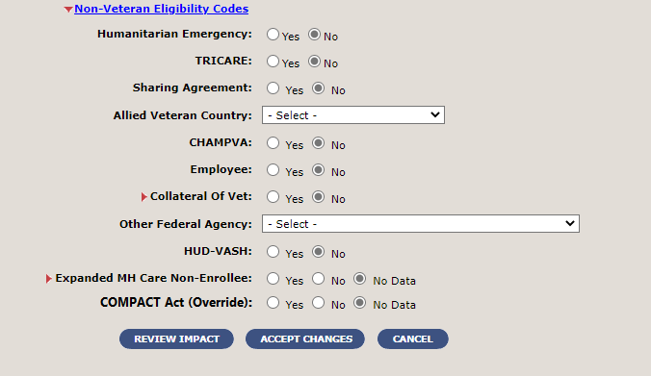
Figure 1: New COMPACT Act (Override) Radio Button
- When a user sets the COMPACT Act (Override) to “Yes” and clicks the “Accept Changes” button, VES validates that one of the scenarios below is true; if neither applies, an error message will display to alert the user that COMPACT Act (Override) cannot be set to Yes:
  - Veteran Indicator = Y, Eligibility Status = Verified, Do You Wish To Enroll = No
  - Veteran Indicator = N, Enrollment Status = Not Applicable, Do You Wish To Enroll = Null or No Data
A new carveout VHAP, COMPACT Eligible, is added to VES and the VES user interface description and long description of the following VHAPs are updated:
- Veteran Restricted Med Benefits
- Non Veteran Other Restricted Med Benefits
- Ineligible
- HUD VASH Restricted Care

Known Issues
No known or open issues were identified in this release.

Product Documentation
The following documents apply to this release:
- VES 6.2.2 Release Notes are uploaded to the VA Software Document Library.
- Additional reference documentation related to this release is stored in GitHub.

