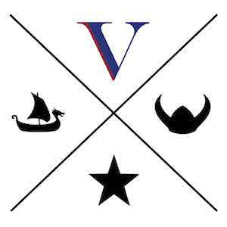
Online Education Modules
Available for VA and community organizations to increase access and enhance utilization of Veteran services and support.

MODULE 1: VA 101
Provides helpful information about the Department of Veterans Affairs (VA) and how to distinguish between federal, state, and community Veteran services.
https://www.softchalkcloud.com/lesson/serve/DrPvmKk1B2EXTL/html (Time: 45 minutes)

MODULE 2: VA BENEFITS
Outlines Veterans Benefits Administration (VBA) services for Veterans and their families as well as describes detailed eligibility requirements and how to refer to VA benefits specialists.
https://www.softchalkcloud.com/lesson/serve/lsPnWXH3G6qYQM/html (Time: 45 minutes)

MODULE 3: EMPATHY FOR OUR VETERAN HEROES
Offers insights of the unique experiences Veterans faced during their time of service with an emphasis on incorporating military cultural competence and understanding of moral injury.
https://www.softchalkcloud.com/lesson/serve/uj6coEzpy14Afw/html (Time: 45 minutes)

MODULE 4: SUICIDE PREVENTION FOR VETERANS
Describes the prevalence and scope of suicide among Veterans and explains the risks related to suicide with Veterans presenting with other medical and psychiatric concerns.
https://www.softchalkcloud.com/lesson/serve/kxsEy5BMCzJ0mg/html (Time: 45 minutes)

VIKINGS educational curriculum was developed by the Kentuckiana Veterans Integration Coalition. The Coalition works to ensure Veterans have access to the services and support needed to maintain healthy, active and independent lives by increasing community knowledge of resources, access to service and care coordination.
Funding for this curriculum was provided by a grant from the Department of Veterans Affairs in collaboration with the national Veteran Community Partnership program.

