“Heroism Knows no Gender”

Liz* is an Army Veteran and a single mom. After losing her job, she struggled to pay the rent and provide for her daughter. Liz’s landlord said she had always been an excellent tenant but his patience was wearing thin as her rent arrears continued to increase. Disheartened with a fruitless job search and unsure of where else to turn, Liz came to the Veterans Outreach Center (VOC). She was immediately connected with a Case Manager, an Employment Specialist, an Accredited State Veterans Benefits Counselor, and the SSVF team.

In order to avoid the immediate crisis of homelessness, the Services To Enable Positive Solutions (S.T.E.P.S) program at the VOC paid Liz’s rent arrears, which had escalated to an amount that was insurmountable. Within a few short days of connecting with the team at VOC, Liz had a job interview that resulted in full-time, meaningful employment. In less than a week, she had a benefits review with an on-site counselor from the New York State Division of Veterans Affairs during which she applied for an increase in disability compensation. The payment of Liz’s back rent allowed her and her daughter to keep a roof over their head. With a roof over their heads and their living situation stabilized, Liz was able to focus on her employment and securing her benefits, which are both components of an Individual Development Plan (IDP) that will help Liz sustain permanent housing in the future.

The VOC was able to stabilize Liz and her daughter while concurrently providing the supportive services necessary for her to maintain permanent housing. The temporary financial assistance was delivered to the landlord in a timely, efficient manner with the help of a S.T.E.P.S collaborative partner. Through coordinated case management, the aforementioned supportive services were provided quickly and effectively. The long-term result of this effort is yet to be determined, but at the 90-day benchmark, Liz has retained both her job and her home. She has realized this goal independently, without requesting any additional financial assistance. Consequently, the VOC was able to better the lives of a mom (a Veteran) and her child immeasurably through SSVF funding.

* Names and some identifying information have been changed to protect confidentiality.

"Your Unselfish Helping Hand Gave Us Hope"

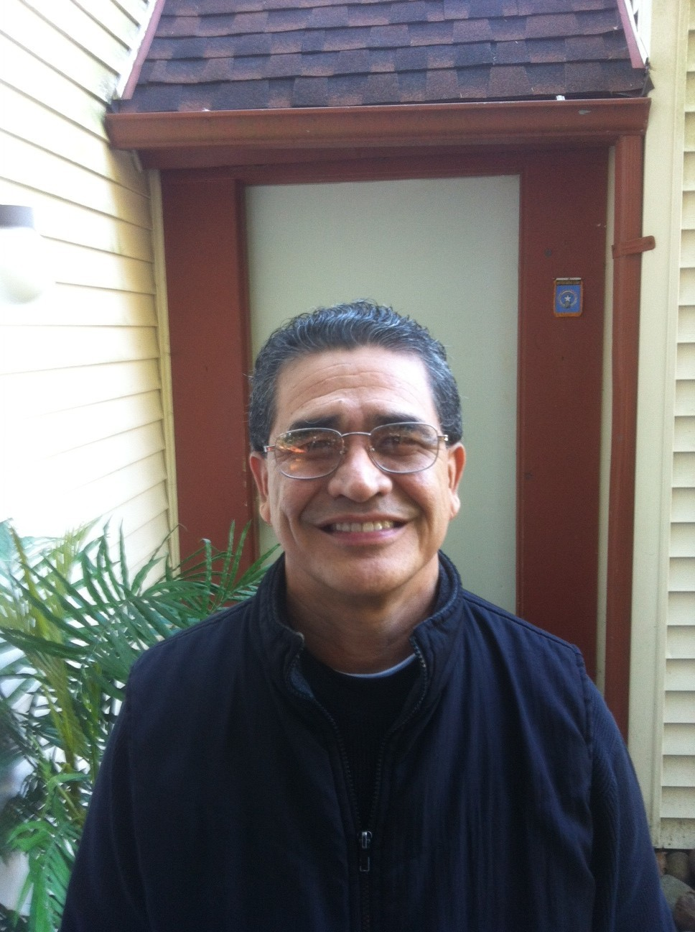Mariano Salas and his family were the first clients to participate in Community Psychiatric Clinic's (CPC) SSVF program. Both Mariano and his wife had lost their jobs and they and their young daughter were facing homelessness. The SSVF program secured their housing and helped stabilize their lives.* Here is Mariano's story in his own words:
"I was on the brink of giving up completely. But truthfully one thing I can say, no words express enough our sincerest gratitude to you in assisting my family and I during a very difficult hardship. Desperation, fear and depression were daily emotions upon my family. But with your unselfish helping hand, you gave us hope, peace, and great big smiles on our faces. Your untiring assistance has given us tremendous hope for a better future. SSVF gave us a boost as we are working so hard to get decent paying jobs to support our family and put food on our table. Today, instead of focusing all our energies on fear of being homeless, we are focusing our energy on securing a stable job and to become self-sufficient. My wife is working now and I have interviews lined up so we can support ourselves and manage our daily living expenses. I am privileged and honored to have been served by SSVF. Thank you SSVF and GOD BLESS YOU ALL."
With deepest gratitude,
Mariano Salas
* Shortly after Mariano submitted comments for this story, he secured employment at VA.

How the Salvation Army Helped a Mother and Her Children Keep Their Home

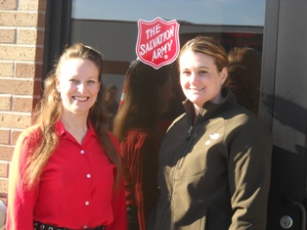
On December 20, 2011, Katie, an SSVF Caseworker at the Salvation Army Bismarck Corps, received a call from a Veteran named Cherié. Cherié was referred by the Family Assistance Advisor at the Military Service Center in Bismarck, ND. According to Cherié, she “didn’t know the Salvation Army had the Veterans program until [she] required help.” Cherié approached the SSVF program because on November 19th, she suffered a head injury resulting in a 3-inch blood clot, skull fracture and a severe concussion; in short, she suffered a traumatic brain injury (TBI). While on unpaid medical leave via physician’s orders, she was terminated from her employer. A single mother of two, her biggest concern was maintaining her current residency.

On December 21st, when Cherié met with Katie, she was very emotional and had difficulty processing her thoughts. She was extremely overwhelmed with how to pay for her rent and utilities and provide for her children while unemployed. Katie provided emotional support as well as resources for a food box, an application for food stamps through the county, contact information for a Veterans employment team representative and lastly, information about a support group for women Veterans in the Bismarck community. In Cherié’s own words, “The SSVF assistance provided peace of mind and helped keep me on my feet, especially with having kids. Katie has been such a calming influence, good about following up and very supportive.”

Since Cherié has been involved with the Salvation Army, she has been able to focus on recovering from her TBI, has found temporary full-time employment for which permanent placement is promising, and is able to provide for her children and keep a roof over their heads. She’s also spreading the word to fellow Veterans throughout the state about the SSVF program.

A Room of One’s Own
A Homeless Vet Comes in out of the Cold with the Help of the Thresholds Veterans Project

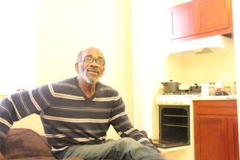
A native of rural Sunflower County, Mr. Dempsey Spruell set out to explore the world by joining the United States Air Force. For 4 years, the young enlisted airman spent much of his time in the service at Sheppard Air Force Base in Wichita Falls, Texas. Having served his country for 4 years, he received an honorable discharge and hoped to enter civilian life with the skills and confidence he had gained in the Air Force.

But life outside of the military was nothing like he expected. Dempsey found himself bouncing from location to location, and eventually settled down in Chicago. The life of three squares a day, pressed uniforms, shined boots and a sense of honor were gone.

Dempsey eventually ended up homeless – like so many other Veterans before him. Disengaged from the community and off the system grid, Dempsey’s new home was not a comfortable warm barracks or apartment. His home became the crushing and cold cement of Lower Wacker Drive.

Even though he had family in the area, his mental illness and substance abuse had stolen his pride. He said he couldn’t bring himself to face his family in the shape he was in.

But Dempsey recently got a fresh start and a “hand up” from the Thresholds Veterans Project. The program, initiated in 2010 to address the complex needs of Veterans with mental health issues, became Dempsey’s safe haven – a port in an unending storm.

Within weeks, Dempsey was getting regular visits from a community support specialist, access to therapeutic care, and – finally – a roof over his head that was not the underside of a bridge.

Today, thanks to the dedication and hard work of the Thresholds Veterans Project, Dempsey has a new studio apartment. He is sleeping in his own bed, a warm respite away from the bone-numbing chill of the Chicago winter. He has a brighter future. He is finding recovery.

The smile on his face is a sure sign he is back on his way to the same honor he felt as a young airman. But it is probably the few simple words he told us that make his story so poignant.

“I have a home. I enjoy bein’ inside.”

# # #

UMOM New Day Centers Helps a Veteran Family Get Back on Their Feet


When you talk to Felipe Medrano, you immediately notice this Army veteran’s positive outlook on life, pleasant demeanor, and willingness to help others. It is difficult to imagine that hard times fall on a person like him. However, less than a year ago, Felipe lost his job at a manufacturing plant and his family lost everything. Felipe, his wife, Aimee, and their four children stayed with a family member for a short time, but faced eviction for having too many people in the apartment. With no place to go, the family found themselves at the Emergency Family Shelter at UMOM New Day Centers.

Just after the family moved in, UMOM was awarded and received funds to implement the Supportive Services for Veteran Families (SSVF) grant. UMOM staff was able to assess the Medrano Family for housing stability and it was determined that the family had relatively low-barriers and would be an excellent candidate for Rapid Rehousing through the SSVF program. As a result, the family immediately began working with a SSVF case manager to locate affordable housing.

The family quickly found housing and with the assistance of their case manager, and worked on budgeting and goal-setting to achieve housing stability. Felipe continued attending night classes at University of Phoenix where he studies accounting. Both Felipe and Aimee were connected to employment resources and after diligent job search, Aimee found employment at a local arts and crafts store. Felipe continues to search for part-time work and also does house painting on a part-time basis.

After three months of rental assistance (which was staged down as the family grew more independent), the Medrano Family is now paying their own rent and continue to thrive. The SSVF program allowed them the opportunity to get back on their feet quickly and provided the extra support and resources for their family’s success.

UMOM New Day Centers operates the SSVF program in partnership with Save the Family Foundation in Maricopa County. SSVF has been of great benefit to the agencies as it has allowed us to truly assess the needs of our Veteran Families and target resources that are appropriate to the housing and supportive needs of the families. Our housing services include Rapid Rehousing and eviction prevention through SSVF, an Emergency and transitional housing option including a Grant and Per Diem transitional program for Veterans and their family members, as well as permanent supportive housing.

“It’s Often the Last Key on the Ring Which Opens the Door.’ ~Proverb

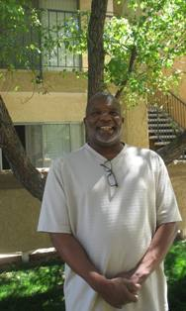
Allen Evans and his wife Cecilia came to participate in Mental Health America’s Operation Healthy Homecoming (SSVF) program with a Pay or Vacate Premises notice in hand and three days before eviction proceedings were to be filed in court. After tapping out the resources of family, friends, and the church, the couple began a quest and visited numerous social service agencies for help, only to be turned away. Operation Healthy Homecoming was Allen’s last stop. As a veteran, Allen bravely served our country in the USN (’73-’77) on the USS Hitchiti.

You see, Allen was diagnosed with cancer earlier in the year and was unable to continue working as a truck driver, forcing the family to survive on Allen’s small disability payment. Cancer treatments required Allen to make the long trek from the High Desert to the VA hospital in West Los Angeles, CA. Though Cecilia was unemployed herself, she made an effort to access mainstream benefits, attend employment workshops, look for work, and provide the love and support so needed by Allen during this difficult time. Allen and Cecilia were committed to seeing things through to a brighter day.

Working with the property management company, the Operation Healthy Homecoming program helped Allen and Cecilia avoid an eviction and maintain their housing, with a plan to downsize to a more affordable unit in the same complex. During this time, Allen was referred to the local VSO who assisted with amending Allen’s VA disability claim. In March 2012, Allen secured a non-service connected disability award by the VA, sufficient to meet the couple’s needs. In addition, Allen has successfully completed his cancer treatments and is looking forward to the day when he can return to work.
In the words of Allen:

‘SSVF not only gives assistance, but it gives hope. Their caring devotion and a true concern for the wellbeing of the people they help gave us hope. I am truly grateful for what they were able to do for my family and me. Thank you and God bless you.’


Client Success Story

After traveling across the country to seek Veteran benefits and medical care, Milagros Espin has finally settled in a home of her own.

Milagros lived in Florida for most of her life. She served in the Navy for five years, from 1972 to 1977, as a nurse, then a dental assistant, and later in classified communications. She has three grown daughters, all serving in the military around the world – in New York, Virginia, and Italy. After Milagros’ divorce depleted her bank account and took her home, she turned to the local VA for housing assistance and medical care for PTSD, but found their options insufficient. Milagros researched VA services throughout Florida and the U.S., and discovered that the best services for her needs were at the VA in Menlo Park, California.

In August 2011, she contacted a shelter on the VA Menlo Park campus, and arranged for her relocation to the west coast. Milagros stayed in the shelter through Thanksgiving, while receiving first-rate VA medical care to treat her PTSD. During the holidays, the shelter was forced to close permanently and evict all of its residents. For a few weeks, she used the remainder of her meager savings from SSDI to stay in a hotel. When those resources ran out, she became homeless living in a parking garage, spending Christmas on the streets.

Milagros connected with an SSVF Case Manager at Shelter Network, who helped her secure temporary shelter. In early 2012, Milagros moved into her own apartment in San Jose, with deposit assistance from SSVF and a HUD-VASH voucher to subsidize ongoing rent.

Milagros is excelling in permanent housing. Her apartment community is safe and clean, and houses many other Veteran SSVF clients. She loves to help cook at social events to support her Veteran neighbors. She is thrilled to have internet access at her home, allowing her to Skype with her daughters around the world. She even created a Facebook page to connect with her Veteran friends from the Menlo Park shelter that closed last winter.

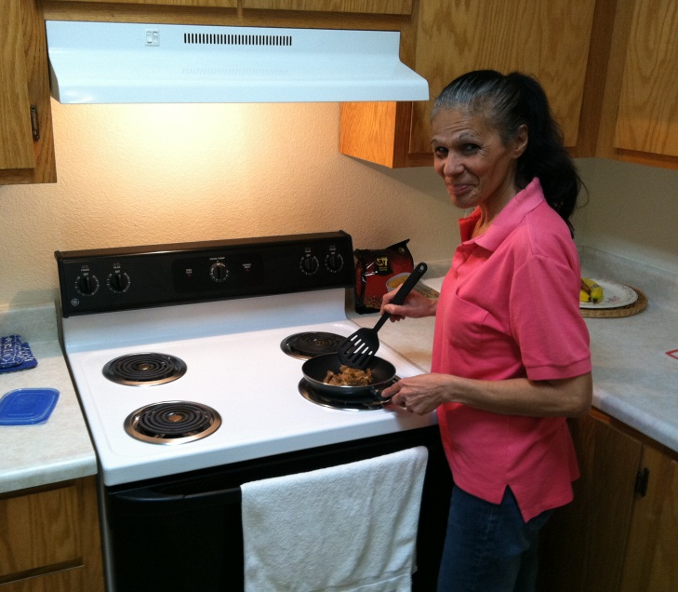
Milagros is incredibly grateful for all the support she has received from Shelter Network and SSVF. “You are all angels,” said Milagros, speaking of the VA and Shelter Network Case Managers. “You helped me get my apartment, my home. I am so happy here, and I feel really blessed.”

Milagros cooks dinner at her new apartment in San Jose.

