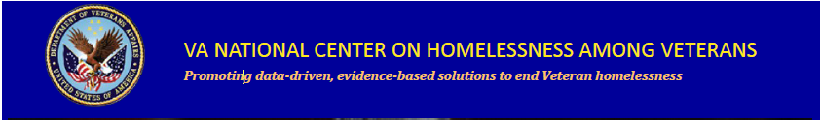
In Collaboration with VHA Employee Education System,
VA’s National Center on Homelessness among Veterans,
Homeless Programs Office, VACO
Presents: The FY 2018 National Education Series:

- October 25, 2017: Opioid Epidemic Response and One Site’s Journey: The Naloxone Project
(TMS 3381467 Item no. VA 34459)

- November 29, 2017: Implementation Science and Homeless Programs
(TMS 3388723 Item no. VA 34581)

- December 20, 2017: Ethics in Serving Homeless Veterans
(TMS 3397302 Item no. VA 34727)

- January 17, 2018: 11:30am -1pm CBT for Homelessness (CBT-H) Overview (TMS 3401499 Item no. VA 34887)

- February 21, 2018: 1:00pm -2:30pm Cultural Competence, LGBT, and Homelessness
(TMS 3406982 Item no. VA 34981)

- March 21, 2018: VBA/Fiduciary Challenges for Homeless Veterans

- April 18, 2018: Whole Health and Homelessness

- May 16, 2018: Telehealth and Homelessness

- June 20, 2018: Trauma Informed Care Evaluation Tool

- July 18, 2018: Policy and Prior Research in Homelessness

- August 15, 2018: Motivational Interviewing with Homeless Veterans

- September 19, 2018: Funding Authorities in HPO
All webinars will be held on a Wednesday
All times will be 1:00 – 2:00 p.m. Eastern unless otherwise indicated
VIDEO: Log into TMS for the Adobe Connect Link
AUDIO: VANTS: 1-800-767-1750 passcode: 22202#
CEU’s are being applied for through ACCME, ANCC, APA, NBCC, ASWB, CA BBS, CRCC, and NYSED
Topics are developed based on the HPO National Knowledge Self-Assessment Survey and TMS Evaluation Feedback
The National Center on Homelessness among Veterans promotes the development of policy and practice that targets ending and preventing Veteran homelessness through supporting the implementation of relevant research findings into clinical practice, providing education and training for VA and community partners, disseminating evidence-based and emerging best practices, and developing new empirical knowledge.
For additional education opportunities, please contact Brenda W. Johnson, Education Coordinator (brenda.johnson4@va.gov)
To learn more about the Center, visit our website at: http://www.va.gov/homeless/nchav/index.asp
and our Education and Training SharePoint site: Education and Training for HPO
Also, connect with us on the VA Pulse site:
Education and Training within VHA’s Homeless Programs Office
https://www.vapulse.net/groups/education-and-training-within-vhas-homeless-program-office/overview

