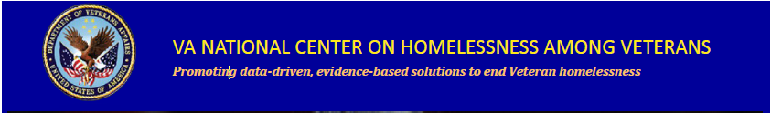
In Collaboration with VHA Employee Education System,
VA’s National Center on Homelessness among Veterans,
Homeless Programs Office, VACO
Presents: The FY 2018 National Education Series:

- October 25, 2017: Opioid Epidemic Response and One Site's Journey: The Naloxone - Recording
( VA 35137)

- November 29, 2017: 2018 Homeless: Implementation Science in Homeless Programs - Recording
(VA 35129)

- December 20, 2017: Ethics in Serving Homeless Veterans
(TMS 3397302 Item no. VA 34727)

- January 17, 2018: 11:30am -1pm 2018 Homeless: Cognitive Behavioral Therapy for Homelessness Prevention (CBT-H) - Recording
(VA 35788)

- February 21, 2018: 1:00pm -2:30pm 2018 Homeless: LGBT Cultural Competence and Veteran Homelessness - Recording
(VA 25804)

- March 21, 2018: 2018 Homeless: VBA Fiduciary Services using a Harm Reduction Approach - Recording
( VA 35776)

- April 18, 2018: 2018 Homeless: Whole Health and Homelessness - Recording
( VA 36107)

- May 16, 2018: “Stable and Able”: Telehealth and Homeless Populations
(TMS Course no. VA 35654)

- June 20, 2018: Trauma-Informed Care Evaluation Tool
(TMS Course no. VA 36011)

- July 18, 2018: Developing Homeless Services in VHA: A Story in 4 Chapters
(TMS 3388723 Item no. VA 34581)

- August 22, 2018: Motivational Interviewing with Homeless Veterans
(TMS 3483324 Item no. VA 36430)

- September 12, 2018: Legislative and Funding Authorities in VA Homeless Programs
All webinars will be held on a Wednesday
All times will be 1:00 – 2:00 p.m. Eastern unless otherwise indicated
VIDEO: Log into TMS for the Adobe Connect Link
AUDIO: VANTS: 1-800-767-1750 passcode: 22202#
CEU’s are being applied for through ACCME, ANCC, APA, NBCC, ASWB, CA BBS, CRCC, and NYSED
Topics are developed based on the HPO National Knowledge Self-Assessment Survey and TMS Evaluation Feedback
The National Center on Homelessness among Veterans promotes the development of policy and practice that targets ending and preventing Veteran homelessness through supporting the implementation of relevant research findings into clinical practice, providing education and training for VA and community partners, disseminating evidence-based and emerging best practices, and developing new empirical knowledge.
For additional education opportunities, please contact Brenda W. Johnson, Education Coordinator (brenda.johnson4@va.gov)
To learn more about the Center, visit our website at: http://www.va.gov/homeless/nchav/index.asp
and our Education and Training SharePoint site: Education and Training for HPO
Also, connect with us on the VA Pulse site:
Education and Training within VHA’s Homeless Programs Office
https://www.vapulse.net/groups/education-and-training-within-vhas-homeless-program-office/overview

