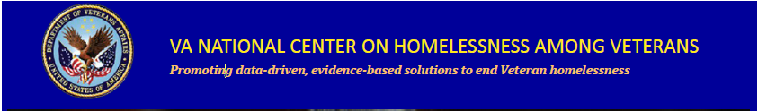
In Collaboration with VHA Employee Education System,
VA’s National Center on Homelessness among Veterans,
Homeless Programs Office, VACO
Presents: The FY 2019 National Education Series:

- October 17, 2018: Ethics in serving Homeless Veterans
(S.O. 3528243 TMS Course no. VA 36825)

- November 28, 2018: Complex Issues and Housing Solutions for Veterans Who Need to Register as Sex Offenders
(TMS Course no. VA 37028)

- December 19, 2018: Behavioral Management Training for Working in the Community
(TMS Course no. VA 37112)

- January 16, 2019: The Opioid Crisis in Rural America
(TMS Course no. VA 37301)

- February 20, 2019: Traumatic Stress and Organizational Dynamics among Homeless Sector Workers
(TMS Course no. VA 37571)

- March 20, 2019: Homeless Programs Competency Development Panel Discussion
(TMS Course no. VA 37887)

- April 17, 2019: Analyzing Racial Disparities in the Homelessness System: What You Should Know
(TMS Course no. VA 38028)

- May 15, 2019: Understanding of the Principles of Leadership and their Use for Working with the
Community and in programs

- June 19, 2019: Understanding of Evidence Based Practice and Practice Informed Care

- July 17, 2019: Money Management for Veterans

- August 21, 2019: Whole Health revisit

- September 18, 2019 Understanding of Service Era Culture as it Relates to Homelessness and Providing Care

All webinars will be held on a Wednesday
All times will be 1:00 – 2:00 p.m. Eastern unless otherwise indicated
VIDEO: VA Personnel - Log into TMS for the Adobe Connect Link
VIDEO: Non-VA Personnel - Log into VA TRAIN for the Adobe Connect Link
AUDIO: VANTS: 1-800-767-1750 passcode: 22202#
CEU’s are being applied for through ACCME, ANCC, APA, NBCC, ASWB, CA BBS, CRCC, and NYSED
Topics are developed based on the HPO National Knowledge Self-Assessment Survey and TMS Evaluation Feedback
The National Center on Homelessness among Veterans promotes the development of policy and practice that targets ending and preventing Veteran homelessness through supporting the implementation of relevant research findings into clinical practice, providing education and training for VA and community partners, disseminating evidence-based and emerging best practices, and developing new empirical knowledge.
For additional education opportunities, please contact Brenda W. Johnson, Education Coordinator (brenda.johnson4@va.gov)
To learn more about the Center, visit our website at: http://www.va.gov/homeless/nchav/index.asp
and our Education and Training SharePoint site: Education and Training for HPO
Also, connect with us on the VA Pulse site:
Education and Training within VHA’s Homeless Programs Office
https://www.vapulse.net/groups/education-and-training-within-vhas-homeless-program-office/overview

