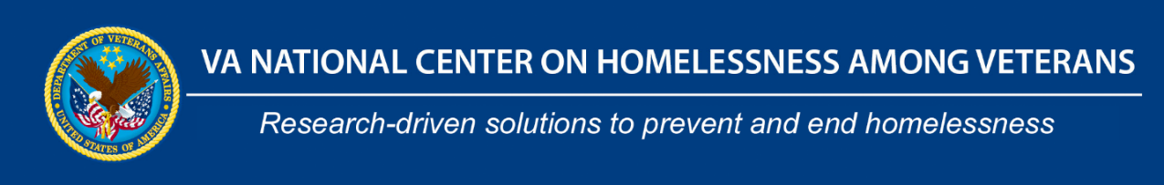
Recruiting for 2022-2023 Year!
National Center on Homelessness among Veterans (NCHAV) Fellowship Track

Purpose:

The VA National Center on Homelessness among Veterans (NCHAV), in collaboration with the VA Office of Academic Affiliations (OAA), has created focused training experiences for health professionals interested in addressing homelessness and criminal justice involvement. These fellowship experiences seek to train and develop the next generation of researchers, change agents, administrators and practitioners working with Veteran homelessness.

Background:

NCHAV was established in 2009 and codified in legislation in 2016 through Public Law 114-315, Sec. 713 to serve as a resource center for “all research and training activities…with respect to Veteran homelessness.”

In 1978, OAA began the VA Special Fellowships Program, which was renamed the VA Advanced Fellowship Program in 2007, to contribute to a talented, well trained recruitment pool for VA and to foster an atmosphere of scientific inquiry and excellence within VA.

This fellowship program will integrate robust homeless experiences and training into existing VA Advanced Fellowship programs (see list under participating sites).

Who can apply?
Clinicians or non-clinicians with a doctoral degree or who have completed all requirements toward a doctoral degree from an accredited institution.

For more information, please contact Jack Tsai, PhD: Jack.tsai2@va.gov
Benefits:
A formal connection with NCHAV and operational partners and be on the cutting-edge of the latest research, policy and educational developments in Veteran homelessness under the guidance of at least one Center mentor.
A cohort of fellows that you interact and collaborate with on Veteran homelessness, including NCHAV funded travel to meet in-person at the annual American Public Health Association Conference.
A supplemented curriculum to the core Advanced Fellowship curriculum that includes unique opportunities to learn from experienced researchers, providers, and policy-makers working on Veteran homelessness.
Lead a project in coordination with NCHAV staff.

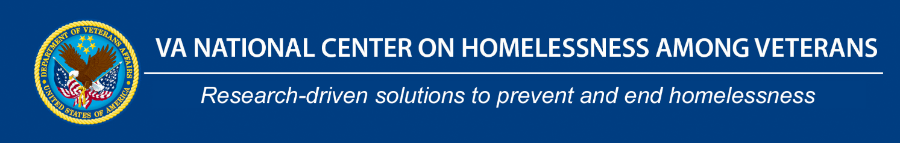

Participating Sites:
Dallas, TX
Core program: Interprofessional Addiction Fellowship.
Fellowship Director: Drs. Geetha Shivakumar and Julia Smith
Point of Contact: Dr. Dina Hooshyar, Dina.Hooshyar@va.gov

Providence, RI
Core program: COIN
Fellowship Director: Drs. Kali Thomas and Whitney Mills
Point of Contact: Dr. Eric Jutkowitz eric_jutkowitz@brown.edu

San Antonio, TX
Core program: GRECC
GRECC Director: Dr. Sara Espinoza
Point of Contact: Dr. Jack Tsai Jack.Tsai2@va.gov

Bronx, NY
Core program: MIRECC
Fellowship Director: Dr. Chi Chan
Point of Contact: Dr. Chi Chan, Chi.Chan1@va.gov

Bedford, MA
Core Program: HSR&D Center (CHOIR)
Fellowship Director: Dr. Stephanie Shimada
Point of Contact: Dr. Hong Yu Hong_Yu@uml.edu

West Haven, CT
Core Program: HSR&D Center (PRIME Center)
Center Director: Dr. Lori Bastian
Point of Contact: Dr. Rajiv Radhakrishnan Rajiv.Radhakrishnan@yale.edu

