Supportive Services for Veteran Families (SSVF)
Financial and Operational Fitness Audit (FOFA)
Timeline

The timeline listed below will provide a general guide to activities by phase of the audit process. A copy of the timeline with specific dates related to your visit¹ will be provided and discussed during the initial kickoff call.
Site Visit Date: |  |  |  | April 21-23, 2020
Phase | Date | Timeline² | Responsible Party | Action
Pre-Site Visit | 1/10/2020 | 15 Weeks Prior | Grantee | Receive engagement letter
 | 1/15/2020 | 14 Weeks Prior | Grantee | Attend kick-off call
 | 1/31/2020 | 12 Weeks Prior | Grantee | Upload preliminary documents requested (PDR) into GIFTS
 | 2/21/2020 | 9 Weeks Prior | Auditor | Review, analyze, and develop expense and payroll audit samples for grantee
 | 2/21/2020 | 9 Weeks Prior | Grantee | Receive expense and payroll audit samples and internal control questionnaires (ICQ's)
 | 3/13/2020 | 6 Weeks Prior | Grantee | Upload expense and payroll audit sample supporting documentation into GIFTS
 | 4/15/2020 | 1 Week Prior | Grantee | Receive follow-up questions regarding audit review work and testing
 | 4/15/2020 | 1 Week Prior | Grantee | Receive Veteran case file sample list
 | 4/15/2020 | 1 Week Prior | Grantee | Provide Auditors with logistical information regarding facility parking, access, etc.
Phase | Date | Timeline | Responsible Party | Action
Week of site Visit | 4/21/2020 | Day 1 | Grantee / Auditor | Attend entrance conference
 |  |  |  | Inventory case files
 |  |  |  | Start case file review work (Auditors only)
 | 4/22/2020 | Days 2³  or 3 | Grantee / Auditor | Face-to-face discussions (case files, expense, payroll, admin, ICQ, etc.…)
 |  |  |  | Discuss issues and develop recommendations
 | 4/23/2020 | Day 3 | Grantee / Auditor | Attend exit conference
Phase | Date | Timeline | Responsible Party | Action
Post-Site Visit | 4/30/2020 | 1 Week Post | Grantee | Provide follow-up documentation
 | 6/5/2020 | 4-6 Weeks Post | Grantee | Receive audit report
 | 6/19/2020 | 14 Days After Report | Grantee | Respond to recommendations (Appendix A)
 | To Be Determined (TBD) | TBD | Grantee | Respond to recommendation follow-up questions and document requests
 | TBD | TBD | Grantee | Receive closeout letter

¹ Example Agenda Excerpt:
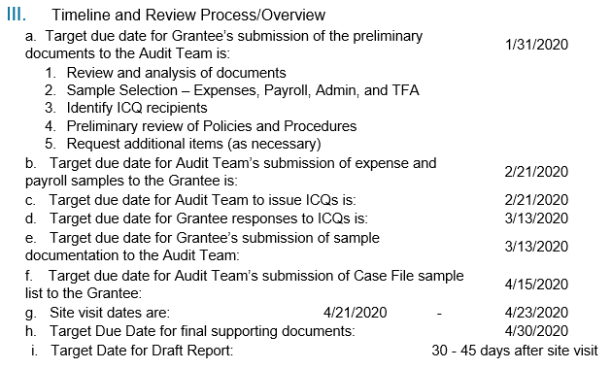
² General timeline for reference, timelines may be adjusted depending on the specific dates associated with your site visit.

³ May be scheduled for a 2 or 3 day site visit - the Engagement Letter and subsequent Kickoff Call will detail the duration of your site visit.

