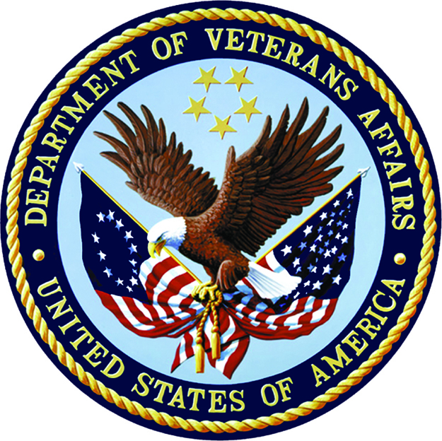
Department of Veterans Affairs
Senior Executive Biography

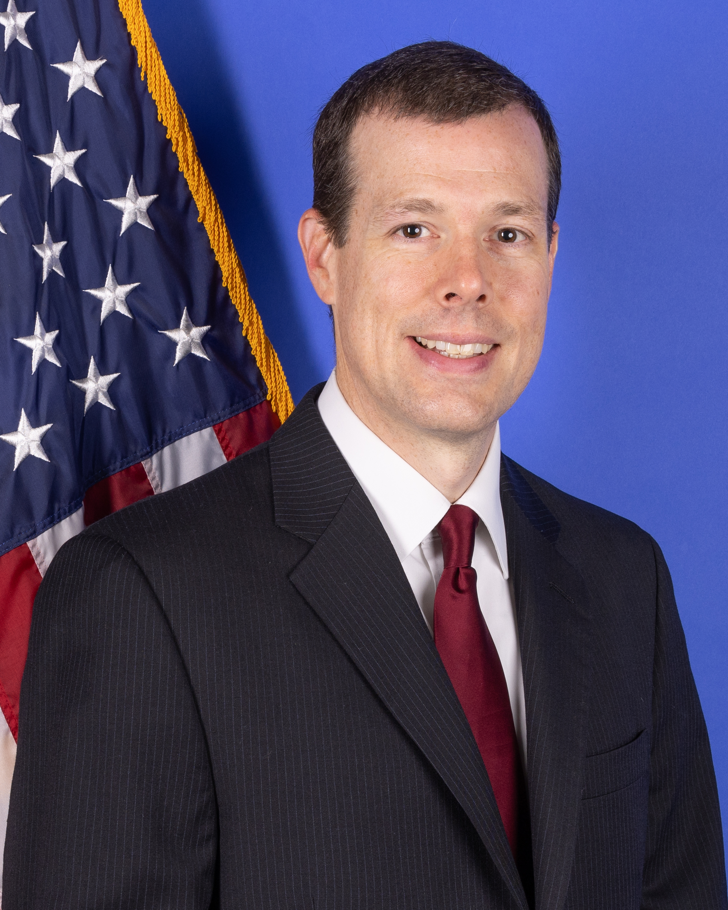
William Scott Slagle, O.D.
Executive Director
Optometry Service

W. Scott Slagle, O.D. was appointed as Executive Director, Optometry Service on November 21, 2021. In this role, he serves as a senior and principal advisor of optometry to the Chief Officer for Specialty Care Services, is responsible for overseeing the National VA Optometry Program, and is jointly responsible with the VHA Executive Director of Ophthalmology for overseeing the VHA National Eye and Vision Care Program.
Doctor Slagle has sound leadership qualities and proven experience. He previously served as a Clinical Optometrist at the Hampton VA Medical Center, where he established an eye clinic in December 2020 at the Chesapeake VA Outpatient Clinic, in Chesapeake, Virginia. Prior to that, he served as a Clinical Optometrist and Optometry Residency Program Director at the Salem VA Medical Center (VAMC) in Salem, Virginia. Doctor Slagle has served as a member of the VA Optometry Field Advisory Board since 2010 and chaired its Education Subcommittee. He has also been the Optometry Service Liaison to the Office of Academic Affiliations, VA Liaison for the Association of Schools and Colleges of Optometry’s Residency Affairs Committee, as well as VA committee member and Chair for the administration of the Optometry Residency Matching Program for optometry residencies. He has served as the Optometry Lead (consultant) for the VISN 6 Surgical Clinical Integrated Community council.
Doctor Slagle received his Doctor of Optometry degree summa cum laude from Southern College of Optometry in Memphis, Tennessee. He subsequently completed a primary eye care residency at the Memphis VAMC. He holds board certification in medical optometry by the American Board of Certification in Medical Optometry. Doctor Slagle holds adjunct faculty appointments at the Southern College of Optometry and Pennsylvania College of Optometry at Salus University; and has been an assistant professor in the Department of Surgery at Virginia Tech Carilion School of Medicine. He is a fellow of the American Academy of Optometry and has numerous peer reviewed publications. Additionally, Doctor Slagle has been awarded VA Optometrist of the Year in 2018 and the Optometrist of the Year in 2011 by the Armed Forces Optometric Society
CAREER CHRONOLOGY:
2021 – Present Executive Director, Optometry Service, VHA, Washington, DC
2020 – 2021 Optometrist, Hampton VA Medical Center
2010 – 2021 Assistant Professor, Dept. of Surgery, Virginia Tech Carilion School of Medicine
2009 – 2020 Optometry Residency Program Director, Salem VA Medical Center
2000 –2020 Optometrist, Salem VA Medical Center

EDUCATION:
2000 Residency in Primary Care Optometry, Memphis Veterans Affairs Medical Center
1999 Doctor of Optometry, Southern College of Optometry, Memphis, TN (summa cum laude)

Bios should be succinct and limited to one page.

