Department of Veterans Affairs

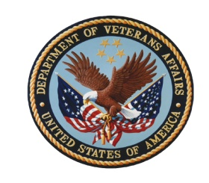

Veterans Affairs Diversity Council (VADC)

VA Central Office, Conference Room 830

December 2, 2009

1:00 – 3:00 PM Eastern Time

Program Agenda

1:00 (10 min.) Welcome and Introductions

Georgia Coffey
Deputy Assistant Secretary for Diversity and Inclusion

1:10 (15 min.) Best Practices

Stephen Pemberton, Chief Diversity Officer and Vice President of
Monster.com

1:25 (5 min.) Diversity Council Operations

- Minutes of VADC meeting on September 2, 2009
- Status of VADC Charter
- Outcomes expected from today’s business

1:30 (15 min.) Employment of Veterans

- Community Prosperity Partnerships Los Angeles, CA
- Direct Hire Authority for Acquisitions
- Executive Order Employment of Veterans in the Federal Government

1:45 (15 min.) Operationalizing the Diversity and Inclusion Strategic Plan

- Performance Report
- FY 2010 SES Plan
- MD-715 Part I
- TV Commercial Recruitment by Healthcare Recruitment and Retention Office
- Career Pathways Committee
- Training curriculum on EEO, Diversity, Conflict Management for Managers and Supervisors and on prevention of harassment
- Cultural Competency Initiative in VHA
- Hispanic Employment Outreach Plan
  - Next Steps

2:00 PM Wrap Up
Next meeting in March 3, 2010
Call for Proposed Agenda Items

3:00 PM Adjourn

