VA DIVERSITY COUNCIL

2014 BIENNIAL REPORT

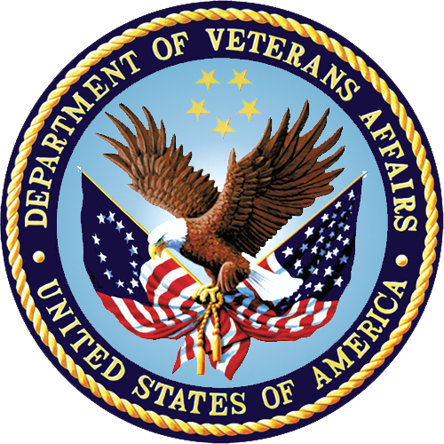

Report from the VA Diversity Council to the
Secretary of the U.S. Department of Veterans Affairs

CONTENTS
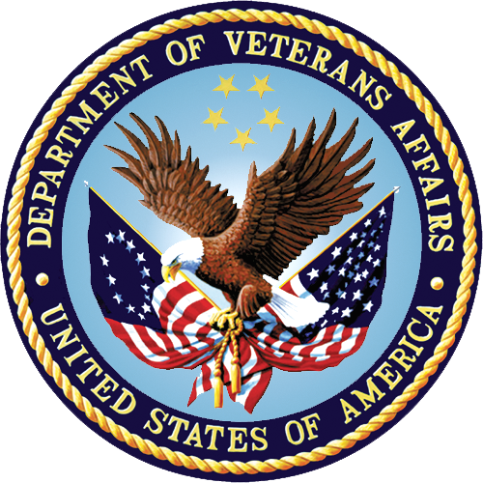
VA DIVERSITY COUNCIL
MESSAGE FROM THE CO-CHAIRS 3
COUNCIL MISSION 4
COUNCIL HISTORY 4
COUNCIL STRUCTURE 4
2012-2014 ACHIEVEMENTS 5
COMMITTEE REPORTS 5
PROGRESS ON 2011 ACTION PLAN 8
2015-2016 ACTION PLAN 13
RECOMMENDATION 13
CURRENT VADC MEMBERS 14

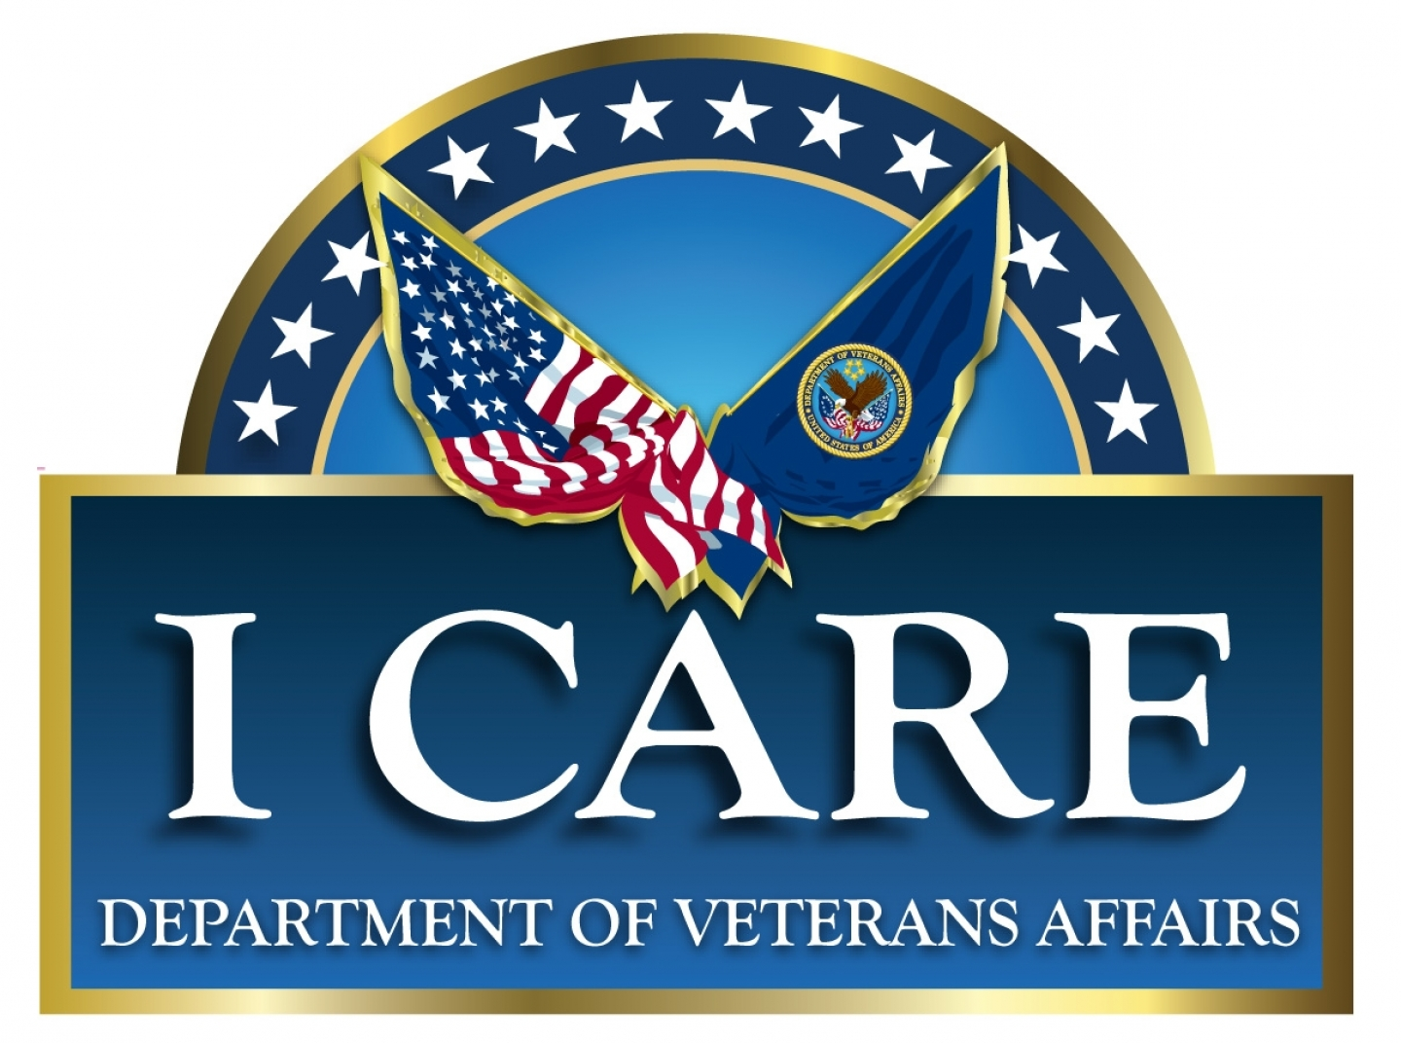

Integrity
Commitment
Advocacy
Respect
Excellence

MESSAGE FROM THE CO-CHAIRS
VA DIVERSITY COUNCIL
The U.S. Department of Veterans Affairs (VA) has made great strides in creating an organization that cultivates a diverse workforce and an inclusive work environment. In 2010, VA’s leadership, acted to strengthen the foundation needed to support VA’s transformation into a 21st century Cabinet-level agency. As diversity was seen as integral to the transformational effort, leadership sought to establish a body that was charged with ensuring that diversity and inclusion policies and practices were institutionalized and integrated at all organizational levels. The VA Diversity Council (VADC) was established from this need.

This is the second biennial VADC report prepared for the Secretary of Veterans Affairs and includes the Council’s mission, history, and other details; chronicles the Council’s 2012-2014 achievements; and lays out the Action Plan which will guide the VADC in its future activities.

We would like to thank each of VA’s Administrations and Staff Offices, our union partners, and our affinity group stakeholders for their invaluable participation on this Council and for their continued support in infusing the principles of diversity and inclusion throughout VA as we strive for 21st century excellence in service to our Veterans.

_______________________________
Gina S. Farrisee
Assistant Secretary for
Human Resources and Administration
VADC Co-Chair

________________________________
Georgia Coffey
Deputy Assistant Secretary for
Diversity and Inclusion
VADC Co-Chair

COUNCIL MISSION
VA DIVERSITY COUNCIL
The VADC serves as an independent executive level body that provides advice and recommendations to the Secretary of Veterans Affairs on areas related to diversity and inclusion (D&I). The Council comprises representatives from each of the Department’s major organizations, staff offices, and stakeholders. It serves as communication link between the workforce, subcomponent organizations, and VA leadership and also as a clearinghouse on D&I issues.

COUNCIL HISTORY

On October 5, 2007, then-Acting Secretary for Veterans Affairs Gordon H. Mansfield announced the establishment of the “VA Diversity Advisory Council” in accordance with the Department of Veterans Affairs Strategic Plan for Fiscal Year (FY) 2006-2011. The initiative gained momentum in early 2009 when a new title was adopted and the charter was finalized. The VADC, the first VA-wide body devoted to diversity matters, was a strategy contained in the new VA Diversity and Inclusion Strategic Plan (DISP). On March 23, 2010, Secretary Eric Shinseki distributed a memo adopting the new charter and the VADC was officially launched.

COUNCIL STRUCTURE

VA’s Office of Diversity and Inclusion (ODI), under the auspices of the Office of Human Resources and Administration (HRA), administers the Council and provides basic financial and administrative support for its operations. To promote transparency and public access, ODI maintains the VADC web page (http://www.diversity.va.gov/council) with meeting agendas and minutes. This site also houses the VADC charter and current membership roster.

The VADC comprises executive-level voting representatives appointed by each of VA’s three Administrations, major Staff Offices, and leaders from each of VA’s five unions: the American Federation of Government Employees, the National Association of Government Employees, the National Federation of Federal Employees, Service Employees International Union, and National Nurses United. The assigned Union representative may be a retired VA employee. The Council meets on a quarterly basis in person and telephonically in Washington DC. VADC meetings are open to all interested VA parties, in the interest of full inclusion and transparency.

The Secretary’s initial call for VADC members was made in FY 2010. In January 2014, the Secretary thanked current members for their service and called for each of VA’s major organizations and staff offices to reaffirm or designate a new representative, at the senior executive level, to serve on the Council.

Voting VADC members and their designees have access to the heads of and are spokespersons for their organizations. When these members or their designees are called to vote on VADC matters, each organization has one vote. The Assistant Secretary for Human Resources and Administration (ASHRA) and Deputy Assistant Secretary (DAS) for Diversity and Inclusion serve as process owners and Co-Chairs of the VADC and may exercise a single combined vote as a tie breaker.
VA DIVERSITY COUNCIL

Nonvoting members include representatives of VA employee resource groups (ERGs) that are structured or chartered to address VA business or employee matters. The ERGs currently represented on the VADC include the VA Blacks in Government chapter; the VA Federal Asian Pacific American Council chapter; the VA Federal Women’s Program; the VA Hispanic Employment Committee; and the VA Lesbian, Gay, Bisexual, and Transgender (LGBT) Committee. Efforts are underway to formally establish a Disability Employment Committee to address employment and retention issues for Individuals with Disabilities (IWD). Also invited to participate on the Council were representatives from Veteran work groups and the American Indian and Alaska Natives community.

2012-2014 ACHIEVEMENTS

Among its notable activities, the Council administered the Secretary’s Annual Diversity and Inclusion Excellence Awards Program to recognize individuals and teams for demonstrating excellence in promoting D&I in VA; created a LGBT Committee and Special Emphasis Program to recognize and address issues related to this important area of our workforce diversity; and updated the VA’s five year DISP in accordance with President Obama’s Executive Order 13583 and the related Government-wide DISP.

Additionally, the Council’s achievements are captured in the following Committee Reports and Progress on the 2011 Action Plan.

COMMITTEE REPORTS

The Council continued efforts to advance the aims of the standing committees established to address areas of interest that have emerged from the Council’s quarterly meetings. These committees report their recommendations and advice to the VADC for full deliberation and discussion. The following represents the mission of each standing committee and the status of their respective activities:

- Diversity and Inclusion Communications Committee: to communicate any messages from the VADC throughout VA as the Council sees fit and to create and communicate D&I messages on behalf of the Council.

Status Report: See Progress on 2011 Action Plan, below.
VA DIVERSITY COUNCIL
- Diversity and Inclusion Strategic Plan and Annual Performance Report Committee: to assist with the update of the VA DISP and to coordinate the compilation of VA-wide information to report in the VA Diversity and Inclusion Annual Report each fiscal year.

Status Report: See Progress on 2011 Action Plan, below.

- Emerging Issues in Diversity and Inclusion Committee: to consider emerging issues in the area of D&I both internal and external to VA.

Status Report: In FY 2013, the Council commissioned the Veterans Health Administration’s National Center for Organization Development (NCOD) to conduct a follow-up assessment on the topic of “Exploring Disparate Perceptions of Fairness and Empowerment by Gender and Race/Ethnicity within the VA Workforce and the Senior Executive Service (SES).” The initial survey-based assessment performed in 2011 was prompted by the results of a Partnership for Public Service survey regarding disparate perceptions of empowerment based on gender in VA. NCOD’s study focused on the following objectives:

- Explore perceived gender differences in employee satisfaction.
- Understand racial differences in employee satisfaction.
- Explore the relationship between the increasing White, non-Hispanic employee population and declining employee satisfaction among other demographic groups.
- Explore the discrepancy across Administrations of retention intentions and work/family balance of female employees compared to their male coworkers.

In response to the baseline survey results, the VADC commissioned NCOD to conduct a second assessment in FY 2013 to further understand why and to what extent these perceived differences exist in VA. This second assessment used point-in-time data (May through September 2013) collected through employee and supervisor focus groups, and key staff interviews (i.e., SES and SES/Title-38 Equivalents). The results in this report provide additional understanding and context to the baseline survey results, report participant-perceived influencing factors shaping gender and race/ethnicity disparities within VA, and propose actionable local-to national solutions recommended by participants.

The Emerging Issues Committee presented additional strategies to address the findings of the NCOD report. These included educational strategies such as cultural competence and D&I training both in-person and virtually, promoting MyCareer@VA, practicing and promoting VA’s I CARE Values (awareness, attitudes, and behaviors across VA), promoting nominations for the Secretary’s Diversity and Inclusion Excellence Awards Program and other recognition, implementing organizational climate groups, and conducting periodic Technical Assistant Reviews. The Emerging Issues Committee has recommended briefing VA’s top leadership on the full results of this report.
VA DIVERSITY COUNCIL
- Disability Employment Committee: to examine issues and challenges related to people with disabilities in the workforce and educate the workforce accordingly.

Status Report: Notwithstanding the temporary absence of a formal committee, Council members were briefed on and promoted the Secretary’s three percent goal of hiring individuals with disabilities and two percent onboard goal for this group in support of President Obama's Executive Order 13548, Increasing Federal Employment of Individuals with Disabilities. Council members were also briefed on strategies to increase hiring and retention for this group by using the ODI’s Centralized Workforce Recruitment Program for College Students with Disabilities and the Centralized Fund for Reasonable Accommodations. Both of these programs are funded under HRA’s Human Capital Investment Plan (HCIP) and have contributed to VA exceeding both goals in FY 2014. VA currently has the highest employment rate of individuals with targeted disabilities among cabinet level Departments.

- LGBT Committee: to address LGBT issues affecting the VA workforce and the Veterans VA serves, particularly in light of the repeal of “Don’t Ask, Don’t Tell” (DADT) and its impact on policies, practices, and protections; and to educate the workforce on related issues.

Status Report: See PROGRESS ON 2011 ACTION PLAN, below.

- Hispanic Employment Committee: to address Hispanic employment, retention, and other issues affecting the VA workforce and the Veterans VA serves.

Status Report: The Council was briefed on and promulgated VA’s Hispanic Employment, Outreach and Retention (HERO) Strategic Plan for FY 2013–2016. Within the permanent VA workforce, Hispanics have a lower than expected representation rate. Specifically, Hispanic men have a lower than expected participation rate at the General Schedule (GS) 11–15 and Title 38 equivalent pay levels. Hispanic women have a participation rate that is lower than expected at the GS 12–15 and Title 38 equivalent pay levels. The HERO plan serves as a strategic framework to promote VA as a model equal opportunity employer for Hispanics and Veterans, through targeted outreach to Hispanic Veterans in colleges and universities, and in the community at large. It incorporates recommendations from the Office of Personnel Management’s (OPM’s) Hispanic Council on Federal Employment, and is aligned with the goals and objectives of the VA FY 2012–2016 DISP. VA’s HERO Plan was cited as a Federal model by the former OPM director.
VA DIVERSITY COUNCIL
Additionally, during this timeframe, a Corporate Outreach and Recruitment Strategic Planning Work Group (CORSPWG) Committee was also established to facilitate a coordinated VA-wide approach to the planning, execution, and participation in outreach and recruitment activities with external affinity group conferences to efficiently utilize VA resources. This Committee played an integral role in leveraging internal VA partnerships to perform corporate level outreach at national diversity affinity group conferences in a cost-efficient manner, and in alignment with VA’s DISP. This integrated strategic approach to outreach resulted in cost savings and reduced VA’s fiscal footprint nationwide. The CORSPWG Committee stood down in 2014 upon implementation of the VHA Attendance and Cost Estimation System created to track and audit external conference attendance.

PROGRESS ON 2011 ACTION PLAN

In years three and four of its existence, the VADC successfully executed operations in accordance with the aims articulated in its charter and focused on the Action Plan as outlined in the VADC 2011 Biennial Report and approved by the Secretary. The following represents the five areas of focus in this Action Plan, and the corresponding accomplishments in each area:

- Update the VA Diversity and Inclusion Strategic Plan within 120 days of the publishing of the Government-wide Diversity and Inclusion Strategic Plan in accordance with the new Executive Order Establishing a Coordinated Government-wide Initiative to Promote Diversity and Inclusion in the Federal Workforce.

Accomplishments: VA updated and published its DISP for Fiscal Years 2012-2016 in accordance with the Government-wide DISP.

VA was instrumental in the development of the landmark Government-wide DISP issued by OPM in November 2011. VA’s first DISP (FY 2009-2013) served as a model for the Government-wide Plan under the auspices of President Obama’s Executive Order 13583 on Establishing a Government-Wide Diversity and Inclusion Initiative. ODI led an inter-office initiative in collaboration with VADC members and other representatives across VA to update the VA DISP to align with both the government-wide plan and VA’s strategic priorities.

VA has long been a leader in building the foundation for D&I in the Federal workforce and proudly ushered in the next era in that continuing journey by announcing the online availability of the DISP for FY 2012-2016 at http://www.diversity.va.gov/products/plan.aspx. The revised plan contains three overarching goals: a diverse workforce, an inclusive workplace, and outstanding public service. Together these three goals create synergy for building a high-performing workforce in service to our Nation‘s Veterans.
VA DIVERSITY COUNCIL
VA DIVERSITY COUNCIL
- Resurvey VA employees to update their race, ethnicity, gender (REG) and disability status for workforce analysis purposes.

Accomplishments: VA issued an all-station memorandum in 2013 requesting that employees update their REG and disability status through a confidential on-line process.

The initial roll out of the campaign to resurvey VA’s workforce began May 9, 2012, with a memorandum for all employees signed by then-ASHRA John U. Sepúlveda encouraging all employees to voluntarily update their disability status on a confidential, protected intranet site. A similar memo was signed by ASHRA Farrisee on December 16, 2013, encouraging employees to update the disability status and race/ethnicity data in their employee records. Employees were encouraged to visit the web pages listed below or to see their supervisors for a paper form that could be returned to their HR offices for processing. VA employees may still update their REG by visiting https://secure.vssc.med.va.gov/SF181 and they may update their disability status by visiting https://secure.vssc.med.va.gov/SF256.

- Expand VA-wide diversity and inclusion communications and shared accountability campaign to all corners of VA to emphasize the business case for diversity and inclusion in VA and underscore the importance of a diverse workforce and an inclusive workplace to VA as a 21st century organization.

Accomplishments: The Council continues to expand its communications on D&I issues VA-wide and to ensure shared accountability from leadership to employees and other stakeholders:

- VA DISP for FY 2012-2016: Councilmembers promulgated the Plan to its respective organizations which assisted in the establishment of a common D&I dialogue VA-wide. The Diversity and Inclusion Communications Committee Lead produced videotaped messages related to the new DISP. These leadership messages from the Deputy Secretary and all three Under Secretaries were made available during VA-wide D&I training sessions, on the July 2012 episode of Diversity News (a 15-minute bi-monthly video that airs the VA Knowledge Network Communications Channel 2, on VA’s Content Distribution Network, and on the ODI Web site at http://www.diversity.va.gov/products/dn.aspx), and on the web page housing the new DISP. Council members also reported their progress on the DISP on a quarterly basis and annually presented their accomplishments to the entire Council. These information sessions allowed organizations to share best practices while also ensuring that D&I practices and principles are applied consistently across the Department.
- Diversity and Inclusion Critical Sub-Element for the Senior Executive Performance Plan: The Council promulgated the following D&I performance sub-elements under Critical Element 2, Leading People: “Advances goals of the VA DISP and meets the Department’s hiring goal for individuals with targeted disabilities, as applicable.”
VA DIVERSITY COUNCIL
- Special Emphasis Groups: The Council was briefed on the following matters to ensure common understanding and promote shared accountability:
- Asian; African American/Black: The Council was briefed on and promoted the activities of ERGs such as the VA Chapters of the Federal Asian Pacific American Council and the Blacks in Government.
- American Indian/Alaska Native: The Council was informed about and promulgated information on the Office of Tribal Government Relations. ODI identified an active ERG in Alaska and its representative serves as a nonvoting member along with the other ERG representatives.
- Although their interests may be addressed by one of the established VADC Committees (listed above under “Committee Reports”), representatives have not been identified for the following ERGs: Hispanics, Individuals with Disabilities, Women, and Veterans.
- NDIP: Council members were briefed on and promulgated the use of the National Diversity Internship Program (NDIP) as a means to increase diversity in the VA recruitment pipeline.
- VA MD 715 EEO Plan and Program Status Report: The Council reviewed and contributed to the VA’s Management Directive 715 Equal Employment Opportunity (EEO) Plan and Report and Diversity State of the Agency briefing.
  - Mandatory EEO, Diversity, and Conflict Management Training for Executives, Managers, and Supervisors: The Council was instrumental in deploying and enforcing this mandatory training in their respective organizations. Overall VA completion rate was 97 percent in October 2013 and 94 percent in October 2014.
  - Whistleblower Protections: The Council promoted VA’s implementation plan to meet the Department’s statutory requirement to ensure that employees are informed of their rights and remedies available to them under the Whistleblower Protection Act and related laws. On October 3, 2014, the U.S. Office of Special Counsel certified VA under its Section 2302(c) Certification Program. Mandatory training for executives, managers and supervisors completion rate was 96 percent.
- MyCareer@VA Days: Council members assisted in the marketing of ODI’s MyCareer@VA pilot program to their respective organizations. As recounted in the inaugural VADC Report, the Council recommended the creation of a career pathways initiative, MyCareer@VA to address pay grade disparities and career bottlenecks in the workforce. The MyCareer@VA Days initiative, led by ODI, delivers tools and support to assist employees with career development and upward mobility. In a sample group of 2013 participants, 78 percent said they went on to create an individual development plan and, of those who applied, 60 percent received promotions or accepted new positions within six months of the event.
VA DIVERSITY COUNCIL
- Collaborate with CSEMO and ODI to further examine the impact of SES Candidate Development Program policies on the diversity of the SES cadre. This may include examining adverse impact analyses conducted by ODI on those selection processes and making recommendations to the Secretary for improvements, including expanding outreach by announcing all SES opportunities.

Accomplishments: ODI engineered a new process to collect applicant flow data for the SES Candidate Development Program (SES CDP). Analysis of collected data highlighted low application rates from historically underrepresented groups. Consequently, ODI recommended new marketing strategies and modifications to the recruitment/selection processes aimed at eliminating potential barriers to equal opportunity and diversity in the applicant pool. This analysis led to ODI’s creation of a new multilateral Memorandum of Understanding between VA and the African American Federal Executive Association, and the Asian American Government Executives Network, to promote leadership development and outreach to these diverse communities for possible participation in VA’s SES CDP. Further, DAS Georgia Coffey now serves as an advising member of the SES CDP board to ensure future policies are consistent with D&I policies and principles.

- Explore the creation of a formal Lesbian, Gay, Bisexual, Transgender (LGBT) Special Emphasis Program VA-wide to address emerging issues resulting from legislative changes impacting this group.

Accomplishments: VA’s LGBT Special Emphasis Program is now formalized and fully operational. ODI has designated a National LGBT Program Manager on its staff responsible for managing the program, leading the LGBT work group created under the auspices of the Diversity Council, and maintaining a LGBT Program web page at http://www.diversity.va.gov/programs/lgbt.aspx. ODI also performs referral and consultative services and delivers cultural competency training addressing LGBT issues. Other related accomplishments in this area include the following:

- In 2014, VACO held its fifth annual LGBT Pride Month event to increase awareness of LGBT issues in the workplace and in our service population.
- The LGBT Workgroup established an LGBT email (LGBTWorkgroup@va.gov) to address issues and concerns that VA employees, Veterans or their beneficiaries might have regarding LGBT issues.
- In 2013, VA updated its Mandatory EEO, Diversity, and Conflict Management Training for Managers and Supervisors to include LGBT protections and cultural competency. VADC members helped to ensure that word about this training reached throughout VA and the Council proudly reports that over 30,000 managers and supervisors have taken this training which educates VA leadership on issues of cultural competency faced by the LGBT community.
VA DIVERSITY COUNCIL
- Dr. Uchenna Uchendu, Chief, Office of Health Equity, provided a briefing to the VADC on the results of the 2013 Healthcare Equality Index (HEI). In FY 2013, 92 VA Medical Centers were recognized as a “Leader in LGBT Healthcare Equality” in the HEI 2013, an annual survey conducted by the Human Rights Campaign Foundation. These VA Medical Centers earned top marks for their commitment to equitable, inclusive care for LGBT patients and their families. In 2013, 121 VA Medical Centers were surveyed (80 percent participation rate). In this instance, the VADC meeting was used as a forum to communicate a best practice and share the good news of VA’s HEI score, an indicator of a LGBT-positive health care environment.
- The Office of the General Counsel (OGC) presented to the Council the “Defense of Marriage Act VA Policy Work Group White Paper for the Secretary of Veterans Affairs.”
- The Office of Human Resources Management presented to the Council the OPM documents: “Memorandum on the Guidance on the Extension of Benefits to Married Gay and Lesbian Federal Employees, Annuitants, and Their Families” and “Benefits Administration Letter: Coverage of Same-Sex Spouses.”
- The VADC supported the inclusion of a voluntary, confidential LGBT self-identification item to the demographics section of the VA All Employee Survey (AES) to help identify issues and potential barriers experienced by these groups. This question was already included in the Federal Employee Viewpoint Survey and was subsequently added to the AES in 2014.
- ODI produced a two-part video series for Diversity News featuring Deborah McCallum, Assistant General Counsel in VA’s OGC and legal counsel for VA's LGBT workgroup, and focusing on post-DOMA decision implications for the VA workforce. The interview is available online at http://www.diversity.va.gov/products/dn.aspx.

VA is proud to have been in the vanguard in this area, adding LGBT protections to its EEO and diversity policies in 2009. These protections were in advance
of the repeal of DADT legislation in 2010, the landmark decision Mia Macy vs. Alcohol Tobacco Firearms (April 2012) extending the protected class of sex
discrimination to include transgender under Title VII of the Civil Rights Act, as amended, the Supreme Court ruling on the unconstitutionality
VA DIVERSITY COUNCIL
of Section 3 of the Defense of Marriage Act (DOMA) in 2013, and the April 20, 2014 ruling by the U.S. Equal Employment Opportunity Commission (EEOC) explicitly protecting gender identity under Title VII of the Civil Rights Act of 1964, as amended.

2015-2016 ACTION PLAN
As the VADC moves into its fifth year of operation under the charter, it will increase its efforts and engagement in driving the D&I initiatives essential for VA meet its commitment to 21st century excellence. In order to meet this commitment, the VADC proposes to adhere to the following Action Plan in FY 2015 and beyond:

- Brief senior leadership on the full NCOD report and associated recommendations on, “Exploring Disparate Perceptions of Fairness and Empowerment by Gender and Race/Ethnicity within the VA Workforce and SES.”
- Update VA’s Recruitment and Selection Best Practices Guide to comply with recent changes in recruitment processes and appointing authorities, and ensure that fairness in the process is insured, and perceptions of favoritism in hiring are addressed.
- Fully implement VA-wide guidance on religious exercise and expression and prevention of religious discrimination in the VA workplace.
- Fully implement the VA’s HERO Plan for FY 2013-2016 to address low participation rates of Hispanics in the VA workforce and simultaneously reach out to underrepresented groups in the Veteran community.
- Formally stand up the Disability Employment committee as a standing committee of the VA Diversity Council to address barriers to IWD in the VA workforce, including the high separation rates for IWD and Disabled Veterans.

RECOMMENDATION

The VADC recommends approval of the FY 2015-16 Action Plan as described above.

Approval:

________________________________________ ________________
Robert A. McDonald, Secretary of Veterans Affairs Date

CURRENT VADC MEMBERS
VA DIVERSITY COUNCIL

CO-CHAIRS
Gina S. Farrisee
Assistant Secretary for Human Resources and Administration (HR&A)

Georgia Coffey
Deputy Assistant Secretary for Diversity and Inclusion

MEMBERS
Office of the Secretary
VACANT

Veterans Health Administration
Michael Culpepper
David Rabb (Alternate)

Veterans Benefits Administration
Ezra Safdie
Lois Scoon (Alternate)

National Cemetery Administration
VACANT
Perdita Johnson-Abercrombie (Alternate)

Office of Public and
Intergovernmental Affairs
Michael Galloucis
VACANT (Alternate)

Office of Construction and Facilities Management/Office of Acquisition, Logistics, and Construction
Rose Quicker
Ruby Harvey (Alternate)

Office of Management
Shirley Pratt
Laurie Park (Alternate)

Office of Information and Technology
Martha Orr
Thomas Martinez (Alternate)

Office of Operations
Security and Preparedness
Kevin Hanretta
Sylvia Dunn (Alternate)

Office of Policy and Planning
Robert Snyder
Steven Carney (Alternate)

Office of Congressional and
Legislative Affairs
Christopher O’Connor
Lawrence Hinkin (Alternate)

Board of Veterans’ Appeals
Bruce Gipe
David Spickler (Alternate)

Office of General Counsel
Michael Hogan
Meghan Flanz (Alternate)

Center for Minority Veterans
Barbara Ward
Earl S. Newsome, III (Alternate)

Center for Women Veterans
Elisa Basnight
Betty Moseley Brown (Alternate)

Office of Small and Disadvantaged Business Utilization
Tom Leney
Chanel Bankston-Carter (Alternate)

Office of Human Resources and Administration
Catherine Mitrano
Advisory Committee Management Office
Jeffrey Moragne
Rebecca Schiller (Alternate)

Office of Veterans Service Organization Liaison
Kevin Secor

Center for Faith-based and Neighborhood Partnerships
Rev. E. Terri LaVelle
Stephen Dillard (Alternate)

Office of Survivors’ Assistance
Wendy Yeldell
Scott Bell (Alternate)

Interagency Care Coordination
VACANT
Carol Weese (Alternate)

White House Liaison
Michelle Dominguez

NONVOTING MEMBERS
Office of Inspector General
Dana Moore
Jason Woodward (Alternate)

Office of Administration
Roy Hurndon

Office of Human Resources Management
Dr. Paula Molloy

Office of Resolution Management
Catherine Mitrano

Office of Labor Management Relations
Kimberly Mosely

Office of Employment Discrimination Complaint Adjudication
Maxanne Witkin

Veteran Employment Services Office
VA DIVERSITY COUNCIL
Lawrence Wark
Dennis May (Alternate)

VA Learning University
George Tanner

Corporate Senior Executive
Management Office
Sheila Hickman
Bill Atkinson (Alternate)

National Chaplain Center (NCC)
Chaplain Michael McCoy

Office of Health Equity (OHE)
Dr. Uchenna Uchendu

UNION REPRESENTATIVES
(VOTING)
American Federation of
Government Employees
Fredna White
William Jefferson (Alternate)

National Association of
Government Employees
Frances Lopez
Evelyn Cipriaso (Alternate)

National Federation of Federal Employees
Tracy Spencer
Debra Clayton (Alternate)

Service Employees International Union
Christine Polnak

National Nurses United
Sandra McMeans

EMPLOYEE RESOURCE GROUP REPRESENTATIVES
(NONVOTING)
American Indians and Alaska Natives
James Kirkland
VA Blacks in Government Chapter
VA DIVERSITY COUNCIL
Renaee Allen

VA Federal Asian Pacific American Council
Ronald Sagudan

