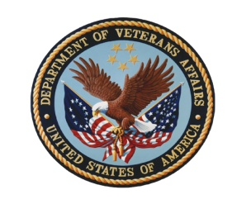

The Department of Veterans Affairs Diversity Council (VADC)

VACO, 810 Vermont Avenue, NW, Conference Room 830
Conference Call 1-800-767-1750, Access Code 79443

Wednesday, March 2, 2011
1:00–3:00 PM (Eastern Time)

Program Agenda

1:00 (15 min.) Welcome (Rafael A. Torres, Acting Principal Deputy Assistant Secretary for
Human Resources and Administration, for John Sepúlveda, Assistant
Secretary for Human Resources and Administration and VADC Co-chair)

1:15 (10 min.) Diversity Council Operations
- Approval of December 1, 2010, VADC Meeting Minutes (Georgia Coffey, Deputy Assistant Secretary for the Office of Diversity and Inclusion, ODI, and VADC Co-chair)
- Confirmation of screening and judging committee members for the Secretary’s Diversity & Inclusion Excellence Awards (Carolyn Wong, Director of Training and Communications, ODI)
- Fiscal year report to the Secretary (Georgia Coffey)

1:25 (15 min.) VA’s Plan for Recruitment and Hiring of People with Disabilities
(Christy Compton, National Disability Program Manager, ODI)

1:40 (40 min.) Career Pathing Initiative (Arthur McMahan, Director, Evaluation and
Career-Technical Training, VA Learning University)

2:20 (15 min.) VA Diversity & Inclusion Internal Memorandum of Understanding
(Tinisha Agramonte, Director of Outreach and Retention, ODI)

2:35 (20 min.) VA’s MD-715 EEO and Diversity State of the Agency Briefing
(David Williams, Director of Workforce Analysis, ODI)

2:55 (5 min.) New Business

3:00 Meeting Adjourn: Next Meeting June 1, 2011
Proposed topics for the next meeting:
- Diversity and inclusion leadership communications plan/MOU
- Diversity and inclusion training for all employees
- Training partnership
- Office of Tribal Government Relations (Stephanie Elaine Birdwell)

