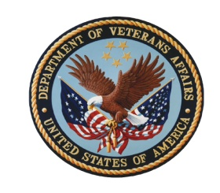

Department of Veterans Affairs Diversity Council (VADC)

810 Vermont Avenue, NW, Conference Room 830, Washington, DC
Conference Call #1 (800) 767-1750 and enter access number 79443

Wednesday, June 2, 2010

1:00 – 3:00 PM Eastern Time

Program Agenda

1:00 (5 min.) Welcome and Introductions
- John U. Sepúlveda,
Assistant Secretary for Human Resources and Administration
- Introduction of James Blockwood, Diversity Training Manager (Carolyn Wong)
- Introduction of Christy Compton, Disability Program Manager (Tinisha Agramonte)

1:05 (10 min.) Diversity Council Operations
- Approval of March 3, 2010, VADC meeting minutes (John Sepúlveda)
- VADC Reference Binders (Carolyn Wong)
- Vote on Proposed VADC Agenda September 1, 2010
- Council Training (Carolyn Wong)
- Health Care Disparities Associated Infections, Obesity, and Health Insurance (recommended by Irene Trowell-Harris and Fernando Rivera)
- OPM Federal Diversity and Inclusion Strategic Plan (Georgia Coffey)
- New EEO, Diversity and Conflict Management SES Performance Element (Ralph Torres and Georgia Coffey)

ACTION ITEMS:

1:15 (15 min.) NCA State of the Agency Briefing on FY10 Progress (Perdita Johnson-Abercrombie)

1:30 (15 min.) VBA State of the Agency Briefing on FY10 Progress (Lois Scoon)

1:45 (15 min.) VHA State of the Agency Briefing on FY10 Progress (Michael Youngblood)

2:00 (30 min.) VA State of the Agency Briefing (Georgia Coffey)

For the good of the order:

2:30 (5 min.) Briefing on SES Diversity and EEO Training (James Blockwood)

(15 min.) New EEO, Diversity and Conflict Management SES Performance Element
(Ralph Torres and Georgia Coffey)

3:00 Meeting Adjourn

