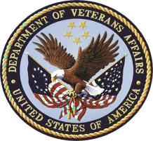
Department of Veterans Affairs Senior Executive Biography

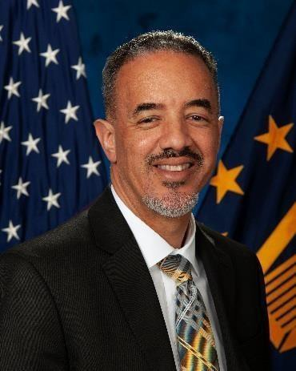

Harvey Johnson
Deputy Assistant Secretary for Resolution Management, Diversity and Inclusion

Mr. Harvey Johnson serves as the Deputy Assistant Secretary for Resolution Management, Diversity and Inclusion at the Department of Veterans Affairs. He serves as the principal advisor to the Secretary of Veterans Affairs and Assistant Secretary for Human Resources and Administration / Operations, Security and Preparedness for the Veterans Affairs. He provides executive leadership to the Office of Resolution Management, Diversity and Inclusion, the
associated field offices and employees. In this capacity, he is responsible for formulating and implementing departmentwide policies and procedures to ensure the integrity, effectiveness, and impartiality of the complaint processing procedures within the Department of Veterans Affairs.

Mr. Johnson is a seasoned executive leader in promoting race and gender equity, resolving conflict, building diverse and inclusive organizations, driving large scale organizational change, strategic planning and business transformation.

Mr. Johnson joined the VA in November 2015. Previously he served as Director, Defense Travel Management Office where he led revolutionary transformation in travel policy, programs, contracts, and station and housing allowances for the Department of Defense (DoD).

A native of Philadelphia PA, Mr. Johnson’s career encompasses 33 years of service with the United States Army in the Infantry and Adjutant General Corps and as an executive with the Department of Defense and Department of Veterans Affairs.

CAREER CHRONOLOGY:
2015 – Present Deputy Assistant Secretary, Resolution Management, Diversity and inclusion
2014 – 2015 Director, Defense Travel Management Office, DoD, Alexandria, VA
2012 – 2014 Acting Director, Defense Travel Management Office, DoD, Alexandria, VA
2009 – 2012 Deputy Director, Defense Travel Management Office, DoD, Alexandria, VA
2008 – 2009 Business Operations Officer, Defense Travel Management Office, Ballston, VA
1988 – 2008 United States Army Officer

EDUCATION:
2020 Certified Life Coach, International Certified Coaches Alliance
2012 Federal Executive Institute, Charlottesville, VA
1988 Bachelors of Arts in Political Science, Morgan State University

