CITI Instructions
www.citiprogram.org

If you have never taken a CITI training course:

- Click on “Register” found in the top right-hand corner of the main CITI Program page.
- In the “Select Your Organization Affiliation” box type “VA Portland, OR – 648”, check the boxes as reflected in the screenshot below and select “Continue To Create Your CITI Program Username/Password.”
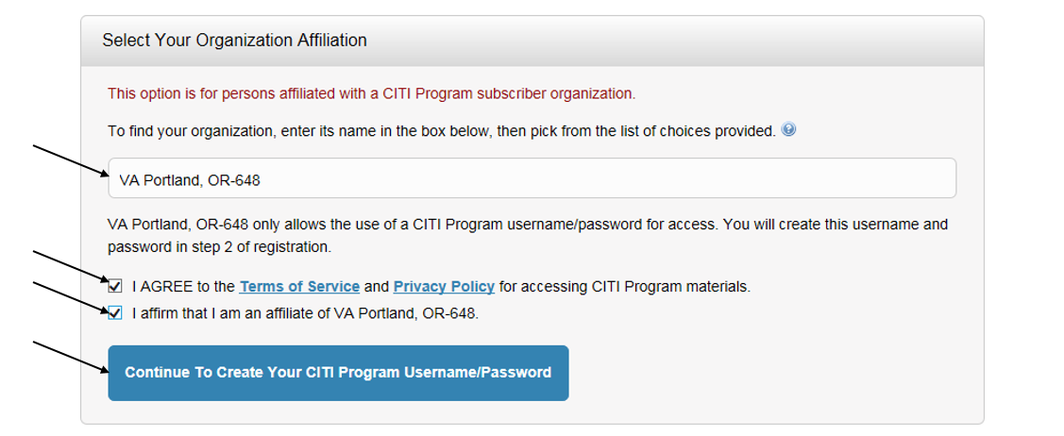
- Go to step 2 -- Enter information into the required fields (marked with a red asterisk) and if possible, provide a secondary email address.
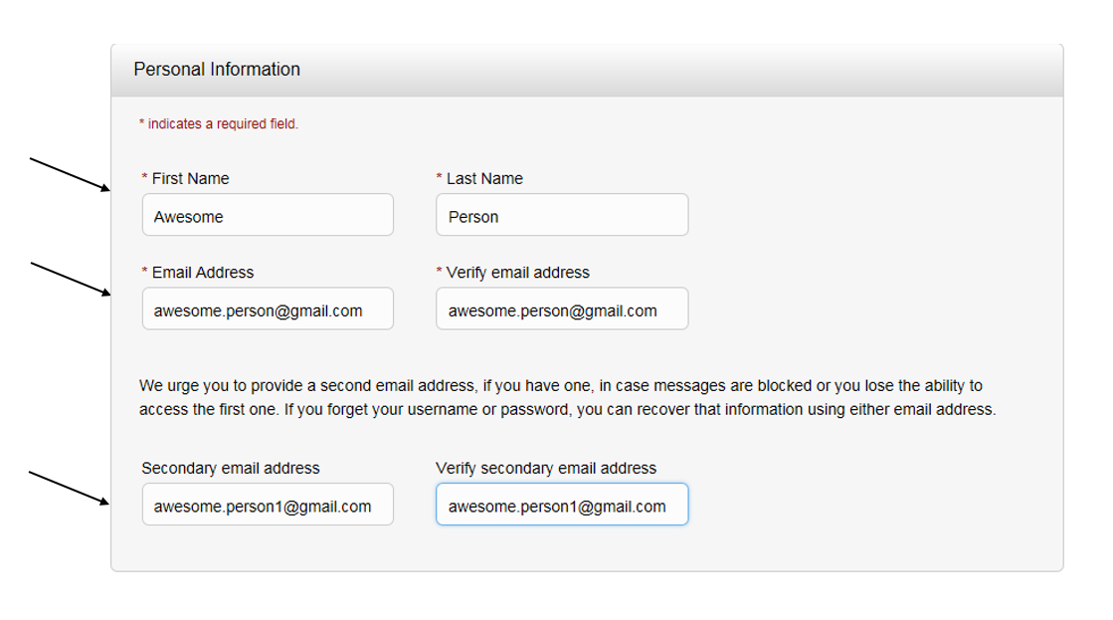
- Go to step 3 --- Enter information into the required fields (marked with a red asterisk).

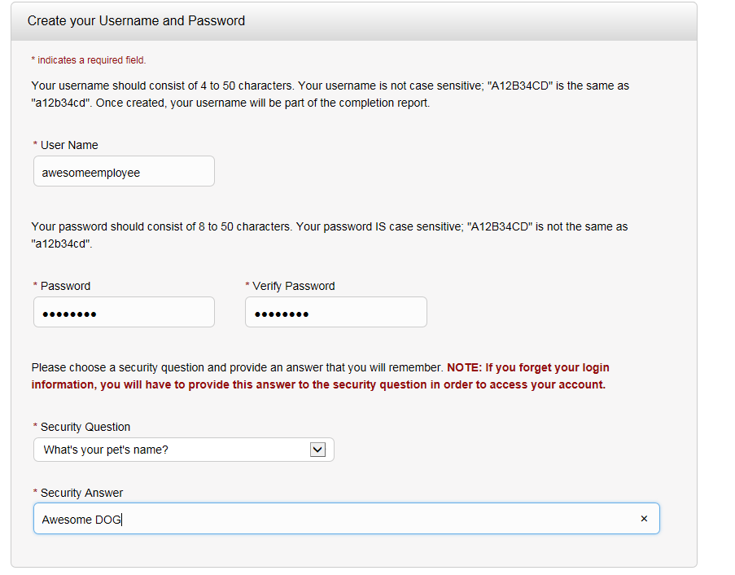

- Repeat this through each step.
- Under step 6, you will be asked to provide your institutional email address. This email address does not have to be a VA email address. It should be the primary email address you provided to the Research Office for general correspondence.
- Under step 7, you will need to indicate the situations that best describe your role at the VA Portland Health Care System (VAPORHCS). NOTE: Our local site does not require the GCP course listed under question 2 or the Disaster Planning for Research Enterprises course listed under question 7.
Once you have successfully registered in CITI, you should be taken to your main welcome page and our institution “Portland, OR-648” can be seen under “Institutional Courses”. To view the required courses added to your learning plan, based on the answers you provided as part of step 7, click on “View Courses” button. This will take you to the training modules.

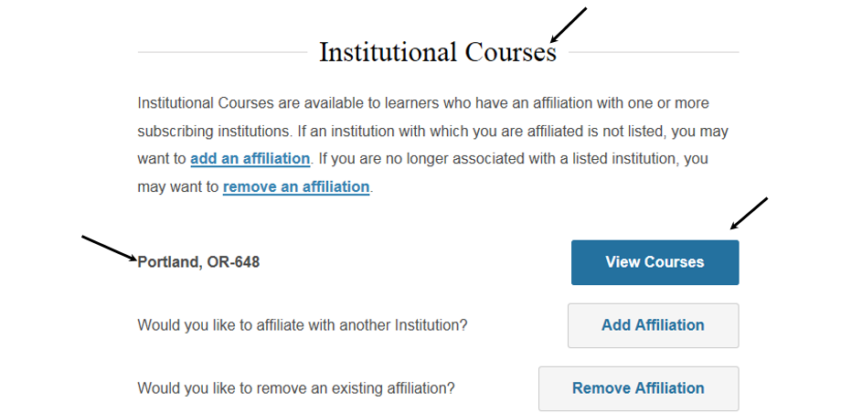

In the Human Subjects training module for instance:
- There are two required modules
- Then you select any 6 of the 18 elective modules to complete the training
- You must complete each module and the short quiz at the end of each one, in order to receive completion credit for the course. In total, the entire course takes 60-90 minutes. NOTE: You do not need to complete the training in one sitting. You may log out and log back in later. If you choose to take a break, when you log back in to complete the course, you will be taken back to your main page where you can click the “View Courses” link to take you back to your course/s.
- The VA has established a minimum "passing" aggregate score of 80% for all quizzes. If you want to improve a score on a quiz, you may revisit the content and repeat any quiz. The software will remember your best score.
- Download a copy of your completion certificate and keep it for your records, as well as for the study files.
If you have previously taken a CITI training course:

- Enter your user name and password. If you have forgotten your user name and/or password, click on “Forgot?” option next to username and/or password.

- From the main page select “View Courses” to the right of “Portland, OR-648”. This will take you to a page that looks like the following screenshot.
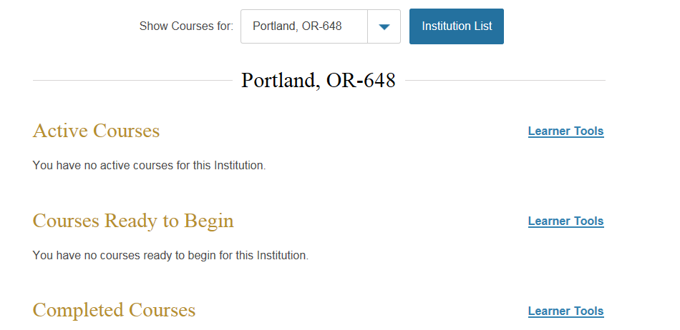
- If you need to complete the Human Subjects refresher course, you must complete a total of 8 modules (2 required modules, and your choice of 6 elective modules that interest you), in order to receive completion credit. NOTE: The VA has established a minimum "passing" aggregate score of 80% for all quizzes. If you want to improve a score on a quiz, you may revisit the content and repeat any quiz. The software will remember your best score.
- Download a copy of your completion certificate and keep it for your records, as well as for the study files.
If you have an active CITI account, but it is not affiliated with our institution (VA Portland, OR-648).

- You will need to take the following steps to affiliate your account with our institution, as we cannot accept the Human Subjects (HS) completion certificate from other institutions such as OHSU. The VA requires the completion of modules other institutions do not have on their learning plan.
- Enter your user name and password. If you have forgotten your user name and/or password, click on “Forgot?” option next to username and/or password.
- To affiliate our institution with your profile, you will need to select the “add an affiliation” button.

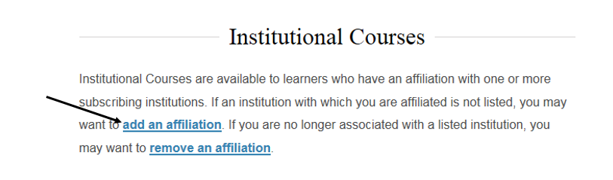

- You will then be taken to the following screen, where you must search for our institution “VA Portland, OR-648”, check the boxes and select “Continue”.
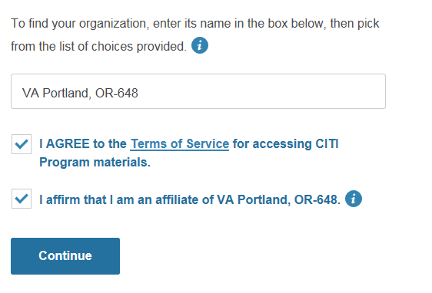
- Once you have successfully affiliated your account with our institution, you will be asked as series of questions about the work you will perform at our institution. NOTE: Our local site does not require the “GCP” or “Disaster Planning for Research Enterprises” courses.
- You should now be able to view and complete the courses assigned to you based on the answers you provided as part of step 11.
- Download a copy of your completion certificate and keep it for your records, as well as for the study files.
If you have any additional questions about the CITI registration or course completion, contact the Research Office at extension 55125.

